Original Research Article

Comparative Analysis of Socio-Economic Empowerment among Tribal Women SHG Members and Non-Members in Gujarat

.

ABSTRACT
higher secondary education (37.50%) compared to non-members (18.75%). A higher proportion of SHG members (36.25%) possessed large herd sizes compared to 15.00% of non-members. Economic indicators showed that 31.25% of SHG members had assets above ₹72,500 compared to 13.75% of non-members, while 27.50% of SHG members reported income above ₹1,13,000 compared to 10.00% of non-members. The mean economic empowerment score was higher for SHG members (65.49) than non-members (54.06). Similarly, the social empowerment index showed a higher mean score for SHG members (69.40 ± 8.92) compared to non-members (37.77 ± 6.53), indicating better self-confidence, skills, and access to services.
Conclusion: The study concludes that SHG participation significantly enhances both economic and social empowerment of tribal women. Strengthening SHG programmes and extending institutional support to non-members can promote inclusive and sustainable rural development.
Commented [DS1]: Limitations can be included
Aims: To analyze and compare the socio-economic empowerment of tribal women SHG members and non-members in Gujarat.
Study design: Ex-post facto research design with comparative analysis.
Place and Duration of Study: The study was conducted in Sabarkantha and Aravalli districts of Gujarat during 2023–2024.
Methodology: A total of 160 tribal women respondents (80 SHG members and 80 non-members) were selected using a multistage purposive sampling technique. Data were collected through personal interviews using a structured schedule. Socio-economic characteristics were analyzed using frequency and percentage, while economic and social empowerment were measured through a composite empowerment index. Mean, standard deviation, and t-test were used for comparison.
Results: The findings revealed that SHG members had better socio-economic status, with

Keywords: Self-Help Groups (SHGs); Tribal Women; Socio-Economic Empowerment; Economic Empowerment Index; Social Empowerment

INTRODUCTION

In rural and tribal regions of India, agriculture and allied activities form the backbone of livelihoods, with women playing a significant role in household income generation and resource management. However, despite their substantial contribution, tribal women often face socio-economic constraints such as limited access to education, financial services, and institutional support, which restrict their overall empowerment and development (Jabeen et

al., 2021). Over the past few decades, Self-Help Groups (SHGs) have emerged as an effective institutional mechanism for promoting women’s empowerment and rural development. SHGs facilitate collective savings, access to microcredit, skill development, and participation in income-generating activities. These groups also enhance women’s decision-making ability, social participation, and access to government schemes and development programmes (Nirmala and Yepthomi, 2014; Nath, 2022). Several studies have reported that participation in SHGs positively influences the socio-economic status of rural women by improving income levels, savings behavior, and access to financial resources. Additionally, SHGs contribute to social empowerment by enhancing self-confidence, communication skills, and community participation among women (Sahni et al., 2022; Jadoun et al., 2021).
Despite these advancements, disparities still exist between SHG members and non-members in terms of access to resources, economic opportunities, and social empowerment. Women who are not associated with SHGs often remain excluded from institutional benefits, leading to lower levels of income, skills, and social participation (Tamuli et al., 2021; Jebessa et al., 2023). However, limited empirical studies have systematically compared the socio-economic empowerment of SHG members and non-members, particularly in tribal regions of Gujarat. Socio-economic empowerment is a multidimensional concept encompassing both economic aspects—such as income, assets, and savings—and social dimensions, including self-confidence, skills, awareness, and access to basic services (Singh and Singh, 2014). A comprehensive assessment integrating these dimensions is essential to understand the overall impact of SHG participation on tribal women’s livelihoods and well-being. In this context, the present study was undertaken to conduct a comparative analysis of socio-economic empowerment among tribal women SHG members and non-members in Gujarat. The specific objectives of the study were:
- To study the socio-economic characteristics of tribal women SHG members and non-members.
- To assess the socio-economic empowerment index of tribal women SHG members and non-members.

MATERIAL AND METHODS

To achieve the study's objectives, a systematic methodology was followed, including site selection, sampling, data collection, and data analysis.
Commented [DS2]: Explain about the methodology fallowed

Study Area

The present study was conducted in Sabarkantha (23.03°N, 73.07°E) and Aravalli (23.5°N, 73.1°E) districts of Gujarat, situated in the western region of India (Figure 1). These districts were purposively selected due to their significant tribal population, comprising 23.16 per cent in Sabarkantha and 21.18 per cent in Aravalli (JJM, 2024). The region is predominantly agrarian, where agriculture and allied activities form the primary source of livelihood, with active participation of tribal women in household and income-generating activities. In recent years, Self-Help Groups (SHGs) have emerged as important grassroots institutions for promoting rural development and women’s empowerment in these districts. Under various livelihood promotion programmes, particularly the National Rural Livelihood Mission (NRLM, 2025), SHGs have facilitated access to microcredit, capacity-building training, and income-generating opportunities for rural women. These institutional mechanisms play a crucial role in enhancing financial inclusion, skill development, and social participation among tribal women.

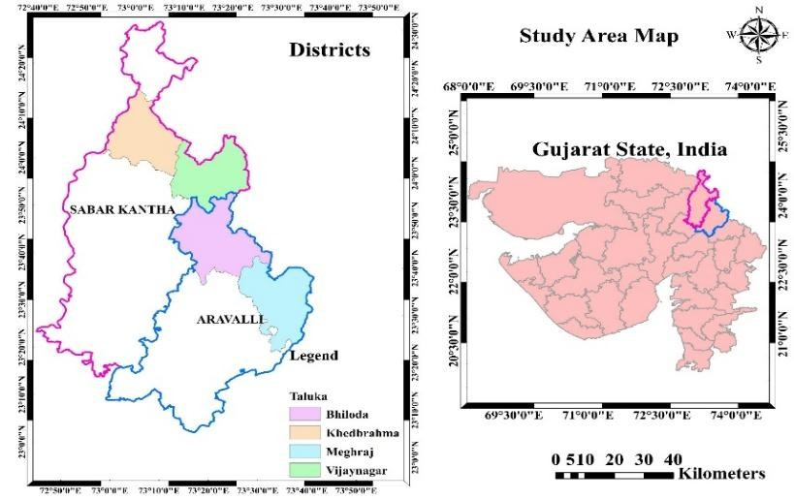
Commented [DS3]: It is not a thesis so map is not required
Fig. 1. Map showing the study area

Sampling and Data Collection
Commented [DS4]: Sections like 2, 2.1,2.2...remove...as it is article

A multistage purposive sampling technique was adopted to select the respondents for the study. In the first stage, Sabarkantha and Aravalli districts of Gujarat were selected purposively due to their high concentration of tribal population and the active presence of Self-Help Groups (SHGs). In the second stage, two talukas from each district—Khedbrahma and Vijaynagar from Sabarkantha, and Bhiloda and Meghraj from Aravalli—were selected based on the intensity of SHG activities and the participation of tribal women in livelihood activities. In the third stage, four villages were selected from each taluka, resulting in a total of sixteen villages. From each selected village, ten tribal women respondents were chosen, comprising five SHG members and five non-members, ensuring equal representation of both groups. Thus, the final sample size consisted of 160 respondents, including 80 SHG members and 80 non-members. The study adopted an ex-post facto research design with a comparative approach to analyze differences between SHG members and non-members without manipulating variables (Kerlinger, 1966). Primary data were collected through personal interviews using a well-structured and pre-tested interview schedule. The schedule was designed to obtain detailed information on socio-economic characteristics and various dimensions of socio-economic empowerment, including economic and social aspects. Secondary data were gathered from SHG records, government reports, and other relevant published sources. This sampling design ensured a balanced and systematic comparison between SHG members and non-members, facilitating a comprehensive analysis of socio-economic empowerment among tribal women.

The socio-economic profile of tribal women of SHG members and non-members

The socio-economic profile of tribal women SHG members and non-members was assessed using key parameters such as age, education, family size, family occupation, and herd size. These variables were selected to understand the socio-economic background of respondents and to facilitate a comparative analysis between SHG members and non-members, as socio-economic characteristics significantly influence participation in development programmes and empowerment outcomes (Pandya and Pandya, 2008; Manjunath, 2014). Respondents were categorized using standardized classification procedures to ensure consistency and comparability with earlier studies. Age was classified into three groups (18–35 years, 36–50 years, and above 50 years) based on standard guidelines (NAEP, 2023). Education levels were categorized from illiterate to graduate level following the classification adopted by
Commented [DS5]: This is enough no need to produce evidence of previous studies here in this paragraph as variables were classified

Pandya and Pandya (2008). Family size was grouped into small, medium, and large categories as suggested by Manjunath (2014), while family occupation categories were defined based on combinations of livelihood activities following Chaudhari (2006). Herd size was considered an important economic indicator reflecting livestock ownership and income-generating potential, and was categorized into small (1–2 animals), medium (3–4 animals), and large (more than 4 animals), following the classification suggested by Savita (2004). This structured classification framework facilitated a systematic comparison between SHG members and non-members, enabling the assessment of socio-economic differentials and their role in influencing the level of socio-economic empowerment among tribal women.

Socio-Economic Empowerment Index

The socio-economic empowerment index was developed to assess and compare the social and economic status of SHG members and non-members. Scores were assigned to selected indicators as per Singh and Singh (2014) to formulate two separate indices Economic and Social Empowerment.

    - Economic empowerment index

This index was based on six indicators: household assets, income, expenditure, savings, loan amount, and housing type. Each respondent received a score for these indicators, and the economic empowerment index (En) was calculated using the formula:

Economic Index (En) = (∑𝐸𝑖 )/ ∑𝐸𝑖(𝑚𝑎𝑥)

Where,

∑ 𝐸_{𝑖} = ith economic indicator
∑ 𝐸_{𝑖(𝑚𝑎𝑥)} = Maximum scores of ith economic indicators

    - Social empowerment index

This index assessed social empowerment through four indicators: self-confidence, skills, social awareness and recognition, and access to public services. Scores were assigned accordingly, and the social empowerment index (Sn) was calculated using a similar formula:

Social Index (Sn) = ∑ 𝑆_{𝑖} / ∑ 𝑆_{𝑖(𝑚𝑎𝑥)}
Where,
∑ 𝑆_{𝑖} = ith social indicator
∑ 𝑆_{𝑖(𝑚𝑎𝑥)} = Maximum scores of ith social indicators

Statistical Tools and Analytical Techniques
Commented [DS6]: 2.1,2.2,2.3,2.4,2.5 all together can be rewrite in just two paragraphs...not seperate

The data were analyzed using appropriate statistical methods. Frequency and percentage were used to describe the socio-economic characteristics of respondents. Mean and standard deviation were computed to compare the economic and social empowerment indices between SHG members and non-members.

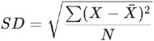
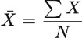
Mean: Standard Deviation:

Where:
- X̅ = Mean
- X = Observations
- N = Number of observations

RESULTS AND DISCUSSION

Socio-Economic Profile of Respondents

The comparative analysis of socio-economic characteristics between SHG members and non-members revealed noticeable differences (Table 1 and figure 2). A higher proportion of SHG members (63.75%) belonged to the middle age group compared to non-members (51.25%), while non-members had a greater share of younger respondents (31.25%). Educational status showed a clear disparity, with SHG members having higher levels of education, as 37.50 per cent had secondary education compared to 18.75 per cent among non-members. In contrast, a larger proportion of non-members were educated only up to the primary level (62.50%) and had a higher illiteracy rate (12.50%). In terms of family occupation, SHG members were more engaged in diversified livelihood activities, with 36.25 per cent involved in agriculture, dairy, and other occupations, compared to 26.25 per cent among non-members. Herd size also differed significantly, as 36.25 per cent of SHG members possessed large herds (>4 animals) compared to only 15.00 per cent of non-members, indicating better economic capacity. Overall, SHG members exhibited relatively better socio-economic status than non-members, suggesting that participation in SHGs contributes to improved livelihood diversification and resource ownership among tribal women.

Table 1. Distribution of sample respondents according to socio-economic characteristics (n=160)
Sr. No. | Categories | Members |  | Non-members
Sr. No. | Age | (F) | (%) | (F) | (%)
1. | Young (18 to 35 years) | 13 | 16.25 | 25 | 31.25
2. | Middle (36 to 50 years) | 51 | 63.75 | 41 | 51.25
3. | Old (>50 years) | 16 | 20.00 | 14 | 17.50
 | Education
1. | Illiterate | 03 | 03.75 | 10 | 12.50
2. | Primary level (1st to 8th std) | 29 | 36.25 | 50 | 62.50
3. | Secondary level (9th to 10th std) | 30 | 37.50 | 15 | 18.75
4. | Higher Secondary (11th to 12th) | 14 | 17.50 | 04 | 05.00
5. | Graduate / Post-graduation | 04 | 05.00 | 01 | 01.25
 | Family size
1. | Small (up to 4 members) | 22 | 27.50 | 16 | 20.00
2. | Medium (5 to 8 members) | 42 | 52.50 | 49 | 61.25
3. | Large (> 8 members) | 16 | 20.00 | 15 | 18.75
 | Family occupation
1. | Dairy | 03 | 02.50 | 06 | 07.50
2. | Agriculture + Dairy | 28 | 53.75 | 38 | 47.50
3. | Agriculture + Dairy + Others | 40 | 36.25 | 21 | 26.25
4. | Dairy + Others | 09 | 07.50 | 15 | 18.75
 | Herd size
1. | Small (1 to 2 animals) | 13 | 16.25 | 21 | 26.25
2. | Medium (3 to 4 animals) | 38 | 47.50 | 47 | 58.75
3. | Large (>4 animals) | 29 | 36.25 | 12 | 15.00

Percentage (%)
Percentage (%)

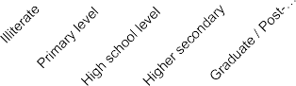
(F - Frequency, % - Percentage)
Age (n=160)
Education Level (n=160)
70
60
50
63.75

51.25
16.25
20
17.5
70
60
50
40
30
20
10
0
62.5
36.25
37.5
40
30
20
10
0
31.25
12.5
3.75
18.75 17.5
5
5
1.25
Young Middle Old

Members Non-members
Members Non-members
Family size (n=160)
Family occupation (n=160)
80.00

60.00
61.25
52.5
60
50
40
30
20
10
0
47.5
50
35
26.25
40.00
27.5
18.75
2018.75
3.75
7.5
18.75
11.25
20.00
0.00
Dairy Agriculture +Agriculture + Dairy +
Small Medium
Large
Dairy
Dairy + Others Others
Members Non-members
Members Non-members
Herd size (n=160)
70
60
50
40
30
20
10
0
58.75
47.5
36.25
26.25
16.25
15
Small Medium Large

Members Non-members
Percentage (%)
Percentage (%)

Fig. 2. Graphical distribution of sample respondents according to socio-economic characteristics
Percentage (%)

Socio-Economic Empowerment Index

The socio-economic empowerment of tribal women was assessed using a composite index comprising both economic and social dimensions, including income, assets, savings, and access to basic services. Such indices are widely used to quantify empowerment and compare different groups in development studies (Singh and Singh, 2014).

    - Economic empowerment index

The Economic Empowerment Index revealed a clear difference between SHG members and non-members (Table 2 and Table 3). SHG members recorded higher scores across key economic indicators, reflecting better financial stability and resource access. A higher proportion of SHG members (31.25%) possessed household assets above ₹72,500 compared to 13.75 per cent of non-members. Similarly, 27.50 per cent of SHG members reported annual income above ₹1,13,000, whereas only 10.00 per cent of non-members fell in this category.

Savings behavior also showed a marked difference, with 35.00 per cent of SHG members having savings above ₹9,800 compared to 15.00 per cent of non-members. In terms of housing, 47.50 per cent of SHG members lived in pucca-owned houses, while the corresponding figure for non-members was 33.75 per cent, indicating better living standards among SHG households.

Table 2. Score of economic empowerment index for SHG members (n=80)
Commented [DS7]: Table 2 and 3 can be clubbed in one table...it will be more clear to readers

Sr.  No. | Economic indicators  /scores | 1 | 2 | 3 | 4 | 5 | 6
1. | Household assets | Below 42500  (08) | 50000  (09) | 57500  (13) | 65000  (10) | 72500  (15) | Above 72500  (25)
2. | Household  income | Below 41000  (12) | 59000  (16) | 77000  (11) | 95000  (10) | 113000  (9) | Above  113000 (22)
3. | Expenditure | Below 37400  (09) | 43000  (07) | 48600  (15) | 54200  (17) | 59800  (07) | Above 59800  (25)
4. | Savings | Below 6800  (09) | 7400  (15) | 8200  (09) | 9000  (04) | 9800  (15) | Above 9800  (28)
5. | Loan | Below 12500  (33) | 15000  (01) | 17500  (17) | 20000  (00) | 22500  (08) | Above 22500  (21)
6. | Housing type | Kutcha (rent) (00) | Kutcha (own)(15) | Semi-pucca (rent)  (00) | Semi-pucca (own)  (27) | Pucca (rent)  (00) | Pucca (own) (38)
(F - Frequency, % - Percentage)

Table 3. Score of economic empowerment index for SHG non-members (n=80)

Sr.  No. | Economic indicators  /scores | 1 | 2 | 3 | 4 | 5 | 6
1. | Household assets | Below 42500  (18) | 50000  (14) | 57500  (16) | 65000  (12) | 72500  (9) | Above 72500  (11)
2. | Household  income | Below 41000  (20) | 59000  (18) | 77000  (15) | 95000  (10) | 113000  (9) | Above  113000 (8)
3. | Expenditure | Below 37400  (15) | 43000  (14) | 48600  (17) | 54200  (11) | 59800  (8) | Above 59800  (15)
4. | Savings | Below 6800  (20) | 7400  (18) | 8200  (13) | 9000  (7) | 9800  (10) | Above 9800  (12)
5. | Loan | Below 12500  (36) | 15000  (3) | 17500  (14) | 20000  (0) | 22500  (9) | Above 22500  (18)
6. | Housing type | Kutcha (rent) (2) | Kutcha (own) (27) | Semi-pucca | Semi-pucca | Pucca (rent)  (0) | Pucca (own) (27)

 |  |  |  | (rent)  (0) | (own)  (24)
(F - Frequency, % - Percentage)

The overall Economic Empowerment Index further substantiated these findings, with SHG members recording a higher mean score (65.49) compared to non-members (54.06) (figure 3). This difference indicates a relatively stronger economic position of SHG members. The improved economic status of SHG members may be attributed to access to microcredit, collective savings, and income-generating opportunities facilitated through SHGs. These findings are consistent with earlier studies, which reported that SHGs significantly enhance financial inclusion and economic self-reliance among rural and tribal women (Kumar and Rao, 2021). Overall, the results suggest that participation in SHGs plays a significant role in improving the economic empowerment of tribal women.
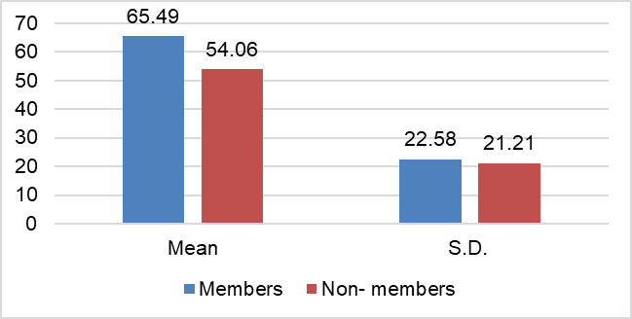

Fig. 3. Average economic empowerment index

    - Social empowerment index

The Social Empowerment Index revealed a substantial disparity between SHG members and non-members (Table 4 and Table 5). SHG members exhibited higher levels of self-confidence, social participation, and access to basic services compared to non-members. Notably, 16 SHG members reported a high level of confidence in handling financial crises and interacting with officials, whereas none of the non-members expressed such confidence.

In terms of skill development, a majority of SHG members rated their communication and business skills as good to excellent, while a large proportion of non-members rated their skills as poor. Similarly, social awareness and participation were higher among SHG members, as reflected in their ability to engage in social issues and decision-making processes.

Access to essential services such as medical facilities, sanitation, and drinking water was also comparatively better among SHG members, who largely rated these services as satisfactory. In contrast, non-members predominantly reported poor access to these facilities, indicating lower social well-being.

Table 4. Score of social empowerment index for SHG members (n=80)
Commented [DS8]: Table 4 and 5 should be clubbed to give a clear picture to reader

Sr.  No. | Social indicators | Not at all | Very little | Somewh at | Much more | To a great extent
Self-confidence
1. | Confidence of financial crisis | 00 | 00 | 37 | 27 | 16
2. | Confidence in meeting official people | 00 | 00 | 40 | 24 | 16
3. | Physical mobility | 00 | 00 | 28 | 39 | 13
Social awareness and recognition
4. | Social awareness | 00 | 00 | 32 | 37 | 11
5. | Respect in the family | 00 | 00 | 40 | 29 | 11
6. | Ability to take up social issues | 00 | 00 | 44 | 27 | 9
Skills |  | Extremel y poor | Poor | Satisfact ory | Good | Excellent
7. | Communication skills | 00 | 00 | 36 | 32 | 12
8. | Business skills | 00 | 00 | 37 | 29 | 14
9. | Financial skills | 00 | 00 | 42 | 24 | 14
Facilities/services
10. | Medical facilities | 00 | 18 | 51 | 11 | 00
11. | Hygienic sanitation facilities | 00 | 29 | 43 | 8 | 00
12. | Drinking water supply | 00 | 27 | 47 | 6 | 00

Table 5. Score of social empowerment index for SHG non-members (n=80)

Sr.  No. | Social indicators | Not at all | Very little | Somewh at | Much more | To a great extent
Self-confidence
1. | Confidence of financial crisis | 0 | 56 | 24 | 00 | 00
2. | Confidence in meeting official people | 29 | 51 | 0 | 00 | 00
3. | Physical mobility | 27 | 38 | 15 | 00 | 00
Social awareness and recognition
4. | Social awareness | 11 | 64 | 5 | 00 | 00
5. | Respect in the family | 19 | 52 | 9 | 00 | 00
6. | Ability to take up social issues | 24 | 48 | 8 | 00 | 00
Skills |  | Extremel y poor | Poor | Satisfact ory | Good | Excellent
7. | Communication skills | 13 | 53 | 14 | 00 | 00
8. | Business skills | 21 | 50 | 9 | 00 | 00
9. | Financial skills | 19 | 56 | 5 | 00 | 00
Facilities/services
10. | Medical facilities | 29 | 38 | 13 | 00 | 00
11. | Hygienic sanitation facilities | 24 | 45 | 11 | 00 | 00
12. | Drinking water supply | 20 | 44 | 16 | 00 | 00

The overall Social Empowerment Index further confirmed these differences, with SHG members recording a significantly higher mean score (69.40 ± 8.92) compared to non-members (37.77 ± 6.53) (figure 4). This indicates a higher level of social empowerment among SHG participants. The findings suggest that SHGs play a crucial role in enhancing self-confidence, skill development, and social inclusion among tribal women. Similar results have

been reported in earlier studies, highlighting the positive impact of SHGs on social empowerment and community participation (Sahni et al., 2022; Jadoun et al., 2021).
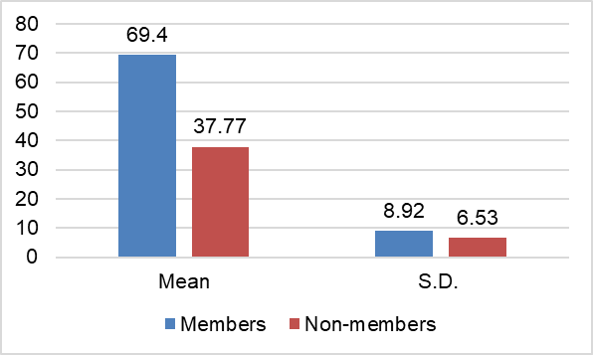

Fig. 4. Average social empowerment index

CONCLUSION

The present study conducted a comparative analysis of socio-economic empowerment among tribal women SHG members and non-members in Gujarat. The findings revealed that SHG members possessed relatively better socio-economic characteristics, including higher educational levels, greater livelihood diversification, and larger herd sizes, compared to non-members. The analysis of the Economic Empowerment Index indicated that SHG members had a stronger economic position, reflected in higher income levels, savings, asset ownership, and improved housing conditions. Similarly, the Social Empowerment Index demonstrated that SHG members exhibited significantly higher levels of self-confidence, skill development, social awareness, and access to basic services than non-members. Overall, the study clearly establishes that participation in Self-Help Groups plays a significant role in enhancing both economic and social empowerment of tribal women. SHGs act as an effective platform for financial inclusion, capacity building, and social transformation, thereby contributing to improved livelihood outcomes. The study suggests that strengthening and expanding SHG programmes in tribal areas can further enhance women’s empowerment. Policy interventions should focus on improving access to credit, skill development, and institutional support for non-SHG women to reduce existing disparities and promote inclusive rural development.
Commented [DS10]: Author can suggest few innovative ways to enhance women empowerment
Commented [DS9]: Reframe sentence

REFERENCES
Chaudhari, R. R., 2006, A study on entrepreneurial behaviour of dairy farmers. M.Sc. (Agri.) Thesis, Univ. Agric. Sci., Dharwad, Karnataka (India).

Jabeen, S., Alam, A. and Jawad, M. (2021). Impact of Social Factors on the Status of Tribal Women: A Case Study of the (Erstwhile) Mohmand Agency. Journal of Development and Social Sciences, 2(4), 440-455.

Jadoun, Y. S., Chadda, A., Singh, J., Kansal, S. K., and Singh, A. (2021). Women empowerment through livestock-based self-help group. International Journal of Livestock Research, 11 (6): 1-10.

Jebessa, G. M., Fikadu, B., Chalchisa, T., Tadese, A., Berhanu, A., Hailu, D. and Seid, A. (2023). Impacts of crossbreed dairy cow adoption on women dietary diversity in southwestern Ethiopia. Journal of Agriculture and Food Research, 12, 100544.

JJM. (2024). Annual report on Jal Jeevan Mission achievements and challenges. Ministry of Jal Shakti, Government of India. Available at: https://jaljeevanmission.gov.in

Kerlinger, F. N. (1966). Foundations of Behavioral Research (4th ed.). Harcourt College Publishers.

Kumar, D. S. and Rao, S. P. (2021). Demographic Profile of Self-Help Group Members Effects the Women’s Entrepreneurship Empowerment. International Journal of Mechanical Engineering, 6(3): 3560-3565.

Manjunath B. K. (2014). A study on perception of precision farming by the farmers. M. Sc. (Agri.) Thesis, Univ. Agric. Sci., Dharwad, Karnataka (India).

NAEP. (2023). National Achievement Survey report for school education. Ministry of Education, Government of India. Available at: https://www.education.gov.in

Nath, P. (2022). Collective Dairy Farming, Women Empowerment and Social Inclusion: A Village-Level Study from Bihar, India. Global Business Review.

Nirmala, V. and Yepthomi, K. K. (2014). Self-help groups: A strategy for poverty alleviation in rural Nagaland. International Research Journal of Social Sciences. 3(6): 23–32.

NRLM. (2025). Progress report of National Rural Livelihood Mission. Ministry of Rural Development, Government of India. Available at: https://aajeevika.gov.in

Pandya, C. D. and Pandya, R. D. (2008). Development and standardization of a scale to measure the socio-economic status of the farmers. Gujarat Journal of Extension Education. 19(1): 7-14.

Sahni, A., Joshi, R. and Malik, M. C. (2022). Role of Self-Help Group and Micro financing in the Social and Economic Development of Rural People in Uttarakhand (A Comprehensive Literature. International Journal of Advances in Engineering and Management, 4(3): 978-982.

Savita, S. S., 2004, Role of rural women in animal husbandry. M.Sc. (Agri.) Thesis, Univ. Agric. Sci., Dharwad, Karnataka (India).

Singh, H. R. and Singh, N. D. (2014). An impact assessment of microfinance: a case study of socio-economic empowerment of SHG members in Manipur (India). Paripex-indian journal of research, 3(1): 141-147.

Tamuli, R. U., Khuman, S. L., Boruah, K. and Saikia, K. (2021). Attributes Influencing Adoption of Health Care Scientific Dairy Management Practices among Tribal and Non-Tribal Dairy Farmers of Assam. International Journal of Social Sciences, 10(04): 357-360.

