Therapeutic Management of Visceral Schistosoma spindale infection in Cattle: A Case Report

Abstract
Schistosomiasis is an economically important parasitic disease affecting livestock in tropical and subtropical regions, including India. The present case study reports a clinical case of visceral schistosomiasis caused by Schistosoma spindale in a five-year-old crossbred cow from Patna, Bihar (India). The cow was presented with history of anorexia, reduced milk yield, and passage of blood and mucus mixed feces for five days. Clinical examination revealed pallor mucosa, dullness, and mild dehydration. Hematological analysis revealed anemia with low hemoglobin (7.8 g/dl), packed cell volume (22%), and total erythrocyte count (4.62 × 10⁶/cumm). Fecal examination using direct smear and sedimentation techniques revealed characteristic spindle-shaped eggs of S. spindale, confirmed the diagnosis. The cow was treated with oral praziquantel (@20 mg/kg, two doses at one-week interval) along with supportive therapy including intravenous fluids, tranexamic acid and haematinics. A remarkable clinical improvement was observed within three days of treatment with restoration of normal feeding and fecal consistency. However, complete recovery was confirmed by negative fecal examination after three weeks post-treatment.
Key words: Cattle; faecal examination; S. spindale; treatment

Introduction:
Schistosomiasis is an economically significant parasitic diseases affecting farmed animals in tropical and subtropical regions including India. The disease is prevalent in cattle, buffaloes, sheep, and goats in India. Although most infections in endemic areas are asymptomatic, increasing incidence results in significant losses in terms of growth, productivity, and increased susceptibility to other parasitic or bacterial diseases. The most common causes of visceral schistosomiasis in cattle are Schistosoma indicum and Schistosoma spindale (Digraskar et al., 2018). The snail, Indoplanorbis exustus is responsible for the transmission of Schistosoma nasale, Schistosoma spindale and Schistosoma indicum as well as other trematodes such as Echinostoma spp. and some spirorchids (Tigga et al., 2014). S. spindale is generally a chronic wasting illness, contributing to substantial reduction of productivity, mortality and economic losses (Bubul et al. 2019). Ruminants are usually infected with cercaria (infective stage) through skin penetration; however, infection can be acquired orally while animals are drinking (Chandran et al. 2022). Blood fluke S. spindale causes visceral schistosomiasis in bovine and characterized by frequent diarrhoea with blood and mucous colic, weight loss and weakness in animals. Further, it can also causes low milk yield and severe mortality with outbreaks leading to high death rates in cattle (Vijayasarath et al., 2023). Diagnosis of schistosomiasis in cattle can only be achieved through the detection of parasite eggs in fecal samples or biopsy specimens from the affected animal (Abera et al. 2020). Detection of subclinical schistosomosis in live animal is difficult since affected do not revealed clinical signs and act as carrier, it is important to detect the disease in live animal so that they can be treated in order to minimize morbidity and economic loss. Routine faecal examination are not so effective for detecting S. spindale infections, leading to lower infection rates in the field. The present communication reports the presence of S. spindale infection in a Crossbred cow and its therapeutic management.
Clinical case presentation:
A five - years old crossbred cow weighing about 300 kg (Figure 1) was examined on request of owner at Haldi Chapra, Danapur, Patna, Bihar for anorexia, reduced milk yield and passing dung mixed with blood and mucous (Figure 2) for five days. The cow had a history of grazing in field. The clinical examination revealed temperature of 101.6⁰F, pale mucus membranes, dullness and mild dehydration as assessed by reduced skin elasticity. The cattle was dewormed with fenbendazole bolus, but no clinical improvement was noticed. Based on the history and clinical signs, it was suspected that the cow might be suffering from a gastrointestinal infection or parasitic infestation. Further, blood and stool sample was collected for blood smear examination, hematological analysis and faecal examination respectively at Institute of Animal Health and Production (IAHP), Bihar, Patna. Haematological profile was estimated by standard procedures. The direct method and sedimentation technique was used for identification of eggs as per the method of Soulsby (1982).

Treatment and Discussion:
Based on history, clinical signs and faecal sample examination by direct and sedimentation technique demonstrated typical eggs bearing a spindle shaped at both ends (Bulbul et al., 2019), confirmed visceral Schistosoma spindale infection. The treatment was prescribed with oral administration of Praziquntel @20mg/kg, two doses three week apart followed by supportive care as intravenous fluid therapy (3 liters of Dextrose Normal Saline and 3 liters of Ringer's Lactate) and injection Tranexamic Acid @ 5mg/kg intramuscularly for 3 days. The cattle showed marked clinical improvement with normal appearance of faeces and normal feeding after three days of treatment. Further, as follow up therapy, haematinics Sharkoferrol @ 50gm daily orally prescribed for 3 weeks to combat anemia. Complete recovery in present case was assessed on the basis of observed clinical improvement by normal feeding, watering and restoration of normal fecal consistency and a negative fecal examination after three weeks post treatment.
The microscopic examination of faecal sample by direct and sedimentation technique revealed the presence of spindle shaped egg with terminal spine at both ends, confirmed for S. spindale infection. The presence of spindle shaped eggs in fecal sample of cattle was also reported by Sakhare et al. (2025). Diagnosis of the visceral schistosomiasis is based mainly on the clinico-pathological pictures, history of access to natural water sources and demonstration of characteristic eggs based on the species in the feces (Urquhart, et al, 1987; Engdaw and Abuhay, 2015). Haematological analysis of affected cattle revealed low levels of Haemoglobin (7.8 gm/dl), PCV (22.0 %) and TEC (4.62 x10⁶/cumm) indicating anaemia (Digraskar et al., 2018 & Rathod et al. 2024), which might be due to haemorrhages caused by the terminal spines of the eggs. The presence of terminal spine eggs involves in the mechanical trauma of the mesenteric veins (phlebitis), intestinal mucosa and submucosa as well as lamina propria leading to acute intestinal syndrome or visceral schistosomosis (Sucharitha et al. 2024). For many years, antimonials (Anthiomaline), trichlorphon, and neguvon have been recognized as schistosomocidal activity, but they have also toxic properties against visceral Schistosome infection in cattle (Engdaw and Abuhay, 2015). Currently, Praziquantel is the drug of choice used worldwide to treat schistosomiasis in humans and animals, and reported to have 100% efficacy against Schistosomiasis (Niaz et al. 2015). Praziquantel increases the permeability of membranes of Schistosoma spp. cells towards calcium ions, resulting in severe spasms and paralysis of the parasites (Keiser and Utzinger, 2004). The recommended dose regimen of praziquantel in present case was in accordance with Digraskar et al. (2018), who suggested that Praziquantel @ 20mg/kg along with standard supportive therapeutic regimen is efficacious for the treatment of schistosomiasis in cattle.
Conclusion:
The present case showed that S. spindale infection can significantly affect the health and productivity of cattle. Early diagnosis and targeted treatment is essential in managing schistosomiasis in cattle. Praziquantel administered at 20 mg/kg, along with appropriate supportive therapy, proved to be highly effective in achieving rapid clinical recovery and complete parasitological clearance. Regular monitoring, improved management practices, and control of snail intermediate hosts are crucial to prevent recurrence and minimize economic losses associated with bovine schistosomiasis.
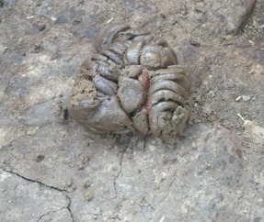
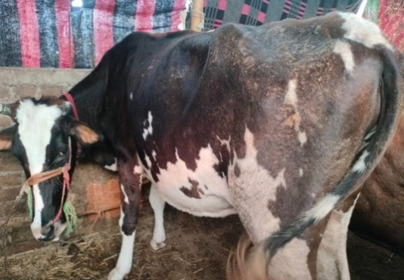
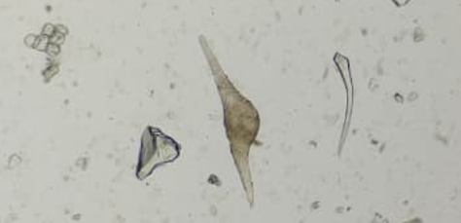
Fig.1. Cattle showing the sign of dullness and dehydration
Fig.2. Dung mixed with blood and mucous of affected cattle
Fig. 3. Arrow showing S. spindale eggs on 10x magnification (Direct smear method)
Fig. 4. Arrow showing S. spindale eggs on 10x magnification (Sedimentation method)

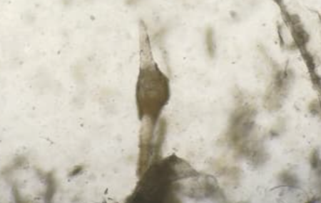

References:
Vijayasarathi, M.K., Latchumikanthan, A. & Velusamy, R. (2023).Occurrence of Schistosoma spindale in bovine calves in Thanjavur district of Tamil Nadu. Indian Journal of Veterinary and Animal Sciences Research, 52 (6), 107-109. https://doi.org/10.56093/ijvasr.v52i6.149504
Tigga, M.N., Bauri, R.K., Deb, A.R. & Kullu, S.S. (2014). Prevalence of snail’s intermediate host infected with different trematodes cercariae in and around Ranchi, Veterinary World, 7(8), 630-634. www.veterinaryworld.org/Vol.7/August-2014/15.pdf
Sudhakar, K., Murthy, G.S.S. & Rajeshwar, G. (2016). An Abattoir Study of Bovine Visceral Schistosomosis in Telangana State, India. International Journal of Agriculture Sciences, 8(58),3205-3208. http://www.bioinfopublication.org/jouarchive.php?opt=&jouid=BPJ0000217
Soulsby, E.J.L. (1982). Helminths, arthropods and protozoa of domesticated animals. 7th ed. London: Bailliere, Tindall; p. 766.
Bulbul, K.H., Das, M., Islam, S., Sarmah, P.C., Tamuly, S., Borah P. & Roy, K. (2019). Molecular epidemiology of visceral schistosomosis caused by Schistosoma spindale infection in cattle of Assam, India, Biological Rhythm Research, DOI: 10.1080/09291016.2019.1616902
Urquhart, G.M., Armour, J., Duncan, & Jennings, F.W. (1987). Veterinary helminthology: Veterinary Parasitology. New York: Churchill Livingstone Inc., Pp. 114-116.
Digraskar, S., Shafi,T.A., Babasaheb, N. & Nithin, B.S.(2018). Successful medicinal management of visceral schistosomiasis in cattle. The Pharma Innovation Journal 2018; 7(2): 27-29. www.thepharmajournal.com
Engdaw, T.A. & Abuhay, A.G. (2015). Overview on: schistosoma infection in cattle. World Journal of Pharmaceutical and Life Sciences. 1(3):1-11.www.wjpls.org.
Niaz, S., Akhter, T., AbdEl-Salam, M.N., Ayaz, S., Shams, S., Ullah, R., Hussain, H. & Wasim, A. M. (2015). Treatment of schistosomiasis by seeds of lagenaria siceraria and its comparison with allopathic drugs in Buffaloes. Indian Journal of Animal Research. 50(2): 235-238. doi: 10.18805/ijar.5959.
Sucharitha, A., Vijaya Sri, N.V.N. & Deepika K.G. (2024). A case report of Schistosoma indicum in a buffalo and its therapeutic management. International Journal of Veterinary Sciences andAnimalHusbandry,9(2),947-948. https://doi.org/10.22271/veterinary.2024.v9.i2m.133
Rathod, Y., Biradar, R., Kasaralikar, V.R. & Halmandage, S. (2024). Diagnosis and therapeutic management of Schistosoma indicum infestation in a Bullock: A case report. International Journal of Veterinary Sciences and Animal Husbandry, 9(2), 388-390. https://doi.org/10.22271/veterinary.2024.v9.i2f.1224
Keiser, J. & Utzinger, J. (2004). Chemotherapy for major food-borne trematodes: a review. Expert Opinion on Pharmacotherapy, 5, 1711-1726. DOI: 10.1517/14656566.5.8.1711
Chandran, D., Lejaniya, A.S., Kumar, A.S., Rajan, A. & Edana, G.G. (2022). Clinical Diagnosis and Therapeutic Management of Schistosomosis (Schistosoma spindale) Infestation in Cattle: A Case Study. Acta Scientific Veterinary Sciences, 4 (8), 66-69. file:///D:/downloads/Shistosoma%20(1).pdf
Abera, M., Fentahun, G. & Peer, F. (2020). Prevalence of bovine schistosomiasis and its associated risk factors in and around Bahir Dar town, northwest Ethiopia. Daagu International Journal of Basic and Applied Research, 2, 66-74. https://dagujournal.org/index.php/dijbar/article/view/15/13
Sakhare, M.P., Siddiqui, M.F.M.F., Kalwaghe, S.T., Wakade, U.U., Shafi, T. A., Mujeeb, S.A. & Lingayat, S. (2025). Therapeutic Management of Acute Intestinal Schistosomiasis in A Red Kandhari Bullock”. Journal of Scientific Research and Reports, 31 (1), 434-39. https://doi.org/10.9734/jsrr/2025/v31i12786

