Original Research Article
Isolation of DL-Proline, 5-oxo- methy ester from A. Bisporus Mushroom Grown in Natural Conditions and Explanation of its Structure Using Spectroscopic Methods

ABSTRACT
Background: Worldwide, A. bisporus is one of the leading fungi in terms of consumption and chemical decomposition of A. bisporus, one of the leading fungi in terms of its richness in various components.
Aims: This study was carried out with the aim of profiling volatile metabolites from ethyl alcohol extraction biomass from naturally grown A. bisporus fungus.
Study design: Based on practical experience
Place and duration of study: The research work was carried out at "Laboratory of Chemistry and Physicochemical Research of Biologically Active Substances" of Karshi State University, March-June 2025.
Methodology: In this process, secondary metabolites were isolated from A. bisporus fungus at the chloroform fractionation step by calonscale chromatography, the substances were analyzed by GX-MS and the structure was studied using YAMR spectroscopic (H, COSY, ROSY, HBMS, HSQC) methods.
Results: At this stage of fractionation, 14 complex secondary metabolites belonging to classes such as esters, imides, amines, organic acids, steroids were detected.
Between them: the amorphous matter was neatly separated. When the chemical structure of the resulting pure substance was determined by physical research methods, it was found that DL-Proline, 5-oxo-, methyl ester.

Keywords: A. bisporus, secondary metabolite, DL-Proline, 5-oxo-, methyl, chromatography, extract, ester, chloroform fraction, chemical structure

- INTRODUTION
Considered to be one of the fungi common in nature, they exhibit significant biological activity along with the development of secondary metabolites of a novel structure, mainly containing terpenoids, nitrogen compounds, steroids, sphingoids, aliphatic compounds, and other structural species, some of which have anti-tumor, anti-neurolysis, antibacterial, anti-angiotensin converting enzyme action (Cao et al., 2024). Five test species of A. bisporus fungus have identified polyols that are predominantly fungal sugars, such as trehalose and mannitol (Wen et al., 2014). When non-volatile flavor components were detected in commercially used mushrooms dried in Taiwan, such as Agaricus blazei (Brazilian fungus), Agrocybe cylindracea (black-famous fungus), and Boletus edulis (king bolete), it was found that all three types had high carbohydrates, crude fiber, and protein content, while raw ash and fat were low. Arabitol, myo-inositol, mannitol, and trehalose have been identified in three fungi (Shu-Yao et al., 2008). A small amount of benzyl isothiocyanate was detected using GC and GC/MS analysis of the composition of A. bisporus, indicating the presence of benzylflucosinolate from A. bisporus (Alexander et al., 1983). When a vaporous volatile extract with a strong fungus-like odor was isolated from the white fungus of Agaricus bisporus, volatile compounds such as 3-methylbutanal, 3-octanone, oct-1-en-3-one, 3-octanol, oct-1-en-3-ol, furfural, benzaldehyde, phenylacetaldehyde, and benzyl spirit were detected by gas chromatography-mass spectrometry (Cronin et al., 1971). In Agaricus bisporus, compounds such as 1-octen-3-ol, benzyl alcohol, and 3-octanone are known to be large flavor compounds. It has been found that increased levels of isovaleraldehyde and 3-octanone such as isovaleraldehyde and 3-octanone during the last shelf life of the fungus may have contributed to its deterioration in quality (Shao et al., 2022). Disambiguation pages with short descriptions the activity of this compound can be explained by the high hydrophobia of the alkyl group, the primary structure of the alkyl group, and the unnetworked structure of the alkyl group being found to exhibit the great toxicity property of 1-octanol (Eugene and Nidiry 2001). Volatile components such as dodecane, benzo-2,3-pyrrole, thetradecane, 2,4-bis(1,1-dimethyletyl) phenol, have been identified in secondary metabolites in A. bisporus (Bartkiene et al., 2023). V A from the No0107 sample of bisporus from Guangzhou contained 27.24% of benzyl alcohol, furancarboxaldehyde, benzaldehyde, 2-(1,1-dimethylyl)-3-methyl-Oxirane, 5,6-dihydro-6-pentyl-2H-Pyran-2-one, and 2-Propen-1-ol. The results showed that the source of the fungus, the origin of the climate, cultivation methods were found to affect the taste of Agaricus bisporus (Yan et al., 2015). When MALDI TOF/TOF MS analysis of Agaricus bisporus extract was performed, sugar compounds such as GH27 alpha-glucosidases, GH47 alpha-mannosidases, GH20 hexosaminidases, and alkaline phosphatases were detected (Morosanova et al., 2020). Ergosterol, trilinoliene, brassicasterol, and linoleic acid have been found in the extract of A. bisporus in dichloromethane (Consolacion et al., 2016). In Mongolia, sugars, nitrogenous compounds, and steroids such as urea, ergosterol, mannitol, ergosterol peroxide have been identified from 95% ethanol extracts of Agaricus silvaticusnindg (Munkhgerel et al., 2014). Agaricus blazei (A. blazei) is a fungus with the ability to produce metabolites with a wide variety of biologic effects. It has been found to contain steroids such as ergosterol, which kill tumors (Shimizu et al., 2016). Compounds such as benzoylergostane, N-benzoyl-L-leucine methyl ester, 2 identified ergostanes, and large amounts of degradable insisterol have been identified from the fruit body of Agaricus blazei along with 2 phenylhexane derivatives (Ueguchi et al., 2011). The most abundant components in volatile compounds and butanol have been identified as phenolic and urea compounds, respectively (Petrova et al., 2007).
- MATERIAL AND METHOD

2.1 Preparation of biomass from piglets
A biomass was prepared from the fruit of A bisporus extracted from the fields of Koson and Kasbi districts of the Kashkadarya region (Nomozova et al., 2026). The resulting extraction mass was placed in a silicon-equipped glass chromatorgraphic shield and fractionated in pure chloroform after being washed in hexane, hexane and chloroform systems. At this step, the obtained fractional sum was driven in a vacuum rotor spar at a speed of 40-50 μm at 61.5°C under water bathing environment. The composition of the obtained samples was examined by thin-layer chromatographic method, similar samples were isolated and verified by GX-MS analysis.
2.2 GX-MS analysis
Chromatec 5000 gas chromatographide (GC) equipped with HP-5 column (30 m × 0.32 mm × 0.25 μm) was performed. Nitrogen was used as the carrier gas. Temperature of the GX evaporator was initially kept at 80°C for 5 min, then temperature was raised to 300°C at a speed of 4°C/min and held for 30min. The components were identified from the mass spectra of each component after comparing it with the available spectral data from the MS library NIST 2017.
  - NMR analysis
NMR spectra were obtained in deuteropyridine and deuterochloroform (δ, m.d., 0-TMS) in the UNITYplus 400 instrument. The correlation of H GDP, 13C GDP spectra, and (COSY) chemical shear was recorded on the Brooker instrument AM 400. The 13C GDP spectra were obtained by completely ruling out the C-N interaction and J- modulation. The 2M NMR spectra of long-range N-C interactions (NMVS) and nuclear energy measurements in the YaEO rotary coordinate system (ROESY) were obtained on the Brooker AC 300 instrument. Deteropyridine has been noted as a solvent in the extraction of spectra. All spectra are obtained according to standard Brooker programs. Indirect recording of carbon signal peaks in heterocorrelation spectra was performed according to the standard methods of ROESY, HSQC. The SSTK values are specified by the LAOCON integration program
- RESULTS AND DISCUSSION
To determine the secondary metabolites of the A. bisporus mushroom grown in natural conditions amorphous substance DL-Proline, 5-oxo- methyl ester was obtained as a result of fractionation in the chloroform system, and its structure was determined using physical research methods and its mass spectrum was obtained (Fig. 1).

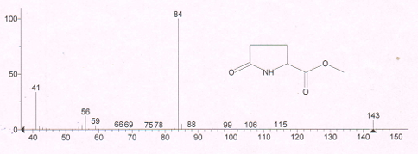
Fig 1. Mass spectrum of methyl ester of 5-oxo-DL-prolinate acid
In the mass spectrum of methyl ester of 5-oxo-DL-prolinate acid, the M+ molecular ion was found to be equal to m/e 143 (C6H9NO3). The molecule is shown to form high-intensity m/e 84 (C4H6NO) ions and m/e 112 (C5H6NO2), 59 (C2H3O2) ions during fragmentation.

High-intensity signals of methyl ester of 5-oxo-DL-prolinate acid in the IR spectrum were detected in the downstream regions (Fig. 2).

Fig 2. IR spectrum of methyl ester of 5-oxo-DL-prolinate acid
In the IR spectrum of the substance, the presence of a gallant vibration of the =N-H bond-specific signal in the proline group = N-H is ν=N-H = 3246.31 cm⁻¹ indicates the presence of an active hydrogen bond in the secondary amine group in the molecule. The 5-oxo-DL-prolinate acid, located in the heteroring of methyl ether, is 2957.63 cm⁻¹ The presence of a noble in the field indicates that the five-membered heteroring junction is bilaterally linked. The presence of very strong valent vibrations specific to the -C=O carbonyl group in the molecule in the 1681.69 cm⁻¹ regions, and the manifestation of the valent vibration specific to the 5-oxo group in the 1735.97 cm⁻¹ regions indicate the presence of two carbonyl groups in the molecule. In the IR spectrum of methyl ether of 5-oxo-DL-prolinate acid, the valent vibrations specific to the –C-C− bond are 1437.12 cm⁻¹ in the fields of agriculture. The valent oscillations specific to the ether-O-CH3 group in the molecule are 1382.96 cm^{−1,} and the depharmaceutical oscillations of the Va–CH3 group are 1206.67 cm⁻¹. The proline in the molecule is located in the heteroring –CH2-CH bonds depharmaceutical oscillations 684,98; 791.82 will be in the fields.

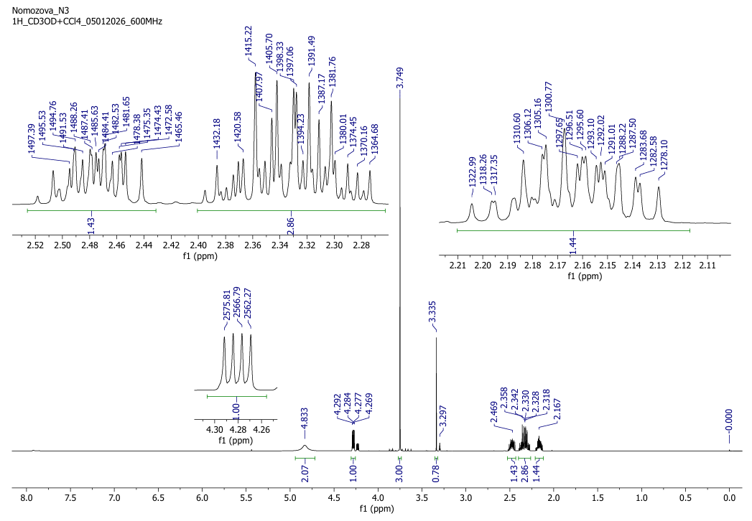
Fig 3. H-NMR spectrum of methyl ester of 5-oxo-DL-prolinate acid

The presence of a singlet signal specific to the -O–CH3 bond at 3,749 m.u. in the H-NMR spectrum of methyl ester of 5-oxo-DL-prolinate acid (Fig. 3), the presence of –CH3 in the molecule and the presence of a singlet signal specific to the NH bond in the proline ring at 3,335 m.u., the presence of a singlet signal specific to the -N-C-H group in the proline ring at 4.28 m.u. indicates that the secondary nitrogen-binding C–H bond is located in the proline ring. A multiplete signal is detected at 2.86 m.u. of the C-3 carbon –CH2- bond located in the proline ring in the molecule, and the proline ring indicates that the molecule has a proline ring at 2.16–2.47 m.u. of the C-4 carbon –CH2- bond. Including the low-intensity presence of the proton-specific quartet signal of the C-2 carbon-based proton-specific quartet signal in the H-NMR spectrum of the substance and the singlet signals of nitrogen-bound hydrogen in the proline ring at 3.29 m.u. indicate the presence of DL-isomers in solution without a mixture.
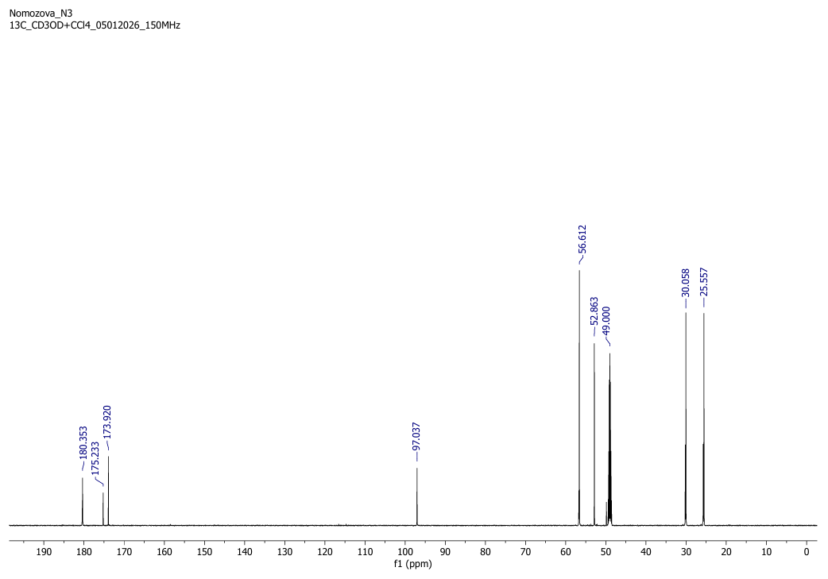
Fig 4. NMR ¹³C spectrum of methyl ester of 5-oxo-DL-prolinate acid

In spectrum ¹³C of the methyl ester of 5-oxo-DL-prolinate acid (Fig. 4), the molecule detects a singlet signal of carbon located in the –O-CH3 group at 52.86 m.u., a singlet signal of the carbonyl group located in the proline ring at 173.92 m.u. (C−5), and a singlet signal of the carbonyl group attached to the proline ring at 180.35 m.u. At 56,612 m.u. of the 3 carbons located in the proline ring, C-2 carbon, which binds to the carbonyl group, has a +M positive mesomer effect of the electron donor-NH group-bound carbon signals, while at 25,557 m.u. (C-3) and 30,058 m.u. (C-4) the carbon-specific singlet signals in the proline ring -CH 2-CH2- carbon-specific singlet signals are detected.

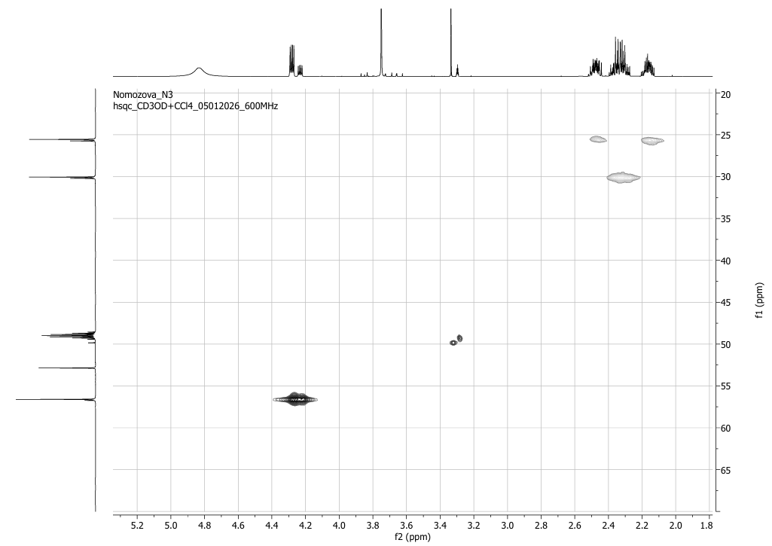
Fig 5. HSQC spectrum of methyl ester of 5-oxo-DL-prolinate acid
At 56,612 m.u. in the HSQC spectrum, the signal of the C-2 carbon in the proline ring indicates that the spin-spin interaction with single proton signals located in the C-2 carbon at 4.28 m.u. in the HSQC spectrum indicates that the proton is located in the C-2 carbon (Fig. 5). The carbon signal of the methyl ether of 5-oxo-DL-prolinate acid to the proline ring at 25,557 m.u. (C-3) in the HSQC spectrum Spin-spin effect with a proton located in C-3 carbon at 2.16–2.47 m.u. specific to two protons in the HSQC spectrum indicates that the proton is located in C-3 carbon. At 30,058 m.u. in the HSQC spectrum, the signal of the C-4 carbon in the proline ring indicates that the proton is located in the C-4 carbon at 2.86 m.u. in the HSQC spectrum.

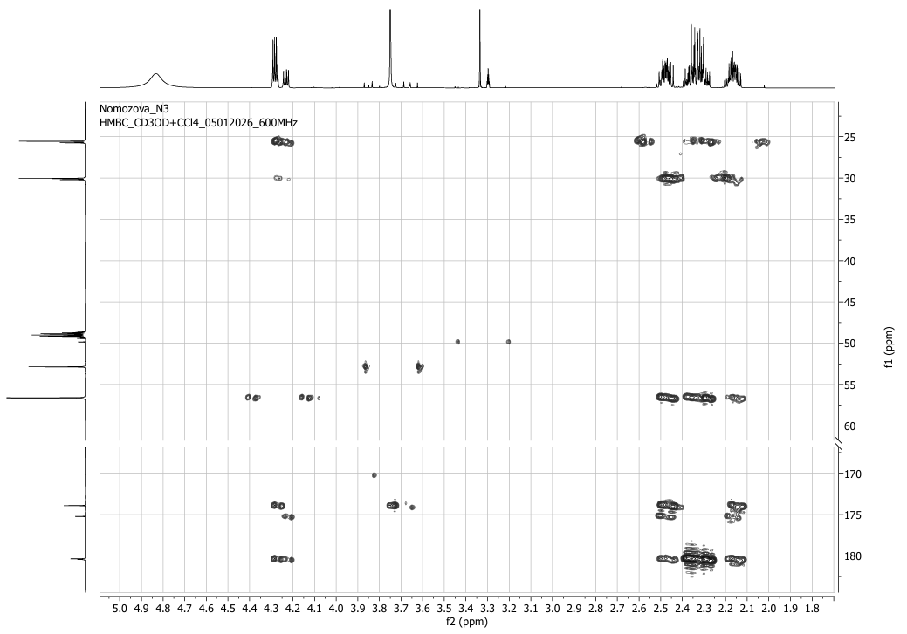
Fig 6. HMBS spectrum of methyl ester of 5-oxo-DL-prolinate acid
At 180,353 m.u. in the HMBC spectrum, the spin-spin interaction of carbon located in the carbonyl group bound to the proline ring at 4.28 m.u. in the HMBC spectrum with protons located in the C-2 carbon-denominated region shows their location (Fig. 6). At 2.86 m.u. in the HMBC spectrum, with protons located in the C-3 carbon, the SSTK 2J=1.39 Gs spin-spin interaction in the heminal state with the protons located in the C-4 carbon at 173.92 m.u. and the C-3 carbon at 25.557 m.u. in the geminal state of SSTK 2J=1.31-1.48 Gs spin-spin exposure indicates the location of the C-5, C-4, C-3 carbons in the geminal state.
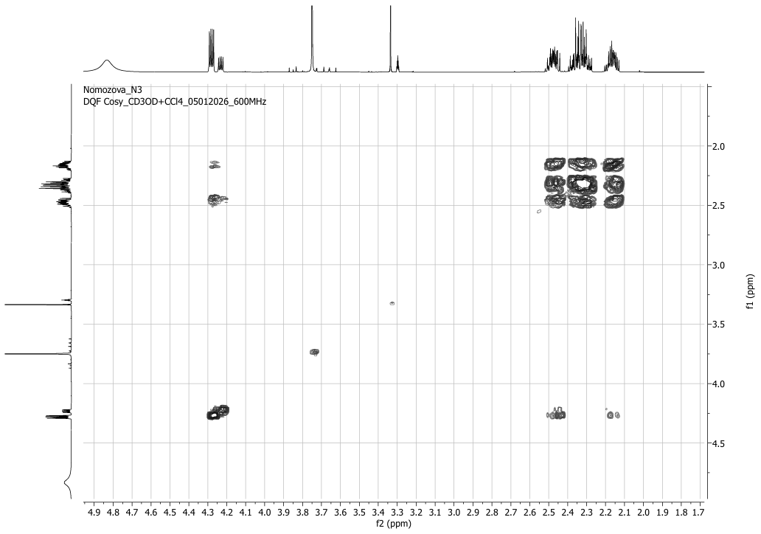Fig 7. COSY spectrum of methyl ester of 5-oxo-DL-prolinate acid
C-4, C-2 in the COSY spectrum, at 2.16-2.46 m.p.m. of protons located in carbons and 4.28; Spin-spin interactions with the signal C-3 carbon-based proton at 2.86 m.u. indicate that they are side-by-side (Fig. 7).
This compound, also known as ethyl pyroglutamate, is used in organic synthesis, peptizes, and biologically oxidative substances. It is also an organic substance used in molecular modeling and analysis of endothelin receptor ligands (Intagliata et al., 2020). A similar L-Proline (TMS) ester volatile compound has also been detected in A. bisporus (Aoife et al., 2010). Shiitake fungus, on the other hand, is known to have a derivative of 2-Pyrrolidinecarboxylic acid-5-oxo-, ethyl (Joanna et al., 2021).
- CONCLUSION
This is a complex ether and is part of the phytochemical profile of the fungus A.bisporus. The fungus is known to be a derivative of the amino acid pyroglutamate.

Disclaimer (Artificial intelligence)

Author(s) hereby declare that NO generative AI technologies such as Large Language Models (ChatGPT, COPILOT, etc.) and text-to-image generators have been used during the writing or editing of this manuscript.

References
Alexander J. MacLeod, Shnehlata D. Panchasara. Volatile aroma components, particularly glucosinolate products, of cooked edible mushroom (Agaricus bisporus) and cooked dried mushroom. Phytochemistry, Volume 22, Issue 3,1983, Pages 705-709ю
Aoife O'Gorman. 2010. Metabolic Profiling and Fingerprinting for the Detection and Discrimination of Mechanical Damage in Mushrooms (Agaricus bisporus) during Storage. Technological University Dublin
Bartkiene E, Zarovaite P, Starkute V, Mockus E, Zokaityte E, Zokaityte G, Rocha JM, Ruibys R, Klupsaite D. Changes in Lacto-Fermented Agaricus bisporus (White and Brown Varieties) Mushroom Characteristics, including Biogenic Amine and Volatile Compound Formation. Foods. 2023; 12(13):2441. https://doi.org/10.3390/foods12132441
Cao Jinfeng, Chen Xuhui, Liu Shiwei, Ding Jianhai. Research Advances in Secondary Metabolites and Biological Activities of Mushroom Genus Fungi. Academic Journal of Agriculture & Life Sciences, 2023, 4(1); doi: 10.25236/AJALS.2023.040109.
Cronin D. A., Margaret K. Ward. The characterisation of some mushroom volatiles. Food and Agriculture Science Journal, Volume22, Issue9, 1971 477-479
Consolacion Y Ragasa, Jo Madeleine Ann Reyes, Maria Carmen S Tan, Robert Brkljača, Sylvia Urban. 2016. Research Article Sterols and Lipids from Agaricus bisporus. International Journal of Pharmaceutical and Clinical Research 2016; 8(10): 1451-1453
Eugene Sebastian J. Nidiry. Structure–fungitoxicity relationships of some volatile flavour constituents of the edible mushrooms Agaricus bisporus and Pleurotus florida. "Flavour and Fragrance Journal", 2001, 16(4), 245-248.
Intagliata S, Helal MA, Materia L, Pittalà V, Salerno L, Marrazzo A, Cagnotto A, Salmona M, Modica MN, Romeo G. Synthesis and Molecular Modelling Studies of New 1,3-Diaryl-5-Oxo-Proline Derivatives as Endothelin Receptor Ligands. Molecules. 2020; 25(8):1851. https://doi.org/10.3390/molecules25081851
Joanna Sissons, B.S. 2021. Using instrumental and sensory evaluation to determine flavor components and potential meaty flavor enhancement of raw and cooked Shiitake and Portobello mushrooms. Denton, tx. August.
Morosanova, M. A., Fedorova, T. V., Polyakova, A. S., & Morosanova, E. I. (2020). Agaricus bisporus crude extract: Characterization and analytical application. Molecules, 25(24), 5996.
Munkhgerel, L., Erdenechimeg, N., Dumaa, M., Zhang, G., Odonmajig, P., & Regdel, D. (2014). Chemical and biological investigation of the Agaricus silvaticus Schaeff ex. Secr. Mongolian Journal of Chemistry, 12, 92–97. https://doi.org/10.5564/mjc.v12i0.180
Nomozova, M.Z., Kamolov, L. S., Nakhatov I., Nuraliyeva D.I. Extraction of secondary metabolites from agaricus bisporus fungus // Universum: химия и биология. 2026, fevral, 2(140), pp 26-30
Petrova A, Alipieva K, Kostadinova E, Antonova D, Lacheva M, Gjosheva M, Popov S, Bankova V. GC-MS studies of the chemical composition of two inedible mushrooms of the genus Agaricus. Chem Cent J. 2007 Dec 20; 1(33). doi: 10.1186/1752-153X-1-33. PMID: 18096035; PMCID: PMC2228291
Ueguchi Y, Matsunami K, Otsuka H, Kondo K. Constituents of cultivated Agaricus blazei. 2011, Journal of Natural Medicines 65(2):307-12. DOI:10.1007/s11418-010-0495-5
Shao,Yang-yang and Gao,Hai-yan and Liu,Rui-ling and Fang,Xiang-jun and Chen,Hang-jun, 20230198419, Chinese, Journal article, China, doi:10.7506/spkx1002-6630-20210906-056, 1002-6630, 43, (5), Beijing, Shipin Kexue / Food Science, (218–226), China Food Publishing Co., Effect of harvesting method on the quality and volatile flavor compounds of Agaricus bisporus., (2022)
Shimizu T, Kawai J, Ouchi K, Kikuchi H, Osima Y, Hidemi R. Agarol, an ergosterol derivative from Agaricus blazei, induces caspase-independent apoptosis in human cancer cells. Int J Oncol. 2016 Apr; 48(4):1670-8. doi: 10.3892/ijo.2016.3391. Epub 2016 Feb 15. PMID: 26893131.
Shu-Yao Tsai, Hui-Li Tsai, Jeng-Leun Mau. Non-volatile taste components of Agaricus blazei, Agrocybe cylindracea and Boletus edulis. Food Chemistry, 2008, 107(3), 977-983, https://doi.org/10.1016/j.foodchem.2007.07.080
Wen Li, Zhen Gu, Yan Yang, Shuai Zhou, Yanfang Liu, Jingsong Zhang. Non-volatile taste components of several cultivated mushrooms. Food Chemistry,2014, 143, 427-431, https://doi.org/10.1016/j.foodchem.2013.08.006
Yan, S. J., Xie, X. M., Lin, S. Z., Xu, X. G., Jiang, S. P., Chen, B., ... & Liu, L. (2015). Study on volatile flavor components from Agaricus bisporus of Tibet. Acta Scientiarum Naturalium Universitatis Sunyatseni, 54, 70-78.

