Review Article

Green human Resource Management and Environmental Sustainability- A Bibliometric Analysis

ABSTRACT

Rapid industrialization and excessive utilization of Natural Resources have risen the problem of global warming. Every Discipline of studies are focusing to curb the problem of climate changes, from science to humanities, the focus of studies related to utilization of resources in sustainable way has increased. In the same way Human Resource Management also focusing on new paradigm of Human Resource Management which would contribute to Environmental Management, this new Paradigm is Known as Green Human Resource Management. Although it seems to be new concept but studies related to this perspective can be related to 1989 or before this duration. Scopus and Web of Science are considered as most reliable source of data for any scientific study, therefore in this research Paper we have taken Database of Scopus for the duration of 1989-2025. Data is collected by searching key words, Green Human Resource Management (GHRM), Employees Green Behavior (EGB) and Environmental Sustainability by restricting the result to Management, Commerce and Accounting. In this paper we focused Various aspects of Bibliometric information, such as Number of Publication per years, Most Cited Authors and top most journals. In this paper we also focused on social structure and country collaboration map of the study field. In this study we found that Green Human Resource Management Practices is a multidisciplinary field of knowledge, Environmental sustainability was previously focused through collective action but now, with the help of Green Human Resource Management Practices focuses directly on employees to tackle the problem of Environmental issues. Green Human Resource Management practices and Human Resource Management Practices are two broad dimensions of this study focusing on environmental sustainability and Innovations respectively. In this study we also found that the number of publications has slightly increases in last 10 years showing increasing interest of scholars and researchers in this field.

Keywords- Green human Resource management, Human Resource Management, Employees Green Behavior, Environment, Sustainability, Natural Resources, Sustainable, Resources.

1. INTRODUCTION

Continuously Global environmental changes and rise of temperature of our environment has led to climate changes which necessitate business organizations to align business objectives and environmental management in strategic manner(Renwick et al., 2013a). In this way Green Human Resource Management has arisen as an appropriate way of management practices which align Human Resource management practices and environmental sustainability with organizational objectives, which ultimately leads to pro environmental behavior of employees, green behavior of Employees(Jabbour et al., 2010a). Green Human Resource Management practices actually encompass to align traditional functions of Human resource management to environmental conscious Human Resource management Practices such as Green Recruitment and selection, Green Training and Development and Green performance appraisal, which ultimately leads to employee’s green behavior and therefore organizational environmental performance (Ren et al., 2018a) On the basis of review of researchers, it can be said that environmental sustainability is not Marely ecological necessity but it also provides competitive advantage to the organizations. Those organizations which are taking green initiatives are more likely to reduce resource consumption, more satisfied stakeholders and get overall performance efficiency(Redondo et al., 2022). Many empirical studies shows that employees green Behavior, green initiative and leadership significantly influence firms’ sustainable performance(Siddique et al., 2025)
The primary analysis of data source of Scopus contains 1220 scholarly publication of Green HRM for the Duration of 1989-2025.The database further focus on the increasing academic attention towards Environmental Protection, Sustainable Development Goals.
2. Review of Literature
Most important thing which emerged from the Scopus database is the term “Green Human Resource Management” (GHRM) in achieving Environmental Performance. Researchers argue that Green Human Resource Management Practices, such as Green Recruitment, Green Selection, Green Employees Development and Green Relations significantly have influence on organizational cultures which ultimately leads to pro environmental behavior of employees, it increases employee’s ecological consciousness(Khan et al., 2022).
In Research it is also found that systematic implementation of Green Human Resource Management Practices leads to reduced resource consumptions, improves compliance with environmental regulation and increase Corporate Environmental Outcome(Valor et al., 2025). Another term that streams in this field is Employees Green Behavior which is voluntary and goal directed behavior of employees which ultimately contribute to environmental sustainability and environmental management. Evidence from the research shows that Green Leadership, Green Relations and Environmental Activities foster Employees Green behavior (Mekoth et al., 2025).Organisations ability to implement Environmental goals are supported by employee’s behavior, in other word employees are the main driving force of any organisation’s objectives achievement(Shahzad et al., 2023). Corporate Environmental Responsibility and Governance also have positive influence in organizational performance, those organizations which implements these things are more likely to perform in field of environmental management as compare to other organisations, firms achieve good stakeholder relations, improved brand equity and competitive advantages(Alghamdi, 2021). Regulatory Framework also acts as the pressurizing agent in implementation of environmentally friendly conduct of Business, corporate governance is consistently focusing on implementation of pro environmental activities within organisations. Studies related to Green Human Resource Management Practices has increased due to the importance of environmental sustainability, importance of aligning Human Resource Practices in Strategic Environmental Management has increased over the period of time. Implementation of traditional Human Resource Management into Environmentally aligned function is the demand of the time(Renwick et al., 2013a)

3. material and methods
The present study adopted bibliometric analysis approach to understand the intellectual structure of Green Human Resource Management practices, it will help in understanding thematic trend, most cited authors, and sources of such valuable scholarly contributions. Bibliometric analysis is widely used to Quantify the scientific research, it helps to identify influential authors, source and documents and thematic pattern in field of study(Aria & Cuccurullo, 2017). In this study Scopus database is extracted from for the period of 1989-2025. The database is considered most reliable scientific indexing platform for peer review journal, using the word Green Human Resource Management Practices (GHRM), Green HR and terms related to Environmental sustainability.
4. Objectives-
- To analyse the annual scientific production.
- To examine the most influential authors, journals, institutions, and countries.
- To evaluate the intellectual structure of the field through citation analysis, co-citation networks, and identification of highly cited documents.
- To explore thematic patterns and research clusters within GHRM by analyzing author keywords, keyword co-occurrence networks, and thematic maps.
- Bibliometric Analysis-
This study conducts a comprehensive bibliometric analysis to map the intellectual, conceptual and social structure of research on Green Human Resource Management (GHRM). The analysis is based on data extracted from the Scopus database, following systematic procedures for data cleaning, screening, and visualization. Using the Bibliometric package and its web interface Bibliography (Aria & Cuccurullo, 2017a), the study evaluates publication patterns, influential contributors, thematic clusters, and research trends. The bibliometric analysis is structured around the objectives outlined earlier. In this study we also utilised Vosview software to create visuals for Authors Co-occurrence and keyword coupling for the study.
  - Descriptive Analysis of Data-
Table Number 1- Descriptive Data Analysis
Description | Results
MAIN INFORMATION ABOUT DATA
Timespan | 1989:2025
Sources (Journals, Books, etc) | 491
Documents | 1220
Annual Growth Rate % | 15.28
Document Average Age | 3.73
Average citations per doc | 45.71
References | 62325
DOCUMENT CONTENTS
Keywords Plus (ID) | 2515
Author's Keywords (DE) | 2671
AUTHORS
Authors | 2956
Authors of single-authored docs | 127
AUTHORS COLLABORATION
Single-authored docs | 145
Co-Authors per Doc | 3.19
International co-authorships % | 35.25
DOCUMENT TYPES
article | 855
book | 35
book chapter | 180
conference paper | 74
conference review | 10
editorial | 4
erratum | 6
note | 4
retracted | 3
review | 49
Source- Extracted from Scopus Database
  - Annual Scientific Production In the field of Green Human Resource Management-
Figure No. 1- The annual scientific production from 2014 to 2025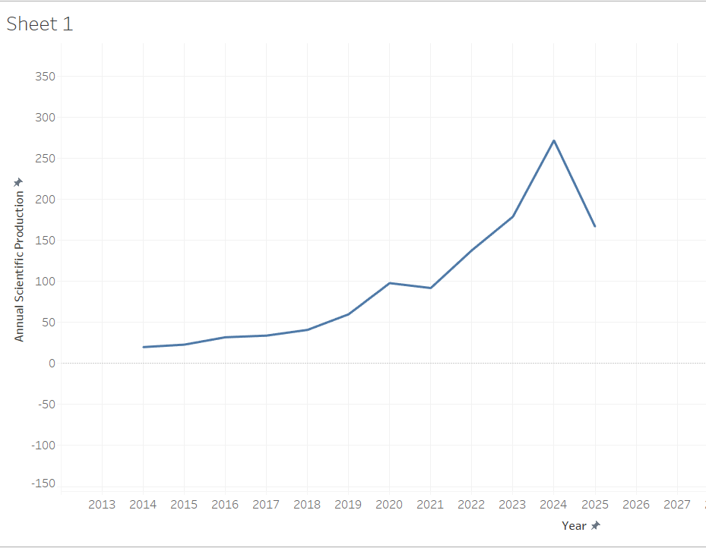
(Source- Created by author)
The above figure shows the annual scientific production from 2014 to 2025. The number of publications increases slowly between 2014 and 2018, indicating the early development of research in this area. From 2019 onward, there is a clear rise in publication output, showing growing interest among researchers. A small decline is visible in 2021, but the overall trend remains upward. The period from 2022 to 2024 records a sharp increase, with the highest number of publications in 2024. The decrease in 2025 is likely due to incomplete data for the year rather than an actual fall in research activity. Overall, the trend suggests that the research area has gained strong and continuous attention over time (Donthu et al., 2021; Zupic & Čater, 2015).

  - Most Influential Journals-
Table Number 2- List of Influential Journals

Sources | Articles
JOURNAL OF CLEANER PRODUCTION | 115
CORPORATE SOCIAL RESPONSIBILITY AND ENVIRONMENTAL MANAGEMENT | 36
BUSINESS STRATEGY AND THE ENVIRONMENT | 34
INTERNATIONAL JOURNAL OF MANPOWER | 31
COGENT BUSINESS AND MANAGEMENT | 22
GREEN HUMAN RESOURCE MANAGEMENT: A VIEW FROM GLOBAL SOUTH COUNTRIES | 20
BENCHMARKING | 19
INTERNATIONAL JOURNAL OF HUMAN RESOURCE MANAGEMENT | 19
INTERNATIONAL JOURNAL OF HOSPITALITY MANAGEMENT | 16
INTERNATIONAL JOURNAL OF ORGANIZATIONAL ANALYSIS | 13
(Source – Extracted From biblioshiny)
The analysis of the above table shows that Journal of Cleaner Production is the most prominent source with 115 articles, indicating its strong focus on sustainability and green practices. Corporate Social Responsibility and Environmental Management (36 articles) and Business Strategy and the Environment (34 articles) also contribute significantly, showing their relevance to environmental management research. HR-focused journals like International Journal of Manpower (31 articles) and International Journal of Human Resource Management (19 articles) highlight growing interest in Green HRM within the HR field. Overall, the distribution reflects that Green HRM research is multidisciplinary, spread across sustainability, business strategy, and human resource management journals.

  - Most Influential Authors-
Table number 3- List of Influential Authors

Most Influence Authors
Author | Articles | Articles Fractionalized
JABBOUR CJC | 22 | 8.00
YUSLIZA MY | 22 | 5.23
PAILLÉ P | 13 | 5.05
RENWICK DWS | 13 | 6.49
RAMAYAH T | 12 | 2.22
CHIAPPETTA JABBOUR CJ | 10 | 2.48
DE SOUSA JABBOUR ABL | 10 | 4.10
PHAM NT | 10 | 3.15
YONG JY | 10 | 2.90
CHAUDHARY R | 8 | 6.03
(Source- Extracted from Biblioshiny)

The bibliometric analysis of Green HRM literature highlights several highly influential authors. (Jabbour et al., 2010b)emerged as the most prolific contributor with 22 publications and a fractionalized authorship score of 8.00. Similarly, (Noor Faezah et al., 2025) demonstrated substantial scholarly output, also with 22 articles, though with a slightly lower fractionalized contribution of 5.23. Other notable contributors (Paillé et al., 2014), who authored 13 studies with a fractionalized score of 5.05, (Renwick et al., 2013b), who also produced 13 publications, achieving a comparatively higher fractionalized score of 6.49. Additional influential scholars in this field are (Anwar et al., 2020) (12 articles; 2.22 fractionalized), (Jabbour & Santos, 2008) (10 articles; 2.48 fractionalized), (Jabbour & de Sousa Jabbour, 2016) (10 articles; 4.10 fractionalized), (Pham et al., 2019)(10 articles; 3.15 fractionalized), (Yong et al., 2019) (10 articles; 2.90 fractionalized), and (Chaudhary, 2020) (8 articles; 6.03 fractionalized). Collectively, these authors represent the core intellectual structure of Green HRM research and significantly shape the development of this field.
  - Most Global Cited Documents-
Figure 2- Most globally cited documents shaping Green Human Resource Management (GHRM) research
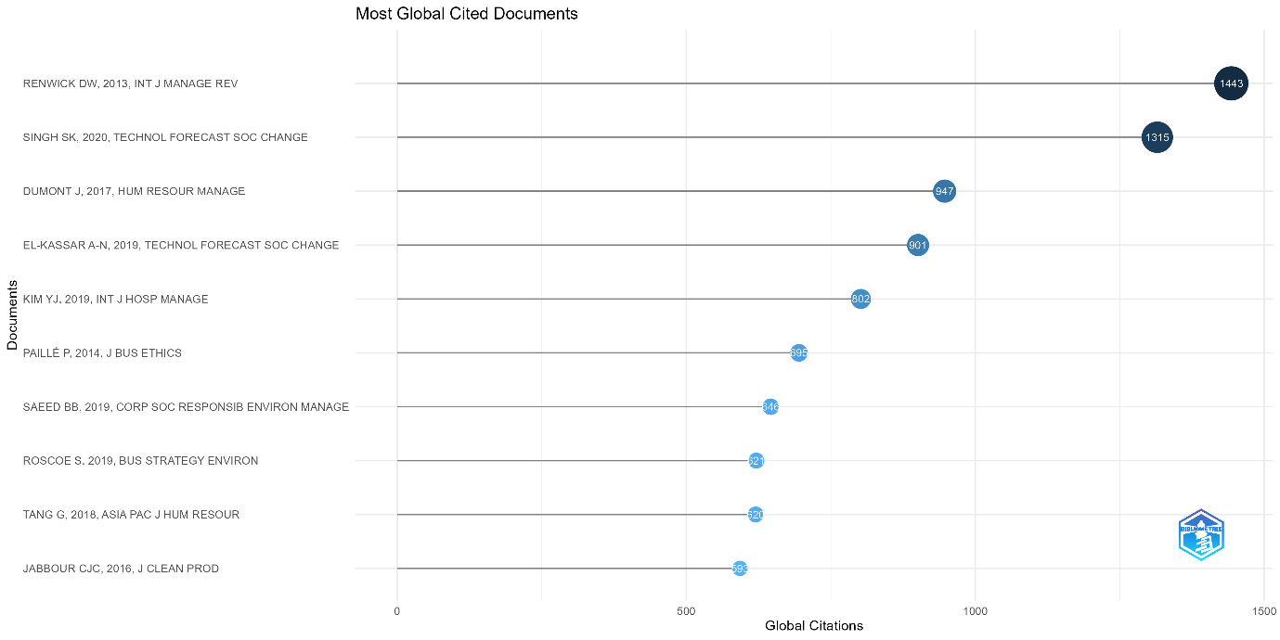
(Source- Extracted from biblioshiny)
The above figure shows the most globally cited documents identify the foundational studies shaping Green Human Resource Management (GHRM) research. (Dumont et al., 2017) is the most influential work, providing strong empirical evidence that GHRM practices promote employee green behaviour through psychological green climate. (Kim et al., 2019) highlights the effectiveness of GHRM in improving eco-friendly behaviour and environmental performance in the hospitality sector. (Renwick et al., 2013c) and (Ren et al., 2018b) serve as seminal review studies that establish the theoretical base and future research agenda of GHRM. (Ren et al., 2018b)contributes methodologically by developing reliable GHRM measurement scales, while Roscoe et al. (2019) emphasizes the role of GHRM in building green organizational culture. Overall, these highly cited documents demonstrate that GHRM research is grounded in strong theoretical foundations and focused on employee behaviour, culture, and environmental performance.

  - Reference Publication Year Spectrograph-
Figure Number 3- Reference Publication Year Spectroscopy
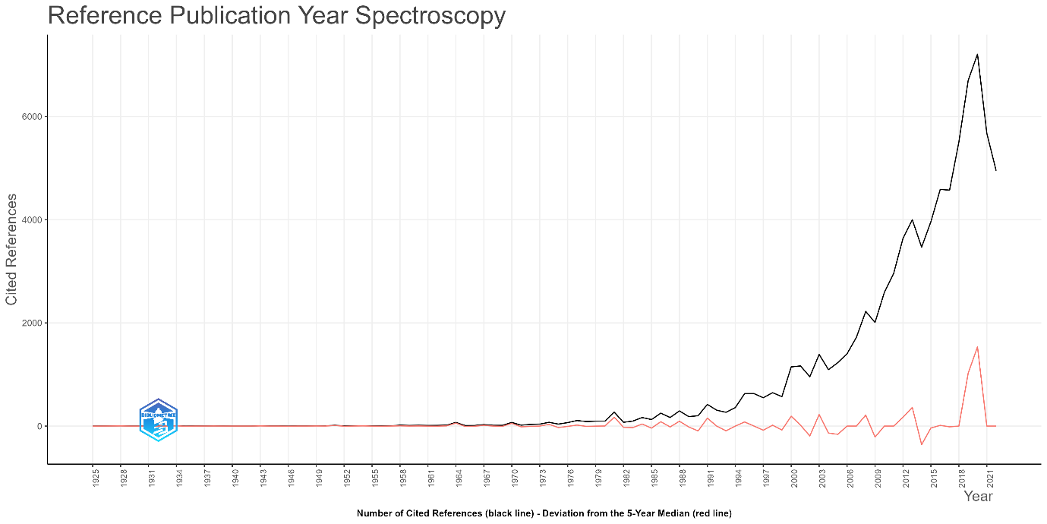
(Source- Extracted from Biblioshiny)
The Reference Publication Year Spectroscopy shows that citations were minimal before the 1980s, indicating weak early foundations. A gradual increase from the 1990s reflects the emergence of sustainability and strategic HRM research. A sharp rise after 2000, and especially after 2010, highlights the rapid growth and consolidation of Green HRM as a research field. The strong citation peaks in recent years indicate the influence of key contemporary studies that have shaped current GHRM theory and empirical research.

  - Co- occurrence network-
Figure 4- Co-occurrence Network indicating green human resource management and human resource management
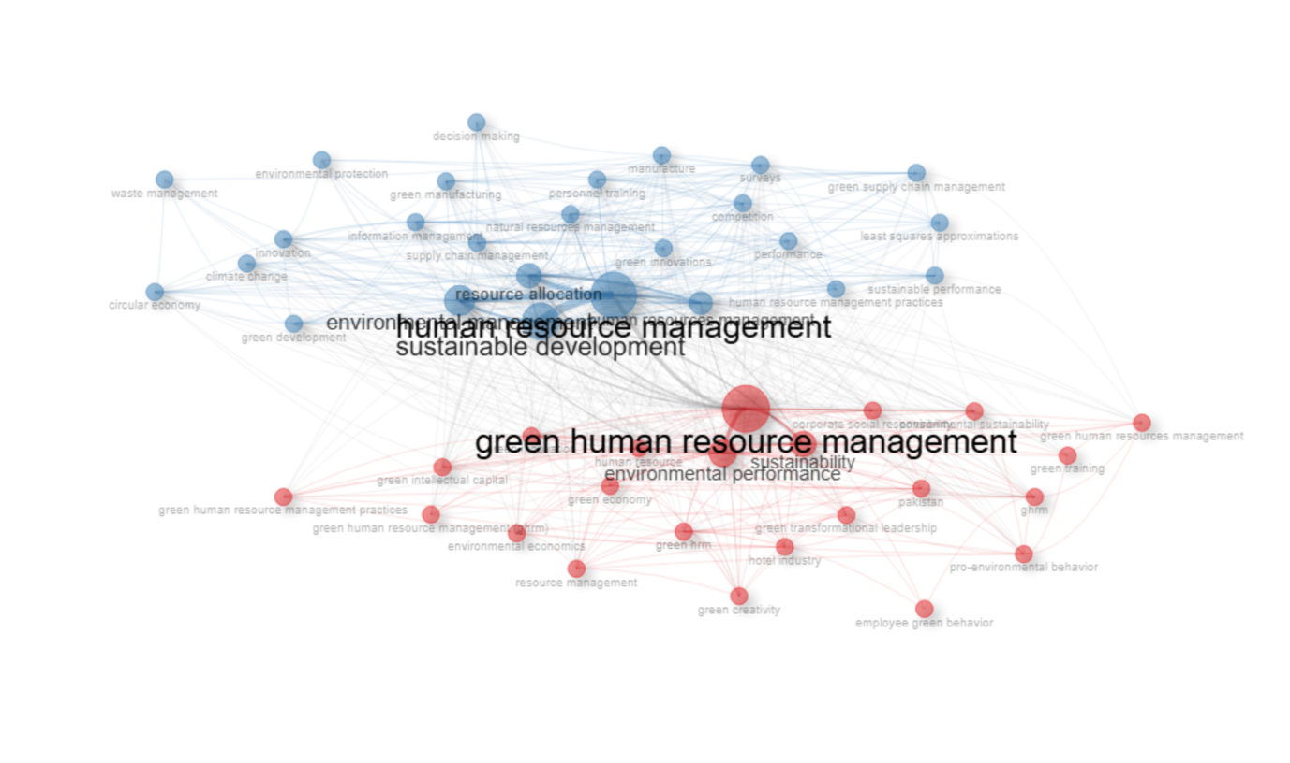
(Source- Extracted from Biblioshiny)

The Co-occurrence Network reveals two dominant thematic clusters.
The red cluster represents the emerging and rapidly developing area of green human resource management, closely linked with terms such as environmental performance, sustainability, green training, green creativity, pro-environmental behaviours, and green transformational leadership. This cluster reflects research focused on how HRM practices contribute to environmental outcomes and sustainable organizational behaviour(van Eck & Waltman, 2010). The blue cluster indicates a broader and more established domain of traditional human resource management connected with sustainable development, environmental management, supply chain management, decision-making, and innovation. This cluster represents the integration of HRM with wider organizational and environmental strategies(Aria & Cuccurullo, 2017b; Zupic & Čater, 2015).
  - Keyword Occurrence-
Figure 5- Keyword co-occurrence network revealing that green human resource management and human resource management form the central and most influential themes
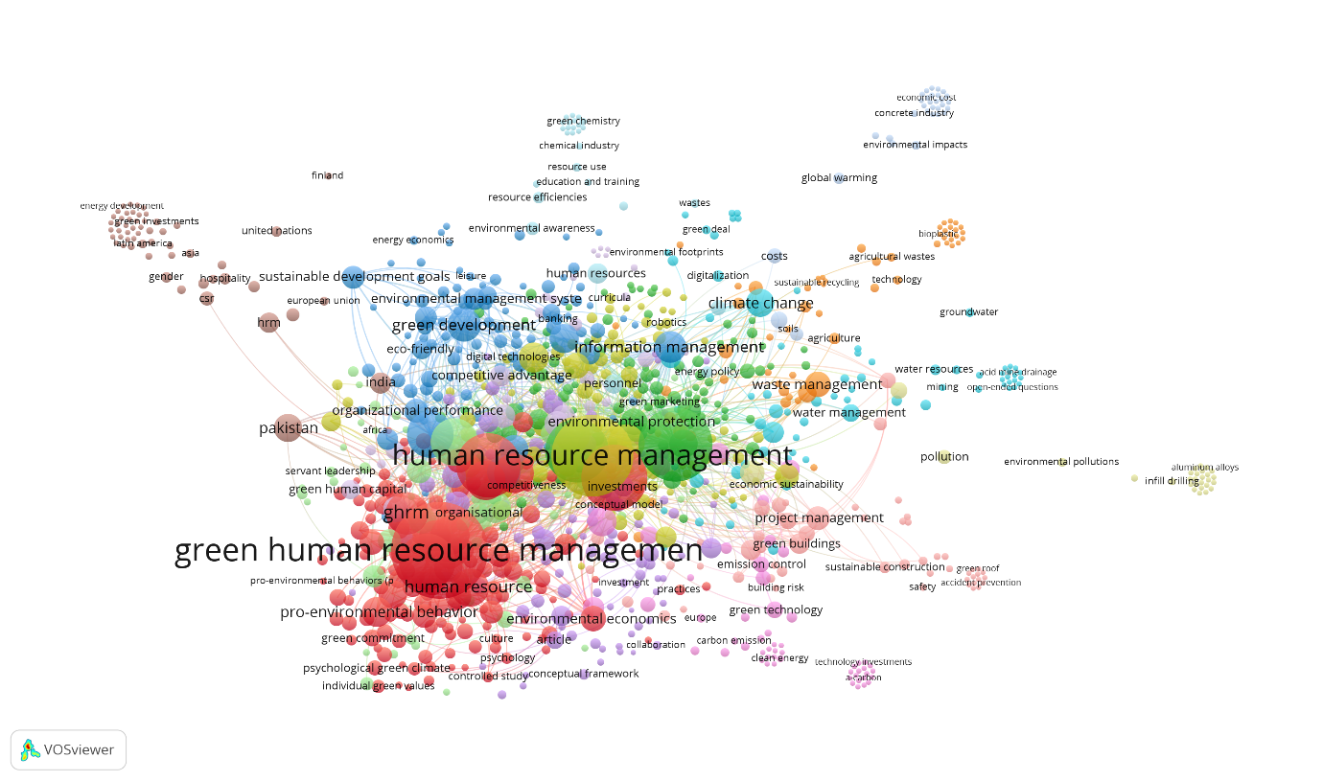
(Source- Extracted by Author)

The keyword co-occurrence network reveals that green human resource management (GHRM) and human resource management form the central and most influential themes, indicating their dominant role in the literature. Strong linkages between GHRM and keywords such as pro-environmental behavior, green commitment, green human capital, and organizational performance suggest that research largely focuses on how HR practices shape employees’ environmental attitudes and behaviors to improve organizational outcomes.
Another prominent cluster connects environmental management systems, sustainable development goals, competitive advantage, and information management, highlighting the strategic and systems-oriented perspective of sustainability research. The presence of climate change, waste management, water management, and environmental protection reflects the integration of HRM with broader environmental and sustainability challenges.
Emerging and peripheral clusters around digitalization, green technology, green buildings, and project management indicate evolving research directions linking GHRM with technological innovation and sector-specific sustainability practices. Country-based nodes such as India and Pakistan show growing research contributions from developing economies.
Overall, the map demonstrates that GHRM acts as a connecting hub between human capital development and environmental sustainability, with increasing interdisciplinary expansion toward technology, climate action, and sustainable resource management.

  - Authors Collaboration Network
Figure 6- Collaboration Network

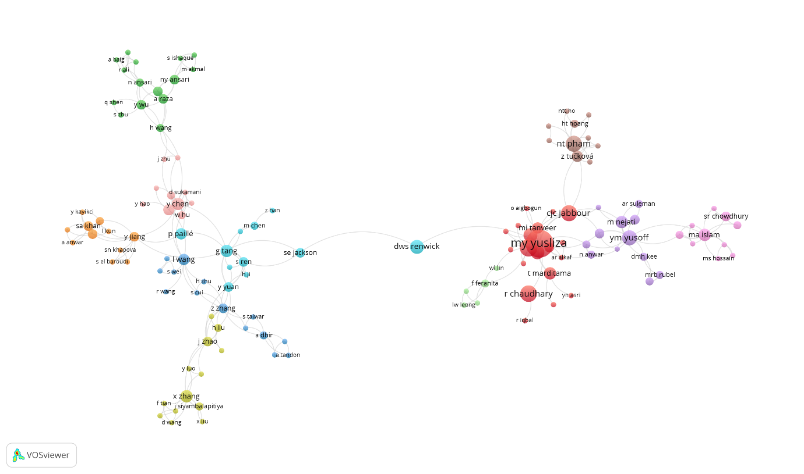
(Source- Extracted by Author)

The author collaboration network reveals two major clusters of influential researchers in Green HRM. The largest and most cohesive cluster is centred around M.Y. Yusliza, who collaborates closely with C.J.C. Jabbour, R. Chaudhary, and N.T. Pham, indicating a strong research community focused on sustainable HRM and environmental performance. Another significant cluster is led by D.W.S. Renwick, whose network connects indirectly with the Yusliza–Jabbour group, reflecting foundational contributions to Green HRM theory and conceptual development. Additional clusters around authors such as P. Paillé, Y. Chen, X. Zhang, and Y. Yuan show region-specific or topic-specific research communities that contribute to environmental behaviour, green innovation, and sustainability practices. Overall, the map highlights that Green HRM research is collaborative but still fragmented, with a few central authors acting as bridging nodes connecting multiple research groups.

  - Country Collaboration Map-
Figure 7-- Country Collaboration Map visualizing global research cooperation patterns
The country collaboration map visualises global research cooperation patterns. The darkest-shaded countries-such as China, India, the United States, and the United Kingdom-represent the most productive contributors to GHRM literature. Strong collaboration lines between these countries show extensive co-authorship networks, indicating that GHRM is a highly internationalised research area.
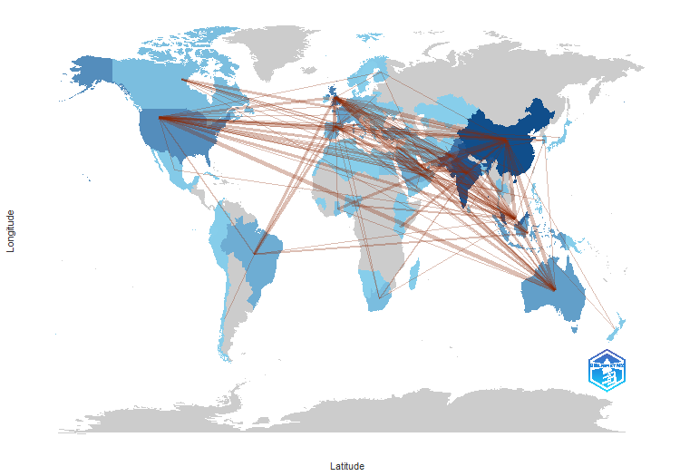
(Source- Created by R tool Biblioshiny)

China and India appear as central hubs, forming dense connections with Southeast Asia, the UK, Australia, and the US. These patterns suggest that emerging economies are leading GHRM research, supported by partnerships with established Western universities. The map highlights a diversified and global research footprint where environmental sustainability and HRM integration have become priority themes across both developed and developing nations(van Eck & Waltman, 2014).
- Implications-
The bibliometric examination delivers important understandings into the evolution and structure of Green Human Resource Management (GHRM) research. The findings establish GHRM as a multidisciplinary and quickly growing field that integrates human resource management with environmental sustainability, with employee green behaviour emerging as a central construct. The study highlights a clear shift from conceptual discussions toward behavioural and performance-oriented research, offering direction for future theory development, Methodologically, the study demonstrates the effectiveness of bibliometric tools in mapping influential authors, journals, themes, and collaboration patterns, thereby offering a replicable framework for sustainability-oriented research reviews. Practically, the findings underscore the strategic role of GHRM practices in promotion pro-environmental behaviour and improving organizational environmental performance. The strong contribution from emerging economies suggests that GHRM is particularly relevant for organizations operating in sustainability-challenged circumstances.

- Conclusion-
This study provides a comprehensive bibliometric overview of Green Human Resource Management (GHRM) research from 1989 to 2025 using the Scopus database. By analysing 1,220 scholarly documents, the study systematically maps the intellectual, conceptual, and social structure of the GHRM domain. The findings reveal a clear and sustained growth in academic interest, particularly after 2015, reflecting the increasing importance of integrating human resource management practices with environmental sustainability objectives.
The descriptive and citation analyses indicate that GHRM research is inherently multidisciplinary, drawing contributions from human resource management, environmental management, business strategy, and sustainability studies. Influential journals such as the Journal of Cleaner Production and Corporate Social Responsibility and Environmental Management have played a central role in disseminating knowledge, while a relatively small group of prolific scholars has significantly shaped the theoretical and empirical foundations of the field.
Thematic analyses based on keyword co-occurrence and co-citation networks show that GHRM functions as a critical linking mechanism between organisational practices and environmental outcomes, with employee green behaviour emerging as a core construct. The results further demonstrate a gradual shift in research focus, from early conceptual discussions to more behaviour-oriented and performance-driven perspectives, highlighting the growing emphasis on employees as key agents of environmental sustainability within organisations.
The collaboration and country-level analyses reveal an increasingly internationalised research landscape, with emerging economies such as China and India playing a prominent role, often in collaboration with researchers from developed nations. Despite this global expansion, the author collaboration network suggests that the field remains partially fragmented, indicating opportunities for stronger cross-regional and interdisciplinary collaboration.
Overall, this bibliometric study contributes by consolidating fragmented GHRM literature, identifying influential contributors, dominant themes, and emerging research directions. The findings provide valuable insights for scholars seeking to understand the evolution of GHRM research and for practitioners and policymakers aiming to align human resource strategies with sustainability goals. Future research may benefit from integrating multiple databases, employing longitudinal thematic analyses, and exploring under-researched contexts to further advance the theoretical and practical development of Green Human Resource Management.
- Limitations of the study-
This study is limited by its reliance on the Scopus database, which may exclude relevant publications indexed elsewhere. The use of bibliometric indicators emphasizes structural and quantitative patterns rather than qualitative insights into the effectiveness of GHRM practices. Additionally, publication data for 2025 may be incomplete, affecting recent trend interpretation. Future research may integrate multiple databases, apply qualitative or meta-analytic approaches, and explore under-researched contexts to advance GHRM scholarship.

References
Alghamdi, S. (n.d.). EFFECT OF GREEN HUMAN RESOURCE PRACTICES ON THE EMPLOYEE PERFORMANCE AND BEHAVIOR: A SYSTEMATIC REVIEW. International Journal of Economics, Business and Management Research, 5(03), 2021. www.ijebmr.com
Anwar, N., Nik Mahmood, N. H., Yusliza, M. Y., Ramayah, T., Noor Faezah, J., & Khalid, W. (2020). Green Human Resource Management for organisational citizenship behaviour towards the environment and environmental performance on a university campus. Journal of Cleaner Production, 256, 120401. https://doi.org/10.1016/j.jclepro.2020.120401
Aria, M., & Cuccurullo, C. (2017a). bibliometrix: An R-tool for comprehensive science mapping analysis. Journal of Informetrics, 11(4), 959–975. https://doi.org/10.1016/j.joi.2017.08.007
Aria, M., & Cuccurullo, C. (2017b). bibliometrix : An R-tool for comprehensive science mapping analysis. Journal of Informetrics, 11(4), 959–975. https://doi.org/10.1016/j.joi.2017.08.007
Chaudhary, R. (2020). Green Human Resource Management and Employee Green Behavior: An Empirical Analysis. Corporate Social Responsibility and Environmental Management, 27(2), 630–641. https://doi.org/10.1002/csr.1827

Donthu, N., Kumar, S., Mukherjee, D., Pandey, N., & Lim, W. M. (2021). How to conduct a bibliometric analysis: An overview and guidelines. Journal of Business Research, 133, 285–296. https://doi.org/10.1016/j.jbusres.2021.04.070
Dumont, J., Shen, J., & Deng, X. (2017). Effects of Green HRM Practices on Employee Workplace Green Behavior: The Role of Psychological Green Climate and Employee Green Values. Human Resource Management, 56(4), 613–627. https://doi.org/10.1002/hrm.21792
Jabbour, C. J. C., & de Sousa Jabbour, A. B. L. (2016). Green Human Resource Management and Green Supply Chain Management: linking two emerging agendas. Journal of Cleaner Production, 112, 1824–1833. https://doi.org/10.1016/j.jclepro.2015.01.052
Jabbour, C. J. C., & Santos, F. C. A. (2008). The central role of human resource management in the search for sustainable organizations. The International Journal of Human Resource Management, 19(12), 2133–2154. https://doi.org/10.1080/09585190802479389
Jabbour, C. J. C., Santos, F. C. A., & Nagano, M. S. (2010a). Contributions of HRM throughout the stages of environmental management: Methodological triangulation applied to companies in Brazil. International Journal of Human Resource Management, 21(7), 1049–1089. https://doi.org/10.1080/09585191003783512
Jabbour, C. J. C., Santos, F. C. A., & Nagano, M. S. (2010b). Contributions of HRM throughout the stages of environmental management: methodological triangulation applied to companies in Brazil. The International Journal of Human Resource Management, 21(7), 1049–1089. https://doi.org/10.1080/09585191003783512
Khan, A. J., Ul Hameed, W., Iqbal, J., Shah, A. A., Tariq, M. A. U. R., & Bashir, F. (2022). Green HRM and employee efficiency: The mediating role of employee motivation in emerging small businesses. Frontiers in Environmental Science, 10. https://doi.org/10.3389/fenvs.2022.1044629
Kim, Y. J., Kim, W. G., Choi, H.-M., & Phetvaroon, K. (2019). The effect of green human resource management on hotel employees’ eco-friendly behavior and environmental performance. International Journal of Hospitality Management, 76, 83–93. https://doi.org/10.1016/j.ijhm.2018.04.007
Mekoth, N., Prabhudesai, R., & Tari, S. (2025). Implications of HR managers’ green attitude: a study of Indian hospitality sector. Journal of Organizational Effectiveness, 12(1), 91–104. https://doi.org/10.1108/JOEPP-05-2023-0219
Noor Faezah, J., Yusliza, M. Y., Farooq, K., Ramayah, T., & Osman, L. H. (2025). Exploring green satisfaction through the lens of perceived corporatesocial responsibility. Industrial and Commercial Training, 57(4), 581–602. https://doi.org/10.1108/ICT-03-2025-0022
Paillé, P., Chen, Y., Boiral, O., & Jin, J. (2014). The Impact of Human Resource Management on Environmental Performance: An Employee-Level Study. Journal of Business Ethics, 121(3), 451–466. https://doi.org/10.1007/s10551-013-1732-0
Pham, N. T., Tučková, Z., & Chiappetta Jabbour, C. J. (2019). Greening the hospitality industry: How do green human resource management practices influence organizational citizenship behavior in hotels? A mixed-methods study. Tourism Management, 72, 386–399. https://doi.org/10.1016/j.tourman.2018.12.008
Redondo, R., Valor, C., & Carrero, I. (2022). Unraveling the Relationship between Well-Being, Sustainable Consumption and Nature Relatedness: a Study of University Students. Applied Research in Quality of Life, 17(2), 913–930. https://doi.org/10.1007/s11482-021-09931-9
Ren, S., Tang, G., & E. Jackson, S. (2018a). Green human resource management research in emergence: A review and future directions. Asia Pacific Journal of Management, 35(3), 769–803. https://doi.org/10.1007/s10490-017-9532-1
Ren, S., Tang, G., & E. Jackson, S. (2018b). Green human resource management research in emergence: A review and future directions. Asia Pacific Journal of Management, 35(3), 769–803. https://doi.org/10.1007/s10490-017-9532-1
Renwick, D. W. S., Redman, T., & Maguire, S. (2013a). Green Human Resource Management: A Review and Research Agenda*. International Journal of Management Reviews, 15(1), 1–14. https://doi.org/10.1111/j.1468-2370.2011.00328.x
Renwick, D. W. S., Redman, T., & Maguire, S. (2013b). Green Human Resource Management: A Review and Research Agenda*. International Journal of Management Reviews, 15(1), 1–14. https://doi.org/10.1111/j.1468-2370.2011.00328.x
Renwick, D. W. S., Redman, T., & Maguire, S. (2013c). Green Human Resource Management: A Review and Research Agenda*. International Journal of Management Reviews, 15(1), 1–14. https://doi.org/10.1111/j.1468-2370.2011.00328.x
Shahzad, M. A., Jianguo, D., & Junaid, M. (2023). Impact of green HRM practices on sustainable performance: mediating role of green innovation, green culture, and green employees’ behavior. Environmental Science and Pollution Research, 30(38), 88524–88547. https://doi.org/10.1007/s11356-023-28498-6
Siddique, N., Naveed, S., & Inam, A. (2025). A bibliometric review on sustainable human resource management (1982–2023). In Journal of Organizational Effectiveness (Vol. 12, Issue 1, pp. 14–36). Emerald Publishing. https://doi.org/10.1108/JOEPP-09-2023-0432
Valor, C., Redondo, R., & Carrero, I. (2025). Workplace greenery and employee green behavior: a moderated-mediation model. Management Research Review, 48(5), 726–745. https://doi.org/10.1108/MRR-07-2024-0562
van Eck, N. J., & Waltman, L. (2010). Software survey: VOSviewer, a computer program for bibliometric mapping. Scientometrics, 84(2), 523–538. https://doi.org/10.1007/s11192-009-0146-3
van Eck, N. J., & Waltman, L. (2014). Visualizing Bibliometric Networks. In Measuring Scholarly Impact (pp. 285–320). Springer International Publishing. https://doi.org/10.1007/978-3-319-10377-8_13
Yong, J. Y., Yusliza, M.-Y., Ramayah, T., & Fawehinmi, O. (2019). Nexus between green intellectual capital and green human resource management. Journal of Cleaner Production, 215, 364–374. https://doi.org/10.1016/j.jclepro.2018.12.306
Zupic, I., & Čater, T. (2015). Bibliometric Methods in Management and Organization. Organizational Research Methods, 18(3), 429–472. https://doi.org/10.1177/1094428114562629

