Original Research Article
Corrosion Inhibition of Mild Steel in Acidic Media using Caladium Tricolor Starch Extract: An Eco-Friendly Approach

Abstract
Caladium tricolor tuber starch (CTS) was extracted and used as corrosion inhibitor for mild steel in 0.5M HCl and 0.5M H₂SO₄ acid media respectively at various concentrations using the gravimetric technique. Results obtained shows that inhibition efficiency of the CTS inhibitor varied with time and concentration. Inhibition efficiency of caladium tricolor starch obtained ranged from 60% - 95% at 0.3g – 0.9g concentration in both acidic media. Maximum efficiency was obtained at concentration of 0.9g at 48 hours in 0.5M H₂SO₄. The mode of adsorption followed the Langmuir isotherm with Gibbs free energy value of indicates strong adsorption of the starch molecules on the mild steel substrate.
Key Words: Starch, Biopolymer, Corrosion, Inhibition, Caladium Tricolor

Introduction
Mild steel, a widely used construction material in industries such as manufacturing, oil and gas, and construction, faces significant corrosion risks in acidic environments. Acidic media like hydrochloric acid (HCl) and sulfuric acid (H₂SO₄) are commonly encountered in processes like pickling, descaling, and oil well acidization, leading to aggressive corrosion of mild steel infrastructure [Aslam et al. 2022]. Corrosion not only damages equipment and structures but also escalates maintenance costs, downtime, and safety risks. The global cost of corrosion is estimated in trillions annually, highlighting the need for effective mitigation strategies.
Synthetic corrosion inhibitors are widely used to protect metals in acidic media. These chemicals often work by adsorbing onto metal surfaces, forming protective barriers against corrosive ions [Swetha et al. 2024]. However, many synthetic inhibitors, such as chromates and heavy metal-based compounds, raise environmental and health concerns due to their toxicity and persistence. This has prompted growing interest in biodegradable, non-toxic alternatives derived from natural sources like plant extracts and biopolymers [Anyiam 2026, Raja & Sethuraman 2018, Alaneme et al. 2016, Marzorati et al 2019, Okafor et al 2018].
Starch extracts, as biodegradable polymers, have emerged as promising corrosion inhibitors for metals in acidic environments. Their effectiveness stems from the presence of hydroxyl (-OH) groups and potential glucosidic linkages that enable adsorption onto metal surfaces, forming protective barriers against corrosive ions. Starches from various plants Sweet potato [, Anyiam et al 2020b], millet [Nwanonenyi et al 2016], corn [Rosliza and Siti 2022], cassava [Xianghong et al. 2022] have been explored for their inhibition properties. When dissolved in acidic media like HCl or H₂SO₄, starch molecules can adsorb physically or chemically on metal surfaces, form a hydrophobic film reducing contact with corrosive electrolytes, chelate metal ions, slowing anodic dissolution.
In acidic solutions, protonation of starch hydroxyls may enhance adsorption on negatively charged metal surfaces, improving inhibition efficiency [Palanisamy 2019]. Studies on similar starches show inhibition efficiency often increases with concentration, typically reaching optimal levels (e.g., 80-95% inhibition at 1-5 g/L [Anyiam et al 2020a]). Factors affecting performance include Starch solubility in acid, Molecular weight/distribution and temperature effects on adsorption [Xie et al. 2025].
Comparisons with synthetic inhibitors sometimes show comparable efficiency for starches, especially in mild conditions [Da Silva etal. 2025]. Limitations include potential biodegradation over long exposure and variability in plant sources. Optimization strategies of starch as a corrosion inhibitor include blending with other green inhibitors (synergism), Chemical modification to enhance solubility/adhesion, nanoparticle encapsulation for controlled release [Fidudusola et al 2025, Han et al 2005].
Caladium tricolor, a tropical plant with starch-rich tubers, presents a viable candidate for corrosion inhibition studies. In South East Nigeria, it is classed as a weed with no economic value. Its tuber starch has been shown to possess unique structural features that may enhance its adsorption onto metal surfaces [Uwem & Ita 2019, Madison 2011, Resslar 2010, Singh et al 2010]. This study evaluates the effectiveness of Caladium bicolor starch extract as a corrosion inhibitor for mild steel in HCl and H₂SO₄ media. Specifically, it examines inhibition efficiency via weight loss and explores adsorption isotherms. Findings could support the use of this natural biopolymer as an environmentally friendly alternative in acid-related industrial processes.

- MATERIALS AND METHODS
2.1 Material Collection and Preparation
Caladium Tricolor Starch Collection and Extraction
Starch extract from Caladium tricolor roots was used for this study. The roots were obtained locally, uprooted, washed, cut into pieces and dried to a constant weight under sun, and then ground to fine powder.
Preparation of Molar Acid Solutions
Stock solutions of 0.5M H₂SO₄, and 0.5M HCl were prepared respectively using serial dilution principle.

Preparation of the coupon
Mild steel coupons used for the study were of 0.5mm in thickness and was mechanically press cut into 3cm x 3cm. Although the coupons were used without additional polishing, they were degreased in absolute ethanol, dried with acetone, and stored in desiccators free from moisture before being used.

2.2 Experimental Method
Gravimetric Measurement Method
The prepared and weighed mild steel coupons 3cm x 3cm were immersed in beakers containing 250 ml of the test solutions with and without the addition of CTS inhibitor (caladium tricolor starch) of concentrations ranging from 0.3g to 0.9g inhibitor concentrations in 0.5 M H₂SO₄ and 0.5 M HCl respectively. The coupons were then retrieved at 24-hours interval progressively until 120hours. The coupons were washed appropriately with fresh water to remove any corrosion product and finally with acetone. The washed coupons were dried and reweighed, the differences in weight of the coupons before and after immersion in different test solutions were taken as the weight loss, which was then used to compute the corrosion rate using the formula:
CR= (∆W x 87600)/DAt ………………………………………………………………(1)
Where CR = Corrosion Rate (mm/yr), ∆W = change in weight (g). D = Density of the coupon (g/cm³), A = area of exposed surface of the coupon (cm²) and t = time of immersion (h).
The inhibitor efficiency was at each concentration of biomass samples calculated by comparing the corrosion rate in the absence (CRo) and presence (CR1) using the relationships;
% IE = (CRo -CRi)/CRo X 100 (2)
where, CRo = corrosion rate of mild steel in blank corrodent, CRi = corrosion rate of mild steel in presence of the inhibitor.
The degree of surface coverage was calculated from the corrosion rate CRo using the equation
Θ = = (CRo -CRi)/CRo (3)

- RESULTS & DISCUSSIONS
3.1 Gravimetric Results:
To establish the effects of exposure time and the concentration of the CBS inhibitor on corrosion inhibition of the test coupons immersed in 0.5 M HCl and 0.5 M H₂SO₄ solutions, the coupons were subjected to weight loss test. The calculated data for weight loss of uninhibited and inhibited mild steel in 0.5M H₂SO₄ is presented in Table 1 and Figure 1. From the Table and Figures presented, weight loss reduced with increasing concentration of inhibitors except for that of 24 hours. This could be as a result of instant adsorption of inhibitor on the metal surface, however with increasing time, weight loss was seen to reduce, and hence, more inhibitor molecules were adsorbed on the metal surface thereby inhibiting corrosion which is in tandem with other works [Anyiam et al 2020b, Nwanonenyi et al 2016]. Conversely, the calculated data and graphical representation of weight loss of mild steel in blank and inhibited 0.5M HCl is presented in Table 1 and Figure 2. Results obtained shows that weight loss increased at different time intervals and followed an inconsistent trend with increasing concentration.
Table 1: Calculated values of weight loss for mild steel in 0.5 M H₂SO₄ in the absence and presence of caladium tricolor extract (CSE and CLE).
Time  Concentration (H2SO4) | 24h | 48h | 72h | 96h | 120h
Blank | 0.85 | 1.94 | 2.52 | 2.50 | 3.02
5ml | 0.08 | 0.14 | 0.20 | 0.24 | 0.28
10ml | 0.08 | 0.13 | 0.16 | 0.22 | 0.27
15ml | 0.09 | 0.12 | 0.17 | 0.22 | 0.24
20ml | 0.08 | 0.09 | 0.14 | 0.20 | 0.22
Concentration (HCl)  Blank | 0.10 | 0.11 | 0.33 | 0.39 | 0.53
5ml | 0.02 | 0.02 | 0.04 | 0.10 | 0.12
10ml | 0.03 | 0.04 | 0.08 | 0.09 | 0.10
15ml | 0.02 | 0.04 | 0.05 | 0.09 | 0.08
20ml | 0.01 | 0.05 | 0.08 | 0.07 | 0.10

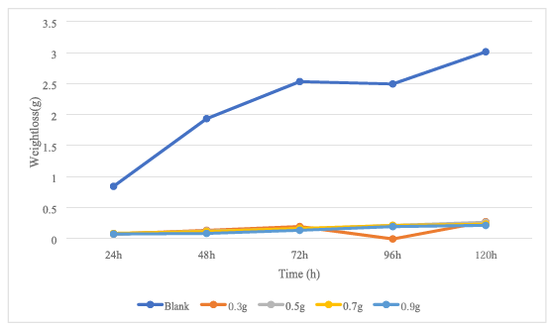
Figure 1: Plot of weight loss against time for mild steel in 0.5M H₂SO₄ without and with caladium tricolor starch.
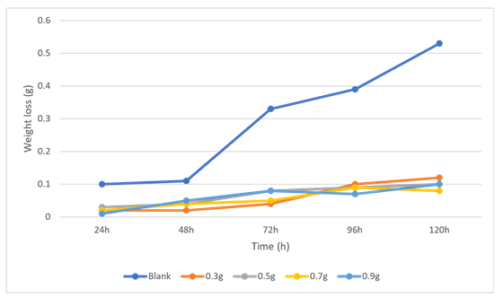
Figure 2: Plot of weight loss against time for mild steel in 0.5M HCL without and with caladium tricolor starch.

Corrosion rate
The calculated data for corrosion rate of mild steel in blank and inhibited 0.5M H₂SO₄ are presented in Table 2 and Figure 3. From the graphical representation of the corrosion rate of mild steel in blank and inhibited 0.5M H₂SO₄, corrosion rate increased slightly with increase in concentration under 24 hours. However, for 48 hours to 120 hours, corrosion rate followed the same trend of decreasing with increase in concentration of the inhibitor. This shows that caladium tricolor starch inhibited mild steel corrosion in 0.5M H₂SO₄, in a concentration-dependent manner as observed from the table and agrees with earlier studies observed by Mobin et al 2011 and Anyiam et al. 2020a.
The calculated values and graphical representation of corrosion rate of mild steel in blank and inhibited 0.5M HCl are presented in Table 2 and Figure 4. From Figure 4, corrosion rate varied slightly with increase in concentration within 24 hours to 120 hours except for that of 48 hours which increased slightly with increase in concentration.

Table 2: Calculated values of corrosion rate, inhibitor efficiency and degree of surface coverage for mild steel in 0.5M H₂SO₄ and 0.5 M HCl in the absence and presence of caladium tricolor starch
 | Corrosion Inhibition |  |  |  |  | Inhibition Efficiency |  |  |  |  | Degree of Surface Coverage
Time | 24 | 48 | 72 | 96 | 120 | 24 | 48 | 72 | 96 | 120 | 24 | 48 | 72 | 96 | 120
Conc.
H₂SO₄
Blank | 49.96 | 55.32 | 47.69 | 34.56 | 32.43
0.3g/l | 4.36 | 8.13 | 3.59 | 3.51 | 3.33 | 91.23 | 85.30 | 92.47 | 90.39 | 89.73 | 0.9123 | 0.8530 | 0.9247 | 0.9039 | 0.8973
0.5g/l | 4.60 | 3.66 | 3.07 | 3.19 | 3.04 | 90.79 | 93.38 | 93.56 | 91.27 | 90.63 | 0.9079 | 0.9338 | 0.9356 | 0.9127 | 0.9063
0.7g/l | 4.62 | 3.60 | 3.04 | 2.99 | 2.77 | 90.75 | 94.03 | 93.62 | 91.81 | 91.46 | 0.9075 | 0.9403 | 0.9362 | 0.9181 | 0.9146
0.9g/l | 4.72 | 2.54 | 2.61 | 2.59 | 2.51 | 90.55 | 95.40 | 94.52 | 92.91 | 92.26 | 0.9055 | 0.9540 | 0.9452 | 0.9291 | 0.9226
HCl
Blank | 5.72 | 2.89 | 6.60 | 5.68 | 6.12
0.3g/l | 1.14 | 0.53 | 0.66 | 0.77 | 1.30 | 80.06 | 81.66 | 90.00 | 86.44 | 78.75 | 0.8006 | 0.8166 | 0.9000 | 0.8644 | 0.7875
0.5g/l | 1.72 | 0.99 | 1.47 | 1.12 | 1.15 | 69.93 | 65.74 | 77.72 | 80.28 | 81.20 | 0.6993 | 0.6574 | 0.7772 | 0.8028 | 0.8120
0.7g/l | 1.16 | 1.05 | 0.99 | 1.24 | 0.87 | 79.72 | 63.66 | 85.00 | 78.16 | 85.78 | 0.7972 | 0.6366 | 0.8500 | 0.7816 | 0.8578
0.9g/l | 0.57 | 1.29 | 1.49 | 0.97 | 1.12 | 90.03 | 55.36 | 77.42 | 82.92 | 81.69 | 0.9003 | 0.5536 | 0.7742 | 0.8292 | 0.8169

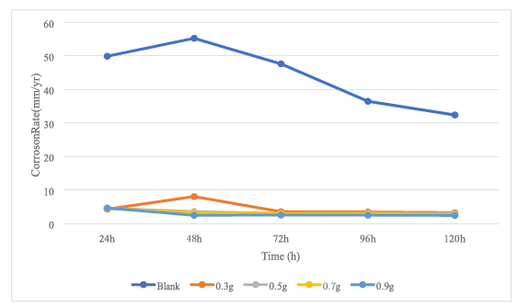
Figure 3: Plot of corrosion rate against time for mild steel in 0.5M H₂SO₄ without and with caladium tricolor starch.
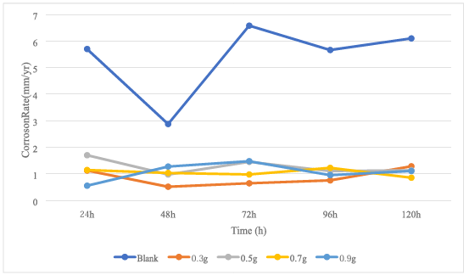

Figure 4: Plot of corrosion rate against time for mild steel in 0.5M HCL without and with caladium tricolor starch.

Inhibition Efficiency
The calculated data for inhibition efficiency of mild steel in blank and inhibited 0.5M H₂SO₄ are presented in Table 2 while Figure 5 shows the graphical representation of inhibition efficiency of mild steel in blank and inhibited 0.5M H₂SO₄ acidic medium. From Figure 5, the inhibition efficiency increased with time for all concentration, after 48 hours there was gradual decline in inhibition efficacy except for 0.3g concentration that decreased first and then increased at 72 hours before decreasing. The decrease in inhibition efficiency with time depicts desorption of the CTS starch molecules adsorbed on the surface of the metal substrates. This is in tandem with other works [Anyiam et al. 2020a, Anyiam et al 2020b, Mobin et al 2011, Huang et al 2022, Othman et al 2018]; the maximum inhibition efficiency being 95.40% at 48 hours in the presence of starch concentration of 0.9g.
On the other hand, the inhibition efficiency data for the CTS inhibitor in 0.5M HCl, are presented in Table 2 and Figure 6. The graphical representation of inhibition efficiency of mild steel in blank and inhibited 0.5M HCl acidic medium shows that the inhibition efficiency increased with concentration and time but took a downward slide after 48 hrs with 0.9g recording the highest inhibition efficacy values.

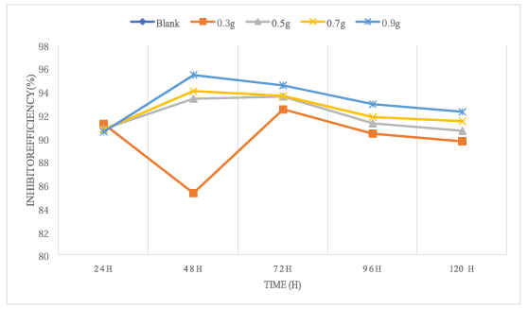
Figure 5: Plot of Inhibition efficiency against time for mild steel in 0.5M H2SO4 without and with caladium tricolor starch.
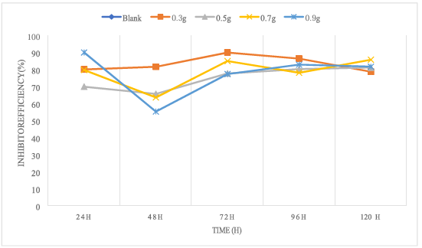
Figure 6: Plot of Inhibition efficiency against time for mild steel in 0.5M HCl without and with caladium tricolor starch.

Adsorption considerations

Figure 7. Plot of Langmuir adsorption isotherms for the adsorption of Caladium Tricolor starch inhibitor on mild steel in 0.5 M H₂SO₄

The free energy of adsorption (∆Gads) and equilibrium constant (Kads) in an adsorption desorption process are related according to Equation 6 as follows:
∆G =−RTIn K 55.5 (6)
where R is the universal gas constant, Kads is the adsorption-desorption equilibrium constant obtained from the intercept of plot of C /θ against C and T is the absolute temperature. The negative ΔG (Gibbs free energy) value of calculated free energy of adsorption was found to be −15.246KJ/mol. The negative value of free energy of adsorption is an indication that CTS inhibitor is adsorbed spontaneously onto mild steel surface whereas the value of ∆Gads being lower than – 20KJ/mol means that the CTS inhibitor is physically adsorbed onto mild steel surface indicating the inhibitor molecules are electrostatically attracted to the metal surface.
Conclusion
The use of caladium bicolor starch as corrosion inhibitor for mild steel in acidic medium (0.5M H₂SO₄ and 0.5M HCl) using gravimetric technique was evaluated in this work. The inhibitive performance of caladium tricolor starch towards the corrosion of mild steel in 0.5 M H₂SO₄ and HCl solution investigated using the gravimetric measurement method established that caladium tricolor starch was a very good inhibitor, with inhibition efficiency up to 95.4% and 90.03% in 0.5 M H₂SO₄ and 0.5M HCl solution respectively. The corrosion inhibition mechanism is based on glucose unit of starch molecules being adsorbed on the active corrosion sites on the mild steel surface. The mode of inhibition adsorption was best modeled using Langmuir adsorption isotherm, and the value of the standard free energy of adsorption indicates strong adsorption of the caladium tricolor starch on the mild steel surface. The trend of inhibition efficiency suggests physiosorption mechanism and it was observed that caladium tricolor starch as a corrosion inhibitor performed better in 0.5M H₂SO₄ acidic medium.

Competing Interests: Authors has declared that no competing interests exist.
REFERENCES
Alaneme, K. K., Olusegun, S. J. & Adelowo, O. T., (2016). Corrosion inhibition and adsorption
mechanism studies of Hunteria umbellata seed husk extracts on mild steel immersed in acidic
solutions. Alexandria Engineering Journal, 55(1), p. 673–681.
Anyiam C. K. (2026). Comparative studies of Caladium Tricolor Stem and Leaf Biomass extract as
corrosion inhibitor for mild steel in acidic media, (In press).
Anyiam, C.K., Ogbobe, O., Oguzie, E.E. et al. (2020). Corrosion inhibition of galvanized steel in
hydrochloric acid medium by a physically modified starch. SN Appl. Sci. 2, 520 https://doi.org/10.1007/s42452-020-2322-2
Anyiam, C.K., Ogbobe, O., Oguzie, E.E. et al. S(2020). ynergistic Study of Modified Sweet Potato
Starch and KI for Corrosion Protection of Mild Steel in Acidic Media. J Bio Tribo Corros 6, 70 https://doi.org/10.1007/s40735-020-00362-x
Aslam, R., Mobin, M., Zehra, S. and Aslam, J. (2022) A comprehensive review of corrosion inhibitors
employed to mitigate stainless steel corrosion in different environments, Journal of Molecular Liquids, Volume 364, , 119992,ISSN 0167-7322, https://doi.org/10.1016/j.molliq.2022.119992.
Da Silva, E. M., Maravilha, T. S. L., Ortiz, R. W. P., Belati, A., Souza, A. B. O., Venancio, F., Manoel, E.
A., Gonçalves, V. O. O., Cavalcante Freitas, T., Silva, J. M., da Silva, M. T., Fontes, R. A., Kartnaller, V., & Cajaiba, J. (2025). Chemically Modified Soluble Starches as Green Scale Inhibitors in Petroleum Production. ACS omega, 11(1), 552–561. https://doi.org/10.1021/acsomega.5c05924
Fidudusola, A. F., Igbafe, S. and Igbafe, A. I. (2025) Synthesis and Application of Starch-Modified
Chitosan-Silver Nanoparticle Composite as Green Corrosion Inhibitor for Mild Steel in Acidic Media, AJERD, vol. 8, no. 3, pp. 134–147, Nov..
Han XZ, Benmoussa M, Gray JA, BeMiller JN, Hamaker BR. (2005) Detection of proteins in starch
granule channels Cereal Chemistry.. ;82(4):351-355. DOI: 10.1094/cc-82-0351.
Huang, L., Chen, WQ., Wang, SS. et al. (2022). Starch, cellulose and plant extracts as green inhibitors
of metal corrosion: a review. Environ Chem Lett 20, 3235–3264 https://doi.org/10.1007/s10311-022-01400-5
Madison, M. T., (2011). Notes on Caladium (Araceae) and its allies. Selbyana, Volume 5, pp. 342-377.
Marzorati, S., Verotta, L. & Trasatti, S., (2019). Green Corrosion Inhibitors from Natural Sources and
Biomass Wastes. Molecules, pp. 40-48.
Mobin, M., Khan, M.A. and Parveen, M. (2011), Inhibition of mild steel corrosion in acidic medium
using starch and surfactants additives. J. Appl. Polym. Sci., 121: 1558-1565. https://doi.org/10.1002/app.33714
Nwanonenyi SC, Madufor IC, Chukwujike IC, Arinze VC (2016) Experimental and theoretical studies
of the inhibitive behaviour of millet starch on the corrosion of aluminium in the sulphuric acid environment. Int J Eng Technol 8:1–13 DOI: 10.9734/IRJPAC/2016/27881`
Okafor, P. C. et al., (2018). Inhibitory action of Phyllanthus amarus extracts on the corrosion of mild
steel in acidic media. Corrosion Science, Volume 50, pp. 2310-2317.
Othman, N. K., Salleh, E. M., Dasuki, Z., & Lazim, A. M. (2018). Dimethyl Sulfoxide-Treated Starch of
Dioescorea hispida as a Green Corrosion Inhibitor for Low Carbon Steel in Sodium Chloride Medium. In Corrosion Inhibitors, Principles and Recent Applications. InTech. https://doi.org/10.5772/intechopen.73552
Palanisamy, G. (2019). Corrosion Inhibitors. In Corrosion Inhibitors. IntechOpen.
https://doi.org/10.5772/intechopen.80542
Raja, P. & Sethuraman, M., (2018) Natural products as corrosion inhibitor for metals in corrosive
media-A review. Materials Letters, Volume 62, pp. 113-116.
Rosliza R. and Siti N. Saudah (2022) Corn starch inhibitive evaluation on marine corrosion of mild
steel J. Phys.: Conf. Ser. 2266 012010 DOI 10.1088/1742-6596/2266/1/012010
Resslar, P., (2010) Caladium bicolor naturalized on the island of Hawaii. In: Records of the Hawaii
Biological Survey for 2008. Hawaii: Bishop Museum Occasional Papers, p. 44–45.
Shwetha KM, Praveen, B.M. & Bharath K. Devendra (2024) A review on corrosion inhibitors: Types,
mechanisms, electrochemical analysis, corrosion rate and efficiency of corrosion inhibitors on mild steel in an acidic environment, Results in Surfaces and Interfaces, Volume 16, 100258, ISSN 2666-8459 https://doi.org/10.1016/j.rsurfi.2024.100258.
Singh, S., Singh, N., Isono, N. & Noda, T., (2010). Relationship of granule size distribution and
amylopectin structure with pasting, thermal, and retrogradation properties in wheat starch. Jounal of Agriculture and Food Chemistry, Volume 58, p. 1180–1188.
Uwem, I. N. & Ita, B. N. (2019) Physicochemical, Functional and Antinutritional Properties of
Starches from Caladium Bicolor and Dioscorea Dumentorum. Eur. J. Chem., 10, 228-233. http s://doi.org/10.5155/eurjchem.10.3.228-233.1833
Xianghong L, Shuduan D., Tong L. & Xiaoguang X. (2019) Cassava starch graft copolymer as a novel
inhibitor for the corrosion of aluminium in HNO3 solution, Journal of Molecular Liquids, Volume 282, 499-514, ISSN 0167-7322, https://doi.org/10.1016/j.molliq.2019.03.044.
Xie, Q., Fan, B., Tao, R., Wang, F. & Sun, Y. (2025), A Comprehensive Review of Starch: Structure,
Properties, Chemical Modification, and Application in Food Preservation. Food Frontiers., 6: 1645-1657. https://doi.org/10.1002/fft2.70040
.

