Thermodynamic Optimization of Hybrid Nanofluid Flow in Parabolic Trough Solar Collectors for Solar-Powered Agricultural Machinery: Advancing Agricultural Sustainability

Abstract
The efficiency of solar-powered farm machinery is often limited by inadequate heat transfer in conventional working fluids, leading to reduced thermal performance of parabolic trough solar collectors (PTSCs). Enhancing the thermophysical properties of the working fluid through hybrid nanofluids presents a promising solution for improving energy utilization in sustainable agricultural systems. This study investigates the thermodynamic behavior of a hybrid nanofluid flow within PTSCs, focusing on heat transfer enhancement, temperature distribution, and entropy generation to optimize the performance of solar-powered farm machinery. A hybrid nanofluid composed of copper $(Cu)$ and aluminum oxide $(Al₂O₃)$nanoparticles suspended in water was modeled in a parabolic trough solar collector. Governing equations for momentum, energy, and entropy were solved numerically using a spectral collocation approach under steady-state conditions. The effects of nanoparticle volume fraction, Reynolds number, and solar radiation intensity on thermal performance were analyzed. The addition of 2% volume fraction of hybrid nanoparticles increased the average heat transfer rate by 28%, while the collector efficiency improved by 15% compared to the base fluid. Increasing the volume fraction to 4% further enhanced the heat transfer rate by 52% and reduced the entropy generation by 12%, indicating a more thermodynamically efficient process. The results also showed that higher Reynolds numbers promoted uniform temperature distribution across the collector, contributing to overall system stability.
Keywords: Hybrid Nanofluid Flow; Parabolic Trough Solar Collectors; Nanoparticle volume fraction; Agricultural sustainability; Spectral collocation approach

1. Introduction
The increasing demand for sustainable energy solutions in agricultural operations has intensified interest in solar-powered farm machinery as an effective means of reducing fossil fuel dependence, greenhouse gas emissions, and operating costs associated with diesel-driven equipment (Kalogirou, 2009; Hazami et al., 2013; Settino et al., 2018). Among the most effective and widely deployed solar thermal technologies are parabolic trough solar collectors (PTSCs), which are concentrated solar power systems capable of delivering medium-temperature heat suitable for agricultural applications such as solar-driven irrigation pumping, crop drying, agro-processing, and thermal assistance for mechanized farm equipment (Tagle-Salazar et al., 2020; Bellos & Tzivanidis, 2018). PTSCs are particularly attractive for rural and off-grid farming environments due to their scalability and relatively high thermal efficiency. Conrado et al. (2017) presented a comprehensive review of the thermodynamic and thermal performance of parabolic trough solar collectors using mathematical models, numerical simulations, experimental investigations, and cost analyses. Their study highlighted key thermal factors, identified major engineering challenges, and outlined future needs for efficient modeling, improved performance evaluation, and cost reduction. Similarly, Yılmaz and Mwesigye (2018) reviewed the development and performance of PTSCs as a mature concentrated solar power technology, discussing optical and thermal performance studies, analytical and ray-tracing optical models, steady and transient thermal analyses, two-phase flow modeling, and performance enhancement strategies such as novel designs, passive heat-transfer techniques, and nanofluid applications. Ahmad et al. (2024) further emphasized the advantages of parabolic trough solar collectors, including scalability, reliability, and long service life for solar power generation, while stressing the need for continued research to improve land-use efficiency, maintenance strategies, and collector technology. In spite of these benefits, the performance of PTSCs is strongly influenced by the thermophysical properties of the working fluid used for heat transport. Recently, there has been a campaign for replacing conventional heat transfer fluids with nanofluids to enhance heat transfer rates and thermal efficiency in PTSCs, thereby improving their viability for practical agricultural energy applications (Said et al., 2015; Mwesigye et al., 2016).
The integration of environmentally friendly technologies that reduce fossil fuel dependence while maintaining high productivity is essential for agricultural sustainability. Solar-powered agricultural systems offer viable solutions for irrigation, crop processing, and mechanized farming; however, their effectiveness is often limited by the low thermal efficiency of conventional solar collectors (Kalogirou, 2014). Recent advances in hybrid nanofluid technology have demonstrated significant potential for enhancing heat transfer and thermodynamic performance in solar thermal systems (Said et al., 2017; Minea, 2020). The use of hybrid nanofluids in parabolic trough solar collectors improves thermal conductivity, reduces entropy generation, and enhances energy utilization efficiency, thereby enabling more reliable and efficient solar-powered agricultural machinery. Consequently, nanofluid-based solar technologies play a critical role in advancing agricultural sustainability through increased renewable energy use and reduced environmental impact (Verma et al., 2018).
Nanofluids are engineered colloidal fluids in which nanoparticles, such as metals, metal oxides, or carbon-based materials, are dispersed in conventional base fluids like water, oil, or ethylene glycol to enhance thermal conductivity and convective heat transfer. Early studies by Choi (1995) and Eastman et al. (1996) showed that even low-volume fractions of nanoparticles can significantly improve heat transfer efficiency compared to conventional fluids. Nanofluids have found applications in advanced cooling of electronics and microelectronics, automotive and heavy-duty engine thermal management, heat exchangers and HVAC systems, nuclear reactors, solar thermal energy systems, and aerospace and defense due to their efficiency and weight advantages. These applications have motivated extensive research into their thermophysical properties. Salim et al. (2023) reviewed magnetic nanofluids, highlighting the effects of nanoparticle magnetization on thermal conductivity, viscosity, and magnetorheological behavior. Mahoite et al. (2024) summarized synthesis methods, stability, and mechanisms for enhancing conduction and convection heat transfer. Fatunmbi and Salawu (2022) and Fatunmbi and Ramonu (2023) investigated micropolar nanofluid flow, heat transfer, phenomenon of micropolar nanofluids subject to thermophoresis, Brownian motion, isothermal and convective heating thermal conditions. Meanwhile, an enhanced heat transfer efficiency has been found with the dispersion of two different nanoparticles in a base fluid, this phenomenon is termed, hybrid nanofluids. However, while mono- and hybrid nanofluids have shown notable improvements in thermal performance, tri-hybrid nanofluids which is formed by dispersing three distinct nanoparticles within a base fluid offer superior thermophysical properties through synergistic effects. These advanced fluids can significantly improve heat transfer rates while maintaining acceptable flow resistance. In this context, Oke et al. (2022) numerically explored flow dynamics of ternary-hybrid nanofluid comprising of CNTs, graphene, and alumina nanoparticles subject to magnetic field force and Coriolis over a 3-D material. Sudharani et al. (2023) investigated the heat transport efficiency of polymer-based hybrid and tri-hybrid nanofluid slip flow under linear thermal radiation over an expanding sheet. Obalalu et al. (2024) evaluated the thermal performance of hybrid nanofluids in a solar-powered energy ship using parabolic trough solar collectors (PTSCs). Salawu et al. (2023) studied the heat transport characteristics of tri-hybrid metallic oxide nanofluids considering nonlinear properties, while Shamshuddin et al. (2024) explored the effects of thermal radiation on tri-hybrid nanofluid flow over a dually stretched plate in porous media. However, most of these studies were done without adequate consideration of the impact of solar radiation on the heat transport phenomenon.
Solar radiation is the energy emitted by the Sun in the form of electromagnetic waves, primarily visible light, ultraviolet, and infrared radiation, and it constitutes a fundamental energy source for most renewable energy technologies (Obalalu et al., 2024; Salawu et al., 2023). In practical engineering and energy applications, solar radiation is commonly quantified as solar irradiance, which plays a crucial role in solar thermal systems and photovoltaic technologies. Its applications span agricultural activities such as solar-powered irrigation, crop drying, greenhouse heating, and agro-processing, as well as thermal management through enhanced heat transfer in nanofluids used in heat exchangers and cooling systems. In solar thermal applications, the improved thermal conductivity and convective heat transfer characteristics of nanofluids enable efficient absorption and transport of solar energy. The interaction between solar radiation and nanofluids not only elevates fluid temperature but also enhances the overall heat transfer efficiency of systems such as solar-powered farm machinery, solar water heaters, and parabolic trough solar collectors. Consequently, incorporating nanofluids into solar systems leads to higher energy capture, faster thermal response, and more effective utilization of solar radiation (Oreyemi et al., 2025; Akindele et al., 2025; Obalalu et al., 2023). In this regard, Eid and Makinde (2018) numerically investigated the transport phenomena of an electrically conducting nanofluid over a convectively heated stretching sheet in a porous medium, considering solar radiation, chemical reactions, Joule heating, viscous dissipation, and magnetic effects. Similarly, Nasir et al. (2024) studied the influence of solar radiation on a three-dimensional radiative non-Newtonian tangent hyperbolic nanofluid over a porous expanding sheet, solving the governing equations using an artificial neural network within the Cattaneo–Christov heat flux framework. Obalalu et al. (2024) further examined the thermal efficiency of a hybrid nanofluid in parabolic trough solar collectors for a solar-powered ship, employing wavelet and Chebyshev techniques to solve the governing equations. Typically, in agricultural activities, solar radiation is widely used for solar-powered irrigation, crop drying, greenhouse heating, and agro-processing. This is due to the fact that it offers clean and cost-effective energy source that enhances efficiency and at the same time decreases fossil fuel use, and supports sustainable farming practices (Yuan et al., 2023; Wei et al., 2025). Most of these studies however, were conducted based on the first law performance metrics of thermodynamics without due consideration for the second law in spite of its applications in various engineering and technological processes.
Beyond first-law performance metrics, thermodynamic evaluation based on the second law—particularly entropy generation analysis—provides deeper insight into system irreversibilities and energy losses. Entropy generation is a thermodynamic measure of irreversibility in physical systems arising from processes such as heat transfer, fluid friction, mass diffusion, and magnetic field effects (Salawu and Fatunmbi, 2027; Obalalu et al., 2025). Through this approach, energy losses and system inefficiencies can be quantified, enabling the identification of dominant sources of irreversibility and guiding performance enhancement. Entropy generation analysis is especially useful for assessing the trade-off between enhanced heat transfer and increased flow resistance in fluid flow and heat transfer studies, particularly those involving nanofluids, porous media, and magnetohydrodynamic systems. The foundational work on this concept was introduced by Bejan (1996) through second-law-based analysis of heat transfer and thermal performance. Since then, numerous researchers have investigated entropy generation using different working fluids and flow configurations. Applications of this analysis include the design and optimization of solar thermal collectors, heat exchangers, and energy conversion devices, where minimizing entropy generation leads to improved thermodynamic efficiency and sustainable operation. For instance, Fatunmbi and Adeniyan (2020) numerically examined entropy generation in MHD micropolar fluid flow induced by a nonlinear expanding sheet under nonlinear thermal radiation and convective heating. Mebarek-Oudina et al. (2024) analyzed entropy generation and thermal performance of a water-based hybrid nanofluid containing $MgO-Al₂O₃$ nanoparticles in an elliptical cavity. Zeshaan et al. (2024) investigated entropy generation minimization in MHD hybrid nanofluid flow through an expanding–contracting porous channel under radiative heat flux using response surface methodology. Several other studies have explored entropy generation across different geometries and configurations (Salawu et al., 2023; Mabood et al., 2022; Akinshilo et al., 2025). Despite these advances, the application of second-law thermodynamic analysis to tri-hybrid nanofluids in parabolic trough solar collectors for solar-powered farm machinery remains largely unexplored.
This study therefore aims to fill this gap by investigating the thermodynamic performance of tri-hybrid nanofluid flow in a parabolic trough solar collector, with the objective of enhancing thermal efficiency and supporting sustainable agricultural mechanization. The hybrid nanofluid consists of a nanoparticle, while accounting for the effects of magnetic fields, viscous dissipation, and solar radiation. The governing equations modeling the thermodynamic phenomena are solved numerically, with tables and graphs used to present the outcomes of the investigation. The findings have applications in the design and optimization of solar-powered agricultural machinery, enhanced heat transfer and thermal management in solar thermal systems, and the development of sustainable, cost-effective, high-performance solar energy systems for off-grid and rural farming environments, thereby promoting environmentally friendly mechanization and long-term agricultural sustainability.
Methodology
2. Flow Configuration and Physical Model Description
The Figure 1 presents a conceptual schematic of a solar-powered parabolic trough system coupled with nanofluid flow dynamics, designed for efficient thermal energy harvesting and utilization in agricultural machinery. Solar radiation is concentrated by a parabolic trough solar collector (PTSC) onto a receiver, where a Williamson nanofluid circulates to enhance heat absorption and transfer. The heated nanofluid is transported through a pump–tank loop, delivering thermal energy for practical use (e.g., hot water output), while cooled nanofluid is recirculated to maintain system efficiency. The right-hand diagram illustrates the boundary-layer flow behavior over a stretching surface in a porous medium, highlighting the evolution of the velocity boundary layer (VBL), thermal boundary layer (TBL), and momentum boundary layer (MBL) under solar heating. The microscopic view emphasizes the role of nanoparticles in improving thermal conductivity and heat transfer performance. The system integrates solar concentration, advanced nanofluid rheology, and fluid–thermal modeling to support sustainable, energy-efficient solar-powered farm machinery.
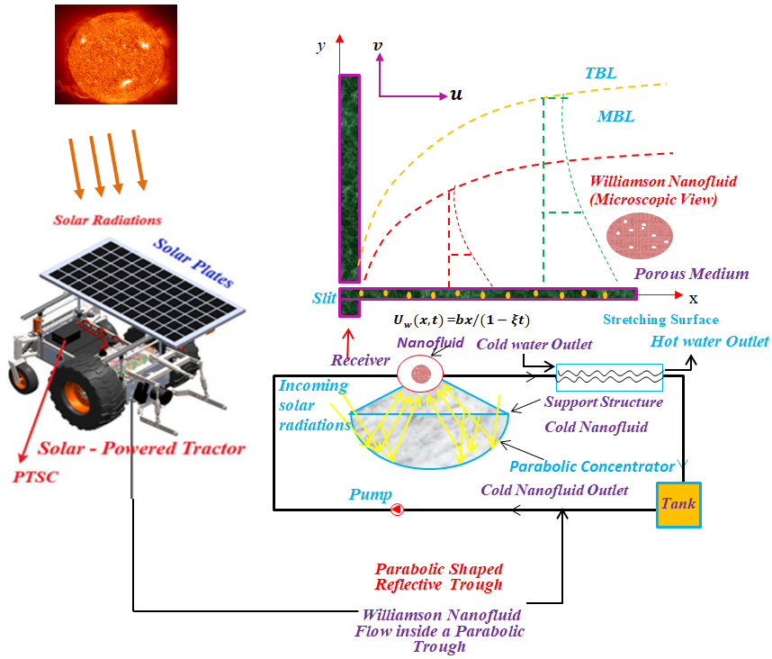
Figure 1: A visual depiction of the Solar-Powered Tractors with a Parabolic Trough Solar Collector.
Incorporating the highlighted assumptions, the formulated governing equations for the present problem are listed as follows:
Continuity Equation:

$\frac{∂\breve{u}}{∂\breve{x}}+\frac{∂\breve{v}}{∂\breve{y}}$ = 0. | (1)
Momentum Equation:

$\frac{∂\breve{u}}{∂t}$+ $\breve{u}\frac{∂\breve{u}}{∂\breve{x}}+\breve{v}\frac{∂\breve{u}}{∂\breve{y}}$ = $\frac{μ_{thnf}}{ρ_{thnf}}\frac{∂^{2}\breve{u}}{∂{\breve{y}}^{2}}-\frac{σ_{thnf}}{ρ_{thnf}}B^{2}\left(t\right)\breve{u}-\frac{μ_{thnf}}{ρ_{thnf}}\left[\sqrt{2β}\left(\frac{∂\breve{u}}{∂\breve{y}}\right)\left(\frac{∂^{2}\breve{u}}{∂{\breve{y}}^{2}}\right)\right]$. | (2)
Energy Equation:
$\frac{∂T}{∂t}+\breve{u}\frac{∂T}{∂\breve{x}}+\breve{v}\frac{∂\breve{T}}{∂\breve{y}}$= $\frac{1}{{\left(ρC_{p}\right)}_{thnf}}\left[k_{thnf}\left(\frac{∂^{2}\breve{T}}{∂{\breve{y}}^{2}}\right)-\left(\frac{∂q_{r}}{∂\breve{y}}\right)+Q\left({\breve{T}-\breve{T}}_{∞}\right)\right]+\frac{σ_{thnf}}{{\left(ρC_{p}\right)}_{thnf}}B^{2}(t){\breve{u}}^{2}$+$\frac{μ_{thnf}}{{\left(ρC_{p}\right)}_{thnf}}\left[{\left(\frac{∂\breve{u}}{∂\breve{y}}\right)}^{2}+\frac{β}{\sqrt{2}}{\left(\frac{∂\breve{u}}{∂\breve{y}}\right)}^{3}\right],$  Entropy Generation Equation: | (3)
$E_{G}=\frac{1}{{\breve{T}}_{∞}^{2}}\left[k_{thnf}+\frac{16σ^{*}{\breve{T}}_{∞}^{3}}{{3k}^{*}}\right]{\left(\frac{∂\breve{T}}{∂\breve{y}}\right)}^{2}$+$\frac{σ_{thnf B^{2}(t)}}{{\breve{T}}_{∞}}{\breve{u}}^{2}$+$\frac{{ μ}_{thnf}}{k{\breve{T}}_{∞}}{\breve{u}}^{2}+\frac{{ μ}_{thnf}}{{\breve{T}}_{∞}}\left[{\left(\frac{∂\breve{u}}{∂\breve{y}}\right)}^{2}+\frac{β}{\sqrt{2}}{\left(\frac{∂\breve{u}}{∂\breve{y}}\right)}^{3}\right],$. | (4)
Subject to:
$\breve{u}$($x$,0) = ${\breve{U}}_{w}+N_{x}\left(\frac{∂\breve{u}}{∂\breve{y}}\right)$,  -$k_{f}\left(\frac{∂\breve{T}}{∂\breve{y}}\right)=h_{g}({\breve{T}}_{w}$- $\breve{T}$),  $\breve{v}$($x$,0) = ${\breve{R}}_{w}$,  $$\breve{u}⟶0, \breve{T}⟶\breve{T}, as \breve{ y}⟶∞.$$ | (5)
In these governing equations (1-5), the velocity component in $x$-direction is $u$, while the velocity component in y-direction is $v$, Temperature $T$, Ambient temperature $T_{∞}$, Vertical coordinate $y$, Horizontal coordinate $x$, slip length $R_{w}$ , Density of THNF $ρ_{thnf}$, Magnetic field strength (time-dependent) $B(t)$, Thermal conductivity of THNF $k_{thnf}$, Heat generation parameter $Q$, Thermal conducting of nanosolid, Dynamic viscosity of THNF $k_{h}$, Shear rate parameter at the wall $N_{x}$, Wall temperature $T_{w}$, Heat transmission factor $h_{g}$, Wall velocity $U_{w}$, Heat capacity of THNF ${\left(ρc_{p}\right)}_{thnf}$, Material parameter $β$, $σ_{thnf}$ Electrical conductivity of THNF,
Mathematical Formulation of Thermophysical Characteristics
The mathematical expressions defining the effective thermophysical characteristics of the base fluid and dispersed nanoparticles are summarized in Table 2. These relations account for the synergistic influence of nanoparticle concentration, morphology, and intrinsic material properties on the overall behavior of the nanofluid system. Furthermore, Figure 1 illustrates the geometrical configurations of the employed nanoparticles along with their corresponding morphological form factors (m), which play a crucial role in determining the effective thermal conductivity and viscosity of the hybrid nanofluid.
Table 1: Physical characteristics of nanoparticles (EO – Engine Oil, Cu – Copper nanoparticles), Ag – Silver (nanoparticles).
Table 1: Thermo-physical characteristics for the base fluid and hybrid nanofluid [57]
Physical property | EO | Cu | $$Ag$$
$ρ/$($kg.m^{-3})$ | 884 | 8933 | 10500
$k/$($W.mK$) | 0.144 | 401.0 | 429
$C_{p}/$($J.kgK$) | 1910 | 385.0 | 235
$σ$(S$m^{-1})$ | 0.125${×10}^{-11}$ | 5.96${×10}^{7}$ | 6.3${×10}^{7}$

$$ρ_{thnf}=\left(1-β_{1}-β_{2}-β_{3}\right)ρ_{f}+β_{1}ρ_{s1}+β_{2}ρ_{s2}+β_{3}ρ_{s3},$$
$$μ_{thnf}=\frac{μ_{f}}{{\left(1-β_{1}-β_{2}-β_{3}\right)}^{2.5}},$$
$${\left(ρc_{p}\right)}_{thnf}=\left(1-β_{1}-β_{2}-β_{3}\right){\left(ρc_{p}\right)}_{f}+β_{1}{\left(ρc_{p}\right)}_{s1}+β_{2}{\left(ρc_{p}\right)}_{s2}+β_{3}{\left(ρc_{p}\right)}_{s3},$$
$$\begin{matrix}σ_{thnf}=\left[\frac{σ_{s1}+2σ_{hnf}-2β_{1}\left(σ_{hnf}-σ_{s1}\right)}{σ_{s1}+2σ_{hnf}+β_{1}\left(σ_{hnf}-σ_{s1}\right)}\right]σ_{hnf}, \\ σ_{hnf}=\left[\frac{σ_{s2}+2σ_{nf}-2β_{2}\left(σ_{nf}-σ_{s2}\right)}{σ_{s2}+2σ_{nf}+β_{2}\left(σ_{nf}-σ_{s2}\right)}\right]σ_{nf}, \\ σ_{nf}=\left[\frac{σ_{s3}+2σ_{f}-2β_{3}\left(σ_{f}-σ_{s3}\right)}{σ_{s3}+2σ_{f}+β_{3}\left(σ_{f}-σ_{s3}\right)}\right]σ_{f}, \\ k_{hnf}=\left[\frac{k_{s2}+(m-1)2k_{nf}-(m-1)β_{2}\left(k_{nf}-k_{s2}\right)}{k_{s2}+(m-1)k_{nf}+β_{2}\left(k_{nf}-k_{s2}\right)}\right]k_{nf}, \\ k_{thnf}=\left[\frac{k_{s1}+(m-1)k_{hnf}-(m-1)β_{1}\left(k_{hnf}-k_{s1}\right)}{k_{s1}+(m-1)k_{hnf}+β_{1}\left(k_{hnf}-k_{s1}\right)}\right]k_{hnf}, \\ k_{nf}=\left[\frac{k_{s3}+(m-1)k_{f}-(m-1)β_{3}\left(k_{f}-k_{s3}\right)}{k_{s3}+(m-1)k_{f}+β_{3}\left(k_{f}-k_{s3}\right)}\right]k_{f}.\end{matrix}$$

3. Similarity Transformations
To facilitate the mathematical formulation and subsequent numerical analysis, appropriate similarity transformations are introduced, following the approach of Refs. [23, 35]. These transformations are defined as:
$ϑ=\sqrt{\frac{b}{υ_{f}(1-χt)}}y,$ $ψ$= $\sqrt{\frac{υ_{f}b}{(1-χt),}}xh(ϑ)$, $ξ(ϑ)=\frac{T-T_{∞}}{T_{w}-T_{∞}}$,  $u=\frac{∂ψ}{∂y}$, and $v=-\frac{∂ψ}{∂x,}$,  $$Ng=\frac{E_{G}μ_{f}T_{∞}^{2}}{k_{f}{\left(T_{w}-T_{∞}\right)}^{2}} .$$ |  | (6)
By substituting the aforementioned similarity transformations into the governing momentum and energy equations, namely Eqs. (1) and (4), the system of partial differential equations is reduced to a coupled set of nonlinear ordinary differential equations. These transformed equations effectively capture the essential physics of the problem in a dimensionless framework, facilitating numerical computation and parametric analysis.  $ζ_{w}$(${h^{''}h}^{'''}$)+ $h^{'''}$+$β_{a}β_{b}({{{hh}^{''}-h}^{'}}^{2}$) - A$h^{'}$-$β_{a}β_{b}$M$h^{'}-$ A$\frac{ϑ}{2}h^{''}$=0, | (7)
$ξ^{''}\left(1+\frac{1}{β_{d}}R_{N}Pr\right)$+ $Pr$M$δ_{c}f^{'2}\frac{β_{a}}{β_{b}}$ + $\frac{PrEc}{β_{a}β_{b}}{h^{''}}^{2}$+$\frac{PrEc}{β_{a}β_{b}}{{ζ_{w}h}^{''}}^{3}$+$\frac{PrQ}{β_{c}}ξ$+$\frac{Prβ_{c}}{β_{e}}\left[{hξ}^{'}-A\left(ξ+\frac{ϑ}{2}ξ^{'}\right)\right],$ | (8)
$$N_{G}=Re\left[β_{d}(1-R_{N})ξ^{'2}+\frac{1}{β_{a}}\frac{Br}{Ω}\left(h^{''2}+ζ_{w}h^{''2}+β_{a}β_{d}Mh^{'2}\right)\right],$$ | (9)
Subjected to
$$h^{'}\left(0\right)=1+ϱh^{''}\left(0\right),h\left(0\right)=S,$$  $h^{'}\left(ϑ\right)⟶0,$ $ξ^{'}\left(0\right)=-B_{i}\left(1-ξ\left(0\right)\right),ξ\left(ϑ\right)⟶0$, $as ϑ⟶∞,$ | (10)
The skin friction coefficient $C_{f}$ and heat transfer rate ($Nu_{x}$) are defined as follows [21, 46]:
$C_{f}=\frac{τ_{w}}{ρ_{f}U_{w}^{2}}$, $and Nu_{x}=\frac{xq_{w}}{k_{f}\left(T_{w}-T_{∞}\right)}$ | (11)
The dimensionless form of the aforementioned quantities is detailed below.
$C_{f}Re_{x}^{1/2}$= $\frac{h''(0)}{β_{a}}\left[1+\frac{ζ_{w}}{2}{\left(h''(0)\right)}^{2}\right]$,$Re_{x}^{1/2} Nu_{x}$=$-\frac{k_{thnf}}{k_{f}}\left[(1-R_{N})ξ^{'}(0)\right]$ | (12)
In these expressions, the involved dimensionless parameters are defined as:
Slippery factor$ϱ=\sqrt{\frac{b}{υ_{f}\left(1-χt\right)}N_{x}}$, Eckert number $Ec$ =$\frac{U_{w}^{2}}{{\left(C_{p}\right)}_{f}\left(T_{w}-T_{∞}\right)}$
A =$\frac{b}{a}$ unsteadiness parameter, Prandtl number $Pr$ =$\frac{υ_{f}}{α_{f}}$
Magnetic field is the M =$\frac{σ_{f}B_{0}^{2}}{bρ_{f}},$ Solar radiation $R_{N}=\frac{16}{3}\frac{σ^{*}T_{∞}^{3}}{k^{*}k_{f}}$
Suction/Injection $S=-U_{w}\sqrt{\frac{(1-χt)}{υ_{f}b}}$, Heat generation $Q=\frac{Q_{0}}{{\left({ρC}_{p}\right)}_{f}b}$
WF parameter $ζ_{w}=ϖ\sqrt{\frac{2b^{3}}{υ_{f}{(1-χt)}^{3}}}$,${Biot number B}_{i}$=$\frac{h_{f}}{k_{o}}\sqrt{\frac{υ_{f}(1-χt)}{b}}$
$Entropy generation N_{G}=\frac{E_{G}b^{2}{ T}_{∞}^{2}}{{k_{f}\left(T_{w}-T_{∞}\right)}^{2}}$, Thermal diffusivity $α_{f }$=$\frac{k_{f}}{{\left(ρC_{p}\right)}_{thnf}}$,
$Entropy generation N_{G}=\frac{E_{G}b^{2}{ T}_{∞}^{2}}{{k_{f}\left(T_{w}-T_{∞}\right)}^{2}}$,$τ_{w}=μ_{thnf}{\left(\frac{∂u}{∂y}+\frac{χ}{\sqrt{2}}{\left(\frac{∂υ_{1}}{∂y}\right)}^{2}\right)}_{y=0}$heating flux
The thermophysical ratios for the hybrid nanofluid are represented as:
${β_{a}=\frac{μ_{thnf}}{μ_{f}}, β_{b}=\frac{ρ_{f}}{ρ_{thnf}}, β}_{c}=\frac{σ_{thnf}}{σ_{f}}, β_{d}=\frac{k_{thnf}}{k_{f}}$ $, β_{e}=\frac{{\left(ρC_{p}\right)}_{thnf}}{{\left(ρC_{p}\right)}_{f}}$ is the ternary hybrid nanofluid.
These parameters collectively describe the effects of magnetohydrodynamic, thermal, and transport phenomena in the ternary hybrid nanofluid system, capturing the coupled influence of viscous dissipation, slip effects, and heat generation on the flow and thermal characteristics.
Spectral collocation solution
We solve the coupled nonlinear ODEs for the dimensionless velocity and temperature
$ξ^{''}\left(1+\frac{1}{β_{d}}R_{N}Pr\right)$+ $Pr$M$δ_{c}f^{'2}\frac{β_{a}}{β_{b}}$ + $\frac{PrEc}{β_{a}β_{b}}{h^{''}}^{2}$+$\frac{PrEc}{β_{a}β_{b}}{{ζ_{w}h}^{''}}^{3}$+$\frac{PrQ}{β_{c}}ξ$+$\frac{Prβ_{c}}{β_{e}}\left[{hξ}^{'}-A\left(ξ+\frac{ϑ}{2}ξ^{'}\right)\right],$ | (13)
$ξ^{''}\left(1+\frac{1}{β_{d}}R_{N}Pr\right)$+ $Pr$M$δ_{c}f^{'2}\frac{β_{a}}{β_{b}}$ + $\frac{PrEc}{β_{a}β_{b}}{h^{''}}^{2}$+$\frac{PrEc}{β_{a}β_{b}}{{ζ_{w}h}^{''}}^{3}$+$\frac{PrQ}{β_{c}}ξ$+$\frac{Prβ_{c}}{β_{e}}\left[{hξ}^{'}-A\left(ξ+\frac{ϑ}{2}ξ^{'}\right)\right],$ | (14)
Subjected to
$$h^{'}\left(0\right)=1+ϱh^{''}\left(0\right),h\left(0\right)=S,$$  $h^{'}\left(ϑ\right)⟶0,$ $ξ^{'}\left(0\right)=-B_{i}\left(1-ξ\left(0\right)\right),ξ\left(ϑ\right)⟶0$, $as ϑ⟶∞,$ | (15)

3. Spectral collocation approach
We solve the two coupled, nonlinear, higher-order ODEs using a Chebyshev Pseudospectral collocation method (also called spectral collocation or Chebyshev collocation). The main ingredients are:
- Truncate or map the semi-infinite domain $\left[0,∞\right)$to a finite interval.
- Choose a set of collocation points (Chebyshev–Gauss–Lobatto).
- Build spectral differentiation matrices $D,D^{(2)},D^{(3)}$.
3. Domain treatment (semi-infinite → finite) Because the domain is $\left[0,∞\right)$, two common, robust approaches are:
A. Truncation. Choose a finite, sufficiently large $ϑ_{max}$​ so that $h^{'}\left(ϑ_{max}\right) ≈0$ and$ξ\left(ϑ_{max}\right)≈0$within prescribed tolerance. Then solve on $\left[0,ϑ_{max}\right]$. This is simple and normally adequate if solutions decay reasonably fast.
B. Mapping to [−1,1]. Use a rational mapping to cover [0 , ∞ ), for example
$$ϑ=L\frac{1+s}{1-s}$$ | (16)
so 𝑠 → 1 − s→1 − corresponds to 𝜗 → ∞ ϑ→∞. This approach has spectral accuracy for rational Chebyshev bases but requires careful handling near 𝑠 = 1 s=1.
4. Collocation points and spectral differentiation matrices
Take $N+1$ collocation points $x_{j}$ on [ $-1,1$ ] given by Chebyshev-Gauss-Lobatto nodes
$$x_{j}=cos⁡\left(\frac{πj}{N}\right), j=0,…,N$$ | (17)
Map these to $ϑ∈\left[0,ϑ_{max }\right]$ via the linear map
$$ϑ_{j}=\frac{ϑ_{max}}{2}\left(1-x_{j}\right)$$ | (18)
(So $x=-1$ maps to $ϑ=ϑ_{max }$, and $x=1$ maps to $ϑ=0$.). Form the Chebyshev differentiation matrix $D_{x}$ on $[-1,1]$ (standard closed-form entries available in the literature). Convert to differentiation with respect to $ϑ$ by chain rule:
$$D_{ϑ}=\frac{2}{ϑ_{max}}D_{x}, D_{ϑ}^{(2)}={\left(\frac{2}{ϑ_{max}}\right)}^{2}D_{x}^{2}, D_{ϑ}^{(3)}={\left(\frac{2}{ϑ_{max}}\right)}^{3}D_{x}^{3}$$ | (19)
where $D_{x}^{k}$ denotes the $k$-th power (matrix product) of the first-derivative matrix on $x$. Denote $h_{j}≈h\left(ϑ_{j}\right)$ and $ξ_{j}≈ξ\left(ϑ_{j}\right)$. Vectors of deritives are obtained by multiplying the differentiation matrices:
$$h^{'}≈D_{ϑ}h, h^{''}≈D_{ϑ}^{(2)}h, h^{'''}≈D_{ϑ}^{(3)}h,$$ | (20)
5. Discrete residuals (interior collocation equations) At each interior collocation point 𝜗 𝑗 ϑ j ​ (i.e. excluding rows reserved for boundary conditions), assemble the residuals of the two differential equations. Define the discrete approximations at node 𝑗.
$$\begin{matrix}h_{j}, h_{j}^{'}={\left(D_{ϑ}h\right)}_{j}, h_{j}^{''}={\left(D_{ϑ}^{(2)}h\right)}_{j}, h_{j}^{'''}={\left(D_{ϑ}^{(3)}h\right)}_{j} \\ ξ_{j}, ξ_{j}^{'}={\left(D_{ϑ}ξ\right)}_{j}, ξ_{j}^{''}={\left(D_{ϑ}^{(2)}ξ\right)}_{j}.\end{matrix}$$  Then the residual at node 𝑗 for equation (7) is | (21)

$$h^{'}≈D_{ϑ}h, h^{''}≈D_{ϑ}^{(2)}h, h^{'''}≈D_{ϑ}^{(3)}h,$$ | (22)
Then the residual at node j for equation (7) is
$$R_{j}^{(h)}=ζ_{w}\left(h_{j}^{''}h_{j}^{'''}\right)+h_{j}^{'''}+β_{a}β_{b}{\left(\left(h_{j}h_{j}^{''}\right)-h_{j}^{'2}\right)}^{2}-Ah_{j}^{'}-β_{a}β_{b}Mh_{j}^{'}-\frac{Aϑ_{j}}{2}h_{j}^{''}$$ | (23)
$$R_{j}^{(ξ)}=\left(1+\frac{1}{β_{d}}R_{N}Pr\right)ξ_{j}^{''}+PrMδ_{c}f^{'2}\left(ϑ_{j}\right)\frac{β_{a}}{β_{b}}+\frac{PrEc}{β_{a}β_{b}}{\left(h_{j}^{''}\right)}^{2}+\frac{PrEc}{β_{a}β_{b}}{\left(ζ_{w}h_{j}^{''}\right)}^{3}$$  $$+\frac{PrQ}{β_{c}}ξ_{j}+\frac{Prβ_{c}}{β_{e}}\left[(hξ)_{j}^{'}-A\left(ξ_{j}+\frac{ϑ_{j}}{2}ξ_{j}^{'}\right)\right]$$ | (24)
boundary conditions
$h(0)=S$ $B_{1}≡h_{0}-S=0$, $h^{'}(0)=1+ϱh^{''}(0): B_{2}≡{\left(D_{ϑ}h\right)}_{0}-1-ϱ{\left(D_{ϑ}^{(2)}h\right)}_{0}=0$  $$ξ^{'}(0)=-B_{i}(1-ξ(0))$$  The obtained results in this study are in good agreement with existing related works in the literature in some limiting scenarios as displayed in Table 2. | (25)
Table 2: Comparison of heat transfer rate ($Nu_{x}$) for varying value of the Prandtl number (pr).
$$Pr$$ | Present outcome | The outcomes of AIshak et al (2007) | The outcomes of Das et al (2015)
0.72 | 0.8086 | 0.80863135 | 0.80876122
1.0 | 1.0000 | 1.00000000 | 1.00000000
3.0 | 1.9237 | 1.92368259 | 1.92357431
7.0 | 3.0723 | 3.07225021 | 3.07314679
10 | 3.7207 | 3.72067390 | 3.72055436

4. Interpretation and analysis of results & discussion
This figure 2a and b illustrates the influence of the Williamson fluid parameter on the velocity profile and the temperature profile for two types of nanofluids: EO – Engine Oil, Cu – Copper nanoparticles), Ag – Silver (nanoparticles). As the Williamson fluid parameter increases, the velocity of the fluid decreases. This is indicated by the downward-pointing arrow. An increase in represents higher non-Newtonian behavior (specifically shear-thinning effects in some contexts, or higher resistance). This increases the fluid's effective viscosity, which slows down the flow within the boundary layer. As the Williamson fluid parameter increases, the temperature of the fluid increases. This is shown by the upward-pointing arrow. The increase in the fluid parameter enhances the thermal boundary layer thickness. This suggests that the higher resistance/friction associated with the increasing Williamson parameter leads to more heat generation or retention within the fluid.
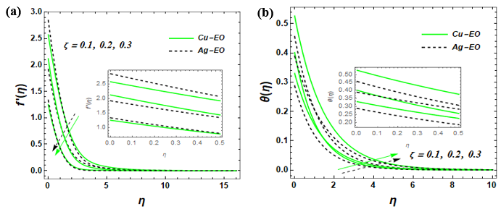
Figure 2(a, b): Imapct of Williamson fluid parameter on $f'(η)$, and $θ\left(η\right)$.
Higher permeability in these mathematical models often correlates with a clogging or resistance effect in the porous matrix (or represents a decrease in the actual Darcy permeability. This adds a "drag" force to the fluid motion, which effectively thickens the momentum boundary layer and forces the fluid to slow down. When the fluid's velocity is restricted by the porous medium, the kinetic energy is essentially converted into thermal energy due to increased internal friction and resistance. This leads to a thickening of the thermal boundary layer, causing the temperature across the fluid to rise (See Figure 2c, d, e).
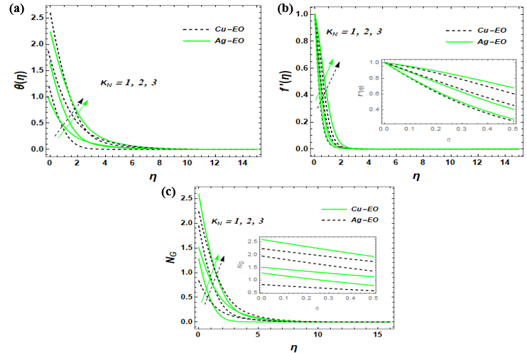
Figure 2c, d, e: Effect of permeability parameter on $f'(η)$, $θ\left(η\right)$, and $N_{G}$.
As the velocity slip parameter increases, the fluid velocity decreases. This is indicated by the downward-pointing arrows (see figure 3a). A higher slip parameter implies less "grip" or friction between the fluid and the surface. This allows the fluid to slide more easily at the boundary, but effectively reduces the momentum transfer into the bulk of the fluid, leading to a thinner momentum boundary layer. As the velocity slip parameter increases, the fluid temperature increases. This is shown by the upward-pointing arrows When velocity slip increases, the fluid velocity near the surface decreases. This reduction in flow rate reduces the convection "cooling" effect that carries heat away from the surface. Consequently, the heat lingers, raising the temperature within the thermal boundary layer (see figure 3b).
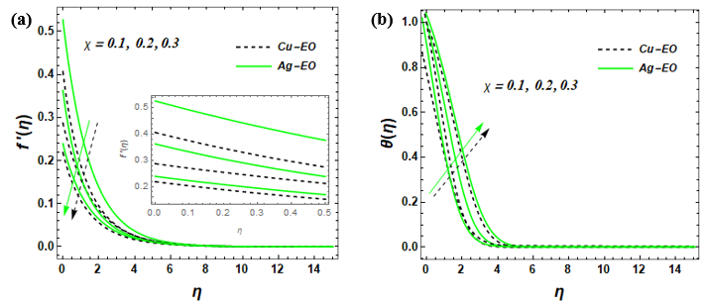
Figure 3(a, b): Impact of $velocity slip$on $f'(η)$, and $θ\left(η\right)$.
As RN increases from (indicated by the rising arrows), the temperature profile increases. Thermal radiation provides additional energy to the fluid. An increase in RN implies a higher rate of radiative heat transport, which thickens the thermal boundary layer and raises the overall temperature of the nanofluid. The Cu-EO (dashed line) generally shows slightly different thermal behavior compared to Ag-EO (solid green line) due to the differing thermal conductivities of copper and silver. Higher thermal radiation increases the temperature gradients within the flow. Since entropy generation is directly tied to heat transfer irreversibility and temperature gradients, the "disorder" or energy loss in the system rises as radiation becomes more dominant (See Figure 4 (a,b).
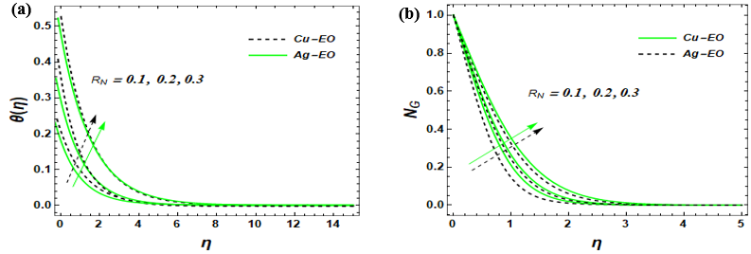
Figure 4(a, b): Impact of $R_{N} and Q$on $θ\left(η\right)$ and $N_{G}$.
In Figure 5a, the graph demonstrates that as the Reynolds number increases, there is a significant rise in the entropy generation within the system. This occurs because a higher Reynolds number corresponds to increased inertial forces and enhanced fluid velocity, which leads to greater random motion and collision of particles, thereby escalating the irreversibility of the system. Figure 5b shows the impact of the Brinkman number, where an increase in Br results in a notable elevation of the entropy generation profile. The Brinkman number represents the ratio of heat produced by viscous dissipation to the heat transported by molecular conduction; therefore, higher values indicate that viscous heating effects are becoming dominant, which naturally increases the energy degradation or entropy. Across both figures, the Cu-EO nanofluid (solid green lines) consistently exhibits higher entropy generation compared to the Ag-EO nanofluid (dashed black lines), likely due to the specific thermal conductivity and viscosity characteristics of copper compared to silver in an oil base.
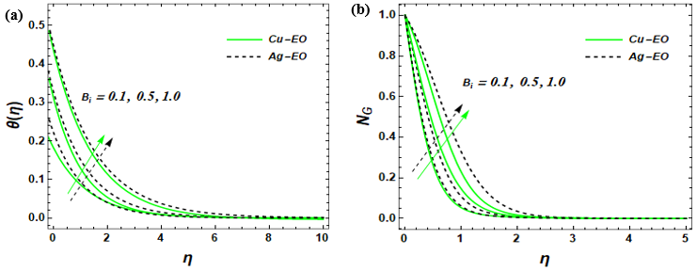
Figure 5(a, b): Impact of $B_{i}$on $θ\left(η\right)$, and ${(N}_{G}).$
Conclusion
This study presented a comprehensive thermodynamic analysis of hybrid nanofluid flow in a parabolic trough solar collector (PTSC) aimed at enhancing the performance and sustainability of solar-powered agricultural machinery. By incorporating three types of nanoparticles into the base fluid, the thermal and flow characteristics were significantly improved compared to conventional fluids and mono- or hybrid nanofluids. The results demonstrated notable enhancements in heat transfer efficiency, thermal conductivity, and energy utilization, leading to higher outlet temperatures and overall thermal performance. Key thermophysical and flow parameters were systematically examined, showing that hybrid nanofluids reduce irreversibility and maximize useful energy output under optimal conditions. From a sustainability perspective, these improvements translate into greater energy efficiency, reliability, and reduced dependence on fossil fuels, thereby lowering operational costs and environmental impact. Overall, the findings confirm that hybrid nanofluids represent a promising pathway for high-efficiency solar thermal technologies and the advancement of sustainable agricultural energy solutions. Hybrid nanofluids in parabolic trough solar collectors improve the heat transfer and efficiency of solar energy-powered agricultural machines, outperforming standard collectors, decreasing the amount of entropy created, and providing a more stable, reliable means of operation. Such systems encourage a greater reliance on renewable forms of energy and fewer GHGs being produced. Continued growth and enhancement of this line of research will play an important role in the development of climate-resilient, sustainable agricultural systems.

COMPETING INTERESTS DISCLAIMER:
Authors have declared that they have no known competing financial interests OR non-financial interests OR personal relationships that could have appeared to influence the work reported in this paper.

REFERENCES
Ahmad, A., Prakash, O., Kausher, R., Kumar, G., Pandey, S., & Hasnain, S. M. (2024). Parabolic trough solar collectors: A sustainable and efficient energy source. Materials Science for Energy Technologies, 7, 99-106.
AIshak, R. Nazar, I. Pop, Mixed convection on the stagnation point flow toward a vertical, continuously stretching sheet, J. Heat Transfer, 129 (2007).
Akindele, A. O., Ogunsola, A. W., Zhiri, A. B., Ohaegbue, A. D., Obalalu, A. M., & Salawu, S. O. (2025). Significance of Solar radiation and Cattaneo-Chistov heat flux on Maxwall tri-component hybrid nanofluid flow with heat generation and entropy analysis: Application in drone technology. Hybrid Advances, 100524.
Akinshilo, A. T., Mabood, F., & Badruddin, I. A. (2025). Thermal and entropy generation analysis of hybrid nanofluid flow through stretchable rotating system with heat source/sink. Waves in Random and Complex Media, 35(6), 10586-10608.
Bejan, A. (1996). Entropy generation minimization: The new thermodynamics of finite‐size devices and finite‐time processes. Journal of Applied Physics, 79(3), 1191-1218.
Bellos, E., & Tzivanidis, C. (2018). Analytical expression of parabolic trough solar collector performance. Designs, 2(1), 9.
Choi, S. U. (1995, November). Enhancing thermal conductivity of fluids with nanoparticles. In ASME international mechanical engineering congress and exposition (Vol. 17421, pp. 99-105). American Society of Mechanical Engineers.
Conrado, L. S., Rodriguez-Pulido, A., & Calderón, G. (2017). Thermal performance of parabolic trough solar collectors. Renewable and Sustainable Energy Reviews, 67, 1345-1359.
Eastman, J. A., Choi, U. S., Li, S., Thompson, L. J., & Lee, S. (1996). Enhanced thermal conductivity through the development of nanofluids. MRS Online Proceedings Library (OPL), 457, 3.
Eid, M. R., & Makinde, O. D. (2018). Solar radiation effect on a magneto nanofluid flow in a porous medium with chemically reactive species. International Journal of Chemical Reactor Engineering, 16(9), 20170212.
Fatunmbi, E. O., & Adeniyan, A. (2020). Nonlinear thermal radiation and entropy generation on steady flow of magneto-micropolar fluid passing a stretchable sheet with variable properties. Results in Engineering, 6, 100142.
Fatunmbi, E. O., Ramonu, O. J., & Salawu, S. O. (2023). Analysis of heat transfer phenomenon in hydromagnetic micropolar nanoliquid over a vertical stretching material featuring convective and isothermal heating conditions. Waves in Random and Complex Media, 1-20.
Hazami, M., Naili, N., Attar, I., & Farhat, A. (2013). Solar water heating systems feasibility for domestic requests in Tunisia: thermal potential and economic analysis. Energy conversion and management, 76, 599-608.
Kalogirou, S. (2009). Thermal performance, economic and environmental life cycle analysis of thermosiphon solar water heaters. Solar energy, 83(1), 39-48.
Kalogirou, S. A. (2014). Solar energy engineering: Processes and systems (2nd ed.). Academic Press.
Mabood, F., Fatunmbi, E. O., Benos, L., & Sarris, I. E. (2022). Entropy generation in the magnetohydrodynamic Jeffrey nanofluid flow over a stretching sheet with wide range of engineering application parameters. International Journal of Applied and Computational Mathematics, 8(3), 98.
Minea, A. A. (2020). Hybrid nanofluids for heat transfer applications – A state-of-the-art review. International Journal of Heat and Mass Transfer, 152, 119487.
Mebarek-Oudina, F., Chabani, I., Vaidya, H., & Ismail, A. A. I. (2024). Hybrid-nanofluid magneto-convective flow and porous media contribution to entropy generation. International Journal of Numerical Methods for Heat & Fluid Flow, 34(2), 809-836.
Mohite, D. D., Goyal, A., Singh, A. S., Ansari, M. I., Patil, K. A., Yadav, P. D., ... & Londhe, P. V. (2024). Improvement of thermal performance through nanofluids in industrial applications: a review on technical aspects. Materials Today: Proceedings.
Nasir, S., Berrouk, A. S., & Aamir, A. (2024). Efficiency analysis of solar radiation on chemical radioactive nanofluid flow over a porous surface with magnetic field. Case Studies in Thermal Engineering, 63, 105231.
Obalalu, A. M., Fatunmbi, E. O., Bhakuni, A. S., Bajaj, M., Abdul-Yekeen, A. M., & Ojewola, O. B. (2024). Investigation of non-Newtonian flow behavior in Oldroyd-B ternary nanofluid: analyzing the thermal efficiency of solar radiation on water pumping systems. In E3S Web of Conferences (Vol. 564, p. 05002). EDP Sciences.
Obalalu, A. M., Fatunmbi, E. O., Madhukesh, J. K., Shah, S. H. A. M., Khan, U., Ishak, A., & Muhammad, T. (2024). Numerical study of hybrid nanofluid and thermal transport in sun-powered energy ship within the application of parabolic trough solar collectors. Multidiscipline Modeling in Materials and Structures, 20(6), 1148-1179.
Obalalu, A. M., Fatunmbi, E. O., Madhukesh, J. K., Shah, S. H. A. M., Khan, U., Ishak, A., & Muhammad, T. (2024). Numerical study of hybrid nanofluid and thermal transport in sun-powered energy ship within the application of parabolic trough solar collectors. Multidiscipline Modeling in Materials and Structures, 20(6), 1148-1179.
Obalalu, A. M., Khan, U., Waqas, M., Abdullah, N., & Elattar, S. (2025). Dynamics of Bio‐Convection Two‐Phase Nanofluid Flow in an Entropy‐Optimized Non‐Newtonian Model With Nonlinear Thermal Radiation and Electromagnetic Effects. Energy Science & Engineering, 13(10), 4955-4972.
Obalalu, A. M., Olayemi, O. A., Olakunle, S. S., & Bode Odetunde, C. (2023). Scrutinization of solar thermal energy and variable thermophysical properties effects on non-Newtonian nanofluid flow. International Journal of Engineering Research in Africa, 64, 93-115.
Oke, A. S., Fatunmbi, E. O., Animasaun, I. L., & Juma, B. A. (2022). Exploration of ternary-hybrid nanofluid experiencing Coriolis and Lorentz forces: case of three-dimensional flow of water conveying carbon nanotubes, graphene, and alumina nanoparticles. Waves in Random and Complex Media, 1-20.
Oreyeni, T., Omokhuale, E., Obalalu, A. M., Adeoye, K. A., Oyem, A. O., Shah, N. A., ... & Adeleke, K. M. (2025). Thermal Characteristics of a Solar-Powered System using Casson Trihybrid Nanofluid Flow with Stratification and Chemical Reactions Effects in Parabolic Trough Solar Collector. Journal of New Horizons in Mathematics, 1(2), 17-36.
Said, Z., Sabiha, M. A., Saidur, R., Hepbasli, A., Rahim, N. A., Mekhilef, S., & Ward, T. A. (2015). Performance enhancement of a flat plate solar collector using titanium dioxide nanofluid and polyethylene glycol dispersant. Journal of Cleaner Production, 92, 343-353.
Salawu, S. O., & Fatunmbi, E. O. (2017). Inherent irreversibility of hydromagnetic third-grade reactive poiseuille flow of a variable viscosity in porous media with convective cooling. Journal of the Serbian Society for Computational Mechanics, 11(1), 46-58.
Salawu, S. O., Akinola, E. I., & Shamshuddin, M. D. (2023). Entropy generation and current density of tangent hyperbolic Cu-C2H6O2 and ZrO2-Cu/C2H6O2 hybridized electromagnetic nanofluid: a thermal power application. South African Journal of Chemical Engineering, 46, 1-11.
Salawu, S. O., Obalalu, A. M., & Shamshuddin, M. D. (2023). Nonlinear solar thermal radiation efficiency and energy optimization for magnetized hybrid Prandtl–Eyring nanoliquid in aircraft. Arabian Journal for Science and engineering, 48(3), 3061-3072.
Salawu, S. O., Obalalu, A. M., Fatunmbi, E. O., Disu, A. B., & Akkurt, N. (2023). Magneto-couple stress of tri-hybrid metallic oxide nanomaterials in porous media with nonlinear properties for thermal technology advancement. Scientific African, 21, e01841.
Selim, M. M., El-Safty, S., Tounsi, A., & Shenashen, M. (2023). Review of the impact of the external magnetic field on the characteristics of magnetic nanofluids. Alexandria Engineering Journal, 76, 75-89.
Settino, J., Sant, T., Micallef, C., Farrugia, M., Staines, C. S., Licari, J., & Micallef, A. (2018). Overview of solar technologies for electricity, heating and cooling production. Renewable and Sustainable Energy Reviews, 90, 892-909.
Shamshuddin, M. D., Salawu, S. O., Panda, S., Mishra, S. R., Alanazy, A., & Eid, M. R. (2024). Thermal case exploration of electromagnetic radiative tri-hybrid nanofluid flow in Bi-directional stretching device in absorbent medium: SQLM analysis. Case Studies in Thermal Engineering, 60, 104734.
S. Das, S. Chakraborty, R. Jana, O. Makinde, Entropy analysis of unsteady magneto-nanofluid flow past accelerating stretching sheet with convective boundary condition, 36 (2015) 1593-1610.
Sudharani, M. V. V. N. L., Prakasha, D. G., Kumar, K. G., & Chamkha, A. J. (2023). Computational assessment of hybrid and tri hybrid nanofluid influenced by slip flow and linear radiation. The European Physical Journal Plus, 138(3), 257.
Said, Z., Saidur, R., Rahim, N. A., Alim, M. A., & Mohammed, H. A. (2017). Performance enhancement of solar collectors using nanofluids. Renewable and Sustainable Energy Reviews, 76, 735–754.
Tagle-Salazar, P. D., Nigam, K. D., & Rivera-Solorio, C. I. (2020). Parabolic trough solar collectors: A general overview of technology, industrial applications, energy market, modeling, and standards. Green Processing and Synthesis, 9(1), 595-649.
Verma, S. K., Tiwari, A. K., & Chauhan, D. S. (2018). Performance enhancement of solar thermal systems using nanofluids: A review. Renewable and Sustainable Energy Reviews, 88, 1–15.
Wei, W., Luo, J., Shi, Y., Yu, C., Li, N., Ji, J., & Yu, B. (2025). A Novel Solar Rooftop Agriculture System Integrated with CNT Nanofluid Spectral Splitter for Efficient Food Production. Buildings, 15(3), 314.
Yılmaz, İ. H., & Mwesigye, A. (2018). Modeling, simulation and performance analysis of parabolic trough solar collectors: A comprehensive review. Applied energy, 225, 135-174.
Yuan, Y., Ji, Y., Wang, W., Shi, D., Hai, L., Ma, Q., ... & Ma, L. (2023). Balancing energy harvesting and crop production in a nanofluid spectral splitting covering for an active solar greenhouse. Energy, 278, 127706.
Zeeshan, A., Ellahi, R., Rafique, M. A., Sait, S. M., & Shehzad, N. (2024). Parametric optimization of entropy generation in hybrid nanofluid in contracting/expanding channel by means of analysis of variance and response surface methodology. Inventions, 9(5), 92.

