Case report

DIPLOPIA REVEALING A FRONTAL MUCOCELE: A CASE REPORT

ABSTRACT
Mucoceles are benign, expansile pseudocystic lesions of the paranasal sinuses caused by sinus ostial obstruction and chronic inflammation. They are rare pathologies, mainly affecting adults, and are most commonly located in the fronto-ethmoidal sinus system. Mucoceles are characterized by clinical polymorphism, insidious onset, and slow progression, which explains why they are often discovered at the stage of ophthalmological complications. Diagnosis is clinical and radiological, and management is essentially surgical.
We report the case of a 65-year-old diabetic male with no previous ophthalmological history who presented with permanent diplopia lasting two weeks. Clinical examination revealed constant vertical binocular diplopia with limited mobility of the left eye, associated with homolateral non-pulsatile ptosis and exophthalmos, without inflammatory signs. The left eye was deviated downward and outward. The remainder of the ophthalmological examination was unremarkable. Orbital magnetic resonance imaging (MRI) revealed a left frontal sinus mucocele with orbital extension. The patient underwent endoscopic marsupialization, with a favorable postoperative outcome.
In conclusion, paranasal sinus mucoceles are rare benign lesions that most often present with ophthalmological symptoms. Their severity lies in the risk of compression of vital adjacent structures. Diagnosis is based on clinical and radiological findings, and treatment is surgical.
Keywords: Mucocele; paranasal sinuses; diplopia; exophthalmos; orbital complications.

INTRODUCTION
Mucoceles are benign, expansile pseudocystic lesions of the paranasal sinuses containing aseptic fluid [1]. They are generally caused by sinus ostial obstruction associated with chronic inflammation.
These rare pathologies occur mainly in adults and are most frequently located in the fronto-ethmoidal sinus system. They are characterized by clinical polymorphism, insidious onset, and slow progression, which explains why they are often diagnosed at the stage of ophthalmological complications such as exophthalmos, diplopia, oculomotor paralysis, and ptosis [2,3].
Exophthalmos, retro-or periorbital pain, and diplopia are the most common presenting symptoms [4]. Despite their benign nature, mucoceles may lead to serious complications, including compressive optic neuropathy, which can threaten visual prognosis and require urgent management [5]. Diagnosis is clinical and radiological, and treatment is essentially surgical.
We report a case of a left frontal sinus mucocele revealed by diplopia and discuss the ophthalmological manifestations, diagnostic approach, management, and prognosis in comparison with data from the literature.

CASE REPORT
A 65-year-old diabetic male with no other significant medical history and no history of orbitofacial trauma presented with permanent diplopia evolving over two weeks, without decreased visual acuity.
Clinical examination revealed constant vertical binocular diplopia with painless limitation of upward and rightward movements of the left eye, associated with homolateral non-pulsatile ptosis and exophthalmos, without inflammatory signs. The left eye was displaced downward and outward (Figures 1 and 2).
Pupillary light reflexes and accommodation reflexes were normal. Intraocular pressure and visual acuity were normal in both eyes. Slit-lamp examination was unremarkable.
Extrinsic involvement of the common oculomotor nerve was suspected as the cause of diplopia, given the presence of exophthalmos and the absence of mydriasis or anisocoria.
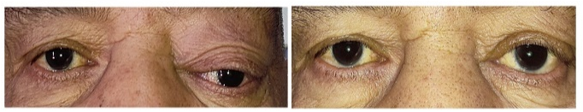
Figure 1 : Preoperative photo (right) and D15 postoperative photo (left) of the patient in the primary gaze position.
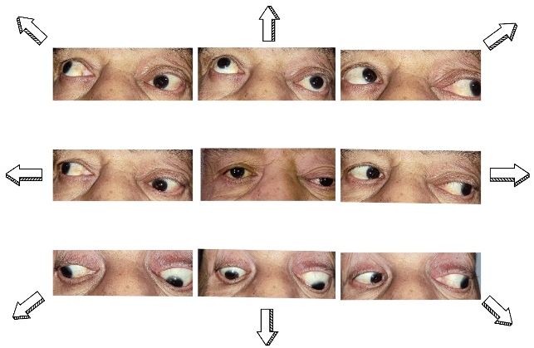
Figure 2: Preoperative photo of patient in 9 gaze positions
An orbital and cerebral magnetic resonance imaging (MRI) scan without contrast injection was performed. It revealed a fluid collection within the left frontal sinus measuring 44 × 25 mm in axial sections and 37 mm in height, extending through the left orbital roof and exerting a mass effect on the extraconal intraorbital fat and the superior rectus muscle. This lesion was responsible for grade II exophthalmos of the left eye (Figure 3). These findings were consistent with a left frontal sinus mucocele.
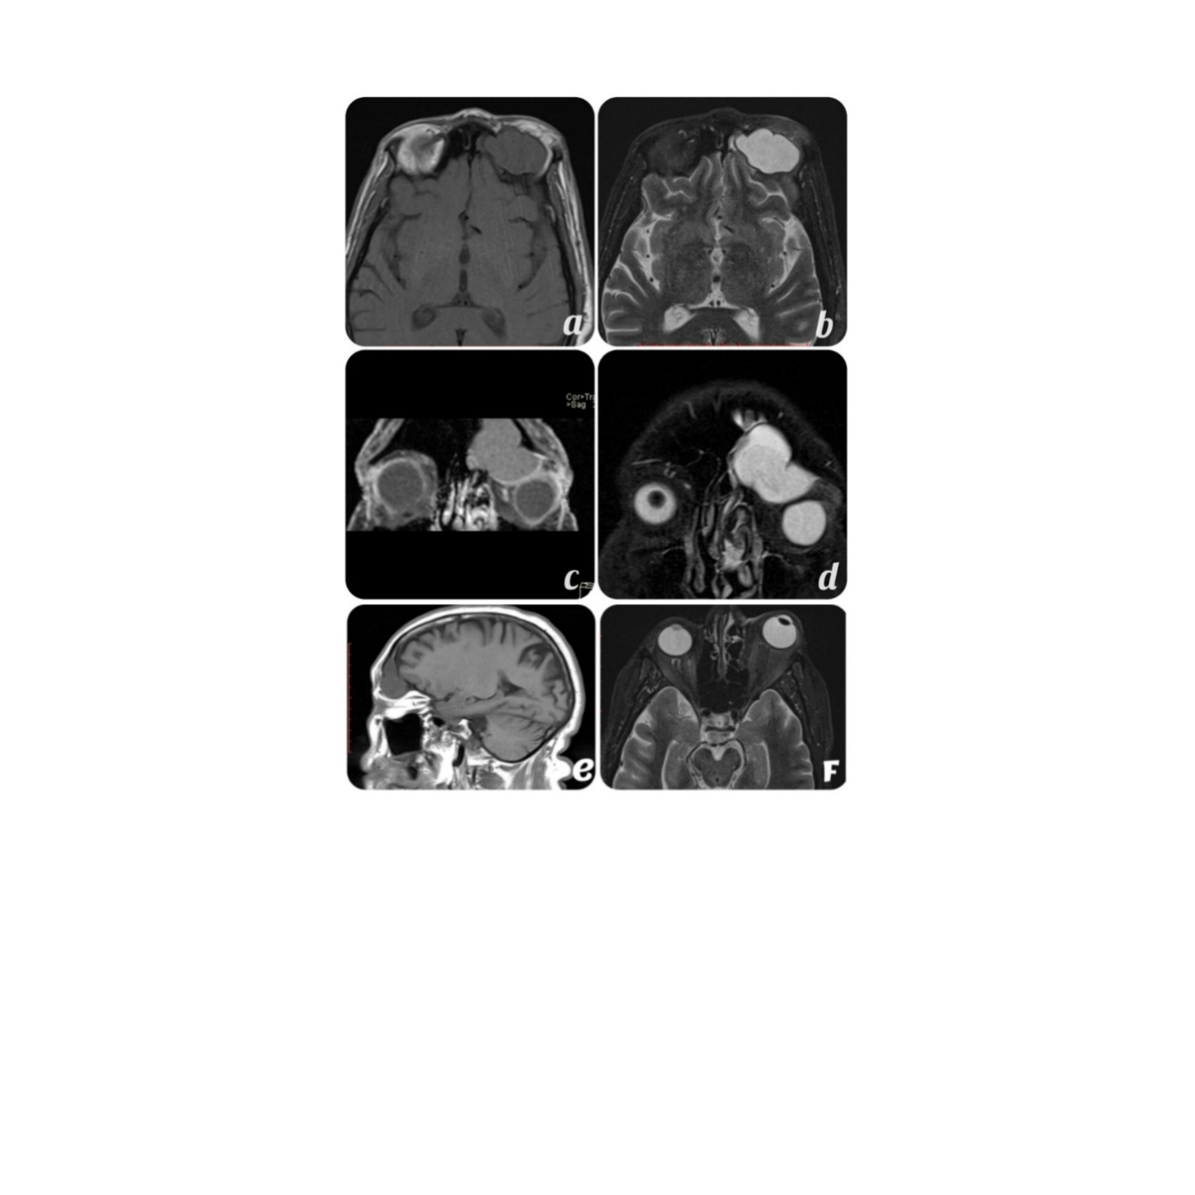
Figure 3. Preoperative orbital MRI. Axial sections in T1-weighted (a) and T2-weighted (b) sequences, and coronal sections in T1-weighted (c) and T2-weighted (d) sequences. A sagittal T1-weighted image shows a frontal sinus mucocele exerting a mass effect on the superior rectus muscle (e). An axial T1-weighted image demonstrates exophthalmos (f).
Based on clinical and radiological findings, a diagnosis of frontal sinus mucocele with orbital extension was established, and the patient was referred to the otorhinolaryngology department. The patient underwent drainage and wide marsupialization of the mucocele via an endonasal endoscopic approach.
The postoperative course was favorable, with complete recovery of visual function. Exophthalmos regressed, diplopia completely resolved, and oculopalpebral motility returned to normal by postoperative day 15 (Figure 4).
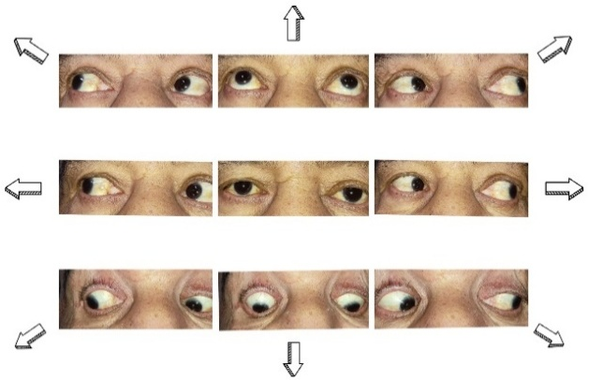
Figure 4. Postoperative day 15 photograph showing the patient in the nine positions of gaze.
DISCUSSION
A mucocele is an expansile, benign pseudocystic lesion arising from the mucosa of the paranasal sinuses. Progressive accumulation of mucus leads to gradual enlargement, causing bone erosion and remodeling, which may result in orbital extension [6]. This extension is explained by the close anatomical relationship between the paranasal sinuses and the orbit. The orbital floor is adjacent to the maxillary sinus, the orbital roof to the frontal sinus, the medial wall to the ethmoidal sinus, and the orbital apex is almost completely surrounded by the sphenoidal sinus [7].
Mucoceles develop as a result of chronic sinus ostial obstruction, which impairs normal drainage [8]. Ostial obstruction and chronic inflammation are the most widely accepted etiopathogenic factors [5,9]. Approximately 65% of mucoceles arise in the frontal sinus and 30% in the anterior ethmoidal sinus [10]. The condition affects both sexes equally and is rare in childhood. The age of onset typically ranges from 20 to 70 years, with a peak between 40 and 60 years [11–13].
Clinical presentation is highly variable and depends on the size and location of the lesion. Many patients, as in our case, present solely with ophthalmological symptoms in the absence of rhinological signs, which may delay diagnosis. Ophthalmologists should therefore consider mucocele when faced with indirect ophthalmic signs [10].
Common ophthalmological manifestations include exophthalmos with downward and outward globe displacement, retro-or periorbital pain, and diplopia. Decreased visual acuity and subcutaneous swelling may also be observed [8, 14,15]. Orbital cellulitis may occur following spontaneous rupture of an infected mucocele into the orbit [16]. In our patient, exophthalmos, globe deviation, and diplopia were present without visual acuity impairment.
Mucoceles of the anterior paranasal sinuses generally exert a mass effect on the orbit, resulting in lateralized exophthalmos, elevated intraocular pressure, restricted ocular motility, and diplopia. In contrast, posterior paranasal sinus mucoceles more commonly cause severe visual impairment, including decreased visual acuity, visual field defects, or loss of light perception due to optic neuritis, which is often irreversible. These visual disturbances may result from direct compression of the optic nerve or its vascular supply, or from inflammatory spread from adjacent infected sinuses [10].
Prompt diagnosis and surgical management are crucial, particularly when visual disturbances are present. However, patients without nasal symptoms may initially be misdiagnosed and treated with corticosteroids for optic neuropathy, leading to delayed treatment [16].
Diagnosis relies on clinical examination and imaging, particularly computed tomography (CT) and magnetic resonance imaging (MRI). CT is useful for assessing the homogeneous hypodense or isodense nature of the lesion, bone erosion, and for excluding tumoral etiologies. MRI provides better soft-tissue characterization, with signal intensity varying according to the stage of the mucocele. Early lesions typically appear hypointense or isointense on T1-weighted images and hyperintense on T2-weighted images, becoming hyperintense on both sequences in chronic stages [2, 6,12].
Surgical management is the treatment of choice. While radical external approaches were previously favored, endoscopic endonasal techniques are now considered the standard of care. Endoscopic marsupialization allows drainage of the mucocele into the nasal cavity with minimal morbidity [17]. The choice of surgical approach depends on the location, size, and extent of the lesion [8,17,18]. In our patient, an exclusively endoscopic approach was sufficient.
The prognosis of anterior paranasal sinus mucoceles is generally favorable, with resolution of ophthalmological symptoms after surgery, as observed in our case [16]. Posterior mucoceles carry a poorer prognosis due to the risk of optic nerve or central retinal artery compression. Severe initial visual impairment and sudden onset are poor prognostic factors, particularly if surgery is not performed within 24 hours. Recurrence is rare but may occur years later, justifying long-term follow-up [12].

CONCLUSION
Frontal sinus mucocele is a rare benign condition that most commonly presents with ophthalmological manifestations. Its severity lies in the risk of compression of adjacent vital structures, potentially leading to functional or even life-threatening complications. Diagnosis is based on clinical and radiological findings, and treatment is exclusively surgical, with generally favorable outcomes.

REFERENCES
1. Devars du Mayne M, Moya-Plana A, Malinvaud D, Laccourreye O, Bonfils P. Sinus mucocele: natural history and long-term recurrence rate. Eur Ann Otorhinolaryngol Head Neck Dis. 2012;129(3):125–130.
2. Badou KE, Buraima F, Kouassi-Ndjeundo J, Ngattia V, Vroh BTS, Yoda M, et al. Sinus mucoceles: an epidemio-clinical and therapeutic study of 25 cases collected in Abidjan (Côte d’Ivoire). Mali Médical. 2015;30(3):1–6.
3. Tritar Z, Loba A, Hmidi K, Gargouri S, Amouri F, Ladjimi A, Khairallah M. Ptosis and paralysis of elevation revealing a frontal mucocele. J Fr Ophtalmol. 2007;30(2 Suppl):S323–S607.
4. Herndon M, McMains KC, Kountakis SE. Presentation and management of extensive fronto-orbital-ethmoid mucoceles. Am J Otolaryngol. 2007;28(3):145–147.
5. Taouri N, et al. Frontal sinus mucocele: a case report. PAMJ Clinical Medicine. 2020;4:70. doi:10.11604/pamj-cm.2020.4.70.23626.
6. Catalano P, Schlewet M. Frontal sinus mucocele after osteoplastic flap surgery: case report. Arch Clin Med Case Rep. 2017;1(3):67–75.
7. Ben Hadj Hamida F, Morax S. Orbital tumors in children. In: Adenis JP, Morax S, editors. Orbito-palpebral pathology. Paris: Masson; p. 495–501.
8. Bilger L, Kauffmann P, Brunhuber C, Bilbault P, Le Borgne P. A lesion of the frontal sinus. Rev Med Internal. 2019;40:846–847. doi:10.1016/j.revmed.2019.04.006.
9. Nefzaoui S, Romdhane N, Sarray M, Ben Amira M, Zoghlami I, et al. Nasosinus mucoceles: contribution of imaging. J Tun ENT. 2023;50:18–22.
10. Zainine R, Loukil I, Dhaouadi A, Ennaili M, Mediouni A, Chahed H, et al. Ophthalmological complications of rhino-sinus mucoceles. J Fr Ophthalmol. 2014:93–98.
11. Aggarwal SK, Bhavana K, Keshri A, Kumar R, Srivastava A. Frontal sinus mucocele with orbital complications: management by varied surgical approaches. Asian J Neurosurg. 2012;7(3):135–140.
12. Regeraji S, Malik B. Frontoethmoidal mucocele with orbital extension. IOSR J Dent Med Sci. 2023;30:28–31.
13. Maiou C, Korais C, Gkrinia E, Saratziotis A, Hajiioannou J, et al. Laterally located mucocele in a hyperpneumatized frontal sinus causing exophthalmos: a total endoscopic approach. J Clin Images Med Case Rep. 2021;2(2):1052.
14. Peral-Cagigal B, Barrientos-Lezcano J, Floriano-Blanco R, García-Cantera JM, Sánchez-Cuéllar LA, Verrier-Hernández A. Frontal sinus mucocele with intracranial and intraorbital extension. Med Oral Patol Oral Cir Bucal. 2006;11:E527–E530.
15. Tseng CC, Ho CY, Kao SC. Ophthalmic manifestations of paranasal sinus mucoceles. J Chin Med Assoc. 2005;68(6):260–264.
16. Khong JJ, Malhotra R, Selva D, Wormald PJ. Efficacy of endoscopic sinus surgery for paranasal sinus mucocele including modified endoscopic Lothrop procedure for frontal sinus mucocele. J Laryngol Otol. 2004;118(5):352–356.
17. Casale M, Costantino A, Sabatino L, Cassano M, Moffa A, Rinaldi V. Image-guided endoscopic marsupialization technique for frontal sinus mucocele with orbital extension: a case report. Int J Surg Case Rep. 2019;61:259–262.

