Essential oils of Melaleuca leucadendra and Melaleuca quinquenervia: chemical composition and efficacy level in controlling in vitro isolates of potentially aflatoxin-producing Aspergillus flavus

Abstract: Among the mycotoxins of health and economic importance, aflatoxins hold a prominent place. This study aims to determine the chemical composition of the essential oils of Melaleuca leucadendra and Melaleuca quinquenervia, and to evaluate their effectiveness in the in vitro control of an Aspergillus flavus strain isolated from peanut seeds in Senegal. Essential oils were extracted from air-dried leaves collected in Fatick and the Mbao Classified Forest using hydrodistillation with a Clevenger-type apparatus. Chemical characterisation was performed using gas chromatography (GC-FID) and gas chromatography–mass spectrometry (GC-MS). Data were statistically analyzed using ANOVA and Student–Newman–Keuls tests at a 5% significance level. The chemical composition analysis of the essential oils revealed high identification rates of 96.8% for Melaleuca quinquenervia and 99.9% for Melaleuca leucadendra. The antifungal assays demonstrated a strong dose-dependent inhibitory effect of both essential oils against Aspergillus flavus ThC2. M. quinquenervia exhibited the highest activity, with inhibition rates ranging from 71.8% at 100 ppm to 92.3% at 1000 ppm. M. leucadendra showed moderate activity, with inhibition ranging from 44.2% to 63.0% across the same concentrations. Overall, the results indicate that both essential oils, particularly that of M. quinquenervia, exhibit strong antifungal potential against A. flavus. Essential oils derived from Melaleuca quinquenervia and Melaleuca leucadendra exhibit distinct chemical compositions that contribute to notable biological activities. These oils demonstrate strong inhibitory effects on mycelial growth and sporulation of Aspergillus flavus, along with a moderate capacity to reduce aflatoxin biosynthesis. Owing to their diverse bioactive compounds and multi-target mechanisms of action, certain essential oils display antimicrobial properties that can surpass those of conventional synthetic agents while reducing the likelihood of resistance development in microorganisms. Consequently, these natural products show significant potential as effective alternatives in integrated biological control strategies aimed at managing crop and stored-product pathogens, particularly aflatoxin-producing fungi.

Keywords: Essential oils, Melaleuca leucadendra, Melaleuca quinquenervia, Chemical composition, Aflatoxin, Aspergillus flavus
Introduction
Besides the fungi that cause diseases and generate direct production losses, there are other molds that are rather known for their ability to secrete toxins highly harmful to humans and animals (Atehnkeng and al., 2008; Probst and al., 2012; Faye and al., 2022). Among the mycotoxins of health and economic importance, aflatoxins hold a prominent place. Aspergillus species of the Flavi Section are the fungi recognized as responsible for the biosynthesis of aflatoxins, and more specifically the species A. flavus (Horn, 2007; Klich, 2007; Norlia and al., 2019; Senghor and al., 2020, 2021; Faye and al., 2022). The levels of A. flavus infestation and aflatoxin contamination remain essentially dependent on the nature and physiological characteristics of the strain, the nature and composition of the substrate (composition and water activity) as well as climatic conditions (temperature and humidity) and environmental factors (insects, microorganisms, presence of lesions on the substrate) (Bhatnagar and al., 2006; Klich, 2007). Indeed, high temperature combined with high relative humidity (Aoudou and al., 2012; N’pagyendou and al., 2021), poor agricultural practices (Manizan and al., 2018; Manga and al., 2023), inconvenient drying, storage, and transport conditions of harvests (Aoudou and al., 2012) undoubtedly exacerbate contamination of numerous cereals (corn, wheat, rice, sorghum, millet, and quinoa), legumes (peanuts), nuts (Brazil nuts, almonds, pistachios, walnuts), seeds (sunflower), spices, and wine (Battilani and al., 2013; Diedhiou and al., 2015; Dieme and al., 2017; Montet, 2022) to aflatoxins. Cosmopolitan, Aspergillus is found in all ecological niches, especially in those of tropical regions located between 40°N and 40°S of the equator, thus encompassing the entire African continent (Chen and al., 2013). However, this geolocation of aflatoxin contamination occurrence has tended to become more widespread over the past few decades due to the consequences of climate change (Battilani and al., 2016), although higher contamination is observed in the driest and hottest areas than in the more humid areas (Akello and al., 2021; Montet, 2022). These mycotoxins cause immeasurable commercial losses (Diedhiou and al., 2015; Jallow and al., 2021; Sabaly and al., 2024) and pose a recurring public health problem (Bazir and al., 2023; Gerdemann and al., 2023). In wealthy countries, exceeding the contamination threshold inevitably leads to the destruction of contaminated food batches. On the other hand, in poor countries, very worrying levels of contamination, often exceeding 20 mg/kg of aflatoxins, are recorded on peanuts and maize (Jallow and al., 2021; Montet, 2022). However, while it is almost impossible to eliminate aflatoxins from food that is already contaminated, it is possible to mitigate, reduce, or even prevent upstream the development of A. flavus species responsible for their biosynthesis. In this perspective, this study aims to objective of determining the chemical composition of the essential oils of Melaleuca leucadendra and Melaleuca quinquenervia and testing their effectiveness on the in vitro control of a strain of A. flavus isolated from peanut seeds in Senegal.

Methodology

1.1 The strain of Aspergillus flavus
The Aspergillus flavus isolate (ThC2) used in this study was obtained from the Phytopathology Laboratory of the Directorate of Plant Protection (DPV) of Senegal from peanut seeds collected in Thiamène (Map 1), a locality in the peanut-growing basin. On AFPA (Aspergillus Flavus Parasiticus Agar) culture medium, the strain appears on the front as clusters of small colonies with a flocculent appearance, white in the center and yellow-green at the periphery, producing many small black sclerotia with a central location, situated at the top of the colonies (Plate 1, A1). On the reverse side of the plate, the isolate is characterized by a very distinctive brown pigmentation in the center surrounded by a yellow margin. Its growth rate is very fast, occupying the entire standard 90 mm Petri dish with mycelium in only 72 hours of culture (Plate 1, A2). On Glycerol medium On nitrate agar (G25N), the isolate grows more slowly. It appears on the surface of the plate as clusters of colonies with a fluffy appearance, characterized by a light yellow color in the center and white at the periphery (Plate 1, B1). On the reverse side of the plate, the white color of young colonies turns yellow in older colonies (Plate 1, B2). Under the microscope, isolate ThC2 shows a hyaline, non-septate conidiophore topped with uniseriate conidial heads producing globular conidia with a clear appearance (Plate 1, A3 and B3).

.
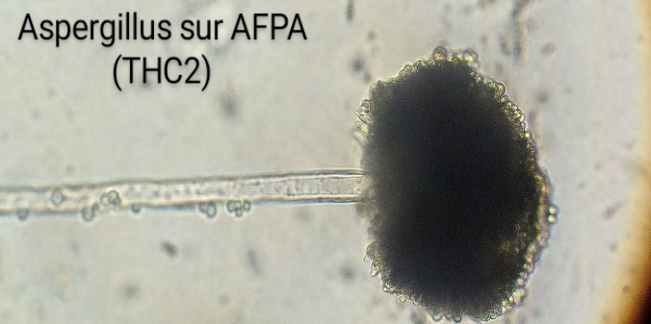
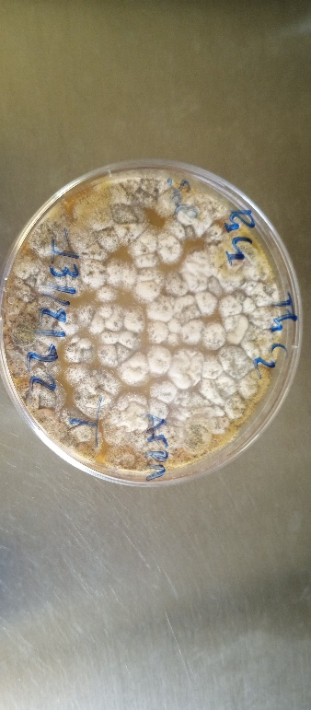
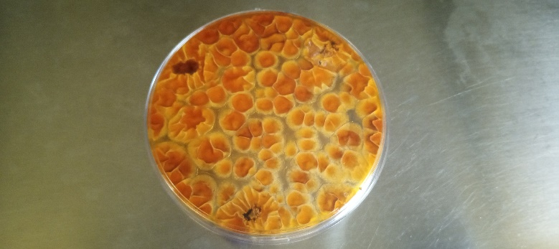
A1
A2
A3
Th2

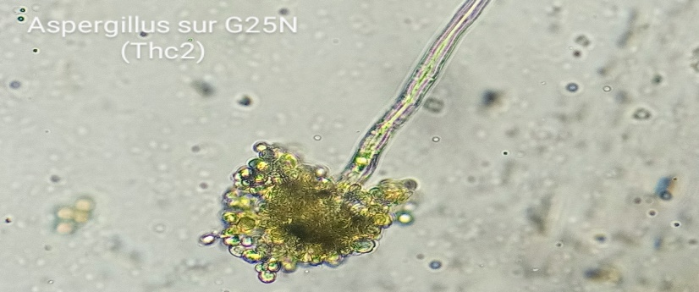
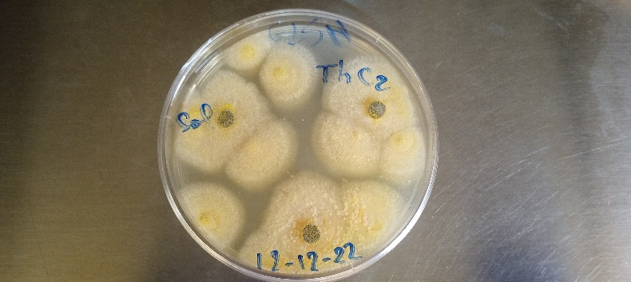
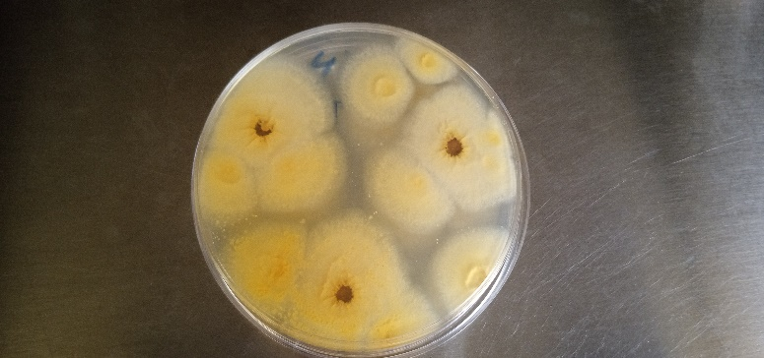
B1
B2
B3
Th2

Plate 1. Macroscopic and microscopic characteristics on AFPA (A1, A2, and A3) and on G25N (B1, B2, and B3) of the A. flavus ThC2 isolate

Essential oils of Melaleuca leucadendra and M. quinquenervia
Essential oils were extracted from leaves of Melaleuca leucadendra and M. quinquenervia collected respectively in Fatick and in the Classified Forest of Mbao (Dakar) (Map 2). The identification of the plant species was carried out at the Laboratory of the Fundamental Institute of Black Africa (IFAN) of Cheikh Anta Diop University of Dakar.
The collected leaves were air-dried for two weeks at room temperature and then hydrodistilled for 5 hours using a Clevenger-type apparatus according to the method recommended in the European Pharmacopoeia.

Determination of the Chemical Composition of Essential Oils
Chromatographic analyses were carried out using a Perkin-Elmer GC Autosystem XL (Waltham, MA, USA) equipped with a dual flame ionization detection (FID) system and fused silica capillary columns, namely Rtx-1 (polydimethylsiloxane) and Rtx-wax (polyethylene glycol) (60 m × 0.22 mm i.d.; film thickness 0.25 μm). The oven temperature was programmed from 60 to 230°C at 2°C/min, then stabilized isothermally at 230°C for 35 minutes; hydrogen was used as the carrier gas (1 mL/min). The injector and detector temperatures were maintained at 280°C, and the samples were injected (0.2 μL of pure oil) in split mode (1:50). The retention indices (RI) of the compounds were determined relative to the retention times of a series of n-alkanes (C5-C30) by linear interpolation using the Van den Dool and Kratz equation (1963) with the aid of using Perkin-Elmer software (Total Chrom navigator). The relative percentages of the oil constituents were calculated from the gas chromatography peak areas, without applying correction factors. The samples were also analyzed with a Perkin-Elmer Turbo mass detector (quadrupole) coupled to a Perkin-Elmer Autosystem XL, equipped with fused silica capillary columns Rtx-1 and Rtx-Wax. The oven temperature was programmed from 60 to 230°C at 2°C/min, then held isothermally at 230°C (35 min); hydrogen was used as the carrier gas (1 mL/min). The following chromatographic conditions were used: injection volume 0.2 μL of pure oil; injector temperature 280°C; split 1:80; ion source temperature 150°C; ionization energy 70 eV; MS (EI) acquired over the mass range 35-350 Da; scan rate 1 s. Component identification was based on: (a) the comparison of their GC retention indices (RI) on non-polar and polar columns, determined from the retention times of a series of n-alkanes with linear interpolation, with those of authentic compounds or literature data; (b) computer matching with commercial mass spectra libraries (Joulain & König, 1998; Adams & others, 2007; NIST (National Institute of Standards and Technology), 2008) and comparison of the spectra with those of our personal library; and (c) comparison of the RIs and MS spectral data of the authentic compounds or literature data.
1.4 The action of essential oils on the A. flavus ThC2 strain
The basic culture medium used in this study is potato dextrose agar (PDA). It was prepared by dissolving PDA powder in distilled water at a dose of 39 g/L, followed by sterilization of the solution at 121°C for 20 minutes. For the essential oils (EO), 1 ml was taken from each and mixed with 1 ml of pure ethanol to promote dissolution. The EO + ethanol mixture was then added at various concentrations (100, 500, and 1000 ppm) to a volume of 100 ml of PDA cooled to about 50°C. The resulting solution was stirred well for 1 minute and distributed into 3 Petri dishes of 9 cm in diameter. As a reference control, Azoxystrobin at a dose of 1000 ppm was used. Similarly, three Petri dishes containing only PDA + ethanol were used as negative controls (Table 1). Cylinders of 6 mm in diameter were taken from each fungal strain, 5 days old on PDA, and placed in the center of the dishes containing the different culture media. All inoculated media were then placed in an incubator set at 25°C. In each Petri dish, the mycelial growth of A. flavus was monitored by daily measurements of the colony diameter using a graduated ruler. After 11 days of culture, the mycelial growth inhibition rate (IR) was calculated using the following formula:

TI (%) = $\frac{DT0-DT }{DT0 }*100$
DT0 = Colony diameter in the negative control; DT = Colony diameter in the treaty
Table 1. Overview of the Various Treatments
Treatment Code | Product(s) | Dose (ppm) | Statut
PDA | PDA only | - | Negative control
Mq₁ | PDA + oil of M. quinquenervia | 100
Mq₂ | PDA + oil of M. quinquenervia | 500
Mq₃ | PDA + oil of M. quinquenervia | 1000
Ml₁ | PDA + oil of M. leucadendra | 100
Ml₂ | PDA + oil of M. leucadendra | 500
Ml₃ | PDA + oil of M. leucadendra | 1000
Azox | Azoxystrobin | 1000 | Positive control

1.5 Statistical Analyses
The data collected during this study were entered and arranged in the Excel spreadsheet. Their statistical analysis was conducted using R software (version 4.3.0) by employing analysis of variance (ANOVA) and the comparison of means using the Student-Newmann-Keuls test at a 5% significance level.

Results
2.1 Chemical composition of the essential oil
The results obtained on the determination of the essential oil composition showed identification rates of 96.8% for Melaleuca leucadendra and 99.9% for Melaleuca quinquenervia. The chemical analysis of M. leucadendra EO reveals that it is largely composed of Phenylpropanoids (99.4%) and slightly of hydrocarbon Sesquiterpenes (0.5%) (Table 2). For M. quinquenervia EO, monoterpenes (79.3% oxygenated monoterpenes and 6.5% hydrocarbon monoterpenes) are predominant compared to sesquiterpenes (7.7% oxygenated sesquiterpenes and 3.3% hydrocarbon sesquiterpenes).
Table 2. Major Compounds of the Studied Oils
Compounds | M quinquenervia | M leucadendra
Phenylpropanoids | - | 99.4
Hydrocarbon monoterpenes | 6.5 | -
Oxygenated monoterpenes | 79.3 | -
Hydrocarbon sesquiterpenes | 3.3 | 0.5
Oxygenated sesquiterpenes | 7.7 | -
Other compounds | - | -
Total identified (%) | 96.8 | 99.9

The results of the composition analysis of the two essential oils studied are recorded in Table 3 below. They show the retention indices and the percentages of each compound. Compounds with percentages below 0.1% are considered traces.
Table 3. Chemical composition of the studied essential oils
Nª | Compounds | lRI^{b} | RIa^{c} | RIp^{d} | M quinquenervia | M leucadendra
1 | α-Pinene | 931 | 931 | 1015 | 5.7 | -
2 | α-Thujene | 932 | 922 | 1023 | 0.1 | -
3 | β-Pinene | 978 | 972 | 1108 | 0.3 | -
4 | Myrcene | 987 | 982 | 1154 | 0.8 | -
5 | α-Phellandrene | 1002 | 996 | 1164 | 0.2 | -
6 | α-Terpinene | 1013 | 1010 | 1174 | 0.4 | -
7 | p-Cymene | 1015 | 1013 | 1264 | 0.7 | -
8 | 1,8-Cineole | 1024 | 1021 | 1209 | 36.1 | -
9 | Limonene | 1025 | 1022 | 1200 | 5.9 | -
10 | (E)--Ocimene | 1041 | 1034 | 1247 | 0.1 | -
11 | -Terpinene | 1051 | 1048 | 1239 | 0.7 | -
12 | Terpinolene | 1082 | 1080 | 1278 | 0.2 | -
13 | Linalol | 1086 | 1081 | 1544 | 0.6 | -
14 | Terpinen-4-ol | 1164 | 1164 | 1570 | 0.9 | -
15 | α-Terpineol | 1177 | 1176 | 1684 | 9.3 | -
16 | Methyleugenol | 1369 | 1367 | 2009 | - | 99.3
17 | β-Caryophyllene | 1421 | 1417 | 1583 | 0.5 | -
18 | Humulene | 1455 | 1450 | 1660 | 0.3 | -
19 | Trans-methyliso- eugenol | 1463 | 1461 | 2175 | - | 0.1
20 | Germacrene D | 1479 | 1476 | 1704 | - | 0.3
21 | Ledene | 1491 | 1490 | 1695 | 0.1 | -
22 | Bicyclogermacrene | 1494 | 1493 | 1712 | - | 0.2
23 | Caryophyllene oxide | 1570 | 1573 | 1959 | 0.1 | -
24 | Globulol | 1589 | 1575 | 2074 | 0.1 | -
25 | Viridiflorol | 1592 | 1591 | 2089 | 28.7 | -
26 | Guaiol | 1593 | 1591 | 2090 | 0.2 | -
27 | Ledol | 1600 | 1596 | 2029 | 1.8 | -
28 | γ-Eudesmol | 1618 | 1617 | 2197 | 0.4 | -
29 | Hinesol | 1632 | 1637 | 2201 | 1.1 | -
30 | Pogostol | 1647 | 1645 | 2225 | 1.4 | -
31 | Bulneosol | 1665 | 1651 | 2204 | 1.7 | -

2.2 Antifungal activity of essential oils (EOs) on the A. flavus ThC2 isolate
The results related to the inhibition of mycelial growth reveal that the antifungal activity of the essential oils of Melaleuca quinquenervia and M. leucadendra varies in magnitude depending on the applied dose (Table 4, Figure 1). Furthermore, this inhibitory action on the A. flavus ThC2 isolate was more pronounced compared to Azoxystrobin.
Indeed, the rates of radial growth inhibition of the fungus were evaluated at 71.76%, 78.31%, and 92.43% for the doses Mq1 (100 ppm), Mq2 (500 ppm), and Mq3 (1000 ppm) respectively of M. quinquenervia EO. They were 44.21%, 52.4%, and 63.02% for the doses Ml1 (100 ppm), Ml2 (500 ppm), and Ml3 (1000 ppm) of M. leucadendra EO. On the reference control (PDA+Azoxystrobin 1000 ppm), the recorded inhibition rate was 49.97%.
The analysis of variance of the mean inhibition rate of mycelial growth of Melaleuca quinquenervia and Melaleuca leucadendra shows a very significant difference (p < 0.000) between the different treatments. The comparison of means reveals different groups a, b, and bc (for M. quinquenervia); e, de, bcd (for M. leucadendra and Azoxystrobine) and f (for the negative control PDA) (Figure 1).

Table 4. Effect of different concentrations of Melaleuca quinquenervia and M. leucadendra essential oils on the reduction of mycelial growth (%) of the A. flavus ThC2 strain.
Doses (ppm) | ThC2 isolate
Doses (ppm) | Inhibition Rate (%)¹ | Average Diameter (cm)¹
PDA | 0 | 9
Mq₁ | 71.8^{b}±7,1 | 3.5±0.15
Mq₂ | 78.3^{b}±3.56 | 2.6±0.02
Mq₃ | 92,3ª±1.1 | 1.3±0.12
Ml₁ | 44,2e±6.5 | 6.60±0.22
Ml₂ | 52,4^{d}±5.1 | 4.90±0.22
Ml₃ | 63,0 ^{c}±2.35 | 4.20±0.22
Azox | 50,0^{d}±4.5 | 5.40±0.22

Legend :
Mq1 :100 ppm HE Melaleuca quinquenervia ; Mq2 :500 ppm HE Melaleuca quinquenervia ; Mq3 : 1000 ppm HE Melaleuca quinquenervia ;
Ml1 :100 ppm HE Melaleuca leucadendra, Ml2 :500 ppm HE Melaleuca leucadendra, Ml3 :1000 ppm HE Melaleuca leucadendra ; Azox : 1000 ppm Azoxystrobine.

Furthermore, the evolution over time of the biological activity of the essential oils of M. quinquenervia and M. leucadendra shows a declining trend at all tested doses. However, this regression of antifungal activity proved to be less pronounced in M. quinquenervia than in M. leucadendra and in Azox. Indeed, the strongest drop was observed in the Ml1 treatment (100 ppm) with an inhibition rate decreasing from 70% to 29.4% between day 1 and day 11.

Figure 1. Evolution of the antifungal activity of M. quinquenervia essential oil on the inhibition of mycelial growth of the A. flavus ThC2 isolate over time.

Legend: Mq1 :100 ppm HE M. quinquenervia ; Mq2 :500 ppm HE M. quinquenervia ;
Mq3 : 1000 ppm HE M. quinquenervia, Azox : 1000 ppm Azoxystrobine.

Figure 2. Evolution of the antifungal activity of M. leucadendra essential oil on the inhibition of mycelial growth of the A. flavus ThC strain over time.

3 Discussion
The results obtained from this study show that the essential oil of M. leucadendra is largely composed of phenylpropanoids (99.4%). A similar rate (95.4%) was reported for a Pakistani chemotype by Siddique and al. (2020). Additionally, a chemotype based on (E)-nerolidol (76.58 to 90.85%) as the main constituent of M. leucadendra essential oil has been reported from India (Padalia and al., 2015).
The essential oil of M. quinquenervia generally contains a significant amount of terpenes. Indeed, from the qualitative analysis of this oil, it was found that 1,8-cineole constitutes the major compound of M. quinquenervia essential oils (36.1%). An Ivorian chemotype revealed in its chemical composition 38.2% of oxygenated monoterpenes (1,8-cineole) as the major constituent of this essential oil (Etienne and al., 2020). Similarly, Fall et al. (2017) report a Senegalese chemotype mainly containing 1,8-cineole (28.87%). Cicció and Chaverri (2021) as well as Hsieh and al. (2021) report concentrations of Viridiflorol evaluated at 42.1% and 11.2% in their respective works. Concentrations ranging from 13 to 66% of Viridiflorol were also found in chemotypes from New Guinea, Sydney, and New Caledonia (Ireland and al., 2002). In our study, a percentage of 5.9% of limonene was revealed in the M. quinquenervia oil. Fall et al. (2017) report a Senegalese chemotype containing much more limonene (11.65%) than that used in our study (0.1%). Furthermore, variable concentrations (2.0 and 5.7%) of this compound were observed in 2 chemotypes of M. quinquenervia in South Africa (Lawal and Oyedeji, 2009). Pinene was also found in M. quinquenervia essential oil with an alpha form (α-pinene) predominant at 5.7%, while the β-pinene rate was minor at 0.3%. Vyry Wouatsa and al. (2014) report a Cameroonian chemotype based on β-Pinene with concentrations ranging between 13.78 and 23.60%. Different concentrations of the β-pinene form were also recorded in two chemotypes of M. quinquenervia A (5.3%) and B (11.3%) by Lawal and Oyedeji (2009) in South Africa. In the same study, the content of the α-pinene form was assessed at 3.0% and 10.8% in these two respective chemotypes. Our results revealed the presence of Terpinen-4-ol and Terpineol in the essential oil of M. quinquenervia. The alpha form was found to be more abundant at 9.3%. Similarly, contents of 0.9 and 1.0% of terpinen-4-ol were obtained in the essential oil of M. quinquenervia by Lawal and Oyedeji (2009). Both forms were found in the oil of M. quinquenervia by Cicció and Chaverri (2021) at a higher rate for α-terpineol (6.5%) than for terpinen-4-ol (2.6%). In the work of Ireland and al. (2002), the concentration of α-terpineol ranged between 0.5 and 14% in essential oils from different M. quinquenervia plants from Sydney, Madagascar and New Caledonia. In this study, the different doses of essential oils (EOs) from Melaleuca quinquenervia and M. leucadendra applied showed varying levels of effectiveness on the A. flavus ThC2 strain. Indeed, considering the characteristics of fungal cells with certain cytological and physiological specificities, sensitivities differ when facing the bioactive molecules they come into contact with (Semal and al., 1989; Chang and al., 1995; Chabasse and al., 2022). These facts would determine the degrees of effectiveness of the products applied to these pathogens (Leroux, 2003; Wei and al., 2023). Indeed, the antifungal potential of M. quinquenervia EO on the inhibition of the mycelial growth of the ThC2 strain was found to be more pronounced than that obtained with M. leucadendra. Our results also showed that the mycelial inhibition rate increases with the dose applied for both EOs. Indeed, the sensitivity of several fungal species to M. quinquenervia has been the subject of several publications, notably on A. flavus (Giraud-Robert, 2004; Nasrine and Zahira, 2015; Diallo and al., 2020). Its effectiveness has also been tested on fungal strains of Candida albicans and Candida glabrata (Yasin and al., 2021). Furthermore, Valková et al., (2022) report total inhibition of the mold Penicillium citrinum by the EO of M. quinquenervia after exposure to a concentration of 500 µL/L. The conclusions of Yasin et al. (2021) indicate that the antifungal power of an EO would rely on its ability to modify the fungal membrane. In this respect, the results of Chaudhari and al. (2022) demonstrated a certain relationship between the main components of EOs and certain bioactivities. Thus, the constituents of EOs stop mycelial growth by inhibiting ergosterol biosynthesis, causing leakage of cellular components, and deteriorating mitochondrial membrane potential. Similarly, the synthesis of AFB1 was halted by the action of the components of the essential oils (EO) on intracellular methylglyoxal. Furthermore, affinities between the main compounds of the EOs and the main catalytic protein of this biosynthetic reaction (Nor-1) were also reported in this study. In the same vein, a decrease in the synthesis of Ochratoxin A (OTA) by Aspergillus carbonarius and A. niger species was reported by Andrade Santiago and al. (2018). They concluded that the compounds of the EO lead to a reduction in OTA synthesis at 15°C, which becomes more pronounced at 25°C. In this study, the EO of M. leucadendra proved to be less effective on the studied strain. The lower sensitivity of the fungal strain to this EO would be related to the less expressive action of the molecules that make up this substance. Thus, studying the antifungal, antiaflatoxigenic, and antioxidant activity of M. leucadendra EO on peas. Chiches, Prakash and al. (2016) determined a minimum inhibitory concentration (MIC) greater than 10 μL/mL of the essential oil (EO) against several molds of stored foodstuffs, notably aflatoxin-producing strains of A. flavus. In the same study, a moderate activity of this EO, almost exclusively composed of methyleugenol (98.4-99.5%), was observed against various microorganisms such as Salmonella aureus and Escherichia coli. However, no inhibitory activity of this EO was observed against Enterococcus faecalis and Pseudomonas aeruginosa, but rather a remarkable anti-inflammatory activity (Diallo and al., 2022). Similarly, Joshi and al. (2021) obtained, at the highest dose (500 ppm) of M. leucadendra EO, inhibition rates of 18.95% ± 1.301 and 39.66% ± 3.53 against Fusarium oxysporum and Curvularia lunata, respectively. Furthermore, an absolute efficacy of this EO, rich in 1,8-cineole (38.2%), viridiflorol (13.4%), α-pinene (12.5%), α-terpineol (9.2%) and in Geranial (22.8%) was obtained against mycelial growth and spore germination of several pathogenic agents at the application dose of 24 μL/mL (Etienne and al., 2020). Similar results were obtained by Diop and al. (2022) following the application of an essential oil of M. leucadendra mainly composed of 1,8-cineole (28.87%), Epiglobulol (23.06%), α-pinene (12.22%), Limonene (11.65%) and α-terpineol (7.06%) on an isolate of A. flavus. Finally, various biological activities have been reported (Ngom and al., 2014; Bashige and al., 2020; Issakou and al., 2022; Sabaly and al., 2024), and it should particularly be noted that the antiproliferative activity demonstrated by essential oils includes, in order of importance: antiprotozoal activity (38%), antibacterial (20%), antifungal (11%), anticancerous (5%), anthelmintic (3%), larvicidal (3%) and insecticidal (2%) (Monzote et al., 2020). Specifically, monoterpenes, due to their pronounced biochemical effects (Couic-Marinier and Lobstein, 2013) destabilize the integrity and stability of microbial cell membranes, lead to their rupture, and cause irreversible damage (Tang and al., 2018; Sokamte Tegang and al., 2018). Furthermore, Sokamte Tegang and al. (2018) specify that phenolic terpenes act by binding to the amine and hydroxyamine groups of microbial membrane proteins, causing an alteration of membrane permeability and leakage of intra-membrane constituents, notably K+ ions.
Conclusion
The essential oils of Melaleuca quinquenervia and M. leucadendra have different chemical compositions. They reveal interesting biological properties, particularly against mycelial growth and sporulation and, to a lesser extent, in the reduction of aflatoxin biosynthesis in Aspergillus flavus. Due to their bioactive, multi-site molecular arsenals, some of these essential oils have antimicrobial activities more toxic than those of synthetic products and are less prone to the development of resistance by microorganisms. They would therefore constitute a good alternative in integrated biological control systems against crop and stored product pathogens, such as Aspergillus flavus (aflatoxin-secreting molds).

COMPETING INTERESTS DISCLAIMER:
Authors have declared that they have no known competing financial interests OR non-financial interests OR personal relationships that could have appeared to influence the work reported in this paper.
References
Akello J., Ortega-Beltran A., Katati B., Atehnkeng J., Augusto J., Mwila C.M., Mahuku G., Chikoye D., Bandyopadhyay R. (2021) – Prevalence of Aflatoxin- and Fumonisin-Producing Fungi Associated with Cereal Crops Grown in Zimbabwe and Their Associated Risks in a Climate Change Scenario. Foods, 10, 287.
Aoudou Y., Léopold T.N., Michel J.D.P., Moses C. (2012) – Inhibition of fungal development in maize grains under storage condition by essential oils.
Atehnkeng J., Ojiambo P.S., Ikotun T., Sikora R.A., Cotty P.J., Bandyopadhyay R. (2008) – Evaluation of atoxigenic isolates of Aspergillus flavus as potential biocontrol agents for aflatoxin in maize. Food Additives & Contaminants: Part A, 25, 1264–1271.
Battilani P., Camardo Leggieri M., Rossi V., Giorni P. (2013) – AFLA-maize, a mechanistic model for Aspergillus flavus infection and aflatoxin B1 contamination in maize. Computers and Electronics in Agriculture, 94, 38–46.
Battilani P., Toscano P., Van Der Fels-Klerx H.J., Moretti A., Camardo Leggieri M., Brera C., Rortais A., Goumperis T., Robinson T. (2016) – Aflatoxin B1 contamination in maize in Europe increases due to climate change. Scientific Reports, 6, 24328.
Bazir H., Bessi H., Benchekroun M.N., Ennaji M.M. (2023) – Hepatocellular carcinoma associated with hepatitis B virus and environmental factors. In: Oncogenic Viruses, pp. 5–27. Elsevier.
Chabasse D., Bouchara J.-P., De Gentile L., Brun S., Cimon B., Penn P. (2022) – Medically Important Molds. 4, rue Larrey, 49033 Angers Cedex.
Chang P.-K., Cary J.W., Yu J., Bhatnagar D., Cleveland T.E. (1995) – TheAspergillus parasiticus polyketide synthase genepksA, a homolog ofAspergillus nidulans wA, is required for aflatoxin B1 biosynthesis. Molecular and General Genetics MGG, 248, 270–277.
Chaudhari A.K., Singh V.K., Das S., Kujur A., Deepika, Dubey N.K. (2022) – Unveiling the cellular and molecular mode of action of Melaleuca cajuputi Powell. essential oil against aflatoxigenic strains of Aspergillus flavus isolated from stored maize samples. Food Control, 138, 109000.
Chen J.-G., Egner P.A., Ng D., Jacobson L.P., Muñoz A., Zhu Y.-R., Qian G.-S., Wu F., Yuan J.-M., Groopman J.D., Kensler T.W. (2013) – Reduced Aflatoxin Exposure Presages Decline in Liver Cancer Mortality in an Endemic Region of China. Cancer Prevention Research, 6, 1038–1045.
Cicció J.F., Chaverri C. (2021) – Chemical composition of essential oils of the tree Melaleuca quinquenervia (Myrtaceae) cultivated in Costa Rica. UNED Research Journal, 13, 10.
Marinier - Couic- F., Lobstein A. (2013) – Composition chimique des huiles essentielles. Actualités Pharmaceutiques, 52, 22–25.
Diallo A., Tine Y., Diop A., Ndoye I., Traoré F., Boye C.S.B., Costa J., Paolini J., Wélé A. (2020) – Chemical Composition and Antibacterial Activity of Essential Oil of Melaleuca quinquenervia (Cav.) S.T. Blake (Myrtaceae). Asian Journal of Applied Chemistry Research, 46–52.
Diallo A., Tine Y., Sène M., Diagne M., Diop A., Ngom S., Ndoye I., Boye C.S.B., Sy G.Y., Costa J., Wélé A., Paolini J. (2022) – The essential oil of Melaleuca leucadendra L. (Myrtaceae) from Fatick (Senegal) as a source of methyleugenol. Composition, antibacterial and anti-inflammatory activities. Journal of Essential Oil Research, 34, 322–328.
Diedhiou P.M., WADE I., SAMB B. (2015) – Study of the Economic Impact of Aflatoxins in Senegal. Bioscope Expertise Qualité.
Dieme E., Fall R., Sarr I., Sarr F., Traore D., Seydi M. (2017) – Aflatoxin Contamination of Cereals in Africa: A Review of Existing Control Methods. International Journal of Biological and Chemical Sciences, 10, 2285..
Diop Y., Faye A., Sarr D., Coly A., Ngom S. (2022) – Efficacy test of Melaleuca leucadendra and Callistemon viminalis essential oils on in vitro control of a strain of Aspergillus flavus isolated from peanut seeds in Senegal. , 7.
Etienne T.V., Mohamed C., Christiane A.S.A. (2020) – antifungal potential of lippia multiflora mold. and melaleuca leucadendron l. essential oils against some root borne fungi of ipomea batatas (l) lam. in côte d’ivoire. Journal of Experimental Biology and Agricultural Sciences, 8, 654–662.
Fall R., Ngom S., Samb A. (2017) – Fumigant Insecticidal Activity of Essential Oils from *Callistemon viminalis*, *Melaleuca leucadendron*, and *Hyptis suaveolens* Against *Sitophilus* spp., a Maize Pest.
Faye A., Diop Y., Sarr D., Gueye P.Y., Coly A. (2022) – Characterization of strains of Aspergillus flavus and A. parasiticus isolated from groundnut (Arachis hypogea), rice (Oryza sativa) and maize (Zea mays) in Senegal. International Journal of Biological and Chemical Sciences, 16, 367–377.
Gerdemann A., Cramer B., Degen G.H., Veerkamp J., Günther G., Albrecht W., Behrens M., Esselen M., Ghallab A., Hengstler J.G., Humpf H.-U. (2023) – Comparative metabolism of aflatoxin B1 in mouse, rat and human primary hepatocytes using HPLC–MS/MS. Archives of Toxicology.
Giraud-Robert A.-M. (2004) – Niaouli Essential Oil (*Melaleuca quinquenervia*) in the Prevention of Radiodermatitis in Breast Cancer*. Phytothérapie, 2.Horn B.W. (2007) – Biodiversity of Aspergillus section Flavi in the United States: A review. Food Additives and Contaminants, 24, 1088–1101.
Hsieh J., Krause S.T., Kainer D., Degenhardt J., Foley W.J., Külheim C. (2021) – Characterization of terpene biosynthesis in Melaleuca quinquenervia and ecological consequences of terpene accumulation during myrtle rust infection. Plant-Environment Interactions, 2, 177–193.
Ireland B.F., Hibbert D.B., Goldsack R.J., Doran J.C., Brophy J.J. (2002) – Chemical variation in the leaf essential oil of Melaleuca quinquenervia (Cav.) S.T. Blake. Biochemical Systematics and Ecology, 30, 457–470.
27. Issakou B.-V., Espérance L., Ossoga G.W., Ousman A.H., Béral ​​M., Tidjani A., Chantal M. (2022) – Antifungal Activity of the Essential Oil of *Cymbopogon citratus* (DC) Stapf (Poaceae): The Case of Molds Isolated from Smoked and Dried Fish from N’Djaména Markets., 23.
Jallow A., Xie H., Tang X., Qi Z., Li P. (2021) – Worldwide aflatoxin contamination of agricultural products and foods: From occurrence to control. Comprehensive reviews in food science and food safety, 20, 2332–2381.
Joshi A., Prakash O., Pant A.K., Kumar R., Szczepaniak L., Kucharska-Ambrożej K. (2021) – Methyl Eugenol, 1,8-Cineole and Nerolidol Rich Essential Oils with their Biological Activities from three Melaleuca Species Growing in Tarai Region of North India. Brazilian Archives of Biology and Technology, 64, e21210186.
Klich M.A. (2007) – Aspergillus flavus: the major producer of aflatoxin. Molecular Plant Pathology, 8, 713–722.
Lawal O.A., Oyedeji A.O. (2009) – Chemical Composition of the Essential Oils of Cyperus rotundus L. from South Africa. Molecules, 14, 2909–2917.
Leroux P. (2003) – Modes d’action des produits phytosanitaires sur les organismes pathogènes des plantes. Comptes Rendus. Biologies, 326, 9–21.
Manga M., Ndiaye M.A.F., Dangue A., Sarr B., Gueye N., Mbaye M.S. (2023) – Diagnostic des pratiques culturales favorables à la production d’aflatoxine et gestion post récolte de l’arachide (Arachis hypogaea L.) au Sénégal.
Manizan A.L., Akaki D., Piro-Metayer I., Montet D., Brabet C., Koffi-Nevry R. (2018) – Evaluation of groundnut cultivation practices promoting aflatoxin contamination in three regions of Côte d’Ivoire. International Journal of Biological and Chemical Sciences, 12, 1590.
Montet D. (2022) – Mycotoxins: Factors of economic segregation in food. Bulletin of the Veterinary Academy of France, 175, 324–330.
36. Nasrine S., Zahira G. (2015) – Evaluation of the in vitro antifungal activity of *Laurus nobilis* L. essential oils on the mycelial growth of *Fusarium sporotrichioides*. ElWahat for Research and Studies, 8, 34–44.Ngom S., Diop M., Mbengue M., Faye F., Kornprobst J.M. (2014) – Chemical Composition and Antibacterial Properties of Essential Oils from *Ocimum basilicum* and *Hyptis suaveolens* (L.) Poit. Collected in the Dakar Region, Senegal.
Norlia M., Jinap S., Nor-Khaizura M.A.R., Radu S., Samsudin N.I.P., Azri F.A. (2019) – Aspergillus section Flavi and Aflatoxins: Occurrence, Detection, and Identification in Raw Peanuts and Peanut-Based Products Along the Supply Chain. Frontiers in Microbiology, 10, 2602.
N’pagyendou L., Ekanao T., Banfitebiyi G., Kondi Y., Simplice K.D. (2021) – INFLUENCE DES PARAMETRES PHYSICO-CHIMIQUES SUR LA CONTAMINATION DES GRAINES D’ARACHIDES COMMERCIALISEES AU NORD TOGO PAR L’AFLATOXINE B1.
Padalia R.C., Verma R.S., Chauhan A., Chanotiya C.S. (2015) – The essential oil composition of Melaleuca leucadendra L. grown in India: A novel source of (E)-nerolidol. Industrial Crops and Products, 69, 224–227.
Prakash B., Kedia A., Singh A., Yadav S., Singh A., Yadav A., Deepika, Dubey N.K. (2016) – Antifungal, Antiaflatoxin and Antioxidant Activity of Plant Essential Oils and Their In Vivo Efficacy in Protection of Chickpea Seeds. Journal of Food Quality, 39, 36–44.
Probst C., Callicott K.A., Cotty P.J. (2012) – Deadly strains of Kenyan Aspergillus are distinct from other aflatoxin producers. European Journal of Plant Pathology, 132, 419–429.
Sabaly S., Tine Y., Diallo A., Faye A., Cisse M., Ndiaye A., Sambou C., Gaye C., Wele A., Paolini J., Costa J., Kane A., Ngom S. (2024) – Antifungal Activity of Cyperus articulatus, Cyperus rotundus and Lippia alba Essential Oils against Aspergillus flavus Isolated from Peanut Seeds. Journal of Fungi, 10, 591.
Semal J., Fraselle J., Impens R., Kummert J., Lepoivre P., Meulemans M., Seilleur P., Vanderveken J., Viseur J. (1989) – Traité de Pathologie Végétale.
Senghor L.A., Ortega-Beltran A., Atehnkeng J., Callicott K.A., Cotty P.J., Bandyopadhyay R. (2020) – The Atoxigenic Biocontrol Product Aflasafe SN01 Is a Valuable Tool to Mitigate Aflatoxin Contamination of Both Maize and Groundnut Cultivated in Senegal. Plant Disease, 104, 510–520.
Senghor A.L., Ortega-Beltran A., Atehnkeng J., Jarju P., Cotty P.J., Bandyopadhyay R. (2021) – Aflasafe SN01 is the First Biocontrol Product Approved for Aflatoxin Mitigation in Two Nations, Senegal and The Gambia. Plant Disease, 105, 1461–1473.
Siddique S., Parveen Z., Firdaus-e-Bareen, Mazhar S. (2020) – Chemical composition, antibacterial and antioxidant activities of essential oils from leaves of three Melaleuca species of Pakistani flora. Arabian Journal of Chemistry, 13, 67–74.
Sokamte Tegang A., Ntsamo Beumo T.M., Jazet Dongmo P.M., Tatsadjieu Ngoune L. (2018) – Essential oil of Xylopia aethiopica from Cameroon: Chemical composition, antiradical and in vitro antifungal activity against some mycotoxigenic fungi. Journal of King Saud University - Science, 30, 466–471.
Valková V., Ďúranová H., Vukovic N.L., Vukic M., Kluz M., Kačániová M. (2022) – Assessment of Chemical Composition and Anti-Penicillium Activity of Vapours of Essential Oils from Abies Alba and Two Melaleuca Species in Food Model Systems. Molecules, 27, 3101.
Vyry Wouatsa N.A., Misra L., Venkatesh Kumar R. (2014) – Antibacterial Activity of Essential Oils of Edible Spices, Ocimum canum and Xylopia aethiopica. Journal of Food Science, 79.
Wei H., Kong S., Jayaraman V., Selvaraj D., Soundararajan P., Manivannan A. (2023) – Mentha arvensis and Mentha × piperita-Vital Herbs with Myriads of Pharmaceutical Benefits. Horticulturae, 9, 224.
Yasin M., Younis A., Ramzan F., Javed T., Shabbir R., Noushahi H.A., Skalicky M., Ondrisik P., Brestic M., Hassan S., El Sabagh A. (2021) – Extraction of Essential Oil from River Tea Tree (Melaleuca bracteata F. Muell.): Antioxidant and Antimicrobial Properties. Sustainability, 13, 4827.

