short communication
ANTIMICROBIAL EFFICACY OF SILVER NANOPARTICLES (AgNPs) IN COMBINATION WITH HAND SANITIZER AGAINST FOODBORNE AND SPOILAGE BACTERIA

ABSTRACT
Silver nanoparticles (AgNPs) are recognized for their broad-spectrum antimicrobial properties against foodborne bacteria, including E. coli, S. aureus, and B. subtilis. This study investigated whether AgNPs at varying concentrations (0.10%, 0.25%, 0.50%) could enhance the antimicrobial efficacy of a diluted hand sanitizer (1%) against these three strains. Bacterial growth was monitored by optical density (OD₆₀₀) at 2, 4, and 24 hours post-inoculation. UV-Visible spectroscopy confirmed AgNP synthesis (SPR peak at 430 nm). The optimum AgNP concentration was organism-dependent: 0.25% AgNPs with 1% sanitizer produced greatest inhibition of E. coli and B. subtilis at 4 hours, while 0.50% AgNPs showed superior and sustained inhibition of S. aureus at 4 and 24 hours. These differences are attributed to cell wall architecture. AgNP-enhanced sanitizers show potential for food safety applications, though cytotoxicity concerns require resolution before human use.
Keywords: silver nanoparticles, AgNPs, antimicrobial activity, hand sanitizer, optical density, E. coli, S. aureus, B. subtilis
INTRODUCTION
Silver nanoparticles (AgNPs) have garnered considerable attention as potent antimicrobial agents due to their unique physicochemical properties and broad-spectrum activity against a wide range of microorganisms. Their effectiveness against bacteria, fungi, and viruses has been extensively reported, making them a promising candidate for incorporation into disinfectant and hygiene products (Rai et al., 2009). Hand sanitizers are widely used to reduce microbial contamination on skin surfaces. According to the Centers for Disease Control and Prevention (CDC), hand sanitizers containing 60–95% alcohol are most effective at inactivating microorganisms, whereas formulations containing less than 60% alcohol demonstrate reduced efficacy (CDC, 2024). A study testing 18 commercial hand sanitizers against five bacteria associated with hospital-acquired infections found that only four (22%) were effective against all bacteria tested, and just five (27%) significantly reduced bacterial load on hands, highlighting that most hand sanitizers may not reliably prevent infection without proper formulation (Muleba et al., 2022).
This research study investigated whether the incorporation of AgNPs at varying concentrations could enhance the antimicrobial efficacy of a commercially available hand sanitizer against three clinically and environmentally relevant bacterial strains: E. coli, S. aureus, and B. subtilis.
Escherichia coli is a Gram-negative, rod-shaped, facultative anaerobic bacterium. Enterohemorrhagic E. coli (EHEC), particularly serotype O157:H7, produces Shiga toxins and is a major cause of foodborne illness, leading to hemorrhagic colitis and hemolytic uremic syndrome (Lim et al., 2010). Bacillus subtilis is a Gram-positive, aerobic, spore-forming bacterium with an optimal growth temperature of 30–35 °C. While generally regarded as safe, it has been implicated in cases of bacteremia (Tokano et al., 2023) and food spoilage, particularly of dairy desserts under temperature-abuse conditions (Moschonas et al., 2021). Staphylococcus aureus is a Gram-positive, coagulase-positive coccus that colonizes skin and mucous membranes. Staphylococcal food-borne disease, caused by preformed enterotoxins, is a leading foodborne illness worldwide, with prevention relying on safe food handling and hygiene practices (Taylor et al., 2025).
RESULTS AND DISCUSSION
UV-Visible spectroscopic analysis of the chemically synthesized AgNPs revealed a characteristic absorption peak at 430 nm, confirming successful nanoparticle synthesis and stability. Sigma (industrially produced) AgNPs exhibited an absorption peak in the range of 400–450 nm, consistent with the surface plasmon resonance (SPR) properties of silver nanoparticles reported in the literature (Choukade et al., 2020).
The average OD₆₀₀ values recorded at 2, 4, and 24 hours for all three bacterial strains are presented in Table 1 (experimental conditions described in Table 1 footnote). The 4-hour time point represented the period of maximum divergence between treatment groups (Figure 2). The OD values reflect relative bacterial growth, with higher OD indicating greater cell density and lower OD indicating reduced growth or cell death.
The results reveal organism-dependent variation in the optimum AgNP concentration. For E. coli and B. subtilis, the combination of 1% sanitizer with 0.25% AgNPs produced the greatest reduction in OD values at 4 hours post-inoculation (OD₆₀₀ = 0.504 and 0.520 respectively), suggesting that 0.25% represents the optimum concentration for these strains. In contrast, S. aureus exhibited a different response, with the 0.50% AgNP group recording a lower OD (1.608) than the 0.25% group (2.067) at 4 hours, and the lowest OD across all treatment groups (1.322) at 24 hours, indicating that 0.50% is more effective for this strain over prolonged exposure.
The reference control (RC) containing AgNPs without sanitizer also demonstrated a reduction in OD after 4 hours, further supporting the inherent antimicrobial activity of AgNPs independent of the sanitizer. The negative control (NC) showed the highest OD values at 4 hours across all strains, confirming uninhibited bacterial growth in the absence of any antimicrobial agent. The general decline in OD values at 24 hours across most groups, including the negative controls, is attributed to the transition into the stationary or decline phase of growth, nutrient depletion, or accumulation of metabolic waste products in the closed-tube environment (Gonzalez & Aranda, 2023).
The organism-specific optimum concentrations can be explained by differences in cell wall architecture. Gram-negative bacteria such as E. coli possess a thinner peptidoglycan layer (~3–4 nm) and an outer membrane containing lipopolysaccharides (LPS) that promote nanoparticle attachment through electrostatic interactions, resulting in increased inhibition even at lower concentrations (Pal et al., 2007). In contrast, Gram-positive bacteria have a much thicker peptidoglycan layer (~30 nm) that acts as a protective barrier (Shrivastava et al., 2007). This architectural difference likely explains why S. aureus requires a higher AgNP concentration for equivalent antimicrobial effect.
Once inside bacterial cells, AgNPs disrupt vital intracellular functions by interacting with enzymes and proteins, displacing essential metal ions such as zinc and iron, and inhibiting key metabolic pathways. AgNPs also target DNA, inducing structural changes that hinder replication and transcription, with Ag⁺ ions inserting between base pairs and condensing the DNA helix (Morones et al., 2005). Furthermore, Ag⁺ binds to thiol groups in proteins, forming stable Ag–S bonds that impair ATP generation, ion transport, and protein activity (Fahim et al., 2024).
The finding that 0.10% AgNPs was less effective than both 0.25% and 0.50% across all strains confirms that sub-optimal concentrations are insufficient for significant antimicrobial enhancement. The failure of 0.50% AgNPs to outperform 0.25% for E. coli and B. subtilis may be due to nanoparticle aggregation or reduced bioavailability of silver ions at higher concentrations (Liao et al., 2019). These findings highlight the potential of AgNP-enhanced sanitizer formulations as antibacterial sprays in food safety and hygiene management. However, AgNPs have been reported to induce oxidative stress, DNA damage, and cytotoxic effects in mammalian cells upon direct application, raising safety concerns for dermal or mucosal exposure (Arora et al., 2008). Therefore, strategies to reduce toxicity — such as surface coating, encapsulation, or the use of biologically synthesized nanoparticles — must be investigated before AgNP-enhanced sanitizers can be recommended for human use.
Table 1 Average Optical Density (OD₆₀₀) Values of Bacterial Cultures at Different Time Intervals
Organism | Time (h) | PC (San) | RC (NP) | NC (Microbe) | 0.1% NP + 1% San | 0.25% NP + 1% San | 0.5% NP + 1% San
S. aureus | 2 | 1.635 | 1.675 | 1.645 | 1.651 | 1.676 | 1.638
 | 4 | 2.029 | 1.519 | 2.484 | 2.016 | 2.067 | 1.608
 | 24 | 1.348 | 1.48 | 1.337 | 1.346 | 1.359 | 1.322
E. coli | 2 | 1.563 | 1.577 | 1.54 | 1.555 | 1.531 | 1.578
 | 4 | 0.551 | 0.435 | 1.629 | 1.967 | 0.504 | 0.972
 | 24 | 1.202 | 1.152 | 1.086 | 1.134 | 1.168 | 0.937
B. subtilis | 2 | 1.511 | 1.547 | 1.518 | 1.521 | 1.512 | 1.488
 | 4 | 0.622 | 0.53 | 1.816 | 1.999 | 0.52 | 0.966
 | 24 | 0.688 | 0.657 | 0.638 | 0.671 | 0.665 | 0.643
PC = Positive Control (1% sanitizer only); RC = Reference Control (sigma AgNPs only, no sanitizer); NC = Negative Control (bacterial culture only, no treatment); San = Sanitizer; NP = Silver Nanoparticles. Experimental procedure: Three bacterial strains (B. subtilis, S. aureus, E. coli) were inoculated (0.4% v/v, 200 µL) into 50 mL Luria Broth (1.25 g/50 mL distilled water, autoclaved at 121°C for 15-20 min) and incubated at room temperature on a shaker for 20-24 h. AgNPs were chemically synthesized and characterized by UV-Visible spectroscopy. Six treatment groups were prepared per strain in 5 mL LB medium: (1) PC: 1% sanitizer only; (2) RC: AgNPs only; (3) NC: bacteria only; (4) 1% sanitizer + 0.10% AgNPs; (5) 1% sanitizer + 0.25% AgNPs; (6) 1% sanitizer + 0.50% AgNPs. OD600 was measured at 2, 4, and 24 h post-inoculation. All measurements performed in triplicate; average values reported.

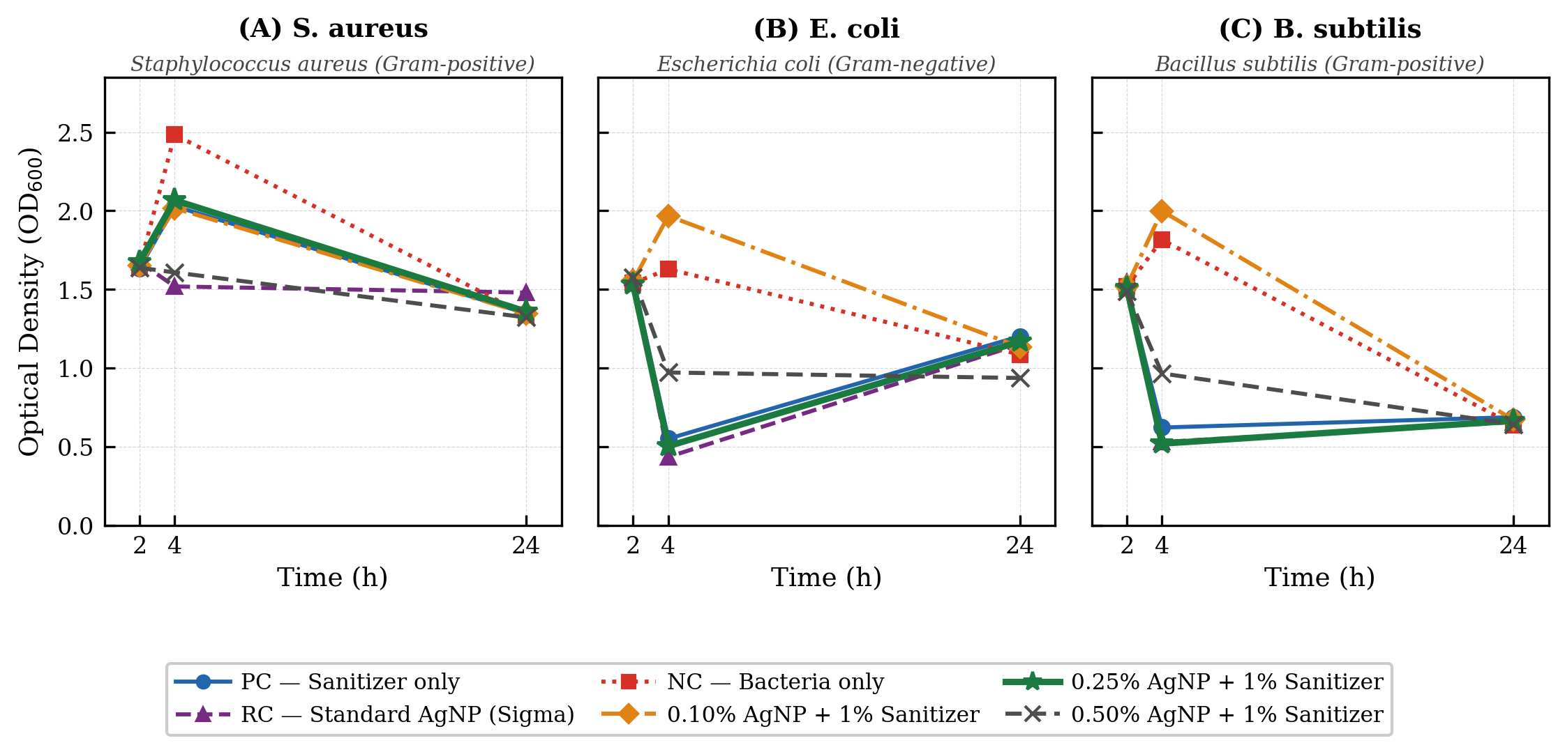Figure 1 Time-course optical density (OD₆₀₀) of (A) S. aureus, (B) E. coli, and (C) B. subtilis cultures treated with 1% hand sanitizer combined with varying concentrations of AgNPs. PC =positive control (1% sanitizer only); RC = reference control (sigma AgNPs only, no sanitizer); NC = negative control (bacterial culture only, no treatment). Data points represent mean values of three independent experiments.
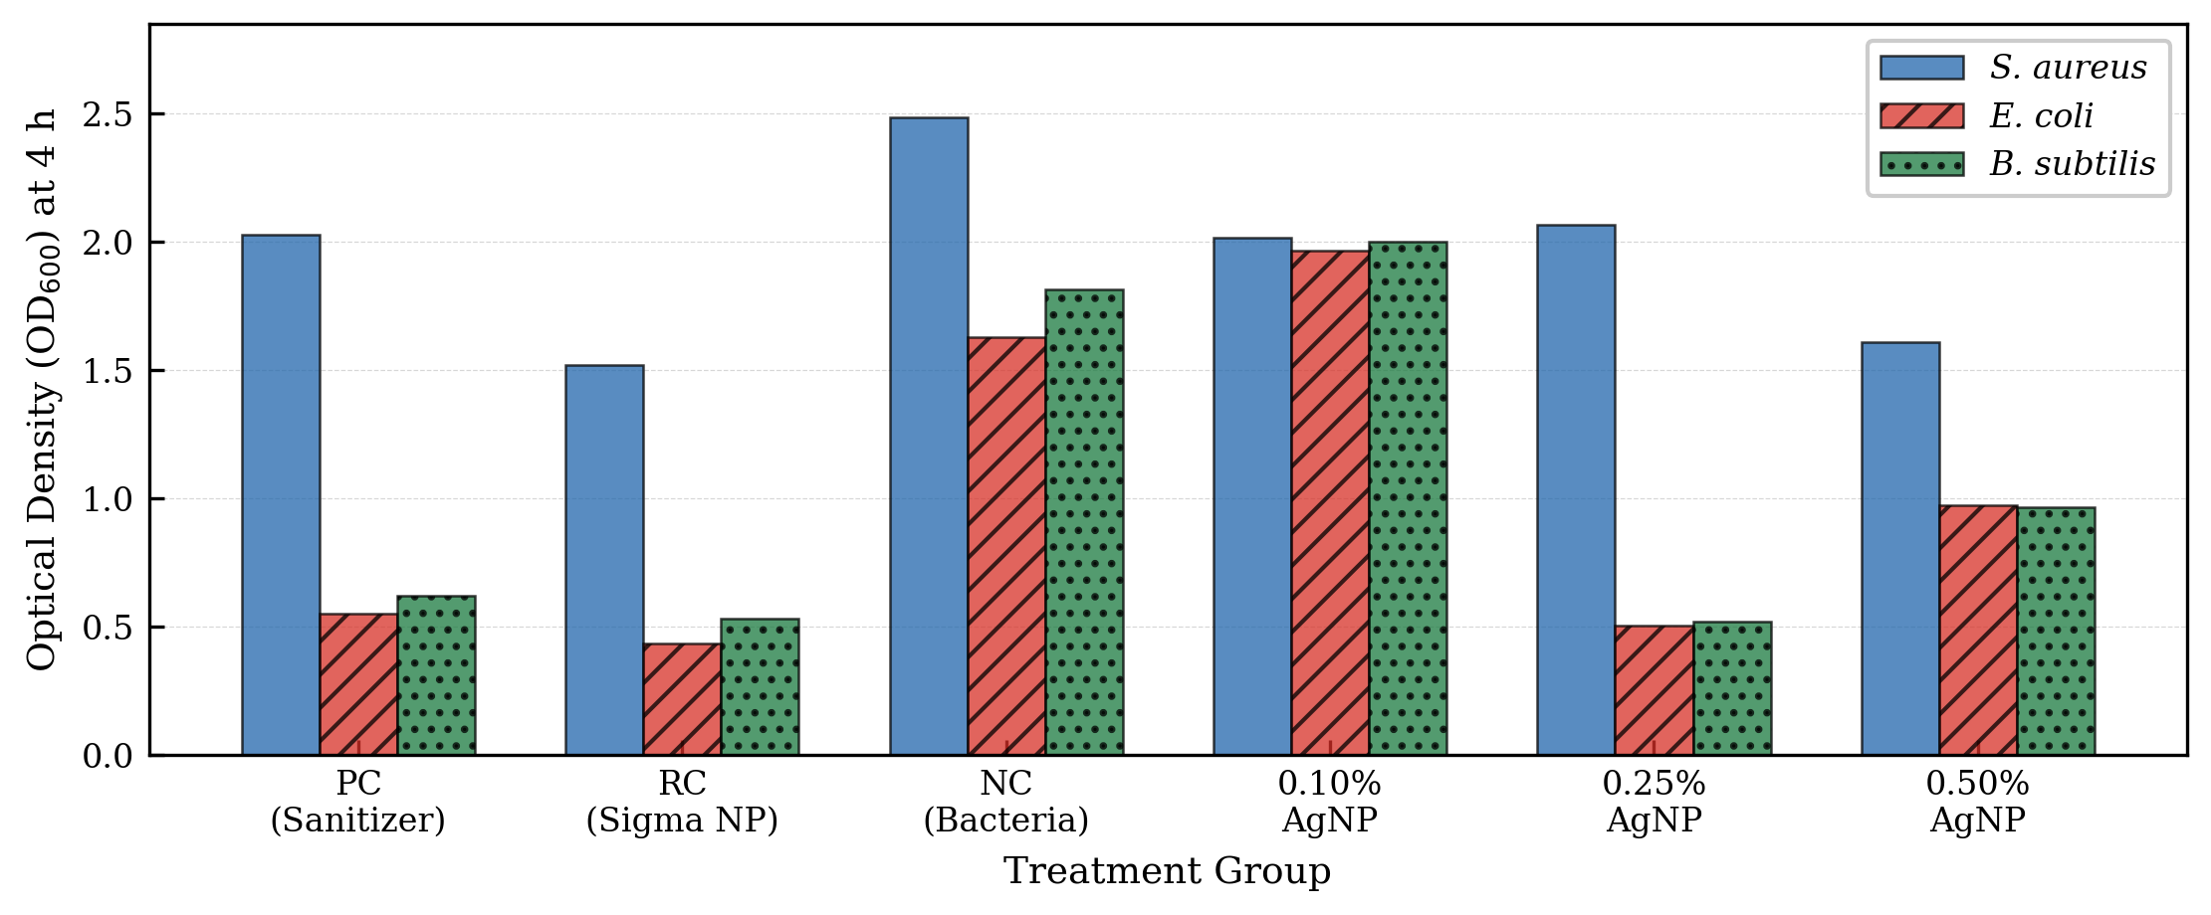
Figure 2 Comparative OD₆₀₀ values at 4 h post-inoculation across all treatment groups for S. aureus, E. coli, and B. subtilis. The 4-hour time point represents the period of maximum divergence between treatment groups. Bars represent mean values of three independent experiments. PC = positive control (sanitizer only); RC = reference control (sigma AgNPs only); NC = negative control (bacteria only).

CONCLUSION
This study demonstrates that the incorporation of silver nanoparticles into hand sanitizer formulations can significantly enhance antimicrobial efficacy against E. coli, S. aureus, and B. subtilis. The optimum AgNP concentration was organism-dependent: 0.25% AgNP combined with 1% sanitizer was most effective against E. coli and B. subtilis, while 0.50% AgNP demonstrated superior and sustained inhibition of S. aureus. These findings support the potential application of AgNP-enhanced sanitizer sprays in food safety and hygiene management, and highlight the importance of tailoring AgNP concentration to the target organism. However, the cytotoxicity of AgNPs remains a critical barrier to their direct use in human-applicable formulations. Future research should focus on reducing the toxicity of AgNPs through surface modification, biological synthesis, or encapsulation techniques, and should evaluate their safety profiles through comprehensive in vitro and in vivo toxicological studies.

CONFLICT OF INTEREST
The authors declare no conflict of interest.

REFERENCES
Arora, S., Jain, J., Rajwade, J. M., & Paknikar, K. M. (2008). Cellular responses induced by silver nanoparticles: In vitro studies. Toxicology Letters, 179(2), 93-100. https://doi.org/10.1016/j.toxlet.2008.04.009
CDC. (2024, June 13). Hand sanitizer facts. Clean Hands. https://www.cdc.gov/clean-hands/data-research/facts-stats/hand-sanitizer-facts.html
Choukade, R., Jaiswal, A., & Kango, N. (2020). Characterization of biogenically synthesized silver nanoparticles for therapeutic applications and enzyme nanocomplex generation. 3 Biotech, 10(11), 462. https://doi.org/10.1007/s13205-020-02450-8
Fahim, M., Shahzaib, A., Nishat, N., Jahan, A., Bhat, T. A., & Inam, A. (2024). Green synthesis of silver nanoparticles: A comprehensive review of methods, influencing factors, and applications. JCIS Open, 16, 100125. https://doi.org/10.1016/j.jciso.2024.100125
Gonzalez, J. M., & Aranda, B. (2023). Microbial growth under limiting conditions: Future perspectives. Microorganisms, 11(7), 1641. https://doi.org/10.3390/microorganisms11071641
Liao, C., Li, Y., & Tjong, S. C. (2019). Bactericidal and cytotoxic properties of silver nanoparticles. International Journal of Molecular Sciences, 20(2), 449. https://doi.org/10.3390/ijms20020449
Lim, J. Y., Yoon, J. W., & Hovde, C. J. (2010). A brief overview of Escherichia coli O157:H7 and its plasmid O157. Journal of Microbiology and Biotechnology, 20(1), 5-14.
Morones, J. R., Elechiguerra, J. L., Camacho, A., Holt, K., Kouri, J. B., Ramirez, J. T., & Yacaman, M. J. (2005). The bactericidal effect of silver nanoparticles. Nanotechnology, 16(10), 2346-2353. https://doi.org/10.1088/0957-4484/16/10/059
Moschonas, G., Lianou, A., Nychas, G. J. E., & Panagou, E. Z. (2021). Spoilage potential of Bacillus subtilis in a neutral-pH dairy dessert. Food Microbiology, 95, 103715. https://doi.org/10.1016/j.fm.2020.103715
Muleba, L., Van Wyk, R., Pienaar, J., Ratshikhopha, E., & Singh, T. (2022). Assessment of anti-bacterial effectiveness of hand sanitizers commonly used in South Africa. International Journal of Environmental Research and Public Health, 19(15), 9245. https://doi.org/10.3390/ijerph19159245
Pal, S., Tak, Y. K., & Song, J. M. (2007). Does the antibacterial activity of silver nanoparticles depend on the shape of the nanoparticle? A study of the Gram-negative bacterium Escherichia coli. Applied and Environmental Microbiology, 73(6), 1712-1720. https://doi.org/10.1128/AEM.02218-06
Rai, M., Yadav, A., & Gade, A. (2009). Silver nanoparticles as a new generation of antimicrobials. Biotechnology Advances, 27(1), 76-83. https://doi.org/10.1016/j.biotechadv.2008.09.002
Shrivastava, S., Bera, T., Roy, A., Singh, G., Ramachandrarao, P., & Dash, D. (2007). Characterization of enhanced antibacterial effects of novel silver nanoparticles. Nanotechnology, 18(22), 225103. https://doi.org/10.1088/0957-4484/18/22/225103
Su, Y., Liu, C., Fang, H., & Zhang, D. (2020). Bacillus subtilis: A universal cell factory for industry, agriculture, biomaterials and medicine. Microbial Cell Factories, 19(1), 173. https://doi.org/10.1186/s12934-020-01436-8
Taylor, T. A., Tobin, E. H., & Unakal, C. G. (2025). Staphylococcus aureus infection. In StatPearls. StatPearls Publishing. http://www.ncbi.nlm.nih.gov/books/NBK441868/
Tokano, M., Tarumoto, N., Imai, K., et al. (2023). Bacterial meningitis caused by Bacillus subtilis var. natto. Internal Medicine, 62(13), 1989-1993. https://doi.org/10.2169/internalmedicine.0768-22

