Original Research Article
Antagonistic activities of indigenous lactic acid bacteria isolated from fermenting cashew apples against the fungal complex causing post-harvest carrot (Daucus carota L.) rot in the department of Daloa (Center-West, Côte d'Ivoire)

Abstract
Carrots are an essential food crop in Côte d'Ivoire; however, their shelf life is limited by dehydration and fungal decay. Given the health risks associated with chemical preservatives, identifying biological conservation alternatives is crucial. This study evaluated the capacity of lactic acid bacteria (LAB) derived from local agricultural residues to inhibit the growth of fungi responsible for carrot rot. The methodological approach first involved isolating LAB from fermenting cashew apples and identifying fungal strains from both healthy and decaying carrot samples. Subsequently, direct in vitro dual-culture assays (bacteria–fungi) were performed on Petri dishes. Thirty-three LAB isolates were purified, and eight fungal genera were identified: Fusarium, Aspergillus, Rhizopus, Rhizoctonia, Mucor, Neurospora, Sclerotinia, and Trichoderma. The genera Rhizoctonia, Fusarium, and Sclerotinia were consistently present regardless of carrot condition, though they were more prevalent in decayed samples. Aspergillus, Mucor, and Rhizopus were detected more frequently in spoiled carrots, whereas Neurospora and Trichoderma were primarily associated with healthy carrots. Confrontation tests were conducted using three LAB isolates of distinct morphotypes (B16, B21, and B33) against seven fungal isolates actively involved in carrot decay (Fusarium sp., Aspergillus sp₁., Aspergillus sp₂., Aspergillus sp₃., Rhizoctonia sp., Mucor sp., and Sclerotinia sp.). All three LAB isolates demonstrated biocontrol potential against carrot rot agents. However, isolate B21 exhibited the strongest inhibitory activity, achieving total inhibition (100%) of Fusarium sp. growth and a significant reduction (96.18%) in Aspergillus sp₁. These results indicate that the use of lactic acid bacteria represents a promising and sustainable biological control alternative for reducing post-harvest carrot losses.
Keywords: carrot, fungi, lactic acid bacteria, biocontrol
- INTRODUCTION
The carrot (Daucus carota L.) is one of the most significant vegetable crops worldwide, with production stabilizing at approximately 42 million tons since 2022 (Coulibaly et al., 2018). In Côte d’Ivoire, particularly in the Daloa department, this sector serves as a cornerstone of the rural economy and urban nutritional security (Kraepiel & Raffaelle, 2023). However, carrots are highly perishable commodities whose preservation in tropical regions is compromised by two critical factors: rapid dehydration due to thermal and hygrometric constraints, and profound pathological alterations (Coulibaly et al., 2018). The post-harvest phase is thus characterized by the incidence of opportunistic fungal complexes, primarily represented by the genera Fusarium, Aspergillus, Botrytis, Rhizoctonia, and Sclerotinia. These decay agents, whose infestation is exacerbated by mechanical injuries during harvest, cause root rot that renders the product unfit for consumption and leads to substantial economic losses (Thomas et al., 2006).
To mitigate these losses, stakeholders in the value chain rely heavily on chemical preservatives such as potassium sorbate or sodium benzoate. However, the uncontrolled application of these synthetic additives and fungicides raises major public health concerns. Studies have shown that residual ingestion can cause severe gastrointestinal disorders and systemic complications, including dizziness and cramps (Gallen & Pla, 2013). In the context of transitioning toward sustainable food preservation, the use of beneficial microorganisms as biocontrol agents represents a promising alternative. Lactic acid bacteria (LAB), ubiquitous microorganisms with GRAS (Generally Recognized As Safe) status, are recognized for their biopreservative properties. Beyond their fermentative role, they synthesize a variety of bioactive secondary metabolites, such as organic acids, hydrogen peroxides, reuterins, and bacteriocins, whose synergistic action inhibits fungal growth by disrupting the membrane integrity of spores and hyphae (Scott, 2024).
In Côte d’Ivoire, the world's leading cashew nut producer, the cashew apple is a neglected by-product that contributes to environmental pollution (Kouassi, 2018). Nevertheless, fermenting cashew apples constitute ecological niches rich in indigenous LAB strains that remain underutilized. Integrating these strains into preservation systems could not only stabilize food products against molds but also preserve their organoleptic qualities (Delavenne, 2012; Denis et al., 2013). Despite the proven potential of lactic acid bacteria, their specific efficacy against carrot rot agents in the Daloa department remains insufficiently documented. Therefore, this study aims to evaluate in vitro the antifungal activity of indigenous LAB strains isolated from local fermentable substrates.
- MATERIALS AND METHODS
  - Study area
Carrot samples used for the isolation of decay agents were collected from markets in the city of Daloa, located in west-central Côte d'Ivoire. Simultaneously, cashew apple samples intended for the isolation of lactic acid bacteria were gathered from an agroforestry plantation (cocoa-cashew intercropping) in the same locality (Figure 1). This department, covering an area of 3820 km², has a population of approximately 705378 (INS, 2022). The soil is of the ferrallitic type. The local climate is tropical, characterized by four alternating seasons: a long rainy season (April to mid-July) punctuated by thunderstorms, a short dry season (mid-July to mid-September), a short rainy season (mid-September to November), and a long dry season (December to March) (Adjiri et al., 2019).
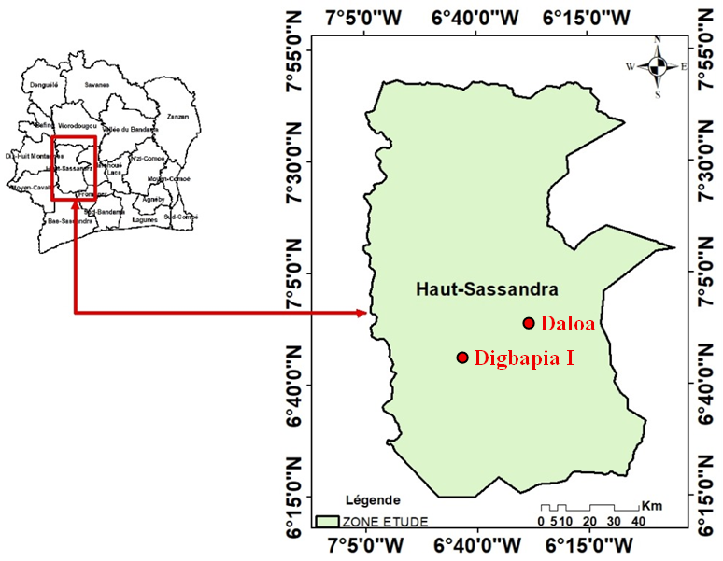

Figure 1: Location map of the study area
  - Sampling
In January 2025, twenty-seven carrot samples were collected from three markets in the city of Daloa (Table 1). In each market, three vendors were randomly selected, and three specimens (two apparently healthy carrots and one showing signs of rot) were collected per vendor. Concurrently, in February 2025, ten fermenting cashew apples were gathered from the ground within a mixed cocoa-cashew plantation located in Digbapia, 15 km from Daloa (Table I). All samples were individually packaged in sterile Stomacher bags and transported to the laboratory for further analysis.
Table 1: Geographic coordinates of the sampling sites
Locations | Geographic Coordinates
Lobia Market | 6°53'54" N and 6°27'10" W
Orly Market | 6°52'19" N and 6°27'17" W
Grand Market | 6°52'53" N and 6°27'28" W
Agroforestry Farm (Digbapia I) | 6°47'56" N and 6°37'13" W

  - Isolation of fungi involved in carrot rot
One half of the apparently healthy carrot samples was stored at 4°C for 14 days before analysis. The decayed carrots and the remaining half of the healthy samples were directly subjected to microbiological analysis.
Fungal isolation was performed according to the technique described by Onautshu et al. (2013). Under aseptic conditions (near a flame), 2 mm² carrot fragments were cut using a sterile blade. Using sterile forceps, five fragments were placed onto Petri dishes containing previously prepared Sabouraud Chloramphenicol Agar. The plates were incubated at 30°C for three to seven days. Morphologically distinct colonies observed on the Petri dishes were then subcultured individually under the same conditions. Two trials were performed for each carrot sample. The resulting pure isolates were coded from Ch1 to Ch55.
  - Phenotypic identification of fungi
Fungal isolates were identified based on morphological observations. Macroscopic characteristics, including mycelium color, shape, and appearance on Sabouraud Chloramphenicol Agar, were recorded. Microscopic identification was performed on 7-day-old colonies using the wet mount technique (slide and coverslip) at 40x magnification (Bouledjeraf et al., 2023). Identification criteria included hyphal septation, conidial shape, and the presence of phialides and chlamydospores.
  - Isolation frequency of fungi
The isolation frequencies of the fungi were determined using the formula below:

- IF: Isolation frequency (expressed as a percentage);
- ni: Total number of isolates of a specific fungal genus across all samples;
- N: Total number of isolates of all fungal genera across all samples.

IF (%) = (ni / N) × 100

where:

  - Ecological diversity indices
Fungal isolate diversity was determined using the Shannon-Weaver (H') diversity index and the Pielou's evenness index (E), calculated according to the following formulas:
- H’: Shannon diversity index;
- S: Total number of species;
- pi: Proportion of species i in the community ( $pi=\frac{ni}{nt}$);
- ni: Number of individuals of species i;
- nt: Total number of individuals;
- H’ < 1: indicates low diversity;
- 1 < H’ < 3: indicates moderate diversity;
- H’ > 3: indicates high diversity.

$H'=-\sum_{i=1}^{S}{p}$i ln(pi)

where:

- E: Pielou's evenness index;
- S: Total number of species.
E values range from 0 to 1:
- As E approaches 0, a single species dominates the community (imbalance);
- As E approaches 1, the species are more evenly distributed within the community (balance).

$E=\frac{H'}{ln⁡(S)}$:

where:

  - Isolation of lactic acid bacteria
Upon arrival at the laboratory, cashew apples were immediately placed in sterile glass flasks. The exuded juice (leachate) underwent spontaneous fermentation for 72 hours.
Stock suspensions (SS) and decimal dilutions were prepared near a Bunsen burner flame in accordance with the NF EN ISO 6887-1 (2017) standard. A 10 mL volume of fermented juice was added to 90 mL of Buffered Peptone Water (BPW) and homogenized for one minute. The mixture was then allowed to stand for 30 minutes at room temperature to allow for microbial resuscitation. Decimal dilutions (up to the desired concentration) were performed by successive transfers of 1 mL into 9 mL of sterile distilled water.
Lactic acid bacteria were isolated using the pour-plate method on Man, Rogosa, and Sharpe (MRS) medium. One milliliter of each dilution was poured with approximately 20 mL of supercooled MRS agar. After homogenization and solidification, the plates were incubated at 30 °C. All dilutions were performed in duplicate. After 24 to 72 hours, morphologically distinct colonies observed on the Petri dishes were subcultured onto fresh MRS medium for purification. The resulting pure isolates were coded from B1 to B33.
  - Phenotypic differentiation of lactic acid bacteria
Bacterial colony differentiation was based on macroscopic characteristics (shape, size, texture, color, and growth) and microscopic characteristics (cell shape and wall staining type). Gram staining was performed for each isolate. Only Gram-positive cells (rods or cocci) arranged in clusters or chains were considered lactic acid bacteria. The various isolates (B1 to B33) meeting these criteria were grouped into morphotypes based on their similarity.
  - Evaluation of antifungal activity of lactic acid bacteria
Fungal genera known to include species responsible for carrot rot were selected. Seven isolates were chosen for confrontation tests: Fusarium (Ch1), Aspergillus (Ch2, Ch5, and Ch6), Rhizoctonia (Ch3), Mucor (Ch4), and Sclerotinia (Ch7). Regarding the lactic acid bacteria, isolates B16, B33, and B21 were selected based on the identified morphotypes.
The inhibitory power of the lactic acid bacteria against these carrot rot fungi was evaluated according to the method of Youté (2022). Two lines of lactic acid bacteria were streaked 4 cm apart on nutrient agar. Fungal explants (6 mm in diameter) were placed in the center of the Petri dish. The plates were incubated at 30 °C for 7 days. The control consisted of a plate containing only the fungus. On the 7th day of confrontation, the radial growth of the rot agents was measured. Three (3) replicates were performed for each fungus-bacteria pair.
The percentage of mycelial inhibition was calculated using the following formula:
- I (%): percentage of mycelial growth inhibition;
- C₀: diameter of the control colonies;
- Cn: mean diameter of the colonies in the presence of the antagonist.
I (%) = (C₀-C_{n}/C₀) × 100

where:

  - Statistical analysis
Statistical analyses were performed using Statistica software version 7.1 (Statsoft Inc., Tulsa, OK, USA). The antifungal activity of the lactic acid bacteria was evaluated by comparing the percentages of mycelial growth inhibition of the rot agents on the seventh day of the in vitro confrontation. A one-way analysis of variance (ANOVA) was conducted, followed by Fisher's LSD test at a significance level of 5% to classify the treatments and identify significant differences between the means.
- RESULTS
  - Morphological characteristics of fungi isolated from carrots
Morphological analysis of fungi isolated from carrots collected in Daloa identified 55 distinct isolates, classified into eight (8) genera: Fusarium, Aspergillus, Rhizopus, Rhizoctonia, Mucor, Neurospora, Sclerotinia, and Trichoderma (Table 2). Macroscopic and microscopic observations revealed specific characteristics for each genus. Fusarium was distinguished by initially whitish colonies that turned reddish after five days of culture, featuring falciform macroconidia and hyaline oval microconidia. Aspergillus isolates showed morphological diversity, ranging from blackish colonies with smooth conidiophores and biseriate aspergillar heads to whitish colonies that turned greenish, with short or long conidiophores depending on the strain. Rhizopus formed whitish colonies with sporangiophores grouped in clusters and well-developed rhizoids. Rhizoctonia exhibited a color progression (whitish to dark brown) and septate hyphae with typically orthogonal branching. Mucor maintained a grayish coloration and was microscopically characterized by non-septate filaments and conidiophores with ovoid columellae. Neurospora presented colonies transitioning from beige to orange, with a dense network of interlaced filaments. Sclerotinia remained whitish throughout its growth; microscopic examination showed hyaline hyphae, sclerotia, and ellipsoidal ascospores. Finally, Trichoderma changed from white to green, featuring verticillate phialides and clustered spherical conidia.
Table 2: Macroscopic and microscopic aspects of fungal genera isolated from carrots
Isolate codes | Genera | Macroscopic appearance | Microscopic appearance
Ch1 ; Ch8 ; Ch9 ; Ch10 ; Ch11; Ch12; Ch13; Ch14 | Fusarium | 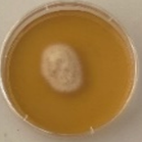  2 cm | 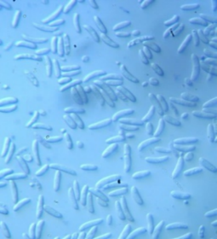  8 μm
Ch2 ; Ch15 ; Ch16 ; Ch17 ; Ch18; Ch19; Ch20; Ch21; Ch22; Ch23 | Aspergillus sp₁. | 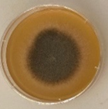  2 cm | 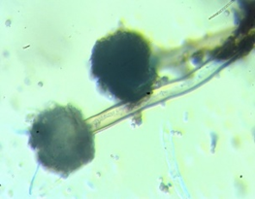  10 μm
Ch5 ; Ch24 ; Ch25 ; Ch26 ; Ch27; Ch28; Ch29; Ch30 | Aspergillus sp₂. | 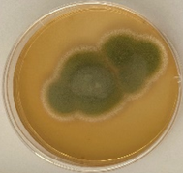  2 cm | 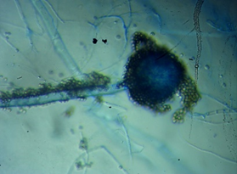  10 μm
Ch6 ; Ch31 ; Ch32 ; Ch33 | Aspergillus sp₃. | 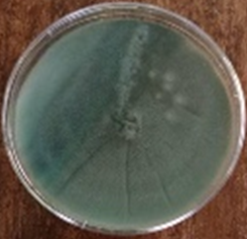  2 cm | 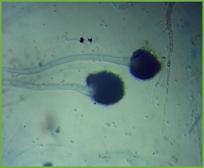  10 μm
Ch38 ; Ch39 ; Ch40 ; Ch54 | Rhizopus | 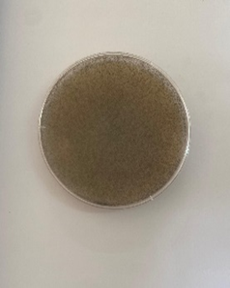  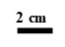 | 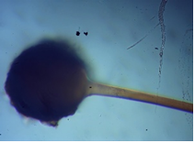  10 μm
Ch3 ; Ch41 ; Ch42 ; Ch43 | Rhizoctonia | 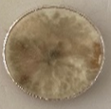 | 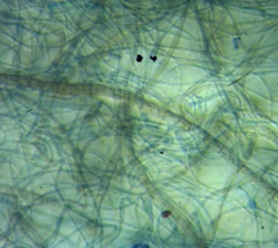  8 μm
Ch4 ; Ch49 ; Ch50 | Mucor | 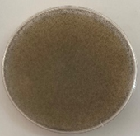 | 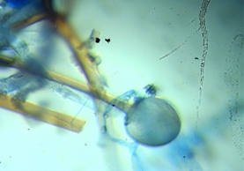  10 μm
Ch51 ; Ch52 ; Ch53 ; Ch55 | Neurospora | 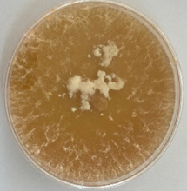 | 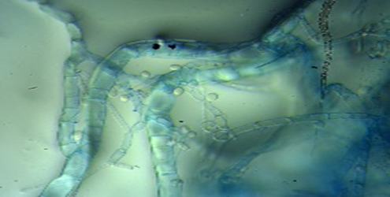  10 μm
Ch7 ; Ch44; Ch45; Ch46 | Sclerotinia | 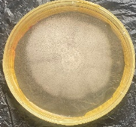 | 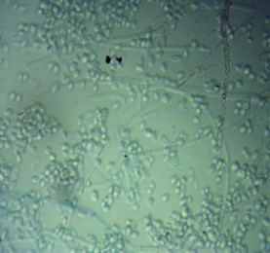  8 μm
Ch34; Ch35; Ch36; Ch37 | Trichodrema | 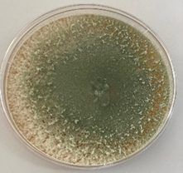 | 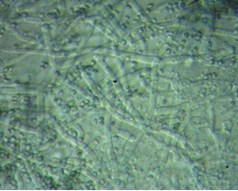  8 μm

  - Diversity of fungi present in carrots from markets in the city of Daloa
    - Fungal genus specific richness based on carrot condition
Fungal specific richness varied according to the condition of the carrots (Table 3). Both decaying carrots and healthy carrots exhibited higher fungal diversity compared to those stored at 4°C in a refrigerator. Specifically, 7 and 6 fungal genera were identified in apparently healthy carrots and decaying carrots, respectively, compared to only 4 genera in stored healthy carrots. The genera Rhizoctonia, Fusarium, and Sclerotinia were consistently present regardless of the carrot condition, though they showed a higher prevalence in altered samples. The genera Aspergillus, Mucor, and Rhizopus were detected more frequently in decaying carrots. In contrast, Neurospora and Trichoderma were primarily associated with apparently healthy carrots.
Table 3: Specific richness of fungi associated with markets in the city of Daloa
Fungal Genera | Healthy carrots | Decaying carrots | Stored healthy carrots
Rhizopus | + | ++ | -
Mucor | + | ++ | -
Aspergillus | - | ++ | ++
Rizoctonia | + | ++ | ++
Fusarium | + | ++ | ++
Neurospora | ++ | - | -
Trichoderma | ++ | - | -
Sclérotinia | + | + | ++
Species richness (S) | 7 | 6 | 4
- : Fungi absent in carrots;
+ : Moderate fungal presence in carrots;
++ : High fungal presence in carrots.

    - Ecological diversity indices based on carrot condition
Fungal diversity according to the physiological state of the carrots is presented in Table 4. Analysis of ecological indices revealed significant variations in fungal richness and distribution. The Shannon diversity index, ranging from 1.60 to 2.05, indicated moderate diversity across all carrots, regardless of their physiological state. Decaying carrots displayed the highest value (H' = 2.05), while healthy and stored carrots presented the lowest values (H' = 1.73 and H' = 1.60, respectively). The Pielou’s evenness index, varying from 0.89 to 0.99, showed an overall balanced distribution of fungal genera. Apparently healthy carrots stored at 4°C (E = 0.99) and decaying carrots (E = 0.98) exhibited the highest indices, reflecting a homogeneous species distribution. In contrast, apparently healthy carrots at room temperature recorded the lowest value (E = 0.89), suggesting a less uniform distribution compared to other physiological states.
Table 4: Diversity indices of pathogenic fungi responsible for carrot rot
Carrot condition | Maximum diversity (Hmax) | Shannon diversity index (H’) | Pielou’s evenness index (E)
Healthy | 1,94 | 1,73 | 0,89
Decaying | 2,07 | 2,05 | 0,98
Stored | 1,60 | 1,60 | 0,99

  - Morphological characteristics of bacteria
Microbiological analysis of fermented cashew apple juice led to the purification of 33 lactic acid bacteria isolates, divided into three distinct morphotypes. The first group consisted of Gram-positive bacilli arranged in clusters, showing slow growth on MRS agar. The second group also included Gram-positive bacilli arranged in chains, but characterized by rapid growth on the MRS culture medium. Finally, the third group consisted of Cocci-type bacteria, also Gram-positive, which displayed rapid growth on MRS agar (Table 5).
Table 5: Macroscopic and microscopic features of selected lactic acid bacteria
Isolate codes | Bacterial cells | Macroscopic appearance |  | Microscopic appearance
BL8, B9, B10, B14 B22, B28, B30, B32, B33 | Gram-positive bacilli | 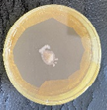 | Circular beige colonies with a creamy appearance, exhibiting very slow growth on MRS (Man, Rogosa, and Sharpe) medium at 30°C. | 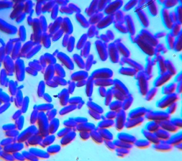  10 μm | Elongated rod-shaped cells; purple staining of the walls (Gram-positive wall).
B5, B6, B11, B12 B13, B18, B19; B20 B21, B23, B24, B25, B31 | Gram-positive bacilli | 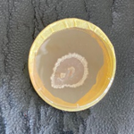 | Circular beige colonies with a creamy appearance, exhibiting moderate growth on MRS (Man, Rogosa, and Sharpe) medium at 30°C. | 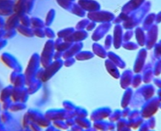  10 μm | Elongated rod-shaped cells arranged in chains; purple staining of the walls (Gram-positive wall).
B1, B2, B3, B4, B7 B15, B16, B17, B26 B27, B29 | Gram-positive cocci | 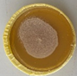 | Circular beige colonies with a creamy appearance, exhibiting rapid growth on MRS (Man, Rogosa, and Sharpe) medium at 30°C. | 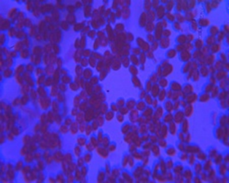  8 μm | Slightly oval spherical cells arranged in clusters; purple staining of the walls (Gram-positive wall).

  - Inhibitory activity of lactic acid bacteria against fungi responsible for carrot rot
The inhibition percentages of the radial growth of carrot rot agents namely Aspergillus sp₁. (Ch2), Fusarium sp. (Ch1), Mucor sp. (Ch4), Rhizoctonia sp. (Ch3), Aspergillus sp₂. (Ch5), Aspergillus sp₃. (Ch6), and Sclerotinia sp. (Ch7) on the 7th day of in vitro dual culture assays are presented in Figure 2. The lactic acid bacteria (B16, B21, and B33) showed a significant reduction in the radial growth of these fungi (Table 6). Isolate B16 revealed strong antagonistic activity against Aspergillus sp₃. with an inhibition percentage of 82.5%, but weakly inhibited Aspergillus sp₁. (7.35%) and Rhizoctonia sp. (14.11%). This bacterium had no effect on Mucor sp. Isolate B33 exhibited strong activity against Fusarium sp. with an inhibition percentage of 96.81%, while its effect on Sclerotinia sp. (29.33%) and Rhizoctonia sp. (16.47%) was low. This bacterium also showed no inhibition against Mucor sp. Finally, isolate B21 showed high inhibition across all rot agents, with maximum activity against Aspergillus sp₁. (96.18%) and Fusarium sp. (100%), but lower inhibition on Mucor sp. (25.88%). The antagonistic mechanisms of these bacteria were generally characterized by rapid space occupancy within the Petri dishes, thereby preventing the growth of the rot agents (Table 7).
Table 6: Analysis of variance
Direct confrontation | F(27 ; 28) | p
Fungi vs. B16 | 145.2873 | 0.000001
Fungi vs. B33 | 157.1311 | 0.000015
Fungi vs. B21 | 103.2523 | 0.000001

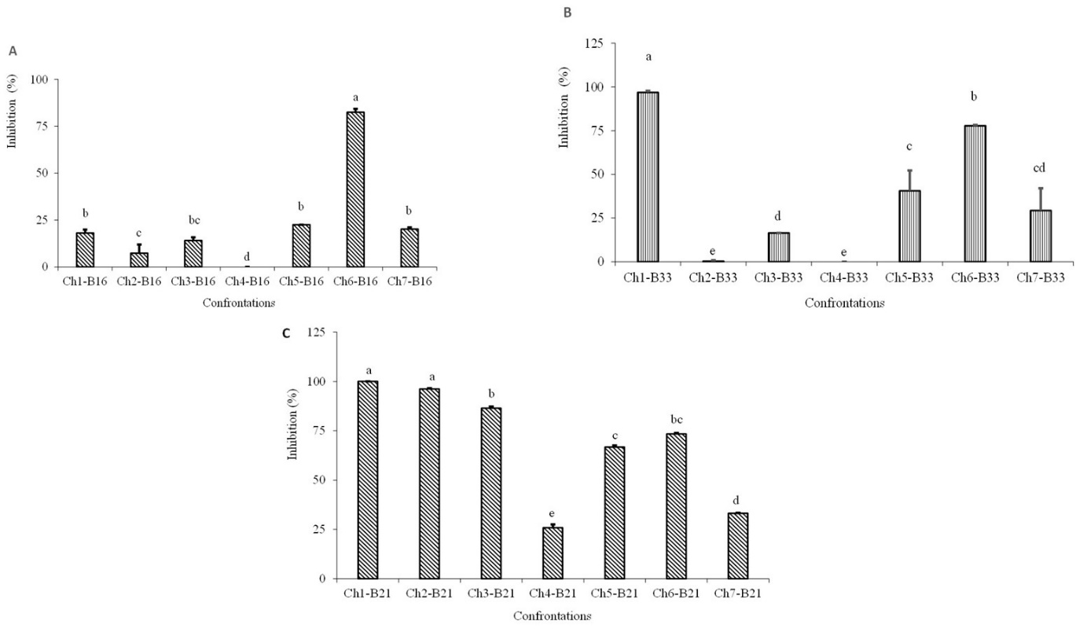
Figure 2: Inhibition percentage of carrot rot fungi by lactic acid bacteria
A: Inhibition by isolate B16; B: Inhibition by isolate B33, C: Inhibition by isolate B21
CH1 (Fusarium sp.), Ch2 (Aspergillus sp₁.), Ch3 (Rizoctonia sp.), Ch4 (Mucor sp.), CH5 (Aspergillus sp₂.), CH6 (Aspergillus sp₃.) et CH7 (Sclerotinia sp.)
Means followed by the same letter are not significantly different according to Fisher's LSD test at the α = 0.05 level.

Table 7: Dual culture assay: Lactic acid bacteria isolate B21 vs. fungi involved in carrot rot
Day 7 dual culture | Negative Control (-)
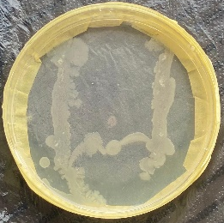  B21  B21  Ch1 | 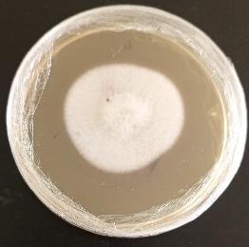  Ch1
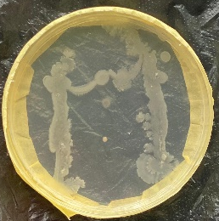  B21  B21  Ch2 | 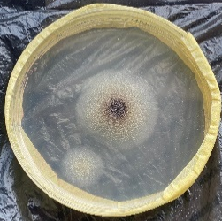  Ch2
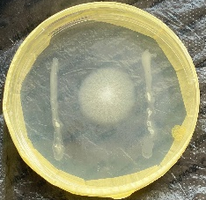  Ch3  B21  B21 | Ch3
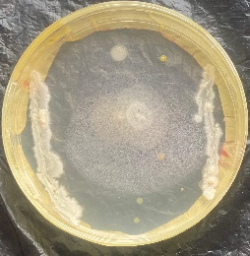  Ch4  B21  B21 | Ch4
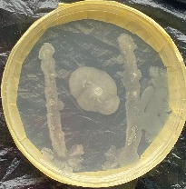  Ch5  B21  B21 | Ch5
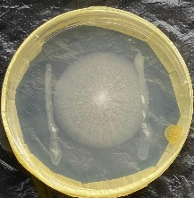  B21  B21  Ch6 | Ch6
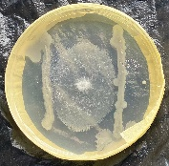  Ch7  B21  B21 | 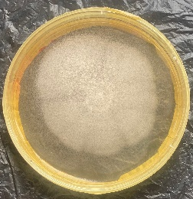  Ch7

- DISCUSSION
This study aimed to evaluate the antifungal profile of lactic acid bacteria (LAB) against carrot rot agents during storage in Daloa. The objective was to propose a natural alternative for post-harvest preservation.
Microbiological analysis of the carrots revealed significant fungal diversity. The isolated fungi belonged to eight (8) genera: Fusarium, Aspergillus, Rhizopus, Rhizoctonia, Mucor, Neurospora, Sclerotinia, and Trichoderma. Previous studies indicate that these fungal genera are frequently associated with root vegetables in tropical regions (Bouchard et al., 2023; Charbonnier et al., 2015; Garbaye, 2013). Analysis of species richness showed greater fungal diversity in decaying carrots and those considered healthy compared to healthy carrots in storage. This observation is consistent with the work of Courtial (2019), indicating that vegetable degradation promotes the proliferation of a wide range of fungi. The low fungal species richness in healthy stored carrots could be attributed to storage conditions unfavorable to microbial growth (refrigerated at -20 °C), as highlighted by Vidal et al. (2016) in their research on vegetable preservation environments in Côte d'Ivoire. Fungal distribution analysis indicated that the genera Rhizoctonia, Fusarium, and Sclerotinia were ubiquitous, regardless of the carrots' condition, with increased abundance in altered and stored carrots. These results corroborate those of Charbonnier et al. (2015), who observed a high prevalence of these genera in altered and refrigerated vegetables. Furthermore, the ubiquity of these genera common pathogens of root vegetables demonstrates their ability to adapt to environmental and nutritional conditions, as noted by Munroe (2006) regarding the adaptability of the fungal microbiome. The genera Aspergillus, Mucor, and Rhizopus were primarily found in altered carrots. According to Bourouda (2010), the presence of these fungal genera in food indicates advanced spoilage. In contrast, Neurospora and Trichoderma were associated with healthy carrots. The healthy appearance of these carrots could be attributed to the presence of these beneficial antagonistic agents. Work by Fofana et al. (2025) emphasizes that these fungi play a positive role by limiting the proliferation of other fungal agents, particularly pathogens. Analysis of ecological diversity indices for fungal genera in carrots marketed in Daloa revealed moderate fungal diversity and an overall balanced distribution of genera. This finding aligns with the results of Benameur & Messaoui (2024) regarding tomatoes and peppers sold in Southeast Asia. These authors also noted moderate fungal diversity with a predominance of certain genera. The high Shannon index value (higher fungal diversity) observed in decomposed carrots could be explained by the availability of organic matter and moisture, which favor the growth of opportunistic and saprophytic fungi (Bazot, 2005). This may also reflect a typical ecological succession of microorganisms.
Microbiological analysis of cashew apple juices identified a wide diversity of lactic acid bacteria after fermentation. These bacteria were classified into three morphotypes: slow-growing Gram-positive bacilli, moderate-growing Gram-positive bacilli, and fast-growing Gram-positive cocci. Similar observations were made by Derouiche et al. (2008), indicating that fermented or fermenting plant products create favorable conditions for the establishment of these bacteria.
In vitro dual culture assays conducted between lactic acid bacteria (B16, B21, and B33) and the rot agents (Aspergillus sp₁., Fusarium sp., Mucor sp., Rhizoctonia sp., Aspergillus sp₂., Aspergillus sp₃., and Sclerotinia sp.) evaluated the biocontrol potential of these bacteria. The results showed significant, though variable, inhibition of the radial growth of rot agents, thereby confirming the effectiveness of lactic acid bacteria in the biocontrol of fungal pathogens (Ezzahraa, 2022). Isolate B21 proved to be the most effective, demonstrating major antifungal activity characterized by total inhibition of the radial growth of Fusarium sp. (100%) and a drastic reduction in that of Aspergillus sp₁. (96.18%). These results corroborate those of Badji & Ait (2017), who observed approximately 80% inhibition of the mycelial growth of Aspergillus fumigatus and Fusarium oxysporum in direct confrontation with Lactobacillus species. Isolate B16 showed significant inhibition of Aspergillus sp₃. (82.5%), but limited efficacy against other rot agents, reflecting target-specific action as indicated by Matarazzo (2019). Isolate B33 also showed strong inhibition of Fusarium sp. (96.81%), highlighting its biocontrol potential, although its efficacy against other rot agents remained limited (Fadlaoui, 2024). Two mechanisms of action were identified in the antagonism of lactic acid bacteria against rot agents: competition and mycoparasitism. In some cases, the antagonists rapidly colonized the Petri dish, growing over the rot agents and completely destroying them by the 5th day of confrontation, indicating a mycoparasitism phenomenon (Morissette et al., 2006). In other cases, the antagonists competed for nutritional resources and space, thereby preventing the development of the rot agents (Fofana et al., 2025).
- CONCLUSION
Aiming to develop a biological control method based on microbial antagonism, this study evaluated the antifungal profile of specific lactic acid bacteria (B16, B21, and B33) isolated from cashews in the Daloa region. The objective was to analyze their efficacy against fungi potentially involved in the post-harvest rot of carrots during storage. Microbiological analysis of the carrots revealed significant fungal diversity, identifying eight genera, including rot agents such as Fusarium, Aspergillus, Rhizopus, Rhizoctonia, Sclerotinia, and Mucor, as well as potential biocontrol agents like Neurospora and Trichoderma. Decaying carrots and those considered healthy exhibited greater fungal diversity than healthy carrots stored in the refrigerator, highlighting the impact of storage conditions on the proliferation of rot agents. Direct confrontation assays between the lactic acid bacteria and carrot rot agents revealed that all tested bacterial isolates possessed a superior ability to combat fungi such as Aspergillus sp₁., Aspergillus sp₂., Aspergillus sp₃., Fusarium sp., Mucor sp., Rhizoctonia sp., and Sclerotinia sp. Among them, isolate B21 demonstrated the strongest antifungal activity, completely inhibiting the growth of Fusarium sp. and significantly reducing that of Aspergillus sp₁. To limit the development of rot agents, the bacteria acted through complex mechanisms such as mycoparasitism and competition for space and nutrients.

- NO CONFLICT OF INTEREST
All authors approve the submitted version and declare no conflicts of interest.

- REFERENCES
Adjiri, A. O., Bintou, K., Natchia, A., Ibrahim, D., & Brou, D. (2019). Physico-chemical characterization and source of mineralization of groundwater in the departments of Daloa and Zoukougbeu (Côte d’Ivoire). Journal of Applied Biosciences, 13(4), 2388-2401. https://doi.org/10.4314/ijbcs.v13i4.40
Badji, T., & Ait, A. C. (2017). Antifungal activity of bacteria of the genera Bacillus and Pseudomonas and effect of their inoculation in pots in tomatoes [Master’s thesis]. Mouloud Mammeri University of Tizi-Ouzou, Algeria, 43 p. https://dspace.ummto.dz/items/8b83d856-cf79-4c52-a220-10b89b310ad4
Bazot, S. (2005). Contribution to the study of the allocation of recent photoassimilates in the plant and the rhizosphere in a perennial grass [Doctoral dissertation]. University of Lorraine, France, 126 p. https://hal.science/tel-00137743/
Benameur, T., & Messaoui, S. (2024). Contribution to the study of the diversity of epiphytic and endophytic fungi of Posidonia oceanica leaves in the Beni Ksila region [Master’s thesis]. Mouloud Mammeri University, Algeria, 75 p. https://dspace.ummto.dz/items/2087be00-5a7c-45e2-9b02-ed8b0bc3a34a
Bouchard, M. F., Lemire, M., & Delesalle, L. (2023). Nutrition. In: Environment and Public Health. EHESP Press, Rennes, France, pp. 683-708. https://shs.cairn.info/article/EHESP_GOUPI_2023_01_0683
Bourouda, N. (2010). Place of the antifungal susceptibility test in the management of fungal infections [Doctoral dissertation]. Mohammed Casablanca University, Morocco, 150 p. https://toubkal.imist.ma/bitstream/handle/123456789/18568/P0522010..pdf?sequence=1
Charbonnier, E., Ronceux, A., Carpentier, A. S., Soubelet, H., & Barriuso, E. (2015). Pesticides. Quae Editions, Versailles, France, 1403 p. https://library.oapen.org/handle/20.500.12657/22802
Coulibaly, L. F., Toure, A., Laope, A. C. S., Coulibaly, N. A., & Soro, Y. R. (2018). Agronomic, physico-chemical and nutritional characterization of four hybrid varieties of carrot (Daucus carota) in northern Côte d'Ivoire. Agronomie Africaine, 30(1), 45-55. https://www.ajol.info/index.php/aga/article/download/178647/168024
Courtial, J. (2019). Pathogenicity and resistance: implication of toxins in the carrot-Alternaria dauci interaction [Doctoral dissertation]. University of Angers, France, 127 p. https://theses.hal.science/tel-03270844/
Delavenne, E. (2012). Antifungal properties of lactic acid bacteria isolated from raw milk [Doctoral dissertation]. University of Western Brittany, France, 102 p. https://theses.hal.science/tel-02358823/
Denis, C., Champomier-Vergès, M. C., Zagorec, M., Talon, R., & Michel, V. (2013). Bioprotective microorganisms. In: Protective Flora for Food Preservation. Quae Editions, Versailles, France, 160 p. https://books.google.fr/books?hl=fr&lr=&id=zt8xha8N4rQC&oi=fnd&pg=PA7&dq=DENIS,+C.,+CHAMPOMIER-VERG%C3%88S,+M.+C.,+ZAGOREC,+M.,+TALON,+R.,+%26+MICHEL,+V.+(2013).+des+micro-organismes+bioprotecteurs.+Flores+protectrices+pour+la+conservation+des+aliments,+7.&ots=Z1GfUWwnMW&sig=CXx3XqX4WqiG1r_uU1y2KUxuNbY
Derouiche, A., Ouni, A., Agrebi, A., Slama, M. R., & Ben S. Chebil, M. (2008). Management of emphysematous pyelonephritis: a study of 21 cases. Progrès en Urologie, 18(2), 102-107. https://doi.org/10.1016/j.purol.2007.08.002
Ezzahraa, E. M. F. (2022). Evaluation of the insecticidal and fungicidal power of bacterial strains isolated from cactus roots against the cactus cochineal (Dactylopius opuntiae) and phytopathogenic fungi [Doctoral dissertation]. Sultan Moulay Slimane University, Morocco, 130 p. https://toubkal.imist.ma/handle/123456789/25800
Fadlaoui, S. (2024). Study of antagonistic microorganisms (Trichoderma) of fusarium wilt (Fusarium spp.), the main fungal disease of cucurbits in the Biskra region [Doctoral dissertation]. Mohamed Khider Biskra University, Algeria, 120 p. http://thesis.univ-biskra.dz/id/eprint/6792
Fofana, O., Voko Bi, R. D. R., & Kouassi, K. C. (2025). Evaluation of Biocontrol of Mycosphaerella fijiensis by five Species of Rhizosphere Fungi of Plantain. Journal of Basic Microbiology, 7, 10010-10029. https://doi.org/10.1002/jobm.70020
Gallen, C., & Pla, J. (2013). Allergy and intolerance to food additives. Revue française d’allergologie, 53, 9-18. https://www.sciencedirect.com/science/article/pii/S1877032013700447
Garbaye, J. (2013). Mycorrhizal symbiosis: an association between plants and fungi. In: Symbiosis. Quae Editions, Versailles, France, pp. 1-280. https://www.torrossa.com/gs/resourceProxy?an=5063883&publisher=FZZ759
INS (Institut National de la Statistique). (2022). Final global results of the Fifth General Census of Population and Housing (RGPH 2021). Technical Report, Ministry of Planning and Development, Abidjan, Côte d'Ivoire, 114 p. https://plan.gouv.ci/uploads/publications/RGPH2021-RESULTATS-GLOBAUX-VF.pdf
Kouassi, E. (2018). Contribution to the valorization of agricultural by-products into bioproducts [Doctoral dissertation]. INP-Toulouse and INP-HB Yamoussoukro, Côte d'Ivoire, 215 p. https://theses.hal.science/tel-04199527/
Kraepiel, Y., & Raffaele, S. (2023). The Silent Language of Plants. Quae Editions, Versailles, France, 168 p. https://www.torrossa.com/gs/resourceProxy?an=5554700&publisher=FZZ759
Matarazzo, L. (2019). Study of the anti-infective properties of Toll-like receptor agonists in combination with antibiotics in the treatment of respiratory infections [Doctoral dissertation]. University of Lille, France, 144 p. https://theses.hal.science/tel-03905217/
Morissette, D. C., Seguin, P., & Jabaji-Hare, S. H. (2006). Expression regulation of the endochitinase-encoding gene sechi44 from the mycoparasite Stachybotrys elegans. Canadian Journal of Microbiology, 52(11), 1103-1109. https://doi.org/10.1139/w06-068
Munroe, G. (2006). Manual on On-Farm Vermicomposting and Vermiculture. Organic Agriculture Centre of Canada, 38 p. https://www.agrireseau.net/documents/Document_96310.pdf
Onautshu, O., Légrève, A., & Dhed'a, D. (2013). Characterization of Mycosphaerella fijiensis populations and epidemiology of black sigatoka of banana in the Kisangani region, DRC. Study Report, Catholic University of Louvain, Belgium, 26 p. https://dial.uclouvain.be/pr/boreal/object/boreal:132061
Scott, J. C. (2024). Domesticating nature: an agriculture of legibility and simplicity. In: Seeing Like a State: How Certain Schemes to Improve the Human Condition Have Failed. CABI Editions, New York, USA, pp. 457-537. https://shs.cairn.info/article/DEC_SCOTT_2024_01_0457
Thomas, A., Gozlan, E., & Loope, L. (2006). Impacts of the introduction of invasive species in New Caledonia. In: Invasive Species in the New Caledonian Archipelago. IRD Editions, Paris, France, pp. 328-357. https://www.documentation.ird.fr/hor/fdi:010040004
Vidal, T., Boixel, A. L., Lusley, P., Leconte, M., de Vallavieille, C. C. P., Huber, L., & Saint-Jean, S. (2016). Combining wheat varieties with strongly differing architectures: a path for improving varietal mixtures efficacy in reducing wheat septoria. 11th Phytopathology-Mycology Conferences, Aussois, France, pp. 32-41. https://hal.science/hal-01564553/
Youté, F. S. A. (2022). Inhibition of the growth of ochratoxinogenic molds by lactic acid bacteria during the fermentation of cocoa beans [Doctoral dissertation]. University of Yaoundé I, Cameroon, 225 p. https://dicames.online/jspui/handle/20.500.12177/10747

