Evolutionary Dynamics of MPXV at the National Laboratory of Clinical Biology and Public Health in Bangui, Central African Republic

Abstract
The recent MPXV epidemic in Africa revealed significant viral diversity and complex transmission dynamics, warranting a sub-regional genomic study. We analyzed 1,630 high-quality MPXV clade Ia genomes from seven Central African countries, revealing the complex and concurrent circulation of sub clades Ia and Ib. Sub clade Ia showed high viral diversity in reservoir hosts, detected through zoonotic transmission and associated with a recently observed persistent human epidemic. In contrast, clade Ib showed evidence of sustained human-to-human transmission in East and Southern Africa. Similar to clade Ia, clade IIb exhibits ongoing zoonotic transmission and a persistent human epidemic linked to the circulation of G1 and G2 lineages. Phylogeographic analyses revealed frequent cross-border transmission and significant interconnectedness, consistent with human mobility corridors and international borders. For example, the Democratic Republic of Congo and Sierra Leone appear to be sources of regional exports, while the Cameroon-Nigeria, Central African Republic-Cameroon, and Central African Republic-DRC interfaces reflect ongoing cross-border zoonotic spillovers. These findings underscore the need for harmonized genomic surveillance, APOBEC3-based triage, and integrated One Health strategies to prevent the escalation of local outbreaks into regional epidemics and to guide vaccine deployment and public health preparedness.

Keywords: Clade dynamics; APOBEC3 mutational signatures; zoonotic transmission; persistent human epidemic.
- Introduction
Monkeypox (mpox) epidemics have historically resulted from the zoonotic spread of monkeypox virus (MPXV) clade I in Central Africa and MPXV clade II in West Africa [1, 2]. However, since 2022, a global mpox epidemic has occurred, with 109,699 laboratory-confirmed cases and 236 deaths in 123 countries from January 2022 to September 2024. This epidemic was much more prevalent in African countries [3, 4]. In response, the World Health Organization (WHO) declared a Public Health Emergency of International Concern [5]. MPXV is an enveloped, double-stranded DNA virus belonging to the Poxviridae family, which includes smallpox viruses (the causative agent of monkeypox) and vaccinia viruses (used in smallpox vaccination). Human-to-human transmission occurs primarily through direct contact with skin lesions, bodily fluids, contaminated objects, or respiratory droplets from an infected person. Animals, particularly rodents, play a crucial role in zoonotic transmission. In humans, MPXV causes Mpox, characterized by fever, lymphadenopathy, and a vesiculopapular rash. There are two distinct genetic clades of MPXV: clade I, found mainly in Central Africa, particularly the Central African Republic (CAR), and associated with severe clinical symptoms and high mortality (4–11%), while clade II, largely confined to West Africa until the 2022 global outbreak, causes less severe disease and a lower mortality rate of <4% [2].
Historically, MPXV clade I has predominated, accounting for 95% of reported cases. In 2017, a major epidemic of MPXV clade IIb occurred in Nigeria, with sustained human-to-human transmission, including through sexual contact. These findings were overlooked until a clade IIb lineage – B.1 – caused a global epidemic in May 2022, with 95,226 confirmed cases in 117 countries by March 2024 [4]. Genomic analyses of B.1 revealed a mutational pattern suggesting non-canonical evolution, driven by an apolipoprotein B messenger RNA editing enzyme, catalytic subunit 3 cytosine deamination (APOBEC3), a hallmark of human-to-human transmission of MPXV [5, 6]. The mutations in MPXV have been confirmed in vitro as originating from the apolipoprotein B mRNA editing enzyme, catalytic polypeptide type 3F (APOBEC3F), suggesting that clade IIb entered human populations as early as 2015 [7]. By April 2024, the global epidemic of clade IIb B.1 had largely subsided, although the virus continued to circulate in Nigeria and other countries. On July 20, 2024, the Central African Republic declared an Mpox epidemic within its territory. It is in this context that this study was conducted, with the objective of determining the prevalence of Mpox at the National Laboratory in Bangui.

- Methodology
  - Type and location of the study
This was a cross-sectional, retrospective study based on a collection of newly completed and near-complete MPXV sequences. Public sequences were extracted from open-access databases such as the Global Influenza All Data Sharing Initiative (GISAID) and other repositories (Pathoplexus), as of August 21, 2025.
  - Inclusion and exclusion criteria
The study included only sequences associated with minimal demographic metadata, such as collection date, country, and region.
  - Sampling and Data Collection
For our study, we conducted a continent-wide genomic analysis of the Mexican smallpox virus (MPXV) across Africa, integrating 3,450 genomes and public sequences representing clades Ia, Ib, IIa, and IIb, covering the period from 1970 to 2025 and originating from more than 24 African Union Member States. All Member States voluntarily contributed their MPXV genomic data via the secure, cloud-based Terra platform, enabling integrated analyses, harmonized interpretation, and the development of a unified study across the subregion.
  - Sequencing and Bioinformatics Analysis
    - Genome Assembly:
Samples from six Member States of the subregion were assembled according to the library preparation strategy. For data generated by probe hybridization capture, genomes were assembled using various pipelines, such as the viral-ngs assemble_denovo_metagenomic pipeline with automated reference genome selection, czid, consensus fasta, metatropics, or other country-specific internal pipelines. When amplicon sequencing was used as the enrichment method, genomes were assembled using the ARTIC-MPXV pipelines for Illumina or Nanopore.
    - Phylogenetic Analysis
We used NextClade v3.16.0 [8] to assign a clade and lineage to each genome, according to the nomenclature [9]. This assignment allowed us to segment the genomes based on their clade of origin. The genomes were compiled for each clade, along with metadata relating to the country of origin and the collection date. For each clade, we used Squirrel v1.2.2 to perform alignment, phylogenetic analysis, and APOBEC3 reconstruction [10]. Squirrel aligns the MPXV genomes by mapping them to RefSeq Clade I or Clade II (access numbers: NC_003310 and NC_063383, respectively) using minimap2 and constructs an alignment using gofasta [11]. By default, the 3’ INT (Inverted Terminal Repeat) region and a set of known problematic regions are masked. The software automatically selects a suitable outgroup to root the tree based on the specified clade and uses IQTREE2 to estimate a maximum likelihood phylogeny, according to the HKY model [12]. Ancestral state reconstructions are performed, and Squirrel uses these node state reconstructions to infer mutations that have occurred along each branch of the phylogeny. Squirrel categorizes each SNP according to whether or not it appears in an APOBEC3 context and plots a phylogeny with these reconstructions along the branches. Initially, Squirrel was run in quality control (QC) mode, which flags SNPs that might arise from assembly or alignment issues (e.g., clustered SNPs, N-adjacent SNPs, convergent SNPs, or reversions from the reference sequence). Each SNP was visually examined, and then Squirrel was run a second time with an additional mask file that included the flagged clustered and N-adjacent SNPs. Convergent SNPs were not masked, and reversions were used to identify potential assembly errors in the genomes. For the combined phylogenetic analysis, a subset of genomes was selected to represent the major diversity of each clade (218 genomes in total, including 64, 100, 13, and 41 for clades Ia, Ib, IIa, and IIb, respectively). The genomes of clades I and II were first aligned and masked separately using SQUIRREL, relative to their respective RefSeq sequences and masked with the appropriate mask files. The alignments were then combined by MAFFT profile alignment, which assumes the phylogenetic independence of each clade [13]. IQTREE2 was used to estimate a maximum likelihood tree, with the HKY model and 1000 ultrafast bootstrap resamplings (Minh et al., 2020).
  - Ethics
This study received approval from the Research Ethics Committee of the Doctoral School of Human and Veterinary Health Sciences at the University of Bangui (ESP/CE/78/2024). Participants provided verbal consent for data collection and analysis.

3. Results
3.1. Genomic Diversity of Clade II (a and b) and Clade I (a and b)
In an unprecedented sub-regional effort, we collected 2,877 MPXV virus genomes from clinical samples, including 1,630 genomes from Clade Ia and 1,247 from Clade Ib (Figure 1). These genomes were analyzed by comparing them to a set of reference genomes previously made available in public databases. They were collected in six Central African countries, all member states of the African Union (AU): Cameroon, Central African Republic (CAR), Democratic Republic of Congo (DRC), Gabon, Guinea, and Republic of Congo (DRC). This broad geographical representation allowed for a nuanced understanding of regional transmission dynamics and the evolutionary trajectories of the virus. This comprehensive dataset covering Central Africa marks a transformative moment in pathogen genomics, offering the most complete view to date of the diversity and evolution of the MPXV clade at the sub-regional and African levels (Figure 1)

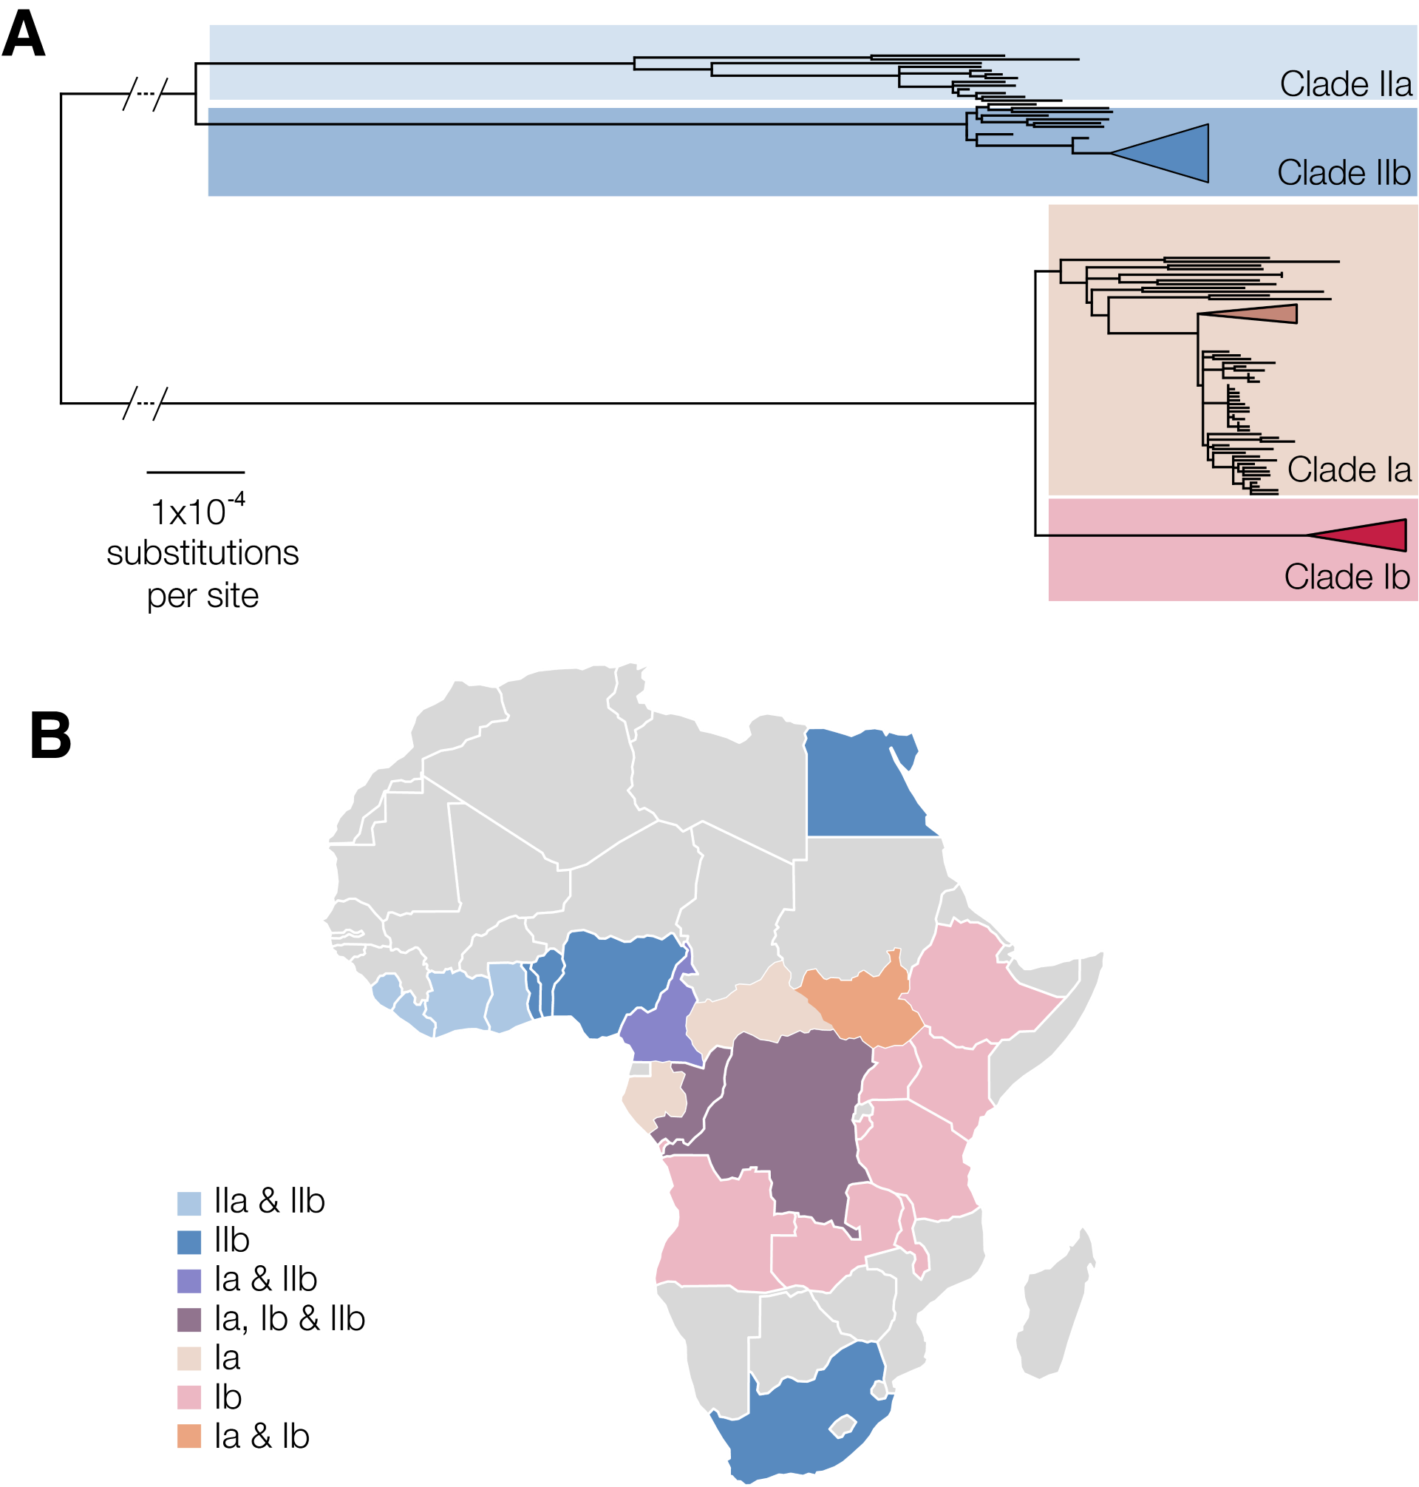

Figure 1: The genetic diversity of MPXV is divided into two main clades: clade I (primarily from Central Africa) and clade II (West Africa). To date, three persistent human epidemics have been characterized, represented by triangles on the phylogenetic tree and corresponding to the persistent human epidemics (sh)-2017 (clade IIb), sh2023 (clade Ib), and sh2024 (clade Ia). B) General distribution of MPXV clades in Africa. Distribution of MPXV clades, including clades Ia, Ib, IIa, and IIb, and their relationship to the lineages responsible for recent epidemics.

3.2. Genomic diversity of MPXV clade Ia
A total of 1,630 MPXV clade Ia genomes from four Central African countries were analyzed. The dataset consisted primarily of genomes from the Democratic Republic of the Congo (DRC, n = 1,514 [92.88%]), with contributions from the Central African Republic (CAR, n = 92 [5.64%]), the Republic of the Congo (DRC, n = 22 [1.35%]), and Cameroon (CAM, n = 2 [0.12%]). To this extensive geographic sample, a set of contextual genomes from clade Ia from the DRC (26), CAR (10), Cameroon (2), Gabon (2), South Sudan (2), and the Republic of the Congo (1) was added. Phylogenetic analysis classified the genomes into different main groups, arbitrarily defined as clusters (Figure 2). Among the previously described clade Ia groups, Group I included genomes from Gabon (2), Cameroon (4), and the Central African Republic (CAR) (2). The two CAR genomes specifically originated from districts near the Cameroonian border. Notably, this group excluded genomes from the Democratic Republic of the Congo (DRC) and the Republic of the Congo (DRC), highlighting the circulation of the virus within a distinct regional reservoir. Group II emerged as the dominant lineage, comprising 1,536 genomes. This group included 20 genomes from the Republic of the Congo (RoC), 90 from the Central African Republic (CAR), and 1,426 from the Democratic Republic of the Congo (DRC). Group II exhibited not only the largest number of genomes but also the greatest genetic diversity (Figure 2). Interestingly, Group II also included genomes linked to the sh2024 outbreak that occurred in Kinshasa, the capital of the DRC. Group III comprised 27 genomes, all originating from the Democratic Republic of the Congo (DRC). Within this group, two distinct subgroups were identified, comprising 13 and 14 genomes, respectively. In addition, we identified a new lineage, called Group VI, closely related to Group III, consisting of 40 genomes from the DRC. Groups IV and V comprised 25 and 6 genomes, respectively, all originating from the DRC. Although small in size, these groups contributed to establishing the overall phylogenetic landscape and highlighted the genomic complexity within the DRC. Finally, two genomes from the DRC and one from the Republic of the Congo did not cluster with any of the previously described groups, suggesting the potential existence of other groups, as was the case for Group V.

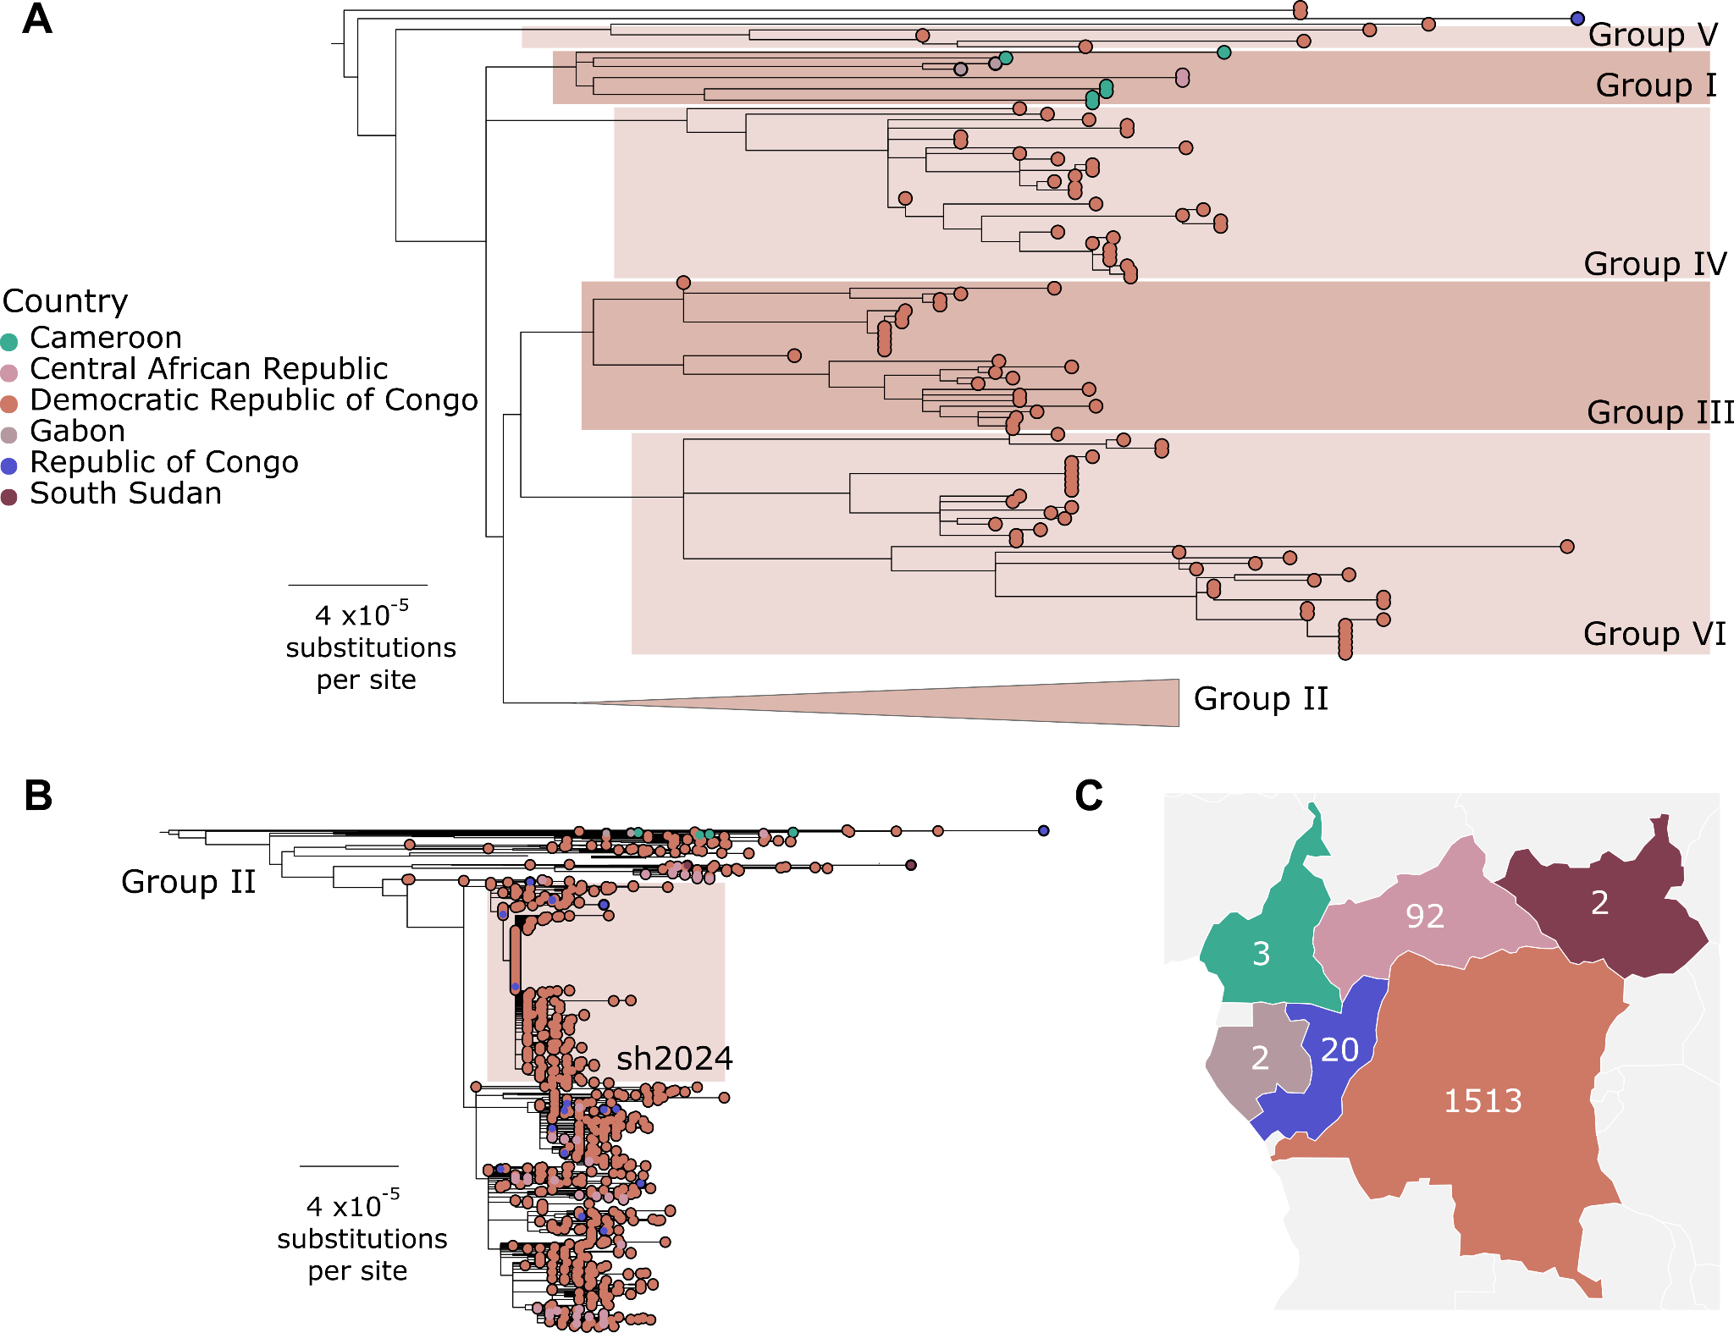

Figure 2. Maximum likelihood phylogenetic tree of MPXV clade Ia. Panel A: Overall tree with the group II genomes grouped together, providing an overview of clade Ia diversity. Panel B: Subtree of group II, highlighting its internal structure and subgroups.
- Discussion
Mpox surveillance in Africa in general, and in the Central African Republic (CAR) in particular, is hampered by a low case confirmation rate, despite the systematic collection of blood, scab, and lesion samples from all suspected patients. The reliability of these results was based on the quality of the data methodologies used. This exclusive access allowed for the acquisition of sequencing data at the sub-regional level and its comparison with data from the Central African Republic at the National Laboratory of Clinical Biology and Public Health. These results confirm the clade structures described previously while also providing new insights into intraclade diversity. Clade Ia appears to be primarily determined by reservoirs in Central Africa, with the DRC, the Republic of China (Republic of China), and the CAR constituting key areas of zoonotic maintenance and diversification. The DRC, in particular, harbors high intraclade diversity (groups II to V) and potential new groups (VI), a DRC-specific cluster, which is consistent with the long-term maintenance of the virus and its local evolution. Neighboring interfaces, such as Cameroon and Gabon, Cameroon and CAR, DRC and CAR, or DRC and the Republic of China, provide clear examples of ongoing zoonotic transmission and cross-border movement. Furthermore, the first documentation of CAR genomes within group I—composed mainly of genomes from Gabon and Cameroon—demonstrates how expanded sampling improves our understanding of the virus's spatial distribution and reinforces the importance of broader regional genomic surveillance. However, we are also observing the emergence of persistent H2H strains in the DRC, indicating that zoonotic maintenance and human-to-human transmission now coexist within this clade Ia [14]. Genomic profiles, combined with transmission within key populations and mobility linked to insecurity and rural vulnerability, promote local amplification and regional spread, thus intensifying the public health threat beyond traditional foci. Unlike clade Ia and ancestral clade I, clade Ib has demonstrated sustained human-to-human transmission, suggesting the involvement of cryptic reservoirs or undetected asymptomatic infections. Its emergence was first observed in the DRC through clustered outbreaks in the eastern region, before spreading to neighboring countries, where significant epidemics have been recorded in Uganda and Burundi [15,16]. Multiple introductions have since been detected in other non-endemic countries in East and Southern Africa, including Ethiopia, Kenya, Tanzania and Malawi, highlighting its geographic expansion and epidemic potential [17].
- Conclusion
Analysis of Mpox virus genomic sequences from the Democratic Republic of Congo, the Central African Republic, Congo-Brazzaville, and Cameroon reveals significant genetic diversity, reflecting both the virus's evolutionary dynamics and the specific epidemiological contexts of each region. The similarities observed between certain sequences suggest epidemiological links and cross-border transmission, while the identified genetic variations demonstrate the virus's ongoing adaptation within human and animal populations. These results underscore the importance of genomic sequencing as a crucial tool for surveillance, understanding transmission, and anticipating the emergence of new Mpox virus lineages in Central Africa. They highlight the need to strengthen regional cooperation, genomic data sharing, and surveillance capacities to improve the prevention and control of future epidemics. Finally, this study contributes to a better understanding of the evolution of the Mpox virus and constitutes a scientific basis for public health.
- References
- Bunge EM, Hoet B, Chen L, et al. The changing epidemiology of human monkeypox—A potential threat? A systematic review. PLoS Negl Trop Dis. 2022;16(2): e0010141.
- Happi C, Adetifa I, Mbala P, Njouom R, Nakoune E, Nkengasong J. Urgent need for a non-discriminatory nomenclature for monkeypox virus. Lancet Infect Dis. 2022 ;22(7) :930–932.
- Van Dijck, C. et al. Émergence du mpox à l'ère post-variolique : une revue narrative sur l'épidémiologie du mpox. Clin. Microbiol Infect. 29, 1487–1492 (2023).
- Isidro J, Borges V, Pinto M, et al. Phylogenomic characterization and signs of microevolution in the 2022 multi-country outbreak of monkeypox virus. Nature Med. 2022 ;28(8) :1569–72.
- Bunge, EM et al. L'évolution de l'épidémiologie de la variole du singe chez l'homme : une menace potentielle ? Une revue systématique. PLoS Negl. Trop. Dis. 16, e0010141 (2022).
- Épidémie de variole du singe (MPX) 2022-2024 : tendances mondiales. Organisation mondiale de la Santé (2024) ; https://worldhealthorg.shinyapps.io/mpx_global/
- Nachega, JB et al. Consortium de recherche sur la variole. La montée de la variole en Afrique : un appel à l’action. Lancet Glob. Santé 2, e1086–e1088 (2024).
- Aksamentov, I., Roemer, C., Hodcroft, E., & Neher, R. (2021). Nextclade: Clade assignment, mutation calling and quality control for viral genomes. Journal of Open Source Software, 6(67), 3773. https://doi.org/10.21105/joss.03773
- Happi, C., Adetifa, I., Mbala, P., Njouom, R., Nakoune, E., Happi, A., Ndodo, N., Ayansola, O., Mboowa, G., Bedford, T., Neher, R. A., Roemer, C., Hodcroft, E., Tegally, H., O’Toole, Á., Rambaut, A., Pybus, O., Kraemer, M. U. G., Wilkinson, E., … De Oliveira, T. (2022). Urgent need for a non-discriminatory and non-stigmatizing nomenclature for the monkeypox virus. PLOS Biology, 20(8), e3001769. https://doi.org/10.1371/journal.pbio.3001769
- O’Toole, Á., Kinganda-Lusamaki, E., Colquhoun, R., Chato, C., Scher, E., Kent, C., Wilkinson, S., Quick, J., Loman, N., Duggan, A. T., Mbala-Kingebeni, P., & Rambaut, A. (2025). Human outbreak detection and best practice MPXV analysis and interpretation with squirrel. Evolutionary Biology. https://doi.org/10.1101/2025.08.13.669859
- Jackson, B. (2022). gofasta: Command-line utilities for genomic epidemiology research. Bioinformatics, 38(16), 4033–4035. https://doi.org/10.1093/bioinformatics/btac424
- Minh, B. Q., Schmidt, H. A., Chernomor, O., Schrempf, D., Woodhams, M. D., Von Haeseler, A., & Lanfear, R. (2020). IQ-TREE 2: New Models and Efficient Methods for Phylogenetic Inference in the Genomic Era. Molecular Biology and Evolution, 37(5), 1530–1534. https://doi.org/10.1093/molbev/msaa015
- Katoh, K., & Standley, D. M. (2013). MAFFT Multiple Sequence Alignment Software Version 7: Improvements in Performance and Usability. Molecular Biology and Evolution, 30(4), 772–780. https://doi.org/10.1093/molbev/mst010
- Kinganda-Lusamaki, E., Amuri-Aziza, A., Fernandez-Nuñez, N., Makangara-Cigolo, J.-C., Pratt, C., Vakaniaki, E. H., Hoff, N. A., Luakanda-Ndelemo, G., Akil-Bandali, P., Nundu, S. S., Mulopo-Mukanya, N., Ngimba, M., Modadra-Madakpa, B., Diavita, R., Paku-Tshambu, P., Pukuta-Simbu, E., Merritt, S., O’Toole, Á., Low, N., … Ahuka-Mundeke, S. (2025a). Clade I mpox virus genomic diversity in the Democratic Republic of the Congo, 2018–2024: Predominance of zoonotic transmission. Cell, 188(1), 4-14.e6. https://doi.org/10.1016/j.cell.2024.10.017
- Wawina-Bokalanga, T., Merritt, S., Kinganda-Lusamaki, E., Jansen, D., Halbrook, M., O’Toole, Á., Pukuta-Simbu, E., Hasivirwe Vakaniaki, E., Ola-Mpumbe, R., Kwete-Mbokama, P., Akil-Bandali, P., Kacita, C., Ponga-Museme, A., Mapenzi-Kashali, N., Amuri-Aziza, A., Tshiani-Mbaya, O., Paku-Tshambu, P., Dantas, P. H. L. F., De Block, T., … Mbala-Kingebeni, P. (2025). Epidemiology and phylogenomic characterisation of two distinct mpox outbreaks in Kinshasa, DR Congo, involving a new subclade Ia lineage: A
- Sganzerla Martinez, G., Kumar, A., Kiganda-Lusamaki, E., Dutt, M., Wawina-Bokalanga, T., Ostadgavahi, A. T., Francisca, M. M., Makangara-Cigolo, J. C., Kelvin, P., Adrienne, A. A., Richardson, C. D., Lokilo, E., Luakanda, G., Ayouba, A., Rimoin, A. W., Mukadi-Bamuleka, D., Delaporte, E., Pilarowski, G., Kindrachuk, J., … Kelvin, D. J. (2024). Mpox virus pangenomics reveals determinants of subclade Ib. Infectious Diseases (except HIV/AIDS). https://doi.org/10.1101/2024.10.31.24315917
- Nachega, J. B., Sam-Agudu, N. A., Ogoina, D., Mbala-Kingebeni, P., Ntoumi, F., Nakouné, E., Njouom, R., Lewis, R. F., Gandhi, M., Rosenthal, P. J., Rawat, A., Wilson, L. A., Kindrachuk, J., Liesenborghs, L., Mills, E. J., Preiser, W., Rimoin, A. W., Sullivan, N. J., Peeters, M., … Muyembe-Tamfum, J. J. (2024). The surge of mpox in Africa: A call for action. The Lancet Global Health, 12(7), e1086–e1088. https://doi.org/10.1016/S2214-109X(24)00187-6

