Original Research Article

Impact of environmental toxicity on systemic inflammation and the progression of bacterial and fungal infections in a mouse model

.
ABSTRACT
Aims: The intensification of human activities in recent years has led to persistent environmental pollution, marked by the accumulation of heavy metals and pesticides due to their widespread and excessive use, raising serious health concerns. At the same time, the resurgence of infectious diseases and the emergence of resistant strains are complicating therapeutic management.
Study design: Experimental study.
Place and Duration of Study: Laboratory of Biotechnology and Valorization of Bioactive Natural Substances Laboratory of the National Center for Floristics (CNF) (Abidjan, Côte d’Ivoire), between July 2023-december 2023.
Methodology: To examine the correlations between exposure to pollutants, inflammatory response, and the worsening of microbial infections. Thus, Wistar rats were exposed to three common environmental pollutants, lead or glyphosate orally or mercury by inhalation, and then infected with Escherichia coli or Candida albicans.
Results: The results obtained show that co-exposure to pollutants and infectious agents significantly worsened the physiological condition of the rats, inducing leukocyte disorganization, persistent systemic inflammation, as well as variable immunosuppression responsible for increased susceptibility to infections. This alteration exhibited increasing severy depending on the toxin (mercury, lead, glyphosate). In contrast, in the absence of toxins, infections remained generally reversible, the maintenance of stable immune parameters. Furthermore, Escherichia coli isolates from rats exposed to lead or mercury showed resistance to fluoroquinolones and reduced sensitivity to beta-lactams and aminoglycosides, while glyphosate did not alter this profile. In addition, Candida albicans isolates remained sensitive to antifungals.
Conclusion: The study showed that exposure to lead and mercury caused severe immunosuppression persistent inflammation and promoted antibiotic resistance, while glyphosate activated persistent chronic systemic inflammation without altering microbial sensitivity.

Keywords: [Environmental toxicity, Microbial infections, Immunotoxicity}
1. INTRODUCTION

The increasing incidence of infections, particularly those linked to the emergence of resistant pathogens, constitutes a major challenge to global public health. Among these, bacterial and fungal infections pose a predominant threat, particularly those caused by bacteria (Escherichia coli, Staphylococcus aureus) and fungi (Candida, Aspergillus, and Cryptococcus) (Dahal et al., 2018 ; Mohsen, 2022). These infections carry a heavy burden of morbidity and mortality, with more than 3.57 million deaths attributable to bacteria and 1.6 million to fungi, exceeding malaria in some cases (Bongomin et al., 2017 ; Dahal et al., 2018). Sub-Saharan Africa remains the most affected region, with more than 90 % of infectious diseases, even though it accounts for only 12 % of the world's population (Fabienne, 2012).
This increased vulnerability is closely linked to unfavorable environmental conditions (Bongomin et al., 2017 ; Kainz et al., 2020). According to the WHO (2022), the environment significantly contributes to the burden of infectious diseases in the region, while simultaneously strengthening that of non-communicable diseases. Thus environmental pollutants, including heavy metals, hydrocarbons, and pesticides, are responsible for nearly 7 million premature deaths each year, over a million of wich occur in Africa (Thurston et al., 2017 ; Caroline et al., 2020 ; OMS, 2024). These substances disrupt physiological homeostasis and induce immunosuppression, compromising the body's ability to control infections (SPF, 2021 ; Hamza et al., 2022 ; Moustapha et al., 2025).
In Côte d'Ivoire, despite the implementation of a health policy, the situation is particularly worrying. Indeed nearly 24 million people are exposed to levels of air pollution exceeding WHO standards (MEDD, 2018). At the same time, more than 7.25 % of the population (1.8 million people) suffer from fungal infections, with alarming prevalence rates of 79.4 % for oropharyngeal infections and 43 % for severe vulvovaginal candidiasis (MEDD, 2018 ; Koffi et al., 2021). The same applies to bacterial infections, which are also a major problem, with urinary tract infections accounting for more than 25 % of cases and a significant proportion of respiratory infections estimated at 8.3 % (Kadiane et al., 2023 ; Gbégbé et al., 2023).
This issue illustrates the double burden faced by populations : environmental exposure and infectious vulnerability. Given this situation, it is crucial to assess the impact of the biotoxicity of environmental pollutants on the organism and on the evolutionary dynamics of bacterial and fungal infections. In this context, Escherichia coli and Candida albicans are two relevant models, due to their clinical prevalence and their major role in opportunistic infections.
Thus, this study conducted on Wistar albino rats, aims to examine the correlations between exposure to pollutants, inflammatory response, and worsening of microbial infections. The expected outcomes should provide key data to better understand the interaction between environmental pollution and human health, particularly in regions heavily exposed to toxic contaminants.

2. material and methods

2.1 Material
2.1.1 Experimental animals : Wistar rats (Rattus norvegicus), aged 8 to 12 weeks, were selected as subjects for this study.
Microorganisms used : A bacterial isolate, Escherichia coli (4744/753), provided by the Medical Biology Laboratory of the Regional Hospital Center of Daloa (Côte d’Ivoire), and a fungi isolate, Candida albicans (0923), from the Laboratory of Biotechnology and Valorization of Bioactive Natural Substances Laboratory of the National Center for Floristics (CNF) (Abidjan, Côte d’Ivoire).
2.1.2 Technical equipment : The study was conducted using standard microbiology laboratory equipment, including the API FUNGUS 3 gallery.
Pollutants : Lead acetate and mercury oxide were supplied by the Laboratory of BioOrganic Chemistry and Natural Substances (LCBOSN) of Félix Houphouët-Boigny University (Abidjan, Côte d'Ivoire). Glyphosate was purchased locally (Bingerville, Côte d'Ivoire).
Antibiotics : The antibiotics used for the antimicrobial profile consisted of five (5) antibacterials (amikacin, kanamycin, tobramycin, cefepime, and levofloxacin) and also five (5) antifungals (amphotericin B, 5-fluorocytosine, fluconazole, itraconazole, and voriconazole).

2.2 Method
2.2.1 Acclimatization and feeding
The rats were kept under standard environmental conditions at 25 °C (± 2) and a 12 hours light/dark cycle. Their diet consisted of pellets (IVOGRAIN®) and bakery bread and free access to water ad libitum.
Before the experiments began, rats were acclimatized for 7 days. The care and handling of rats was carried out in strict compliance with the recommendations on rats (CCPA, 2020).

2.2.2 Preparation of concentrations
The concentrations of lead acetate, mercury oxide, and glyphosate were prepared respectively in accordance with the toxicological reference values with threshold effects adopted by ANSES in 2023 (15 µg. L⁻¹) for lead, ATSDR in 2022 (0.3 µg/m³) for mercury, and CSS in 2020 (0.5 mg/kg/day) for glyphosate.

2.2.3 Preparation of bacterial suspension
This suspension was prepared according to the method used by Cziek et al. (2000) with some modifications.
For this purpose, the bacterial isolate in previously prepared Müller-Hinton agar was incubated at 37 °C for 24 hours. Then, a few colonies were isolated and enriched overnight at 37 °C in 50 mL of buffered peptone water (BPW). Following centrifugation at 7000 tr/10 min, the sediment was suspended in a sterile aqueous solution of 10 % skimmed milk powder and diluted to an estimated concentration of 10⁵ CFU. One (1) mL of this suspension was used to inoculate rats orally on days D₀, D₅, and D₉.

2.2.4 Preparation of fungal suspension
The fungal suspension was prepared followed the method used by Russell & Jones (1973), with a few modifications.
The fungal isolate was subculturer on Sabouraud agar supplemented with chloramphenicol and incubated at 35 °C for 48 hours. The resulting growth was harvested, washed twice by centrifugation at 7000 tr/10 min and suspended in 10 mL of sterile saline solution (0.9 % NaCl) to obtain a final concentration of 6.10⁸ cells/mL.
Each rat was orally inoculated with 0.1 mL of this suspension on days D₀, D₆, D₈, and D₁₀.

2.2.5 Intoxication and development of infection in rats
The study was conducted in accordance with OCDE recommendations 403, 407, 423, and 436 (OCDE, 2001). These methods aim to assess the correlations between exposure to environmental pollutants, systemic inflammation, and the progression of experimental infections.
A total of 54 Wistar rats (Rattus norvegicus) of similar weight were used. The animals were divided into nine (9) Batches of six (6) rats :
• Batch T₀ : negative control (healthy food and water).
• Batches T₁ and T₂ : positive controls infected with Escherichia coli and Candida albicans, respectively.
• Batches ACP₁ and ACP₂ : exposed to lead acetate (orally) and infected respectively by Escherichia coli and Candida albicans
• Batches OME₁ and OME₂ : exposed to mercury oxide (inhalation for 4 hours) and infected with Escherichia coli and Candida albicans, respectively.
• Batches GLY₁ and GLY₂ : exposed to glyphosate (orally) and infected respectively by Escherichia coli and Candida albicans.
All rats were acclimatized before the experiments began. In order to prevent non-specific superinfections and standardize inoculation conditions, a reference antibiotic and antifungal agent were administered : ciprofloxacin 500 mg (0.5 % on D₁ before bacterial infection) and lymecycline 300 mg (0.1 % starting from D₅ before fungal infection) at a rate of 1 mL/100 g body weight.
The infections were then carried out orally :
• Escherichia coli (1 mL of bacterial suspension) on days D₀, D₅, and D₉.
• Candida albicans (0.1 mL of fungal suspension) on days D₀, D₆, D₈, and D₁₀.
Daily clinical monitoring was performed, including monitoring of behavior, appetite, and mobility, recording specific signs of infection. Individual weighings were performed from D₁ to D₂₈ to monitor weight changes as proxy for toxicity and infection.
Weight gain (WG) was calculated using the formula below (Ghasemi et al., 2021) :

$$WG (\%)=\frac{Pt-Pi}{Pi}×100$$
2.2.6 Blood test
The complete blood count (CBC) was performed using 2 mL of blood collected an automaton (Mindray BC-30s). The CRP assay was carried out an automaton (KROMA PLUS Rayto) with 2 mL of blood collected.

2.2.7 Antimicrobial susceptibility profile testing

2.2.7.1 Bacterial isolates

Escherichia coli isolates from infected rats were identified according to the method described by Vilchez et al. (2009). Fecal samples from batches T₀, T₁, ACP₁, OME₁, and GLY₁ were collected and then seeded on MacConkey agar supplemented with crystal violet. The isolates obtained were incubated at 37 °C for 24 hours. Thus, the young colonies were collected using a platinum loop and suspended in 10 mL of 0.9 % (NaCl). The turbidity of the suspension was adjusted to 0.5 McFarland (10⁸ CFU/mL) in accordance with CA-SFM/EUCAST recommendations (SFM, 2024).
The susceptibility test was carried out the agar diffusion method. The standardized suspension was seeded on Mueller-Hinton agar, and antibiotics discs were placed on the surface using sterile forceps. After incubation at 37 °C for 24 hours, the inhibition zones formed around the discs were measured using ImageJ software (version 1.54d).

2.2.7.2 Fungals isolates

Candida albicans isolates from infected rats were identified using chromogenic agar (CHROMagar™ Candida) and their antifungal susceptibility profile was assessed the ATB FUNGUS 3 gallery compliance with the methods of Vilchez et al. (2009) and Preeti et al. (2017).
Fecal samples from batches T₀, T₂, ACP₂, OME₂, and GLY₂ were homogenized in 0.9 % NaCl and then inoculed on Sabouraud agar supplemented with chloramphenicol.
A representative colony was then sampled, diluted in saline solution (NaCl) and spread on CHROMagar™ Candida before incubation at 35 °C for 48 hours. Colonies exhibiting a coloration confirmed the presence of C. albicans.
Confirmed isolates were subjected to antifungal susceptibility test by microdilution in semi-solid medium using the ATB FUNGUS 3 gallery wich includes amphotericin B, 5-fluorocytosine, fluconazole, itraconazole, and voriconazole. From young colonies (48 hours), a standardized suspension at 2 McFarland was prepared using a Densimat, diluted in ATB F2 Medium, and then distributed into the wells of the gallery. After incubation at 35 °C for 48 hours, the growth was read visually against a black background. The minimum inhibitory concentration (MIC) was defined as the lowest antifungal concentration allowing significant inhibition of growth.

2.2.8 Statistical analyses
The data obtained were subjected to variance analysis using GraphPad Prism software version 10.2.0 variance analysis (ANOVA). The inhibition diameters of the antibiograms were determined using ImageJ software version 1.54d. Tukey's multiple comparison test was used to compare the variance of the controls with that of the other groups. The difference is considered significant for a probability level of P < .05.

3. results and discussion

3.1 Results
3.1.1. In vivo impact of pollutants on pathogen infectivity
In negative control rats (batch T₀), free from infection and any exposure to the pollutants tested, no signs of distress or behavioral changes were observed, alongside a gradual and insignificant increase in weight (P > .05) throughout the experiment (Figure 1), confirming a normal physiological development in the absence of chemical or infectious stress.
In the positive control rats from batches T₁ and T₂, infected with E. coli and C. albicans respectively without exposure to toxins, moderate signs of altered general condition were observed. All rats in these two batches had ruffled fur, hypovigilance, frequent sneezing, and mild diarrheal syndrome. These symptoms were accompanied by a transient, non-significant weight loss (P > .05), followed by a gradual recovery from the 14th day for rats infected in batch T₁ and the 21st day for those infected with C. albicans (batch T₂), reflecting reversible physiological stress related to the infection in the absence of co-exposure to a toxic agent (Figure 1).
Furthermore, in rats infected with E. coli (batch ACP₁) and C. albicans (batch ACP₂) and then exposed to lead, a marked deterioration in health was observed with dull fur, impaired social interaction, hypovigilance, partial anorexia, severe diarrhea syndrome, and obstructive dyspnea. These alterations were followed by a very significant reduction (P < .0001) in body growth without recovery. This reflects a major deleterious effect of lead on the pathophysiological condition of the exposed animals (Figure 1).
As for the OME₁ (infected with E. coli) and OME₂ (infected with C. albicans) groups exposed to mercury, severe deterioration was also observed, characterized by marked weight loss, impaired social interaction, obstructive dyspnea, and several cases of mortality from the second week onwards. Body growth dropped significantly (P < .05), with no possible recovery, confirming the particularly deleterious effect of mercury on the well-being, metabolism, and survival of infected rats compared to controls (Figure 1).
In rats exposed to glyphosate and infected with E. coli and C. albicans, respectively (batches GLY₁ and GLY₂), a noticeable but less severe behavioral alteration was observed, characterized by a dull coat, hypovigilance, a tendency toward social isolation, moderate diarrhea, and transient weight loss, accompanied by non significant weight loss followed by a gradual recovery on the 12th day for animals in batch GLY₁ and on 21st day for those in batch GLY₂. This reveals a disruptive effect of glyphosate, less intense than that induced by lead or mercury (Figure 1).

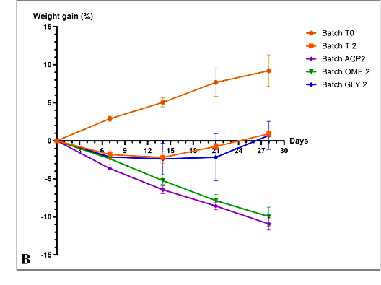
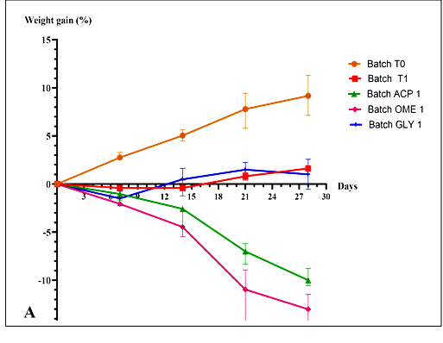

Figure 1 : Curve showing evolution weight gain in rats infected and exposed to pollutants.
A : Infected with E. coli ; B : Infected with C. albicans

3.1.2 Effects of pollutants on leukocyte and inflammatory response
In the negative control rats (batch T₀, uninfected and unexposed), leukocyte parameters remained statistically stable throughout the experiment (p > .05), as did serum CRP levels. These results reflect the absence of toxic-infectious stress and confirm the normal physiological state of the animals in this lot (Figure 2).

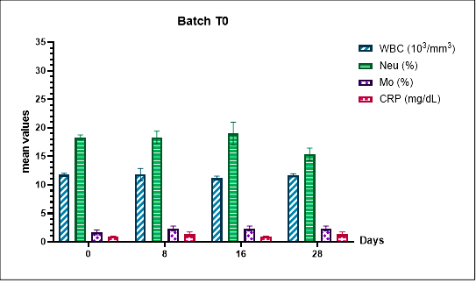

Figure 2 : Histogram showing evolution in leukocyte and inflammatory parameters in negative control rats (batch T₀).
WBC : White blood cells ; Neu : Neutrophils ; Mo : Monocytes ; CRP : C-reactive protein
In positive controls (batches T₁ and T₂), infected with E. coli and C. albicans respectively and not exposed to toxins (lead, mercury, glyphosate), a moderate and non-significant increase in CRP (P > .05) was observed, associated with significant hyperleukocytosis, mainly linked to an increase in neutrophils during the experiment (P < .05) (Figure 3). Monocyte levels remained relatively stable, without significant variation. These results show a moderate activation of the immune response, reflected by neutrophilic leukocytosis in response to infections without toxic stress for these animals of these two batches.
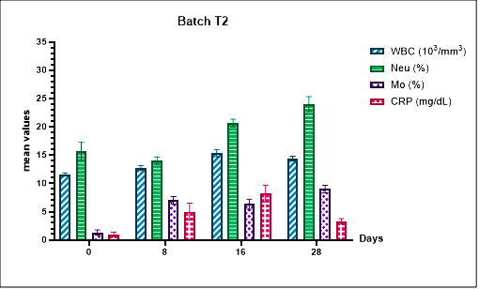
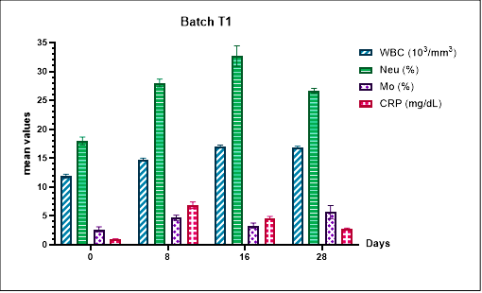

Figure 3 : Histogram showing evolution in leukocyte and inflammatory parameters in rats : batch T₁ (Infected with E. coli) and batch T₂ (Infected with C. albicans) unexposed.
WBC : White blood cells ; Neu : Neutrophils ; Mo : Monocytes ; CRP : C-reactive protein

In animals from batches ACP₁ and ACP₂, exposed to lead acetate and then infected with E. coli and C. albicans, respectively, a highly significant hyperleukocytosis (p≤0.001) was observed in both batches, with a marked increase in neutrophils only in animals infected with E. coli during the first week. This early response was followed by a sharp and significant drop (P < .05) in these same parameters, the number of white blood cells and neutrophils, while the serum CRP level increased gradually and very significantly (P ≤ .01). Furthermore, during the experimental period, the monocyte level increased gradually and significantly (P ≤ .05) (Figure 4).
These results suggest that lead exposure leads to a gradual suppression of the leukocyte response, while enhancing systemic inflammation through an immunosuppressive effect, thereby increasing the rats' vulnerability to bacterial and fungal infections.

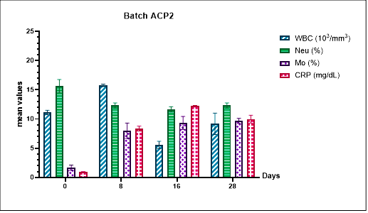
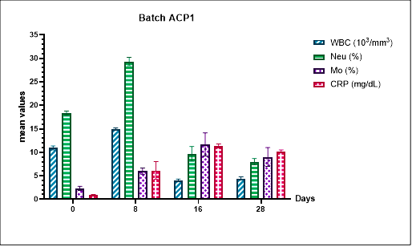

Figure 4 : Histogram showing evolution in leukocyte and inflammatory parameters in rats (batches ACP₁ et ACP₂)
WBC: White blood cells; Neu: Neutrophils; Mo: Monocytes ; CRP: C-reactive protein

In rats exposed to mercury (OME₁ and OME₂ batches) and infected with E. coli and C. albicans, respectively, hyperleukocytosis was observed from the first few days in animals from both groups, with a neutrophilic predominance in the OME₁ group (P < .01). This early response was followed by a sharp and significant (P < .05) drop in these same parameters (white blood cell and neutrophil counts), while a gradual increase in monocytosis was observed in animals in both groups. At the same time, serum CRP levels rose very significantly (P ≤ .01) (Figure 5).
These results reveal that exposure to mercury induces a disruption of the leukocyte profile and persistent systemic inflammation, reflecting an immunosuppressive effect that promotes the progression of bacterial and fungal infections.

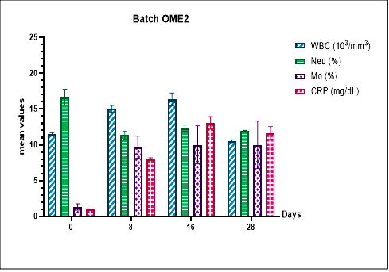
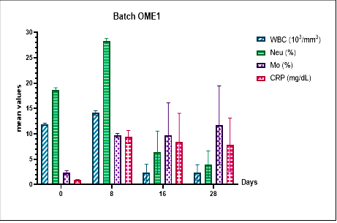

Figure 5 : Histogram showing evolution in leukocyte and inflammatory parameters in rats (batches OME₁ et OME₂)
GB : Globules blancs ; Neu ; Neutrophiles ; Mo : Monocytes ; CRP : Protéine-C-réactive
Regarding animals exposed to glyphosate (batches GLY₁ and GLY₂) and infected with E. coli and C. albicans, respectively, a very significant leukocytosis was observed in both batches, with a marked increase in neutrophils in batch GLY₁ (P ≤ .001). In contrast, in animals from batch GLY₂, a sharp and significant drop in neutrophils was observed (p < .05).
Furthermore, animals from both lots showed a parallel, gradual and significant increase in monocyte levels (P ≤ .05). This change was accompanied by a very significant increase in CRP levels (P ≤ .0001) (Figure 6). These results suggest that exposure to glyphosate leads to a transient disruption of the leukocyte profile and persistent ineffective systemic inflammation, compromising the immune response and promoting the persistence of bacterial and fungal infections.

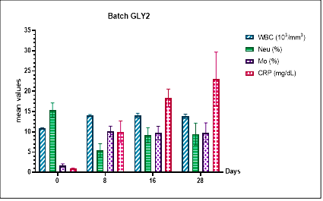
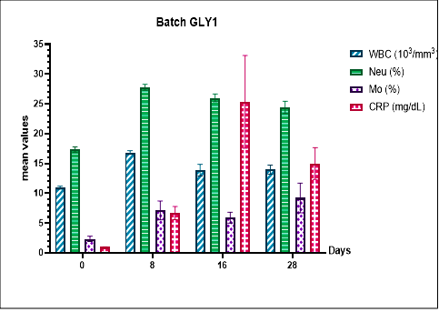

Figure 6 : Histogram showing evolution in leukocyte and inflammatory parameters in rats (batches GLY₁ et GLY₂)
GB : Globules blancs ; Neu ; Neutrophiles ; Mo : Monocytes ; CRP : Protéine-C-réactive
3.1.3 Influence of pollutants on pathogen susceptibility
E. coli isolates from positive control rats (batch T₁), which were not exposed to toxic agents, showed no significant variation in inhibition diameters for the three (3) classes of antibiotics tested: beta-lactam (cefepime), aminoglycoside (amikacin), and fluoroquinolone (levofloxacin) (Table I). These results suggest that the antibiotic susceptibility profile (antibiogram) of these isolates remained stable in the context of infection without biological stress.
Similarly, isolates from infected rats in batch GLY₁, exposed to glyphosate, showed no significant variation in inhibition diameters (Table I). This suggests that, in this toxic-infectious model, exposure to glyphosate did not induce any change in the susceptibility profile of the isolates.
In contrast, isolates from infected rats exposed to lead acetate (batch ACP₁) and mercury oxide (batch OME₁) showed intermediate susceptibility to beta-lactam (cefepime) and aminoglycoside (amikacin), as well as marked resistance to fluoroquinolone (levofloxacin) (Table I). These observations confirm that exposure to lead or mercury promotes an alteration in the sensitivity profile of Escherichia coli isolates, reflecting the emergence of antibiotic-resistant phenotypes.

Table 1 : Inhibition diameters (mm) of Escherichia coli 4447/753 isolates after the experiment
Antibiotic | Initial profile (IP) | Batch T₁ | Batch ACP₁ | Batch OME₁ | Batch GY₁ | Norms (CLSI, 2023)
Aminoglycoside  (Amikacin) | 21 | 21.27±0.15 | 17.78±0.98 | 18.23±0.60 | 21.32±0.06 | S ≥ 20
 |  |  |  |  |  | R ≤ 16
Beta-lactam (Cefepime) | 26 | 26.67±0.16 | 21.09±0.25 | 22.17±0.07 | 26.15±0.33 | S ≥ 25
 |  |  |  |  |  | R ≤ 18
Fluoroquinolone (Levofloxacin) | 21 | 24.18±0.27 | 13.39±0.19 | 12.20±0.26 | 21.39±0.12 | S ≥ 21
 |  |  |  |  |  | R ≤ 16

S : Susceptible ; R : Resistant.

As for the yeast isolates from batches T₂, ACP₂, OME₂, and GLY₂ infected with Candida albicans, no resistance to standard first-line antifungals (fluconazole, itraconazole, voriconazole, and amphotericin B) was observed. Minimum inhibitory concentrations (MICs) remained constant for all batches (Table II), indicating preserved susceptibility according to the criteria of the ATB FUNGUS 3 gallery. These results suggest that exposure to toxic agents did not alter the antifungal susceptibility profile of this yeast isolate (C. albicans 0923).

Table 2 : MIC of Candida albicans 0923 isolates after exposure to pollutants

Antifungal | ATB FUNGUS 3 Norms | Initial profile (PI) | Batch T₂ | Batch ACP₂ | Batch OME₂ | Batch GLY₂ | Results
Fluconazole (FCA) | S ≤ 8 mg/L | 1 | 1 | 1 | 1 | 1 | S
Fluconazole (FCA) | R ≥ 64 mg/L
Itraconazole (ITR) | S ≤ 0.12 mg/L | 0.125 | 0.125 | 0.125 | 0.125 | 0.125 | S
Itraconazole (ITR) | R ≥ 1 mg/L
Voriconazole (VRC) | S ≤ 1 mg/L | 0.06 | 0.06 | 0.06 | 0.06 | 0.06 | S
Voriconazole (VRC) | R ≥ 4 mg/L
Amphotéricine B (AMB) | S - mg/L | 0.5 | 0.5 | 0.5 | 0.5 | 0.5 | S
Amphotéricine B (AMB) | R ≥ 2 mg/L

S : Susceptible ; R : Resistant

3.2 Discussion
The results of our study reveal a worrying correlation between environmental pollution, induction of severe ineffective inflammation and worsening of microbial infections, such as those caused by Escherichia coli and Candida albicans.
Conducted on a murine model, this observation highlights the direct impact of environmental pollutants (lead, mercury, glyphosate) on infectious dynamics and immune response, with potential implications for human health and for public health. The clinical manifestations observed, associated with significant hematological and biochemical alterations, highlight a marked disruption of leukocyte and inflammatory functions.
Thus, in rats infected with E. coli and C. albicans and not exposed to the studied toxins, hyperleukocytosis was observed, reflecting an effective immune response to the infectious proliferation. This hyperleukocytosis was accompanied by a moderate increase in C-reactive protein (CRP), an inflammatory marker, and gradual weight recovery. This profile can be explained by transient metabolic stress induced by immune activation, with secretion of pro-inflammatory cytokines (IL-1β, TNF-α, IL-6). These mediators, known to stimulate CRP production, temporarily alter energy metabolism and appetite (inflammatory anorexia), while promoting the eradication of pathogens (Hotamisligil, 2006 ; Semple et al., 2011). These observations are consistent with those of Lytvynenko & Makyeyeva (2021), who report hyperleukocytosis with marked neutrophilia during purulent peritonitis in rats, as well as those of Colette et al. (2020), who describe weight recovery and gradual recovery after intraperitoneal inoculation of a microbial isolate over 90 days.
Conversely, in rats infected with either E. coli or C. albicans and exposed to lead, severe leukopenia secondary to transient hyperleukocytosis was observed, reflecting a collapse of the immune response. This immune suppression favored the persistence of a systemic inflammatory state, marked by excessive elevation of CRP, considerable weight loss, and a general deterioration in clinical condition. These results suggest that lead inhibits the effectiveness of the leukocyte response while exacerbating the production of pro-inflammatory mediators, amplifying the deleterious effects of infection. These findings align the work of Flora et al. (2012), who showed that lead exposure induces major oxidative stress, impaired immune function, and increased acute phase proteins. The same applies of the work of López et al. (2020), who report increased leukocyte apoptosis in workers chronically exposed to lead, increasing their vulnerability to infection.
Similarly, exposure of infected rats (E. coli or C. albicans) to mercury led to very severe leukopenia, following transient hyperleukocytosis. This deep immune suppression resulted in persistent systemic inflammation, marked by excessive CRP elevation, significant weight loss, marked clinical deterioration, and several deaths. These results reflect an overall weakening of the immune response and impaired hematopoiesis, compromising the body's ability to effectively control infection. These results corroborate the findings of Vianna et al. (2019), who through a systematic review of 1,297 studies published between 1950 and 2018, showed that chronic exposure to mercury induced various hematological effects affecting all cell lines, with a predominance of anemia, leukopenia, and neutropenia, often associated with death. Similar results were reported by Winiarska et al. (2020), describing a significant decrease in body weight, elevated inflammatory markers, and multivisceral lesions in rats exposed to mercury.
Regarding exposure to glyphosate, rats infected with E. coli or C. albicans showed persistent leukocytosis, reflecting excessive and prolonged stimulation of the inflammatory response. This condition was accompanied by significantly elevated CRP levels, slight weight loss, and clinical impairment, suggesting the persistence of chronic inflammation. This profile can be explained by glyphosate's ability to disrupt oxidative metabolism, leading to excessive production of reactive oxygen species (ROS) which are responsible for cellular oxidative stress and persistent activation of the NF-κB (Nuclear Factor kappa-light-chain-enhancer of activated B cells) pathway. Abnormal activation of this pathway induces overexpression of pro-inflammatory cytokines (IL-6, TNF-α), maintaining a systemic inflammatory state (Marino et al., 2021 ; Sikora et al., 2023). Similar observations have been reported by Mao et al. (2018) and Duforestel et al. (2019), who report dysregulation of the NF-κB pathway by glyphosate. It is the same in the work of Yuhong et al. (2022), which describes a disorganized innate immune response in infected rats.
In addition to the alterations observed, in vivo exposure to the toxic agents studied (lead, mercury, glyphosate) influenced the infectious dynamics by modifying the susceptibility of pathogens. Observations made on bacterial isolates not exposed to pollutants, particularly Escherichia coli, revealed an unchanged, stable susceptibility profile, regardless of the duration of infection. These pathogens remained sensitive to the three classes of antibiotics tested, in line with their initial profile. This reflects the absence of selective pressure and suggests that a pathogen's antibiotic susceptibility profile remains unchanged during reinfection. These results are in agreement with those of Hidad et al. (2022), who showed that recurrence of the same E. coli strain could occur more than 400 days after the index infection, with low antimicrobial resistance rates.
In contrast, those from rats exposed to lead and mercury exhibited an altered profile, characterized by intermediate resistance to beta-lactams and aminoglycosides and marked resistance to fluoroquinolones. These results indicate that lead and mercury cause intoxication by disrupting host-microbe interactions and inducing adaptive mechanisms, exerting indirect selective pressure conducive to the emergence of less sensitive bacterial strains, independently of any antibiotic pressure. This phenomenon was also observed at the University of Geneva, where Pseudomonas aeruginosa developed resistance to imipenem in the presence of metals particularly cobalt and cadmium, even at low concentrations (Anton, 2005 ; Danielle, 2011). The same applies to the work of Pal et al. (2015), who showed that exposure to environmental pollutants, such as metals, promotes co-localization on plasmids of antibiotic and heavy metal resistance genes.
Furthermore, bacterial isolates from rats exposed to glyphosate retained a susceptibility profile similar to that of the controls. They remained susceptible to the three classes of antibiotics tested. This stability suggests that, despite being an environmental pollutant, glyphosate does not exert selective pressure comparable to heavy metals and does not promote the co-selection of resistance genes. These results corroborate those of Pöppe et al. (2020), who showed that Salmonella enterica, an enterobacterial species exposed to glyphosate, did not develop cross-resistance or permanent activation of tolerance or stress mechanisms.
As for yeast isolates, particularly Candida albicans isolated from lead, mercury, and glyphosate exposure, no change in susceptibility to first-line antifungals was observed. Minimum inhibitory concentrations (MICs) remained unchanged compared to the initial profile. This suggests that this fungal isolate is less sensitive to the selective pressures exerted by these pollutants and does not develop tolerance or induced resistance, unlike bacteria. These observations are consistent with those of Hunsaker & Franz (2019), who showed that C. albicans, although adapting its metal homeostasis in response to fluconazole, did not exhibit a loss of clinical susceptibility, with MICs remained stable despite these adaptations.

4. Conclusion

This study highlights the exacerbating role of environmental pollution on immunity and microbial infectivity. The results show that exposure to lead and mercury resulted in severe leukopenia, hematopoietic dysregulation, and persistent and ineffective systemic inflammation, leading to severe immunosuppression and increased mortality. At the same time, bacterial isolates from these models revealed a shift towards antibiotic resistance profiles, confirming the role of heavy metals as inducers of selective pressures and catalysts of genetic co-selection mechanisms. Conversely, exposure to glyphosate, although associated with chronic ineffective inflammatory activation, did not alter the antimicrobial susceptibility of pathogens tested. The species Candida albicans, for its part, remained phenotypic stability with regard to antifungal agents.
These results highlight the major health hazard posed by heavy metals, not only through their cytotoxic and immunotoxic effects, but also through their silent contribution to the emergence and spread of direct antibiotic resistance, and reinforce the need to consider environmental pollutants in an integrated approach to combating antibiotic resistance.

References
- Dahal, R. H. & Chaudhary, D. K. (2018). Microbial infections and antimicrobial resistance in Nepal : current trends and recommendations. The Open Microbiology Journal, 12, 230.
- Mohsen, N. (2022). Global burden of bacterial antimicrobial resistance in 2019 : a systematic analysis, Lancet, 399, 629-655.
https://doi.org/10.1016/ S0140-6736(21)02724-0
- Bongomin, F., Gago, S., Oladele, R. O., & Denning, D. W. (2017). Global and multi-national prevalence of fungal diseases estimate precision. Journal of fungi, 3(4), 1-57.
- Fabienne, K. (2012). Les nouvelles menaces des maladies infectieuses émergentes. Rapport d ́information N°638, Sénat Session extraordinaire de 2011-2012, 233p. https://www.senat.fr/rap/r11-638/r11-638_mono.html
- Kainz, K., Bauer, M. A., Madeo, F. & Carmona-Gutierrez, D. (2020). Fungal infections in humans : The silent crisis. Microbial Cell, 7, 143-145.
- OMS (2022). Stratégie régionale actualisée pour l’action sur les déterminants environnementaux de la santé humaine dans la région Africaine 2022-2032. Rapport, Soixante-douzième session, Comité Régional de l’Afrique, République Togolaise, 11p. https://www.afro.who.int/sites/default/files/2022-07/AFR-RC72-10%20Strat%C3%A9gie%20r%C3%A9gionale%20pour%20l%E2%80%99action%20sur%20les%20d%C3%A9terminants%20environnementaux%20de%20la%20sant%C3%A9%20humaine%20dans%20la%20R%C3%A9gion%20africaine%202022-2032.pdf
- Thurston, G. D., Kipen, H., Annesi-Maesano, I. (2017). A joint ERS/ATS policy statement : what constitutes an adverse health effect of air pollution ? An analytical framework. European Respiratory Journal, 49, 1600419.
https://doi :10.1183/13993003.00419-2016
- Caroline, M., Sébastien, L., Bénédicte, J. & Émeline, L. (2020). Métaux, pollution de l’air et santé, les mousses, des alliées originales en épidémiologie. Médecine/Sciences, 36, 376-81
- OMS (2024). Pollution de l’air ambiant (extérieur). En ligne https://www.who.int/fr/news-room/fact-sheets/detail/ambient-(outdoor)-air-quality-and-health
- Santé Publique France (SPF) (2021). Imprégnation de la population française par les métaux et métalloïdes. Programme national de biosurveillance, Esteban 2014-2016. Synthèse/Etudes et Enquête, Saint-Maurice, France, 12p.
https://www.santepubliquefrance.fr/docs/impregnation-de-la-population-francaise-par-les-metaux-et-metalloides.-programme-national-de-biosurveillance.-esteban-2014-2016
- Hamza, R., Sarmad, A. Q., Tuan, A. N., Muhammad, B. & Hafiz, M. N. I. (2022). 20 - Microbial degradation of environmental pollutants. In Micro and Nano Technologies (Eds), Hafiz, M.N. Iqbal, M. B., Tuan A. N., Ghulam Y. (Elsevier, 509-528). Biodegradation and Biodeterioration At the Nanoscale.
- Moustapha, K., Guillaume, Y. Y., Timothée, A. O., Amadou, D., Ange, N. G. K., Barthélemy, K. A. & Joseph, A. D. (2025). Incidence of Lead and Mercury Biotoxicity in Rats with Escherichia coli Infections. International Journal of Current Microbiology Appllied Sciences, 14(05), 170-180. https://doi.org/10.20546/ijcmas.2025.1405.017
- Ministère de l’Environnement et du Développement Durable (MEDD) (2018). La Politique Nationale de l’Environnement et du Développement Durable. Rapport, Abidjan, Côte d’Ivoire, 91p.
https://environnement.gouv.ci/wp-content/uploads/2022/08/Politique-Nationale-de-lEnvironnement-et-du-Developpement-Durable-2018.pdf
- Koffi, D., Bonouman, I. V., Touré, A. O., Kouadjo, F., N’Gou, M. B. R., Sylla, K., et al. (2021). Estimates of serious fungal infection burden in Côte d’Ivoire and country health profile. Journal of Medical Mycology, 31(1), 101086.
- Kadiane, O. N. J., Koné, D., Oussou, K. R., Yapo, M. T., Karidioula, J. M., Tiéoulé, S. C., et al. (2023). Prévalence des infections nosocomiales au Centre Hospitalier Universitaire (CHU) de Bouaké, Côte d'Ivoire. Revue africaine d’Anesthésiologie et de Médecine d’Urgence, 28 (2), 61-65.
- Gbégbé, D. A., N’Zi, N. P., Monthaut, S., Allé, A. P. & Angaman, D. M. (2023). Prévalence et écologie microbienne des infections des voies urinaires au CHR de Daloa (Côte d’Ivoire). Journal of Applied Biosciences, 192, 20319-20330.
- Conseil Canadien de Protection des Animaux (CCPA). (2020). Lignes directrices du CCPA : les rats, 119 p.
https://ccac.ca/Documents/Normes/Lignes_directrices/Lignes_directrices_du_CCPA_sur_les_rats-Sept2022.pdf
- Agence nationale de sécurité sanitaire de l'alimentation, de l'environnement et du travail (ANSES). (2023). Liste des Valeurs Toxicologiques de Référence (VTR) de l’ANSES. 7p. https://www.anses.fr/fr/content/liste-des-valeurs-toxicologiques-de r%C3%A9f%C3%A9rence-vtr-de-l%E2%80%99anses
- Agency for Toxic Substances and Disease Registry (ATSDR). (2022). Toxicological profile for mercury. U.S Department of health and human services, 847p. https://www.atsdr.cdc.gov/ToxProfiles/tp46.pdf
- Conseil Supérieur de la Santé (CSS) (2020). Formulations de glyphosate et contenant du glyphosate. Avis n° 9561, Bruxelles, Belgique, 62p.
https://www.hgr-css.be/fr/avis/9561/formulations-de-glyphosate-et-contenant-du-glyphosate ?
- Cziek, A., Literak, I., & Scheer, P. (2000). Survival of Escherichia coli O157 in faeces of experimentally infected rats and domestic pigeons. Letters in Applied Microbiology, 31(5), 349-352.
- Russell, C., & Jones J., H. (1973). Effects of oral inoculation of Candida albicans in tetracyclinetreated rats. Journal of Medical Microbiology, 6, 275-279.
- OCDE (2001). Ligne directrice de L’OCDE pour les essais de produits chimiques. En ligne https://www.oecd.org/fr/data/methods.html.
- Ghasemi, A., Jeddi, S. & Kashfi, K. (2021). The laboratory rat : Age and body weight matter. EXCLI Journal, 20, 1431-1445.
- Vilchez, S., Reyes, D., Paniagua, M., Bucardo, F., Möllby, R., & Weintraub, A. (2009). Prevalence of diarrhoeagenic Escherichia coli in children from Leon, Nicaragua. Journal of medical microbiology, 58(5), 630-637.
- Société Française de Microbiologie (SFM) (2024). Détermination de la sensibilité aux antibiotiques. In : CA-SFM / EUCAST : Société Française de Microbiologie, Paris, France, 12-37.
https://www.sfm-microbiologie.org/wp-content/uploads/2024/06/CASFM2024_V1.0.pdf
- Preeti, S., Sorabh, S., S., & Divya, S. (2017). Evaluation of Candida species from clinical specimens by using CHROMagar. International Journal of Advanced Research, 5(2), 750-1755.
- Clinical and Laboratory Standards Institute (CLSI) (2023). Antimicrobial Susceptibility Summary 2023. Clinical Microbiology, Department of Pathology and Laboratory Medicine, UCLA Health System, 50p.
https://asp.mednet.ucla.edu/file/43239/2023_antibiogram_corrected.pdf
- Hotamisligil, G. S. (2006). Inflammation and metabolic disorders, Nature, 14, 444(7121), 860- 867. https://doi : 10.1038/nature05485
- Semple, J. W., Italiano, J. E. & Freedman, J. (2011). Platelets and the immune continuum, Nature Reviews Immunology, 11(4), 264-274.
- Lytvynenko, R. O. & Makyeyeva, V. L. (2021). Hematological leukocytes ratio indices: predictors of acute purulent fecal peritonitis in nonlinear laboratory rats. Journal Advanced Biotechnology and Experimental Therapeutics, 4(2), 120-132. https://doi:10.5455/jabet.2021.d113
- Colette, C., Magali, T., Matthieu, B., Jean-Loup B., Olivier F., Koussay D., et al., (2020). Pathogenic Leptospira and their animal reservoirs : testing host specificity through experimental infection. Scientific Reports, 10(1), 7239. https://doi.org/10.1038/s41598-020-64172-4
- Flora, G., Gupta, D. & Tiwari, A. (2012). Toxicity of lead : a review with recent updates. Interdisciplinary toxicology, 5(2), 47.
- López, V. N. C., Hernández, G., Maldonado, V. M., Calderón, S. J. V. (2020). Leukocyte apoptosis, TNF-α concentration and oxidative damage in leadexposed workers. Toxicology and Applied Pharmacology, 391, 114901. https://doi.org/10.1016/j.taap.2020.114901
- Vianna, A. D. S., Matos, E. P. D., Jesus, I. M. D., Asmus, C. I. R. F. & Câmara, V. D. M. (2019). Human exposure to mercury and its hematological effects : a systematic review, Cadernos de saude publica, 35 (2), e00091618.
- Winiarska, M. A., Baranowska, W. E., Kwiecień, M., Grela, E. R., Szwajgier, D., Kwiatkowska, K., et al. (2020). The role of dietary antioxidants in the pathogenesis of neurodegenerative diseases and their impact on cerebral oxidoreductive balance. Nutrients, 12(2), 435. https://doi:10.3390/nu12020435
- Marino, M., Mele, E., Viggiano, A., Nori, S. L., Meccariello, R. & Santoro, A. (2021) Pleiotropic Outcomes of Glyphosate Exposure : From Organ Damage to Effects on Inflammation, Cancer, Reproduction and Development. International Journal of Molecular Sciences, 22, 12606. https://doi.org/10.3390/ ijms222212606
- Sikora, J., Jagielska, J., & Kaszkowiak, K. (2023). The effect of low doses of glyphosate on reactive oxygen species production by human granulocytes. European Journal of Biological Research, 13(3), 161-172.
https://doi.org/10.5281/zenodo.8428575
- Mao, Q., Manservisi, F., Panzacchi, S., Mandrioli, D., Menghetti, I., Vornoli, A., et al. (2018). The Ramazzini Institute 13-week pilot study on glyphosate and Roundup administered at human-equivalent dose to Sprague Dawley rats : effects on the microbiome. Environmental Health, 17, 1-12.
- Duforestel, M., Nadaradjane, A., Bougras, C. G, Briand, J., Olivier, C., Frenel, et al., (2019). Glyphosate Primes Mammary Cells for Tumorigenesis by Reprogramming the Epigenome in a TET3-Dependent Manner. Frontiers in Genetics, 10, 1-14.
https://pmc.ncbi.nlm.nih.gov/articles/PMC6777643/
- Yuhong, H., Fei, X., Yongkang, Q., Kai, X., Yunqiu, P., Jiawei, et al. (2022). Hematological effects of glyphosate in mice revealed by traditional toxicology and transcriptome sequencing, Environmental Toxicology and Pharmacology, 92, 103866. https://doi.org/10.1016/j.etap.2022.103866.
- Hidad, S., Van der Putten, B., Van Houdt, R., Schneeberger, C., Kuil, S. D. (2022). Recurrent E. coli Urinary Tract Infections in Nursing Homes : Insight in Sequence Types and Antibiotic Resistance Patterns. Antibiotics, 11, 1638.
https:// doi.org/10.3390/antibiotics11111638
- Anton, V. (2005). Résistance aux antibiotiques : les métaux lourds en question. Revue Médicale Suisse, p1820.
https://www.revmed.ch/view/633807/4915382/RMS_27_1820.pdf
- Danielle, C. (2011). Fiche technique : Pseudomonas aeruginosa. Fiche technique Bactériologie, Centre Toulousain pour le Contrôle de qualité en Biologie clinique, Toulouse, France, 4p.
https://www.ctcb.com/documentation/Fiches%20techniques%20BAC/Pseudomonas%20aeruginosa%20(Edition%202011).pdf
- Pal, C., Bengtsson, P. J., Kristiansson, E. & Larsson, D. J. (2015). Co-occurrence of resistance genes to antibiotics, biocides and metals reveals novel insights into their co-selection potential, BMC genomics, 16, 1-14.
- Pöppe, J., Bote, K., Ramesh, A., Murugaiyan, J., Kuropka, B., Kühl, et al. (2020). Selection for resistance to a glyphosate-containing herbicide in Salmonella enterica does not result in a sustained activation of the tolerance response or increased cross-tolerance and cross-resistance to clinically important antibiotics. Applied and Environmental Microbiology, 86 : e01204-20. https://doi.org/10.1128/AEM.01204- 2
- Hunsaker, E. W. & Franz, K. J. (2019). Candida albicans reprioritizes metal handling during fluconazole stress. Metallomics, 11(12), 2020-2032.

