Assessment of Hydrological Response and Parameter Sensitivity in the Jonk Sub-Basin Using SWAT-CUP

Abstract
This study assesses the hydrological response of the Jonk sub-basin using the Soil and Water Assessment Tool (SWAT) integrated with Remote Sensing (RS) and Geographic Information System (GIS) techniques. The model was developed using spatial inputs such as Digital Elevation Model (DEM), land use/land cover, and soil data, along with climatic parameters including precipitation and temperature, while SWAT-CUP was employed for calibration, validation, and sensitivity analysis. The model exhibited satisfactory performance, with calibration results showing good agreement between observed and simulated streamflow (R² = 0.83, NSE = 0.82) and validation results (R² = 0.84, NSE = 0.88), indicating reliable predictive capability. Sensitivity analysis revealed that HRU_SLP.hru, GWQMN.gw, and OV_N.hru are the most influential parameters governing runoff, emphasizing the role of slope, groundwater threshold, and surface characteristics. SWAT-CUP is an effective tool for hydrological model calibration, validation, and uncertainty analysis, enhancing simulation accuracy and supporting sustainable watershed management and water resource planning.
Keywords: SWAT model, SWAT-CUP, Hydrological modeling, Runoff simulation, Calibration and validation, Sensitivity analysis, GIS and Remote Sensing, Jonk sub-basin
Introduction
Watershed models are essential tools for evaluating the impacts of land use and climate change on water resources, as they simulate complex hydrological processes while considering spatial variability within a basin. The integration of Remote Sensing (RS) and Geographic Information Systems (GIS) provides accurate and up-to-date spatial data, which is crucial for effective watershed modeling. These technologies enable the extraction and analysis of key parameters such as land use, soil characteristics, and topography, thereby supporting reliable runoff estimation and water resource planning.
Runoff plays a significant role in a wide range of applications, including flood forecasting, irrigation planning, reservoir management, water supply systems, and environmental assessment. It can be estimated using both direct methods, such as field-based instruments, and indirect methods, including empirical and analytical approaches like the SCS Curve Number method and unit hydrograph techniques. Accurate runoff prediction is essential for minimizing errors in the design and management of hydraulic structures and for ensuring sustainable utilization of water resources.
Among the various hydrological models available, the Soil and Water Assessment Tool (SWAT) have gained widespread acceptance due to its ability to simulate long-term watershed processes effectively. In this study, SWAT was applied in conjunction with SWAT-CUP for calibration and sensitivity analysis of model parameters. The model demonstrated satisfactory performance, indicating its reliability and suitability for hydrological assessment and water resource management in the study area.
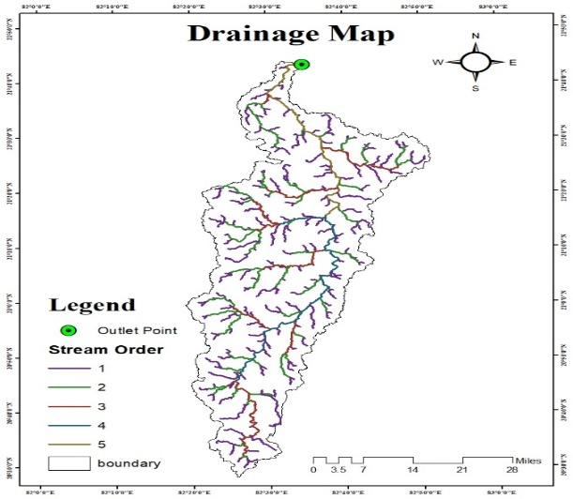
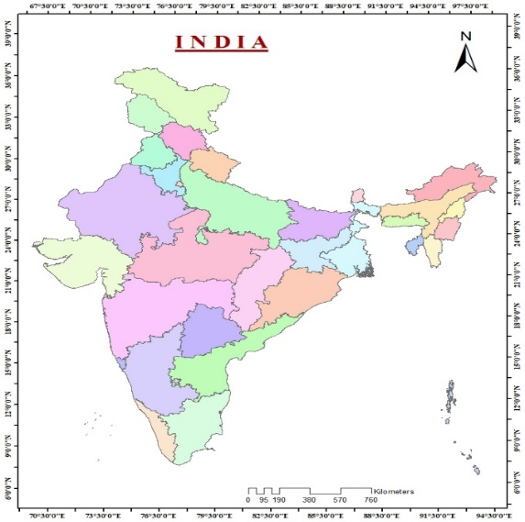
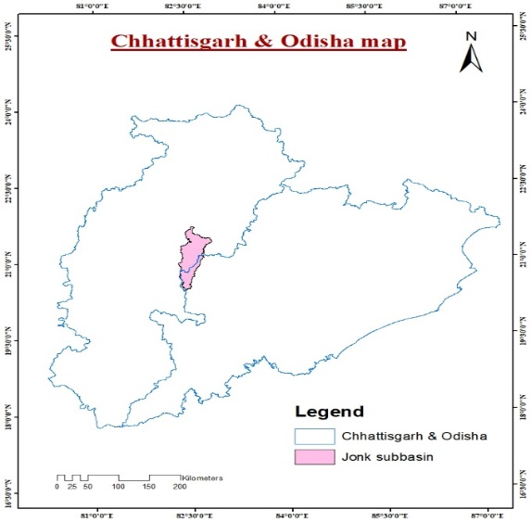
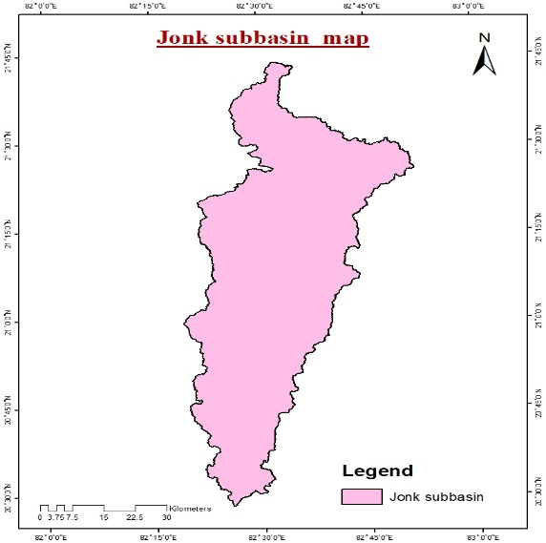
Study Area

Fig 1: Location Plan of Jonk Sub-Basin
The Jonk sub-basin is located between 82°25′37″E to 82°34′02″E longitudes and 20°28′17″N to 21°42′55″N latitudes, covering an area of about 3,330 km². The elevation ranges from 203 m to 868 m above mean sea level. The Jonk River originates from the Khariar Hills in Nuapada district of Odisha and flows northward through Mahasamund and Gariyaband districts before joining the Mahanadi River at Shivrinarayan in Balodabazar district. The river, approximately 215 km long, is fed by several tributaries such as Bhandar, Kolar, Machka, Chirar, Bagh, Bhuisa, Karnel, and Lamhar, and partly forms the boundary between Chhattisgarh and Odisha.
Land use in the watershed is dominated by agriculture, forest, and settlements, which together account for nearly 95% of the total area. Major crops grown during the Kharif season include paddy, maize, and pulses, while wheat and other cereals are cultivated during the Rabi season. The region experiences a subtropical climate, with temperatures ranging from 2.35°C to 48.4°C. The average annual rainfall is about 1,237 mm, with most precipitation occurring during the monsoon months (July–September) and very little rainfall during the rest of the year.
Methodology
The Soil and Water Assessment Tool (SWAT) is a physically based and widely adopted hydrological model developed to assess the impact of land management practices on water resources, sediment transport, and agricultural productivity in large and complex watersheds. Its capability to simulate long-term hydrological processes under varying land use, soil, and climatic conditions makes it a robust tool for watershed-scale analysis. The model integrates multiple hydrological and environmental processes, including surface runoff, evapotranspiration, groundwater flow, percolation, and channel routing, thereby providing a comprehensive representation of watershed dynamics.
The implementation of the SWAT model requires the integration of spatial datasets such as Digital Elevation Model (DEM), land use/land cover, and soil maps, which form the basis for watershed characterization. These inputs are processed through a systematic procedure involving watershed delineation, classification and reclassification of spatial data, and the generation of Hydrological Response Units (HRUs). HRUs represent homogeneous areas within the watershed defined by unique combinations of land use, soil, and slope, enabling improved representation of spatial heterogeneity in the model.
In addition to spatial inputs, the model incorporates climatic data such as precipitation, temperature, wind speed, relative humidity, and solar radiation, which are essential for simulating hydrological processes. These data are organized into SWAT-compatible formats along with supporting databases, including weather generator and soil property datasets. Following the preparation of all required inputs, the model is executed to simulate the hydrological behavior of the watershed, providing valuable insights for water resource planning and management.
Data Collection
The study utilized meteorological, topographical, geographical, and hydrological data for model development. Meteorological data included precipitation, temperature, humidity, wind speed, and solar radiation, while topographical data were obtained from ISRO Bhuvan (Cartosat-1, 30 m) in the form of a Digital Elevation Model (DEM). Soil and land use/land cover (LULC) data were sourced from National Bureau of Soil Survey and Land Use Planning (NBSS&LUP) Nagpur, Bhuvan, and Global Land 30, and historical streamflow data were collected from Water Resources Development Chhattisgarh, Central Water Commission (CWC) Bhubaneshwar, and India WRIS for calibration and validation purposes.
The SWAT model, a physically based tool for long-term hydrological simulation, was used to estimate runoff using the SCS-CN method. The modeling process involved watershed delineation into sub-basins, followed by the creation of Hydrological Response Units (HRUs) based on soil, land use, and slope characteristics, with the overall procedure implemented through a systematic workflow.

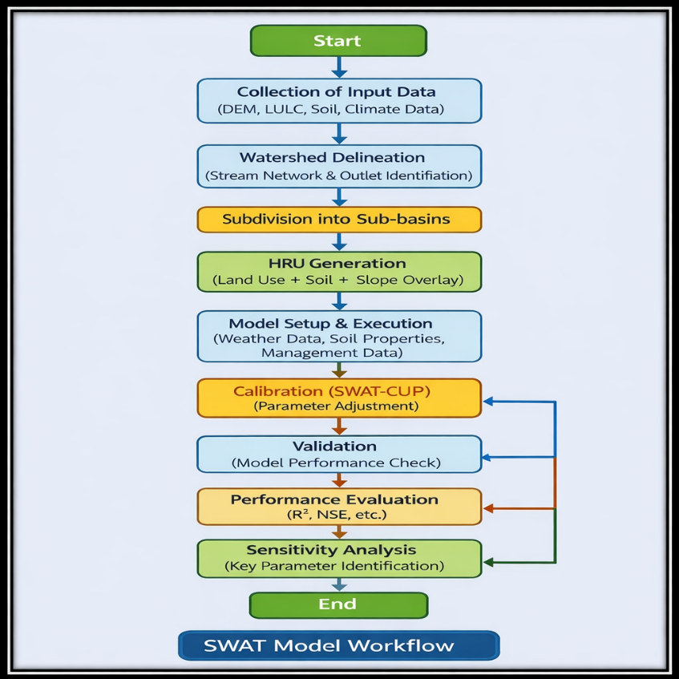

Fig 2: FLOWCHART OF SWAT MODEL FOR JONK SUBBASIIN
The SWAT model workflow begins with the collection of essential input data, including Digital Elevation Model (DEM), land use/land cover (LULC), soil, and climate data, followed by watershed delineation to define stream networks and outlet points. The basin is then subdivided into smaller sub-basins, and Hydrological Response Units (HRUs) are generated by overlaying land use, soil, and slope characteristics. After setting up and running the model with relevant weather, soil, and management inputs, calibration is performed using SWAT-CUP to optimize parameters, followed by validation to assess model reliability. The model’s performance is evaluated using statistical indicators such as R² and NSE, and sensitivity analysis is conducted to identify key influencing parameters, ensuring a robust and scientifically reliable hydrological simulation process.
DESCRIPTION OF SWAT STEPS
Description of the SWAT Model
The SWAT (Soil and Water Assessment Tool) model operates based on a comprehensive water balance approach (Parikh, 2019). It is designed to estimate both runoff volumes and peak flow rates within a watershed.The water balance equation used in the SWAT model is expressed as:
$$SW_{t}=SW_{0}+\sum_{i=1}^{t}{(}R_{day}-Q_{surf}-E_{a}-W_{seep}-Q_{gw})$$
Where, SW₀ represents the initial soil moisture content, SWₜ denotes the final soil moisture content after time t, Rday is the precipitation on day i, and t indicates the time period in days. Qsurf refers to the surface runoff on day i, Ea represents evapotranspiration on day i, Wseep denotes the water lost through percolation and and lateral flow from the soil profile on day i, and Qgw represents the groundwater return flow on day i. All variables are measured in millimeters (mm).
Watershed delineation and HRU analysis
Watershed delineation is carried out using DEM data to generate the stream network and divide the catchment into sub-basins with defined outlets. Each sub-basin is further subdivided into Hydrological Response Units (HRUs) using raster datasets. HRUs represent unique combinations of land use/land cover, soil type, and slope, capturing spatial variability within the watershed. The process involves geoprocessing of LULC, soil, and slope maps, where data are prepared using lookup tables, reclassified, and integrated through overlay analysis to generate detailed HRUs for hydrological assessment.
In HRU (Hydrologic Response Unit) analysis, each sub-basin is further divided into smaller spatial units known as HRUs, which represent unique combinations of land use/land cover, soil characteristics, and slope. These units are generated using raster-based datasets, allowing the model to effectively capture the spatial variability within the watershed and improve the accuracy of hydrological simulations.
The creation of HRUs involves processing geospatial data such as land use/land cover maps, soil maps, and slope maps. These datasets are first classified using lookup tables and then reclassified into standardized categories, followed by overlay analysis to identify distinct combinations. The resulting HRUs enable a more detailed assessment of watershed processes, and their spatial distributions are presented in Figures 3.

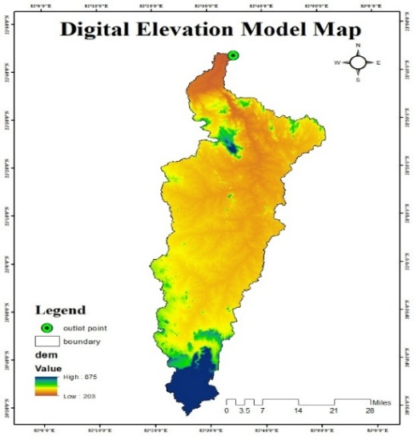
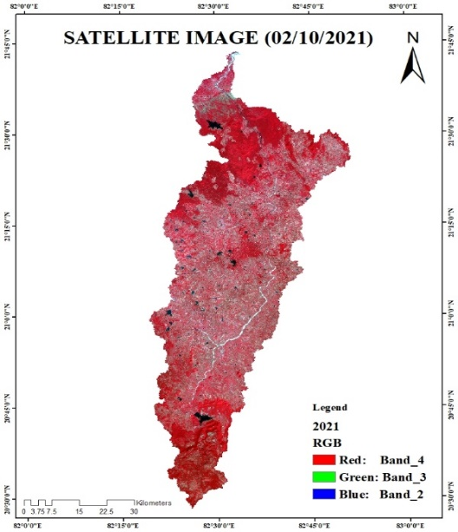
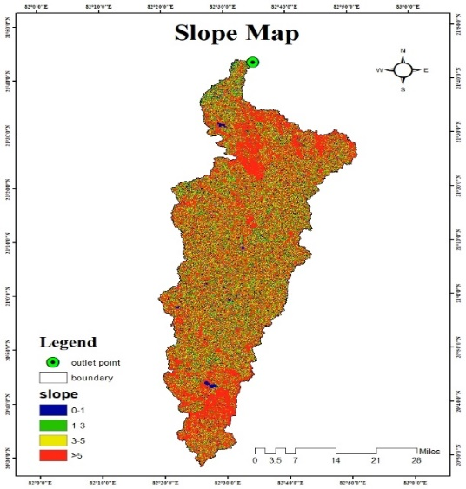
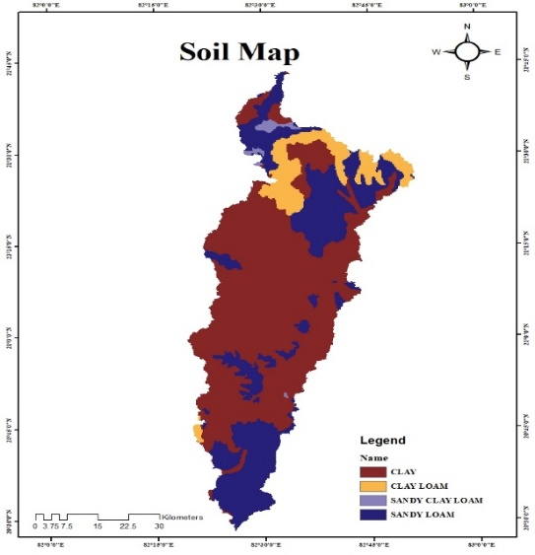

Fig 3: Maps of Jonk Subbasin
Sequential Uncertainty Fitting (SUFI-2)
The Sequential Uncertainty Fitting algorithm (SUFI-2) quantifies the difference between observed and simulated values in terms of uncertainty. It is widely used to estimate and standardize parameter uncertainties in hydrological models.
In SUFI-2, uncertainties in input parameters are represented using probability distributions, reflecting the variability and lack of precise knowledge in model inputs. The resulting uncertainty in model outputs is expressed through the 95% Prediction Uncertainty (95PPU), which indicates the range within which most observed data are expected to fall.
Two important indicators used in SUFI-2 are:
- P-factor: Represents the proportion of observed data that falls within the 95PPU range, indicating the model’s predictive accuracy.
- R-factor: Refers to the average width of the 95PPU band divided by the standard deviation of the observed data, reflecting the degree of uncertainty.
The R-factor helps assess the reliability and stability of the uncertainty analysis, while the P-factor indicates how well the model captures observed variations.
Model Calibration and Validation
Calibration is a crucial step in hydrological modeling, as it ensures that the model accurately represents real-world physical processes. In this study, calibration focused on parameters that significantly influence runoff behavior, including:
- Soil properties
- Groundwater parameters
- Main channel characteristics
- Land management practices
A warm-up period of two years (1991–1992) was used to stabilize the model before calibration. The model was then calibrated over a seventeen-year period (1993–2010). To improve model performance, a total of 14 key parameters were adjusted during the calibration process using appropriate optimization techniques.
RESULTS AND DISCUSSION
Calibration And Validation Results
For the Jonk sub-basin, the calibration results obtained using SWAT-CUP indicate a strong model performance, with r² and NSE values of 0.83 and 0.82, respectively, reflecting a high degree of agreement between observed and simulated data. During the validation phase, the model maintained satisfactory predictive capability, with r² and NSE values of 0.84 and 0.88, respectively, demonstrating its reliability under independent conditions.
Data sets | r² | NSE
Calibrated period | 0.83 | 0.82
Validated period | 0.84 | 0.88
Table 1: Performance evaluation of the ArcSWAT model

Fig 4 And 5: Scatter Graph of Daily Simulated and Observed Stream Flow During Calibration (1995-2000) And Validation (2001-2006) Respectively.
The scatter plots illustrating calibration (1993–2010) and validation (2011–2020) demonstrate a strong agreement between observed and simulated streamflow, indicating satisfactory model performance. During the calibration period, the regression equation (y = 0.816x + 2.307) with an R² value of 0.831 suggests that approximately 83.1% of the variability in observed streamflow is well captured by the model, although the slope less than unity indicates a slight underestimation of higher flows. Similarly, the validation results (y = 0.9242x − 1.4581; R² = 0.8325) confirm the model’s robustness and predictive capability, with a marginal improvement in slope, implying better alignment with observed data across a wider range of flows. In both periods, the clustering of points along the 1:1 reference line reflects good model accuracy, though some dispersion at higher discharge values indicates minor deviations, which are typical in hydrological simulations due to uncertainties in input data and model structure. Overall, the consistency in statistical performance between calibration and validation phases highlights the reliability of the model in reproducing streamflow dynamics for the study watershed.
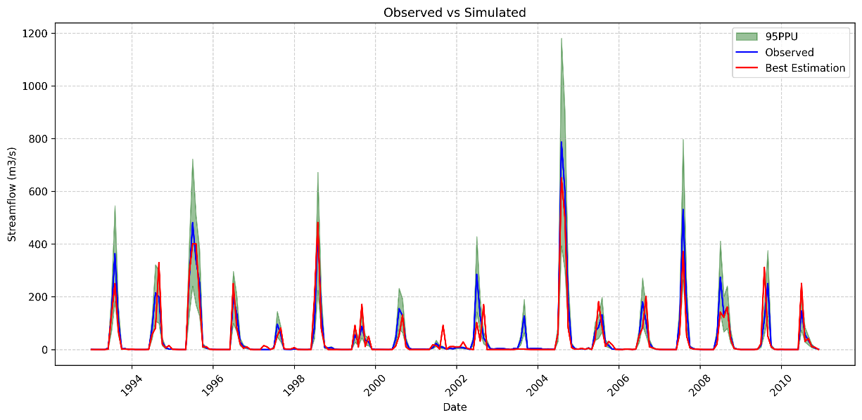
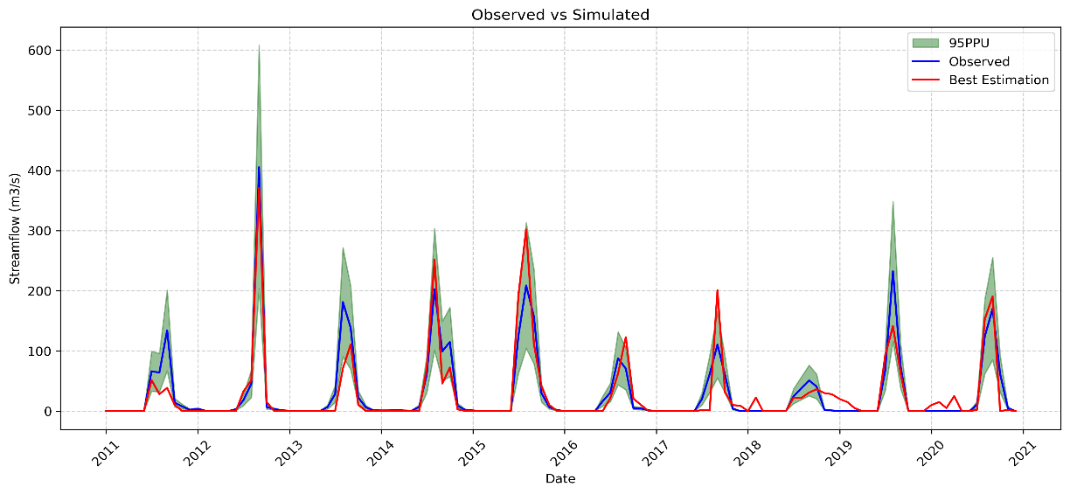

Fig 6 And 7: Comparison of Simulated and Observed Stream Flow During Calibration (1995-2000) and Validation (2001-2006) Respectively.
The observed and simulated streamflow hydrographs for the calibration (1993–2010) and validation (2011–2020) periods demonstrate that the model effectively captures the temporal dynamics and magnitude of runoff events, particularly during peak flow conditions. The close alignment between the observed (blue) and simulated best estimation (red) curves indicates a strong correspondence in reproducing the timing and intensity of hydrological responses, while the 95% prediction uncertainty (95PPU) band (green) envelops most of the observed data, reflecting an acceptable level of uncertainty and reliability in model predictions. Notably, the model performs well in simulating high-flow events, although slight underestimation or overestimation is evident during extreme peaks, which is common in watershed-scale modeling due to variability in rainfall inputs and parameter uncertainty. During low-flow periods, minor discrepancies can also be observed, suggesting some limitations in representing baseflow processes. Nevertheless, the consistency in performance across both periods, along with the containment of observed values within the uncertainty bounds, underscores the robustness and predictive capability of the model for long-term hydrological assessment in the study area.
Sensitivity Analysis
The sensitivity analysis performed using SWAT-CUP identifies the relative influence of key model parameters on streamflow simulation, with R_ESCO.bsn (Soil Evaporation Compensation Factor) emerging as the most sensitive parameter (P-value = 0.94, rank 14). This highlights the critical role of soil evaporation processes in controlling water balance within the basin. Other highly sensitive parameters include R_SOL_AWC.sol (Available Water Capacity of Soil Layer) and A_CN2.mgt (SCS Curve Number for Moisture Condition II), which govern soil moisture retention and surface runoff generation, respectively. Their high sensitivity indicates that accurate representation of soil hydraulic properties and land use management practices is essential for reliable hydrological modeling.
Moderately sensitive parameters such as V_ALPHA_BF.gw (Baseflow Alpha Factor) and V_GW_DELAY.gw (Groundwater Delay Time) reflect the importance of groundwater dynamics in sustaining streamflow, particularly during non-precipitation periods. Similarly, R_CH_K2.rte (Effective Hydraulic Conductivity in Main Channel) and R_GW_REVAP.gw (Groundwater “Revap” Coefficient) influence water movement between channel, soil, and groundwater systems. Parameters like R_CH_N2.rte (Manning’s Roughness Coefficient for Main Channel) and R_EPCO.bsn (Plant Uptake Compensation Factor) also show moderate sensitivity, indicating their role in channel flow resistance and plant water uptake processes.
In contrast, parameters such as A_SLSUBBSN.hru (Average Slope Length), R_RCHRG_DP.gw (Deep Aquifer Percolation Fraction), R_OV_N.hru (Manning’s n Value for Overland Flow), V_GWQMN.gw (Threshold Depth of Water in Shallow Aquifer for Return Flow), and A_HRU_SLP.hru (Average Slope Steepness) exhibit low or negligible sensitivity (P-value ≈ 0.00). This suggests that, within the context of the study watershed, these parameters have minimal impact on streamflow simulation compared to dominant surface runoff and soil-water processes. Overall, the results are consistent with findings from previous SWAT-based studies, where parameters related to runoff generation, soil properties, and groundwater processes are typically identified as the most influential in hydrological modeling.

Parameter Name |  | t – Stat | P – Value | Sensitivity Rank
R_ESCO.bsn |  | -0.06 | 0.94 | 14
R_SOL_AWC. Sol |  | 0.21 | 0.82 | 13
A_CN2.mgt |  | -0.23 | 0.81 | 12
V_ALPHA_BF.gw |  | -0.59 | 0.55 | 11
V_GW_DELAY.gw |  | 0.61 | 0.54 | 10
R_CH_K2.rte |  | 0.72 | 0.47 | 9
R_ GW_REVAP.gw | -0.75 |  | 0.45 | 8
R_CH_N2.rte | -0.89 |  | 0.37 | 7
R_EPCO.bsn | -1.07 |  | 0.28 | 6
A SLSUBBSN.hru | 1.29 |  | 0.19 | 5
R_RCHRG_DP.gw | 2.03 |  | 0.04 | 4
R_OV_N.hru | 4.15 |  | 0.00 | 3
V GWQMN.gw | 4.24 |  | 0.00 | 2
A HRU_SLP.hru | -10.24 |  | 0.00 | 1
Table 2: Sensitivity Analysis Result of Parameters

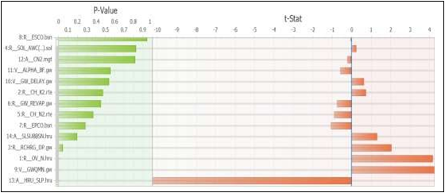
Fig 8 Global statistics (t-test and P-values) of sensitive parameters for streamflow measurement

CONCLUSION
The present study successfully demonstrates the applicability of the SWAT model integrated with GIS and remote sensing techniques for simulating the hydrological behavior of the Jonk sub-basin with a high degree of accuracy. The model effectively captured the spatial heterogeneity of the watershed through HRU-based discretization and realistically represented key hydrological processes such as surface runoff, evapotranspiration, and groundwater flow. The calibration (1993–2010) and validation (2011–2020) results, with strong statistical indicators (R² = 0.83 and NSE = 0.82 during calibration; R² = 0.84 and NSE = 0.88 during validation), confirm the robustness and reliability of the model in reproducing observed streamflow dynamics. Furthermore, the close agreement between observed and simulated hydrographs, along with the satisfactory inclusion of observed values within the 95% prediction uncertainty (95PPU) band, highlights the model’s capability to simulate both peak and low flow conditions with acceptable uncertainty.
The sensitivity analysis provides critical insights into the dominant controls governing hydrological response in the basin. Parameters such as ESCO (soil evaporation compensation factor), SOL_AWC (available water capacity), and CN2 (curve number) were identified as highly sensitive, emphasizing the significance of soil moisture dynamics and surface runoff generation processes. Additionally, groundwater-related parameters such as ALPHA_BF and GW_DELAY also exhibited notable influence, indicating the importance of subsurface flow contributions in sustaining streamflow. In contrast, parameters related to slope and overland flow resistance showed comparatively lower sensitivity, suggesting that runoff generation in the study area is more strongly governed by soil and groundwater interactions than by topographic variability alone. These findings are consistent with established hydrological modeling studies and reinforce the need for precise parameterization of soil and groundwater characteristics.
Overall, the study establishes SWAT-CUP as an efficient and reliable framework for calibration, validation, and uncertainty analysis, significantly enhancing model performance and predictive confidence. The consistent model efficiency across both calibration and validation phases indicates its suitability for long-term hydrological assessment and scenario analysis. Therefore, the developed modeling framework can serve as a valuable decision-support tool for sustainable watershed management, water resource planning, and the formulation of adaptive strategies to address future climatic and land use changes in the Jonk sub-basin.
REFERENCES
ASCE, Anon., GIS Modules and Distributed Models of Watersheds. American Society of Civil Engineers, Reston, VA, 1999.
P.W. Gassman, M.R. Reyes, C.H. Green, J.G. Arnold, The soil and water assessment tool: Historical development, applications,
D.N. Moriasi, J.G. Arnold, M.W. Van Liew, R.L. Bingner, R.D. Harmel, & T.L. Veith, Model evaluation guidelines for systematic quantification of accuracy in watershed simulations, ASABE. 50:3 (2007) 885-900.
J.G. Arnold, D.N. Moriasi, P.W. Gassman, K.C. Abbaspour, M.J. White, R. Srinivasan, C. Santhi, R.D. Harmel, A. Van Griensven, M.W. Van Liew, N. Kannan, M.K. Jha, SWAT: Model use, calibration, and validation, Trans. ASABE. 55:4 (2012) 1491-1508.
P. Shi, Y. Hou, T. Xie, C. Chen, X. Chen, Q. Li, S. Qu, X. Fang, X.R. Srinivasan Application of a SWAT model for hydrological modeling in the Xixian watershed, China J.Hydrol. Eng., 18 (2013), pp. 1522-1529
K. Khalid, M.F. Ali, N.F. Abd Rahman, M.R. Mispan, M.Z.A. Rasid, S.H. Haron, & M.S.F. Mohd, Optimization of the spatial input parameter in distributed hydrological model, ARPN J. Eng. Appl. Sci. 10:15 (2015) 6628-6633.
M.F. Ali, N.F. Abd Rahman, K. Khalid, N.D. Liem Langat river basin hydrologic model using integrated GIS and ArcSWAT interface Appl. Mech. Mater., 567 (2014), pp. 86-91
P.S. Murty, A. Pandey, S. Suryavanshi Application of a semidistributed hydrological model for basin levels waters balance of Ken basin of Central India Hydrol. Processes. Wiley Online Library (2013)
K.T. White, I. Chaubey Sensitivity, calibration, and validations for a multisite and multivariable SWAT model, J Am. Water Resour. As. (2005), pp. 1077-1089
J. Schuol, K.C. Abbaspour Using monthly weather statistics to generate daily data in a SWAT model application to West Africa Ecol Model., 201 (2007)

