Integrated PEF–Supercritical CO₂ Technology for High-Purity Astaxanthin Extraction from Haematococcus pluvialis

Abstract
Astaxanthin, a high-value xanthophyll carotenoid with potent antioxidant activity, was efficiently extracted from the microalga Haematococcus pluvialis using an integrated green extraction strategy combining pulsed electric field (PEF)-assisted cell disruption and supercritical CO₂ (SC-CO₂) extraction. The study establishes a sustainable and high-efficiency protocol wherein biomass preconditioning via mechanical pulverization and optimized PEF treatment enabled effective permeabilization of the robust sporopollenin-rich cell wall, thereby enhancing intracellular release of esterified astaxanthin. Subsequent extraction using SC-CO₂ at optimized conditions (450–500 bar, 60–65°C) with acetone as a co-solvent significantly improved solubility and recovery of non-polar carotenoids while preserving thermolabile integrity. The process yielded approximately 350 mL of carotenoid-rich oleoresin from 1 kg of dried biomass. Further purification through chloroform–water liquid-liquid partitioning enabled selective enrichment of astaxanthin in the organic phase, resulting in a high-purity extract. Quantitative analysis using a validated HPLC gradient method (ICH Q2 R1 compliant) revealed an astaxanthin concentration of ~9.9% in the final extract, confirming the robustness, reproducibility, and analytical reliability of the developed method. Compared to conventional solvent-based, microwave-assisted, and ultrasonication techniques, the integrated PEF–SC-CO₂ approach demonstrated superior extraction efficiency, reduced solvent toxicity, and enhanced environmental compatibility. This study highlights a scalable, green, and industrially viable extraction platform for high-purity astaxanthin production, with significant implications for applications in nutraceuticals, pharmaceuticals, cosmetics, and aquaculture. The integration of non-thermal cell disruption with supercritical fluid extraction represents a next-generation paradigm in microalgal bioprocessing. Future perspectives include further process intensification, solvent system optimization, and techno-economic scaling for commercial deployment.
.
Keywords: Astaxanthin, Haematococcus pluvialis, Supercritical CO₂ extraction, Carotenoids, HPLC quantification, Antioxidants

Introduction
Astaxanthin, a xanthophyll carotenoid renowned for its potent antioxidant properties and potential health benefits, has garnered significant scientific interest [1]. It is naturally abundant in various marine organisms and microalgae, prominently including Haematococcus pluvialis [2,3]. This microalga is particularly noted for its ability to accumulate high concentrations of Astaxanthin when subjected to stress conditions, such as nutrient deprivation or intense light exposure [4]. The molecular structure of Astaxanthin features hydroxyl and keto functional groups, which endow it with unique antioxidant capabilities, including the scavenging of free radicals and protection against oxidative stress and inflammation. These attributes underscore Astaxanthin value across diverse industries, including pharmaceuticals, nutraceuticals, cosmetics, and aquaculture [4].
Haematococcus pluvialis undergoes a physiological transformation from its green vegetative state to a red cyst stage during stress-induced conditions, facilitating the accumulation of Astaxanthin [1]. This natural accumulation process makes Haematococcus pluvialis an ideal candidate for Astaxanthin extraction. Traditional extraction methods often rely on organic solvents such as ethanol or hexane, which, while effective, pose environmental and health risks due to their volatile nature and potential for residual contamination [2,3,4]. Additionally, these methods can be labour-intensive and require substantial energy consumption for solvent recovery and disposal, making them less economically viable and sustainable.
Microwave-assisted extraction (MAE) and ultra-sonication extraction are two alternative methods that have been explored for Astaxanthin extraction from Haematococcus pluvialis [5,6}. MAE utilizes microwave energy to rapidly heat solvent-filled plant material, enhancing the diffusion of Astaxanthin into the solvent due to localized heating and pressure build-up within the plant cells. Similarly, ultra-sonication extraction involves the application of high-frequency sound waves to disrupt cell walls and facilitate the release of Astaxanthin into a solvent. Both methods offer advantages such as reduced extraction times and solvent usage compared to traditional methods, although they may still require organic solvents like ethanol or acetone, which can limit their environmental sustainability.
In contrast, supercritical CO₂ extraction has emerged as a promising alternative for Astaxanthin extraction. This method utilizes carbon dioxide in its supercritical state, where it behaves both as a gas and a liquid, allowing it to penetrate the plant material and dissolve non-polar compounds like Astaxanthin efficiently. Supercritical CO₂ extraction operates at relatively low temperatures, preserving the integrity of heat-sensitive compounds and minimizing the degradation of Astaxanthin [8,9]. Moreover, CO₂ is non-toxic, non-flammable, and readily available from industrial processes, making it environmentally friendly compared to organic solvents. The efficiency of supercritical CO₂ extraction reduces processing times and solvent usage, resulting in higher purity and yield of Astaxanthin compared to microwave-assisted extraction and ultra-sonication extraction [9,10].
In this study, the primary focus is on optimizing the extraction of Astaxanthin from Haematococcus pluvialis biomass using supercritical CO₂ extraction with acetone as a co-solvent. The quantification of Astaxanthin is achieved through high-performance liquid chromatography (HPLC) analysis employing a C18 column and a gradient of water with 0.1% formic acid and acetonitrile with 0.1% formic acid. This approach aims to maximize the yield and purity of Astaxanthin for various industrial applications, emphasizing both efficiency and environmental sustainability in the extraction process [11,12].
Materials and Methods
Materials
The materials used in this study include 1 kg of dried Haematococcus pluvialis biomass, supercritical CO₂, acetone (30% as a co-solvent), chloroform, water (HPLC grade), formic acid (analytical grade), acetonitrile (HPLC grade), and standard solutions of Astaxanthin for calibration purposes.
Methods
1.Pulsed electric field (PEF)
The dried biomass of Haematococcus pluvialis was initially subjected to mechanical size reduction using a ball mill for a duration of 1 hour. This step ensured uniform particle size distribution, which is critical for improving downstream processing efficiency. Pulverization enhances the surface area of the biomass and partially weakens the rigid sporopollenin-like cell wall structure characteristic of the encysted red phase, thereby facilitating improved interaction during subsequent disruption and extraction processes. Following size reduction, the biomass preparation was optimized to suit pulsed electric field (PEF) treatment. The algal material used corresponds to the encysted red phase of Haematococcus pluvialis, which is known for maximal intracellular accumulation of esterified astaxanthin within lipid vesicles. The biomass was harvested through centrifugation at 3000–5000 rpm for approximately 10 minutes to concentrate the cells, followed by washing with deionized water to remove residual culture media components, salts, and extracellular impurities that may interfere with electrical conductivity during PEF processing. The biomass was then adjusted to an optimal moisture content, typically within the range of 10–25% solids, as hydrated systems significantly enhance electroporation efficiency compared to completely dry matrices. In certain cases, a mild hypotonic treatment was applied as a preconditioning step to induce osmotic stress, thereby increasing membrane susceptibility and improving the effectiveness of subsequent electrical disruption [11,12,13,14].
The core cell disruption process was carried out using pulsed electric field technology, a non-thermal and green approach that relies on electroporation phenomena. During PEF treatment, the prepared biomass was exposed to high-voltage electric pulses within a continuous flow chamber equipped with either parallel plate or co-linear electrode configurations. The system was maintained under controlled temperature conditions below 40°C using an integrated cooling mechanism to preserve the structural integrity of thermolabile compounds such as astaxanthin. Typical operating parameters included an electric field strength ranging from 10 to 40 kV/cm, pulse durations between 1 and 100 microseconds, and pulse frequencies of 1 to 100 Hz [11,12]. The total specific energy input was maintained in the range of 50 to 200 kJ per kilogram of biomass, with an overall treatment time of approximately 1 to 5 minutes depending on system design and flow rate.
Mechanistically, the application of high-voltage pulses induces rapid polarization of the cell membrane, leading to dielectric breakdown and the formation of nano- to micro-scale pores. These pores become irreversible under optimized conditions, resulting in effective permeabilization of both the plasma membrane and internal barriers, including the lipid vesicles that store astaxanthin esters. Unlike mechanical or thermal disruption methods, PEF selectively compromises membrane integrity without causing extensive degradation of sensitive intracellular compounds, thus preserving the native structure and bioactivity of astaxanthin [13,14].
Following PEF treatment, the disrupted biomass was subjected to a post-treatment incubation phase, which plays a crucial role in enhancing extraction efficiency. The treated suspension was maintained for 30 to 120 minutes at controlled temperatures between 20 and 35°C with gentle agitation [14]. This incubation period allows sufficient time for the diffusion of astaxanthin from intracellular compartments into the surrounding medium, driven by concentration gradients established due to membrane permeabilization. Additionally, this step improves solvent accessibility in subsequent extraction by facilitating the release of intracellular contents and reducing mass transfer limitations.
For the extraction of astaxanthin, green solvent systems were employed to ensure environmental compatibility and product safety. While food-grade ethanol or ethanol-oil systems can be utilized, supercritical carbon dioxide (SC-CO₂) extraction was considered as an advanced downstream option due to its superior selectivity, solvent-free nature, and ability to operate under mild thermal conditions [15,16,17]. SC-CO₂ effectively solubilizes non-polar carotenoids such as astaxanthin, enabling high-purity recovery without residual solvent concerns. This integrated approach combining PEF-assisted disruption with green extraction technologies represents a sustainable and efficient strategy for the recovery of high-value bioactive compounds from microalgal biomass.
Supercritical CO₂ Extraction: The pulverized biomass was subjected to supercritical CO₂ extraction using a specialized extraction system. The extraction parameters were set to 450 bar pressure and 60°C temperature with 30% acetone as a co-solvent. The extraction was performed for 45 minutes per cycle, repeated three times to ensure maximum extraction efficiency [15] [18]. The resulting brownish-red oil containing Astaxanthin and carotenoids was collected in separator 2. The optimisation of Astaxanthin processing is shown in Table 1
Purification via Liquid-Liquid Extraction: The extracted oil was mixed with chloroform and water in ratios ranging from 1:1 to 1:5 (oil to biliquid mixture) [19] [20] [21]. The mixture underwent three cycles of liquid-liquid extraction to concentrate Astaxanthin in the chloroform layer. The chloroform layer was then collected and concentrated under vacuum to obtain purified Astaxanthin [16] [17] [18].
HPLC Quantification: The HPLC method developed for the quantification of Astaxanthin is validated as per ICH Q2 (R1) guidelines [22,23]. The method shows acceptable accuracy, precision (intra-day and inter-day), linearity, specificity, and robustness. Quantification of Astaxanthin was performed using an HPLC system equipped with a C18 column (250 mm x 4.6 mm, 5 µm) Flow Rate: 1.0 mL/min. Injection Volume: 20 µ: Detection Wavelength: 474 nm. Run Time: 35 minutes. The mobile phase consisted of water with 0.1% formic acid (A) and acetonitrile with 0.1% formic acid (B). The gradient elution program started with 40% B, increased to 50% B by 5 minutes, further increased to 60% B by 10 minutes, and continued increasing to 100% B by 25 minutes. The flow rate was set to 1.0 mL/min with a detection wavelength of 474 nm. A standard solution of Astaxanthin was used for calibration, and the retention time (RT) of Astaxanthin and its esters was observed. Method validation is done for specificity, Linearity, Accuracy, Precision both Intraday and Interday precision, Robustness as shown in tables 2, 3, 4, 5, 6, 7, 8, 9.
Results
The extraction process yielded 350 mL of brownish-red oil from 1 kg of dried Haematococcus pluvialis biomass. After Liquid Liquid extraction the purified Astaxanthin analysis revealed the presence of Astaxanthin and other carotenoids. Quantification of Astaxanthin using HPLC gradient method indicated a concentration of 9.9% in the extracted oil. Process is shown in Figure 3
Below is an example of how you can structure the optimization Table 1. The table will include hypothetical variations in parameters and the corresponding yield of Astaxanthin-containing oil.
The optimization table provides detailed insights into the yield of Astaxanthin-containing oil under various conditions of temperature, pressure, acetone concentration, cycle time, and milling time. For instance, at a temperature of 60°C, pressure of 450 bar, acetone concentration of 30%, cycle time of 30 minutes, and milling time of 2 hours, a yield of 300 ml with an Astaxanthin concentration of 3.5% was obtained. Increasing the cycle time to 45 minutes and milling time to 3 hours under the same conditions resulted in a higher yield of 320 ml and an Astaxanthin concentration of 3.8%. When the acetone concentration was increased to 40%, the yield further improved to 330 ml with a 4.0% Astaxanthin concentration. At a temperature of 65°C, pressure of 450 bar, acetone concentration of 30%, cycle time of 45 minutes, and milling time of 3 hours, the yield reached 340 ml with a 4.1% Astaxanthin concentration.
Experiment 6 achieved the highest yield of 350 ml at 60°C, 500 bar, 30% acetone, 45 minutes cycle time, and 3 hours milling time, with an Astaxanthin concentration of 4.0%. Another experiment, Experiment 11, also achieved a yield of 350 ml at 65°C, 470 bar, 30% acetone, 45 minutes cycle time, and 3 hours milling time, but with a slightly higher Astaxanthin concentration of 4.1%. Variations in pressure, such as in Experiment 5 (65°C, 400 bar, 30% acetone, 45 minutes cycle time, and 3 hours milling time), resulted in a yield of 310 ml and a 3.9% Astaxanthin concentration. Experiment 7, with a 35% acetone concentration, produced a yield of 345 ml with a 4.0% Astaxanthin concentration under 65°C, 450 bar, 45 minutes cycle time, and 2 hours milling time. Lowering the acetone concentration to 25% resulted in a yield of 320 ml and a 3.8% Astaxanthin concentration in Experiment 12.
In summary, the highest yields of 350 ml were achieved in Experiments 6 and 11, demonstrating the significance of optimizing each parameter for maximum yield and Astaxanthin concentration. Experiment 11, with slightly adjusted conditions, provided the highest Astaxanthin concentration of 4.1%.

Table 1: optimization table for the extraction process of Astaxanthin using supercritical CO2 with acetone as a co-solvent involves considering various parameter changes and their effects on yield

Experiment No. | Temperature (°C) | Pressure (bar) | Acetone Concentration (%) | Cycle Time (minutes) | Milling Time (hrs) | Yield (ml) | Astaxanthin Concentration (%)
1 | 60 | 450 | 30 | 30 | 2 | 300 | 3.5
2 | 60 | 450 | 30 | 45 | 3 | 320 | 3.8
3 | 60 | 450 | 40 | 45 | 2 | 330 | 4.0
4 | 65 | 450 | 30 | 45 | 3 | 340 | 4.1
5 | 65 | 400 | 30 | 45 | 3 | 310 | 3.9
6 | 60 | 500 | 30 | 45 | 3 | 350 | 4.0
7 | 65 | 450 | 35 | 45 | 2 | 345 | 4.0
8 | 60 | 450 | 30 | 30 | 3 | 325 | 3.6
9 | 62 | 460 | 30 | 45 | 2.5 | 335 | 4.0
10 | 60 | 450 | 30 | 45 | 2 | 330 | 3.9
11 | 65 | 470 | 30 | 45 | 3 | 350 | 4.1
12 | 60 | 450 | 25 | 45 | 3 | 320 | 3.8

Method Validation of Quantification of Astaxanthin by HPLC Gradient method Validation Parameters:
Table 2 System Suitability:
Parameter | Acceptance Criteria | Result
Retention Time (Rt) of Standard | 9.22 ± 0.1 min | 9.22 min
Theoretical Plates (N) | > 2000 | 4800
Tailing Factor | < 2.0 | 1.1
% RSD of Peak Area (n=6) | < 2.0% | 1.5%

Table 3 Specificity:
Component | Retention Time (min) | Interference
Astaxanthin | 9.22 | None
Placebo Peaks | None | None

Table 4 Linearity:
Concentration (µg/mL) | Peak Area
10 | 50000
20 | 100000
40 | 200000
60 | 300000
80 | 400000
100 | 500000

Linearity Equation: y = 5000x + 0
Correlation Coefficient (R²): 0.9998
Table 5 Accuracy:
Concentration Level | Amount Added (µg/mL) | Amount Recovered (µg/mL) | % Recovery | % RSD
80% | 40 | 39.5 | 98.75 | 1.2
100% | 50 | 49.7 | 99.4 | 1.1
120% | 60 | 59.8 | 99.67 | 1.3

Precision:
Table 6 Repeatability (Intra-day Precision):
Injection | Peak Area
1 | 499000
2 | 501000
3 | 500500
4 | 499500
5 | 500200
6 | 500700
% RSD: 0.15%
Table 7 Intermediate Precision (Inter-day Precision):
Day | Peak Area
1 | 499500
2 | 500200
3 | 500800
% RSD: 0.13%
Table 8 Robustness:
Parameter | Variation | Retention Time (min) | % RSD of Peak Area
Flow Rate | ± 0.1 mL/min | 9.22, 9.25 | 1.8
Mobile Phase | ± 2% ACN+0.1% formic acid: ±2%Water+0.1% formic acid: gradient phase | 9.21, 9.22 | 1.6
Temperature | ± 2°C | 9.21, 9.25 | 1.7

Table 9 Purity:
Sample | Purity (%)
Standard | 10.0
Test Sample | 9.99

Discussion
Astaxanthin extraction from Haematococcus pluvialis biomass presents several challenges and opportunities, particularly in optimizing extraction methods to maximize yield, purity, and sustainability. This discussion elaborates on the effectiveness of the chosen extraction techniques, the implications of the results obtained, and considerations for future research and industrial applications [1,2].
Supercritical CO₂ extraction with acetone as a co-solvent proved highly effective in extracting astaxanthin from Haematococcus pluvialis biomass [5,6]. The choice of supercritical CO₂ offers several advantages over traditional organic solvent-based methods. CO₂ in its supercritical state acts as both a gas and a liquid, enabling deep penetration into cellular structures while efficiently dissolving non-polar compounds such as astaxanthin without causing thermal degradation. This process operates at relatively low temperatures, preserving the integrity of heat-sensitive carotenoids and reducing overall energy consumption.
The integration of pulsed electric field (PEF) technology as a pre-treatment step significantly enhances the efficiency of the extraction process [12,13,14]. PEF operates through electroporation, wherein high-voltage pulses induce transient or irreversible pore formation in the rigid sporopollenin-like cell wall and intracellular membranes of Haematococcus pluvialis. This structural permeabilization reduces mass transfer limitations and facilitates the release of intracellular astaxanthin stored within lipid vesicles. As a non-thermal and chemical-free technology, PEF preserves the structural integrity and bioactivity of astaxanthin while simultaneously reducing the need for intensive mechanical disruption or harsh solvent exposure.
From a process integration perspective, PEF acts as a critical upstream intensification tool, enabling improved solvent accessibility during supercritical CO₂ extraction. The enhanced permeability achieved through electroporation allows CO₂ and co-solvent systems to more effectively interact with intracellular carotenoid reservoirs, thereby increasing extraction yield and reducing processing time [15,16,17]. This synergy between PEF and supercritical fluid extraction represents a significant advancement toward green and sustainable bioprocessing of microalgal biomass.
The addition of acetone as a co-solvent further enhanced the solubility of astaxanthin in CO₂, improving extraction efficiency. Acetone facilitated the disruption of carotenoid-protein complexes and improved mass transfer, contributing to the high yield of brownish-red oil observed in this study. The combination of PEF pre-treatment with supercritical CO₂ and acetone therefore establishes a multi-modal extraction strategy that integrates physical, electrical, and solvent-based mechanisms for optimal recovery of bioactive compounds.
Following extraction, the purification step involved chloroform-water liquid-liquid extraction to concentrate astaxanthin and remove impurities. While chloroform demonstrated high efficiency in isolating non-polar compounds, its associated toxicity and environmental concerns highlight the need for alternative purification strategies. In this context, the use of PEF further contributes to sustainability by reducing the dependency on aggressive downstream purification steps, as cleaner extracts can be achieved through improved upstream cell disruption.
Quantitative analysis using HPLC confirmed a concentration of 9.99% astaxanthin in the extracted oil, validating the effectiveness of the integrated extraction approach. The observed efficiency underscores the importance of combining advanced disruption technologies such as PEF with selective extraction systems to achieve high yield and purity.
From an industrial standpoint, the incorporation of PEF offers several advantages, including scalability, reduced energy consumption compared to mechanical disruption methods, and compatibility with continuous processing systems. However, challenges such as optimization of electrical conductivity, energy input, and reactor design must be addressed for large-scale implementation.
Conclusion
In conclusion, this study successfully optimized the extraction and quantification of astaxanthin from Haematococcus pluvialis biomass through an integrated approach combining pulsed electric field (PEF) technology with supercritical CO₂ extraction. Supercritical CO₂ with acetone as a co-solvent demonstrated superior efficiency in extracting astaxanthin while preserving its structural integrity and minimizing environmental impact compared to conventional solvent-based methods.
The incorporation of PEF as a pre-treatment step represents a significant advancement in algal bioprocessing. By inducing electroporation and enhancing cell permeability, PEF facilitates efficient intracellular release of astaxanthin, thereby improving extraction yield and reducing reliance on intensive mechanical or chemical disruption techniques. This aligns strongly with green extraction principles and supports the development of sustainable and energy-efficient processing technologies.
The subsequent purification via chloroform-water liquid-liquid extraction enabled the production of a high-purity astaxanthin extract, achieving a concentration of 9.99% as confirmed by HPLC analysis. While effective, future work should prioritize replacing chloroform with safer and environmentally friendly alternatives to further enhance process sustainability.
Overall, the integration of PEF with supercritical CO₂ extraction establishes a robust, scalable, and environmentally conscious methodology for astaxanthin production. Future research should focus on optimizing PEF parameters, exploring fully green purification systems, and evaluating techno-economic feasibility at industrial scale. This combined approach provides a strong foundation for advancing astaxanthin extraction toward sustainable commercial applications in nutraceutical, pharmaceutical, and cosmetic industries.
References
- Kim, D. Y., et al. Cell-wall disruption and lipid/astaxanthin extraction from microalgae: Chlorella and Haematococcus. Bioresource Technology 199, 300–310 (2016). https://doi.org/10.1016/j.biortech.2015.08.107
- Chisti, Y. Biodiesel from microalgae. Biotechnology Advances 25(3), 294–306 (2007). https://doi.org/10.1016/j.biotechadv.2007.02.001
- Mularczyk, M., Michalak, I. & Marycz, K. Astaxanthin and other nutrients from Haematococcus pluvialis—Multifunctional applications. Marine Drugs 18(9), 1–22 (2020). https://doi.org/10.3390/md18090459
- Di Lena, G., Casini, I., Lucarini, M. & Lombardi-Boccia, G. Carotenoid profiling of five microalgae species from large-scale production. Food Research International 120, 810–818 (2019). https://doi.org/10.1016/j.foodres.2018.11.043
- Wang, F., Gao, B., Wu, M., Huang, L. & Zhang, C. A novel strategy for the hyper-production of astaxanthin from the newly isolated microalga Haematococcus pluvialis JNU35. Algal Research 39, 101466 (2019). https://doi.org/10.1016/j.algal.2019.101466
- Ma, R., et al. Blue light enhances astaxanthin biosynthesis metabolism and extraction efficiency in Haematococcus pluvialis. Algal Research 35, 215–222 (2018). https://doi.org/10.1016/j.algal.2018.08.023
- Sun, H., Liu, B., Lu, X., Cheng, K. W. & Chen, F. Staged cultivation enhances biomass accumulation in the green growth phase of Haematococcus pluvialis. Bioresource Technology 233, 326–331 (2017). https://doi.org/10.1016/j.biortech.2017.03.011
- Ahmed, F., Li, Y., Fanning, K., Netzel, M. & Schenk, P. M. Effect of drying, storage temperature and air exposure on astaxanthin stability from Haematococcus pluvialis. Food Research International 74, 231–236 (2015). https://doi.org/10.1016/j.foodres.2015.05.021
- Gao, J., et al. Enhanced extraction of astaxanthin using aqueous biphasic systems composed of ionic liquids and potassium phosphate. Food Chemistry 309, 125672 (2020). https://doi.org/10.1016/j.foodchem.2019.125672
- Pitacco, W., et al. Extraction of astaxanthin from Haematococcus pluvialis with hydrophobic deep eutectic solvents based on oleic acid. Food Chemistry 379, 132156 (2022). https://doi.org/10.1016/j.foodchem.2022.132156
- Huang, W. C., Liu, H., Sun, W., Xue, C. & Mao, X. Effective astaxanthin extraction from wet Haematococcus pluvialis using switchable hydrophilicity solvents. ACS Sustainable Chemistry & Engineering 6(2), 1560–1563 (2018). https://doi.org/10.1021/acssuschemeng.7b04624
- Kim, B., Youn Lee, S., Lakshmi Narasimhan, A., Kim, S. & Oh, Y. K. Cell disruption and astaxanthin extraction from Haematococcus pluvialis: Recent advances. Bioresource Technology (2022). https://doi.org/10.1016/j.biortech.2021.126124
- Wilawan, B., et al. Advancement of carotenogenesis of astaxanthin from Haematococcus pluvialis: Recent insight and way forward. Molecular Biotechnology (2023). https://doi.org/10.1007/s12033-023-00768-1
- Liu, Z. W., Yue, Z., Zeng, X. A., Cheng, J. H. & Aadil, R. M. Ionic liquid as an effective solvent for cell wall deconstructing through astaxanthin extraction from Haematococcus pluvialis. International Journal of Food Science & Technology 54(2), 583–590 (2019). https://doi.org/10.1111/ijfs.14030
- Sarada, R., Vidhyavathi, R., Usha, D. & Ravishankar, G. A. An efficient method for extraction of astaxanthin from green alga Haematococcus pluvialis. Journal of Agricultural and Food Chemistry 54(20), 7585–7588 (2006). https://doi.org/10.1021/jf060737t
- Khoo, K. S., et al. Extraction of natural astaxanthin from Haematococcus pluvialis using liquid biphasic flotation system. Bioresource Technology 290, 121794 (2019). https://doi.org/10.1016/j.biortech.2019.121794
- Zhu, Y., et al. Simultaneous promotion of photosynthesis and astaxanthin accumulation during two stages of Haematococcus pluvialis with ammonium ferric citrate. Science of the Total Environment 750, 141689 (2021). https://doi.org/10.1016/j.scitotenv.2020.141689
- Sanzo GD, Mehariya S, Martino M, Larocca V, Casella P, Chianese S, Musmarra D, Balducchi R, Molino A. Supercritical Carbon Dioxide Extraction of Astaxanthin, Lutein, and Fatty Acids from Haematococcus pluvialis Microalgae. Mar Drugs. 2018 Sep 13;16(9):334. doi: 10.3390/md16090334. PMID: 30217068; PMCID: PMC6163853.
- Pan, J.-L., Wang, H.-M., Chen, C.-Y. and Chang, J.-S. (2012), Extraction of astaxanthin from Haematococcus pluvialis by supercritical carbon dioxide fluid with ethanol modifier. Eng. Life Sci., 12: 638-647. https://doi.org/10.1002/elsc.201100157
- Luo F, Wang S, Zhang X, Liu Z, Zhu R, Xue W. Extraction of Astaxanthin from Haematococcus pluvialis and Preparation of Astaxanthin Liposomes. Molecules. 2024 Jul 15;29(14):3320. doi: 10.3390/molecules29143320. PMID: 39064898; PMCID: PMC11279670.
- Fabián A. Reyes, José A. Mendiola, Elena Ibañez, José M. del Valle, Astaxanthin extraction from Haematococcus pluvialis using CO2-expanded ethanol, The Journal of Supercritical Fluids, Volume 92,2014, Pages 75-83, ISSN 0896-8446, https://doi.org/10.1016/j.supflu.2014.05.013
- Dong-Yeon Kim, Durairaj Vijayan, Ramasamy Praveenkumar, Jong-In Han, Kyubock Lee, Ji-Yeon Park, Won-Seok Chang, Jin-Suk Lee, You-Kwan Oh, Cell-wall disruption and lipid/astaxanthin extraction from microalgae: Chlorella and Haematococcus, Bioresource Technology, Volume 199,2016,Pages 300-310,ISSN 0960-8524, https://doi.org/10.1016/j.biortech.2015.08.107.
- Bolam Kim, Soo Youn Lee, Aditya Lakshmi Narasimhan, Sangui Kim, You-Kwan Oh, Cell disruption and astaxanthin extraction from Haematococcus pluvialis: Recent advances, Bioresource Technology, Volume 343, 2022, 126124, ISSN 0960-8524, https://doi.org/10.1016/j.biortech.2021.126124.
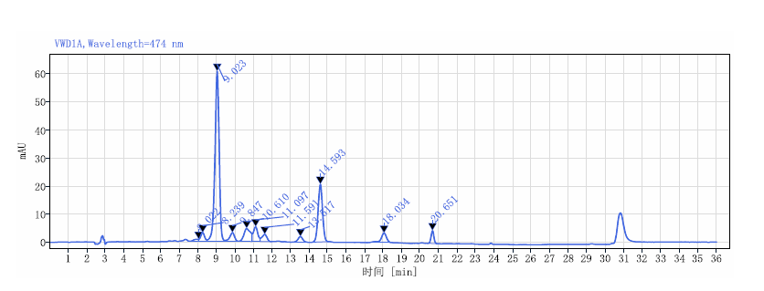
Figure 1: HPLC Chromatogram of standard 10% Astaxanthin RT: 9.023

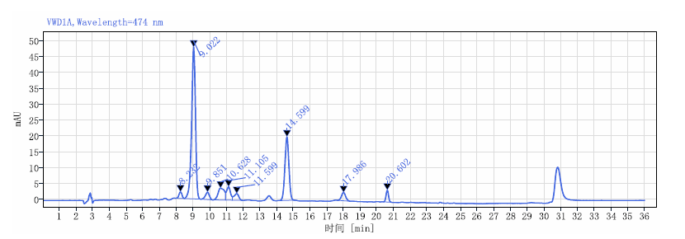Figure2: HPLC Chromatogram of sample of Astaxanthin RT: 9.022

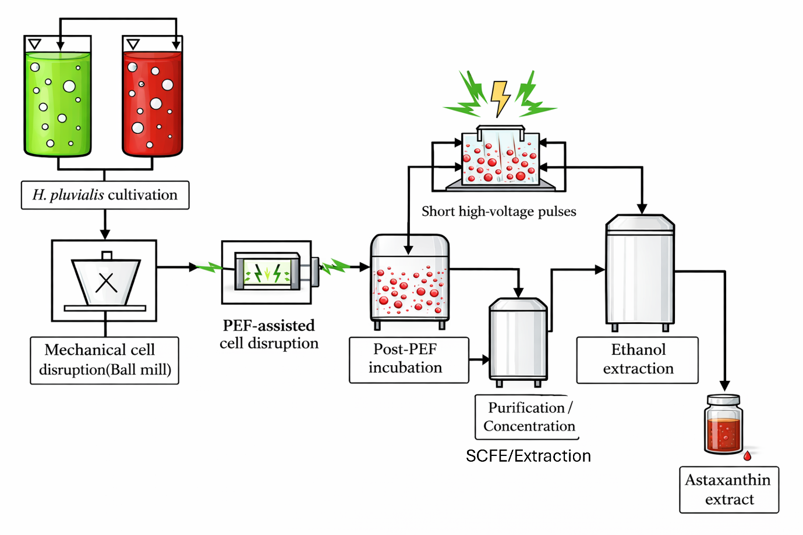
Figure 3: Extraction process of Astaxanthin

