Assessment of Fertigation Effect on Growth Performance and Biomass Accumulation in Ginger (Zingiber officinale Rosc.) Varieties

ABSTRACT

A field experiment was conducted during the kharif season of 2021 at the Department of Horticulture, Gandhi Krishi Vignana Kendra (GKVK), University of Agricultural Sciences, Bengaluru, Karnataka to evaluate the effect of fertigation on vegetative growth and biomass distribution in two ginger (Zingiber officinale Rosc.) cultivars, Rio-de-Janeiro and Himachal. The study assessed growth parameters such as number of leaves and tillers per plant, leaf length and breadth, and biomass partitioning at different crop growth stages.
Fertigation treatments significantly influenced growth and biomass accumulation in both cultivars. Among the treatments, T₂ [200% RDF (200:100:100 kg N: P₂O₅: K₂O ha⁻¹) through fertigation + FYM 30 t ha⁻¹ + neem cake 2 t ha⁻¹] recorded superior performance throughout the crop period. T₂ resulted in the highest number of leaves per plant (up to 115.86 in Rio-de-Janeiro and 112.40 in Himachal at 180 DAP) and maximum tillers per plant (10.26 and 9.66, respectively). Leaf growth was also enhanced under T₂, with maximum leaf length (19.10 cm in Rio-de-Janeiro and 19.53 cm in Himachal) and leaf breadth (1.79 cm in Rio-de-Janeiro).
Biomass allocation was significantly affected by fertigation treatments. T₂ recorded the highest contribution of rhizomes along with increased allocation to aerial parts and roots in both cultivars on both fresh and dry weight basis. Rhizome contribution under T₂ exceeded 87% on a fresh weight basis and remained dominant on a dry weight basis, indicating efficient partitioning towards the economic yield.
The improved performance under T₂ may be attributed to the combined effect of continuous nutrient supply through fertigation and the addition of organic amendments, which enhanced soil fertility, nutrient availability, and nutrient use efficiency. The results demonstrate that integrated nutrient management through fertigation significantly improves vegetative growth and biomass distribution in ginger, with T₂ emerging as the most effective treatment for maximizing growth and rhizome yield.

Keywords: Fertigation, Ginger Cultivars, Growth Attributes, Biomass accumulation, Integrated Nutrient Management.

INTRODUCTION

Ginger (Zingiber officinale Rosc.) is one of the most important spice crops cultivated widely in tropical and subtropical regions of the world. It belongs to the family Zingiberaceae and is valued for its rhizomes, which are extensively used as a spice, condiment and medicinal ingredient. India is the largest producer and exporter of ginger, contributing a major share to global production. Ginger rhizomes are rich in essential oils, oleoresins and bioactive compounds such as gingerol and shogaol, which are responsible for their characteristic flavour and medicinal properties (Ravindran and Babu, 2005). The crop plays a significant role in the spice economy of India and is widely cultivated in several states including Kerala, Karnataka, Meghalaya, Odisha and the North-Eastern region.

Productivity of ginger largely depends on proper nutrient management and efficient utilization of fertilizers. Being a heavy feeder crop, ginger requires a balanced and continuous supply of nutrients for optimum vegetative growth, rhizome development and yield. Conventional methods of fertilizer application often result in lower nutrient use efficiency due to leaching and fixation losses. Fertigation, the application of fertilizers through irrigation systems, has emerged as an efficient technique for improving nutrient availability, enhancing nutrient use efficiency and promoting better crop growth (Hagin et al., 2002). Fertigation ensures uniform distribution of nutrients in the root zone and enables plants to absorb nutrients in a timely and efficient manner.

Integration of inorganic fertilizers with organic sources such as farmyard manure (FYM) and neem cake is also known to improve soil physical, chemical and biological properties. Organic amendments enhance soil microbial activity, improve soil structure and increase nutrient availability, thereby supporting better plant growth and productivity (Sadanandan et al., 2002). Integrated nutrient management practices have been reported to significantly improve vegetative growth, biomass production and rhizome yield in ginger (Hedge et al., 2012; Singh et al., 2015).

Vegetative growth parameters such as number of leaves, number of tillers and leaf size are important indicators of crop vigour and photosynthetic capacity, which ultimately influence biomass accumulation and rhizome development. Efficient partitioning of assimilates towards economically important plant parts such as rhizomes plays a crucial role in determining the productivity of ginger. However, information on the influence of fertigation combined with organic amendments on growth attributes and biomass distribution in different ginger cultivars is limited. Therefore, the present investigation was undertaken to evaluate the effect of fertigation on vegetative growth parameters and biomass contribution of different plant parts in two ginger cultivars, Rio-de-Janeiro and Himachal.

MATERIALS AND METHODS

A field experiment was conducted to study the effect of different fertigation levels with organic amendments under field conditions on vegetative growth and biomass accumulation in ginger (Zingiber officinale Rosc.) cultivars and the details of experimental site and soil characteristics, experimental design and treatments, recording of observations and statistical analysis are described below:

Experimental site and soil characteristics: A field experiment was conducted during the kharif season of 2021 at the Department of Horticulture, Gandhi Krishi Vignana Kendra (GKVK), University of Agricultural Sciences, Bengaluru, Karnataka to evaluate the performance of ginger cultivars under different fertigation levels and their effect on vegetative growth and biomass accumulation. The experimental site is located in the Southern Dry Zone of Karnataka, which receives an average annual rainfall of 800–900 mm, fairly distributed between May and November. The experiment was carried out on red sandy loam soil in the horticultural experimental block of GKVK. The soil was well drained with a nearly neutral reaction (pH 6.4). Initial soil analysis revealed that the soil was low in organic carbon (0.35%), low in available nitrogen (201.14 kg ha⁻¹), medium in available phosphorus (34.00 kg ha⁻¹) and medium in available potassium (152 kg ha⁻¹).

Experimental design and treatments: The experiment was laid out in a Randomized Complete Block Design (RCBD) with three replications. Eleven fertigation treatments were evaluated on two ginger cultivars, Rio-de-Janeiro and Himachal. Each cultivar was grown in a net plot size of 10.0 m × 1.0 m, maintaining a spacing of 45 cm between rows and 30 cm between plants. The details of the treatments are presented in Table-1. Crop establishment and nutrient management: The experimental field was prepared by ploughing followed by harrowing to obtain a fine tilth. After levelling, ridges and furrows were formed for planting. The seed rhizomes were procured from Zonal Agricultural Research Station (ZARS), Chamarajanagara. Healthy, disease-free and uniformly sized rhizome fingers with well-developed buds were selected for planting. Prior to planting, farmyard manure (FYM) was applied at 30 t ha⁻¹ as a basal dose and incorporated into the soil during land preparation. The crop was fertilized using urea (46% N), single superphosphate (16% P₂O₅) and muriate of potash (60% K₂O) as sources of nitrogen, phosphorus and potassium, respectively.

Nitrogenous fertilizers were applied in two split doses, while phosphatic and potassic fertilizers were applied as a basal dose. The fertilizers were applied in rows and mixed thoroughly with the soil. The required quantity of fertilizers for each plot was calculated according to the respective treatment. All recommended agronomic practices such as irrigation, weed management and plant protection measures were followed uniformly for all treatments to ensure optimum crop growth and development.

Recording of observations: Observations on vegetative growth parameters were recorded from five randomly selected and tagged plants in each treatment. Data were collected at 30, 60, 90, 120, 150, 180 and 210 days after planting (DAP). Dry matter accumulation was determined by recording the dry weight of different plant parts. Plant samples were first weighed for fresh weight and then dried in a hot air oven at 70°C until a constant weight was obtained. The mean value was expressed as dry matter per plant (g).

Statistical analysis: The experimental data were subjected to analysis of variance (ANOVA) appropriate for Randomized Complete Block Design (RCBD). The significance of treatment effects was tested using the F-test at 5% probability level, and critical difference (CD) values were calculated wherever treatment effects were found significant. The two cultivars were analyzed separately as independent experiments.

Table-1: Treatment details of the experiments on fertigation regimes of ginger cultivars
Treatment | Details of fertigation
T1 | RDF (100:50:50 N: P2O5: K2O kg /ha normal fertilizers) + FYM 30 t/ha, Neem cake 2 t/ha
T2 | 200 % RDF (200:100:100 N: P2O5: K2O kg/ha) Fertigation + FYM 30t/ha, Neem cake 2 t/ha
T3 | 150 % RDF (150:75:75 N: P2O5: K2O kg/ha) Fertigation + FYM 30t/ha, Neem cake 2 t/ha
T4 | 100 % RDF (100:50:50 N: P2O5: K2O kg/ha) Fertigation + FYM 30t/ha, Neem cake 2 t/ha
T5 | 75 % RDF (75:37.5:37.5 N: P2O5: K2O kg/ha) Fertigation + FYM 30t/ha, Neem cake 2 t/ha
T6 | 50 % RDF (50:25:25 N: P2O5: K2O kg/ha) NF soil application + 50% Fertigation (50:25:25 NPK kg/ha) WSP + FYM 30 t/ha, Neem cake 2 t/ha
T7 | 100 % RDF (100:50:50 N: P2O5: K2O kg/ha NF) + Azotobacter + PSB + AMF + KMB + FYM 30 t/ha, Neem cake 2 t/ha
T8 | 75 % RDF (75:37.5:37.5 N: P2O5: K2O kg/ha WSF) + Azotobacter + PSB + AMF +KMB + FYM 30 t/ha, Neem cake 2 t/ha
T9 | 50 % RDF (50:25:25 N: P2O5: K2O kg/ha WSF) + Azotobacter + PSB +AMF + KMB + FYM 30 t/ha, Neem cake 2 t/ha
T10 | 50 % RDF (50:25:25 N: P2O5: K2O kg/ha WSF) + 25 % N: P2O5: K2O Foliar spray at 60, 90, 120 DAP + Azotobacter + PSB + AMF + KMB + FYM 30 t/ha, Neem cake 2 t/ha
T11 | 100 % RDF (100:50:50 N: P2O5: K2O kg/ha WSF) + Azotobacter + PSB + AMF + KMB + FYM + Neem cake
Ginger special (5 ml/L) was common for all the treatments but for the treatment T10, 25 % N: P2O5: K2O Foliar spray was given in different stages of crop growth (60, 90 and 120 DAP).

RESULTS AND DISCUSSION

Leaves per ginger plant: Data presented in Table-2 depicts the total number of leaves per plant of different treatments of ginger cultivars viz., Rio-de-Janerio and Himachal. Data indicates that the number of leaves per plant in ginger cultivars Rio-de-Janeiro and Himachal was significantly influenced by different fertigation treatments at all the growth stages (60, 120 and 180 DAP). Among the treatments, T2 [200% RDF (200:100:100 kg N:P₂O₅:K₂O ha⁻¹) through fertigation + FYM 30 t ha⁻¹ + neem cake 2 t ha⁻¹] recorded the highest number of leaves per plant in both cultivars (Fig.1). In Rio-de-Janeiro, T2 recorded 10.60, 108.73 and 115.86 leaves per plant at 60, 120 and 180 DAP, respectively, which was on par with T3 (10.46, 98.93 and 103.40). Similarly, in Himachal, T2 recorded 10.00 leaves per plant at 60 DAP and 105.06 and 112.40 leaves per plant at 120 and 180 DAP, respectively, which were on par with T3 (94.26 and 99.73 at 120 and 180 DAP) (Fig.2). There was statistically significant difference found in number of leaves among treatments for both the cultivars at all crop growth stages.

The increased number of leaves per plant observed under higher fertigation levels in the present study may be attributed to the continuous and balanced supply of nutrients through fertigation along with the addition of organic amendments such as FYM and neem cake, which improve soil fertility, microbial activity and nutrient availability. Adequate nitrogen supply through fertigation promotes vegetative growth, particularly leaf production and expansion, while phosphorus and potassium enhance overall plant vigor and physiological activities. Similar findings were reported by Amarananjundeshwara (1997), who observed that fertigation with water soluble fertilizers significantly increased plant height, number of leaves and overall growth in potato compared to conventional fertilizer application. Likewise, Sadarunnisa et al. (2010) and Leva et al. (2013) reported that higher levels of fertigation improved vegetative growth parameters including number of leaves and tillers in turmeric. In ginger, increased fertilizer application was also found to enhance vegetative growth attributes such as plant height, number of leaves and tillers (Mohanty et al., 1988; Mohanty et al., 1993; Singh and Bhanuneopaney, 1993). Further, Ajithkumar and Jayachandran (2002) reported a general increase in plant height, number of tillers and leaves with higher fertilizer doses in ginger. These findings support the present results where higher fertigation levels combined with organic inputs significantly enhanced the number of leaves per plant in both ginger cultivars.

Table-2: Effect of fertigation treatments on leaves per plant in ginger cultivars
Treatments | Leaves per plant (No.)
Treatments | Rio-de-Janeiro |  |  | Himachal
Treatments | 60 DAP | 120 DAP | 180 DAP | 60 DAP | 120 DAP | 180 DAP
T1 | 8.46 | 50.46 | 54.40 | 7.00 | 48.00 | 51.26
T2 | 10.60 | 108.73 | 115.86 | 10.00 | 105.06 | 112.40
T3 | 10.46 | 98.93 | 103.40 | 9.60 | 94.26 | 99.73
T4 | 9.80 | 79.13 | 88.13 | 9.26 | 81.13 | 85.40
T5 | 9.26 | 78.60 | 82.46 | 8.93 | 75.13 | 79.13
T6 | 8.93 | 76.26 | 80.73 | 8.46 | 73.86 | 78.20
T7 | 9.66 | 84.86 | 86.25 | 8.73 | 76.40 | 80.53
T8 | 9.53 | 77.60 | 83.26 | 8.86 | 75.86 | 78.86
T9 | 9.20 | 61.00 | 65.20 | 8.13 | 58.496 | 63.06
T10 | 9.50 | 64.25 | 70.33 | 8.26 | 60.10 | 64.34
T11 | 10.06 | 83.33 | 89.66 | 9.60 | 84.06 | 88.26
F test | * | * | * | * | * | *
SEm ± | 0.18 | 4.93 | 5.21 | 0.25 | 4.82 | 5.17
CD at 5% | 0.53 | 14.55 | 15.37 | 0.74 | 14.26 | 15.25

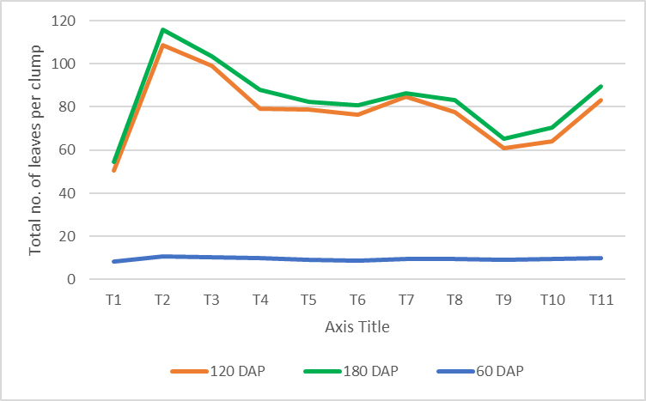

Fig. 1: Effect of fertigation treatments on number of leaves per plant in ginger (Rio-de Janeiro)

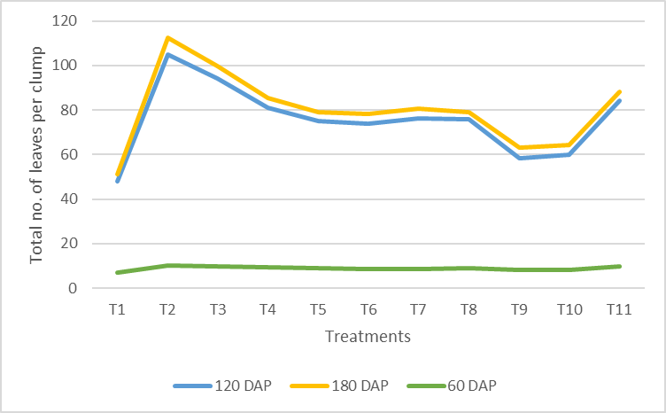
Fig.2: Effect of fertigation treatments on number of leaves per plant in ginger (Himachal)

Tillers per ginger plant: Data presented in Table-3 depicts the number of tillers per plant as influenced by different treatments in ginger cultivars Rio-de-Janerio and Himachal. Data shows that the number of tillers per plant in ginger cultivars Rio-de-Janeiro and Himachal was significantly influenced by different fertigation treatments at 120 and 180 DAP (Fig. 3 and Fig. 4). Among the treatments, T2 [200% RDF (200:100:100 kg N:P₂O₅:K₂O ha⁻¹) through fertigation + FYM 30 t ha⁻¹ + neem cake 2 t ha⁻¹] recorded the highest number of tillers per plant in both cultivars. At 120 DAP, T2 recorded 9.33 tillers per plant in Rio-de-Janeiro and 8.60 in Himachal, which were on par with T3 (8.73 and 7.93, respectively). At 180 DAP, T2 continued to record the highest number of tillers (10.26 in Rio-de-Janeiro and 9.66 in Himachal), which were statistically on par with T3 (9.40 and 8.80, respectively). It is evident that the number of tillers per plant varied significantly among different treatments in ginger cultivars (Rio-de-Janeiro and Himachal) at each stage (p<0.05).

The increased number of tillers per plant observed under higher fertigation levels in the present study could be attributed to the continuous and balanced supply of nutrients through fertigation along with the incorporation of organic amendments such as FYM and neem cake, which enhance soil fertility, nutrient availability and microbial activity. Adequate nitrogen promotes vigorous vegetative growth and tiller formation, while phosphorus and potassium support root development and overall plant growth, leading to increased tillering. Similar findings were reported by Mohanty et al. (1988) and Mohanty et al. (1993), who observed that higher fertilizer doses significantly increased plant height, number of tillers and leaves in ginger. Likewise, Singh and Bhanuneopaney (1993) reported maximum tillers and higher rhizome yield of ginger with increased NPK levels. Further, Ajithkumar and Jayachandran (2002) noted a general increase in vegetative growth parameters including tillers per plant with higher fertilizer application. Similar responses to fertigation were also reported in turmeric, where improved tiller production and growth were observed with higher fertigation levels (Sadarunnisa et al., 2010; Leva et al., 2013; Reddy et al., 2017). These findings corroborate the present results where higher fertigation levels combined with organic inputs significantly enhanced the number of tillers per plant in both ginger cultivars.

Table-3: Effect of fertigation treatments on tillers per plant in ginger cultivars

Treatments | Tillers per plant (No.)
Treatments | Rio-de-Janeiro |  | Himachal
Treatments | 120 DAP | 180 DAP | 120 DAP | 180 DAP
T1 | 4.60 | 4.86 | 4.06 | 4.40
T2 | 9.33 | 10.26 | 8.60 | 9.66
T3 | 8.73 | 9.40 | 7.93 | 8.80
T4 | 7.46 | 7.93 | 6.93 | 7.26
T5 | 5.86 | 6.46 | 5.33 | 6.00
T6 | 4.60 | 5.40 | 4.46 | 4.66
T7 | 6.00 | 6.60 | 5.10 | 5.86
T8 | 5.73 | 6.66 | 5.33 | 6.20
T9 | 5.06 | 5.20 | 4.06 | 4.93
T10 | 5.10 | 5.60 | 5.08 | 5.25
T11 | 6.00 | 6.53 | 5.26 | 6.66
F test | * | * | * | *
SEm ± | 0.40 | 0.46 | 0.38 | 0.45
CD at 5% | 1.18 | 1.35 | 1.12 | 1.32

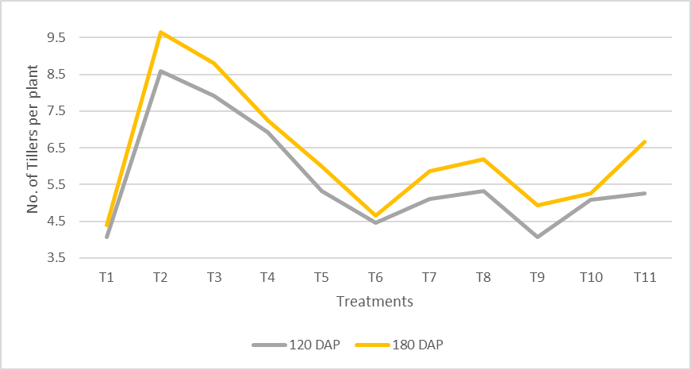
Fig.3: Effect of fertigation treatments on number of tillers per plant in ginger (Rio-de-Janeiro)

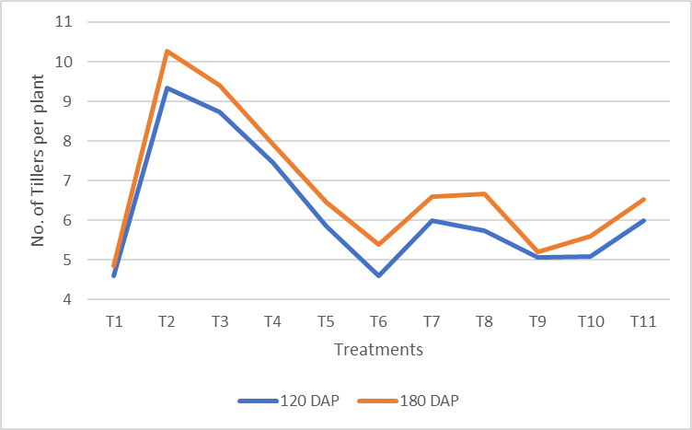
Fig.4: Effect of fertigation treatments on number of tillers per plant in ginger (Himachal)

Leaf (petiole) length and breadth of ginger cultivars: The data for leaf (petiole) length of different treatments of ginger cultivars (Rio-de-Janeiro and Himachal) are given in Table-4 and Fig.5. Among the treatments, T2 [200% RDF (200:100:100 kg N:P₂O₅:K₂O ha⁻¹) through fertigation + FYM 30 t ha⁻¹ + neem cake 2 t ha⁻¹] recorded the maximum leaf length after 180 DAP in both cultivars. In Rio-de-Janeiro, T2 recorded 19.10 cm, which was on par with T3 (18.73 cm) and T11 (18.06 cm). Similarly, in Himachal, the highest leaf length of 19.53 cm was recorded in T2, which was statistically on par with T3 (19.46 cm), T11 (18.53 cm) and T4 (18.46 cm). The data recorded were statistically significant for all the treatments among two cultivars.

The data for leaf breadth of ginger cultivars (Rio-de-Janeiro and Himachal) as influenced by different treatments is presented in Table 3 and Fig. 6. Among the treatments, T2 recorded the highest leaf breadth after 180 DAP. In Rio-de-Janeiro, the maximum leaf breadth of 1.79 cm was recorded under T2, which was superior compared to other treatments.

The increased leaf (petiole) length and breadth observed under higher fertigation levels in the present study may be attributed to the continuous and balanced supply of nutrients through fertigation combined with organic amendments such as FYM and neem cake, which improve soil fertility, nutrient availability and microbial activity. Adequate nitrogen enhances vegetative growth and leaf expansion, while phosphorus and potassium promote cell division, tissue development and overall plant vigor, resulting in larger leaf size. Similar findings were reported by Mohanty and Sharma (1978), who observed increased leaf length and breadth in ginger with higher levels of NPK along with organic manures. Likewise, Singh and Bhanuneopaney (1993) reported improved vegetative growth parameters including leaf development with higher fertilizer application in ginger. Further, Ajithkumar and Jayachandran (2002) reported a general increase in plant height, number of leaves and leaf area with increased fertilizer levels in ginger. Similar responses were also observed in turmeric, where higher fertilizer doses significantly improved leaf length, breadth and overall vegetative growth (Swain et al., 2007; Sunil et al., 2014). These findings support the present results, where higher fertigation levels along with organic inputs significantly enhanced leaf length and breadth in both ginger cultivars.

Table-4: Effect of fertigation treatments on leaf (petiole) length and breadth in ginger cultivars

Treatments | Leaf (petiole) length (cm) at 180 DAP |  | Leaf breadth (cm) at 180 DAP
Treatments | Rio-de-Janeiro | Himachal | Rio-de-Janeiro | Himachal
T1 | 14.20 | 15.53 | 1.20 | 1.36
T2 | 19.10 | 19.53 | 1.79 | 1.90
T3 | 18.73 | 19.46 | 1.61 | 1.70
T4 | 17.36 | 18.46 | 1.57 | 1.67
T5 | 16.90 | 17.46 | 1.43 | 1.55
T6 | 14.66 | 14.86 | 1.30 | 1.40
T7 | 17.66 | 17.86 | 1.55 | 1.67
T8 | 17.2 | 17.53 | 1.49 | 1.49
T9 | 14.63 | 15.53 | 1.30 | 1.40
T10 | 15.10 | 16.25 | 1.32 | 1.45
T11 | 18.06 | 18.53 | 1.60 | 1.70
F test | * | * | * | *
SEm ± | 0.42 | 0.41 | 0.05 | 0.04
CD at 5% | 1.25 | 1.18 | 0.15 | 0.13

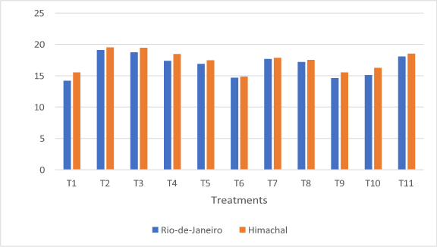
Fig. 5: Effect of fertigation treatments on leaf (petiole) length in ginger cultivars

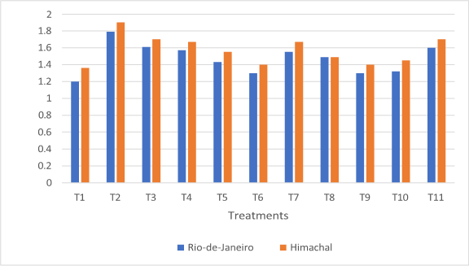
Fig. 6: Effect of fertigation treatments on leaf breadth in ginger cultuvars

Contribution of fresh weight by different parts of ginger cultivars: The percentage contribution of fresh weight by different plant parts was significantly influenced by fertigation treatments in both ginger cultivars (Table-5; Fig. 7 and Fig. 8). In Rio-de-Janeiro, treatment T2 [200% RDF (200:100:100 kg N:P₂O₅:K₂O ha⁻¹) through fertigation + FYM 30 t ha⁻¹ + neem cake 2 t ha⁻¹] recorded the highest contribution of aerial parts (16.99%), which was on par with T3 (15.20%). The same treatment also recorded the highest contribution of roots (10.71%) and rhizomes (88.59%), which was on par with T3 (88.48%), T10 (83.26%), T9 (83.15%) and T8 (82.93%). Similarly, in Himachal, T2 recorded the highest contribution of aerial parts (12.09%), roots (8.57%) and rhizomes (87.98%). The rhizome contribution under T2 was on par with T3 (87.32%), T9 (85.59%), T10 (85.52%), T11 (85.44%), T5 (85.36%), T7 (84.52%), T6 (83.96%) and T4 (82.94%).

The higher contribution of fresh weight by aerial parts, roots and rhizomes observed under higher fertigation levels in the present study may be attributed to the continuous and balanced supply of nutrients through fertigation along with the addition of organic amendments such as FYM and neem cake, which enhance soil fertility, nutrient availability and microbial activity. Adequate supply of nitrogen promotes vigorous vegetative growth, while phosphorus and potassium improve root development and translocation of photosynthates towards rhizome formation, ultimately resulting in greater biomass accumulation and higher contribution of rhizomes to the total fresh weight. Similar findings were reported by Mohanty et al. (1988) and Mohanty et al. (1993), who observed increased plant growth and rhizome yield in ginger with higher levels of NPK fertilizers. Likewise, Singh and Bhanuneopaney (1993) reported that higher fertilizer doses significantly improved rhizome length, weight and yield in ginger. Further, Ajithkumar and Jayachandran (2002) noted increased vegetative growth and rhizome yield with higher fertilizer levels. Similar responses to fertigation were also observed in turmeric, where higher fertilizer doses significantly enhanced plant growth, rhizome development and yield (Swain et al., 2007; Sunil et al., 2014). These findings corroborate the present results, where higher fertigation levels combined with organic inputs resulted in greater biomass accumulation and higher rhizome contribution in both ginger cultivars.

Table-5: Effect of fertigation treatments on contribution of fresh weight by different parts of ginger cultivars

Treatments | Contribution of fresh weight by different parts of ginger cultivars (%)
Treatments | Rio-de-Janeiro |  |  | Himachal
Treatments | Aerial parts | Roots | Rhizomes | Aerial parts | Roots | Rhizomes
T1 | 6.01 | 5.41 | 76.57 | 6.59 | 2.47 | 80.16
T2 | 16.99 | 10.71 | 88.59 | 12.09 | 8.57 | 87.98
T3 | 15.20 | 8.67 | 88.48 | 11.27 | 7.31 | 87.32
T4 | 13.89 | 4.11 | 78.90 | 10.89 | 6.31 | 82.94
T5 | 6.67 | 4.74 | 77.44 | 9.15 | 5.49 | 85.36
T6 | 9.24 | 5.51 | 78.58 | 10.75 | 5.55 | 83.96
T7 | 12.66 | 7.11 | 80.23 | 11.16 | 4.32 | 84.52
T8 | 12.72 | 6.22 | 82.93 | 7.13 | 5.43 | 81.80
T9 | 11.09 | 5.76 | 83.15 | 9.38 | 5.03 | 85.59
T10 | 10.84 | 5.90 | 83.26 | 9.32 | 5.16 | 85.52
T11 | 14.64 | 7.83 | 79.95 | 8.76 | 7.28 | 85.44
F-test | * | * | * | * | * | *
SEm ± | 0.97 | 0.58 | 1.06 | 0.44 | 0.54 | 0.69
CD at 5% | 2.75 | 1.65 | 3.01 | 1.24 | 1.52 | 1.96

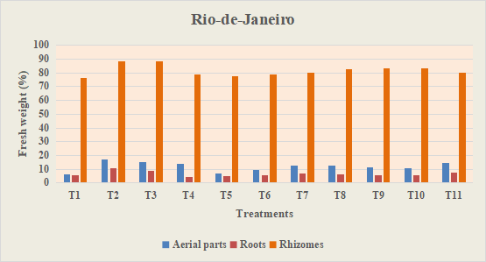
Fig.7: Effect of fertigation treatments on contribution of fresh weight by different parts of ginger cultivar (Rio-de-Janeiro)

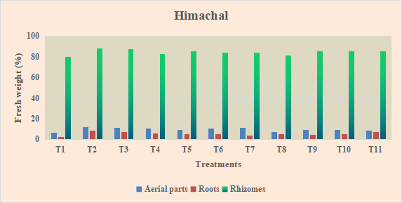
Fig.8: Effect of fertigation treatments on contribution of fresh weight by different parts of ginger cultivar (Himachal)

Contribution of dry weight by different parts of ginger cultivars: The percentage contribution of dry weight by different plant parts varied significantly among the treatments in both ginger cultivars (Table-6; Fig. 9 and Fig. 10). In Rio-de-Janeiro, treatment T2 [200% RDF (200:100:100 kg N:P₂O₅:K₂O ha⁻¹) through fertigation + FYM 30 t ha⁻¹ + neem cake 2 t ha⁻¹] recorded the highest contribution of aerial parts (18.98%), which was on par with T3 (16.78%) and T6 (16.63%). The same treatment also recorded the highest contribution of roots (7.43%), which was on par with T3 (5.41%), and rhizomes (87.52%), which was on par with T3 (84.58%). Similarly, in Himachal, T2 recorded the highest contribution of aerial parts (23.51%), which was on par with T3 (22.44%), T8 (20.33%), T4 (20.17%) and T5 (19.71%). The highest contribution of roots (8.63%) and rhizomes (83.45%) was also recorded in T2, with rhizome contribution being on par with T3 (82.88%) and T10 (81.93%).

The higher contribution of dry weight by aerial parts, roots and rhizomes observed under higher fertigation levels in the present study may be attributed to the continuous and balanced supply of nutrients through fertigation along with organic amendments such as FYM and neem cake, which improve soil fertility, nutrient availability and microbial activity. Adequate supply of nitrogen promotes vegetative growth and biomass production, while phosphorus enhances root development and potassium facilitates efficient translocation of photosynthates to storage organs, resulting in greater dry matter accumulation in rhizomes. Similar findings were reported by Mohanty et al. (1988) and Mohanty et al. (1993), who observed increased plant growth and higher rhizome yield in ginger with increased levels of NPK fertilizers. Likewise, Singh and Bhanuneopaney (1993) reported that higher fertilizer doses significantly improved vegetative growth and rhizome yield in ginger. Further, Ajithkumar and Jayachandran (2002) reported increased plant growth and rhizome yield with higher fertilizer levels. Similar responses were also reported in turmeric where higher fertilizer application significantly increased biomass accumulation and rhizome yield (Swain et al., 2007; Sunil et al., 2014). These findings support the present results where higher fertigation levels along with organic inputs resulted in greater dry matter accumulation and higher rhizome contribution in both ginger cultivars.

Table-6: Effect of fertigation treatments on contribution of dry weight by different parts of ginger cultivars
Treatments | Contribution of dry weight by different parts of ginger cultivars (%)
Treatments | Rio-de-Janeiro |  |  | Himachal
Treatments | Aerial parts | Roots | Rhizomes | Aerial parts | Roots | Rhizomes
T1 | 8.68 | 2.95 | 75.69 | 11.19 | 4.83 | 67.86
T2 | 18.98 | 7.43 | 87.52 | 23.51 | 8.63 | 83.45
T3 | 16.78 | 5.41 | 84.58 | 22.44 | 8.20 | 82.88
T4 | 15.25 | 4.80 | 79.95 | 20.17 | 5.13 | 74.70
T5 | 12.47 | 5.33 | 75.79 | 19.71 | 7.77 | 72.52
T6 | 16.63 | 4.13 | 79.24 | 13.24 | 5.36 | 77.85
T7 | 14.43 | 4.51 | 81.06 | 17.78 | 5.33 | 76.89
T8 | 13.08 | 5.16 | 81.51 | 20.33 | 4.90 | 72.66
T9 | 10.84 | 4.90 | 84.26 | 12.11 | 5.01 | 81.93
T10 | 11.00 | 5.15 | 83.85 | 12.63 | 5.51 | 81.86
T11 | 13.62 | 3.80 | 81.22 | 16.94 | 5.21 | 71.47
F-test | * | * | * | * | * | *
SEm ± | 0.88 | 0.35 | 1.00 | 0.96 | 0.32 | 1.02
CD at 5% | 2.58 | 1.02 | 2.93 | 2.81 | 0.93 | 2.99

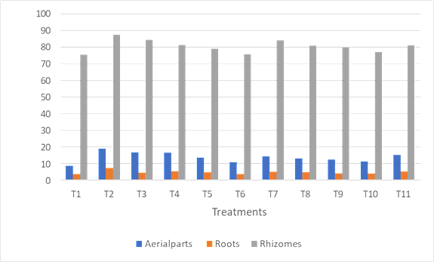
Fig.9: Effect of fertigation treatments on contribution of dry weight by different parts of ginger cultivar (Rio-de-Janerio)

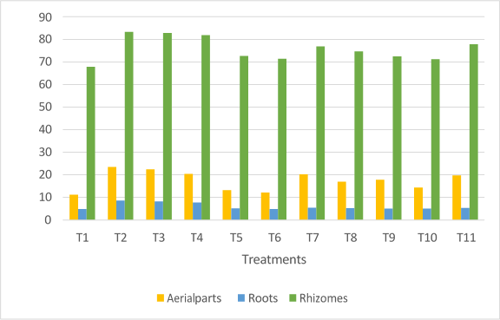
Fig.10: Effect of fertigation treatments on contribution of dry weight by different parts of ginger cultivar (Himachal)

DISCUSSION

The improved vegetative growth and biomass distribution observed under treatment T2 [200% RDF (200:100:100 kg N:P₂O₅:K₂O ha⁻¹) through fertigation + FYM (30 t ha⁻¹) + neem cake (2 t ha⁻¹)] may be attributed to the balanced and continuous supply of nutrients through fertigation along with the addition of organic amendments. The integration of inorganic fertilizers with FYM and neem cake likely enhanced soil fertility, nutrient availability and microbial activity, thereby improving nutrient uptake and overall plant growth. Adequate availability of essential nutrients, particularly nitrogen and potassium, plays a crucial role in promoting vegetative growth, including increased number of leaves, tillers and leaf size (length and breadth), by enhancing cell division, cell elongation and physiological activities in the plant. The improved vegetative growth in turn increases photosynthetic efficiency and assimilate production, which contributes to better biomass accumulation and partitioning towards economically important plant parts such as rhizomes. Consequently, higher percentage contribution of both fresh and dry weight by rhizomes was recorded under this treatment. The synergistic effect of organic and inorganic nutrient sources might have improved nutrient use efficiency and plant vigour, leading to enhanced growth and rhizome development in ginger.

Similar findings were reported by Sadanandan et al. (2002), Hedge et al. (2012) and Singh et al. (2015), who observed that integrated nutrient management and higher nutrient supply through fertigation significantly improved vegetative growth, biomass production and rhizome yield in ginger.

CONCLUSION

The present study conducted during the kharif season of 2021 at the Department of Horticulture, Gandhi Krishi Vignana Kendra (GKVK), University of Agricultural Sciences, Bengaluru, Karnataka demonstrated the fertigation levels significantly influenced vegetative growth, biomass accumulation and partitioning in ginger (Zingiber officinale) cultivars Rio-de-Janeiro and Himachal. Among the different treatments evaluated, T₂ [200% RDF (200:100:100 kg N:P₂O₅:K₂O ha⁻¹) through fertigation along with FYM (30 t ha⁻¹) and neem cake (2 t ha⁻¹)] recorded superior performance in terms of vegetative growth parameters and biomass distribution. This treatment produced the highest number of leaves per plant (115.86 in Rio-de-Janeiro and 112.40 in Himachal at 180 DAP), maximum number of tillers (10.26 and 9.66 per plant, respectively), and larger leaf size with greater leaf length and breadth compared to other treatments. The enhanced vegetative growth under this treatment was reflected in improved photosynthetic activity and higher biomass accumulation.

Fertigation treatments also markedly influenced biomass partitioning, with T₂ recording the highest contribution of rhizomes on both fresh weight (88.59% in Rio-de-Janeiro and 87.98% in Himachal) and dry weight basis (87.52% and 83.45%, respectively). The improved growth and higher allocation of assimilates towards rhizomes may be attributed to the balanced and continuous supply of nutrients through fertigation combined with the beneficial effects of organic amendments such as FYM and neem cake, which enhanced soil fertility, nutrient availability and microbial activity, thereby improving nutrient uptake and nutrient use efficiency.

Overall, the results indicate that integrated nutrient management through fertigation along with organic amendments plays a vital role in improving vegetative growth and biomass production in ginger. Hence, the application of 200% RDF through fertigation combined with FYM and neem cake can be considered an effective nutrient management strategy for for improving vegetative growth attributes and biomass accumulation in ginger cultivars under the southern dry zone conditions of Karnataka.

REFERENCES

Ajithkumar, K. and Jayachandran, B.K., 2002, Effect of major nutrients on growth and rhizome yield of ginger (Zingiber officinale Rosc.) intercropped in coconut garden. South Ind. Hort., 50(4-6): 702-707.

Amarananjundeshwara, H., 1997, Studies on fertigation of potato (Solanum tuberosum L.). M. Sc. (Agri.) Hort. Thesis (Unpub.), Univ. Agric. Sci., Bangalore.

Hagin, J., Sneh, M. and Lowengart-Aycicegi, A. 2002. Fertigation: Fertilization through irrigation. IPI Research Topics No. 23. International Potash Institute, Basel, Switzerland.

Hegde, N. K, kurbar, A. R, Hanamashetti, S. I. and Kulkarni, m., 2006, Quality of ginger genotypes grown under open and coconut shade. Biomedical Res. J. 1(2):120-124.

LEVA, R. L., THANKI, J. D., PATEL, D. D. AND PATEL, U. T., 2013, Effect of different planting methods and levels of fertigation on turmeric (Curcuma longa L.). Bioinfolet, 10 (3A): 811-813.

Mohanty, D. C. and Sharma, Y. N., 1978, Performance of ginger in tribal areas of Orissa, India, as influenced by method of planting, seed treatment, manuring and mulching. J. Pl. Crops, 6(1): 14-16.

Mohanty, D. C., Sharma, Y. N., Naik, B. S. and Panda, B. S., 1988, Influence of fertilizer cum seed rates on yield and performance of the selected ginger clones in eastern ghats high land zone of Orissa. Indian Cocoa Arecanut Spices J., 12(1): 1-3.

Mohanty, D. C., Sharma, Y. N., Panda, B. S. and Edinson, S., 1993, Studies on fertilizers management and seed rates in ginger variety Suruchi. Ind. Cocoa Arecanut Spices J., 16(3-4): 101-104.

Ravindran, P.N. and Babu, K.N. 2005. Ginger: The Genus Zingiber. CRC Press, Taylor and Francis Group, Boca Raton, Florida, USA.

Reddy, G. R. A., Tiwari, K. N. and Santosh, D. T., 2017, Yield response of turmeric (Curcuma longa L.) under drip fertigation and plastic mulch conditions. Int. J. Pure App. Biosci., 5(4): 1265-1269.

Sadarunnisa, S., Madhumathi, C., Rao, G. S. and Sreenivasulu, B., 2010, Effect of fertigation on growth and yield of turmeric (Curcuma longa L.) cv. Mydukur. J. Hortic. Sci., 5(1): 78-80.

Sadanandan, A.K., Hamza, S. and George, J.K. 2002. Effect of integrated nutrient management on yield and quality of ginger (Zingiber officinale Rosc.). Journal of Spices and Aromatic Crops, 11(2): 107–110.

Singh, A. K. and Neopaney, B., 1993, Effect of NPK combinations and spacings on yield and quality traits of ginger. Himachal J. Agric. Res., 19(1-2): 25-30.

Singh, A.K., Gautam, U.S. and Singh, J. 2015. Impact of Integrated Nutrient Management on Ginger production. Bangladesh Journal of Botany, 44(2): 341–344.

Sunil, A., Satyareddi, and Angadi, S. S., 2014, Response of turmeric (Curcuma longa L.) varieties to irrigation methods and graded levels of fertilizer. Res. Environ. Life Sci., 7(4): 237-242.

Swain, S. C., Rath, S. and Ray, D. P., 2007., Effect of NPK levels and mulching on growth, yield and economics of turmeric in rainfed uplands. Orissa J. Hort., 35(1): 58-60.

