Ethion-induced Tissue Damage in Tilapia Oreochromis mossambicus (Peters, 1852): A Histopathological Insight

.
ABSTRACT

Aquatic ecosystems are increasingly threatened by agrochemical contamination, particularly from organophosphate pesticides introduced through agricultural runoff and industrial effluents. This study investigated the acute toxicity and histopathological effects of Ethion [O, O, O′, O′-tetraethyl-S, S′-methylene bis (phosphorodithioate)] on Oreochromis mossambicus (Mozambique tilapia), an ecologically and economically important freshwater fish species. The median lethal concentration (96-h LC₅₀) of Ethion was determined to be 0.271 ± 0.10 mg/L, indicating high acute toxicity. Fish exposed to sublethal concentrations (0.027, 0.054, and 0.081 mg/L) exhibited pronounced behavioral alterations, including erratic swimming, hyperactivity, and loss of equilibrium, reflecting neurotoxic effects associated with acetylcholinesterase inhibition. Histopathological examination revealed progressive, dose-dependent tissue alterations across vital organs. Gills showed epithelial lifting, lamellar fusion, and necrosis, indicating impaired respiration and osmoregulation. The liver exhibited cytoplasmic vacuolation, sinusoidal dilation, nuclear pyknosis, and necrosis, suggesting hepatocellular degeneration and disrupted detoxification. Renal tissues demonstrated glomerular shrinkage, tubular necrosis, and inflammatory infiltration, reflecting impaired ion regulation and excretory dysfunction. The presence of enlarged melano-macrophage centres indicated activation of defence mechanisms against oxidative stress. These findings demonstrate that Ethion exposure causes severe structural and functional impairments in O. mossambicus, even at sublethal concentrations, underscoring the ecological risks posed by organophosphate contamination. Histopathological biomarkers observed in this study provide a sensitive diagnostic tool for assessing pesticide-induced toxicity in aquatic organisms and can aid in establishing safe environmental limits for pesticide usage.

Keywords: Aquatic toxicity, Ethion, Histopathology, Pesticide toxicity Oreochromis mossambicus

1. INTRODUCTION

Aquatic ecosystems are increasingly threatened by the influx of agrochemicals released through agricultural runoff and industrial effluents (Gao et al., 2025). Among these, organophosphate pesticides are extensively used because of their high insecticidal efficiency and relatively short environmental persistence. However, the continuous and indiscriminate application of these compounds has led to their accumulation in aquatic environments, posing severe toxicological risks to non-target organisms, particularly fish (Kumar et al., 2021).
Ethion (O, O, O′, O′-tetraethyl-S, S′-methylene bis(phosphorodithioate)) is a broad-spectrum organophosphate pesticide widely used in agriculture to control sucking insects and mites (Devault & Karolak, 2021). Although effective in pest management, ethion exhibits moderate toxicity to aquatic organisms because it inhibits acetylcholinesterase (AChE), an enzyme essential for normal cholinergic nerve transmission. Once introduced into aquatic systems, ethion can be absorbed through the gills, skin, and gastrointestinal tract of fish, leading to biochemical, physiological, and histopathological disturbances that impair key biological functions, such as respiration, osmoregulation, and detoxification (Merugumalla et al., 2025).
Fish serve as excellent bioindicators of aquatic pollution because of their sensitivity to toxicants and their capacity to reflect the health status of aquatic ecosystems (Yancheva et al., 2016; Garham & Katherine, 2004). Oreochromis mossambicus (Peter 1852) (Mozambique tilapia) is of particular interest in ecotoxicological studies because of its ecological adaptability, economic importance, and availability as an affordable protein source for low-income populations (Chordiya & Chandanshive, 2023). Hence, it represents a suitable model organism for assessing the toxicological effects of pesticides, such as ethion.
Histopathological analysis has proven to be a reliable and sensitive biomarker for evaluating pollutant-induced stress in fish (Hinton et al., 2018). Structural and cellular alterations in vital organs, particularly the gills, liver, and kidneys, are direct indicators of toxicant exposure. The gills, which are the primary interface with the aquatic environment, often exhibit epithelial lifting, lamellar fusion, and necrosis upon pesticide exposure (Velmurugan et al.,2015). The liver, a major organ involved in metabolism and detoxification, typically exhibits vacuolation, sinusoidal congestion, and necrosis under organophosphate stress (Ghayyur et al., 2021; Bhuvaneshwari et al.,2015). Similarly, the kidneys, which are essential for osmoregulation and excretion, may reveal tubular degeneration, glomerular shrinkage, and necrosis, indicating compromised physiological function (Reddy & Rawat, 2013).

Several studies indicate the harmful effects of ethion and related organophosphates on fish. Merugumalla et al. (2025) found that ethion exposure in Labeo catla led to significant inhibition of AChE activity and behavioral abnormalities. Vinayan & Tijare (2025) reported neurobehavioral changes in Danio rerio, such as erratic swimming and rapid opercular movement, highlighting ethion's neurotoxicity. Kabir et al., (2019) documented histopathological changes in Oreochromis niloticus, including liver and kidney damage, even at sublethal doses of Sumithion. Additionally, Kumar, et al., (2025) noted increased toxicity of dimethoate in Channa punctatus over time, with decreasing LC₅₀ values during exposure. These results highlight the consistently toxic potential of organophosphates in multiple fish species. However, despite extensive research on other organophosphates, there is limited information on the histopathological consequences of ethion exposure in O. mossambicus, a species of both ecological and economic relevance.
Given the widespread use, lipophilic nature, and persistence of Ethion in aquatic systems, understanding its sublethal effects on fish is vital. Histopathological evaluation of ethion-induced tissue alterations can provide valuable biomarkers for environmental monitoring and ecotoxicological assessment. Therefore, the present study aimed to investigate the histopathological effects of ethion on the kidney, gill, and liver tissues of O. mossambicus under controlled laboratory conditions. These findings are expected to enhance our understanding of organophosphate-induced cellular damage and contribute to improved environmental risk assessment and pesticide management strategies in freshwater ecosystems.

2. material and methods

The method given in APHA 24th edition was used for finding LC50.
2.1. Procurement and Acclimatization of Fish
Healthy O. mossambicus (length: 8.4 ± 0.5 cm; weight: 7.57 ± 0.23 g) were procured from ponds of College of Fishery Science, Nagpur. The fish were acclimatised for 15 days in aerated glass aquaria under laboratory conditions. During acclimatisation, the fish were fed a commercial pelleted diet twice daily, and 50% of the water was replaced every 24 h to maintain water quality. Feeding was withheld for 24 h before the commencement of the experiment to reduce metabolic waste.
2.2. Determination of Median Lethal Concentration (LC₅₀)
Acute toxicity tests were performed in glass tanks (40 L capacity) containing 20 L of water. A preliminary range-finding test was conducted at concentrations of 0.025, 0.050, 0.1, 0.2, 0.3, 0.4, 0.5, and 0.6 mg/L of ethion to determine the mortality range. Based on the no-observed-effect concentration (NOEC) and the concentration causing complete mortality, the definitive test was conducted at concentrations of 0.050, 0.1, 0.2, 0.3, 0.4, and 0.5 mg/L. Each concentration was tested in triplicate, with 10 fish per replicate. Fish were exposed for 96 h under static-renewal conditions, with water replacement and ethion re-administration every 24 h. Replacement of ethion was done due to its evaporative nature. Mortality was recorded at 24-h intervals, and dead fish were promptly removed. Water quality parameters were maintained at 27 ± 1°C temperature, pH 7.5, and dissolved oxygen >5 mg/L. A 12:12 h light–dark photoperiod was maintained throughout the study.
2.3. Preparation of Stock Solution
Commercially available ethion (brand name: Fosmite) was used in this study. Fosmite is a 50% EC formulation containing 54.5% w/w of the active ingredient. The required ethion quantities were weighed using an analytical balance (Wensar HPB220, India). Micropipettes were used to withdraw ethion and prepare stock solutions.
Stock solutions were freshly prepared daily before administration using the following formula: Weight of Tafethion (mg) = [Required concentration (mg/L) × Tank volume (L) × 100] / 54.5. A 10X concentrated stock solution (10 mL per dose) was prepared for each concentration [10X stock solution = Weight of Tafethion for dose (mg) × 10]. From each stock, 1 mL was pipetted into the tank using a 1 mL pipette with a fresh tip for each dose. Mild aeration was provided throughout the exposure period of the experiment. The water in all tanks was completely replaced every 24 h, and the same concentration of ethion was re-administered.
2.4. Acute Toxicity Testing
Fish were exposed to 0.1, 0.2, and 0.3× LC₅₀ concentrations i.e. 0.027, 0.054 and 0.081 mg/L of ethion for 96 h under static-renewal conditions. Each treatment was replicated thrice with 10 fish per replicate tank. Behavioural responses and mortality were observed at 24 h intervals. The water quality was maintained as previously described.
2.5. Histopathological Examination
At the end of the exposure period, gill, kidney, and liver tissues were dissected from the control and treated fish for histopathological evaluation. Samples were fixed in 10% neutral buffered formalin for 24–48 h, dehydrated through graded ethanol (70%, 80%, 90%, and absolute ethanol), cleared in xylene, and embedded in paraffin wax. Sections (4–5 µm) were obtained using a rotary microtome and were mounted on glass slides. The slides were stained with haematoxylin and eosin (H&E) following standard protocols.
The stained sections were examined under a light microscope at varying magnifications, and representative photomicrographs were obtained. Histopathological alterations were evaluated and compared between the control and ethion-exposed groups to assess organ-level toxic effects.
2.6. Data Analysis
The median lethal concentration (LC₅₀) was calculated by probit analysis using the R software based on cumulative mortality at 96 h. Histopathological changes were qualitatively described, and representative alterations were documented using photomicrographs.

3. results and discussion

The 96-hour acute toxicity assay demonstrated a clear, concentration-dependent increase in the mortality of O. mossambicus exposed to ethion. No mortality was observed at 0.025 mg/L, which was identified as the No Observed Effect Concentration (NOEC), while 100% mortality occurred at 0.5 mg/L. Probit analysis estimated the 96-hour LC₅₀ value of ethion to be 0.271 ± 0.10 mg/L, indicating a high level of acute toxicity of this organophosphate pesticide to freshwater fish. Mortality followed a dose-dependent pattern, with higher concentrations resulting in earlier onset and complete lethality. Similar LC₅₀ values have been reported for other organophosphate pesticides in different fish species, such as dimethoate in Channa punctatus and ethion in Labeo catla. Variations in these values are attributed to differences in fish size, metabolic rate, water quality, and experimental conditions (Kumar et al., 2025; Merugumalla et al., 2025).
Behavioural responses served as early indicators of ethion-induced toxicity. During exposure, the treated fish exhibited erratic swimming, hyperactivity, loss of equilibrium, surfacing behaviour, and excessive mucus secretion prior to death, while control fish remained active with normal feeding and schooling behaviour. Fish exposed to sublethal concentrations (0.1, 0.2, and 0.3 times the LC₅₀) showed progressive behavioural changes throughout the 96-hour exposure period. Initial hyperactivity and jerky movements were observed within the first 12 to 24 hours, followed by surfacing, mucus secretion, and loss of balance. At higher concentrations, respiratory distress and lethargy became evident, while behavioural responses were less pronounced at lower concentrations. These behavioural abnormalities are characteristic of neurotoxicity induced by organophosphate compounds, which are associated with acetylcholinesterase inhibition. This results in the accumulation of acetylcholine at neuromuscular junctions, disrupting normal nerve transmission (Vinayan & Tijare, 2025).
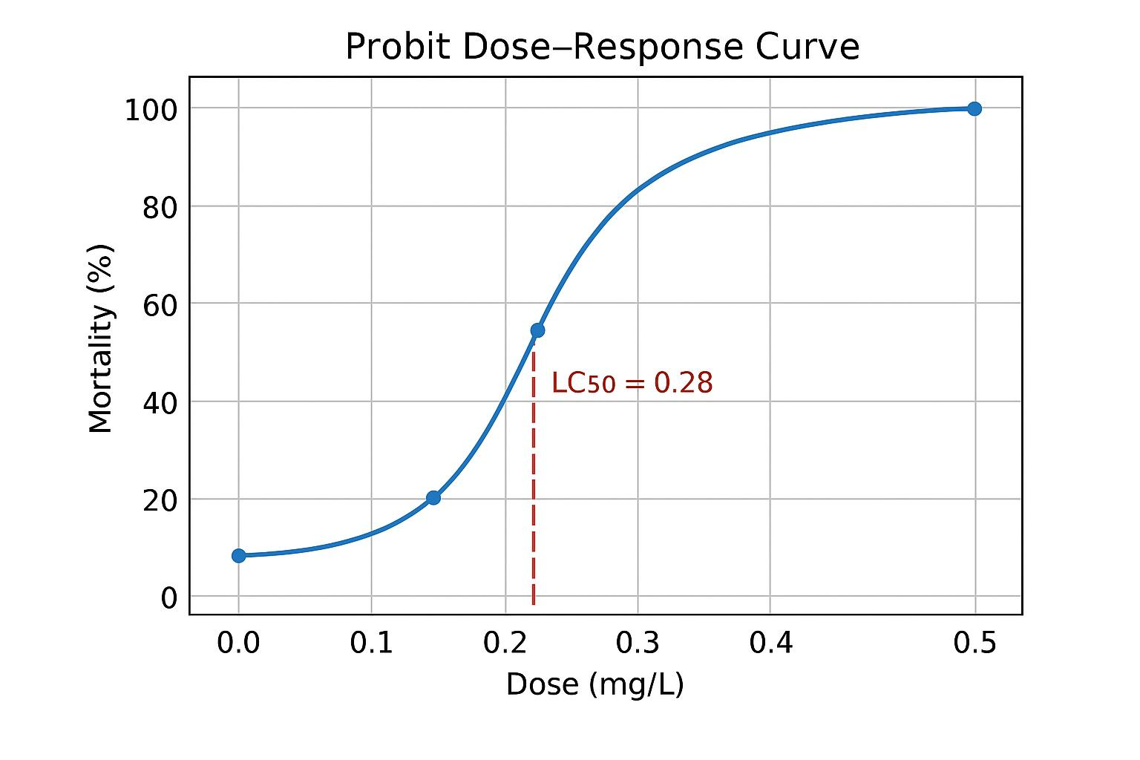

Figure 1. Probit Dose response curve

Histopathological examinations revealed that the gills, kidneys, and liver are highly susceptible to damage from ethion, with lesion severity increasing in a dose-dependent manner. The gill tissues of control fish exhibited normal architecture, with well-organised primary and secondary lamellae and an intact epithelial lining. In contrast, fish exposed to ethion displayed progressive pathological alterations. At 0.027 mg/L, necrosis of the secondary lamellae, destruction of the primary lamellar epithelium, and mild cellular oedema were observed. At 0.054 mg/L, the lesions became more pronounced, including haemorrhages, extensive lamellar necrosis, epithelial lifting, and oedema. At the highest concentration (0.081 mg/L), severe degeneration of both primary and secondary lamellae, marked epithelial lifting, and extensive oedema were evident. These alterations indicate impaired gas exchange and osmoregulatory dysfunction (Fernandes et al., 2020). Similar gill lesions have been reported in Oreochromis niloticus exposed to Sumithion and Labeo rohita exposed to chlorpyrifos (Kabir et al., 2019; Gupta et al., 2017). Although epithelial lifting may initially serve as a protective response to minimise toxicant uptake, prolonged exposure leads to irreversible damage and respiratory distress (Hinton et al., 2018).
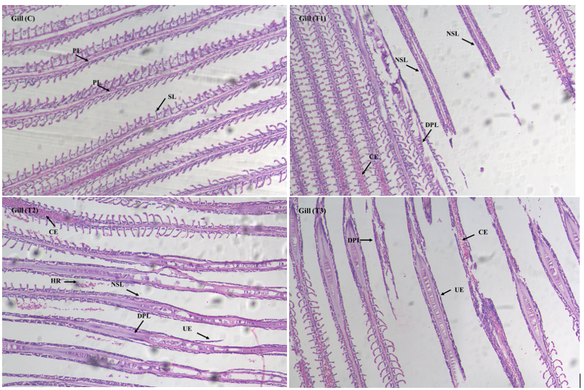
Figure 2. Histopathological alterations in the Gill of O. mossambicus exposed to Ethion. (C) Control, (T1) fish exposed to 0.027 mg/L, (T2) 0.054 mg/L, (T3) 0.081 mg/L. PL: Primary lamellae, SL: Secondary lamellae, NSL: Necrosis of secondary lamellae, DPL: Destruction of primary lamellae, CE: Congestion, HE: Haemorrhage, UL: Uplifting of Epithelium

The kidney tissues of control fish showed normal glomeruli and renal tubules; however, treated fish exhibited progressive renal degeneration. Mild alterations at 0.027 mg/L included slight narrowing of proximal tubules, glomerular shrinkage, and mild karyolysis. At 0.054 mg/L, significant pathological changes were observed, including tubular dilation, inflammatory cell infiltration, vacuolization, widening of Bowman’s space, and further glomerular shrinkage. At 0.081 mg/L, severe renal damage became evident, featuring marked necrosis, tubular dilation, collapsed or degenerated glomeruli, vascular congestion, and extensive inflammatory infiltration. Enlargement of melano-macrophage centres at higher concentrations indicates an activation of defence mechanisms against oxidative and toxic stress (Bjørgen & Koppang, 2024). Similar renal impairments have been reported in Channa punctatus and Clarias batrachus following exposure to organophosphate pesticides such as dimethoate and malathion (Reddy & Rawat, 2013; Kumar et al., 2025). These lesions impair ion regulation and excretory efficiency, leading to osmotic imbalance and eventual mortality (Reda et al., 2025).
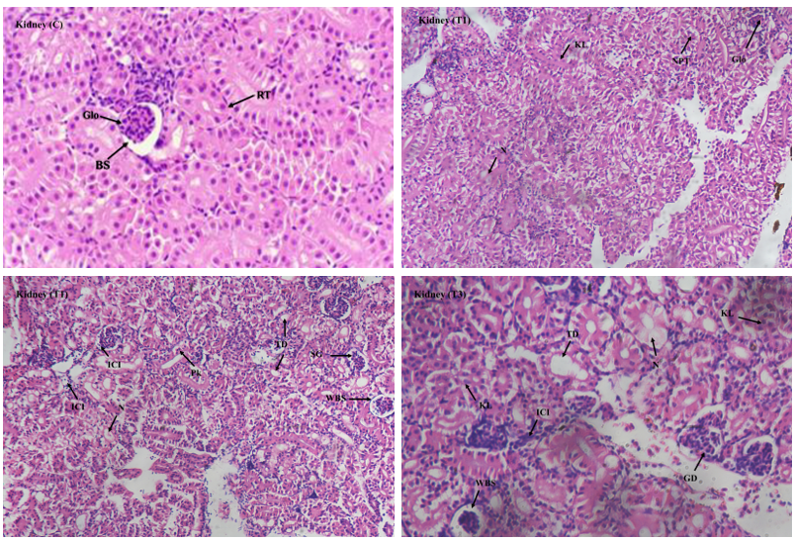
Figure 3. Histopathological alterations in the Kidney of O. mossambicus exposed to Ethion. (C) Control, (T1) fish exposed to 0.027 mg/L, (T2) 0.054 mg/L, (T3) 0.081 mg/L. Glo: Glomerulus, BS: Bowman’s capsule, RT: Renal Tubule, N: Necrosis, KL: karyolysis, NPT: Narrowing of Proximal renal tubule, ICI: Inflammatory cell infiltration, Pk: Pyknosis, TD: Tubular dilation, SG: Shrunken Glomerulus, WBS: Widening of Bowman Space, GD: Glomerular Damage

Histopathological evaluation of liver tissues revealed progressive, dose-dependent hepatic damage following ethion exposure. Control exhibited normal liver architecture, characterised by well-organised hepatic cords, polygonal hepatocytes with centrally located nuclei, and evenly distributed sinusoids. At a concentration of 0.027 mg/L, mild alterations were observed, including cytoplasmic vacuolation, slight dilation of the sinusoids, and disorganisation of hepatic cords, along with mild congestion of the central vein. At 0.054 mg/L, there was clear cytoplasmic degeneration of hepatocytes, nuclear pyknosis, loss of cellular boundaries, marked sinusoidal dilation, infiltration of inflammatory cells around central and portal areas, distortion of hepatic cords, and focal necrosis, indicating moderate hepatocellular injury. At the highest concentration of 0.081 mg/L, severe hepatic lesions manifested as extensive necrosis, pronounced inflammatory infiltration, congestion of blood capillaries, ballooning degeneration, severe sinusoidal dilation, and significant disorganisation of hepatic cords. These findings align with the liver's primary role in xenobiotic metabolism and detoxification (Hinton et al., 2018). Similar hepatic alterations have been reported in species such as Labeo catla and Oreochromis niloticus exposed to ethion and other organophosphate pesticides (Merugumalla et al., 2025; Kabir et al., 2019).
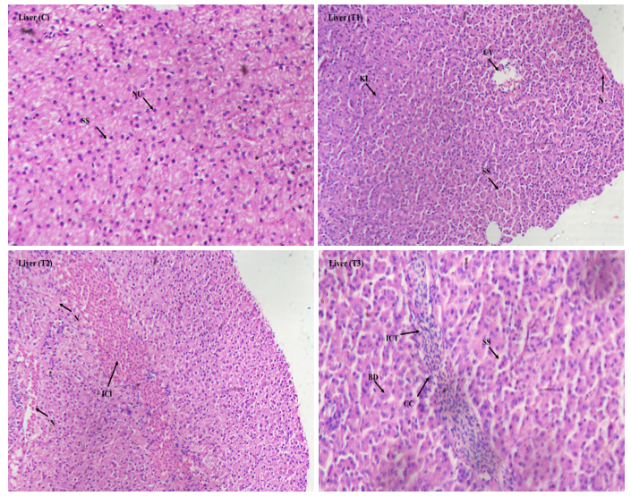
Figure 4. Histopathological alterations in the Liver of O. mossambicus exposed to Ethion. (C) Control, (T1) fish exposed to 0.027 mg/L, (T2) 0.054 mg/L, (T3) 0.081 mg/L. SS: Sinusoidal space, NU: Nucleus of liver cell, KL: Karyolysis, CV: Central vein, N: Necrosis, ICI: Inflammatory cell infiltration, BD: Ballooning Degeneration, CC: Cellular congestion

The combined patterns of mortality, behavioural disturbances, and histopathological changes clearly indicate systemic toxicity due to ethion exposure in O. mossambicus. The progressive structural deterioration of the gills, kidneys, and liver reflects impairment of respiratory, metabolic, and excretory functions, ultimately affecting fish survival. Notably, the presence of significant lesions at sublethal concentrations implies that even low levels of ethion contamination can lead to chronic physiological stress and reduced fitness in fish populations.
The observed toxic effects can be attributed to the lipophilic nature of ethion, which allows for easy penetration across biological membranes and bioaccumulation in tissues. Once absorbed, ethion is metabolised into its oxon form, a more potent inhibitor of acetylcholinesterase, leading to neurotoxicity and oxidative damage (Devault & Karolak, 2021). Prolonged inhibition of acetylcholinesterase disrupts neurotransmission and induces oxidative imbalance, which helps explain the behavioural abnormalities and progressive cellular degeneration observed in this study (Formicki et al., 2025).
Overall, these findings corroborate previous reports on the harmful effects of organophosphate pesticides on aquatic organisms and expand existing knowledge by providing detailed histopathological evidence of sublethal toxicity induced by ethion in O. mossambicus. The results highlight that ethion contamination, even at environmentally relevant concentrations, poses a significant threat to fish health and aquatic biodiversity.

4. Conclusion

In conclusion, ethion exposure induces marked physiological and histopathological changes in O. mossambicus in a concentration-dependent manner. This study highlights the sensitivity of the gills, liver, and kidneys as target organs for ethion toxicity. The observed lesions can serve as reliable biomarkers for monitoring organophosphate contamination in aquatic ecosystems. Further research involving biochemical and molecular biomarkers is recommended to elucidate the mechanistic pathways of ethion-induced oxidative stress and establish safe environmental concentration limits for aquatic life protection.

Competing interests

The authors declare no conflict of interest.

References

American Public Health Association, American Water Works Association, Water Environment Federation. Lipps WC, Braun-Howland EB, Baxter TE, eds. Standard Methods for the Examination of Water and Wastewater. 24th ed. Washington, D.C.: APHA Press; 2023.
Bhuvaneshwari, R., Padmanaban, K., & Babu Rajendran, R. (2015). Histopathological alterations in muscle, liver and gill tissues of zebra fish Danio rerio due to environmentally relevant concentrations of organochlorine pesticides (OCPs) and heavy metals. International Journal of Environmental Research, 9(4), 1365-1372.
Bjørgen, H., & Koppang, E. O. (2024). The melano-macrophage: The black leukocyte of fish immunity. Fish & shellfish immunology, 148, 109523.
Chordiya, S. P., & Chandanshive, N. E. (2023). Bioaccumulation of Heavy Metals in Organs of Freshwater Fish O. mossambicus Collected from two Sites of Ujani Backwaters. Ecology, Environment & Conservation. 29 (1) 498-507. http://doi.org/10.53550/EEC.2023.v29i01.073
Devault, D.A., & Karolak, S. (2020). Wastewater-based epidemiology approach to assess population exposure to pesticides: a review of a pesticide pharmacokinetic dataset. Environmental Science and Pollution Research 27, 4695–4702. https://doi.org/10.1007/s11356-019-07521-9
Fernandes, C. E., da Silveira, A. W., do Nascimento Silva, A. L., de Souza, A. I., Povh, J. A., dos Santos Jaques, J. A., & Franco-Belussi, L. (2020). Osmoregulatory profiles and gill histological changes in Nile tilapia (Oreochromis niloticus) exposed to lambda-cyhalothrin. Aquatic Toxicology, 227, 105612.
Formicki, G., Goc, Z., Bojarski, B., & Witeska, M. (2025). Oxidative Stress and Neurotoxicity Biomarkers in Fish Toxicology. Antioxidants, 14(8), 939. https://doi.org/10.3390/antiox14080939
Ghayyur, S., Khan, M. F., Tabassum, S., Ahmad, M. S., Sajid, M., Badshah, K., & Qamer, S. (2021). A comparative study on the effects of selected pesticides on hemato-biochemistry and tissue histology of freshwater fish Cirrhinus mrigala (Hamilton, 1822). Saudi Journal of Biological Sciences, 28(1), 603-611.
Graham R. Scotta & Katherine A. Sloman. (2004). The effects of environmental pollutants on complex fish behaviour: integrating behavioural and physiological indicators of toxicity. Aquatic Toxicology 68, 369–392.
Hinton, D. E., Baumann, P. C., Gardner, G. R., Hawkins, W. E., Hendricks, J. D., Murchelano, R. A., & Okihiro, M. S. (2018). Histopathologic biomarkers. In Biomarkers (pp. 155-210). CRC Press.
Kabir, M., Shahjahan, M., Chowdhury, P., & Rahman, M. S. (2019). Histopathological and environmental effects of the insecticide, sumithion on the fish, tilapia (Oreochromis niloticus) in pond condition. International Journal of Agricultural Research, Innovation and Technology, 9(1), 84-95.
Kumar, M., Yadav, A. N., Saxena, R., Paul, D., & Tomar, R. S. (2021). Biodiversity of pesticides degrading microbial communities and their environmental impact. Biocatalysis and Agricultural Biotechnology, 31, 101883.
Kumar, V., Singh, R., & Sharma, A. (2025). Acute toxicity and behavioral response of Channa punctatus (Bloch) to dimethoate exposure. International Journal of Zoological Investigations, 11(2), 435–442. https://doi.org/10.33745/ijzi.2025.v11i02.035
Merugumalla, S., Anapana, G., & Vakita, V. R. (2025). Effects of Ethion (50% EC) on Acetylcholinesterase Activity in the Freshwater Fish Catla catla. Uttar Pradesh Journal of Zoology, 46(17), 197-205.
Punniyakotti Elumalai, Xuke Gao, Punniyakotti Parthipan, Junyu Luo, Jinjie Cui(2025) Agrochemical pollution: A serious threat to environmental health. Current Opinion in Environmental Science & Health. 43. https://doi.org/10.1016/j.coesh.2025.100597
Reda, R. M., Zaki, E. M., AA Aioub, A., Metwally, M. M., Yassin, A. M., & Mahsoub, F. (2025). Behavioral, biochemical, immune, and histological responses of Nile tilapia (Oreochromis niloticus Linnaeus, 1758) to lead, mercury, and pendimethalin exposure: individual and combined effects. Environmental Sciences Europe, 37(1), 11.
Reddy, P. B., & Rawat, S. S. (2013). Assessment of aquatic pollution using histopathology in fish as a protocol. International Research Journal of Environment Sciences, 2(8), 79-82.
Velmurugan, B., Cengiz, E. I., Yolcu, M., Uğurlu, P., & Selvanayagam, M. (2020). Cytological and histological effects of pesticide chlorpyriphos in the gills of Anabas testudineus. Drug and Chemical Toxicology, 43(4), 409-414.
Vinayan, K. V., & Tijare, R. V. (2025). Effect of Ethion on behavioral pattern response in Danio rerio (Zebrafish). Environment Conservation Journal, 26(4), 1196–1203. https://doi.org/10.36953/ECJ.33553112
Yancheva, V., Velcheva, I., Stoyanova, S., & Georgieva, E. (2016). Histological biomarkers in fish as a tool in ecological risk assessment and monitoring programs: a review. Applied ecology and environmental research, 14(1), 47-75.

