Entrepreneurial Challenges in Skill Development Programmes for Solar-Based Enterprises: Evidence from Tribal Communities in Ladakh, India

Abstract
Vocational skill cultivation initiatives focusing on enterprise creation are frequently utilized to foster economic stability among indigenous populations in isolated regions. This study examines the operational challenges faced by 320 participants attending a solar lantern and LED bulb fabrication programme in Ladakh, India, conducted under the Ministry of Electronics and Information Technology. Primary data were collected through a structured questionnaire administered via Google Forms and analysed using the Garrett ranking technique to prioritise perceived constraints. Findings indicate that perceived need for more advanced and interactive pedagogical approaches emerged as the foremost concern, reflecting trainees’ demand for more interactive and advanced learning rather than deficiencies in instructional delivery, with a mean Garrett score of 61.21 and a consensus of 29.7 per cent. This was followed by lack of financial support after training (58.63) and issues related to lighting and power supply (54.92). In contrast, language barriers (40.53) and transportation problems (38.98) ranked lowest, indicating relatively minor concerns. Although participants reported certain instructional and facility-related limitations, the structured design and delivery of the training programme ensured the provision of adequate infrastructure and training support. Power disruptions were largely attributed to geographical and climatic conditions rather than programme inefficiencies. The study highlights the need for further strengthening of experiential learning, financial linkages and post-training support to enhance the sustainability of enterprise development in remote regions, building upon the existing effectiveness of the programme.
Key words: Renewable energy entrepreneurship, Skill development programmes, Solar lantern and LED fabrication, Tribal communities, Sustainable livelihoods, Garrett ranking technique

Introduction
Cultivating local business ownership is continuously acknowledged as a pragmatic methodology for augmenting wealth generation across indigenous populations, specifically within isolated sectors where customary agricultural practices are heavily constrained by geographic detachment and severe weather patterns. Within topographies akin to Ladakh, heavily restricted occupational avenues severely curtail engagement with mainstream economic trajectories. Consequently, specialized vocational training regimens designed to stimulate self-employment function as indispensable mechanisms for traversing the substantial divide separating socio-economic marginalization from formal commercial participation, thereby establishing durable communal fortitude (Mondal et al., 2018), (Mishra, 2020).
Commercial entities operating on renewable energy platforms, notably those revolving around photovoltaic ‘solar’ technologies, possess immense viability within elevated mountainous ecospheres by concurrently mitigating localized power deficits and engineering resilient pathways for decentralized autonomous employment (Palit, 2013). Modern programmatic assessments continually stress that formalized educational interventions must be strategically coupled with sustained institutional guidance to guarantee the longevity of newly minted micro-enterprises and to amplify the commercial confidence of the participants (Cumberland et al., 2024). Nevertheless, the subjective difficulties articulated by learners during these developmental sessions frequently mirror ambitious desires for elevated instructional sophistication and seamless operational continuity rather than signaling absolute administrative incompetence regarding the foundational delivery of the curriculum (Ahlborg and Hammar, 2014).
Addressing this specific intersection, the Ministry of Electronics and Information Technology orchestrated specialized Tribal Entrepreneurship Training Programmes concentrated on the localized manufacturing of solar lanterns and LED bulbs. Even though such administrative endeavors supply the requisite foundational architecture, the rigorous quantitative evaluation of participant feedback remains critical for pinpointing precise domains where the pedagogical execution and subsequent transitional scaffolding might be systematically optimized (Sinha et al., 2020). Therefore, this empirical research utilizes the mathematical Garrett ranking formulation to systematically categorize the documented constraints, establishing a definitive boundary between internal programmatic provisions and broader ecologically imposed limitations (Rolffs et al., 2015). Viewed through the lens of long-term ecological viability, decentralized commercial ventures rooted in clean technology simultaneously advance accessible modern energy distribution, equitable labor opportunities and localized fiscal expansion within disadvantaged demographic segments (Batchelor et al., 2023). Operating inside highly vulnerable biospheres like Ladakh, distributed off-grid solar initiatives actively sustain climate-adaptive economic survival frameworks. Scrutinizing the direct feedback of the beneficiaries is consequently imperative for successfully expanding these vital governmental interventions beyond their immediate, localized geographical boundaries.
Study Area
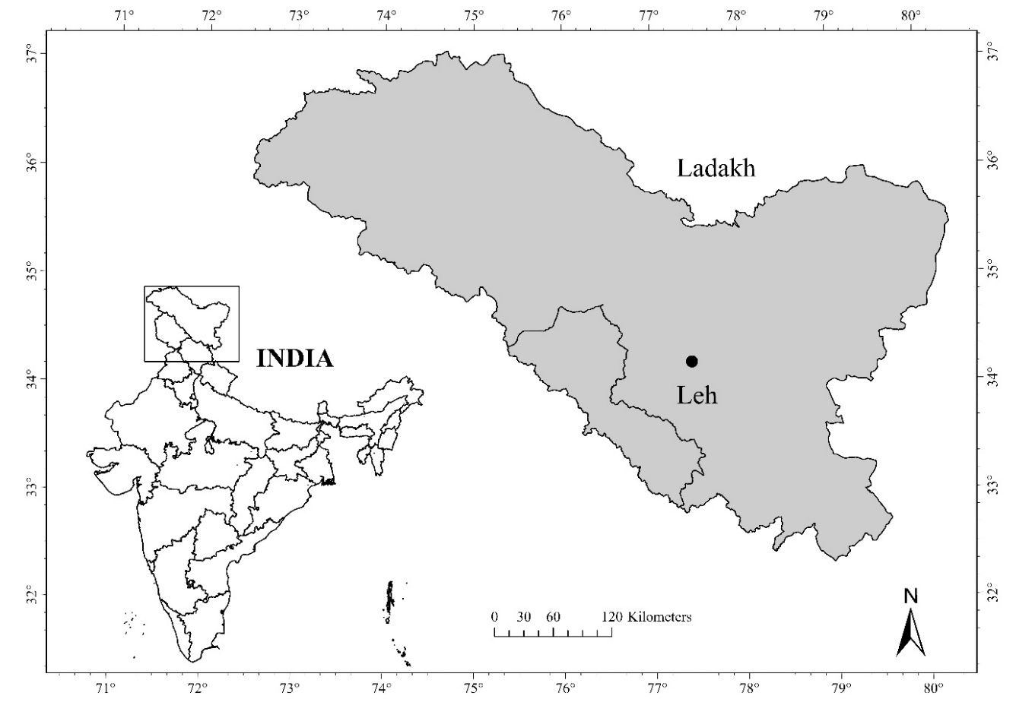
The study was conducted in the Union Territory of Ladakh.
Figure 1: Study location
Situated at India’s northernmost boundary, this territory spans longitudinally between 74°E to 80°E and latitudinally from 32.5°N to 35.5°N. The rugged Ladakhi terrain features extreme altitudes, sparse populations and volatile meteorological conditions that severely restrict viable commercial activities, seasonal mobility and centralized market accessibility (Bhattacharyya, 2022). Prolonged winters and challenging topographies further impair the reliability of conventional utility networks across the region (Urpelainen, 2014).
Despite formidable geographic constraints, the Ladakh environment receives abundant solar radiation annually, rendering photovoltaic technology highly suitable for localized off-grid energy generation (Bhattacharyya, 2015). Consequently, the decentralized assembly of solar hardware serves as an adaptive livelihood strategy for native populations (IRENA, 2020). Structured ‘solar lantern’ fabrication training occurred at well-equipped instructional hubs across the Leh and Kargil districts. To ensure consistent daily attendance from dispersed remote villages, local authorities provided organized transportation utilizing dedicated passenger buses.
Objectives of the study
The primary objectives of this research were to identify and mathematically stratify the operational and environmental obstacles perceived by trainees during the Tribal Entrepreneurship Training Programme on solar lantern and LED bulb construction using the Garrett ranking framework, ultimately formulating targeted policy recommendations to strengthen future indigenous business incubation initiatives in high-altitude regions.
Research design
Utilizing a descriptive research architecture, this study evaluated a previously assessed cohort comprising 320 trainees who completed the Tribal Entrepreneurship Training Programme on solar lantern and LED bulb fabrication under the Ministry of Electronics and Information Technology. Absolute consistency in knowledge dissemination was maintained, as every trainee received identical pedagogical instruction, academic curriculum and temporal study duration.

Data collection
Primary data were collected using a structured questionnaire administered through Google Forms to the entire cohort of trainees. The questionnaire was developed based on academic literature, expert consultations and localized programmatic considerations. Unlike prior evaluations measuring general attitudes, this investigation focused specifically on stratifying perceived operational and environmental challenges. The collected responses were analysed to differentiate programme-specific limitations from broader regional infrastructural constraints.
Analytical tool: Garrett ranking technique
The Garrett ranking methodology mathematically prioritized socio-economic and logistical hurdles by instructing respondents to rank barriers based on perceived severity. These ordinal values were transformed into percentage coordinates using the equation: Percent Position = 100(R − 0.5) / N, where R signifies the assigned rank and N represents the total number of evaluated challenges. These positions were converted into Garrett scores via a standard referential matrix. Analysts computed mean scores to establish final hierarchical positions, where elevated outcomes indicate higher perceived severity. This mechanism perfectly suits perception-based institutional evaluations by prioritizing relative weighting, thereby circumventing the statistical vulnerabilities of absolute frequency counts.
Results and discussion
Investigators systematically audited the socio-economic and functional bottlenecks articulated by the trainees to decipher the precise localized hurdles hindering clean energy commercialization within the territory. The exhaustive findings derived from the Garrett ranking computations, which mathematically order these specific restrictions grounded on the comparative evaluations of the respondents, are documented extensively.

Table 1: Garrett Ranking of Perceived Challenges and Programme Feedback (N = 320)
S. No. | Challenges | Mean Garrett Score | Final Rank
1 | Perceived need for improved teaching methods | 61.21 | I
2 | Lack of financial support after training | 58.63 | II
3 | Poor lighting and power supply | 54.92 | III
4 | Lack of post training follow up support | 54.18 | IV
5 | Harsh climatic conditions | 47.88 | V
6 | Inadequate practical hands-on training | 47.02 | VI
7 | Training was beneficial | 46.64 | VII
8 | Difficulty in understanding technical concepts | 46.49 | VIII
9 | Language barriers | 40.53 | IX
10 | Transportation problems | 38.98 | X

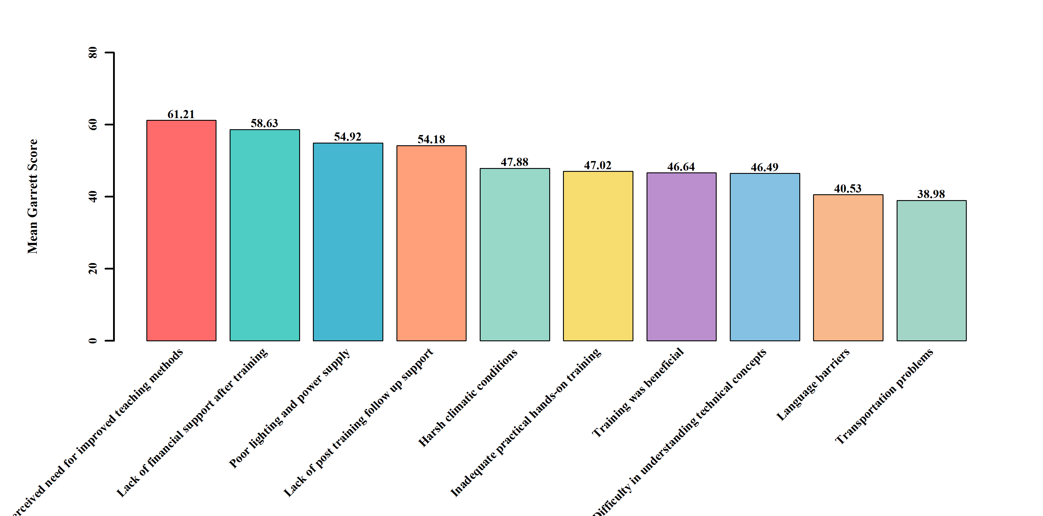Figure 2: Comparative Garrett scores across identified challenges
Conforming to the preliminary hierarchical breakdown, perceived need for more advanced pedagogical techniques materialized as the most formidable obstacle, capturing the premier position via a mean Garrett score of 61.21. This primary complication was intimately trailed by a lack of financial support after training, which secured the secondary rank with a recorded metric of 58.63. Inadequate illumination and electrical grid instability exhibiting a score of 54.92 alongside a deficit in transitional mentorship generating a score of 54.18 commanded the third and fourth hierarchical placements, respectively. It remains fundamentally crucial to recognize that the parameter identifying ‘Training was beneficial’ achieving a score of 46.64 and Rank VII constitutes a distinctly affirmative evaluative sentiment rather than a literal operational barrier. Researchers deliberately integrated this specific variable into the Garrett ranking framework to successfully capture the holistic programmatic appreciation of the trainees operating in tandem with their reported grievances. This intermediate statistical output does not signify general displeasure. Conversely, the metric proves that the cohort recognized the foundational utility of the educational intervention while simultaneously assigning a tangibly heavier urgency to more immediate financial, infrastructural and procedural dilemmas (Sharma and Singh, 2022).
To provide deeper analytical clarity, the identified challenges can be interpreted in light of existing entrepreneurship and skill development literature, while also considering the effective implementation of the training programme.
Although perceived need for improved teaching methods emerged as the highest-ranked concern, this perception should not be interpreted as a failure of instructional delivery. The structured implementation of the programme and uniform training delivery indicate that the training was conducted in a structured and systematic manner by competent trainers. The elevated ranking instead reflects the growing expectations of trainees for more advanced, interactive and experience-based learning approaches. In entrepreneurship and technical education, it is widely recognized that as learners gain exposure, they tend to demand higher levels of practical engagement and problem-solving depth (Gibb, 2011, Johnson et al., 2022). Therefore, this finding reflects a need for more advanced and interactive pedagogical approaches rather than a deficiency in trainer capability.
The lack of financial support after training represents an external structural limitation rather than a shortcoming of the training programme itself. While the initiative successfully imparted technical skills and foundational knowledge required for enterprise development, access to financial capital typically falls beyond the operational scope of skill development interventions. Existing literature highlights that even well-designed training programmes require complementary financial ecosystems, such as micro-credit and institutional funding to enable enterprise formation (Brixiova et al., 2020, Ahmad et al., 2023). Thus, this challenge reflects a post-training ecosystem gap rather than inefficiency in programme delivery.
The identification of limited post-training follow-up support should be interpreted as a demand for extended institutional engagement rather than an absence of support mechanisms. The training programme effectively delivered core competencthies within its defined timeframe however, participants indicated the need for continued mentorship and guidance during the transition to real-world enterprise operations. Research indicates that such expectations are common among first-time entrepreneurs, particularly in remote regions where ongoing advisory support enhances confidence and sustainability (Ndlovu et al., 2025, Ubfal et al., 2022). Hence, this finding suggests an opportunity for programme expansion rather than a weakness in its implementation.
Although some trainees reported inadequate hands-on experience, this perception should be viewed in the context of rising expectations in technical training. The programme did incorporate practical components however, given the complexity of solar technology, participants may have desired more intensive and prolonged practical exposure. Skill development literature suggests that higher demand for hands-on training often reflects learner engagement and interest rather than programme inadequacy (Rana et al., 2020).
The variable ‘training was beneficial’ represents a positive evaluation and reinforces the overall effectiveness of the programme. Its inclusion alongside challenges provides a balanced perspective, demonstrating that participants recognized the value and relevance of the training despite suggesting areas for improvement. Such responses are typical in programme assessments where beneficiaries acknowledge core benefits while recommending enhancements (Sharma and Singh, 2022).
Difficulty in understanding technical concepts can be attributed to differences in educational background and limited prior exposure to technical subjects among trainees. In rural and tribal contexts, such challenges are expected when introducing specialized engineering concepts. This does not indicate ineffective teaching, but rather highlights the need for further simplification and contextualization of content (World Bank, 2018).
Language barriers, although present, were ranked relatively low, indicating that communication strategies adopted during the training were largely effective. Minor difficulties may arise in linguistically diverse regions however, the low severity suggests that trainers were able to convey content successfully to the majority of participants (Rahman et al., 2021).
Transportation challenges are typically significant in remote mountainous regions however, their low ranking in this study indicates that logistical arrangements made by the programme authorities were effective. Organized transport facilities appear to have successfully minimized accessibility issues for most participants (Bhattacharyya, 2022).
Overall, these findings indicate that the training programme was effectively implemented and the identified challenges primarily reflect contextual constraints, participant expectations and opportunities for further strengthening rather than fundamental deficiencies in programme delivery.
To extract more granular perspectives regarding the precise dissemination of these sentiments across the surveyed population, analysts scrutinized the frequency distribution of the hierarchical rankings across varying tiers of severity.
Table 2: Distribution of challenge rankings across trainee responses (frequency)
Challenges | Ranked 1st | Ranked 2 to 3rd | Ranked 4 to 5th | Ranked Below 5th
Perceived need for improved teaching methods | 95 | 89 | 72 | 64
Lack of financial support after training | 78 | 85 | 68 | 89
Poor lighting and power supply | 62 | 71 | 58 | 129
Lack of post training follow up support | 58 | 65 | 52 | 145
Harsh climatic conditions | 45 | 51 | 42 | 182
Inadequate practical hands-on training | 43 | 48 | 40 | 189
Training was beneficial | 42 | 46 | 38 | 194
Difficulty in understanding technical concepts | 41 | 45 | 36 | 198
Language barriers | 32 | 38 | 30 | 220
Transportation problems | 28 | 35 | 27 | 230

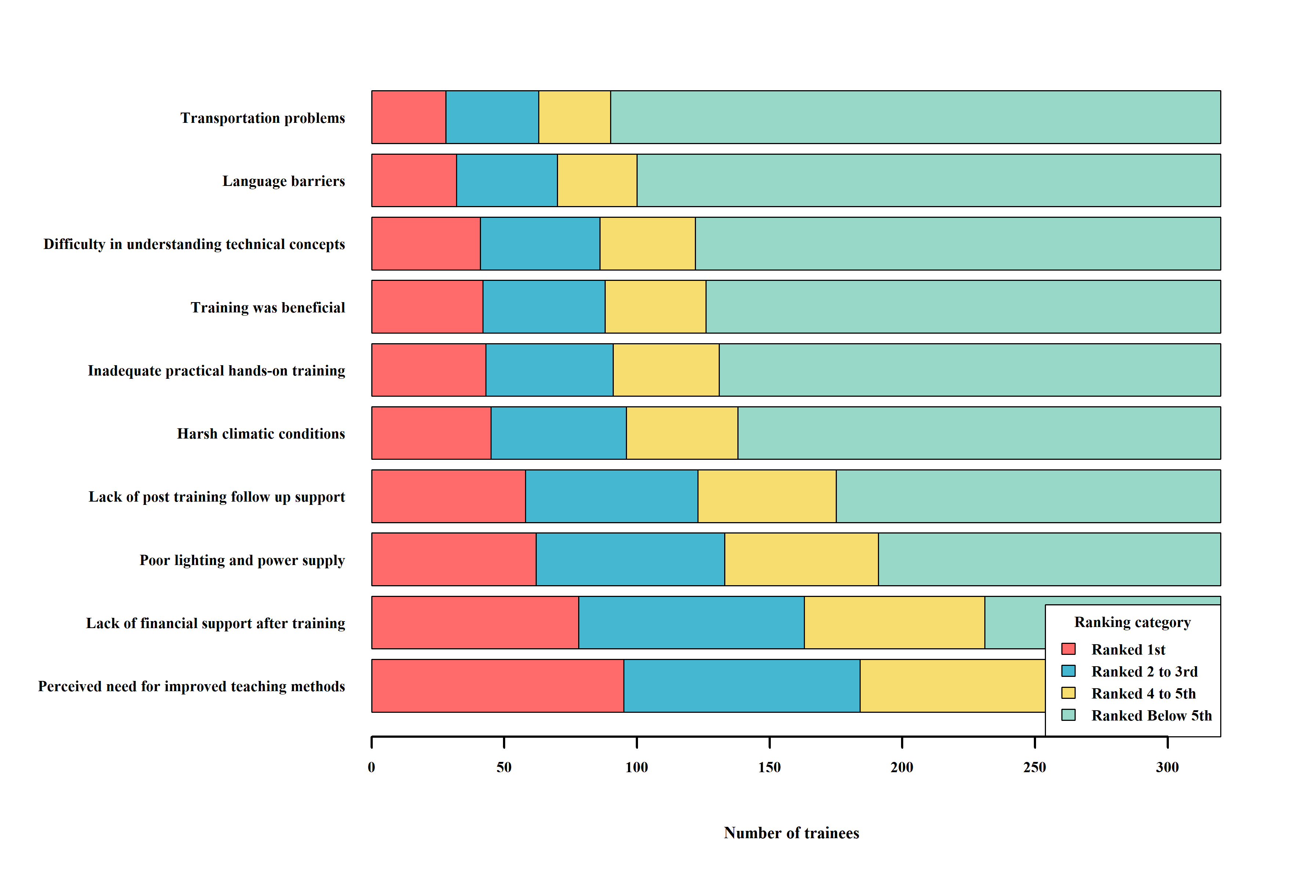 Figure 3: Distribution of challenge rankings across trainee responses
The distributional metrics supply a highly sophisticated comprehension of the operational priorities held by the participants. As an illustration, 95 distinct trainees designated perceived need for enhancement in pedagogical techniques as their absolute paramount concern ranking it 1st, while an additional 89 individuals positioned this identical issue within the 2nd to 3rd priority slots. In a parallel statistical trajectory, the lack of financial support after training was positioned 1st by 78 separate respondents and secured the 2nd to 3rd positions among 85 participants. This intense clustering within the uppermost statistical quartiles highlights the severe and immediate requirement for uninterrupted fiscal architecture immediately following the termination of the academic phase (Brixiova et al., 2020), (Ahmad et al., 2023). In stark contrast, broader systemic complications encompassing transit complications and linguistic obstacles were massively relegated to the Ranked Below 5th classification by 230 and 220 trainees, respectively. This highly polarized statistical dispersion visually and mathematically corroborates that the foundational instructional communication tactics and the fundamental transit logistics supplied by the administrative body operated with high efficacy and adequately satisfied the overwhelming majority of the trainee base (Rahman et al., 2021).
Analysts executed a comprehensive evaluation of opinion variances and consensus percentages to systematically segregate these identified impediments into actionable administrative tiers.
Table 3: Consensus score, opinion spread and priority classification of challenges
Challenges | Garrett Score | Consensus Score (%) | Opinion Spread (%) | Trainees in Top Half (%) | Priority Level
Perceived need for improved teaching methods | 61.21 | 29.7 | -9.7 | 57.5 | High
Lack of financial support after training | 58.63 | 24.4 | 3.4 | 50.9 | High
Poor lighting and power supply | 54.92 | 19.4 | 20.9 | 41.6 | High
Lack of post training follow up support | 54.18 | 18.1 | 27.2 | 38.4 | High
Harsh climatic conditions | 47.88 | 14.1 | 42.8 | 30.0 | Moderate
Inadequate practical hands-on training | 47.02 | 13.4 | 45.6 | 28.4 | Moderate
Training was beneficial | 46.64 | 13.1 | 47.5 | 27.5 | Moderate
Difficulty in understanding technical concepts | 46.49 | 12.8 | 49.1 | 26.9 | Low
Language barriers | 40.53 | 10.0 | 58.8 | 21.9 | Low
Transportation problems | 38.98 | 8.8 | 63.1 | 19.7 | Low

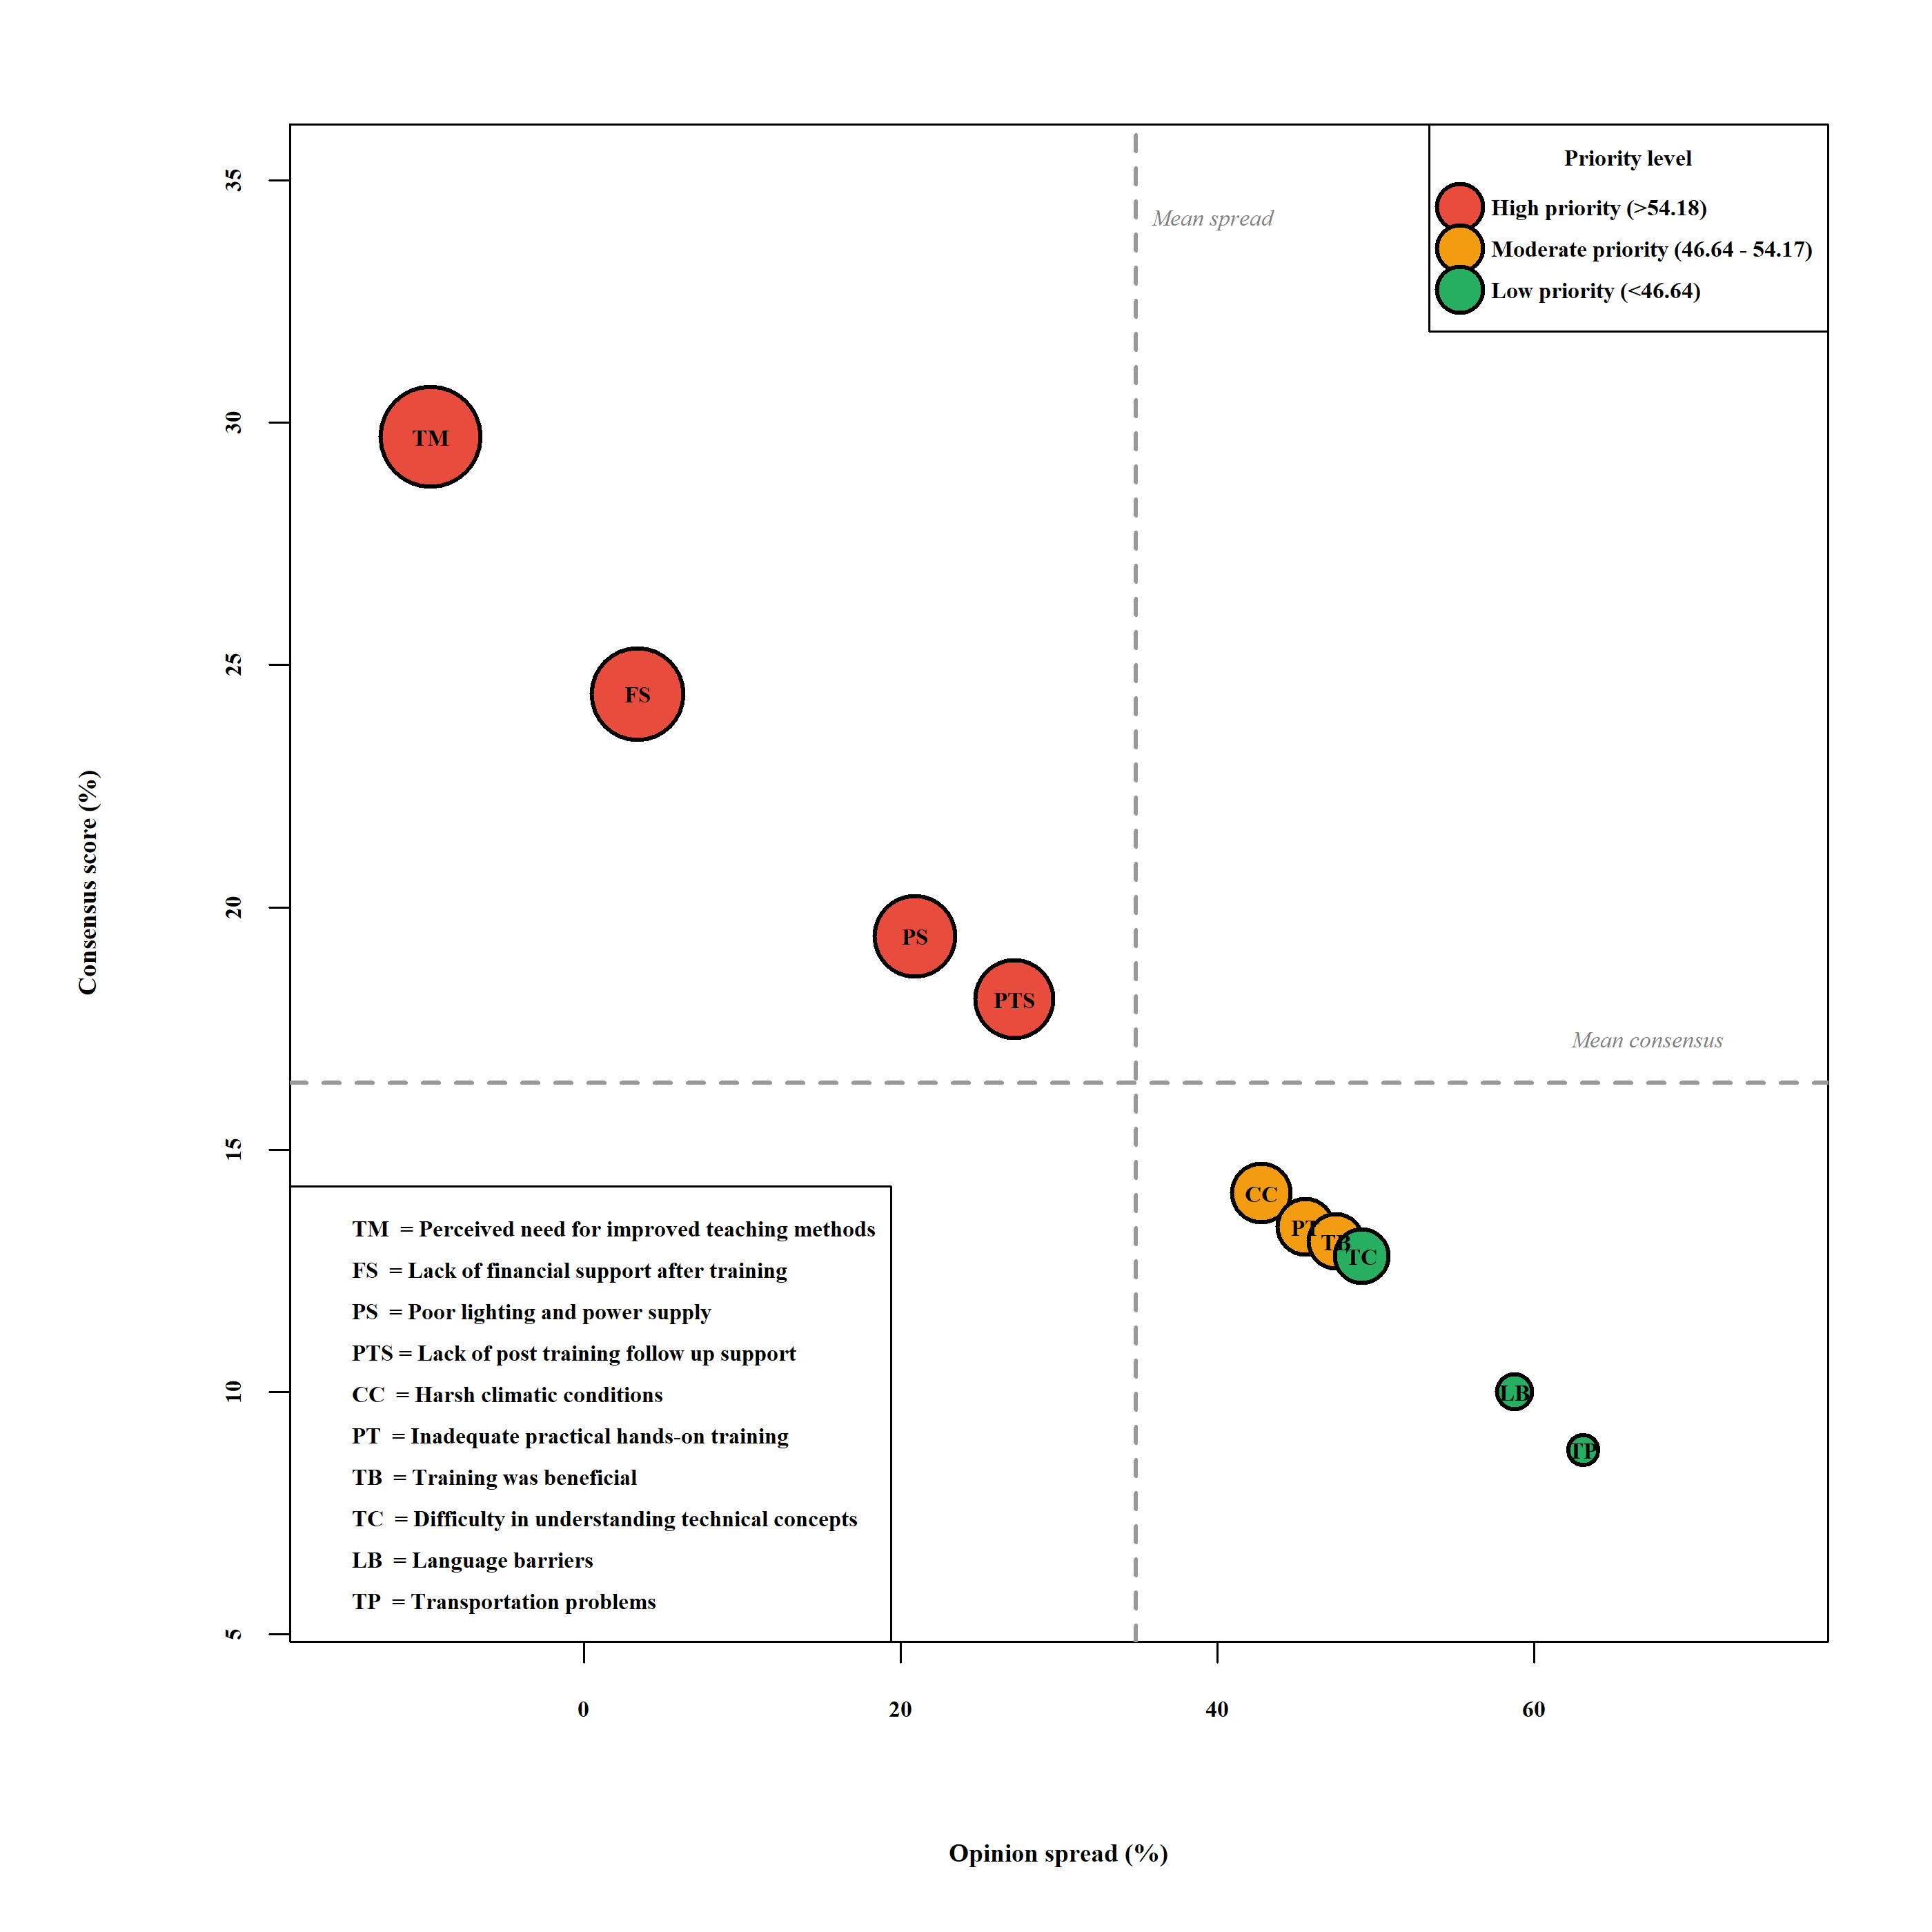Figure 4: Consensus score versus opinion spread analysis of training challenges

The priority matrix categorizes these limitations into High, Moderate and Low urgency tiers utilizing numerical averages, consensus ratios and opinion divergences. Perceived need for enhanced pedagogical approaches recorded a 29.7 per cent consensus and a -9.7 per cent opinion spread, with 57.5 per cent of respondents classifying it as a primary anxiety. The lack of financial support after training achieved a High Priority designation, displaying a 24.4 per cent consensus and a minor 3.4 per cent variance. These metrics denote a unified requirement for transitional seed capital to formalize micro-enterprises (Omer and Noguchi, 2020). Ecological variables scoring 47.88 and insufficient hands-on instruction scoring 47.02 constituted Moderate Priority concerns. Concurrently, complex engineering assimilation, linguistic barriers and transit logistics exhibited expansive opinion spreads of 49.1 per cent, 58.8 per cent and 63.1 per cent, relegating them to the Low Priority demographic.
Contextualizing these quantitative calculations through qualitative administrative realities remains imperative. Governing bodies successfully delivered the curriculum via structured timetables, supplying adequate physical materials and infrastructural frameworks ensuring continuous attendance. Consequently, the statistical dominance of pedagogical limitations signifies heightened learner ambitions for superior experiential knowledge acquisition and advanced diagnostic troubleshooting within a demanding engineering discipline, rather than systemic instructional failure (Sarkodie and Adams, 2020), (Gaur and Tiwari, 2023).
Similarly, the prominent ranking of the lack of financial support after training emphasizes a universally recognized bottleneck obstructing indigenous commercialization. While the intervention imparted essential mechanical competencies, actualizing a commercial entity strictly demands initial venture capital and formalized marketplace integration, elements routinely transcending standard vocational blueprints (Batinge et al., 2023), (George et al., 2021). The trainees acutely perceived this transitional vacuum as a paralyzing barrier.
Furthermore, reported electrical constraints were primarily linked to sporadic territorial power failures prevalent in meteorologically volatile sectors like Ladakh. These infrastructural collapses functioned independently of programmatic architecture, underscoring external regional limitations rather than internal administrative incompetence (Jain et al., 2022). Environmental determinants, predominantly severe meteorological patterns, were accurately quantified as intermediate barriers, highlighting the unavoidable influence of rugged topography on commercial consistency (Pachauri et al., 2021).
Synthesizing the Garrett formulations reveals that while authorities adequately provisioned baseline logistical support, participants demanded systemic amplification. This requested enhancement targets modernized instructional methodologies, uninterrupted financial architectures and structural immunities against regional grid failures. These mathematical deductions align with contemporary evaluations arguing that technical knowledge transfer must inextricably link to resilient commercial incubation ecosystems to generate durable socio-economic prosperity (Johnson et al., 2022), (Batchelor et al., 2023).
Conclusion
This research critically evaluated the operational impediments reported by participants of a specialized solar lantern and LED bulb fabrication program designed for tribal communities in Ladakh. Analytical results derived from the mathematical Garrett ranking formulation revealed that perceived limitations in pedagogical approaches, along with financial and infrastructural constraints, received the highest severity classifications, largely reflecting participant expectations and external ecosystem gaps rather than deficiencies in programme implementation. However, the findings suggest that despite these perceptions, the programme maintained consistent delivery and adequate training support confirmed the continuous provision of adequate instructional facilities and logistical scaffolding. Furthermore, documented power failures were largely attributed to the severe local climate and regional geographical vulnerabilities rather than internal programmatic deficiencies inherent to the educational initiative.
Moreover, overarching environmental constraints, specifically the harsh atmospheric conditions typical of this high-altitude topography, were categorized merely as moderate operational hurdles. Conversely, logistical challenges such as transit accessibility and linguistic barriers registered negligible severity. This finding empirically validates the effectiveness of the localized transportation networks and communication strategies implemented by the governing bodies. Ultimately, the statistical evidence confirms that administrators successfully delivered the essential foundational support. The high prioritization of specific bottlenecks highlights targeted areas requiring qualitative enhancements to better align programmatic execution with participant aspirations and the formidable physical realities of the territory.
Policy implications
Given that the programme successfully delivered its foundational objectives, this study recommends the strategic modernization of existing programmatic frameworks instead of merely addressing rudimentary logistical gaps. To alleviate concerns regarding instructional delivery, institutional leaders must integrate highly experiential, hands-on diagnostic exercises tailored to the complex engineering demands of photovoltaic hardware. Concurrently, resolving the lack of financial support after training must become a primary administrative objective. Developmental agencies should enhance their fiscal incubation structures by embedding micro-credit access and initial venture capital directly into the post-training environment (Brixiova et al., 2020), (Ahmad et al., 2023). To protect these learning centers from inevitable regional power outages, administrators must deploy resilient infrastructural contingencies, such as decentralized backup generators and high-capacity battery storage systems (Urpelainen, 2014). Finally, institutions managing these commercial incubation initiatives must establish rigorous postgraduate mentorship and localized supply chain connections to effectively transform technical skills into viable micro-enterprises. Integrating these strategic upgrades into the tribal entrepreneurship training frameworks managed by the Ministry of Electronics and Information Technology (MeitY) will substantially augment their long-term efficacy, geographic scalability and socio-economic impact across isolated mountainous regions identical to Ladakh.

REFERENCES
Ahlborg, H. and Hammar, L. (2014). Drivers and barriers to rural electrification in Tanzania and Mozambique: Grid-extension, off-grid, and renewable energy technologies. Renewable and Sustainable Energy Reviews, 34: 290-304.
Ahmad, N., Naveed, A. and Shabbir, M. S. (2023). Financial inclusion, micro-credit, and the growth of rural micro-enterprises: Evidence from developing economies. Finance Research Letters, 52: 103550.
Batchelor, S., Brown, E., Scott, N. and Leary, J. (2023). Transitions to modern energy cooking services: Policy implications for sustainable development. Energies, 16(2): 894.
Batinge, B., Musango, J. K. and Brent, A. C. (2023). Entrepreneurial challenges and sustainable energy transitions in Sub-Saharan Africa. Renewable and Sustainable Energy Reviews, 173: 113098.
Bhattacharyya, S.C. (2015). Mini grids for rural electrification of developing countries: Analysis and case studies from South Asia. Springer, London.
Bhattacharyya, S.C. (2022). Rural electrification experiences from South Asia: Technological pathways and socio-economic impacts. Energies, 15(14): 5064.
Brixiova, Z., Kangoye, T. and Said, M. (2020). Training, human capital, and gender gaps in entrepreneurial performance. Economic Modelling, 85: 367-380.
Cumberland, D.M., Kerrick, S.A., Cocco, A.R. and Tapolsky, M.A. (2024). Entrepreneurship program evaluation: Examining the impact of a training program on women and underrepresented groups. Small Business Institute Journal, 20(2): 1-8.
Desai, V. (2016). Dynamics of entrepreneurial development and management. Himalaya Publishing House, Mumbai.
Gaur, A. and Tiwari, G. N. (2023). Performance of solar-based decentralized off-grid systems in high-altitude regions. Solar Energy, 251: 145-156.
George, G., Haas, M. R. and Pentland, A. (2021). Purpose-driven business and sustainable development goals in remote communities. Journal of Management Studies, 58(8): 2153-2172.
Gibb, A.A. (2011). Concepts into practice: Meeting the challenge of entrepreneurship education. International Journal of Entrepreneurial Behaviour and Research, 17(2): 146-165.
International Renewable Energy Agency (IRENA). (2020). Renewable energy and jobs – Annual review. IRENA, Abu Dhabi.
Jain, A., Sharma, R. and Singh, P. (2022). Solar energy deployment in India: Policy frameworks, challenges, and opportunities. Energy Policy, 162: 112792.
Johnson, T., Martinez, R. and Crusat, J. (2022). Entrepreneurship education: The effects of challenge-based learning on entrepreneurial mindset. Administrative Sciences, 12(1): 10.
Kumar, S. and Joshi, P.K. (2019). Skill development initiatives and entrepreneurial outcomes in rural India. Indian Journal of Extension Education, 55(3): 1-7.
Mishra, V. (2020). Rural entrepreneurship in India: Challenges and institutional support mechanisms. International Journal of Management, 11(5): 134-143.
Mondal, A. H., Kamp, L. M. and Pachauri, S. (2018). Solar energy technologies and rural development in marginalized contexts. Energy, 148: 1044-1055.
Ndlovu, E.N., Ebewo, P.E., Mlotshwa, S.H. and Shumba, K. (2025). Entrepreneurial coaching and self-efficacy: A systematic review. Education Sciences, 15(2): 237.
NITI Aayog. (2018). Strategy for New India @75. Government of India, New Delhi.
Omer, A. M. and Noguchi, T. (2020). Renewable energy resources, sustainable development, and rural empowerment. Renewable and Sustainable Energy Reviews, 124: 109789.
Pachauri, S., Pelz, S., Bertram, C., Rao, S. and Riahi, K. (2021). Access to clean energy and its integration with sustainable development targets. Nature Energy, 6(11): 1067-1075.
Painuly, J.P. (2011). Barriers to renewable energy penetration: A framework for analysis. Renewable Energy, 24(1): 73-89.
Palit, D. (2013). Solar energy programs for rural electrification: Experiences and lessons from South Asia. Energy Policy, 62: 1423-1433.
Rahman, M., Amran, A. and Ahmad, N. (2021). Enhancing entrepreneurial success through structured capacity building and financial literacy. Journal of Business Research, 132: 671-682.
Rana, M., Hossain, G.M.S. and Hasan, M. (2020). Effectiveness of entrepreneurship skill development training: A case study. Indian Journal of Commerce and Management Studies, 11(3): 30-44.
Rao, N. D., Min, J. and Mastrucci, A. (2021). Energy access and living standards: A framework for holistic assessment. Nature Energy, 6(8): 782-789.
Rolffs, P., Ockwell, D. and Byrne, R. (2015). Beyond technology transfer: Innovation in off-grid solar energy in developing nations. Science and Public Policy, 42(6): 773-785.
Sarkodie, S. A. and Adams, S. (2020). Electricity access, human development index and sustainable economic growth. Energy Strategy Reviews, 29: 100480.
Sharma, A. and Singh, S. (2022). Rural entrepreneurship and skill development: A perceptual study of localized training interventions. Journal of Enterprising Communities, 16(4): 589-608.
Singh, R. and Raghuvanshi, R.S. (2012). Entrepreneurship development programmes: An impact assessment. Journal of Entrepreneurship and Management, 1(1): 35-42.
Sinha, A., Shah, M. I. and Sengupta, T. (2020). The role of renewable energy entrepreneurship in mitigating socio-economic disparities. Technological Forecasting and Social Change, 150: 119782.
Tenenbaum, B., Greacen, C., Siyambalapitiya, T. and Knuckles, J. (2014). From the Bottom Up: How Small Power Producers and Mini-Grids Can Deliver Electrification and Renewable Energy in Africa. World Bank Publications.
Ubfal, D., McKenzie, D., Hoelzlein, M. and Valdivia, M. (2022). The impact of entrepreneurship training on firm outcomes. Journal of Innovation and Entrepreneurship, 11(1): 1-21.
Ulsrud, K., Winther, T., Palit, D. and Rohracher, H. (2011). Village-level solar power in remote regions: A socio-technical analysis of sustainability. Geoforum, 42(3): 327-337.
Urpelainen, J. (2014). Grid and off-grid electrification: An integrated model with applications to rural India. Energy for Sustainable Development, 19: 66-71.
World Bank. (2018). Skill development and entrepreneurship: Lessons from developing countries. World Bank, Washington DC.
World Economic Forum. (2020). Entrepreneurship training and development: Pathways to sustained socio-economic growth. WEF, Geneva.

