Original Research Article

Constraints in adoption of preferred rice varietal traits among paddy farmers of Telangana

Abstract:
Rice is an essential staple food globally, providing a major source of calories for a significant portion of the world's population. In India, where agriculture is a cornerstone of the economy, rice production has seen remarkable growth over recent decades. This expansion is driven by advancements in agricultural technology, such as the adoption of high-yielding seeds, chemical fertilizers, and agrochemicals. As a result, India has become a leading player in rice production, covering extensive areas and significantly contributing to the nation's food grain output. In Telangana, paddy production has surged due to government initiatives, irrigation projects, and strategic investments. The development of high-yielding rice varieties, tailored to the region's soil conditions, has been instrumental in this growth. These varieties are resistant to various biotic and abiotic stresses, ensuring a consistent increase in paddy production. The state's impressive progress in rice cultivation is reflected in the substantial data on area coverage, production, and productivity. The study delves into the problems faced by the paddy farmers of the State. Paddy farmers face challenges like low market prices, lack of technical knowledge, and limited access to services. Both coarse and fine variety adopters share these issues. The study suggests promoting varietal diversity, improving research and seed distribution, and providing better market infrastructure and financial support to enhance rice farming in Telangana.
Keywords: Rice production, Telangana, High-Yielding Varieties, Paddy farmers, Challenges, Coarse variety adopters, Fine variety adopters .
Introduction:
India is primarily an agrarian economy, with about 54.6 percent of the total population employed in the agricultural and allied sector (Census, 2011). The previous two years have seen brisk expansion in the agriculture industry. The industry, which employs the most people, contributed a significant 18.8% (2021–2022) of the country's Gross Value Added (GVA), growing by 3.6% in 2020–2021 and 3.9% in 2021–2022 (Economic survey, 2022). The main factors influencing the sector's overall growth have been expansion in related industries including cattle, dairying, and fishing.
The adoption of high-yielding seeds, chemical fertilizers, and agrochemicals has driven a significant technological transformation in agriculture. This progress is further supported by substantial investments in irrigation, infrastructure, and institutional support such as credit and extension services. Moreover, continuous legislative measures, including the central government's procurement of agricultural output at predetermined prices and the provision of input subsidies, have played a crucial role in sustaining and enhancing this transformation. (Negi et al., 2020).
Rice is one of the most popular staple foods consumed worldwide and is also an excellent source of complex carbohydrates. Rice is the world’s second most important cereal crop following only corn. Historically, Asia has produced most of the world's rice. China was the world's top producer of paddy for the year 2020/2021, followed by India with a production of over 148.3 million metric tonnes (Source: www.statista.com).
In India, rice is one of the most important staple food crops, in terms of both consumption and production. India’s rice production increased tremendously in the past five decades, from 30.44 million tons in 1966-67 to 122.27 million tonnes in 2020-21 (India, MoAFW, Annual report 2021-22). Since rice is one of the key staple foods in the world, productivity improvements in the rice industry are crucial to achieving this objective, especially in Asia where there is no room for land development.
In India, rice occupies one third of the total cropped area and contributes 40 per cent of total food grain production in the country. India, being the leading rice producing country in the world, stands first in terms of area and second in production, covering an area of about 46.38 million ha and production of 130.29 million tonnes of rice with an average productivity of 2809 kg/hectare in 2021-22 (Agricultural Statistics at a glance, 2022).
HYVs have brought real and substantial increases in production as they can respond to increasing application of fertilizer resulting in higher yields and, in part, to produce two or sometimes even three, crops a year. The benefits of HYVs are significant. As intended, these have decreased the reliance of developing countries on food grain imports, despite rising population (Edward, 1986).
Paddy Production in Telangana:
Telangana is popularly known as the rice bowl of South India. Telangana boasts a diverse range of rice varieties cultivated across the state. Coarse varieties like MTU 1010 and MTU 1001, along with fine varieties like BPT 5204 and Telangana Sona, dominate the agricultural landscape. These varieties offer desirable traits such as high yields, disease resistance, and suitability to local soil conditions. Paddy is the major staple food crop of Telangana, with about 39.19 lakh hectares (97.97 lakh acres) cultivated during the 2021-22 year (Directorate of Economics and Statistics (DES), Telangana, 2021-22).
Paddy cultivation holds a prominent place in Telangana's agricultural landscape. Over the years, the state has witnessed substantial growth in paddy cultivation, both in terms of area and production. This growth can be attributed to various factors, including investments in irrigation projects and government procurement policies. Despite challenges posed by the pandemic, the state has achieved remarkable success in paddy procurement, ensuring support for farmers and stability in the agricultural sector.
Methodology:
The study utilized a multistage sampling method to select the study area and respondents. 10 districts in Telangana were chosen based on their high paddy production, with one mandal selected from each district based on the density of paddy farmers. Four villages were then chosen from each mandal, focusing on those with the highest number of paddy farmers. From each village, 10 paddy farmers were randomly selected, totaling 400 respondents across 40 villages. The sample size was determined using the Yamane formula, resulting in 200 coarse variety adopters and 200 fine variety adopters for further analysis. The primary data was collected from the sampled respondents by personal interview method through questionnaire during June- August 2023.
Garrett’s ranking technique may be used to identify and prioritize the constraints in adoption of preferred rice varietal traits by farmers and to offer suitable suggestions (Joy and Radhakrishnan, 2014). As per this method, respondents will be asked to assign the rank for all the problems and the outcome of such ranking will be converted into Score value with the help of the following formula:
Percentage position = 100 (R_{ij} -0.5)
N_{j}
Where,
R_{ij} – Rank given for the factor i^{th} factor by the j^{th} individual
N_{j} – Number of factors ranked by the j^{th} individual
The percentage position is converted into scores by referring to the table by Henry Garrett (1969). Then for each problem, the scores of each individual will be added and then total value of scores and mean values of score will be calculated. The problems having highest mean value will be considered to be the most serious problem faced by the farmers.

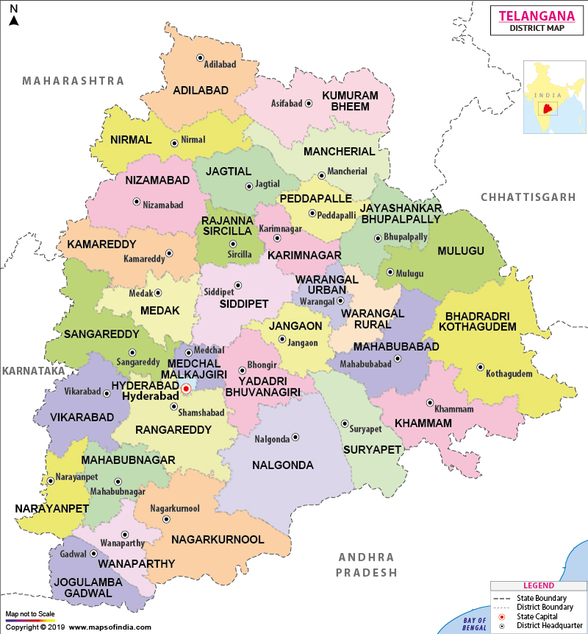
Figure 1. Map of Telangana state showing 33 districts

Results and Discussions:
In the present study, efforts were made to study the constraints faced by the paddy farmers in adoption of preferred rice varietal traits and also some suggestions were given to improve the rice breeding programme in the Telangana state. The key findings were presented and discussed in the following sections.
  - Socio-economic profile of the surveyed paddy farmers:
Majority of the paddy farmers were in the age group of 41-55 years, while 57.00 percent being coarse variety adopters and 58.00 percent being fine variety adopters respectively. Majority of the paddy farmers were educated up to secondary school, in case of both coarse variety adopters(55.00 percent) and fine variety adopters (52.00 percent). Majority of the paddy farmers have larger families, while 50.00 percent being coarse variety adopters and 46.00 percent being fine variety adopters respectively. In terms of annual income, 94.93 percent of income source for coarse variety adopters and 93.76 percent for fine variety adopters comes from agriculture, whereas 5.07 percent of income source for coarse variety adopters and 6.24 percent for fine variety adopters comes from non- agriculture viz., daily wages, business etc. Majority of the farmers have 31-40 years of paddy farming experience, in case of both coarse variety adopters(39.50 percent) and fine variety adopters (31.00 percent). Majority of the paddy farmers have small land holdings(1-2 ha), while 36.00 percent being coarse variety adopters and 35.50 percent being fine variety adopters respectively. Majority of the paddy farmers depend on Co-operative banks for agricultural credit, in case of both coarse variety adopters(47.00 percent) and fine variety adopters (54.50 percent). The results were consistent with the findings of Shinde (2006), Pandey et al., (2012) and Mali et al. (2014).
Table 1 Socio-economic profile of the surveyed farmer households
S. No | Particulars | Coarse Variety Adopters |  |  | Fine Variety Adopters
S. No | Particulars | Number of respondents | Percent to total |  | Number of respondents | Percent to total
1 | Age
 | 25- 40 years | 31 | 15.5 |  | 45 | 22.5
 | 41 -55 years | 114 | 57 |  | 116 | 58
 | >55 years | 55 | 27.5 |  | 39 | 19.5
2 | Education level
 | Illiterate | 29 | 14.5 |  | 18 | 9
 | Primary | 32 | 16 |  | 46 | 23
 | Secondary | 110 | 55 |  | 104 | 52
 | Higher Secondary | 28 | 14 |  | 29 | 14.5
 | Graduation and above | 1 | 0.5 |  | 3 | 1.5
3 | Family Size
 | Nuclear (1 to 4) | 21 | 10.5 |  | 39 | 19.5
 | Small (5 to 6) | 79 | 39.5 |  | 69 | 34.5
 | Large (>6) | 100 | 50 |  | 92 | 46
4 | Paddy farming experience
 | Less than 10 | 2 | 1 |  | 22 | 11
 | 11 to 20 | 28 | 14 |  | 57 | 28.5
 | 21 to 30 | 70 | 35 |  | 49 | 24.5
 | 31 to 40 | 79 | 39.5 |  | 62 | 31
 | Greater than 40 | 21 | 10.5 |  | 10 | 5
5 | Source of Credit
 | Commercial Banks | 76 | 38 |  | 73 | 36.5
 | Cooperative Banks | 94 | 47 |  | 109 | 54.5
 | None | 30 | 15 |  | 18 | 9
6 | Income Source of the paddy farmers
 | Agriculture | 431715 |  | 403910
 | Non-Agriculture | 23100 |  | 26850
 | Aggregate | 454815 |  | 430760

  - Prioritizing the constraints in adoption of preferred rice varietal traits:
    - Prioritizing the constraints in adoption of preferred rice varietal traits of Coarse variety adopters:
Problems faced by the Coarse variety adopters are given in the following Table 2. Low market price was given 1st rank with the Garrett score 77.06 which says it is the most serious constraint faced by the farmers. Lack of technical knowledge was given 2nd rank with the Garrett score of 71.36. The 3rd rank was given to Lack of extension service accessibility with the Garrett score of 61.21, Susceptible to drought, floods & lodging was given 4th rank with the Garrett score of 59.64, Susceptible to pests and diseases was given 5th rank with the Garrett score of 58.37, 6th rank was given to Longer growth duration with the Garrett score 52.27, Non availability of loan facilities was given 7th rank with the Garrett score 44.93, Non preference by Millers was given 8th rank with the Garrett score 32.53, Lack of seed availability in right time due to high demand was given 9th rank with the Garrett score 31.98, Poor seed quality issues was given 10th rank with the Garrett score 29.28 which indicates it is a not serious constraint, Non availability of required varieties during sowing period was given 11th rank with the Garrett score 29.05 which implies it is the least serious constraint.
In conclusion, the challenges faced by coarse variety adopters, as highlighted by their respective Garrett scores, underscore the critical need for targeted interventions and support mechanisms. The prominence of low market prices, coupled with issues related to knowledge gaps and limited access to extension services, emphasizes the importance of addressing economic and informational barriers. Additionally, environmental vulnerabilities, such as susceptibility to adverse weather conditions and pest-related concerns, warrant strategic mitigation efforts. The extended growth duration, financial constraints related to loan availability, and market dynamics, as indicated by non-preference from millers, constitute pivotal considerations for farmers. Acknowledging these challenges and their varying degrees of severity provides valuable insights for policymakers and stakeholders in crafting interventions that can enhance the resilience and productivity of farmers in the coarse variety adoption context.
Table 2 Constraints faced by the coarse variety adopters:
S.No. | Constraints | Coarse Variety Adopters
S.No. | Constraints | Mean Score | Rank
 | Low market price | 73.70 | 1
 | Lack of technical knowledge | 72.24 | 2
 | Lack of extension service accessibility | 65.49 | 3
 | Susceptible to drought, floods & lodging | 59.58 | 4
 | Susceptible to pests and diseases | 58.25 | 5
 | Longer growth duration | 52.73 | 6
 | Non availability of loan facilities | 44.95 | 7
 | Lack of seed availability in right time due to high demand | 32.20 | 8
 | Non availability of required varieties during sowing period | 31.83 | 9
 | Poor seed quality issues | 30.67 | 10
 | Non preference by Millers | 27.52 | 11

- Prioritizing the constraints in adoption of preferred rice varietal traits of Fine variety adopters:
Problems faced by the Fine variety adopters are given in the following Table 3. Low market price was given 1st rank with the Garrett score 73.70 which says it is the most serious constraint faced by the farmers. Lack of technical knowledge was given 2nd rank with the Garrett score of 72.24. The 3rd rank was given to Lack of extension service accessibility with the Garrett score of 65.49 and Susceptible to drought, floods & lodging was given 4th rank with the Garrett score of 59.58, Susceptible to pests and diseases was given 5th rank with the Garrett score of 58.25, 6th rank was given to Longer growth duration with the Garrett score 52.73, Non availability of loan facilities was given 7th rank with the Garrett score 44.95, Lack of seed availability in right time due to high demand was given 8th rank with the Garrett score 32.20, Non availability of required varieties during sowing period was given 9th rank with the Garrett score 31.83, Poor seed quality issues was given 10th rank with the Garrett score 30.67 which indicates it is a not serious constraint, Non preference by Millers was given 11th rank with the Garrett score 27.52 which implies it is the least serious constraint.
In summary, the challenges confronting Fine variety adopters, gauged by Garrett scores, illuminate critical areas requiring focused attention and solutions. The pre-eminence of low market prices, alongside issues related to knowledge gaps and restricted access to extension services, demands nuanced interventions that address both economic and informational constraints. Environmental susceptibilities and pest-related challenges add layers of complexity to the agricultural landscape. By acknowledging the nuanced severity of these issues, policymakers and stakeholders can craft more targeted and impactful strategies to fortify the resilience and prosperity of those engaged in Fine variety adoption.
Table 3 Constraints faced by the fine variety adopters:
S.No. | Constraints | Fine Variety Adopters
S.No. | Constraints | Mean Score | Rank
 | Low market price | 73.70 | 1
 | Lack of technical knowledge | 72.24 | 2
 | Lack of extension service accessibility | 65.49 | 3
 | Susceptible to drought, floods & lodging | 59.58 | 4
 | Susceptible to pests and diseases | 58.25 | 5
 | Longer growth duration | 52.73 | 6
 | Non availability of loan facilities | 44.95 | 7
 | Lack of seed availability in right time due to high demand | 32.20 | 8
 | Non availability of required varieties during sowing period | 31.83 | 9
 | Poor seed quality issues | 30.67 | 10
 | Non preference by Millers | 27.52 | 11

- Suggestions for Improving Rice Breeding Programme in Telangana:
- Promote varietal diversity by incentivizing farmers and conducting awareness campaigns to reduce reliance on dominant varieties like MTU-1010 and BPT 5204.
- Strengthen research and development efforts by increasing funding and fostering collaborations between agricultural institutions and international organizations like IRRI.
- Enhance seed distribution systems by supporting certified seed production and establishing seed banks to preserve genetic diversity and ensure access to a wider range of varieties.
- Provide extension services and farmer training programs to educate farmers on cultivation practices and showcase the performance of different rice varieties through field demonstrations.
- Develop market infrastructure and price support mechanisms to facilitate the marketing of diverse rice varieties and ensure fair prices for farmers.
- Prioritize climate-smart breeding programs to develop varieties resilient to climate change impacts such as drought, flood, and salinity.
- Implement digital data collection platforms for real-time monitoring of rice cultivation and variety performance.
- Offer financial support and incentives for breeding projects and establish risk mitigation funds to support farmers in case of crop failure.
- Strengthen policy and regulatory frameworks to streamline the approval and commercialization of new rice varieties and align policies with agricultural development goals to enhance varietal diversity and resilience.
Summary and Conclusion:
Rice holds a critical position in India's agriculture-driven economy, supporting a substantial portion of its population. Technological advancements, such as high-yielding seeds, chemical fertilizers, and substantial investments in irrigation and infrastructure, have significantly boosted agricultural productivity. Rice, a major staple food, has seen a substantial increase in production, particularly in India, which is the second-largest producer globally. India is a global leader in rice production, with Telangana emerging as a prominent contributor. The state has witnessed a remarkable expansion in paddy cultivation, supported by government initiatives and sustained investments. One significant factor in this progress is the development of high-yielding rice varieties tailored to the region's unique soil conditions. These varieties not only offer increased yields but also exhibit resistance to various pests and environmental stressors.
In Telangana, known as the rice bowl of South India, paddy cultivation is widespread, with a diverse range of rice varieties being cultivated. The state has seen significant growth in paddy cultivation due to investments in irrigation projects and government procurement policies. The study utilized a multistage sampling method to select respondents from ten districts in Telangana, focusing on the constraints faced by paddy farmers in adopting preferred rice varietal traits. The key findings indicate that farmers face several challenges, including low market prices, lack of technical knowledge, limited access to extension services, and environmental vulnerabilities. Both coarse and fine variety adopters shared similar issues, with low market prices being the most significant constraint. The study suggests promoting varietal diversity, strengthening research and development, enhancing seed distribution, providing extension services, and developing market infrastructure to improve the rice breeding program in Telangana. Additionally, it recommends prioritizing climate-smart breeding programs and offering financial support to farmers.
References:
Edward, C.W. (1986), Beyond the Green Revolution: New Approaches for Third World Agriculture, World watch Paper 73.
Joy, J.P., and Radhakrishnan, R., (2014), A Study of Work Stress and Coping Strategies among Tile Factory Workers in Calicut District in Kerala. International Journal of Scientific and Research Publications, 4(4).
Mali, K.N., Belli, R.B. and Kitturmath, M.G. (2014), Study of the socio - economic characteristics of dairy and non- dairy farmers. Agriculture Update, 9(1): 54-58.
Negi, D.S., Kumar, A., Birthal, P.S., Tripathi, G. (2020), Adoption and Impact of Hybrid Rice in India- Evidence from a Large-Scale Field Survey. International Food Policy Research Institute, Discussion Paper: 01910.
Pandey, D. K. and Upadhayay, A. D. (2012), Socio-Economic Profile of Fish Farmers of an Adopted Model Aquaculture Village: Kulubari, West Tripura. Indian Research Journal of Extension Education, Special Issue (Volume II): 55-58.
Shinde, D. N. (2006), Use of communication media in adoption of improved practices of soybean M.Sc. (Agri.) Thesis Marathwada Krishi Vidyapeeth, Parbhani.
https://www.indiabudget.gov.in/economicsurvey/
https://desagri.gov.in/
https://www.statista.com/statistics/255945/top-countries-of-destination-for-us-rice-exports-2011/
https://www.tsdps.telangana.gov.in/Atlas.pdf

