BRIDGING KNOWLEDGE GAPS IN HERPES ZOSTER PREVENTION AND VACCINE ACCEPTANCE THROUGH A KNOWLEDGE ATTITUDE PRACTICE STUDY FOR SUSTAINABLE HEALTH

Abstract
Background: Shingles (Herpes Zoster) is a painful viral disease caused by reactivation of the Varicella-zoster virus, primarily affecting individuals with a history of chickenpox. Despite the availability of effective vaccines, awareness and preventive practices remain inadequate in many populations.
Objective: This study aimed to assess the knowledge, attitude, and practice (KAP) regarding shingles among adults and to identify gaps influencing prevention and vaccine acceptance.
Methods: A cross-sectional, questionnaire-based study was conducted among 310 participants aged 17 years and above. The survey collected data on demographic characteristics, history of chickenpox, awareness of shingles and vaccination, perception of disease severity, and preventive practices.
Results: The findings indicated moderate awareness of shingles and its symptoms, with most participants recognizing the viral cause and common clinical features. However, awareness of the shingles vaccine was limited, and willingness to receive vaccination was relatively low. Attitudes toward prevention and information-seeking behaviour varied across demographic groups. Preventive practices such as isolation and hygiene were inconsistently followed.
Conclusion: Although general knowledge about shingles was satisfactory, significant gaps were observed in vaccine awareness, preventive practices, and proactive attitudes toward disease prevention. The study highlights the need for targeted health education programs and public health interventions to improve awareness and enhance vaccine acceptance within the community.
Keywords:
Attitude, Herpes Zoster, Knowledge, Practice, Preventive Practices, Public Health, Shingles, Vaccination.

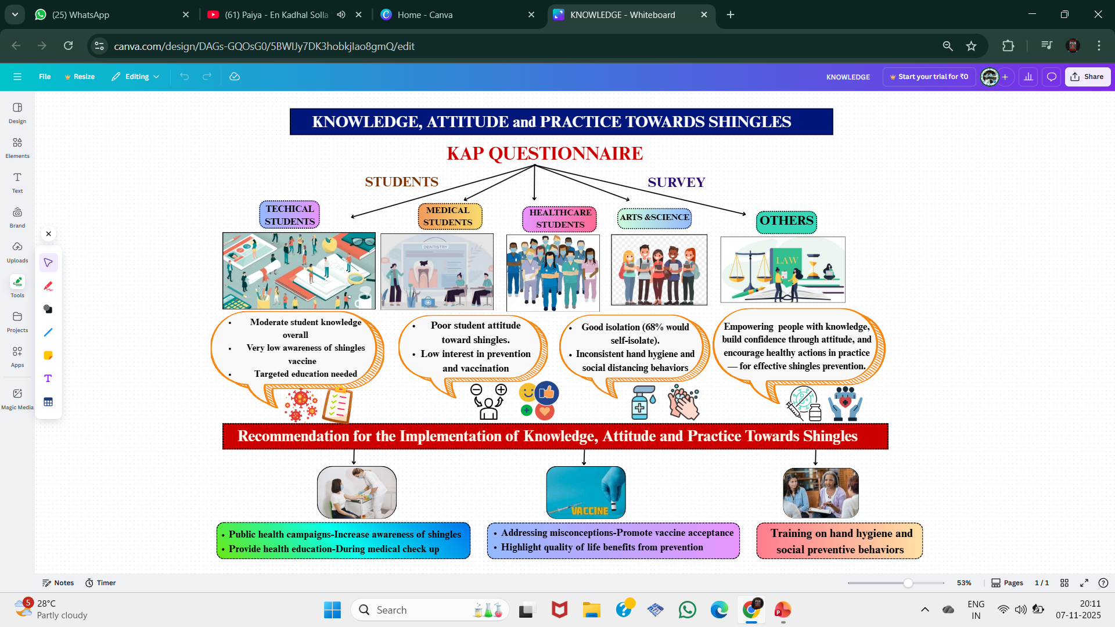
FIG 1:GRAPHICAL ABSTRACT
1.INTRODUCTION
A painful rash containing fluid-filled blisters, which develops when revived by the varicella-zoster virus (VZV) in its latent hiding place of the sensory nerve ganglia following the initial infection, the disease is called shingles or Herpes Zoster[1]. Clinical tests usually point to the fact that the virus follows those nerve pathways, leading to a one-sided, band-like, outbreak of blisters that is confined to a single dermatome which is usually the face or the body[2]. The Varicella zoster virus (VZV) causes two distinct diseases: the first is chickenpox, or varicella, which usually occurs in childhood or adolescence, and the second is shingles, which can occur later in life when the virus reactivates[3].
Epidemiology of Shingles is more than 1.2 million people in the U.S. are diagnosed with Herpes Zoster each year, leading to a significant increase in morbidity. According to estimates from the U.S. Centers for Disease Control and Prevention (CDC), over 30% of Americans will develop Herpes Zoster at some point in their lives. It is likely that a large percentage of the people will be shingles (Herpes Zoster), which is a common disorder that is caused by the latent varicella-zoster virus reactivating, at one point in their lives. Based on epidemiological records, the rate has been rising in the last few decades[4]. An example is in Olmsted County, Minnesota, where a population-based cohort study revealed that the rate age- and sex-adjusted had more than four times elevated, with the rate of 0.76 cases per 1000 person-years of 1945-1949 turning to 3.15 cases per 1000 person-years of 2000-2007. Such results are in line with the earlier research and are largely attributed to the aging population and a shift in the trend of immunity and varicella exposures. Among people over 55, the incidence also increased until 2006, after which it began to decline[5,6]. The Varicella zoster virus spreads easily. Although many may not recall having had chickenpox or may have had a subclinical infection, over 90% of adults have been infected. Consequently, most adults in countries like Australia are susceptible to Herpes Zoster. Evidence also suggests that the global prevalence of Herpes Zoster is increasing [7,8].
Shingles, also known as Herpes Zoster, occurs when the Varicella- zoster virus (VZV) becomes reactivated in the body.VZV is a double-stranded DNA virus, enveloped, and a member of the Herpesviridae family. Its genome encodes about 70 proteins[9]. When the virus reactivates, it replicates in the cell bodies of neurons and releases virions that travel down the nerve to the skin within the area innervated by that ganglion. This leads to blistering and localized inflammation in the skin. The pain associated with Herpes Zoster is caused by the inflammation of the affected nerves [10,11].
Herpes Zoster initially presents with a transient prodromal phase characterized by burning, tingling or neuropathic pain in a single dermatome, often accompanied by low-grade fever, malaise or headache[12]. The symptoms include a unilateral erythematous rash on the dermatome in 4872 hours which rapidly develops into clumped vesicles like primary varicella[13,14].Shingles pain is moderate to acute, and the slightest touch or breeze can cause sharp and severe pain of oversensitive skin.

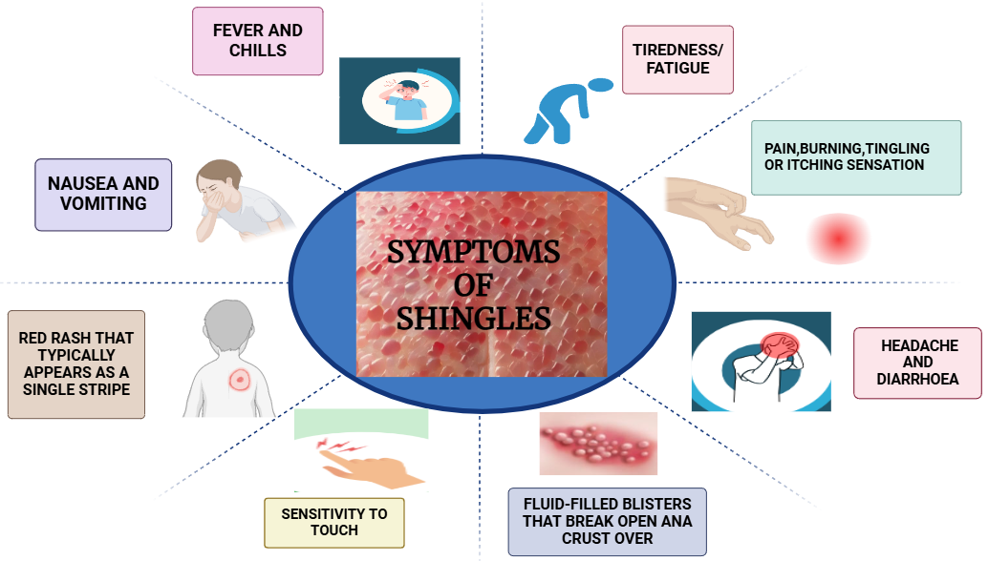
FIG 2:SIGN AND SYMPTOMS OF SHINGLES
Herpes Zoster is contagious and can be transmitted through close contact with an infected person. The virus can potentially be transmitted via inhalation of respiratory secretions in the air. After entering the body, it travels through the bloodstream and lymphatic system, initially infecting the epithelial cells of the respiratory tract or conjunctiva[15,16]. HZ is more prevalent in the elderly and those with immunodeficiency where about 22 percent of the cases may develop post-herpetic neuralgia (PHN). The pain may take several months and even years and has a tremendous impact on the quality of life [17]. HZ typically occurs as a non-midline vesicular dermatological rash, which crusts in 10 days. The discomfort of the rash can be extremely inconsistent; the patients may develop hypersensitivity or tingling, paining, or burning aches [18].
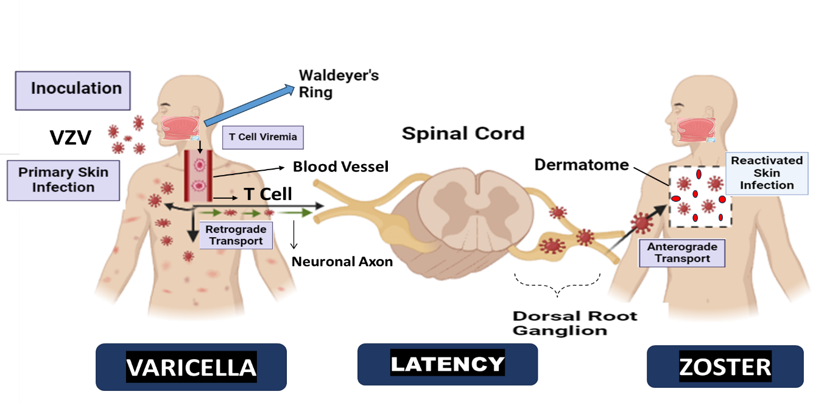
FIG 3:TRANSMISSION OF SHINGLES
Pathophysiology of shingles is caused by the Varicella-zoster virus (VZV), a double-stranded DNA virus related to the herpes simplex virus. Most people contract this virus in childhood, resulting in chickenpox[19]. While the immune system eventually clears the virus from most parts of the body, it remains dormant, or latent, in the trigeminal ganglion at the base of the skull or the dorsal root ganglia near the spinal cord. The reactivation of the virus, known as Herpes Zoster, leads to cutaneous lesions, which stimulate Varicella-zoster virus-specific T-cell proliferation. The production of interferon alpha helps resolve the illness[20,21].
The reactivation of varicella-zoster virus leads to the rapid and intense recall immunological reaction within healthy persons with normal immunity[22]. This reaction entails the formation of more VZV-specialized IgG, IgM and IgA antibodies and better cell mediated immunity which is of long-lasting protection[23]. Only those who have previously contracted VZV can develop shingles. While shingles can occur at any age, nearly half of cases in the U.S. occur in individuals aged 50 or older. Although shingles can recur, it is rare compared to the frequent recurrences of herpes simplex symptoms. It is very unlikely for someone to experience more than three recurrences of shingles[24,25]
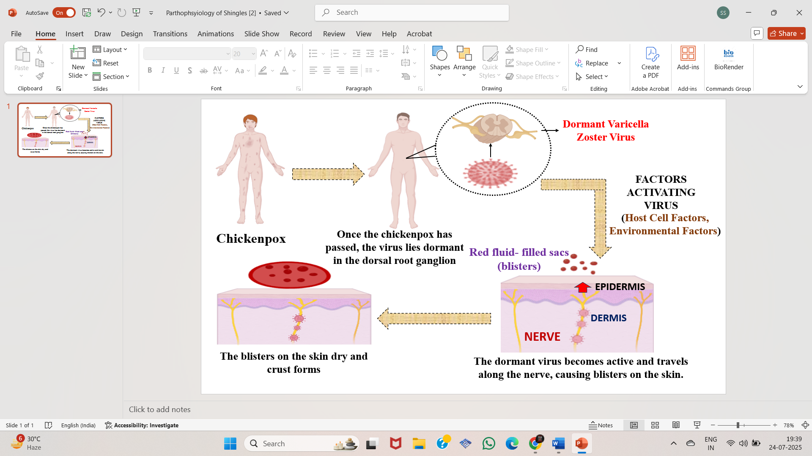
FIG 4:PATHOPHYSIOLOGY OF SHINGLES
Complications of skin scarring can occur due to postherpetic neuralgia, which is post-shingles pain that persists for more than a month after the rash appears. Secondary or superimposed bacterial infections may also affect the rash. The rash can evolve or spread due to the progression of shingles [26,27].Eye complications may include inflammation of the front part of the eye, and sometimes the entire eye, leading to pain, blurred vision, and potential involvement of internal organs, especially if the shingles affects the face or the area around the eyes[28].
The goals of treating Herpes Zoster include controlling immediate pain, hastening the healing of the rash, minimizing complications, and reducing the risk of postherpetic neuralgia (PHN) and other late-appearing sequelae[29,30]. An additional goal is to reduce the risk of VZV spreading through the skin and viscera, which is especially important for individuals with compromised immune systems. Antiviral medications can expedite recovery and decrease the likelihood of complications[31,32]. These medications are most effective when taken within three days of the rash onset. You will likely be prescribed one of three antiviral medications to combat the virus[33].

- Famciclovir (Famvir)
- Acyclovir (Zovirax)
- Valacyclovir (Valtrex)
2.MATERIAL AND METHODS
Study population:
This was a questionnaire-based, cross-sectional study which measured knowledge, attitude, and practice (KAP) of shingles (Herpes Zoster) in adult age (17 years and above). The sample was 310 participants, mostly students of the university (20 ± 2 years old with an equal number of men and women) and the study covered demographics, chickenpox background, shingles awareness, vaccine awareness, and prevention behaviour.
Procedure:
The questionnaire of self-structured type was used in collecting the data of this study. A structured questionnaire was created as an online tool and was distributed to the respondents who were undergraduate students in the university through Google Forms. This approach made it easy to access and collect the data effectively. The questionnaire was divided into four major parts; The first part included the socio-demographic data, such as age, gender, education level, record of a persistent illness, and past dental history with chickenpox. The second part evaluated the information on Herpes Zoster. The knowledge component consisted of the questions that were based on the causative factor, risk factor, symptoms, complications, transmission, and awareness of shingles vaccine. Section three was the attitude component which evaluated the perception of participants in terms of severity of the disease, susceptibility, prevention, and willingness to be vaccinated. The fourth part contained practice component that evaluated the preventive behaviours and health seeking behaviour concerning shingles. The responses were collected with the help of a Likert-type scale and close-ended questions. Based on the total possible scores, knowledge, attitude, and practice scores were then calculated and were categorized into poor (<60%), average (60-80%), and good (> 80) scores.
Statistical Analysis:
The entry and analysis of data was done with the help of Student T test and Chi Square test, which was applied to compare study result between groups. The analysis of socio-demographic variables and KAP responses was summarized using descriptive statistics (frequency, percentage, mean, and standard deviation). The KAP scores were based on the sum of responses on the structured questionnaire to which individual item scores (e.g., 1 point to correct knowledge questions, 5-point Likert scales to attitude/practice questions) were added and then classification was made (poor, <60 percent), average (60-80 percent) and good (>80 percent).
Based on the type of variables under study, the student t-test was used to compare groups regarding continuous variables, and the Chi-square test or Fisher exact test were used to compare groups in the categorical variable case. Chi-square or Fisher exact tests were used to test the associations between KAP categories and socio-demographic variables (i.e., gender, educational level, and history of chronic disease).
The relationship between knowledge, attitude, and practice scores was measured based on the spearman rank correlation coefficient. The p-value of 0.05 was found to be significant statistically with a 95 percent confidence level being used to test the results.
3. RESULTS AND DISCUSSION
Results:
The study population comprised 310 individuals with a mean age of 20 ± 2 years. The sample demonstrated an equal gender representation, with males and females each accounting for 50% (n = 155 per group). Most participants were graduates (80.0%), followed by those with secondary education (11.9%). A smaller proportion had completed postgraduate education (6.8%), while only a few participants reported a diploma (1.0%) or primary education (0.3%). Only 12 individuals (3.9%) indicated the presence of a chronic medical condition, while the remaining 298 (96.1%) reported none. With respect to previous exposure to chickenpox, 237 participants (76.5%) reported a positive history, 65 (21.0%) reported no prior infection, and 8 (2.6%) were unsure (Table 1).

Variable | Category | Frequency (%)
Age (years) | Mean ± SD | 20 ± 2
Gender | Male | 155 (50.0)
Gender | Female | 155 (50.0)
Educational level | Primary education | 1 (0.3)
Educational level | Secondary education | 37 (11.9)
Educational level | Diploma | 3 (1)
Educational level | Graduate | 248 (80)
Educational level | Postgraduate | 21 (6.8)
History of Chronic Disease | Yes | 12 (3.9)
History of Chronic Disease | No | 298 (96.1)
Ever had chickenpox | Yes | 237 (76.5)
Ever had chickenpox | No | 65 (21)
Ever had chickenpox | Do not know | 8 (2.6)

Table 1: Socio-demographic Characteristics of Study Participants (n = 310)
Analysis of individual knowledge-related questionnaire responses revealed varying levels of awareness among participants. A large proportion (90.9%) correctly identified the causative agent of shingles as the varicella-zoster virus. More than half (68%) believed that individuals in contact with patients with shingles could become infected. Regarding age-related susceptibility, 38.1% agreed or strongly agreed that young people do not develop shingles, while 40.7% disagreed with this statement. Responses to the lifetime risk of shingles showed that 41.6% selected a neutral response to the statement that the lifetime risk is up to one-third. Most participants (66.4%) agreed that immunocompromised individuals are at higher risk, and 60% correctly acknowledged that a history of chickenpox increases the risk of shingles later in life. However, 73.2% agreed that shingles occurs only in individuals above 50 years of age. Awareness of the shingles vaccine was limited, with 26.2% reporting prior awareness, while 59.4% had not heard of it. Regarding vaccination eligibility, 73% correctly agreed that the vaccine is approved for individuals above 50 years. Commonly identified symptoms included rash (60%) and blisters (26.8%), whereas fewer participants identified complications such as blindness and hearing loss.
Responses to attitude-related questionnaire components demonstrated variability among participants. Nearly half of the participants (45.4%) expressed willingness to learn more about shingles, while 46.7% were unsure. Willingness to receive the shingles vaccine was reported by 5.9% of participants, whereas 51.2% were unsure. More than half (53.8%) were unsure about preventive practices related to shingles, and 38.3% reported concern about developing the disease in the future. Additionally, 44.4% agreed or strongly agreed that shingles has a substantial impact on health, while 32% strongly disagreed.
Responses to the practice-related questionnaire components indicated variability in preventive behaviours. A majority of participants (68.1%) reported always isolating themselves when they suspected infection. In contrast, only 7.7% reported always washing their hands with soap and water after visiting crowded areas. Hand washing after sneezing or coughing was reported by 66% of participants. Avoidance of cultural practices such as hugging and handshaking was reported rarely by 43.8% of respondents. Avoidance of large social gatherings was reported sometimes by 66.9% of participants, while 17% reported always avoiding such gatherings.
Regarding knowledge scores, nearly half of the participants 48.1% demonstrated an average level of knowledge, while 39.7% were categorised as having poor knowledge. Only 12.2% of participants achieved a good knowledge score. Assessment of attitude scores showed that the majority of participants 53.2% had an average attitude, followed by 43.5% with a poor attitude, and 3.2% with a good attitude. In terms of practice, more than half of the participants 57.7% demonstrated average practice levels, whereas 29.7% exhibited good practice, and 12.6% had poor practice scores (Table 2).
Variable | Poor (<60%) | Average (60–80%) | Good (>80%)
Knowledge | 123 (39.7) | 149 (48.1) | 38 (12.2)
Attitude | 135 (43.5) | 165 (53.2) | 10 (3.2)
Practice | 38 (12.6) | 179 (57.7) | 92 (29.7)

Table 2: Distribution of Knowledge, Attitude, and Practice (KAP) Scores among Participants

Figure 5: Distribution of Knowledge, Attitude, and Practice Levels
Evaluation of relationships between socio-demographic characteristics and KAP domains demonstrated no significant differences across gender categories (p > 0.05). Educational attainment was significantly related to attitude scores (p = 0.003); however, no meaningful association was identified with knowledge or practice components. Participants with a history of chronic disease did not show a significant association with knowledge or attitude scores. However, a statistically significant association was observed between chronic disease history and practice scores (p = 0.047) (Table 3).
Variable | Knowledge χ²/Fisher p | Attitude χ²/Fisher p | Practice χ² / Fisher p
Gender | 3.32 (0.19) | 5.56 (0.104) | 3.73 (0.534)
Educational Level | 8.47 (0.39) | 23.22 (0.003) * | 12.92 (0.110)
History of Chronic Disease | 1.82 (1.000) | 4.19 (0.330) | 5.58 (0.047) *

Table 3: Relationship of socio-demographic characteristics with KAP domain scores
Correlation analysis using Spearman’s rho indicated that knowledge and attitude scores were not significantly related (ρ = 0.057, p = 0.319). However, knowledge demonstrated a moderate inverse relationship with practice scores (ρ = −0.262, p < 0.001), suggesting that higher knowledge levels did not necessarily correspond to improved practices. Conversely, attitude scores showed a moderate positive correlation with practice scores (ρ = 0.257, p < 0.001), indicating that favourable attitudes were associated with better behavioral practices (Table 4).
Variable Pair | Spearman’s rho (ρ) | p-value
Knowledge ↔ Attitude | 0.057 | 0.319
Knowledge ↔ Practice | -0.262 | < 0.001*
Attitude ↔ Practice | 0.257 | < 0.001*

Table 4: Spearman’s rank correlation coefficients among KAP domains

Figure 6: Spearman correlation between Knowledge, Attitude, and Practice
The gender-wise distribution of KAP scores showed that among males, 50.9% had average knowledge, 34.8% had poor knowledge, and 14.2% demonstrated good knowledge. Among females, the distribution was 45.2% average knowledge, 44.5% poor knowledge, and 10.3% good knowledge. Attitude scores were predominantly in the average category for both males (58.1%) and females (48.4%). Practice scores also showed a similar pattern across genders, with no statistically significant differences observed (Table 5).
KAP Variable | Gender | Poor n (%) | Average n (%) | Good n (%) | χ² / p-value
Knowledge | Male | 54 (34.8) | 79 (50.9) | 22 (14.2) | 3.32 / 0.19
Knowledge | Female | 69 (44.5) | 70 (45.2) | 16 (10.3) | 3.32 / 0.19
Attitude | Male | 63 (40.6) | 90 (58.1) | 2 (1.3) | 5.56 / 0.104
Attitude | Female | 72 (46.5) | 75 (48.4) | 8 (5.2) | 5.56 / 0.104
Practice | Male | 15 (9.7) | 97 (62.6) | 43 (27.7) | 3.73 / 0.534
Practice | Female | 24 (15.5) | 82 (52.9) | 49 (31.6) | 3.73 / 0.534
Table 5: Gender-wise Distribution of Knowledge, Attitude, and Practice Scores
Participants without a prior history of chronic illness predominantly exhibited average knowledge (48.7%) and attitude (52.3%) levels, while 28.5% demonstrated good practice behaviors. In contrast, those reporting chronic disease showed a greater proportion of poor knowledge (58.3%), yet a comparatively higher percentage achieved good practice scores (58.3%). It should be noted that the number of individuals in the chronic disease subgroup was relatively small.
Inferential testing indicated no statistically meaningful relationship between chronic disease history and either knowledge (p = 1.000) or attitude scores (p = 0.330). However, a significant association was identified with practice scores (p = 0.047), suggesting that individuals with chronic conditions tended to demonstrate more favorable practice patterns (Table 6).
KAP Variable | Chronic disease history | Poor n (%) | Average n (%) | Good n (%) | χ² / Fisher p
Knowledge | No | 116 (38.9) | 145 (48.7) | 37 (12.4) | 1.82 / 1.000
Knowledge | Yes | 7 (58.3) | 4 (33.3) | 1 (8.3) | 1.82 / 1.000
Attitude | No | 133 (44.6) | 156 (52.3) | 9 (3.0) | 4.19 / 0.330
Attitude | Yes | 2 (16.7) | 9 (75.0) | 1 (8.3) | 4.19 / 0.330
Practice | No | 39 (13.1) | 174 (58.4) | 85 (28.5) | 5.58 / 0.047*
Practice | Yes | 0 (0) | 5 (41.7) | 7 (58.3) | 5.58 / 0.047*

Table 6: Distribution of KAP domains according to chronic disease status

Figure 7: Knowledge, Attitude, and Practice of Chronic Disease Status

Discussion:
This study identified substantial gaps in knowledge and attitude towards shingles among a predominantly young and educated population, despite comparatively better preventive practice patterns. Although more than half of the participants demonstrated average practice (57.7%) and nearly one-third exhibited good practice (29.7%), only 12.2% achieved good knowledge scores, and 3.2% demonstrated a good attitude. This discordance between awareness and behaviour mirrors findings from recent KAP studies conducted in Asia–Pacific and Middle Eastern regions, where preventive engagement has been shown to occur independently of comprehensive disease-specific understanding[34–36]. These findings underscore the complex and non-linear relationship between cognition, perception, and health behaviour.
The predominance of average (48.1%) and poor (39.7%) knowledge levels is notable given that a substantial proportion of participants (76.5%) reported a prior history of chickenpox. Since varicella infection is a prerequisite for latent varicella-zoster virus reactivation, this finding suggests limited awareness of the biological link between chickenpox and shingles. Similar deficiencies in understanding viral latency, reactivation, and complications such as post-herpetic neuralgia have been reported in multiple population-based studies[34,37,38]. The persistent misconception that shingles primarily affects older adults likely contributes to reduced perceived susceptibility among younger individuals, as documented in earlier studies[39–41], and may partially explain the low proportion of participants with good knowledge in the present study.
Attitude scores were predominantly average (53.2%) or poor (43.5%), with very few participants expressing a clearly favourable preventive outlook. Educational attainment demonstrated a statistically meaningful relationship with attitude scores (p = 0.003), while no significant association was observed with knowledge or practice. This suggests that formal education may influence general health perceptions and beliefs without necessarily translating into improved disease-specific literacy or consistent preventive behaviour. Similar patterns have been reported in previous KAP and vaccine acceptance studies, which highlight the limitations of general educational attainment alone in improving awareness of specific infectious diseases such as shingles[35,42,43]. These findings align with the Health Belief Model, wherein perceived severity and susceptibility rather than factual knowledge alone play a pivotal role in shaping attitudes[44].
Practice scores in the present study were comparatively better than knowledge and attitude scores, with only 12.6% of participants demonstrating suboptimal practices. A significant relationship was identified between a history of chronic disease and practice scores (p = 0.047), with participants reporting chronic illness exhibiting a higher proportion of good practice (58.3%) compared to those without chronic disease (28.5%). This may reflect increased healthcare engagement, heightened risk perception, and greater exposure to preventive counselling among individuals with comorbid conditions. Similar associations between chronic disease status and improved preventive behaviours, including vaccination uptake, have been documented previously[35,45]. However, further research involving larger samples is required to validate this finding.
Correlational analysis further elucidated the complex relationships among KAP domains. No meaningful correlation was detected between knowledge and attitude (ρ = 0.057, p = 0.319), suggesting that increased factual knowledge did not necessarily translate into more favourable perceptions. Interestingly, a significant negative correlation was identified between knowledge and practice (ρ = −0.262, p < 0.001), while a significant positive correlation was observed between attitude and practice (ρ = 0.257, p < 0.001). The negative correlation observed between knowledge and practice may indicate suggesting that practice is influenced by factors other than knowledge, such as social norms, personal experience, or healthcare exposure. Although counterintuitive, the inverse association between knowledge and practice has been reported in behavioural science and vaccine hesitancy literature and may reflect optimism bias, misinformation, or overestimation of personal immunity despite awareness of disease facts [46–48]. In contrast, the positive attitude and practice relationship reinforces the central role of beliefs and perceptions in driving preventive behaviour, as supported by established behavioural models[42,44].
Correlation analysis showed no significant association between knowledge and attitude (ρ = 0.057, p = 0.319), suggesting that greater levels of knowledge did not necessarily lead to more positive perceptions. A statistically meaningful inverse relationship was identified between knowledge and practice (ρ = −0.262, p < 0.001), suggesting that greater factual awareness did not translate into better preventive behaviour. This inverse relationship may reflect optimism bias, misinformation, or overestimation of personal immunity despite awareness of disease facts, as described in vaccine hesitancy literature [46–48]. In contrast, attitude demonstrated a significant positive association with practice (ρ = 0.257, p < 0.001), reinforcing the concept that perceptions and beliefs are more directly linked to preventive actions than knowledge alone[42,44].
No statistically significant gender-based differences were observed across knowledge, attitude, or practice domains (p > 0.05), indicating broadly similar levels of awareness and behaviour among male and female participants. This finding is consistent with prior studies reporting minimal gender influence on shingles-related awareness and preventive practices, particularly in younger populations [34,40,49]. These results suggest that public health interventions should be broadly targeted rather than gender-specific.
From a public health perspective, the findings emphasise the need for multifaceted interventions that extend beyond information dissemination. Despite relatively acceptable practice levels, the low prevalence of good knowledge and favourable attitudes highlights deficiencies in perceived susceptibility and disease relevance. Educational strategies should therefore focus on correcting age-related misconceptions, reinforcing the lifelong risk of shingles following varicella infection, and emphasising the potential severity and long-term complications of the disease [39,44,48]. Leveraging healthcare providers, academic institutions, and digital health platforms may be particularly effective in improving attitudes and sustaining preventive behaviours. Given the availability of effective shingles vaccines, improving awareness among younger adults may also contribute to improved long-term vaccine acceptance [34,37,50].
CONCLUSION
This study identifies notable deficiencies in knowledge, attitudes, and practices concerning shingles and its vaccination among university students. While most participants recognized the Varicella-zoster virus as the cause of shingles, awareness of the HZ vaccine and its preventive benefits was low. Misconceptions about the age groups affected, limited recognition of symptoms, and low willingness to be vaccinatedoften influenced by costwere evident. Interest in prevention was moderate, and knowledge of risk factors such as immunocompromised status was variable. These results emphasize the necessity for focused educational strategies aimed at improving vaccine awareness, early symptom identification, and prevention strategies, especially for high-risk and underserved populations. Public health campaigns tailored to younger populations may also play a role in long-term prevention by building awareness early.
LIMITATIONS
Several limitations must be acknowledged when interpreting these findings.First, the cross-sectional nature of the study assesses knowledge, attitudes, and practices at one specific time point, which may not reflect changes over time. Second, the study population was limited to university students, thereby potentially limiting the applicability of the results to other age groups, particularly the elderly or rural populations. Third, the use of self-reported responses may have introduced recall bias as well as social desirability bias. In addition, the survey did not assess participants’ actual clinical exposure to shingles or their detailed understanding of post-herpetic neuralgia, which may have influenced the knowledge scores.
RECOMMENDATIONS
Subsequent research should consider recruiting larger and more heterogeneous populations, covering various socio-demographic groups and geographical areas. Longitudinal research designs may facilitate the evaluation of changes in awareness and attitudesfollowing educational interventions. Public health programs should prioritize integrating shingles awareness into broader health education campaigns, with particular attention to the benefits, accessibility, and affordability of the HZ vaccine. Collaboration with healthcare providers to promote accurate information, especially in high-risk and underserved communities, will be essential to improving prevention and vaccination rates.
CONFLICT OF INTEREST
None declared
LIST OF ABBREVIATIONS
- ACIP – Advisory Committee on Immunization Practices
- CDC – Centers for Disease Control and Prevention
- DNA – Deoxyribonucleic Acid
- HZ – Herpes Zoster
- IgA – Immunoglobulin A
- IgG – Immunoglobulin G
- IgM – Immunoglobulin M
- KAP – Knowledge, Attitude, and Practice
- PHN – Postherpetic Neuralgia
- SD – Standard Deviation
- VZV – Varicella-Zoster Virus
- χ² – Chi-Square Test
- ρ (rho) – Spearman’s Rank Correlation Coefficient

REFERENCES:
[1] Shah S, Dahal K, Thapa S, Subedi P, Paudel BS, Chand S, et al. Herpes Zoster vaccination and the risk of dementia: A systematic review and meta-analysis. Brain Behav 2024;14. https://doi.org/10.1002/brb3.3415.
[2] Chen J, Shantakumar S, Si J, Gowindah R, Parikh R, Chan F, et al. Knowledge, attitude, and practice toward Herpes Zoster (HZ) and HZ vaccination: Concept elicitation findings from a multi-country study in the Asia Pacific. Hum Vaccin Immunother 2024;20. https://doi.org/10.1080/21645515.2024.2317446.
[3] Shrestha AC, Field E, Rajmokan M, Lambert SB. Assessing the impact of chickenpox and shingles vaccination using intermittent enhanced surveillance in Queensland, Australia. Vaccine 2023;41. https://doi.org/10.1016/j.vaccine.2023.11.015.
[4] BalajiS D, Srinivasa Rangan A, Kumar SM, Prasanna Karthik S, Vinayakam Gopalakrishnan K, Balaji S, et al. A Rare Case of Facial Nerve Palsy After Primary Varicella Infection. Afr J Biomed Res 2766;27:2766–7. https://doi.org/10.53555/AJBR.v27i1S.1892.
[5] Randolph SA. Shingles. Workplace Health Saf 2015;63. https://doi.org/10.1177/2165079915607499.
[6] Wehrhahn MC, Dwyer DE. Herpes Zoster: Epidemiology, clinical features, treatment and prevention. Aust Prescr 2012;35. https://doi.org/10.18773/austprescr.2012.067.
[7] John AR, Canaday DH. Herpes Zoster in the Older Adult. Infect Dis Clin North Am 2017;31. https://doi.org/10.1016/j.idc.2017.07.016.
[8] Rafferty E, McDonald W, Qian W, Osgood ND, Doroshenko A. Evaluation of the effect of chickenpox vaccination on shingles epidemiology using agent-based modeling. PeerJ 2018;6. https://doi.org/10.7717/peerj.5012.
[9] Oliver SL, Zhou M, Arvin AM. Varicella-zoster virus: Molecular controls of cell fusion-dependent pathogenesis. Biochem Soc Trans 2020;48. https://doi.org/10.1042/BST20190511.
[10] AlMuammar S, Albogmi A, Alzahrani M, Alsharef F, Aljohani R, Aljilani T. Herpes Zoster vaccine awareness and acceptance among adults in Saudi Arabia: a survey-based cross-sectional study. Trop Dis Travel Med Vaccines 2023;9. https://doi.org/10.1186/s40794-023-00202-z.
[11] Smetana J, Šošovičková R, Polcarová P, Chlíbek R. New options for vaccination against shingles. Vakcinologie 2018;12.
[12] Aparna M, Ganapathy D, Rohinikumar S. Awareness of herpetic neuritis among dental practitioners. International Journal of Research in Pharmaceutical Sciences 2020;11. https://doi.org/10.26452/ijrps.v11iSPL3.3057.
[13] Mali S. Herpes Zoster: etiology, clinical features and treatment options, and case report. Egyptian Journal of Oral & Maxillofacial Surgery 2012;3.
[14] Chowdhury NH, Biswas AC, Islam MA, Milki FU, Khan SR. Shingles: Extensive Clinical Presentation of Herpes Zoster Infection. Bangladesh Journal of Otorhinolaryngology 2020;22. https://doi.org/10.3329/bjo.v22i2.45103.
[15] Davis LE, King MK. Shingles (Herpes Zoster) and post-herpetic neuralgia. Curr Treat Options Neurol 2001;3. https://doi.org/10.1007/s11940-001-0028-3.
[16] Alhothali OS, Alhothali AS, Hanif AA, Bondagji MF, Aljabri HM, Goweda R. A Cross-Sectional Study of the Knowledge, Practice, and Attitude Towards Herpes Zoster Vaccination Among the General Population in the Western Region of Saudi Arabia. Cureus 2023. https://doi.org/10.7759/cureus.33508.
[17] Thompson RR, Kong CL, Porco TC, Kim E, Ebert CD, Acharya NR. Herpes Zoster and Postherpetic Neuralgia: Changing Incidence Rates from 1994 to 2018 in the United States. Clinical Infectious Diseases 2021;73. https://doi.org/10.1093/cid/ciaa1185.
[18] Alleft LA, Alhosaini LS, Almutlaq HM, Alshayea YM, Alshammari​​ SH, Aldosari MA, et al. Public Knowledge, Attitude, and Practice Toward Herpes Zoster Vaccination in Saudi Arabia. Cureus 2023. https://doi.org/10.7759/cureus.49396.
[19] Mueller NH, Gilden DH, Cohrs RJ, Mahalingam R, Nagel MA. Varicella Zoster Virus Infection: Clinical Features, Molecular Pathogenesis of Disease, and Latency. Neurol Clin 2008;26. https://doi.org/10.1016/j.ncl.2008.03.011.
[20] Liesegang TJ. Varicella Zoster Viral Disease. Mayo Clin Proc 1999;74. https://doi.org/10.4065/74.10.983.
[21] Cohen JI. Clinical practice: Herpes Zoster. N Engl J Med 2013;369. https://doi.org/10.1056/NEJMcp1302674.
[22] Dadu F, Kumar S, R. S, M. R, Kumar M. An acute case of Herpes Zoster ophthalmicus with post-herpetic neuralgia and cranial nerve neuropathies. International Journal of Advances in Medicine 2022;9. https://doi.org/10.18203/2349-3933.ijam20222107.
[23] Sampathkumar P, Drage LA, Martin DP. Herpes Zoster (Shingles) and postherpetic neuralgia. Mayo Clin Proc 2009;84. https://doi.org/10.4065/84.3.274.
[24] Janniger CK. Herpes Zoster: Practice Essentials, Background, Pathophysiology. Medscape 2022.
[25] Carter TM. Shingles: Not Just a Rash. Journal for Nurse Practitioners 2020;16. https://doi.org/10.1016/j.nurpra.2019.10.013.
[26] Litt JCB, Kim S, Woodman R, MacIntyre R, Cunningham T. Australian zoster study: GP and patient views about Herpes Zoster (shingles), its complications, and the likely acceptance of a zoster vaccine (Zostavax). International Journal of Infectious Diseases 2014;21. https://doi.org/10.1016/j.ijid.2014.03.1320.
[27] Yawn BP, Saddier P, Wollan PC, St. Sauver JL, Kurland MJ, Sy LS. A population-based study of the incidence and complication rates of Herpes Zoster before zoster vaccine introduction. Mayo Clin Proc 2007;82. https://doi.org/10.4065/82.11.1341.
[28] Holodniy M. Prevention of shingles by varicella zoster virus vaccination. Expert Rev Vaccines 2006;5. https://doi.org/10.1586/14760584.5.4.431.
[29] Carmichael JK. Treatment of Herpes Zoster and postherpetic neuralgia. Am Fam Physician 1991;44. https://doi.org/10.3344/kjp.2008.21.2.93.
[30] Nazarko L. Diagnosis, treatment and prevention of shingles: the role of the healthcare assistant. British Journal of Healthcare Assistants 2019;13. https://doi.org/10.12968/bjha.2019.13.1.20.
[31] Nikkeis AF, Piérard GE. Recognition and Treatment of Shingles. Drugs 1994;48. https://doi.org/10.2165/00003495-199448040-00004.
[32] Bakacs T, Sandig V, Kovesdi I. Combination Therapy for the Treatment of Shingles with an Immunostimulatory Vaccine Virus and Acyclovir. Pharmaceuticals 2023;16. https://doi.org/10.3390/ph16020226.
[33] Patil A, Goldust M, Wollina U. Herpes Zoster: A Review of Clinical Manifestations and Management. Viruses 2022;14. https://doi.org/10.3390/v14020192.
[34] Chang C, Tang H, Zhang X, Zhu C, Feng Y, Ye C. Knowledge, attitudes, and practices of the general population, Herpes Zoster patients, and dermatologists toward Herpes Zoster in China: A quantitative cross-sectional survey. Hum Vaccin Immunother 2024;20. https://doi.org/10.1080/21645515.2024.2338980.
[35] Turkistani SA, Althobaiti FJ, Alzahrani SH. The Knowledge, Attitude and Practice Among Makkah Physicians Towards Herpes Zoster Vaccination, Saudi Arabia, 2023. Cureus 2023. https://doi.org/10.7759/cureus.49393.
[36] Alshrari AS. Evaluation of the General Population’s Knowledge, Attitudes, and Practices about Herpes Zoster Vaccination in the Northern Border and Al-Jouf Region of Saudi Arabia. Adv Life Sci 2025;12. https://doi.org/10.62940/als.v12i2.3701.
[37] Harpaz R, Ortega-Sanchez IR, Seward JF. Prevention of Herpes Zoster: recommendations of the Advisory Committee on Immunization Practices (ACIP). MMWR Recommendations and Reports : Morbidity and Mortality Weekly Report Recommendations and Reports / Centers for Disease Control 2008;57.
[38] Gershon AA, Breuer J, Cohen JI, Cohrs RJ, Gershon MD, Gilden D, et al. Varicella zoster virus infection. Nat Rev Dis Primers 2015;1. https://doi.org/10.1038/nrdp.2015.16.
[39] Kawai K, Yawn BP. Risk Factors for Herpes Zoster: A Systematic Review and Meta-analysis. Mayo Clin Proc 2017;92. https://doi.org/10.1016/j.mayocp.2017.10.009.
[40] Cunningham AL, Lal H, Kovac M, Chlibek R, Hwang S-J, Díez-Domingo J, et al. Efficacy of the Herpes Zoster Subunit Vaccine in Adults 70 Years of Age or Older. New England Journal of Medicine 2016;375. https://doi.org/10.1056/nejmoa1603800.
[41] Forbes HJ, Bhaskaran K, Thomas SL, Smeeth L, Clayton T, Langan SM. Quantification of risk factors for Herpes Zoster: Population based case-control study. BMJ (Online) 2014;348. https://doi.org/10.1136/bmj.g2911.
[42] Betsch C, Schmid P, Heinemeier D, Korn L, Holtmann C, Böhm R. Beyond confidence: Development of a measure assessing the 5C psychological antecedents of vaccination. PLoS One 2018;13. https://doi.org/10.1371/journal.pone.0208601.
[43] Dubé E, Laberge C, Guay M, Bramadat P, Roy R, Bettinger JA. Human Vaccines & Immunotherapeutics Vaccine hesitancy An overview. Taylor & Francis 2013;9.
[44] Rosenstock IM. The Health Belief Model and Preventive Health Behavior. Health Education & Behavior 1977;2. https://doi.org/10.1177/109019817400200405.
[45] Tseng HF, Smith N, Harpaz R, Bialek SR, Sy LS, Jacobsen SJ. Herpes Zoster vaccine in older adults and the risk of subsequent Herpes Zoster disease. JAMA 2011;305. https://doi.org/10.1001/jama.2010.1983.
[46] Weinstein ND. Optimistic biases about personal risks. Science (1979) 1989;246. https://doi.org/10.1126/science.2686031.
[47] Bish A, Yardley L, Nicoll A, Michie S. Factors associated with uptake of vaccination against pandemic influenza: A systematic review. Vaccine 2011;29. https://doi.org/10.1016/j.vaccine.2011.06.107.
[48] Brewer NT, Weinstein ND, Cuite CL, Herrington JE. Risk Perceptions and Their Relation to Risk Behavior. Annals of Behavioral Medicine 2004;27. https://doi.org/10.1207/s15324796abm2702_7.
[49] Lu PJ, Euler GL, Harpaz R. Herpes Zoster vaccination among adults aged 60 years and older, in the U.S., 2008. Am J Prev Med 2011;40. https://doi.org/10.1016/j.amepre.2010.10.012.
[50] Oxman MN. Zoster vaccine: Current status and future prospects. Clinical Infectious Diseases 2010;51. https://doi.org/10.1086/653605.

