Review Article

Medicinal Significance of Pyracantha crenulata: Insights into Botany, Phytochemistry, and Pharmacology

Abstract
Background: Pyracantha crenulata (Roxb.) M. Roem. is an evergreen shrub also called as Himalayan firethorn, belongs to family Rosaceae inherent in the Himalayan areas of India, China and Nepal. Many parts of the plant have been utilized from long time in indigenous medicine to treat infections, inflammation, metabolic problems and cardiovascular diseases. Because of its diverse pharmacological properties and rich phytochemical compounds, Pyracantha crenulata has been gaining progressively scientific attention in last few years. Aim: The primary focus of this review is to provide a comprehensive overview of the botanical characteristics, phytochemical composition, and experimentally confirmed pharmacological properties of Pyracantha crenulata.
Methods: This review is based on published literature recovered from scientific databases like PubMed, Scopus, Web of Science and Google Scholar the current review provides an in-depth assessment of the botanical features, phytochemistry and pharmacological activities of Pyracantha crenulata.
Results: The biological activities of Pyracantha crenulata are mainly ascribed to the presence of flavonoids, phenolic acids, triterpenoids, sterols, glycosides and essential micronutrients, in accordance with phytochemical analyses. Various extracts have manifest notable antioxidant, cardioprotective, anti-inflammatory, antibacterial, antidiabetic, hepatoprotective and neuroprotective activities in research studies.
Conclusion: This review aims to compile and synthesize the available scientific data and provide a targeted resource for researchers in pharmacognosy and natural product research.

Keywords: Pyracantha crenulata, Himalayan firethorn, phytochemistry, medicinal plants

1. Introduction
Pyracantha crenulata, often called Ghingharu or Himalayan firethorn, is the perennial deciduous shrub native to Kumaon region in Uttarakhand. It belongs to Rosaceae family and is identified by its prickly branches and groups of magnificent, small white flowers that are followed by vibrant red berries (Osmaton 1927). The plant is found in many countries which include India, China and Japan where it has been used to treat wide range of diseases. Due to its ample number of biological resources and ethnobotanical significance in traditional medicine, the plant has captivated a lot of attention (Joshi et al., 2023).
Pyracantha crenulata has been assessed for various phytochemicals to study its possible remedial uses. The plant is rich in essential oils and contains a variety of secondary metabolites which includes triterpenoids and diterpenoids such labdanes, abietanes and ent-kauranes. These phytochemicals have anti-inflammatory, antioxidant, antibacterial and anticancer activities (Singh et al., 2020). Pyracantha crenulata is used four both culinary and therapeutic purposes in Southeast Asian countries. The flowers of Pyracantha have one ovary and twenty stamens which makes them hermaphrodite. Indian Hawthorn or Ghingharu are common names for this prickly, perennial deciduous shrub (Brandis, 1921). Pyracantha is a good soil binder used to stabilize deteriorated slope areas. That is vulnerable to landslides (Gamble, 1972). In Garhwal folk and traditional medicine, the fruit of this plant has been used to cure significant diseased conditions such as diabetes, hypertension, blood pressure, and circulatory disorders particularly angina (Spectrum, 2010). The fruit is used to cure burns, heart failure, myocardial debility and Buerger's disease. It is also an appetizer, cardiotonic, diuretic, vasodilator, and sedative. Old age individuals eat the fruit to feel refreshed and to ease body and joint discomfort. Yogurt and fruit powder are used to treat bloody dysentery (Chauhan, 1999; Khare, 2004;Khare, 2007;Pade et al., 2007; Saklani et al., 2011; Saklani and Chandra, 2014). The leaves are used to make herbal teas, sunburn treatments, and face creams because of their anti-inflammatory, immunomodulatory, and antioxidant properties (Simoons, 1990). The plant is seeded as an ornamental and makes a great hedge (Dimitri, 2009). It contains calcium, potassium, protein, carbs, lipids, fibers, vitamin C, vitamin A, vitamin B, vitamin B2, vitamin B12, and vitamin E (Negi et al., 2009). The majority of Pyracantha species contain bio-flavonoids that are very helpful in treating heart and blood circulation problems (Peschel et al., 2008). The antioxidants present in plant lessen the harm caused by free radicals. Up to the 18th century, this herb was used medicinally to treat respiratory disorders and circulatory system disorders. Increasing blood flow to the coronary heart muscle and repairing the regular heartbeat are considered in ayurvedic medicine. This has an effect due to bioflavonoid content of fruits. The fruit and flowers of plants are thought to have a minor heart-tonic effect in other medical systems (Osmaston, 1926). Additionally, because of its diuretic, depurative, tonic, antirheumatic, cardiotonic, hypoglycemic, hypotensive, anti-inflammatory and lithontripic qualities, it is said to be helpful in treating a variety of conditions in Ayurvedic medicine, including hepatic, stomach, and skin disorders (Himalay, 1999; Fern, 2008; Otsuka et al., 1981). Despite its widespread use, more research is needed to understand the mechanisms by which Pyracantha crenulata exerts its medicinal properties and to investigate its potential uses in contemporary medicine (Pandey et al., 2024). The current review attempts to provide a detailed understanding of Pyracantha crenulata by summarizing the information on its phytochemical and pharmacological aspects.
2. Methodology
2.1Source and Search Strategy
An extensive literature survey was conducted to gather relevant data on Pyracantha crenulata published up to the year 2025. Appropriate scientific papers were collected from electronic databases such as PubMed, Google Scholar, and ScienceDirect. Search terms included keywords related to Pyracantha crenulata. Chemical structures were drawn using ChemDraw according to journal’s guidelines. Keywords used for the search included Pyracantha crenulata, Himalayan firethorn, Ghingharu, pharmacognosy, phytochemistry, pharmacology and traditional uses. Relevant peer-reviewed research articles, review papers, books and ethnomedicinal reports published in the English language were screened.
2.2Inclusion and Exclusion Criteria
The present review includes all available and relevant scientific literature on Pyracantha crenulata published up to the year 2025. Studies related to its pharmacognostic, phytochemical, pharmacological, and traditional uses reported in peer-reviewed journals, books and authenticated sources in the English language were considered. Publications related to other species of the genus Pyracantha without specific reference to Pyracantha crenulata were excluded. Studies with insufficient scientific evidence, unclear methodology, duplicate data or those unrelated to the medicinal relevance of the plant were not included.
3. Botanical and Geographical distribution
Pyracantha crenulata is a perennial shrub found in China and the Himalayas, ranging from Sutlaj to Bhutan at elevations of 800–2500 meters (Khare, 2004; Khare, 2007, Pande et al., 2007; Saklani et al., 2011; Saklani and Chandra, 2014). In Uttarakhand, it grows between 1000 and 2600 nm. It is extensively distributed in the districts of Nainital, Chamoli, Uttarkashi, Tehri, Almora, Bageshwar, Champawat, and Pithoragarh (Saklani and Chandra, 2012; Saklani and Chandra2014). It is a significant plant in the Himalayan foothills and can be found atan altitude between 1600 and 2500 meters in Uttarakhand, Himachal Pradesh, the northern easternstate of India and Nepal (Brandis, 1921). Figure 1
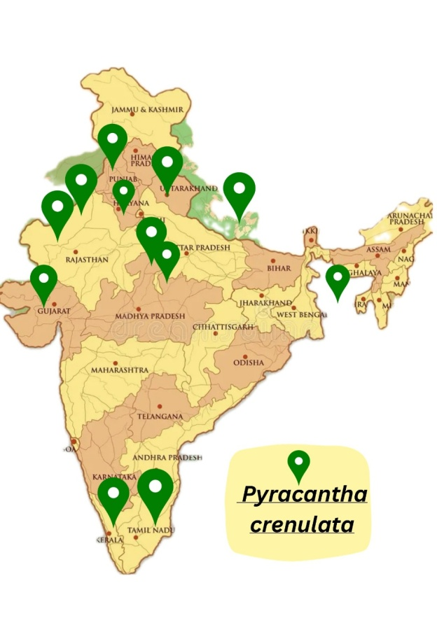
Figure 1: Geographical distribution map of Pyracanths crenulata in India
3.1Synonyms: Pyracantha crenulata (D. Don) M. Roem.: Mespilus crenulata D. Don; Crataegus crenulata (D. Don) Roxb.; Cotoneaster crenulatus (D. Don) K. Koch
3.2Local Names: Nepali: Ghangaru, Gangaru, Kaathgedi; Sherpa: Mharu; Gurung: Bhonpujo, Chento, Rishinpojo; Tamang: Chhernekanda; Magar: Ghangaru; Hindi: Ghingaru (Manandhar 2002). English: Nepalese White Thorn, Fire thorn, Nepalese fire thorn, Himalayan fire thorn (Manandhar 2002); Pashto: Khra sharavo (Ahmad and Pieroni 2016)
3.3Plant Profile (Chauhan, 1999)
Botanical name: Pyracantha crenulate (D,Don) M. Roemer
Common name: Nepalese firethom
Local name: Ghingaru
Kingdom: Plantae
Phylum: Anthrophyta
Class: Magnoloipsida
Order: Rosales
Family: Rosacea
Genus: Pyracantha
Species: crenulata
3.4Botanical Features
Pyracantha crenulata is an attractive evergreen shrub that is appreciated for its distinctive botanical characteristics. Recognizing and utilizing this plant in both natural and cultivated environments needs an understanding of its morphology and botanical features.
Morphology: Usually growing to a height of 1.5 to 3 meters, Pyracantha crenulata is a strapping shrub with numerous branches. Its dense, upright growth habit leads to dense thicket of branches covered in shiny leaves. Its name, "firethorn," originates from the spiky prickle that oftenly adorn the branches, protecting them from herbivores.
Leaves: One of the unique features of Pyracantha crenulata is its foliage. The lustrous, leathery touch and dark green color make them an appealing background for the berries and flowers of the plant. Generally elliptical to ovate in shape, the leaves are between 2-5 cm long. The distinctive characteristic of its leaves is their finely serrated margins, which give them an acrenulated look, thus the name ‘‘crenulata’’.
Flowers: Pyracantha crenulata produces numerous small, white flowers in clusters called corymbs during the spring. Pollinators like bees and butterflies are drawn to these flowers, which appear at the apex of the branches. The lovely aroma of flowers and five-petaled arrangement add to their ornamental attractiveness.
Fruits: The beauty of Pyracantha crenulata is highlighted by the number of colorful berries it produces after flowering. Based on the climate and the cultiver, the berries start with green colour and in the end develop to red or orange in colour. All over the winters, these berries remain on the plant, producing stunning contrast with the dark green leave and giving birds and other creatures with food source.
Root System: Pyracantha crenulata have fibrous root system helps anchor the plant in diversity of soil types and provides stability against soil erosion. When planting this plant in gardens or landscapes, it is important to give sufficient space for development of root even though the root system is not very invasive.
Thorns: The plant has sharp thorns, which are found along its branches, are one of its most perceptible protective features. These thorns save the plant from harm and stop animals that graze. They add to the strength of the plant and capacity to grow, even though they could present trouble when trimming or maintenance chore.
Broadly, botanical characteristics of Pyracantha crenulate support its horticultural potential, ecological value, and beautiful appeal. It is a useful inclusion to gardens, parks because of its heavy foliage, prominent blossoms, vibrant berries and robust growth habit, which increase the landscape with beauty and utility both (Jaiswal et al., 2024). Figure 2
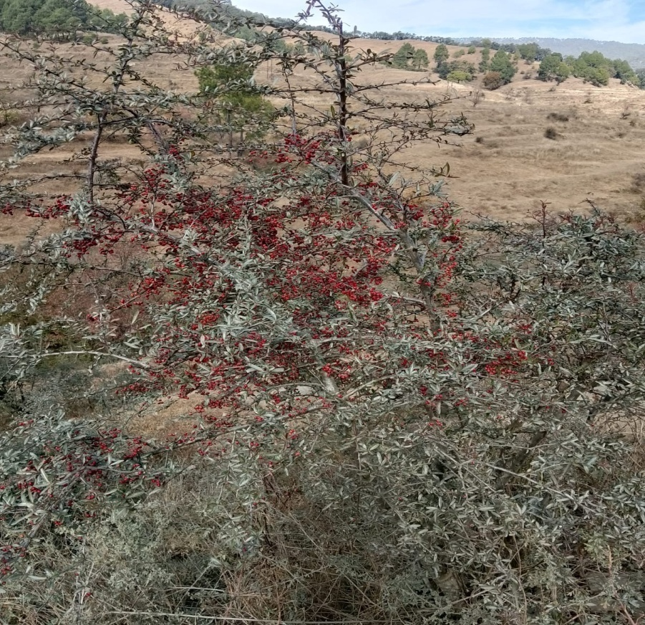
Figure 2: Pyracantha crenulata in its habitat
4. Chemical constituents
All medicinal herbs are rich in various crucial chemical compounds. The studies done previously have found that Pyracantha crenulata is high in calcium, potassium, carbohydrates, protein, lipids, fibers, vitamin C, vitamin A, vitamin B, vitamin B2, vitamin B12, vitamin E, and some species are high in bioflavonoids (Negi et al., 2009; Peschel et al., 2008).
As per previous research, Pyracantha crenulata has a number of chemical compounds that contribute to its healing qualities. It consists of flavonoids, phenolic chemicals, saponins and triterpenoids. Flavonoids are well known for their antioxidant properties, which give the plantthe capacity to fight off oxidative stress and neutralize free radicals (Beigmohamadi, Rahmani, 2011). Moreover, phenolic compounds also have antioxidant qualities, which may increase the therapeutic potential of the plant (Rashidi et al., 2020). Various compounds such as vitexin, leucocyanidin, leucoanthocyanidin, flavonoids, flavonol, kaempferol, glycoside, quercetin, beta-sitosterol and oligomeric saponins were found in plant [17]. Anti-inflammatory and antioxidant qualities of triterpenoids like ursolic and oleanolic acid, will possibly contribute to the curative effects of the plant (Peschel et al., 2008). Many biological applications, such as antibacterial and anti-inflammatoryhave been shown for saponins. Quantitative biochemical study on leaf extract of Pyracantha crenulata showed notable amounts of fiber, protein, carbohydrates, ascorbic acid and other physicochemical characteristics of the plant. Phytochemical studies validate the presence of medicinally important components such as phenols, alkaloids, saponins, glycosides, and tannins (Guglani et al., 2022). The floral components also produce chemicals such as tyramine, O-methoxyphenyl ethylamine, and phenyl ethylamine. Chlorogenic acid and 2-phenylchromones are other components, and pyracrenic acid has been extracted from the bark. The main fatty acids in the seed oil are linoleic, oleic, and palmitic acids (Nayik and Gull, 2020; Chauhan and Banerjee, 2025). Chemical compounds and their structure are well drawn in figure 3.
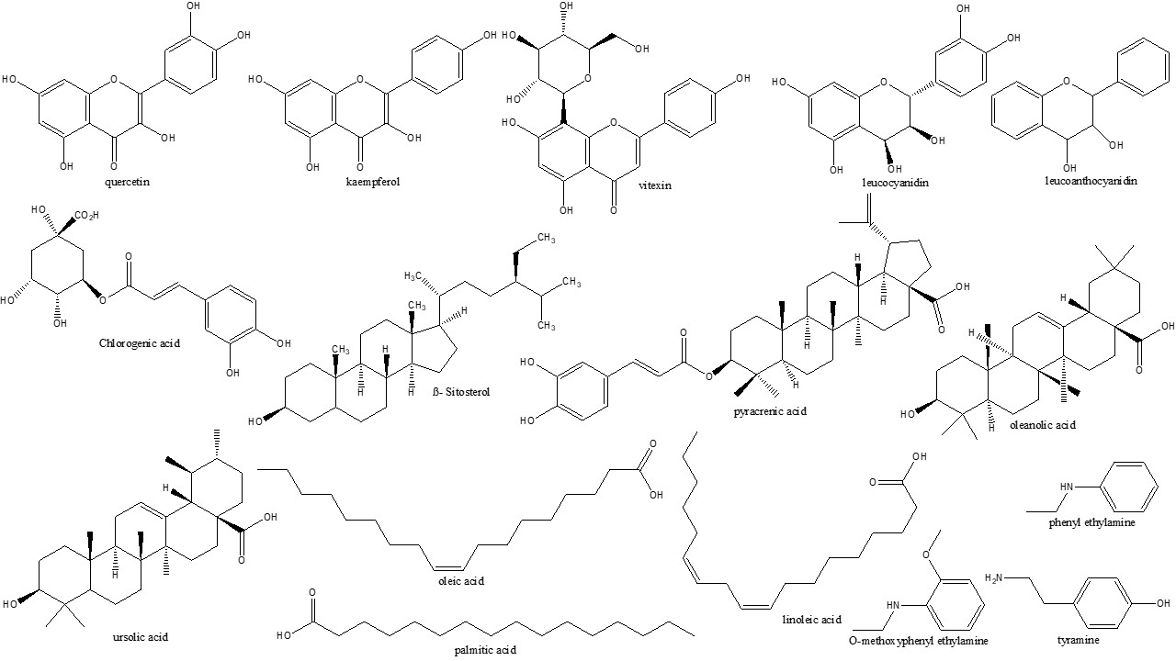
Figure 3: Chemical structures of constituents present in Pyracantha crenulata
5. Uses
Leaves are used to make sunburn cream, herbal tea, and lotions. Wood is used to make agricultural equipment, walking sticks, and inexpensive home goods. Bark is used to treat severe menstrual bleeding. The stem bark is beneficial for fever, particularly malaria. Berries contain antioxidants that decrease the harm caused by free radicals. Baths with a root decoction are used to treat physical discomfort (Janakiram et al., 2019; Gudzenko et al., 2013; Kumar et al., 2016; Bahuguna et al., 2009). When administered topically, a bark extract shields all parts of the body against frostbite and sunburn. When used to treat diabetes, its fruit juice has a hypoglycemic impact.
5.1Local Handicraft and Other Uses
Infar-western provinces of Nepal, branches are used to agricultural tools and as walking sticks (Giretho). Branches are used to make fuelwood. The plant is grown as ornamentals for its eye-catching fruits and makes a great hedge (Polunin and Stainton 1984; Manandhar 2002; Sharma et al. 2003; Pendry 2011; Shrestha et al. 2018).
6. Pharmacological Activities
The plant Pyracantha crenulata has long been utilized in herbal therapy to treat a variety of illnesses. Based on reports, it has hepatoprotective, anti-inflammatory, anti-urolithic, anti-microbial and antioxidant properties (Alsayari et al., 2018). These actions inferred that Pyracantha crenulata may be utilized in the therapy of ailments related with oxidative stress, inflammation, tissue necrosis, digestion and health of the liver. Minerals, protein, vitamins, β-carotene, amino acids and other phenolic compounds are also present in the plant (Janakiram et al., 2019). To entirely understand the exact mode of action and potential, more scientific research is needed (Gudzenko et al., 2013).
6.1Anti-urolithogenic Activity
Urolithiasis also called urinary stones are a continuing and recurrent health problem that influence people of all ages. The curative qualities Pyracantha crenulata may offer a solution to this problem. Recently, anti-urolithic prospective of plant has drawn added attention from researchers. It is one of the many plants that have historically been used to treat urolithiasis, in accordance with ethnobotanical research. In line with research, treating calculogenic rats with Pyracantha crenulata juice of fruit and alcoholic extracts (250 mg/kg b.w., p.o.) had both therapeutic and preventive effects, notably reducing the increased deposition of stone-forming component in the kidneys. This implies that the fruit may have a cytoprotective impact, better kidney function, lessen the precipitation of calcium oxalate and assist prevent the development of urinary stones (Kumar et al., 2016). Anti-urolithic properties of plant are due to saponin-rich components of the plant (Bahuguna et al., 2009).
6.2Anti-inflammatory Activity
Chemicals such as phenolic compounds, flavonoids and triterpenoids present in Pyracantha crenulata fruits have been correspond to the biological actions of the plant. The anti-inflammatory potential may be due to the strong antioxidant capacity of these chemical compounds. The antioxidant and anti-inflammatory potential of extracts of this plant have been additionally supported by studies showing their capability to scavange free radicals and lessen lipid peroxidation (Joshi and Madhu, 2020). A novel compound Pyracrenic acid found in the bark was found to have granulation suppressive properties (Otsuka et al., 1981). Bioflavonoids, which are found in plant have been manifested in clinical trials to decrease cholesterol levels in person with heart disease. In addition, the leaves of plant demonstrated potent immunomodulatory and anti-inflammatory potential.
6.3Anti-hypertensive Properties
The bioactive components found in the plant with its cardioprotective potential are flavonoids and oligomeric proanthocyanidins. Standardized compositions from numerous Crataegus species consists of these chemicals, which are used to heal moderate cardiac issues (Tassell et al., 2010).
6.5Antimicrobial Activity
The previous study was done focusing on assessing in vitro antimicrobial activities of wild edible fruit of Pyracantha crenulata. Antimicrobial properties were evaluated by disc diffusion method against ten strains of bacteria and three strains of fungus. The fruits extract (ethanolic) showed significant activity (18mm, 17mm and 15mm) against Shigella flexneri, Escherichia coli and Streptococcus pyogenes against food poisoning bacteria. The fruits have been found to rich in nutrients such as crude protein, fiber and carbohydrates and also non nutritional such as phenolic, saponins and flavonoids. The plant has strong antibacterial and antifungal properties, especially against Gram-positive bacteria and pathogenic Candida species. These activities have been associated due to the presence of various bioactive plant chemicals, such as phenolic compounds, flavonoids, and terpenoids.
6.6Analgesic Activity
The analgesic activity of hydroethanolic extracts from the leaves and fruits of Pyracantha crenulata have been evaluated in rodents using various algesia models such as the formalin-induced rat paw irritation test, tail immersion test, tail flick test and Eddy's hot plate model. To further clarify the mechanisms, molecular docking and dynamics investigations were done. Through both cerebral and peripheral pain pathways, the research showed that Pyrancantha crenulata fruit and leaves extracts considerably reduced pain in every algesic models examined. They were effective at relieving pain as diclofenac, which was the standard reference used in the study. Molecular studies showed how gallic acid which was found in Pyracantha crenulata leaf extract by HPTLC analysis, interconnected with mu-opioid and cyclooxygenase-2 (COX-2) receptors, showing that these extracts had an impact on these receptors in the management of pain.The traditional use of this plant for pain relief is supported by the analgesic potential of Pyracantha crenulata extracts, which are probably mediated by their impact on COX-2 and mu-opioid receptors. The work gives a scientific base for analgesic qualities of Pyracantha crenulata and justifies its ethnopharmacological use (Tewari et al., 2024).
6.7Anti-cancer Activity
The extracts of Pyracantha crenulata have been shown in studies to noticeably decrease the growth of many cancer cells. Using MTT assay, aqueous leaf extract silver nanoparticles demonstrate anti-cancer activity against liver (Hep-2) cancer (Gupta et al., 2023). It has been shown that the plant cause cancer cells to undergo apoptosis, which results in their programmed cell death. Pro-anthocyanidins, phenols, polysaccharides and dietary fibers aretheactive components found in the plant that support its anti-tumor properties.
6.8Anti Diabetic Activity
Using computational research, the anti-diabetic potential of Pyracantha crenulata is assigned to its abundance of phytochemicals which is having higher dock scores against antidiabetic action than conventional drugs. Based on molecular docking investigation, many chemical constituents may act as potent inhibitors of diabetic proteins IUOK (Arya 2024).
6.9Antioxidant Activity
In last few years, Pyracantha crenulata antioxidant properties have drawn more attention from scientists. The capacity of the plant to scavenge free radicals and protect against oxidative stress has been the subject of diverse research. In the 2,2-azinobis (3-ethylbenzothiazoline-6-sulfonic acid) and 1,1-diphenyl-2-picrylhydrazyl tests, the leaves and fruits of Pyracantha crenulata have been shown to have antioxidant qualities with IC₅₀ values of 10.61 μg/ml and 12.73 μg/ml, respectively. Notable amounts of total phenolic (128.78 mg/g), tannin (385.15 mg/g), and flavonoid (22.81 mg/g) contents were found by phytochemical analysis. These results implicit that total phenolic, tanninand flavonoid contents are increased by the lyophilized leaf extract (Guglani et al., 2022). The summarised pharmacological activities of various parts of the plant are well explained in Table 1.
Table 1: Summary of Pharmacological activity of different parts of the plant Pyracantha crenulata
Pharmacological activity | Dose/concentration | Plant part/ extract | Experimental models | Observation | Ref.
Analgesic | - | Leaves and fruits/hydroethanolic extract | Wistar rats; tail immersion, tail flick, hot plate, formalin tests | Reduced nociception comparable to diclofenac; modulation of receptors | Tewari et al., 2024).
Antioxidant | IC₅₀/EC₅₀: ABTS (0.029mg/mL), DPPH (0.047mg/mL), andFRAP (0.025mg/mL) | Leaves/ alcoholic extract | In vitro assays | High radical scavenging and reducing activity | Guglani et al., 2021
Antioxidant | IC₅₀ value: approx. 15.7-71.6μg/mL | Leaves/isolated compounds | In vitro DPPH assay | Compounds showed antioxidant effects | Kumar et al., 2024
Antidiabetic | IC₅₀ value 44.79 µg/ml at 100 µg/ml in the α-amylase inhibitory assay and 30.09 µg/ml at 100 µg/ml in the α-glucosidase inhibitory assay | Fruit/ ethanolic extract | In vitro enzyme inhibition | Inhibition of digestive enzymes | Dumka et al., 2025
Antiurolithogenic | 250 mg/kg b.w. p.o | Fruit/ juice and alcoholic extract | Albino rats; ethylene glycol induced urolithiasis | Reduction in calcium oxalate precipitation, improved kidney function | Bahuguna et al., 2009
Antibacterial and Antifungal | 10 mg/ml and 50 mg/ml | Fruit/ethanolic extract | In vitro disc diffusion against bacterial and fungal strains | Zones of inhibition (18, 17, 15 mm) against bacteria and fungi | Saklani and Chandra, 2014
Antimicrobial and anticancer (nanoparticles) | Various in vitro doses | Leaves/ gold nanoparticles of aqueous extract | AuNPs evaluated on microbial cultures and cancer models | Bacterial inhibition zones and reduced cancer cell proliferation | Gupta et al., 2025

7. Conclusion
With a growing number of scientific evidence and traditional use, Pyracantha crenulata is emerging as a noteworthy medicinal plant with substantial therapeutic importance. The present review provides a clear basis for the recognition of plant and pharmacognostic assessment by putting together the information that is currently accessible on its botanical features, geographical regions and ethnomedicinal significance. Pyracantha crenulata is a rich source of bioactive compounds, such as flavonoids, phenolic acids, triterpenoids, sterols and glycosidic chemicals which are strongly related to its mentioned biological activity, according to phytochemical exploration. Several of its traditional claims have been validated by pharmacological studies that have shown a wide range of actions including antioxidant, cardioprotective, anti-inflammatory, antibacterial, antidiabetic, hepatoprotective and neuroprotective properties. Nevertheless, the majority of recent research is restricted to preclinical and in vitro models, with differences in plant parts utilized, extraction techniques, and experimental models. Therefore, systematic phytochemical standardization, the discovery of active principles, molecular mechanisms of action, and thorough safety evaluations should be the main targets of future study. Overall, this study highlights plant’s potential as a useful candidate in natural product-based drug discovery and underlines the need of more well-planned research to fully recognize its pharmacological and therapeutic benefits.
Conflict of interest
The authors declare that they have no competing interests.
AI Disclosure Statement
The authors hereby declare that no generative or assistive artificial intelligence tools, including but not limited to those used for text generation, data analysis, image creation, or manuscript preparation, were utilized at any stage during the development of this manuscript. All content was created solely by the authors.

References
Ahmad K, Pieroni A. Folk knowledge of wild food plants among the tribal communities of Thakht-e-Sulaiman Hills, North-West Pakistan. J Ethnobiol Ethnomed. 2016;12:17. https://doi.org/10.1186/s13002-016-0090-2.
Alsayari A, Ghazwani M, Almaghaslah D, Alhamhoom Y, Louis J, Altohami J, et al. Potential analgesic and diuretic activity of Crataegus oxyacantha Linn. Res J Pharm Technol. 2018; 11(6):2476-82. https://doi.org/10.5958/0974-360X.2018.00457.2
Arya GC. A systematic study of Pyracantha crenulata phytoconstituents for their anti-diabetic activity using computational techniques. Curr Anal Chem. 2024;20(5):318-34. https://doi.org/10.2174/01157341112774082 31226075200
Bahuguna YM, Rawat MS, Juyal V, Gusain K. Evaluation of Pyracantha crenulata Roem for antiurolithogenic activity in albino rats. Afr J Urol. 2009; 15(3):159-66. https://doi.org/10.1007/s12301-009-0029-0
Beigmohamadi M, Rahmani F. Genetic variation in hawthorn (Crataegus spp.) using RAPD markers. Afr J Biotechnol. 2011; 10(37):7131-5.
Brandis D, Indian Trees: an account of trees, shrubs, woody climber, bamboos & palms, indigenous or commonly cultivated in the British Indian empire. Constable & Company, Ltd., London, p 294, 1921
Chauhan A, Banerjee R. Evaluation of traditional uses, phytochemical constituents, therapeutic uses and prospects of Pyracantha genus: a systematic review. Nat Prod Res. 2025; 39(4):922-34. https://doi.org/10.1080/14786419.2024.2319660
Chauhan NS. Medicinal and aromatic plants of Himachal Pradesh. New Delhi: Indus Publishing; 1999.
Dimitri MJ, Enciclopedia de Agricultura y Jardinería, Ed. ACME, Buenos Aires, 1: 433-435;1972
Dumka, H., Veerma Ram, & Tangri, P (2025). Phytochemical profiling and evaluation of in-vitro antidiabetic effects of Pyracantha crenulata (D. Don) M. Roem. fruit extracts. Journal of Applied Pharmaceutical Research, 13(5), 299-308. https://doi.org/10.69857/joapr.v13i5.1456
Fern K. Plants of a future. England: Plants of a Future Species Database; 2008.
Gamble JS. A manual of Indian timbers: an account of the growth, distribution, and uses of the trees and shrubs of India and Ceylon, with descriptions of their wood-structure. Bishen Singh Mahindra Pal Singh Publication, Dehra Dun.,1972
Gudzenko A. Development and validation of an RP-HPLC method for the simultaneous determination of vitexin-2″-O-rhamnoside and hyperoside in leaves and flowers of hawthorn. World J Pharm Res. 2013; 2(5):1270-86.
Guglani A, Pandey HK, Arya RK, Gaddam B. The nutritional profile, phytochemical investigation and in vitro antioxidant activity of the leaves extract of Pyracantha crenulata collected from the middle hill climatic conditions of the Western Himalayas. Indian J Pharm Sci. 2022; 84(1):182-8.
Guglani A, Rajeshwar K.K. Arya, H.K. Pandey, Singh AK, Bisht D.Variation in Antioxidant Activity and Phyto-Constituents in Different Parts of Pyracantha crenulata Collected from Middle Hill Climatic Condition of Western Himalayas.Nat. Volatiles & Essent. Oils, 2021; 8(4): 12455-12468.
Gupta S, Jasrotia S, Jugran S, Syal S, Godbole V, Pallavi A, Kandwal A, Purohit R Purohit MC. Biosynthesis and characterization of gold nanoparticles using Pyracantha crenulata leaves and evaluation of its antimicrobial and anticancer activities. International Journal of Environmental Sciences ISSN: 2229-7359Vol. 11 No. 23s, 2025.
Gupta S, Jasrotia S, Kandwal A, Rawat R, Purohit MC. Green synthesis of silver nitrate nanoparticles using leaves of Pyracantha crenulata and its anticancer activity on liver cancer.2023. Journal of Mountain Research 18(2):273-283.
Himalaya. 1st ed. Srinagar Garhwal, India: Trans-Media; 1999.
Jaiswal J, Upadhyaya K, Arya V. Pyracantha crenulata: A Review of Its Botanical Features, Ecological Significance, And Horticultural Potential. nt. J. of Pharm. Sci., 2024, Vol 2, Issue 7, 1387-1396.
Janakiram T, Safeena SA, Prasad KV. Status of indigenous ornamental plants in India. New Delhi: Indian Council of Agricultural Research, Krishi Anusandhan Bhavan, Pusa; 2019.
Joshi RK, Laurindo LF, Barbalho SM. Chemical components and bioactivities of Pyracantha crenulata (D. Don) wild and cultivated from Uttarakhand, India: a review. Am J Essent Oils Nat Prod. 2023; 11(1):34-7.
Joshi SK, Madhu BA. Phenological attributes of Pyracantha crenulata —a high-value multipurpose shrub of the Himalaya. Not Sci Biol. 2020; 12(1):30-41.
Khare CP. Indian Herbal Remedies: Rational Western Therapy, Ayurvedic and Other Traditional Usage, Botany, Springer-Verlag Berlin Heidelberg, 163;2004.
Khare CP. Indian Medicinal Plants: An Illustrated Dictionary. Springer-Verlag New York, 176; 2007.
Kumar A, Parveen M, Khan AA, Nami SAA, Raza Ghalib M, Malik A, Alam M. Phytochemical investigation and spectral characterization of isolated compounds from Pyracantha crenulata (D. Don) M. Roem (syn. Crataegus crenulata Roxb) leaves: evaluation of antioxidant activity and molecular docking analysis. Nat Prod Res. 2024 Oct 7:1-10.
Kumar BN, Wadud A, Jahan N, Sofi G, Bano H, Makbul SA, et al. Antilithiatic effect of Peucedanum grande C.B. Clarke in chemically induced urolithiasis in rats. J Ethnopharmacol. 2016; 194:1122-9.
Manandhar NP. Plants and people of Nepal. Portland: Timber Press; 2002.
Nayik GA, Gull A, editors. Antioxidants in fruits: properties and health benefits. Berlin: Springer; 2020. p. 201-25. https://doi.org/10.1007/978-981-15-7285-2
Negi PS, Singh R, Bhakuni DS, Ahmed Z. Crataegus: A multipurpose plant of Himalayan Hills. Technical pamphlet, DIBER (DRDO) Haldwani, 2009
Osmaston AE. A forest flora for Kumaon. Allahabad: Superintendent, Government Press, United Provinces; 1927.
Osmaston AE. A forest flora for Kumaon. Periodical Experts Book Agency, Delhi.1926
Otsuka H, Fujioka S, Komiya T, Goto M, Hiramatsu Y, Fujimura H. Studies on anti-inflammatory agents. V. A new anti-inflammatory constituent of Pyracantha crenulata Roem. Chem Pharm Bull (Tokyo). 1981; 29(11):3099-104.
Pande PC, Tiwari L, Pande HC. Ethnoveterinary plants of Uttaranchal-A review. Indian Journal of Traditional Knowledge 6 (3): 444-458;2007
Pandey M, Joshi S, Sharma S. Total importance value of medicinal plants in Jaunpur Range, Garhwal Himalaya, Uttarakhand. Ann Plant Soil Res. 2024; 26(2):311-6.
Peschel W, Bohr C, Plescher A, Variability of total flavonoides in Crataegus –Factor evaluation for the monitored production of Industrial starting material. Fitoterapia, 79:6–20; 2008
Peschel W, Bohr C, Plescher A. Variability of total flavonoides in Crataegus: Factor evaluation for the monitored production of industrial starting material. Fitoterapia. 2008;79:6–20
Polunin O, Stainton A. Flowers of the Himalaya. New Delhi: Oxford University Press; 1984.
Rakesh Kumar Joshi, Lucas Fornari Laurindo and Sandra M Barbalho. Chemical components and bioactivities of Pyracantha crenulata (D. Don) wild and cultivated from Uttarakhand, India: A review. American Journal of Essential Oils and Natural Products 2022; 10(1): 34-37
Rashidi H, Tahmasebi W, Khalili M, Ahmadi R. Simultaneous effect of one-month Crataegus supplementation and rehabilitation program on cardiac contractile strength, blood pressure, heart rate, and functional capacity of patients with heart failure. J Basic Clin Pathophysiol. 2020; 8(2):28-36.
Saklani S, Chandra S, Mishra AP. Evaluation of antioxidant activity, quantitative estimation of phenols, anthocyanins and flavonoids of wild edible fruits of Garhwal Himalaya. J Pharm Res. 2011; 4(11):4083-6.
Saklani S, Chandra S, Mishra AP. Evaluation of nutritional profile, medicinal value and qualitative estimation in different parts of Pyrus pashia, Ficus palmate and Pyracantha crenulata . J Global Trends Pharmaceutical Sci. 2 (3): 350-354; 2011.
Saklani S, Chandra S, Preliminary phytochemical evaluation of Garhwal Himalaya wild edible fruit Pyracantha crenulata , Journal of Pharmacy Research, 5(6), 3434-3436;May-2012.
Saklani S, Chandra S. In vitro antimicrobial activity, nutritional value, antinutritional value and phytochemical screening of Pyracantha crenulata fruit. Int J Pharm Sci Rev Res. 2014; 26(1):1-5.
Sharma I, Joshi N, Roy B, Shrestha R. Flora of Royal Botanical Garden (Phanerogams). Godawari: Department of Plant Resources, Royal Botanical Garden; 2003. p. 62.
Shrestha KK, Bhattarai S, Bhandari P. Handbook of flowering plants of Nepal (Volume 1. gymnosperms and angiosperms: Cycadaceae – Betulaceae). Jodhpur: Scientific Publishers; 2018.
Simoons FJ., Food in China: A Cultural and Historical Inquiry, CRC Press, New Delhi, 259;1990
Singh A, Rana S, Singh R. Wild and cultivated vegetables of the Indian Himalaya and their use as vegetables and in traditional medicine. Int J Veg Sci. 2020; 26(4):385-407.
Solaiman AH, Nishizawa T, Sultana N, Sarker B, Rahman R, Shahjahan M, et al. Antimicrobial and antioxidant activity analysis of some medicinal plants of Bangladesh. Adv Plants Agric Res. 2015; 2(2):00057.
Spectrum, Science Reporter, Himalaya Red Berry- Wonder Heart Tonic, 16-18; 2010
Tassell MC, Kingston R, Gilroy D, Lehane M, Furey A. Hawthorn (Crataegus spp.) in the treatment of cardiovascular disease. Pharmacogn Rev. 2010; 4(7):32-41.
Tewari D, Bawari S, Sah AN, Sharma H, Joshi BC, Gupta P, et al. Himalayan Pyracantha crenulata (D. Don) M. Roem. Leaf and fruit extracts alleviate algesia through COX-2 and mu-opioid receptor-mediated pathways. J Ethnopharmacol. 2024; 318:117004.

