Original Research Article
D-Ribose-L-Cysteine Mitigates Bisphenol A-Induced Anxiety-Like and Depressive-Like Behaviours in Experimental Mice

Abstract
Aim: This study investigated whether DRLC alleviates BPA-induced anxiety-like and depressive-like behaviours in mice.
Study Design: A 14-day experimental study was conducted under standard conditions at the Pharmacology Laboratory, Delta State University, Abraka, Nigeria.
Methodology: Adult male mice were divided into four groups: control, BPA-only, and BPA with DRLC at 50 mg/kg and 100 mg/kg. BPA was administered alternately for 14 days to induce neurobehavioural changes, while DRLC was given orally. Behavioural tests included the Light/Dark Box, Elevated Plus Maze, Hole Board, Tail Suspension, Social Interaction Tests, and Forced Swim. Brain tissues were analyzed using Griess (for NO), TBA (for MDA), and DTNB (for GSH). Equipment used included UV-Vis spectrophotometers, centrifuges, digital timers, and validated Behavioural test apparatus.
Results: BPA exposure led to significant anxiety- and depression-like behaviours and disrupted redox balance, shown by elevated NO, MDA, MPO, and ACTH, and reduced SOD, CAT, GPx, and GSH. DRLC treatment reversed these effects, restoring antioxidant levels and Behavioural function.
Conclusion: DRLC effectively counters BPA-induced neurobehavioural disturbances in mice by restoring redox homeostasis, highlighting its neuroprotective potential.
Keywords: Bisphenol A, D-Ribose L-Cysteine, anxiety, depression, oxidative stress, behavioural changes

1. INTRODUCTION
Bisphenol A (BPA) is a ubiquitous industrial chemical used in the production of polycarbonate plastics and epoxy resins (Mitta et al., 2025). BPA has become an environmental and public health concern because it poses a significant health risk to exposed individuals. Human exposure to BPA could occur via inhalation, dermal, oral, perinatal, or fetal routes (Hahladakis et al., 2023). BPA's widespread application in food and beverage containers, thermal paper receipts, and other consumer products has led to near-universal human exposure. While the inclusion of BPA in the manufacturing of plastic products has revolutionized numerous industries due to its durable and versatile properties, its endocrine-disrupting potential has raised alarms regarding its potential adverse effects on human health, particularly on neurological function. The endocrine-disrupting activity of BPA stems from its ability to mimic or interfere with the actions of endogenous hormones, primarily estrogen (Costa & Cairrao, 2024; Li et al., 2023). This interaction can disrupt the delicate hormonal balance within the body, leading to a cascade of effects across multiple organ systems. In the context of neurodevelopment, BPA exposure during critical periods, such as prenatal and early postnatal life, has been linked to various neurobehavioral alterations, including impairments in learning, memory, and social behavior. Notably, numerous animal studies have demonstrated that BPA exposure can induce anxiety-like and depressive-like behaviors, suggesting a potential role in the pathophysiology of mood disorders (Frederick et al., 2021; Dumitrascu et al., 2020). The mechanisms underlying BPA-induced neurotoxicity are multifaceted and involve oxidative stress and the generation of free radicals. Several pathways, such as estrogen receptor activation, neurotransmitter dysregulation (Zheng et al., 2021), epigenetic modifications, and inflammation (Abdou et al., 2022), have also been proposed. Given the potential for BPA to induce anxiety-like and depressive-like behaviors, there is a growing need for effective strategies to mitigate its neurotoxic effects. Hence, anti-oxidant based interventions have emerged as a promising approach, with a focus on identifying compounds that can counteract the adverse effects of BPA on the brain. D-ribose L-Cysteine (DRLC) is a prodrug of L-Cysteine that promotes the brain's production of glutathione (Isibor et al.,2026; Isibor et al., 2022), a crucial antioxidant molecule that has shown beneficial effects in mitigating neurotoxicity.
2. MATERIALS AND METHODS
2.1 Equipment and reagents used
Bisphenol A (Sigma-Aldrich), D-ribose L-Cysteine compound [(4R)-2-[(1R,2R,3R)-1,2,3,4-tetrahy droxybuty1]- 1,3-thiazolidine-4-carboxylic acid] (pharmaceutical-grade formulation), Light/Dark Box, EPM, and Hole Board apparatus, UV-Vis spectrophotometer (for NO, MDA, CAT, GSH, GPx, SOD, MPO assays), Griess reagent (NO detection), TBARS reagent (MDA), DTNB (GSH), o-dianisidine and H₂O₂ (MPO), Centrifuge (10,000 rpm), digital timer, Syringe and needle, gloves, , ELISA kits for ACTH, Dichromate/acetic acid solution (CAT), adrenaline (SOD assay).

2.2 Experimental Animals

Male swiss mice weighing 24.0 -26.0 g used in this study were obtained from the Central Animal House, Faculty of Basic Medical Sciences, Delta State University, Abraka and were housed in plastic cages at room temperature under standard conditions. They were fed with balanced rodent pellet diet and water ad libithum. Mice were acclimatized for a period of 10 days before commencement of experiment. The experiment procedure was performed in accordance with the National Institute of Health (NIH) Guideline for the Care and Use of Laboratory Animals.

2.3 Drug Preparation and Treatment Groups
125 mg of DRLC was dissolved in 12.5 ml of distilled water to obtain a stock solution of 10 mg/ml. 0.02 g of BPA was dissolved in 0.2 ml of dimethyl sulfoxide which was further diluted in 20 ml of distilled water. The animals were allotted into four (4) groups (n=6): group 1 received distilled water (10 ml/kg i.p), group 2 received BPA (10 mg /kg p.o), groups 3 and 4 received graded doses of DRLC (50 mg/kg and 100 mg/kg) respectively. The doses of DRLC used for this study was based on previous studies (Isibor et al., 2022). Animals were treated for 14 consecutive days. At the end of the experimental protocol, behaviour assessment (Light/Dark Box, Elevated Plus Maze, Hole Board, Forced Swim, Tail Suspension, and Social Interaction Tests) were performed on the animals.
2.4 Behavioural Assessment
2.4.1 Light and Dark Box Test
The Light and Dark Box (LDB) apparatus, as described by Omogbiya in 2021, was used to assess the anxiety-like behavior of mice. The LDB apparatus consists of two compartments, one dark and one lighted (light), connected by a small opening. Each mouse was placed alone in the light compartment with its back to the opening, and they were given five minutes to explore both compartments freely. The total time spent in the light chamber was recorded using a stop watch. Less time in the light zone indicates higher anxiety-like behavior, while more time suggests decreasing anxiety (Omogbiya et al., 2021).

2.4.2 Elevated Plus Maze (EPM) Test
The EPM apparatus consists of two open arms (30 × 5 cm) and two closed arms (30 × 5 × 15 cm), all elevated 50 cm above the floor. Each mouse was placed in the center of the maze facing an open arm and allowed to explore for 5 minutes. The number of entries and the amount of time spent in the open arms were recorded using a video-recording system. A decrease in open-arm activity is interpreted as anxiety-like behavior (Eduviere et al., 2022).
2.4.3 Hole Board Test
Exploratory behaviour was evaluated using the Hole Board apparatus consisting of a flat platform (40 × 40 cm) with evenly spaced holes (3 cm in diameter) (Takeda et al., 1998). Mice were placed individually at the centre of the board and observed for 5 minutes. The number of head dips (defined as insertion of the head into a hole) was recorded (using a video recording system) as a measure of exploratory behaviour and anxiety. A lower number of head dips suggested increased anxiety and depressive-like behaviour, typically associated with reduced exploratory drive and heightened fear.
2.4.4 Tail Suspension Test (TST)
Depressive-like behaviour was assessed using the Tail Suspension Test (Steru et al., 1985). Mice were suspended by the tail using adhesive tape affixed 1 cm from the tip of the tail. Each mouse was suspended for 6 minutes, and the duration of immobility (complete lack of movement) was recorded using a stopwatch, during the last 4 minutes. Increased immobility time is considered an indicator of behavioural despair.
2.4.5 Social Interaction Test
Mice were assessed for social interest and motivation using the social interaction test (Moy et al., 2004). Each test mouse was placed in an open-field arena containing a wire-mesh enclosure housing an unfamiliar mouse (stranger) and an identical empty enclosure on the opposite side. The time spent by the test mouse exploring each enclosure was recorded (using a stopwatch) over 5 minutes. Reduced time interacting with the stranger mouse is indicative of social withdrawal and depressive-like behaviour.
2.4.6 Forced Swim Test (FST)
The FST was conducted using a transparent cylinder (height 25 cm; diameter 20 cm) filled with water (25°C) to a height of 15 cm (Porsolt et al., 1977). Each mouse was placed in the water for 6 minutes, and the immobility time during the last 4 minutes was recorded using a stopwatch. Immobility was defined as the absence of any movement except those necessary to keep the head above water. Increased immobility time reflects depressive-like behaviour.

2.5 Sample Collection
At the end of behavioural assessments, mice were anesthetized euthanized under deep ether anaesthasia and sacrificed by cervical dislocation. Blood samples were collected via cardiac puncture for serum isolation. Brains were rapidly excised, and the hippocampus and prefrontal cortex were dissected on ice. Tissues were homogenized in phosphate buffer (0.1 M, pH 7.4) and centrifuged at 10,000 rpm for 10 minutes at 4°C. The resulting supernatants were stored at -20°C for subsequent biochemical analyses (Ben-Azu et al., 2018).
2.6 Biochemical Assays
2.6.1 Determination of Nitric Oxide (NO)
Griess reagent was used to quantify total nitrite in brain tissue (Green et al., 1982). The supernatant fraction (100 μL) was mixed with 10µL of Griess reagent (1:1 mixture of 1% sulfanilamide in 5% phosphoric acid and 0.1% N-1-naphthyl ethylenediamine dihydrochloride). The nitrite level was determined using a standard curve prepared with sodium nitrite (0-100 μM), and absorbance was measured at 540 nm via a UV-spectrophotometer, and concentrations were expressed as μmol/mg tissue.
2.6.2 Determination of Malondialdehyde (MDA) levels
The thiobarbituric acid-reactive substances (TBARS) assay was used to determine MDA concentration ((Ohkawa et al., 1979).). A brain supernatant fraction (0.1 mL) was combined with 0.5 mL of TCA (30%) and 0.5 mL of thiobarbituric acid (0.75%) after being diluted 20 times with 0.15 M Tris-KCl buffer. After that, the reaction mixture was heated for 45 minutes at 80 °C in a water bath. After halting the reaction for ten minutes in an ice-cold water bath, the tubes were centrifuged for five minutes at 4000 rpm. After the supernatant fraction was separated, a UV/Vis spectrophotometer (INESA, 752 N) was used to measure the absorbance at 532 nm. Values were expressed as nmol MDA/mg protein.
2.6.3 Myeloperoxidase (MPO) Activity
MPO activity, a marker of inflammation, was measured using a method described by (Bradley et al., 1982). Brain homogenates were suspended in extraction buffer, freeze-thawed, sonicated, and centrifuged. Supernatants were incubated with o-dianisidine and H₂O₂ in phosphate buffer. The change in absorbance at 450 nm over 3 minutes was recorded, and MPO activity was expressed in U/mg protein.
2.6.4 Brain Adrenocorticotropic Hormone (ACTH) concentration
ACTH concentrations in brain extracts were measured using a competitive enzyme-linked immunosorbent assay (ELISA) for mice following manufacturer’s instruction (RayBiotech Pharmaceuticals). Samples were diluted appropriately to fall within the linear range of the standard curve (0.1-1000 pg/ml). ACTH levels were normalized to total protein content and expressed as ng per mg protein.
2.6.5 Superoxide Dismutase (SOD) Activity
SOD activity was measured based on its ability to inhibit adrenaline oxidation (Misra and Fridovich, 1972). Brain homogenate was added to carbonate buffer, and the reaction was initiated with adrenaline. The change in absorbance at 480 nm was recorded, and SOD activity was calculated as units/min/mg protein.
2.6.6 Catalase (CAT) Activity
CAT activity was determined by adding supernatant to phosphate buffer and hydrogen peroxide. After reaction incubation, dichromate/acetic acid was added and absorbance was read at 570 nm. Results were expressed as µmol H₂O₂ decomposed/min/mg protein (Sinha, 1972).
2.6.7 Glutathione Peroxidase (GPX) Activity
GPX activity was estimated from brain homogenates. The enzyme catalyzed the reduction of hydrogen peroxide using GSH as a substrate. The change in absorbance was measured spectrophotometrically and GPX levels were reported in U/mg protein (Paglia and Valentine, 1967).
2.7.8 Reduced Glutathione (GSH)
GSH levels were determined using the DTNB method. Supernatant was mixed with TCA, centrifuged, and the resulting supernatant was reacted with DTNB. Absorbance was measured at 412 nm, and GSH was expressed in µmol/g tissue (Moron et al., 1979).
2.8 Statistical Analysis
All experimental results were expressed as mean ± standard error of the mean (SEM). Statistical significance was determined at a threshold of p < 0.05. Data obtained from behavioral and biochemical evaluations were analyzed using one-way analysis of variance (ANOVA), followed by Tukey’s post hoc test for multiple comparisons. Analyses were performed using GraphPad Prism® version 10.01 (GraphPad Software, Inc., La Jolla, CA, USA).
3.0 Results & Discussions
3.1 Effect of D-ribose L-Cysteine (DRLC) on anxiety-like behaviour in mice treated with Bisphenol A (BPA) utilizing the Light and Dark Box.
The effect of D-ribose L-Cysteine on anxiety-like behaviour in mice subjected to Bisphenol A on anxiety-like behaviour was evaluated using the LDB on alternate days for a period of 14 days. The result revealed that the amount of time spent in the dark compartment significantly (p < .05) [figure 1] increased in the Bisphenol A-treated mice when compared with the control group which indicates an increase in anxiety and a marker for anxiety-like behaviour. However, D-ribose L-Cysteine (50mg/kg and 100mg/kg. p.o) significantly (p < .05) decreased the amount of time spent in the dark compartment when compared to the Bisphenol A-subjected group.
3.2 Effect of D-ribose L-Cysteine (DRLC) on anxiety-like behaviour in mice treated with Bisphenol A (BPA) utilizing the Elevated Plus Maze (EPM).
The effect of D-ribose L-Cysteine on anxiety-like behaviour in mice subjected to Bisphenol A on anxiety-like behaviour was also evaluated using the EPM. The result revealed that the amount of time spent in the closed arm significantly (p < .05)[figure 2] increased in the Bisphenol A-treated mice when compared with the control group, which indicates an increase in anxiety and a marker for anxiety-like behaviour. However, D-ribose L-Cysteine (50mg/kg and 100mg/kg. p.o) significantly (p < .05) decreased the amount of time spent in the closed arm when compared to the Bisphenol A subjected group.

3.3 Effect of D-ribose L-Cysteine (DRLC) on anxiety-like behaviour in mice treated with Bisphenol A (BPA) utilizing the Hole board test (HBT).
The effect of D-ribose L-Cysteine on anxiety-like behaviour in mice subjected to Bisphenol A was also evaluated using HBT. The result revealed that the Frequency of head dips was significantly (P <.05) [figure 3] reduced in the Bisphenol A-treated mice when compared with the control group, which indicates an increase in anxiety and a marker for anxiety-like behaviour. However, D-ribose L-Cysteine (50mg/kg and 100mg/kg. p.o) significantly (p <.05) increased the frequency of head dips when compared to the Bisphenol A subjected group.
3.4 Effect of D-ribose L-Cysteine (DRLC) on depressive-like behaviour in mice treated with Bisphenol A (BPA) utilizing the Tail Suspension test (TST).
The effect of D-ribose L-Cysteine on depressive-like behaviour in mice subjected to Bisphenol A on alternate days for 14 days was evaluated using the TST. The result revealed that the time of immobility was significantly (P < .05) [figure 4] elevated in the Bisphenol A-treated mice when compared with the control group, which indicates an increase in depression and a marker for depressive-like behaviour. However, D-ribose L-Cysteine (50mg/kg and 100mg/kg. p.o) significantly (p < .05) reduced the immobility time when compared to the Bisphenol A subjected group.
3.5 Effect of D-ribose L-Cysteine (DRLC) on depressive-like behaviour in mice treated with Bisphenol A (BPA) utilizing the Social Interaction Test (SIT).
The effect of D-ribose L-Cysteine on depressive-like behaviour in mice subjected to Bisphenol A was evaluated using SIT. The result revealed that the social preference percentage was significantly (P < .05) [figure 5] reduced in the Bisphenol A-treated mice when compared with the control group, which indicates a decrease in social interaction and a marker for depressive-like behaviour. However, D-ribose L-Cysteine (50mg/kg and 100mg/kg. p.o) significantly (p <.05) increased the social preference percentage when compared to the Bisphenol A subjected group.
3.6 Effect of D-ribose L-Cysteine (DRLC) on depressive-like behaviour in mice treated with Bisphenol A (BPA) utilizing the Forced Swim Test (FST).
The effect of D-ribose L-Cysteine on depressive-like behaviour in mice subjected to Bisphenol A on alternate days for 14 days using the FST. The result revealed that the time of immobility was significantly (P <.05) [figure 6] elevated in the Bisphenol A-treated mice when compared with the control group, which indicates an increase in depression and a marker for depressive-like behaviour. However, D-ribose L-Cysteine (50mg/kg and 100mg/kg. p.o) significantly (p <.05) reduced the immobility time when compared to the Bisphenol A subjected group.
3.7 Effects of D-ribose L-Cysteine (DRLC) on brain Nitric Oxide (NO) activity in Bisphenol A-treated mice
The effect of D-ribose L-Cysteine (DRLC) on brain Nitric Oxide activity was assayed for in mice subjected to Bisphenol A. The result revealed that the brain NO activity was significantly (p < .05) [Figure 7] elevated in the Bisphenol A (BPA) treated mice when compared with the control group. However, D-ribose L-Cysteine (50mg/kg and 100mg/kg, p.o) significantly (P < .05) reduced the activity level of NO in mice brain serum when compared to the Bisphenol A treated mice.
3.8 Effects of D-ribose L-Cysteine (DRLC) on brain Malondialdehyde (MDA) activity in Bisphenol A-treated mice
The effect of D-ribose L-Cysteine (DRLC) on brain Malondialdehyde activity in mice subjected to Bisphenol A. The result revealed that the brain MDA activity was significantly (p < 0.05) [figure 8] elevated in the Bisphenol A (BPA) treated mice when compared with the control group. However, D-ribose L-Cysteine (50mg/kg and 100mg/kg, p.o) significantly (P < 0.05) reduced the activity level of MDA in mice brain serum when compared to the Bisphenol A-treated mice.
3.9 Effects of D-ribose L-Cysteine (DRLC) on brain Myeloperoxidase (MPO) enzyme activity in Bisphenol A-treated mice
The effect of D-ribose L-Cysteine (DRLC) on brain Myeloperoxidase activity was assayed for in mice subjected to Bisphenol A. The result revealed that the brain MPO activity was significantly (p < 0.05) [figure 9] elevated in the Bisphenol A (BPA) treated mice when compared with the control group. However, D-ribose L-Cysteine (50mg/kg and 100mg/kg, p.o) significantly (P < .05) reduced the activity level of MPO in mice brain serum when compared to the Bisphenol A treated mice.
3.10 Effects of D-ribose L-Cysteine (DRLC) on brain Adrenocorticotropic hormone activity in Bisphenol A-treated mice
The effect of D-ribose L-Cysteine (DRLC) on brain adrenocorticotropic hormone activity was assayed for in mice exposed to Bisphenol A. The result revealed that the brain adrenocorticotropic activity was significantly (p < .05) [figure 10] elevated in the Bisphenol A (BPA) treated mice when compared with the control group. However, D-ribose L-Cysteine (50mg/kg and 100mg/kg, p.o) significantly (P < .05) reduced the activity level of adrenocorticotropic hormone in mice brain serum when compared to the Bisphenol A treated mice.

3.11 Effect of D-ribose L-Cysteine (DRLC) on brain Superoxide dismutase (SOD) level in mice treated with Bisphenol A.
The effect of D-ribose L-Cysteine (DRLC) on antioxidant status (SOD) was assayed for in mice exposed to Bisphenol A is shown in the figure below [figure 11]. Bisphenol A significantly decreased the concentration of SOD in the brain when compared with the control group. One-way ANOVA revealed a significant difference among treatment groups. Post-hoc comparison indicated that treatment with D-ribose L-Cysteine (50mg/kg and 100 mg/kg, p.o) significantly (p < 0.05) reversed the Bisphenol A induced reduction in SOD concentration.
3.12 Effects of D-ribose L-Cysteine (DRLC) on brain Catalase (CAT) activity in Bisphenol A-treated mice
The effect of D-ribose L-Cysteine (DRLC) on brain Catalase (CAT) activity was assayed for in mice subjected to Bisphenol A. The result revealed that the brain CAT activity was significantly (p < 0.05) [figure 12] reduced in the Bisphenol A (BPA) treated mice when compared with the control group. However, D-ribose L-Cysteine (50 mg/kg and 100 mg/kg, p.o) significantly (P <0.05) increased the activity level of CAT in mice brain serum when compared to the Bisphenol A-treated mice.
3.13 Effect of D-ribose L-Cysteine (DRLC) on brain Glutathione peroxidase (GPx) level in mice treated with Bisphenol A.
The effect of D-ribose L-Cysteine (DRLC) on antioxidant status (GPx) was assayed for in mice exposed to Bisphenol A [figure 13]. Bisphenol A significantly decreased the concentration of Glutathione peroxidase (GPx) in the brain when compared with the control group. One-way ANOVA revealed a significant difference among treatment groups. Post-hoc comparison indicated that treatment with D-ribose L-Cysteine (50 mg/kg and 100 mg/kg, p.o) significantly (p < .05) reversed the Bisphenol A induced reduction in GPx concentration.
3.14 Effect of D-ribose L-Cysteine (DRLC) on brain reduced Glutathione (GSH) level in mice treated with Bisphenol A.
The effect of D-ribose L-Cysteine (DRLC) on antioxidant status (GSH) was assayed for in mice exposed to Bisphenol A is shown below [figure 14]. Bisphenol A significantly decreased the concentration of reduced Glutathione (GSH) in the brain when compared with the control group. One-way ANOVA revealed a significant difference among treatment groups. Post-hoc comparison indicated that treatment with D-ribose L-Cysteine (50 mg/kg and 100 mg/kg, p.o) significantly (p < .05) reversed the Bisphenol A induced reduction in GSH concentration.

3.15 List of Figures

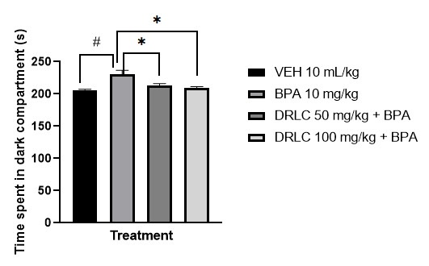
Figure 1: Effect of D-ribose-L-Cysteine on Vanadium-induced anxiety-like behaviour in mice utilizing the Light and Dark Box
Values represent the mean ± S.E.M of six animals per group
# p< .05 compared to the control group (ANOVA followed by Turkey’s post hoc test).
* p< .05 compared to the pathologic group (ANOVA followed by Turkey’s post hoc test).

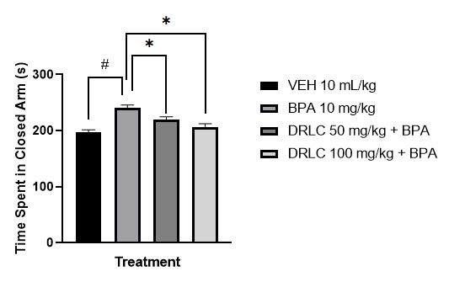
Figure 2: Effect of D-ribose-L-Cysteine on Vanadium-induced anxiety-like behaviour in mice utilizing the Elevated Plus Maze
Values represent the mean ± S.E.M of six animals per group
# p<0.05 compared to the control group (ANOVA followed by Turkey’s post hoc test).
* p<0.05 compared to the pathologic group (ANOVA followed by Turkey’s post hoc test).

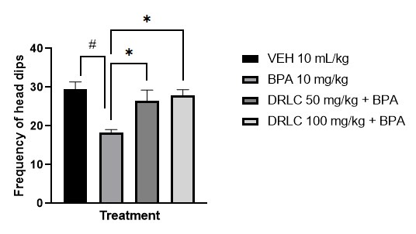
Figure 3: Effect of D-ribose-L-Cysteine on Bisphenol A-induced anxiety-like behaviour in mice utilizing the Hole Board Test
Values represent the mean ± S.E.M. of six animals per group
# p < .05 compared to the control group (ANOVA followed by Turkey’s post hoc test).
* p < .05 compared to the pathologic group (ANOVA followed by Turkey’s post hoc test).

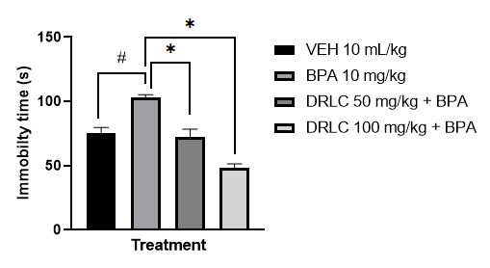
Figure 4: Effect of D-ribose-L-Cysteine on Bisphenol A-induced depressive-like behaviour in mice utilizing the Tail Suspension Test
Values represent the mean ± S.E.M of six animals per group
# p < .05 compared to the control group (ANOVA followed by Turkey’s post hoc test).
* p <.05 compared to the pathologic group (ANOVA followed by Turkey’s post hoc test).

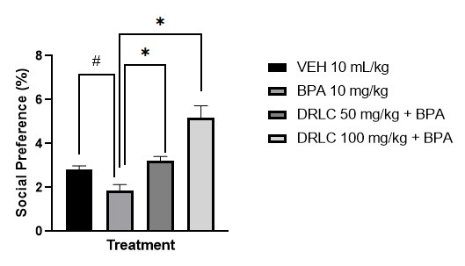
Figure 6: Effect of D-ribose-L-Cysteine on Bisphenol A induced depressive-like behaviour in mice utilizing the Social Interaction Test
Values represent the mean ± S.E.M of 6 animals per group
# p<0.05 compared to the control group (ANOVA followed by Turkey’s post hoc test).
* p<0.05 compared to the pathologic group (ANOVA followed by Turkey’s post hoc test).
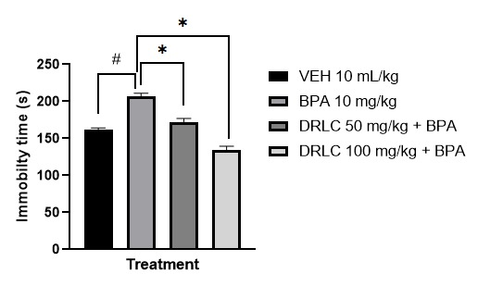
Figure 7: Effect of D-ribose-L-Cysteine on Bisphenol A induced depressive-like behaviour in mice utilizing the Force Swim Test
Values represent the mean ± S.E.M of 6 animals per group
# p<0.05 compared to the control group (ANOVA followed by Turkey’s post hoc test).
* p<0.05 compared to the pathologic group (ANOVA followed by Turkey’s post hoc test).

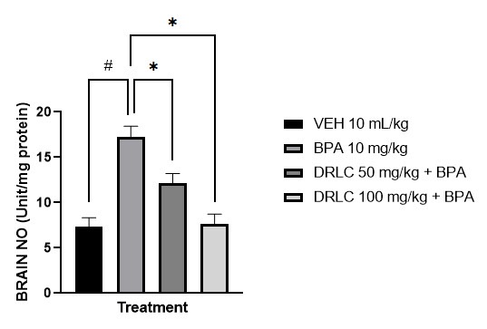
Figure 8: Effect of D-ribose-L-Cysteine on Bisphenol A-induced anxiety and depressive-like behaviour in mice in Nitric Oxide (NO) in the brain
Values represent the mean ± S.E.M of six animals per group
# p<0.05 compared to the control group (ANOVA followed by Turkey’s post hoc test).
* p<0.05 compared to the pathologic group (ANOVA followed by Turkey’s post hoc test).

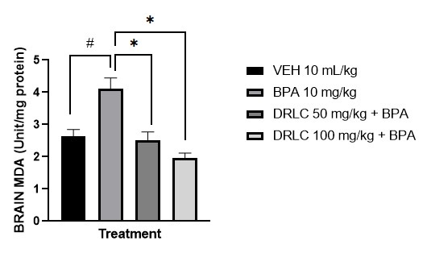

Figure 9: Effect of D-ribose-L-Cysteine on Bisphenol A induced anxiety and depressive-like behaviour in mice in Malondialdehyde (MDA) in brain
Values represent the mean ± S.E.M of six animals per group
# p < .05 compared to the control group (ANOVA followed by Turkey’s post hoc test).
* p < .05 compared to the pathologic group (ANOVA followed by Turkey’s post hoc test).

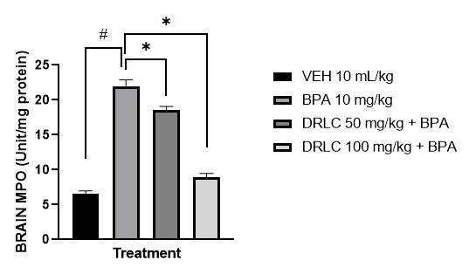
Figure 10: Effect of D-ribose-L-Cysteine on Bisphenol A-induced anxiety and depressive-like in mice in Myeloperoxidase (MPO) in brain
Values represent the mean ± S.E.M of six animals per group
# p < .05 compared to the control group (ANOVA followed by Turkey’s post hoc test).
* p < .05 compared to the pathologic group (ANOVA followed by Turkey’s post hoc test).

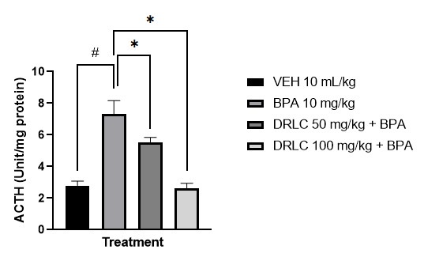
Figure 11: Effect of D-ribose-L-Cysteine on Bisphenol A induced anxiety and depressive-like behaviour in mice in Adrenocorticotropic (ACTH) hormone in the brain
Values represent the mean ± S.E.M for 6 animals per group
# p < .05 compared to the control group (ANOVA followed by Turkey’s post hoc test).
* p < .05 compared to the pathologic group (ANOVA followed by Turkey’s post hoc test).

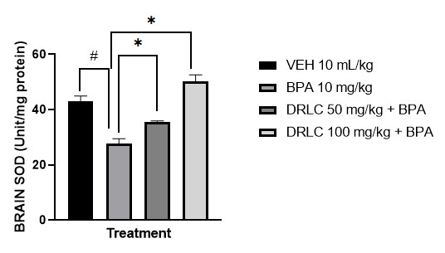
Figure 12: Effect of D-ribose-L-Cysteine on Bisphenol A induced anxiety and depressive-like behaviour in mice in Superoxide dismutase (SOD) in brain
Values represent the mean ± S.E.M of six animals per group
# p < .05 compared to the control group (ANOVA followed by Turkey’s post hoc test).
* p < .05 compared to the pathologic group (ANOVA followed by Turkey’s post hoc test).

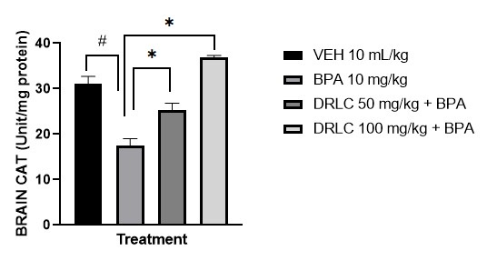
Figure 13: Effect of D-ribose-L-Cysteine on Bisphenol A induced anxiety and depressive-like behaviour in mice in Catalase (CAT) in brain
Values represent the mean ± S.E.M for 6 animals per group
# p<0.05 compared to the control group (ANOVA followed by Turkey’s post hoc test).
* p<0.05 compared to the pathologic group (ANOVA followed by Turkey’s post hoc test).

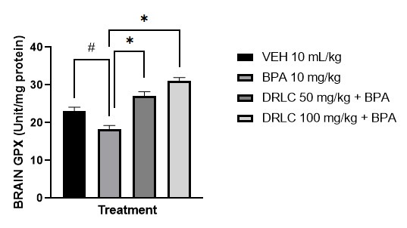
Figure 14: Effect of D-ribose-L-Cysteine on Bisphenol A-induced anxiety and depressive-like behaviour in mice in Glutathione Peroxidase (GPx) in the brain
Values represent the mean ± S.E.M for 6 animals per group
# p<0.05 compared to the control group (ANOVA followed by Turkey’s post hoc test).
* p<0.05 compared to the pathologic group (ANOVA followed by Turkey’s post hoc test).

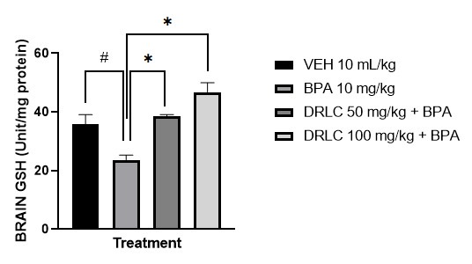
Figure 15: Effect of D-ribose-L-Cysteine on Bisphenol A-induced anxiety and depressive-like behaviour Glutathione (GSH) level in mice brain
Values represent the mean ± S.E.M of six animals per group
# p<0.05 compared to the control group (ANOVA followed by Turkey’s post hoc test).
* p<0.05 compared to the pathologic group (ANOVA followed by Turkey’s post hoc test).

4.0 Conclusion

D-Ribose L-Cysteine significantly attenuates anxiety-like and depressive-like behaviours induced by Bisphenol A in mice. Its action involves the restoration of antioxidant defenses, reduction of oxidative/nitrosative stress, and normalization of stress hormone levels.
8.0 Consent
Not applicable
9.0 Ethical Approval
All authors hereby declare that "Principles of laboratory animal care" (NIH publication No. 85-23, revised 1985) were followed, as well as specific national laws where applicable. All experiments have been examined and approved by the “ethics committee of Faculty of Allied Health Sciences, Delta State University, Abraka, with approval number RBC/FBMC/DELSU/24/645

COMPETING INTERESTS DISCLAIMER:
Authors have declared that they have no known competing financial interests OR non-financial interests OR personal relationships that could have appeared to influence the work reported in this paper.

References
Mitta H, Li L, Havaei M, Parida D, Feghali E, Elst K, et al. Challenges and opportunities in catalytic hydrogenolysis of oxygenated plastics waste: Polyesters, polycarbonates, and epoxy resins. Green Chem. 2025;27(1):10-40.
Hahladakis JN, Iacovidou E, Gerassimidou S. An overview of the occurrence, fate, and human risks of the bisphenol-A present in plastic materials, components, and products. Integr Environ Assess Manag. 2023;19(1):45-62.
Li Y, Chen X, Wang Z, Liu H. Environmental pollutants and their impact on human health: A focus on BPA. Int J Environ Res Public Health. 2023;20:145.
Costa HE, Cairrao E. Effect of bisphenol A on the neurological system: A review update. Arch Toxicol. 2024;98:1-73.
Frederick M, Johnson L, Smith T, Nguyen H. Mechanisms of BPA neurotoxicity in the hippocampus. Neurosci Lett. 2021;745:135587.
Dumitrascu M, Popescu A, Ionescu D, Georgescu R. The role of BPA in neurodevelopmental and memory disorders. Neurotoxicology. 2020;83:68-79.
Zheng L, Huang Y, Wu J, Li S. The interplay between oxidative stress and cognitive deficits: BPA’s role in neurodegeneration. J Toxicol. 2021;12:148-162.
Abdou M, Abd Elkader HTAE, El-Gendy AH, El-Refaei AF, El-Shafei DA, El-Sherbiny A, et al. Neurotoxicity and neuroinflammatory effects of bisphenol A in male rats: The neuroprotective role of grape seed proanthocyanidins. Environ Sci Pollut Res. 2022;29:9257-9268.
Isibor H, Eduviere AT, Ben-Azu B, Akpovwre CO. Ameliorative Effects of D-Ribose-L-Cysteine on Hematological Indices and Metabolic Intermediates in Diabetic Male Wistar Rats. Emerging Frontiers in Translational Biomedicine and Health Sciences. 2025; 2:61-71.
Isibor H, Ajayi AM, Ben-Azu B, Omeiza NA, Ademola AP, Umukoro S. D-ribose-L-cysteine reduces oxidative stress and inflammatory cytokines to mitigate liver damage, and memory decline induced by copper sulfate in mice. J Trace Elem Med Biol. 2022;73:127001.
Omogbiya AI, Aladeokin AC, Eze IA, Oboh G. Antidepressant-like effect of ellagic acid in unpredictable chronic mild stress-exposed mice. J Behav Brain Sci. 2021;11(3):139-153.
Eduviere AT, Enaohwo MT, Otomewo LO. Quercetin supplementation modulated exploratory and anxiety-related behaviours in mice subjected to hypoxic stress. Afr J Pharm Res Dev. 2022;14(1):40-51.
Takeda H, Tsuji M, Matsumiya T, Kubo M, Yamagami K. Brain regional Fos expression induced by the anxiolytic effect of diazepam in the elevated plus maze test in rats. Brain Res. 1998;814(1-2):38-45.
Steru L, Chermat R, Thierry B, Simon P. The tail suspension test: A new method for screening antidepressants in mice. Psychopharmacology (Berl). 1985;85(3):367-370.
Moy SS, Nadler JJ, Young NB, Perez A, Holloway LP, Barbaro RP, et al. Sociability and preference for social novelty in five inbred strains: An approach to assess autistic-like behavior in mice. Genes Brain Behav. 2004;3(5):287-302.
Porsolt RD, Bertin A, Jalfre M. Behavioral despair in mice: A primary screening test for antidepressants. Arch Int Pharmacodyn Ther. 1977;229(2):327-336.
Ben-Azu B, Umukoro S, Aderibigbe AO, Ajayi AM, Fajemiroye JO, Koola M, et al. Neurobehavioural and biochemical effects of co-exposure to chlorpyrifos and cypermethrin in mice. Neurotoxicol Teratol. 2018;66:52-64.
Ohkawa H, Ohishi N, Yagi K. Assay for lipid peroxides in animal tissues by thiobarbituric acid reaction. Anal Biochem. 1979;95(2):351-358.
Bradley PP, Priebat DA, Christensen RD, Rothstein G. Measurement of cutaneous inflammation: Estimation of neutrophil content with an enzyme marker. J Invest Dermatol. 1982;78(3):206-209.
Misra HP, Fridovich I. The role of superoxide anion in the autoxidation of epinephrine and a simple assay for superoxide dismutase. J Biol Chem. 1972;247(10):3170-3175.
Sinha AK. Colorimetric assay of catalase. Anal Biochem. 1972;47(2):389-394.
Paglia DE, Valentine WN. Studies on the quantitative and qualitative characterization of erythrocyte glutathione peroxidase. J Lab Clin Med. 1967;70(1):158-169.
Moron MS, Depierre JW, Mannervik B. Levels of glutathione, glutathione reductase and glutathione S-transferase activities in rat lung and liver. Biochim Biophys Acta. 1979;582(1):67-78.

