Original Research Article

Room Temperature Precipitation Synthesis and Application of a Zinc Pyromellitate Salt

Abstract
A The complex, [Zn₄(H₂B4C)_{2.5}(OH)₃(H₂O)₅]ˑ10H₂O was synthesized with zinc acetate dihydrate and 1,2,4,5-benzenetetracarboxylic acid under room temperature precipitation method and at the natural pH of the reaction mixture. The composition of the complex was determined by the elemental analysis (EA), Fourier Transform Infra-red Spectroscopy (FT-IR), Scanning Electron Microscopy (SEM), Thermogravimetry (TG) Analysis, Powder X-ray Diffraction (PXRD), and Braunauer-Emmett-Teller (BET) Analysis. The complex showed a typical III mesoporous isotherm showing surface adsorption. This complex was used as precursor for the preparation of nanosize ZnO. The effect of calcination temperature on the prepared ZnO was also studied. The result of the experiment showed that the crystallite size of the nano-ZnO increases with temperature
Keywords: Thermal decomposition, room-temperature precipitation method, zinc oxide, thermal decomposition.

Introduction
The aromatic carboxylate ligands such as 1,2,4,5-benzencarboxylic acid(H₄B4C) have been reported in the literature as a ligand for the synthesis of complexes [1-2]. It is comprised of four carboxyl groups capable of completely or partially deprotonate to give rich coordinated nodes. It can also act as a hydrogen-bond donor and acceptor depending on the number of deprotonation. The anions off which are suitable for the preparation of inorganic-organic framework structures[3- 4]. H₄B4C is the ligand chosen in this study, owing to its rigid planar C10 backbone, due to the πbonding of the benzene ring with the four freely rotating and flexible carboxylate groups. Its deprotonation can result in four possible charges (1- to 4-) [5-6]. Coordination through the carboxylic acid groups can occur, by the donation of the lone pairs of electrons on the carbonyl to form a bond and the deprotonation of OH to bond with a metal ion with ease.
Nanophase material due to their distinctive surface effect, macroscopic quantum tunnelling and volume effect, can be applied to the fields of electricity, optics, catalysis, mechanics, explosives and as combustion [7]. There has been a vast range of research on the synthesis of nano structures such as wires, sheets, fibres, ribbons e.t.c due to their wide applications in various fields. One of such is ZnO; a low cost, eco-friendly and efficient conductor [8]. ZnO which is a wide-band-gap semiconductor has a broad application such as rubber additives, transducers, gas sensor and also applicable in photocells[9]. In the laboratory, many methods are available for the synthesis of nano-ZnO [10-11], these are divided into chemical and physical methods. Through precipitation process and variation of solution concentration, pH and the washing medium, zinc oxide nano particles with different morphology have also been reported [12]. Nevertheless, chemical methods are the most studied, one of which is the thermal decomposition of zinc complexes with organic acid. In this paper, zinc pyromellitate complex was synthesized via room temperature precipitation method and used as precursor for the preparation of nano-ZnO
2. Materials and Methods

2.1. Materials and Physical Measurements
All chemical reagents used were purchased from Sigma Aldrich and used as received without further purification. The metal salts, zinc acetate dehydrate; Zn(CH₃COO)₂·2H₂O), and the methanol used as a solvent are an Analar grade.
Elemental analyses for C and H were performed on Elementar Analysensysteme varioMICRO V1.6.2 GmbH analysis system. The percentage amounts of the zinc was determined using a Perkin-Elmer Analyst200 Atomic Absorption. FTIR spectra was obtained within the range of 4000 – 500 cm⁻¹ using a Perkin-Elmer Spectrum 100FT-IR with ATR attachment. The powder X-ray powder diffraction data was recorded on a Bruker D8 Discover X-ray powder diffractometer equipped with a proportional counter, using Cu-Kα radiation (λ=1.5405 Ǻ, nickel filter). Data collection were in the range 2θ = 5 - 65˚, scanning at 0.5˚ min⁻¹ with a filter time- constant of 1.1s per step and a divergent slit width of 0.6 mm. SEM imaging was carried out using a Vega TESCAN TS 5136LM microscope operated at 20 kV, at a working distance of 20 mm. Samples were coated with gold before imaging to prevent charge building up on the surface. Thermogravimetry analysis data was obtained using a Perkin-Elmer TG-4000 (Pyris Version 4.01 Software fitted with ±1% instrumental error) as customized by the manufacturer in an air atmosphere in the temperature range of 25-700 ºC with a heating rate 100 ºC min⁻¹ and constant gas flow rate of 19.8 mLmin⁻¹. N₂ adsorption properties were measured on a Micromeritics ASAP 2020 HD analyzer. Control of the cryogenic temperature of 77 K was achieved using liquid nitrogen. Prior to measurement, degassing was carried out at 90 ºC for four days.
2.2 Synthesis of [Zn₄(H₂B4C)(H₂O)_{2.5}(OH)₃(H₂O₅]·10H₂O
A mixture of Zn(CH₃CO₂)₂ˑ2H₂O (0.4390 g, 2.0 mmol), H₄B4C (0.2542 g, 1.0 mmol) and 20 ml of MeOH/H₂O (50:50 v/v) was stirred for 30 minutes at ambient temperature. The resulting solution was allowed to stand for 12hrs, filtered and washed with methanol, followed by drying in air to obtain a white microcrystalline powder of the complex.
2.3 Preparation of nano-ZnO
The complex [Zn₄(H₂B4C)(H₂O)_{2.5}(OH)₃(H₂O₅]·10H₂O was calcined at 400 ºC, and 800 ºC for 1.5 hr, to obtain the nano-ZnO. This is followed by studying the effect of the calcination temperature on the nano-ZnO properties.

3. Results and discussion
3.1. Composition and Property of the Complex
The Calc. Expt (%) analysis of the title complex are in good agreement: C, 23.92 (24.74); H, 3.53(24.74); Zn, 23.21(23.47). Although a single crystal of this complex could not be obtained, the results of elemental analysis, thermal analysis and FTIR spectra showed the composition to be [Zn₄(H₂B4C)_{2.5}(OH)₃(H₂O₅]·10H₂O (M_{r} =1213.15). At room temperature, this complex is fairly stable.
The powder X-ray diffraction pattern of the complex is shown in Figure 1. The pattern has a low baseline but strong diffraction peak indicating a good crystalline state. This is similar to the reported structure of [Zn₂(btca)H₂O)₄][13]. The X-ray diffraction patterns for this complex accounts for seventeen reflections. The calculated inter-planar d-spacing have been calculated using the Bragg‘s equation: nλ = 2dsin θ, together with relative intensities for the most intense peak. The unit cell calculations for cubic symmetry from the all-essential peaks yielding h k l (Miller indices) unit cell parameter values (Appendix 1) were carried out using PANalytical XPert HighScore 3.0 software. These Miller indices have been compared with the calculated ones and found to be in good agreement

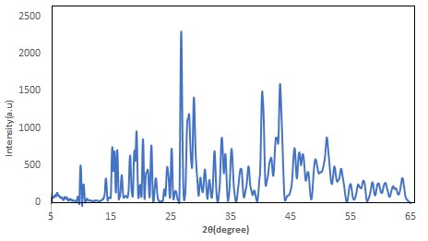
Figure 1. Powder X-ray diffraction pattern of the precusor, [Zn₄(H₂B4C)_{2.5}(OH)₃(H₂O₅]·10H₂O.

3.3 FTIR Spectroscopy Analysis
The FTIR spectra of the ligand and the complex (Figure 2) are as shown. The first band of interest in the IR spectrum of this compounds is the νO-H. This band which appeared between 3007–2871 cm⁻¹ in the ligand shifted to a higher wavenumber (3448 -3157 cm⁻¹) in the complex. The sensitivity to hydrogen bonding (intra and inter) is indicated by the broadness of the band, and may be said to be loosely bound to the metal ions through a hydrogen bond [14]. The evidence of complex formation was obtained by comparing the infrared spectra for the free ligand and the complex. The carbonyl region offers information on the type of coordination which exists between the metal and the carboxylic acid group of the ligand. In the complex, a shift of the asymmetric stretching vibration frequency ν_{as}COO from higher wavenumber (1694 cm⁻¹) in the free ligand) to lower wavenumber, 1549 cm⁻¹ is observed in this complex. While the symmetric vibration frequency ν_{sy}COO shifts from 1264 cm⁻¹ to higher wavenumber 1374 cm⁻¹ suggesting coordination of the carbonyl oxygen to the metal. The observed splitting of the ν_{as}COO band has been attributed to many causes e.g. two coordination modes, polymer–dimer equilibrium or coupling between neighbouring carboxylate groups. The splitting difference ∆ν, between the asymmetric and symmetric stretch in this complex is 192 cm⁻¹. These value which is larger than the corresponding value in Na₄B4C (95 cm⁻¹), indicates that the carboxylate groups behave as monodentate ligand [15].

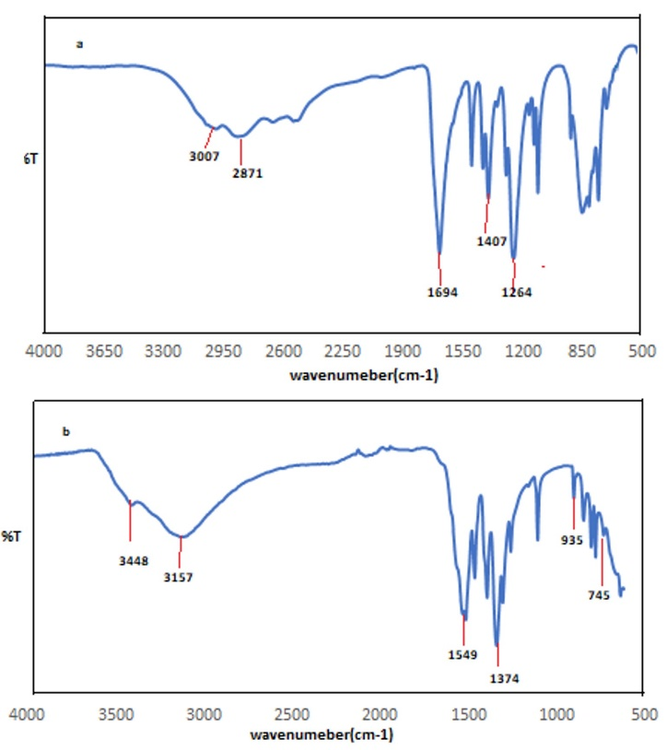
Figure 2. FTIR Spectrum of a) H₄B4C, b) [Zn₄(H₂B₄C)_{2.5}(OH)₃(H₂O)₅]·10H₂O
3.4 Thermogravimetry Analysis
The thermogravimetric and differential thermogravimetry (TGA-DTG) curves of the thermal decomposition for the studied complex is shown in Figure 3. A three-step loss with the second step occurring as a two-stage loss was observed. The first weight loss of 15.01% (calculated 14.84%) between 41 -105 ºC is due to the loss of 10H₂O molecules. The second weight loss of 8.74 % (calculated 8.82%) is a two-step loss (shoulder (i) in TG curve) between 105-175 ºC, attributed to the loss of coordinated 5H₂O molecules and an OH respectively. The third weight loss of 2.91%

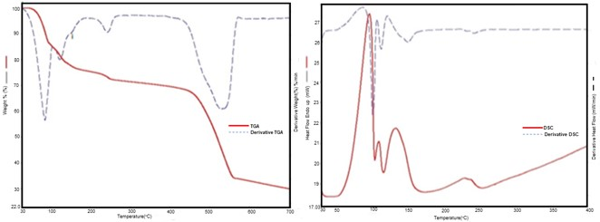
Figure 3.TGA-Derivative TGA and the corresponding DSC/ Derivative DSC for
Zn₄(H₂B4C)_{2.5}(OH)₃(H₂O)₅]·10H₂O
(calculated 2.89%) is a loss of coordinated 2OH⁻ groups (likely lost as H₂O) between 212 ºC – 261 ºC. This high temperature of dehydration indicates that the water molecules are coordinated ones. The remaining material is stable up to 437 °C beyond which it decomposes with a final weight loss of 38.92% (calculated 39.59%) which is assigned to the decarboxylation of the ligand structure leaving 33.84% (calculated 33.77%) residue in the form of amorphous carbon and ZnO. The residual XRPD pattern confirmed the formation of ZnO. The TGA thermogram of this compound is comparable to the compound reported by Anirban and Susanta, 2015[16].

The proposed reactions of decomposition are illustrated below and it is in good agreement with the observed mass losses.

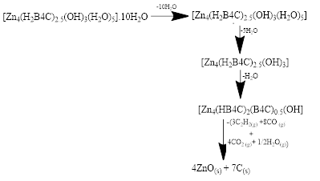
Its DSC and derivative DSC revealed four endotherm peaks in the temperature range of 40-250 ºC. The enthalpy change (ΔH) associated with the first mass loss in the TGA (dehydration step) in the temperature range 41-105 ºC is 337 Jg⁻¹ (associated energy 408 kJmol⁻¹). With this energy, it suggests that 10H₂O molecules were removed. Upon calculation, each water molecule requires 40.8 kJmol⁻¹ to be removed from the structure. When this is compared to the enthalpy of vaporization of water at 100 °C (kJmol⁻¹) it indicates that the water was held to the structure by a weak hydrogen bond.

3.5. Nitrogen Gas Adsorption Properties

To examine the porous nature of the complex, N₂ adsorption-desorption characteristics of the desolvated compound was investigated at 77 K, and its isotherm is as presented in Figure 5. This complex show typical Type III mesoporous isotherm as defined by IUPAC classification scheme [17] and with characteristic hysteresis of adsorption and desorption. The BET surface area; 5.151 m²g⁻¹, Langmuir Surface area; 5.387 m-²g⁻¹ pore volume; 0.012 cm³g⁻¹, and pore size; 39.6 nm obtained from the nitrogen adsorption data, are far smaller than those reported in the literature. The mesoporous material is typical of pore size 2 - 50 nm. This type of isotherm revealed only surface adsorption, which suggested that N₂ molecules cannot diffuse into the pores of this complex at 77 K. It also suggests that the coordinated H₂O molecules play important role in the stability of the complex.

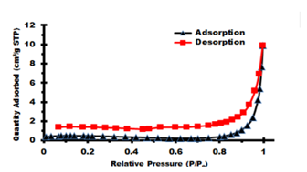

Figure 4: Nitrogen adsorption/desorption of [Zn₄(H₂B4C)_{2.5}(OH)₃(H₂O)₅]·10H₂O

3.6 Nano-Zn-O Particle size and Morphology
The nano-ZnO was prepared by using the complex [Zn₄(H₂B4C)_{2.5}(OH)₃(H₂O₅]·10H₂O as precursor through the thermal decomposition reaction. The reaction involved calcining the complex at 400 ºC, and 800 ºC for 1.5hr. The powder XRD patterns of the products obtained are shown in Figure 5. The diffractograms show prominent peaks at 2θ= 31.79º, 34.5 º, 36.26º, 47.73º, 56.67º, 62.83º, 67.51º, 67.93º, 69.20º, 3.47º and 77.29º which correspond to the diffraction planes 100, 002, 101,102, 110, 103, 200, 112, 201, 004 and 202 respectively. This diffraction peaks are in agreement with the JCPDS file (36-1415) and can be indexed as hexagonal wurtzite structure of ZnO (a = 3.3249 Å, c =5.206 Å). The intensity and sharpness of the peaks are observed to increase with calcining temperature showing increased crystallinity, this characteristic has been reported in the literature[7].

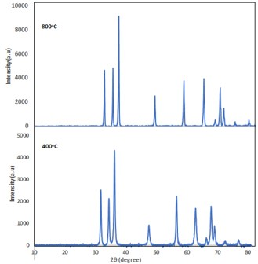
Figure 5: Powder X-ray Diffraction of calcined [Zn₄(H₂B4C)_{2.5}(OH)₃(H₂O)₅]·10H₂O at different Temperature.

The broadening of the diffraction peaks for the nano-ZnO obtained at 400 ºC indicates that the crystallite size were smaller than those obtained 500 ºC, this is in agreement with characteristic of nano-size particles [18]. This statement also agrees with the values obtained for the average crystallite size of the nano-ZnO products (16 nm and 23 nm for 400 ºC and 500 ºC respectively) estimated using the Scherrer equation. Diffraction peaks due to impurities were not observed confirming the purity of the synthesized product.
The SEM images of the precursor a, nano-ZnO (b) and FT-IR spectrum are shown in Figure 6. The SEM image of the precursor show a well dispersed homogenous shape and size of plate-like structures while b show an agglomerate of the plate-like structure, out of which some individual crystals are visible.
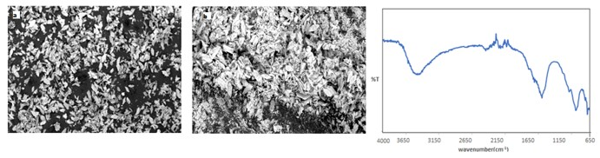
Figure 6. SEM images of (a and b) and FT-IT Spectrum of nano-ZnO

- Conclusions.

The synthesis of zinc nanoparticles have been achieved through a simple, cheap and eco-friendly method which involves the calcination at 400 ºC and 800 ºC of the zinc pyromellitate salt. The confirmation of the successful formation of zinc nanoparticles was achieved by Powder XRD, SEM, and IR. The result showed that the nano particles formed at 400 ºC contained smaller crystallite size particles than those obtained at higher temperature. It also proves that process can be considered for production of some other nanostructures. We hope to test the applicability of this nanoparticle for pollution monitoring and other functional materials.

References
1.Karanović, L., Poleti, D., Bogdanović, G. A.,Spasojević-de Biré, A.. Disodium hexaaquacobalt(II) bis[dihydrogen 1,2,4,5-benzenetetracarboxylate(2–)] tetrahydrate. Acta Crystallographica Section C Crystal Structure Communications(1999), 55,(6), 911-913.
DOI: 10.1107/S0108270199002498
2. Sanda, S., Goswami, S., Jena, H. S., Parshamoni, S. Konar, S. A family of three magnetic metal organic frameworks: their synthesis, structural, magnetic and vapour adsorption study. CrystEngComm.(2014), 16 (222), 4742-4752

3. Cao, R., Sun, D.,Y. Liang, Y., Hong, M., Tatsumi, K., Qian Shi. Syntheses and Characterizations of Three-Dimensional Channel-like Polymeric Lanthanide Complexes Constructed by 1,2,4,5-Benzenetetracarboxylic Acid. Inorganic Chemistry(2002), 41, 2087-2094

4.Shi, Q., Cao, R., Sun, D., Hong, M., Liang, Y. Solvothermal syntheses and crystal structures of two metal coordination polymers with double-chain structures. Polyhedron (2001), 20(28), 3287-3293. DOI: 10.1016/s0277-5387901)00945-7

5.Halouani, M., Abdelhedi, M., Dammak, M., Audebrand, N., Ktari, L. Structural studies and conductivity of [Fe(O₃C₄)(COO)]·H₂O based H₄btec (H₄btec = 1,2,4,5-benzenetetracarboxylic acid). Open Journal of Inorganic Chemistry(2013),3 100-108. 2013.
DOI: 10.4236/ojic.2013.34012

6.Zhong, D, Guo, H., Deng, J., Chen, Q., Luo, X. Two coordination polymers of benzene-1,2,4,5-tetracarboxylic acid (H₄BTC): In situ ligand syntheses, structures, and luminescent properties. CrystEngComm. (2015),17(18), 3519-3525

7.Hayat, K., Gondal, M. A., Khaled, M. M., Ahmed, S., Shemsi, A. M. Nano ZnO synthesis by modified sol gel method and its application in heterogeneous photocatalytic removal of phenol from water. Applied Catalysis A: General (2011), 393,122–129
DOI: 10.1016/j.apcata.2010.11.032

8.Uma S. N., Chitra D. S. Synthesis and characterization of nano ZnO rods via microwave assisted chemical precipitation method. Journal of Solid State Chemistry (2013), 197 483–488.
DOI: 10.1016/j.jssc.2012.08.011

9.Wang Z. and Li H. L. Highly ordered zinc oxide nanotubules synthesized within the anodic aluminum oxide template. Applied Physics A: Materials Science and Processing.(2002), 74(2), 201-203. DOI: 10.1007/s003390100856

10.Geetha, M. S., Nagabhushana, H., Shivananjaiah, H. N. Green mediated synthesis and characterization of ZnO nanoparticles using Euphorbia Jatropa latex as reducing agent. Journal of Science: Advanced Materials and Device s(2016), 1(3), 301-310.
DOI: 10.1016/j.jsamd.2016.06.015

11. Khorsand Z. A., Razali, R., Abd Majid, W. H., Darroudi, M. Synthesis and characterization of a narrow size distribution of zinc oxide nanoparticles. International Journal of Nanomedicine(2011), 6(1) 1399-1403
DOI:10.2147/IJN.S19693

12.Rodríguez-Paéz, J. E., Caballero, A. C., Villegas, M., Moure, C.,Durán, P.,Fernández, J. F. Controlled precipitation methods: Formation mechanism of ZnO nanoparticles. Journal of the European Ceramic Society(2001), 21(7) , 925-930. DOI: 10.1016/S0955-2219(00)00283-1

13.Yang, R., Wang, M., Liu, T., Zhong, G. Room Temperature Solid State Synthesis, Characterization, and Application of a Zinc Complex with Pyromellitic Acid. Crystal(2018), 8(2),56. DOI: 10.3390/cryst8020056

14.Łyszczek, R. Thermal investigation and infrared evolved gas analysis of light lanthanide (III ) complexes with pyridine-3,5-dicarboxylic acid. Journal of Analytical and Applied Pyrolysis (2009), 86, 239-244. DOI: 10.1016/j.jaap.2009.07.003

15.Deacon, G. B., Phillips, R. J. Relationships between the Carbon-Oxygen Stretching frequencies of Carboxylato complexes and the type of Carboxylate Coordination. Coordination Chemistry Reviews(1980), 33,227-250. DOI: 10.1016/S0010.8545(00)80455-5

16.Anirban K., and Susanta H., Synthesis, supramolecular structure and thermal study of a new dinuclear zinc(II) complex derived from benzene-1,2,45-tetracarboxylic acid. Z. Kristallogr. (2015); 230(3): 185–191. 185-191. DOI: 10.1515/zkri-2014-1812

17.IUPAC. Reporting physisorption data for gas/ solid systems with special reference to the determination of surface area and porosity. Pure & Appl. Chem(1985), 57(4), 603-619.

18.Rautio, J., Perämäki, P., Honkamo, J.,Jantunen, H. Effect of synthesis method variables on particle size in the preparation of homogeneous doped nano ZnO material. Microchemical Journal (2009), 91 272–276.
DOI: 10.1016/j.microc.2008.12.007

APPENDIX 1
Table 1. Powder indexing result of [Zn₄(H₂B4C)_{2.5}(OH)₃(H₂O)₅]·10H₂O
Peak  No. | 2θ [°] | θ [°] | Sinθ | sin²θ | 1000sin²θ | 1000sin²θ /CF  h²+k²+l² hkl |  | d spacing  obs cal
1 | 13.8030 | 6.9020 | 0.1202 | 0.0144 | 14.440 | 1.00 | 100 | 6.4105 | 6.3409
2 | 15.7110 | 7.8560 | 0.1367 | 0.0187 | 18.680 | 1.2936 | 100 | 5.6359 | 5.5981
3 | 17.0920 | 8.5460 | 0.1486 | 0.0220 | 22.080 | 1.5291 | 110 | 5.1837 | 5.1833
4 | 19.3950 | 9.6970 | 0.1684 | 0.0283 | 28.370 | 1.9647 | 110 | 4.5730 | 4.5384
5 | 23.5540 | 11.7770 | 0.2041 | 0.0417 | 41.660 | 2.8850 | 111 | 3.7740 | 3.7418
6 | 25.1670 | 12.5830 | 0.2179 | 0.0475 | 47.460 | 3.2867 | 111 | 3.5357 | 3.5269
7 | 26.7090 | 13.3540 | 0.2309 | 0.0534 | 53.350 | 3.6946 | 200 | 3.3350 | 3.3239
8 | 27.5730 | 13.7870 | 0.2383 | 0.0568 | 56.790 | 3.9328 | 200 | 3.2324 | 3.2424
9 | 29.1810 | 14.5910 | 0.2519 | 0.0635 | 63.460 | 4.3947 | 200 | 3.0578 | 3.0507
10 | 31.0170 | 15.5080 | 0.2674 | 0.0715 | 71.490 | 4.9508 | 210 | 2.8809 | 2.8988
11 | 32.7290 | 16.3650 | 0.2818 | 0.0794 | 79.380 | 5.4972 | 210 | 2.7339 | 2.7866
12 | 33.4300 | 16.7150 | 0.2876 | 0.0827 | 82.720 | 5.7285 | 211 | 2.6783 | 2.6678
13 | 35.1920 | 17.5960 | 0.3023 | 0.0914 | 91.390 | 6.3289 | 211 | 2.5481 | 2.5249
14 | 36.7100 | 18.3550 | 0.3149 | 0.0992 | 99.170 | 6.8677 | 7 | 2.4461 | 2.4403
15 | 38.5790 | 19.2900 | 0.3304 | 0.1091 | 109.130 | 7.5575 | 220 | 2.3318 | 2.3326
16 | 40.9590 | 20.4790 | 0.3499 | 0.1224 | 122.410 | 8.4772 | 221 | 2.2017 | 2.1936
17 | 43.2740 | 21.6370 | 0.3687 | 0.1359 | 135.960 | 9.4155 | 221 | 2.0891 | 2.0891

