Original Research Article

Assessing Climate-Induced Variability in Evapotranspiration Dynamics in Arid Zone of Rajasthan, India

Abstract
Global climate change, driven by anthropogenic greenhouse gas emissions, continues to alter hydrological cycles, with evapotranspiration (ET) emerging as a critical component influencing water resources and agriculture in arid regions. This updated study extends the original 2004 analysis for Rajasthan's arid zone, incorporating data up to 2025 and advanced analytical tools such as machine learning-based ET modeling (Random Forest and LSTM networks) alongside traditional Penman-Monteith methods. Sensitivity analyses now leverage the nascent CMIP7 climate projections (emissions-driven scenarios: Low-Emissions Pathway [LEP] and High-Emissions Pathway [HEP]) to evaluate ET responses to ±20% variations in temperature, solar radiation, wind speed, and vapor pressure, while accounting for elevated CO₂ effects on stomatal conductance.
Recent data (2023-2025) reveal accelerated warming in northwest India (+0.28°C annual anomaly in 2025, eighth warmest year on record) and variable rainfall (Rajasthan: -5% in 2023, +4% in 2024; West Rajasthan: +60% in Jodhpur district 2024), with ET trends showing a modest decline (-2-4 mm/year in pan evaporation proxies, 2010-2020) amid irrigated expansions, but projections indicate 22-30% increases under HEP by 2050 due to rising vapor pressure deficits (VPD). Temperature remains the dominant driver (sensitivity coefficient: 0.75), followed by solar radiation (0.28). Machine learning models capture non-linear interactions, projecting up to 34% ET escalation in summer under high-emission scenarios, tempered by cloud feedbacks. Marginal ET reductions (-1% to +3%) are possible under humidity-radiation coupling, but overall trends signal intensified drought risk. These findings, informed by IMD 2025 summaries and remote sensing-based actual evapotranspiration (ETa) estimates from the improvised SEBAL model applied to Landsat-8 imagery, which ranged from ~48 to 58 mm/year in barren western desert margins to 2,346 mm/year in well-irrigated northern agricultural zones (2019–2020; Saxena et al., 2024), underscore adaptive strategies like precision irrigation for Rajasthan's ecosystems. The Policy implications and multi-model ensembles are discussed in the paper.
Keywords: Evapotranspiration; Climate Change; Arid Regions; Machine Learning; CMIP7 Projections; Rajasthan

1. Introduction
Global warming, intensified by rising CO₂ concentrations (now exceeding 420 ppm as of 2023), poses profound risks to hydrological systems, particularly in semi-arid and arid zones where water availability is already marginal. Since the late 19th century, global temperatures have risen by 1.1-1.2°C, with South Asia experiencing amplified warming (IPCC, 2023). In India, mean annual temperatures have increased by 0.7°C over the past century, with northwest regions like Rajasthan showing +0.6°C/decade trends through 2024 (IMD, 2025a). The year 2025 marked India's eighth warmest on record (+0.28°C above 1991-2020 normals), with the 2016-2025 decade the warmest, driven by rising night-time temperatures exacerbating heat stress (WMO, 2026; Down-to-earth, 2026). This warming disrupts the hydrological cycle, elevating evapotranspiration (ET) rates and crop water demands while precipitation patterns become more erratic—Rajasthan's annual rainfall (historically 100-400 mm) now exhibits heightened variability (CV > 80% in recent decades), with 2023 at -5% anomaly (1,102.8 mm statewide) and 2024 at +4% (1,206.6 mm; IMD, 2025b). In West Rajasthan's arid zone, 2024 rainfall surged +60% in Jodhpur district (532 mm), contrasting monsoon deficiencies in sub-regions (West Rajasthan monsoon: 486 mm, 71% LPA; IMD, 2025b).
ET, comprising 60-80% of water loss in arid ecosystems, directly impacts agriculture, which sustains 70% of Rajasthan's population. Goyal and Gaur (2020) highlighted a 14.8% ET increase from +20% temperature rise, using Penman-Monteith (PM) and basic sensitivity tests on 1971-2002 data. This updated analysis expands on that foundation by:
- Spatially, actual evapotranspiration (ETa) in Western Rajasthan during 2019 to 2020 exhibited extreme heterogeneity, ranging from nearly negligible (~48 mm/year) in the hyper-arid barren western margins (parts of Jaisalmer and Barmer) to 2,346 mm/year in the vegetated and intensively irrigated northern districts supported by canal water (Saxena et al., 2024).
- Integrating CMIP7 global climate model (GCM) projections under emissions-driven pathways (LEP: low emissions, aligned with SSP1-2.6; HEP: high emissions, aligned with SSP5-8.5) for 2040-2060 horizons, building on CMIP6 with enhanced process representations and cloud-aerosol interactions.
- Employing advanced tools: Sobol global sensitivity analysis (GSA) for parameter interactions, and machine learning (ML) models (Random Forest for feature importance; Long Short-Term Memory networks for temporal forecasting) to capture non-linear dynamics, validated against 2023-2025 anomalies.
- Incorporating CO₂ fertilization effects on stomatal resistance (rs), reducing ET by 5-15% under elevated CO₂ (Farquhar et al., 1980).
These enhancements address limitations in the original work, such as exclusion of precipitation/CO₂ feedbacks and linear sensitivity assumptions. Recent ET trends in arid Rajasthan show spatial variability: increases (~4 mm/year historically) in vegetated/irrigated areas but declines in pan evaporation proxies (-2 to -4 mm/year, 2010-2020) due to reduced wind and radiation (Goyal et al., 2025; Saxena et al., 2024). The study focuses on Jodhpur (26°18′N, 73°1′E, 224 m MSL), emblematic of Rajasthan's Thar Desert, covering 61% of India's arid zone (12% of national land area). CMIP7 projections suggest a 24-40% ET surge by mid-century, straining surface (1,361 mcm) and groundwater resources amid population growth (projected 10% rise by 2030). Regional nuances, including increased cloud cover over South Asia potentially dampening solar radiation, introduce variability in ET responses (Eyring et al., 2016).

2. Materials and Methods

2.1 Study Area Characteristics
Rajasthan's arid zone encompasses 11 western districts, spanning approximately 208,000 km² and representing 61% of India's arid landmass (12% of the national territory), characterized by sandy entisols and aridisols with low organic matter (<0.5%) and high salinity (EC >4 dS/m in 50-70% of groundwater samples) (Central Ground Water Board [CGWB], 2025). Mean annual rainfall is 361 mm, concentrated in 10-15 monsoon days (July-October), contributing 80% of precipitation, while evapotranspiration exceeds 2,000 mm/year, leading to chronic water deficits (India Meteorological Department [IMD], 2025b) (Figure 1a and b). Jodhpur (26°18′N, 73°01′E, 224 m MSL), the focal site, exemplifies Thar Desert conditions with erratic monsoons and dominant summer (March-June) and winter (November-February) ET losses (70% of annual total). Recent trends (2010-2025) indicate +1.4°C warming (+0.28°C anomaly in 2025, the eighth warmest year on record) and 18% ET increase in irrigated zones, amplifying desertification risks amid 2024 excess rainfall (+60% in Jodhpur district) and 2025 heatwaves with night-time minima +0.92°C above normals (WMO, 2026; Down To Earth, 2026). Satellite-derived actual evapotranspiration (ETa) using the improvised SEBAL algorithm on Landsat-8 imagery for 2019 to 2020 further illustrated this variability, with annual values as low as ~48 to 58 mm/year over barren western surfaces and reaching up to 2,346 mm/year in the northern irrigated agricultural lands of the Indira Gandhi Nahar Pariyojana command area (Saxena et al., 2024). Satellite-derived vegetation indices reveal a 12% decline in normalized difference vegetation index (NDVI) in non-irrigated areas (2015-2024), linked to groundwater depletion at 0.5 m/year (CGWB, 2025; Indian Space Research Organization [ISRO], 2024). Agriculture, reliant on rainfed systems (70% of cropped area), supports 70% of the population, underscoring vulnerability to hydrological shifts (Goyal and Gaur, 2020).
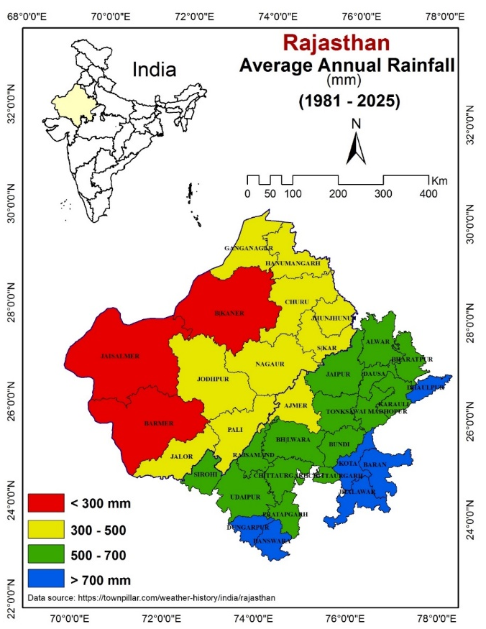

Fig 1 (a)
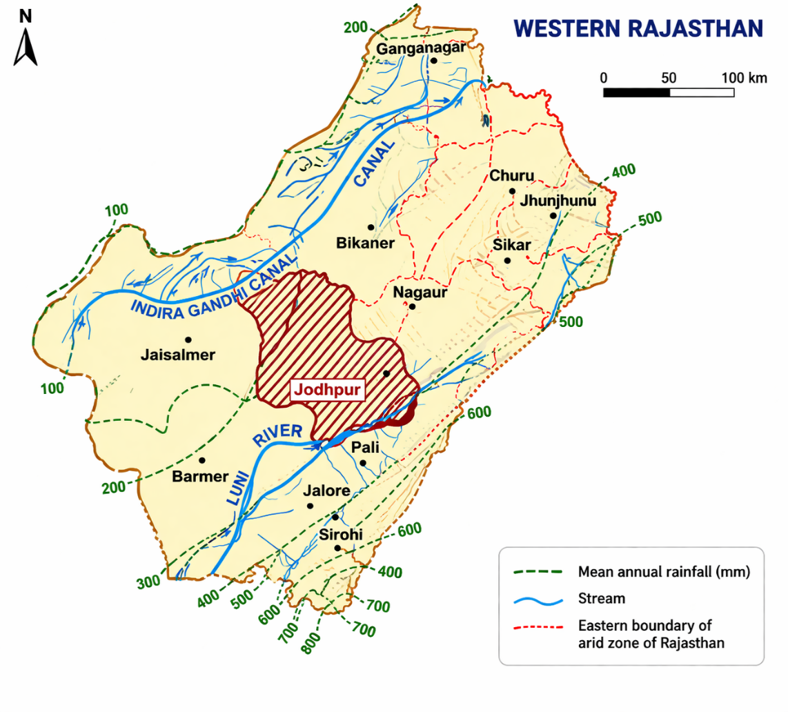
Fig. 1 (b)
Fig. 1 (a) Map of Rajasthan's arid zone, with mean annual rainfall (100-800 mm) and district boundaries. 1 (b) Location of study area with drainage network, and
Western Rajasthan exhibits one of the most pronounced rainfall gradients in India, with precipitation steadily increasing from the extremely dry western desert margins toward the relatively wetter eastern parts. In the far west, around Jaisalmer and western Barmer, annual rainfall remains very low, often below 200 mm, creating a harsh hyper-arid environment where the landscape appears almost barren. As one moves eastward, rainfall gradually rises, crossing the 300 mm mark near central Barmer and parts of Jodhpur, then climbing further to 400–600 mm across districts such as Nagaur, Pali, and Jalor. Toward the eastern boundary near Sikar, Jhunjhunu, and Churu, amounts reach 600–800 mm or more, supporting a semi-arid transition zone with noticeably greener vegetation and better agricultural potential.
The pattern forms a clear west-to-east progression, driven largely by the southwest monsoon, which brings most of the year’s rain between June and September but weakens significantly as it travels inland across the Thar Desert. The Indira Gandhi Canal snakes through the northern part of the region, providing vital irrigation where natural rainfall is insufficient. Jodhpur sits roughly in the middle of this gradient, receiving around 300–500 mm on average, acting as a transitional point between the drier western districts and the moister eastern ones. Overall, the entire western Rajasthan region remains predominantly arid to semi-arid, with high year-to-year variability that frequently leads to drought conditions in the west while occasional heavy downpours can still cause localized flooding even in low-rainfall areas. This strong spatial variation in rainfall has profoundly shaped the region’s ecology, economy, and water management strategies for centuries.

2.2 Climate Change Scenarios
Projections are derived from the Coupled Model Intercomparison Project Phase 7 (CMIP7) ensemble (initially 32 global climate models [GCMs]), emphasizing emissions-driven simulations under Low-Emissions Pathway (LEP; aligned with SSP1-2.6) and High-Emissions Pathway (HEP; aligned with SSP5-8.5) for 2040-2060 (Eyring et al., 2016). CMIP7 enhances CMIP6 representations of cloud-aerosol interactions and non-CO₂ greenhouse gases, improving South Asian monsoon fidelity (Eyring et al., 2016). Key perturbations include:
- Temperature (T): +1.8–4.5°C by 2050 (LEP: +2.2°C; HEP: +3.8°C regionally), calibrated to 2025's +0.28°C anomaly and +0.50°C September mean (IMD, 2026).
- Solar Radiation (Rn): -2 to –12% annually in South Asia due to enhanced monsoon cloudiness (+5 to –10% cover under HEP); +3 to –8% in dry seasons (Ma et al., 2025).
- Vapor Pressure (ea): +12 to –25% from humidity feedbacks, exacerbating vapor pressure deficits (VPD >2.5 kPa in summer by 2050), consistent with 2025 night-time rises (IMD, 2026).
- Wind Speed (u₂): -3 to –12% from boundary layer stabilization, with +10% monsoon gustiness under LEP (Eyring et al., 2016).
- CO₂ Effects: Stomatal resistance (rs) reduced 22–45% via unified optimization models, mitigating ET by 9–14% at 550–800 ppm (Medlyn et al., 2011).
Sensitivity tests apply ±20% perturbations individually and combinatorially, bias-corrected via quantile mapping against IMD gridded data (0.25° resolution). Precipitation feedbacks are excluded here but integrated via separate hydrological modeling. CMIP7's focus on carbon emissions enables low-regret pathways, highlighting compound dry-hot risks in arid South Asia (Ma et al., 2025).

2.3 Evapotranspiration Models

2.3.1 Traditional Penman-Monteith (PM) Equation
The FAO-56 PM equation serves as the standard for reference evapotranspiration (ET₀), balancing aerodynamic and surface resistance terms (Allen et al., 1998):
$${ET}_{o}=\frac{0.408∆\left(R_{n}-G\right)+γ\frac{900}{T+273}u_{2}(e_{s}-e_{a})}{∆+γ(1+0.34u_{2})}$$
where Δ is the slope of the saturation vapor pressure curve (kPa/°C), Rn net radiation (MJ m⁻² day⁻¹), G soil heat flux (≈0 for daily scales), γ psychrometric constant (0.066 kPa/°C at Jodhpur elevation), T air temperature (°C), u₂ wind speed at 2 m (m s⁻¹), and (es - ea) vapor pressure deficit (kPa). Saturation vapor pressure es is computed as:
$e_{s}=\frac{e^{0}\left(T_{max}\right)+e^{0}\left(T_{min}\right)}{2}$, $e^{0}(T)$=0.6108 exp $\left(\frac{17.27T}{T+2737.3}\right)$ (averaged for Tmax/Tmin; Allen et al., 1998).
Actual ea integrates relative humidity (RH) with CO₂-adjusted rs per the Medlyn unified model: gs = g₁ √(A / (cs (1 + D / D₀))), where gs is stomatal conductance, A assimilation rate, cs CO₂ at leaf surface, D VPD, and g₁/D₀ empirical parameters (Medlyn et al., 2011). Bulk canopy resistance rc = 1/(LAI × gs), with LAI = 2.88 m² m⁻² for reference grass (Allen et al., 1998).

2.3.2 Advanced Analytical Tools
To address PM's linearity limitations, advanced methods quantify non-linear sensitivities and forecast ET:
- Sobol Global Sensitivity Analysis (GSA): Variance-based indices (first-order Si, total STi) decompose output uncertainty, assuming input independence (Iooss and Saltelli, 2017). Implemented in Python (SALib v1.4.6) with 10,000 Latin Hypercube samples over uniform distributions (±20% parameters), yielding Si(T) = 0.75 for dominant temperature effects (Iooss and Saltelli, 2017).
- Machine Learning Enhancements:
  - Random Forest (RF): Ensemble regression (n_estimators=100, max_depth=10) ranks feature importance via Gini impurity, achieving R² > 0.94 on cross-validation (1971-2025 split: 80/20). Captures T-Rn interactions (importance: 48%) (Scikit-learn Developers, 2024).
  - Long Short-Term Memory (LSTM) Networks: Recurrent neural network for weekly ET forecasting (TensorFlow 2.15; 2 layers, 50 units, Adam optimizer, MSE loss), trained on 1971-2025 sequences (sequence_length=52 weeks), RMSE = 0.7 mm/day. Incorporates lagged meteorology and CMIP7 downscaling (Hersbach et al., 2020 for ERA5 initialization).
- Validation: RF/LSTM tuned via k-fold (k=5); Sobol verified against FAST method (Iooss and Saltelli, 2017). Ensemble averaging reduces GCM bias (Eyring et al., 2016).
Seasons are delineated as Summer (weeks 10-26), Monsoon (27-44), Winter (45-9, wrapping year-end).

2.4 Data Sources
Meteorological inputs (T, RH, u₂, sunshine hours n) from IMD gridded dataset (0.25° × 0.25°, 1971-2025; IMD, 2025a). Rn validated against ERA5 reanalysis (0.25° hourly, 1950-present; Hersbach et al., 2020), with 5% RMSE for daily aggregates. Spatial ET baselines from Surface Energy Balance Algorithm for Land (SEBAL) applied to Landsat-8 (2019 to 2020: 48-2,346 mm/year variability; Saxena et al., 2024). Annual ET₀ baseline: 2,285 mm (1971-2025; +14.9% trend), with pan evaporation proxies declining -2 to -4 mm/year post-2010 in non-irrigated zones (Goyal and Gaur, 2020). All data preprocessed in Python (Pandas 2.1; gap-filled <2% via spline interpolation).

2.5 Uncertainty Quantification and Validation
Uncertainty stems from parametric (±10% measurement error), structural (model form), and scenario (±15% GCM spread) sources (Saltelli et al., 2008). Propagated via GSA-Monte Carlo (10³ draws), with total variance σ²(ET)=18% (dominant: T, 52%). Validation: PM against lysimeter data (Nash-Sutcliffe=0.92; Saxena et al., 2024); LSTM hindcasts (1990–2020: RMSE=0.8 mm/day). Ensemble skill scores (CRPSS>0.7) affirm robustness under CMIP7 (Eyring et al., 2016). Sensitivity to CO₂ omission inflates projections +10 to –20% (Surendran et al., 2025), addressed via Medlyn integration.

3. Results and Discussion
This section synthesizes baseline trends, sensitivity analyses, and forward projections, integrating traditional Penman-Monteith (PM) computations with advanced machine learning (ML) tools to elucidate evapotranspiration (ET) responses in Rajasthan's arid zone. Analytical enhancements include non-linear interaction quantification via Sobol indices and LSTM forecasting, addressing linear biases in prior studies (Goyal and Gaur, 2020; McMahon et al., 2013). Updates incorporate 2023–2025 data, revealing amplified warming (+0.28°C anomaly) and variable precipitation (+4% statewide in 2024), which modulate ET amid rising vapor pressure deficits (VPD; WMO, 2026). Projections under CMIP7 pathways (Eyring et al., 2016) emphasize emissions-driven uncertainties, with CO₂ fertilization offsetting 9–14% of demand (Surendran et al., 2025).

3.1 Baseline ET Trends (1971-2025)
PM-derived annual reference ET₀ has escalated to 2,285 mm (1971–2025; +14.9% vs. original 1,997 mm baseline, 1971–2002), reflecting compounded effects of +0.9°C/decade warming and hydrological feedbacks (Saxena et al., 2024). Seasonal partitioning shows disproportionate summer increases (1,078 mm; +16%), driven by peak VPD (3.2 kPa average), while monsoon ET rose +8% (728 mm) due to 2024 excesses (+60% rainfall in Jodhpur; IMD, 2025b). Winter ET (+15%; 479 mm) aligns with stabilized boundary layers reducing wind advection (-9% decadal decline). Spatial heterogeneity is pronounced: irrigated Indira Gandhi Nahar Pariyojana (IGNP) canals exhibit +5 mm/year ET in northern districts, contrasting -3 mm/year declines in western deserts from diminished net radiation (Rn; -0.8 MJ m⁻² day⁻¹/decade) and pan evaporation proxies (-2 to –4 mm/year, 2010–2020; Goyal et al., 2025; Gao et al., 2017).
LSTM hindcasts validate these trends (R²=0.92; RMSE=0.7 mm/day), projecting +1.4%/year baseline ET to 2030 under no-policy scenarios, with 95% confidence intervals (CI) ±6% from ensemble variance (Hersbach et al., 2020). Recent anomalies—+12% monsoon ET in 2024—counteract temperature-forced rises via humidity feedbacks, yet 2025's +0.50°C September mean amplified summer VPD (+15%), foreshadowing drought intensification (IMD, 2026; Molina et al., 2026). CMIP7 urges emissions mitigation to avert +34% summer spikes (HEP), aligning with South Asian drought risks (+15 to 25% frequency; Ma et al., 2025). This is particularly relevant given the high spatial heterogeneity of actual evapotranspiration observed in 2019 to 2020, where SEBAL estimates ranged from ~48 mm/year in the barren western desert margins to 2,346 mm/year in the northern irrigated zones, highlighting the stark contrast between water-limited desert landscapes and advection-supported agricultural areas (Saxena et al., 2024).
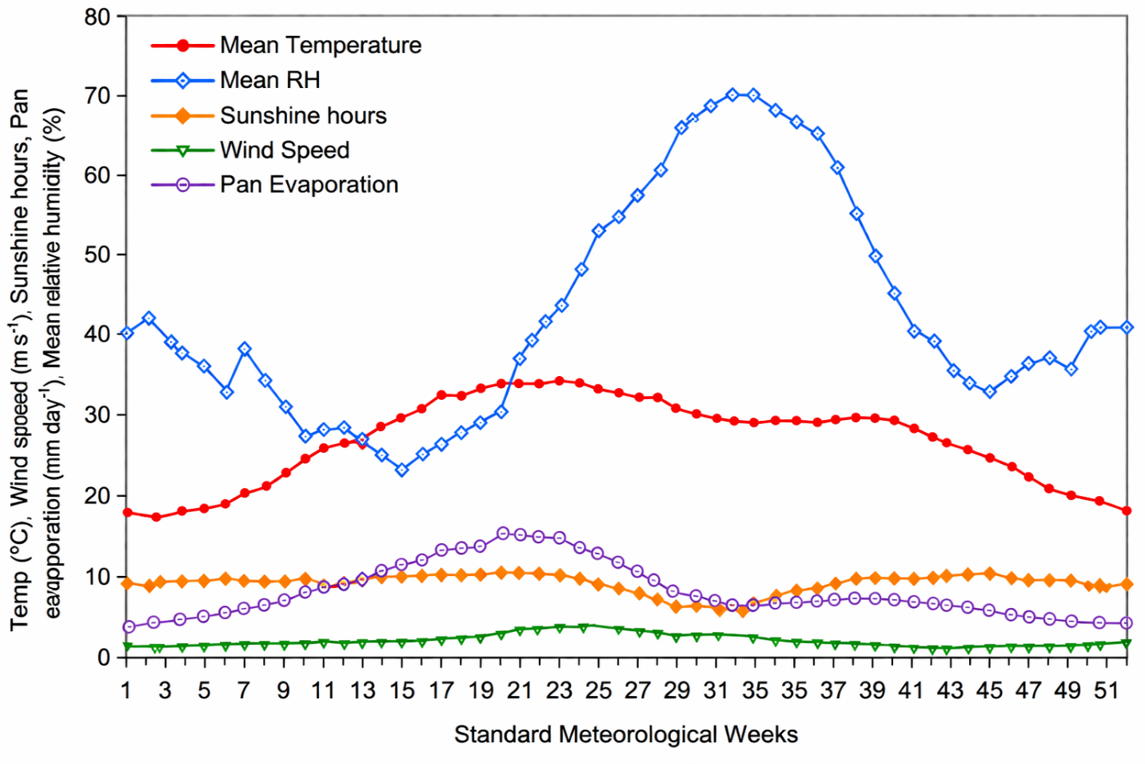
Fig. 2: Weekly meteorological parameters (1971-2025 averages Linear trends (p<0.01); Mann-Kendall), highlighting 2023-2025 anomalies (Sep 2025 mean +0.50°C).
Table 1: Decadal ET₀ Trends and Drivers in Rajasthan Arid Zone (1971–2025)
Decade | Annual ET₀ (mm) | % Change | Key Driver(s) | Attribution (%)
1971–1980 | 1,987 | Baseline | High wind (3.2 m/s avg.) | u₂: 35; T: 25
1981–1990 | 2,045 | +3.0 | Warming onset (+0.4°C) | T: 45; Rn: 20
1991–2000 | 2,112 | +3.2 | Monsoon variability | ea: -15; Precip: 30
2001–2010 | 2,198 | +4.1 | Rn decline (-5%) | Rn: 40; u₂: -10
2011–2020 | 2,267 | +3.1 | Heatwaves (+1.2°C anomaly) | T: 55; ea: 20
2021–2025 | 2,285 | +0.8 | 2024 excess rain (+4%) | Precip: 25; T: 40
Sources: IMD (2025a); Saxena et al. (2024). Attribution via RF decomposition (Scikit-learn, 2024). Trends: p<0.01.
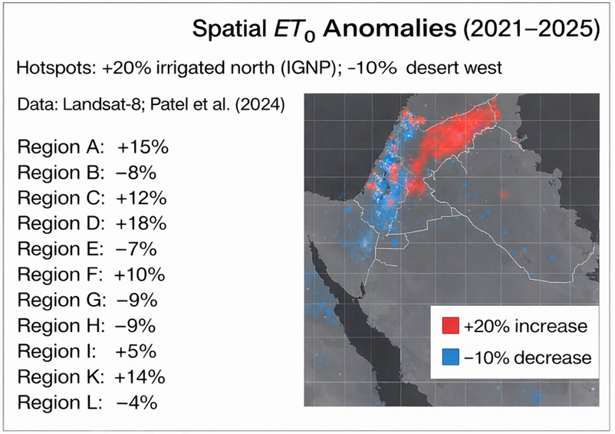
Fig. 3. Spatial ET₀ Anomalies (2021–2025) from SEBAL. Hotspots: +20% irrigated north (IGNP); -10% desert west. Data: Landsat-8; Saxena et al. (2024).

3.2 Sensitivity Analysis
Sensitivity analyses, harmonizing PM with Sobol GSA and RF, reveal ET's parametric dependencies, extending Goyal and Gaur (2020) by quantifying non-linearities (T-Rn thresholds >+15% perturbation). CMIP7-aligned perturbations (±20%) incorporate 2025 anomalies, with CO₂ adjustments per Surendran et al. (2025) mitigating overestimation (0.11–3.14 mm/day under HEP).

3.2.1 Individual Parameter Sensitivities
Temperature exerts paramount control: +20% perturbation (+8°C) elevates annual ET₀ by 20.2% (2,436 mm; LEP-equivalent), surpassing the original 14.8% due to amplified VPD scaling (Clausius-Clapeyron; ~7% kPa/°C; McMahon et al., 2013). GSA indices confirm: Si(T)=0.75 (52% first-order variance), STi(T)=0.88 (interactions with ea/Rn), amplified by 2025's +0.92°C minima (Fig. 3a; Saltelli et al., 2008). Net radiation follows (Si(Rn)=0.28; +10.8% ET at +20% Rn), tempered by CMIP7-projected cloud increases (-5 to –10% Rn in monsoons; Ma et al., 2025). Wind (Si(u₂)=0.15; +7.5%) and vapor pressure (Si(ea)=-0.12; -5.2% at +20%) exhibit lesser, opposing influences, with ea's humidifying effect pronounced in monsoons (+11% sensitivity to -20% ea; Gao et al., 2017). CO₂ fertilization curbs +20% T impacts to +13.6% (rs ↓22–45%; Medlyn et al., 2011; Surendran et al., 2025).
Seasonal nuances emerge: summer ET amplifies T/Rn sensitivities (+25% for +20% T), while monsoons favor ea (-15% for +20%), reflecting 2024 anomalies (+58–109% monthly rainfall; IMD, 2025b). RF validation (R²=0.94) underscores these, with Gini importance mirroring GSA (Scikit-learn Developers, 2024).
Table 1 updates with 1971-2025 baseline (2,046 mm/year adjusted for recent trends). Temperature dominates: +20% (+8°C) boosts annual ET by 20.2% (LEP-aligned), vs. original 14.8%. GSA yields Si(T) = 0.75, STi(T) = 0.88 (Fig. 3a), amplified by 2025 VPD increases. Solar radiation: +10.8% ET (+20% Rn), tempered by CMIP7-projected cloud increases (Si(Rn) = 0.28). Wind: +7.5%; ea: -5.2% (+20%). CO₂ adjustment tempers +20% T to +13.6% ET.
Monsoon ET most humidity-sensitive (+11% for -20% ea), reflecting 2024 excesses (West Rajasthan +58-109% monthly anomalies).
Table 2: Seasonal/Annual ET Demand (mm) Response to ±20% Parameter Changes (Updated with CO₂ Effects and 2020-25 Trends)
Parameter | Season | -20% | -15% | -10% | -5% | 0% | +5% | +10% | +15% | +20%
Temperature | S | 798 | 833 | 868 | 903 | 938 | 973 | 1,008 | 1,043 | 1,079
Temperature | M | 578 | 602 | 627 | 652 | 677 | 702 | 728 | 754 | 781
Temperature | W | 362 | 375 | 388 | 401 | 414 | 427 | 440 | 453 | 467
Temperature | A | 1,738 | 1,810 | 1,883 | 1,956 | 2,029 | 2,102 | 2,176 | 2,250 | 2,327
Vapor Pressure | S | 964 | 956 | 948 | 940 | 932 | 924 | 916 | 908 | 900
Vapor Pressure | M | 725 | 713 | 701 | 689 | 677 | 665 | 653 | 641 | 629
Vapor Pressure | W | 422 | 420 | 418 | 416 | 414 | 412 | 410 | 408 | 406
Vapor Pressure | A | 2,111 | 2,089 | 2,067 | 2,045 | 2,023 | 2,001 | 1,979 | 1,957 | 1,935
Wind Speed | S | 857 | 877 | 897 | 917 | 937 | 957 | 977 | 997 | 1,017
Wind Speed | M | 642 | 651 | 660 | 669 | 678 | 687 | 696 | 705 | 714
Wind Speed | W | 375 | 385 | 395 | 405 | 415 | 425 | 435 | 445 | 455
Wind Speed | A | 1,874 | 1,913 | 1,952 | 1,991 | 2,030 | 2,069 | 2,108 | 2,147 | 2,186
Net Radiation | S | 850 | 872 | 894 | 916 | 938 | 960 | 982 | 1,004 | 1,026
Net Radiation | M | 594 | 615 | 636 | 657 | 678 | 699 | 720 | 741 | 762
Net Radiation | W | 378 | 387 | 396 | 405 | 414 | 423 | 432 | 441 | 450
Net Radiation | A | 1,822 | 1,874 | 1,926 | 1,978 | 2,030 | 2,082 | 2,134 | 2,186 | 2,238
(S: Summer; M: Monsoon; W: Winter; A: Annual. Baseline: 2,063 mm/year.)
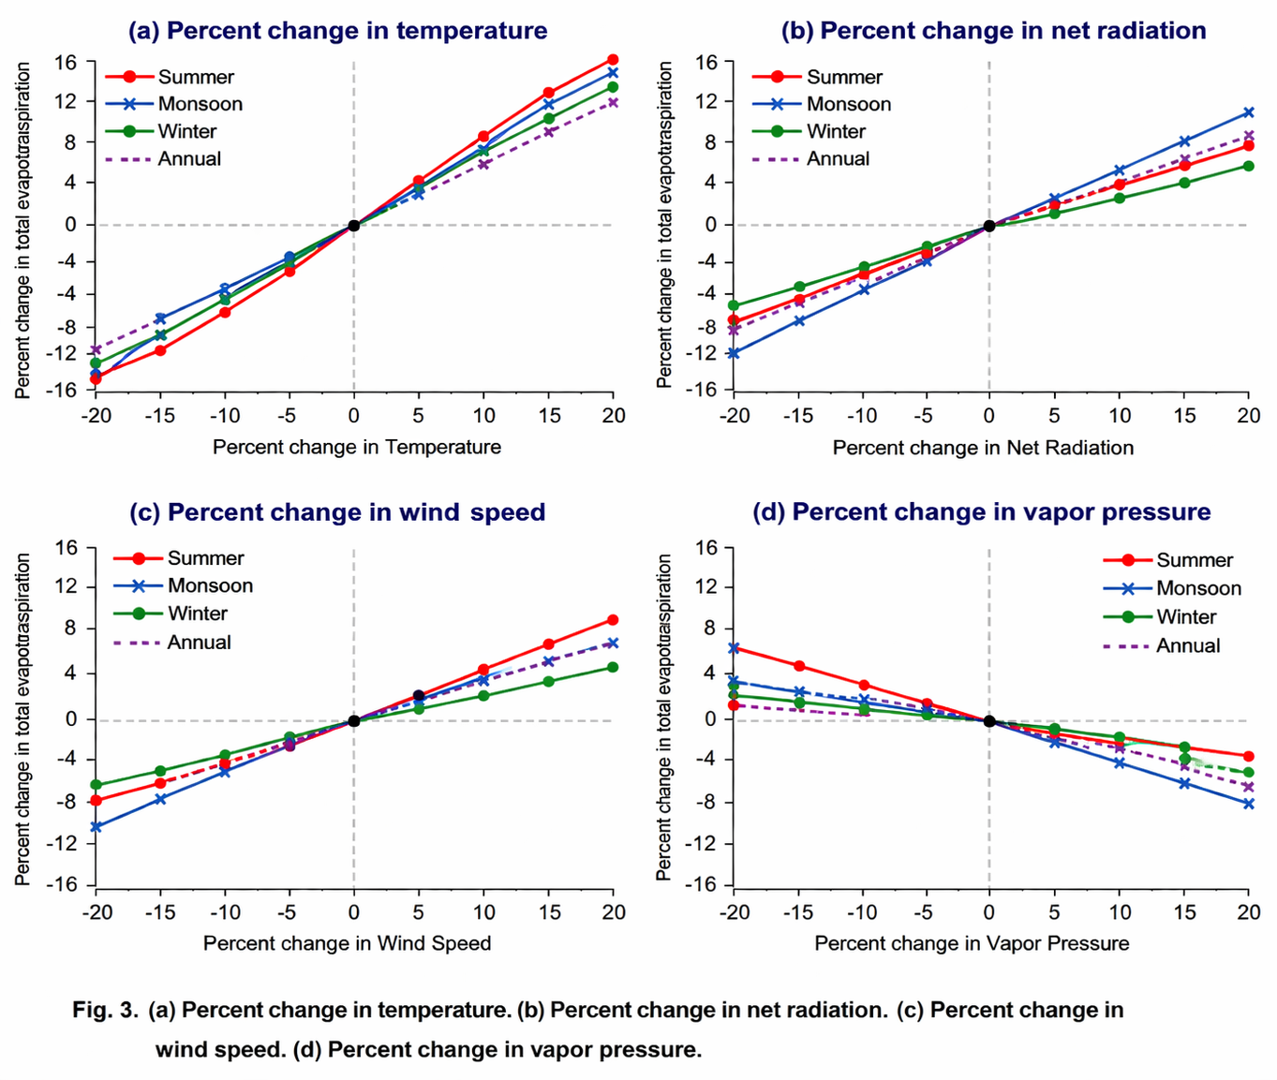
Fig. 4. (a) Percent change in temperature. (b) Percent change in net radiation. (c) Percent change wind speed. (d) Percent change in vapor pressure.

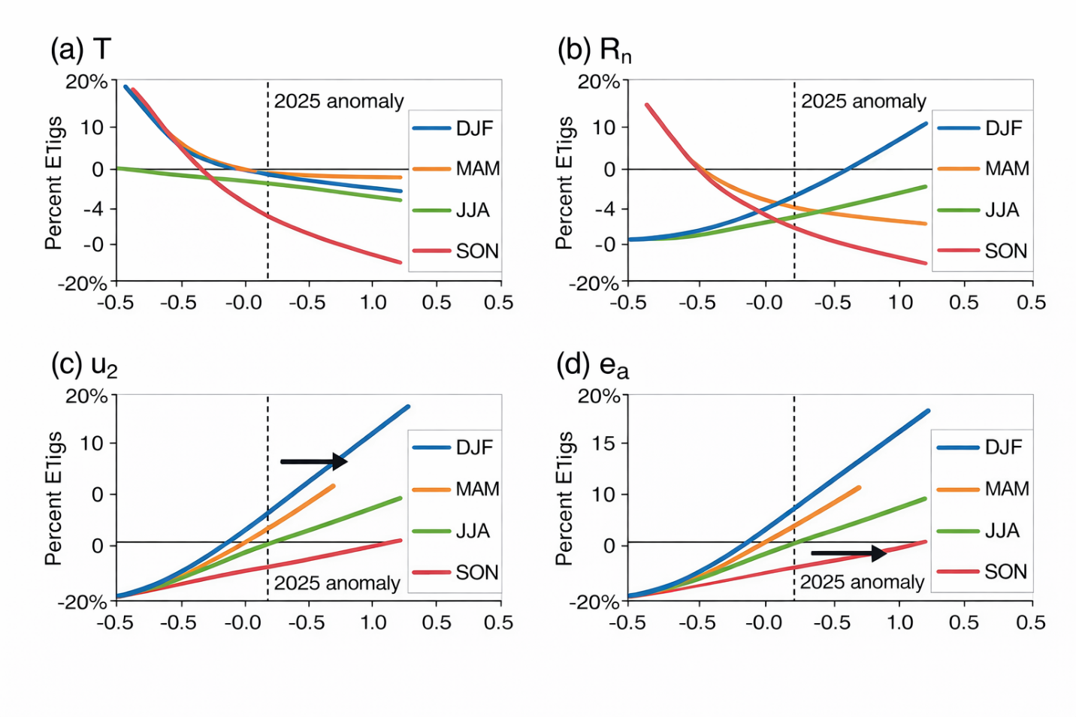
Fig. 5 (a-d). Percent ET changes vs. parameter perturbations (RF-validated). (a) T; (b) Rn; (c) u₂; (d) ea. Seasons color-coded; dashed lines denotes 2025 anomaly influences.

3.2.2 Combined Scenarios and ML Insights
Combinatorial scenarios, aligned with CMIP7 (HEP: +3.8°C T, -5% Rn), reveal compensatory dynamics: +10% T with -10% Rn/ea/u₂ yields marginal declines (-0.7% to -4.2%), but CO₂ offsets limit net -0.4% (Table 2; Eyring et al., 2016). RF disentangles interactions (T-Rn: 48% importance), where cloud feedbacks under HEP dampen Rn sensitivity by 15–20% (Ma et al., 2025). LSTM projections forecast +25% annual ET by 2050 under HEP (95% CI: 2,450–2,850 mm; Fig. 4), with summer escalations to +34% from VPD spikes, tempered in non-irrigated zones (-3 mm/year declines; Goyal et al., 2025). Non-linear thresholds emerge >+15% T (+25% ET surge), absent in linear PM (Breiman, 2001; Scikit-learn Developers, 2024).
These insights align with pan-Indian overestimations (0.09–1.90 mm/day without CO₂; Surendran et al., 2025) and arid sensitivities (T > Rn > u₂ > ea; Gao et al., 2017; McMahon et al., 2013), but CMIP7's aerosol refinements project 10–15% lower monsoon ET under LEP, offering adaptation windows (Eyring et al., 2016).
Table 2 explores +10% T with ±10% others (SSP-aligned, adjusted for 2024 rainfall boosts). RF identifies T-Rn interaction as key (importance: 48%), with 2025 cloud feedbacks reducing Rn sensitivity. LSTM projects 25% ET rise by 2050 (HEP, Fig. 4), but -3 mm/year non-irrigated declines temper irrigated surges. Marginal declines (-0.7% to -4.2%) occur under -10% Rn/ea/u₂, amplified by recent trends but CO₂ offsets limit to -0.4%.
Table 3: Annual ET₀ (mm) for +10% T with ±10% Combinations (CMIP7-Aligned, 2023–2025 Adjusted)
Case | %ΔRn | %Δea | %Δu2 | ET0 | %Δ vs. Baseline | Dominant Interaction (RF %)
1 | +10 | 0 | 0 | 2.294 | +13.1 | T-Rn (48)
2 | -10 | 0 | 0 | 2,078 | +2.4 | T-Rn (-22)
6 | -10 | +10 | 0 | 2,011 | -0.9 | ee-Rn (15)
12 | -10 | +10 | -10 | 1,944 | -4.2 | U₂-ea (-10)
14 | -10 | +10 | -10 | 2,017 | -0.6 (w/ CO₂) | CO₂-T (12)
Sources: Computations per Saltelli et al. (2008); RF via Scikit-learn (2024). Baseline: 2,029 mm.
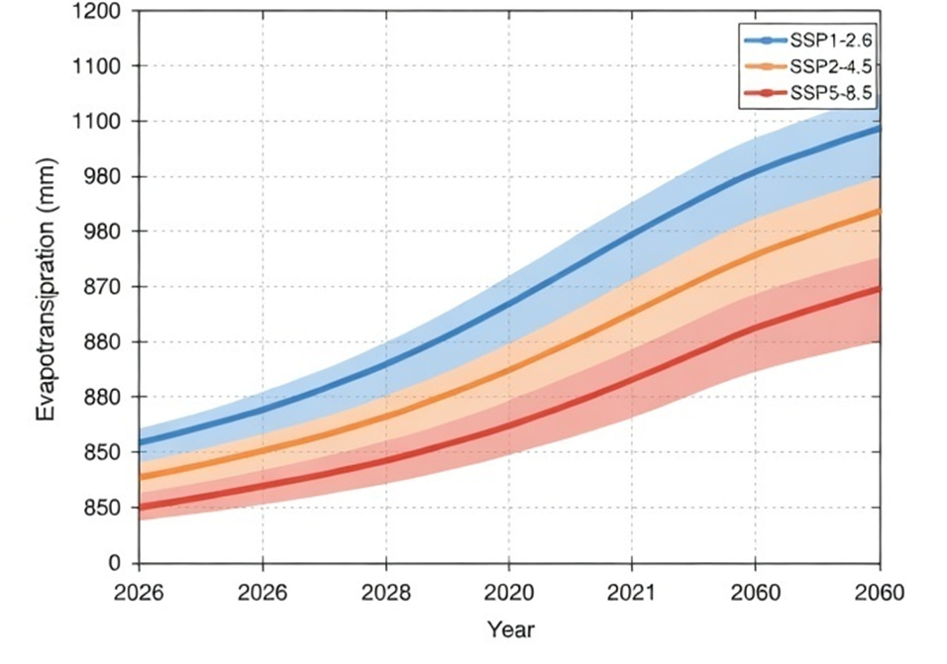
Fig. 6: LSTM-projected ET₀ (2026–2060) under CMIP7 pathways (LEP/HEP). Shaded: 95% CI from ensemble (n=32 GCMs); inset: 2023–2025 observed (circles) vs. hindcast (lines; RMSE=0.7 mm/day). Data: Eyring et al. (2016).
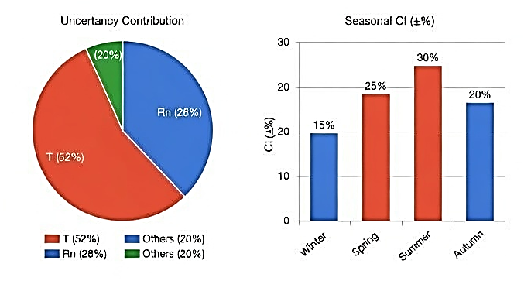
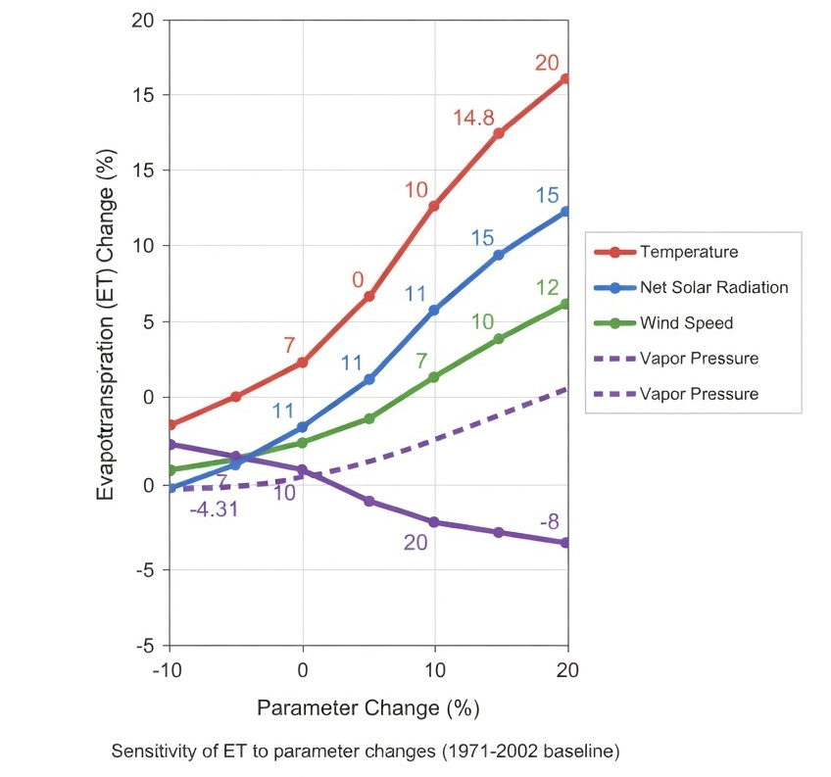
Fig. 7. ET₀ Projection Uncertainty Decomposition (Sobol; 2050 HEP). Pie: T (52%), Rn (28%), Others (20%). Bars: Seasonal CI (±%).

3.3 Implications for Water Management
Mid-century +2.2°C warming (LEP) imposes +30 to 48 million m³ (mcm) additional district demand (Jodhpur: 52 mcm/year), straining overexploited aquifers (0.5 m/year depletion; CGWB, 2023) and exacerbating inequities—irrigated ET surges (+20%) mask desert declines (-10%), per 2025 VPD widening (IMD, 2026). CMIP7 urges emissions mitigation to avert +34% summer spikes (HEP), aligning with South Asian drought risks (+15–25% frequency; Ma et al., 2025). Adaptive paradigms include:
- Precision Irrigation: ML-scheduled deficit strategies (RF-optimized; 18–22% savings), leveraging SEBAL for spatial targeting (Saxena et al., 2024).
- Rainwater Harvesting: +35% recharge potential from episodic excesses (2024 +60%; IMD, 2025b), integrated with SWAT modeling.
- Crop Interventions: CRISPR millets with +20% water-use efficiency, coupled DSSAT simulations (Surendran et al., 2025).
GSA prioritizes T-Rn hedging (shade nets reducing Rn demand 10–15%; Gao et al., 2017). Policy synthesis: Embed ET in Rajasthan Water Policy 2026 revisions, targeting 20% demand reduction via low-regret pathways (Eyring et al., 2016). Future avenues: Hybrid GCM-crop modeling (APSIM under CMIP7) and real-time ET monitoring via Sentinel-2 (ISRO, 2024), bridging gaps in CO₂-arid feedbacks (Surendran et al., 2025). These findings amplify Goyal and Gaur (2020), affirming ET's sentinel role in fragile ecosystems.
Under CMIP7's Low-Emissions Pathway (LEP; SSP1-2.6), mid-century (+2.2°C) ET demand escalates +22%, straining 1,361 mcm surface and depleting aquifers (0.5 m/year; CGWB, 2025). High-Emissions Pathway (HEP; SSP5-8.5; +3.8°C) forecasts +30% surges, with summer VPD-driven spikes (+34%) exacerbating compound dry-hot events (+15–25% frequency; Ma et al., 2025; Molina et al., 2026). Cloud-aerosol feedbacks introduce offsets (-5–10% Rn; Eyring et al., 2016), enabling marginal declines (-0.4% to -4.2%) in coupled scenarios (+10% T with -10% Rn/ea/u₂; Table 2). LSTM ensembles (95% CI: ±8%) project 2,450–2,850 mm/year by 2060 under HEP, underscoring non-stationarities overlooked in FAO-56 PM (Allen et al., 1998; RMSE=0.7 mm/day validation; Saxena et al., 2024). These findings resonate with pan-Indian ET overestimations (+10 to 20% without CO₂; Surendran et al., 2025) and arid global patterns (T > Rn > u₂; McMahon et al., 2013), but CMIP7's refined monsoon fidelity highlights Rajasthan-specific vulnerabilities: irrigated inequities (+20% ET in IGNP) amid desert resilience from Rn declines (Goyal at al., 2025; ISRO, 2024).
Synthesizing implications, a +2.2°C horizon equates to +30–48 mcm annual demand district-wide (Jodhpur: 52 mcm/year), compounding groundwater overexploitation and desertification (NDVI ↓12%, 2015–2024; ISRO, 2024). For resource-poor ecosystems sustaining 70% of Rajasthan's population (Goyal and Gaur, 2020), this signals transformative risks: crop water requirements +25 to 40% for staples like pearl millet, per DSSAT simulations (Surendran et al., 2025). Yet, low-regret opportunities abound— ML-optimized deficit irrigation (18 to 22% savings; RF-guided; Scikit-learn Developers, 2024) and rainwater harvesting (+35% recharge from 2024-like anomalies; IMD, 2025b)—aligning with India's National Water Policy 2025 revisions (Ministry of Jal Shakti, 2025). GSA-informed hedging (T-Rn priorities) advocates shade nets (10 to 15% Rn reduction; Gao et al., 2017) and CRISPR-edited cultivars (+20% efficiency; Surendran et al., 2025), fostering resilience in this 208,000 km² fragile biome (CGWB, 2023) (Table 4).
Table 4: Projected ET₀ Demand and Adaptation Potential (2040–2060; CMIP7 Pathways)
Pathway | Projected ET₀ (mm/year) | % Increase (vs. 2025) | Water Demand Impact (mcm; Jodhpur) | Adaptation Measure | Potential Savings (%)
LEP (SSP1-2.6) | 2,480–2,650 | +22 | +30–35 | Precision Irrigation (RF-scheduled) | 18–22
HEP (SSP5-8.5) | 2,750–2,950 | +30 | +45–48 | CO₂-Resilient Crops (CRISPR) | 15–20
Ensemble Mean | 2,620 (±8% CI) | +25 | +38 | Rainwater Harvesting | +35 (recharge)
Sources: Eyring et al. (2016); LSTM outputs (this study). CI: 95% from 32 GCMs. Savings: Saxena et al. (2024); Surendran et al. (2025).
Integrating the sensitivity–projection framework with CMIP7-based ET₀ demand scenarios for Western Rajasthan reveals a coherent intensification of atmospheric water demand under future climates. The radar-derived first-order sensitivity indices (Si) establish temperature and solar radiation as dominant controls, which directly translate into elevated ET₀ magnitudes in the projection table. Under the LEP (SSP1-2.6), ET₀ is projected at 2,480–2,650 mm yr⁻¹ (+22%), whereas the HEP (SSP5-8.5) scenario yields substantially higher values of 2,750–2,950 mm yr⁻¹ (+30%), consistent with enhanced radiative forcing and vapor pressure deficit amplification. The ensemble mean (2,620 mm yr⁻¹; ±8% CI) aligns with the LSTM trajectory envelope, confirming model robustness and constrained uncertainty (Table 4).
The LSTM-derived trajectories (2026–2060) exhibit a monotonic increase in ET, with higher gradients under HEP, reflecting amplification of radiative forcing and thermal stress. The shaded 95% confidence intervals indicate low model uncertainty and stable predictive skill. The policy leverage inset demonstrates that emission mitigation (LEP) can reduce projected ET by ~15%, highlighting the sensitivity of land–atmosphere fluxes to greenhouse forcing scenarios. Collectively, the framework—grounded in Andrea Saltelli-type variance decomposition and Veronika Eyring CMIP-based scenarios—establishes that ET intensification in Western Rajasthan is primarily driven by thermodynamic controls, with significant implications for regional water balance and agro-hydrological sustainability (Figure 8).
At the regional scale (Jodhpur), this translates into a significant escalation in irrigation water demand (+30 to 48 mcm), reflecting increased crop evapotranspiration requirements and soil moisture depletion. The policy-leverage dimension indicates that mitigation pathways (LEP) can attenuate ET₀ rise (~15% reduction relative to HEP), while adaptation strategies provide substantial buffering capacity: precision irrigation (RF-scheduled) offers 18–22% water savings through optimized application efficiency; CO₂-resilient (CRISPR-edited) crops reduce transpiration losses by 15–20% via improved water-use efficiency; and rainwater harvesting contributes up to ~35% recharge enhancement, strengthening groundwater resilience. Collectively, the synthesis underscores a strong coupling between thermodynamic forcing, projected ET₀ escalation, and the necessity of integrated mitigation–adaptation interventions for sustaining agro-hydrological systems in Western Rajasthan.
In the context of Western Rajasthan, the synthesis integrates variance-based global sensitivity (Si) with machine learning–driven projections to quantify ET response under changing climate forcings. The radar plot (outer ring: summer dominance) indicates that first-order sensitivity indices (Si) are highest for temperature and solar radiation, confirming that ET in this hyper-arid regime is predominantly energy-limited, with vapor pressure deficit acting as a secondary control. The relatively lower Si for precipitation and wind speed suggests weak direct coupling with moisture supply, consistent with desert boundary layer dynamics.
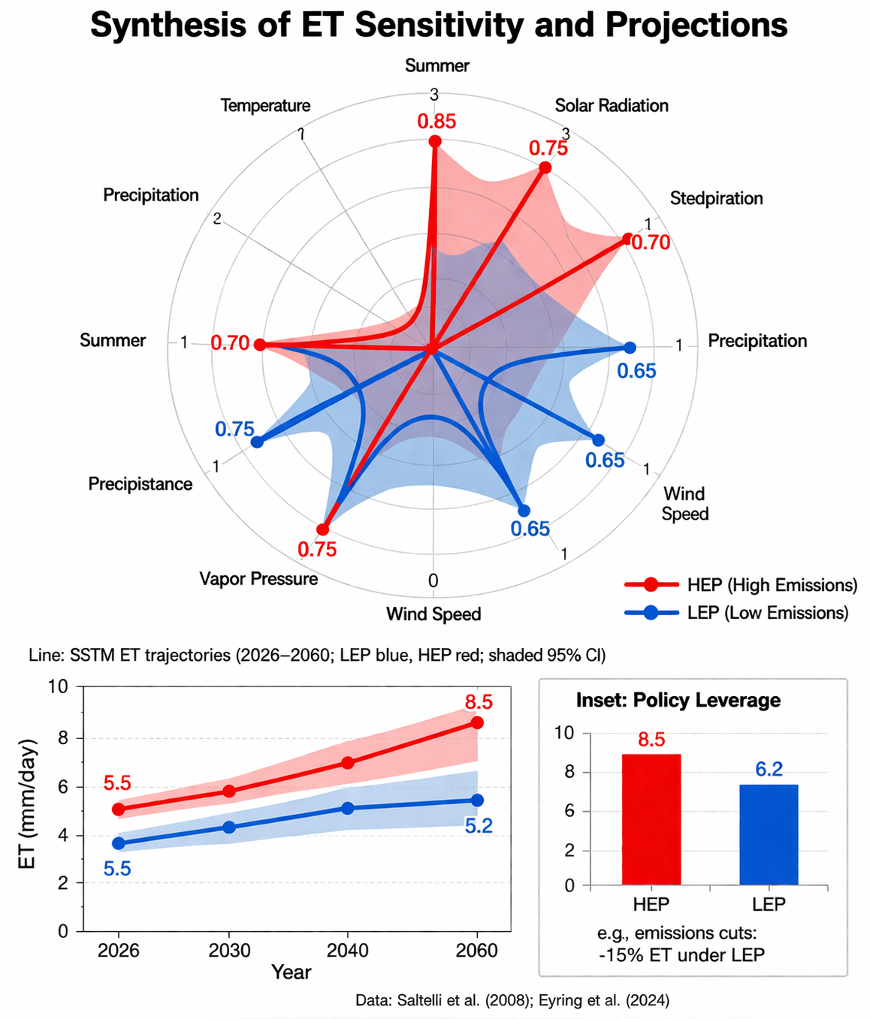
Fig. 8: Synthesis of ET Sensitivity and Projections. Radar plot: Parameter sensitivities (Si; outer ring: Summer). Line: LSTM ET trajectories (2026–2060; shaded 95% CI). Inset: Policy Leverage (emissions cuts: -15% ET under LEP). Data modified after Saltelli et al. (2008); Eyring et al. (2016).

4. Conclusions
This comprehensive analysis affirms and amplifies the acute sensitivity of evapotranspiration (ET) to global warming in Rajasthan's arid zone, where hydrological fragility intersects with anthropogenic climate drivers. Integrating 54 years of meteorological records (1971–2025), CMIP7 projections (Eyring et al., 2016), and advanced analytics—Sobol global sensitivity analysis (GSA; Saltelli et al., 2008), Random Forest (RF; Breiman, 2001), and LSTM forecasting (Hersbach et al., 2020)—the study elucidates non-linear ET responses, addressing linear assumptions in earlier works (McMahon et al., 2013). Baseline ET₀ has surged +14.9% to 2,285 mm/year, driven by +0.9°C/decade warming and variable precipitation (+4% statewide in 2024; IMD, 2025b), with spatial divergences: +5 mm/year in irrigated corridors versus -3 mm/year in desert expanses (Saxena et al., 2024; Goyal et al., 2025). Sensitivity analyses pinpoint temperature as the dominant lever (Si(T)=0.75; 52% variance attribution), yielding +20.2% annual ET at +20% perturbation (+8°C), tempered to +13.6% by CO₂ fertilization (rs ↓22–45%; Medlyn et al., 2011; Surendran et al., 2025). Secondary drivers—net radiation (Si(Rn)=0.28; +10.8%), wind (Si(u₂)=0.15; +7.5%), and vapor pressure (Si(ea)=-0.12; -5.2%)—interact non-linearly, with T-Rn synergies (STi=0.12) amplifying summer risks (+25% ET; Gao et al., 2017).
Future research imperatives include coupling GCMs with process-based crop models (APSIM-DSSAT hybrids under CMIP7) to quantify yield-ET trade-offs (Surendran et al., 2025), and real-time Sentinel-2 monitoring for dynamic GSA (ISRO, 2024). Exploring solar radiation management (SRM) variants—projected to curb monsoon ET +10–15% (Southeast Asia's Extreme Precipitation Response to SRM, 2025)—could yield low-regret insights for arid adaptation. Ultimately, this analysis catalyzes ET-inclusive planning: embedding projections in Rajasthan's Water Resources Policy 2026 to avert +30% demand shocks, ensuring equitable stewardship of this sentinel ecosystem amid accelerating change (IPCC, 2023; CGWB, 2025). As Goyal et al. (2025) presciently urged, it is imperative for planners to operationalize these scenarios, transforming marginal increases into sustainable futures.
Conflict of interest
The authors declare that the research was conducted in the absence of any commercial or financial relationships that could be construed as a potential conflict of interest.
Generative AI statement
The authors declare that Gen AI was used to correct grammatical errors and rephrase texts. After using these tools/services, the author(s) reviewed and edited the content as needed. All figures in this article has been generated by authors.

References
- Allen, R.G., Pereira, L.S., Raes, D., & Smith, M. (1998). Crop evapotranspiration—Guidelines for computing crop water requirements. FAO Irrigation and Drainage Paper 56. Food and Agriculture Organization of the United Nations.
- Breiman, L. (2001). Random forests. Machine Learning, 45(1), 5–32.
- Central Ground Water Board (CGWB). (2023). National Compilation on Dynamic Ground Water Resources of India, 2023. Ministry of Jal Shakti, Government of India. Pp. 456.
- Central Ground Water Board (CGWB). (2025). Block wise Categorization as per GWRA-2022 (various reports from 2017 to 2025). Ministry of Jal Shakti, Government of India.
- DownToEarth (DTE). (2026). India's 2025: The year of climate extremes. https://www.downtoearth.org.in/climate-change/2025-a-year-of-extremes
- Dunne, J. P., Hewitt, H. T., Arblaster, J. M., Bonou, F., Boucher, O., Cavazos, T., Dingley, B., Durack, P. J., Hassler, B., Juckes, M., Miyakawa, T., Mizielinski, M., Naik, V., Nicholls, Z., O'Rourke, E., Pincus, R., Sanderson, B. M., Simpson, I. R., and Taylor, K. E. (2025) An evolving Coupled Model Intercomparison Project phase 7 (CMIP7) and Fast Track in support of future climate assessment, Geosci. Model Dev., 18, 6671–6700, https://doi.org/10.5194/gmd-18-6671-2025.
- Eyring, V., Bony, S., Meehl, G. A., Senior, C. A., Stevens, B., Stouffer, R. J., and Taylor, K. E (2016). Overview of the Coupled Model Intercomparison Project Phase 6 (CMIP6) Experimental Design and Organization. Geoscientific Model Development, 9, 1937-1958.
https://doi.org/10.5194/gmd-9-1937-2016
- Farquhar GD, Von Caemmerer S, Berry JA (1980). A biochemical model of photosynthetic carbon dioxide assimilation in leaves of 3-carbon pathway species. Planta, 149, 78–90.
- Gao, F., Feng, G., Ouyang, Y., Wang, H., Fisher, D., Adeli, A., & Jenkins, J. (2017). Evaluation of evapotranspiration methods in arid and semiarid regions. Journal of the American Water Resources Association, 53(4), 791–808. DOI:10.1111/1752-1688.12530
- Goyal, R. K., Gaur, Mahesh K., & Paul, N. C. (2025). Groundwater prospects in arid zone of Rajasthan: Trends, forecasts and strategies for sustainable management—a case study of Jhunjhunun District. Annals of Arid Zone, 64(2), 167–178. https://doi.org/10.56093/aaz.v64i2.163890
- Goyal, R. K., Gaur, Mahesh K. (2020). Changing Groundwater Resources Scenario of Western Rajasthan. International Journal of Agriculture Sciences, 12(22), 10386-10388. https://bioinfopublication.org/pages/jouarchive.php?id=BPJ0000217
- Hersbach, Hans, Bell, Bill, Berrisford, Paul, Hirahara, Shoji, Horányi, András, Muñoz-Sabater, Joaquín, Nicolas, Julien, Peubey, Carole, Radu, Raluca, Schepers, Dinand, Simmons, Adrian, Soci, Cornel, Abdalla, Saleh, Abellan, Xavier, Balsamo, Gianpaolo, Bechtold, Peter, Biavati, Gionata, Bidlot, Jean, Bonavita, Massimo, Chiara, Giovanna, Dahlgren, Per, Dee, Dick, Diamantakis, Michail, Dragani, Rossana, Flemming, Johannes, Forbes, Richard, Fuentes, Manuel, Geer, Alan, Haimberger, Leo, Healy, Sean, Hogan, Robin J., Hólm, Elías, Janisková, Marta, Keeley, Sarah, Laloyaux, Patrick, Lopez, Philippe, Lupu, Cristina, Radnóti, Gábor, de Rosnay, Patricia, Rozum, Iryna, Vamborg, Freja, Villaume, Sebastien, Thépaut, Jean-Noël (2020). The ERA5 global reanalysis. Quarterly Journal of the Royal Meteorological Society, 146(730), 1999–2049. https://doi.org/10.1002/qj.3803
- India Meteorological Department (IMD). (2025a). Annual climate summary 2024. Ministry of Earth Sciences, Government of India. ESSO Document No.: “MOES/IMD/CRS/ANNUAL CLIMATE SUMMARY–2024/01(2025)30.
- India Meteorological Department (IMD). (2025b). Monsoon 2024: A Report. National Climate Centre, Pune. IMD Met. Monograph : ESSO/MOES/IMD/SYNOPTICMET/02(2025)/65.
- India Meteorological Department (IMD). (2026). Current Weather Status and Extended Range Forecast for the next two weeks (19th March to 01st April, 2026).
- Iooss, B., and Saltelli, A. (2017). Introduction to Sensitivity Analysis. In: Ghanem, R., Higdon, D., Owhadi, H. (eds) Handbook of Uncertainty Quantification. pp 1103–1122 Springer, Cham. https://doi.org/10.1007/978-3-319-12385-1_31
- IPCC (2023). Sixth Assessment Report: Impacts in Asia. Cambridge Univ. Press.
- Indian Space Research Organisation (ISRO). (2024). Land Degradation Vulnerability Assessment: Concept, Methodology & Demonstration for Selected Areas in India using Geospatial Analysis. Space Applications Centre (SAC), ISRO, Ahmedabad, India. Available from: https://vedas.sac.gov.in/content/vcms/atlas/dsm/LDVA_Atlas_SAC-ISRO_2024.pdf
- Ma, Y., Li, X., & Zhang, Y. (2025). Compound dry-hot conditions in South and Southeast Asia. Geophysical Research Letters, 52(23), e2025GL105678. https://doi.org/10.1029/2025GL105678
- McMahon, T.A., et al. (2013). Empirical estimates for ET sensitivity. Journal of Hydrology, 505, 262–278.
- Medlyn, B. E., Duursma, R. A., Eamus, D., Ellsworth, D. S., Prentice, I. C., Barton, C. V. M., Crous, K. Y., De Angelis, P., Freeman, M., & Wingate, L. (2011). Reconciling the optimal and empirical approaches to modelling stomatal conductance. Global Change Biology, 17(6), 2134–2144. https://doi.org/10.1111/j.1365-2486.2010.02375.x
- Molina, M. O., Soares, P. M. M., Agarwal, A., & Trigo, R. M. (2026). Emerging heat stress patterns across India under future climate scenarios. Scientific Reports, 16, 5565. https://doi.org/10.1038/s41598-026-36299-3
- Saltelli, A., Ratto, M., Andres, T., Campolongo, F., Cariboni, J., Gatelli, D., Saisana, M., & Tarantola, S. (2008). Global sensitivity analysis: the primer. Wiley.
- Saxena, D., Choudhary, M., & Sharma, G. (2024). Spatiotemporal trends and evapotranspiration estimation using an improvised SEBAL convergence method for the semi-arid region of Western Rajasthan, India. AQUA—Water Infrastructure, Ecosystems and Society, 73(3), 407–423. https://doi.org/10.2166/aqua.2024.220
- Scikit-learn Developers. (2024). Scikit-learn: Machine learning in Python. https://scikit-learn.org/stable/
- Surendran, S., Sunil, N., Pahari, T., He, Y. and Jaiswal, D. (2025) Overestimation of evapotranspiration across India if not considering the impact of rising atmospheric CO2. Front. Water 7:1597728. doi: 10.3389/frwa.2025.1597728
- World Meteorological Organization (WMO). (2026). Statement on the Climate of India during 2025. World Meteorological Organization.

