Emergence of Wetland Neighbourhoods in Port Harcourt and the Challenge to the Urban Planner

Abstract
This study investigates the emergence and expansion of wetland neighbourhoods in Port Harcourt, examining their spatial dynamics, underlying drivers, and implications for urban planning. Rapid urbanization, rising land values, and increasing housing costs in the formal city have driven development into environmentally sensitive wetland areas. Using a mixed-method approach, primary data were collected through 131 structured questionnaires administered across six selected neighbourhoods, supported by field observations and secondary data. Findings reveal that wetland neighbourhoods are not solely occupied by low-income groups but increasingly attract middle-income residents seeking affordable alternatives. However, their development is largely unregulated, with limited adherence to planning standards related to land-use compatibility, infrastructure provision, and environmental management. The absence of a coherent policy framework and effective development control mechanisms has resulted in poorly structured settlements, increased flood vulnerability, and broader urban management challenges. The study argues that wetland urbanization in Port Harcourt reflects systemic failures in housing provision and land-use governance. It recommends the formulation of wetland-specific planning policies, strengthened development control, and the integration of geospatial technologies to guide sustainable urban growth.

Keywords: Wetland urbanization, Informal development, Land-use planning, Housing,
Port Harcourt, Spatial growth

1. Introduction
The expansion of land-use activities across the globe has significantly altered wetland ecosystems, particularly in developing countries where regulatory control is often weak. These transformations have resulted in the degradation and, in many cases, the complete loss of natural wetland systems (Ajibola et al., 2012). Rapid urban population growth and the increasing demand for residential and commercial land uses have been identified as major drivers of pressure on urban wetlands (Azous & Horner, 2000).
Historically, wetlands in deltaic regions of Nigeria were utilized primarily for fishing, water supply, and infrastructure development such as bridges and roads. However, these activities have increasingly disrupted the ecological functions of wetlands. Wetlands provide critical ecosystem services, including water storage, flood regulation, purification, and pollution control, as well as habitat for diverse plant and animal species (Zedler & Kercher, 2005; Faulkner, 2004). The alteration of these natural systems not only undermines ecological balance but also reduces the long-term benefits derived by urban populations. Consequently, scholars and planning professionals have consistently advocated for the protection and sustainable management of wetlands (Davidson et al., 2019). Despite these calls, wetland degradation has continued to accelerate, largely driven by rapid urban expansion in developing regions.
Port Harcourt, a rapidly growing urban centre in the Niger Delta, is characterized by extensive wetland ecosystems and limited arable land suitable for development. Since its establishment in 1913, the city has experienced rapid population growth and economic expansion. By the late 1970s, available dry land within the city had largely been exhausted by residential and commercial uses (Kio-Lawson, 2014). This development was influenced by the city’s strategic role in Nigeria’s economic structure, particularly as a hub for oil and commercial activities.
Initial pressure on wetlands in Port Harcourt was driven by the need to exploit natural resources and support the growing urban population. However, the emergence of a severe housing shortage in the late 1970s redirected attention toward wetlands as alternative spaces for residential development. Low-income populations, unable to afford housing in the inner city, began to occupy these marginal lands, leading to the development of informal “waterside settlements” characterized by poor infrastructure, high density, and environmental degradation (Kio-Lawson, 2013; 2015).
Over time, the dynamics of wetland occupation have evolved. While early settlements were predominantly informal and associated with the urban poor, recent developments indicate the emergence of more organized residential neighbourhoods exhibiting elements of modern infrastructure and construction. These newer settlements differ significantly from traditional squatter communities and increasingly attract low- and middle-income groups seeking affordable housing alternatives. The relatively lower cost of land and rent in wetland areas has made them attractive options for urban residents who are priced out of the formal housing market.
Although the development of wetland neighbourhoods has contributed to alleviating housing pressure in the inner city, it has also introduced significant planning and environmental challenges. These include poor land-use organization, inadequate infrastructure, increased flood risk, and weak compliance with planning standards. The rapid and largely uncontrolled expansion of these neighbourhoods raises critical questions for urban planning and management: what are the implications of wetland urbanization for sustainable city development, and how can these challenges be effectively addressed?

2. Statement of the Problem
Housing shortage remains one of the most persistent and pressing challenges confronting Port Harcourt (Kio-Lawson, 2015). The situation has reached critical levels due to the very low scale of public housing provision, thereby leaving housing delivery largely in the hands of the private sector. This, combined with the limited availability of arable land suitable for physical development, has significantly shifted development pressure toward the wetlands surrounding the city.
The initial encroachment into these wetlands was driven by low-income populations who, unable to afford accommodation in the inner residential areas, sought alternative shelter in these marginal environments. Studies indicate that these early settlers were predominantly urban poor, lacking the financial capacity to compete within the formal housing market (Kio-Lawson, 2015). The absence of effective government control and planning intervention allowed such settlements to develop in an unregulated manner, resulting in numerous social and environmental challenges.
In recent times, however, a new dimension of the problem has emerged—the rapid growth of semi-organized wetland neighbourhoods. Unlike earlier squatter settlements, these developments are increasingly characterized by more structured physical layouts and are occupied by residents who do not necessarily fall within the low-income category. Their expansion, occurring largely without formal planning approval, monitoring, or regulatory oversight, raises serious concerns about the effectiveness of urban planning mechanisms in the city.
The continued proliferation of these neighbourhoods has significant implications for environmental sustainability, land-use functionality, and urban livability. Development in these areas often occurs without adherence to established planning standards, thereby compromising environmental quality and increasing vulnerability to flooding and infrastructure inefficiencies. The absence of coordinated planning and development control has left these settlements evolving in ways that may undermine long-term urban stability.
Therefore, the core problem addressed in this study is the uncontrolled expansion of wetland neighbourhoods in Port Harcourt and its implications for sustainable urban development. The consequences of such unregulated growth extend beyond the immediate need for housing, posing broader risks to environmental integrity, urban functionality, and the overall quality of life within the city.

3. Literature Review
Urban wetland transformation has emerged as a critical concern in rapidly urbanizing regions, particularly within developing countries where institutional capacity for land-use regulation is often weak or fragmented. A growing body of literature indicates that wetlands are increasingly being converted into residential, commercial, and infrastructural uses as a result of rapid population growth, housing deficits, and escalating urban land values (Zedler & Kercher, 2005; Davidson et al., 2019; Seto et al., 2012). These transformations not only alter the ecological integrity of wetlands but also reshape urban spatial structures in ways that introduce new environmental and planning challenges.
In many cities across Africa and the Global South, urban expansion has extended into ecologically sensitive zones such as wetlands, floodplains, and coastal areas. This pattern of development is closely linked to affordability constraints and the need for proximity to economic opportunities, particularly among low- and middle-income populations (UN-Habitat, 2020; Douglas et al., 2008). As formal housing markets fail to meet demand, households and small-scale developers increasingly occupy marginal lands that are more accessible but environmentally vulnerable. Empirical evidence from coastal African cities further demonstrates that such settlements are often exposed to recurrent flooding, inadequate infrastructure, and heightened environmental risks (Adelekan, 2010).
Within the Nigerian context, the inadequacy of formal housing delivery systems has significantly contributed to the proliferation of alternative settlement forms, including waterfront communities and reclaimed wetland neighbourhoods. Studies in Port Harcourt and other urban centres reveal that the inability of government and private sector mechanisms to provide affordable housing has compelled residents to seek accommodation in marginal spaces outside formal planning control (Kio-Lawson, 2015; Olotuah & Adesiji, 2005). While earlier research predominantly characterized these areas as squatter settlements marked by poor housing quality and infrastructural deficits, emerging evidence points to a transition toward semi-formal wetland neighbourhoods occupied by relatively stable, income-earning populations. This shift reflects evolving dynamics in urban land markets and housing accessibility.
Environmental scholarship has consistently highlighted the ecological consequences of wetland encroachment. Wetlands perform critical ecosystem functions, including flood regulation, water purification, and biodiversity conservation (Mitsch & Gosselink, 2015; MEA, 2005). Their conversion for urban development disrupts these functions, leading to increased flood risk, loss of biodiversity, and the obstruction of natural drainage systems (Junk et al., 2013). In rapidly growing cities, these impacts are often compounded by poor planning practices and unregulated land reclamation activities, which further exacerbate environmental vulnerability.
From a planning perspective, the expansion of settlements into wetlands is closely associated with deficiencies in land-use governance and development control. Weak enforcement of planning regulations, absence of up-to-date master plans, and the prevalence of informal land transactions contribute to uncoordinated and incompatible land-use patterns (Watson, 2009; de Satgé & Watson, 2018). International planning frameworks emphasize the importance of integrated and enforceable spatial planning systems in managing urban growth and protecting environmentally sensitive areas (UN-Habitat, 2015, 2020). However, in many cities, including Port Harcourt, such frameworks are either absent or inadequately implemented, resulting in fragmented urban expansion.
Despite the growing body of literature on wetland degradation and informal urban development, there remains a significant gap in empirical studies that integrate socio-economic drivers, spatial dynamics, and planning implications of wetland urbanization within a unified analytical framework. Existing studies often examine these dimensions in isolation, thereby limiting a comprehensive understanding of the phenomenon. This study seeks to address this gap by providing an integrated analysis of wetland neighbourhoods in Port Harcourt, combining socio-economic assessment with spatial and planning perspectives to inform sustainable urban development strategies.

4. Theoretical and Conceptual Framework
The emergence and expansion of wetland neighbourhoods in rapidly urbanizing cities such as Port Harcourt can be more robustly interpreted through an integrated theoretical lens that combines urban informality, spatial justice, and land-use governance frameworks. These perspectives collectively explain how structural urban dynamics, institutional limitations, and socio-economic inequalities shape settlement patterns in environmentally sensitive areas.
Contemporary scholarship on urban informality has moved beyond earlier binary distinctions between formal and informal development to emphasize informality as a mode of urbanization embedded within state practices and market systems (Roy, 2005; Roy, 2009; Watson, 2014). Informality is now widely understood as a continuum of regulatory flexibility, negotiated legality, and adaptive survival strategies, particularly in cities of the Global South (McFarlane & Waibel, 2012; Bhan, 2019). Within this framework, wetland neighbourhoods in Port Harcourt can be conceptualized as hybrid urban formations, where development occurs through the interaction of private land markets, indigenous land ownership systems, and weak regulatory enforcement. These spaces are not entirely unplanned but are instead shaped by localized logics of land subdivision, incremental development, and socio-economic accessibility.
The concept of spatial justice further provides a critical analytical lens for understanding the uneven distribution of urban opportunities and risks. Building on the foundational work of Soja (2010), recent studies have emphasized how urban spatial structures often reproduce socio-economic inequalities by systematically excluding vulnerable populations from well-serviced and safe environments (Fainstein, 2010; Marcuse et al., 2018). In the context of Port Harcourt, the exclusion of low- and middle-income groups from formal land markets, due to escalating land values and housing costs, has led to their displacement into marginal and ecologically fragile environments such as wetlands. This process reflects what has been described as environmental injustice, where disadvantaged groups disproportionately bear exposure to environmental hazards including flooding, poor drainage, and infrastructure deficits (Anguelovski et al., 2016).
In parallel, land-use governance theory highlights the central role of institutional capacity, regulatory frameworks, and planning instruments in shaping urban development outcomes. Effective land-use governance requires coherent policies, enforceable development control mechanisms, and up-to-date spatial planning tools such as master plans and zoning regulations (UN-Habitat, 2020; Healey, 2007). However, in many rapidly growing cities, including Port Harcourt, governance systems are often characterized by weak enforcement, fragmented institutional responsibilities, and the prevalence of informal land transactions (de Satgé & Watson, 2018). These conditions facilitate uncoordinated spatial expansion into wetlands, resulting in patterns of development that lack conformity with planning standards related to accessibility, drainage, building setbacks, and land-use compatibility.
More recent urban scholarship also emphasizes the role of housing market dynamics and speculative urbanism in driving the occupation of marginal lands (Aalbers, 2016; Obeng-Odoom, 2020). Rising land values in formal urban cores create affordability barriers, pushing households and small-scale developers toward alternative spaces where land is cheaper but environmentally risky. In this sense, wetland neighbourhoods represent a spatial manifestation of broader structural imbalances in urban land and housing systems.
Drawing from these theoretical perspectives, this study adopts an integrated conceptual framework that links three interrelated drivers:
- Housing market pressures, including rising land values and limited access to affordable housing
- Institutional and planning failures, particularly weak development control and absence of guiding spatial plans
- Environmental vulnerability, associated with the occupation and transformation of wetland ecosystems
Together, these factors provide a comprehensive explanation for the emergence, spatial configuration, and socio-environmental characteristics of wetland neighbourhoods in Port Harcourt. This integrated approach enables a deeper understanding of wetland urbanization not merely as a planning anomaly, but as a structurally produced outcome of contemporary urbanization processes in the Global South.

5. Study Area: Geography of Port Harcourt
Port Harcourt was established in 1913 by the colonial administration as a modern seaport designed to facilitate the export of agricultural produce from the hinterlands of Eastern and Northern Nigeria (Akpoghomeh, 1995; Okoye, 2013). The initial city occupied approximately 13,000 acres of land belonging to the Ikwerre communities in the north and the Okrika communities in the south (Akpoghomeh, 1995). Beyond its port function, the city rapidly evolved into an administrative and commercial centre, serving as a major convergence point for diverse ethnic groups, including the Ikwerre, Okrika, Kalabari, and Ibani (Weli & Briggs-Kamara, 2015).
The development of port infrastructure and the expansion of railway networks connecting Port Harcourt to other parts of Nigeria significantly enhanced its economic importance, attracting migrants and traders from across the country (Onyegbula, 2010). This growth was further accelerated by the discovery of crude oil in the Niger Delta and the subsequent designation of Port Harcourt as the capital of Rivers State, which transformed the city into a major hub for oil and gas activities (Aaron, 2012; Weli & Briggs-Kamara, 2015). Today, the city hosts numerous multinational oil companies and accommodates a population exceeding 5 million people (National Population Commission [NPC], 2020), making it one of the fastest-growing urban centres in Nigeria.
Geographically, Port Harcourt is located within the Niger Delta region and is characterized by an intricate network of rivers, creeks, and mangrove swamps, particularly along its eastern, western, and southern boundaries (Nwilo & Badejo, 2006; Uyigue & Agho, 2007). This unique ecological setting significantly influenced early urban development patterns, which were concentrated on the relatively dry and more stable northern axis of the city. These areas provided more suitable and cost-effective conditions for physical development compared to the waterlogged southern zones (Weli, 2014).
However, rapid population growth, economic expansion, and increasing demand for urban land have led to the exhaustion of available dry land, thereby driving urban expansion into surrounding agricultural lands and marginal wetland areas (Nwilo & Badejo, 2006; Uyigue & Agho, 2007). This outward expansion has fundamentally altered the spatial structure of the city and intensified development pressures on environmentally sensitive ecosystems.
Climatically, Port Harcourt falls within the humid tropical (sub-equatorial) climate zone, with an average annual temperature of about 30°C and high rainfall throughout the year, averaging approximately 2,300 mm (NIMET, 2020; Uyigue & Agho, 2007). These climatic conditions, combined with the city’s low-lying terrain and extensive wetland systems, contribute to its high vulnerability to flooding and environmental hazards (Douglas et al., 2008). The city is served by multiple modes of transportation, including road, water, rail, and air, reinforcing its role as a major economic and logistical hub in the Niger Delta region.

6. Emergence of Wetland Neighbourhoods in Port Harcourt
The emergence of wetland neighbourhoods in Port Harcourt can be traced to rapid population growth and economic expansion in the post-civil war period. The establishment of multinational oil companies, expansion of transportation networks, and increasing commercial activities attracted large numbers of migrants into the city. However, the existing urban infrastructure and housing supply were insufficient to accommodate this rapid influx of population.
This imbalance led to an acute housing shortage, resulting in a sharp increase in land values and rental costs within the core and inner-city areas. Consequently, low-income populations, unable to afford formal housing, were compelled to seek alternative accommodation in marginal environments. Many of these residents preferred locations close to the city centre for economic reasons and therefore moved into the southern and western peripheries characterized by mangrove swamps and flood-prone wetlands. This pattern aligns with broader urbanization trends in Sub-Saharan Africa, where rapid population growth and weak planning systems drive settlement expansion into environmentally sensitive areas (UN-Habitat, 2020; Cobbinah & Erdiaw-Kwasie, 2021).
This marked the initial phase of wetland encroachment in the city, largely driven by the urban poor. The early settlements that emerged in these areas, commonly referred to as “waterside settlements,” were predominantly informal and characterized by poor housing conditions, lack of infrastructure, high occupancy rates, and unsanitary environments (Kio-Lawson, 2013; 2015). Despite these challenges, the relatively low cost of land and the ease of informal land reclamation made these areas attractive to residents. Over time, these settlements expanded significantly and became an integral part of the city’s spatial structure, with about thirty-two such communities currently in existence (Kio-Lawson, 2015). Similar patterns of informal wetland occupation have been documented across African cities, where unregulated urban expansion produces fragmented and environmentally vulnerable settlement forms (Adelekan, 2016; Güneralp et al., 2017).
The environmental degradation and social challenges associated with these settlements eventually prompted government intervention. Some waterside communities were cleared and redeveloped into planned residential neighbourhoods with improved physical structures and basic infrastructure. These interventions were intended to relocate displaced low-income populations and provide more functional living environments. However, the implementation process was undermined by political interference, resulting in a significant proportion of the housing units being allocated to middle-income individuals rather than the original beneficiaries.
This outcome triggered a new phase of wetland development. The improved infrastructure and spatial organization of the redeveloped areas attracted further interest in adjacent wetland lands. Private developers and individuals began to acquire and develop these surrounding areas, leading to the emergence of more organized residential neighbourhoods. This transition reflects broader dynamics of urban land markets in developing cities, where rising land values and accessibility considerations drive the transformation of marginal lands into semi-formal residential areas (Angel et al., 2011; Watson, 2014).
Unlike the earlier waterside settlements, these newer developments exhibit relatively better building quality and some level of infrastructure provision. Nevertheless, they continue to lack formal planning approval and regulatory oversight. Empirical studies have shown that weak institutional frameworks and ineffective land-use governance are major drivers of such unregulated developments in rapidly growing cities (UN-Habitat, 2020; Owusu et al., 2022).
Land transactions in these wetland areas are typically controlled by indigenous landowners, who determine plot sizes and layout patterns without adherence to established planning standards. Development often involves land reclamation through sand filling and incremental construction processes. While these neighbourhoods display some degree of spatial organization and functionality, the absence of formally approved development plans has resulted in layouts that fall short of urban planning requirements, particularly with respect to road networks, drainage systems, building setbacks, and land-use compatibility.
Overall, the evolution of wetland neighbourhoods in Port Harcourt reflects a transition from informal, low-income settlements to semi-organized, mixed-income residential environments. However, their continued expansion without effective planning control poses significant challenges for environmental sustainability, infrastructure provision, and long-term urban development. Such patterns of wetland urbanization have been linked to increased flood risk, ecological degradation, and disruption of natural hydrological systems in comparable urban contexts (Adelekan, 2016; Davidson et al., 2019).
.
Land transactions in these wetland areas are typically controlled by indigenous landowners, who determine plot sizes, road alignments, and overall layout patterns without adherence to established planning standards. In most cases, these decisions are guided by local knowledge and economic considerations rather than formal urban planning regulations.
Prior to development, land preparation is required due to the marshy nature of the terrain. This is commonly achieved through sand filling or other locally adapted reclamation techniques to make the land suitable for construction. The relatively low cost of land in these areas has increasingly attracted not only low-income groups but also segments of the middle- and high-income population. For some, this shift represents an opportunity to secure affordable housing, while for others, it serves as a strategic investment in an emerging urban frontier.
Through the combined efforts of landowners and developers, these areas have gradually evolved into semi-organized residential neighbourhoods with some degree of spatial structure and functionality. Unlike earlier “waterside settlements,” buildings in these neighbourhoods are predominantly constructed using permanent materials such as cement, and road networks, though often substandard, are developed to allow vehicular access. In some cases, basic drainage considerations for domestic wastewater are incorporated into the layout.
However, despite these improvements, the absence of formally approved development plans continues to limit their conformity to standard urban planning principles. Critical issues persist regarding aesthetic quality, efficiency of spatial layout, respect for building setbacks, privacy, and land-use zoning. These deficiencies highlight a significant gap between the existing development pattern and the ideal characteristics of planned urban neighbourhoods, thereby reinforcing concerns about long-term functionality, environmental sustainability, and urban livability.

6. Research Design and Sampling
This study adopted a mixed-method research design, integrating quantitative and qualitative approaches to examine the characteristics and dynamics of wetland neighbourhoods in Port Harcourt. The research design combined structured questionnaire surveys with field observations and key informant interviews to ensure a comprehensive understanding of the study area.
A preliminary survey identified fourteen (14) established wetland neighbourhoods across the city (see Table 1). From this population, six (6) neighbourhoods were purposively selected to ensure adequate spatial representation and coverage of varying development characteristics.
Within the selected neighbourhoods, a total of fifty-five (55) streets were enumerated. Using a 40% sampling ratio, twenty-one (21) streets were selected for detailed investigation. Subsequently, a building-level enumeration within the sampled streets identified seven hundred and twenty (720) buildings. From this population, a 20% sample size was drawn, resulting in one hundred and thirty-one (131) buildings.
Household heads within the selected buildings constituted the target respondents, leading to the administration of 131 structured questionnaires. A systematic random sampling technique was employed in selecting buildings along each sampled street to ensure uniform coverage and minimize selection bias.
In addition to the questionnaire survey, direct field observations and informal interviews were conducted to capture contextual and qualitative insights, particularly regarding physical development patterns, environmental conditions, and local governance structures within the neighbourhoods.

Table 1: Wetland Neighbourhoods in Port Harcourt
S/N | Wetland Neighbourhood
1 | Marine Base
2 | Koko Ama
3 | Eastern By-pass
4 | Okuru
5 | Ibeto
6 | New Road
7 | Borikiri UPE
8 | Ogbogoro
9 | Aggrey
10 | Ndoki
11 | Abuloma
12 | Amadi
13 | Eagle Island
14 | Rumuoluomeni
Total | 14
Researchers’ Fieldwork 2025

Table 2: Sampled Neighbourhoods and Sampling Structure
S/N | Neighbourhood | Streets | Sampled Streets | Buildings | Sampled Buildings
1 | Borikiri | 10 | 4 | 127 | 25
2 | Amadi | 8 | 3 | 85 | 17
3 | Rumuoluomeni | 13 | 5 | 164 | 33
4 | Ibeto | 8 | 3 | 120 | 24
5 | Eastern By-pass | 6 | 2 | 80 | 16
6 | New Road | 10 | 4 | 144 | 28
Total | 55 | 21 | 720 | 131
Researchers’ Fieldwork 2025

6.1 Spatial Analysis of Wetland Neighbourhood Expansion
To complement the socio-economic analysis, spatial analysis techniques were employed to examine the distribution and expansion of wetland neighbourhoods in Port Harcourt.
Geospatial data were obtained from satellite imagery, existing land-use maps, and field observations. The spatial analysis involved:
- Mapping the location of identified wetland neighbourhoods
- Overlaying settlement patterns on wetland and flood-prone zones
- Assessing proximity to major roads and urban infrastructure
- Identifying patterns of spatial clustering
The analysis revealed that wetland neighbourhoods are predominantly concentrated along the southern and western fringes of the city, corresponding with mangrove swamp zones and tidal floodplains. These areas are characterized by high environmental vulnerability but remain attractive due to their proximity to the urban core.
Further spatial examination indicates that the expansion of these neighbourhoods has led to the encroachment on natural drainage channels, contributing to increased flooding within both the wetland settlements and adjoining inner-city areas.
The spatial pattern also suggests a transition from dispersed informal settlements to more organized but unregulated neighbourhood layouts, reflecting the growing involvement of private developers and middle-income residents.

7. Results
The results of the study are presented in two main categories: socio-economic characteristics of residents and environmental and physical attributes of wetland neighbourhoods. In addition to descriptive statistics, the analysis incorporates comparative assessment of land values, income levels, and development patterns to explain the underlying drivers of wetland urbanization.

7.1 Characteristics of Wetland Neighbourhoods in Port Harcourt

7.1.1 The Residents: Who Are They?
Land prices and rental values in wetland neighbourhoods are generally lower than those in the inner-core residential areas of Port Harcourt, although they remain higher than those observed in traditional “waterside” settlements. This intermediate cost structure positions wetland neighbourhoods as relatively affordable alternatives within the urban housing market.
Field evidence, particularly relating to land acquisition and the cost-intensive process of site preparation (such as sand filling and foundation reinforcement), indicates that developers in these areas are not predominantly from the low-income category. Rather, the financial requirements associated with wetland development suggest the increasing participation of middle-income, and in some cases higher-income, groups.
This socio-economic profile is further reflected in the nature of the physical structures observed. Although not fully compliant with modern architectural and planning standards, buildings in these neighbourhoods are typically constructed using permanent materials and exhibit a level of structural investment that distinguishes them from the informal housing commonly found in waterside settlements. This represents a clear departure from the substandard and temporary structures traditionally associated with earlier wetland occupation.

Table 3 Comparative analysis of cost of Land in Wetland Neighbourhood and the Inner-City Areas
Size of Land (in feet) | Average cost of land in 2022(measured in Naira)
Size of Land (in feet) | Urban Wetland | High Density Area | Medium Density Area | Low Density Area
100x50 | 3.5m | 15m | 18m | 35m.
100x25 | 3m | 12.5m | 15m | 22.5m
50x50 | 2.5m | 12m | 13.5m | 17.5m.
50x25 | 2m | 5m | 12m | 15m
Researchers’ fieldwork 2025
Table 3 presents a comparative analysis of land values in wetland neighbourhoods relative to those in the inner-city residential areas, further illustrating the economic positioning of these emerging settlements within the broader urban land market.
Table 4 Comparative analysis of rent on Common Residential Accommodation Types in Wetland Neighbourhood and the Inner-City Areas (2022)
Accommodation Type | Average Yearly Rent on Residential Accommodation (in Naira)
Accommodation Type | Wetland Neighbourhood | High Density Area | Medium Density Area | Low Density Area
Self-Contain | 200,000 | 400,000 | 600,000 | 1.2m
1Bedroom flat | 400,000 | 600,000 | 800,000 | 2.5m
2 Bedroom flat | 600,000 | 800,000 | 1million | 3.5million
3 Bedroom Flat | 700,000 | 900,000 | 1.2million | 6million
Researchers’ fieldwork 2025

The analysis indicates that both land values and rental costs in wetland neighbourhoods are significantly lower than those in the inner-city areas. This relative affordability serves as a key driver for residential relocation, encouraging many urban dwellers to either build homes or secure rental accommodation within these areas. However, the socio-economic profile of residents suggests that they cannot be classified as the urban poor. This is evident in both the nature of the physical structures developed and the income distribution of residents, as presented in Table 5.
Table 5 Monthly Income of Residents of Urban Wetland in Port Harcourt
Monthly Income (in naira) | Frequency | Percentage (%)
1000-40999 | 10 | 7.6
50000-90999 | 15 | 11.4
100000-140,999 | 20 | 15.2
150,000190,999 | 20 | 15.2
200,000-240,999 | 18 | 13.7=
250,000-290,999 | 15 | 11.4
300,000-340999 | 21 | 16
350,000-390,999 | 8 | 6.1
400,000+ | 4 | 3.1
Total | 131 | 100
Researchers’ fieldwork 2025
The national minimum wage in Nigeria currently ranges between ₦70,000 and ₦80,000. However, the income distribution of residents in the study area reveals that only 19% earn below ₦100,000 per month, a threshold which, given prevailing inflationary conditions, may reasonably be classified as low income. The majority of respondents fall within the middle-income bracket, with 55% earning between ₦100,000 and ₦290,999, while a further 22.1% earn between ₦300,000 and ₦390,999.
These findings suggest that, although many residents may not possess sufficient financial capacity to access land or housing in the high-cost inner-city areas, they cannot be categorized as the urban poor. Rather, they represent a relatively stable, economically active population with moderate income levels. This is further supported by their educational attainment and employment status, as presented in Tables 4 and 5.
Table 6 Educational Status of Residents of Urban Wetland Neighbourhoods in Port Harcourt
Educational Status | Frequency | Percentages (%)
No education | 15 | 11.5
Primary education | 10 | 7.6
Secondary | 35 | 26.7
Vocational | 40 | 30.5
Tertiary | 31 | 23.6
Total | 131 | 100
Researchers’ fieldwork 2025
Table 7: Employment Status of Residents of Urban Wetland Neighbourhood in Port Harcourt
Employment Status | Frequency | Percentages (%)
Public Servants | 53 | 40.5
Employed by Private Firm | 20 | 23.6
Artisan/Handicraft | 15 | 11.5
Local Manufacturing | 10 | 7.6
Trading | 31 | 23.6
Total | 131 | 100
Researchers’ fieldwork 2025
The analysis indicates that developing residential properties in urban wetland areas is both technically and financially demanding. Site preparation alone involves significant costs, particularly due to the need for land reclamation and specialized foundation systems suited to the waterlogged terrain. Respondents identified limited accessibility to building sites as a major constraint, with construction materials often transported via locally made canoes or manually carried through swampy environments. These logistical challenges substantially increase the overall cost of construction.
Despite these constraints, wetland development remains a viable option for many developers who are unable to afford the high land costs in the inner-city areas. Approximately 28.7% of property owners reported that they relied on bank loans to finance land acquisition in these areas. The combined effect of high development costs and financing constraints contributes to the prolonged duration of construction projects, as reflected in the building completion timelines presented in Table 6.

Table 8: Duration of Completion of buildings by Respondents who are Landlords
Duration | Frequency | Percentages (%)
1-2years | 10 | 9.9
3-4years | 25 | 24.8
5-6years | 30 | 29.7
7-8years | 36 | 35.6
Total | 101 | 100
Researchers’ fieldwork 2025
Note: About 23% of the respondents are tenants therefore they are not included here.

8. Discussion
The findings of this study demonstrate that the emergence of wetland neighbourhoods in Port Harcourt is not simply a product of informal encroachment, but rather the outcome of a complex interaction between housing market dynamics, institutional limitations, and environmental constraints.
The relatively lower cost of land and housing in wetland areas functions as a significant pull factor, particularly for middle-income households that are priced out of the formal land market. This reinforces broader urban theory which suggests that expansion into marginal lands is driven primarily by affordability pressures rather than locational preference. In this context, wetland neighbourhoods represent an intermediate housing solution within the urban land market hierarchy.
However, the spatial structure of these neighbourhoods reveals clear deviations from established planning standards. The absence of effective development control mechanisms has resulted in irregular layouts, inadequate road hierarchies, and poorly integrated infrastructure systems. These deficiencies reflect systemic weaknesses in urban governance and planning enforcement.

8.1 Spatial (Map-Based) Interpretation
Analysis of the spatial distribution (as shown in your GIS/map outputs) indicates that wetland neighbourhoods are predominantly clustered along the southern and western peripheries of the city, corresponding with low-lying mangrove zones and flood-prone areas. The pattern suggests a peripheral expansion model, where development progresses outward from the urban core into environmentally marginal lands.
The map further reveals:
- Fragmented and uncoordinated street patterns, indicating absence of planned layouts
- Encroachment along natural drainage channels, contributing to hydrological disruption
- Linear development along access corridors, suggesting opportunistic land subdivision by indigenous landowners
- Spatial discontinuity, with weak connectivity between neighbourhoods and the formal city
This spatial configuration reinforces the argument that development is largely market-driven and informally regulated, rather than guided by formal planning frameworks. From a spatial justice perspective, the occupation of environmentally vulnerable wetlands highlights inequalities in access to safe and serviced urban land. While these neighbourhoods provide critical housing opportunities, they simultaneously expose residents to environmental risks, particularly flooding and infrastructure deficits.
The study also reveals a clear transition from traditional squatter settlements to semi-organized wetland neighbourhoods. This shift reflects changes in the socio-economic profile of residents—from predominantly low-income groups to a more mixed-income population. Consequently, the planning challenge is no longer limited to informal settlement upgrading but now requires more integrated and forward-looking urban development strategies.

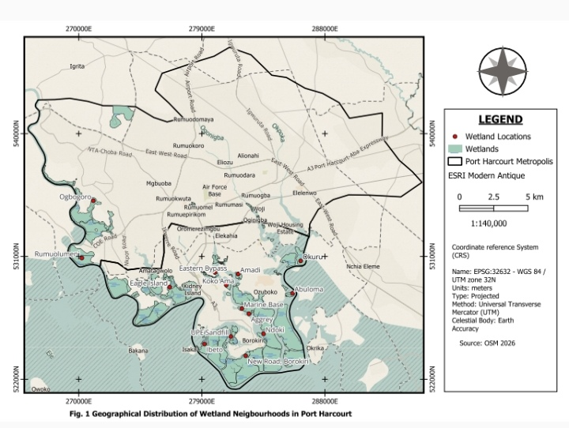

8.2 Environmental Conditions of Wetland Neighbourhoods
Wetland neighbourhoods in Port Harcourt exhibit distinct environmental and infrastructural characteristics shaped by both their ecological setting and the absence of formal planning control.
The road network typically consists of a primary access road that connects the neighbourhood to external routes and feeds into a system of secondary and tertiary streets. These roads, often determined by indigenous landowners rather than formal planning standards, range in width from approximately 4.2 to 7.2 metres. Most of these roads are untarred, making them difficult to navigate, particularly during the rainy season. In many cases, their narrow widths discourage on-street parking and limit accessibility.
Drainage infrastructure is largely absent or poorly developed. Wastewater from residential buildings is frequently discharged directly onto the streets, contributing to unsanitary conditions and environmental degradation. The lack of development control also leads to encroachment on road alignments, as property boundaries often extend beyond designated survey limits, further constraining road width and preventing the installation of drainage systems.
Building patterns within these neighbourhoods reflect minimal compliance with planning standards. Structures are often erected without regard for required setbacks, resulting in overcrowded conditions where buildings are closely spaced, sometimes with rooflines nearly touching. This raises concerns regarding ventilation, privacy, and fire safety. High perimeter walls are commonly constructed for security purposes, further limiting spatial openness.
Solid waste management is another critical challenge. In the absence of designated waste collection points, residents often resort to using domestic waste as a means of land reclamation. While this practice temporarily raises ground levels, it contributes to environmental hazards during flooding events, as waste materials are frequently redistributed into streets and residential areas.
Flooding remains a defining environmental issue in these neighbourhoods. Residents described a recurrent flooding period locally referred to as “Big Water”, occurring approximately 4–5 times annually, with peak intensity between December and January. During this period, canals overflow, submerging roads and restricting both pedestrian and vehicular movement. Buildings with low foundation levels are particularly vulnerable, leading to frequent incidences of residential flooding.
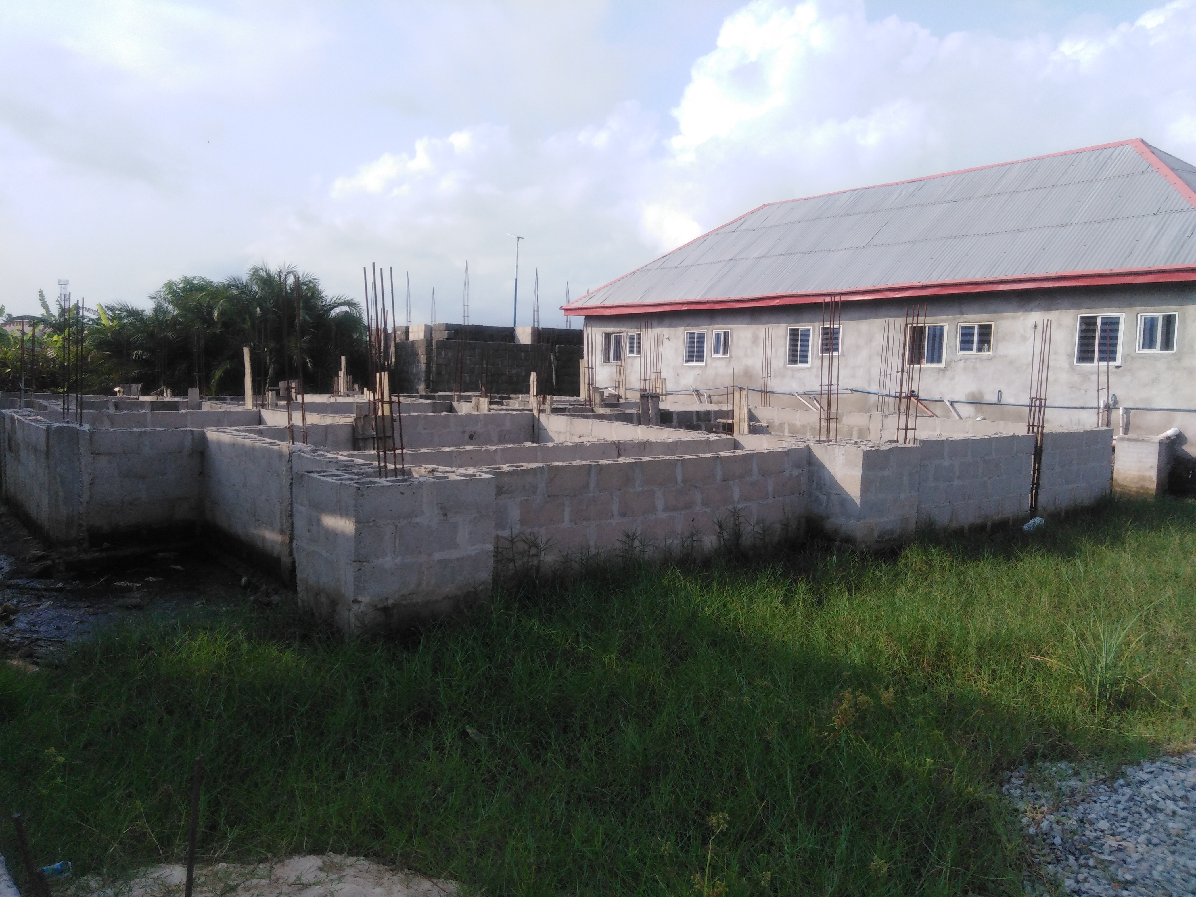
Plate 1: Normal DPC for residential buildings in Urban Wetland Neighbourhood in Port Harcourt
Some of these settlements boast of some public infrastructure like market and health facility unlike the squatter settlements. Laterite roads are common in these settlements and are mostly through self-help by land developers. In some areas before a developer mobilize to his site to start development, he is expected to deposit a truck of sand or laterite to the street. These contributions are used to open up new roads or extend existing ones in the neighbourhood.
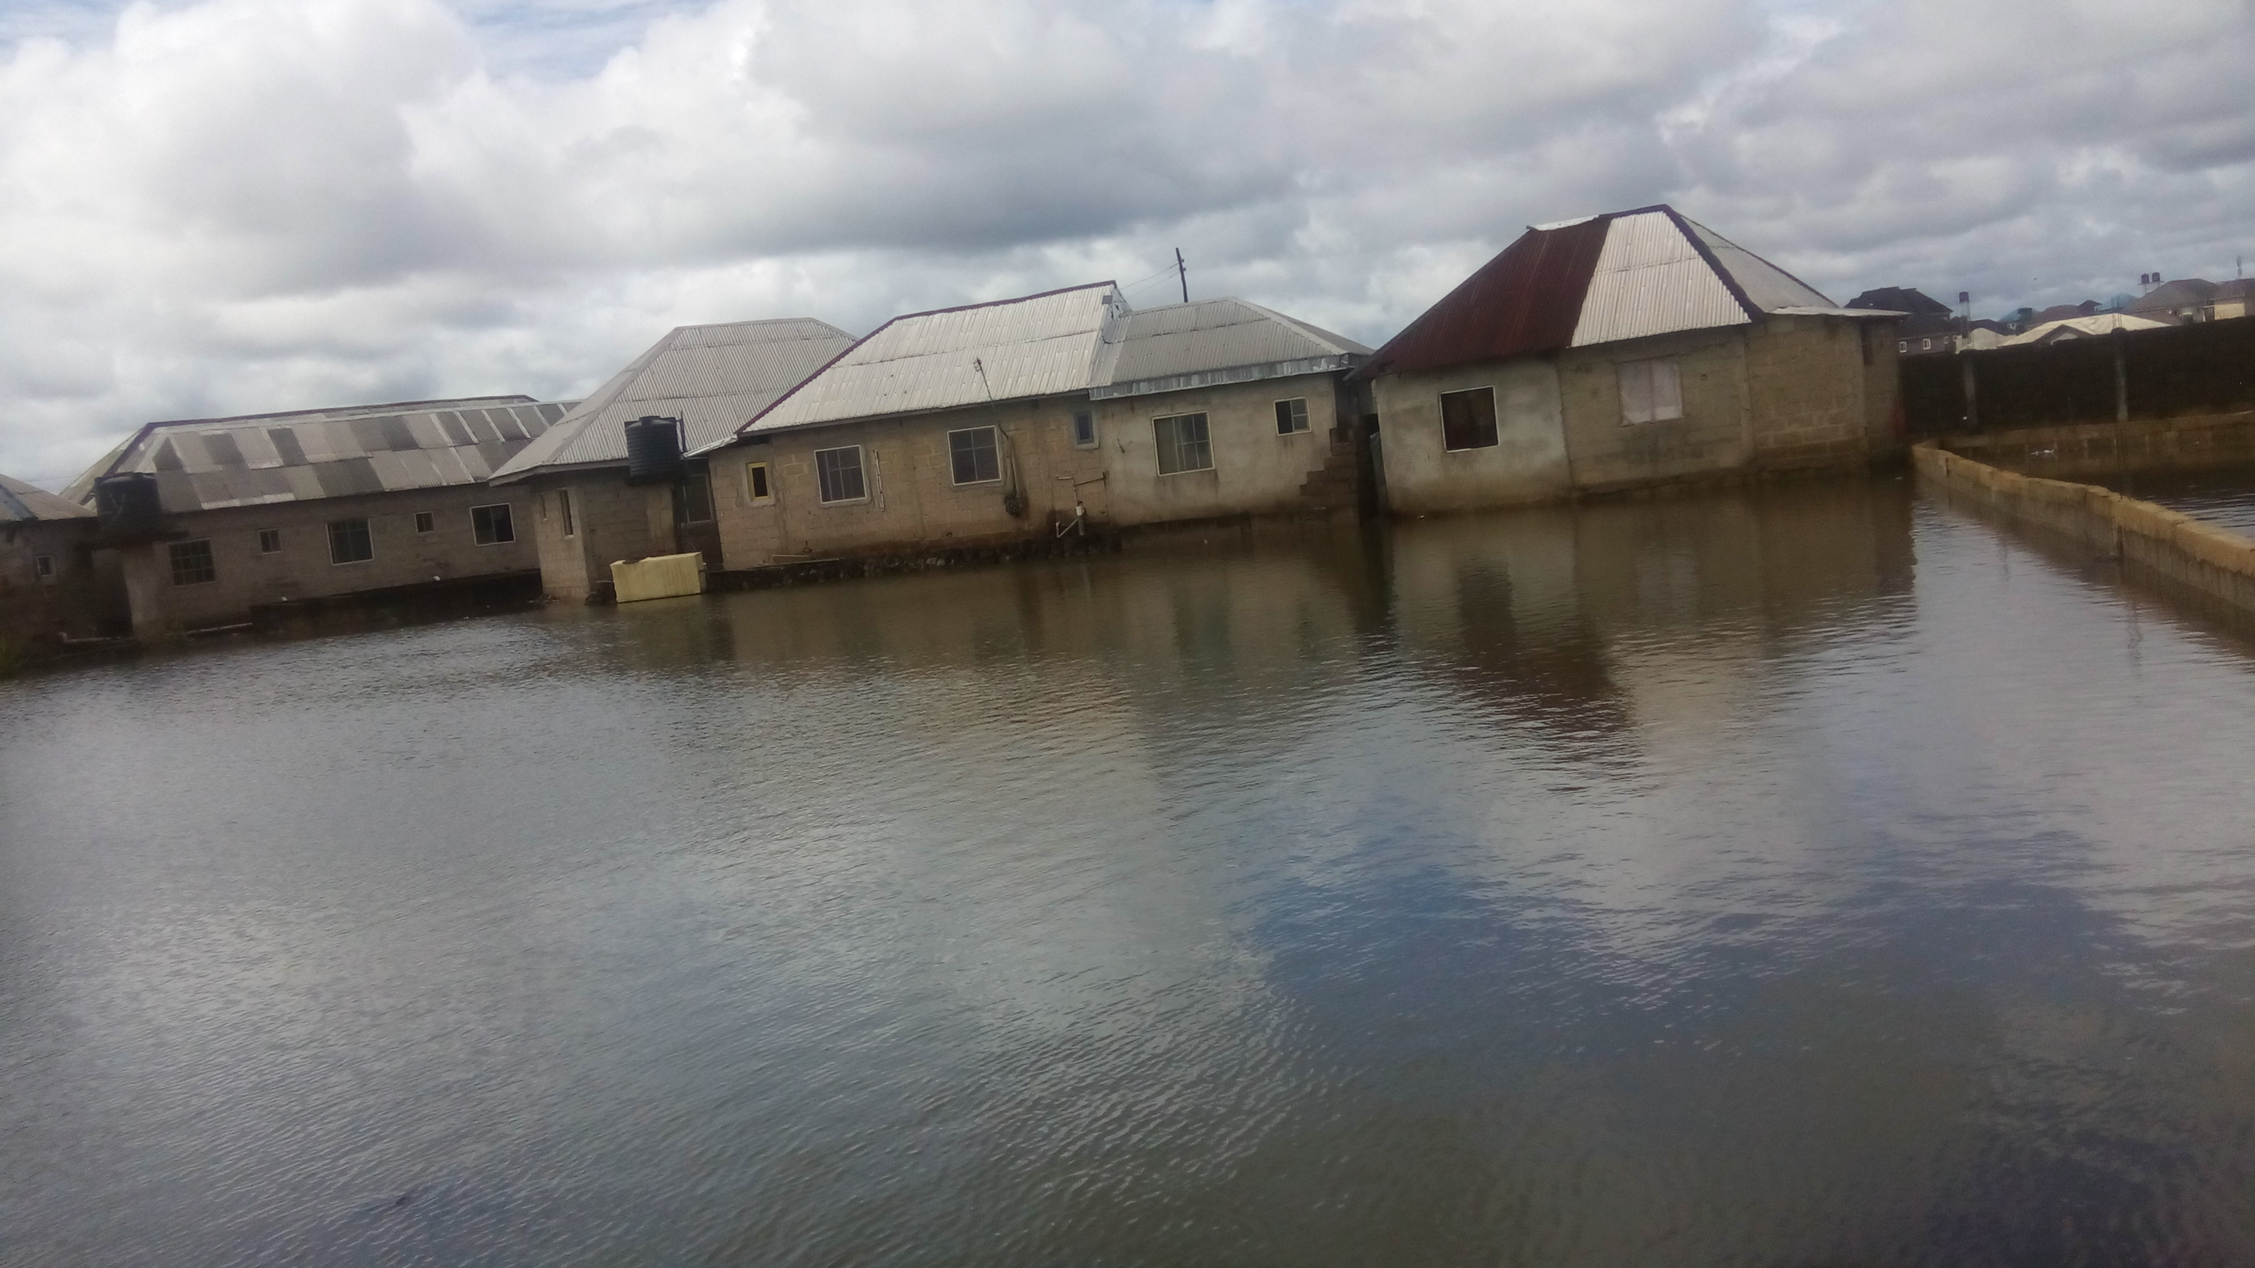
Plate 2: ‘Big water’ season in urban wetland Neighbourhoods in Port Harcourt.

9. Law, Administration, and the Challenge to Urban Planning

9.1 Law and Administration in Wetland Neighbourhoods
Although statutory planning laws governing Port Harcourt formally apply to wetland neighbourhoods, the internal administration of these areas is largely governed by informal, community-based systems. These localized governance structures vary across neighbourhoods but are typically organized through landlord associations composed of resident property owners.
These associations establish and enforce rules that regulate neighbourhood activities, with executive committees either elected or appointed to oversee implementation. Key priorities across most wetland neighbourhoods include security, electricity supply, and road maintenance. In many cases, access to these neighbourhoods is controlled through gated entry points, with restrictions placed on movement—such as limited visitor access after certain hours and, in some instances, prohibition of specific transport modes like tricycles.
Security arrangements are collectively financed, with landlords contributing monthly levies toward private security services. Similarly, residents contribute to the provision and maintenance of electricity infrastructure, including transformers, poles, and cabling. New property owners are often required to pay connection fees to neighbourhood electricity committees before accessing power supply.
Road development and maintenance also rely heavily on collective action. Contributions from developers and residents are pooled to construct or upgrade access roads, reflecting a strong culture of self-help and community-driven infrastructure provision. Beyond infrastructure, these associations also play important social roles, including financial and logistical support during community events such as bereavement ceremonies. Additional revenue is generated through mechanisms such as fines and development levies imposed on new entrants.
Overall, governance within wetland neighbourhoods reflects a hybrid system in which formal state regulation is weak or absent, and informal institutions assume responsibility for service provision and local order.

9.2 Growth of Wetland Neighbourhoods and the Challenge to Urban Planning
Wetland neighbourhoods in Port Harcourt, much like earlier squatter settlements, are located on marginal lands and have developed largely outside the framework of formal urban planning. According to the Nigerian Urban and Regional Planning Act 1992, all physical development within urban areas is expected to conform to an approved master plan. However, Port Harcourt currently lacks an operational master plan to effectively guide urban development.
This situation is further exacerbated by persistent housing shortages, limited availability of developable land, and rising land and rental costs in the inner city. These pressures have driven both population and economic activities toward wetland areas, where development continues largely unchecked. Notably, there is no comprehensive official record of the scale, distribution, or spatial patterns of these neighbourhoods.
Institutionally, the absence of a functional planning board—as stipulated by national planning legislation—has weakened the capacity for development control. The Ministry of Urban Development and Physical Planning, although responsible for managing urban growth, lacks the necessary planning instruments and enforcement mechanisms to regulate development effectively.
Empirical findings from this study indicate that a significant proportion of buildings in wetland neighbourhoods (approximately 72.2%) were constructed without approved building plans. As a result, development processes are largely controlled by local landowners and informal builders who often lack technical expertise in wetland construction and urban planning principles.
This unregulated development has led to a range of structural and environmental challenges, including building collapse, cracked walls, unstable foundations, and increased vulnerability to flooding—particularly during the “Big Water” season. The absence of planning oversight has also resulted in poor land-use organization, lack of functional infrastructure, and disregard for key planning principles such as setbacks, zoning, and spatial compatibility.
In urban planning practice, development control is only effective when guided by clearly defined policies, standards, and regulatory frameworks. In their absence, development becomes fragmented, inefficient, and unsustainable. The continued expansion of wetland neighbourhoods without a coherent policy framework or planning intervention poses significant risks to the future growth and functionality of the city.
Already, some of these impacts are becoming evident, particularly in the form of recurrent flooding in parts of the core urban area. This has been attributed, in part, to the obstruction of natural drainage channels by unregulated wetland development. If left unchecked, these trends may undermine the long-term sustainability of Port Harcourt as a rapidly growing urban centre.

10. Conclusion and Policy Implications
The study has demonstrated that wetland neighbourhoods in Port Harcourt are a product of structural deficiencies in the urban planning system, particularly in housing provision and development control. While these neighbourhoods have contributed to alleviating housing shortages, their unregulated growth poses significant environmental and planning challenges.
To address these challenges, a comprehensive policy framework for wetland development is required. This should include:
- Preparation of a wetland-specific land-use plan to guide development
- Strengthening development control mechanisms to ensure compliance with planning standards
- Implementation of flood risk management strategies
- Regularization and upgrading of existing wetland neighbourhoods
- Integration of geospatial technologies (GIS and UAV mapping) for monitoring urban expansion.
Furthermore, collaboration between government agencies, planning professionals, and local communities is essential to ensure sustainable development of wetland areas.

References
Aalbers, M. B. (2016). The financialization of housing: A political economy approach. Routledge.
Aaron, K. K. (2012). New corporate social responsibility models for oil companies in Nigeria’s delta region: What challenges for sustainability? Progress in Development Studies, 12(4), 259–273. https://doi.org/10.1177/146499341201200402
Adelekan, I. O. (2010). Vulnerability of poor urban coastal communities to flooding in Lagos, Nigeria. Environment and Urbanization, 22(2), 433–450. https://doi.org/10.1177/0956247810380141
Ajibola, M. O., Adewale, B. A., & Ijasan, K. C. (2012). Effect of urbanization on Lagos wetlands. International Journal of Business and Social Science, 3(17), 310–318.
Akpogomeh, O. S. (2005). 4. A Guide to Port Harcourt Metropolis and its Environs. Ibadan: Kraft Book Ltd.
Angel, S., Parent, J., Civco, D. L., & Blei, A. M. (2011). The dimensions of global urban expansion. Progress in Planning, 75(2), 53–107.
Anguelovski, I., et al. (2016). Equity impacts of urban land use planning for climate adaptation. Journal of Planning Education and Research, 36(3), 333–348. https://doi.org/10.1177/0739456X16645166
Azous, A., & Horner, R. R. (Eds.). (2000). Wetlands and urbanization: Implications for the future. CRC Press.
Bhan, G. (2019). Notes on a southern urban practice. Environment and Urbanization, 31(2), 639–654.
Güneralp, B., Lwasa, S., Masundire, H., Parnell, S., & Seto, K. C. (2017). Urbanization in Africa: challenges and opportunities for conservation. Environmental research letters, 13(1), 015002.
Davidson, N. C., et al. (2019). Worth of wetlands: Revised global monetary values. Marine and Freshwater Research, 70(8), 1189–1194.
de Satgé, R., & Watson, V. (2018). Urban planning in the Global South. Palgrave Macmillan.
Douglas, I., et al. (2008). Unjust waters. Environment and Urbanization, 20(1), 187–205.
Fainstein, S. S. (2010). The just city. Cornell University Press.
Faulkner, S. (2004). Urbanization impacts on wetlands. Urban Ecosystems, 7(2), 89–106.
Zischg, A. P., & Bermúdez, M. (2020). Mapping the sensitivity of population exposure to changes in flood magnitude: prospective application from local to global scale. Frontiers in Earth Science, 8, 390.
Healey, P. (2006). Urban complexity and spatial strategies: Towards a relational planning for our times. Routledge.
Junk, W. J., An, S., Finlayson, C. M., Gopal, B., Květ, J., Mitchell, S. A., ... & Robarts, R. D. (2013). Current state of knowledge regarding the world’s wetlands and their future under global climate change: a synthesis. Aquatic sciences, 75(1), 151-167.
Kio-Lawson, D. (2013). Marginal settlements in Port Harcourt. World Environment, 3(3), 78–84.
Kio-Lawson, D. (2015). The squatters of Port Harcourt. Developing Country Studies, 5(22), 40–49.
Yakubu, O. H. (2017). Particle (soot) pollution in Port Harcourt Rivers State, Nigeria—double air pollution burden? Understanding and tackling potential environmental public health impacts. Environments, 5(1), 2.
Fransolet, A., Phillips, A., da Schio, N., Vastenaekels, J., Baró, F., Lambert, D., & Bauler, T. (2025). Reconciling the Just City and the Sustainable City in the Era of Just Transitions: A Review of Urban Visions. Available at SSRN 5205911.
McFarlane, C., & Waibel, M. (Eds.). (2012). Urban informalities. Ashgate.
MEA. (2005). Ecosystems and human well-being. World Resources Institute.
Mitsch, W. J., Bernal, B., & Hernandez, M. E. (2015). Ecosystem services of wetlands. International Journal of Biodiversity Science, Ecosystem Services & Management, 11(1), 1-4.
National Population Commission (NPC). (2020). Population projections for Nigeria.
Nigerian Meteorological Agency (NiMet). (2020). Climate data report for southern Nigeria.
Cazenave, A., & Cozannet, G. L. (2014). Sea level rise and its coastal impacts. Earth's Future, 2(2), 15-34.
Obeng-Odoom, F. (2020). The commons in an age of uncertainty. University of Toronto Press.
Aluko, O. (2012). Impact of poverty on housing condition in Nigeria: A case study of Mushin Local Government Area of Lagos State. Journal of African Studies and Development, 4(3), 81.
Simon, D. (2002). Transport and development in the Third World. Routledge.
Roy, A. (2005). Urban informality. Journal of the American Planning Association, 71(2), 147–158.
Roy, A. (2009). Why India cannot plan its cities. Planning Theory, 8(1), 76–87.
Seto, K. C., Güneralp, B., & Hutyra, L. R. (2012). Global forecasts of urban expansion to 2030 and direct impacts on biodiversity and carbon pools. Proceedings of the National Academy of Sciences, 109(40), 16083-16088.
Soja, E. W. (2010). Seeking spatial justice. University of Minnesota Press.
Citaristi, I. (2022). United nations human settlements programme—UN-habitat. In The Europa directory of international organizations 2022 (pp. 240-243). Routledge.
Habitat, U. N. (2020). The value of sustainable urbanization. World Cities Report.
Uyigue, E., & Agho, M. (2007). Climate change in Niger Delta. CREDC.
Watson, V. (2009). Seeing from the South. Urban Studies, 46(11), 2259–2275.
Watson, V. (2014). African urban fantasies. Environment and Urbanization, 26(1), 215–231.
Sampson, A. P., Weli, V. E., Nwagbara, M. O., & Eludoyin, O. S. (2021). Urban growth dynamics and land use change in port harcourt metropolis, nigeria between 1986 and 2020. International Journal of Progressive Research in Science and Engineering, 2(11), 47-56.
Gong, J., Hu, Z., Chen, W., Liu, Y., & Wang, J. (2018). Urban expansion dynamics and modes in metropolitan Guangzhou, China. Land use policy, 72, 100-109.
Zedler, J. B., & Kercher, S. (2005). Wetland resources. Annual Review of Environment and Resources, 30, 39–74.

