Relationship between river flow volumes and changes in land cover, land use and climate in the Mara Basin in the period between 1983 and 2014

Abstract
The Mara River basin, a vital transboundary system within the Lake Victoria and Nile basins, supports the globally renowned Mara–Serengeti ecosystem and diverse indigenous land uses. Rapid population growth has led to deforestation in the upper catchment and encroachment downstream, threatening river flow volumes. Limited knowledge exists on how human activities and climate change affect these flows, prompting this study. Using Multiple Correlation and Regression Models, the research examined relationships between water yields and predictor variables—land use, land cover, and climate. Results showed a perfect model fit (R² = 1.000), with rainfall emerging as the most significant factor, explaining 93% of river flow variability (r = 0.939, p = 0.010). In contrast, temperature (r = 0.061, p = 0.461) and forest cover (r = -0.670, p = 0.108) had weaker, non-significant effects. The findings highlight rainfall as the dominant driver of flow variability, while land use and cover changes remain important stressors. Sustaining the Mara River’s ecological and hydrological functions requires urgent conservation measures to safeguard flow volumes and ecosystem integrity.
Key words: Mara River, river flow volumes, land cover land use, climate change, correlation, regression, sensitivity indices.

Introduction
Land cover, land use and climate change are the main causes of changes in the global environment and global ecology, contributing directly to changes in the environment resources and services (Schroter et al., 2005; Hansen et al., 2001). Land use is expressed by the human actions practiced in a physical environment for socio-economic wellbeing (FAO, 2010). Land use is dynamic and changes over time with population, causing variations in the elements of the hydrological cycle (Tracy and Scott, 2013). Climate change refers to intensified events and catastrophe that relate to climate variability such as droughts and floods. It is a function of a complex interaction between the components of a climate system, which comprise the atmosphere, oceans and seas as well as land and vegetation cover (IPCC 2001). The interactive responses by any of these components of climate system to external energy sources (mainly solar radiation and human induced) determine the background conditions that govern the world’s weather and climate patterns (Wilson et al., 2009). Although solar radiation is the main source of energy contributing to changes in climate patterns, human induced changes in the composition of the atmosphere and the land surface is such a significant source of energy to the climate system. This is because the induced changes modify the likely effects of solar radiation by altering the energy balance between the incoming solar radiation and outgoing terrestrial radiation (UNEP, 2009b).
The nature and extent of surface water and vegetation cover, which form part of the feedback processes within the global climate system have implications on the climate patterns as well (Wilson et al., 2009). According to Le Treut et al, (2007), the earth surface absorbs about two thirds of the solar energy reaching the top of the atmosphere with the rest reflected back to space as long wave radiation. The absorbed energy warms both the atmosphere and the earth’s surface and therefore for the earth to balance the incoming solar radiation it must radiate the same amount of energy back to space, through the long wave radiation (IPCC, 2001). The energy balance initiative of the earth is however, interfered with through the accumulation of human induced greenhouse gases in the atmosphere. This is because these gases allow the incoming short-wave radiation to pass through but not the outgoing long wave radiation which is instead, redirected back to the surface, causing more warming on the earth surface and in the atmosphere alike (IPCC, 2013; IPCC, 2007).
Long term changes in the global and regional climate patterns have been experienced over time in terms of increased global temperatures (indicating climate change) which have been attributed to shift in the energy balance basically due to anthropogenic factors (IPCC, 2007). A report by FAO, (2008), warns that climate change will have a significant effect on hydrology and water resources manifested in increased catastrophes such as floods, droughts and landslides, which may result from changes in forest cover. Human beings contribute to global climate change by altering the composition of the greenhouse gases in the atmosphere and to the regional climate by changing the surface albedo through socio-economic activities that alter the earth’s vegetation cover (Forster et al, 2007; UNEP/IVM, 1998).
IPCC (2007), states that since pre-industrial times there has been a positive trend in the concentrations of greenhouse gases in the atmosphere, attributed to increased human activities on the earth surface. The changes in the atmosphere have altered the energy balance of the climate system the effects of which, are being experienced in increased temperatures, reduced rainfall and increased frequencies of severe and extreme events such as droughts and floods (Dessu et al., 2014). Studies reveal that Africa is one of the world’s most vulnerable regions to climate change implications due to high poverty levels and over-reliance on natural resources and rain-fed agriculture in pursuit of socio-economic development (WWF, 2002; IPCC 2001; WRI, 1996). The studies report that Africa’s climate is already warmer than it was 100 years ago with an upward trend, based on the predictions of the future greenhouse gases (GHG) triggered climate changes (Christensen et al., 2007).
During the 20th century, the continent of Africa warmed at the rate of 0.05ºC per decade with most warming experienced from the month of June to November compared with the period from December to May (Hulme et al., 2001). In Africa, five warmest years on record had all occurred by 2000 with 1988 and 1995 recording the highest temperatures that superseded the 2000 temperature values. Globally however, periods of rapid warming were observed between 1910s and 1930s and the period after the 1970s (IPCC, 2001; Herrero et al., 2010). Climate variability and change have and will continue to exert significant impact on the water resources in the whole world. The main hydrological processes including stream flow volume, evapotranspiration, soil moisture, water temperature, occurrence and magnitude of runoff as well as the frequency and gravity of floods will all influence environmental conditions.
The IPCC, (2007) predicts that the continent of Africa will bear the largest burden of climate change given its vulnerability to the main drivers of the phenomenon that largely include anthropogenic activities. Therefore, developing an understanding of watersheds’ hydrological response to land use and land cover (physical), and climate related (rainfall and temperature) changes is critical to the planning and management of water resources (Awotwi et al., 2015). Climate change is expected to continue into the future with a potential acceleration over the rest of the 21st century due to human induced greenhouse gases emission (IPCC, 2007). The severe droughts that have occurred in most parts of Kenya in the past few decades are a testimony of the fact that Kenya is already vulnerable to climate change impacts (UNEP, 2009; PELUM -Kenya, 2010).
The need to protect the natural flow regimes in the watersheds is critical to the earth scientists (Zang et al., 2012). The best that can be done in the emanating scenario is to have a detailed regional climate change predictions framework which can be used to formulate sustainable laws, policies and regulations that can support adaptive, mitigating and coping strategies aimed at sustainable natural resources utilization. Not much is in the offing to have such predictions in the study area and this is a deterrent to the implementation of necessary mitigations, adaptations and coping strategies that would result in sustainable natural resources utilization and continued provision of ecosystem services. This study came up with climate change scenarios together with detailed projections for the Mara basin in particular and for East African region in general due to similar physiographic characteristics and location within the tropic. The results of these changes and predictions were required in the analysis of the present and future impacts of climate change on the Mara River hydrological regimes.

Trends in Climate Variability and Change
A study by Schneider et al., (2013) that investigated the response of river flow regimes to climate change scenarios in Europe, reported that climate change would modify the flow regimes through alterations in precipitation, temperature and snow cover. The period between 1900 and 2005 showed rise in precipitation in northern parts of Europe, the eastern sections of North and South America, northern and central parts of Asia and, parts of Central and Eastern Africa (IPCC, 2007). Areas across the Mediterranean, African Sahel and southern regions of Asia had a decline over the same period (IPCC, 2007). Predictions in precipitation strongly indicate possibility of increment in the higher latitudes and decline around the sub-tropical regions. Additionally, concentration of greenhouse gases is projected to increase and will have severe impacts on global climate systems during the 21st century more than any other time in history (McCarthy et al., 2001; WWF, 2002; IPCC, 2007).
Most parts of Africa have experienced marked increase in temperature during the 1960s with a mean warming of about 0.7°C across the globe over the 20th century. During the same period, mean annual temperature in Kenya increased by 1ºC with an upward projection as climate change implications continue to bite (IPCC, 2013; UNEP, 2009). The severity of extreme events are increasing while rainfall is decreasing in amounts and reliability that is affecting agricultural production in most parts of the country given that, two-thirds of Kenya are rangelands (GoK, 2010). This study investigated changes in climatic conditions and tried to establish the relationships in trends of climate change, land cover/land use and river flow volumes.

Impact of Climate Change on Water Resources
FAO, 2008 reports that climate change would have significant effect on hydrology and water resources that would manifest in increased cases of flooding, droughts and landslides. These will be influenced by the reduction in forest cover as more land is opened up for settlement and agriculture. Anthropogenic factors top the list as the major cause to changes in climate systems (Dai et al., 2016). According to the reports by most studies, climate change has adversely affected the hydrological cycles and forest ecosystems in all their composition of species and communities such as type of trees and abundance, tree biomass, productiveness, distribution, constitution as well as hydrological regimes (Chen et al., 2014; Michaletz et al., 2014; Dai et al., 2016).
Changes in forest biomass is one of the notable indicators in assessing forest quality and therefore applied in many studies seeking to determine ecological responses of forests to anthropogenic disturbances and climate change and the consequent effect on the hydrological regimes. Studies, including that by Zhuo et al. (2017) report that, climate change impacts on forest ecosystem have to be investigated well beyond the baseline climate study period of thirty years. In most cases, the impacts of climate change manifest in extreme events such as droughts and floods, which usually culminate in the deaths of livestock, crop failures, destruction of property and loss of lives (Schneider et al., 2013). These extreme events hinder economic development and therefore, are a hindrance to poverty eradication efforts. Unfortunately, there is limited literature and knowledge of such extreme events in Africa that would help avert disaster by providing early warning indicators (KNMI, 2006). Other effects of climate change such as rising temperature and changes in precipitation are undeniably clear with impacts already affecting ecosystems, biodiversity and peoples’ livelihoods (IPCC, 2007).
High temperatures and variations in rainfall, whether too much or too little, have far reaching consequences on lifeforms, food security, economic activities, physical infrastructure, natural resources and the general environment with wanton implications on national and global security ((Schneider, et al., (2013; O’Keeffe, et al., 2007). Climate change is set to exacerbate occurrence of climate related disasters including droughts and floods. Future projections of the impacts suggest worsening situations with continued rise in temperatures while precipitation becomes more unpredictable.
Predictions from existing climate scenarios report that the driest regions of the world will become even drier (UNESCO, 2006) hence, signaling the risk of persistent droughts in many parts of Africa. East African climate is already experiencing large variability in rainfall and occurrence of extreme events such as droughts and floods (Nganga, 2006). East African region is reported to have suffered from both deficient and excess rainfall implications in the past few decades, manifesting in increased cases of droughts and floods (Chen et al., 2014; Webster et al., 1999). According to Shongwe et al., (2009), the number of reported cases of hydro-meteorological disasters in the East African region have increased steadily to the present since 1980s with floods as the main cause of disaster.
According to the available studies on issues related to climate change, developing countries are the most affected with Sub-Saharan Africa topping the list. In the tropical agro-ecological zones and worst, the semi-arid areas, there is a significant reduction in crop yields, a big source of fear in Africa since her large areas of marginal agriculture may be forced out of production due to aridity (IPCC, 2013). It is projected that sub-Saharan Africa will experience about 33% loss in crop productivity between 2060 and by 2080, resulting in a negative net balance in crop-production, with estimated net losses of about 12% of its current production (Parry et al, 1999).
Although climate change is mostly seen in a negative perspective as having adverse effects, some studies have depicted climate change as a key contributor to changes in forest cover (Gustafson et al., 2010; Basu et al., 2011). However, land use changes would have effects that are more adverse and therefore offset the positive effects brought about by climate change. Gustafson et al., (2010) conducted a study in south-central part of Siberia and found out that climate change effects were less than effects of land use changes and disturbances (Zhuo et al., 2017).
The GoK, (2011) states that Kenya is susceptible to issues of climate variability as it relies on agriculture as the main livelihood for a nation that has high poverty level. According to the government report, 80% of farmers in Kenya depend on rain-fed agriculture and therefore, any reduction in rainfall makes most people vulnerable and food insecure due to climate change impacts (GoK, 2011). Because climate and land use change implications on the environment are intertwined, the study set to establish how the two affect one another and how they individually and collectively impact the Mara River flows regimes, especially in the sub basins. It went further to look at the projected implications for sustainable utilization of the Mara basin resources. Not much of this kind of information exists at the sub basins, save some information existing at basin scale. Another important fact to note is that, a good number of studies of this kind have been carried-out in the headwaters only and therefore, do not reflect the situation in the basin. The outcome of this study is therefore very important to the policy makers to formulate policies and regulations that would promote informed decisions in the management of transboundary Mara River basin resources.

Climate Change Scenarios
Climate change scenario is a representation of the difference between possible future climate scenario, based on climate projections resulting from responses of the climate system to scenario of greenhouse gases and aerosols emission (attributed to social-economic and technological developments) as simulated by climate models, and the baseline climate (Wilson et al, 2009; Jones et al, 2004). It describes what the future global climatic condition is likely to be, based on coherent and internally consistent set of assumptions concerning the driving forces and their key relationships (Miller and Yates, 2005). Such scenarios have been constructed and explicitly used in the investigation of the potential impacts of anthropogenic climate change.
There is more than enough evidence that human activities have influenced climate in different regions globally and that this influence will increase in the future and lead to albeit, unknown climate scenarios (Mitchell et al, 1999). In fact, it is important to establish possible future scenarios of climate change attributed to anthropogenic factors (land use change and greenhouse gases emission) since this is the only way to assess the socio-economic and ecological implications for climate change. This would help in the formulation of policies and regulations aimed at making informed decisions on the necessary adaptive and mitigating measures to put in place.

Modelling Climate Change
Climate modeling employs the use of computer models of climate system to simulate interactions of the earth’s components of climate system and their response to solar radiation (Jones et al, 2004). Climate models are thus, fundamental research tools for understanding and predicting both natural and anthropogenic changes in the earth’s climate (Rummukainen, 2010; Wilby and Miller, 2009). Current climate models suggest a future increasing rates of occurrence and strength of floods and droughts, the effects of which, are already being felt by the rural communities in developing countries (Porter et al. 2014; Coe and Stern 2011; Bernstein et al. 2007) due to inadequate data that can aid informed decision-making.
The Atmosphere-Ocean General Circulation Models (AOGCMs) simulate climate changes under a range of future greenhouse gas emission scenarios and act as primary tools for future climate assessments. According to IPCC (2001 and 2007), general circulation models for reducing climate change occurrences are driven through specific complex dynamic systems such as the socio-economic projections, various air concentrates of the key gases that absorb and emit radiant energy and related effects, therefore their future evolution are highly uncertain. Understanding the uncertainties in models of climate is necessary in analyzing climate change, which includes modelling of climate, evaluation of impacts, mitigation and adaptation.
Global Climate Models (GCMs) have been used to provide useful climate change projections at large spatial scale, but their projections at the regional and local scales are still limited especially in developing countries (Zang et al., 2012; Omondi, 2010). Many current climate change studies in developing regions are however, currently based on global models driven scenarios. Several attempts to use statistical, dynamical or hybrid downscaling methods to derive regional climate change scenarios have been in the offing (IPCC, 2007). Such attempts include the Coordinated Downscaling Experiments (CORDEX) - (Yu et al, 2014) project and the Couple Model Inter-comparison (CMIP5) project which attempt to provide the downscaled analysis of various GCMs.
The need to understand changes and predict future climate has led to the use of Regional Climate Models (RCMs) for climate studies and future climate projections. The RCMs provide better information than their large-scale global parent models but their use in the regional climate analysis is, however, still limited and mostly relies on the global parent models. Nonetheless, regional climate and hydrological models have been used to assess the influence of climate change on water resources especially in the Mara River Basin, the Blue Nile Basin of Ethiopia and the Volta Catchment in Ghana (Mango et al., 2010; Awotwi et al., 2015).
Climate analysis using the regional model indicated that Kenya is likely to experience average rise in annual temperature of between 1°C and 5°C in the period between 2020 and 2100. During the same period, the long and short rainy seasons are likely to become wetter, particularly in the short rains from October to December (Anyah et al, 2007). Global Climate Models predict increases in rainfall in northern Kenya by 40% by the end of 21st century while the regional model suggests that there may be greater rainfall in the West. This study however, did not use climate modelling in trying to understand hydrological responses to changes in land cover, land use and climate in the Mara basin, since its application was not within the scope of this study.

Goal and Objectives of the study
The main objective of this paper is to create a simulation of river flow under different land cover/land use given varying climate scenarios in the Mara River basin. This is met by the following specific sub-objectives:
- To determine the relationship between water yields and the predictor variables
- To assess the model’s suitability in predicting the water yields
- To ascertain the effects of the predictor variables on water yield variability

Study Area
The Mara River basin is a transboundary resource linking the two East African countries of Kenya and Tanzania and is situated on longitudes 33º47′ E and 35º47′E, and latitudes 0º38′ S and 1º52′S with a length of about 395 km. (Figure 1)
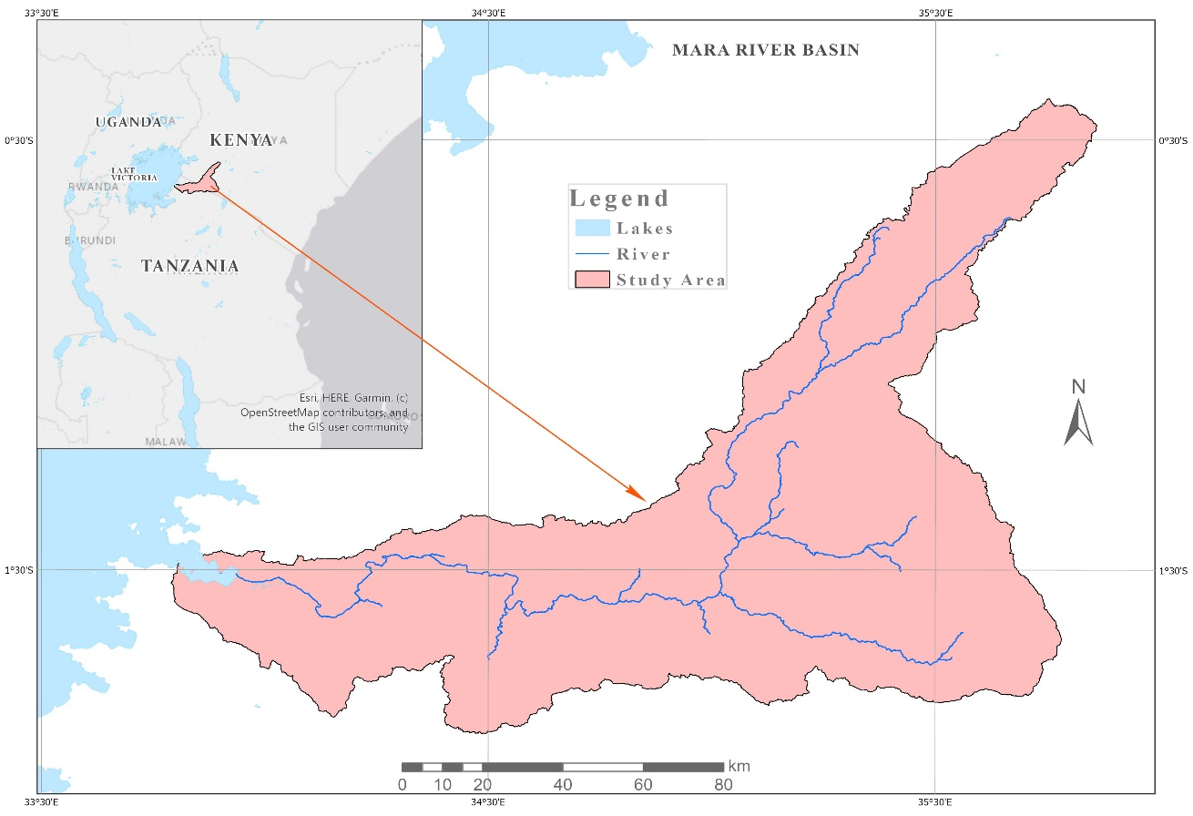
Figure 1: Location of Mara River Basin astride Kenya and Tanzania (Source: WREM International, 2008)
It drains a surface area of 13,750 km² of which, 8,941 km² (65%) is found in Kenya while 4,809 km2 (35%) is found in Tanzania. The basin originates from the Napuiyapui Swamp in Mau Escarpment. It traverses Nakuru, Bomet and Narok Counties in Kenya and Ngoro Ngoro, Serengeti, Tarime and Musoma Rural Districts in Tanzania.
The climate of Mara River basin is influenced largely by the movement of the Inter- Tropical Convergence Zone (ITCZ) air mass, modified by the local topography and the proximity of Lake Victoria, Atlantic and Indian oceans. Inter-Tropical Convergence zone is characterized by low and medium level convergences, usually marked by a line of thunderstorms and showers in most cases. It marks the boundary between the two inter-hemispheric monsoon wind systems over the region. Omeny et al., (2008) report that ITCZ is the main synoptic scale system that affects the intensity, distribution and migration of seasonal rainfall over the Eastern Africa region.
The eastern extent of the meridional arm of the ITCZ enhances the penetration of westerly winds further eastwards giving rise to enhanced June-July-August (JJA) rainfall over the western side of Kenya, including the Mara River basin from the Atlantic Ocean, the Congo basin, and Lake Victoria (Kiangi et al, 1981). The third rainfall peak observed in the western parts of Kenya during the JJA season are due to the movement of these air masses (Okoola, 1996). The zonal component of the ITCZ migrates north and south of the equator following the seasonal match of the sun with a time lag of about one month. It traverses the Mara catchment area twice a year bringing with it the long rains during the March-April-May (MAM) season and the short rains during the September-October-November (SON) season.
The temperature contrasts between the lake and the land during the day and night, resulting in a land breeze during the day and a sea breeze during the night. The Lake Victoria basin experiences rainfall throughout the year due to land-sea breeze interaction, enhanced during the three rainfall seasons (Sabiiti, 2008). Figure 3.6 is Hydrological Cycle of the Mara River basin derived from the SWAT simulation output. It clearly shows among other things, the average annual values for precipitation, evapotranspiration, potential evapotranspiration, surface flow, percolation, lateral flow, return flow and revap from shallow aquifer. The difference between the averages in rainfall and potential evapotranspiration is very small, meaning that, the basin is a rainfall deficient area.
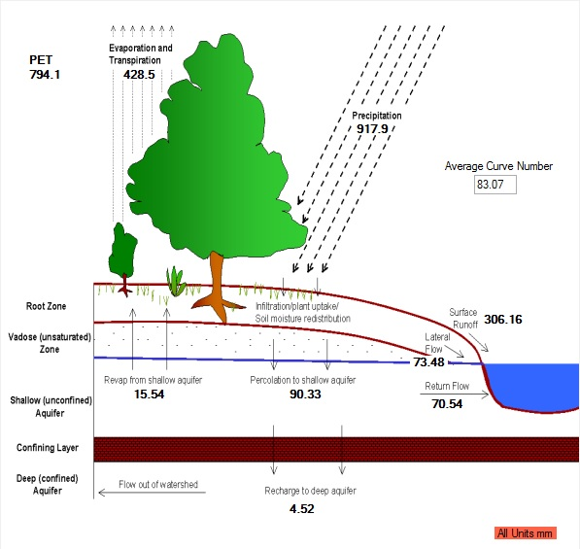
Figure 2: Hydrological Cycle (Source: Researcher, 2017)

Unlike in the higher latitudes where climatic patterns are marked by high seasonal variability in temperatures, precipitation and evapotranspiration, among others, the climatic parameter with the highest variability within the tropics is rainfall. This is because seasonal temperature changes are relatively small within the tropics compared to the rainfall due to the insignificant seasonal changes in the solar radiation. The warmest month is normally February while July in the coldest, with an average range of about 10˚C between the warmest and the coldest months (Ahrens, 2009).

Methodology
The objectives of the research were met by simulating projected water yields using projected temperature and rainfall as inputs under two main forest cover scenarios: forest cover and built-up area change scenarios and forest conservation scenario (Figure 1). The impacts of land cover, land use and climate change on discharge in the Mara River basin were evaluated through multivariate analysis using multiple regression and correlation model with simulated long-term precipitation, temperature and land cover/use as independent variables and simulated water yield as dependent variable between 1983 and 2014 and projected to 2030.

2.1 Multiple Regression Model
Multiple Regression and Correlation model (Equation 1) was used in this study for impact analysis or to predict the river flow regimes as the dependent variable based on its covariance with the predictor (independent) variables of rainfall, temperature and land cover. The Multiple Correlation and Regression Model was used to generate the river flow sensitivity indices under different land cover/land use and climate scenarios, predicting the model suitability in predicting variations in water yields and to ascertain the effects of the predictor variables (land use, land cover and climate change) on water yield variability in the Mara. The level of significance was tested at α ₌ 0.05, using Pearson Correlation Coefficient.
Y= a + β₁X₁ + β₂X₂ + β₃X₃ +β₄X₄…+ β_{n}X_{n} + Ɛ ………………….……………….…… 1
Where:
Y is the value of the dependent variable (Water Yield); a is the Y intercept; β₁, β₂, β₃, β₄, ··· β_{n} are the regression coefficients, each representing the amount of change in Y (Water Yield) for one unit of change in the corresponding X value when the other X values are held constant. X₁, X₂, X₃, X₄, ··· X_{n} are the independent variable (rainfall, land use etc.) and έ is estimated error term or residuals of the regression.

2.2 Pearson Coefficient of Correlation
Pearson Coefficient of Correlation (r) was applied in this study to measure the strength of association between water yield, one dependent variable and land cover, land use, rainfall, temperature, surface flow, ground water and percolation as predictor variables Objective 3). The correlation coefficients are -1 to +1, where values close to zero (0) mean no relation between the variables. The calculation of the correlation coefficient was performed using Equation 2 in which x represents the independent variable and y represents the dependent variable. The significance of trends were tested at α = 0.05 level of confidence.
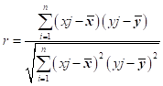
……………………………………………….... 2
Where:
r is the correlation coefficient and, xj and yj are the jth observations for the two variables, $\overline{x}$ and $\overline{y}$ are arithmetic means of the observations of the two variables and N is the number of observations.

Results and Discussions
The results of the analyses of the intertwining effects under varying land cover, land use and climate scenarios on the river flow volumes are discussed in terms of ten-year moving averages in water yields and the predictor variables of precipitation, surface flow, ground water, percolation and evapotranspiration and through scatter plots of the same predictors with the water yields. Thus, the third objective: ‘Simulation of River Flow under different Land Cover/Land Use and Climate Scenarios in the Mara Basin’ was addressed here. Variations in surface flow, ground water, percolation and evapotranspiration informed on the differences in land cover and land use scenarios and therefore the implications of these predictor variables on the water yields were actually implications attributed to differences in land cover and land use scenarios. Equally, simulating river flows under changing precipitation and evapotranspiration and land cover/land use scenarios gave impacts of climate change on water yields. Evapotranspiration explained the changes in temperature and therefore the implications of temperature on water yields.

Relationship between Water Yields and Precipitation
The trends in the ten-year moving averages for water yields and precipitation, as follow same pattern in that, an increase in precipitation results in an increase in water yields while a decrease leads to a decrease in the same. Precipitation is the most critical contributor to the water yields in the basin, feeding the river system mainly through these other variables under consideration. These variables are also known as predictors for they can be used to predict variations in water yields in the basin, hence very important in the process of hydrological cycle. Between 1994 and 2000, both precipitation and water yield were below the trend lines, gradually increasing to attain the maximum level in 2003 when precipitation was 1027.467 mm and water yields, 550.83m³. For the next six years, the values did not change much, reaching 1002.568mm and 536.696m³ in 2009 before crossing the trend lines in 2012 (Figure 3). The negative values in the trend line equations indicate decreases in both.

Figure 3: Water Yield and Precipitation

The basin experienced good amount of rainfall between 2002 and 2010, thus, the higher values of precipitation and water yields compared with the other years (Figure 3). From 2012 to the present, both precipitation and water yields have been on the lower side of the trend lines, indicating that the rains have gradually decreased in the basin and will continues to become less and less with time resulting in equally low water yields, as per the projections to 2030. The years beyond 2029 are likely to register slight increases in precipitation and therefore water yields that would mainly revolve around the trend line, unless corrective measures are taken to stop the trends. The R² of 0.2912 for water yields and 0.2849 for precipitation indicate that decrease in the two variables from one year to another is however not significant statistically, which will definitely become significant if deforestation and other degradation including drought occurrences continue.

Relationship between Water yield and Surface flow
The results of the 10-year moving averages of water yields and surface flow give similar curves and trend lines in that, a decrease in surface flow results in a decrease in water yield and vice versa. The two trend lines show decreasing trends for the entire period of study as indicated by the negative trend line equations. Like in the case observed on Figure 4, the R-square (R²) of 0.2912 and 0.2237 for water yields and surface flow indicate none significant change statistically, in-between the years (Figure 5). The volume of change from one year to the next in either the surface flow or water yields was not large enough to be distinguished from another year.
The observation is that, the water yields were higher than the surface flow in any given year because water yields receive from other sources including percolation and ground water while some water that would have added to surface flow percolate into the soil. The year 1991 had the lowest water yield and surface flow, a condition necessitated by severe drought in the basin. The period between 2001 and 2010 recorded the highest water yields and the highest surface flows, meaning that the years had high amounts of rainfall and recharge from ground water and percolation reservoirs. The years showing declining trends in water yields and surface flows may be due to reduced rainfall in the basin and abstraction of water by the various users.

Figure 4: Water Yield and Surface Flow

High temperatures under reducing rainfall scenarios promote evapotranspiration that leaves the soils and the general environment dry. Such conditions result in loss of pasture, crop failure and loss of surface water especially in the Mara basin with negative impacts on livelihoods and biodiversity. Surface flow is influenced by the nature of ground cover in that, well-protected surfaces promote infiltration while bare surfaces increase overland flows. This is contrary to the situation in the Mara where forestland, shrub land and grassland are all reducing while surface flow is also decreasing instead of increasing. This is a situation attributed to reduction in rainfall due to the deforestation and climate variability and change implications.

Relationship in the Water Yields and Ground Water
The ten-year moving averages for water yields and ground water exhibit similarity in their variability and trends over the study period such that, an increase in ground water results in an increase in water yields and vice versa. Importantly, both the ground water is also on the decline in the basin as shown by the negative trend line equation, a situation expected to go beyond the projected year, 2030 due to increased human interventions on the landscape and climate related issues. The decline in ground water will be accelerating at a higher rate in future compared to the decline in water yields as indicated by the widening gap in the two trend lines (Figure 5).

Figure 5: Water Yield and Ground Water

This could be because of increased/continued removal of ground cover (especially deforestation), which results in more runoff than infiltration and therefore less water reaching the under-ground reservoirs. Deforestation also reduces volume and rate of evapotranspiration and this reduces the amount of moisture in the atmosphere, resulting in less or poor rain formation, hence reduction in ground water and water yields over time. Just like in the case of surface flow and water yield, the ground water volumes are lower than the water yields throughout the study period. Under normal cases, water yields would be higher than ground water due to additions from percolation, surface flow and direct raindrops. The low ground water values could also be due to abstraction of ground water through boreholes and other avenues to fulfill the needs of the various water users in the basin, a case that would render the basin water deficient if not controlled.
R² of 0.3212 and 0.2912 indicate that ground water has moderately changed/reduced in its annual values compared with the water yields. The results on land cover and land use classification indicated that deforestation is still ongoing and therefore the trends in ground water and water yields simply confirm the impacts of land cover and land use change on the Mara hydrography. The lowest water yields and ground water were before 1994, highest water yields between 2002 and 2004 while highest ground water was in 2003. The period between 2004 and 2011 show gradual reduction above the mean values after which, the values are generally below the average values to 2030 with 2027 to 2029 recording among the least. All these are indication of worsening implications of land cover, land use and climate change scenarios on rainfall and water yields in the Mara River basin.

Relationship in the Water Yields and Percolation
The annual trends in water yield and percolation have similar curve meaning that they follow the same pattern. The pattern witnessed here is that similar to those of those of surface flow and ground water with water yields (Figures 4 and 5). Years of low percolation resulted in low water yields with the water yields being much above the percolation values since it receives from other sources like surface flow and ground water (Figure 6). Up to 2000, both the water yields and percolation were at their lowest (about 360m³); the same pattern was observed in rainfall, surface flow and ground water (both being below average). From 2000 to 2003 water yields increased from 470 to 550m³ (maximum), a value that was almost the same up to 2005 before starting to decline, reaching its mean value in 2012.
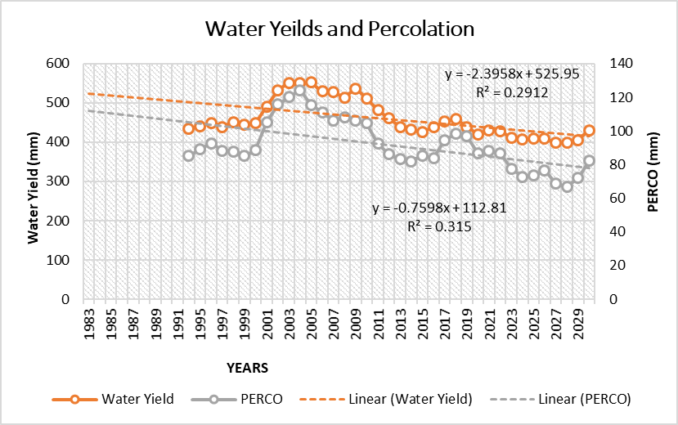
Figure 6: Water Yield and Percolation

From 2012 up to 2030, water yields were generally below the trend lines, except for 2017, 2018 and the projected 2030. Percolation was also above average between 2001 and 2010 and from 2017 to 2019. Most of the projections are below the mean, meaning that most years will have even lesser percolation with intensified deforestation and general removal of surface cover including grass and shrubs. The minimum percolation values were before 1995 with the lowest of all due in 2028 while the highest percolation was in 2004, around the time of maximum precipitation and water yields. Reduction in percolation is also because of decreasing trends in rainfall in the basin.
The declining trends in water yields and percolation as shown by the negative equations are a worrying scenario especially that, the projected values are tending to be below the trend lines, meaning less and less percolation and water yields in the basin in future. This is because, percolation, just like surface flow and ground water is influenced by ground cover. Unprotected soil due to deforestation and reduction in grassland and shrub land as witnessed in the Mara basin result in increased surface flows as opposed to percolation and therefore, we expect less percolation and less addition to water yields from percolation. The gradient of the percolation trend line is becoming steeper with time, meaning that, it will reduce further with time as long as the surface cover removal including deforestation will still be going on, which would always result in reduced water yields in the basin. The R² of 0.315 means that variations in percolation is moderately affecting variations in the water yields. In other words, decrease in percolation is causing moderate reduction in water yields. This situation will become worse with continued removal of ground cover with increased.

Relationship in the Water Yields and Actual Evapotranspiration
Comparing the trends in water yields and evapotranspiration between 1983 and 2030 like in the foregoing cases, the trends in evapotranspiration were in fact linear, following the trend line of the same. The two trend lines are expected to level off by 2021. The R² of 0.0266, for evapotranspiration trend line, which is also negative in its equation, indicates that variations in evapotranspiration have no direct cause on the variations on water yields. Of course, from land cover and land use point of view, and from variations in temperatures, evapotranspiration affects water yields. In the case of land cover and land use, less amount of water vapour is taken into the soil when the vegetation cover is removed, resulting in low formation of precipitation and therefore less water yields in the end (Figure 7).

Figure 7: Water Yield and Actual Evapotranspiration

When temperatures increase with increased degradation and presence of greenhouse gases for example, evapotranspiration rates are increased and in the presence of large water bodies encourage rain formation, which would result in increased water yields. The case in the Mara is however, the opposite because the basin is largely a marginal area with few large water bodies, high temperatures do not necessary reflect high evapotranspiration (see for example Figure 7). Evapotranspiration parse is actually not a good measure of variations in water yields since the amount of water evaporating from a given water body and plants is minimal over a short period. In this study therefore, actual evapotranspiration was used as an attribute of land cover and land use in measuring the impacts on water yields.

Water Yields Parameters and Their Relationships
The results of the correlation matrix analysis of the model output data of precipitation, surface flow, lateral flow, ground water, percolation, surface water, evapotranspiration and potential evapotranspiration (predictor variables) and water yield (dependent variable) are presented and discussed. The aim was to give an in-depth understanding on how the above subcomponents of precipitation predict river discharge variations and attribute the same to changes in land cover, precipitation and temperature. The Correlation Matrix indicate that there was strong positive correlation between water yield, precipitation, surface flow, ground water and percolation with r values of 0.830, 0.822, 0.701 and 0.701 respectively and P values in each case of less than 0.05.
This means, precipitation, surface flow, ground water and percolation have strong positive correlation with water yields that are significantly significant. Importantly, variations in these predictor variables cause significant variations in the water yields in the Mara River Basin. An increase in any of them, for example precipitation, results in an increase in the water yields and reverse is the case with a decrease in any. Land use practices that lead to reduction in precipitation amounts and reliability such as deforestation and abstraction of ground water through boreholes would result in reduced water yields in the basin. Actual Evapotranspiration had an r of 0.265 and a P value of 0.072, implying that there is either a weak or no correlation between water yields and actual evapotranspiration in the Mara basin. In addition, based on the P value, the relationships are not significant statistically.

Table 1: Correlation Matrix of SWAT Output Predictors and Water Yield (1983-2030)
 | Prec | Surq | Latq | Gwq | Perco | Sw | Et | Pet | Water Yield
Prec | 1
Surq | 0.533537 | 1
Latq | 0.181793 | 0.026936 | 1
Gwq | 0.760762 | 0.171595 | 0.181499 | 1
Perco | 0.765351 | 0.174356 | 0.200187 | 0.987338 | 1
Sw | 0.653872 | 0.266628 | 0.399709 | 0.444063 | 0.490622 | 1
Et | 0.581082 | -0.0727 | 0.215938 | 0.534862 | 0.522664 | 0.549317 | 1
Pet | -0.44722 | -0.11796 | -0.1731 | -0.50124 | -0.51434 | -0.38003 | -0.15798 | 1
Water Yield | 0.829934 | 0.822188 | 0.130274 | 0.700572 | 0.700724 | 0.464768 | 0.264575 | -0.373 | 1

However, when the potential evapotranspiration was considered against the water yields, a weak negative correlation coefficient of -0.373 was observed with a P value of less than 0.05. Potential Evapotranspiration being the total water budget required to escape into the atmosphere, this situation implies that, the higher the potential evapotranspiration the lower the water yields. As regards the surface water, the coefficient of correlation recorded r of 0.485 and a P that is less than 0.05, indicating that, surface water has a mild influence on water yields in the Mara River basin and therefore fail as a predictor in variations in water yields.

Model Suitability in Predicting Variations in Water Yields
The results of the analysis of the model of precipitation, surface flow, percolation, ground water, evapotranspiration, potential evapotranspiration and lateral flow for suitability of predicting the water yields were affirmative. Model summary, (Table 2), which is also known as the power of the model, contains the power of the regression model for predicting dependent variable, which is water yields in this case. The power of regression model is measured by the coefficient of determination (R²), which values lie between -1 and 1 such that, the closure the power to either -1 or 1, the higher the percentage of the dependent variable that is explained by the predictor variables in the model.
Table 2: Model Summary
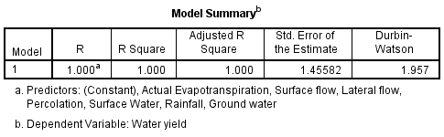
The R Square and Adjusted R Square have coefficient of determination (R²) of 1.000. It means that, when other potential predictor variables are considered, the predictors in the model would still explain about 100% of the variations in the water yields (Table 2). This implies that, the model is good enough for predicting water yields in the Mara River basin. The significance of the model for the prediction was given by the analysis of variance (ANOVA). Analysis of variance is an integral part of the multiple regression exercise and good in working out differences amongst more than two sample means at the same time. Table 3 has an F of 35923.18 with a P of 0.000. This indicates that the model made of precipitation, surface flow, lateral flow, ground water, percolation, actual evapotranspiration and surface water is statistically significant in predicting water yield in the Mara River Basin.
Table 3: Analysis of Variance (ANOVA) of Predictor Variables
ANOVAª
Model |  | Sum of Squares | df | Mean Square | F | Sig.
1 | Regression | 532953.476 | 7 | 76136.211 | 35923.18 | .000^{b}
1 | Residual | 82.657 | 39 | 2.119
1 | Total | 533036.134 | 46

Effect of Each Predictor Variable on Water Yields Variability
This subsection gives the effect of each independent variable of rainfall, surface flow, lateral flow, percolation, ground water, actual evapotranspiration and surface water on the water yields in the Mara as contained in the Coefficients of the Predictors Model (Table 4). The coefficients of the model indicate the association and significant levels of each variable to variations in the water yields. Regression Coefficients corresponding to the predictor variables give the predictors that are statistically significant in predicting the expected outcomes. As indicated on the table, the surface flow, ground water, percolation and actual evapotranspiration have t values of 231.936, 25.112, 15.778 and 4.990 with P values of 0.000 respectively.
Table 4: The Coefficients of the Predictors in the Model
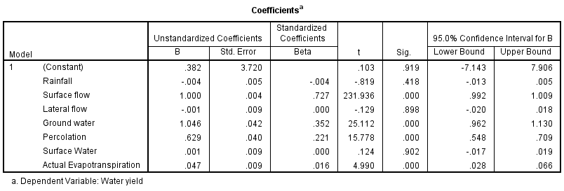

The t values of 231.936, 25.112, 15.778 and 4.990 and Ps of 0.000 explain that, the coefficients corresponding to these predictors are statistically significant and therefore, may be used for predicting water yields in the Mara River basin. On the other hand, the t values of -0.819, -0.129 and 0.124 with P values of 0.418, 0.898 and 0.902 for rainfall, lateral flow and surface water respectively indicate that rainfall, lateral flow and surface water are statistically not significant in predicting the water yields in the Mara. Importantly, the correlation coefficients model show that surface flow is very significant in predicting water yields with ground water and percolation following at a distance. Actual Evapotranspiration may also be used to assess variations in water yield specifically during droughts. The coefficients model specifies that, rainfall is not a good predictor of water yield variations. This is because it gives its water to surface flow, percolation, ground water, among others before the water can reach the streams. Surface flow is an attribute of the amount of rainfall and surface cover while percolation are influenced by ground cover and soil type.
In tropical areas, surface flow will increase with deforestation and torrential rainfall while in subtropical and marginal areas it will be dependent on the magnitude of rainfall. Good ground cover enhances percolation and therefore good ground water reservoir, which add to water yields in the Mara basin. Evapotranspiration influences water yields mainly through improved rain formation and this requires good forest cover to provide avenue for evapotranspiration. The situation in the Mara is that of deforestation and degradation that discourages formation of good amount of rainfall hence the observed decline in both rainfall and water yield. These conditions have negative impacts on the many systems in the Mara River basin.

Partial Scatter Plots of Water Yield and Predictor Variables
The results of partial regression plot of the predictor variables in the model (precipitation, surface flow, lateral flow, ground water, percolation, surface water and actual evapotranspiration) with water yield are presented and discussed, for a deeper understanding on their contribute to the water yields in the Mara River basin. These are plots showing the line of best fit and the deviations thereof, between the dependent variable and each of the independent (predictor) variables, Figures 8 - 12. These are derivatives of hydrological cycle, which is a critical process to the availability of both surface and ground water resources. The hydrological cycle is influenced by anthropogenic factors and variations in climatic conditions especially accumulation of greenhouse gases in the atmosphere, resulting in global warming and therefore climate change. precipitation is top on the list of components of the hydrological cycle that affect the water resources in the Mara since it has direct input into the availability of water resources in the basin.

Water Yields and Precipitation
From the partial regression scatter plot of precipitation against water yields (Figure 8), the coefficient of determination, R² = 0.689. This is a strong positive correlation, since it indicates that 68.9% variations in water yield is explained by precipitation while other predictors explain 31.1% of the variations. The 68.9% contribution of precipitation to variations in water yield is a significant input by rainfall to the water yields.
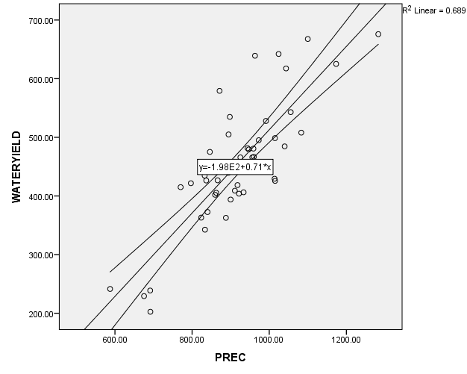
Figure 8: Scatter plot of Precipitation and Water Yield

This is the opposite of the results contained in Table 4, which by comparing contribution of each predictor variable, namely- precipitation, surface flow, lateral flow, percolation, ground water, evapotranspiration (predictor in the model) with water yields variations indicated that, precipitation is not in any way significant statistically in the variations in the water yields. Activities that reduce precipitation amounts and distribution (such as deforestation and climate change implications) in the basin will impact negatively on percolation, surface flow and ground water, among others. This will lead to reduced atmospheric and soil moisture hence, dry soils with serious implications on microorganisms, livelihoods, biodiversity and environmental quality.

Correlation between Water Yields and Surface Flow
The scatter plot of surface flow and water yield has a perfect positive correlation with the coefficient of determination (R²) of 0.999, which implies that, approximately 99.9% of the variation in water yield is explained by surface flow, leaving a mere 0.1% explained by the other predictors including these in this model. This indicates that an increase in surface flow volumes results in an increase in water yields almost one on one while the opposite is the case when surface flow decreases like during droughts. In essence, surface flow explains 99.9% variations in water yield compared to 68.9% from precipitation (Figure 8).
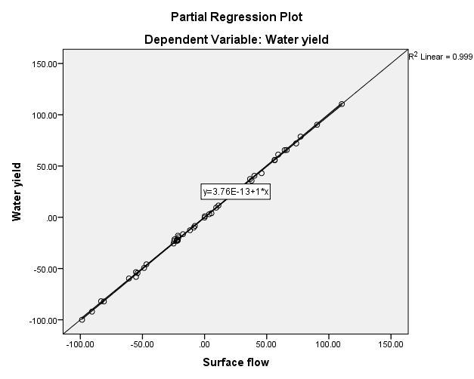
Figure 9: Scatter plot of Surface flow and Water Yield

In the study area, precipitation (specifically rainfall) is the main source of surface flow. It means that, activities that reduce precipitation such as deforestation, situations that are still ongoing in the Mara would definitely cause reduction or failure in precipitation and therefore reduction in surface flow. This would have serious implications on the river flow volumes or water yields with extremely low base flows and very high peak flows due to droughts followed by periods of excessive rains, cases already witnessed.

Water Yields and Ground Water
The scatter plot of water yield against ground water (Figure 10) indicates a strong positive correlation. This is supported by the coefficient of determination, R² = 0.942, implying that approximately 94.2% variations in water yield are explained by groundwater while only 5.8% is explained by other factors. Reduction in ground water in the Mara basin will result in a reduction in water yield. For example, excessive abstraction of ground water for domestic, urban and industrial uses through channels such as boreholes would reduce the available ground water and therefore, the amount of water yield and degraded underground conditions.
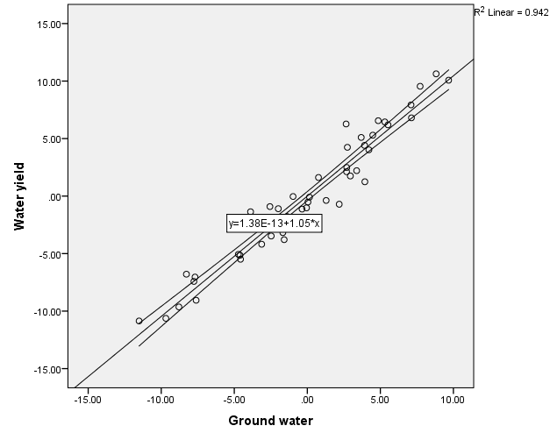
Figure 10: Scatter Plot for Ground Water and Water Yield

Such reductions in ground water would interfere with the water balance equation leading not only to the reduced water yield but also to reduced soil moisture content which with time, may lead to collapse in the various economic sectors, especially agriculture. Thus, ground water is only next to surface flow in order of their contributions to the Mara River flow volumes.

Water Yields and Percolation
The scatter plot of water yield against percolation also gave a strong positive correlation coefficient with a coefficient of determination, R² = 0.865 in linearity hence accounting for 86.5% variations in water yields. The other predictors explain a mere 13.5% of the variations, thus, the outliers observed on the diagram. During precipitation, the water percolates into the soil, experiences a time lag before the percolated water finds its way, and adds to the water yields. The period between the time it precipitates and the time-percolated water reaches the stream (time lag) results in the outliers as seen on Figure 11. Notably, activities resulting in removal of vegetation cover and hardening of the surfaces including building of pavements would increase surface run-off with increased erosion and environmental degradation not only in the Mara basin but also in any given environment or watershed
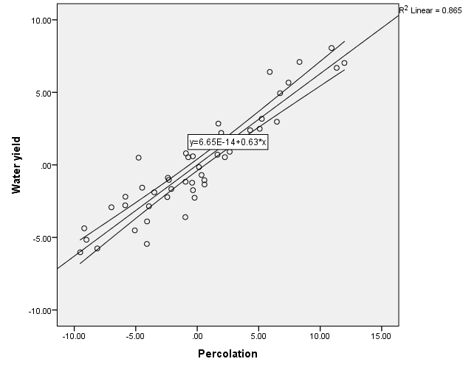
Figure 11: Scatter Plot for Percolation and Water Yield

Water Yields and Actual Evapotranspiration
Regression plot of actual evapotranspiration and water yield had R² of 0.390, meaning a weak or no association between the two. Going by the value of P = 0.072, which is more than the significance level of 0.05, it is clear that, there is no correlation between the actual evapotranspiration and water yield, this supports the result contained on Figure 7. The scatter plot (Figure 12) shows the deviations from the line of good fit with many points as outliers and therefore supports the facts in the correlation matrix (Table 3.). Since evapotranspiration removes water from the surface and the soils, it is important to note that, severe evapotranspiration would reflect negatively on the water balance with implications on the soil and atmospheric moisture.
Increased temperatures in marginal area like the Mara basin may results in evapotranspiration that may leave environment very dry that may not support agriculture and other economic activities including pastoralism and conservation areas. In the presence of large water bodies and good forest cover, evapotranspiration enhances formation of precipitation thereby keeping the environment moist. Looking at evapotranspiration differently, it is the link between the terrestrial and atmospheric systems, since it brings about the process of hydrological cycle, without which, there would be no precipitation forming. Figure 12 indicates that Evapotranspiration contributes very little to the variations in water yields, meaning that the variations are due to other variables, especially human uses in the various sectors of the economy.
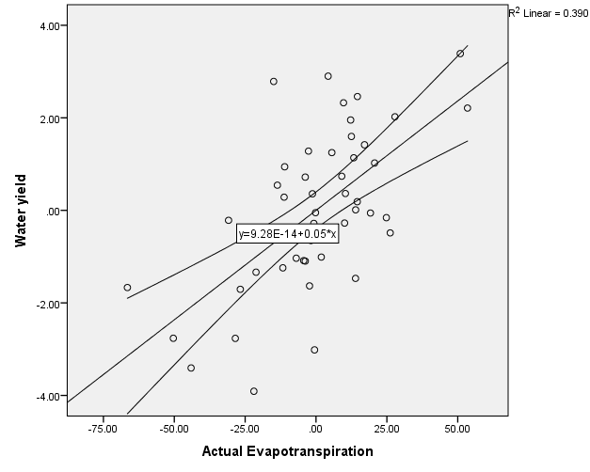
Figure 12: Scatter Plot for Actual Evapotranspiration and Water Yield

Water Yields and Potential Evapotranspiration
The coefficient of determination R² between Potential Evapotranspiration and the water yield was 0.139 (Figure 13). It is less than 0.3, and therefore no correlation between Potential Evapotranspiration and water yields. The curve actually gives a relationship but on a declining trend from the rest. When two linear variables are regressed, the relationships that exist (R²⁾ has less value compared to results from correlation matrix. (Table 3). Correlation Matrix for potential evapotranspiration and water yield gives r values of -0.373 and a P value of 0.010, meaning a weak negative correlation but somehow significant at 0.010 level because high temperatures as witnessed in the Mara basin and the larger Lake Victoria basin results in conventional rains that, when realized, results in some increase in water yield. Importantly, the scatter plot results for surface flow, groundwater, percolation and precipitation with water yield have coefficients of determination (R²) of 0.999, 0.942, 0.865, 0.689 in that order, accounting for 99.9%, 94.2%, 86.5% and 68.9% variations in the water yields in the Mara River basin.
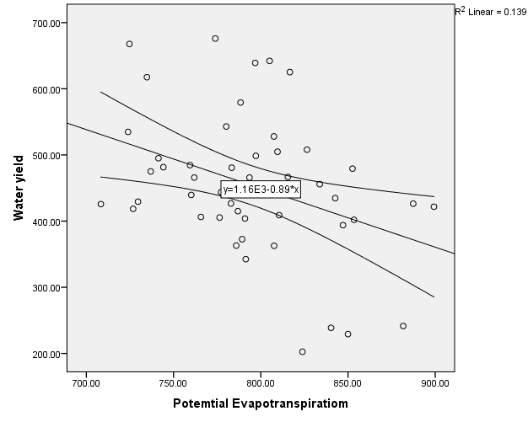
Figure 13: Scatter Plot for Potential Evapotranspiration and Water Yield

On the other hand, scatter plot of actual evapotranspiration and potential evapotranspiration with water yields have no significance association and therefore not good predictors in the variations in water yields. These three predictors of surface flow, ground water and percolation have higher coefficient of determination than precipitation because precipitation majorly adds to the water yields through these predictor variables with only a small percentage gadding to the water yields directly from raindrops. The declining trends in forestland, shrub land and grassland in impacting the Mara River flow volumes through reduced precipitation, ground water, percolation and evapotranspiration. Evapotranspiration is the linkage between the terrestrial and atmospheric system in that it takes moisture to the atmosphere, initiating the process and sustaining the hydrological cycle.
Deforestation and removal of vegetation cover reduce the leaf coverage available for aiding evapotranspiration, a condition that results in less moisture released into the atmosphere. The outcome would be reduced precipitation that is also unevenly distributed. Equally, reduced forest cover results in less or no infiltration of precipitation into the soil but instead, drains off as surface flow that minimizes the ground water reservoirs. Removal of forest cover leads to accumulation of greenhouse gases in the atmosphere, adding to global warming process and climate change implications, especially high temperatures and reduced precipitation that is unreliable and characteristically erratic, as being witnessed in the Mara River Basin. This study therefore rejects the third objective ‘There is no significant relationship between the simulated river flow and changes in land cover/land use and climate in the Mara River Basin.

Conclusion
This study established that, there exists a significant relationship between the simulated river flows and changes in land cover, land use and climate in the Mara River Basin. The simulated model of forestland, built-up areas, rainfall and air temperature and river flow gave an R Squared and R Squared Change of 1.000. The model of forestland, built-up area, rainfall and temperature is perfect for predicting variations in river flow in the Mara River Basin, with 100% variations explained by the variables in the model. The same model gave an r of 0.939 and P of 0.010 for rainfall, meaning that, 93% variations in river flow is explained by variations in rainfall. Thus, variations in rainfall is significant in predicting variations in river flow in the Mara than variations in temperature (r of 0.061 and a P of 0.461) and forest cover (r of -0.670 and a P of 0.108). In essence, forest cover has inverse effect on river flows in that, when forestland increases, the flow should be on the decline due to increased infiltration and vice versa.

Reduction in forest cover, in normal cases, should result in increased flows due to reduced ground cover and therefore reduced infiltration. The position of this study is that, reduction in forest cover is resulting in reduced rainfall due to reduced evapotranspiration rates and therefore, reduced flow volumes. Specifically, reduction in vegetation cover leads to accumulation of greenhouse gases in the atmosphere, heating the atmosphere instead of it being cooled to allow for rain formation. High temperatures especially during dry seasons are resulting in marked reduction in river flow volumes, although direct influence on the flow volumes are minimal.
The climate of the Mara River basin is changing, and will progressively become warmer and drier, if the trends of change in the main cover types including forest cover, rangelands, temperature and rainfall, were to continue. Any further conversion of forestland to either farmland or pasture land is likely to result in more reduction in base flows and increased peak flows during dry and rainy seasons respectively. These changes would worsen the already unbearable challenges experienced in increased incidences of droughts and floods that have more often than not, resulted in loss of livestock, livelihoods and human life.

Recommendation
From the study, the following are recommendation that could be considered:
- Results of this study have shown that a combination of both land cover, land use and climate change leads to reduced water yields in the transboundary Mara basin and, in essence this region. Concerted efforts must be made to conserve this critical system.
- The climate change implications are already taking their toll in the Mara River Basin. Future researchers should carry out further investigations on this through climate modelling, using models like PRECIS RCM to complement the hydrological modelling results.
- Globally, the governments have recognized the challenge of sustainability in natural resources utilization and the fact that, no single government can work alone in this area. It is imperative that, governments of Kenya and Tanzania work together on matters pertaining to the conservation of the transboundary Mara resources, especially through the framework of the East African Commission or Secretariat.

References
Ahrens C. D., (2009): Meteorology Today, an introduction to weather, climate and the
Environment, Ninth Edition, Brooks/Cole 10 Davis Drive, Belmont CA94002, USA, 439-499
Anyah, R. O. and Qiu, W. (2011). Characteristic of 20th and 21st century precipitation and temperature patterns and changes over the Greater Horn of Africa, Int. J. Climatology, 31, doi:10.1002/joc.2270, in press.
Awotwi, A., Kumi, M., Jansson, P.E., Yeboah, F. and Nti I.K., (20015). "Predicting Hydrological Response to Climate Change in the White Volta Catchment, West Africa." J Earth Sci Clim Change 6, no. 1 (2015): 1-7.
Bernstein, L., Bosch, P., Chen, Z., Christ, R. and Davidson, O., (2007) Climate Change 2007. Synthesis Report; Summary for Policy Makers, IPCC, 2007.
Chen, X., Kumar, M. and McGlynn, B.L., (2014). Variations in streamﬂow response to large hurricane-season storms in a Southeastern US watershed. J. Hydrometeorol. http://dx.doi.org/10.1175/JHM-D-14-0044.
Christensen, J.H., Hewitson, B., Busuioc, A., Chen, A., Gao, X., Held, I., Jones, R., Kolli, R.K., Kwon, W.T., Laprise, R., Magaña Rueda, V.L., Mearns, Menéndez, C.G., Räisänen, J., Rinke, A., Sarr, A. and Whetton, P. (2007): Regional Climate Projections. In: Climate Change 2007: The Physical Science Basis. Contribution of Working Group I to the Fourth Assessment Report of the Intergovernmental Panel on Climate Change [Solomon, S., D. Qin, M. Manning, Z. Chen, M. Marquis, K.B. Averyt, M. Tignor and H.L. Miller (eds.)]. Cambridge University Press, Cambridge, United Kingdom and New York, NY, USA, 847-871.
Coe, R. and Cooper P., (2011). "Assessing and Addressing Climate-indiced Risk in Sub-Saharan Rain-fed Agriculture." Experimental Agriculture 47, no. 4 (2011): 963-984.
Dai, Erfu, Zhuo Wu, and Quansheng Ge (2016). "Predicting the responses of forest distribution and aboveground biomass to climate change under RCPs scenarios in southern China." Global Change Biology, 2016: 3642-3661.
Dessu, S.B., Melesse, A.M., Bhat, M.G. and McClain M.E. (2014). Assessment of water resources availability in the Mara River Basin. CATENA 115(O) 104-114 doi: http://dx.doi.org/10.1016/j.catena. 2013.11.017.
FAO, (2008). Forests and Water; A Thematic Study Prepared in the Framework of the Global Forest Resources Assessment 2005; Forestry Paper 155, Rome, 92.
Forster, P., Ramaswamy, V., Artaxo, P., Berntsen, T.R., Betts, Fahey, D.W., Haywood, J., Lean, J., Lowe, D.C., Myhre, G., Nganga, J., Prinn, R., Raga, Schulz, G.M. and Van Dorland, R. (2007). Changes in Atmospheric Constituents and in Radiative Forcing. In: Climate Change 2007. The Physical Science Basis. Contribution of Working Group I to the Fourth Assessment Report of the Intergovernmental Panel on Climate Change [Solomon, S., D. Qin, M. Manning, Z. Chen, M. Marquis, K.B. Averyt, M.Tignor and H.L. Miller (eds.)]. Cambridge University Press, Cambridge, United Kingdom and New York, NY, US, 129-234.
GoK, (2010). Rehabilitation of the Mau Forest Ecosystem Programme. Prepared by the Interim Co-ordinating Secretariat, Office of the Prime Minister, on Behave of the Government of Kenya, with Support from the United Nations Environment Programme, April 2010, 260
GoK, (2011). Agricultural Sector Development Support Programme. Ministry of Agriculture, September Sci Clim Change 6: 249. doi:10.4172/2157-7617.1000249, 2011.
Gustafson J.R., Brooks P.D., Molotch N.P., and Veatch W.C. (2010): Estimating snow sublimation using natural chemical and isotopic tracers across a gradient of solar radiation. Water Resources Research 46: W12511.
Herrero, M., Thornton P.K., Notenbaert A.M., Wood S., Msangi S., Freeman H.A., Bossio D., Dixon J., van de Steeg J., Lynam J., Parthasarathy Rao P., Macmillan S., Gerard B., McDermott J., Seré C., Rosegrant M.W. (2010). Smart investments in sustainable food production: revisiting mixed crop livestock systems. Science 327:822-825
Hulme, M, Doherty, R. M., Ngara, T. New M. G. and Lister D., (2001). "African Climate change: 1990 - 2100." Climate Research, 2001: 145-168.
IPCC, (2001). Climate Change 2001. Impacts, Adaptations and Vulnerability. Contribution of Working Group II to the Third Assessment Report of the Intergovernmental Panel on Climate Change. Cambridge, UK: Cambridge University Press, 2001.
IPCC, (2007). Climate Change, 2007: Synthesis Report. Contribution of Working Groups I, II and III to the Fourth Assessment Report of the Intergovernmental Panel on Climate Change [Core Writing Team, Pachauri, R.K and Reisinger, A. (Eds.). IPCC, Geneva, Switzerland.
IPCC, (2013). Climate change 2013: the physical science basis: Working Group I contribution to the Fifth assessment report of the Intergovernmental Panel on Climate Change. Cambridge University Press.
Jones, R.G., Noguer, M., Hassle, G.G., Hudson, D., Wilson, S.S., Jenkins, G.J. and Mitchell, J.F.B., (2004). Generating High Resolution Climate Change Scenarios Using PREIS, Met Office Hadley Centre, Exeter, UK, 44pp, April 2004.
Kiangi, P.M.R., Kavishe, M.M. and Patnaik, J.K., (1981): Some Aspects of the Mean Tropospheric Motion Field in East Africa during the Long Rains Season. Kenya J. of Sci. and Tech. (A), 2, 91-103.
KNMI, (2006). "Climate change in Africa, (2006). Changes in extreme weather under global warming, Royal Netherlands Institute of Meteorology." n.d.
Le Treut, H., Somerville, R., Cubasch, U., Ding, Y., Mauritzen, C., Mokssit, A., Peterson T. and Prather, M. (2007): Historical Overview of Climate Change. In: Climate Change 2007: The Physical Science Basis. Contribution of Working Group I to the Fourth Assessment Report of the Intergovernmental Panel on Climate Change [Solomon, S., D. Qin, M. Manning, Z. Chen, M. Marquis, K.B. Averyt, M. Tignor and H.L. Miller (eds.)]. Cambridge University Press, Cambridge, United Kingdom and New York, NY, USA, 93-127.
Mango, L.M., Melesse, A.M., McClain, M.E., Gann, D. and Setegn, S.G. (2010). "Land use and climate change Impacts on the hydrology of the Upper Mara River Basin, Kenya: Results of a modeling study to support better resource management." Hydrol Earth Syst Sci, 2010: 2245-2258.
McCarthy, J.J., Canziani, O.F., Leary, N.A., Dokken, D.J. and White, K.S. (Eds.) (2001). Climate Change 2001: Impacts, Adaptation and Vulnerability. Contribution of Working Group II to the Third assessment Report of the Intergovernmental Panel on Climate Change. Cambridge University Press, Cambridge, UK and New York, USA.
Michaletz, S. T., Cheng, D. and Kerkhoff, A. J. (2014). "Convergence of terrestrial plant production across global climate gradients." Nature, 2014: 39-43.
Miller, K. and Yates, D. (2005). Climate Change and Water Resources: A Primer for Municipal Water Providers, jointly sponsored by AWWA and UCAR, 94.
Mitchell, J.F.B., Johns, T.C., Eagles, M., Ingram W.J. and Davis R.A. (1999). Towards the Construction of Climate Change Scenarios. Climate Change, 41, 547-581, Kluwer academic publishers, printed in the Netherlands.
Nganga, J. K., (2006). Climate change impacts, vulnerability and adaptation assessment in East Africa, paper presented at the United Nations Framework Convention on Climate Change (UNFCCC) African Regional Workshop on adaptation, Accra, Ghana, 21–23 September 2006.
O’Keeffe J., Piet L., Erik de R., van Steveninck W D., Anne van D., and Peter van der S., (2007). “The Environmental Integrity of Water Resources”, UNESCO-IHE, Institute for Water Education, Delft, the Netherlands (Includes case study on the Mara Basin).
Okoola, R. E. (1996). Space-Time Characteristics of the ITCZ over Equatorial Eastern Africa during Anomalous Years. Phd Thesis, Department of Meteorology, University of Nairobi.
Omeny, P.A., Ogallo, L., Okoola, R., Hendon H. and Wheeler, M. (2008). East African Rainfall Variability Associated with the Madden-Julian Oscillation, Journal of Kenya Meteorological Society, A Journal in Meteorology and Related Sciences, Volume 2, Numbers 1-2, October 2008, 105-114.
Omondi, P.A., (2010). Teleconnections between Decadal Rainfall Variability and Global Sea Surface Temperatures and Simulations of Future Climate Scenarios Over East Africa. PhD Thesis, University of Nairobi Kenya: 1-23.
Parry M., Rosenzweig, C. and Iglesias A. (1999). Climate change and world food security: a new assessment. Global Environmental Change, 9 (1999), S51-S67.
PELUM – Kenya, (2010). "Ecological Land Use Management and Organic
Farming/agriculture in Kenya". PELUM - Kenya 2010, Chapter 1, Section 2.
Rummukainen, M. (2010). State-of-the-art with regional climate models; Advanced Review, WIREs Climate Change 2010 I, 82-96
Schneider, C., Laize, C.L. R., Acreman, M.C. and Flörke, M., (2013). Hydrol. Earth Syst. Sci., 17, 325–339, 2013 www.hydrol-earth-syst-sci.net/17/325/2013/ doi: 10.5194/hess-17-325-2013.
Shongwe, M.E., Oldenborgh, G.J. and Van Den Hurk, B.J. (2009) Projected Changes in Mean and Extreme Precipitation in Africa under Global Warming. Journal of Climate, 22, 3819-3837.https://doi.org/10.1175/2009JCLI2317.1
Basu, N. B., S. E. Thompson, and P. S. C. Rao (2011), Hydrologic and biogeochemical functioning of intensively managed catchments: A synthesis of top-down analyses, Water Resour. Res., 47, W00J15, doi:10.1029/2011WR010800
UNEP, (2009). Treaties and Ratification, UNEP Ozone Secretariat, 2009, http://ozone.unep.org (accessed 2 September 2012).
UNEP, (2009b). Climate Change Science Compendium 2009, edited by McMullen C.P. and Jabbour J.
UNEP/IVM (1998). Handbook on Methods for Climate Change Impact Assessment and Adaptation Strategies; Edited by J.F. Feenstra, I. Burton, J.B. Smith, R.S.J. Tol, Version 2.0, October, 1998, 464.
UNESCO (2006). Water: a shared responsibility. The UN World Water Development Rept 2. UNESCO, Paris.
Webster, P.J., Moore, A.M., Loschnigg, J.P., Lebden, R.R., (1999). Coupled Ocean-Atmospheric dynamics in the Indian Ocean during 1997-98. Nature 401, 356-360.
Wilby, R. and Miller, K. (2009).Technical Paper (3): Climate Models and Scenarios. Water Research foundation and sponsors (UKWIR, WERF and NCAR), 2.
Wilson, S., Hassel, D., Hein, D., Jones R. and Taylor, R. (2009). Installing and using the Hadley Centre regional climate modelling system, PRECIS; version 1.8.2, precis.metoffice.com, September 11, 2009, 167.
WRI, (1996). "World Resources 1996-97: A Guide to the Global Environment". WRI, 1996.
WWF, (2002). "A World of Science Retrospective on Climate Change (2002- 2007). WWF International in December 2002”.
Yu, X., Lamačová, A., Duffy, C., Krám, P., Hruśka, J., White, T., Bhatt, G., 2014. Modeling long-term water yield effects of forest management in a Norway spruce forest. Hydrol. Sci. J. http://dx.doi.org/10.1080/02626667.2014.897406
Zang, C. F., Liu, J., van der Velde, M., and Kraxner, F.: Assessment of spatial and temporal patterns of green and blue water ﬂows under natural conditions in inland river basins in Northwest China, Hydrol. Earth Syst. Sci., 16, 2859–2870, doi: 10.5194/hess-162859-2012, 2012.
Zhuo, Wu, Dai Erfu, Quansheng Ge, XI Weimin, and Xiaofan Wang (2017). "Modelling the integrated effects of land use and climate change scenarios on forest ecosystem aboveground biomass, a case study in Taihe County of China." Geographical Sciences, 2017: 205-222.

