Geospatial Assessment of Land Use and Land Cover Transformation and Its Implications for Urban Growth in Jalandhar District, Punjab

ABSTRACT
Aims: Land use and land cover (LULC) change is an important predictor of environmental change and human-environment interactions. It demands observing these changes to manage the land sustainably and plan the areas.
Study Design: This paper uses the remote sensing and Geographic Information System (GIS) analysis of the spatial and temporal features of land use and land cover.
Place and Duration of Study: Jalandhar district, Punjab in 2001–2021.
Methodology: The maximum likelihood algorithm was used to produce LULC maps out of a supervised classification of multi-temporal satellite data (Landsat-5 TM 2001 and Landsat-8 OLI/TIRS 2021) at a 30-m spatial resolution. The images under the categories were grouped into five large land-use categories such as water bodies, built-up areas, barren land, forest/vegetation and cultivated land. The study of change detection and the change transformation matrix established where land-use conversions would be detected and the direction of change during the study period.
Results: The results show that cultivated land has had the highest land-use proportion over the years, occupying 74.54 per cent and 73.29 per cent of the total land area in 2001 and 2021, respectively. However, the percentage of built-up area has increased significantly from 2001 (18.48) to 2021 (21.29), mainly due to urbanization and infrastructure development. The arid land had declined from 3.20 percent to 1.37 percent, while forest cover remained fairly consistent. The transformation matrix shows that approximately 296.11 km² of agricultural land was changed to built-up areas, the largest land transformation in the district.
Conclusion: The findings reveal the growing importance of urbanization in agricultural landscapes and the need for sustainable land-use planning to maintain a balance between urban development and the conservation of agricultural and environmental resources. Through the study, the researcher demonstrates how remote sensing and GIS techniques can be useful, especially for monitoring land-use dynamics and for environmental planning and management in the region.
Keywords: Land Use Land Cover (LULC), Remote Sensing, Geographic Information System (GIS), Urban Expansion, Landsat Imagery

INTRODUCTION
One of the most valuable natural resources is land; it is the source of economic activity, ecological processes, and people. The way land is used and managed has a significant impact on regional development, agricultural production, and environmental sustainability. Land use and land cover (LULC) are common terms in geographical studies that describe land features and land use. Land cover refers to the physical and biological features on the Earth's surface, such as plant life, water bodies, forests, agricultural lands, and population centers. On the other hand, land use accounts for how people utilize these land resources in their various socioeconomic endeavours, including transportation, industry, recreation, agriculture, and settlements. Land use and land cover are used together as a spatial manifestation of human society and the natural environment (Turner et al., 2007; Lambin & Geist, 2006). Changes in land use and land cover are among the most important indicators of environmental change and human-environment interrelations. These changes are driven by both natural and human factors, including urbanization, economic growth, population growth, and technological advancement. LC changes significantly affect environmental systems by altering ecological balance, biodiversity, hydrological processes, and climatic conditions (Foley et al., 2005; Ellis et al., 2013). The transformation of natural landscapes into agricultural or urban areas endangers the sustainability of natural resources and alters the structure and functioning of ecosystems. Consequently, tracking land-use and land-cover dynamics has been of great importance for environmental management and sustainable development planning.
Socioeconomic growth and population pressure have driven increased demand for land worldwide in recent decades. The change in land use has increased in most regions due to industrialization, urbanization, agricultural growth, and infrastructure development. Among the key land cover changes driven by these processes, deforestation, agricultural land conversion to urban areas, natural ecosystem degradation, and landscape fragmentation should be listed (Seto et al., 2012; Song et al., 2018). These alterations affect regional climate systems, water resources, food security, and the environment. This has made LULC dynamics analysis to gain significance as far as the geographical and environmental studies are concerned. The changes in land use and land cover can now be easily monitored and analyzed due to advances in geospatial technologies. Geographic Information Systems (GIS) and remote sensing proved efficient for studying temporal and spatial trends in land change. Remote sensing can be used to detect land cover changes continuously and consistently at large geographical scales because of the availability of satellite-based Earth surface data. Contrastingly, GIS simplifies the storage, integration, and analysis of spatial data, assisting academics in understanding land-use patterns over time (Jensen, 2015; Weng, 2012). The integration of remote sensing and GIS has since been widely used in the mapping, tracking and analysis of LULC changes in different environmental settings. Satellite imagery programs like Landsat and Sentinel have enabled the study of land-alteration processes over long periods. Multi-temporal satellite data can enable researchers to assess land cover conditions over time and identify levels and trends of land-use change. The databases provide useful information for analyzing environmental degradation, vegetation cover, urbanization, and agricultural activity. As a result, the use of remote sensing LULC analysis has become increasingly significant as a method for regional planning, environmental control, and the evaluation of land resources (Coppin et al., 2004; Zhu, 2017).
The changes in land-use in India over the last few decades have been characterized by the increasing rate of economic growth, shifting population, as well as increasing infrastructure in the country. In most regions natural and agricultural landscape has been converted into urbanized regions because of the increasing need to house people, create transport systems, industrial estates, and commercialized business. With the rapid development of urban centers, there has been the development of peri-urban landscape where urban development is increasingly being built at the expense of rural areas. All these changes have a significant effect on land resource management, environmental sustainability, and agricultural productivity (Roy et al., 2015; Mishra et al., 2020). The state of Punjab in northwestern India is one of the most heavily farmed regions of the country. The state made a significant contribution to the Green Revolution, boosting agricultural output by promoting the adoption of high-yielding crop varieties, irrigation, and modern agricultural practices. Consequently, a large share of the land in Punjab has always been used for agricultural activities, mainly rice and wheat farming (Dhillon & Sidhu, 2015). Nevertheless, over the past decades, land-use organization in the state has changed with the trends of urbanization, industrialization, and the development of transportation infrastructure. Agricultural landscapes have been gradually changing in several districts due to the growth of residential colonies, industrial estates, and urban centers. City development in Punjab is mostly seen in areas close to major cities and transit centres. Increased infrastructure development, economic opportunities, and population density have contributed to the transformation of agricultural land to built-up regions and commercial land use. Besides modifications in the landscape's spatial organization, these changes create obstacles to environmental conservation and sustainable land management (Kaur & Kaur, 2021). It is therefore important to monitor these transformations to understand how land resources are utilized and to develop strategies for balancing regional growth.
The Jalandhar district of central Punjab has experienced a significant socioeconomic development in the last 20 years. The area has a popularity with its expanding urbanization, business growth and industrialization. The residential, commercial and transportation areas have increased the amount of land that is required by the increasing urbanization, population and economic development. There are high chances that significant modifications in the distribution of agricultural land, built-up area, and any other form of land use occurred as a result of the effects of these projects on the land-use and land-cover distribution of the district. Most changes in LULC in the Jalandhar district have not been adequately examined geospatially, although analyzing the land transformation process is important in rapidly developing areas. Thus, to understand the district's spatial structure over the years, a systematic analysis of land-use dynamics is needed. Such analysis can support better land-use planning and environmental management by informing the trends and forces driving land transformation.
In this regard, the current paper applies remote sensing and GIS to examine the temporal and spatial changes in land use and land cover in Jalandhar district over the years 2001 and 2021. The proposed study seeks to identify predominant land-use types, evaluate trends in land-cover features, and assess the extent of land change over the study period using multi-temporal satellite imagery. The findings of the current research are expected to contribute to the knowledge base on land-use trends in Punjab and provide valuable information for regional planning and sustainable land resource management.

LITERATURE REVIEW
Land use and land cover (LULC) changes have now become among the most essential indicators of environmental change and human-environmental interactions. By observing the LULC dynamics, researchers are able to identify the influence of urbanization, population increase, agricultural development, and industrial growth to natural resources. Given the fact that they provide the spatial and temporal resolution of very large geographic regions, remote sensing and Geographic Information System (GIS) prove useful in examining these dynamics. According to recent findings, satellite imagery and GIS technologies are important for determining and monitoring land transformation at local, regional, and global levels. LULC differences have been studied in numerous global investigations using geospatial approaches and satellite data.
Mallupattu and Reddy (2013) examined changes in LULC in Tirupati, India, and found significant growth in urban areas, accompanied by a corresponding decline in agricultural land, using remote sensing and GIS methods. Their paper showed that Landsat imagery was useful for monitoring long-term land-use changes. Similarly, Tewabe (2020) investigated land-use dynamics using change-detection techniques in GIS and found that geospatial analysis is a valuable source of data for sustainable land management and planning. The other interesting research article was by Naikoo et al. (2020), which discussed changes in LULC in the National Capital Region (NCR) of Delhi and identified the factors driving the rapid increase in built-up areas as infrastructure development, economic growth, and migration. The analysis depicted the extent of transformation of agricultural lands and natural sceneries by urbanization. Equally, the article by Seyam et al. (2023) applies remote sensing and GIS to investigate LULC change in Bangladesh and found that the changes were mainly due to population pressure and industrial development. Researchers have highlighted that multi-temporal satellite data is required to monitor land change at a global level. In a study, Mariye et al. (2024) used Landsat imagery spanning multiple periods, revealing that agricultural development and increased settlement were the key contributors to land cover change in Ethiopia. Similarly, Zhu (2022) stressed the value of remote sensing as a tool for land change studies, as satellite imagery enables the observation of both temporal and spatial forecasts of land transformation. Many studies have examined the dynamics of LULC across different regions of India. Thakur et al. (2020) studied land-use changes in the Achanakmar-Amarkantak Biosphere Reserve using remote sensing and GIS and found significant reductions in forest cover driven by human activities and land conversion. Pushpalatha et al. (2025) also studied the LULC change in Mysuru district using the LISS-III satellite images and discovered that the characteristics of built-up and agricultural land had significantly changed due to urban expansion.
Furthermore, research has been conducted in Punjab and other areas. A recent study on land-use change in the Bathinda district found that urban growth led to a reduction in agricultural and vegetative cover and a significant increase in built-up areas. The same results were obtained in a study in Chandigarh, where LULC patterns and trends were determined using satellite imagery and machine learning to analyze urban expansion. Moreover, most categorization and change-detection methods applied to LULC studies have been discussed in several review articles. Chughtai and Majeed (2021) examined multiple techniques for detecting LULC and concluded that the best approach for mapping LULC is supervised classification using the Maximum Likelihood algorithm. Likewise, Liu et al. (2023) have highlighted the growing importance of advanced remote sensing and machine learning techniques for investigating trends in global land-use transformation.
All things considered, it is possible to state that the influence of urbanization, economic growth, population increase, and infrastructural development on LULC changes is substantial, as reported by previous research. Remote sensing and GIS provide effective, accurate tools to track these changes and support sustainable land management. Conversely, very little is known about the spatiotemporal dynamics of land cover and use in rapidly developing areas such as Jalandhar in Punjab. Therefore, this study aims to apply remote sensing and GIS to analyze LULC change in the Jalandhar district between 2001 and 2021.

STUDY AREA
The district of Jalandhar is situated in the Doaba area of the Indian state of Punjab. Geographically, Jalandhar district is located between latitudes 31°33′ N and longitudes 75°58′ E. Its average elevation is 220-230 meters above mean sea level. The districts of Hoshiarpur to the north and northeast, Kapurthala to the west, Ludhiana to the south, and Moga to the southwest form the district's borders. The area is part of the rich Indo-Gangetic plains, which support intensive farming, particularly rice and wheat. The district has a mixed rural-urban settlement pattern with a population of approximately 2.19 million, according to the 2011 Census of India.

Methodology
The Present study examines the Land Use and Land Cover (LULC) of Jalandhar district from 2001 to 2020 by using geospatial techniques. Multitemporal satellite imagery is used to analyze the spatial distribution and changes in different land-use categories. Landsat- 5 TM and Landsat-8 OLI/TIR with a spatial resolution of 30 m were used for the years 2001 and 2021, which were obtained from the United States Geological Survey (USGS) Earth Explorer. For image interpretation and validation, ancillary data, such as district administrative boundaries and high-resolution Google Earth imagery, were used as reference data. To eliminate atmospheric distortions and enhance image quality, the satellite images underwent standard preprocessing techniques, including geometric and radiometric corrections and image enhancement, prior to classification. To limit the analysis to the study area, the images were cropped to the Jalandhar district boundary.

Fig: 1: The study site
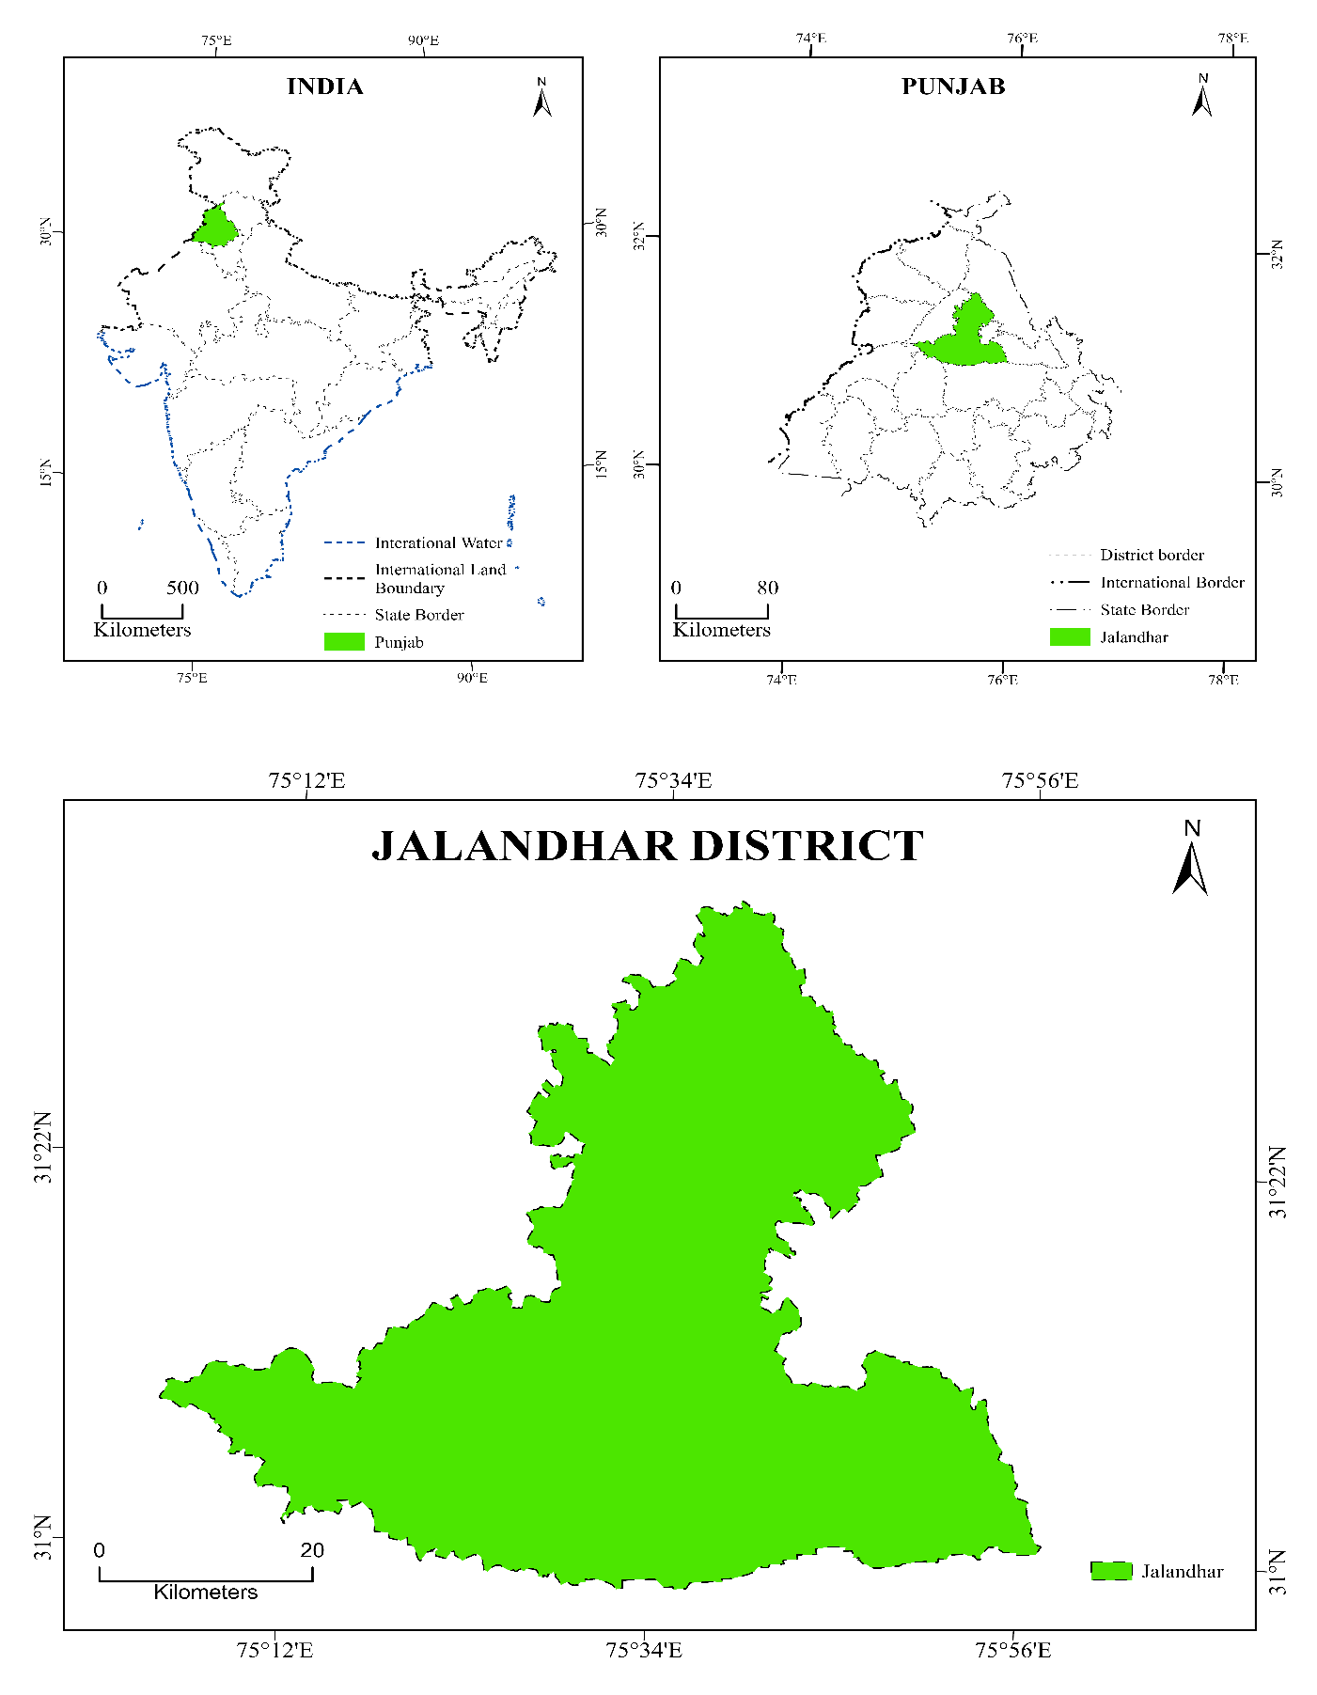
Source: Census of India, 2011
Fig 2: The map of Jalandhar district 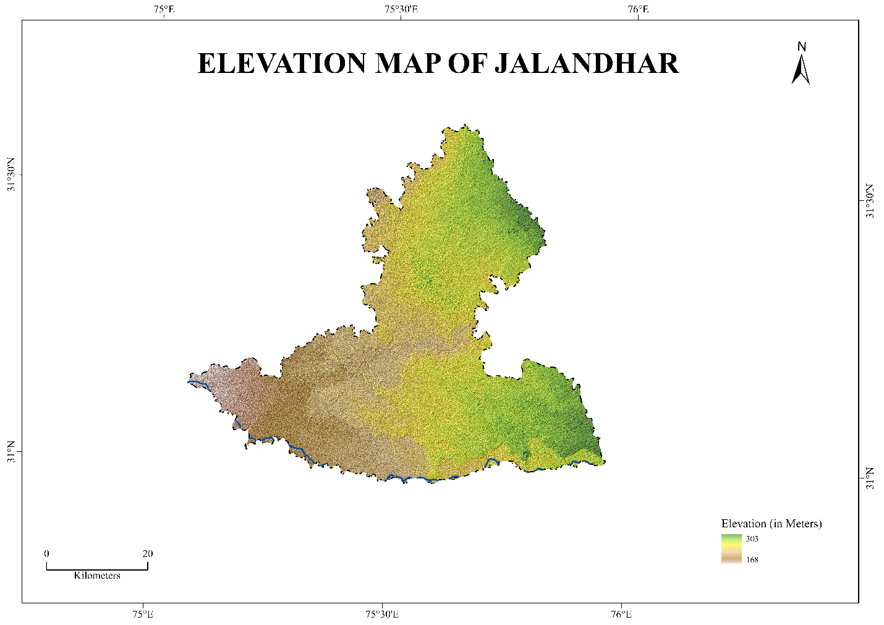
Source: Space Shuttle Endeavour/ SRTM
Table 1. Description of Data Sources
DATA TYPE | SATELLITE/SENSOR | DATE OF ACQUISITION | SPATIAL RESOLUTION | WRS  PATH | WRSROW | SOURCE
Satellite Image | Landsat 5 TM | 2001/03/23 | 30m | 148 | 038 | USGS Earth Explorer
Satellite Image | Landsat 8 OLI_TIRS | 2021/12/25 | 30m | 148 | 038 | USGS Earth Explorer
Administrative Boundary | - | - | - | - | - | Survey of India
DEM | Space Shuttle Endeavour/ SRTM | 2000/2/11 | 30m | - | - | USGS Earth Explorer

The satellite imagery was supervised classified into major land use and land cover classes using the Maximum Likelihood Classification (MLC) algorithm. Based on visual interpretation of the imagery and reference data from Google Earth, training samples representing various land cover types were chosen. The five main LULC categories—agricultural land, built-up area, vegetation or forest cover, water bodies, and barren land—were applied to the classified photos. To determine the extent and spatial pattern of land-use transformation, a change-detection analysis was performed by comparing the LULC maps of 2001 and 2021 using GIS overlay techniques, after creating classified maps for both years. Using randomly generated reference points and an error matrix (confusion matrix), an accuracy assessment was conducted to evaluate the classification results' reliability. Several statistical metrics, such as overall accuracy, producer accuracy, and user accuracy, were computed from the confusion matrix.
- Overall Accuracy = $\frac{Correct pixels in class}{Total Samples} ×100$

- Producer Accuracy = $\frac{Correct pixels in class}{\begin{aligned}Total Refrences \\ Pixels of that class\end{aligned}}$

- User Accuracy = $\frac{Correct pixels in class}{\begin{aligned}Total Classified \\ Pixels of that class\end{aligned}}$
To determine the degree of agreement between the classified and reference data while accounting for chance agreement, the Kappa coefficient (KHAT statistic) was also calculated. The Kappa coefficient is expressed as
Kappa Coefficient (K) = $\frac{(Po​-Pe​)}{1-Pe}$
RESULTS AND DISCUSSION
Land Use Land Cover Pattern in 2001
To study the LULC of Jalandhar in 2001, a map was prepared from a LANDSAT 5 (TM) satellite image. The five main LULC categories in Jalandhar district—water bodies, built-up area, barren land, forest/vegetation, and cultivated land—are represented on the classified map
According to the analysis, 2,177,877 units of land, or 74.54% of the district's total area, were under cultivation in 2001, dominating the Jalandhar district's landscape. The district's agrarian nature, in which agriculture underpins the local economy, is reflected in the predominance of agricultural land. A continuous agricultural landscape is formed by the extensive distribution of cultivated land in the district's central, southern, and western regions. The built-up area accounted for the second-largest share, at 539,940 units, or 18.48% of the total area. The urban center of Jalandhar and the nearby towns accounted for the majority of these built-up areas. Along important transit routes and rural communities, smaller areas of developed land were also noted. 11,472 units, or 3.82% of the total area, were covered by forests and vegetation. Rather than dense natural forests, the district's forest cover is primarily made up of dispersed vegetation patches, plantation belts, and tree cover along roads and canals. Barren land accounted for 93,527 units, or 3.20% of the entire geographical area, which was covered by these areas. These areas are scattered throughout the district in small patches and include open land, fallow land, and uncultivated surfaces. With 7,426 units, or just 0.25% of the total area, the water bodies occupied the least space. These bodies of water are primarily rivers, irrigation canals, and small ponds, all of which are crucial to the region's agricultural system. According to the district's 2001 LULC map, agricultural land predominated, with comparatively little urban development and tiny areas of other land cover types.

Fig: 3: Land Use and Land Cover in Jalandhar district in 2001
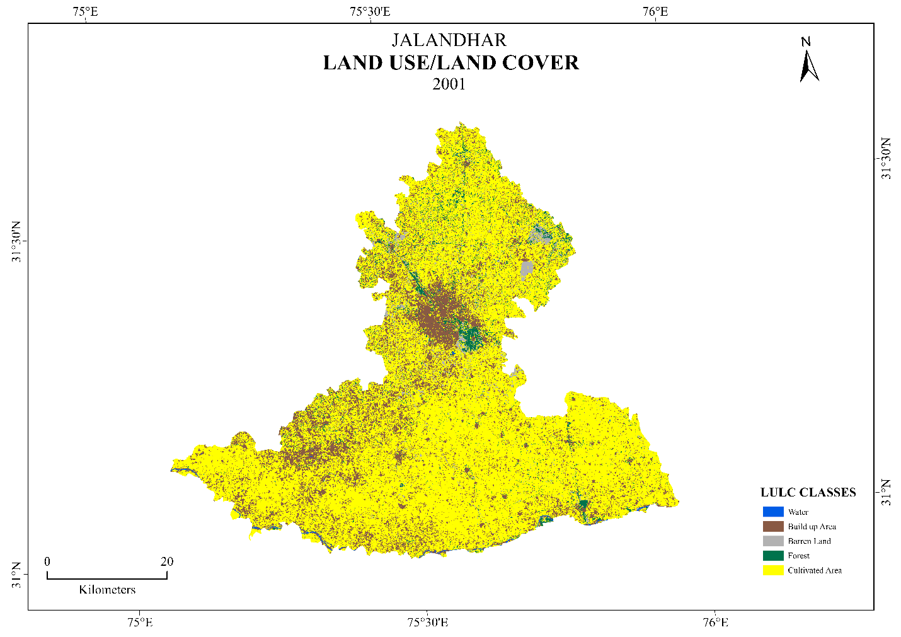
Source: Landsat 5 TM

Land Use Land Cover Pattern in 2021
Landsat-8 OLI/TIRS imagery acquired on November 25, 2021, was used to create the LULC map for that year. Compared with 2001, the classified map shows discernible shifts in the spatial distribution of land use categories.
It is revealed that cultivated land still dominates the landscape, covering 2,141,396 units of area, or 73.29 percent of the total area. Despite agricultural land being the largest land-use category in the district, its area has reduced marginally over the study period.
In 2021, the built-up area rose sharply to 622,010 units, accounting for 21.29% of the total area. The overall growth of the urbanized land is predominantly concentrated around Jalandhar city and the peri-urban areas. This increase is a sign of high urbanization, population growth, and infrastructure development in the district over the last 20 years. This forest and vegetation cover occupies 112969 units of area, which is 3.87% of the total geographical area. The vegetation is still patchy, largely restricted to plantation belts, canal banks, and scattered green patches throughout the district. In 2021, the barren land recorded a low of 39,967 units, comprising 1.37% of the total area. The decrease in idle land could also be explained by the conversion of previously unused land to agricultural or civilized land. The water bodies cover 5,300 units of area, constituting 0.18% of the overall area, indicating a slight change from the previous period. In general, the LULC trend in 2021 is characterized by the growing role of urbanization and human activity, particularly the development of built-up areas on former agricultural and barren land.

Fig: 4: Land Use and Land Cover in Jalandhar district in 2021
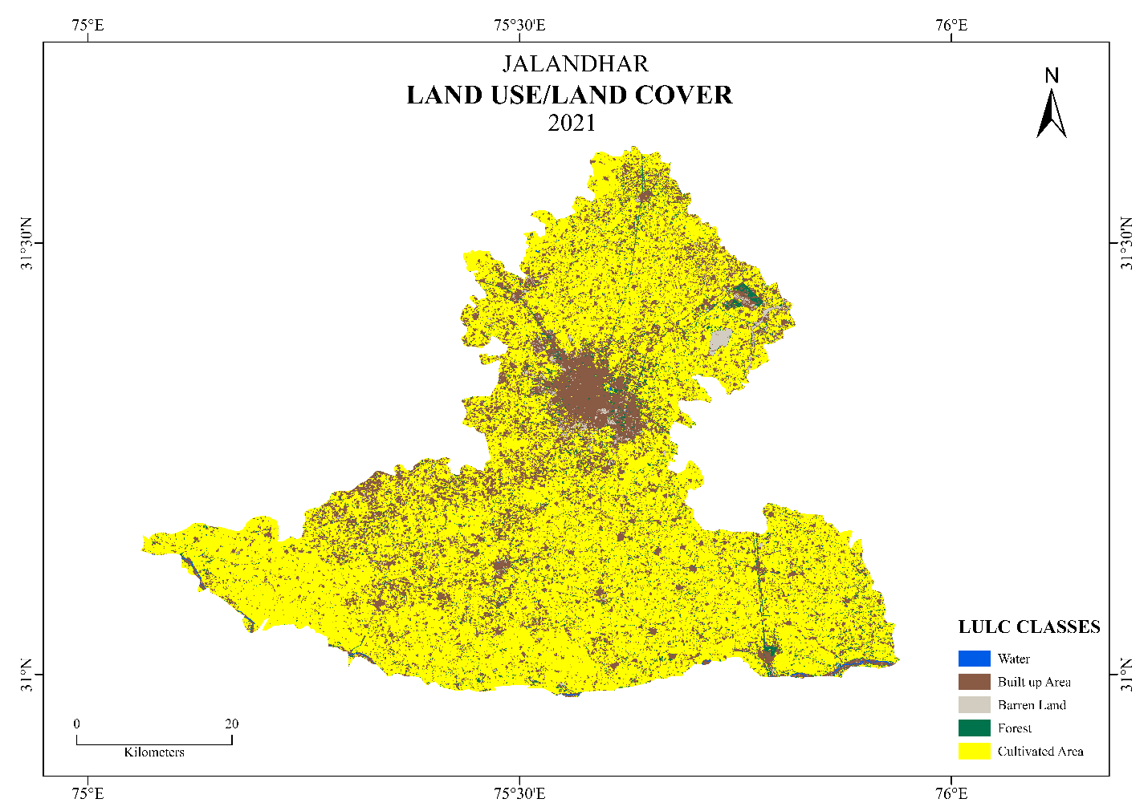
Source: Landsat 8 OLI_TIRS
LULC Change in Jaladhar district: 2001 to 2021
An analysis of LULC maps from 2001 and 2021 shows that the spatial distribution of land-use categories has changed significantly. The built-up area increased by approximately 2.81 percent during the study period, indicating rapid urbanization in Jalandhar district. The forest cover is slightly growing by 0.05, which proves that the vegetation cover is fairly stable. Conversely, the land under cultivation reduced by around 1.25 percent, indicating that agricultural land was slowly being converted into urban land. On the same note, the barren land declined by approximately 1.83, which might be attributed to the transformation of the land that was not in use to agricultural or residential development. The water bodies experience a slight increase of about 0.07, indicating fairly stable water resources in the district.
All in all, the analysis shows that the major driver of land-use change in the Jalandhar district during 2001-2021 is urbanization and infrastructure development, which have led to an increase in built-up areas and the gradual transformation of the agricultural landscape.
Table 2: Land Use/ Land Cover Change (2001 and 2021)
LULC Classes | 2001 |  | 2021 |  | 2001-2021
LULC Classes | Area (km²) | Area (per cent) | Area (km²) | Area (per cent) | Change (Per cent)
Water | 7426 | 0.25 | 5300 | 0.18 | 0.07
Built Up | 539940 | 18.48 | 622010 | 21.29 | 2.81
Barren | 93527 | 3.20 | 39967 | 1.37 | -1.83
Forest | 111472 | 3.82 | 112969 | 3.87 | 0.05
Cultivated | 2177877 | 74.54 | 2141396 | 73.29 | -1.25
Source: Landsat 5 TM (2001) and LANDSAT 8 OLI/TIR (2021)
Accuracy Assessment of LULC Classification
The quality of the classified land-use and land-cover maps for 2001 and 2021 was assessed using a confusion matrix derived from reference sample points. The accuracy assessment is a significant procedure in remote sensing studies because it evaluates the credibility of classification products by comparing classified pixels with ground reference data.
In the 2001 LULC map, 100 reference points were utilized in validation. The confusion matrix shows that classification accuracy varies across the five land use classes. The user accuracy values range from 0.60 to 0.95, corresponding to the classification reliability of single land cover categories. The constructed and developed classes are relatively accurate in classification, but some confusion is evident among classes such as forest and barren land. The total classification accuracy based on the confusion matrix is 78, and the Kappa coefficient is 0.725, indicating high agreement between the classified image and the reference data. Based on common standards, the Kappa value is above 0.70, indicating reliable classification in land-use research.
To evaluate the accuracy of the 2021 LULC map, 100 validation points and 20 reference samples per land use were used. According to the confusion matrix, all classes were properly classified, and the user and producer accuracies for all categories range from 0.85 to 1.00. Thus, the general classification accuracy of the 2021 map is 93 per cent, and the Kappa coefficient is 0.89, indicating that the classification and reference samples fully agree. Generally, the evaluation of accuracy indicates that the categorized LULC maps used in the study are suitable for studying land-use and land-cover changes in the Jalandhar district. The high overall accuracy and Kappa coefficients indicate that classification using the Maximum Likelihood algorithm yielded reliable results for change detection analysis.
LULC Transformation in Jalandhar District
The analysis of the LULC maps from 2001 and 2021 demonstrates that the district of Jalandhar has experienced significant shifts in land-use categories. To measure transitions in land
between categories during the study period, a transformation matrix was developed. The matrices are very clear about the extent of stability and change across all land-use types.
As indicated by the transformation matrix, cultivated land was the most dominant and stable land-use category in the district. Of the total cultivated land in 2001, only 1,505.26 km² was under cultivation in 2021, indicating high continuity of agricultural land use in the district. Nevertheless, part of the cultivated land had been converted to other land-use classes. Conversion of cultivated land to built-up land was the largest land transformation in the study area, accounting for approximately 296.11 km². Such a change indicates rapid urban growth and infrastructure development within and around Jalandhar. Moreover, approximately 46.71 km² of agricultural land became forest or vegetation cover, whereas 44.85 km² became barren land, and 1.01 km² became
water bodies. The built-up area also indicates a high rate of persistence during the study period. The built-up land area was approximately 182.30 km², indicating stability in the already established urban settlements. The accumulated class, however, obtained a large portion of the land of other types. According to the matrix, approximately 296.11 km² of cultivated land, 34.12 km² of forest land, 22.70 km² of barren land, and 1.30 km² of water bodies were transformed into built-up areas. It means that urbanization has been built predominantly at the cost of farmland and green cover. There was a moderate change in the barren land category. Approximately 9.43 km² of unproductive land remained unchanged, while 16.25 km² was converted to cultivated land, suggesting that the unused land should be reclaimed for agricultural use. Moreover, 6.80 km² of barren land also became built-up areas, 2.54 km² forest or vegetation cover, and 0.05 km² water bodies. The forest or vegetation group also clearly experienced some changes. The forest area was left at 12.25 km², while 67.13 km² was converted to cultivated land, indicating intensified agricultural operations in certain areas of the district. Moreover, 13.62 km² of forest land was converted to built-up land, indicating that urban development was encroaching on vegetated areas. Less than 5.09 km² was turned into useless land, and 0.18 km2 of water bodies. Changes in water bodies are relatively small compared to changes in the rest of the land use. The water bodies that were not changed occupied about 0.80 km², which was transformed into cultivated land; 1.79 km² into built-up regions; 0.21 km² into forest; and 0.10 km² into barren land.
Overall, the transformation matrix indicates that the largest change in land use in the Jalandhar district during 2001-2021 was the conversion of cultivated land to built-up areas, reflecting a high rate of urbanization and the development of residential, commercial, and industrial activities.
Fig: 5: Land Use/ Land Cover Changes during 2001-2021
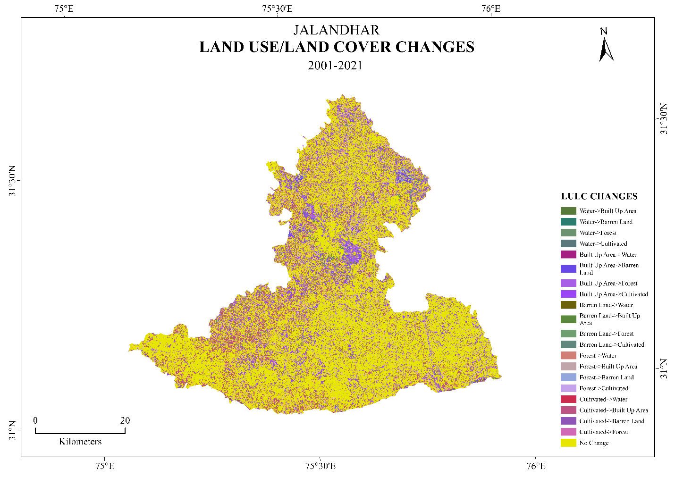
Source: Landsat 5 TM (2001) and LANDSAT 8 OLI/TIR (2021)
Meanwhile, a portion of unproductive land has been terraced to become arable, indicating agricultural growth in some sectors of the district. The above changes underscore the growing strain of human activities on land resources and the significance of sustainable land-use planning in delivering balanced regional development.

Table 3: Jalandhar district Transformation Matrix
Land Use Categories | Water  (km²) | Built-Up Area  (km²) | Barren Land  (km²) | Forest  (km²) | Cultivated  (km²)
Water | 0.80 | 0.83 | 0.10 | 0.21 | 1.79
Built-Up Area | 1.30 | 182.30 | 22.70 | 34.12 | 296.11
Barren Land | 0.05 | 6.80 | 9.43 | 2.54 | 16.25
Forest | 0.18 | 13.62 | 5.09 | 12.25 | 67.13
Cultivated | 1.01 | 296.11 | 44.85 | 46.71 | 1505.26
Source: Landsat 5 TM (2001) and LANDSAT 8 OLI/TIR (2021)
Conclusion and Policy Implications
The present study examined the spatial and temporal changes in land use and land cover (LULC) in Jalandhar district in 2001 and 2021 using remote sensing and GIS. The discussion showed that the agricultural base is still largely evident in the district's landscape, with cultivated land dominating, but it has changed greatly over the last 20 years. The most significant alteration observed is the increase in built-up areas, largely achieved through the conversion of agricultural land and, to a certain degree, vegetation cover. The trend shows that urban pressure is growing due to population growth, infrastructure development, and economic growth in and around Jalandhar city. The transformation matrix also shows that a significant portion of the agricultural land has been converted to built-up areas, indicating the growing role of anthropogenic activity in the region's landscape. The fact that some of the barren land has been transformed into cultivated land has been a concern, as agricultural land is continually being consumed by urban development, raising questions about the sustainability of agriculture and food security in the region in the long run. These results highlight the importance of effective land-use planning and policy interventions that balance urban growth with the protection of agricultural and ecological resources. Urban sprawl can be controlled through planned urbanization, land-use zoning, and encouraging vertical urban development, thereby helping eliminate uncontrolled sprawl and the loss of productive agricultural lands. Concurrently, green areas, plantation belts, and conservation and expansion of canal-side vegetation are necessary to ensure ecological equilibrium and environmental quality. Another key factor highlighted in the study is the role of incorporating geospatial technologies, including remote sensing and GIS, into land management and planning procedures to monitor land changes and support evidence-based decision-making. In general, the combination of protective agricultural land use policies, urban growth, and environmental resources conservation is crucial to the realization of the balanced development of the region of the Jalandhar district (Foley et al., 2005; Lambin & Geist, 2006; Seto et al., 2012; Roy et al., 2015).

Competing Interest
The authors declare that there are no competing interests regarding the publication of this paper.

References
Ambin, E. F., & Geist, H. J. (2006). Land-use and land-cover change: Local processes and global impacts. Springer. https://doi.org/10.1007/3-540-32202-7
Chughtai, A. H., & Majeed, H. (2021). A review on change detection method and accuracy assessment for land use land cover. Egyptian Journal of Remote Sensing and Space Science. https://doi.org/10.1016/j.ejrs.2021.01.005
Coppin, P., Jonckheere, I., Nackaerts, K., Muys, B., & Lambin, E. (2004). Digital change detection methods in ecosystem monitoring. International Journal of Remote Sensing, 25(9), 1565–1596. https://doi.org/10.1080/0143116031000101675
Dhillon, B. S., & Sidhu, R. S. (2015). Agricultural development and sustainability in Punjab. Agricultural Economics Research Review, 28(2), 197–206. https://doi.org/10.5958/0974-0279.2015.00031.3
Ellis, E. C., Kaplan, J. O., Fuller, D. Q., Vavrus, S., Klein Goldewijk, K., & Verburg, P. H. (2013). Used planet: A global history. Proceedings of the National Academy of Sciences, 110(20), 7978–7985. https://doi.org/10.1073/pnas.1217241110
Foley, J. A., DeFries, R., Asner, G. P., Barford, C., Bonan, G., Carpenter, S. R., & Snyder, P. K. (2005). Global consequences of land use. Science, 309(5734), 570–574. https://doi.org/10.1126/science.1111772
Foley, J. A., et al. (2005). Global consequences of land use. Science, 309(5734), 570–574. https://doi.org/10.1126/science.1111772
Jensen, J. R. (2015). Introductory digital image processing. Pearson. https://doi.org/10.1016/B978-0-13-405816-7.00001-2
Kaur, H., & Kaur, P. (2021). Urban growth and land transformation in Punjab. Environment and Urbanization Asia, 12(2), 205–220. https://doi.org/10.1177/09754253211014721
Lambin, E. F., & Geist, H. (2006). Land-use and land-cover change: Local processes and global impacts. Springer. https://doi.org/10.1007/3-540-32202-7
Liu, B., et al. (2023). Review of land use change detection methods using remote sensing and GIS. Land, 12(5), 1050. https://doi.org/10.3390/land12051050
Mallupattu, P. K., & Reddy, J. R. S. (2013). Analysis of land use/land cover changes using remote sensing and GIS: A case study of Tirupati, India. The Scientific World Journal. https://doi.org/10.1155/2013/268623
Mariye, M., et al. (2024). Remote sensing and GIS-based study of land use/cover changes and driving factors. Heliyon. https://doi.org/10.1016/j.heliyon.2024.e20588
Mishra, V. N., Rai, P. K., & Mohan, K. (2020). Prediction of land use changes using geospatial techniques. Applied Geography, 118, 102189. https://doi.org/10.1016/j.apgeog.2020.102189
Naikoo, M. W., et al. (2020). Analyses of land use land cover change and built-up expansion in the National Capital Region of Delhi. Journal of Urban Management. https://doi.org/10.1016/j.jum.2020.03.001
Pushpalatha, V., et al. (2025). Land use land cover classification and change detection using remote sensing and GIS. Environmental Monitoring and Assessment. https://doi.org/10.1016/j.rse.2025.114000
Roy, P. S., et al. (2015). Development of decadal land use and land cover database for India. Remote Sensing, 7(3), 2401–2430. https://doi.org/10.3390/rs70302401
Roy, P. S., Roy, A., Joshi, P. K., Kale, M. P., Srivastava, V. K., Srivastava, S. K., & Dwevidi, R. S. (2015). Development of decadal land use and land cover database for India. Remote Sensing, 7(3), 2401–2430. https://doi.org/10.3390/rs70302401
Seto, K. C., Güneralp, B., & Hutyra, L. R. (2012). Global forecasts of urban expansion. Proceedings of the National Academy of Sciences, 109(40), 16083–16088. https://doi.org/10.1073/pnas.1211658109
Seto, K. C., Güneralp, B., & Hutyra, L. R. (2012). Global forecasts of urban expansion to 2030 and direct impacts on biodiversity and carbon pools. Proceedings of the National Academy of Sciences, 109(40), 16083–16088. https://doi.org/10.1073/pnas.1211658109
Seyam, M. M. H., et al. (2023). Identifying land use land cover changes using remote sensing and GIS techniques. Remote Sensing Applications: Society and Environment. https://doi.org/10.1016/j.rsase.2022.100847
Singh, S., et al. (2025). Assessment of land use land cover change in Bathinda district using GIS techniques. GeoJournal. https://doi.org/10.22271/27067483.2025.v7.i9b.415
Song, X. P., et al. (2018). Global land change from 1982 to 2016. Nature, 560, 639–643. https://doi.org/10.1038/s41586-018-0411-9
Tewabe, D. (2020). Assessing land use and land cover change detection using remote sensing and GIS. Cogent Food & Agriculture. https://doi.org/10.1080/23311932.2020.1778998
Thakur, T. K., et al. (2020). Land use land cover change detection through geospatial analysis in forest ecosystems. Trees, Forests and People. https://doi.org/10.1016/j.tfp.2020.100009
Turner, B. L., Lambin, E. F., & Reenberg, A. (2007). Land change science. Proceedings of the National Academy of Sciences, 104(52), 20666–20671. https://doi.org/10.1073/pnas.0704119104
Turner, B. L., Lambin, E. F., & Reenberg, A. (2007). The emergence of land change science for global environmental change and sustainability. Proceedings of the National Academy of Sciences, 104(52), 20666–20671. https://doi.org/10.1073/pnas.0704119104
Weng, Q. (2012). Remote sensing of urban environments. International Journal of Remote Sensing, 33(18), 5905–5924. https://doi.org/10.1080/01431161.2012.689499
Weng, Q. (2012). Remote sensing of urban environments. International Journal of Remote Sensing, 33(18), 5905–5924. https://doi.org/10.1080/01431161.2012.689499
Zhu, Z. (2017). Change detection using Landsat time series. Remote Sensing of Environment, 198, 111–122. https://doi.org/10.1016/j.rse.2017.05.013
Zhu, Z. (2022). Remote sensing of land change: A multifaceted perspective. Remote Sensing of Environment. https://doi.org/10.1016/j.rse.2022.113056

