Original Research Article

Environmental and Health Impact of Waste Management in Ebonyi State, Nigeria: Challenges and Opportunities

.
ABSTRACT
Poor waste management practices in Nigeria pose significant environmental and public health risks. This study examines residents' perceptions of waste management practices in Ebonyi State, their impacts, and the associated challenges. Primary data were collected through a semi-structured questionnaire to gather residents' comprehensive perception. A total of 453 respondents were randomly selected; 248 reside near designated waste bins/dumpsites, while 205 reside far from or without designated dumpsites/waste bins. Pearson’s Chi square test was used to compare environmental and health impact variables in the two categories. The results revealed that those residing near public dumpsites/waste bin dispose of 63% of their waste at the public dumpsite/waste bin, 37% by burning, open dumping and other methods, while those without public dumpsite/waste bin in their area dispose of only about 33% at the public dumpsite and 67% by open dumping, burning and other methods. 73%, 67%, 58%, and 35% reported witnessing air pollution, littering in public places, water pollution, and soil pollution, respectively, as a result of poor waste disposal. Similarly, 69%, 48%, 43%, 32%, and 29% reported suffering from malaria, diarrhoea/dysentery, cough, cholera, and skin diseases, respectively. However, when comparing the two categories, results showed that environmental effects and disease outbreaks resulting from poor waste disposal are significantly worse in areas without public waste bins/dumpsites, with a P-value <0.05. The respondents identified inadequate waste collection and disposal systems (73%), lack of proper waste recycling facilities (69%), weak enforcement (64%), and insufficient public awareness (50%) as the key challenges. However, opportunities exist through circular economy approaches, such as recycling and waste-to-energy initiatives, which can reduce environmental and public health risks while creating economic benefits. Therefore, stricter enforcement of EBSEPA laws, a public education campaign, and the provision of more waste collection and functional recycling facilities are recommended to improve waste management systems in the state.

Keywords: Solid waste, environment, health, dumpsite, waste bins, challenges

1.0 INTRODUCTION

Waste disposal is a widespread issue affecting most developing and underdeveloped countries worldwide (Ike et al., 2018; Ferronato & Torretta, 2016). In Nigeria, managing agricultural, industrial, and domestic waste has been a persistent challenge over the years, with numerous difficulties arising from the handling of solid waste from residential, industrial, and commercial sectors (Ike et al., 2018; Onuoha et al., 2024). Similarly, waste management remains a vital environmental and public health concern in Ebonyi State. Despite the government's efforts and rapid urbanisation, Ebonyi State continues to face problems related to improper waste disposal, such as indiscriminate littering, open dumping, and unsuitable landfill practices, which have resulted in significant environmental damage and health hazards (Nwofe, 2015).
Municipal waste continues to increase daily due to the rapid growth of industrialisation and urbanisation. Several bloggers, researchers, and influencers have highlighted the unbearable situation caused by unsustainable and indiscriminate waste disposal and management in Abakaliki Metropolis (Oginyi, 2010; Nwofe, 2015; Okwesili et al., 2016; Anozie et al., 2017; Echeweozo et al., 2017).
A significant amount of research has been conducted on the environmental and health impacts of quarrying waste management in Nigeria, including Ebonyi State and other regions, focusing on managing tailing/rejected stones, dust, and water discharged from the quarry pit, as well as other solid waste generated at the quarry site (Oshim et al., 2024). However, few localised studies specifically investigate the environmental and health challenges of waste disposal and management in Ebonyi State. Additionally, some researchers have conducted observational, experimental, and cross-sectional studies using field surveys, laboratory analysis, and interviews with stakeholders. However, no research has been conducted using cross-sectional studies to gather residents' perceptions on both the health and environmental impacts of poor waste disposal and its challenges. A single body cannot handle waste management – it needs the input of the government, stakeholders, and residents to develop actionable ways to improve waste management in Ebonyi State that incorporate the perspectives of all parties.
This study aims to evaluate residents' perceptions of waste management practices, their impacts, and challenges. The primary objectives of this study are to assess the environmental and health implications of waste management practices in Ebonyi State and to identify key challenges and potential opportunities for sustainable solutions. This will provide insights into public perceptions, existing waste management practices, and policy gaps, as determined through a comprehensive review and data collected via a semi-structured questionnaire. The findings of this study will contribute to achieving the United Nations' Sustainable Development Goals (SDGs). It will also provide recommendations for the policymakers, stakeholders, environmental agencies, and the government of Ebonyi State to enhance waste disposal systems, mitigate health risks, and promote sustainable waste management policies and practices in Ebonyi State.
1.1 GLOBAL AND NATIONAL WASTE MANAGEMENT TRENDS
Waste management is a pressing global challenge that affects both ecosystems and public health, as well as sustainable development, worldwide (Mahajan, 2023; Agboola et al., 2025). Business Waste (2024) reported that over 2 billion tons of waste are generated worldwide annually. Similarly, the World Bank (2018) added that the figure is expected to increase to 3.4 billion tons per year by 2050, significantly. In underdeveloped and developing countries like Nigeria, over 90% of waste is mismanaged through open dumping, landfills, or burning, which exacerbates environmental and health risks, including air and water pollution, land degradation, and the spread of diseases (Ferronato & Torretta, 2016; Mahajan, 2023; Agboola et al., 2025). However, in other developed countries, such as the United States, Canada, the United Kingdom, and others, waste is turned into wealth through sustainable waste management practices, including the use of non-recyclable waste to generate energy through waste incineration (Reddy et al., 2023; Karim et al., 2025).
In a developing country like Nigeria, the implemented waste disposal and treat-ment system includes open-air burning, open dumping, burial, recycling, and com-posting as waste management practices (Ferronato & Torretta, 2016; Noiki et al., 2021). Rapid population growth, weak enforcement, and inadequate infrastructure have led to a waste crisis in many states within Nigeria (Unegbu and Yawas, 2024). Although the Nigerian government has made substantial progress in reducing indiscriminate dumping and disposal, it still faces challenges related to improper waste disposal and management due to poor enforcement, inadequate funding, and limited public awareness (Sridhar et al., 2017).
1.2 CURRENT WASTE MANAGEMENT PRACTICES IN EBONYI STATE
Municipal waste (from domestic, institutional, and commercial sources), industrial waste (from mining, production, and other industrial activities), and Agricultural waste (from agricultural activities) are the three major types of waste generated in Ebonyi State (Nwofe, 2015; Okwesili et al., 2016; Odejobi et al., 2024). Due to growing urbanisation and population, the volume of waste produced continues to increase daily; however, no information is available on the total annual tons of waste generated in Ebonyi State (Nwofe, 2015; Okwesili et al., 2016).
According to Nwofe (2015), the residential sector generates the highest amount of municipal waste, accounting for about 71% of the municipal waste in Abakaliki metropolis. This means that household waste, including food scraps, packaging, and other discarded materials, constitutes a substantial portion of the metropolitan area's waste. The remaining 29% of the waste originates from various sources, including commercial and industrial activities and public spaces (Nwofe, 2015).
Oshim et al. (2024) stated that Ebonyi State is one of the mineral-rich states in Nigeria, and that a massive volume of waste is generated from mining/quarrying sites across different communities in the state. A significant amount of industrial waste originates from small-scale industries, including quarrying and other similar activities (Oshim et al., 2024; Okafor and Obaze, 2025). They are limited but still growing. Agricultural waste is the most significant volume of waste generated in rural areas, although it is less prevalent in urban areas. However, Nwofoke et al. (2017) noted that the rice husk piled up at rice mills has resulted in severe environmental pollution and health hazards, suggesting the need for improved waste disposal.
In Ebonyi State, solid waste is being dumped into landfills, water bodies, and littered everywhere, resulting in serious environmental and health issues for both the public and aquatic life (Onuoha et al., 2024; Nwofe, 2015). While wastewater is discharged into rivers and drainage channels, contaminating both surface water and groundwater, it also poses a significant health risk to residents, especially those in rural areas who lack access to borehole or tap water and depend on river or stream water for drinking and cooking ( Okafor and Obaze, 2025; Okafor et al., 2025).
Municipal solid waste disposal in the state is characterised by open dumping and low waste collection and recycling efficiency. In the metropolitan area, waste is deposited into public waste bins and collected by the Ebonyi State Environmental Protection Agency (EBSEPA) (Nwofe, 2015; Njaka, 2024). In Abakaliki metropolis, waste collected by the EBSEPA is taken to the landfill, with a smaller percentage being recycled (Ejike-Alieji et al., 2025). While in rural areas, waste is disposed of through open dumping, burning, and burial.
Nwofe (2015) and Okwesili et al. (2016) conducted a field survey on municipal solid waste management, reporting that urban solid waste in Abakaliki is managed through a combination of government-designated and informal dumpsites, with widespread in-discriminate disposal and a lack of regular collection. Studies have also confirmed that approximately 30% to 60% of the waste generated is not collected by waste management authorities, resulting in littered waste and causing severe health and environmental issues, as open dumping and low collection have been adopted in Ebonyi State (Nnaji, 2015; Nwofoke et al., 2017).
Consequently, Anozie et al. (2017) stated that 98.1% of hospitals in Ebonyi State practice indiscriminate disposal, with only 1.9% following standard procedures. Similarly, Oginyi (2018) and Oshim et al. (2024) reported that poor waste handling in quarry industries results in dust and particulate pollution, affecting both workers and nearby communities. Additionally, wastewater from quarry sites contaminates surface water and groundwater.
1.3 IMPACTS OF POOR WASTE DISPOSAL ON THE SURROUNDINGS AND THE RESIDENTS
Many residents in the state face outbreaks of waterborne diseases, water pollution, air pollution, and land degradation resulting from improper waste disposal (Nwofe, 2015; Okwesili & Iroko, 2016; Anozie, 2017; and Echeweozo et al., 2025).
In recent years, numerous researchers have investigated the current waste management practices, examining their health and environmental impacts. Researchers such as Nwofe (2015), Okwesili and Iroko (2016), Oginyi (2010), Echeweozo et al. (2025), and others. The consensus between them is that the current waste management practices in Ebonyi state create numerous health and environmental challenges.
Poor waste disposal contributes to the spread of infectious diseases, such as cholera and malaria, as well as environmental problems that reduce agricultural productivity. Ewash (2023), through a volunteer –Dr. Kelechuchwu Okezie reported the outbreak of Cholera in the State, which claimed the lives of many residents in the state. This disease outbreak was linked to water contamination resulting from contaminated water, poor hygiene and sanitation in the State (Oweibia et al., 2025). Aborode et al. (2025) linked the outbreak of Cholera to inadequate infrastructure for waste disposal and water supplies.
Nwofe (2015) found out from his studies that the waste dump sites in Abakaliji metropolis both designated and non-designated on the major streets and several open spaces are left unattended for long periods such that the rubbish heaps; encroach on the roads thereby limiting the road users access, generating serious air pollution issues, constituting significant nuisance when blown over by winds, and distorts the aesthetic view of the metropolis. Similarly, Echeweozo et al. (2025) reported that the surrounding farmlands around the waste dump site and landfill are contaminated due to soil pollution, resulting in high concentrations of Pb and Fe that have the potential to cause adverse health effects for both humans and plants in the area. Okafor et al. (2025) added that effluents discharged from the slaughterhouse lead to groundwater pollution.
Improper waste disposal in Ebonyi State has resulted in environmental degradation. Okwesili and Iroko (2016) reported the implications of some households in the state that will soon be cut off by flood arising from blocked drainage channels and some streets and roads that will soon be cut off by flood as a result of indiscriminate littering and heaps of waste, and people will contract epidemics if nothing is done.
Oginyi (2010), Nwofe (2015), Okwesili & Iroko (2016), Anozie (2017), and Echeweozo et al. (2025) reported that the health and environmental impacts of waste management in Ebonyi state have high severity. Some researchers also noted the contributing factors that led to poor waste management in the state. Factors such as poor waste collection, inadequate infrastructure, limited agency capacity, unattended/overstayed waste, open dumping, and many more (Oginyi, 2010; Nwofe, 2015; Okwesili & Iroko, 2016; Anozie, 2017; and Echeweozo et al., 2025). Okwesili & Iroko (2016) concluded from their studies that the devastating effects of urban solid waste management in Abakaliki are due to inappropriate and inadequate management.
The researchers have conducted extensive work on the impacts of current waste management practices in the State; however, many of the studies employed observational and cross-sectional research designs, involving laboratory analyses and interviews with key informants -stakeholders. However, there is no study that incorporates residents' perceptions. There is no doubt that improper waste management in Ebonyi State has resulted in numerous environmental and health issues affecting the state's residents. A single body cannot handle proper and sustainable waste management; it requires co-operation between the government, industries, and residents to achieve efficient results. Therefore, there is a need to hear the residents' comprehensive perception on the issue to recommend the best waste management practices in the state.
1.4 INSTITUTIONAL FRAMEWORK FOR WASTE MANAGEMENT IN EBONYI STATE
The Ministry of Environment primarily manages Ebonyi State's waste management system through the Ebonyi State Environmental Protection Agency (EBSEPA), with some involvement from the local government and some private sectors (Nwofe, 2015; Okwesili & Iroko, 2016). The Ebonyi State government enacted the Ebonyi State Environmental Protection Agency Law in 1999 (Nwofe, 2015; Faga & Nwanga, 2023; Njaka, 2024; Omaka & Okorie, 2024). There was another law that repealed it in 2009, and now the 2015 law has repealed that of 2009 (Ebonyi State Environmental Protection Law, No.009 of 2015; Omaka & Okorie, 2024). Ebonyi State Environmental Protection Law enforces waste and environmental protection through the Ebonyi State Environmental Sanitation Law. This law prohibits the indiscriminate disposal of waste and mandates proper waste management. It establishes sanitation offences with penalties, such as fines or prosecution by the State Environmental Sanitation Court, for their offenders. Progressive News (2025) stated that Ebonyi State enforces sanitation Laws, with a 50,000 Naira fine for indiscriminate waste disposal. This is one of the commitments to maintaining environmental cleanliness in Abakaliki. This fine applies to anyone caught dumping waste indiscriminately.
The EBSEPA is responsible for regulating municipal waste disposal, enforcing penalties for environmental violations, and monitoring environmental pollution. They are also responsible for licensing waste collectors, implementing public health mandates such as monthly sanitation exercises, and designating approved dumpsites.
Many researchers have reported that authorities and the government, through the EBSEPA, have not made appreciable efforts to recruit and train the required manpower with the technical skills and competencies necessary to address the ever-increasing solid waste (Okwesili and Iroko, 2016). Okwesili and Iroko (2016) also highlighted the lack of approved dumpsites and the weak capacity of the relevant agencies in the state. Omaka & Okorie (2024) reported that corruption within some of the agencies responsible for enforcing environmental legislation on pollution control in the state, as well as inadequate funding, are significant challenges to implementing the Environmental Protection Law in the State.
Existing studies have highlighted the challenges and policy gaps within the institutional framework responsible for managing waste in Ebonyi State, including inadequate infrastructure, weak enforcement of existing waste management laws, corruption, low waste collection rates, and the approval of public waste bins, as well as a lack of technical skills and competencies among waste management authorities.
2. materialS and methods

2.1 STUDY AREA
Ebonyi State is located in the southeastern region of Nigeria, positioned between latitudes 5°40' and 6°45' North and longitudes 7°30' and 8°30' East (Diagi, 2018). Ebonyi State shares boundaries with four other Nigerian states: Benue to the north, Enugu to the west, Cross River to the east, and Abia to the south. According to City Population (2022), Ebonyi State had an estimated population of 3,242,500 as of 2022.
This research focused on the Abakaliki metropolis and its surrounding areas in Ebonyi State. Abakaliki metropolis is the urban heartbeat of Ebonyi state, facing a severe and most pressing waste management crisis caused by rapid population growth, unchecked urbanisation, and inefficient waste disposal systems, leading to serious environmental and public health risks. Abakaliki metropolis is situated at 6.32° North latitude and 8.12° East longitude (Oroke et al., 2020). The study area includes the Abakaliki Local Government Area (LGA), Ebonyi LGA, Ezza North LGA, Izzi, and their surrounding localities (those living near or around the Abakaliki metropolis), as shown in Figure 1. The estimated population of the Abakaliki metropolis area is 723,000 in 2025 (Macrotrends, 2025).
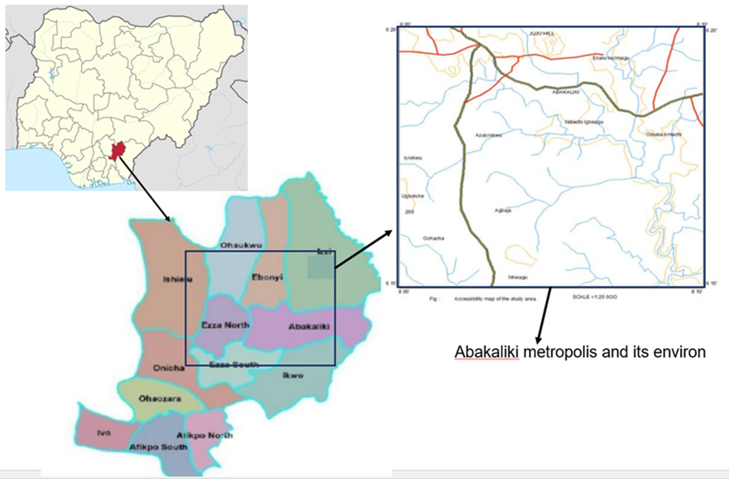Figure 1: Map of the study area.
2.2 METHODOLOGY
This study adopted a descriptive and cross-sectional research design to assess the impacts, challenges, and future improvements of waste management in Ebonyi State. A comprehensive review was conducted to understand waste management practices, their impacts, and the gaps in laws and policies. This study combined both qualitative and quantitative approaches. The cross-sectional survey design allows for the collection of primary data from randomly selected respondents within a specific timeframe. The respondents are those who currently reside in Ebonyi State and those who have relocated from Ebonyi State within the last 10 months. This enables individuals who previously lived in Ebonyi State and those currently residing there to provide insights into current and past waste management practices, as well as challenges and opportunities for improvement. Those who have relocated from Ebonyi State within the last 10 months were included, as there have been no changes in waste management practices and policies in Ebonyi State over the past year.
2.2.1 DATE COLLECTION AND SOURCE
This study employed an online questionnaire complemented by face-to-face link sharing for data collection. The instrument used was a Google Forms questionnaire. Potential respondents were approached in person, and a Google Form link was shared with them, along with an explanation of the purpose and clarification of any questions they may have had. Additionally, the Google Form questionnaire link was disseminated via WhatsApp groups, DMs, and Facebook platforms to target residents, environmental workers, health workers, students, farmers, and others to provide a comprehensive description of their experiences from the respondents' perspectives. The combined strategy enhanced participation rates by using digital convenience while ensuring inclusivity for populations with limited internet access and promoting diverse representation across the study area. The Google form was left open to accept responses for three weeks and then closed.
2.2.2 SAMPLING METHOD AND DATA ANALYSIS
The study area has a total population of 723,000 people (Macrotrends, 2025). A random sampling method was employed. Out of the 723,000 people, 467 responded; however, 14 individuals did not meet the eligibility criteria, and their responses were therefore excluded. The use of random sampling was intended to prevent bias in participant selection. A sample size of 453 was considered representative, making it manageable and capable of providing reliable results.
The questionnaire was divided into three sections and contained both closed and open-ended questions to gather information. This is to enable the respondents to give their comprehensive perceptions. Section one includes eligibility questions such as age and place of residence. Section two covers waste generation, disposal, laws, and waste management practices to enhance understanding of waste management practices and laws. Section three addresses environmental and health impacts, challenges, and strategies to improve waste management. Descriptive statistics, such as frequency, percentages, and mean, were used to analyse the quantitative data in pie charts, bar charts, and tables. The qualitative responses were thematically analysed to identify recurring challenges and opportunities. Pearson’s chi-square test was used to compare the environmental and health impacts of waste management in the area, to determine whether there is a significant difference in impact between those with designated waste bins/dumpsites and those without.
3. results and discussion

3.1.1 SOCIO-ECONOMIC PROFILE OF THE RESPONDENTS
The result in Table 1 presents the demographic profile of the respondents, focusing on age, gender, employment status, and residency. Out of the eligible 453 respondents, 22.1% are within the age of 18-25, 53% the age of 26-35, 19.6% the age of 36-55, 3.8% the age of 46-55, and 1.5% are 56 and above. Out of the 453 eligible respondents, 68.4% were males and only 31.6% were females. This indicates that more males responded than females. Out of the 453 respondents, 54% are students, 22.5% are civil servants, 15.5% are self-employed, 1.8% are farmers, and 6.2% are from other professions, including health workers. This indicated that the respondents were predominantly students, civil servants, and self-employed individuals with a diverse age range and evenly distributed gender, reflecting urban residents with diverse occupations and characteristics.

Table 1: The demographic information of the respondents
Particulars | Variables | Frequency | Percentage | Mode
Age (Years) | 18-25 | 100 | 22.10%
 | 26-35 | 240 | 53% | 26-35
 | 36-45 | 89 | 19.60%
 | 46-55 | 17 | 3.80%
 | 56+ | 7 | 1.50%
 | Total | 453 | 100.00%
Gender | Male | 310 | 68.40% | Male
 | Female | 143 | 31.60%
 | Total | 453 | 100.00%
Occupation | Student | 245 | 54.10% | Student
 | Farmer | 8 | 1.80%
 | Self employed | 70 | 15.50%
 | Civil servant | 102 | 22.50%
 | Others | 28 | 6.20%
 | Total | 453 | 100.00%

3.1.2 TYPES OF WASTE GENERATED BY THE RESIDENTS
Out of the 453 respondents, 98% generate household waste, 7.1% industrial waste, 23.8% agricultural waste, and 8.2% others (Figure 2). This indicates that 71.5% of the waste generated in the study area is domestic waste from homes and other residential areas. 17.4% of the agricultural waste is generated from farms and other agricultural activities, and 5.2% is industrial waste. This revealed that domestic waste is generated in greater quantities in urban areas, indicating that a higher percentage of agricultural waste is generated in rural areas, as opposed to urban areas, where a lower rate is generated.
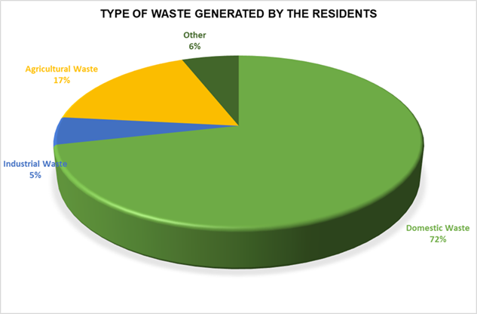
Figure 2: The type of waste generated by the residents
3.1.3 METHODS OF WASTE DISPOSAL BY THE RESIDENTS
Out of the 453 respondents, 54.7% reported that they have designated public waste bins or dumpsites in their area. In contrast, 45.3% reported that there are no public waste bins or dumpsites in their area (Figure 3). 98% of residents in areas with public waste bins or dumpsites dispose of their waste at the government waste collection dumpsite managed by the EBSEPA (public dumpsite). In contrast, 21% of the waste is disposed of through open dumping, 23% through burning, 7% through reuse and recycling, and 1% is buried Figure 3. In comparison, 48% of the residents who do not have public waste bins/dump sites in their area dispose of their waste at the government dumpsite, while 50% of the waste is disposed of through open dumping, 39% through burning, 3% through recycling/reuse, and 3% through burial.
This revealed that 63% of those who reside in area where there are public waste bins/dumpsites dispose of their waste at the designated public dumpsite with only about 31% of waste been dispose of through burning and open dumping, while 62% of those that reside where there are no public bins/dumpsites dispose of their waste through open dumping and burning with only about 33% waste been disposed of at the designated EBSEPA collection dumpsites. However, this indicates that Abakaliki metropolis still practices open dumping and burning, as 46% of the waste generated by residents is disposed of unsustainably, which is harmful to both the environment and public health. Due to the lack of public waste bins, residents often resort to open dumping and burning.
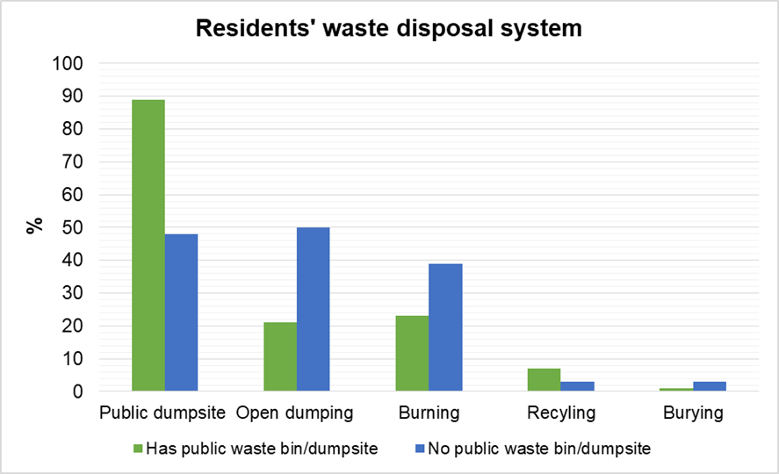
Figure 3: Waste disposal system by the resident
3.1.4 RESIDENTS' PERCEPTION OF WASTE SORTING AND RECYCLING
41% of the respondents who have public waste bins/dumpsites sort their waste, while 59% don’t sort their waste. However, 27% of the respondents who do not have public waste bins or a dumpsite in their area sort their waste, while 73% don’t sort their waste. Furthermore, 19% of the respondents who have public waste bins/dumpsites have used the waste recycling facility in the state, while 81% have not. Nevertheless, 11% of the respondents who do not have public waste bins or a dumpsite in their area have used the recycling facility in the state, while 89% have not (Figure 4). Additionally, 31% of the respondents who have public waste bins or dumpsites reported knowing the location of the waste recycling facility in the state, while 68% reported not knowing. In contrast, 16% of respondents who do not have public waste bins or a dumpsite in their area reported knowing where the waste recycling facility is, while 84% reported not knowing.
55% of the respondents who have public waste bins or dumpsites reported they have patronised the scavengers, while 45% have not. In contrast, 56% of the respondents who do not have public waste bins or a dumpsite in their area reported that they have patronised the scavengers, while 44% have not. This reveals that 61% of the respondents don’t sort their waste, 76% are unaware of the location of the recycling facility, and 85% have never participated in waste recycling. However, they prefer to patronise the scavengers, as 55% of the total respondents re-ported that they have patronised the scavengers.
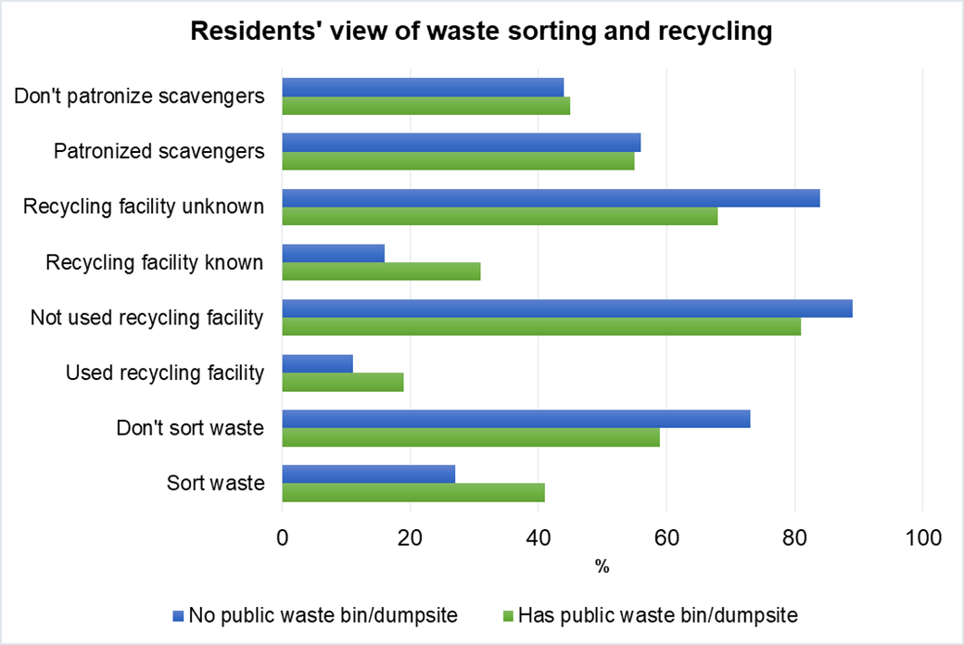
Figure 4: Residents’ awareness of waste sorting and recycling
3.1.5 RESIDENTS’ PERCEPTION OF THE EBSEPA AND ENFORCEMENT
74%, 19%, 3% and 4% of the respondents who have public waste bins or dumpsites in their area reported that waste collection by EBSEPA is done weekly, every two weeks, monthly and never, respectively. In contrast, 35%, 10%, 23%, and 31% of those without public waste bins or a dumpsite in their area reported that waste collection by EBSEPA is done weekly, every two weeks, monthly, and never, respectively (Table 2).
47%, 45% and 8% of the respondents who have public waste bins or dumpsites in their area responded that the EBSEPA officials waste monitoring is very often, occasionally and never respectively, in contrast, 20%, 62%, and 18% of those who don’t have public waste bins or a dumpsite in their area responded that the EBSEPA officials waste monitoring is very often, occasionally and never respectively (Table 2).
12%, 55%, and 33% of the respondents who have public waste bins or dumpsites in their area responded EBSEPA law enforcement is excellent, good and poor respectively, in contrast, 2%,43% and 55% of those who don’t have public waste bins or a dumpsite in their area responded that EBSEPA law enforcement is excellent, good and poor respectively (Table 2).
67% of those who have public waste bins or dumpsites in their area responded that the government's negligence is a key factor for the poor waste disposal in the state, while 78% of those who don’t have public waste bins or a dumpsite in their area (Table 2). This indicates that those who do not have a public waste bin or dumpsite are more affected by the government's negligence, EBSEPA's poor law enforcement, and poor waste collection and monitoring, as 47% of the respondents reported that they are dissatisfied and very dissatisfied with the way waste is disposed of in the state (Figure 5).
Table 2: Residence perception of EBSEPA and enforcement
 |  | Have Public waste Bins/dumpsites |  | No public Waste Bin/dumpsite
Key Factor | Response | Frequency | Percentage | Frequency | Percentage
Waste collection by EBSEPA | Weekly | 182 | 74% | 72 | 35%
Waste collection by EBSEPA | Every two weeks | 47 | 19% | 21 | 10%
Waste collection by EBSEPA | Monthly | 8 | 3% | 47 | 23%
Waste collection by EBSEPA | Never | 10 | 4% | 63 | 31%
Waste collection by EBSEPA | Total | 247 | 100% | 204 | 100%
EBSEPA Officials' Waste Disposal Monitoring | Very often | 117 | 47% | 42 | 20%
EBSEPA Officials' Waste Disposal Monitoring | Occasionally | 112 | 45% | 126 | 62%
EBSEPA Officials' Waste Disposal Monitoring | Never | 19 | 8% | 37 | 18%
EBSEPA Officials' Waste Disposal Monitoring | Total | 248 | 100% | 205 | 100%
EBSEPA Law enforcement | Excellent | 30 | 12% | 4 | 2%
EBSEPA Law enforcement | Good | 136 | 55% | 89 | 43%
EBSEPA Law enforcement | poor | 82 | 33% | 112 | 55%
EBSEPA Law enforcement | Total | 248 | 100% | 205 | 100%
Government negligence is responsible for poor waste management | Yes | 165 | 67% | 160 | 78%
 | No | 23 | 9% | 7 | 3%
 | Maybe | 60 | 24% | 38 | 19%
 | Total | 248 | 100% | 205 | 100%

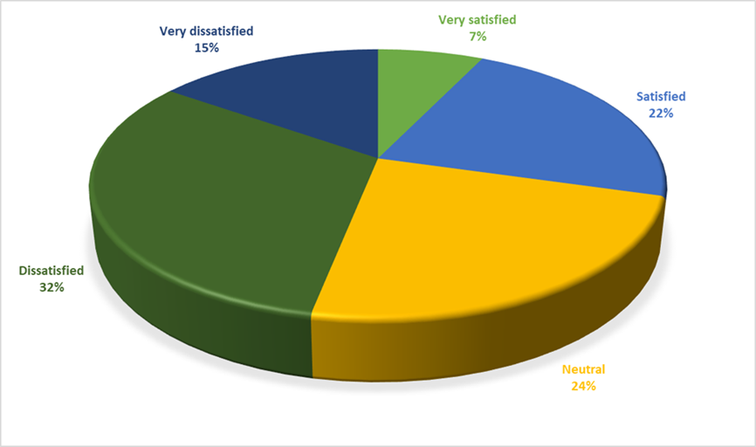
Figure 5: Resident perception of the government role
3.1.6 RESIDENTS' VIEW OF ENVIRONMENTAL EFFECTS OF WASTE DISPOSAL
73%, 55%, 54%, and 30% of those who have public waste bins or dumpsites in their area reported witnessing air pollution, littering in public places, water pollution, and soil pollution, respectively, related to poor waste disposal in their area. In contrast, 74%, 78%, 62%, and 40% of those who don’t have public waste bins or a dumpsite in their area report air pollution, littering in public places, water pollution, and soil pollution, respectively, as being related to poor waste disposal in their area (Figure 6). This suggests that individuals residing in areas without public waste bins/dumpsites experience more environmental issues than those living in areas with public waste bins or dumpsites.
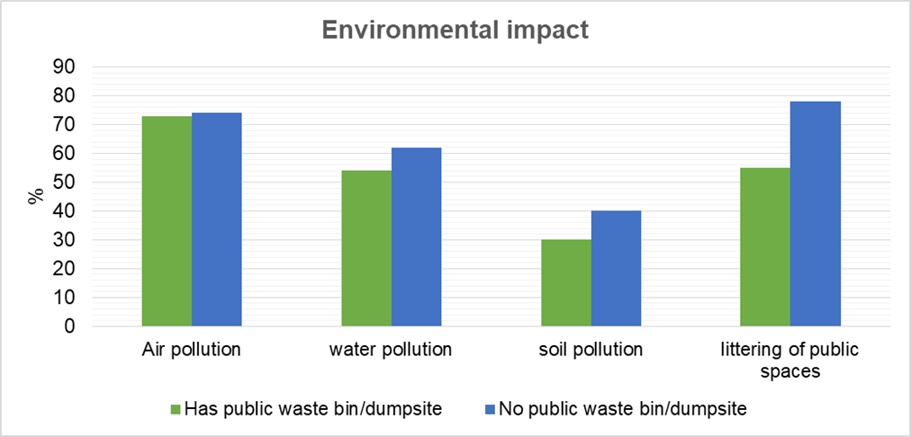
Figure 6: Resident perception of the environmental effects
3.1.7 RESIDENT PERCEPTION OF THE HEALTH IMPACTS OF WASTE DISPOSAL
35%, 70%, 28%, 15%, and 32% of those who have public waste bins or dumpsites in their area reported suffering from cough, malaria, diarrhoea/dysentery, skin infection, and cholera, respectively, related to poor waste disposal in their area. In contrast, 64%, 78%, 81%, 53%, and 38% of those who don’t have public waste bins or a dumpsite in their area reported suffering from cough, malaria, diarrhoea/dysentery, skin infection, and cholera, respectively, as being related to poor waste disposal in their area (Figure 7). This suggests that individuals living in areas without public waste bins or dumpsites have been more affected by diseases associated with poor waste disposal.
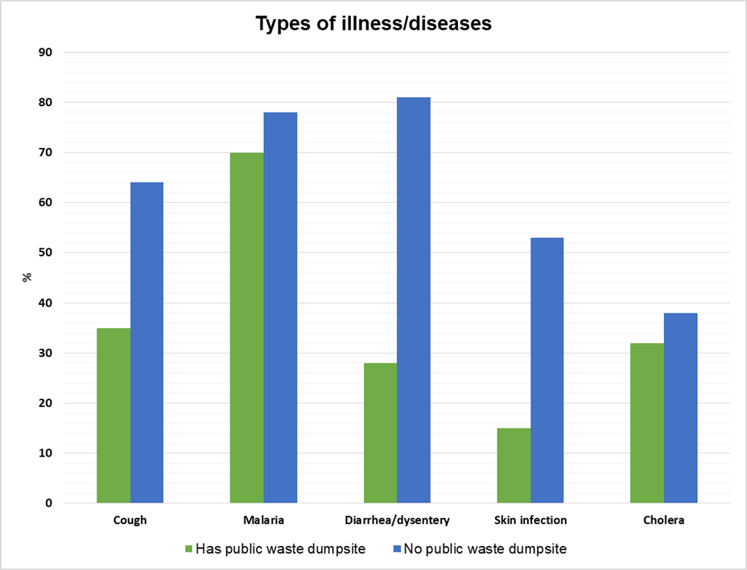
Figure 7: Resident view of the health effects
3.1.8 SIGNIFICANT DIFFERENCE IN THE IMPACTS BETWEEN AREAS WITH WASTE BINS AND WITHOUT WASTE BINS
Table 3 below present the results of the test for significant difference. The result shows that based on the environmental impacts, there is a statistical significant difference in littering of public area between the areas with waste bins and without waste bins. The results of the health impacts shows that there is statistical difference in cough, diarrhea/dysentery and skin infection. This indicates that environment impacts (littering of public space and soil pollution) and health impact such as cough, diarrhea/dysentery and skin infections are significantly higher in areas without waste bins.
Table 3: Test for difference between with waste bins and without waste bins
Environmental Impact |  | Air Pollution | Water Pollution | Littering of Public Space | Soil Pollution
Environmental Impact | Chi-Square Value | 0.31 | 2.85 | 21.76 | 5.37
Environmental Impact | P-Value | 0.57 | 0.09 | <0.0001 | 0.02
Environmental Impact | Difference | No significant difference | No Significant Difference | There is a significant Difference | There is a significant Difference
Health Impact |  | Cough | Malaria | Diarrhea/dysentery | Skin Infection | Cholera
Health Impact | Chi-Square Value | 13.84 | 0.32 | 53.87 | 37.31 | 0.62
Health Impact | P-Value | 0.0002 | 0.57 | <0.0001 | <0.0001 | 0.43
Health Impact | Difference | There is a significant Difference | No significant difference | There is a significant Difference | There is a significant Difference | No significant difference

3.1.9 RESIDENTS’ SUGGESTED CHALLENGES OF POOR WASTE MANAGEMENT
69% of those who have public waste bins or dumpsites in their area reported that poor waste disposal and management in the state is a result of inadequate waste collection and disposal system, 59% reported inefficient enforcement, 30% insufficient funding, 62% lack of proper waste treatment and recycling facilities, and 40% lack of public awareness (Figure 8). In contrast, 77% of those who have public waste bins or dumpsites in their area reported that poor waste disposal and management in the state is a result of inadequate waste collection and disposal system, 69% reported inefficient enforcement, 49% insufficient funding, 77% lack of proper waste treatment and recycling facilities and 60% lack of public awareness.
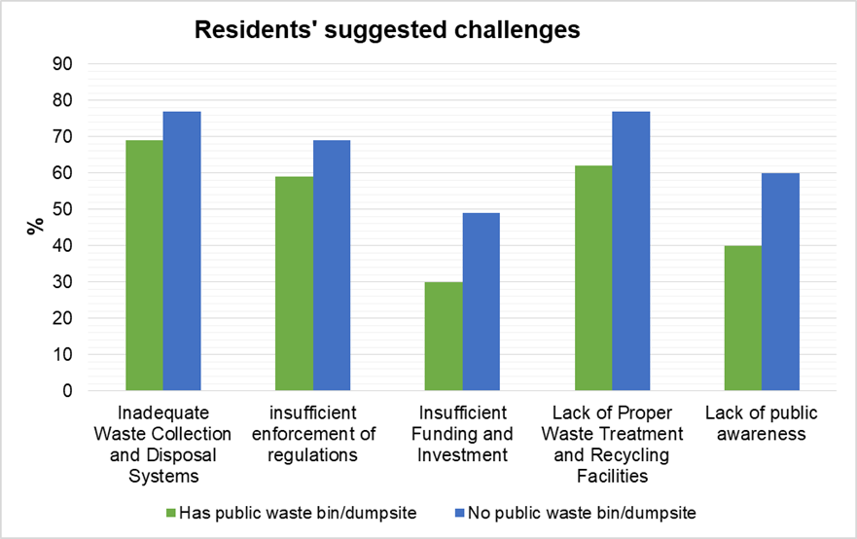
Figure 8: Resident suggested challenges
3.1.10 RESIDENTS' SUGGESTIONS FOR IMPROVING WASTE MANAGEMENT
50% of those who have public waste bins or dumpsites in their area indicated that strict enforcement of EBSEPA laws for improving waste disposal and management in the state, 28% indicated adequate infrastructure and funding, 34% public awareness, 22% encourage waste recycling, 42% more waste bins and dumpsites and 37% frequent monitoring and proper coordination among authorities (Figure 9). In contrast, 52% of those who have public waste bins or dumpsites in their area indicated that the strict enforcement of EBSEPA laws for improving waste disposal and management in the state, 45% indicated adequate infrastructure and funding, 45% public awareness, 22% encourage waste recycling, 60% more waste bins and dumpsites and 31% frequent monitoring and proper coordination among authorities.
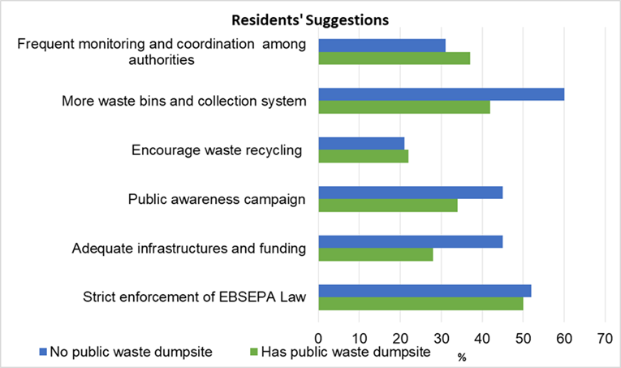
Figure 9: Resident suggestions of what can be done for improving waste disposal
3.2 DISCUSSION
This study assessed the waste disposal system, its environmental impacts, health risks, and challenges associated with waste management practices in Ebonyi State. The result revealed that domestic waste is the most significant type of waste generated in Abakaliki metropolis, accounting for approximately 72%. This aligns with the research conducted by Nwofe (2015), who also found that domestic waste is the most significant type of waste generated in the Abakaliki metropolis. This study also highlighted that residents disposed of their waste at the designated dumpsite/waste bins, as well as through open dumping, burning, and burying (Onuoha et al., 2024). However, it also noted that those who reside near designated waste bins or dumpsites dispose of most of their waste at the designated dumpsite/waste bins, while those who reside far from or without designated dumpsites/waste bins practice a more unsustainable waste disposal system, such as open dumping, burning, and burying.
These findings align with observational and field survey studies conducted by researchers such as Nwofe (2015), Okwesili and Iroko (2016), Oginyi (2010), and Echeweozo et al. (2025), which have reported similar environmental degradation and health risks associated with poor waste management. However, unlike areas with better EBSEPA waste bins or dumpsites, those without proper waste collection systems and dumpsites face more severe environmental and health issues, as well as unique challenges, including limited waste bins and dumpsites, a lack of public awareness, inadequate recycling facilities, and weak enforcement. This highlights the need for general monitoring by the authorities to identify specific regions without a proper waste disposal system, thereby enabling the development of effective waste management policies.
The high prevalence of diarrhoea, malaria, cough, skin infections, and cholera in areas without EBSEPA waste bins or dumpsites suggests that open dumping and burning releases hazardous matter and increases the risk of disease outbreaks, which is consistent with the global report on water and air pollution arising from improper hygiene and waste disposal systems (Nwofe, 2015; Okwesili & Iroko, 2016; Anozie, 2017; and Echeweozo et al., 2025). Furthermore, the leaching of heavy metals, microbial pathogens, and other hazardous substances into surface water and groundwater in areas without waste bins and dumpsites contributes to the elevated levels of chronic and acute health problems, including long-term effects from heavy metal poisoning and other waterborne diseases, such as diarrhea and cholera (Echeweozo et al., 2025). Despite the challenges, Ebonyi State has the potential to adopt circular economy models, utilising recyclable waste to generate wealth for the state and utilising organic waste for biogas production, thereby promoting a circular economy. This study highlights that inadequate waste disposal systems, such as open dumping and burning, significantly contribute to air pollution, littering of public places, water and soil contamination, as well as the spread of diseases like malaria, cough, diarrhoea, cholera, and skin diseases among residents. Additionally, the lack of a proper waste collection system, designated waste dumpsite/waste bins, inadequate recycling infrastructure, as well as weak enforcement of the EBSEPA laws, have worsened these challenges (Faga & Nwanga, 2023; Omaka & Okorie, 2024).
In terms of actionable strategies to improve waste management in the state, the findings of this study support several interventions that can enhance waste management and mitigate environmental impacts and public health risks. Increasing the frequency of waste collection and monitoring by the EBSEPA, provision of more waste bins/dumpsite, stricter enforcement of EBSEPA law and provision of adequate recycling facilities are seen as the most critical actions, reflecting a common issue in an urban settlements where infrequent waste collection and lack of designated public waste bins/dumpsite lead to indiscriminate dumping and the increased spread of waste-related diseases and environmental issues (Nwofe, 2015; Okwesili et al., 2016; Mahajan, 2023). Additionally, public-private partnerships and community-led initiatives for waste collection and recycling have been recognized as the most effective means of promoting local ownership and responsibility in waste management, as they leverage private-sector efficiency and innovation with government oversight to foster direct involvement and ownership at the local level (Tahir et al., 2024).
These findings underscore the urgent need for the state government to adopt waste recycling and waste-to-energy initiatives to mitigate environmental and health risks and call for collaborative efforts among EBSEPA authorities, the government, industries, and residents.
This study was limited by its reliance on self-reported environmental and health data, which may be subject to recall bias. Additionally, the sampling was limited to the Abakaliki metropolitan area, overlooking variations in waste disposal practices in rural areas across the state. Future studies could incorporate observational field studies and longitudinal health assessments, as well as broader geographic coverage across both rural and urban areas within the state.
4. CONCLUSIONS
This study has statistically concluded that significant differences exist between waste disposal methods and management in areas with EBSEPA waste bins or dumpsites and those without. This study also revealed that the environmental and health impacts of inadequate waste management in Ebonyi State are more severe in areas without EBSEPA waste bins or designated dumpsites. The key findings indicated that the open dumping and burning of waste have contributed to severe air pollution, as well as soil and water pollution. Furthermore, resident exposure to these pollutants is linked to outbreaks of cholera, diarrhoea, skin infections, malaria, cough, and other respiratory illnesses. This study has demonstrated that inadequate waste disposal systems and poor hygiene have contributed to outbreaks of disease and the escalation of environmental degradation in the state. This study also concluded that a lack of waste collection and disposal systems, weak enforcement of EBSEPA laws, inadequate public awareness, inadequate waste recycling systems, and insufficient funding have been significant challenges to waste management in the state. However, opportunities exist to transition to sustainable waste management practices by adopting community-based recycling programs, implementing waste-to-energy initiatives, strengthening enforcement of EBSEPA law, and developing stronger government policies to mitigate environmental degradation and reduce public health risks. Additionally, partnerships with private organisations can also enhance waste collection and processing efficiency. Therefore, there is an urgent need for integrated waste management strategies to achieve effective waste management practices, which are essential for meeting the SDGs related to clean water, responsible consumption, sanitation, zero hunger, and environmental sustainability.
5 RECOMMENDATIONS
- The government should revive the state's waste recycling facility and provide incentives to encourage waste recycling.
- The EBSEPA laws should be adequately implemented and enforced. The EBSEPA law enforcement agencies and personnel should be trained to enhance the likelihood of proper waste handling and management, and to enforce the EBSEPA law, as well as to identify and prosecute defaulters.
- The EBSEPA authorities should conduct a general inspection across the state to identify areas without waste bins or designated dumpsites/waste bins, and en-sure proper waste collection and disposal in these areas.
- There should be frequent waste collection and monitoring by the EBSEPA and other private waste management sectors, with proper coordination among them. The government should partner with private companies for efficient urban waste collection.
- Waste dumpsites and bins should not be located too close to residential buildings to prevent the breeding of malaria parasites, flies, and other insects. They should be appropriately located and managed to minimise their environmental impacts and reduce their health risks to residents. The dumpsites should be controlled or fenced to prevent trash from being blown away by the wind and to prevent blockage of drainage channels.
- There should be a proper waste campaign to sensitise the public and create awareness of appropriate and sustainable waste disposal and management. Sensitisation should be conducted in various settings, including the market, social media, schools, and communities, to educate both rural and urban residents, as well as the young and old, about the effects of poor waste management. The resident should be educated about the importance of sorting waste and recycling, and encouraged to do so.
- The scavengers should be appropriately trained and employed to assist with waste collection, as residents prefer to patronise them rather than go to the recycling facility. They should be well-educated to avoid scattering the waste and causing further trouble.
- The government should provide adequate infrastructure, such as waste collection bins, tractors, and vehicles, for proper waste collection and disposal, and allocate funds to ensure efficient work among the relevant authorities. As our findings revealed, the government's negligence is the primary factor contributing to poor waste management in the state.
- The government should ban open dumping and burning of municipal waste in urban areas, as they cause numerous environmental and health issues. This will encourage the residents to use the EBSEPA waste bins and dumpsites.
- The government should employ more workers to ensure effective waste collection and management, thereby achieving efficient results. And map out a mechanism to penalise waste management officers, groups, and individuals who indulge in corrupt practices, such as collecting bribes from defaulters in-stead of facing the law.

Consent

Participants were fully informed about the study's purpose, their rights, and the voluntary nature of their participation. Informed consent was secured, and confidentiality was protected by anonymising personal information. Participants were assured that their responses would remain anonymous and that no personal details would be recorded.

Ethical approval

Ethical considerations were thoroughly addressed during the data collection process. Approval to use the Google questionnaire was obtained from the relevant authorities in the School of Engineering at the University of Greater Manchester, following permission from the course tutors.

References

Ike, C.C., Ezeibe, C.C., Anijiofor, S.C. & Daud, N.N. (2018). Solid waste management in Nigeria: problems, prospects, and policies. The Journal of Solid Waste Technology and Management, 44(2), pp.163-172. https://doi.org/10.5276/JSWTM.2018.163
Ferronato, N. & Torretta, V. (2019). Waste mismanagement in developing countries: A review of global issues. International journal of environmental research and public health, 16(6), p.1060. https://doi.org/10.3390/ijerph16061060
Onuoha, D.C., Odoh, C.C. and Odoh, G. A. (2024). Review of the Environmental and Health Implications of Plastic Wastes Pollution in Nigeria. IIARD International Journal of Geography & Environmental Management (IJGEM), 10(3). Avail-able from: https://doi.org/10.56201/ijgem.v10.no3.2024.pg258.300
Nwofe, P.A. (2015). Management and disposal of municipal solid wastes in Abakaliki metropolis, Ebonyi State, Nigeria. Interna-tional Journal of Scientific Research in Environmental Sciences, 3(3), p.107. http://dx.doi.org/10.12983/ijsres-2015-p0107-0118
Oginyi, C.N. (2010). Occupational health hazards among quarry employees in Ebonyi State, Nigeria: sources and health implications. International Journal of Development and Management Review, 5(1), pp.140-149. https://www.ajol.info/index.php/ijdmr/article/view/56229
Okwesili, J., Chinyere, N., Iroko, N. C. (2016). Urban solid waste management and environmental sustainability in Abakaliki Urban, Nigeria. European Scientific Journal, 12(23). https://doi.org/10.19044/ESJ.2016.V12N23P155
Anozie, O.B., Lawani, L.O., Eze, J.N., Mamah, E.J., Onoh, R.C., Ogah, E.O., et al. (2017). Knowledge, attitude and practice of healthcare managers to medical waste management and occupational safety practices: Findings from Southeast Nigeria. Journal of clinical and diagnostic research: JCDR, 11(3), p.IC01. https://doi.org/10.7860/JCDR/2017/24230.9527
Echeweozo, E.O., Nworie, C.I., Ojobeagu, A.O., Otah, P.B. & Okoro, I.J. (2025). Health risk assessment due to environmental radioactivity and heavy metal contamination at the central solid waste dumpsite in Ebonyi State, Nigeria. Journal of the Nigerian Society of Physical Sciences, pp.2160-2160. https://orcid.org/0000-0002-7091-8023
Oshim, F. O., Ijeh, E. C., Amaefule, W. A., Ayajuru, N. C., Amaefule, E. O., Anumaka, C. C. (2024). Socioeconomic and Envi-ronmental Impacts of Quarrying in Nigeria: A Comprehensive Review of Sustainable Quarrying Practices and Innovative Technologies. International journal of research and scientific innovation, 11(6), 324-349 DOI: https://doi.org/10.51244/IJRSI.2024.1106026
Mahajan, R. (2023). Environment and health impact of solid waste management in developing countries: A review. Current World Environment, 18(1), p.18. http://dx.doi.org/10.12944/CWE.18.1.3
Agboola, S.O., Inetabor, G.M., Bello, O.O., Bello, O.S. (2025). Waste Pollution and Management: Current Challenges and Future Perspectives. In: Yatoo, A.M., Sillanpää, M. (eds) Smart Waste and Wastewater Management by Biotechnological Approaches. Interdisciplinary Biotechnological Advances. Springer, Singapore. https://doi.org/10.1007/978-981-97-8673-2_1
Business Waste. (2024). Waste Facts. Available from: https://www.businesswaste.co.uk/waste-facts/
World Bank. (2018). What a Waste 2.0: A Global Snapshot of Solid Waste Management to 2050. Available from: https://datatopics.worldbank.org/what-a-waste/
Reddy, V.V., Kumar, P., Rao, A.L.N., Kumar, R., Singh, S., Asha, V. & Kareem, S.H. (2023). Waste to wealth generation: Innovative methodologies in resource utilization and minimization in circular economy. In E3S web of conferences, 453, p. 01035). EDP Sciences. https://doi.org/10.1051/e3sconf/202345301035
Karim, R., Waaje, A., Roshid, M. M., & Yeamin, M. B. (2025). Turning the Waste Into Wealth: Progressing Toward Global Sustainability Through the Circular Economy in Waste Management. In R. Sucheran (Ed.), Sustainable Waste Management in the Tourism and Hospitality Sectors, (pp. 507-552). IGI Global Scientific Publishing. https://doi.org/10.4018/979-8-3693-6110-8.ch019
Noiki, A.A., Afolalu, S.A., Yusuf, O.O., Emetere, M.E., Ongbali, S.O., Oloyede, O.R., et al. (2021). Impact assessment of the current waste management practices in Nigeria. In IOP Conference Series: Materials Science and Engineering 1107(1), p. 012172). IOP Publishing. https://doi.org/10.1088/1757-899X/1107/1/012172
Unegbu, H.C.O. & Yawas, D.S. (2024). Optimizing construction and demolition waste management in Nigeria: challenges, regulatory frameworks, and policy solutions. Discover Civil Engineering, 1(1), p.141. https://doi.org/10.1007/s44290-024-00142-3
Sridhar, M., Oluborode, J.A. & Zacchaeus, U. (2017). Waste management policy and implementation in Nigeria. International Journal of Advanced Education and Research, 3, (23) 35. https://thestudiesjournal.com/assets/archives/2017/vol3issue3/3-3-14-673.pdf
Odejobi, O.J., Ajala, O.O. & Osuolale, F.N. (2024). Review on potential of using agricultural, municipal solid and industrial wastes as substrates for biogas production in Nigeria. Biomass Conv. Bioref. 14, 1567–1579. https://doi.org/10.1007/s13399-022-02613-y
Okafor, O. C., & Obaze, W. O. (2025). Assessment of Heavy Metal Contents of Surface Water Around Waste Dumpsites in Ebonyi, Enugu and Anambra States, Southeastern Nigeria. Environmental Forensics, 26(4), 545–562. https://doi.org/10.1080/15275922.2025.2459403
Nwofoke, C., Onyenekwe, S. & Agbo, F. (2017). Willingness to Pay (WTP) for an Improved Environmental Quality in Ebonyi State, Nigeria. Journal of Environmental Protection, 8, 131-140. https://doi.org/10.4236/jep.2017.82011
Okafor, O.C., Njoku, C., Nwojiji, M. & Akwuebu, A.N. (2025). Evaluation of Pollution Potentials of Slaughterhouse Effluents on Groundwater Qualities in Ebonyi State Southeast Nigeria. Environmental Forensics, 26(3), pp.309-323. https://doi.org/10.1080/15275922.2024.2431322
Njaka, K. (2024). An Appraisal of the Impacts of Ebonyi State Environmental Protection Agency Law and other Legal Frame-work in the Preservation of the Environment. Available at SSRN: https://ssrn.com/abstract=4688559
Ejike-Alieji, A.U.P., Nzeadibe, T.C. & Ezeah, C. (2025). Household Knowledge and Vulnerability Assessment of Sustainable Solid Waste Management in Ebonyi State, Nigeria. The Journal of Solid Waste Technology and Management, 51(1), pp.59-71. https://doi.org/10.5276/jswtm/iswmaw/511/2025.156
Nnaji, C. C. (2025). Status of municipal solid waste generation and disposal in Nigeria. Management of Environmental Quality: An International Journal, 26 (1): 53–71. https://doi.org/10.1108/MEQ-08-2013-0092
Ewash. (2023). Six die of fresh Cholera outbreak in Ebonyi. https://washnigeria.com/2023/01/06/cholera-outbreak-in-eboyi-state/#
Oweibia, M., Egberipou, T., Wilson, T.R., Timighe, G.C. & Ogbe, D.P.D. (2025). Factors Associated With The Propagation Of Cholera In Epidemics Across The Geopolitical Zones Of Nigeria: A Systematic Review. medRxiv, pp.2025-05. https://doi.org/10.1101/2025.05.09.25327340
Aborode, A.T., Adesola, R.O., Onifade, I.A., Adesiyan, R., Ibiam, V.A., Jinadu, N.A. & Bakre, A.A. (2025). Outbreak of cholera in Nigeria: the role of One Health. Discover Public Health, 22(1), p.125. https://doi.org/10.1186/s12982-025-00526-5
Faga, H.P. & Nwanga, J.O. (2023). Appraisal of the Legal Framework against Environmental Degradation Arising from Quar-ry Industry in Ebonyi State. International Review of Law and Jurisprudence (IRLJ), 5(3), p.134. https://heinonline.org/HOL/LandingPage?handle=hein.journals/inlrwolw5&div=72&id=&page=
Omaka, C.A. & Okorie, O.B. (2024). Appraising the Challenges to Effective Enforcement of Legislation on Control of Environmental Pollution in Nigeria. Journal of Commercial and Property Law, 11(3), pp.15-32. file:///C:/Users/PC/Downloads/2+APPRAISHING+THE+HALLENGES%20(1).pdf
Ebonyi State Environmental Protection Law. (2024). No.009 of 2015; 30 https://law.thecwsc.org/wp-content/uploads/2020/10/Ebonyi-State-Environmental-Protection-Law.pdf
Progressive News. (2025). Ebonyi Enforces Sanitation Laws with N50,000 Fine for Indiscriminate Waste Disposal. https://progressivenews.ng/ebonyi-enforces-sanitation-laws-with-n50000-fine-for-indiscriminate-waste-disposal/
Diagi, B.E. (2018). Analysis of rainfall trend and variability in Ebonyi State, South Eastern Nigeria. Environmental and Earth Sciences Research Journal, 5(3), pp.53-57. https://doi.org/10.18280/eesrj.050301
City Population (2022). Ebonyi (State, Nigeria –Population Statistics, Chart and map. https://citypopulation.de/en/nigeria/admin/NGA011__ebonyi/
Oroke, A.M., Sarihan, E., Ogbuene, E.B. & Ani, C. (2020). Assessment of Noise Pollution Level in Abakaliki Metropolis, Ebonyi State Nigeria. Theoretical and Empirical Researches in Urban Management, 15(1), pp.75-83. https://www.ceeol.com/search/article-detail?id=888397
Macrotrends. (2025). Abakaliki, Nigeria Metro Area Population (1950-2025) https://www.macrotrends.net/global-metrics/cities/206382/abakaliki/population
Tahir, J., Atkinson, M., Tian, Z., Kassem, M., Ahmad, R. & Martinez, P. (2024). A critical analysis of public private partnership model in energy from waste projects. Sustainable Futures, 8, p.100240. https://doi.org/10.1016/j.sftr.2024.100240

