CONCERNS OF VENDORS AND PUBLIC SPACE USE: STRATEGIES FOR EXISTENCE AND GROWTH IN BAMENDA CITY, CAMEROON

ABSTRACT
The nexus between rapid urbanisation and persistent economic hardship has intensified the use of public spaces for informal commercial activities in many Cameroonian cities. In Bamenda City, street vending has emerged as a crucial survival strategy for a large fraction of the urban population, particularly amid rising unemployment and declining formal economic opportunities. Notwithstanding its importance for livelihoods, street vending continues to generate recurring conflicts related to space use, urban planning, sanitation, traffic congestion, and municipal governance. This study examines the major challenges faced by street vendors in their daily use of public spaces and explores feasible strategies for promoting existence and economic growth within these spaces. Both quantitative and qualitative research approaches were employed, involving field observation, interviews with vendors, and consultation with the main resource persons. Data were analysed with descriptive and inferential statistical approaches with the help of SPSS version 20, Microsoft Excel, and ArcGIS 10.3 software. The study identifies major challenges, including spatial congestion, inadequate infrastructure, insecurity, weak regulatory enforcement, and limited participation of vendors in urban planning processes within market arenas. Findings further reveal the existence of a wide range of socio-economic activities serving as livelihood strategies for vendors. However, the continued marginalisation of informal economic activities within Bamenda City’s governance frameworks exacerbates tension and undermines effective public space management. The study argues that inclusive urban planning, the creation of designated vending zones, improved market infrastructure, participatory governance, and a balanced regulatory framework are essential for harmonising vendor activities with broader urban development goals. By integrating informal economic actors into city planning and upholding the Afro-Endogenous development approach, Bamenda can enhance improved social inclusion, improve urban functionality, and strengthen the resilience and adaptability of local economic growth. Such measures are essential for encouraging social stability, economic resilience, and harmonious use of public space.
Keywords: Vendors, public space, strategies, Afro-endogenous, Bamenda City, Cameroon

I. INTRODUCTION
Through urban history, public spaces have represented important elements in the urban configuration. They are known to provide residents with well-being, reliance, and inclusion. Every community needs such places, where all feel welcome and where all can “enjoy being part of the great congress of humanity”. Aside, public spaces play a critical role in shaping urban development, serving not only as physical spaces for recreation and interaction but also as arenas for social, political, and economic expression (Ntakana et al., 2025).
Substantial literature indicates that, in most Cities with sufficient public spaces, there are well-maintained, safe, and attractive places to live and work in, and most streets are multifunctional areas for social interaction, economic exchange, and cultural expression among a wide diversity of participants (Assako, 2012, and UN-Habitat,2017). It is also opined that the inability of cities to generate enough employment opportunities has contributed to widespread informality. Half of the global urban workforce is informally employed, more so in the global South (UN-Habitat,2017).
Still in the vision, public spaces of European cities and villages are frequent points of information exchange, important events (processions, celebrations, and festivals), market as well as for real encounters outside the virtual world (Grunskis, Mankus, 2013).
Even though there is rapid urbanisation in many cities of Africa, they exhibited public space patterns that are more of an Afro-endogenous setting, compounded with enormous cities’ concerns to cope alongside soaring urbanization. Aside, the Politics of Governing African Urban Spaces (2018) argues for inclusive definitions that go beyond tranquil parks, focusing on multifunctional spaces that support mobility, commerce, social exchange, youth activities, and cultural life, contrary to the European context.
Moreover, many African urban scholars conceptualise public space as a lived, socially produced, and economically functional arena shaped by informality, survival strategies, and everyday negotiations between citizens and the state. Mabogunje (1968, 1993) early noted that in African cities, streets, markets, and open spaces evolve beyond their planned purposes to become critical platforms for livelihood and social interaction, particularly for low-income urban residents. This standpoint is extended by Simone (2004), who describes African public spaces as fluid and improvised environments where networks of survival, informal economies, and social relations are enacted in ways that confront formal planning logics.
Pieterse (2008) further situates public space within the framework of citizenship and contestation, arguing that these spaces reveal the tensions between governance structures and the urban poor’s right to the city. Similarly, Watson (2009) critiques conventional urban planning for failing to recognise the “stubborn realities” of informality that define how public spaces are actually used in African cities. Myers (2011) reinforces this argument by calling for an “African urbanism” that rethinks public space through the lenses of colonial legacies, poverty, and informal practices rather than imported Western ideals.
Anthropological contributions deepen this understanding. De Boeck and Plissart (2004) illustrate how residents of Kinshasa culturally reinterpret streets and open areas as symbolic and socially negotiated spaces, while Olivier de Sardan (2005) and Alain Marie (1997) emphasise public space as an arena of everyday negotiation, individual agency, and informal governance.
Collectively, these intellectuals present public space in African cities as a livelihood space, a contested political terrain, a socially negotiated environment, and a reflection of resilience in the face of economic hardship and governance limitations.
Seemingly, in Cameroon, Public space is a key enabler of the start-up of economic development in cities. Streets, sidewalks, markets, squares, and parks are accessible, safe, and inclusive avenues of the basic infrastructure that supports the economic vibrancy and growth of cities (Yemmafouo,2018).
Formal urban planning approaches in Cameroonian cities are largely driven by ideals of order, aesthetics, and modernity, often implemented through urban beautification and redevelopment programs. These approaches prioritize regulated land uses, fixed infrastructure, and visually “clean” cityscapes, which tend to redefine public spaces as zones for circulation, leisure, or formal commerce (Assako,2012). He further holds that informal practices such as street vending, which rely on flexibility, proximity to pedestrian flows, and affordability, are frequently labelled as illegal, disorderly, or incompatible with planned urban functions. Accordingly, vendors are displaced from strategic public spaces, marginalised in planning decisions, and forced into precarious or peripheral locations, highlighting how formal planning frameworks often exclude informal livelihoods despite their central role in urban life. This posed the problem of urban public space Afro-Indigenous conceptualisation. This conceptualisation is particularly relevant to Bamenda City, where street vending and informal activities in public spaces are not merely violations of urban order but essential survival mechanisms and expressions of citizens’ adaptation to socio-economic realities. Sadly, the marginalisation of these informal economic activities within Bamenda City’s governance frameworks exacerbates tension and undermines effective public space management.
It is against this backdrop that this study seeks to investigate the concerns of vendors in relation to public space use and strategies for existence and growth in Bamenda City. This investigation is crucial to understanding the need for public spaces that are inclusive, responsive to Afro-endogenous needs, and reflective of individual perceptions.
II.STUDY AREA AND METHODS

2.1. Study Area
Bamenda is the administrative seat of Mezam Division and the Regional Headquarters of the North West Region, and the largest town in the North West Region. Bamenda City covers a surface area of about 37.560 km². It has seven Sub Divisional Councils and a population of about 800,000 inhabitants (Kimengsi & Fogwe, 2017). Figure 1 depicts a map of Bamenda City in Cameroon.
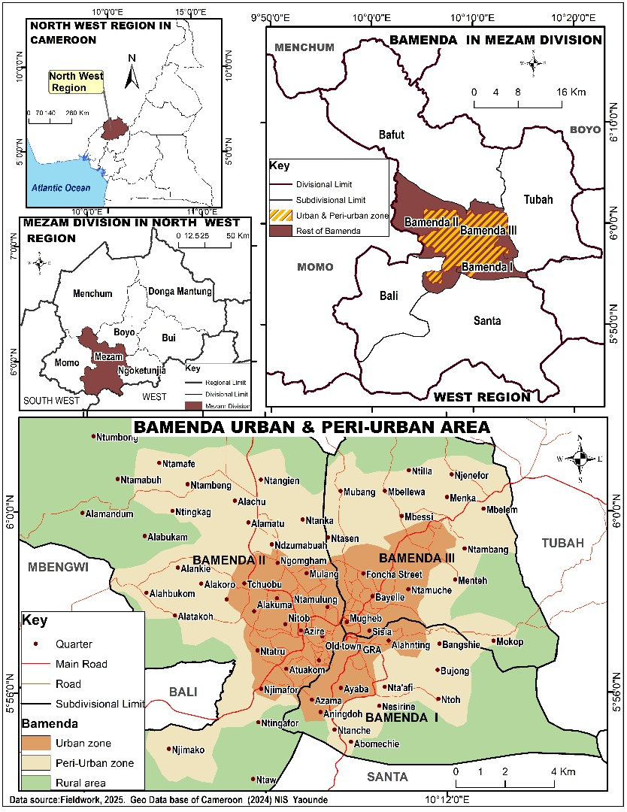
Figure 1.: Location of Bamenda City in the North Region of Cameroon
Bamenda City is a cosmopolitan city, which is one of the bedrocks of Cameroon politics with a very strong traditional setup and extremely powerful Fons and Fondoms. The population, though cosmopolitan, has a greater majority of local ethnic groups, which include Bamendakwe, Nsongwa, Chomba, Mbattu and Nkwen, who practice subsistence farming.

2.2. Methods
The study used a mixed research design integrating both quantitative and qualitative methods to investigate the concerns of vendors and strategies for existence and growth in public spaces in Bamenda city. To facilitate a quantitative assessment of the study variables, a total of 170 questionnaires was administered systematically to vendors in the three municipalities of Bamenda I, II, and III. Field surveys and observations were equally conducted in the city to assess the activities linked to vendors in public spaces, and strategies for existence and growth in Bamenda City. For the purpose of in-depth analysis of the results from the quantitative analysis, a further approach called the qualitative method was conducted. This data was acquired from documents and reports from the Bamenda I, II, and III municipal councils regarding urban planning and vendor regulations. Quantitative data collected from the field was summarized using descriptive and inferential statistical approaches, while the qualitative data were analysed using content and thematic approaches. The cartographical data enabled the production of maps. In addition, the use of SPSS version 20, Microsoft Excel, and ArcGIS 10.3 software helped with the spatial analysis. Results were qualitatively, quantitatively, and cartographically analysed and presented in the form of tables, charts, photographs and maps for clarity.

III. RESULTS AND DISCUSSIONS

3.1. Spatial Distribution of Public Spaces in Bamenda City
The study area displayed public spaces structured into formal (officially designed), informal (unofficial), and semi-public (privately owned, publicly accessible) spaces. The informal types which are the main focus of this work cut across roadsides, sports fields, market spots, green spaces, parking lots, clandestine motor stops, and streets. These spaces are spread across the three Municipalities of Bamenda City, each serving distinct social and economic functions and involving different actors. Figure 2 presents a visual representation of the proportion of various public space typologies in Bamenda City.

Figure 2: Types of public spaces in Bamenda City
Figure 2 reveals that roadsides as informal spaces, accounting for 40%, dominate the public spaces with socio-economic deeds, while clandestine motor stops areas, streets, and roads are the least frequented by such activities. This highlights the diversity of public spaces in Bamenda, each characterised by distinct functions and spatial configurations. It is here where we observed Street vending representing an iconic example of an economic opportunity for the urban working poor that presents a management challenge to city governments, notably whether and how to regulate access to public space for informal livelihoods. This is consistent with the results of Sourav et al., (2023), who posited that streets, pathways, and their nearby leftover spaces in developing countries often serve as significant public places where vendors earn a living. Figure 3. illustrates a spatial view of public spaces most especially where the Vendors operate in the study area.
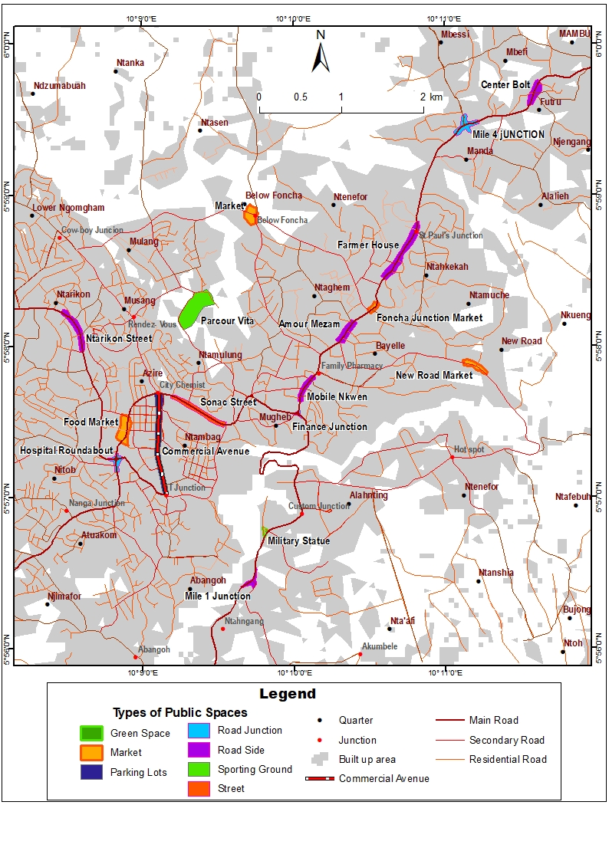
Figure 3: Spatial view of public space types in Bamenda City
Source; Field Work 2024
As illustrated in figure 3, the majority of public spaces in Bamenda City are concentrated within the Bamenda II and Bamenda III Municipalities. In contrast, Bamenda I Municipality is predominantly characterised by well-planned residential neighbourhoods and administrative/government facilities, with comparatively fewer active public spaces. The map profusely highlights the main categories of public spaces across the study area, including roadside vending zones, market yards, informal motor parks, streets, road junctions, and sporting grounds where vendors are frequent. The typology and spatial distribution of public spaces in the study area reveal a type of City shaped by a lot of economic corridors and activities in informal spatial practices. This case study deviates from the works of Adegunloye et al., (2022) and Irene (2021), who pointed out that public spaces connect one part of the city to the other and must be related to the physical elements of the city that shape the image. And that there is a positive relationship between public spaces and the city's image.

3.2. Vendors’ activities in public spaces in Bamenda City
Bamenda City is endowed with a myriad of socio-economic activities spread over the urban open public spaces. The activities varied in terms of space, actors, and the space tenancy agreement. The common activities in these places are mostly practiced by street vending, which is one of the main preoccupations of this paper. Vending activity as a specific spatial phenomenon in the study area is observed to be a major form of livelihood for many people in the informal economy. This gives almost daily drama of groups of informal traders moving from one place to another, and perhaps eventually cycling back to the same place when the attention of the municipal police is focused elsewhere. Figure 4 illustrates various economic activities carried out by street Vendors in Bamenda City.
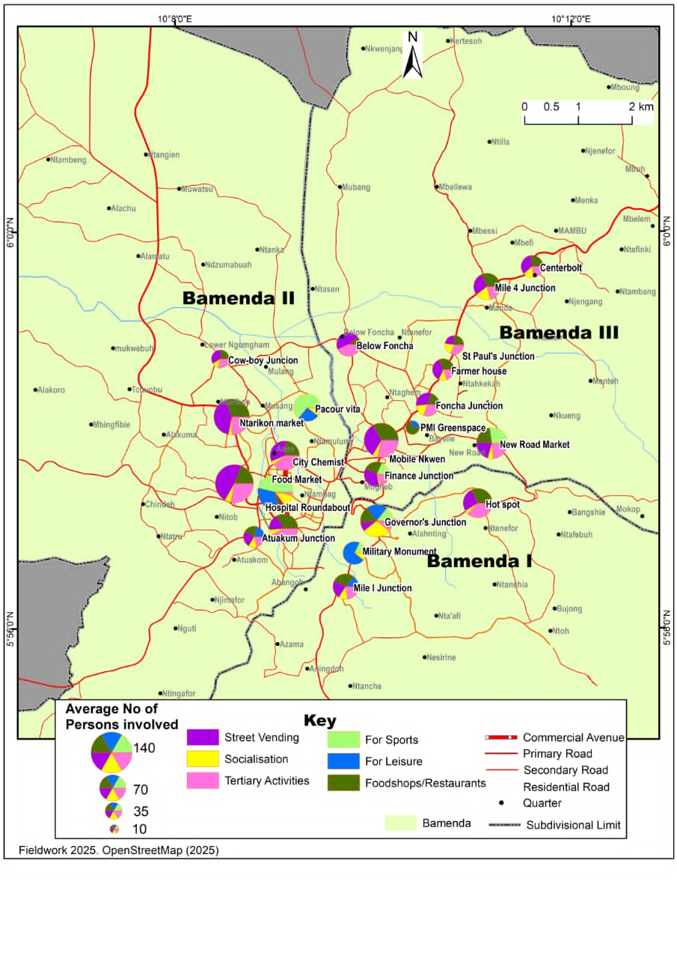
Figure 4. Economic activities in the Bamenda City Public spaces
Source: Fieldwork,2023
Figure 4 indicates the various economic activities in public spaces in the Bamenda City. Field evidence indicates that street vending or hawking (38,6%) champion the major activity occupying public spaces, and the rest are average, carried out by different actors in the area. It is realised that; the occupation of most of these places is in conformity with the municipal authorities with the premise of temporal occupation orders. Figure 5 illustrates samples of street vending displacement of article for sales on public spaces in Bamenda City Commercial Avenue.
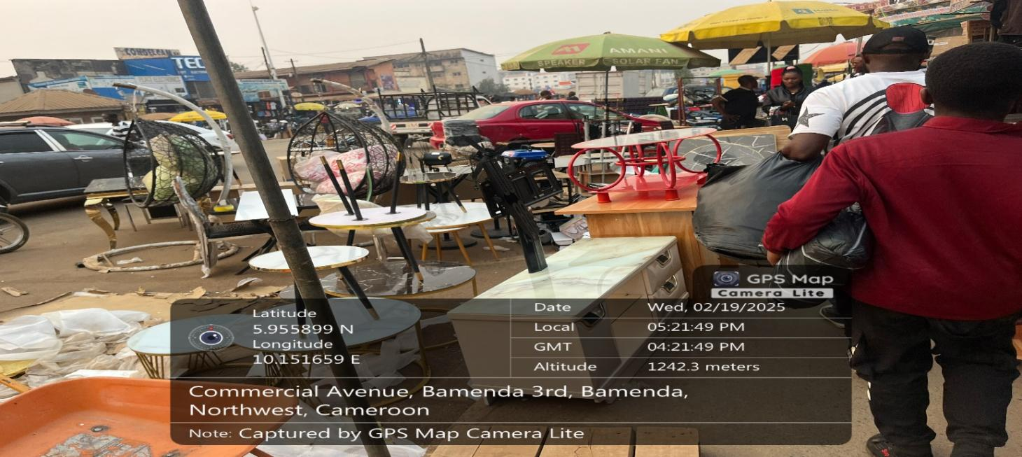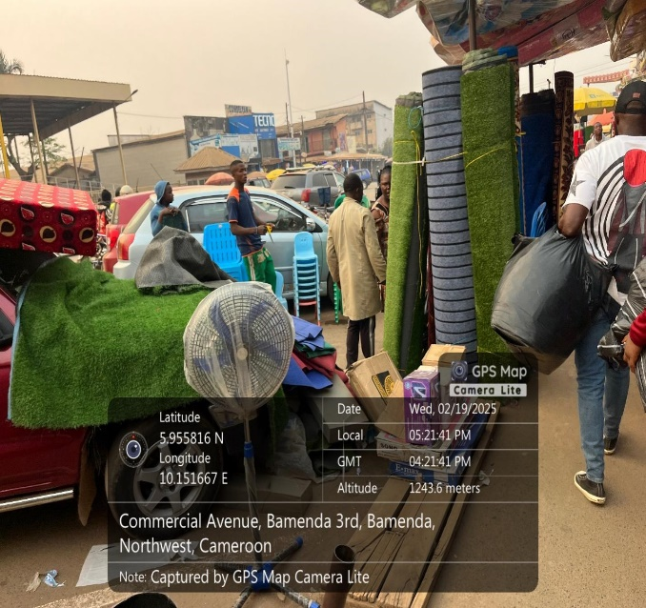
Figure 5: Sample of vendors’ occupation at Commercial Avenue in Bamenda City
Source: Fieldwork, 2024
The photo above vividly illustrates public space occupation at commercial avenue in Bamenda City. The proliferation of hawking in urban areas such as Bamenda, coupled with the constant movement and displacement of goods for sale, underscores the important role that informal economic activities play within the urban fabric. Far from being marginal or peripheral, street vending reflects a dynamic and adaptive form of commerce that meets the immediate needs of urban residents. The visibility of goods displayed on streets, sidewalks, and public squares signals not only economic vitality but also the social and cultural integration of informal trade within the cityscape as well as Afro-indigenous practices. In effect, the study upholds that, the determination and ubiquity of this activity suggest that it grips substantial values, both economically and socially, for the Bamenda urban community that worth much more development. Despite all, it provides livelihoods for vendors, access to affordable goods for consumers, and contributes to the vibrancy and functionality of public spaces. This prominence within the urban environment challenges many school of thoughts perceptions of informality as chaotic or undesirable, it instead highlights it as a critical component of urban life that supports mobility, sustenance, and social interaction in Bamenda City and beyond.
Underscored by Peimani et al., (2024), public spaces in the Global South cities generally involved informal actors and activities competing for access, use, and visibility, with street vending being one of the most prevalent forms of urban informality. However, despite the crucial role of street vendors in shaping the streetscape and promoting employment productivity, they often faced little dignity and tolerance from authorities as in the study area. Street vendors have always attracted high volumes of pedestrian traffic, acting as external stimuli or social catalysts that impact people’s relationships, especially women. This study aligns with the situation in the study area, where most women constitute the bulk of the population occupying Bamenda streets for varied economic activities to meet their families' basic needs. A situation which exposed their cultural values as opposed to the Europeans model.

3.3. Reasons for Street Vending Activities in Bamenda City

Urban public spaces serve as critical arenas for social interaction, economic activity, and cultural expression in cities across Africa Ntakana, et al., (2025). In Bamenda, the capital of the Northwest Region of Cameroon, these spaces are not only centres of movement and gathering but also main sites for informal economic activity, particularly street vending. The occupation of public spaces by vendors is shaped by multiple interrelated factors, including proximity to consumers, perceived security, employment opportunities, affordability, environmental conditions, family and social gatherings, and the availability of essential amenities.
Street vending in Bamenda reflects both economic necessity and urban spatial dynamics. For many individuals excluded from formal employment, public spaces provide accessible and low-cost opportunities to earn a livelihood. The strategic positioning of vendors in areas with high foot traffic, near social gathering points, and in spaces with basic amenities allows them to maximize sales while responding to the needs of the urban population. Furthermore, public spaces function as communal hubs, where social, cultural, and economic activities converge, highlighting the complex relationship between urban planning, social behaviour, and informal economies.
Understanding the motivations behind vendors’ use of public spaces in Bamenda City is crucial for urban policy and planning. Its not only illuminates the economic strategies of urban dwellers but also provides insights into how Bamenda City can accommodate informal activities with more or less compromising order, and public welfare. This study explores these driving factors proximity, security, employment, affordability, cleanliness, family gatherings, and amenities to provide a comprehensive analysis of why vendors occupy public spaces in Bamenda City. Table 1 captures quantitative analysis of the various reasons vendors are thrilled to use public open spaces in Bamenda City.
Table 1: Reasons for Public Space Use by Vendors in Bamenda City
Reasons | Percentage
Proximity | 9,5%
Amenities available | 2,3%
Security | 15,3%
Cleanliness | 3,6%
Accessibility | 10,8%
Family gatherings | 1,8%
Income generation | 46,2%
Affordability | 10,4%
Total | 100 %
Source: Fieldwork, 2024

3.4. Temporal patterns of vendors’ use of public spaces in Bamenda City

The use of public spaces by vendors in Bamenda City is not static but follows distinct temporal patterns influenced by human behaviour, economic considerations, climatic conditions, and security realities. Vendors strategically align their activities with periods of peak customer presence to maximise sales while minimising risks and physical strain as indicated in table 2. Understanding these temporal dynamics is crucial, as it highlights how vendors adapt to daily urban rhythms, the distribution of public spaces, and surrounding infrastructure.
Moreover, the interaction between temporal patterns and spatial accessibility, how far vendors and residents are from public spaces creates a complex set of behaviours that shape the functionality, congestion, and vibrancy of urban areas Ntakana,et al., (2025). The studies suggest that, by analysing these patterns, stakeholders can better design urban policies, regulations, and public space management strategies that support informal livelihoods while maintaining order, accessibility, and safety in the city. Table 2 summarizes temporal patterns and spatial accessibility by vendor activities in Bamenda City.
Table 2: Temporal patterns of vendors’ use of public spaces in Bamenda City
Time of Day | Vendor Activity Level | Characteristics / Observations | Drivers / Influencing Factors | Examples / Locations
Morning (6:00 AM – 10:00 AM) | Highest activity | Peak customer traffic; vendors sell breakfast items, farm produce, snacks, newspapers, and mobile credit; early operation to avoid municipal enforcement | High foot traffic from commuters; freshness of perishable goods; favorable climate; avoiding officials | Central core areas: City Chemist, Finance Junction, Mobile Nkwen, PMI Neighborhood
Afternoon (12:00 PM – 2:00 PM) | Moderate activity | Surge in food vending for lunch; buyers who missed morning errands; activity declines after peak | Worker lunch breaks; residual shopping needs; midday heat in dry season discourages prolonged vending | Areas near markets and workplaces
Evening (After 5:00 PM) | Lower activity | Streets less crowded; vendors leave before dark; security and transport limitations reduce presence | Security concerns (socio-political instability); reduced transportation; exhaustion | Peripheral areas and markets with security risks
Whole Day (All day vending) | Limited / rotational activity | Physically exhausting; some vendors operate in shifts or rotations; restricted by municipal regulations | Lack of shelter/sanitation; need for rest; legal restrictions; rotational space-sharing | Front of main markets: Ntarinkon Market, Food Market, Mobile Nkwen
Sources: Field work,2024

3.5. Creole-Based Lingua Franca (Language) among Street Vendors in Bamenda City

In Bamenda City, street vendors rely primarily on Cameroonian Pidgin English, alongside standard English and local Grass fields languages, to conduct everyday economic activities in public spaces such as streets, markets, and Bus stop. This language serves as a shared urban lingua franca, enabling vendors to attract customers, negotiate prices, coordinate with peers, and manage interactions with authorities. Its informal, flexible, and culturally resonant nature makes it a critical tool for sustaining economic activity and organising the flow of urban life in densely populated public spaces. Table 3 showcases some common pidgin English phrases and their meanings in English language.
Table 3: Common Pidgin English Phrases in Bamenda
Pidgin English | English Language Meaning | Purpose in Public Space
“Ma sista, come see oh!” | “My sister, come and see!” | Vendor calls attention to passersby, attracting potential customers.
“Broda, wetin you di find?” | “Brother, what are you looking for?” | Engages customers directly, starting negotiation.
“Fine tomato here! Fresh-fresh!” | “Good tomatoes here, very fresh!” | Marketing phrase to highlight product quality.
“Na last price oh!” | “This is the final price” | Signals firmness in bargaining; used to close deals
“How much you get?” | “How much do you have?” | Opens the price negotiation process with buyers.
“You di buy plenty, I go reduce.” | “If you buy a lot, I’ll reduce the price.” | Incentive for bulk purchases; builds customer rapport.
“I no di lie you.” | “I’m not lying to you.” | Builds trust and credibility in the transaction
“Carry go!” | “Take it.” | Concludes a sale; instruction for the customer to take the goods.
“Make I wrap am?” | “Should I wrap it?” | Offers convenience and signals service quality.
“Man di come!” | “Authorities are coming!” | Alerts vendors and peers to approaching officials; used in coordinated action.
Source: Field work,2025
The summary of the creole-based lingua franca in Table 3 commonly expressed through Cameroon Pidgin English, plays a relevant role in public space interactions in Bamenda City. It functions as an effective medium of communication that bridges linguistic, educational, and social differences among vendors and customers. Beyond facilitating trade, this lingua franca enhances social cohesion, conveys cultural identity, and adds vibrancy to urban public spaces. Its widespread use underscores its importance as both an economic tool and a unifying social language within Bamenda’s city informal urban economy. As noted by Alobwede (1998), Cameroon Pidgin English serves as a vital unifying force in culturally diverse urban centres. In Bamenda, this lingua franca does more than facilitate transactions; it serves as a tool for social capital, resonating with Simo's (2001) assertion that CPE is the lifeblood of the informal urban economy.

3.6. Street vendors in the face of challenges in Bamenda City
In the specific context of Bamenda, public space management is further complicated by the diverse array of informal economic actors, including market stallholders, street hawkers, fuel sellers, and food vendors. These actors play a vital role in the local economy by ensuring the steady provision of goods and services, creating employment opportunities, and supporting food distribution, particularly for low-income households. Despite these contributions, the informal sector operates within a framework of challenges that affect both vendors and the broader urban environment. Main issues include insecurity and crime, overcrowding of streets and marketplaces, traffic congestion, poor sanitation, inaccessibility of main urban spaces, high rents and taxes, and instances of illegal occupation of public areas.
The daily experiences of street vendors in Bamenda City reveal a dynamic tension: they are indispensable to the city’s economic and social life, yet their activities often clash with urban planning goals and regulatory frameworks. Figure 6 illustrates the myriad of challenges confronting street vendors in Bamenda, highlighting the need for nuanced policies that integrate informal livelihoods into sustainable urban development strategies. Addressing these challenges requires a balanced approach that safeguards public order, ensures accessibility and sanitation, and simultaneously supports the informal economy that sustains an important portion of the city’s population. Figure 6 illustrates the main challenges face by vendors in open public spaces.

Figure 6: Challenges faced by street vendors in public spaces in Bamenda City
Source: Fieldwork, 2024
From Figure 6, it is evident that public spaces in the study area face numerous and diverse challenges. These challenges arise from multiple triggers and have varying impacts on both vendors operating within these spaces and the surrounding urban environment. This situation reflects broader urban issues highlighted by Jude et al., (2017), who argue that cities worldwide are increasingly confronted by the “triple threats” of informal vending activities, congestion, and environmental degradation. In Bamenda City, the intensified use of public spaces for street vending remains a particularly pressing concern.
While street vending constitutes a vital component of the urban informal economy, its unregulated expansion disrupts normal mobility, urban aesthetics, and the functionality of public spaces. Street vending around major markets, in particular, has become a thorny issue for urban policymakers, economists, planners, designers, and local councils. It can contribute to traffic congestion, litter, and grime; however, these challenges are not solely caused by vendors. Pedestrian movement, vehicular traffic, inadequate enforcement, and insufficient municipal sanitation services also play significant roles in shaping the urban environment.
Moreover, many street vendors comply with municipal regulations by paying operating fees and local taxes, even though most earn incomes below the threshold for personal or corporate taxation. This underscores the economic contribution of vendors to the city despite the challenges associated with informal operations.
Given the aforementioned challenges and their impacts in the study area, this study argues that, there is a pressing need for balanced and inclusive urban planning that not only supports the economic survival of street vendors but also promotes the orderly, sustainable, and safe use of public spaces, ensuring that informal livelihoods and urban functionality coexist harmoniously.

4. Strategies for street vendors’ survival in public spaces in Bamenda City

Vendors in Bamenda City, operating in the highly contes ted environment of poorly regulated public spaces, employ a range of proactive and reactive survival strategies. Based on field inquiries, 85% of operators rely on highly mobile infrastructure, such as wheelbarrows and baskets, to vanish within seconds during municipal police raids at centres like the Commercial Avenue, Food Market and Mobile Nkwen. Field investigations also reveal that, in high-density junctions such as the Hospital Roundabout and Finance Junction, vendors tap into massive pedestrian flows, often settling near formal businesses to capture a 70% overlap in customer bases. This spatial encroachment is balanced by extreme temporal flexibility, with approximately 60% of vendors shifting to "shadow hours," operating late at night or in the very early morning to serve clandestine bus stops (travelling to towns like Bafoussam, Dschang, Mbouda, Yaounde, and Douala) and commuters while avoiding the daytime gaze of the municipal police. Financial resilience in this contested environment often requires a "tax" on thin margins; roughly 45% of vendors engage in informal payments to security personnel to secure temporary non-eviction or the return of seized goods. To manage the lack of formal infrastructure, 70% of vendors have established a "subterranean" logistics network, paying small fees to store products overnight in the backyards of trusted neighbours rather than transporting them daily. Furthermore, to hedge against enforcement targeting specific commodities, over 55% of vendors have diversified their inventory, often pairing perishable food items with high-turnover electronics or phone credit. Ultimately, these strategies transform Bamenda’s public spaces into a living laboratory of informal urban planning, where economic necessity consistently outpaces formal regulation.
Table 4: Street Vendors' Survival Strategies in Bamenda City
Strategy Category | Specific Tactic/Variable | Prevalence (%) | Primary Risk Mitigated | Key Locations Affected
Spatial Mobility | Use of mobile infrastructure (wheelbarrows, baskets) | 85 | Asset Confiscation | Commercial Avenue, Mobile Nkwen
Spatial Selection | Anchoring near formal businesses/junctions | 70 | Low Sales Volume | Hospital Roundabout, Finance Junction
Temporal Shift | Night/Early morning operations (Off-peak) | 60 | Municipal Raids | Amour Mezam, Mobile Nkwen and finance junction Clandestine Bus Stops
Logistics | Informal overnight storage with neighbours/shops | 70 | Theft and Transport Costs | Ntarikon Market, Food Market
Economic Hedging | Product diversification (Food and Electronics) | 55 | Market Volatility | Main Road Junctions
Informal Governance | Payments to security | 45 | Eviction/Harassment | Highly Contested Centers

Source: Fieldwork,2025
The data reveal that spatial mobility (85%) is the most critical survival determinant, indicating that a vendor's ability to retreat physically is more important than the profitability of its location. Furthermore, the high reliance on informal storage (70%) suggests a deeply integrated community network that compensates for the city's lack of formal infrastructure. The 45% engagement in informal payments highlights a significant "shadow tax" that reduces the net profit of the informal sector but provides a necessary, albeit fragile, layer of workspace stability.

8-CONCLUSION
This study has demonstrated that public spaces in Bamenda City constitute some important socio-economic assets, particularly for the urban working poor whose livelihoods depend heavily on informal economic activities. Yet, the value of these spaces is often overlooked or underestimated in urban policy and planning processes. This oversight has limited meaningful engagement with the potential of public spaces as inclusive, multi-functional urban systems capable of accommodating both formal and informal activities, as well as diverse socio-economic groups. In Bamenda City, public spaces including markets, roads, roadsides, sidewalks, green areas, sports fields, and parking lots are unevenly distributed across Bamenda I, II, and III municipalities, with varying levels of functionality shaped by poor infrastructure, inadequate maintenance, and limited inclusive design hence creating a huge gap.
Findings from the study reveal that vendors are drawn to public spaces thanks to a combination of interrelated factors such as proximity to customers, accessibility, availability of basic amenities, perceived security, cleanliness, opportunities for social and family interactions, income generation, and overall affordability. These spaces therefore serve not only as economic platforms but also as important social environments that support everyday urban life. However, despite the efforts of municipal authorities and other stakeholders, the absence of clear policy direction, weak enforcement mechanisms, and inadequate maintenance frameworks have resulted in persistent challenges. These include illegal occupation of public spaces, overcrowding, poor sanitation, traffic congestion, tax evasion and recurring conflicts between vendors, pedestrians, and authorities.
The study thus, underscores that these challenges are not solely the result of street vending but rather reflect broader shortcomings in public space governance and urban management policies. Consequently, addressing vendors’ concerns and improving public space use in Bamenda requires a shift from exclusionary and reactive approaches toward balanced, inclusive, and participatory planning strategies in the context of Afro-endogenous perspectives. In this light, coordinated collaboration among municipal authorities, vendors’ associations, urban planners, designers, and community members is essential to develop a quality, functionality, and accessibility of public spaces. Ensuring and integrating informal livelihoods into urban planning frameworks, Bamenda City can promote co-existence, economic growth, and sustainable urban development while certifying that public spaces remain orderly, safe, and inclusive for all users.

REFERENCES
Alobwede d’Epie, C. (1998). Bending the stems of the bushes: Pidgin English in Cameroon. English Today, 14(1), 20–26.
Assako, R. J. A. (2012). À propos de l’opération d’embellissement de Yaoundé, capitale d’Afrique centrale. Les Cahiers d’Outre-Mer, 259, 371–393. https://doi.org/10.4000/com.6652
Adegunloye O.O.1, Folorunso C.O.2, Taiwo, A.A.3, and Adegbehingbe (2022). Nexus between Public Spaces and City Image: A Case Study of Akure,Nigeria . covenant Journal of Research in the Built Environment (CJRBE) Vol. 10 No. 1, June, 2022SSN: p. 2384-5724e.2384-5716
Budi, R. N. (2021). Cameroonian Women in the Informal Petrol Trade: The Case of Bamenda City Council Area, 1980-2017. African Studies Quarterly, 20(2), 23-42.
Grunskis, J., and Mankus, J. (2013). Research on the Importance of Public Spaces in Modern European Cities. Procedia Engineering, 57, 356–361.
Irene Doosuur Mngutyo. (2021) Interrogating Access to Public Space for Peace, Security and Development of African Cities. Urban and Regional Planning. Vol. 6, No. 1, 2021, pp. 26-40. doi: 10.11648/j.urp.20210601.13
Jude Ndzifon Kimengsi and Zephania. (2017). Urban Green Development Planning Opportunities and Challenges in Sub-Saharan Africa: Lessons from Bamenda City, International Journal of Global Sustainability, ISSN 1937-7924 2017, Vol. 1, No.1
Mabogunje, A. L. (1993). Perspective on urban land and urban management policies in Sub-Saharan Africa. Washington, DC: World Bank.
Mabogunje, A.L (1968). Public space in African cities often evolves beyond its planned purpose into a livelihood arena for urban residents
Marie, A. (1997). La ville africaine et ses mutations. Paris: L’Harmattan.
Myers, G. A. (2011). African cities: Alternative visions of urban theory and practice. London: Zed Books.
Ntakana, K., Mbanga, S., and Mosiea, T. (2025). Urban public space development: themes and trends in the urban planning rhetoric. Frontiers in Built Environment, 01. DOI: 10.3389/fbuil.. 2025.1456638
Olivier de Sardan, J.-P. (2005). Anthropologie et développement: Essais en socio-anthropologie du changement social. Paris: Karthala.
Peimani, N., and Kamalipour, H. (2024). Informal public space: Exploring street vending in Tehran. Journal of Urbanism: International Research on Placemaking and Urban Sustainability. https://doi.org/10.1080/17549175.2024.2348792
Pieterse, E. (2008). Cityness in the African city: Re-imagining urban life. Urban Studies, 45(3), 556–570.
Plissart, R. (2004). Kinshasa: The imaginary city. Brussels: Fonds Mercator
Simo Bobda, A. (2001). English in the Cameroon territory: Its development and education. Peter Lang.
Sourav Zaman1 and Nafia Nawreen Ahmed (2023). The Impact of Street Vendors on Social Sustainability of Public Places: The Case of Khulna City in Bangladesh, Department of Architecture, Northern University of Business and Technology, ISVS e-journal, Vol. 10, Issue 3.
Street Hawking and Urban Disorder in Bamenda II Subdivision, Northwest Region of Cameroon. (2025). Research Guru.
UN-HABITAT (2017). Improving Public Space Worldwide Over: Hanoi, Vietnam © Love Strandell/Katla Studios
Watson, V. (2009). The planned city sweeps the poor away: Urban planning and 21st century African cities. Progress in Planning, 72(3), 151–193
Yemmafouo, A. (2018). Street Vending Power Relationships and Governance of Public Spaces in Bafoussam, West Cameroon. Current Urban Studies, 6, 611-629. https://doi.org/10.4236/cus.2018.64032

