Original Research Article

Socioeconomic Status as a Predictor of Career Risk-Taking Behaviour Among Secondary School Students in West Bengal

ABSTRACT

Career choices are not merely decisions about the future, but reflections of how individuals perceive risk, opportunity, and possibility. In this context, this study examines whether socioeconomic status (SES) predicts career risk-taking behaviour among secondary school students in West Bengal. Using a descriptive survey design, data were collected from 212 students through multistage sampling and analysed using descriptive and inferential statistics. The findings indicate that the majority of students (74.5%) exhibit a moderate level of career risk-taking behaviour, with a mean score of 116.66 (SD = 20.51). Inferential analyses revealed no significant relationship between SES and career risk-taking behaviour (r = -0.035, p = 0.610). The Chi-square test also indicated no significant association (χ²(6) = 2.760, p = 0.838). Similarly, one-way ANOVA showed no significant differences across income groups (F(3,208) = 0.871, p = 0.457). Multiple regression analysis further confirmed that SES, gender, and type of school do not significantly predict career risk-taking behaviour (R = 0.098, R² = 0.010, F(3,208) = 0.676, p = 0.568). The findings suggest that career risk-taking behaviour is largely independent of socioeconomic status and demographic factors. Instead, it may be influenced by psychological and contextual variables. The study highlights the need for a multidimensional approach to career development beyond economic determinants.

KEYWORDS
- Socioeconomic Status (SES)
- Career Risk-Taking Behaviour
- Secondary School Students
- Career Decision-Making
- West Bengal

- Introduction
Career development during adolescence constitutes a critical phase in which individuals begin to formulate aspirations, evaluate opportunities, and engage in decision-making processes that shape their future trajectories. Within this domain, career risk-taking behaviour, defined as the propensity to pursue uncertain or non-conventional career pathways, has emerged as an important construct in contemporary career research. The increasing complexity of global labour markets, characterised by technological disruption and evolving occupational demands, necessitates greater adaptability and risk orientation among young individuals (World Economic Forum, 2020). Socioeconomic status (SES), commonly operationalised through indicators such as family income, parental education, and occupational status, has traditionally been regarded as a key determinant of educational and career outcomes (Sirin, 2005). Empirical evidence suggests that students from higher SES backgrounds tend to have greater access to educational resources, career information, and social capital, which may facilitate exploratory and risk-taking career behaviours (OECD, 2018; UNESCO, 2019). Conversely, lower SES contexts are often associated with constrained opportunities and increased preference for stable and secure career options (Bourdieu, 1986). Recent theoretical and empirical developments challenge the deterministic view of SES, emphasising the role of psychological and contextual factors in shaping career behaviour. Social Cognitive Career Theory highlights the importance of self-efficacy, outcome expectations, and personal goals in influencing career-related decisions (Lent et al., 1994). Similarly, Bandura’s concept of self-efficacy underscores the role of individual agency in navigating career choices, often independent of structural constraints (Bandura, 1997). These perspectives suggest that career risk-taking behaviour may not be solely determined by socioeconomic conditions.
Social and institutional factors such as parental expectations, peer influence, and educational environments significantly contribute to students’ career orientations (Eccles, 2009). Gender and academic stream have also been identified as influential variables, shaping both aspirations and perceived career opportunities (Eccles & Wigfield, 2002). Furthermore, the diversification of career pathways in contemporary economies, including entrepreneurship and interdisciplinary professions, has altered traditional notions of career stability and risk (NITI Aayog, 2021; Government of India, 2020). Despite these developments, there remains a paucity of empirical research examining the relationship between socioeconomic status and career risk-taking behaviour within the Indian secondary school context. Existing literature has predominantly focused on academic achievement and access to education, with limited attention to behavioural dimensions of career decision-making (Tilak, 2002; Kingdon, 2007). This gap is particularly significant in regions such as West Bengal, where socioeconomic diversity and educational variation provide a relevant context for such investigation. The present study addresses this gap by examining whether socioeconomic status functions as a predictor of career risk-taking behaviour among secondary school students in West Bengal. Employing a quantitative design and multiple statistical techniques-including correlation, chi-square, ANOVA, and regression-the study provides a comprehensive analysis of both relational and predictive dimensions. Notably, the findings indicate that socioeconomic status does not have a statistically significant relationship with career risk-taking behaviour, thereby challenging conventional assumptions regarding economic determinism in career development.
These results contribute to the broader discourse by suggesting that career risk-taking behaviour may be more strongly influenced by psychosocial and contextual factors than by socioeconomic status alone. The study thus underscores the need for a multidimensional approach to career guidance and educational policy, emphasising the role of motivation, exposure, and institutional support in shaping students’ career trajectories.
- Rationale of the study
Career risk-taking behaviour represents a critical dimension of adolescents’ career development, particularly in rapidly changing socio-economic contexts. While socioeconomic status (SES) is often assumed to influence career-related attitudes and opportunities, empirical evidence examining its role in shaping career risk-taking behaviour remains limited, especially within the Indian secondary education context. The present study addresses this gap by investigating the predictive role of SES in relation to career risk-taking behaviour among secondary school students in West Bengal. Given the increasing emphasis on diverse and non-traditional career pathways, understanding whether socioeconomic factors significantly shape students’ risk orientation is essential. By integrating demographic variables and employing multiple statistical analyses, this study contributes to the existing literature by providing empirical evidence on the extent to which SES influences-or fails to influence-career risk-taking behaviour. The findings offer important implications for educational planning and career guidance frameworks, particularly in contexts characterised by socioeconomic diversity.
- Research Objectives

- To assess the levels of career risk-taking behaviour among secondary school students.
- To analyse the distribution of students based on demographic variables such as gender, academic stream, type of school, and monthly family income.
- To determine the association between socioeconomic status and levels of career risk-taking behaviour.
- To compare career risk-taking behaviour across different socioeconomic (income) groups.
- To examine the influence of demographic variables (gender, type of school, and academic stream) on career risk-taking behaviour.
- To analyse the predictive role of socioeconomic status and demographic variables on career risk-taking behaviour.
- To assess the accuracy and explanatory power of the regression model in predicting career risk-taking behaviour.

- Methodology of the Study

Method | The method used in the present study is a descriptive survey method and quantitative in nature
Sample | The sample of the study comprised 212 secondary School Students from different districts of West Bengal. Among them, 90 were male, and 122 were female, representing a balanced distribution of gender within the sample.
Tool Used | Standardised questionnaire was employed as the primary tool for data collection to measure the level of Career Risk-Taking Behaviour Among Secondary School Students in West Bengal.
Sampling Technique | Multistage sampling is used for data collection from various schools in different districts of West Bengal.

- Results and Discussion

  - To assess the levels of career risk-taking behaviour among secondary school students. Distribution of Students Based on Levels of Career Risk-Taking Behaviour.
Table 1: Distribution of Students Based on Levels of Career Risk-Taking Behaviour
CRTB_Level
 |  | Frequency | Percent | Valid Percent | Cumulative Percent
Valid | Low Career Risk-Taking Behaviour | 28 | 13.2 | 13.2 | 13.2
Valid | Moderate Career Risk-Taking Behaviour | 158 | 74.5 | 74.5 | 87.7
Valid | High Career Risk-Taking Behaviour | 26 | 12.3 | 12.3 | 100.0
Valid | Total | 212 | 100.0 | 100.0

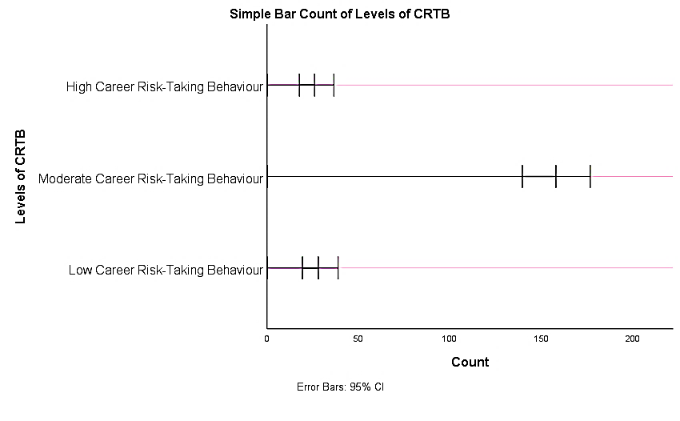
Figure 1: Bar Chart Showing Levels of Career Risk-Taking Behaviour
Figure 1 illustrates the distribution of students across different levels of career risk-taking behaviour. It is evident from the bar chart that the majority of students (74.5%) fall under the moderate level of career risk-taking behaviour, as indicated by the tallest bar. In contrast, a smaller proportion of students exhibit low (13.2%) and high (12.3%) levels of career risk-taking behaviour, represented by comparatively shorter bars. This pattern suggests that most students adopt a balanced approach toward career decisions, showing a moderate willingness to take risks while still considering stability. Only a limited number of students are either highly risk-averse or highly risk-oriented in their career choices.

  - To analyse the distribution of students based on demographic variables such as gender, academic stream, type of school, and monthly family income.
Table 2: Distribution of Students Based on Gender
Gender of the Students
 |  | Frequency | Percent | Valid Percent | Cumulative Percent
Valid | Male | 90 | 42.5 | 42.5 | 42.5
Valid | Female | 122 | 57.5 | 57.5 | 100.0
Valid | Total | 212 | 100.0 | 100.0

The distribution of students based on gender shows that out of the total sample (N = 212), 90 students (42.5%) were male and 122 students (57.5%) were female. This indicates that the sample consisted of a higher proportion of female students compared to male students.
Table 3: Distribution of Students Based on Academic Stream
Stream of the student
 |  | Frequency | Percent | Valid Percent | Cumulative Percent
Valid | Science | 67 | 31.6 | 31.6 | 31.6
Valid | Arts | 69 | 32.5 | 32.5 | 64.2
Valid | Commerce | 76 | 35.8 | 35.8 | 100.0
Valid | Total | 212 | 100.0 | 100.0

The distribution of students across different academic streams reveals that 67 students (31.6%) belonged to the Science stream, 69 students (32.5%) were from the Arts stream, and 76 students (35.8%) were from the Commerce stream. This indicates a relatively balanced representation of students across all three streams, with a slightly higher proportion from the Commerce stream.
Table 4: Distribution of Students Based on Type of School
Type of School
 |  | Frequency | Percent | Valid Percent | Cumulative Percent
Valid | Government School | 175 | 82.5 | 82.5 | 82.5
Valid | Government Aided School | 37 | 17.5 | 17.5 | 100.0
Valid | Total | 212 | 100.0 | 100.0

The distribution based on type of school shows that the majority of students, 175 (82.5%), were from Government schools, while 37 students (17.5%) were from Government-aided schools. This indicates that most respondents in the study were enrolled in Government schools.
Table 5: Distribution of Students Based on Monthly Family Income (Socioeconomic Status)
Monthly Family Income
 |  | Frequency | Percent | Valid Percent | Cumulative Percent
Valid | 10000 Below | 69 | 32.5 | 32.5 | 32.5
Valid | 10000-20000 | 134 | 63.2 | 63.2 | 95.8
Valid | 20000-30000 | 8 | 3.8 | 3.8 | 99.5
Valid | 30000 Above | 1 | .5 | .5 | 100.0
Valid | Total | 212 | 100.0 | 100.0

Table 5 presents the descriptive statistics of career risk-taking behaviour among secondary school students. The total sample consisted of 211 students. The scores ranged from 35 to 175, with a mean score of 116.66 and a standard deviation of 20.51. This indicates a moderate level of career risk-taking behaviour among the students, with some variability in responses. students based on monthly family income indicates that 69 students (32.5%) belonged to families earning below ₹10,000 per month. The majority of students, 134 (63.2%), fell within the ₹10,000–₹20,000 income group. A smaller proportion, 8 students (3.8%), belonged to the ₹20,000–₹30,000 category, while only 1 student (0.5%) reported a family income above ₹30,000. This suggests that most students in the sample belong to lower and middle-socioeconomic backgrounds.
Table 6: Monthly Family Income * Levels of Career Risk-Taking Behaviour Crosstabulation
Monthly Family Income * Levels of Career Risk-Taking Behaviour Crosstabulation
Count
 |  | Levels of Career Risk-Taking Behaviour |  |  | Total
 |  | Low Career Risk-Taking Behaviour | Moderate Career Risk-Taking Behaviour | High Career Risk-Taking Behaviour | Total
Monthly Family  Income | 10000 Below | 10 | 50 | 9 | 69
Monthly Family  Income | 10000-20000 | 18 | 101 | 15 | 134
Monthly Family  Income | 20000-30000 | 0 | 6 | 2 | 8
Monthly Family  Income | 30000 Above | 0 | 1 | 0 | 1
Total |  | 28 | 158 | 26 | 212
Table 6 presents the distribution of students across different levels of career risk-taking behaviour based on their monthly family income. Among students with family income below ₹10,000, 10 students exhibit low, 50 moderate, and 9 high levels of career risk-taking behaviour. In the ₹10,000–₹20,000 income group, 18 students fall under low, 101 under moderate, and 15 under high levels. Similarly, in the ₹20,000–₹30,000 group, 6 students show moderate and 2 show high risk-taking behaviour, with none in the low category. Among students with income above ₹30,000, only 1 student is observed in the moderate category. Overall, it is evident that across all income groups, the majority of students fall under the moderate level of career risk-taking behaviour. This suggests a similar pattern of behaviour irrespective of income levels.

  - To determine the association between socioeconomic status and levels of career risk-taking behaviour.
Table 7: Chi-Square Tests
Chi-Square Tests
 | Value | df | Asymptotic Significance (2-sided)
Pearson Chi-Square | 2.760ª | 6 | .838
Likelihood Ratio | 3.816 | 6 | .702
Linear-by-Linear Association | .361 | 1 | .548
N of Valid Cases | 212
a. 5 cells (41.7%) have expected count less than 5. The minimum expected count is .12.
Table 7 shows the results of the Chi-square test examining the association between monthly family income and levels of career risk-taking behaviour. The obtained Chi-square value was χ²(6) = 2.760 with a p-value of 0.838, which is greater than the significance level of 0.05. This indicates that there is no statistically significant association between socioeconomic status and career risk-taking behaviour among secondary school students. Therefore, the null hypothesis is accepted, suggesting that family income does not significantly influence students’ levels of career risk-taking behaviour.

  - To compare career risk-taking behaviour across different socioeconomic (income) groups.

Table 8: One-Way ANOVA of Career Risk-Taking Behaviour by Socioeconomic Status
ANOVA
CRT_Behaviour Scale
 | Sum of Squares | df | Mean Square | F | Sig.
Between Groups | 1097.714 | 3 | 365.905 | .871 | .457
Within Groups | 87358.791 | 208 | 419.994
Total | 88456.505 | 211
A one-way ANOVA was conducted to examine whether there are significant differences in career risk-taking behaviour among students across different income groups. The results indicated that there is no statistically significant difference in career risk-taking behaviour based on monthly family income, F(3, 208) = 0.871, p = 0.457 (p > 0.05). This suggests that students from different socioeconomic backgrounds do not differ significantly in their levels of career risk-taking behaviour. Therefore, socioeconomic status, as measured by monthly family income, does not have a significant impact on students’ career risk-taking behaviour.
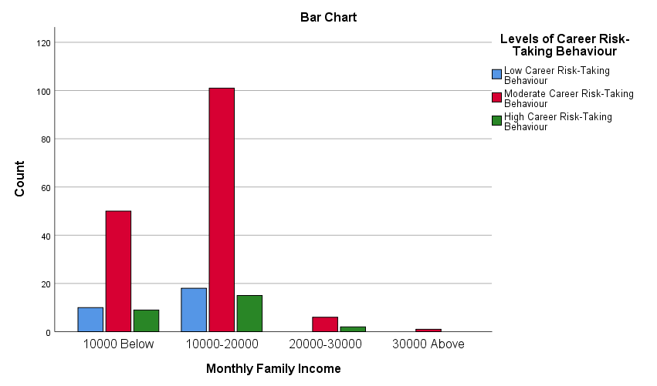
Figure 2: Bar Chart Showing Distribution of Career Risk-Taking Behaviour Across Monthly Family Income Groups
  - To examine the influence of demographic variables (gender, type of school, and academic stream) on career risk-taking behaviour.
Table 9: Gender and Levels of Career Risk-Taking Behaviour among Secondary School Students
Gender of the Students * Levels of Career Risk-Taking Behaviour Crosstabulation
 |  | Levels of Career Risk-Taking Behaviour |  |  | Total
 |  | Low Career Risk-Taking Behaviour | Moderate Career Risk-Taking Behaviour | High Career Risk-Taking Behaviour | Total
Gender of the Students | Male | 11 | 65 | 14 | 90
Gender of the Students | Male | 12.2% | 72.2% | 15.6% | 100.0%
Gender of the Students | Female | 17 | 93 | 12 | 122
Gender of the Students | Female | 13.9% | 76.2% | 9.8% | 100.0%
Total |  | 28 | 158 | 26 | 212
 |  | 13.2% | 74.5% | 12.3% | 100.0%

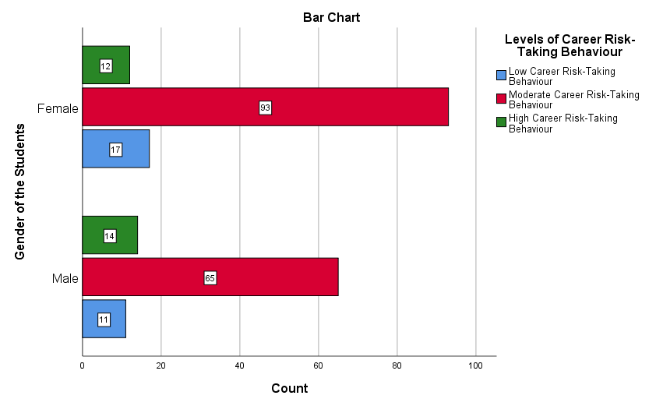
Figure 3: Bar Chart Showing Gender Differences in Levels of Career Risk-Taking Behaviour
Table 9 indicates that among male students, 72.2% exhibit moderate, 12.2% low, and 15.6% high career risk-taking behaviour. Similarly, among female students, 76.2% show moderate, 13.9% low, and 9.8% high levels. Overall, the majority of students (74.5%) fall under the moderate category.
Table 10: Type of School * Levels of Career Risk-Taking Behaviour Crosstabulation
Type of School * Levels of Career Risk-Taking Behaviour Crosstabulation
Count
 |  | Levels of Career Risk-Taking Behaviour |  |  | Total
 |  | Low Career Risk-Taking Behaviour | Moderate Career Risk-Taking Behaviour | High Career Risk-Taking Behaviour | Total
Type of School | Government School | 23 | 132 | 20 | 175
Type of School | Government Aided School | 5 | 26 | 6 | 37
Total |  | 28 | 158 | 26 | 212
Table 10 presents the distribution of students’ levels of career risk-taking behaviour with respect to the type of school. Among students studying in government schools, 23 exhibit low, 132 moderate, and 20 high levels of career risk-taking behaviour. In comparison, among students from government-aided schools, 5 fall under low, 26 under moderate, and 6 under high levels of career risk-taking behaviour. It is observed that in both categories of schools, the majority of students demonstrate a moderate level of career risk-taking behaviour. The distribution pattern across government and government-aided schools appears to be relatively similar, with only minor variations in the proportion of students across different levels
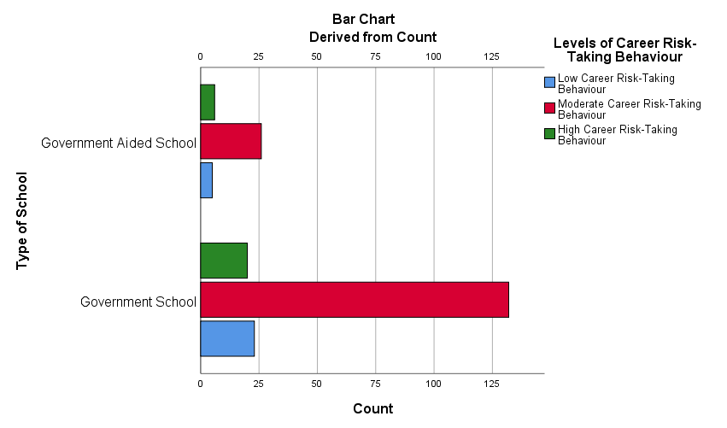
Figure 4: Bar Chart Showing Distribution of Career Risk-Taking Behaviour Across Types of School
Table 11: Distribution of Career Risk-Taking Behaviour Across Academic Stream
Stream of the student * Levels of Career Risk-Taking Behaviour Crosstabulation
Count
 |  | Levels of Career Risk-Taking Behaviour |  |  | Total
 |  | Low Career Risk-Taking Behaviour | Moderate Career Risk-Taking Behaviour | High Career Risk-Taking Behaviour | Total
Stream of the student | Science | 8 | 52 | 7 | 67
Stream of the student | Arts | 7 | 51 | 11 | 69
Stream of the student | Commerce | 13 | 55 | 8 | 76
Total |  | 28 | 158 | 26 | 212
Table 11 presents the distribution of students’ levels of career risk-taking behaviour across different academic streams. Among students from the Science stream, 8 exhibit low, 52 moderate, and 7 high levels of career risk-taking behaviour. In the Arts stream, 7 students fall under low, 51 under moderate, and 11 under high levels. Similarly, among Commerce students, 13 exhibit low, 55 moderate, and 8 high levels of career risk-taking behaviour. It is evident that across all three academic streams, the majority of students demonstrate a moderate level of career risk-taking behaviour. Although slight variations are observed in the distribution of low and high levels among the streams, the overall pattern remains consistent. These findings indicate that the academic stream of the students does not substantially influence their level of career risk-taking behaviour, as similar trends are observed across Science, Arts, and Commerce groups.
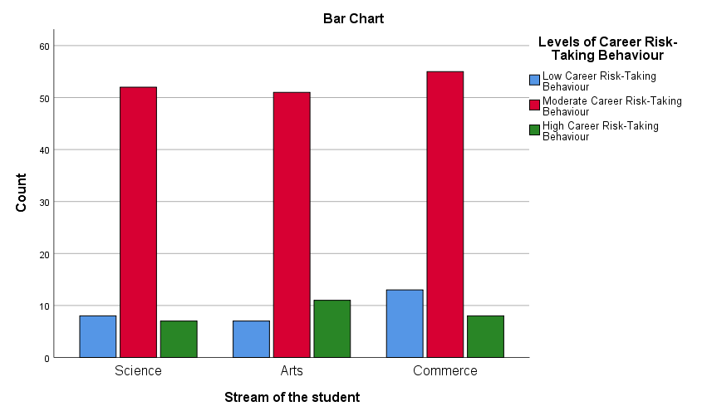
Figure 5: Bar Chart Showing Distribution of Career Risk-Taking Behaviour Across Academic Stream
  - To analyse the predictive role of socioeconomic status and demographic variables on career risk-taking behaviour.
Table 12: Summary of Multiple Regression Analysis Predicting Career Risk-Taking Behaviour
Model Summary^{b}
Model | R | R Square | Adjusted R Square | Std. Error of the Estimate | Change Statistics
 |  |  |  |  | R Square Change | F Change | df1 | df2 | Sig. F Change
1 | .098ª | .010 | -.005 | 20.52233 | .010 | .676 | 3 | 208 | .568
a. Predictors: (Constant), Gender of the Students, Type of School, Monthly Family Income
b. Dependent Variable: CRT_Behaviour Scale
The model summary indicates that the multiple correlation coefficient (R) is 0.098, suggesting a very weak relationship between the independent variables (monthly family income, gender, and type of school) and career risk-taking behaviour. The coefficient of determination (R²) is 0.010, which indicates that only 1.0% of the variance in career risk-taking behaviour is explained by the predictor variables. The adjusted R² value (-0.005) further confirms that the model has very low explanatory power.
Table 13: ANOVA for Multiple Regression Analysis Predicting Career Risk-Taking Behaviour
ANOVAª
Model |  | Sum of Squares | df | Mean Square | F | Sig.
1 | Regression | 853.945 | 3 | 284.648 | .676 | .568^{b}
1 | Residual | 87602.559 | 208 | 421.166
1 | Total | 88456.505 | 211
a. Dependent Variable: CRT_Behaviour Scale
b. Predictors: (Constant), Gender of the Students, Type of School, Monthly Family Income
The ANOVA results show that the overall regression model is not statistically significant, F(3, 208) = 0.676, p = 0.568 (p > 0.05). This indicates that the set of independent variables does not significantly predict career risk-taking behaviour. Therefore, the regression model is not a good fit for the data.
Table 14: Regression Coefficients for Predicting Career Risk-Taking Behaviour
Coefficientsª
Model |  | Unstandardized Coefficients |  | Standardized Coefficients | t | Sig.
 |  | B | Std. Error | Beta | t | Sig.
1 | (Constant) | 125.813 | 7.657 |  | 16.432 | .000
1 | Monthly Family Income | -1.148 | 2.559 | -.031 | -.449 | .654
1 | Type of School | -1.168 | 3.721 | -.022 | -.314 | .754
1 | Gender of the Students | -3.717 | 2.855 | -.090 | -1.302 | .194
a. Dependent Variable: CRT_Behaviour Scale
The regression coefficients indicate that none of the independent variables significantly predict career risk-taking behaviour. Monthly family income (β = -0.031, p = 0.654), type of school (β = -0.022, p = 0.754), and gender (β = -0.090, p = 0.194) all have non-significant p-values (p > 0.05). This suggests that changes in socioeconomic status, school type, or gender do not significantly influence students’ career risk-taking behaviour.

  - To assess the accuracy and explanatory power of the regression model in predicting career risk-taking behaviour.
Table 15: Residuals Statistics for Multiple Regression Model
Residuals Statisticsª
 | Minimum | Maximum | Mean | Std. Deviation | N
Predicted Value | 112.5984 | 119.7800 | 116.6085 | 2.01175 | 212
Residual | -84.78002 | 58.93679 | .00000 | 20.37592 | 212
Std. Predicted Value | -1.993 | 1.577 | .000 | 1.000 | 212
Std. Residual | -4.131 | 2.872 | .000 | .993 | 212
a. Dependent Variable: CRT_Behaviour Scale
The residuals statistics provide information about the accuracy and distribution of the predicted values in the regression model. The predicted values of career risk-taking behaviour range from 112.60 to 119.78, with a mean of 116.61 and a standard deviation of 2.01, indicating a relatively narrow spread of predicted scores. The residual values range from -84.78 to 58.94, with a mean of 0.00 and a standard deviation of 20.38. The mean residual of zero suggests that the model does not systematically overestimate or underestimate the dependent variable. However, the wide range of residuals indicates substantial variability between observed and predicted values.
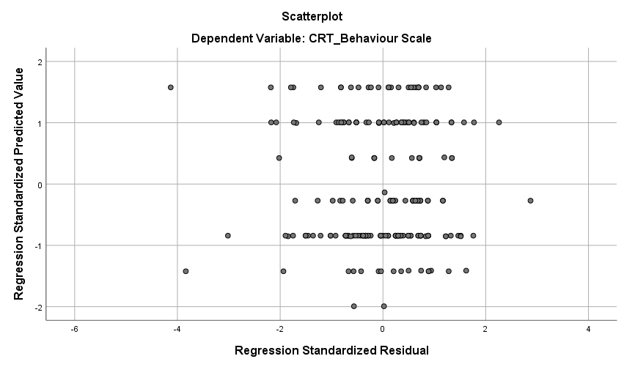
Figure 6: Scatterplot of Standardised Residuals vs Standardised Predicted Values
The lack of a distinct pattern in the scatterplot suggests that the independent variables included in the model do not adequately explain variations in career risk-taking behaviour. This supports the non-significant findings obtained from regression analysis and highlights the limited role of socioeconomic and demographic factors in predicting the outcome variable.

- Findings and Conclusion

Based on the statistical analyses conducted, the following major findings were observed. The majority of students (74.5%) exhibited a moderate level of career risk-taking behaviour, indicating a balanced approach toward career decision-making, with limited inclination toward extreme risk-taking or risk aversion. The distribution of students across demographic variables revealed a relatively balanced representation in terms of gender and academic stream, while a large proportion of students belonged to government schools and lower to middle socioeconomic backgrounds. The analysis of the relationship between socioeconomic status and career risk-taking behaviour using the Chi-square test indicated that there is no significant association between the two variables (p > 0.05). The one-way ANOVA results further confirmed that there is no significant difference in career risk-taking behaviour across different income groups, suggesting that students from varying socioeconomic backgrounds exhibit similar behavioural patterns. The crosstab analysis across demographic variables such as type of school and academic stream showed a consistent pattern, with the majority of students in all groups demonstrating a moderate level of career risk-taking behaviour, indicating minimal influence of these variables. The multiple regression analysis revealed that socioeconomic status, along with demographic variables such as gender and type of school, does not significantly predict career risk-taking behaviour (R² = 0.010, p > 0.05), indicating very low explanatory power of the model. The residual analysis and scatterplot further supported the regression findings, showing a lack of a clear pattern and weak predictive accuracy, with some variability and the presence of outliers.

The findings of the present study clearly indicate that socioeconomic status does not play a significant role in influencing or predicting career risk-taking behaviour among secondary school students in West Bengal. Despite traditional assumptions that economic background shapes career-related attitudes, the results consistently demonstrate non-significant relationships across multiple statistical techniques, including correlation, chi-square, ANOVA, and regression analyses. The predominance of moderate career risk-taking behaviour across all socioeconomic and demographic groups suggests that students tend to adopt a balanced and cautious approach toward career decisions, irrespective of their economic background. This indicates that career risk-taking behaviour is likely influenced more by psychological, social, and contextual factors rather than purely structural variables such as income.

The study challenges the deterministic view of socioeconomic status and emphasises the need for a multidimensional perspective in understanding career development. It highlights that factors such as personal interests, self-efficacy, parental guidance, peer influence, and educational exposure may play a more crucial role in shaping students’ career-related decisions.
In conclusion, the study contributes to the existing literature by providing empirical evidence that career risk-taking behaviour among adolescents is largely independent of socioeconomic status, thereby offering important implications for educational policy, career guidance, and future research.

Reference:
Bandura, A. (1986). Social foundations of thought and action: A social cognitive theory. Prentice-Hall.
Bandura, A. (1997). Self-efficacy: The exercise of control. W. H. Freeman. https://www.uky.edu/~eushe2/Bandura/Bandura1997AC.pdf
Becker, G. S. (1993). Human capital: A theoretical and empirical analysis, with special reference to education (3rd ed.). University of Chicago Press.
Bourdieu, P. (1986). The forms of capital. In J. Richardson (Ed.), Handbook of theory and research for the sociology of education (pp. 241–258). Greenwood. https://www.jstor.org/stable/223241
Bradley, R. H., & Corwyn, R. F. (2002). Socioeconomic status and child development. Annual Review of Psychology, 53, 371–399. https://doi.org/10.1146/annurev.psych.53.100901.135233
Buchmann, C., DiPrete, T. A., & McDaniel, A. (2008). Gender inequalities in education. Annual Review of Sociology, 34, 319–337. https://doi.org/10.1146/annurev.soc.34.040507.134719
Coleman, J. S. (1988). Social capital in the creation of human capital. American Journal of Sociology, 94, S95–S120.
Desai, S., & Kulkarni, V. (2008). Changing educational inequalities in India. Demography, 45(2), 245–270. https://doi.org/10.1353/dem.0.0001
Eccles, J. S. (2009). Who am I and what am I going to do with my life? Child Development, 80(3), 682–692. https://doi.org/10.1111/j.1467-8624.2009.01342.x
Eccles, J. S., & Wigfield, A. (2002). Motivational beliefs, values, and goals. Annual Review of Psychology, 53, 109–132. https://doi.org/10.1146/annurev.psych.53.100901.135153
Ginzberg, E. (1951). Toward a theory of occupational choice. Occupations, 30(7), 491–494.
Government of India. (2020). National Education Policy 2020. https://www.education.gov.in
Jencks, C. (1972). Inequality: A reassessment of the effect of family and schooling in America. Basic Books.
Kingdon, G. G. (2007). The progress of school education in India. World Development, 35(10), 1681–1695. https://doi.org/10.1016/j.worlddev.2006.10.008
Krumboltz, J. D. (2009). The happenstance learning theory. Journal of Career Assessment, 17(2), 135–154. https://doi.org/10.1177/1069072708328861
Lent, R. W., Brown, S. D., & Hackett, G. (1994). Toward a unifying social cognitive theory. Psychological Review, 101(2), 326–348. https://doi.org/10.1037/0033-295X.101.2.326
Lent, R. W., Brown, S. D., & Hackett, G. (2000). Contextual supports and barriers. Journal of Counseling Psychology, 47(1), 36–49. https://doi.org/10.1037/0022-0167.47.1.36
NITI Aayog. (2021). National strategy for artificial intelligence. https://www.niti.gov.in
OECD. (2018). Education at a glance 2018: OECD indicators. https://www.oecd.org/education/education-at-a-glance/
Savickas, M. L. (2013). Career construction theory. In S. D. Brown & R. W. Lent (Eds.), Career development and counseling (pp. 147–183). Wiley.
Sirin, S. R. (2005). Socioeconomic status and academic achievement. Review of Educational Research, 75(3), 417–453. https://doi.org/10.3102/00346543075003417
Super, D. E. (1990). A life-span, life-space approach to career development. In D. Brown et al. (Eds.), Career choice and development (pp. 197–261). Jossey-Bass.
Tilak, J. B. G. (2002). Determinants of household expenditure on education. Economic and Political Weekly, 37(6), 540–551. https://www.jstor.org/stable/4412478
UNESCO. (2019). Global education monitoring report. https://en.unesco.org/themes/education
World Bank. (2020). World development report 2020. https://www.worldbank.org
World Economic Forum. (2020). The future of jobs report 2020. https://www.weforum.org/reports/the-future-of-jobs-report-2020

