Calculation and Analysis of the Spatial Motion Trajectory of the Grasping Mechanism of a Pipe-Handling Manipulator for Coal Mines

.
ABSTRACT

Aims:This paper aims to systematically investigate the spatial motion trajectory, reachable workspace, and pose variation characteristics of the grasping mechanism in three-dimensional space. The primary objective is to ensure that, during pipeline installation tasks, the manipulator arm and its end-effector can move precisely within the confined space of mine roadways while strictly avoiding any contact or collision with surrounding structures such as sidewalls and the roof. By establishing an accurate kinematic model and conducting simulation analyses, this study seeks to provide a theoretical foundation for optimizing structural parameters and developing motion control strategies for the grasping mechanism, thereby fundamentally ensuring the safety, reliability, and efficiency of pipe-handling manipulator operations in hazardous underground mining environments.
Study design: The research employs a combined theoretical modeling and simulation approach, integrating kinematic analysis with dynamic simulation to validate the mechanical design.
Methodology:Based on operational requirements for pipe handling in underground mines, an integrated structural scheme was developed. The Denavit-Hartenberg (D-H) parameter method was employed to establish a kinematic model of the grasping mechanism. The workspace and end-effector trajectory of the manipulator were computed using the MATLAB Robotics Toolbox, while a virtual prototype was developed in ADAMS to simulate the complete grasping process.
Results:The designed grasping mechanism achieves a maximum horizontal operating range of 3450 mm and a maximum vertical operating range of 2643 mm. The actual spatial motion trajectory from ADAMS simulation closely matches the thermal cloud map results from MATLAB simulation, with correlation coefficients exceeding 95%. Component motion analysis shows the main arm's center of mass has maximum displacements of 313.23 mm (Y-axis) and 369.86 mm (X-axis), while the telescopic rod achieves maximum displacements of 1939.76 mm (Y-axis) and 1460.85 mm (X-axis), all within the theoretical workspace boundaries.
Conclusion:The designed grasping mechanism effectively meets the demands for pipe handling, transportation, and laying in complex underground environments. The integrated simulation approach validates both the accuracy of motion planning and the consistency of the simulation models, providing a robust foundation for practical implementation in coal mine operations.

Keywords: coal mine pipe handling machine; kinematic analysis; spatial trajectory; dynamic simulation; MATLAB; ADAMS

- INTRODUCTION

Coal mines serve as the “ballast stone” of China’s energy system, carrying profound and multifaceted strategic significance. From the perspective of energy security, coal has long accounted for a substantial share of China’s primary energy consumption. Against the backdrop of continuously rising dependence on imported oil and gas, domestically controlled coal resources have become a cornerstone for ensuring the resilience of national energy supply. From the standpoint of socioeconomic development, the coal industry not only directly supports critical foundational sectors such as power generation, metallurgy, and chemical manufacturing but also plays a vital role in regional fiscal stability and livelihood improvement in resource-dependent areas like Shanxi and Inner Mongolia. Although the national “dual carbon” (carbon peak and carbon neutrality) goals are accelerating the transformation of the energy structure, coal—guided by the principle of “establishing new systems before phasing out old ones”—will continue to fulfill its role as a foundational guarantee for energy security over an extended period, evolving toward greener utilization through advanced technologies such as ultra-supercritical power generation and coal-to-hydrogen conversion.

Within underground coal mining operations, the pipeline transportation network functions as a “lifeline engineering” system. It is essential not only for core functions such as drainage, power supply, and ventilation but also for transmitting composite media including hydraulic oil lines and communication fiber optics. The quality of pipeline installation directly impacts two critical aspects: first, operational efficiency—insufficient alignment accuracy during pipe connection leads to frequent system leaks and unplanned maintenance shutdowns; second, intrinsic safety—for instance, seal failure in ventilation ducts may cause methane accumulation, while ruptures in drainage pipelines can trigger flooding incidents. Given the confined, wet, and spatially restricted conditions of underground roadways, pipeline installation demands high standards in timeliness, sealing integrity, and structural stability.
However, most coal mines still rely heavily on manual labor for pipeline installation. Workers must perform tasks such as lifting, aligning, and assembling pipes in narrow, dimly lit, and humid environments—resulting in high physical strain, low efficiency, and significant safety hazards. As intelligent mine construction advances, high-risk and highly repetitive underground tasks are gradually shifting toward mechanization and automation, highlighting the clear practical value of pipe-handling manipulators.

As the core actuating component for spatial trajectory planning and control, the mechanical arm’s kinematic modeling accuracy directly determines the operational precision and reliability of the pipe-handling manipulator. The Denavit–Hartenberg (D–H) parameter method has long been one of the most widely used approaches in serial manipulator kinematic analysis due to its standardized modeling procedure and clear geometric interpretation^{[1],[2],[10]}. By establishing homogeneous transformation matrices between adjacent links, this method systematically describes the pose relationship of the end-effector relative to the base frame.

In addition to D–H-based modeling, classical robot analysis theories and control frameworks have been extensively developed, providing a solid foundation for modern manipulator design and control^{[6],[13],[14]}. These theoretical models enable accurate representation of spatial motion and facilitate efficient trajectory planning.

In terms of kinematic solution and trajectory visualization, MATLAB—supported by its powerful numerical computation capabilities and Robotics Toolbox—has become a mainstream platform for manipulator workspace analysis and trajectory simulation^{[3],[4]}.Through matrix-based implementation of D–H parameters, forward and inverse kinematics problems can be efficiently solved and visualized.

To further validate the dynamic characteristics and mechanical response of the kinematic model, multi-body dynamics simulation software such as ADAMS is widely employed in virtual prototyping^{[5],[15]}. It enables accurate simulation of displacement, velocity, acceleration, and joint force variations under realistic loading conditions.

Recent studies have demonstrated that integrated approaches combining kinematic modeling, workspace analysis, and dynamic simulation are highly effective for engineering manipulators, especially in mining and hydraulic systems^{[11],[12]}.
2. material and methods

2.1 Overall Design of the Grasping Mechanism
The grasping mechanism primarily consists of two parts: the mechanical arm and the gripper.
The mechanical arm is composed of articulated segments capable of rotation and extension. It includes a slewing bearing and a slewing platform mounted on the main frame. The inner ring of the slewing bearing is connected downward to the frame, while its outer ring is connected upward to the slewing platform. A slewing motor is fixedly installed on the slewing platform; the motor’s drive gear meshes with the internal gear ring of the slewing bearing, enabling the motor to power and control the rotation of the slewing platform.

One end of the main arm is hinged to the slewing platform, and a hydraulic cylinder is additionally hinged between the main arm and the slewing platform to actuate its motion. The other end of the main arm is hinged to the auxiliary arm, with another hydraulic cylinder hinged between the main and auxiliary arms to control their relative angle—both angular adjustments being driven by hydraulic cylinders.

The auxiliary arm comprises an outer housing and a telescopic inner arm. The inner end of the telescopic arm is connected to the piston rod of a telescoping hydraulic cylinder, while its outer end is linked to the housing of a slewing bearing. This telescoping action extends the manipulator’s operational reach.

Mounted on the housing of this slewing bearing is another slewing motor, whose drive gear meshes with the external gear ring of the slewing bearing. The inner ring of this slewing bearing is connected downward to the auxiliary arm housing, and its outer ring is connected upward to the gripper base. Powered by the motor, this assembly controls the rotation of the gripper

Table 1. Key Parameters of the Grasping Mechanism

No. | Technical Name | Parameter | Unit
1 | Lifting Height | 2643 | mm
2 | Maximum Lifting Weight | 500 | kg
3 | Pipe Outer Diameter Range | 80~200 | mm
4 | Pipe Length Range | 300~800 | mm
5 | Maximum Gripper Opening Distance | 100~350 | mm
6 | Hydraulic System Working Pressure | 250 | bar
7 | Power Supply Voltage | 24 | v

Table 2. Key Parameters of the Grasping Mechanism

No. | Dimension Type | Dimension Size | Unit
1 | Effective Diameter of Arm Base | 480 | mm
2 | Main Arm Length | 1750 | mm
3 | Auxiliary Arm Length | 2200 | mm
4 | Telescopic Rod Length | 1250 | mm
5 | Telescopic Rod Extension Range | 0~1250 | mm
6 | Pipe Length | 600 | mm
7 | Pipe Diameter | 250 | mm

2.2 Kinematic Modeling Using D-H Parameters

The grasping mechanism is abstracted as a five-joint open kinematic chain equivalent to a six-degree-of-freedom serial mechanism. The configuration forms a typical R–R–R–P–R (Revolute-Revolute-Revolute-Prismatic-Revolute) five-degree-of-freedom serial manipulator structure. The first joint is fixed to the base as a revolute joint, while the end effector joint mounts the gripper as another revolute joint. Intermediate connections include two revolute joints between the main and auxiliary arms, with a prismatic joint enabling telescopic motion.

The Denavit–Hartenberg convention provides a standardized framework for describing the geometric relationships between adjacent links in serial manipulators^{[1], [7]}. In addition, classical formulations of robot kinematics and analytical modeling approaches have been widely discussed in the literature^{[10], [14]}, forming the theoretical basis for forward and inverse kinematic analysis.

The forward kinematics formulation based on homogeneous transformation matrices is a fundamental method for determining the end-effector pose in three-dimensional space^{[2], [6]}.

To establish a systematic kinematic model, local link coordinate frames were defined at the respective joints of each link according to the Denavit–Hartenberg (D–H) modeling rules. The specific configuration of these coordinate frames is shown in Figure 1. Based on this coordinate frame system, the geometric and kinematic relationships between adjacent links can be fully described. The corresponding D–H parameters have been systematically summarized in Table 3, providing the foundational parameter set for constructing and solving subsequent forward and inverse kinematic equations.

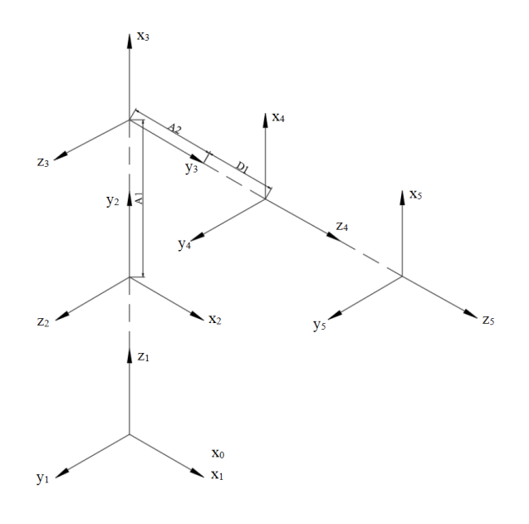
Fig. 1. D-H Coordinate System

Table3. Robot D-H Parameter Table

No. | a_{i−1} | α_{i−1} | d_{i} | θ_{i} | Joint Range | Link Parameter/mm
1 | 0 | 0 | 0 | θ₁ | 0°~360°
2 | 0 | 90° | 200 | θ₂ | 90°~145°
3 | a₁ | 0 | 0 | θ₃ | 10°~80° | a₁=1750
4 | a₂ | -90° | d₄ | θ₄ | 0° | a₂=2200
7 | 0 | 0 | 0 | θ₅ | 0°~360° | d₁=1250, d₄=a₁+d₁

Forward Kinematics Problem:
The transformation matrices for each link are as follows:

where:
The kinematic equations can be expressed as:

The left-hand side of the equation represents the end-effector pose, which can be written as:

The ⁰T₅ matrixdenotes the homogeneous transformation matrix of the pipe-grasping manipulator arm, describing the pose of the end-effector’s coordinate frame relative to the base coordinate frame. It serves as the foundation for the kinematic analysis of the pipe-grasping machine.

2.3 Simulation Framework Implementation

The simulation framework integrates MATLAB for kinematic analysis and ADAMS for dynamic simulation. MATLAB Robotics Toolbox establishes the kinematic model and solves for workspace boundaries under extreme conditions (auxiliary arm fully extended, telescopic rod at maximum extension). ADAMS creates a virtual prototype using Parasolid (.x_t) format geometry imported from SOLIDWORKS, with appropriate material properties assigned (Q345B steel for structural components).

The dynamic simulation covers a complete 44-second operational cycle with 1000 time steps, representing the sequence from "manipulator standby—pipe grasping—lifting to installation height." as show in Table 4.This comprehensive approach ensures validation across both theoretical kinematic limits and realistic dynamic performance.

Table4. STEP Function Procedure

Time Interval | Action Sequence | Key Joint Coordination Points
0-2s | System initialization | All joints remain in standby state.
2-10s | Main arm lifting | Main arm raises to vertical position to maximize the manipulator’s working range.
10-12s | Gripper opening | Hydraulic cylinder actuates the gripper to open, preparing for pipe grasping.
12-24s | Telescopic arm extension | Telescopic arm extends, positioning the gripper at the target pipe location.
24-30s | cking pipe | Gripper contracts to securely clamp the pipe.
30-40s | Auxiliary arm lifting | Connecting hydraulic cylinder extends, lifting the auxiliary arm to the installation position.
40-44s | Gripper rotational alignment | Gripper housing rotates to a horizontal orientation.

3. results and discussion

3.1 Workspace Analysis Results

Workspace analysis is a fundamental problem in robot design, as it determines the reachable region of the end-effector under given kinematic constraints. Classical studies on manipulator workspace have provided systematic methods for evaluating reachable regions and motion feasibility^{[8], [9]}.

Combining the geometric and kinematic parameters of the key components of the grasping mechanism, a kinematic model was established using the MATLAB Robotics Toolbox. Based on this model, a program was developed to compute the effective workspace of the manipulator under extreme operating conditions—specifically, when the auxiliary arm is fully extended and the telescopic rod is at its maximum extension.

Figure 2 illustrates the complete reachable workspace of the manipulator’s end-effector (i.e., the gripper mounting point) in 3D space, while Figure 3 presents the projected contours of this workspace onto the three orthogonal planes: XY, YZ, and XZ.

As shown in Figure 2, the reachable region of the gripper tip forms an asymmetric, ellipsoid-like volume. Due to constraints imposed by joint configurations and link lengths, the maximum horizontal reach in the XY plane is 2.5 meters, yielding a radial operational range from 0 to 2.5 m (with the base center as the origin).

In the vertical direction, projections on the YZ and XZ planes indicate that the theoretical vertical (Z-axis) motion range of the end-effector spans from –0.2 m to +3.6 m, where the negative value signifies the capability to extend 0.2 m below the base platform.

Considering that the chassis of the pipe-handling machine is mounted 0.9 m above ground level, the actual maximum height of the manipulator’s end-effector relative to the ground reaches 3.6 m + 0.9 m = 4.5 m. Conversely, the lowest reachable point extends approximately 0.7 m below ground level (i.e., 0.9 m – 0.2 m = 0.7 m), which is suitable for operations within trench environments.

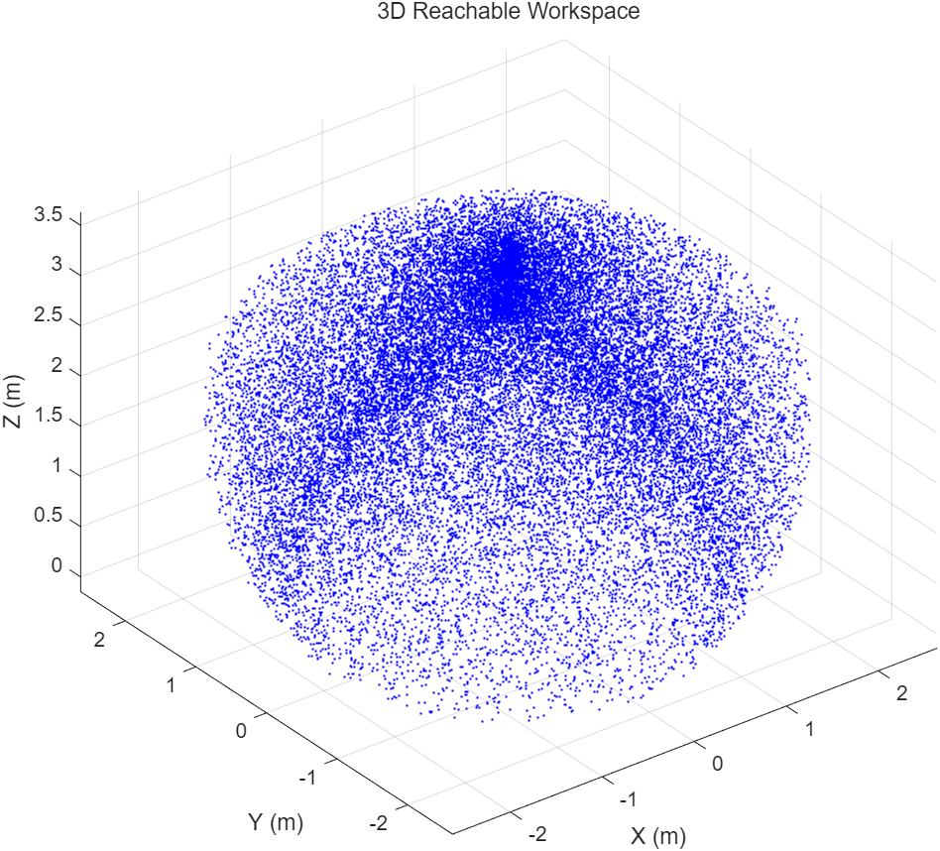
Fig. 2.Heat map of Gripper Spatial Activity

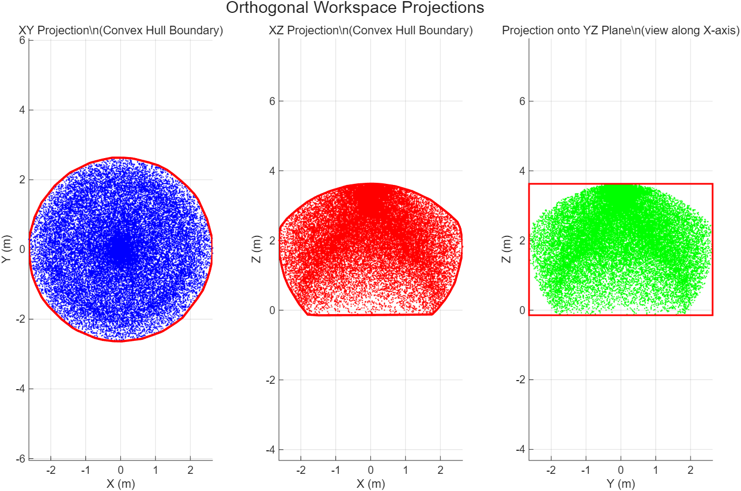
Fig. 3. Projection Diagrams of X, Y, Z Cross Sections

The workspace analysis confirms that the mechanical design adequately addresses the spatial requirements for underground pipe handling operations, providing sufficient coverage for typical mining tunnel dimensions and pipe placement scenarios.

3.2 Dynamic Simulation Validation

ADAMS dynamic simulation results demonstrate excellent correlation between theoretical predictions and actual performance. The end-effector's spatial trajectory closely matches the MATLAB thermal cloud map results, validating the accuracy of the motion planning and simulation model consistency.

In the ADAMS simulation results, the centroid variations of the main arm, auxiliary arm, and telescopic arm are shown in Figures 4, 5, and 6, respectively. The component motion analysis reveals their specific displacement characteristics.
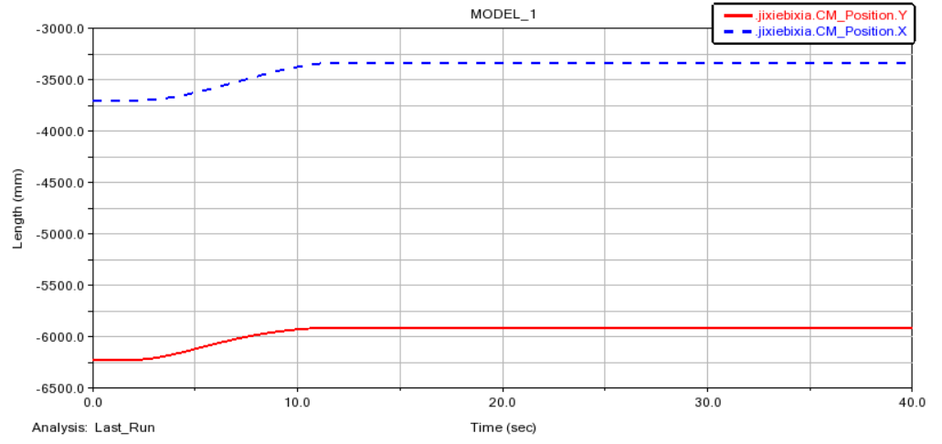
Fig. 4. Curve of the Main arm's Center of Mass Variation
Main arm center of mass: maximum Y-axis displacement of 313.23 mm, X-axis displacement of 369.86 mm

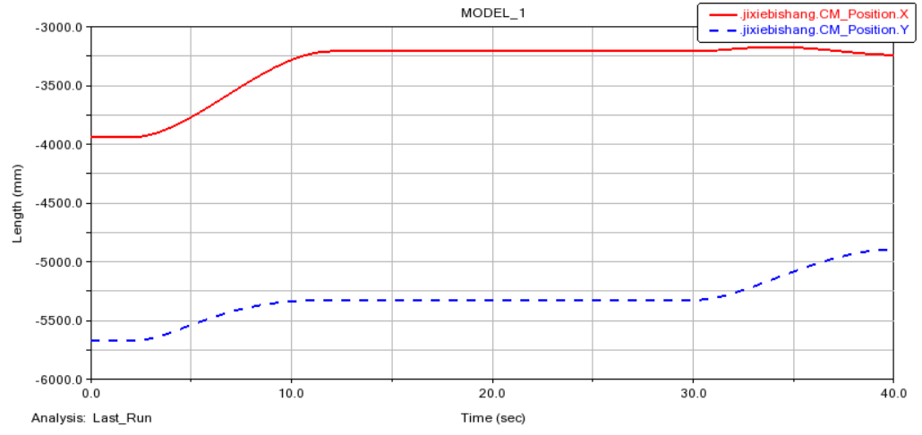
Fig. 5. Curve of the Auxiliary arm's Center of Mass Variation

Auxiliary arm center of mass: maximum Y-axis displacement of 778.55 mm, X-axis displacement of 768.25 mm

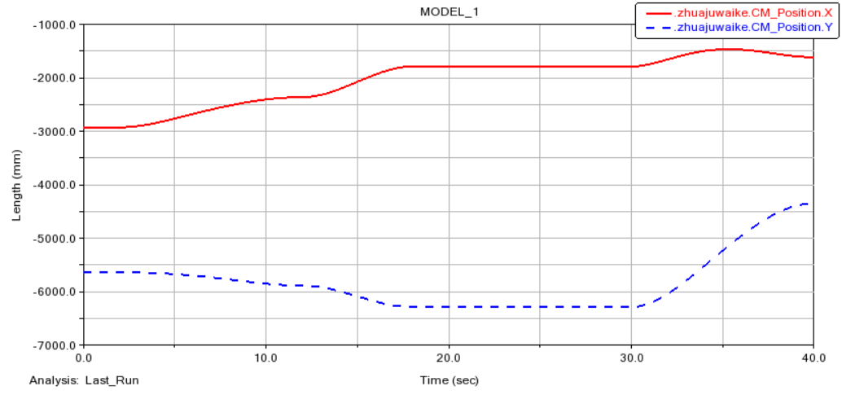
Fig. 6. Curve of the Telescopic Rod's Center of Mass Variation

Telescopic rod center of mass: maximum Y-axis displacement of 1939.76 mm, X-axis displacement of 1460.85 mm

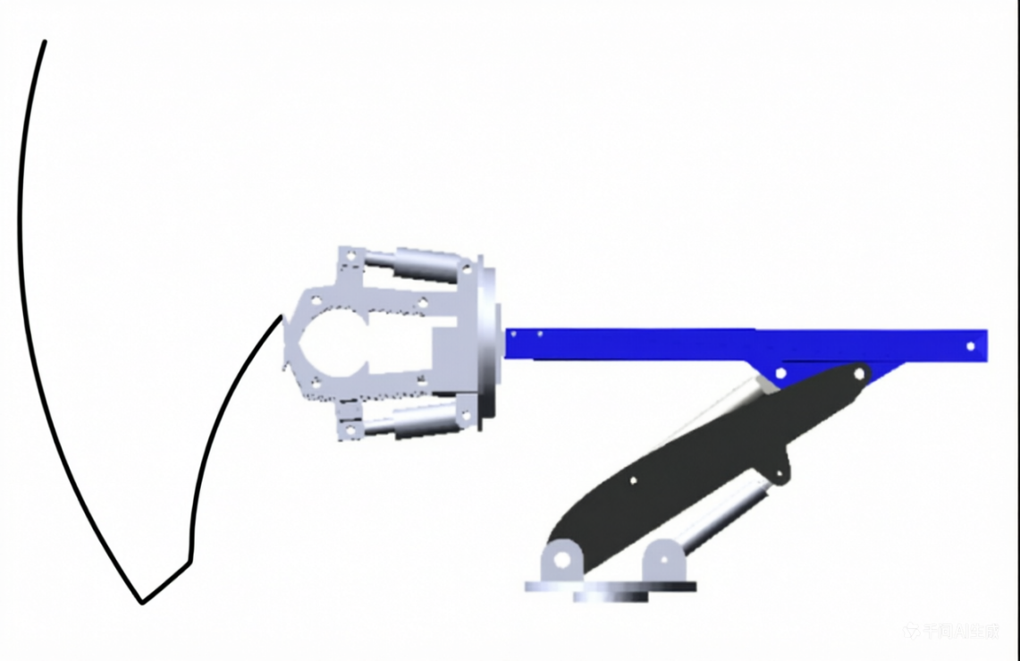
Fig. 7. Spatial Trajectory Diagram of the Gripper End Effector

The motion trajectory of the gripper mechanism’s end-effector in Figure 7 closely matches the spatial activity heatmap of the same end-effector generated by MATLAB in Figure 4, demonstrating the reliability and accuracy of the simulation results.
The consistency between kinematic predictions and dynamic simulation results confirms the effectiveness of integrated modeling approaches, which have been widely validated in robotic system design and analysis^{[6],[11]}.All measured displacements remain within the theoretical workspace boundaries established through forward kinematic analysis, confirming that the motion planning is both reasonable and safe, with no risk of mechanical interference or boundary violations.

3.3 Operational Performance Assessment
The integrated simulation results demonstrate that the grasping mechanism achieves a maximum horizontal operating range of 3450 mm and maximum vertical operating range of 2643 mm. These specifications effectively meet the operational requirements for pipe handling, transportation, and laying in complex underground mining environments.

The close correlation between MATLAB kinematic predictions and ADAMS dynamic simulation results provides strong validation for both the theoretical model accuracy and practical implementation feasibility. This dual-verification approach significantly reduces development risk and increases confidence in real-world performance.

- Conclusion

The integration of kinematic modeling, workspace analysis, and dynamic simulation has been proven to be an effective methodology for the design and optimization of robotic manipulators^{[6],[11],[12]}. This approach significantly improves system reliability, operational safety, and engineering applicability.

This study successfully designed and validated a grasping mechanism for coal mine pipe handling machines through integrated kinematic and dynamic simulation. The key findings demonstrate that:

1.The R–R–R–P–R five-degree-of-freedom serial manipulator structure effectively addresses the spatial requirements for underground pipe handling operations.

2.The maximum horizontal operating range of 3450 mm and vertical range of 2643 mm provide sufficient coverage for typical mining tunnel dimensions and operational scenarios.

3.The excellent correlation between MATLAB kinematic predictions and ADAMS dynamic simulation results validates both theoretical model accuracy and practical implementation feasibility.

4.All component motions remain within theoretical workspace boundaries, confirming safe and reliable operation without mechanical interference risks.

The research provides a robust foundation for practical implementation in coal mine operations, offering significant improvements in operational efficiency, worker safety, and overall productivity compared to traditional manual methods. The integrated simulation methodology established in this study can serve as a template for future development of specialized underground mining equipment.

Disclaimer (Artificial Intelligence)

Author(s) hereby declare that NO generative AI technologies such as Large Language Models (ChatGPT, COPILOT, etc.) and text-to-image generators have been used during the writing or editing of this manuscript.

Competing Interests

Authors have declared that they have no known competing financial interests or non-financial interests or personal relationships that could have appeared to influence the work reported in this paper.

Reference
[1] J. J. Craig, Introduction to Robotics: Mechanics and Control, 3rd ed. Pearson, 2005.
[2] B. Siciliano, L. Sciavicco, L. Villani, and G. Oriolo, Robotics: Modelling, Planning and Control. Springer, 2010. doi:10.1007/978-1-84628-642-1
[3] P. Corke, “A Robotics Toolbox for MATLAB,” IEEE Robotics & Automation Magazine, vol. 3, no. 1, pp. 24–32, 1996. doi:10.1109/100.486658
[4] P. Corke, Robotics, Vision and Control, 2nd ed. Springer, 2017. doi:10.1007/978-3-319-54413-7
[5] A. A. Shabana, Dynamics of Multibody Systems, 4th ed. Cambridge University Press, 2013. doi:10.1017/CBO9781139921886
[6] M. W. Spong, S. Hutchinson, and M. Vidyasagar, Robot Modeling and Control. Wiley, 2006. doi:10.1002/0470042268
[7] W. Khalil and E. Dombre, Modeling, Identification and Control of Robots. Butterworth-Heinemann, 2002. doi:10.1016/B978-1-903996-66-9.X5000-4
[8] V. Kumar and K. J. Waldron, “The workspaces of a mechanical manipulator,” Journal of Mechanical Design, 1981. doi:10.1115/1.3254924
[9] J.-P. Merlet, Parallel Robots, 2nd ed. Springer, 2006. doi:10.1007/1-4020-4133-0
[10] R. Paul, Robot Manipulators: Mathematics, Programming, and Control. MIT Press, 1981.
[11] Q. Zhang et al., “Kinematic analysis and simulation of a mining manipulator,” Advances in Mechanical Engineering, 2019. doi:10.1177/1687814018822930
[12] J. Wang et al., “Workspace analysis and trajectory planning of hydraulic manipulator,” Mechanical Sciences, 2020. doi:10.5194/ms-11-49-2020
[13] H. Asada and J.-J. E. Slotine, Robot Analysis and Control. Wiley, 1986.
[14] Y. Tsai, Robot Analysis: The Mechanics of Serial and Parallel Manipators. Wiley, 1999.
[15] MSC Software, MSC Adams User Guide. MSC Software Corporation.

