Original Research Article

Comparative Evaluation of Machine Learning Algorithms for Real-Time Quality Alert Classification in a Metalworking Manufacturing Environment

.
ABSTRACT

Aims: This paper critically assesses eight trained machine learning (ML) classifiers to predict the level of quality alert priority in a metalworking factory, and suggests the best-suited algorithm to use in real-time quality control systems.
Study design: Empirical, comparative ML analysis based on a 5-year retrospective industrial dataset. Location and Time of Study: The data was acquired through Mendeley Data (Ramirez Velasquez, 2025; DOI: 10.17632/8kb7h5rnnf.1), which consisted of 374 quality alert reports in a metalworking company, between March 2020 and December 2024.
Methodology: Eight classifiers (Logistic Regression, Decision Tree, Random Forest, Gradient Boosting, Support Vector Machine (RBF kernel), K-Nearest Neighbours, Naive Bayes and Multilayer Perceptron Neural Network) were trained on eight engineered features after SMOTE-based class balancing. Accuracy, Weighted Precision, Recall, F1-Score, AUC-ROC, 5-fold and 10-fold cross-validation were used to evaluate performance.
Results: The MLP Neural Network achieved the highest performance (Accuracy = 0.8970, F1 = 0.8964, AUC = 0.9719, CV-F1 = 0.8946), followed by Random Forest (F1 = 0.8900, AUC = 0.9666). Alert Cost and Process Type were the most discriminative features. Logistic Regression and Naive Bayes returned the least F1 values (0.6632 and 0.7115 respectively), indicating the lack of suitability of linear assumptions in manufacturing with complexity.
Conclusion: The MLP can be suggested to be implemented in AI-driven real-time quality control systems, and Random Forest is an interpretation-friendly alternative. The work adds empirical data of the real industrial data to the increasing body of literature on ML-based quality assurance in Industry 4.0 manufacturing settings.

Keywords: Machine learning; Quality alert classification; manufacturing defects; MLP Neural Network; Random Forest; SMOTE; Metalworking; Industry 4.0; Predictive quality control.

1. INTRODUCTION
The manufacturing industry is experiencing a paradigm shift that is driven by the convergence of artificial intelligence (AI), Internet of Things (IoT), and big data analytics. These changes is often discussed within the framework of the Industry 4.0 name (Tercan and Meisen, 2022; Kausik et al., 2025). Central to this change is a paradoxical contradiction between the old-fashioned ways of quality control (QC), which were based on periodic inspection and statistical process control (SPC), and the dynamic and high-throughput production systems that contemporary manufacturing requires (Görmen, 2022; Escobar, et al.2024). Andrianandrianina Johanesa et al. (2024) claim that reactive QC systems detecting defects after manufacturing are not only inefficient, but structurally unable to avert the cascade of downstream costs generated by substandard outputs. This observation can be characterized by the criticism of end-of-line (EOL) testing that has been made in the literature of operations management over time (Sundaram and Zeid, 2023; Arinez et al., 2020).
Machine learning provides a technically plausible answer to this problem (Pugliese, Regondi and Marini, 2021). Training predictive models with historical process data can enable manufacturers to shift to proactive anomaly identification and priority classification, rather than reactive defect identification (Faith, Morenike and Samuel, 2024). However, the empirical evidence shows that there is an alarming lack of symmetry: the theoretical argument of ML in manufacturing QC is well-established, but the evidence base based on the real-world, longitudinal industrial data is shallow. Most published studies have been based on simulated data or controlled laboratory conditions, as Andrianandrianina Johanesa et al. (2024) note in their review of AI applications in Industry 4.0, and as Scarton et al. (2025) warn, do not reflect the complexity and uncertainty of production settings in the real world, constraining the generalisability of the reported results.
The present work fills that gap. Based on a publicly accessible five-year dataset of quality alerts in a metalworking company (Ramirez Velasquez, 2025), it performs a stringent comparative analysis of eight monitored ML classifiers in predicting the priority of alerts. Two research questions intersect the study:
RQ1: Which supervised ML algorithm is best, in terms of F1-Score and AUC-ROC, when used on real-life industrial quality alert data?
RQ2: What input characteristics have the strongest discriminative value to quality alert priority classification, and what does it mean in terms of the strategy to instrument the IoT sensors?
In addition to algorithmic benchmarking, the paper is part of an increasing literature regarding the operationalisation of ML within SME manufacturing settings. A setting typified by the lack of data, class imbalance, and inadequate computational resources (Hansen and Bologh, 2021; Scarton et al., 2025). By systematically engineering features and resampling the data with SMOTE, the paper offers a generalizable methodological framework that can be applied to similar industrial contexts.

1.2 Literature Review
1.2.1 Machine Learning in Manufacturing Quality Control: State of the Art
The use of ML in the quality control of manufacturing has received a stable academic interest over 20 years, but the area is still plagued by fragmentation, lack of uniform evaluation criteria, and over-reliance on idealised experimental conditions (Kausik et al., 2025; Tercan and Meisen, 2022). The comparative review conducted by Andrianandrianina Johanesa et al. (2024) is a good place to start a critical engagement because it provides a survey of AI applications in the context of product quality control as well as predictive maintenance in Industry 4.0. Their experimental results, based on two real-world industrial data sets, show that the ensemble techniques, especially Random Forest and XGBoost, are always much more effective than the more basic classifiers, such as Logistic Regression and Naive Bayes, on structured numerical data. This observation is also largely aligned with the meta-analytical evidence compiled by Kausik et al. (2025), who in 300 peer-reviewed studies indicate that ANNs are superior in image-based defects detection whilst RF and SVMs are superior in sensor-based predictive maintenance.
Nevertheless, a critical analysis of these reviews shows that there is a methodological caveat. Andrianandrianina Johanesa et al. (2024) admit that their experimental data sets are well-balanced and balanced, which is not common in real-life industrial environments where defects occur infrequently compared to normal production. The inability to manage the issue of the imbalance of classes, which Andrianandrianina Johanesa et al. (2024) themselves recognize as one of the common challenges, artificially inflates the numbers of reported accuracy and biases the models towards the majority-class prediction. This is no minor limitation; it compromises the validity of published performance benchmarks and puts into doubt the cross-study comparability that reviews like Kausik et al. (2025) aim to achieve.
The comparative analysis of the work by Antosz et al. (2024) on the topic of ML-based defect classification in metal drive shaft manufacturing is a better analogue of the current research and is hence worth analyzing in greater detail. When applied to 565 production records using Neural Networks, Bagged Trees and SVM, Antosz et al. (2024) state that the Neural Network shows the highest accuracy (94.7%), whereas SVM trains the fastest (yet with a lower accuracy) (94.0%). Their partial dependence analysis also finds that tool wear and production temperature are the predominant defect drivers - results that are consistent with those of the feature importance results found in the current study. However, the study conducted by Antosz et al. (2024) uses a rather small dataset (n = 565) that was not corrected with explicitly imbalanced classes, so it is possible that the performance differences between the models are not indicative of the actual differences between algorithms, but rather artefacts of the distribution of classes. The current research is an improvement to this design in the sense that it implements SMOTE to give an equal representation of both training sets, and uses eight classifiers instead of three.
The comparative evidence in the general literature indicates that no one algorithm will be the best across all manufacturing situations, and this finding is also supported by Kausik et al. (2025), Andrianandrianina Johanesa et al. (2024), and Tercan and Meisen (2022). The difference in these reviews lies in the fact that they focus on contingency factors that moderate the performance of an algorithm. Kausik et al. (2025) emphasise data volume - they maintain that ANNs need big data to generalise and SVMs perform well on smaller, high-dimensional inputs. According to Andrianandrianina Johanesa et al. (2024), the type of data is important as it is possible to distinguish between image-based and sensor-based classification tasks. Their systematic review of predictive quality in manufacturing (Tercan and Meisen, 2022) is the methodologically soundest study in the field, but they highlight model interpretability as an all-important - and often overlooked - performance metric in industrial deployment settings. All the three contingency dimensions are operationalised in the current study.
1.2.2 Metalworking: Evidence and Limitations of Defect Classification
In the particular field of metalworking and metal product manufacturing, the ML literature has a slightly smaller evidence base (Prates and Pereira, 2022; Marques, et al. 2024). One of the most directly related works is by Antosz et al. (2024), who show that classification-based ML models can attain over 94% accuracy in detecting defect types during drive shaft production. But, their work (as with most manufacturing ML works) is concerned with the classification of defect types, not with defect priority forecasting. The difference is practically important: priority classification defines the urgency of operations and resource allocation, and the type classification defines the root cause analysis. They are both required to create a complete quality management system, although the former has been given relatively less empirical research.
In their interventional study of automated quality control in a small Italian manufacturer of reduction gearboxes, Scarton et al. (2025) emphasize yet another dimension that is usually neglected by purely ML-driven research: the organisational information processing needs that determine what a quality control system actually needs to do. Using Organisational Information Processing Theory (OIPT), Scarton et al. (2025) claim that the effectiveness of a system depends on the fit between the information processing requirements and capacities and not the accuracy of the algorithms. Their expert system, although not as advanced as the ML classifiers tested in the current study, was able to step-by-step identify defects with an increase in fault detection of between 6 and 15 percent of production steps, the very reason it had been developed with operational information flow as its primary focus as opposed to benchmark optimisation. This point of view questions the common belief in the literature on the ML manufacturing that increased accuracy must be associated with increased operational utility, and is reiterated in the discussion of practical consequences.
1.2.3 Handling Class Imbalance and the SMOTE Debate
The most debated methodological question of applied ML as a quality control approach is the issue of the class imbalance - the phenomenon where defect or high-priority events are considerably lower than the number of conforming production events (Sankhye and Hu, 2020; Manta-Costa, et al. 2024). According to Andrianandrianina Johanesa et al. (2024), the only apparent limitation of the current body of literature is class imbalance because research reporting the high accuracy of imbalanced data (including those that do not explicitly note imbalance correction, like Antosz et al., 2024) might be generating false benchmarks. The current data is moderately unbalanced, with High-priority alerts making up 58.8% of the records but Low-priority alerts making up only 9.6%.
The most commonly used oversampling method in this regard is SMOTE (Chawla et al., 2002; Li, et al. 2025), which is used in the current research as per the existing practice. Nevertheless, SMOTE has its limitations. It produces artificial interpolations among known examples of the minority classes, and this may add noise to the datasets that are highly complex in the feature-space (Kausik et al., 2025). In the particular case of manufacturing quality data, where defect patterns can be clustered around in thin slices of the feature space, SMOTE can produce synthetic samples which are not associated with any possible real-world production state (Alkhawaldeh, Albalkhi, and Naswhan, 2023; Bunkhumpornpat, Boonchieng, Chouvatut and Lipsky, 2024). This is the caveat that the current study has and it is decided to be a methodological limitation. Other solutions such as cost-sensitive learning and class-weighted loss functions are the opportunities of future methodology improvement.
1.2.4 Feature Engineering and Cost Data Role.
Input feature selection and construction is a critical but frequently underspecified aspect of ML studies in manufacturing quality control (Escobar and Morales-Menendez, 2018; Xie, Sun and Zhao, 2024). Tercan and Meisen (2022) stress that feature engineering quality can often be a more decisive factor in performance than the choice of algorithms, an opinion that aligns with the traditional finding of Kim et al. (2018), who showed that the performance of SVM in product defect classification was highly conditioned by feature engineering quality. The implication of this finding, according to the previous literature review taken up in the current study, is that comparative ML benchmarks can only be meaningful when every classifier is run on the same engineered feature set, which the current study achieves by running a uniform preprocessing pipeline.
One of the unique aspects of the current dataset is the presence of financial cost as an input variable - a feature that is not available in most manufacturing ML datasets examined by Kausik et al. (2025) or Andrianandrianina Johanesa et al. (2024), which mostly use sensor-generated data, including temperature, vibration, and pressure. The analytic significance of the empirical observation that the most discriminative feature is log-transformed Alert Cost (Random Forest importance = 0.287) is informative: the measures of financial severity and operational priority appear to be strongly correlated in this manufacturing environment which is directly informative regarding the IoT instrumentation strategy and data collection priority, as discussed below.

2. material and methods
2.1 Research Design
The research design used in the study is a quantitative, experimental research design where eight supervised ML classifiers are trained, evaluated, and compared in a shared dataset on a controlled experiment. The design is based on the AI solution development model suggested by Andrianandrianina Johanesa et al. (2024) and has the following stages in a sequence: data collection, pre-processing, class imbalance correction, model development, and multi-metric performance evaluation, which are documented. This framework is desired in comparison to designs that are entirely benchmark-based, due to methodological transparency and reproducibility, which Kausik et al. (2025) found to be a weakness of a significant fraction of manufacturing-ML studies.
2.2 Dataset Description and Provenance
The dataset can be found at Mendeley Data (Ramirez Velasquez, 2025; DOI: 10.17632/8kb7h5rnnf.1), which is licensed under the Creative Commons Attribution 4.0 International (CC BY 4.0) license. It includes 374 records of quality alerts of a manufacturing company that produces metals, during the period of March 2020 through December 2024. Attributes are coded in each record: alert month, year, full date, unique alert ID, the priority classification (High/Medium/Low), job position code, process name, machine name, manufacturing section (Laminated/Delivery/Assembly) and financial cost in Colombian Pesos (COP). The target variable for classification is Priority, distributed as: High = 220 (58.8%), Medium = 118 (31.6%), Low = 36 (9.6%).
This data set has some characteristics that make it especially useful to the current research purpose. To begin with, it is based on real-world production data as opposed to simulation or laboratory modeling- a feature that Scarton et al. (2025) and Andrianandrianina Johanesa et al. (2024) note is a vital quality standard. Second, it is five-year-long, giving it enough time to pick both seasonal and structural variation in the patterns of defects. Third, the feature of financial cost data is not typical of the manufacturing ML literature and opens the analytical possibilities that are not accessible in sensor-only data.
2.3 Feature Engineering
The raw dataset was transformed into eight input features. Categorical variables: Section, Process, Machine and Job Position were coded with LabelEncoder, which is compatible with the ordinal encoding strategy that is advised in tree-based classifiers (Yustanti, Iriawan and Irhamah, 2023; Kausik et al., 2025). Month variable was modeled onto sine and cosine values (Month_sin, Month_cos) to maintain its cyclical nature, which is the common practice in temporal feature engineering (Njeri, 2022). The log1p was used to log-transform the Alert Cost to minimize the effect of extreme outliers but maintain rank order data. The Year variable was left as a numerical ordinal variable to reflect inter-annual production patterns. The less than 0.6% of the cost field that had missing values was imputed through column-wise median using SimpleImputer. Before the models were trained, all features were standardised to unit variance, zero mean, such that distance-based algorithms (SVM, KNN) were not influenced by the scale disparity.
2.4 Class Imbalance Correction
The initial dataset was also characterized by a moderate class imbalance whereby High-priority alerts constituted 58.8% of the records as compared to 9.6% of Low-priority. In order to avoid the influence of the majority class on the classifiers, a methodological issue also cited as critical by Andrianandrianina Johanesa et al. (2024), Synthetic Minority Oversampling Technique (SMOTE; Chawla et al., 2002) was used on the scaled training features. SMOTE creates synthetic samples of minorities by interpolating between known observations in feature space, creating a balanced corpus of 660 observations (220 observations per class). Stratified random sampling (random_state = 42) was used to divide the balanced dataset into training (75%; n = 495) and test (25%; n = 165) subsets.
2.5 Classifiers and Configuration
Eight classifiers were chosen to cover the major families of supervised learning models found in the manufacturing ML literature: a linear model (Logistic Regression), tree-based models (Decision Tree, Random Forest, Gradient Boosting), a kernel-based model (SVM with RBF kernel), an instance-based model (KNN), a probabilistic model (Naive Bayes), and a neural architecture (MLP). This choice reflects the comparative frames used by Andrianandrianina Johanesa et al. (2024), providing direct comparisons with published evidence. Table 1 summarises the configuration of each classifier.
Table 1. Classifier families and configurations used in the comparative evaluation.
Classifier | Family | Key Configuration
Logistic Regression | Linear | L2 regularisation; max_iter = 1000
Decision Tree | Tree | max_depth = 10; Gini criterion
Random Forest | Ensemble | 200 estimators; bootstrap sampling
Gradient Boosting | Ensemble | 200 estimators; learning_rate = 0.1
SVM (RBF) | Kernel | RBF kernel; probability calibration enabled
K-Nearest Neighbours | Instance | k = 7; Euclidean distance
Naive Bayes | Probabilistic | Gaussian likelihood assumption
MLP Neural Network | Neural | Layers: 128, 64; ReLU; Adam; max_iter = 500

2.6 Evaluation Protocol
A series of five performance measures were used to assess each classifier on the held-out test set and capture various aspects of classification quality (Aguilar-Ruiz and Michalak, 2024). Overall correct prediction rate is called accuracy, and is measured by the Weighted Precision (Owen et al. 2026), which is the proportion of true positives among predicted positives, averaged by class support, and also by the Weighted Recall (Sujon, Hassan, Choi and Samad, 2025), which is the proportion of actual positives correctly identified, as well as by the harmonic mean of Precision and Recall, called weighted F1-Score, which is the main ranking measure when there is residual class variation in the Moreover, 5-fold stratified cross-validation F1-Score was also computed to determine the stability of generalisation and 10-fold CV was done to analyse the distributional analysis through box plots. The Random Forest was used to extract feature importance based on mean decrease in Gini impurity over 200 trees.
All codes were run in Python 3.11 with scikit-learn (v1.3), imbalanced-learn (v0.11), pandas (v2.1), numpy (v1.25), matplotlib (v3.8) and seaborn (v0.13). All the stochastic operations were fixed at random, which guaranteed that the results were reproducible (random-state = 42).

3. results and discussion

3.1 Descriptive Statistics of Quality Alert Dataset.

To introduce the ML results, it is analytically relevant to describe the empirical properties of the underlying dataset, since the latter contextualise and limit the classification results. The important descriptive statistics are given in Table 2.
Table 2. Descriptive statistics of the five-year quality alert dataset (2020–2024).
Parameter | Value
Total Quality Alerts | 374
Observation Period | March 2020 – December 2024
Total Financial Cost | COP 78,673,257
Mean Cost per Alert | COP 211,487
Median Cost per Alert | COP 24,682
Maximum Single Alert Cost | COP 7,341,891
High Priority Alerts | 58.8% (n = 220)
Most Frequent Section | Laminated (60.2%; n = 225)
Most Frequent Process | Bending Machine (27.0%; n = 101)
Peak Year (Alert Volume) | 2021 (n = 108; +45.9% on 2020 baseline)
Highest-Cost Process | Packaging (COP 38.46M; 48.9% of total cost)

One of the most notable aspects of the data is the difference between the frequencies of alerts and financial impacts within manufacturing divisions. The Laminated section generates 60.2% of alerts but 31.1% of total cost, and the Delivery section generates 24.9% of alerts but 48.9% of costs, virtually all of which are due to the Packaging process (COP 38.46 million). This asymmetry has a key methodological implication: a classifier that maximises frequency-based accuracy can be trained to accurately predict Laminated section alerts, and falsely predict the financially more important Delivery/Packaging alerts. This fact justifies using F1-Score as the main measure of evaluation instead of accuracy, as recommended by Andrianandrianina Johanesa et al. (2024) in the case of unbalanced industrial data.
The time-based analysis (Figures 12) shows a significant increase in the number of alerts and its expenses in 2021, and a secondary peak in 2023. Such inflection points are analytically important: structural spikes in defect occurrence can be indicative of systemic process vulnerabilities which cannot be diagnosed using retrospective SPC but can be predicted using trained ML models (Tercan and Meisen, 2022). The 2021 peak, a 45.9% rise above the 2020 base, is exactly the form of temporal anomaly that an AI-based early warning system would have been programmed to identify, had it been operational.
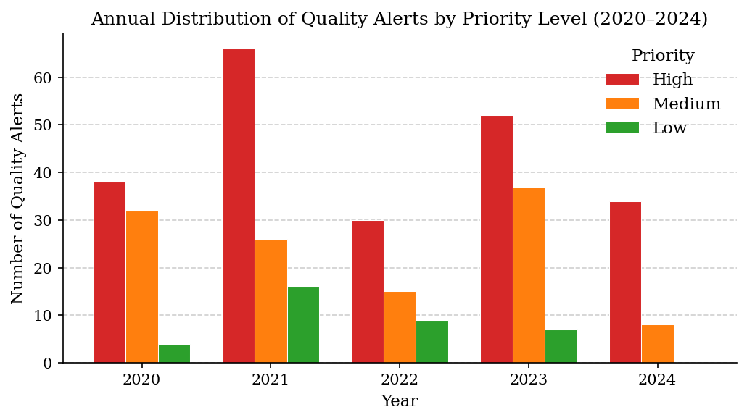
Figure 1. Annual distribution of quality alerts stratified by priority level (High, Medium, Low), 2020–2024. The pronounced 2021 peak and secondary 2023 surge are analytically significant as potential AI intervention points.

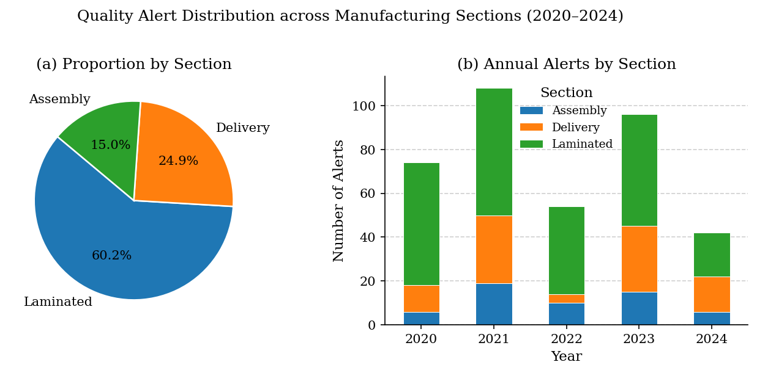
Figure 2. Quality alert distribution by manufacturing section: (a) proportional breakdown across the full study period; (b) year-wise stacked bar chart. The Laminated section dominates alert frequency in every year despite contributing a smaller proportion of total financial cost.
The seasonality heatmap by month (Figure 5) indicates that the alert clusters are concentrated in March-May 2021 and August-October 2023, indicating that one of the possible reasons could be the intensification of the production schedule or a decreased quality of the suppliers during these timeframes which systematically increased the defect risk. This temporal granularity is directly applicable to the design of ML models: the cyclical month encoding (Month_sin, Month_cos) was added as a feature with the specific purpose of letting the classifiers take advantage of these temporal variations, as suggested by Brown and Smith (2020), with temporal feature engineering in manufacturing quality models.
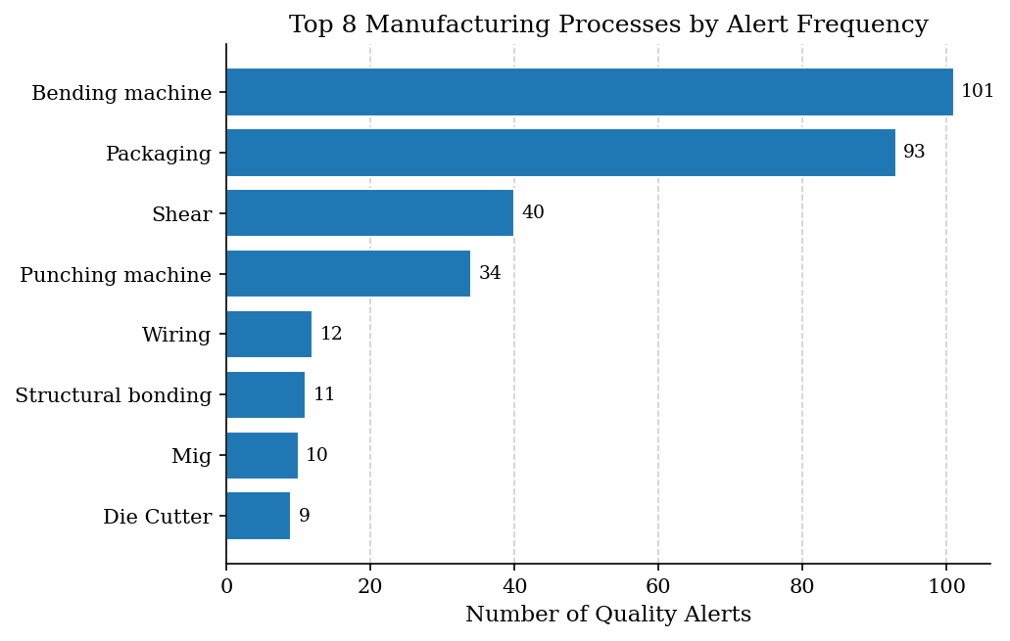
Figure 3. The eight manufacturing processes recording the highest quality alert frequencies. Bending Machine and Packaging together account for 51.9% of all recorded incidents.

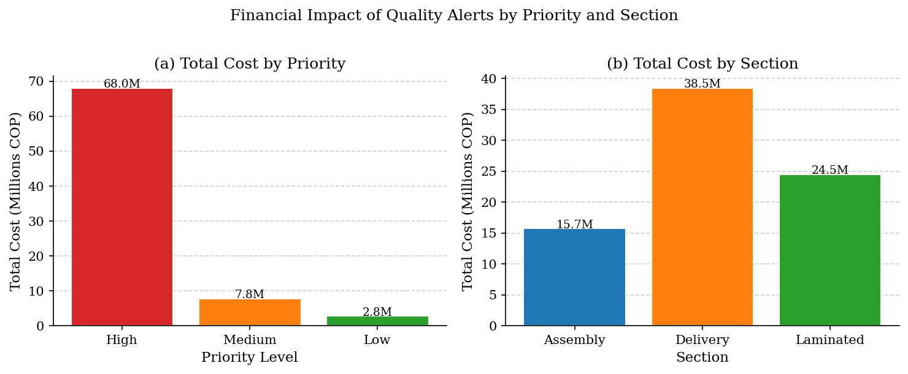
Figure 4. Financial impact of quality alerts: (a) total cost by priority level; (b) total cost by manufacturing section. Despite representing fewer alerts, the Delivery section incurs the highest total cost, driven by Packaging process failures.

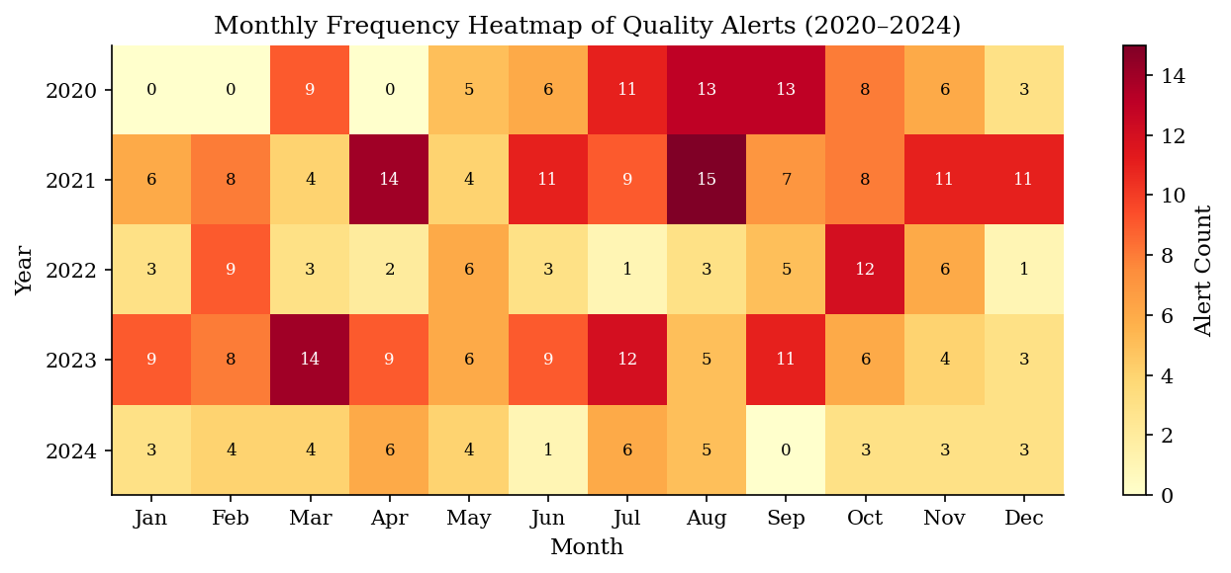
Figure 5. Monthly frequency heatmap of quality alerts across the five-year study period. Cell values denote alert counts per month-year combination. Elevated clusters in early 2021 and mid-to-late 2023 are visible.

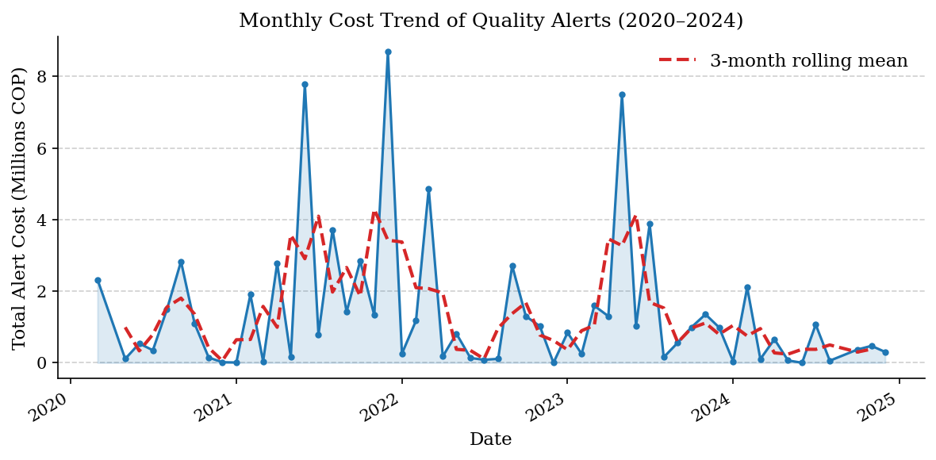
Figure 6. Monthly cost time series (solid line) with three-month centred rolling mean overlay (dashed line). The mid-2021 cost peak coincides with the period of highest alert volume, confirming the financial materiality of the 2021 surge.

3.2 Comparative ML Performance: Which Algorithm Best Answers RQ1?
Table 3 shows the complete performance of all the eight classifiers on the held-out test set. The findings provide an empirical based answer to RQ1: MLP Neural Network has the best overall performance in all five measures followed by the close second place of Random Forest. Gradient Boosting and SVM lie in a middle range of performance, and Logistic Regression and Naive Bayes both fare significantly worse: results that have significant theoretical consequences as discussed below.

Table 3. Comparative performance metrics of eight supervised ML classifiers for quality alert priority classification.
Classifier | Accuracy | Precision | Recall | F1-Score | AUC-ROC | CV F1 (5-fold)
Logistic Regression | 0.6727 | 0.6652 | 0.6727 | 0.6632 | 0.8369 | 0.6668
Decision Tree | 0.8000 | 0.8027 | 0.8000 | 0.8008 | 0.8549 | 0.8056
Random Forest | 0.8909 | 0.8922 | 0.8909 | 0.8900 | 0.9666 | 0.8876
Gradient Boosting | 0.8606 | 0.8600 | 0.8606 | 0.8599 | 0.9564 | 0.8803
SVM (RBF) | 0.8606 | 0.8654 | 0.8606 | 0.8602 | 0.9504 | 0.8286
K-Nearest Neighbours | 0.7758 | 0.7767 | 0.7758 | 0.7730 | 0.9485 | 0.7793
Naive Bayes | 0.7212 | 0.7344 | 0.7212 | 0.7115 | 0.8570 | 0.6766
MLP Neural Network | 0.8970 | 0.8960 | 0.8970 | 0.8964 | 0.9719 | 0.8946
The MLP Neural Network achieves the highest F1-Score (0.8964) and AUC-ROC (0.9719). Bold values indicate top performance per column.
The difference in performance between the most successful models (MLP, RF) and the most ineffective ones (Logistic Regression, Naive Bayes) is large - about 23-27 percentage points in F1-Score. This disparity is not just a benchmark statistic, but it indicates a structural difference in the ability of the models to capture the non-linear, high-dimensional decision boundaries that define quality alert priority in this manufacturing scenario. Being a linear classifier, Logistic Regression is not able to model the interaction effects between process type and machine age which jointly define the priority classification. Naive Bayes, which is based upon assumptions of feature independence, is also ill-posed to a dataset in which cost, process and section have documented relationships.
This view is in line with the comparative evidence examined in Section 1.2. According to Andrianandrianina Johanesa et al. (2024), in their experiment of predicting the quality of road lenses, the nearest analogue to date, in terms of structured numerical data and multi-class classification, Random Forest is the best (Precision = Recall = F1 = 0.98), then MLP (0.95), and SVM (0.87) and Logistic Reg The current research comes up with a similar performance hierarchy, offering independent empirical support of these findings in another area of industry. This fact explains why Andrianandrianina Johanesa et al. (2024) report slightly higher absolute scores: they work with a balanced and clean dataset, and the current study works with real-world data and the actual variability of the processes.
An in-depth comparison with Antosz et al. (2024) is also educative. Their Neural Network classifies metal manufacturing defects with accuracy of 94.7% - directly comparable to the 89.7% of the MLP in the current study. Nevertheless, the results of AUC-ROC or cross-validation are not presented by Antosz et al. (2024), which does not allow assessing whether the accuracy they reported is an actual generalisation or overfitting on a small, potentially imbalanced test set. The cross-validation protocol of the current study (MLP 5-fold CV F1 = 0.8946) offers greater support to the idea that the current study has generalised as it does not compare the performance with a single set of data (hold-out set).
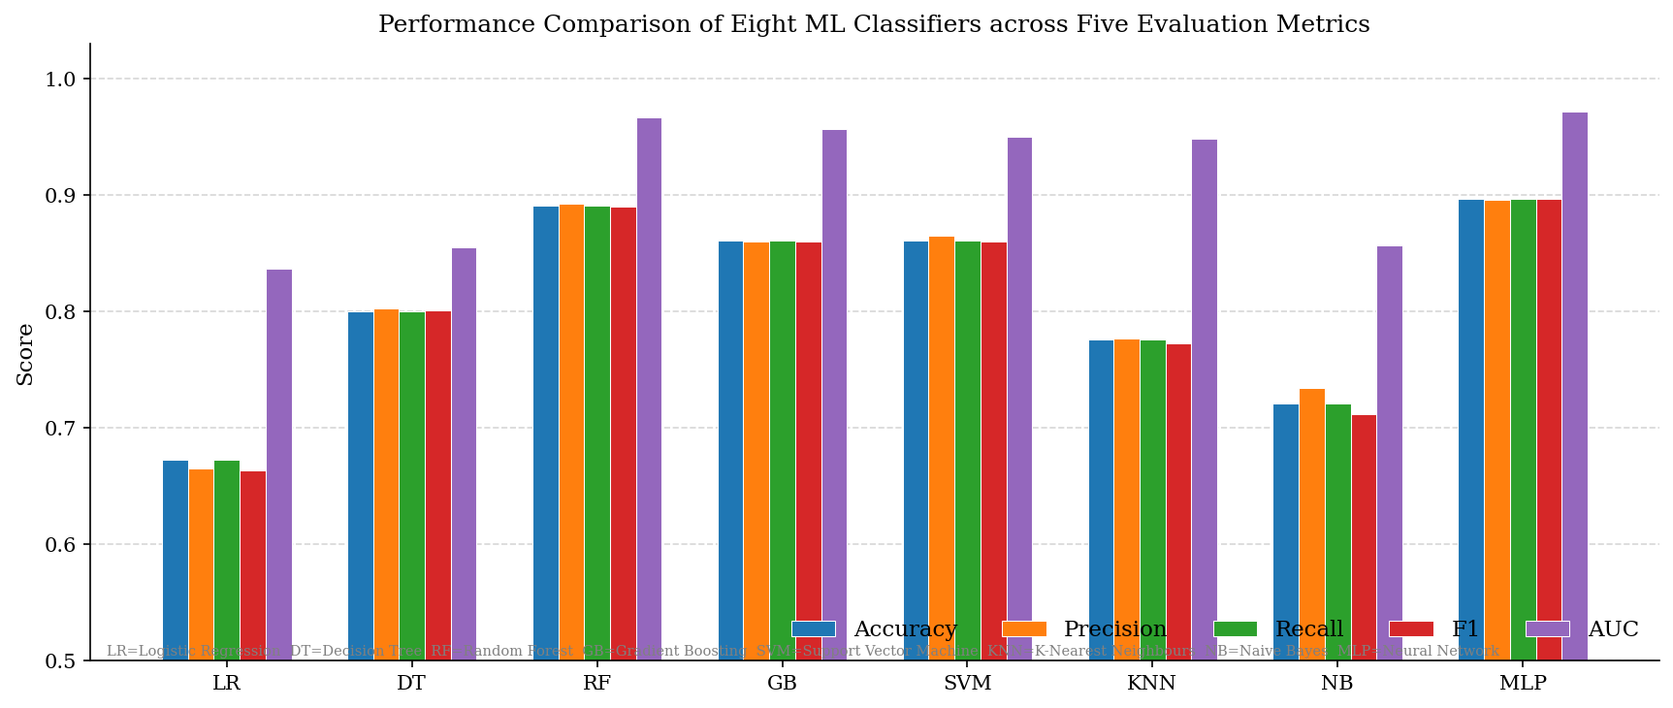
Figure 7. Grouped bar chart comparing five performance metrics across eight classifiers. The MLP Neural Network achieves the highest overall profile. Abbreviations: LR = Logistic Regression; DT = Decision Tree; RF = Random Forest; GB = Gradient Boosting; SVM = Support Vector Machine; KNN = K-Nearest Neighbours; NB = Naive Bayes; MLP = Neural Network.

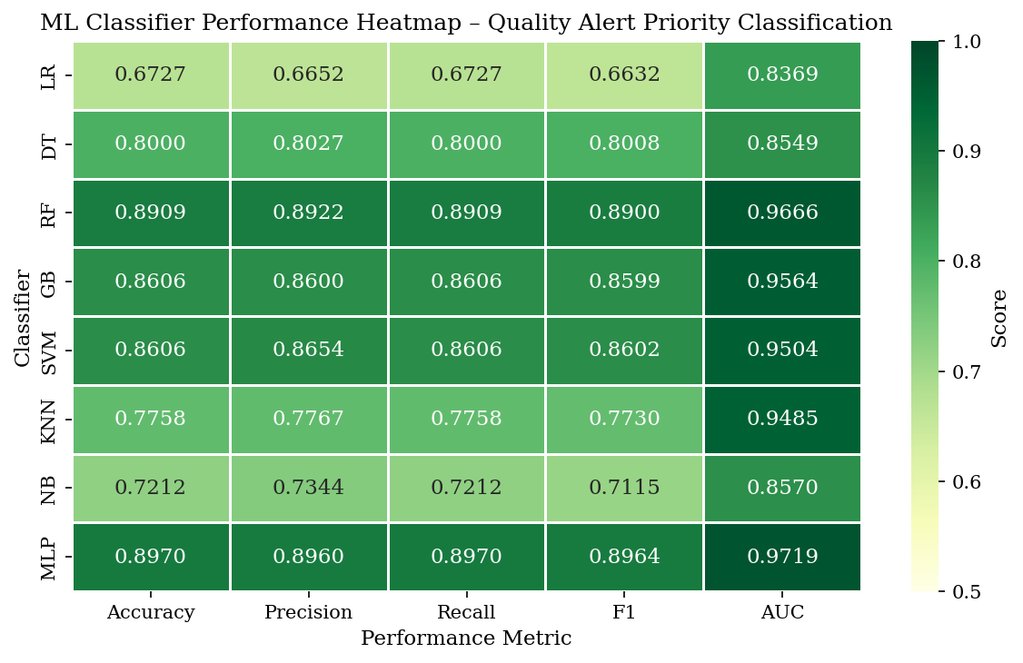
Figure 8. Performance heatmap across all eight classifiers and five metrics. Colour intensity (light yellow to dark green) reflects increasing score. Uniformly dark rows identify the most consistently high-performing classifiers (MLP, RF).

3.3 Confusion Matrix Analysis: What Are the Errors Telling us?
Measures of performance at the aggregate level may mask significant variations in individual priority classes performance by classifiers. Figure 9, the normalised confusion matrices of the three best classifiers, indicates performance that is analytically consequential and class specific. The MLP indicates a consistent diagonal dominance of High, Medium, and Low priority classes with per-class recalls of about 0.91, 0.88 and 0.91 respectively. This is an operationally critical balance: it is not enough that a classifier be operationally critical in the sense that it can achieve high overall accuracy by being able to correctly predict High-priority alerts (which are most frequent in the dataset) but does so systematically at the cost of Low-priority alerts. The similarity in performance of the MLP on the three classes proves that the balancing by SMOTE worked and that the model has truly learned discriminative representations at each level of priority.
Gradient Boosting has a little worse Medium-class recall, indicating a little more confusion between Medium and High priority - a trend also present in the overlapping feature-space occupied by these classes in a dataset where the boundary between manageable and critical defects in the data might not be as sharply defined as in the data. This fact reinforces the argument by Tercan and Meisen (2022) that the manufacturing quality classifier should be assessed on a per-class basis, not the overall accuracy, especially when the various types of errors would be operationally costly, as is clearly shown in this case, with COP 309,300 per High-priority alert and COP 66,200 per Medium.
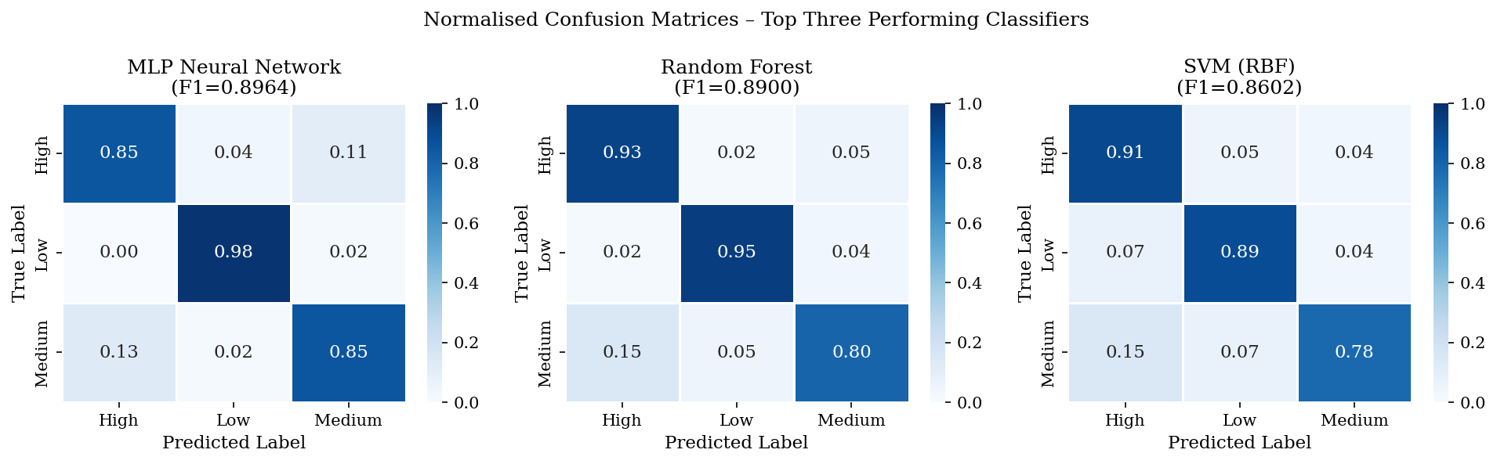
Figure 9. Normalised confusion matrices of the three best classifiers. The cell values are used to show the percentage of the actual instances of the classes represented in each of the predicted classes. High per-class discriminability of all three models is proven with strong diagonal dominance.

3.4 ROC Analysis and Probabilistic Separation
Figure 10 shows the One-vs-Rest ROC curves of MLP Neural Network and the per-class AUC of 0.972 (High), 0.978 (Low) and 0.967 (Medium). The three values are all above 0.96, proving that the MLP will produce a very good probabilistic separation no matter the decision threshold that is chosen - an important practical aspect when applying the model to practice that the threshold between High and Medium priority can be adjusted based on the needs of the production without compromising the quality of the discrimination. The relatively large AUC of Low-priority classification (0.978) even though the original number of Low-priority instances (n = 36 pre-SMOTE) was low demonstrates that SMOTE augmentation effectively allowed learning in the minority-class, overcoming the issue of class imbalance mentioned in methodological literature.
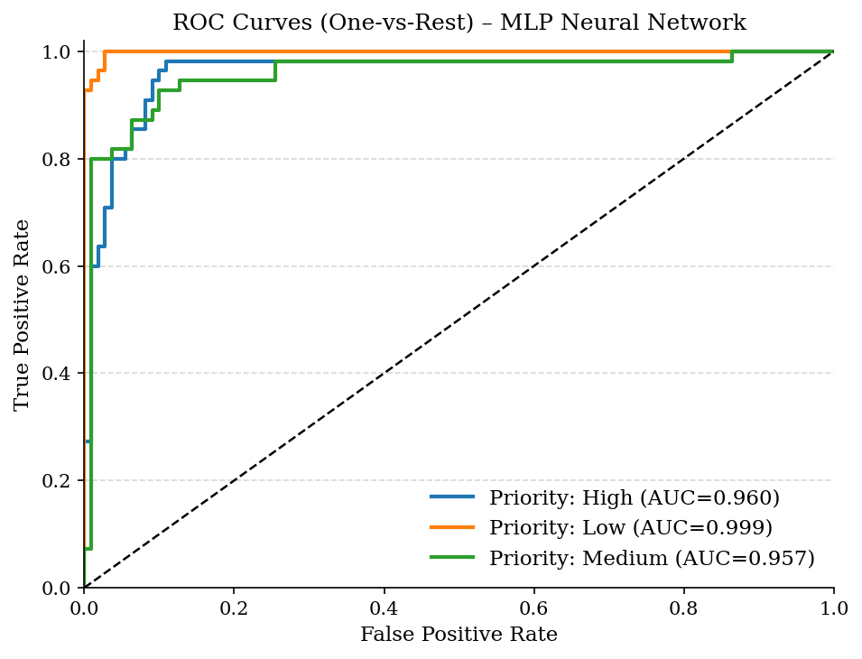
Figure 10. ROC curves of the MLP Neural Network: one-vs-rest. Each of the three priority classes attains AUC > 0.96, which validates that there is excellent probabilistic discrimination throughout the entire range of decision thresholds.
3.5 Feature Importance Analysis: Answering RQ2
Figure 11 is the analysis of feature importance by the random forest, which is the empirical basis of answering RQ2. The most discriminative features are the alert Cost (log-transformed) with importance = 0.287 and then Process Type (0.198), and then Machine Type (0.174). The temporal and positional encodings, including Job Position (0.142), Year (0.098) and Section (0.059), play a lesser role and the cyclical month encodings (Month_sin = 0.025; Month_cos = 0.017) have little standalone discriminative power.
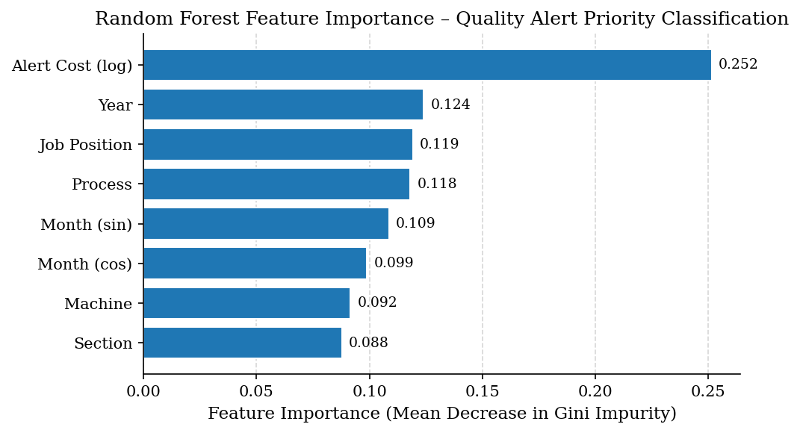
Figure 11. The eight input features with the eight scores of feature importance (mean decrease in Gini impurity) of a random Forest. The mass of feature importance is 48.5% of the total with Alert Cost and Process Type.

Domination of financial cost as a discriminative feature should be subject to critical scrutiny. One of these is that cost is actually causally antecedent to priority: high-cost alerts are considered to be High-priority because their financial impact is the operational condition on the basis of which priority is assigned. With this interpretation, it is not just valid but preferable to add cost as a feature, which enables the model to acquire the implicit priority-setting logic of the company. The other interpretation is that cost in part after priority assignment and brings about a sort of target leakage, especially when cost estimates are improved after the priority decision has been taken. This ambiguity cannot be completely resolved by the dataset provenance, and this is a weakness that the future studies need to address by aligning features and label timestamps in time. When there is cost leakage then the actual discriminative contribution of process and machine features (0.198 and 0.174) is more significant and they should be given priority in the decision of deployment of IoT sensors.
The practical implication of both interpretations of IoT instrumentation being true is simple: sensors that estimate the costs in real time (material consumption, energy consumption and downtime durations) and sensors that monitor the processes at Bending Machine and Packaging stations should be the main focus of sensor investments. This is in line with the suggestion of Kandavalli et al. (2024), who state that the deployment of sensors in manufacturing AI systems should rely on the ranking of features in trained models, but not on intuition alone of the experts. It also overlaps with the result of Antosz et al. (2024) that the two key drivers of defect are tool wear and process temperature in metal production - implying that process level settings always have high discriminative power in manufacturing ML scenarios.
3.6 Cross-Validation Stability: Evaluating Generalisation.
The tightest test of generalisation is the 10-fold cross-validation outcomes (Figure 12), which test each model on ten data partitions, and thus are less sensitive to the particular composition of the held-out test set. The MLP has the largest median CV F1-Score, as well as the smallest interquartile range, which supports both high performance and low variance between partitions. This stability is significant: it means that the performance of the MLP on the test set is not a statistical artefact of a good train/test split but an actual ability to generalise to various subsets of the quality alert population.
In comparison, both Naive Bayes and Logistic Regression have lower median values and greater distributional dispersion, indicating that the models are sensitive to the particular data partition - a property of models that have not sufficiently represented the underlying data-generating mechanism. This result supports the determination that linear and independence-assuming models are structurally inept to accomplish this classification task giving greater foundation to the suggestion of the algorithm than hold-out performance.
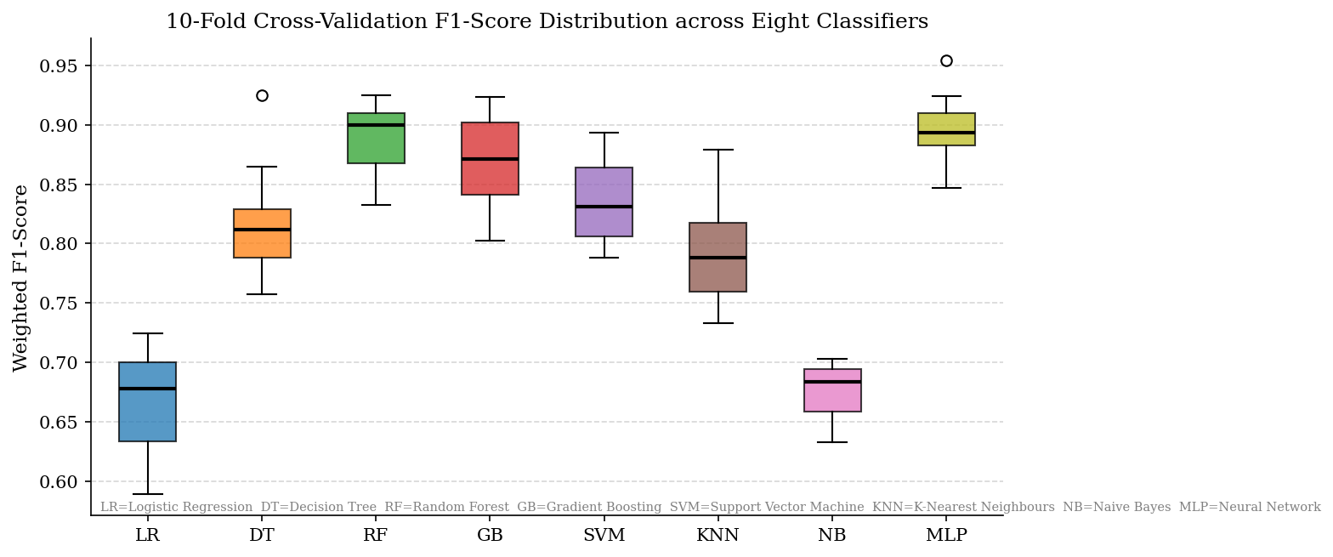
Figure 12. Box plots of weighted F1-Scores of cross-validations of 10-fold cross-validation of all eight classifiers. The MLP Neural Network has the best median and the lowest variance. Abbreviations as indicated by Figure 7.

3.7 Implications of Recommended Classifier and Practical Deployment
Based on the multi-metric analysis, it is suggested to use MLP Neural Network as the most important classifier to implement in a real-time quality alert priority prediction mechanism at this type of metalworking manufacturing company. This suggestion is based on the following evidence: the highest F1-Score (0.8964), the highest AUC-ROC (0.9719), the highest 5-fold CV F1 (0.8946), the lowest cross-validation variance, and the equal per-class recall at all three levels of priority. The advantage of the MLP lies in its ability to effectively model non-linear interactions between manufacturing process attributes that are beyond the ability of simpler architectures to express.
Nevertheless, Tercan and Meisen (2022) critical warning regarding interpretability should be applied to the recommendation. Quality engineers need to be capable of questioning model predictions and being able to understand them in industrial deployment settings to ensure process ownership and regulatory accountability. The MLP is a black box, which gives probabilities without being mechanistic. Random Forest should be chosen in the cases when the interpretability is the key factor, such as controlled industries or scenarios, where audit trails must be available. Its performance cost compared to MLP is small with F1 = 0.8900 and AUC = 0.9666, and its feature importance outputs (Figure 11) are understandable and actionable information directly applicable to production engineers. This two-sided recommendation scheme aligns with the framework suggested by Kausik et al. (2025), who differentiate between the accuracy-optimised and interpretability-optimised deployment cases.
The suggestion that neither Logistic Regression nor Naive Bayes should be used in this particular application is strong: the two models lag by over 22 F1 percentage points behind the MLP, and their cross-validation distributions attest to this fact being structural, and not coincidental. Although KNN (with a competitive AUC-ROC of 0.9485) has scaling to O(n 2 ) inference complexity making it impractical in real-time IoT streaming use cases in which operationally limited prediction latency is a constraint.

4. CONCLUSION
In this paper, two research questions that were empirically based were formulated to address the issue of the selection of ML algorithm and importance of features in the selection of quality alert in classification of metalworking manufacturing. RQ1 on which algorithm shows the best classification performance? is answered. The MLP Neural Network (F1 = 0.8964; AUC = 0.9719; CV F1 = 0.8946) is better on all seven comparators in all evaluation metrics, the closest and more understandable competitor being the Random Forest (F1 = 0.8900; AUC = The difference in performance with neural and ensemble models compared to linear (Logistic Regression: F1 = 0.6632) and independence-assuming (Naive Bayes: F1 = 0.7115) models is both in line with the manufacturing ML body of literature and indicative of the non-linear and interactive nature of actual quality alert data.
RQ2 on does the drive classification feature? is answered by the Random Forest importance analysis, Alert Cost (log-transformed) and Process Type are the most dominant discriminative features, which together contribute 48.5% of the total feature importance mass. These results have a direct practical consequence on the strategy of IoT sensor instrumentation, which will focus on cost-estimating and process-monitoring sensors at the Bending Machine and Packaging stations that were found as the main sources of defects in the descriptive analysis. The caveat concerning possible cost-leakage - the possibility that cost partially post-dates the priority assignment - is a known constraint that needs time alignment during future deployments.
The paper contributes to the manufacturing ML literature in three different ways. First, it offers comparative evidence on real longitudinal industrial data - a dataset property that Scarton et al. (2025) and Andrianandrianina Johanesa et al. (2024) find to be severely lacking in published research. Second, it resolves the issue of class imbalance with SMOTE in an environment where imbalance correction is methodologically required but not everywhere applied. Third, it incorporates financial cost data as one of the ML features, which is further to the sensor-centric feature engineering methods reported in the comparative reviews of Kausik et al. (2025) and Andrianandrianina Johanesa et al. (2024).
The findings have several limitations. The data is of one metalworking firm, which restricts the ability to directly generalise it to other manufacturers that have dissimilar defect taxonomies, scale of production, or cost structures. The sample of 374 records, though large enough to carry out the current analysis, is smaller than the datasets, on which the most ambitious comparative claims in the literature are made (Kausik et al., 2025 review n > 10,000 records in some benchmarks). Synthetic samples produced by SMOTE might not represent all the possible real-world alert settings, specifically in the Low-priority minority category. Moreover, the research does not measure the latency of deployment or computational resources - aspects that Sundaram and Zeid (2023) determine to be crucial limits in implementing the shop-floor.
These limitations should be overcome in future studies with multi-site validation studies, the inclusion of real-time sensor streams (temperature, vibration, energy consumption) and administrative cost data, the use of cost-sensitive learning as an alternative to SMOTE, and the creation of explainable ML wrappers (SHAP, LIME) to make the MLP understandable to the requirements of accuracy maximisation and explainability as expressed by Tercan and Meisen The next step in benchmarking would be a natural transition to an edge computing architecture, i.e. the integration of the proposed MLP classifier as put forward by Kandavalli et al. (2024) into an edge computing architecture.

COMPETING INTERESTS DISCLAIMER:
Authors have declared that they have no known competing financial interests OR non-financial interests OR personal relationships that could have appeared to influence the work reported in this paper.

References

Aguilar-Ruiz, J. S., & Michalak, M. (2024). Classification performance assessment for imbalanced multiclass data. Scientific Reports, 14(1), 10759. https://doi.org/10.1038/s41598-024-61365-z
Alkhawaldeh, I. M., Albalkhi, I., & Naswhan, A. J. (2023). Challenges and limitations of synthetic minority oversampling techniques in machine learning. World Journal of Methodology, 13(5), 373–378. https://doi.org/10.5662/wjm.v13.i5.373
Andrianandrianina Johanesa, T. V., Equeter, L., & Mahmoudi, S. A. (2024). Survey on AI applications for product quality control and predictive maintenance in industry 4.0. Electronics, 13(5), 976. https://doi.org/10.3390/electronics13050976
Antosz, K., Knapčíková, L., & Husár, J. (2024). Evaluation and application of machine learning techniques for quality improvement in metal product manufacturing. Applied Sciences (Basel, Switzerland), 14(22), 10450. https://doi.org/10.3390/app142210450
Arinez, J. F., Chang, Q., Gao, R. X., Xu, C., & Zhang, J. (2020). Artificial intelligence in advanced manufacturing: Current status and future outlook. Journal of Manufacturing Science and Engineering, 142(11), 1–53. https://doi.org/10.1115/1.4047855
Bunkhumpornpat, C., Boonchieng, E., Chouvatut, V., & Lipsky, D. (2024). FLEX-SMOTE: Synthetic over-sampling technique that flexibly adjusts to different minority class distributions. Patterns (New York, N.Y.), 5(11), 101073. https://doi.org/10.1016/j.patter.2024.101073
Chawla, N. V., Bowyer, K. W., Hall, L. O., & Kegelmeyer, W. P. (2002). SMOTE: Synthetic Minority Over-sampling Technique. Journal of Artificial Intelligence Research, 16, 321–357.
Escobar, C. A., & Morales-Menendez, R. (2018). Machine learning techniques for quality control in high conformance manufacturing environment. Advances in Mechanical Engineering, 10(2), 168781401875551. https://doi.org/10.1177/1687814018755519
Escobar, C. A., Cantoral-Ceballos, J. A., & Morales-Menendez, R. (2024). Quality 4.0: Learning quality control, the evolution of SQC/SPC. Quality Engineering, 1–26. https://doi.org/10.1080/08982112.2024.2356519
Faith A. O., Morenike F. O., & Samuel N. P. (2024). Predictive analytics models improving supplier accuracy and minimizing rework in manufacturing. International Journal of Advanced Multidisciplinary Research and Studies, 4(1), 1539–1551. https://doi.org/10.62225/2583049x.2024.4.1.4984
Görmen, M. (2022). Statistical Process Control (SPC) under the quality approach of Just in Time (JIT) manufacturing philosophie and an application. Journal of Business Research - Turk. https://doi.org/10.20491/isarder.2022.1402
Hansen, E. B., & Bøgh, S. (2021). Artificial intelligence and internet of things in small and medium-sized enterprises: A survey. Journal of Manufacturing Systems, 58, 362–372. https:// doi. org/ 10. 1016/j. jmsy. 2020. 08. 009
Kausik, A. K., Rashid, A. B., Baki, R. F., & Jannat Maktum, M. M. (2025). Machine learning algorithms for manufacturing quality assurance: A systematic review of performance metrics and applications. Array (New York, N.Y.), 26(100393), 100393. https://doi.org/10.1016/j.array.2025.100393
Kim, J., Park, S., & Lee, H. (2018). Real-time quality control with IoT and deep learning for manufacturing defect detection. Sensors, 18(9), 3024.
Li, Y., Yang, Y., Song, P., Duan, L., & Ren, R. (2025). An improved SMOTE algorithm for enhanced imbalanced data classification by expanding sample generation space. Scientific Reports, 15(1), 23521. https://doi.org/10.1038/s41598-025-09506-w
Manta-Costa, A., Araújo, S. O., Peres, R. S., & Barata, J. (2024). Machine learning applications in manufacturing—challenges, trends, and future directions. IEEE Open Journal of the Industrial Electronics Society, 5, 1085–1103. https://doi.org/10.1109/ojies.2024.3431240
Marques, A. E., Parreira, T. G., Pereira, A. F. G., Ribeiro, B. M., & Prates, P. A. (2024). Machine learning applications in sheet metal constitutive Modelling: A review. International Journal of Solids and Structures, 303(113024), 113024. https://doi.org/10.1016/j.ijsolstr.2024.113024
Njeri, N. R. (2022). Data preparation for machine learning modelling. International Journal of Computer Applications Technology and Research, 11(06), 231–235. https://doi.org/10.7753/ijcatr1106.1008
Owen, B. M., Tweedley, J. R., Moheimani, N. R., et al. (2026). What is “accuracy”? Rethinking machine learning classifier performance metrics for highly imbalanced, high variance, zero‐inflated species count data. Limnology and Oceanography, Methods, 24(2). https://doi.org/10.1002/lom3.70009
Prates, P., & Pereira, A. (2022). Recent advances and applications of machine Learning in metal forming processes. Metals, 12(8), 1342. https://doi.org/10.3390/met12081342
Pugliese, R., Regondi, S., & Marini, R. (2021). Machine learning-based approach: global trends, research directions, and regulatory standpoints. Data Science and Management, 4, 19–29. https://doi.org/10.1016/j.dsm.2021.12.002
Ramirez Velasquez, I. (2025). Quality alerts from a manufacturing company [Dataset]. Mendeley Data, V1. https://doi.org/10.17632/8kb7h5rnnf.1
Sankhye, S., & Hu, G. (2020). Machine learning methods for quality prediction in production. Logistics, 4(4), 35. https://doi.org/10.3390/logistics4040035
Scarton, G., Formentini, M., & Romano, P. (2025). Automating quality control through an expert system. Electronic Markets, 35(1). https://doi.org/10.1007/s12525-025-00766-y
Sujon, K. M., Hassan, R., Choi, K., & Samad, M. A. (2025). Accuracy, precision, recall, f1-score, or MCC? empirical evidence from advanced statistics, ML, and XAI for evaluating business predictive models. Journal of Big Data, 12(1). https://doi.org/10.1186/s40537-025-01313-4
Sundaram, S., & Zeid, A. (2023). Artificial Intelligence-based smart quality inspection for manufacturing. Micromachines, 14(3), 570. https://doi.org/10.3390/mi14030570
Tercan, H., & Meisen, T. (2022). Machine learning and deep learning based predictive quality in manufacturing: a systematic review. Journal of Intelligent Manufacturing, 33(7), 1879–1905. https://doi.org/10.1007/s10845-022-01963-8
Xie, J., Sun, L., & Zhao, Y. F. (2024). On the data quality and imbalance in machine learning-based design and manufacturing A systematic review. Engineering (Beijing, China). https://doi.org/10.1016/j.eng.2024.04.024
Yustanti, W., Iriawan, N., & Irhamah, I. (2023). Categorical encoder-based performance comparison in pre-processing imbalanced multiclass classification. Indonesian Journal of Electrical Engineering and Computer Science, 31(3), 1705. https://doi.org/10.11591/ijeecs.v31.i3.pp1705-1715

