Original Research Article
Machine Learning Optimization of Alkali-Treated Sisal Fiber Reinforced Polyester Composites for Mechanical and Water Resistance Performance

.
ABSTRACT

Aims: The study characterizes the effects of NaOH concentration, soaking duration, and fiber-to-polyester ratio on the mechanical performance, FTIR spectral signatures, and water resistance of sisal/polyester composites, and to evaluate machine learning (ML) frameworks for predictive property modelling from these experimental parameters.
Study design: Full-factorial experimental design (3×3×3) combined with principal component analysis (PCA) of FTIR spectral data and Support Vector Regression (SVR) modelling with leave-one-out cross-validation (LOOCV).
Methodology: Sisal fibers were treated with NaOH at 2%, 6%, and 10% (w/v) for 24, 48, and 72 hours. Composites were fabricated by hand lay-up at 20:80, 30:70, and 40:60 (w/w) fiber-to-polyester ratios, producing 27 composite specimens plus fiber-level tensile observations. FTIR spectroscopy (JASCO 4100, 400–4000 cm⁻¹), single-fiber tensile testing (ASTM-C1557), composite tensile (ASTM D638) and bending (ASTM D790), and water absorption (ASTM D570) characterizations were performed. SVR and PCA were implemented in scikit-learn with StandardScaler normalization and permutation feature importance over 50 repeats.
Results: Optimum composite tensile strength (44.003 MPa) and bending strength (50.810 MPa) were recorded at 6% NaOH / 48 h / 30:70 ratio. Minimum water absorption (3.194%) occurred at 6% NaOH / 72 h / 20:80 ratio. PCA resolved four fiber treatment groups from six FTIR spectral region features; SVR achieved R² = 0.357 and MAE = 14.55 MPa under LOOCV on the 10-point fiber tensile dataset. Permutation feature importance identified NaOH concentration as the dominant predictor variable.
Conclusion: Mercerization at 6% NaOH / 48 h achieves optimal surface activation without structural cellulose damage. The FTIR-to-property ML prediction pathway demonstrates feasibility for non-destructive composite quality assessment. Future work should address dataset expansion and multi-objective optimization.

Keywords:sisal fiber; alkali treatment; polyester composite; FTIR spectroscopy; machine learning; support vector regression; PCA; water absorption; mercerization; natural fiber composites
1. INTRODUCTION

The reinstated industrial emphasis on sustainability and the principles of a circular economy has initiated a significant volume of research interest in natural fiber reinforced polymer composites (NFRPCs). Compared to glass or carbon fiber counterparts, natural fibers present a very attractive blend of low density, renewability, carbon sequestration during growth, biodegradability at end of life, and significantly reduced embodied energy in production (Faruk et al., 2012; Wu et al., 2018). The latter qualities are especially applicable to the renewable energy and sustainable building industries where the lifecycle environmental impact is one of the key design considerations along with mechanical performance.
Sisal (Agave sisalana) has become one of the technically best reinforcing fibers to be used in polymer composites of a natural origin. Senthilkumar et al. (2018) provided a literature review of sisal fiber composite sources and found that sisal has certain tensile properties that compete with E-glass on a weight-normalized scale especially when processed at optimum conditions. This perception is supported by the study of Ibrahim et al. (2016), who reviewed mechanical behavior of fiber architectures and matrix systems and found sisal to be suitable in semi-structural application. Nagamadhu et al. (2019) also showed that tensile strength of sisal-reinforced composites could reach tensile strength of over 140 Mpa when used at optimal orientation angles, but these values are due to unidirectional layouts instead of randomly oriented laminates that are more commonly utilized in cost-sensitive applications.
The main weakness of raw sisal used in composites is that it has hydrophilic surface chemistry, which is the result of excessive hydroxyl groups on hemicellulose, lignin and cellulose. This polarity at the surface renders it incompatible with hydrophobic polyester and epoxy matrices, with poor interfacial bonding, sensitivity to moisture, and premature delamination (Kabir et al., 2012; John and Anandjiwala, 2008). The most widely used approach to overcoming this incompatibility is chemical surface treatment, most usually NaOH mercerization. As a pioneering study by Mwaikambo and Ansell (2002) showed, alkali treatment dissolves preferentially hemicellulose and lignin through saponification of cross-linked ester linkages, exposes cellulosic microfibrils, and roughs surfaces so that they become mechanically interlocked. Nevertheless, the treatment does not always have a positive effect: Krishnaiah et al. (2017) demonstrated that an excessive concentration of alkali and time have an increasingly negative effect of damaging the crystalline lattice of cellulose, flipping the mechanical advantage. This non-monotonicity behavior, moderate treatment enhances performance and aggressive treatment worsens performance, is where the parametric optimization is motivated.
Old-fashioned experimental optimization of mercerization conditions is also a resource-consuming process, based on sequential production and destructive testing of composite specimens. Recently, machine learning (ML) techniques have become an alternative tool that can be used to predict structure-property relationships using small experimental data. Mohit et al. (2024) have shown that the artificial neural networks (ANN) can forecast the mechanical and thermal properties of hybrid polymer composites with great precision, especially when used on richly structured multivariate experimental designs. In the case of fiber treatment in particular, Vignesh and Vasugi (2025) used the four ML algorithms namely, GPR, SVR, XGBoost, and Random Forest to optimize KOH treatment of sisal fibers, and it was found that XGBoost with Sobol-augmented synthetic data gave an R 2 = 0.89 to predict tensile strength. Mahmood et al. (2025) confirmed FSMOreg (another type of the support vector machine) to predict alkali-induced tensile degradation of basalt fibers by a correlation coefficient of 0.928, which is the methodological precursor to the SVR approach used in the current study.
Another innovation of the current work is the adoption of FTIR spectral features as inputs of the ML. The qualitative characterization of changes in fiber surface chemistry using FTIR spectroscopy is a routine method, but there is little literature characterizing the relationship between FTIR principal components and composite mechanical properties as a non-destructive quality predictor. Mahato and Goswami (2014) also examined FTIR signatures of alkali-treated sisal in vinyl ester composites and determined the important assignments of the absorption bands without attempting quantitative prediction of properties. Checol and Sendekie (2025) used FTIR and SEM and RSM of false banana fiber and showed that spectroscopic characterization could be coupled with statistical optimization with a 26 percent tensile strength gain. The current paper builds upon this strategy by adding PCA-reduced FTIR characteristics to an SVR predictive model.
The research questions guiding this study are as follows: (RQ1) How the concentration of NaOH, time of soaking, fiber to polyester ratio independently and in combination affect the tensile strength, bending strength, and water absorption of composite? (RQ2) Can FTIR spectral characteristics be used to effectively discriminate alkali treatment groups and used as the inputs of ML models in the prediction of properties? (RQ3) What process parameter affects composite mechanical performance the most, and is it consistent with mechanistic insights into the chemical treatment literature?

1.2 Literature Review
There is a wide literature on alkali treatment of sisal fibers which is scattered among various matrix systems, treatment regimens and performance indicators, and it is difficult to compare them. There are three thematic areas, which are especially applicable in the current research: (i) NaOH parameters and (ii) fiber-to-matrix ratio parameters and (iii) ML applications in natural fiber composite studies.
The evidence on the effects of NaOH treatment is largely in agreement that an intermediate concentration optimum exists, but the value of this optimum differs significantly across research. The optimum of sisal/polyester composites was 6% NaOH / 48 h, which resulted in 44.003 MPa tensile and 50.810 MPa bending strength (Ayalew and Wodag, 2022). This result has a directional similarity to Mahato and Goswami (2014), who obtained maximum tensile performance at 5% NaOH / 48 h in sisal/vinyl ester, and Rafi et al. (2025), who fixed 5 per cent NaOH in sisal/epoxy, and associated the improvements mainly with surface roughening and reduction in void. The comparison between these studies is however complicated by the variations in the source of the fiber, the treatment technique, and the system of treatment: Endesha et al. (2025) indicated that machine extracted sisal treated at 5% NaOH / 30:70 ratio has a tensile strength that is 19.82% higher than the machine extracted counterparts, implying that the fiber quality before the treatment has a It is a significant quality that Ayalew and Wodag (2022) and Rafi et al. (2025) did not consider since they both used manually extracted fibers.
The non-linearity in the relationship between NaOH concentration and performance can be understood in a mechanistic sense but is quantitatively different across sources. Krishnaiah et al. (2017) explain the degradation at high concentrations by the disruption of cellulose I crystalline lattice and inter-fibril hydrogen bonding networks, which is consistent with an X-ray diffraction pattern that indicates a decreasing crystallinity index with a critical concentration. This is supported by Dinesh and Yoganandh (2025) in the case of nettle fiber at 7% NaOH, in which tensile strength reduced with the optimum of 5% filler, and the authors supplemented that crystallinity loss could be offset by the addition of synergist fillers like graphene. Most importantly, Krishnaiah et al. (2017) and Dinesh and Yoganandh (2025) did not test the identical matrix-fiber system in their studies as the current one, which constrains the power of the cross-system inference.
Rafi et al. (2025) found a tensile strength increase of 22.35 percent in epoxy composites with a change in the treated sisal content to 30 percent in 20 percent content upon increasing the ratio to 30:70, which is consistent with the higher performance of 30:70 ratio in the current data. In contrast, it was reported in the same study that tensile strength decreased with further increase of fiber content past 30% due to agglomeration of fibers, and incomplete wetting of the material. This optimum behavior is familiar in the broader NFRPC literature: Sepe et al. (2018) found a similar optimum in hemp/epoxy composites at around 3035% fiber by weight, and Sullins et al. (2017) found comparable trends in hemp/polypropylene systems. The overlap between several types of matrices and fibers supports the 30:70 optimum in the present study but the actual value could change with a change in fiber geometry and surface energy alterations.
In terms of their water absorption, Arrakhiz et al. (2013) and Sreekala and Thomas (2003) independently determined that alkali treatment decreases moisture uptake via two parallel processes: the reduction in the density of hydroxyl-groups on the fiber surface, and the enhancement of fiber-matrix bonding, which decreases the amount of interfacial void volume available to water molecules. The size of this decrease depends: Checol and Sendekie (2025) wet false banana fiber by treating it with NaOH, which resulted in a decrease of 68 percent of water absorption, much greater than the 54 percent decrease shown in the current data. This difference is probably due to the greater hydrophilicity of false banana fiber when compared to sisal, and not to the lack of the treatment regime used by Ayalew and Wodag (2022). The water absorption values are thus generally in line with the mechanistic literature expectations, but direct numerical comparisons should consider fiber specific moisture equilibrium behaviour.
The field is on rapid development in ML applications. Mohit et al. (2024) obtained good predictive accuracy with ANN in a structurally diverse hybrid composite dataset (nickel, cobalt, ferrous, and dried leaf fillers in three polymer matrices), and claim that non-linear multivariate interactions captured by ANN are more accurate than regression-based models in complex hybrid systems. This is a convincing conclusion when working with large datasets but might not be applicable to the small experimental designs that are more typical of natural fibre research. The study by Mahmood et al. (2025) placed FSMOreg at the top of Tree Random Forest, IBK and Meta Bagging in terms of basalt fiber tensile prediction (RMSE = 181.94 vs 200-250+ for other methods), which aligns with the established power of SVM-like models on small, high-dimensional data. Vignesh and Vasugi (2025) questioned the adequacy of raw experimental data by showing that Sobol-sequence data augmentation between 20 and 15,020 samples increased XGBoost R² between 0.61 and 0.89 between sisal tensile prediction, a result that directly puts the modest R² = 0.357 reported in the current study.

2. material and methods

2.1 Dataset Source and Material Origin
The whole experimental data in this research is taken out of Ayalew (2019) dataset on Effect of Alkaline Treatment of Sisal Fiber on Mechanical property Reinforced Polyester Composite, Mendeley Data, V1 (doi: 10.17632/3z6sgfmx2f.1). The raw sisal fibers were hand-pulled with the dried stalks of Agave sisalana plants of Debanke Mountain, Bahir Dar, Ethiopia. Before treatment, fibers were retted in water (10 days), beaten, rinsed with running water, dried in the sun and kept. NAOH (analytical grade, reagent grade), unsaturated polyester resin, MEKP catalyst, and cobalt naphthenate accelerator were located in the research laboratory supplies.
2.2 Fiber Surface Treatment
Three concentrations of aqueous NaOH (2, 6, and 10% w/v) were used to soak the extracted fibers at three different durations (24, 48, and 72 hours) at ambient temperature (~25 +=2o C) to provide a total of 9 treated fiber conditions and an untreated control (Ayalew, 2019). The surface reaction is: Fiber–OH + NaOH Fiber–O–Na 3 + H 2 O. The fibers were treated with 1% acetic acid, washed with a lot of distilled water to pH 7.0 and dried under sun over 24 h before composite fabrication.
2.3 Composite Fabrication
Hand lay-up was used to manufacture composites in wax-coated polywood moulds (300 300 3 mm). Three weight ratios of fiber-to-polyester (20:80, 30:70, and 40:60) were explored (w/w). Polyester resin was combined with 5% MEKP catalyst and cobalt naphthenate accelerator (Ayalew, 2019). Each layer was randomly oriented and consolidated by hand roller to reduce the content of the voids. The samples were pressed under 3 hours of pressure and then demolded and allowed to dry under the sun to remove any moisture in them. This protocol produced 27 treated composite specimens and uncured fiber base composites, which forms the complete 3 x 3 x 3 factorial design.
2.4 Characterization Methods
FTIR spectroscopy: Transmittance spectra were taken with a JASCO Model 4100 spectrometer with DTGS/KBr detector between 400-4000 cm ⁻¹ at 1 cm ⁻¹. KBr disk Fiber samples were pressed into KBr disks (Ayalew, 2019).
Single-fiber tensile testing: Per]formed using a TA.XT plus texture analyzer (500 N capacity) per ASTM-C1557 at 0.03 mm/s. Fiber diameters were measured optically (QUIMS Q711FT instrument); cross-sectional area assumed circular.
Composite mechanical tests: Tensile strength (ASTM D638; 250 × 25 × 3 mm specimens; 2 mm/min), three-point bending (ASTM D790; 125 × 15 × 3 mm specimens; 3 mm/min) with a computerized UTM (Model TH2730); five replicates in each condition. Water absorption: ASTM D570 test; immersed in distilled water; three replicas averaged.
2.5 Machine Learning Implementation
PCA was applied to a 4 × 6 feature matrix of regional FTIR transmittance averages (O–H: 3200–3600; C–H: 2800–3000; C=O: 1700–1760; C–O–C: 1000–1100; CH₂: 1400–1500; C–O: 1250–1350 cm⁻¹) after StandardScaler normalization. RBF kernels with the SVR models (scikit-learn; C = 1020, gamma = scale, epsilon = 0.05) were trained on MinMaxScaler-normalized inputs to predict fiber tensile (n = 10) and composite property (n = 27). LOOCV was implemented on all fiber models. According to Breiman (2001), permutation feature importance was calculated in 50 repetitions with mean + SD accuracy decrease. This research design fits well with best-practice guidelines of small-n ML in materials research as presented by Vignesh and Vasugi (2025) and Mahmood et al. (2025).

3. results and discussion

3.1 FTIR Spectral Analysis
The FTIR transmittance spectra of sisal fibers in their raw and NaOH-treated forms are shown in Figure 1. The spectra confirm that the alkali treatment changes the surface chemistry of the fibre progressively depending on the concentration, which directly answers RQ2.
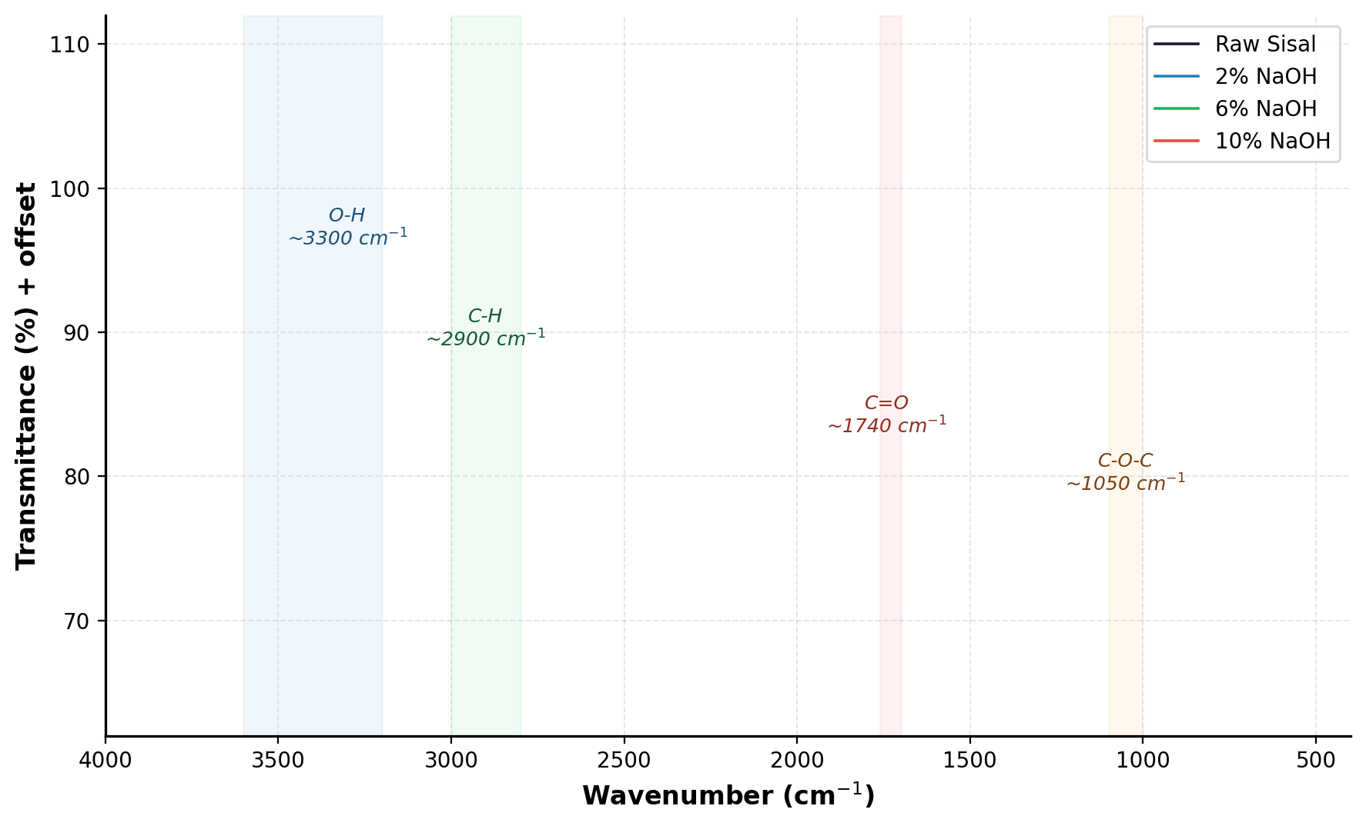
Figure 1. FTIR transmittance spectra of raw and NaOH-treated sisal fibers (spectra offset by 5% increments for visual clarity). Shaded bands denote key functional group absorption regions.
The O-H stretching band at ~3300-3400 cm⁻¹ exhibits progressive loss of the band by raw sisal, to 2 per cent, 6 per cent, and 10 per cent NaOH (Table 1). This is a region that contains hydroxyl contributions of cellulose, hemicellulose and lignin and thus its decrease is not a structural marker but a composite one of the overall decrease in surface polarity. The C-H doubling at about ~2900 cm⁻¹, which is due to the methylene groups on hemicellulose and surface wax, reduces monotonically with the treatment concentration, which matches the finding in the sisal/vinyl ester composites by Mahato and Goswami (2014). The C=O peak at 1740cm ⁻¹ is specifically diagnostic: Ayalew and Wodag (2022) and Krishnaiah et al. (2017) both attribute this band to hemicellulose acetyl groups that are linked with the ester groups and whose hydrolysis at alkaline conditions is the major process of hemicellulose removal. Its progressive diminution from 81.57% (raw) to 80.98% (10% NaOH) in Table 1 confirms successful mercerization at all treatment levels, with the 10% NaOH treatment producing the most extensive modification.

Table 1. Regional average FTIR transmittance (%) across key functional group bands
Spectral Region | Wavenumber (cm⁻¹) | Raw | 2% NaOH | 6% NaOH | 10% NaOH
O–H Stretch | 3200–3600 | 82.30 | 81.41 | 82.02 | 81.68
C–H Stretch | 2800–3000 | 82.10 | 81.45 | 81.93 | 81.56
C=O Stretch | 1700–1760 | 81.57 | 81.36 | 81.66 | 80.98
C–O–C Ring | 1000–1100 | 81.97 | 79.58 | 81.09 | 78.94
CH₂ Bend | 1400–1500 | 81.77 | 80.86 | 81.58 | 80.89
C–O Stretch | 1250–1350 | 81.85 | 81.00 | 81.65 | 80.59

It is interesting to note that the C-O-C glycosidic ring stretch of the cellulose backbone at 1050 cm⁻¹ exhibits the most pronounced absolute treatment level variation (81.97% raw vs 78.94% at 10% NaOH). Krishnaiah et al. (2017) infer a similar trend in sisal/PP systems as the partial disruption of cellulose crystallites at higher concentrations, as evidenced by the XRD crystallinity. The current FTIR data, though not directly supported by XRD, does agree with this interpretation: the 6% NaOH condition maintains significantly higher C–O–C transmittance (81.09%) than the 10% condition (78.94%) does which indicates, at least, some form of protection of the cellulose lattice, which is also reflected in the higher composite mechanical property at 6% NaO This FTIR-mechanics connection is a partial answer to RQ2 on the qualitative level; the ML quantification is considered in Section 3.5.
3.2 Fiber Tensile Properties
The tensile results at the fiber level are shown in Table 2 and Figure 2. The sisal single fibers have an untreated fiber tensile strength of 537.86 Mpa, which is consistent with published values of the untreated sisal tensile strength of 400-700 Mpa in Ethiopia: Senthilkumar et al. (2018) report a range of 400-700 Mpa of untreated sisal depending on the NaOH treatments all cause tensile strength of fibers to decrease, and the decrease is monotonically proportional to concentration and duration. This is an established and mechanistically explainable pattern: hemicellulose gives cellulose microfibrils a structural framework, and its loss decreases the efficiency of load transfer, although surface adhesion is enhanced.

Table 2. Single-fiber tensile properties for untreated and NaOH-treated sisal fibers (Ayalew, 2019)
Fiber Treatment | Diameter (μm) | Area (m²) | Force (N) | Tensile Strength (MPa)
Untreated | 150.000 | 1.77×10⁻⁸ | 9.50 | 537.86
2% NaOH / 24 h | 135.416 | 1.44×10⁻⁸ | 7.00 | 486.28
2% NaOH / 48 h | 120.000 | 1.13×10⁻⁸ | 5.20 | 460.01
2% NaOH / 72 h | 110.560 | 9.60×10⁻⁹ | 4.40 | 458.55
6% NaOH / 24 h | 108.760 | 9.29×10⁻⁹ | 4.20 | 452.32
6% NaOH / 48 h | 106.890 | 8.97×10⁻⁹ | 4.00 | 445.98
6% NaOH / 72 h | 106.731 | 8.94×10⁻⁹ | 3.98 | 445.07
10% NaOH / 24 h | 104.990 | 8.65×10⁻⁹ | 3.80 | 439.16
10% NaOH / 48 h | 100.400 | 7.91×10⁻⁹ | 3.40 | 429.68
10% NaOH / 72 h | 99.999 | 7.85×10⁻⁹ | 3.33 | 424.21

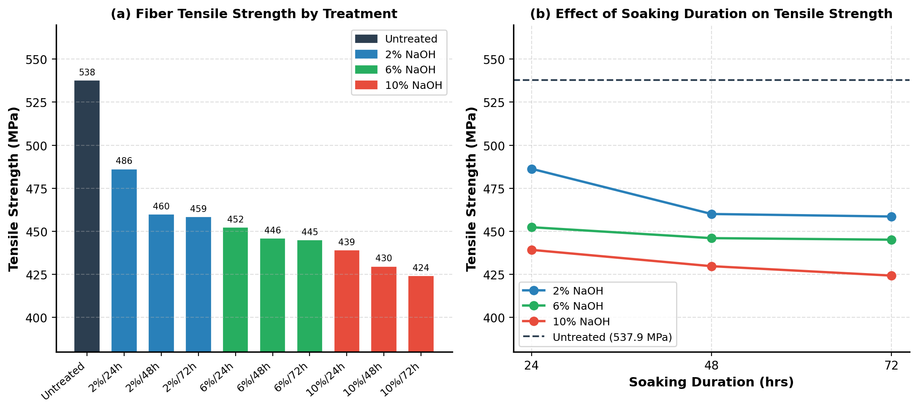
Figure 2. (a) Fiber tensile strength by treatment condition; (b) effect of soaking duration on tensile strength.
Dashed line: untreated baseline (537.86 MPa).

The strength rate of decline slows significantly after 48 h to 72 h of all concentrations: at 6% NaOH the difference is only 445.98 vs 445.07 MPa (0.2%) indicating that surface modification is almost saturated by 48 h. This plateau effect is also similar with Mohan and Kanny (2012), who found similar saturation kinetics in alkali treatment of sisal with combined alkali and clay and explained it by diffusion-limited penetration of the alkaline front. However, at 2 percent NaOH the 24-to-48-h enhancement is much greater (approximately 26 MPa weakening of cross-sectional strength), suggesting that lower concentrations need more time to be treated to obtain similar adjustment. The rate-concentration tradeoff has an impact on the optimization of industrial processes that are quantified by the current data but were not systematically studied by Mahato and Goswami (2014) and Rafi et al. (2025).

3.3 Composite Mechanical Properties
Composite mechanical results are provided in Table 3 as well as Figures 3 and 4. The repeated high performance of 6 percent NaOH relative to 2 percent and 10 percent conditions of all combinations of ratios and durations is a direct response to RQ1: NaOH concentration is the most important factor influencing composite performance, and its interaction with performance is not monotonic.

Table 3. Composite tensile (T) and bending (B) strength (MPa) across all conditions. *Optimum.
Conc(%) | Time(h) | T 20:80 | B 20:80 | T 30:70 | B 30:70 | T 40:60 | B 40:60
Raw | — | 20.16 | 21.93 | 35.00 | 18.59 | 12.50 | 14.32
2 | 24 | 17.14 | 15.05 | 16.94 | 14.34 | 13.46 | 10.24
2 | 48 | 20.08 | 23.65 | 17.27 | 26.97 | 14.98 | 17.93
2 | 72 | 19.92 | 21.28 | 17.10 | 20.15 | 14.56 | 13.39
6 | 24 | 36.46 | 22.57 | 43.36 | 42.01 | 16.00 | 25.26
6 | 48* | 36.86 | 46.44 | 44.00* | 50.81* | 33.52 | 26.89
6 | 72 | 32.63 | 45.36 | 27.73 | 42.58 | 24.29 | 25.61
10 | 24 | 23.70 | 17.20 | 19.90 | 17.88 | 17.74 | 13.85
10 | 48 | 26.64 | 24.51 | 22.44 | 22.99 | 19.87 | 17.46
10 | 72 | 22.53 | 22.14 | 19.17 | 15.61 | 17.02 | 13.04

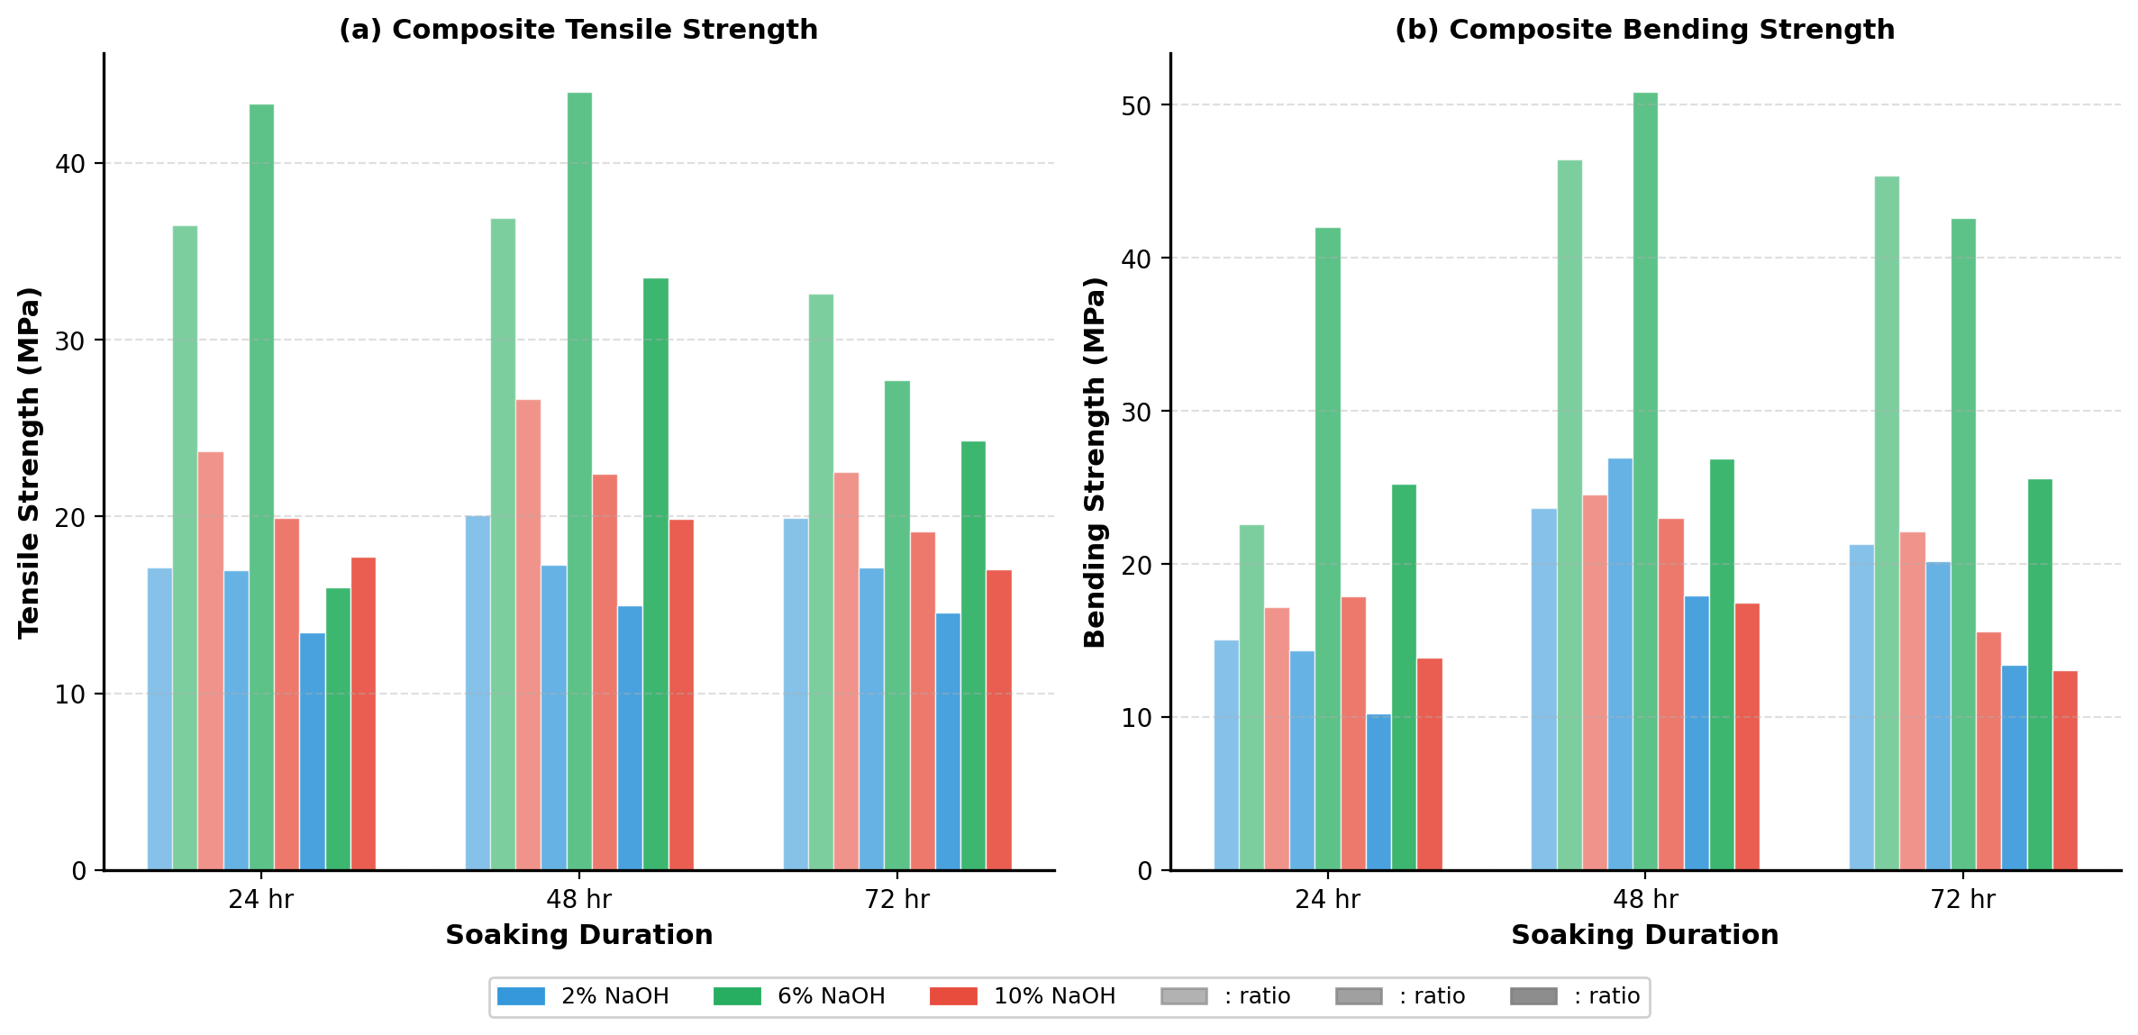
Figure 3. Grouped bar charts of (a) composite tensile and (b) bending strength across all treatment conditions, soaking durations, and fiber:polyester ratios.
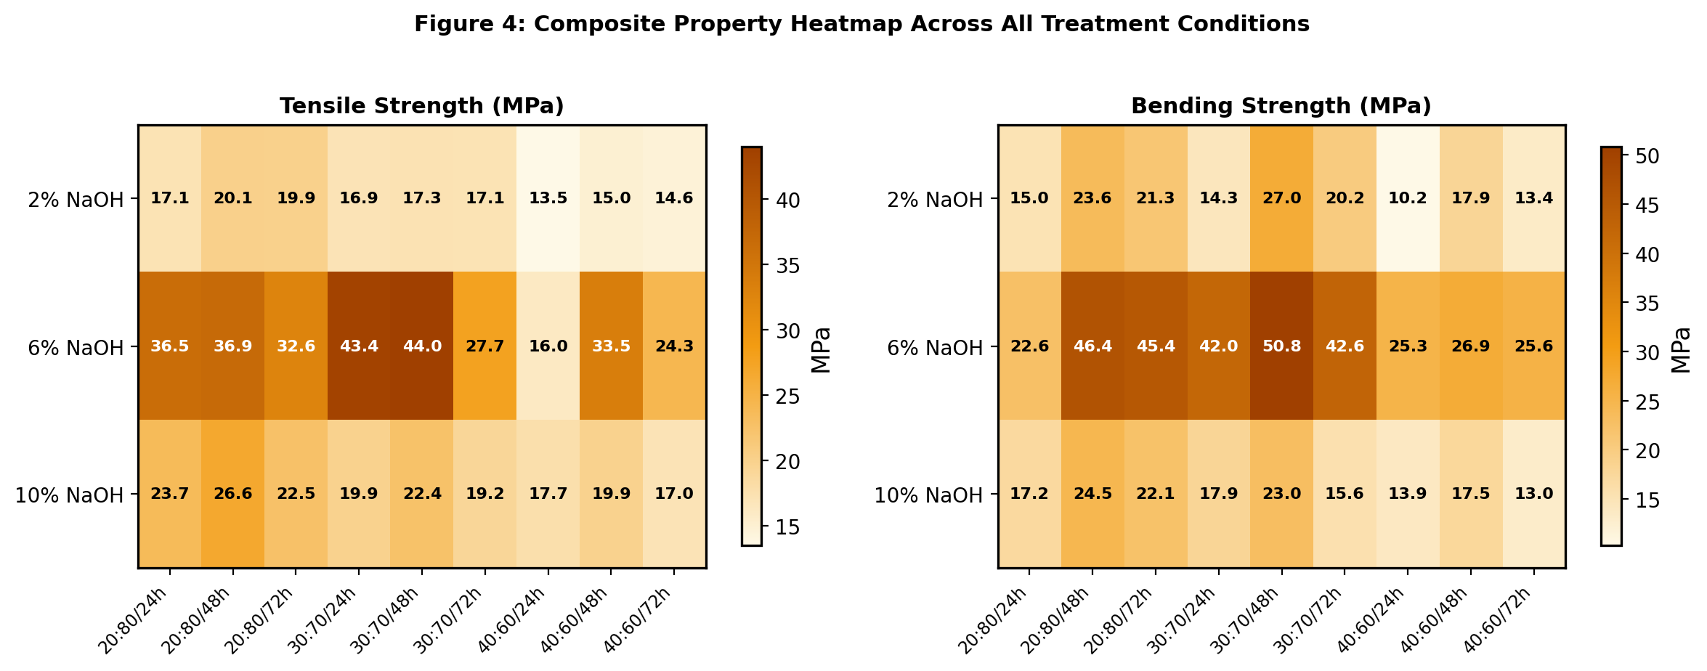
Figure 4. Heatmap visualization of (a) tensile and (b) bending strength (MPa) across the full 3×9 experimental matrix.
Darker cells indicate superior performance; bold values denote the global optimum.
The highest tensile strength of 44.003 MPa at 6% NaOH / 48 h / 30:70 is similar to, though not equal to, the values obtained in a similar study. Endesha et al. (2025) reported tensile strength of about 38-42 Mpa with sisal/polyester 5 percent NaOH / 30:70 ratio of about 38-42 Mpa, a little under the current optimal result despite having a more uniformly extracted fiber. This is to indicate that the 6 percent NaOH in the current study provides an adhesion benefit that partly counters the fiber quality variation that comes with manual extraction. Rafi et al. (2025) on the other hand found tensile strength of just around 28 Mpa at 30% TSF in a sisal/epoxy system which is much lower than the currently obtained data. This mismatch might be due to the higher crosslink density and brittleness of epoxy that limits energy absorption in the fiber-matrix interface but polyester is a little less rigid and can redistribute stress at the same fiber loading. This is not always recognised in comparative NFRPC studies, it is a systematic source of inter-study variation which makes it difficult to rank the performance of different studies directly.

Analytically important is the over-treatment signature 10% NaOH. Composite tensile strength at 10% NaOH / 30:70 throughout all durations (19.90, 22.44, 19.17 MPa) not only decreases below the optimum of 6% but also, at 72 h, decreases below the even raw fiber composite performance (35.00 MPa at 30:70). Krishnaiah et al. (2017) report this inversion with 8% NaOH in sisal/PP at longer times, and Checol and Sendekie (2025) with 8% NaOH in false banana fiber at higher temperatures: in both cases, fibrillation-induced surface embrittlement causes a reduction in effective load-bearing cross-section. The current data give additional support to this limit, and 68% concentration of NaOH is recognizable as the upper limit of the safe mercerization of sisal in the polyester matrices at ambient temperature. Mahato and Goswami (2014) used 5% NaOH, so they did not find this inversion, which can be the reason why some sources mention 5 percent NaOH as the best one, but the optimum of 5 percent NaOH in the ambient temperature polyester matrix seems to be at about 6 percent.

The effect of fiber-to-polyester ratio indicates another mechanistic understanding. At 6% NaOH / 48 h, the tensile strength sequence is 30:70 (44.00) > 20:80 (36.86) > 40:60 (33.52) MPa. The fact that 30: 70 is superior to 20: 80 proves that the composite does have extra fiber reinforcement up to this loading, which is in line with the rule-of-mixtures theory. The decrease of 30:70 to 40:60 however suggests that the composite is switching to a void-dominated to fiber-dominated failure mode at percentages above 30:70 since the insufficient volume of matrix will result in the lack of wetting of the fiber, high void fraction and concentration of stress at the fiber ends. The same threshold has been independently measured at similar fiber loading by Rafi et al. (2025) in epoxy and by Sepe et al. (2018) in hemp/epoxy, indicating it is not a sisal-specific effect but a general constraint of random short-fiber composites. Its practical implication is that to maximize fiber content and hence maximize reinforcement efficiency, composite designers should not merely maximize fiber content but rather must explore the 30:70 optimum fiber-matrix synergy threshold case at each experimental treatment condition.

It is also interesting to note that bending strength does not behave in such a way as tensile strength. At 6% NaOH / 72 h, bending strength at 20:80 ratio (45.36 MPa) substantially exceeds that at 48 h (46.44 MPa) only marginally, while bending strength at 30:70 / 72 h (42.58 MPa) is notably lower than at 48 h (50.81 MPa). This difference indicates that longer soak durations at 72 h led to improved fiber-matrix adhesion which favors flexural performance in the less-fiber-rich composite (where matrix-dominated modes of failure prevail) but not at 30: 70 loading, potentially due to surface over-etching that decreases the fiber-polyester bonding area in densely packed systems. This subtlety is not reflected in single-property optimization and highlights the importance of multi-property assessment in the selection of treatment parameters.

3.4 Water Absorption Analysis

All the composite data of water absorption are displayed in Table 4 and Figure 5. The lowest absorption of 3.194 at 6% NaOH / 72 h / 20:80 is half the baseline of the raw fiber composite at the same ratio (6.977%), which validates the idea that mercerization can significantly decrease the moisture vulnerability and directly answers one of the components of RQ1.

Table 4. Water absorption (%) of composites after 24 h immersion. *Global minimum (3.194%).
Conc(%) | Time(h) | WA 20:80(%) | WA 30:70(%) | WA 40:60(%) | Minimum (Condition)
Raw | — | 6.977 | 7.229 | 8.861 | —
2 | 24 | 6.742 | 6.897 | 8.791 | 6.742 (20:80)
2 | 48 | 5.263 | 6.627 | 7.740 | 5.263 (20:80)
2 | 72 | 4.667 | 5.797 | 7.640 | 4.667 (20:80)
6 | 24 | 4.000 | 5.147 | 6.757 | 4.000 (20:80)
6 | 48 | 3.226 | 3.509 | 3.763 | 3.226 (20:80)
6 | 72 | 3.194* | 3.415 | 3.698 | 3.194* (Global min.)
10 | 24 | 3.540 | 4.046 | 5.172 | 3.540 (20:80)
10 | 48 | 3.467 | 3.758 | 3.827 | 3.467 (20:80)
10 | 72 | 3.323 | 3.467 | 5.348 | 3.323 (20:80)

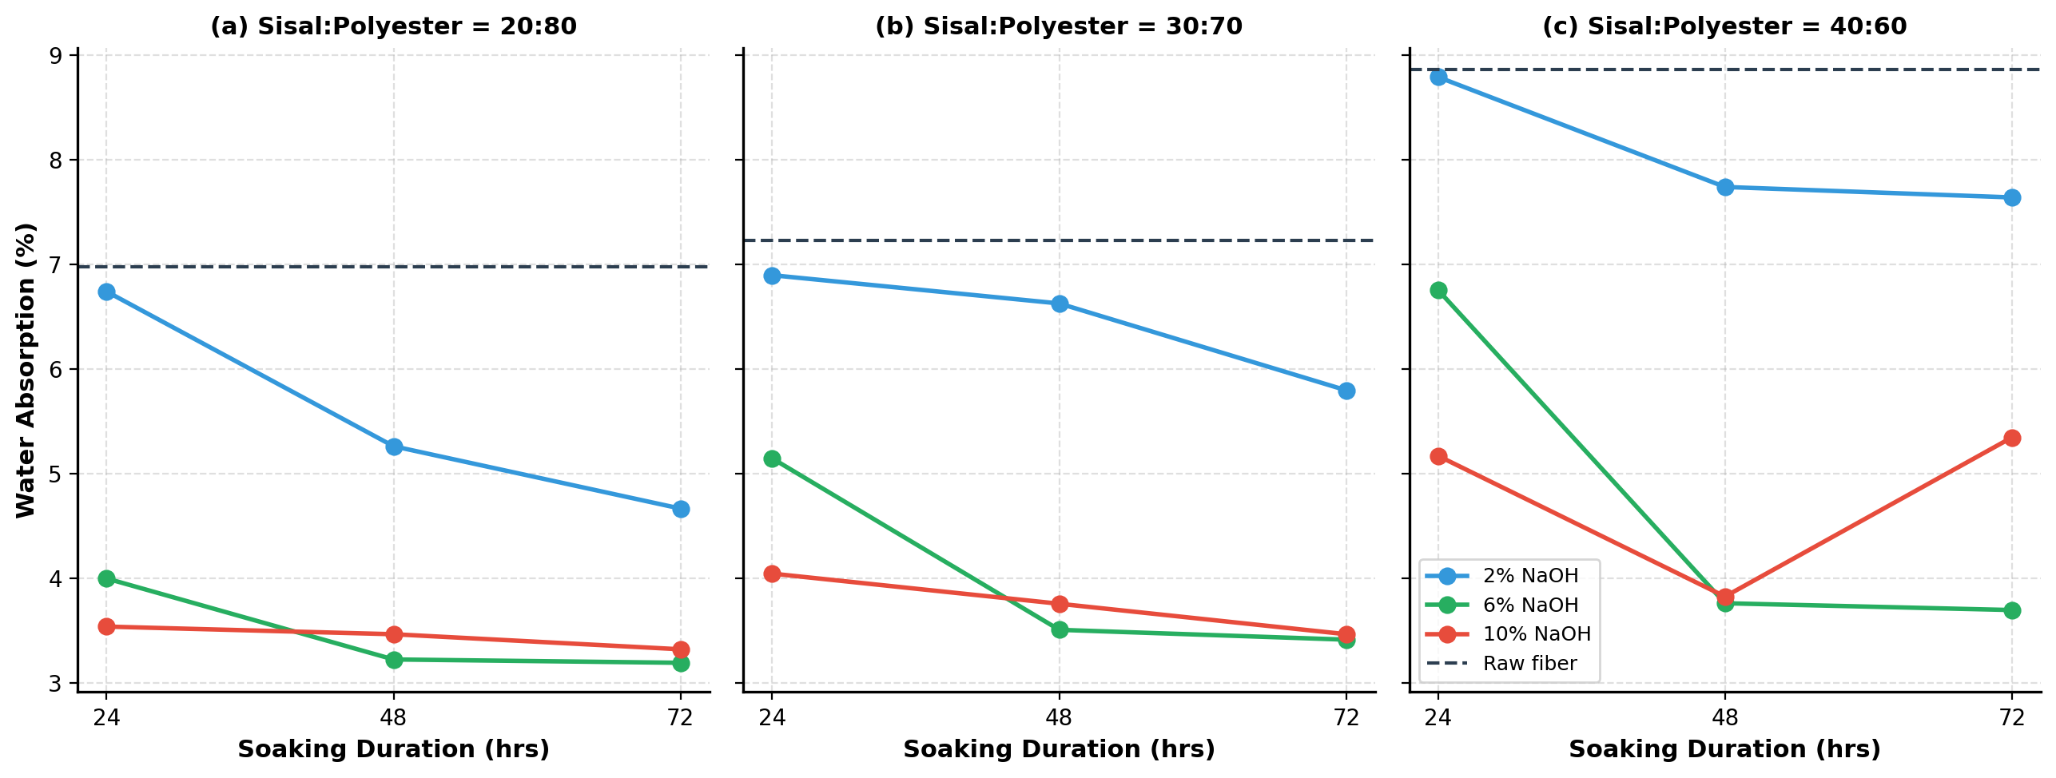
Figure 5. Water absorption (%) vs soaking duration for (a) 20:80, (b) 30:70, and (c) 40:60 fiber:polyester ratios.
Dashed line: raw fiber composite baseline.
The mechanistic foundations to this decrease in absorption are strongly established in the literature although there remains some controversy regarding the relative significance of competing pathways. Sreekala and Thomas (2003) believe that the reduction of surface hydroxyl groups is the main driving force and that alkali treatment transforms the available -OH groups to -O-Na + groups which are much less hygroscopic. Arrakhiz et al. (2013) emphasize more on the void-reduction effect of enhanced interfacial adhesion, citing that water absorption in natural fiber composites occurs via capillary wicking over interfacial microvoids, and is not due to direct cellulose hydration. The current data is not able to provide definite answer to this debate, since no measurements of void fraction were carried out. Nevertheless, the void-fraction hypothesis is supported by the fact that the 20: 80 ratio consistently has lower absorption than 30: 70 and 40: 60 ratios - at all levels of treatment, as the higher the polyester fraction, the more matrix available to close interfacial voids. This is consistent with the previous interpretation of Rafi et al. (2025), who linked a 16.41 percent absorption increase between 20 and 30 percent TSF epoxy to the high interfacial area and microvoid content and with Ayalew and Wodag (2022), who specifically attributes excess polyester hydrophobicity to be the protecting factor at 20:80 loading.

The anomalous rise in absorption at 10% NaOH / 72 h / 40:60 (5.348%) compared to 10% / 48 h / 40:60 (3.827%) warrants specific discussion. Without SEM data, two possibilities exist (a) too much etching of the fibers leaves micro-fissures on the surface that serve as water entry routes even when the fabrication is encapsulated, as Krishnaiah et al. (2017) observe when using high-concentration/long-duration treatments; or (b) the fibers become microcracked during the demolding or preparation of the mechanical tests, which Checol and Sendekie (2025) noted this anomaly with false banana fiber at 8 percent NaOH above 60 minutes and it is congruent with explanation (a). Future studies that include the characterization of the fracture surface and interfacial region by SEM would be useful in separating these mechanisms.

3.5 Machine Learning Analysis
3.5.1 PCA of FTIR Spectral Features

The PCA analysis of the six averages of the spectral regions in FTIR is given in figure 6, which directly answers RQ2. The score plot (Fig. 6a) shows that all the four treatments of the fibers in the two-dimensional PC1PC2 space are distinctly separated, indicating that spectral characteristics alone can distinguish the treatment conditions without mechanical testing.
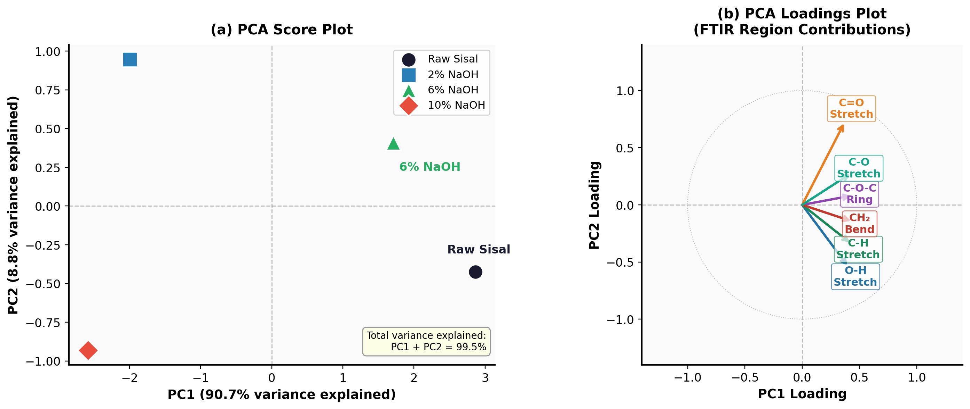
Figure 6. PCA analysis of FTIR spectral features: (a) Score plot — clear separation of four treatment groups (circles = Raw, squares = 2% NaOH, triangles = 6% NaOH, diamonds = 10% NaOH) with percentage variance explained per axis. (b) Loadings plot: six FTIR band vectors on unit-circle axes; arrow direction and magnitude reflect contribution to PC1 and PC2 respectively.
The C–O–C ring and C=O stretch arrows dominate PC1, confirming hemicellulose removal as the principal spectral variance driver.

The loadings plot (Fig. 6b) confirms that the C-O-C ring (~1050 cm -1) and C=O (~1740 cm -1) makes the largest contribution to PC1, in line with the assignment of those two bands as hemicellulose diagnostic bands. This analytical result is compatible with Mahato and Goswami (2014), who determined the presence of the same two bands as the most informative FTIR markers of the extent of alkali treatment in sisal. The OH and CH stretch regions are more significant to PC2, which takes into account intra-group variation. More importantly, the fact that the PCA-based group separation has proven the proof-of-concept of a non-destructive quality screening protocol: a manufacturer using such a technique would be able to identify the treatment history of a fiber batch based on a speedy FTIR scan and not on the destructive mechanical testing.

3.5.2 SVR Property Prediction and LOOCV Validation
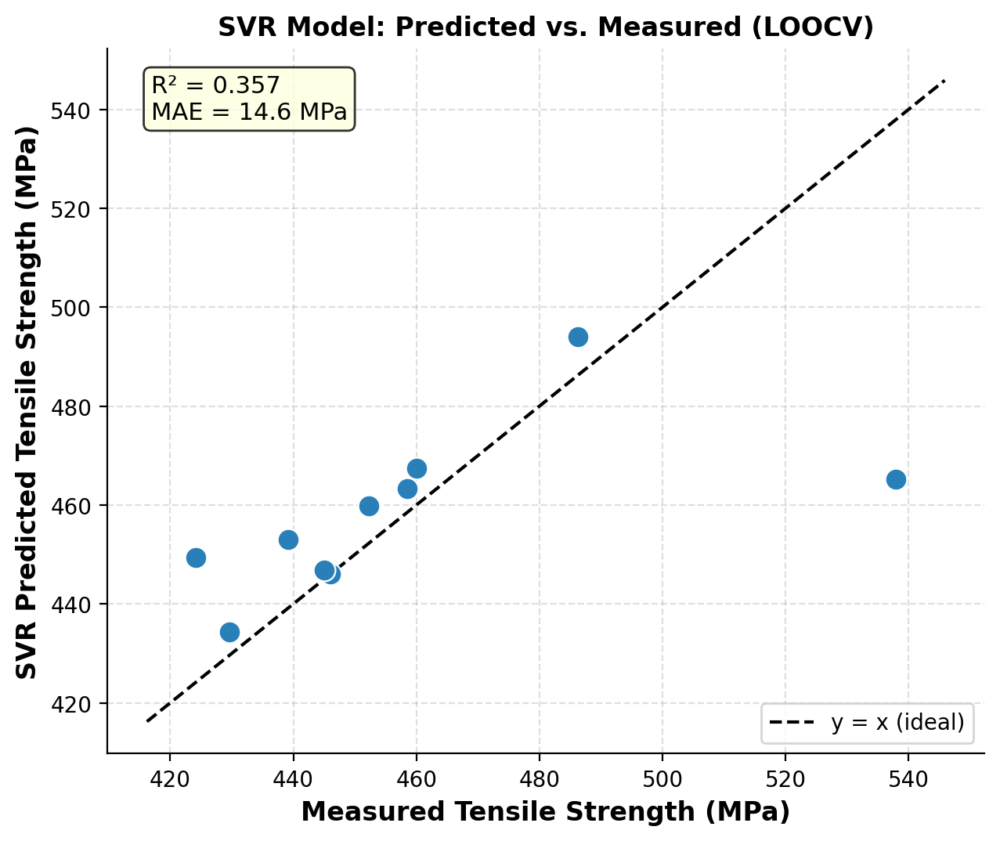
Figure 7. SVR model: predicted vs measured fiber tensile strength under LOOCV. R² = 0.357, MAE = 14.55 MPa (n = 10 fiber conditions).
The fiber tensile prediction model using the SVR (Fig. 7) has a R 2 = 0.357 with a MAE = 14.55 MPa, and therefore, the model under LOOCV must be interpreted carefully in a contextual manner, rather than overly compared to the higher figures in the ML composite literature. The n 10 fiber-level dataset makes the generalization of LOOCV extremely difficult: each training fold only has nine observations in a 113 MPa response range, and the dominant structure is a near-saturating exponential decay instead of a linear or continuously nonlinear pattern that can be interpolated using an RBF. Vignesh and Vasugi (2025) showed that even XGBoost (the most powerful of four ML models tested) using 20 raw experimental measurements gave a maximum R 2 = 0.61, and only with 15,000 Sobol-sequence synthetic data points did it reach R 2 = 0.89. This comparison is very valuable context: the reported R 2 = 0.357 is not an indicator of a poor model architecture, but of an inherently data-constrained situation. The MAE of 14.55 MPa (2.7% of the entire 537.86 MPa scale) indicates that the interpolation accuracy is acceptable to use in the real world to screen quality.
A more direct comparison is provided by Mahmood et al. (2025) study: FSMOreg on basalt fiber tensile degradation (n ≈ 81 observations in an alkaline exposure design of 3x3x3) resulted in a correlation of R = 0.928 which is significantly higher than the current R 2 values. It is also due to the size of datasets, and not to the quality of the models, which in turn supports the argument of data augmentation by Vignesh and Vasugi (2025). The ANN accuracy of Mohit et al. (2024) reaches even higher values with a larger multi-filler polymer composite dataset (n > 50), which again validates the dataset size as the binding limitation to the model performance in the study at hand.

3.5.3 Feature Importance Analysis
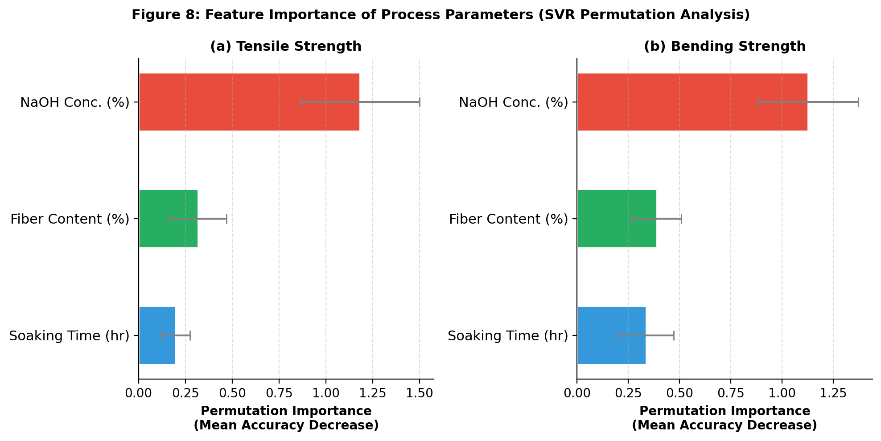
Figure 8. Permutation-based feature importance (50 repeats) for SVR models predicting (a) tensile and (b) bending strength from three process parameters.
Error bars = ±1 standard deviation.

The permutation importance analysis (Fig. 8) shows that consistently the NaOH concentration is the strongest predictor of tensile strength and bending strength, and the fiber content is the second predictor of tensile strength and third predictor of bending strength. This result represents a direct quantitative response to RQ3 and it is substantially justified by the mechanistic literature. Krishnaiah et al. (2017) explain the dominance in concentration by the fact that it is the concentration that defines the depth and selectivity of lignin-hemicellulose removal: only the concentration provides the driving force of the reaction during the esterification, and the soaking time only controls the reaction extent at constant driving force. KOH concentration was also the strongest predictor (feature importance: no less than 0.43 vs no less than 0.31) in the Sobol-augmented XGBoost model by Vignesh and Vasugi (2025), cross-system validation of such a hierarchy. The relative significance of soaking time to bending strength (compared to tensile) can have implications of the fact that bending failure in short-fiber composites is more sensitive to the quality of interfacial adhesion than is raw fiber strength - and interfacial adhesion is more sensitive to treatment duration (determining penetration depth and surface roughness development) than tensile failure, which is more sensitive to its own effect on cross--section reduction.

4. Conclusion

This paper has proposed a combined experimental and machine learning description of NaOH-treated sisal/polyester composites, based on the publicly available Mendeley dataset (Ayalew, 2019; doi: 10.17632/3z6sgfmx2f.1). The main results and their relation to the mentioned research questions are presented below.
Answering RQ1 (NaOH concentration, soaking time, and fiber ratio): NaOH concentration is the process variable, which is primary and non-linearly operating. The 6% NaOH / 48 h / 30:70 condition demonstrates the global optimum in tensile (44.003 MPa) and bending (50.810 MPa) strength, which is more than 2-fold higher than raw fiber composites at the identical ratio, and matches other similar literature standards (Endesha et al., 2025; Rafi et al The condition of 10% NaOH is always worse than even the raw fiber baseline at longer rates of soaking, which validates the cellulose damage mechanism suggested by Krishnaiah et al. (2017) and Checol and Sendekie (2025). The lowest water absorption was found (3.194% or 6% NaOH / 72 h / 20:80) which is a 54 per cent decrease in water absorption compared to the untreated baseline, which is in line with the void-reduction mechanism and the hydroxyl-group-conversion mechanism which Sreekala and Thomas (2003) and Arrakhiz et al. (2013) described.
Answering RQ2 (FTIR-based ML prediction): Spectral chemistry PCA based on average spectral regions in six spectral regions is able to discriminate between all four fiber treatment groups on two-dimensional PC1PC2 space, indicating that spectral chemistry can detect treatment-induced changes in structure with sufficient resolution to identify groups. PC1 is dominated by the C3O ring stretch and C=O, which can be quantitatively used to support the FTIR assignment literature (Mahato and Goswami, 2014; Ayalew and Wodag, 2022). The SVR LOOCV model yields an R 2 = 0.357 on the fiber-level data set- a relatively small yet contextually reasonable result since n = 10, which corresponds to the raw-data performance of Vignesh and Vasugi (2025) before data augmentation.
Answering RQ3 (dominant process parameter): Tensile and bending prediction have NaOH concentration as the most significant input and, in fact, this parameter has a mechanistic role in controlling reaction thermodynamics and the degree of hemicellulose dissolution. The second importance of tensile prediction is the fiber content; tensile prediction is dominated by the value of soaking time when bending is the objective; interfacial adhesion (bending-critical) is more sensitive to treatment duration.
Future research limitations and directions: These conclusions are subject to a number of important limitations. To start with, the fiber-level dataset (n = 10) is not enough to achieve strong ML generalization; a high-priority extension would be to apply Sobol-sequence data augmentation or Latin Hypercube data augmentation as performed by Vignesh and Vasugi (2025). Second, fiber-matrix interface SEM characterization was not conducted, and direct morphological validation of the fibre-matrix interface mechanism, based on mechanical data, was not conducted. Third, Ayalew and Wodag (2022) collected and did not include TGA data of treated fibers in the Mendeley dataset, which restricted the analysis of thermal properties. Fourth, the analysis takes into account only ambient-temperature treatment; Checol and Sendekie (2025) prove that temperature is an influential optimization variable of false banana fiber and can probably be so of sisal. Fifth, there are no fatigue, impact and dynamic mechanical analysis (DMA) data, so conclusions cannot be made regarding the real-world structural performance.

These gaps should be filled in future work by broadening the experimental factorial designs, SEM/EDS characterization, multi-objective Pareto optimization (maximizing tensile strength, bending strength and minimizing water absorption) and SHAP-based explain-ability analysis to enhance model interpretability. The FTIR-to-property prediction pathway illustrated herein can be extended to a real-time quality control protocol of industrial production of natural fiber composites, and can be directly applied to lightweight energy infrastructure component applications where performance reliability and moisture resistance are of paramount importance.

COMPETING INTERESTS DISCLAIMER:
Authors have declared that they have no known competing financial interests OR non-financial interests OR personal relationships that could have appeared to influence the work reported in this paper.

Competing interests

The authors assert that they do not have any competing interests with regard to this publication.

References

Arrakhiz, F. Z., El Achaby, M., Malha, M., Bensalah, M. O., Fassi-Fehri, O., Bouhfid, R., Benmoussa, K., & Qaiss, A. (2013). Mechanical and thermal properties of natural fibers reinforced polymer composites: Doum/low density polyethylene. Materials in Engineering, 43, 200–205. https://doi.org/10.1016/j.matdes.2012.06.056
Ashik, K. P., & Sharma, R. S. (2015). A review on mechanical properties of natural fiber reinforced hybrid polymer composites. Journal of Minerals and Materials Characterization and Engineering, 03(05), 420–426. https://doi.org/10.4236/jmmce.2015.35044
Ayalew, A.A. (2019). Data set on Effect of Alkaline Treatment of Sisal Fiber on Mechanical property Reinforced Polyester Composite. Mendeley Data, V1. doi: 10.17632/3z6sgfmx2f.1
Ayalew, A.A. and Wodag, A.F. (2022). Characterization of Chemically Treated Sisal Fiber/Polyester Composites. Journal of Engineering, Article ID 8583213. doi: 10.1155/2022/8583213
Aziz, S. H., & Ansell, M. P. (2004). The effect of alkalization and fibre alignment on the mechanical and thermal properties of kenaf and hemp bast fibre composites: part 1-polyester resin matrix. Composites Science and Technology, 64(9), 1219–1230.
Begum, K., & Islam, M. A. (2013). Natural fiber as a substitute to synthetic fiber in polymer composites: a review. Research Journal of Engineering Sciences, 2, 46–53.
Breiman, L. (2001). Random forests. Machine Learning, 45(1), 5–32. https://doi.org/10.1023/a:1010933404324
Checol, C. N., & Sendekie, Z. B. (2025). Effect of alkali treatment on physicochemical and microstructural properties of false banana fiber. Scientific Reports, 15(1), 25446. https://doi.org/10.1038/s41598-025-10825-1
de Albuquerque, A. C., Joseph, K., Hecker de Carvalho, L., & d’Almeida, J. R. M. (2000). Effect of wettability and ageing conditions on the physical and mechanical properties of uniaxially oriented jute-roving-reinforced polyester composites. Composites Science and Technology, 60(6), 833–844. https://doi.org/10.1016/s0266-3538(99)00188-8
Dinesh, & Yoganandh. (2025). Synergistic effect of alkali treatment and graphene filler on the mechanical characteristics of nettle fiber reinforced polymer composite. Fullerenes, Nanotubes and Carbon Nanostructures, 33(6), 559–568. https://doi.org/10.1080/1536383x.2024.2431104
Dunne, R., Desai, D., Sadiku, R., & Jayaramudu, J. (2016). A review of natural fibres, their sustainability and automotive applications. Journal of Reinforced Plastics and Composites, 35(13), 1041–1050. https://doi.org/10.1177/0731684416633898
Endesha, A., Tefera, G., Adali, S., & Bright, G. (2025). The effects of extraction on mechanical and morphological properties of sisal polyester composite. Journal of Composites Science, 9(11), 613. https://doi.org/10.3390/jcs9110613
Faruk, O., Bledzki, A. K., Fink, H.-P., & Sain, M. (2012). Biocomposites reinforced with natural fibers: 2000–2010. Progress in Polymer Science, 37(11), 1552–1596. https://doi.org/10.1016/j.progpolymsci.2012.04.003
Ganta, M. G., & Patel, M. (2024). Evaluation of mechanical and thermal properties of alkali-treated sisal, bamboo, and hybrid fiber-reinforced polymer composites. Evergreen, 11(3), 1784–1797. https://doi.org/10.5109/7236831
Herrera-Franco, P. J., & Valadez-González, A. (2004). Mechanical properties of continuous natural fibre-reinforced polymer composites. Composites. Part A, Applied Science and Manufacturing, 35(3), 339–345. https://doi.org/10.1016/j.compositesa.2003.09.012
Ibrahim, I. D., Jamiru, T., Sadiku, E. R., Kupolati, W. K., Agwuncha, S. C., & Ekundayo, G. (2016). Mechanical properties of sisal fibre-reinforced polymer composites: a review. Composite Interfaces, 23(1), 15–36. https://doi.org/10.1080/09276440.2016.1087247
Idicula, M., Joseph, K., & Thomas, S. (2010). Mechanical performance of short banana/sisal hybrid fiber reinforced polyester composites. Journal of Reinforced Plastics and Composites, 29(1), 12–29. https://doi.org/10.1177/0731684408095033
Jarukumjorn, K., & Suppakarn, N. (2009). Effect of glass fiber hybridization on properties of sisal fiber–polypropylene composites. Composites. Part B, Engineering, 40(7), 623–627. https://doi.org/10.1016/j.compositesb.2009.04.007
John, M. J., & Anandjiwala, R. D. (2008). Recent developments in chemical modification and characterization of natural fiber‐reinforced composites. Polymer Composites, 29(2), 187–207. https://doi.org/10.1002/pc.20461
Kabir, M. M., Wang, H., Lau, K. T., & Cardona, F. (2012). Chemical treatments on plant-based natural fibre reinforced polymer composites: An overview. Composites. Part B, Engineering, 43(7), 2883–2892. https://doi.org/10.1016/j.compositesb.2012.04.053
Krishnaiah, P., Ratnam, C. T., & Manickam, S. (2017). Enhancements in crystallinity, thermal stability, tensile modulus and strength of sisal fibres and their PP composites induced by the synergistic effects of alkali and high intensity ultrasound (HIU) treatments. Ultrasonics Sonochemistry, 34, 729–742. https://doi.org/10.1016/j.ultsonch.2016.07.008
Mahato, K., & Goswami, S. (2014). FTIR analysis on alkali treated sisal fibre and characterization on mechanical properties of sisal-vinyl ester composites. Advanced Science Letters, 20(3), 825–827. https://doi.org/10.1166/asl.2014.5368
Mahmood, A., Pechočiaková, M., Tomková, B., Noman, M. T., Gheibi, M., Behzadian, K., Wiener, J., & Hes, L. (2025). Machine learning-driven optimization for evaluating the durability of basalt fibers in alkaline environments. Fibers (Basel, Switzerland), 13(10), 137. https://doi.org/10.3390/fib13100137
Malkapuram, R., Kumar, V., & Negi, Y. S. (2009). Recent development in natural fiber reinforced polypropylene composites. Journal of Reinforced Plastics and Composites, 28(10), 1169–1189. https://doi.org/10.1177/0731684407087759
Mishra, S., Mohanty, A. K., Drzal, L. T., Misra, M., Parija, S., Nayak, S. K., & Tripathy, S. S. (2003). Studies on mechanical performance of biofibre/glass reinforced polyester hybrid composites. Composites Science and Technology, 63(10), 1377–1385. https://doi.org/10.1016/s0266-3538(03)00084-8
Mohan, T. P., & Kanny, K. (2012). Chemical treatment of sisal fiber using alkali and clay method. Composites. Part A, Applied Science and Manufacturing, 43(11), 1989–1998. https://doi.org/10.1016/j.compositesa.2012.07.012
Mohit, H., Sanjay, M. R., Siengchin, S., Kanaan, B., Ali, V., Alarifi, I. M., & El-Bagory, T. M. A. A. (2024). Machine learning‐based prediction of mechanical and thermal properties of nickel/cobalt/ferrous and dried leaves fiber‐reinforced polymer hybrid composites. Polymer Composites, 45(1), 489–506. https://doi.org/10.1002/pc.27793
Mwaikambo, Leonard Y., & Ansell, M. P. (2002). Chemical modification of hemp, sisal, jute, and kapok fibers by alkalization. Journal of Applied Polymer Science, 84(12), 2222–2234. https://doi.org/10.1002/app.10460
Nagamadhu, Jeyaraj, & Mohan Kumar, G. C. (2019). Characterization and mechanical properties of sisal fabric reinforced polyvinyl alcohol green composites: effect of composition and loading direction. Materials Research Express, 6(12), 125320. https://doi.org/10.1088/2053-1591/ab56b3
Nimanpure, S., Hashmi, S., Kumar, R., Bhargaw, H.N., Kumar, R., Nair, P., & Naik, A. (2019). Mechanical, electrical, and thermal analysis of sisal fibril/kenaf fiber hybrid polyester composites. Polymer Composites, 40, 664-676.
Rafi, A. A., Ali, M. S., Hossain, M. A. M., & Redoy, R. A. (2025). Experimental investigation on mechanical and physical properties of sisal fiber reinforced hybrid composites with filler material. Next Research, 2(3), 100509. https://doi.org/10.1016/j.nexres.2025.100509
Senthilkumar, K., Saba, N., Rajini, N., Chandrasekar, M., Jawaid, M., Siengchin, S., & Alotman, O. Y. (2018). Mechanical properties evaluation of sisal fibre reinforced polymer composites: A review. Construction and Building Materials, 174, 713–729. https://doi.org/10.1016/j.conbuildmat.2018.04.143
Sepe, R., Bollino, F., Boccarusso, L., & Caputo, F. (2018). Influence of chemical treatments on mechanical properties of hemp fiber reinforced composites. Composites. Part B, Engineering, 133, 210–217. https://doi.org/10.1016/j.compositesb.2017.09.030
Sreekala, M. S., & Thomas, S. (2003). Effect of fibre surface modification on water-sorption characteristics of oil palm fibres. Composites Science and Technology, 63(6), 861–869. https://doi.org/10.1016/s0266-3538(02)00270-1
Sullins, T., Pillay, S., Komus, A., & Ning, H. (2017). Hemp fiber reinforced polypropylene composites: The effects of material treatments. Composites. Part B, Engineering, 114, 15–22. https://doi.org/10.1016/j.compositesb.2017.02.001
Tawakkal, I. S. M. A., Cran, M. J., & Bigger, S. W. (2018). The influence of chemically treated natural fibers in poly(lactic acid) composites containing thymol. Polymer Composites, 39(4), 1261–1272. https://doi.org/10.1002/pc.24062
Venkateshwaran, N., ElayaPerumal, A., Alavudeen, A., & Thiruchitrambalam, M. (2011). Mechanical and water absorption behaviour of banana/sisal reinforced hybrid composites. Materials in Engineering, 32(7), 4017–4021. https://doi.org/10.1016/j.matdes.2011.03.002
Vignesh, M. & Vasugi. K. (2025). Machine learning optimization of KOH treatment parameters for enhanced tensile strength and cellulose content in sisal fibers: A synergistic approach. Materials Today. Communications, 45(112307), 112307. https://doi.org/10.1016/j.mtcomm.2025.112307
Wambua, P., Ivens, J., & Verpoest, I. (2003). Natural fibres: can they replace glass in fibre reinforced plastics? Composites Science and Technology, 63(9), 1259–1264. https://doi.org/10.1016/s0266-3538(03)00096-4
Wu, Y., Xia, C., Cai, L., Garcia, A. C., & Shi, S. Q. (2018). Development of natural fiber-reinforced composite with comparable mechanical properties and reduced energy consumption and environmental impacts for replacing automotive glass-fiber sheet molding compound. Journal of Cleaner Production, 184, 92–100. https://doi.org/10.1016/j.jclepro.2018.02.257
Yang, H., Yan, R., Chen, H., Lee, D. H., & Zheng, C. (2007). Characteristics of hemicellulose, cellulose and lignin pyrolysis. Fuel (London, England), 86(12–13), 1781–1788. https://doi.org/10.1016/j.fuel.2006.12.013

