Polyaluminium chloride (PAC) as a highly efficient inorganic coagulant: An update of its cost-effective manufacturing process-A review

.
ABSTRACT

Aims: Polyaluminium chloride (PAC) has emerged to be the most effective coagulant for water treatment over most conventional coagulants because of its low dosage amounts required, less flocculation time, less sludge, high efficiency and low aluminium residues remains in treated water. It is more efficient than aluminium sulphate because it works at all turbidity levels and it does not cause significant drop in pH. The current commercial preparation method involves the use of rigorous conditions and an expensive raw material which drives high production cost such that its adoption by low-income economies is hindered. Over the years various studies have been devoted to find cost effective methods of producing PAC. Thus, the present review provides a systematic review of such methods.
Study design: Systematic review of literature.
Place and Duration of Study: Harare Institute of technology Jan-March 2026.
Methodology: Data collection was performed by searching major databases, Scopus, Google scholar, Scifinder and Springer up to March 2026 with the key phrases cost-effective or low-cost methods of preparing PAC.
Results: The study reveals that there is a general agreement that in order to bring down the cost, methods that utilizes locally available, affordable, sustainable and promote ecofriendly efforts and allows the use of mild preparation conditions should be adopted. Natural, industrial, mining and home waste residues have been selected for use as raw materials in PAC preparations. Among the raw materials selected bauxite, kaolin and aluminium tins and scrapings have been widely studied and they produced PAC that was pure, highly efficient and of desirable basicity. Its performance was not inferior to PAC produced by the standard industrial preparation method. Calcination and electrochemical methods have been reported to be cost effective methods that do not depend on the use of vigorous conditions. Thus, PAC produced using these alternative procedures was said to be also useful not only in the treatment of waste water but also in treating drinking water.
Conclusion: Although the PAC produced by alternative methods was extensively checked for quality in terms of purity (Al/OH) ratio, contamination and other important parameters, few studies went further to utilize it to treat real environmental water and check the feasibility in terms of process cost and efficiency in its application in a real industrial set up. This gap require interrogation so that the studies can be complete and useful.

Keywords: Polyaluminium chloride, Cost-effective preparation methods, mineral residues, industrial waste, bauxite, kaolin and aluminium scrapings

1. INTRODUCTION

Over the years aluminium sulphate has been a widely used coagulant within the water treatment industry where it was used as a flocculant to remove contaminates, unwanted colours and general turbidity from water (Dushkin, 2023). However, the use of aluminium sulphate leaves behind large traces of aluminium in treated water, which requires further filtration and results in generating vast quantities of sludge-like waste which when disposed of at landfills results in pollution (Srinivasan, Viraraghavan and Subramanian, 1999). These disposal costs have a direct impact on the operational costs of water treatment plant so it is beneficial to seek alternatives that reduce this (Mukherjee, Bhattacharya and Mondal, 2012). Although such treatment residuals possess many physical and chemical properties that makes them suitable for use in a more sustainable purpose such as use in construction materials and even soil nutrients however there are well documented concerns regarding aluminium toxicity in soil and damaging implications for ecosystems which limit this application (Alasfar and Isaifan, 2021). On the other hand, Poly Aluminium Chloride PAC, has been developed as an alternative to aluminium sulphate (Dutta, 2020). PAC offers great advantages. It hydrolyses with greater ease, obtains better coagulation, and rapidly forms flocs making this a much more efficient product. It also possesses lower doses of aluminium therefore leaving significantly fewer aluminium residuals and sludge waste product (Nansubuga et al., 2013; Region and Brasiliensia, 2018; Summary, 2026).
Polyaluminium chloride PAC is now the most widely considered effective coagulant in water and wastewater treatment facilities becoming superior to aluminium sulphate because of its wide pH application range 5-9 (Cuong et al., 2025). It also offers wide applications including removal of colloids, suspended particles, toxic metals, colour and phosphates (Youssef et al., 2023). Fig 1 illustrates how it works to purify water.
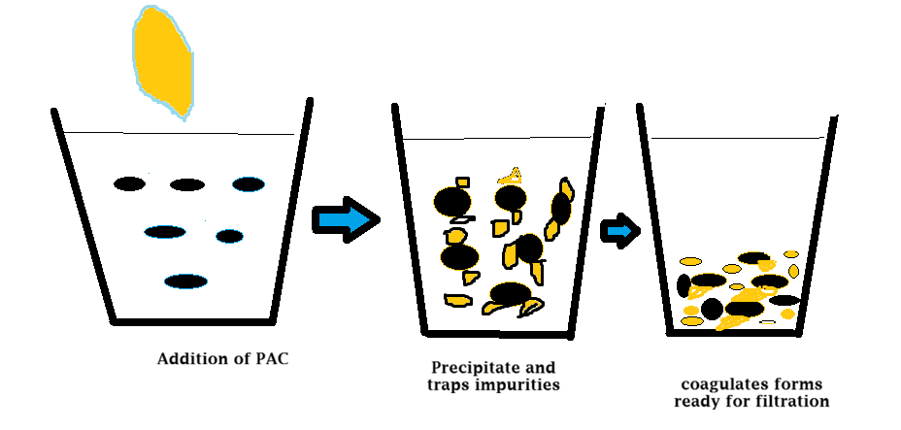
Fig 1 Waste contaminates removal by coagulation
It has superior turbidity removal however leaving minimum aluminium residual concentrations (Mohamed et al., 2024). The primary use of PAC is coagulation and flocculation (Xiao, 2019). When added to water it forms positively charged aluminium flocs. The flocs attract and neutralize impurities in the water such as charged metals, suspended solids, organic matter and some microorganisms (Li et al., 2010). PAC also find uses in the oil and gas industries for oil refining where the product works as an oil-water emulsion destabilizer offering excellent separation performance (Dąbrowska, 2018). In terms of crude oil, any water presence equals a reduced commercial value and higher refining costs, so this product is essential in ensuring optimum efficiency. PAC is also used in the production of deodorants and anti-perspirant products as the active ingredients that essentially creates a barrier on the skin and helps to reduce levels of sweat (Dawn et al., 2022). In the paper and pulp industries, it is used as a coagulant in papermill wastewater.
The manufacturing process of PAC involves separate production of two reagents solutions that consist of aluminium, Fig 2. The first solution is basic aluminium chloride that is produced from an aluminium containing raw material such as AL₂O₃ or other aluminium containing mineral ores or residues such as bauxite or waste material (Nurmakova et al., 2025). The process occurs under forceful conditions such as high temperature, pressure, extended concentrated acid contact time usually HCL, H₃PO₄ or mixture of them mixed to give appropriate proportions (Zhou et al., 2014). The other solution is sodium aluminate which is formulated as NaAlO₂, or Na₂Al₂O₄. Sodium aluminate is manufactured by the dissolution of aluminium raw material in a strong NaOH/KOH/Na₂CO₃ (Zouboulis and Tzoupanos, 2010). The production of PAC is then achieved by introduction of sodium aluminate solution into the basic aluminium chloride solution while stirring (Gemilang et al., 2024).

Fig 2 Manufacturing procedure of polyaluminium chloride
Previously many PAC preparation methods based on commercial reagent aluminium hydroxide as well as various preparation procedure modifications have been applied in industry (Ali and Al-hilli, 2025). Modifications ranged from Al raw materials acid/base dissolution to procedures that use high temperatures and pressure however the reported methods are complicated with disagreeing yields (Hessam and Mehdinejad, 2021). For these manufacturing procedures to be accessible to developing countries less complexity and cost effectiveness are important parameters (Adiono, Suaebah and Rohmawati, 2025). They designate the ability of the procedures to be adopted for commercial purposes. The generic manufacturing procedures for PAC entails consumption of much energy, increased pressure and extended contact period which converts to high production cost Kassa et al., 2024. For PAC preparation procedures to be accessible also to developing economies alternative ways should be investigated by providing effective preparation routes that are cost effective. In this review alternative cost-effective PAC manufacturing procedures are discussed particularly procedures with similar products such as commercially available PAC in terms of percentage aluminium content, basicity, density, aluminium species and coagulation performance. The review endeavors to give a comprehensive up to date knowledge on the evolution of cost-effective PAC manufacturing procedures over the years that can be adopted for commercial purposes.

2. material and methods

A dual-phase methodological framework which aimed at giving a systematic analysis of novel methods that are cost effective and have great potential for industrial application. The first phase was a systematic synthesis of the existing literature to comprehensively catalog cost effective polyaluminium chloride manufacturing procedures. The subsequent secondd phase involved leveraging on the accumulated data to describe a robust and more novel method in order to establish a low-cost standardized protocol that has industrial applications in low- and medium-income economies.
- Research methodology and data collection
Data collection involved searching major databases, Scopus, Google scholar, Scifinder and Springer up to March 2026. The keyword combinations used were, polyaluminium chloride novel manufacturing methods, polyaluminium chloride new cost-effective manufacturing methods, polyaluminium chloride cost effective preparation procedures, polyaluminium chloride low-cost manufacturing processes, alternative low cost polyaluminium chloride manufacturing procedures, Low cost polyaluminium chloride preparation routes and Industry applicable polyaluminium chloride manufacturing procedures.
4 Study selection criteria
So as to bypass the procedures associated with high cost and non-integrity studies and only isolate the literature relevant to novel low-cost procedures, the following eligibility criteria applied:
4.1 Inclusion criteria
The following criteria were followed:
- Primary research articles that detailed novel cost-effective methods
- Studies that evaluated industrial applications of low-cost PAC manufacturing processes
Exclusion criteria
The review excluded all:
- Literature with manufacturing processes that involve high heating, pressure and extended contact time.
- Literature with incompatible designs including, secondary literature such as broad reviews lacking primary data, non-peer-reviewed preprints and conference abstracts that lacked methods.

4.2 Extraction of data
Data was extracted systematically into a spread sheet for all studies that were included. The following data were captured: authors, year of publication, raw materials that was used, parameters used and industrial scale designs adopted.
3. results and discussion

4.1 Overview of primary documents selected
The total publications that were screened systematically were 338, relevant records from Google scholar were 150, Science Direct 100, Scopus 66 and SciFinder 22. On analysis the final selection consisted of 17 primary publications reporting cost effective manufacturing procedures, and 5 with real industrial applications. Cross sectional analysis of the studies revealed that 15 of them Table 1 were published in the late 20th century, between 2010 and 2026 which is an indication of a current contemporary effort and much interest in low-cost PAC preparation procedures. Most importantly the source material provides a solid foundation anchoring cost reduction in the preparation methods of PAC, raw materials used and their industrial application feasibility in terms of product quality, yield and removal capabilities.
4.2 Cost effective methods for preparation of PAC
The cost effectiveness of a preparation method is an important parameter because it designates the ability of the methods to be adopted in industry. In order to reduce the cost of preparing PAC reviewed articles, Table 1, show that this can be achieved through three adjustments that is either changing the preparation method or the aluminium substrate source and the leaching or dissolution agent. Studies devoted to reducing the cost inherent in the production of PAC appeared as early as 1999 when (Lu, Qu and Tang, 1999) proposed an electrochemical dissolution method that involved utilizing aluminium sheets as anode and aluminium chloride aqueous solution as electrolyte. The method used low voltage and high current intensity during electrolysis. The method was successful and 70% yield was achieved and the product consisted of high levels of aluminium and favorable basicity ratio of 2:4 (OH/Al). For all the key terms used to extract information, there is a general consensus in the studies that efforts should be channeled to finding locally available low-cost materials such as industrial waste to reduce the preparation cost of PAC. The widely studied industrial waste residues are bauxite waste residues, aluminium waste such as scraps and cans and mud/clay (Kassa et al., 2024; Bai et al., 2025). Utilizing such materials reduces the cost of purchasing starting raw materials. Other ways of reducing cost that comes out from analyzing published literature include adopting mild preparation conditions (Tang et al., 2015). The general commercial PAC preparation method involved utilizing aluminium hydroxide as the major raw material which is mixed with 20% HCL under high temperature (110-140ºC) and pressure 4 x 10⁵ Pa for prolonged hours, 4h (Zhou et al., 2014). Due to high cost of raw materials and the rigorous operating conditions this hinders its adoption by many developing economies. Also, this method produces PAC that has high purity but low basicity (Tang et al., 2015). Because of the inherent cost the method s` utilization in the preparation is only limited to drinking water and not for waste water. In order to have a cost-effective method (Li et al., 2010), utilized low grade bauxite and calcium aluminium that consisted of low levels of impurities to synthesize high Al and basicity PAC. The method had a lower cost than the commercial method. For the preparation of PAC to be cost effective the numerous factors that include, affordability, accessibility, sustainability and eco-friendly should be considered when selecting raw materials. Thus, production of poly aluminum chloride using bauxite, bauxite waste residues and other natural materials is regarded as the innovative technology of choice (Lu et al., 2014).
Table 1 Cost effective polyaluminium chloride preparation methods
Method of preparation | Materials used to reduce cost | Effect on preparation cost | References
Acid leaching | Red mud | Use of locally available industrial waste reduced cost of raw materials | (Cheng, Xu and Liu, 2022)
Acid leaching | Aluminium dross | Locally available industrial by product | Chao et al., 2021
Electrochemical dissolution | Aluminium sheets | Moderate controlled conditions which avoid high temperature and high pressure | Lu et al., 1999
Electrolysis | Basic Aluminium hydroxide | Substituting anode and Al source-from bulk electrolyte brings down production cost | Hu et al., 2005
Basification | Kaolinite | Locally available raw material | Kassa et al., 2024
Basification | Fresh aluminium hydroxide gels | Allow the use of mild preparation conditions that saves energy | Tang et al., 2015
Acid dissolution | Granular metallic | Allow the use of mild conditions | Zouboulis and Tzoupanos, 2010
Acid leaching | Low grade bauxite and calcium aluminium | Use of locally available law grade bauxite | Li et al., 2010
Acid dissolution | Beverages can | Use of locally available waste product | (Ali and Al-hilli, 2025)
Acid leaching | Kaolin | Use of locally available natural material | Mohamed et al., 2024
Acid dissolution | clay-brine cryolite | Use of locally available material | Zhou et al., 2014
Acid leaching | Aluminium factory waste | Use of industrial waste | Cuong et al., 2025
Acid leaching | Bauxite tailings solid waste | Use of industrial solid waste | (Ma et al., 2014)
Acid dissolution | Aluminium scraps | Use of industrial waste | Hesain et al., 2015
Alkaline leaching | Bauxite | Use of industrial waste | Aziz and Agus wahyudi, 2010
Acid dissolution | Waste household aluminium foil | Use of industrial waste | Youssef et al., 2023
Acid leaching and dissolution | Kaolin | Use of natural substrate | Xiao, 2019

4.2.1 Bauxite as the chosen low-cost input raw material
Upon scanning the published literature, bauxite or residual bauxite have been the widely chosen cost effective input raw material (In et al., 2024). This is because bauxite ore is a good source of aluminium (Modi and Dewangan, 2024). It possesses a hard off-white or reddish-brown rock color (Kumar et al., 2023). It is the third mostly abundant element on earth (Silveira et al., 2021). In the modern world, it is becoming the most popular raw material due to its corrosion resistance, good electrical conductivity and light weightlessness (Muds, 2018). It is among the top five hardest elements in nature after diamond and silicon carbide (Sun et al., 2026). Naturally it is not found in a metallic form but it occurs as silicate (clays), oxides and hydroxides due to its high reactivity (Swain, Lee and Park, 2022). Bauxite was first reported in Les Bauxite (France) in 1821 (Angélica, Kahn and Paz, 2018). It was later found to consists of mixtures of hydrous aluminium oxides and hydroxide, iron hydroxides, free silica and clay as a major constituent (Jiménez-vázquez et al., 2025). As the demand of aluminium and aluminium based products in modern world sores, it is now being mined in every continent of world (Lamidi et al., 2024). Australia houses the largest reserves of bauxite in world (54%) which consists of residual concentration of aluminium oxide in a hydrous form formed during weathering of minerals of aluminosilicates (Territory, 2011). The red-colored bauxite has been shown to consist of high contents of iron. The hydrated alumina, aluminium hydroxide exists also naturally as polymorph, mainly occurring as a mineral gibbsite. According to the (Dobra et al., 2022) four known forms of aluminum hydroxide are gibbsite, bayerite, ordstrandite and doyleite and these have different physical and chemical properties.

The processing of bauxite has been achieved using different methods and reagents in each instance endeavoring to develop a cost-effective protocol. In a recent study (Pervaiz et al., 2015), bauxite processing into aluminium hydroxide was achieved as shown in the Fig 3. The extraction process started by crushing the bauxite into powder and 130 mL of 10% sodium hydroxide was added to 10 g and slurred. The solution was heated at 120 atm for 40 min. After cooling the slurry was centrifuged at 8500 rpm to a clear solution and 2M solution of HCl was added. For basification a 10% solution of Na₂CO₃ was mixed in solution until neutral.
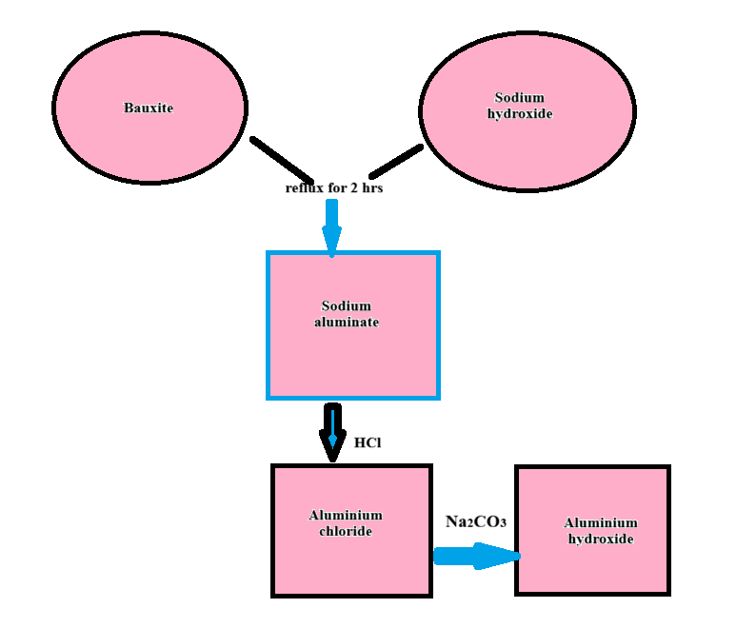
Fig 3. Treatment of bauxite by base dissolution
In another study bauxite was initially treated with hydrochloric acid as shown in Fig 4 below.
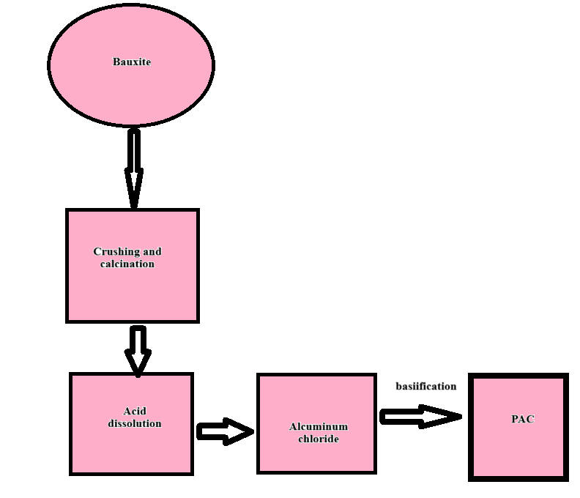
Fig 4 Treatment of Bauxite by acid dissolution.

Calcination, acid or base dissolution and selecting more reactive materials afforded a chance to adopt methods with reduced operating conditions. A one-step process using 10% hydrochloric acid as a cosolvent along with a base sodium hydroxide or sodium carbonate allows for quicker dissolution and shorter, less extreme reaction conditions (e.g., 80–90°C) compared to traditional method (Abdo et al., 2020).
4.3 Low-cost methods and industrial application case studies
Table 2 shows that out of the 17 publications of the cost-effective options produced PAC, only 5 shows PAC that was tested for removal efficiency in real contaminated water. Many of the studies ended by characterizing the produced PAC in terms of composition, OH/Al ratio and morphology. In a recent study by Mohamed et al., (2024) the efficiency of Kaolin synthesized PAC was tested first by dissolving one gram of PAC in 1000 ml in distilled water to a solution of 1mg/ml and the solution was used in jar test experiments using agricultural waste water. Each 1 L of raw water was mixed with 3 ppm PAC and continuously stirred at 200 rpm for 1 minute, and then slow stirring for 5 min. After that the solution was left to stand for 20 minutes. The kaolin synthesized PAC showed comparable removal efficiency as compared to the conventional one. The maximum removal percentage of turbidity, TSS, TOC, Nitrogen content and COD in agricultural wastewater reached 96.25, 98, 75, 90,96.25%, 98%, 75%, 90%, and 97%, respectively using kaolin synthesized, while the maximum removal for conventional PAC reached 95%, 97%, 80%, 84.4%, and 75%, respectively. Youssef et al., (2023) synthesized PAC from household waste aluminum foil and utilized it to treat petroleum waste water. The synthesized PAC showed high removal efficiency for dissolved organic matter. This shows that using cheaper sources of Al will not compromise the integrity and removal efficiency of the synthesized PAC
Table 2 Performance characteristics of cost effective
Low-cost method | Product quality | Removal efficiency | References
Use of kaolin | High | Very good | Mohamed et al., 2024
clay-brine cryolite | High | Good | Zhou et al., 2014
Waste aluminium foils | High | Very good | Youssef et al., 2023
Use of kaolin | High | Good | Xiao, 2019
Aluminium factory waste | High | Good | Cuong et al., 2025

4. Conclusion

From the forgoing discussion it has been shown that cost effective methods are achieved by utilizing readily available, sustainable natural or waste residues comprising of significant amounts of aluminium. The most applied materials are bauxite, bauxite waste residues, industrial and mining residues and aluminium scrapings. In most reported procedures, the initial phase of the process involved either acid or alkaline leaching or dissolution to produce aluminium enriched product. Other few studies utilized electrochemical methods with aluminium as anodes and ACl₃ as electrolyte. PAC products with high levels of Al and desirable basicity were obtained. All the proposed procedures aim apart from utilizing locally available sustainable materials was also to afford a preparation method that utilizes mild conditions unlike the rigorous conditions applied in the current industrial preparation processes. Although a number of studies reports cost effective PAC preparation protocols, very few of the studies report real applied use. Many stopped at analyzing the quality of the product used in terms of morphology, aluminium/basicity ratio and levels of impurity. The few utilized river and industrial waste water as a substrate to investigate the efficiency of PAC produced through the use of cost-effective materials. The efficiency achieved were not inferior to those obtained for PAC produced by industrial approved high-cost methods. Purity levels of PAC produced was also very good such that it was mentioned to be suitable for drinking water purification. Although bauxite and its waste residues was a favorite for many researchers as raw material of choice to achieve low-cost PAC preparation methods, however studies on its application to treat waste water are still limited providing a gap that needs to be filled. Also, most of the studies utilized less contaminated bauxite waste residues, studies that utilizes high contaminated bauxite waste residues are also required without elevating the cost.

Consent

Not applicable

Ethical approval

Not applicable

References

Abdo, S.M. et al. (2020) ‘Groundwater for Sustainable Development Cationic Starch and Polyaluminum Chloride as Coagulants for River Nile Water Treatment’, 10(January), p. 100331.
Adiono, M., Suaebah, E. and Rohmawati, L. (2025) ‘EFEKTIVITAS ALUMUNIUM SULFAT DALAM MENGURANGI KEKERUHAN AIR PADA UJI JAR TEST PT . HANARIDA TIRTA BIRAWA SIDOARJO’, 14(492), pp. 21–26.
Alasfar, R.H. and Isaifan, R.J. (2021) ‘Aluminum environmental pollution : the silent killer’, 1, pp. 44587–44597.
Ali, A.H. and Al-hilli, M.F. (2025) ‘Optimization of the Preparation Conditions of Polyaluminum Chloride by Recycling of Cans’, 23(4), pp. 38–52.
Angélica, R.S., Kahn, H. and Paz, S.P.A. (2018) ‘A proposal for bauxite quality control using the combined Rietveld - Le Bail - Internal Standard PXRD method – Part 2 : Application to a gibbsitic bauxite from the Paragominas region , northern Brazil’, 122(September 2017), p. 66075.
Beg, M.D.H. et al. (no date) ‘Preparation of Polyaluminium Chloride from Kaolin and Its Application in Phosphorus-Containing Wastewater Preparation of Polyaluminium Chloride from Kaolin and Its Application in Phosphorus-Containing Wastewater’. Available at: https://doi.org/10.1088/1755-1315/252/4/042058.
Cheng, Y., Xu, L. and Liu, C. (2022) ‘Environmental Technology & Innovation Red mud-based polyaluminium ferric chloride flocculant : Preparation , characterisation , and flocculation performance’, Environmental Technology & Innovation, 27, p. 102509. Available at: https://doi.org/10.1016/j.eti.2022.102509.
Cuong, L.M. et al. (2025) ‘Synthesis and Characterization of Poly-Aluminum Chloride ( PAC ) from Aluminum Factory Waste for Water Treatment Applications T ổng hợp và đặc trưng thành phần của Poly-Aluminum Chloride ( PAC ) từ xỉ thải nhà máy nhôm để ứng dụng trong xử lý nước’, 41(3), pp. 107–114.
Dąbrowska, L. (2018) ‘The use polyaluminium chlorides with various basicity for removing of organic matter from water’, Desalination and Water Treatment, 134(December 2017), pp. 80–85. Available at: https://doi.org/10.5004/dwt.2018.22660.
Dawn, A. et al. (2022) ‘Structure − Function Correlations in the Mechanism of Action of Key Antiperspirant Agents Containing Al(III) and ZAG Salts’, (Iii). Available at: https://doi.org/10.1021/acsami.1c22771.
Dobra, G. et al. (2022) ‘Technical Properties and Uses of the Aluminum Hydroxide , Dried , Milled and Classified’, 15(6), pp. 10–22. Available at: https://doi.org/10.9790/5736-1506021022.
Dushkin, S. (2023) ‘Study of the process of activation of aluminum sulfate coagulant solutions during filtration on rapid filters’, (6), pp. 3–8.
Dutta, M.K. (2020) ‘Petroleum and Chemical Industry International Energy and Water conservation by Coagulant Change over from Aluminum Sulfate to Poly Aluminum Chloride ( PAC ) at a Conventional Water Treatment Plant’.
Gemilang, S. et al. (2024) ‘Synthesis of poly aluminium chloride ( PAC ) from aluminum cable waste through the polymerization process’, 13(2), pp. 47–51.
Hessam, A. and Mehdinejad, M.H. (2021) ‘Investigating the feasibility of removing the rapid mixing unit in conventional surface water treatment and its effect on turbidity removal’, 16(4), pp. 1173–1181. Available at: https://doi.org/10.2166/wpt.2021.070.
In, A. et al. (2024) ‘Heliyon Mapping the research landscape of bauxite by-products ( red mud ): An evolutionary perspective from 1995 to 2022’, 10(October 2023). Available at: https://doi.org/10.1016/j.heliyon.2024.e24943.
Jiménez-vázquez, A. et al. (2025) ‘Catalytic Applications of Natural Iron Oxides and Hydroxides : A Review’.
Kumar, M. et al. (2023) ‘Resources , Conservation & Recycling Alumina recovery from bauxite residue : A concise review’, 198(July), p. 107158.
Lamidi, Y.D. et al. (2024) ‘EXTRACTION OF PURE ALUMINA FROM KAOLIN : A REVIEW’, 9(3), pp. 191–200. Available at: https://doi.org/10.36868/ejmse.2024.09.03.191.
Li, F. et al. (2010) ‘Preparation and performance of a high purity poly-aluminum chloride’, 156, pp. 64–69. Available at: https://doi.org/10.1016/j.cej.2009.09.034.
Lu, G., Qu, J. and Tang, H. (1999) ‘THE ELECTROCHEMICAL PRODUCTION OF HIGHLY EFFECTIVE POLYALUMINUM CHLORIDE’, 33(3), p. 1999.
Lu, R. et al. (2014) ‘Novel polyaluminum ferric chloride composite coagulant from Bayer red mud for wastewater treatment’, 52, pp. 7645–7653. Available at: https://doi.org/10.1080/19443994.2013.831791.
Ma, D. et al. (2014) ‘Feasible conversion of solid waste bauxite tailings into highly crystalline 4A zeolite with valuable application’, 34, p. 2372.
Modi, M. and Dewangan, P. (2024) ‘Beneficiation of Bauxite Ore Characterized by Low- Grade and High Silica Content Using Crushing and Scrubbing Technique’, 72(7), pp. 207–213.
Mohamed, F.M. et al. (2024) ‘Novel method of poly aluminum chloride extraction from kaolin and its application for wastewater treatment’, Desalination and Water Treatment, 317(February), p. 100178. Available at: https://doi.org/10.1016/j.dwt.2024.100178.
Muds, R. (2018) ‘Aluminum Mineral Mineral Processing Processing and and Metallurgy : Metallurgy : Iron- Bauxite and Bayer Red Muds Rich Bauxite and Bayer’. Available at: https://doi.org/10.5772/intechopen.78789.
Mukherjee, S., Bhattacharya, A.K. and Mondal, S.N. (no date) ‘Impact of aluminium based hydrolyzing coagulants and aids in river water clarification’, 164, pp. 299–309. Available at: https://doi.org/10.2495/WP120.
Nansubuga, I. et al. (2013) ‘Effect of polyaluminium chloride water treatment sludge on effluent quality of domestic wastewater treatment’, 7(April), pp. 145–152. Available at: https://doi.org/10.5897/AJEST12.194.
Nurmakova, S. et al. (2025) ‘Method of Water Purification Using Coagulant from Substandard Bauxite’.
Pervaiz, M. et al. (2015) ‘Extraction and applications of aluminum hydroxide from bauxite for commercial consumption’, 1(2), pp. 99–102.
Region, B.S. and Brasiliensia, A.L. (2018) ‘Thematic Section : The use of polyaluminium chloride as a restoration measure to improve water quality in tropical shallow lakes’, 30.
Silveira, C.G. et al. (2021) ‘Red Mud from the Aluminium Industry : Production , Characteristics , and Alternative Applications in Construction Materials — A Review’.
Srinivasan, P.T., Viraraghavan, T. and Subramanian, K.S. (1999) ‘Aluminium in drinking water : An overview’, 25(1), pp. 47–56.
Summary, E. (2026) ‘A Comparative Guide to the Efficacy of Polyaluminum Chloride in Water Treatment 🔒 FULL PROTOCOL TRUNCATED 🔒 FULL PROTOCOL TRUNCATED’, (March), pp. 1–7.
Sun, W. et al. (2026) ‘The Use of Red Mud in Agricultural Soil Cadmium Remediation : A Critical Review’, pp. 1–15.
Swain, B., Lee, C.G. and Park, J.R. (2022) ‘Resources , Conservation & Recycling Advances Assessment of bauxite residue as secondary resource for rare earth metal and valorization challenges : A perspective’, Resources, Conservation & Recycling Advances, 14(April), p. 200078. Available at: https://doi.org/10.1016/j.rcradv.2022.200078.
Tang, X. et al. (2015) ‘Chemical Engineering Research and Design An alternative method for preparation of polyaluminum chloride coagulant using fresh aluminum hydroxide gels : Characterization and’, 4, p. 65120827.
Territory, N. (2011) ‘Case study – bauxite residue management at Rio Tinto Alcan Gove ’, pp. 203–212. Available at: https://doi.org/10.36487/ACG.
Youssef, H.H. et al. (2023) ‘Synthesis of Polyaluminum Chloride Coagulant from Waste Aluminum Foil and Utilization in Petroleum Wastewater Treatment’, pp. 1–18.
Zhou, F. et al. (2014) ‘Preparation and Characteristics of Polyaluminium Chloride by Utilizing Fluorine-Containing Waste Acidic Mother Liquid from Clay-Brine Synthetic Cryolite Process’, 2014.
Zouboulis, A.I. and Tzoupanos, N. (no date) ‘Author ’ s personal copy Alternative cost-effective preparation method of polyaluminium chloride ( PAC ) coagulant agent : Characterization and comparative application for water / wastewater treatment ☆’. Available at: https://doi.org/10.1016/j.desal.2009.09.053.

