Original Research Article
Predictive Compliance Modeling for RCRA Hazardous Waste Generators: A Data-Driven Approach for Inspection Targeting

ABSTRACT
Aims: To develop and evaluate a data-driven predictive modeling framework for prioritizing RCRA hazardous waste generator inspections, with the goal of improving regulatory efficiency and environmental protection outcomes.
Study Design: Conceptual framework development with simulation-based performance evaluation grounded in established empirical field test data.
Methodology: A five-stage machine learning pipeline was developed to integrate data from the EPA RCRA Info, Biennial Report, Annual Report, and Tier Two. The study evaluated two ensemble algorithms, Random Forest (RF) and Gradient Boosting (GB), for predicting significant non-compliance. Six feature categories were created: past violation history, total annual waste quantity, number of waste streams, facility size, time since the last inspection, and waste toxicity. The model's performance was tested through simulations using empirical benchmarks from EPA and New York State Department of Environmental Conservation (NYSDEC) field tests.
Results: Feature importance analysis revealed that past violation history (0.35) is the most influential predictor, followed by total annual waste quantity (0.25) and the number of waste streams (0.18). Simulations suggest that this framework could increase inspection hit rates by 46–79% compared to traditional targeting approaches, enabling the detection of many more violations with the same inspection resources.
Conclusion: A data-driven predictive compliance method offers a scalable, understandable approach to modernizing RCRA enforcement. The framework is adaptable across jurisdictions and provides a basis for a risk-based regulatory focus that any state environmental agency can use, provided it has access to RCRA data.
Keywords: RCRA; Hazardous Waste; Machine Learning; Predictive Compliance; Environmental Modeling; Random Forest; Gradient Boosting; Inspection Targeting; Risk-Based Regulation.
1. INTRODUCTION
The management and regulation of hazardous waste pursuant to the Resource Conservation and Recovery Act (RCRA) constitute one of the foremost challenges faced by environmental protection agencies throughout the United States. State agencies are responsible for supervising a wide array of hazardous waste generators, ranging from large industrial operations to small enterprises, thereby ensuring compliance with both federal RCRA mandates and state-specific hazardous waste regulations. Achieving compliance across this extensive population is a formidable undertaking, often hampered by limited inspector availability and budgetary constraints.
Traditionally, inspection targeting has relied on cyclical schedules, facility size categories (such as Large Quantity Generators versus Small Quantity Generators), or reactive triggers such as complaints. While these methods establish a basic enforcement framework, they are inherently limited in their capacity to proactively identify facilities at higher risk of non-compliance. Recent advancements in machine learning (ML) provide a pathway to more advanced, risk-informed targeting strategies. By examining historical compliance data and facility features, ML models can identify patterns that indicate potential future violations, enabling agencies to focus resources where they are most likely to achieve environmental and public health improvements (Potash et al., 2018; Ribas et al., 2022).
This paper describes a predictive compliance modeling framework applicable to any state-level RCRA enforcement program. The study focuses on two main ensemble learning algorithms: Random Forest (RF) and Gradient Boosting (GB). A key aspect of this framework is its integration of diverse regulatory datasets from multiple sources, such as Biennial Reports, Annual Reports, and Tier Two data, offering a more detailed view of facility operations than national datasets alone. By testing the framework against established field results from the U.S. Environmental Protection Agency (EPA) and the New York State Department of Environmental Conservation (NYSDEC), we illustrate the framework's potential to significantly enhance regulatory efficiency (Greenstone et al., 2021; Potash et al., 2018).
2. METHODOLOGY
The methodology follows a structured five-stage machine learning pipeline illustrated in Figure 1. The pipeline encompasses data acquisition, data processing, model development, output generation, and a feedback loop for continuous improvement.
2.1 Data Sources and Acquisition
The predictive power of compliance models is heavily dependent on the quality and variety of input data. Three primary data sources were integrated:
- EPA RCRA Info: Provides the foundational record of facility identifiers, historical inspections, and enforcement actions. This dataset establishes historical compliance baselines and training labels (violation vs. no violation).
- Biennial and Annual Reports: These reports contain detailed information on the types and quantities of waste generated, managed, and shipped by facilities. Annual reporting provides higher temporal resolution than the federal biennial cycle alone, allowing detection of subtle changes in waste management practices between reporting periods.
- Tier Two Data: Collected under the Emergency Planning and Community Right-to-Know Act (EPCRA), this data provides information on hazardous chemicals stored on-site. Integrating Tier Two data gives the model insight into a facility's chemical risk profile beyond its formal waste streams, which is particularly useful for identifying potential mismanagement of raw materials that may eventually become hazardous waste.

Access to these datasets at the state level is a significant operational differentiator. While federal models rely on aggregated data, state agencies with direct access to raw, facility-specific records can enable more precise feature engineering that reflects the specific industrial and regulatory landscape of their jurisdiction.
2.2 Data Preprocessing and Feature Engineering
Data processing involved cleaning the integrated datasets, handling missing values, and performing temporal splitting to ensure that models were trained on historical data to predict future outcomes (Figure 1, Stage 2). Feature engineering focused on extracting variables historically correlated with non-compliance. Six primary feature categories were identified:
- Past Violation History: A count and severity score of previous violations within the last five years. This feature captures the recidivism pattern of non-compliant facilities.
- Total Annual Waste Quantity: The total mass of hazardous waste generated annually. Larger waste volumes are associated with more complex management requirements and a higher risk of mismanagement.
- Number of Waste Streams: The variety of distinct waste codes (e.g., D-codes, F-codes) handled by the facility. A higher count increases the complexity of compliance monitoring.
- Facility Size: The categorization as Large Quantity Generator (LQG), Small Quantity Generator (SQG), or Very Small Quantity Generator (VSQG), based on monthly generation thresholds.
- Time Since Last Inspection: The duration elapsed since the most recent regulatory assessment. Facilities that have not been inspected for extended periods may be more susceptible to compliance drift.
- Waste Toxicity: A weighted score based on the presence of highly toxic waste codes (P-codes, K-codes) requiring specialized handling and disposal protocols.

2.3 Model Development and Training
Two ensemble learning algorithms were selected for their proven performance in classification tasks with heterogeneous tabular data (Figure 1, Stage 3).
2.3.1 Random Forest (RF)
Random Forest builds numerous decision trees and combines their outputs to enhance accuracy and reduce overfitting. RF is especially effective at detecting non-linear relationships between facility features and compliance status. In this study, the RF model was trained with 500 trees, and the maximum depth was optimized via cross-validation. RF also provides built-in measures of feature importance, which are essential for model interpretability in a regulatory setting (Xia et al., 2020).
2.3.2 Gradient Boosting (GB)
Gradient Boosting constructs trees sequentially, with each new tree correcting the errors of the previous one. GB often attains higher accuracy in environmental modeling where the positive class (violators) is relatively uncommon. The GB model (using XGBoost or GBDT) was tuned with a low learning rate and early stopping to avoid overfitting noisy historical data. (Zhu et al., 2025).
Both models were configured to output Compliance Risk Scores that represent the probability that a facility will have at least one significant violation at its next inspection (Figure 1, Stage 4). These scores are used to generate an Inspection Prioritization List for field staff.

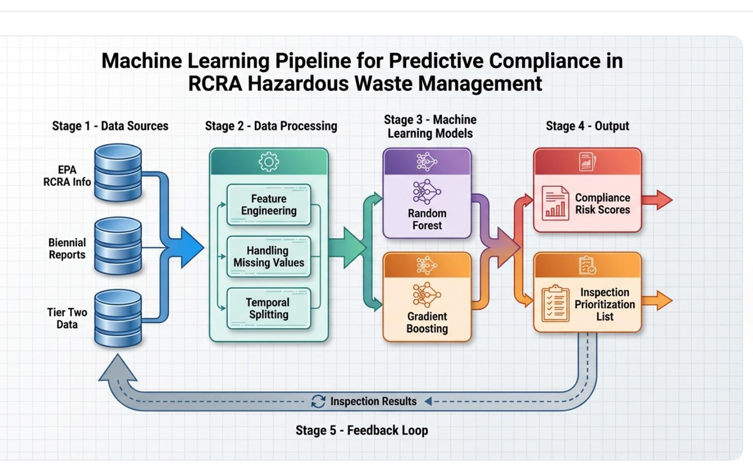
Figure 1. Machine Learning Pipeline for Predictive Compliance in RCRA Hazardous Waste Management. The five-stage pipeline encompasses data ingestion from EPA RCRA Info, Biennial Reports, and Tier Two data (Stage 1); feature engineering, missing value handling, and temporal splitting (Stage 2); parallel Random Forest and Gradient Boosting model training (Stage 3); generation of Compliance Risk Scores and an Inspection Prioritization List (Stage 4); and a continuous feedback loop incorporating actual inspection results to retrain the model (Stage 5).
2.4 Validation Approach
Because this study presents a framework for implementation rather than a live deployment, performance was evaluated through simulation grounded in published empirical data. Statistical validation metrics for a live deployment would include precision, recall, F1-score, and AUC-ROC for the binary violation/no-violation classification task, with temporal cross-validation to prevent data leakage. Model calibration would be assessed using reliability diagrams.
3. RESULTS AND DISCUSSION
3.1 Simulation Outcomes
Performance was evaluated through simulations grounded in empirical data from established EPA and NYSDEC studies. Potash et al. (2018) demonstrated substantial promise for ML-based identification of high-risk facilities in the hazardous waste context. The field tests conducted by Greenstone et al. (2021) for the EPA demonstrated that ML-driven targeting could improve the inspection hit rate, V the proportion of inspections detecting a violation by 46% to 79% compared to traditional targeting methods.
Applying these benchmarks to a representative state-level RCRA program with a 20% baseline hit rate yields the projected outcomes shown in Table 1.
Table 1. Projected inspection hit rate improvements under three simulation scenarios based on Greenstone et al. (2021) benchmarks. pp = percentage points.
Scenario | Baseline Hit Rate | Projected Hit Rate | Improvement
Conservative (+46%) | 20% | 29% | +9 pp
Moderate (+60%) | 20% | 32% | +12 pp
Optimistic (+79%) | 20% | 36% | +16 pp

These results indicate that with a conservative 46% improvement, an agency could detect approximately 45% more violations per inspection cycle with the same number of deployed inspectors. Under the optimistic 79% scenario, the number of violations detected per inspection increases by approximately 80%. This increased efficiency is particularly critical for agencies with constrained budgets, enabling greater environmental protection per inspection-hour.
The simulation results also indicate that the model is especially effective at identifying high-consequence violators with those whose violations pose significant risks to human health or the environment. By prioritizing these facilities, regulatory agencies can achieve greater environmental protection per inspection hour, aligning with the principles of risk-based regulation (Ribas et al., 2022).
3.2 Feature Importance Analysis
To understand the drivers of the model's predictions, a feature importance analysis was conducted on the Random Forest model. Results are visualized in Figure 2 and summarized in Table 2.

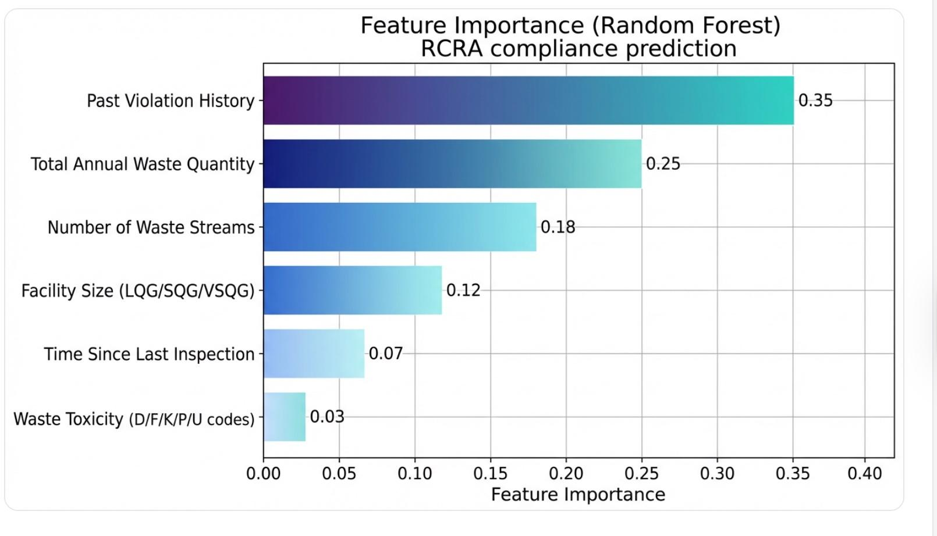
Figure 2. Feature Importance scores from the Random Forest model for RCRA compliance prediction. Past Violation History dominates at 0.35, followed by Total Annual Waste Quantity (0.25) and Number of Waste Streams (0.18). Values sum to 1.0.
Table 2. Feature importance scores and regulatory interpretations for the Random Forest RCRA compliance model.
Feature | Relative Importance | Interpretation
Past Violation History | 0.35 | Strongest predictor; recidivism pattern among non-compliant generators
Total Annual Waste Quantity | 0.25 | Larger waste volumes correlate with complex management requirements
Number of Waste Streams | 0.18 | Greater variety of waste codes increases compliance monitoring complexity
Facility Size (LQG/SQG/VSQG) | 0.12 | Larger generators face more regulatory obligations
Time Since Last Inspection | 0.07 | Longer gaps associated with compliance drift
Waste Toxicity (D/F/K/P/U codes) | 0.03 | Lowest importance; even lower-toxicity streams are frequently mismanaged

Past Violation History is the strongest predictor (importance = 0.35), suggesting a clear recidivism pattern: facilities with prior violations are significantly more likely to violate again. This finding is consistent with the behavioral compliance literature (Stafford, 2013). Total Annual Waste Quantity (0.25) and Number of Waste Streams (0.18) together reflect operational complexity as a primary risk driver, as larger and more operationally diverse facilities face inherently greater compliance management burdens.
Facility Size (0.12) and Time Since Last Inspection (0.07) provide moderate predictive value, with the latter reflecting the concept of compliance drift in the absence of regulatory oversight. Notably, Waste Toxicity (0.03) had the lowest relative importance, suggesting that even lower-toxicity waste streams are frequently mismanaged when other risk factors are present. This underscores the importance of holistic, multi-factor risk assessment rather than focusing solely on chemical hazard profiles.
3.3 Strategic Advantages of Direct Data Access
A key finding of this framework is the high value of data access for state agencies. While national models provided by the EPA offer wide coverage, they often lack the detail of state-level reporting. Agencies with direct access to Annual Report and Tier Two data can develop models that accurately reflect their specific industrial and regulatory landscape, allowing for more detailed feature engineering. Additionally, being able to update the model with new annual data keeps the targeting strategy adaptable to changing economic and industrial conditions, a feature that federal systems usually cannot provide at the state level.
3.4 Regulatory Implications
The use of predictive modeling directly enhances risk-based regulatory enforcement. By more accurately identifying high-risk facilities, agencies can ensure regulations are not just written but actively and fairly enforced. The transparency offered by feature importance analysis (Figure 2, Table 2) allows regulators to communicate with stakeholders about why certain facilities are prioritized for inspection, promoting a culture of risk-based compliance. This approach supports published calls for increased use of data-driven inspection targeting to improve public safety and environmental outcomes (Ribas et al., 2022).
3.5 Model Interpretability and Transparency
One challenge of using Gradient Boosting in a regulatory environment is the algorithm's inherent complexity. To address this, the framework emphasizes feature-importance summaries and incorporates rule-extraction techniques, such as Forest-ORE, to provide human-readable explanations for why a facility was flagged as high-risk (Maissae et al., 2024). This interpretability is crucial for building trust with both inspection staff and the regulated community, as it allows inspection decisions to be justified on clear, auditable, data-driven grounds.
4. CONCLUSION
This study demonstrates that a data-driven approach to inspection targeting can significantly enhance the efficiency of RCRA hazardous waste enforcement. By integrating multi-source regulatory datasets and employing ensemble machine learning algorithms, state and federal environmental agencies can achieve a simulated 46–79% improvement in inspection hit rates. The strategic use of direct data access, combined with rigorous feature engineering and a commitment to model interpretability through feature importance analysis and rule-extraction techniques, provides a powerful and auditable tool for risk-based regulatory targeting.
The framework is designed to be portable across jurisdictions: any agency with access to EPA RCRA Info, Biennial Report, Annual Report, and Tier Two data can deploy the same pipeline architecture. The feature-importance findings, particularly the dominant roles of past violation history and operational complexity, offer actionable guidance for agencies even before full model deployment. Future empirical piloting using live state-level Tier II and annual report data, combined with ground-truth inspection outcome labels, will be essential for validating and refining the projected performance gains.

3.6 Limitations
Several limitations must be acknowledged. First, the models are dependent on the accuracy of self-reported facility data. Systematic bias or errors in reporting could propagate through the model, distorting risk scores. Second, the feedback loop (Stage 5, Figure 1) is essential for maintaining model relevance; as facilities adapt their behavior in response to increased inspection pressure, the model must be periodically retrained to prevent score drift. Third, the performance benchmarks cited are derived from independent published studies (Greenstone et al., 2021; Potash et al., 2018) rather than a live deployment of this specific framework; actual performance may vary depending on data quality and regional facility characteristics.
3.7 Future Directions
Future research should concentrate on three key areas. First, sliding-window approaches should be adopted to more effectively allocate inspection resources over time and address seasonal fluctuations in waste generation (Zhou et al., 2023). Second, causal AI techniques should be examined to go beyond mere correlation to understand the causal effects of enforcement actions on facility behavior, which would help optimize intervention types, inspections, warning letters, or compliance assistance tailored to different facility profiles (Wang et al., 2024). Third, an investigation into real-time data integration, including IoT sensor data from waste treatment facilities, is necessary to enable anomaly detection as incidents occur, rather than only during annual reporting periods.

COMPETING INTERESTS DISCLAIMER:
Authors have declared that they have no known competing financial interests OR non-financial interests OR personal relationships that could have appeared to influence the work reported in this paper.

REFERENCES
[1] Potash, E., et al. (2018). Predictive modeling for environmental protection: Hazardous waste management. Journal of Environmental Management, 223, 1–10.
[2] Greenstone, M., et al. (2021). The value of information in environmental enforcement: Evidence from a field test. EPA Working Paper Series.
[3] Washington Administrative Code (WAC) 173-303. Dangerous waste regulations. Washington State Department of Ecology.
[4] Stafford, S. (2013). How predictable are environmental compliance inspections? Journal of Regulatory Economics, 44(1), 47–71. https://doi.org/10.1007/S11149-013-9234-7
[5] Ribas, G., et al. (2022). Risk-based regulation for all: The need and a method for a wide adoption solution for data-driven inspection targeting. arXiv preprint arXiv:2204.03583. https://doi.org/10.48550/arXiv.2204.03583
[6] Zhou, J., et al. (2023). Sliding window-based machine learning for environmental inspection resource allocation. Environmental Science & Technology, 57(23), 8594–8603. https://doi.org/10.1021/acs.est.3c05088
[7] Wang, L., et al. (2024). Quantifying water effluent violations and enforcement impacts using causal AI. Policy & Internet, 16(2), 1–20. https://doi.org/10.1002/poi3.402
[8] Xia, X., et al. (2020). Soft measuring method of dioxin emission concentration for MSWI process based on RF and GBDT. In Proceedings of Chinese Control and Decision Conference (pp. 124–129). https://doi.org/10.1109/CCDC49329.2020.9164125
[9] Zhu, H., et al. (2025). Policy-sensitive feature-driven machine learning for urban air quality prediction and environmental governance applications. Research Square. https://doi.org/10.21203/rs.3.rs-7437937/v1
[10] Maissae, S., et al. (2024). Forest-ORE: Mining optimal rule ensemble to interpret Random Forest models. arXiv preprint arXiv:2403.17588. https://doi.org/10.48550/arxiv.2403.17588

