Numerical Investigation of Thermal and Hydraulic Performance for Grid-Type Earth-to-Air Heat Exchangers: A Comparative Study of U-Type and Z-Type Configurations

Keywords:  EAHE system; Greenhouse cooling; Grid configuration (U-type, Z-type), Numerical CFD simulation; passive and renewable; Thermal–hydraulic performance. | Abstract  Heating and cooling needs in greenhouses constitute a significant portion of total energy use, and therefore the adoption of passive and renewable approaches is important. Earth-to-air heat exchangers (EAHEs) exploit the relatively constant subsurface temperature to precondition ventilation air and may provide a sustainable option for greenhouse applications. Although grid-type configurations are particularly relevant to systems that require relatively large airflow rates, most previous studies have discussed isolated performance indicators under different geometrical and operating conditions, which makes fair comparison difficult. This study presents a numerical comparison of two grid-type EAHE configurations, Z-type and U-type, under identical geometric and operating conditions using four dimensionless performance parameters: thermal effectiveness ε, total pressure-loss coefficient K, airflow division uniformity coefficient Ω, and overall performance factor η* (defined as the ratio of heat-transfer rate to pumping power). The results show that the U-type layout improves flow distribution and reduces hydraulic losses. Ω increased from 0.79 to 0.87 for the U-type, while it decreased from 0.73 to 0.64 for the Z-type, resulting in a 38% improvement at high flow rates. Total pressure losses decreased by more than 28%, resulting in a corresponding reduction in fan-power demand. The thermal performance remained relatively similar, with ε differences ranging from 1% to 2%. However, η* was consistently higher for the U-type arrangement, exceeding the Z-type by more than 40% at the highest Reynolds number. The results indicate that the U-type EAHE offers the better overall thermal-hydraulic performance for passive, energy-efficient greenhouse ventilation.

Introduction

One of the main challenges today is the high amount of energy required for heating and cooling for greenhouse in agricultural section, which makes the use of renewable energy sources increasingly important. Geothermal energy constitutes a substantial category of renewable energy applicable in many sectors, including power generation, space heating, and cooling systems. The interest in sustainable and passive technology has been increasing. Earth-to-air heat exchangers have emerged as sustainable solutions in ventilation and air-conditioning systems due to their capacity to draw on the relatively steady soil temperature at a specific depth (3-4 m) to improve the quality of incoming air. By exchanging heat between the air and the ground, the system can provide cooling during the summer and heating during the winter. The grid-pipe configuration is very significant among the diverse design layouts. In this layout, a header pipe is installed at both the entrance and the exit: ambient air is distributed through several buried parallel pipes and then collected before being supplied to the indoor space, as seen in Figure 1. This configuration is suitable for large buildings that require a lot of preconditioned air to flow through them. Given this importance, several previous studies investigated grid-type EAHE arrangements from different aspects, such as heat transfer, effectiveness, the effect of pipe diameter and number, and airflow distribution patterns in the network.
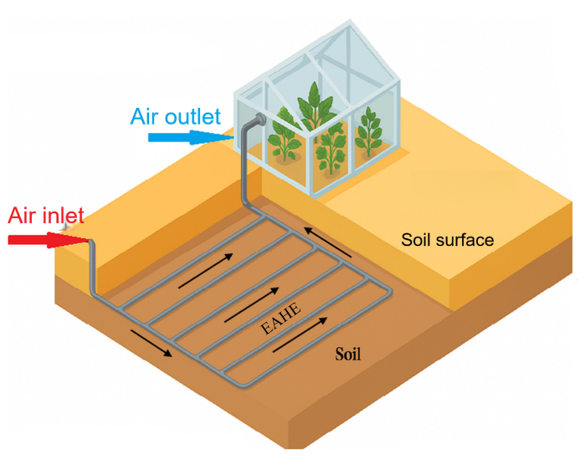

Figure 1: Schematic of EAHE system.

Previous studies have extensively investigated the design and performance of Earth-to-Air Heat Exchanger (EAHE) systems, with particular emphasis on grid-type configurations and their thermo-hydraulic behavior under various operating conditions.
Badescu and Isvoranu [1] created a mathematical approach in the evaluation of different grid geometries and airflow paths and showed that Z-paths can be more thermally efficient than U-paths. Whereas, Amanowicz and Wojtkowiak [2] carried out an experiment on the hydraulic and flow distribution characteristics of grid designs. The analysis showed that alterations of air supply scheme including transition of Z-type to U-type can be successfully used to enhance uniformity of airflow and reduction of pressure loss, which is 9 per cent better heating transfer performance as compared to the conventional Z-type design. The relevance of the effect of the geometric parameters and airflow distribution on overall performance was proven by the subsequent analyses. Ahmed et al [3] numerical and experimental analysis of a grid EAHE system was performed in a hot-humid climate with major consideration to the length of pipes, their diameter, and the flow rate as some of the factors that influence the cooling potential. Amanowicz and Wojtkowiak [4, 5] motivated further research by them which demonstrated the influence of non-uniform airflow in grid pipes. Their results showed that under static pressure imbalance in pipes it is possible to achieve variation in the flow distribution which is up to five times, thereby increasing the overall pressure losses and reducing thermal efficiency. Amanowicz [6] in CFD and simulated models showed that modification of air supply configuration between Z-type and U-type leads to a reduction of total pressure losses by 6-36% and enhancement of flow uniformity by 11-80%. A number of applied studies have provided significant information with regards to the functioning of EAHE systems under a variety of environmental conditions. Sakhri et al. [7] conducted experiments in dry Algerian conditions, but demonstrating the high level of heating and cooling efficiency of the system in various seasons. Mushtaq and Muter [8] focused on the benefits of grid arrangement in poultry houses in Nasiriyah, and Ahmad and Prakash [9] experimented to identify the effects of pipe diameter and velocity on effectiveness, and Mohammed et al. [10] modeled alternative EAHE systems in Iraq, which validated that multi-pipe systems have high potential as a cooling system. Recently, Eman Hummood et al. [11] carried out a numerical experiment whereby computational fluid dynamics was used to find out the impacts of the disturbed soil thickness on the effectiveness of Earth-to-Air Heat Exchangers (EAHE) when the length of the pipes was varied and lengthened with varying flow velocities in Nasiriya, in southern Iraq. The results revealed that there were at least changes in the flow velocity or pipe length in determining the temperature of the wall at the 1D to 6D levels in low velocities. This stability is associated with the effect of the temperature around the growing layer of soil on its growing thickness. Sofyan et al. [12] applied Ansys Fluent to measure the cooling performance of EAHE systems in parallel and series configurations. Their results showed that losses of pressure in parallel systems were about six times less than those in series systems. It was found that parallel systems were more efficient by approximately 15 percent than series systems even though the latter produced air at much lower temperatures than the former.
Though previous studies have enabled improvement of understanding of EAHE systems, most of them have addressed one aspect of performance i.e., either thermal, hydraulic or geometric performance with other operating and boundary conditions. This weakness complicates the direct comparison of their results and the general conclusions. Moreover, a limited number of studies have been able to conduct a comprehensive comparison of the various grid-type layouts under identical conditions in terms of which a set of equivalent dimensionless performance measures is used. As such, there is a research gap on the topic of fair and overall performance comparisons in different layouts.
To address this gap, the present numerical study compares two grid-type EAHE configurations, Z-type and U-type, under identical operating and geometric conditions. The comparison is intended to isolate the effect of the flow path alone, since both layouts have the same pipe number, pipe diameter, buried length, and burial depth. Four dimensionless indicators form the basis of the investigation: the effectiveness (ε), the total pressure-loss coefficient (K), the airflow uniformity coefficient (Ω), and the overall performance factor (η*). Taken together, these indicators provide a standardized framework for a fair comparison between the two layouts and make it possible to interpret the thermal benefit together with the hydraulic penalty.

Problem Description

The model studied in this paper is a 3D grid-pipe earth-to-air heat exchanger system used for greenhouse cooling, investigated in two layouts: U-type and Z-type. The geometry was selected to represent a practical small-greenhouse application under Nasiriyah conditions while maintaining the same pipe material, diameter, branch length, spacing, and burial depth in both layouts so that only the effect of the flow path is examined. The EAHE was modeled using PVC pipes that are 3 mm thick. Both structures are designed as a buried grid at a depth of 3.5 m, where it is composed of six parallel pipes with a 1 m interval between them, a diameter of 0.1016 m, and a length of 6.93 m. All six pipes are joined by two main pipes having a diameter of 0.1016 meters and a length of 5.7 m.

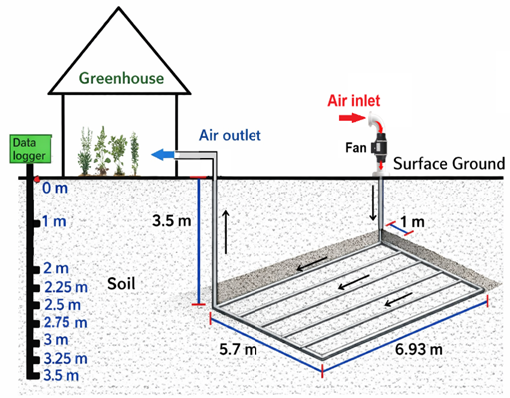
Figure 2: Schematic of EAHE system with greenhouse.
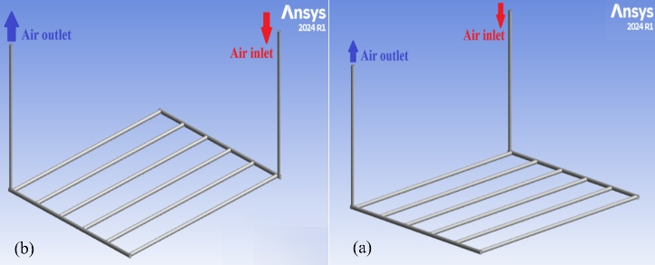
Figure 3: Geometric models of the EAHE: (a) U-type and (b) Z-type.
Disturbed soil
The soil layer in the vicinity of the EAHE pipe is affected by heat transfer, and this region is referred to as the thermally disturbed soil illustrated in Figure 4.
There is no universal formula to calculate the thickness of the thermally disturbed soil layer [13], as it strongly depends on soil thermal properties, climatic conditions, and operational parameters of the EAHE system, several researches suggested that the thickness of disturbed soil should be equivalent to the radius of the pipe (δ = R₁) [14, 15], twice the pipe diameter [16] and four times the pipe diameter [17].
In this study, the disturbed soil domain radius (R₂) was taken to be twice the outer radius of the pipe (R₂ = δ + R₁) [15].
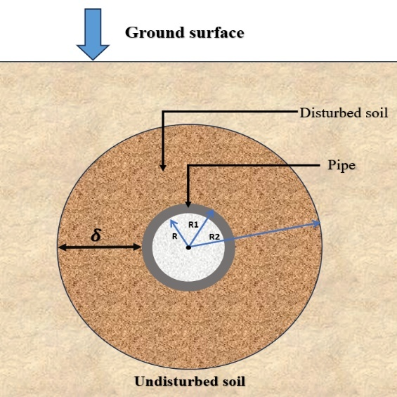
Figure 4: The cross-sectional schematic of the EAHE pipe depicts the thickness of the disturbed soil layer.
Mathematical Model

In order to simplify the analytical formulation and ensure the problem's tractability, the mathematical model was constructed based on certain simplifying assumptions [18, 19]:
1-The system operates under steady-state conditions.
2-The flow velocity is uniform and constant throughout the domain.
3-The soil exhibits consistent physical characteristics and remains of a homogenous.
4-The airflow is described as subsonic (M<0.3), letting its treatment as an incompressible fluid with assumed constant thermal conductivity, density, and specific heat capacity.
5-Perfect thermal contact exists between the pipe wall and the surrounding soil.
6-A turbulent flow regime (Re > 4000) is observed inside the pipe, and the corresponding turbulent correlations are applied.

Governing equations and boundary conditions

This analysis employed the following equations of heat transfer and fluid flow [11, 20]:
Continuity equation:
$div \overline{V}$ = 0 (1)
Momentum equations:
x-dir.
$\frac{∂\overline{u}}{∂t}+div \left(\overline{u} \overline{V}\right)+ div\left(\overline{uˈ Vˈ}\right)= - \frac{1}{ρ} \frac{∂\overline{p}}{∂\overline{x}}+ ν div \left(grad \left(\overline{u}\right)\right)$ (2)
y-dir.
$\frac{∂\overline{v}}{∂t}+div \left(\overline{v} \overline{V}\right)+ div\left(\overline{vˈ Vˈ}\right)= - \frac{1}{ρ} \frac{∂\overline{p}}{∂\overline{y}}+ ν div \left(grad \left(\overline{v}\right)\right)$ (3)
z-dir.
$\frac{∂\overline{w}}{∂t}+div \left(\overline{w} \overline{V}\right)+ div\left(\overline{wˈ Vˈ}\right)= - \frac{1}{ρ} \frac{∂\overline{p}}{∂\overline{w}}+ ν div \left(grad \left(\overline{w}\right)\right)$ (4)
Energy equation:
$\frac{∂U\tilde{T}}{∂x}+ \frac{∂V\tilde{T}}{∂y}+ \frac{∂W\tilde{T}}{∂z}=\frac{k}{ρ cp} \left(\frac{∂}{∂x} \left(\frac{∂\tilde{T}}{∂x}\right)+ \frac{∂}{∂y} \left(\frac{∂\tilde{T}}{∂y}\right)+ \frac{∂}{∂z} \left(\frac{∂\tilde{T}}{∂z}\right)\right)$ (5)
The effectiveness of earth to air heat exchanger can be defined as [21]:
$ε=\frac{T_{i}-T_{o}}{T_{i}-T_{s}}$ (6)
Where Ts refers to the undisturbed soil temperature, which is assumed to be equal to the temperature of the pipe wall [22].
The overall performance factor (η*) is employed to evaluate the overall performance of the EAHE system. It is defined here as the ratio of the heat-transfer rate between air and soil to the necessary air pumping power [15, 23]. Since both quantities are expressed in watts, η* is dimensionless and directly reflects the balance between thermal benefit and hydraulic penalty.
$η^{*}= \frac{Q_{EAHE}}{P.P}$ (7)
The heating and cooling potential of EAHE system has been determined using the following equation. [10]:
$Q_{EAHE}=\dot{m }C_{P} \left( T_{i}-T_{o}\right)$ (8)
P.P: is the pumping power, as computed by Eq. (9) [11]:
$P.P=\dot{V}{ ∆P}_{tot}$ (9)
$\dot{V}=\frac{\dot{m}}{ρ}$ (10)
Pressure drop denotes a difference in total pressure between the inlet and outlet sections of the EAHE pipes:
${∆P}_{tot}=P_{i}-P_{o}$ (11)
The total pressure loss coefficient (K) is a nondimensional value which is used to represent the degree of resistance of flow experienced in a system. It develops a correlation between the total pressure drop and dynamic pressure of the moving fluid. The coefficient is used as a basic measure in the evaluation of system configurations, the establishment of energy dissipation, and substantiation of power needs of fans in ventilation systems and heat exchange systems. The coefficient is calculated using Eq. (12) [6]:
$K=\frac{2 .{ ∆P}_{tot}}{ρ.{ v}^{2}}$ (12)
Flow uniformity coefficient (Ω) is a non-dimensional value that characterizes the evenness of the total volumetric flow distribution across the parallel pipes. This study relates flow maldistribution to system performance by analyzing grid-pipe EAHE layouts with the same number of parallel pipes under identical conditions. The ideal equal share, denoted by Ω = 1, signifies a perfectly uniform distribution, while Ω < 1 reflects growing maldistribution. The formulation adopted in Eq. (13) follows [24] and was selected because it directly compares the branch flow rates with the mean branch flow rate, which makes it suitable for comparing layouts of the same exchanger size.
$Ω=1-\frac{1}{{\dot{V}}_{a}} .\sqrt{\frac{\sum_{i=1}^{n}{{({\dot{V}}_{i}-{\dot{V}}_{a})}^{2}}}{n(n-1)}}$ (13)
Boundary conditions:
The following boundary conditions have been utilized _{t}o complete the model:
Inlet boundary condition:
At the inlet of the EAHE pipe, constant velocity values of 3, 5, 7, 9, 11, 13, 15, and 17 m/s were prescribed to represent a wide operating range from low to high airflow rates. This range was selected to show the thermal-hydraulic trade-off over practical operating conditions and to include the upper design point required for the greenhouse application considered in this study. The inlet dry-bulb temperature (T_{i}) was defined for turbulent-flow conditions. A constant inlet temperature of 50°C was imposed to represent the severe summer ambient conditions of Nasiriyah, southern Iraq, based on recorded temperatures during the hottest days of July 2025.
Outlet boundary conditions:
At the outlet, the relative pressure was considered zero atmospheric pressure.
Wall:
The horizontal part of the EAHE pipes is subjected to a constant soil-temperature boundary condition, as demonstrated in Figure 2. The wall temperature is maintained at 𝑇_{𝑠} = 26.1 ∘ C, representing the undisturbed-soil temperature measured experimentally in the present study at a depth of 3.5 m in southern Iraq and consistent with the value reported for the study area in [25]. The two vertical segments were assumed to be adiabatic to simplify the numerical solution. Since the temperature changes along these two sections occur in opposite directions, their overall effect on the outlet air temperature is expected to be small compared with the horizontal buried section, where the surrounding soil temperature remains relatively stable. This assumption has been widely adopted in previous EAHE numerical studies [7], [13].
Numerical Solution:
The finite volume approach is used to numerically solve the governing equations and boundary conditions system mentioned above. Computational Fluid Dynamics (CFD) modeling is employed to solve the three-dimensional Navier–Stokes equations and to simulate the development of the airflow.
Computational Fluid Dynamics (CFD) modeling:
The primary purpose of using Computational Fluid Dynamics (CFD) in the present work is to predict the airflow and heat-transfer behavior inside the EAHE pipes under the specified boundary conditions [25]. ANSYS Fluent 2024 R1 software was used to conduct the CFD analysis. To simulate turbulent flow, the realizable k–ε turbulence model with enhanced wall treatment was adopted. This model was selected because it provides stable and reliable predictions for turbulent internal flows in ducts and manifolded pipe systems and has been used successfully in comparable EAHE studies [5, 6, 11]. The energy equation was solved because heat transfer was included in the computational model. CFD modeling makes it possible to determine the airflow characteristic values at multiple points within the EAHE system through the numerical mesh. The convergence criterion for the momentum and energy equations was taken as 1 × 10⁻⁶.

Mesh independence test:
A mesh independence test was conducted as part of the mesh sensitivity analysis to ensure that the numerical results are not influenced by the mesh resolution. Four progressively refined meshes were examined. The selected Mesh 3 contained approximately 4.23 × 10⁶ elements. The final mesh quality was acceptable, with a maximum skewness of 0.757 and a minimum orthogonal quality of 0.243. Figure 5 presents the outlet-air temperature profile for the tested meshes. The change in outlet temperature from Mesh 3 to Mesh 4 was negligible (ΔTo ≈ 0.0004 K), which indicates grid-independent results. Therefore, Mesh 3 was selected as a practical compromise between solution accuracy and computational cost. Table 1 summarizes the tested meshes, their element counts, and the predicted EAHE outlet-air temperature 𝑇_{𝑜}.
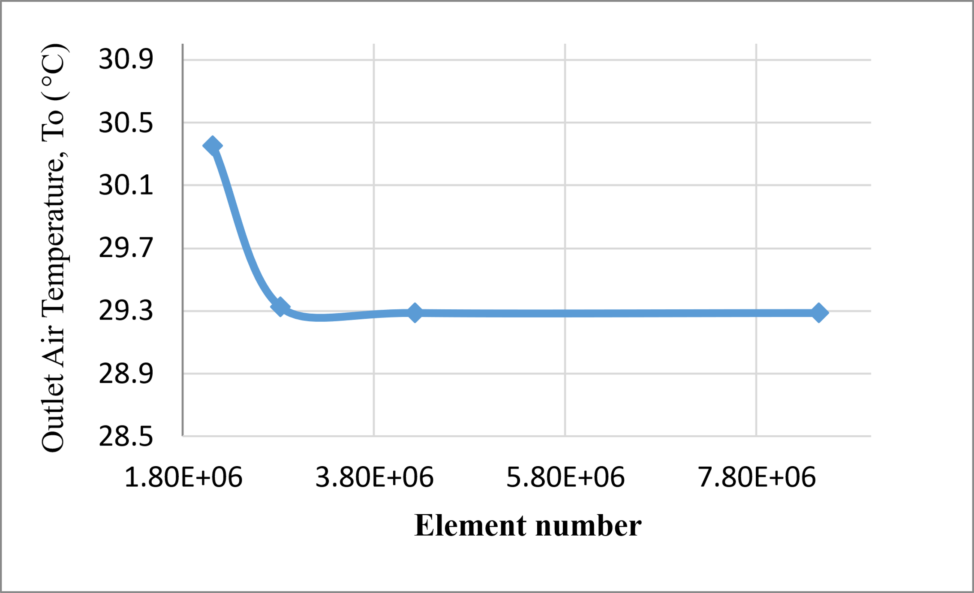 | Table 1: Mesh-independence test.  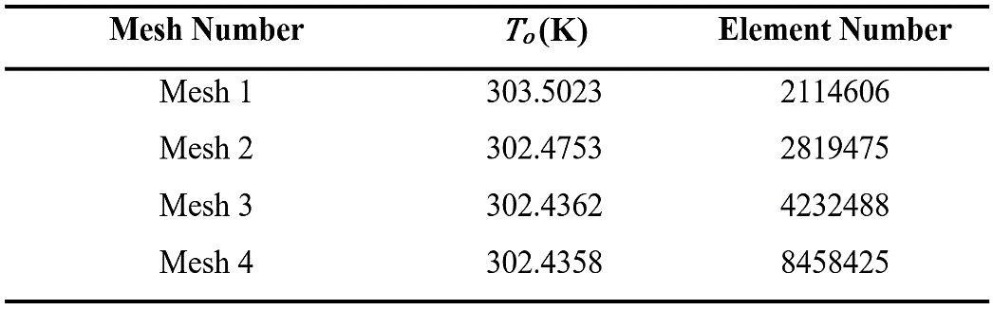
Figure 5: Effect of the element number on the outlet air temperature of the EAHE.

Results and discussion:

To verify the developed numerical model, the experimental and numerical benchmark case reported in [26] was reproduced under the same geometry and operating conditions. The EAHE system described in [26] consists of a pipe with a diameter of 0.1016 m, a length of 11.88 m, and a burial depth of 3.5 m. Air was driven through the pipe at a constant velocity of 4.52 m/s, with inlet temperatures ranging from 33°C to 52°C, while the pipe surface temperature was maintained equal to the undisturbed soil temperature of 30°C. Figure 6 compares the simulation results of the present model with the experimental and numerical results reported by Hasan and Eman [26] for the relationship between inlet and outlet air temperatures. The figure shows excellent agreement between the current model and the reference data, with average errors of 3.03% and 0.08%, respectively. These small deviations indicate that the current numerical model is implemented correctly and is sufficiently accurate for the reference thermal case. Although the benchmark used for verification is thermal in nature, the airflow distribution and pressure-loss trends predicted in the present study are in line with previously reported investigations of multi-pipe EAHE flow performance [2], [4], [5], [6].
The numerical simulations were conducted under the climatic conditions of Nasiriya, southern Iraq, assuming constant thermal and physical properties of air and soil, as listed in Table 2.

Table 2: The thermos physical properties of air and soil [13].

Material | Density  (kg/m³) | Specific heat (J/kg. °C) | Thermal conductivity (W/m. °C)
Air | 1.225 | 1007 | 0.0242
Saturated soil | 2000 | 880 | 1.4
PVC | 1380 | 900 | 0.16

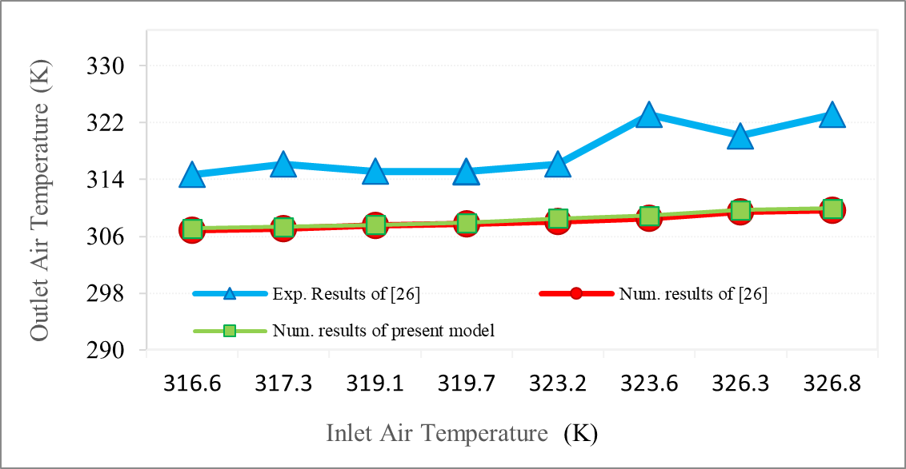

Figure 6: Variation of outlet air temperature with inlet air temperature as a comparison between the present model with numerical and experimental result of [26].

Hydraulic Performance:
In Figure 7, the velocity distribution across the parallel pipes shows a gradual variation. The color variations are rather regular, which means that the air velocity variations across pipes are not excessive. The gradual decline in velocity can be explained by frictional pressure losses along the pipe walls and changes in the flow direction within the grid pipe. Both of these factors relate to the observed decrease in velocity.
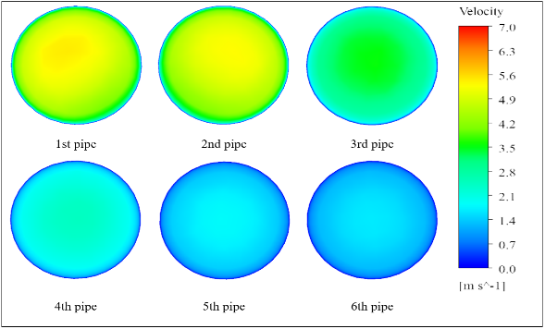

Figure 7: Velocity contours on the YZ cross-sectional plane at the mid-length of parallel pipes in the U-type EAHE parallel pipes.
Figure 8 indicates that the velocity change across the pipes was not even. Close to uniform blue-cyan outlines, which are synonymous with low and stable velocities, are found on the first four pipes. The fifth pipe is revealed in a green color which means the moderate velocity and the sixth pipe is in the red-orange color that demonstrates the maximum velocity of the airflow. This is caused by the Z-type flow design and the nature of the pressure drop causes more airflow to flow in the direction of the terminal pipes that have lesser hydraulic resistance.

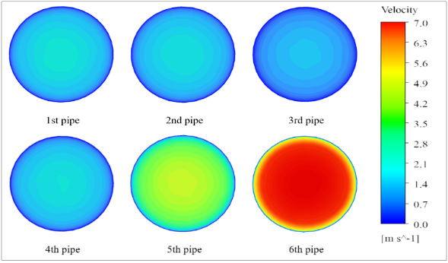

Figure 8: Velocity contours on the YZ cross-sectional plane at the mid-length of parallel pipes in the Z -type EAHE parallel pipes.
In Figure 9, the pattern of velocity distribution along the pipes is more uniform. As the color transitions between the inlet and the outlet are relatively gradual, the air flowing through the 1st to the 6th pipe constantly reduces. The gradual decrease in the velocity of the air that is observed can be attributed to the fact that the energy on the path of flow is constantly dissipated, and frictional losses that oppose the movement. The U-type design provides an opportunity to distribute the airflow more evenly through the pipes to minimize impactful maldistribution.
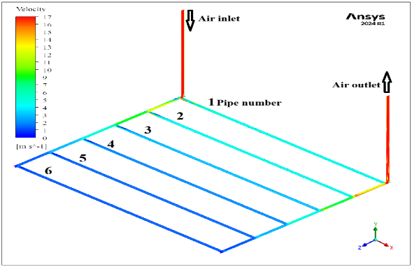
Figure 9: Velocity contour distribution on the XZ longitudinal plane, illustrating the airflow behavior within the U-type EAHE parallel pipes.
Figure 10 shows a clear non-uniform velocity distribution. Red and orange show higher velocity, while the other pipes mostly show blue, indicating much lower velocity. The last pipe next to the outlet has the most airflow. The Z-type configuration has an uneven flow distribution because of the idea of minimal hydraulic resistance. This means that more air flows into the last pipes. So, the Z-type configuration has more speed changes than the U-type configuration.

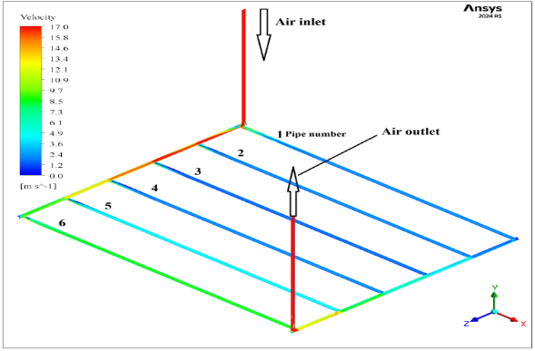
Figure 10: Velocity contour distribution on the XZ longitudinal plane, illustrating the airflow behavior within the Z-type EAHE parallel pipes.
Figure 11 exhibits a U-type, where the pressure is more evenly distributed out along the pipes. This means that the flow pattern in the arrangement is more balanced. The air flows from the intake to the outlet, and the pressure slowly drops. The color transitions from green to yellow at the inlet, where pressure is elevated, and shifts to light cyan at the outlet, where pressure is reduced. The consistent and uniform pressure drop across the parallel pipes maintains a relatively similar airflow pattern throughout the entire system.
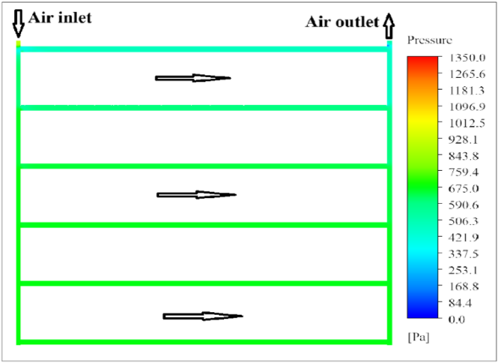
Figure 11: Static pressure distribution on the longitudinal plane located along the pipe axis of the 6-pipe EAHE in the U-type configuration.
Figure 12 displays the entrance’s location in the Z-type, which has the highest-pressure values, which subsequently gently drop down the pipe's length. The decrease can really be seen around the last pipe's outlet area. The last pipe lets more air through since it has less hydraulic resistance. This means that the air doesn't flow the same way all over. Flowing semiequally through the pipes in accordance with the above-mentioned pressure distribution.
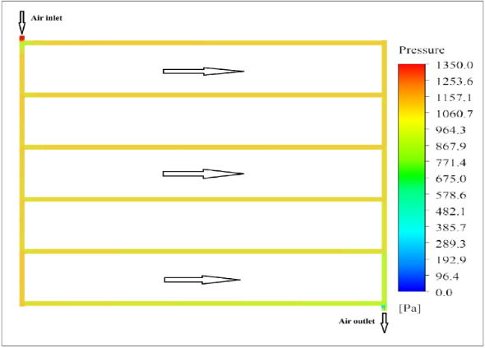

Figure 12: Static pressure distribution on the longitudinal plane located along the pipe axis of the 6-pipe EAHE in the Z-type configuration.
Figure 13 shows the distribution of the airflow in the Z-type and U-type layouts considerably differs. A concentration of the airflow toward the last pipes of the grid (especially on the 6th pipe where it reaches 225.8 m³/h) is observed with Z-type configuration. This irregular trend indicates the effect of the continually decreasing hydraulic resistance parallel to the flow direction, which causes notable maldistribution. The U-type layout shows a consistent distribution through the pipes, and pipe 1st holds the highest flow rate (124.8 m³/h) and a gradual decrease towards the final pipe. This is a semi-uniform distribution of the U-type layout, which becomes more effective in hydraulic and thermal efficiency.
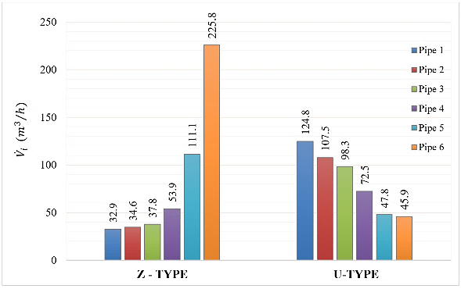

Figure 13: Comparison of airflow division between Z-type and U-type EAHE layouts.
Figure 14 illustrates the change in the degree of uniformity coefficient of the airflow Ω with Reynolds number of U-type and Z-type EAHE systems. In the case of the U-type, Ω is rising continuously at approximately 0.79 at Re =1.9 x 10 4, to approximately 0.87 at Re = 10.8 x 10 4 meaning that this layout maintains a steady distribution of airflow to higher flow rates. This action is in agreement with the pattern of semi-uniform flow and the distribution of pressure that is well balanced in the manifolds. However, by contrast, the Ω of Z-type appears to decrease steadily between 0.73 and 0.64 throughout the similar Reynolds number. This tendency indicates that a greater velocity results in a decrease in uniformity of the airflow. This is explainable by the fact that there is significant pressure gradient which helps to push air through the pipes that are situated near the inlet and the outlet sections. The green curve shows the percentage change (∆Ω %) of U-type to Z-type. The enhancement is about 15 per cent at low Reynolds numbers to an almost 38 per cent at the largest number of numbers tested. This implies that the U-type has enhanced capabilities of flow distribution, especially during high flow situations. The improvement of the airflow distribution coefficient percentage was evaluated with the help of the Eq. (14):
$∆Ω \% = \left|\frac{Ω_{ U}-{Ω }_{Z}}{{Ω }_{Z}}\right| ×100$ (14)
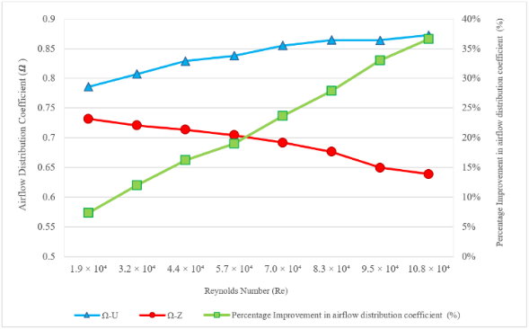

Figure 14: Comparison of the variation of the airflow distribution coefficient (Ω) with the Reynolds number for U- and Z-type configurations and the percentage improvement between Z- and U-type EAHE configurations.
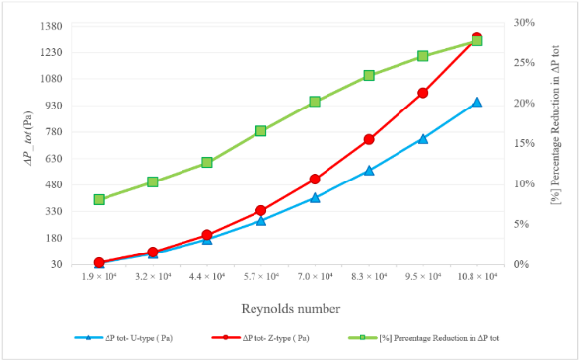

Figure 15: Comparison of total pressure losses and its percentage reduction between Z-type and U-type EAHE configurations at different Reynolds numbers.
Figure 15 illustrates the total pressure loss for the Z-type and U-type EAHE setups at different Reynolds numbers. It also shows the relative reduction in total pressure loss (ΔPₜₒₜ %). The Z-type loses roughly 1300 Pa of pressure at the greatest Reynolds number, whereas the U-type loses just about 940 Pa. As the flow rate goes up, the differences become evident because of more friction and a longer flow path in the Z-type configuration. The green curve indicates that the relative reduction in total pressure loss exceeds 28% at the highest flow rate, as calculated by Eq. (15):
${ΔP}_{tot} \% = \left|\frac{\left({{ΔP}_{tot},}_{U}- {{ΔP}_{tot},}_{Z}\right)}{{{ΔP}_{tot},}_{Z}}\right|× 100$ (15)
These results indicates that the U-type configuration looks to have a hydraulic advantage since the pressure losses are always reduced, no matter what the operating conditions are When Reynolds numbers are high and pressure losses have a large influence on how well a hydraulic system performs and its power is consumed, the U-type configuration is more hydraulically efficient than the Z-type.
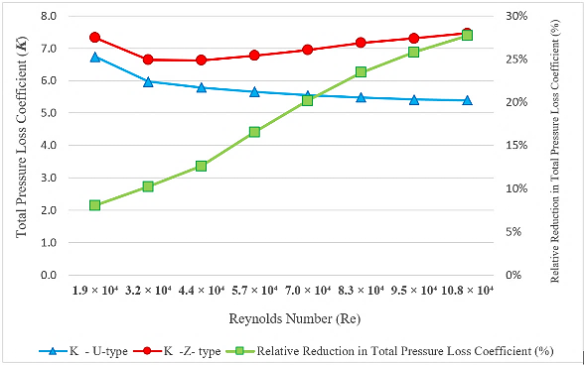

Figure 16: Comparison of the total pressure losses coefficient (K) and its relative reduction with Reynolds number between Z-type and U-type EAHE configurations.
Figure 16 shows that the Z-type always has the highest coefficients of total pressure loss (K) than the U-type, irrespective of the Reynolds number indicating the flow resistance. The K of the Z-type is 6.8 to 7.5, where the U-type is 5.2 to 5.8 meaning that the U-type is better in hydraulics. The percent change in the relative reduction (∆K %), increases with the Reynolds number to a point where the relative reduction is at approximately 30 percent of the highest flow rate. Equation (16) was used to compute the relative decrease in that of total pressure losses coefficients:
$∆K \% = \left|\frac{K_{ U}-K_{ Z}}{K_{Z}}\right| ×100$ (16)
The comparison of the results reveals that the U-type design offers a more diffuse airflow distribution and lower hydraulic losses, especially at high Reynolds numbers, and, thus, is better at hydrostatic performance.
As shown in Figure 17, the power input in fans in both designs rises as Reynolds number rises, as flow rates increase and so does the pressure loss. Z-type structure always requires additional power of fans compared to the U-type structure. The green curve shows the percentage change of fan power consumption (ΔP.P %) which approaches steadily higher since low Reynolds numbers about 7 percent and approaches 28 percent at the extreme case. Eq. (17) was applied in calculating the relative reduction:
$∆F.P \% = \left|\frac{{F.P}_{ U}-{F.P}_{ Z}}{{F.P}_{ Z}}\right| ×100$ (17)
This tendency proves that the U-type layout is more energy-efficient than the Z-type one is significantly as the airflow rate and friction rise. The fact that the U-type system has a lower total pressure losses and more even distribution of airflow is the main reason why the difference between the two systems is larger.
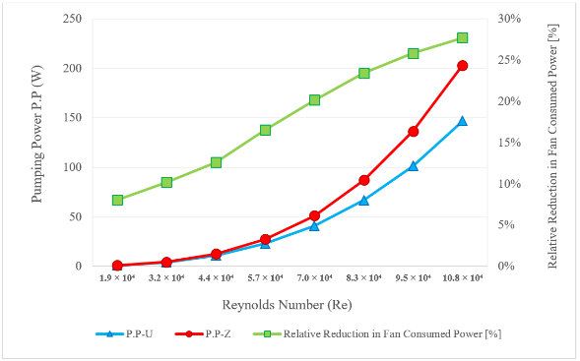

Figure 17: Comparison of fan power consumption and its relative reduction between U-type and Z-type EAHE configurations across different Reynolds numbers.
Thermal Performance:
Figure 18 (U-type structure) indicated that the temperature of the pipes is gradual but relatively constant and the temperature decreases gradually. The temperature analysis of the first three pipes is much high, and the remaining three pipes have lower temperatures as seen by the changing of yellow-green to blue. Such a layout demonstrates a more balanced airflow and a more efficient moving of the heat over the pipes.
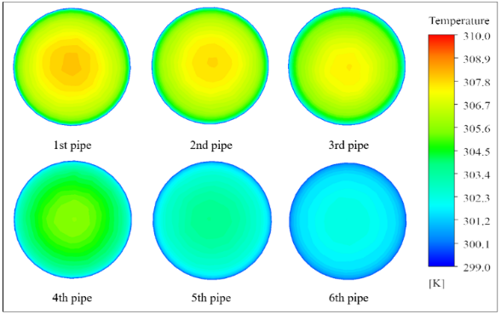

Figure 18: Temperature contour distribution on the YZ plane at the mid-length of the parallel pipes of the U-type EAHE.
Figure 19 displays the temperature distribution is uneven (the Z-type configuration). The pipes continuing to the left of the entrance are cooler in temperature than the 5th and 6th pipes, as can be seen by the yellow and orange areas in the pipes. In general, the comparison between the two arrangements makes it evident that the U-type system has a more even temperature distribution and relatively better heat transfer along the pipes. This is because the airflow is approximately uniform and the thermal exchange is uniform. The Z-type system, in comparison, achieves elevated temperatures in its final pipes. The big difference in static pressure allows the air to flow through the last pipes faster, this significantly affects the temperature distribution and decreases the thermal efficiency of the EAHE system.
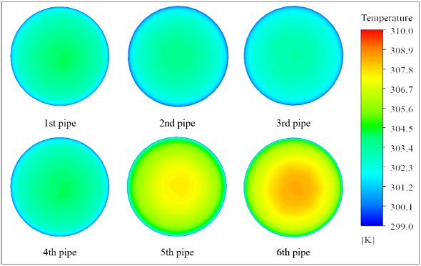

Figure 19: Temperature contour distribution on the YZ plane at the mid-length of the parallel pipes of the Z-type EAHE.
Figure 20 the temperature in the U-type construction lowers gradually and semi-uniformly from the air input to the output along each pipe. The color change from warm colors (orange to yellow) at the entrance to cooler colors (green to blue) at the exit shows that the parallel pipes transfer heat in a relatively uniform pattern. This pattern indicates that the transfer of air and heat between the parallel pipes is efficient.
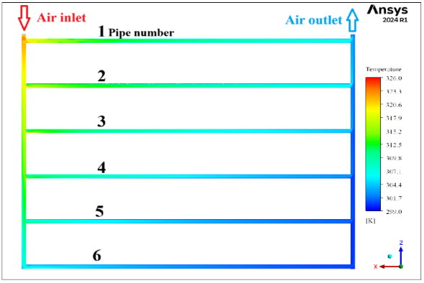
Figure 20: Temperature distribution on the longitudinal plane passing through the pipe axis of the 6-pipe EAHE in the U-type configuration.
Figure 21 the Z-type configuration, has a temperature profile that is not as uniform. The temperature remains high near the inlet region but decreases significantly toward the outlet, especially at the end of the flow path. The appearance of warmer colors in the last pipes suggests that most of the airflow passes through these pipes, resulting in less effective cooling in the other pipes. These variations suggest that the U-type structure will lead to a more uniform temperature drop and a better thermal transfer, whereas the Z-type structure will lead to a smaller uniformity of the thermal distribution because of uneven airflow.
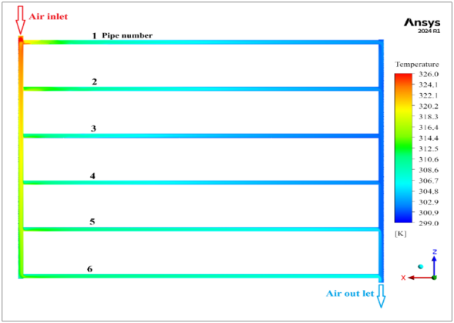

Figure 21: Temperature distribution on the longitudinal plane passing through the pipe axis of the 6-pipe EAHE in the Z-type configuration.
Figure 22 shows the outlet air temperature (Tₒ) variation of both U-type and Z-type EAHE setup at various Reynolds numbers and the relative temperature drop between the two arrangements. The figure indicates that the temperature of the outlet air rises with an increase in Reynolds numbers in both the setups. The increased velocity of the flow decreases the air residence time in the pipes therefore reducing heat transfer with the surrounding soil. Within the range of test, the U-type layout presents a mildly lower outlet temperature than the Z-type, with a relative change (ΔTₒ %) of between 1% and 2% as shown by the green curve, which was calculated by using Eq. (18):
$∆T_{o} \% = \left|\frac{{T_{O},}_{U}-{T_{O},}_{Z}}{{T_{O},}_{Z}}\right| ×100$ (18)
This uniform but minor variation testifies to the fact that the U-type construction offers more uniform air-flow and more effective heat-transfer along the parallel pipes, and this fact increases the cooling capacity.
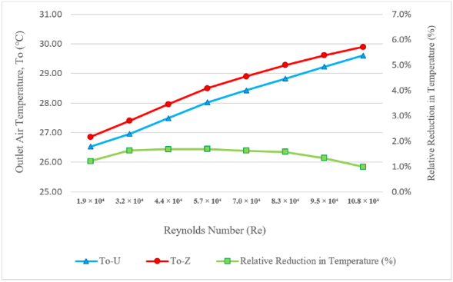
Figure 22: Comparison of outlet air temperature and its relative reduction percentage between U-type and Z-type EAHE configurations at different Reynolds numbers.
Figure 23 presents the change of the effectiveness (ε) of the system of U-type and Z-type EAHE systems with various Reynolds numbers and the percentage change (Δε %) observed between the two layouts. The efficiency of the two systems reduces gradually with the increment in the Reynolds number. This decrease is mainly caused by the reduction in the residence time of the air in the pipes with higher flow rates, and this in turn reduces the heat exchange between the air and the soil surrounding it. The U-type pattern, over the entire trajectory, is always marginally superior to the Z-type and shows a relative increase of something like 1 to 2 percent, which is the result of the calculation of Eq. (19):
$∆ε \% = \left|\frac{ε_{ U}-ε_{ Z}}{{ε }_{Z}}\right| ×100$ (19)
The difference is rather small; however, it continuously proves that the U-type design is the one that is more effective in heat transfer and which ensures a more uniform airflow inside the pipes underground. In observing such thermal behavior coupled with significantly lower pressure losses, it is evident that the U-type system is more efficient in general regarding thermal and hydraulic efficiency, more so at high conditions of Reynolds number.
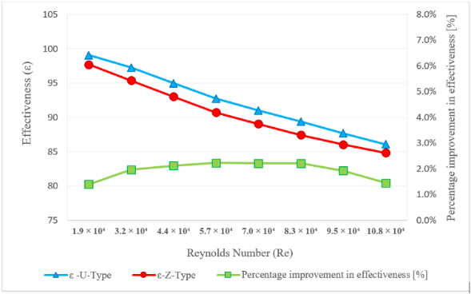
Figure 23: Comparison of effectiveness (ε) between U-type and Z-type EAHE systems and its percentage improvement in effectiveness with Reynolds number.
Figure 24 shows how the rate of heat transfer (Q _{EAHE}) varies with Reynolds number both in U-type and Z-type configuration. The higher the Reynolds number, the higher is the rate of heat transfer in both layouts. This is due to increased velocities of flow which increases convective heat transfer due to increase in air turbulence and resulting in degrading of the thermal boundary layer along the walls of the pipes. The U-type geometry is always exhibiting a small better rate of the heat transfer than the Z-type, and the relative enhancement (∆Q _{EAHE} %) is approximately 1- 2, as shown by Eq. (20):
$∆Q_{EAHE} \% = \left|\frac{{Q }_{U}-{Q }_{Z}}{Q_{Z}}\right| ×100$ (20)
This minor difference suggests that the two systems possess similar cooling potentials; though, the U-type has a small thermal benefit because of the more homogenous flow distribution. The U-type design exhibits superior thermal-hydraulic behavior than the Z-type system due to the low-pressure losses, which can be essentially attributed to the lower pressure loss.
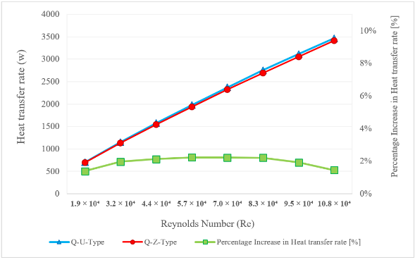

Figure 24: Comparison of heat transfer rates (Q _{EAHE}) for U-type and Z-type EAHE configurations and its percentage increase in heat transfer rate with Reynolds number.
Overall Thermal-Hydraulic Performance:
After examining the behavior of the hydraulic and thermal separately, the overall thermal-hydraulic performance offers a more integrated and obvious comparison of the two set-ups.
Figure 25 demonstrates how the overall performance factor (η*) varies for the U-type and Z-type EAHE configurations at different Reynolds numbers. A decreasing trend is observed as Reynolds number increases because the rise in pumping power becomes greater than the corresponding increase in heat-transfer rate. Nevertheless, the U-type always shows larger η* values, indicating a better combined thermal-hydraulic behavior. Since both layouts use the same pipe material, diameter, and total buried length, this improvement is achieved without additional buried-pipe cost and is reflected directly in lower fan-power demand. Relative improvement (Δη*%), which is determined by Eq. (21):
$∆η^{*} \% = \left|\frac{{η^{*}}_{U}-{η^{*}}_{Z}}{{η^{*}}_{Z}}\right| ×100$ (21)
The relative enhancement rises as high as approximately 20 percent at low Reynolds numbers to more than 40 percent at the greatest, which proves that the U-type layout has a greater thermal-hydraulic performance.
Although the benchmark used for verification is thermal in nature, the predicted airflow distribution patterns and pressure-loss trends obtained in the present study are also consistent with previously reported investigations of multi-pipe EAHE flow performance [2], [4], [5],[6].
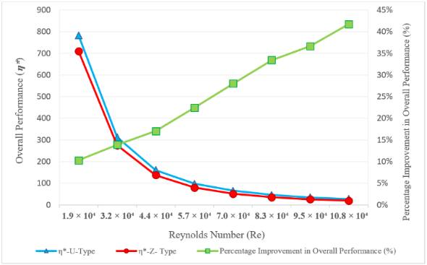

Figure 25: Comparison of the overall performance index (η*) and its percentage improvement between U-type and Z-type EAHE configurations under various Reynolds numbers.
Conclusions:
A quantitative comparison was carried out for two grid-type Earth-to-Air Heat Exchanger (EAHE) layouts, U-type and Z-type, under identical geometrical and operating conditions to evaluate their cooling performance. The major conclusions are the following:
- The U-type layout was more evenly distributed in air flow, velocity, and pressure distributed more equally throughout the grid. The uniformity coefficient of airflow (Ω) was enhanced by almost 38 percent in greater Reynolds numbers in comparison to the Z-type layout with this stability.
- The U-type system demonstrated a significant figure of reduction of hydraulic resistance, and the total pressure loss was greater than 28 percent lower than that in the Z-type. The resultant power demand of fans became lower and this resulted in energy efficiency.
- The thermal characteristics of the two systems were nearly identical, and the thermal performance of both systems varied by 12-2 percent in thermal effectiveness (ε) and the outlet air temperature. The U-type was slightly higher due to the more stable flow and the higher concentration of the temperature along the pipes.
- In the case of overall performance, the U-type configuration always reached higher values of overall performance indicator (η*) than the Z-type by over 40 percent at the maximum Reynolds number. It means that the U-type system achieves a more efficient compromise between thermal and flow dynamics.
- Overall, the U-type EAHE achieved the better overall thermal-hydraulic performance, combining reduced energy consumption with uniform airflow and consistent cooling. It is therefore recommended as the optimal grid configuration for passive, energy-efficient greenhouse ventilation, particularly under high flow conditions.
The present analysis is based on steady-state CFD simulations with constant thermophysical properties and a prescribed soil-temperature boundary condition. Accordingly, the results are intended to provide a comparative thermal–hydraulic assessment of the two layouts under the investigated conditions and should be interpreted within the framework of the modeling assumptions adopted in this study.

CHART 1. Nomenclature
$$C_{P}$$ | Specific heat (J\kg. K)‎ | $${\dot{V}}_{i}$$ | Volumetric flow rate in each pipe (m³/h)‎
d | Inner diameter of the pipe (m) | Z | Axial coordinate (m)‎
EAHE | Earth to Air Heat Exchanger | $${ΔP}_{tot}$$ | Total pressure losses (Pa)‎
$$g$$ | Body force (gravity) (m/s²) | Greek symbols
K | Total pressure loss coefficient | $$δ$$ | Thickness of disturbed soil (m)
k | Air thermal conductivity (W/m·K) | $$ε$$ | Effectiveness
$$\dot{m}$$ | Mass flow rate (kg/s)‎ | η* | Overall performance factor (-)
n | Number of parallel pipes | θ | Angular coordinate (rad)
P.P | Pumping power (W) | $$ν$$ | Kinematic viscosity (μ/ρ) (m²/s)
$$p$$ | Pressure (Pa) | ρ | Density (kg/m3)‎
Q | Heat transfer rate (W)‎ | $$Φ$$ | Viscous dissipation (W/m³)
R₁ | Outer radius of the pipe (m) | $$Ω$$ | Airflow uniformity coefficient
R₂ | Radius of the disturbed soil domain (m) | Subscripts
r | Radial coordinate (m) | i | Inlet
T | Temperature (K) ‎ | o | Outlet
$$v$$ | Velocity (m/s) | s | Undisturbed soil
$$\dot{V}$$ | Volumetric flow rate (m³/h)‎ | U | Refers to U-type EAHE configuration
$${\dot{V}}_{a}$$ | Average volumetric flow rate in parallel pipes (m³/h)‎ | Z | Refers to Z-type EAHE configuration

COMPETING INTERESTS DISCLAIMER:
Authors have declared that they have no known competing financial interests OR non-financial interests OR personal relationships that could have appeared to influence the work reported in this paper.

References

[1] Badescu, V., Isvoranu, D. (2011). Pneumatic and thermal design procedure and analysis of earth-to-air heat exchangers of registry type. Applied Energy, 88(4): 1266–1280. https://doi.org/10.1016/j.apenergy.2010.10.019
[2] Amanowicz, Ł., Wojtkowiak, J. (2011). An effect of flow nonuniformity in earth-to-air multi-pipe heat exchangers (EAHEs) on their thermal performance. https://www.researchgate.net/publication/315853238, accessed on Oct. 07, 2025.
[3] Ahmed, S.F., Amanullah, M.T.O., Khan, M.M.K., Rasul, M.G., Hassan, N.M.S. (2016). Parametric study on thermal performance of horizontal earth pipe cooling system in summer. Energy Conversion and Management, 114: 324–337. https://doi.org/10.1016/j.enconman.2016.01.061
[4] Amanowicz, Ł., Wojtkowiak, J. (2017). Experimental investigation and CFD simulation of multi-pipe earth-to-air heat exchangers (EAHEs) flow performance. In: E3S Web of Conferences. EDP Sciences. https://doi.org/10.1051/e3sconf/20172200002
[5] Amanowicz, Ł., Wojtkowiak, J. (2018). Validation of CFD model for simulation of multi-pipe earth-to-air heat exchangers (EAHEs) flow performance. Thermal Science and Engineering Progress, 5: 44–49. https://doi.org/10.1016/j.tsep.2017.10.018
[6] Amanowicz, Ł. (2018). Influence of geometrical parameters on the flow characteristics of multi-pipe earth-to-air heat exchangers – experimental and CFD investigations. Applied Energy, 226: 849–861. https://doi.org/10.1016/j.apenergy.2018.05.096
[7] Sakhri, N., et al. (2021). Experimental study of an earth-to-air heat exchanger coupled to the solar chimney for heating and cooling applications in arid regions. Journal of Thermal Analysis and Calorimetry, 145(6): 3349–3358. https://doi.org/10.1007/s10973-020-09867-6
[8] Hasan, M.I., Muter, M. (2021). Study the effects of configuration and design parameters on the performance of earth-to-air heat exchanger used in poultry houses. Basrah Journal for Engineering Sciences, 21(1): 1–9.
[9] Ahmad, S.N., Prakash, O. (2022). Thermal performance evaluation of an earth-to-air heat exchanger for the heating mode applications using an experimental test rig. Archives of Thermodynamics, 43(1): 185–207. https://doi.org/10.24425/ather.2022.140931
[10] Ali, M.H., Kurjak, Z., Beke, J. (2023). Investigation of earth air heat exchangers functioning in arid locations using Matlab/Simulink. Renewable Energy, 209: 632–643. https://doi.org/10.1016/j.renene.2023.04.042
[11] Hummood, E., Hasan, M.I., Abd, G. (2024). Investigating the effects of disturbed soil thickness on the performance of earth-air heat exchanger. International Journal of Heat and Technology, 42(3): 1101–1110. https://doi.org/10.18280/ijht.420337
[12] Sofyan, S.E., Riayatsyah, T.M.I., Khairil, Hu, E., Tamlicha, A., Pahlefi, T.M.R., Aditiya, H.B. (2024). Computational fluid dynamic simulation of earth air heat exchanger: A thermal performance comparison between series and parallel arrangements. Results in Engineering, 24: 102932. https://doi.org/10.1016/j.rineng.2024.102932
[13] Hasan, M.I., Jabbar, E.K. (2021). Fabricating and testing of the ground coupled air conditioner for residential applications in Iraqi weather. Energy, 216: 119256. https://doi.org/10.1016/j.energy.2020.119256
[14] Al-Ajmi, F., Loveday, D.L., Hanby, V.I. (2006). The cooling potential of earth-air heat exchangers for domestic buildings in a desert climate. Building and Environment, 41(3): 235–244. https://doi.org/10.1016/j.buildenv.2005.01.027
[15] Ronge, D., Kadam, V., Shende, S., Kate, P., Waghmare, V., Patil, O. (2020). Design of an Earth Air Heat Exchanger System for Space Cooling in Hot and Dry Climate of Pandharpur, India. Aegaeum Journal, 8(6): 1594–1602. https://www.researchgate.net/publication/343212160, accessed on Oct. 07, 2025.
[16] Gauthier, C., Lacroix, M., Bernier, H. (1997). Numerical simulation of soil heat exchanger-storage systems for greenhouses. Solar Energy, 60(6): 333–346. https://doi.org/10.1016/S0038-092X(97)00022-4
[17] Misra, R., Bansal, V., Agarwal, A. (2016). Investigation of thermal performance of EATHE system under intermittent operation: A CFD approach. International Journal of Engineering Technology, Management and Applied Sciences, 4(4): 340–349. https://www.researchgate.net/publication/301957131, accessed on Oct. 07, 2025.
[18] Hasan, M.I., Noori, S.W. (2018). Numerical investigation of earth to air heat exchanger for cooling and heating applications. Proc. 3rd Int. Scientific Conference, Mar. 14–15, pp. 1–10.
[19] Niu, F., Yu, Y., Yu, D.H., Li, H.R. (2015). Heat and mass transfer performance analysis and cooling capacity prediction of earth to air heat exchanger. Applied Energy, 137: 211–221. https://doi.org/10.1016/j.apenergy.2014.10.008
[20] Gan, G. (2015). Simulation of dynamic interactions of the earth-air heat exchanger with soil and atmosphere for preheating of ventilation air. Applied Energy, 158: 118–132. https://doi.org/10.1016/j.apenergy.2015.08.081
[21] Hegazy, A., Mohamed, S.Z. (2023). Unlocking geothermal energy for sustainable greenhouse farming in arid regions: a remote-sensed assessment in Egypt’s New Delta. Scientific Reports, 13(1). https://doi.org/10.1038/s41598-023-48667-4
[22] Hasan, M.I., Noori, S.W. (2018). Evaluating the influence of some design and environmental parameters on the performance of earth to air heat exchanger. Journal of Engineering and Sustainable Development, 22(2): 10–29. https://doi.org/10.31272/jeasd.2018.2.2
[23] Amanowicz, Ł., Wojtkowiak, J. (2020). Thermal performance of multi-pipe earth-to-air heat exchangers considering the non-uniform distribution of air between parallel pipes. Geothermics, 88. https://doi.org/10.1016/j.geothermics.2020.101896
[24] Hammadi, S.H., Mohammed, A.H. (2014). Application of Earth Tube Heat Exchanger and Solar Chimney for Natural Cooling System in Basrah City. Basrah Journal for Engineering Sciences, 14(2): 23–32.
[25] Hasan, M.I., Noori, S.W. (2019). A study of the potential of using the earth to air heat exchanger for cooling and heating of residential buildings in Iraq. Heat Transfer – Asian Research, 48(8): 3902–3927. https://doi.org/10.1002/htj.21574
[26] Alshamry, E.A.H. (2024). Investigation of air cooling in Nassiriya oil field using geothermal heat exchangers. M.S. thesis, Dept. Mechanical Engineering, University of Thi-Qar, Thi-Qar, Iraq, Jul. 2024.

