Study of the effect of the behavior of reinforced beams containing small openings

ABSTRACT:
The presence of openings in reinforced concrete beams is one of the most negatively affecting factors on their behavior. In this research, we explored a method to enhance the behavior of reinforced concrete beams with openings, which involves covering the beam with a thin, welded metal mesh and cement mortar (Ferrocement). To study the effect of the strengthening layer, we conducted a numerical analysis using the ABAQUS program for 7 reinforced concrete beams containing square-shaped openings in the shear zone with different dimensions relative to the height of the beam. This research adopts an analytical approach, where a numerical model will be created for reinforced concrete beams reinforced with Ferrocement using the ABAQUS finite element program. The model's validity will be verified through calibration and simulation with available experimental studies. These beams will be analyzed under nonlinear static loading, and the maximum displacement in the center of the beam and the maximum shear stress on its cross-sections will be determined. It was found that the transition in the middle of the span in the reinforced beams was reduced compared to the case in the unreinforced beams, and the performance improved significantly in resisting the maximum shear stress in the reinforced concrete beams, as a result of the presence of the strengthening layer (Ferrocement), which led to a noticeable improvement in the behavior of these reinforced beams containing openings.

Keywords: ferrocement, concrete beams, Abaqus program, finite element method, shear stress
- Introduction
Beams are linear structural elements that transfer loads from the slabs to the columns or walls they support. Determining the strength and stability of a load-bearing system depends on the contribution made by each element. Running conduits and pipes under beams requires an increased height on each floor, causing significant waste. Therefore, efforts are made to route these conduits and pipes through openings prepared in beams to reduce the floor height as much as possible. However, this change in the beam's cross-section will result in:
- Stress concentration at the corners of the openings.
- Reduced stiffness and increased deformation.
Openings can occupy a large or small space in the beam, depending on the required function and the desired geometric shape, which can be circular, rectangular, square, trapezoidal, triangular, or even irregular, among other shapes. Openings in beams offer significant benefits, as they reduce the weight and dimensions of the extensions passing through them, resulting in shorter actual lengths than if other paths were followed[1], Construction engineering today increasingly needs to reinforce existing structures to prevent their failure or to increase their capacity to withstand new functional loads that may be imposed on them. There are many methods used for reinforcement, including carbon fiber reinforcement, fiberglass reinforcement, and concrete reinforcement. Numerical studies have been conducted on strengthening reinforced concrete columns using a ferrocement layer, including one conducted by researcher Ali at Damascus University[2], who used the welded metal mesh shown in Figure 1.
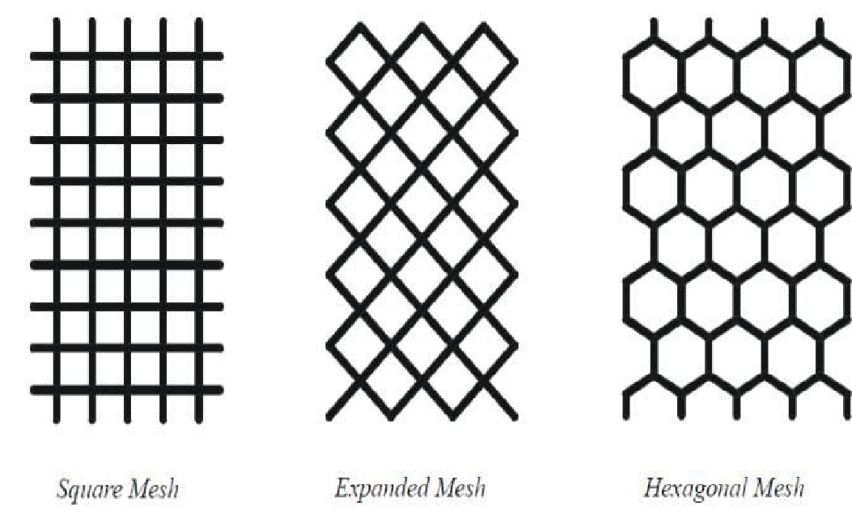
Figure 1: Types of metal networks within the Ferrocement layer.

In this research, we will strengthen concrete beams containing openings using cement mortar reinforced with a welded metal mesh (ferrocement). This method is useful for stopping cracks, helping the beam withstand greater external forces, and compensating for weaknesses caused by the presence of openings in the beam. Ferrocement is a commonly used type of reinforced concrete, consisting of a thin cement mortar layer reinforced with a relatively small-diameter reinforcing mesh. It is characterized by its low cost, as indicated by numerous studies, including those mentioned in the reference.
Research Importance and Objectives:
- Given the need to use openings in concrete beams to ensure the passage of essential service supplies, thus reinforcing existing ones when necessary.
- To highlight the role of the ferrocement layer in strengthening beams and improving the behavior of their structural systems.
- The reinforcing mesh can take a geometric shape (square, circular, etc.) for any section to be reinforced.
The objectives of this research are as follows:
- Study the strengthening of a beam containing openings reinforced with ferrocement.
- Study the effect of opening dimensions in reinforced beams on the behavior and strength of reinforced concrete beams containing these openings, particularly those related to the value of the stock and the maximum shear stress of the beams.
- Develop a computer model to simulate the behavior of concrete beams containing openings reinforced with ferrocement.
- LITERATURE REVIEW
Darko Živkovic , Predrag Blagojevic , Danijel Kukaras , Radovan Cvetkovic , Slobodan Rankovic (2024)[3]
In this study, the researcher conducted a test of (15) reinforced concrete beam samples measuring (250, 150, 3000) mm, where he used 4 models with a ferrocement strengthening process model with different sizes of wire meshes, and the process was verified using the finite element method (FEM), where the results for the models were good compared to the non-reinforced models.
Abeer M. Erfan, Ragab M. Abd Elnaby, Ammar Elhawary, Taha A. El-Sayed (2021)[4]
In this study, the researcher studied the behavior of reinforced concrete walls using various types of ferrocement. He used (10) wall models with dimensions of (1000, 1500, and 150) mm. The models were subjected to central and eccentric loads, and were examined experimentally and analyzed nonlinearly using the finite element method (FEM). The results were good for models made from ferrocement compounds.
Edosa Megarsa and Goshu Kenea (2022)[5]
In this study, the researcher conducted an extensive analytical study of the shear strength performance of reinforced concrete beams using ferrocement. He simulated the models nonlinearly in the program (Abaqus 6.14). He used (15) models and two-point forces. The results showed that when forces were applied, the shear strength of beams reinforced with wire meshes was stronger than those without reinforcement.
Muthumani Soundararajan, Shanmugam Balaji, Jayaprakash Sridhar, and Gobinath Ravindran (2022)[6]
In this study, the researcher created (10) specimens of 1220, 100, and 150 mm in diameter using reinforced concrete reinforced with galvanized ferrocement at rates of 1.76% and 2.35%. The experimental results showed that ferrocement is effective and provides excellent reinforcement for reinforced concrete elements.
Roula Taha, Muneeb AL Allaf, Ihssan Tarsha (2024)[7]
In this study, the researcher evaluated and compared the torsional strength and torsional angle of different types of ferrocement compounds and measured them using linear and nonlinear analysis. The results showed that using Styrene Butadiene Rubber (SBR) as a bonding material is an effective method for maintaining the cohesion of reinforced concrete beams.

- Research methodology and materials used:
This research adopts the analytical approach. A numerical model of reinforced concrete beams reinforced with ferrocement will be created using the ABAQUS finite element program. The model will be validated through calibration and simulation using available experimental studies. These beams will be analyzed under nonlinear static loading, and the maximum displacement at the center of the beam and the maximum shear stress on its cross-sections will be determined.
  - Working stage
    - Finite Element Model
The ABAQUS finite element program was used to fully simulate the reinforced concrete beam covered with a ferrocement layer, as shown in Figure 1.
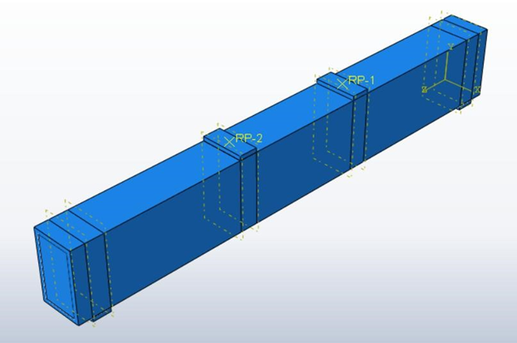
Figure 2: Model of a reinforced concrete beam fully reinforced with Ferrocement.
In our study, we have shown the same dimensions and parameters that were adopted in the reference.[8] Where the beam has a cross-section with dimensions (b*h = 150 * 300) mm, and a length of L = 2200 mm, reinforced with 3T12 main reinforcement, 2T10 suspension reinforcement, and ø8/200 mm transverse reinforcement, as shown in Figure 2. Figure (4) shows the details of the beam, fully reinforced with a 20 mm thick Ferrocement layer on each side, where within the reinforcement layer is the metal mesh used with a diameter of 0.7 mm and square openings with opening dimensions of 125.5*12 mm, as shown in Figure (5).
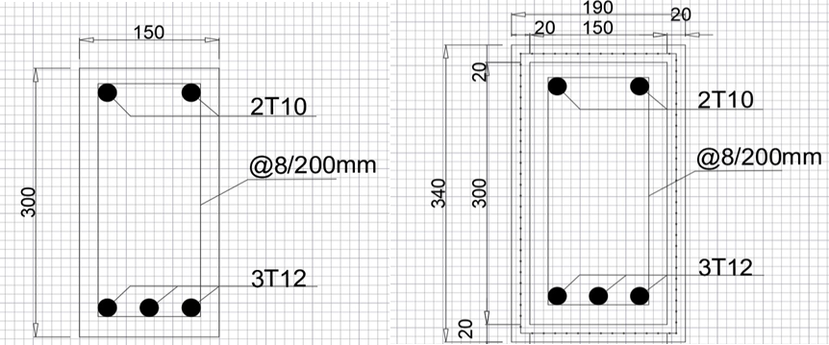
Figure 3: Cross-section details of the unreinforced beam. Figure 4: Cross-section details of the reinforced beam.
All the studied beams have simple support and are loaded with two identical forces, and the center of the opening is 300 mm away from the center of the support, as in Figure 3.
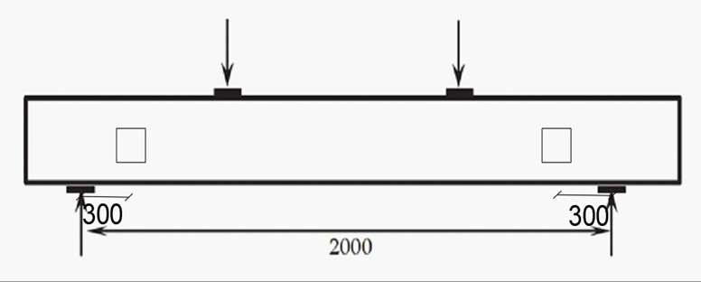
Figure 5: Reinforced concrete beam without support.

Figure (6) The reinforcement mesh used as support within the ferrocement layer[9]

    - Concrete Modeling
The C3D8 element was used to model the concrete. It is a solid element consisting of eight nodes, each with three degrees of freedom (three translations). It is from the group of three-stress elements with regular deformations and linear dimensions. Figure 7 shows the spatial element used, which is the same model used by the researcher.[10]
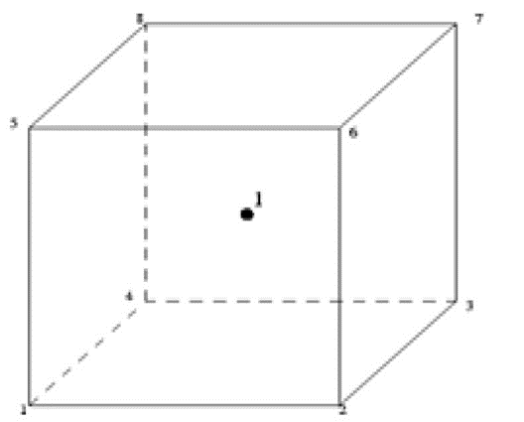
Figure (7) Element C3D8.
The Concrete Damaged Plasticity (CDP) model was used to characterize the inelastic behavior of concrete in tension and compression, or it can be used to represent the nonlinear behavior of concrete, considering the gradual decrease in elastic stiffness resulting from the occurrence of relative plastic straining in both tension and compression. Figures (8) and (9) show the stress-deformation diagram adopted for concrete in tension and compression.
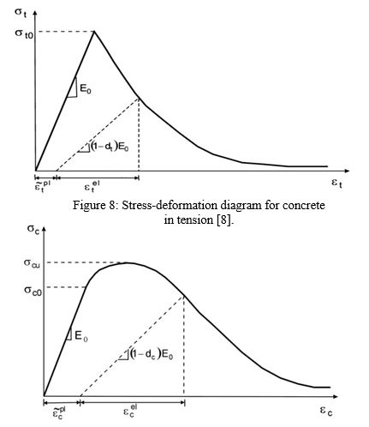
Figure (9) Stress-deformation diagram for concrete in compression[8]
    - Steel Reinforcing Modeling
The T3D2 element was used as the one used in the reference.[11] , which is a truss element consisting of two nodes, each node containing three degrees of freedom (3 translations), as Figure 10 [11] Shows the model of the T3D2 element.
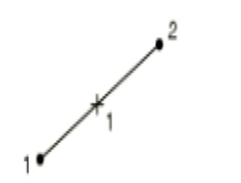
Figure (10) Element T3D2[10] .
To understand the behavior of steel and reinforcing bars, stress-strain diagrams used by researchers were utilized and incorporated into finite element models. Figure 11 shows a stress-strain diagram for reinforcing steel.
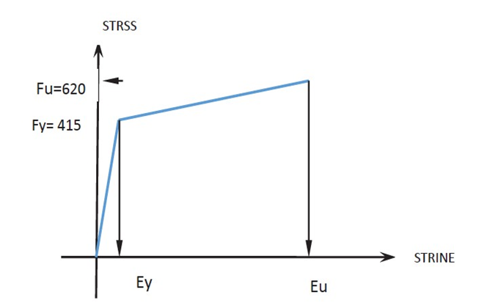
strain
stress
Figure 11: Stress-strain diagram for reinforcing steel[8]
    - Modeling the reinforcement network within the ferrocement layer
The reinforcement network is modeled using a uniaxial element with three degrees of freedom at each node, namely translations in the x, y, and z directions. It can withstand deformations and plasticity.
    - Study Parameters
We studied the effect of the dimensions of the square opening whose center is 300 mm away from the center of the support, where we changed the dimensions of the opening relative to the height of the beam (H), as this change included three values: (0.25*H, 0.5*H, 0.75*H)
    - Model Verification
We adopted the reinforced concrete beam model from the Studies[8], [11] And compared the transition obtained by the researcher at the center of the beam with the transition obtained using the ABAQUS program. The comparison showed good convergence in the results obtained, as the transition matched 92% at the ultimate strength of 150 KN, as shown in Figure 12.
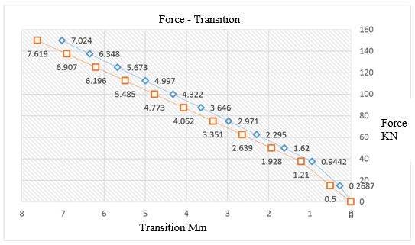 Figure (12) Force- Transition diagram for the beams in the reference study in red and modeling in blue on the ABAQUS program.
  - Results and discussions
All the studied beams contain two openings in the shear zone, where the dimensions of one opening were changed about the height of the beam shown in Table 1. The studied beams with or without reinforcement, the maximum Transition value, and the maximum shear stress.

Table 1: Details of the studied beam and their results.
Name of Beam | Opening Dimensions (mm) | Applied force (KN) | Transition (mm) | Maximum shear stress (MPa)
(A) Standard Sample | It does not contain any openings. | 150 | 7.024 | 2.46
(1-A) Unsupported Sample | 0.25*H=75 | 150 | 7.341 | 2.44
(2-A) Supported Sample | 0.25*H=75 | 150 | 2.551 | 2.53
(3-A) Unsupported Sample | 0.5*H=150 | 115 | 7.734 | 1.762
(4-A) Supported Sample | 0.5*H=150 | 150 | 2.691 | 2.51
(5-A) Unsupported Sample | 0.75*H=225 | 10 | 8.492 | 0.117
(6-A) Supported Sample | 0.75*H=225 | 150 | 6.047 | 2.517

Figure 13 also shows a comparison of the force transition diagram for the beams (A-1), (A-2) and the standard sample.

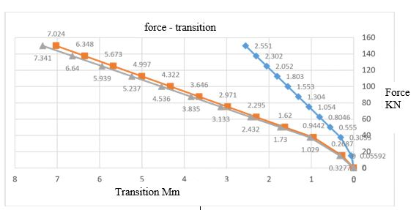

Figure (13) Force- Transition diagram for the beams (A-1, in gray), (A-2 in blue), and the standard sample in red.

We note from Figure 13) the force-transition diagram for the reinforced beam containing (2-A) holes, the standard sample (A), and the unreinforced beam containing (1-A) holes. The Transition at a force of 150 KN reached the following values: 2.551 mm, 7.024 mm, and 7.341 mm, respectively. We note that the difference between the values of beam (1-A) and the standard sample (A) was very small, not exceeding 5%. However, the Transition for beam (2-A) decreased by 64% compared to the standard sample. In other words, the Transition decreased by 65% in beam (2-A) compared to the Transition in beam (1-A). Figure (14) shows a comparison of the force-transition diagram for beams (3-A), (4-A), and the standard sample.

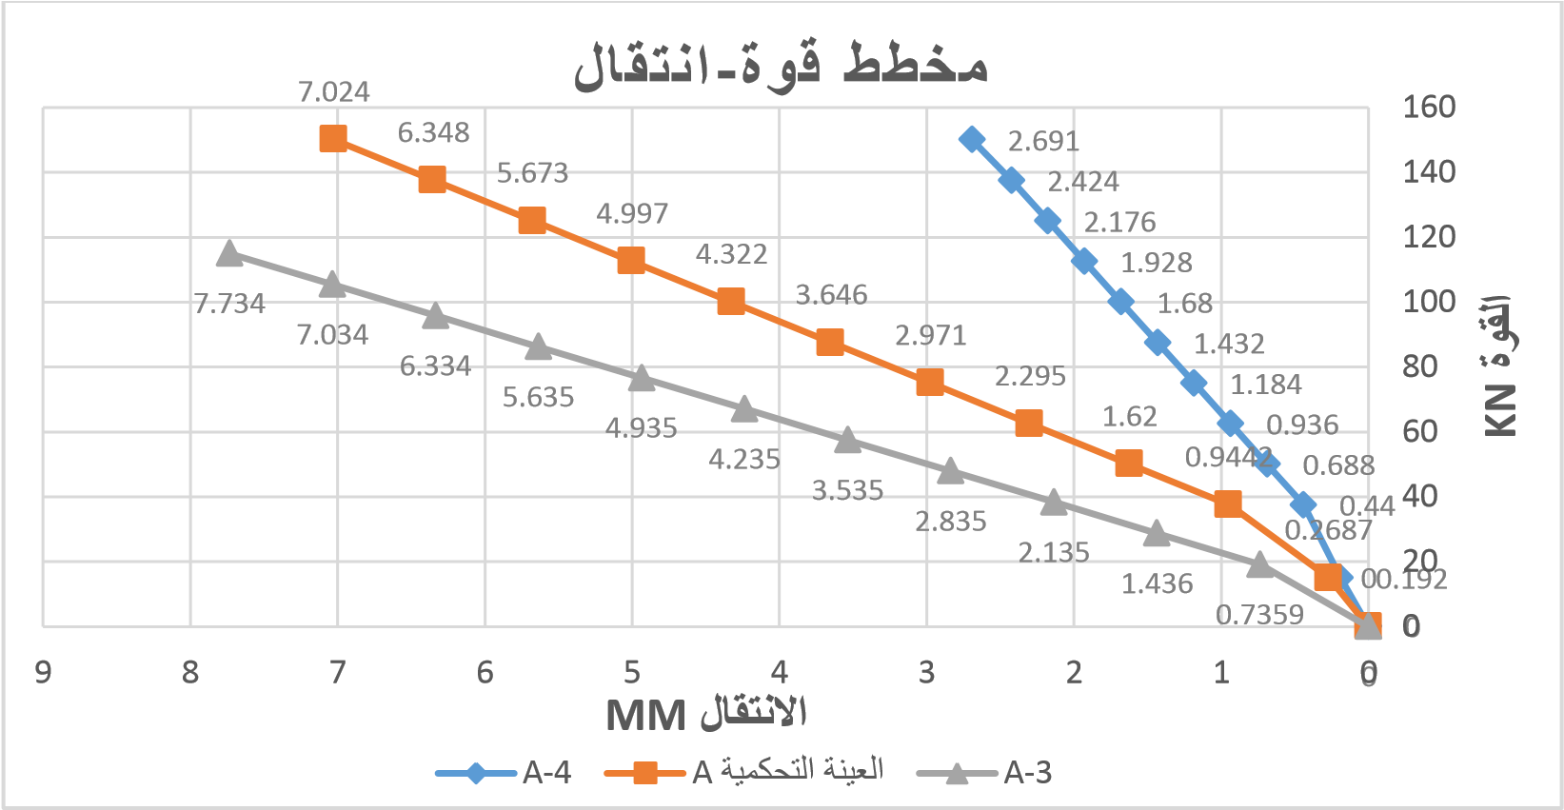
Transition Mm
Force KN
Force - Transition
Figure (14) Force- Transition diagram for beams (A-3, in gray), (A-4, in blue), and the standard sample in red.

Figure (14) shows that the displacement reached 2.691 mm for the reinforced beam (4-A) containing holes when the force reached 150 KN, while the Transition was 7.024 mm for the standard sample (A) for the same force. The Transition for the unreinforced beam (3-A) containing holes reached 7.734 mm for the force of 115 KN. The force applied to the beam (3-A) decreased by 23%, while the Transition increased by 10 % compared to the standard sample (A). Similarly, the Transition in the beam (4-A) decreased by 62% compared to the standard sample (A) and decreased by 65% compared to the beam (3-A). Figure 15 shows a comparison of the force-transition diagram for the beams (6-A), (5-A), and the standard sample.

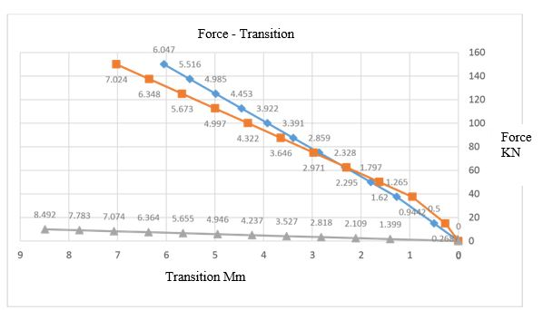
Figure (15) Force- Transition diagram for beams (A-5, in gray) (A-6, in blue) and the standard sample in red.
Transition MM
Force - transition

We also conclude from the diagram in Figure (15) that the value of the force applied to beam (5-A) decreased by 93%, and the Transition increased by 20% compared to the standard sample (A), while the Transition in beam (6-A) decreased by 14% compared to the standard sample (A), and by 29% compared to beam (5-A). It was observed that the Transition in beam (1-A) increased by 5% compared to that of the standard sample (A) at a Transition of 150 kN. The Transition in beam(3-A) increased by 11% compared to that of the standard sample (A) at a Transition of 115 kN. The Transition in beam (5-A) increased significantly at a strength much lower than that of the standard sample (A). This is due to the increased dimensions of the opening relative to the height of the beam without reinforcement. The Transition of reinforced beams (2-A) and (4-A) decreased significantly by 64% and 62%, respectively, compared to the standard sample (A) at a strength of 150 kN. The Transition of reinforced beam (6-A) decreased by 14% compared to the standard sample (A) at the same strength of 150 kN. The decrease in Transition in reinforced beams is due to the ferrocement layer. As for the maximum shear stress, we notice a relative increase in the reinforced beams (2-A) (4-A) (6-A), and (A) compared to the standard sample (A), due to the ferrocement layer, while we notice a relative decrease in its value in the unreinforced beams (1-A) (3-A) and a significant decrease in the unreinforced beam (5-A).
  - Conclusion and Recommendations
For all the above, the study concluded the following:
The current study demonstrated the effectiveness of using ferrocement-reinforced cement mortar to reinforce reinforced concrete beams containing openings.
The presence of an opening in the beam leads to a significant decrease in the beam's load-bearing capacity.
Beams containing openings 0.25 times the height of the beam (small openings) had no significant effect on the beam's behavior or the intensity of shear stress distribution.
Beams containing openings and reinforced with ferrocement exhibited greater load-bearing capacity than unreinforced beams, with varying percentages depending on the opening dimensions.
The reinforcement layer contributed to reducing the displacement value occurring in the beam's center, with varying percentages depending on the opening dimensions.
The ferrocement layer significantly contributed to the beam's shear resistance.

We recommend the following:
Use different types and numbers of reinforcing meshes within the ferrocement layer.
Use different specifications for reinforced cement mortar and concrete with different strengths.
Study the effect of having openings of various other shapes.

COMPETING INTERESTS DISCLAIMER:
Authors have declared that they have no known competing financial interests OR non-financial interests OR personal relationships that could have appeared to influence the work reported in this paper.

References
[1] F. El Ame, J. N. Mwero, and C. K. Kabubo, “Openings Effect on the Performance of Reinforced Concrete Beams Loaded in Bending and Shear,” 2020. [Online]. Available: www.etasr.com
[2] A. Al, H. Kikhia, and Y. Ali, “Retrofitting Of Reinforced Concrete Columns Using Locally Available Welded Wire Meshes (WWMs),” Dec. 2015.
[3] D. Živković, P. Blagojević, D. Kukaras, R. Cvetković, and S. Ranković, “Comprehensive Analysis of Ferrocement-Strengthened Reinforced Concrete Beam,” Buildings, vol. 14, no. 4, Apr. 2024, doi: 10.3390/buildings14041082.
[4] A. M. Erfan, R. M. Abd Elnaby, A. Elhawary, and T. A. El-Sayed, “Improving the compressive behavior of RC walls reinforced with ferrocement composites under centric and eccentric loading,” Case Studies in Construction Materials, vol. 14, Jun. 2021, doi: 10.1016/j.cscm.2021.e00541.
[5] E. Megarsa and G. Kenea, “Numerical Investigation on Shear Performance of Reinforced Concrete Beam by Using Ferrocement Composite,” Math Probl Eng, vol. 2022, Feb. 2022, doi: 10.1155/2022/5984177.
[6] M. Soundararajan, S. Balaji, J. Sridhar, and G. Ravindran, “Sustainable Retrofitting and Moment Evaluation of Damaged RC Beams Using Ferrocement Composites for Vulnerable Structures,” Sustainability (Switzerland), vol. 14, no. 15, Aug. 2022, doi: 10.3390/su14159220.
[7] Roula Taha, Muneeb AL Allaf, and Ihssan Tarsha, “Experimental and Analytical Evaluation to Strengthened R.C Beams Using Ferrocement Under Torsion,” Steps For Civil, Constructions and Environmental Engineering, vol. 2, no. 3, pp. 9–17, Sep. 2024, doi: 10.61706/sccee1201121.
[8] A. A. AL-Dhabyani and A. AL-Ansi, “Numerical Analysis for Reinforced Concrete Beams with Circular Openings in Flexural and Shear Zones Strengthened by Steel Plates,” Journal of Science and Technology, vol. 23, no. 2, pp. 31–48, Dec. 2018, doi: 10.20428/jst 23.2.2.
[9] T. A. El-Sayed and A. M. Erfan, “shear strength of ferrocement composite box section concrete beams,” Constr Build Mater, vol. 172, pp. 608–617, May 2018, doi: 10.1016/j.conbuildmat.2018.03.273.
[10] Ever J. Barbero, “Finite Element Analysis of Composite Materials Using Abaqus® Structural Health Monitoring Technologies and Next-Generation Smart Composite Structures Jayantha Ananda Epaarachchi and Gayan Chanaka Kahandawa, FRP Deck and Steel Girder Bridge Systems: Analysis and Design, 2023. doi: 10.1201/9781003108153.
[11] J. Suresh and R. A. Prabhavathy, “Behaviour Of Steel Fibre Reinforced Concrete Beams With Duct Openings Strengthened By Steel Plates,” International Journal of Advanced Information Science and Technology (IJAIST), vol. 3, no. 8, pp. 53–61, Aug. 2014, doi: 10.15693/ijaist/2014.v3i8.53-61.

