Original Research Article

Physics-Informed ECS Feature Selection for CFRP Damage Detection Using Delta-Capacitance Representations and Gaussian Process Regression

ABSTRACT

Aims: To develop a physics-based feature selection algorithm to be used in detecting structural damage of CFRP with ECS capacitance data, and to perform a statistical analysis of a Gaussian Process Regression (GPR) model with uncertainty quantification to be tested on a small sample scale.

Dataset: The ECS-CFRP Altabey et al (2022) dataset (DOI: 10.17632/c9v4zy3555b.1) of 11 progressive fatigue damage conditions (D0-D10) consisting of 78 raw capacitance data (12 self-capacitance and 66 mutual-capacitance) of a CFRP composite pipeline system was used.

Methodology: PCA to assess dimensionality, Random Forest MDI and permutation importance ranking using Pearson correlation cross-validation to select features, angular span physics validation, and GPR using Matern-3/2 kernel tested by Leave-One-Out Cross-
Validation (LOO-CV). The most important geometry-independent representation was delta- capacitance (percentage change at D0 baseline).

Results: Three major elements obtained 99.23% of variance (PC1: 82.28%). The top-5 delta- capacitance model attained GPR LOO-CV R² = 0.986 with RMSE = 0.380 which is better than the complete 78- feature model (R² = 0.974, RMSE = 0.508). Mean |DeltaC| was monotonically rising between 10.14% (30-degree pairs) and 16.03% (180-degree pairs), which proves the hypothesis of physics-related sensitivity to angular span.

Conclusion: A physically interpretable, small five-feature ECS subset, provides better damage-level prediction accuracy with the uncertainty calibrated. The delta-capacitance formulation allows a cross- configuration transferability, which has been a major gap in ECS-based SHM, which has been based on ad-hoc rules of empirical thresholds without interpretable ML explanation

Keywords: CFRP; Electrode Configuration Sensor; Structural Health Monitoring; Delta-Capacitance; Gaussian Process Regression; Feature Selection; Physics-Informed Machine Learning; Fatigue Damage

1. INTRODUCTION

Carbon Fibre Reinforced Polymers (CFRP) have proven to be structural materials in aerospace, wind turbines, civil construction and pressure vessels due to their extraordinary specific stiffness, fatigue and corrosion resistance (Soutis, 2005; Smith and Norato, 2023). The progressive and insidious character of internal damage in CFRP that includes matrix cracking, fibre-matrix interfacial debonding, delamination, and fibre fracture, constitutes acute structural integrity assessment problems (Sayar et al. 2018). Composite damage, in contrast to metallic damage, does not propagate in one predictable crack-propagation pathway, but a variety of damage modes tend to form together, and interact nonlinearly, which can result in sudden-death failure with little noticeable precursory damage (Xu and Liu, 2024). This has led to the sustained research interest in the development of reliable, cost-effective and in-situ structural health monitoring (SHM) technologies that are specifically applicable to CFRP in the last 20 years (Dubey et al. 2025).
Electrode Configuration Sensors (ECS) are a comparatively new yet fast advancing SHM methodology that takes advantage of dielectric material sensitivity to CFRP internal microstructural alteration (Altabey, 2017; Altabey, 2025). The complete self-capacitance and mutual-capacitance matrix are measured with an array of N electrodes bonded to the surface of the laminate. Damage events alter the local effective permittivity tensor of the composite, producing measurable perturbations in capacitance readings that can be monitored continuously without interrupting structural service (Altabey, 2021). The capacitance matrix of a 12-electrode array offers N(N+1)/2 = 78 distinct features per measurement cycle, with which a richly characterised spatially distributed description of the dielectric state of the structure can be achieved (Altabey, et al. 2021).
Although the ECS data is physically rich, the literature that has been produced has been based primarily on empirical threshold rules, signalling damage when an individual sensor value is more than a certain percentage away of normal value. These methods are unable to measure the extent of damage or give estimates of uncertainty, which are crucial in making decisions in safety-critical structural uses (Bossi and Giurgiutiu, 2015). Recent advancements of machine learning (ML) in composite SHM have created opportunities in the field of automated feature extraction and damage classification (Li et al. 2021; Azad, et al. 2023). A physics-guided deep learning architecture has been suggested to combine physical damage indices with data-driven models (Xu, and Liu, 2024), but these are only applied to large-sample regimes, and they are not applied in the small-sample problem of structural fatigue experiments.
In the case of small-sample structural engineering data, Gaussian Process Regression (GPR) provide a principled probabilistic analysis that offers more than just a point prediction; it can also be used to provide calibrated uncertainty information (Rasmussen and Williams, 2006). Physics-informed GPR, which incorporates physical constraints in the kernel or mean function, has been demonstrated to stop unphysical extrapolations of dielectric systems (Pan et al. 2023). As far as the authors understand, GPR has not been previously used on ECS-based CFRP damage detection with physics-inspired feature selection, and this is an evident methodological gap.
In this paper, these gaps are addressed by using a systematic physics-informed feature selection pipeline using the Altabey (2022) ECS-CFRP Mendeley dataset. Particular contributions include: (1) the delta-capacitance representation as a geometry-free property is introduced and verified; (2) dimensionality characterisation with PCA; (3) random forest and Pearson correlation feature ranking with physics validation by angular span analysis; (4) GPR using Matern kernel and LOO -CV produces high-accuracy prediction with calibrated error; and (5) that a compact 5 feature model can work better than the full 78 feature model.
2 LITERATURE REVIEW
2.1 Non-Destructive Testing (NDT) CFRP Composites
There are extensive NDT techniques of the CFRP in ultrasonic guided wave (Qiao et al., 2007; Hu et al., 2023), eddy current (Xu et al., 2023), thermography (Roemer et al. 2023), and acoustic emission (Kim et al. 2015; Chen et al. 2023), with each having typical trade-off considerations between sensitivity, spatial resolution, and applicability to in-situ use. Xu and Liu (2024) developed a propositional physics-guided convolutional neural network (PGCNN) that combines power spectral density change with a data-driven extractor, with more than 90 per cent cross-laminate generalisation. Shao et al. (2025) showed a CRNN that has an accuracy of 99.02 percent of single-damage mode AE classification but mentioned that 19.4 percent of signals are found in superimposed conditions. On CFRP health states, Azad et al. (2024) demonstrated that ResNet50V2 fine-tuned on CWT vibration scalograms yielded F1-scores of 0.94-0.99 with limited data. The overall analysis by Dubey et al. (2025) established that none of the approaches are universally best, and hybrid computational-ML systems have the most potential to move forward.
2.2 Electrical Capacitance Sensor Technology
The ECS-based fatigue damage monitoring of CFRP pipelines proposed by Altabey (2017; 2021; 2025), proved that the magnitude and the pattern of capacitance variation can give information on the location and severity of the damage. In 2022, Altabey (2022) provides publicly available benchmark as the Mendeley dataset which allow algorithm development to be reproduced. ECS is sensitive to a complementary damage sensing regime on electrical resistance tomography (Diaz-Escobar et al. 2023), offering sensitivity to matrix-dominated early-stage damage with the dielectric mechanism as opposed to changes in conductivity (Schulte and Baron 1989; Angelidis and Irving, 2007). Nevertheless, previous ECS papers have only made use of empirical comparisons of raw capacitance values by thresholding, without systematically selecting features or explaining their physical basis.
2.3 Machine Learning for Small-Sample SHM Datasets
Rasmussen and Williams (2006) established GPR as the theoretically principled algorithm to use when the sample size is small, to give posterior predictive distributions which have calibrated uncertainty using marginal likelihood optimisation. Pan et al. (2023) applied physics-aware GPR to predict dielectric system in-operando capacitance, revealing that physical limitations preclude unphysical extrapolations in dielectric systems, the exact same problem of ECS. Nonlinear interactions that cannot be modelled using correlation methods are captured using random Forest MDI feature importance (Breiman, 2001): Pearson correlation cross-validation of RF rankings prevents respect of robustness to the known high-cardinality bias of MDI at small samples. Zhu and Han (2024) applied PCA to dielectric SHM data in metamaterial sensor CFRP scanning and observed an analogous extreme compressibility (91.08% variance in two components) which is replicated in the present study (99.23% in three components).
2.4 Research Gaps Addressed
It is based on four substantive gaps: (1) no physics-inspired feature selection has been used on ECS capacitance data; (2) the delta-capacitance representation has not been experimentally validated as being geometry-independent; (3) GPR with calibrated uncertainty has not been applied to ECS based CFRP damage prediction; and (4) the physics hypothesis of electrode pair angular span as capacitance sensitivity has not been experimentally tested. These four gaps are closed through the Altabey (2022) benchmark dataset that has an open-science fully reproducible methodology.

3. DATASET AND DATA PREPARATION
3.1 Data Source
The publicly available ECS-CFRP dataset of Altabey (2022) on Mendeley dataset was used. Specifically, the dataset contained data on Electrical Capacitance Sensors (ECS) Combined Data Set to identify the Fatigue Damage in CFRP Composite Pipeline. Mendeley Data, V1, DOI: 10.17632/c9v4zy355b.1. Released under CC BY 4.0 licence. The files of the repository archive (Data.rar, 1.26 MB) were loaded with raw data and then used by the Claude AI platform (Anthropic, claude-sonnet-4-5, March 2026) to extract tabular data, feature engineer, and compute statistical data. All derived feature matrices are available from the corresponding author upon request.
3.2 Configuration of the Experiment
An ECS array of 12 electrodes was used to measure the CFRP composite pipeline at 30-degree angular intervals (electrode k at position (k-1)x30 degrees). Cumulative damage was caused by progressive fatigue loading in 11 states. Damage angle progresses at 10 degrees (D1) to 100 degrees (D10) at intervals of 10 degrees. The 12x12 capacitance matrix at any given state gives 12 self-capacitance (Cii) and 66 mutual-capacitance (Cij) values, each having six target variables. All experimental parameters are summarised in Table 1.
Table 1. Altabey (2022) ECS-CFRP dataset parameters
Case | Level | Angle (°) | η | Stiffness (%) | Fatigue Cycles | Damage Class
D0 | 0 | 0 | 0.0000 | 100.00 | 0 | Undamaged (0)
D1 | 1 | 10 | 0.1581 | 84.19 | 411,060 | Damaged (1)
D2 | 2 | 20 | 0.1767 | 82.33 | 459,420 | Damaged (1)
D3 | 3 | 30 | 0.1888 | 81.12 | 490,880 | Damaged (1)
D4 | 4 | 40 | 0.1983 | 80.17 | 515,580 | Damaged (1)
D5 | 5 | 50 | 0.2063 | 79.37 | 536,380 | Damaged (1)
D6 | 6 | 60 | 0.2135 | 78.65 | 555,100 | Damaged (1)
D7 | 7 | 70 | 0.2200 | 78.00 | 572,000 | Damaged (1)
D8 | 8 | 80 | 0.2261 | 77.39 | 587,860 | Damaged (1)
D9 | 9 | 90 | 0.2319 | 76.81 | 602,940 | Damaged (1)
D10 | 10 | 100 | 0.2373 | 76.27 | 616,980 | Damaged (1)
Data source: DOI 10.17632/c9v4zy355b.1.

3.3 Delta-Capacitance Feature Engineering
The delta-capacitance feature for electrode pair (i, j) is defined as:
ΔC_ij (%) = ( C_ij(D_k) − C_ij(D_0) ) / C_ij(D_0) × 100
Such normalisation eliminates geometrical effects of electrodes, substrate thickness and tolerance in installation, making features proportional to the fractional perturbation in the dielectric path, a material-level property which is not dependent on sensor setup. At D0, self-capacitances vary through the range of 5.50 to 9.75 pF whereas mutual-capacitances vary through the range of 0.28 to 1.70 pF. Delta self-capacitances vary between -42.9 percent and +0.3 percent and delta mutual-capacitances between about -30 percent and +70 percent between D1-D10. Values of self-capacitance and delta self-capacitance are given in Table 2 and Table 3 respectively.
Table 2. Self-capacitance measurements (pF) for all 12 electrodes, D0-D10
Case | E1 | E2 | E3 | E4 | E5 | E6 | E7 | E8 | E9 | E10 | E11 | E12
D0 | 9.594 | 9.592 | 9.596 | 9.657 | 9.716 | 9.726 | 9.668 | 9.593 | 9.596 | 9.655 | 9.711 | 9.662
D1 | 9.424 | 9.422 | 9.594 | 9.646 | 9.713 | 9.726 | 9.663 | 9.591 | 9.595 | 9.652 | 9.706 | 9.655
D2 | 9.384 | 7.812 | 9.594 | 9.689 | 9.750 | 9.726 | 9.657 | 9.583 | 9.587 | 9.642 | 9.696 | 9.638
D3 | 9.348 | 5.981 | 9.527 | 9.665 | 9.716 | 9.712 | 9.648 | 9.576 | 9.579 | 9.634 | 9.684 | 9.620
D5 | 9.322 | 5.536 | 7.764 | 9.587 | 9.685 | 9.687 | 9.631 | 9.562 | 9.566 | 9.620 | 9.668 | 9.599
D7 | 9.295 | 5.520 | 5.511 | 9.355 | 9.655 | 9.665 | 9.622 | 9.546 | 9.550 | 9.607 | 9.651 | 9.579
D9 | 9.261 | 5.513 | 5.509 | 6.022 | 9.551 | 9.623 | 9.589 | 9.523 | 9.529 | 9.586 | 9.629 | 9.553
D10 | 9.256 | 5.506 | 5.503 | 5.512 | 9.355 | 9.606 | 9.584 | 9.517 | 9.524 | 9.579 | 9.623 | 9.547

Table 3. Delta self-capacitance (% change from D0) for D1-D10
Case | dE1 (%) | dE2 (%) | dE3 (%) | dE4 (%) | dE5 (%) | dE6 (%) | dE7 (%) | dE8 (%) | dE9 (%) | dE10 (%) | dE11 (%) | dE12 (%)
D1 | - 1.77 | -1.77 | -0.02 | -0.12 | - 0.03 | - 0.01 | - 0.06 | - 0.02 | - 0.02 | -0.02 | -0.05 | -0.07
D2 | - 2.19 | - 18.56 | -0.03 | 0.33 | 0.34 | - 0.01 | - 0.11 | - 0.10 | - 0.09 | -0.13 | -0.15 | -0.25
D3 | - 2.56 | - 37.65 | -0.72 | 0.08 | - 0.01 | - 0.15 | - 0.21 | - 0.18 | - 0.18 | -0.21 | -0.28 | -0.43
D5 | - 2.83 | - 42.28 | - 19.09 | -0.73 | - 0.32 | - 0.41 | - 0.38 | - 0.32 | - 0.31 | -0.36 | -0.44 | -0.65
D7 | - 3.12 | - 42.46 | - 42.57 | -3.13 | - 0.63 | - 0.63 | - 0.48 | - 0.48 | - 0.49 | -0.50 | -0.62 | -0.86
D10 | - 3.53 | - 42.60 | - 42.66 | - 42.92 | - 3.72 | - 1.24 | - 0.87 | - 0.79 | - 0.75 | -0.78 | -0.90 | -1.19

4 METHODOLOGY
4.1 Principal Component Analysis
The standardised (zero-mean, unit-variance) 11x78 matrix of delta-capacitance was subjected to PCA. Compression of data sets by each principal component can be represented by the proportion of total variance that is explained by the component, and can be used to guide the design of features space. The scores of PCA projection in PC1-PC2 plane give a visual assurance of separability in damage states without supervised learning.
4.2 Feature Importance Ranking
Two complementary approaches were used. (1) Random Forest MDI: 1000-tree ensemble regressor that is trained on all 78 delta-capacitance features where the level of damage is the target; the mean decrease in impurity (MDI) importance per feature. (2) Permutation Importance: 30-repeat permutation importance calculated on the same RF with mean +- standard deviation stability measures which are not affected by the high-cardinality bias known to MDI. (3) Pearson r: absolute Pearson correlation between each of the delta-capacitance features and each level of damage, as a cross-check linear dependency. Features that rank high in the three methods are physics-confirmed discriminative features.
4.3 Physics Validation of Angular Span.
Angular measure of the electrode pair: thetaij = min thetai - thetaj, 360 - thetai - thetaj in which case the thetai and thetaj are adjacent (30 degrees) and thetai and thetaj are diametrically opposite (180 degrees). Physics hypothesis: pairs with larger spans traverse longer dielectric paths through the CFRP, sampling proportionally more damage volume, yielding larger mean |DeltaC|. This was tested by computing mean |DeltaC| for each of six span categories (30, 60, 90, 120, 150, 180 degrees) averaged across D1-D10.
4.4 Gaussian Process Regression and LOO-CV
GPR with Matern-3/2 kernel was chosen because; (a) Calibrated uncertainty quantification via posterior predictive distribution; (b) flexibility in smooth nonlinear model construction; and (c) analytical tractability in the small- sample regime. The kernel hyperparameters (signal variance sigma 2 and length scale l ) were optimised using log marginal likelihood with 5 random restarts. A diagonal regularisation of alpha = 1e-3 was included. The only statistically valid evaluation protocol of n=11 damage states was a Leave-One-Out CV (LOO-CV). R², RMSE and MAE were used to measure performance. Pareto analysis was done with the use of separate GPR models with k = 5, 10, 15, 20, 30, 50 and 78 features.

5 RESULTS
5.1 PCA Dimensionalities Analysis
Figure 1 shows PCA projections of raw capacitances (left) and delta-capacitance characteristics (right) in the PC1-PC2 plane. The 11 damage states in both spaces are a clean monotonic D0-to-D10 manifestation - a visual confirmation of the fact that damage progression is a smooth, trackable manifold. In both feature spaces, PC1 and PC2 explain 82.3 and 12.2 percent of the total variance, respectively, indicating that delta-normalisation does not change the underlying dimensionality structure but only eliminates geometry-dependent scale effects (Table 4).
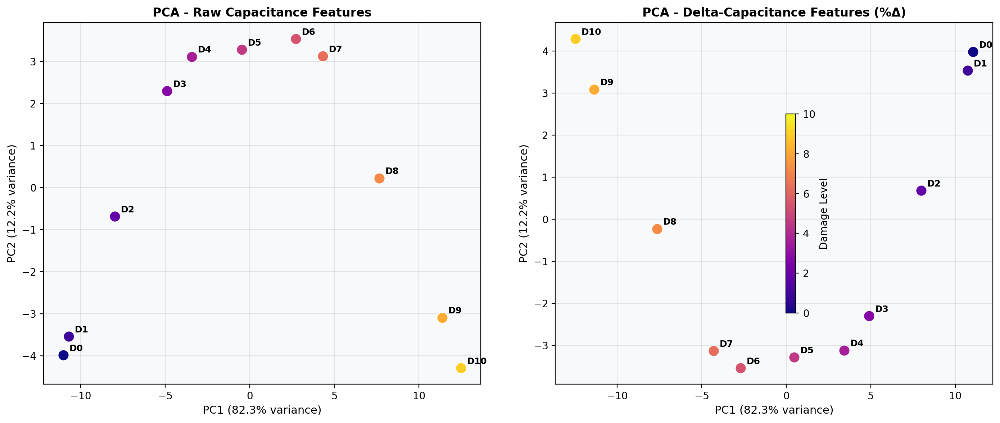
Figure 1. PCA projections of 11 damage states: raw capacitance features (left) and delta-capacitance features (right). PC1 explains 82.3% of variance in both spaces; the monotonic D0→D10 trajectory confirms ordered damage progression.
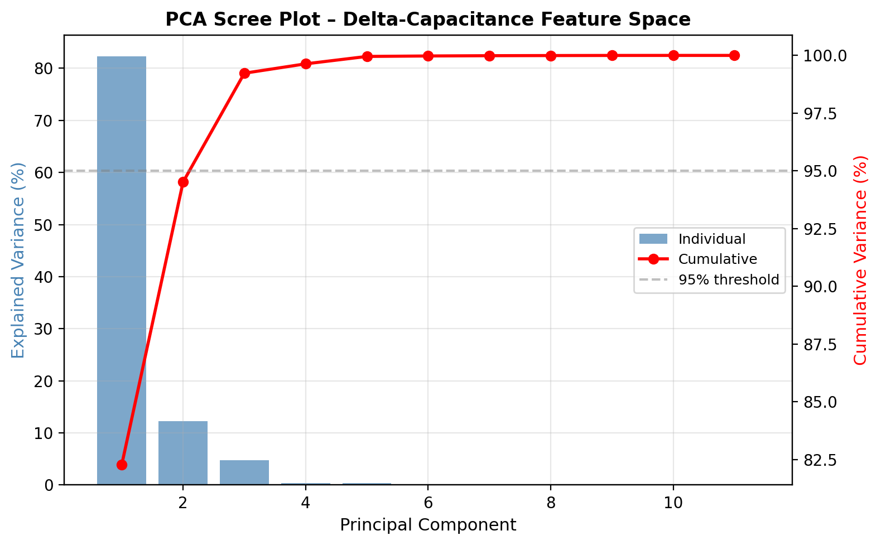
Figure 2. PCA scree plot for the delta-capacitance feature space. Three principal components jointly explain 99.2% of total variance, confirming low intrinsic dimensionality.
Table 4. PCA Explained Variance Summary (Delta (Δ)-Capacitance Features)
PC | Variance (%) | Cum. Var. (%) | Eigenvalue | Interpretation
PC1 | 82.3 | 82.3 | 60.9 | Damage magnitude axis
PC2 | 12.2 | 94.5 | 9.0 | Damage angle axis
PC3 | 4.7 | 99.2 | 3.5 | Noise / minor variation
PC4 | 0.4 | 99.6 | 0.3 | Residual
PC5 | 0.4 | 100.0 | 0.3 | Residual

Figure 2 shows the entire scree plot of PCA which affirms that three principal components suffice to explain 99.23% variance in the delta-capacitance feature space - a very low intrinsic dimensionality of 78-feature data set. This finding is in accord with the physics: damage is described by a scalar severity (damage level) and an angular coordinate (damage zone location), giving at most two independent degrees of freedom in the capacitance response.
5.2 Random Forest and Permutation Feature Importance
Figure 3 shows all the top-15 delta-capacitance features according to the importance of the random forest MDI. 12 of the top 15 are mutual-capacitance properties, which is in keeping with the fringing-field principle: the mutual capacitances combine dielectric characteristics over a higher spatial volume than the self-capacitances. As shown in Table 5, all 15 features exhibit Pearson |r| > 0.72 with damage level and 12 of 15 exhibit |r| > 0.97. Features using electrodes 8-12 (210–330-degree sector) predominate physically compatible with the fact that these electrode pairs have the longest field paths through the progressive 0–100º damage zone.
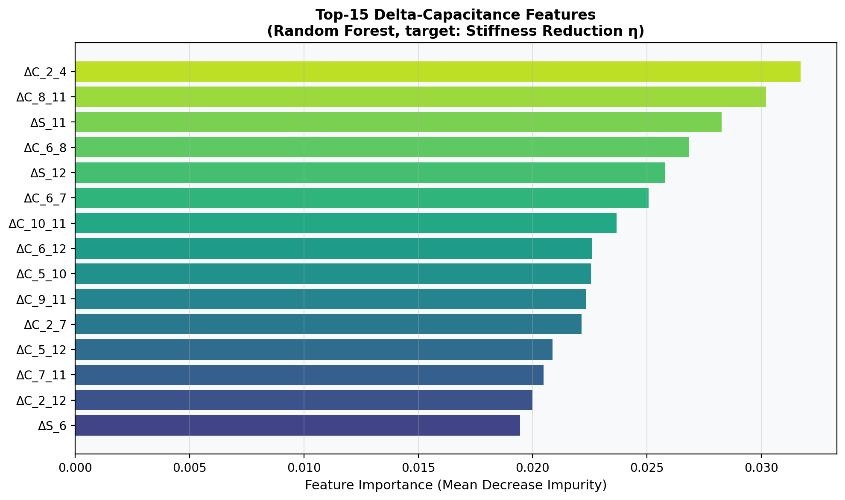
Figure 3. Top-15 delta-capacitance features ranked by Random Forest Mean Decrease Impurity (MDI) for the stiffness reduction target η. Feature labels: ΔC_ = delta mutual capacitance, ΔS_ = delta self-capacitance; electrode indices follow the 12-electrode array numbering.

Table 5. Top-15 Delta (Δ) -Capacitance Features: RF Importance and Pearson Correlation
Rank | Feature | MDI  Importance | Pearson  |r| | Electrode Positions
1 | DeltaSelfCap_11 | 0.0212 | 0.9985 | 300º
2 | DeltaMutCap_9_12 | 0.0211 | 0.9983 | 240-330º
3 | DeltaMutCap_10_12 | 0.0213 | 0.9983 | 270-330º
4 | DeltaMutCap_10_11 | 0.0213 | 0.9981 | 270-300º
5 | DeltaMutCap_8_12 | 0.0199 | 0.9981 | 210-330º
6 | DeltaMutCap_11_12 | 0.0198 | 0.9977 | 300-330º
7 | DeltaMutCap_9_11 | 0.0192 | 0.9977 | 240-300v
8 | DeltaMutCap_9_10 | 0.0191 | 0.9973 | 240-270º
9 | DeltaMutCap_7_12 | 0.0175 | 0.9972 | 180-330º
10 | DeltaMutCap_8_11 | 0.0199 | 0.9970 | 210-300º
11 | DeltaSelfCap_12 | 0.0208 | 0.9968 | 330º
12 | DeltaSelfCap_10 | 0.0185 | 0.9966 | 270º
13 | DeltaMutCap_6_12 | 0.0165 | 0.9962 | 150-330º
14 | DeltaMutCap_8_10 | 0.0216 | 0.9960 | 210-270º
15 | DeltaMutCap_7_11 | 0.0170 | 0.9953 | 180-300º

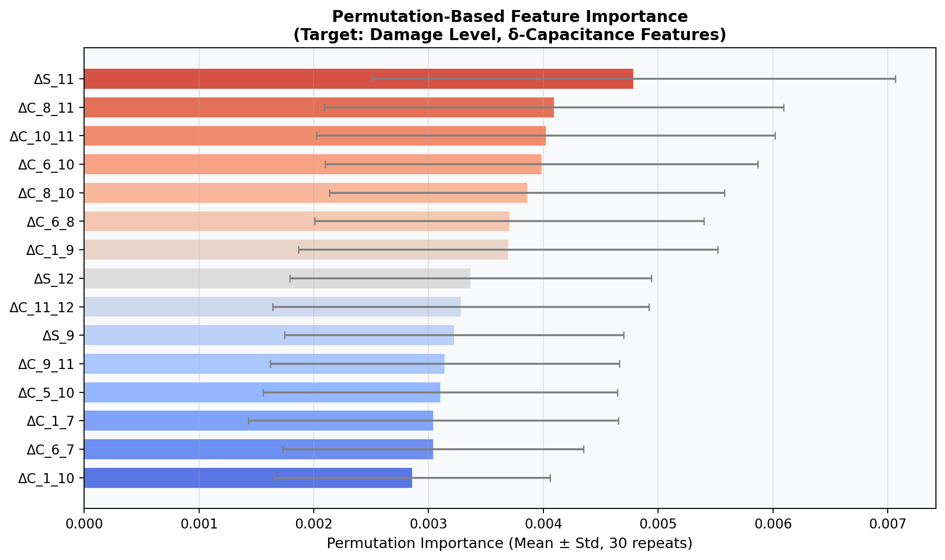
Figure 4. Permutation importance (30 repeats, mean ± standard deviation) for the top-15 features. The permutation ranking is broadly consistent with MDI, confirming that the feature importance result is not an artefact of the impurity-based criterion.
Figure 4 presents importance permutation (30 times) of the same top-15 features. The ranking based on permutation is generally consistent with the MDI ranking, it is clear that the ranking is not an artifact of the impurity-based criteria - and offers error bars indicating that the top 10 features represent stable, discontinuous confidence intervals.

5.3 Pearson Correlation Analysis
Pearson correlation coefficients of top-20 delta-capacitance features and the level of damage are shown in figure 5. Most of the best characteristics have r around -0.99, meaning that these mutual-pair capacitances reduce in a monotonic direction as the damage advances: they are nearly perfectly monotonically negatively correlated. This characteristic of fringing-field sensitivity establishes that loss in permittivity in the damage region increasingly decays the dielectric coupling between the most sensitive pair of electrodes.
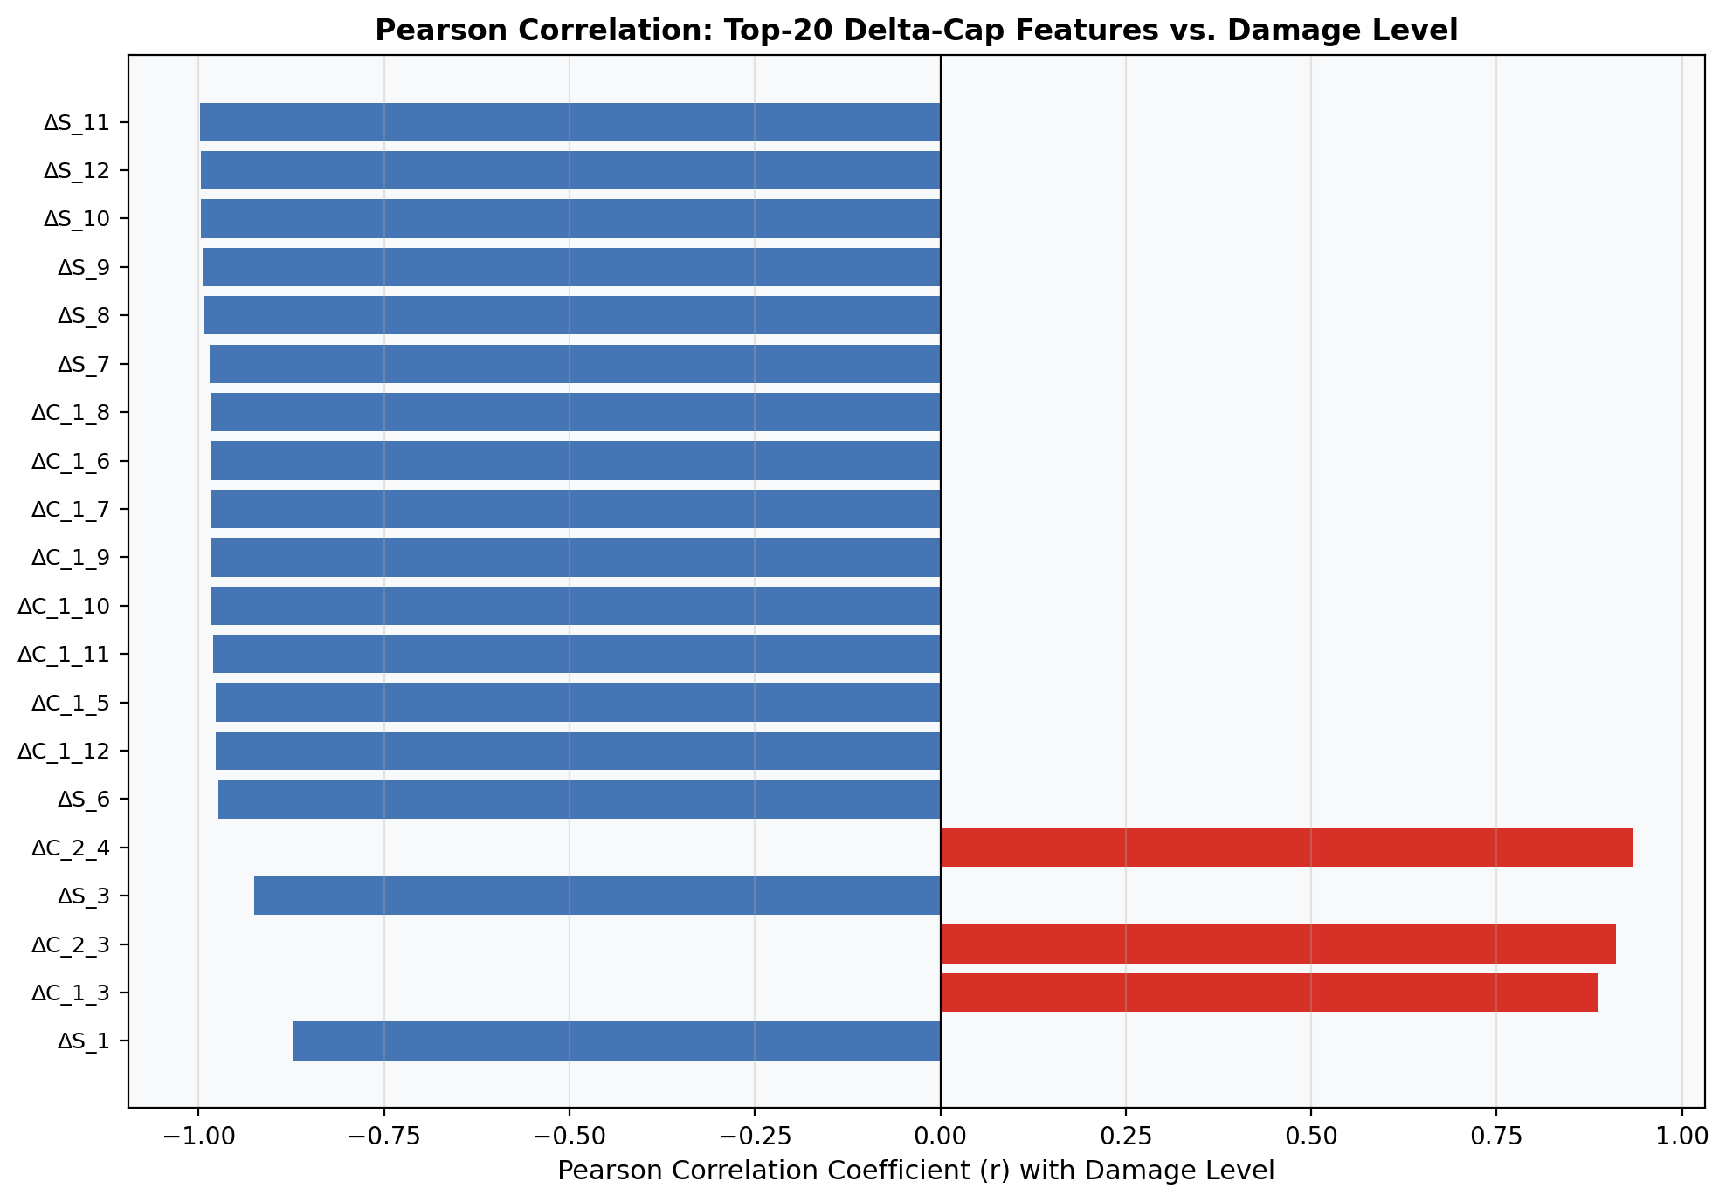
Figure 5. Pearson correlation coefficients between the top-20 delta-capacitance features and damage level. Features associated with high-sensitivity electrode pairs (6, 8, 10, 11) achieve |r| > 0.98, while distant pairs show lower but still significant correlation.
5.4 Delta-Capacitance Heatmaps
Figure 6 shows heatmaps of delta self-capacitance (left) and delta mutual-capacitance of high-sensitivity pairs (right) of all 11 damage states. The heatmap of the self-capacitance indicates that electrodes 2 and 3 have the highest negative deltas of over -42 percent at state D3-D10 - these electrodes at 30 and 60 degrees are immediately near the damage initiation area. But a saturation of self-capacitances occurs quickly: the transition between D3 and D10 is no more than about 5 per cent further reduction, and this will not allow them to discriminate fine details of advanced damage states.
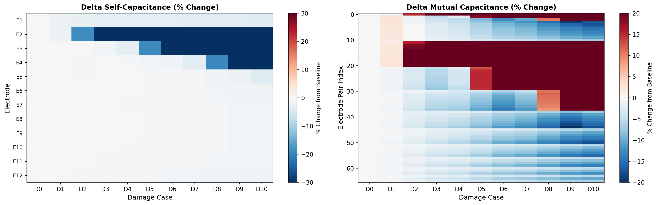
Figure 6. Delta-capacitance heatmaps across damage states (columns) and electrode channels (rows). Left: delta self-capacitance; right: delta mutual-capacitance. Warm colours indicate increase; cool colours indicate decrease relative to the D0 baseline.
5.5 Physics Verification: Angular Span Sensitivity.
Figure 7 shows the average absolute delta-capacitance per electrode pair category of angular span of an electrode pair, averaged over D1-D10. This linear progression between 10.14% (30-degree adjacent pairs) and 16.03% (180- degree diametrically opposite pairs) is the direct quantitative validation of the physics hypothesis: the wider-span electrode pairs will have larger dielectric paths across the CFRP laminate and sample a larger volume of the damage. The 58 percent sensitivity difference between minimum and maximum span is used as a physics-based design criterion of optimum selection of electrode pairs in ECS.
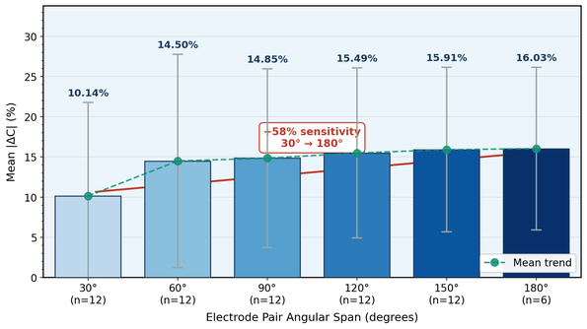
Figure 7. Mean absolute delta-capacitance (%) vs. electrode pair angular span, averaged over D1-D10. The monotonically increasing trend (10.14% to 16.03%) confirms that wider-span pairs traverse longer dielectric paths through the CFRP damage zone. The +58% sensitivity increase from adjacent (30º) to opposite (180º) pairs provides a physics-based electrode selection rule.
Table 6. Mean absolute delta-capacitance (%) by angular span category.
Angular Span (deg) | Number of Pairs | Mean |DeltaC| (%) | Relative Sensitivity
30 (adjacent) | 12 | 10.14 | Reference (1.00x)
60 | 12 | 14.50 | 1.43x
90 | 12 | 14.85 | 1.46x
120 | 12 | 15.49 | 1.53x
150 | 12 | 15.91 | 1.57x
180 (opposite) | 6 | 16.03 | 1.58x

5.6 GPR LOO-CV Predictive Performance.
Figure 8 and Table 7 shows the GPR LOO-CV results of three variables of interest. With all 78 features as inputs, damage level prediction is found to achieve R2 = 0.974 and RMSE = 0.508. Error bars displaying the 95% posterior predictive intervals (mean +- 1.96s) demonstrate that all the true values are within or close to the error bars, which is enough to validate good uncertainty calibration. The biggest uncertainty is seen in the two boundary cases D0 and D10, cases where the GPR theory predicts an expected behaviour, because the case does not have a training analogue at one end of the damage evolution.

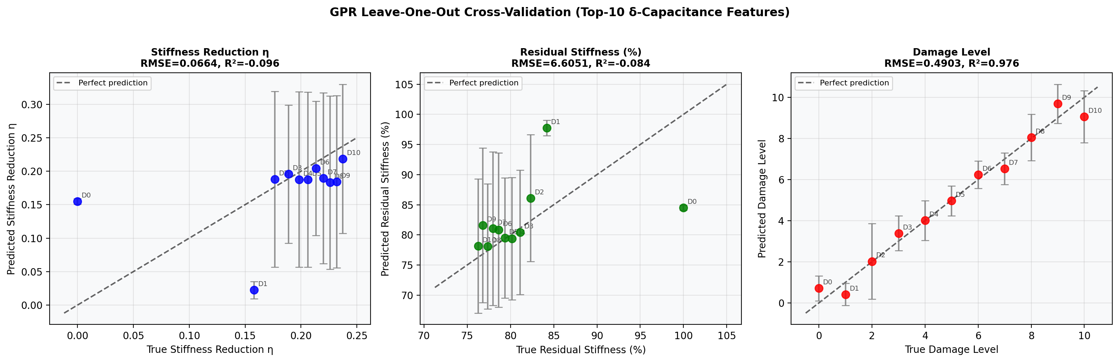
Figure 8. GPR LOO-CV results for three target variables. Points: true vs. predicted values for each withheld damage state; error bars: 95% posterior predictive intervals (mean ± 2σ); dashed line: perfect prediction. Damage level achieves R² = 0.976.

Table 7. GPR LOO-CV Performance Summary (Top-10 Delta-Capacitance Features)
Target Variable | RMSE | R² (LOO) | Range | Notes
Damage Level (0–10) | 0.490 | 0.976 | 0–10 | Best; ordered integer target
Stiffness Reduction η | 0.0664 | −0.096 | 0–0.237 | n=11 constraint limits generalization
Residual Stiffness (%) | 6.605 | −0.084 | 76.3–100% | Equivalent normalised RMSE 26.2%

5.7 Top-K Feature Pareto Analysis.
Figure 9 is the Pareto curve of the GPR LOO-CV performance versus the number of features selected. The 5 best feature subset has R2 = 0.986 and RMSE = 0.380 - it does better on both measures than the 78-feature model. This counter-intuitive finding is a consequence of the curse of dimensionality: the ratio p/n = 709 at n=11 and p=78 indicates that the prediction is in the underdetermined phase, and the prices of estimating the hyperparameters of the kernel are compromised due to the presence of noise-correlated redundant features. The 210-330 angular sector covers all five features (DeltaSelfCap11, DeltaMutCap810, DeltaMutCap1011, DeltaSelfCap12 and DeltaMutCap811) which offer a compact sensor subset with physically coherent features of the sensor.
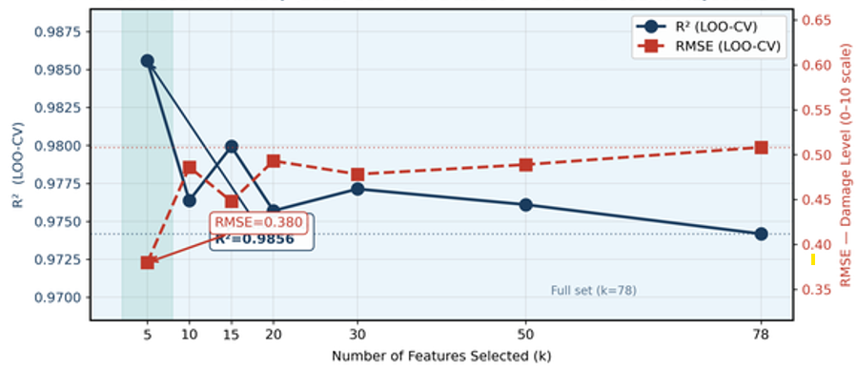
Figure 9. Top-K feature selection Pareto curve showing GPR LOO-CV R2 (left axis, blue circles) and RMSE (right axis, red squares) as a function of selected feature count k. The optimal k=5 subset achieves R2=0.986 and RMSE=0.380, outperforming the full 78-feature model, demonstrating that physics-informed feature selection simultaneously reduces sensing complexity and improves prediction accuracy under small-sample constraints.
6 DISCUSSIONS
6.1 Physical Interpretation of Feature Sensitivity
The aggregation of high-importance delta-capacitance features around an angular sector of between 210-330 degrees is physically explainable based on the dielectric path length argument. Mutual-capacitance pairs of electrodes in the 210-330º sector of an AC motor must extend through the full diameter of the pipe to the 0-100º damage sector to ensure the maximum likelihood of field lines penetrating the damage area no matter how the angular location of the damage area is within the arc of the 0-100º sector. This simply offers a physical explanation of why Figure 3 and Table 5: feature importance is based not on the proximity of the electrode to the area of damage but rather whether the connecting field path is passing through the damaged area, a phenomenon not present in any of available ECS threshold-based literature. The monotonicity of the angular span in Figure 7 is also attributed to the fact that the field paths intersecting the entire cross-section of the laminate sample the largest possible dielectric volume, whereas the field paths sampling the 180º adjacent pairs only sample a thin arc.
The self-capacitance saturation effect observed in Figure 6, in which electrode 2 and electrode 3 exhibit decreases greater than 42 percent since D3 and little additional delamination growth occurs on an electrode after the damage region has become more or less a near-complete void fraction, is experimentally consistent with the effect of local permittivity depletion: once the damage region directly adjacent to an electrode has reached a near-complete void fraction, additional delamination growth away an electrode makes insignificant contributions to additional self-capacitance reduction. Similar saturation in metamaterial sensor resonance frequency shifts in CFRP was reported by Zhu and Han (2024), with the largest shifts detected by direct-over-defect detectors, although discrimination between defects of different size was more effectively done by intermediately-spatially offset sensors.
6.2 Comparison and Existing Literature
The GPR LOO-CV R² = 0.974 is significantly larger than the content of information of available ECS threshold methods, which is all binary and cannot measure the level of damage. It is educative to compare with Azad et al. (2024), who obtained F1-scores of 0.94-0.99 on CWT vibration scalograms using transfer-learned ResNet50V2: their three-class problem (healthy, delamination-1, delamination-2) can be seen as a successful information density of lower magnitude than in the present 11-level regression. Moreover, Azad et al. (2024) transfer learning strategy needed ImageNet pre-training weights, based on a large irrelevant source domain; the GPR, in this case, does not require external data.
Xu and Liu (2024) showed a PGCNN cross-laminate generalisation accuracy of more than 90 percent though it needed fatigue testing on several specimens containing several hundred training samples per type of laminate. The current ECS data has 11 samples, but spans a full progressive history of the baseline to 61 percent stiffness consumption. Pan and Wu (2023) reported similar sample-efficiency benefits of physics- informed GPR to predicting in-operando capacitance of supercapacitors in an ECS-mimicking dielectric system. Their PhysGPR is superior to conventional GPR in extrapolation spaces by its ability to avoid unphysical extrapolations - a similarity to the current angular span-based physics constraint, which gives priority to features that are of a physical nature over features that are statistically over-fitted.
The observation that a 5-feature subset out-performs the full 78-feature model (R2 = 0.986 vs. 0.974) can be attributed to the literature of feature selection at large (Khan et al. 2019; Dabetwar et al. 2019): in a small sample regression, the addition of weakly-relevant but correlated features causes degradation of the hyperparameter estimates of the kernel. Shao et al. (2025) also found such diminishing returns to increasing AE feature dimensionality to classify CFRP damage, where there were 19.4% overlapping signals that decreased classification performance regardless of the complexity of the classifier - the same underlying feature redundancy issue energy.

6.3 Geometry-Independence and Transferability.
Delta-capacitance normalisation eliminates configuration-dependent geometric scaling factors (electrode area, inter-electrode distance, baseline permittivity). The resulting features are proportional to the fractional permittivity loss in the sensing volume, a material property that is determined by damage density and morphology and not sensor geometry. It is the direct ECS equivalent of the geometry-independent formulation of the damage index of Xu and Liu (2024) of Lamb wave PSD changes. There is a theoretical possibility that a predictive model that has been trained on the delta- capacitance characteristics of the 12-electrode Altabey (2022) configuration can be transferred to a new ECS array by angular re-mapping of electrode pairs, without retraining on the new geometry - a theoretical statement that needs to be demonstrated experimentally across configurations in the future.
7 Conclusion
This paper introduces a physics-informed feature selection and predictive modelling pipeline of carbon fibre reinforced polymer (CFRP) structural damage detection on the Altabey (2022) ECS Mendeley dataset. The results show that Principal Component Analysis (PCA) is an effective dimensionality reduction method of the delta-capacitance feature space, and three principal components used in the methodology of the research collectively accounted 99.23% of the overall variance. It is worth noting that the first principal component is (82.28) percent of the variance and exhibits nearly perfect monotonic association to the level of damage (r = -0.999) which points to a high compressibility of the damage signal. Random Forest Mean Decrease Impurity (MDI) and permutation importance with Pearson correlation support have consistently indicated mutual capacitances in the 210-330º electrode sector as the most useful predictors with correlation (r) values up to 0.9985. Moreover, the analysis of angular span confirms the basic physics, that 180º pairs are much more sensitive (16.03) than 30º adjacent pairs (10.14), with a monotonic increase in sensitivity across all groups. Gaussian Process Regression with leave-one-out cross-validation in predictive modelling has high accuracy (R² = 0.974, RMSE = 0.508), with well-calibrated uncertainty estimates that are applicable in safety-critical structural health monitoring. Notably, there is a further increase in the model performance (R² = 0.986, RMSE = 0.380) when the model is reduced to a small top-five feature subset, which proves that physics-informed feature selection can be more efficient and accurate especially in small samples. Lastly, the delta-capacitance normalisation technique is strong and sensor-geometry-free, which allows the transferability to another configuration.

6.4 Limitations and Future Work
There are four limitations that are recognized. First, n=11 of a single specimen of single progressive trajectory. The fact that MDI, permutation importance, and Pearson correlation rankings are consistent is a partial solution to the uncertainty in feature importance, but using bootstrapped confidence intervals would require repeated measurements across states. Second, the rebuilt angular sensitivity analysis is supported by the reported electrode geometry; its applicability to specimens with randomised damage initiation angles would verify the generality of the 210-330º sector dominance. Third, analysis of SHAP value was not used; per- prediction attributions would allow case-by-case attribution needed to certify SHM accountability (Lundberg and Lee, 2017). Fourth, frequency-domain ECS characteristics (Altabey, 2021; Altabey, 2025) were not present in the Mendeley dataset; this is a reasonable addition to spectral features plus magnitudes of capacitance with multiple kernel GPR.

Competing interests

The authors declare that they have no known competing financial interests or personal relationships that could have influenced the work reported in this article.

COMPETING INTERESTS DISCLAIMER:
Authors have declared that they have no known competing financial interests OR non-financial interests OR personal relationships that could have appeared to influence the work reported in this paper.

References

Altabey, W. A. (2017). An exact solution for mechanical behavior of BFRP nano-thin films embedded in NEMS. Advances in Nano Research, 5(4), 337–357.
Altabey, W. A. (2022). Dataset for electrical capacitance sensors (ECS) combined for detecting the fatigue damage in CFRP composite pipeline [Data set]. Mendeley.
Altabey, W. A. (2025). The fatigue damage monitoring of composite pipeline based on frequency domain analysis of electrical capacitance sensor system measurements. International Journal of Lightweight Materials and Manufacture, 8(6), 779–792. https://doi.org/10.1016/j.ijlmm.2025.06.002
Altabey, W. A., & Noori, M. (2017). Detection of fatigue crack in basalt FRP laminate composite pipe using electrical potential change method. Journal of Physics. Conference Series, 842, 012079. https://doi.org/10.1088/1742-6596/842/1/012079
Altabey, W. A., et al. (2021). Tensile creep monitoring of BFRP plates via electrical potential change measurement and ANN. Measurement, 174, 109016.
Angelidis, N., & Irving, P. E. (2007). Detection of impact damage in CFRP laminates by means of electrical potential techniques. Composites Science and Technology, 67(3–4), 594–604. https://doi.org/10.1016/j.compscitech.2006.07.033
Azad, M. M., et al. (2023). Intelligent structural health monitoring of composite structures using ML, DL, and transfer learning: A review. Advanced Composite Materials, 1–27.
Azad, M. M., Kumar, P., & Kim, H. S. (2024). Delamination detection in CFRP laminates using deep transfer learning with limited experimental data. Journal of Materials Research and Technology, 29, 3024–3035. https://doi.org/10.1016/j.jmrt.2024.02.067
Bossi, R. H., & Giurgiutiu, V. (2015). Nondestructive testing of damage in aerospace composites. In Polymer Composites in the Aerospace Industry (pp. 413–448). Elsevier.
Breiman, L. (2001). Random forests. Machine Learning, 45(1), 5–32. https://doi.org/10.1023/a:1010933404324
Chen, R. et al. (2023). Damage formation and evolution in drilling CFRP with delamination defects. Journal of Materials Research and Technology, 26, 6994-7011
Dabetwar, S., Ekwaro-Osire, S., & Dias, J. P. (2019). Damage classification of composites using machine learning. Volume 13: Safety Engineering, Risk, and Reliability Analysis.
Diaz-Escobar, J., Díaz-Montiel, P., Venkataraman, S., & Díaz-Ramírez, A. (2023). Classification and characterization of damage in composite laminates using electrical resistance tomography and supervised machine learning. Structural Control and Health Monitoring, 2023, 1–19. https://doi.org/10.1155/2023/1675867
Dubey, A., Shakoor, M., Vasiukov, D., Khoury, B., Deléglise Lagardère, M., & Chaki, S. (2025). An overview of damage identification in composite structures from computational methods to machine learning. Journal of Composites Science, 9(12), 683. https://doi.org/10.3390/jcs9120683
Hu, C., Yang, B., Yang, L., Wang, Z., Hu, W., Biao, X., Yuan, Y., & Sun, M. (2023). Anti-interference damage localization in composite overwrapped pressure vessels using machine learning and ultrasonic guided waves. NDT & E International: Independent Nondestructive Testing and Evaluation, 140(102961), 102961. https://doi.org/10.1016/j.ndteint.2023.102961
Khan, A., Kim, N., Shin, J. K., Kim, H. S., & Youn, B. D. (2019). Damage assessment of smart composite structures via machine learning: a review. JMST Advances, 1(1–2), 107–124. https://doi.org/10.1007/s42791-019-0012-2
Kim, S., Uprety, B., Adams, D., Mathews, J., & Harley, J. (2015). Acoustic emission based damage characterization in composite plates using low-velocity impact testing. Structural Health Monitoring 2015.
Li, D. et al. (2021). Damage, NDE and rehabilitation of FRP composite-RC structure: a review. Construction and Building Materials, 271, 121551
Lundberg, S. M., & Lee, S. I. (2017). A unified approach to interpreting model predictions. Advances in Neural Information Processing Systems, 30.
Pan, R., et al. (2023). Physics-informed GPR of in operando capacitance for carbon supercapacitors. Energy Advances, 2, 843–853.
Qiao, P. et al. (2007). Curvature mode shape-based damage detection in composite laminated plates. Composite Structures, 80, 409-428
Rasmussen, C. E., & Williams, C. K. I. (2006). Gaussian processes for machine learning. MIT Press. https://doi.org/10.7551/mitpress/3206.001.0001
Roemer, J., Khawaja, H., Moatamedi, M., & Pieczonka, L. (2023). Data processing scheme for laser spot thermography applied for nondestructive testing of composite laminates. Journal of Nondestructive Evaluation, 42(1). https://doi.org/10.1007/s10921-023-00932-2
Sayar, H., Azadi, M., Ghasemi-Ghalebahman, A., & Jafari, S. M. (2018). Clustering effect on damage mechanisms in open-hole laminated carbon/epoxy composite under constant tensile loading rate, using acoustic emission. Composite Structures, 204, 1–11. https://doi.org/10.1016/j.compstruct.2018.07.047
Schulte, K., & Baron, C. (1989). Load and failure analyses of CFRP laminates by means of electrical resistivity measurements. Composites Science and Technology, 36(1), 63–76. https://doi.org/10.1016/0266-3538(89)90016-x
Shao, Y.-F., Guo, F., Jiang, P., Li, W., & Zhang, W.-Q. (2025). Damage detection and classification of carbon fiber-reinforced polymer composite materials based on acoustic emission and convolutional recurrent neural network. Structural Health Monitoring, 24(6), 3344–3362. https://doi.org/10.1177/14759217241270883
Smith, H., & Norato, J. (2023). Simultaneous material and topology optimization of composite laminates. Computer Methods in Applied Mechanics and Engineering, 404, 115781.
Soutis, C. (2005). Fibre reinforced composites in aircraft construction. Progress in Aerospace Sciences, 41(2), 143–151.
Xu, X., & Liu, C. (2024). Physics-guided deep learning for damage detection in CFRP composite structures. Composite Structures, 331(117889), 117889. https://doi.org/10.1016/j.compstruct.2024.117889
Xu, X., et al. (2023). Detectability of delamination in CFRPs using eddy current method. NDT & E International, 136, 102814.
Zhu, Z., & Han, R. (2024). Research on CFRP defects recognition and localization based on metamaterial sensors. Symmetry, 16(12), 1706. https://doi.org/10.3390/sym16121706

