The Effect of Thermal Cycling Cycles on the Microstructure and Properties of Cu/In-48Sn-xGNSs/Cu Solder Joints

Abstract：The effects of thermal cycling cycles (200, 400, 600, 800, and 1000 cycles) on the microstructure, shear properties, and shear fracture morphology of the joints were investigated. The results indicate that as the number of thermal cycles increases, the microstructure of both composite brazing joints gradually coarsens, the thickness of intermetallic compounds (IMCs) at the interface shows a gradual increase, and the shear strength gradually decreases. Under the same thermal cycling conditions, the rate of microstructural coarsening and the rate of IMC thickening for the In-48Sn-0.05GNS composite brazing joint were both significantly lower than those for the In-48Sn brazing joint. Analysis of the shear fracture surface morphology revealed that the fracture mechanism of the In-48Sn composite brazing joints shifted from ductile fracture to brittle fracture, while that of the In-48Sn-0.05GNS composite brazing joints gradually transitioned from ductile fracture to a ductile-brittle mixed fracture.
Keyword：In-48Sn solder ; Graphene ; Microstructure ; Mechanical Properties

Introduction
Solder joints play a critical role in the electrical connection, mechanical attachment, and thermal management of electronic components and circuit boards. Although individual solder joints are minuscule in size, their reliability is decisive for the proper operation of electronic devices^{[1]}. From consumer electronics to aerospace, solder joint reliability is directly linked to product lifespan and safety.
Related researchers^{[2][3]} found that adding graphene nanosheets to lead-free solders can refine the microstructure of solder joints and improve their mechanical properties. YIN^{[4]} et al. prepared a graphene-nanosheet-reinforced low-silver Sn-0.3%Ag-0.7%Cu (SAC0307) composite solder using powder metallurgy technology. The study demonstrated that the addition of graphene improved the microstructure hardness, shear strength, and wettability of the solder alloy. The fracture mechanism of the solder joints shifted from typical brittle fracture to ductile fracture. Bhavan S J et al.^{[5]} added graphene to Sn-Ag alloys. The results indicated that graphene refined the grain structure, increased interfacial complexity, and enhanced isotropy, thereby significantly improving the microstructure of the Sn-Ag alloys.
Due to mismatched coefficients of thermal expansion among electronic packaging materials, thermal cycling during equipment power-on and power-off cycles subjects solder joints to alternating stresses, leading to thermal fatigue failure^{[6]}. Therefore, it is of great significance to thoroughly investigate the evolution of composite solder joints (including their microstructure, interfacial intermetallic compounds, and shear properties) under thermal cycling. In-48Sn composite brazing alloys are widely used in the field of electronic packaging due to their low melting point (118°C) and excellent electrical conductivity^{[7]}; however, there is limited research on the effects of thermal cycling cycles on the microstructure and properties of In-48Sn brazing alloys. In this paper, accelerated thermal cycling tests were conducted on Cu/In-48Sn-xGNSs/Cu (x = 0, 0.05) composite solder joints at temperatures ranging from -35°C to 110°C, primarily to investigate the effects of thermal cycling cycles on the microstructure, shear properties, and shear fracture morphology of the solder joints.

1. Methodology

Experiment
Take an appropriate amount of the prepared In-48Sn and In-48Sn-0.05GNSs composite brazing paste. Select a 99.99% pure copper substrate, with the upper copper substrate measuring 10 × 10 × 4 mm and the lower copper substrate measuring 12 × 12 × 4 mm. After grinding and polishing the copper substrates, use a precision coating tool to apply the brazing paste to the copper substrates to complete the sample coating, as shown in Figure 1. Place the coated samples in a TWB-100 wafer bonding machine, set the vacuum to 50 Pa, the bonding temperature to 180°C, and the bonding time to 5 minutes, followed by 10 minutes of air cooling, to obtain the bonded samples.

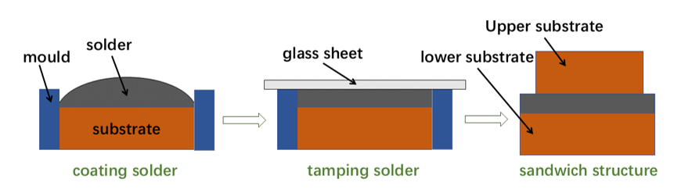
Fig. 1 Schematic Diagram of the Flux Coating Process

Place the prepared bonded joint specimens in a TH-800 rapid temperature cycling chamber for thermal cycling testing. Ensure that the specimens do not come into contact with one another and that airflow circulation is unobstructed to guarantee temperature uniformity. The temperature range for the thermal cycling test is set to -35°C to 110°C, with a holding time of 15 minutes for both the high-temperature and low-temperature phases, and a heating and cooling rate of 10°C/min. The number of thermal cycles is set to 200, 400, 600, 800, and 1,000, respectively, with each thermal cycle lasting approximately 45 minutes.

2. Experimental Results and Discussion

2.1 Microstructure of the weld joint
Figure 2 shows the microstructure of In-48Sn and In-48Sn-0.05GNSs composite solder joints after 200, 400, 600, 800, and 1,000 thermal cycles between -35°C and 110°C. Figure 3 shows the average grain size of the γ-InSn4 phase in In-48Sn and In-48Sn-0.05GNS solder joints at different thermal cycle counts. The microstructure of both solder joints consists primarily of a Sn-rich phase (γ-InSn4) and an In-rich phase (β-In3Sn)^{[8]}. Combining the two figures reveals that, as the number of thermal cycles increases, the microstructure of both composite solder joints exhibits a gradual coarsening trend. Under identical thermal cycling conditions, the grain coarsening rate of the In-48Sn-0.05GNSs solder joints is significantly lower than that of the In-48Sn solder joints. After 200 thermal cycles, the average grain sizes of the Sn-rich phase (γ-InSn4) in the In-48Sn and In-48Sn-0.05GNSs composite solder joints reached 10.4 μm and 4.1 μm, respectively. After 400 thermal cycles, the average grain size of the γ-InSn4 phase increased further, reaching 13.1 μm and 5.1 μm, respectively. After 1,000 thermal cycles, the average grain size of the γ-InSn4 phase in both types of joints reached its maximum values of 28.6 μm and 13.8 μm.
The core mechanism is the Zener pinning effect of graphene. Grain coarsening is accompanied by grain boundary migration; graphene is distributed at the grain boundaries between the two phases. When grain boundaries encounter graphene during migration, they can be pinned by the ultra-high strength of the graphene, thereby reducing the grain boundary mobility and further decreasing the grain size^{[9]}. Even at high temperatures of 110°C, the extremely high thermal stability of graphene ensures that its physical barrier function remains effective. On the other hand, two-dimensional graphene sheets with high aspect ratios tend to be distributed at grain boundaries^{[10]}. When graphene adsorbs onto grain boundaries or crystal surfaces, the original “metal-metal” interface is transformed into two “metal-graphene” interfaces. As a two-dimensional material, graphene is extremely stable, and the interfaces it forms with the metal substrate often have lower energy than the highly disordered metal grain boundaries. According to the principle of minimum interfacial energy, the adsorption of graphene reduces the total interfacial free energy of the system^{[11]}.
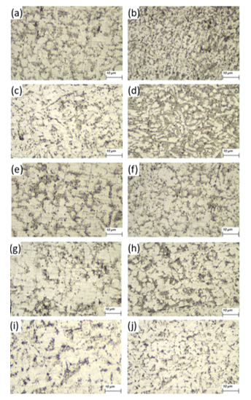
Fig. 2 Microstructure of the solder joints under different thermal cycle cycles
(a) In-48Sn 200次，(b) In-48Sn-0.05GNSs 200次，(c) In-48Sn 400次，(d) In-48Sn-0.05GNSs 400次，(e) In-48Sn 600次，(f) In-48Sn-0.05GNSs 600次，(g) In-48Sn 800次，(h) In-48Sn-0.05GNSs 800次，(i) In-48Sn 1000次，(j) In-48Sn-0.05GNSs 1000次

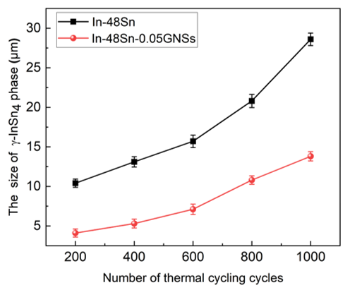
Fig. 3 The average grain size of the γ-InSn4 phase in In-48Sn and In-48Sn-0.05GNS solder joints under different thermal cycle cycles

2.2 Morphology and Thickness of Intermetallic Compounds
Figure 4 shows the IMC morphology at the joint interface of In-48Sn and In-48Sn-0.05GNS composite solders under different numbers of thermal cycles. Figure 5 illustrates the relationship between the number of thermal cycles and the thickness of the IMC layer at the joint interface of the composite solder. The data in the figures show that when the number of thermal cycles is 200, the IMC layer thicknesses at the interfaces of the In-48Sn and In-48Sn-0.05GNS composite solder joints are 3.639 μm and 3.174 μm, respectively; As the number of thermal cycles continues to increase, the thickness of the interfacial IMC layer shows a gradual upward trend. When the number of thermal cycles reaches 1,000, the thickness of the interfacial IMC layer for both types of solder joints reaches a peak, at 5.462 μm and 4.915 μm, respectively. At this stage, the surface morphology of the IMC layer also tends to become smoother and more uniform. The primary reason for this change is that, as the number of thermal cycles increases, both the atomic diffusion rate and the grain growth rate within the IMC layer undergo changes. Overall, the process evolves from rapid growth in the initial stage to gradual, stable growth in the later stages. During this process, the grains gradually grow larger until they come into contact with one another, forming a relatively continuous and flat surface. This phenomenon can be explained by Fick’s second law^{[12]}:
$$\begin{aligned}\frac{∂C}{∂t}=D\frac{∂^{2}C}{∂x^{2}}\end{aligned}$$
In the equation, C represents the concentration at a specific location x, t represents time, and D represents the diffusion coefficient, which characterizes the ability of atoms to diffuse through a material at a specific temperature. In actual diffusion processes, temperature has a significant effect on the diffusion coefficient. When the number of thermal cycles is low, the formation of the IMC layer is primarily driven by rapid atomic diffusion reactions at high temperatures during welding and rapid cooling after welding. At this stage, the diffusion process is constrained, leading to non-uniform growth of the IMC layer^{[13]}. During thermal cycling, the weld joint repeatedly undergoes heating and cooling, providing energy for the diffusion of alloying elements. The formation of IMC is a diffusion-controlled process. After a sufficient number of thermal cycles, the diffusion coefficient D increases. Repeated thermal cycles provide sufficient time and energy for element migration, promoting atomic diffusion at the interface and leading to a more uniform distribution of atoms. This accelerates the growth of the IMC layer and results in a relatively uniform growth rate^{[14]}.
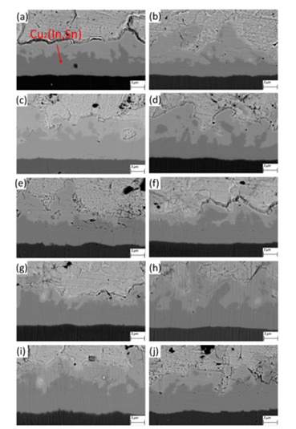
Fig. 4 The morphology of intermetallic compounds at the interface of composite solder joints under different thermal cycling cycles(a) In-48Sn 200次，(b) In-48Sn-0.05GNSs 200次，(c) In-48Sn 400次，(d) In-48Sn-0.05GNSs 400次，(e) In-48Sn 600次，(f) In-48Sn-0.05GNSs 600次，(g) In-48Sn 800次，(h) In-48Sn-0.05GNSs 800次，(i) In-48Sn 1000次，(j) In-48Sn-0.05GNSs 1000次

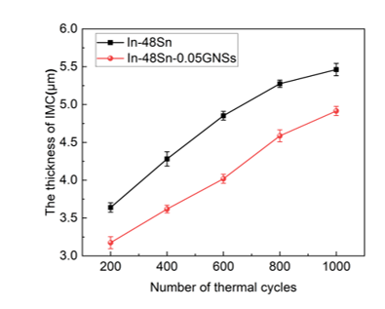
Fig. 5 The influence law of thermal cycle cycles on the thickness of intermetallic compounds at the interface of solder joints of composite solders

2.3 Shear strength of the weld joint
During thermal cycling, solder joints are subjected to thermal cycling loads. Due to the cyclic exposure to high and low temperatures, periodic cyclic stresses develop within the solder joints, leading to stress concentrations in certain areas and a gradual decrease in shear strength^{[15]}. Figure 6 shows the effect of thermal cycling cycles on the shear strength of solder joints made with In-48Sn and In-48Sn-0.05GNSs composite solders. After 200 thermal cycles, the shear strengths of the In-48Sn and In-48Sn-0.05GNSs composite solder joints were 7.9 MPa and 16.9 MPa, respectively. After 600 thermal cycles, the shear strengths of the joints made with the two composite brazing alloys were 5.7 MPa and 15.2 MPa, respectively, representing decreases of approximately 27.8% and 10.1% compared to the values after 200 thermal cycles. When the number of thermal cycles reached 1,000, the shear strengths of the joints for the two composite brazing alloys were 3.1 MPa and 12.7 MPa, respectively, representing decreases of approximately 45.6% and 16.4% compared to the values after 600 thermal cycles. The results indicate that the shear strength of solder joints made with In-48Sn and In-48Sn-0.05GNSs composite solders gradually decreases with an increase in the number of thermal cycles. However, the shear strength of joints made with the In-48Sn-0.05GNSs composite brazing alloy consistently remained higher than that of In-48Sn, and exhibited a slower rate of decline. This difference stems from the multifaceted regulatory effects of graphene on the microstructure, interfacial behavior, and stress transfer of the brazing alloy^{[10]}.
First, one of the key factors influencing the shear strength of solder joints is the characteristics of the intermetallic compound (IMC) layer between the solder and the copper substrate^{[16]}. IMC exhibits significant brittleness; when its thickness exceeds a critical threshold, brittle fracture is highly likely to occur^{[17]}. Graphene effectively suppresses excessive IMC growth, thereby delaying the strength degradation of solder joints at its root. Second, graphene acts to refine the grain structure within the solder. Cyclic temperature changes during thermal cycling induce recrystallization and grain coarsening in the solder^{[18]}, which can lead to the formation of coarse equiaxed grains. Grain coarsening reduces the number of grain boundaries, significantly lowering the resistance to crack propagation, while simultaneously causing a marked decline in the strength and toughness of the matrix. Meanwhile, graphene at a concentration of 0.05 wt.% acts as a heterogeneous nucleation core, refining the matrix grains during the solidification stage of the brazing material. Finally, due to its extremely high elastic modulus and mechanical strength, graphene rapidly disperses locally concentrated thermal stresses over a larger area of the matrix, preventing excessive stress accumulation at defects^{[19]}. Consequently, after multiple thermal cycles, In-48Sn-0.05GNSs solder joints still maintain a shear strength far higher than that of pure In-48Sn solder joints, demonstrating excellent in-service reliability.
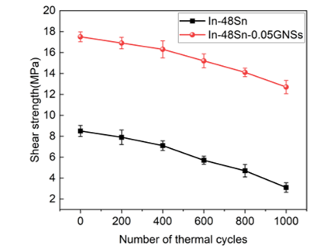
Fig. 6 The influence of heat cycle cycles on the shear strength of solder joints of composite materials

2.4 Fracture morphology of solder joints
Figure 7 shows the shear fracture surface morphology of In-48Sn and In-48Sn-0.05GNSs composite solder joints after 200, 600, and 1,000 thermal cycles, respectively. As the number of thermal cycles increases, the shear fracture surface of the In-48Sn composite brazing joints gradually transitions from ductile fracture to brittle fracture, while that of the In-48Sn-0.05GNSs composite brazing joints gradually transitions from ductile fracture to a ductile-brittle mixed fracture.
In-48Sn is a typical low-melting-point eutectic solder with a relatively soft matrix structure; it tends to form brittle intermetallic compounds (IMCs) at the interface with Cu substrates, resulting in a significant deterioration of the fracture mechanism as the number of thermal cycles increases^{[20]}. After 200 thermal cycles of In-48Sn composite solder joints, as shown in Figures (a–b), the fracture surface exhibits distinct small-scale tearing traces and a dimple-like structure, with a small number of scattered pores present locally. These features indicate that ductile fracture occurred during the tensile process^{[21]}. After 600 thermal cycles of the In-48Sn composite solder joints, ductile pits are still observable in Figures (c–d); in the upper left corner of Figure (c), a localized, flaking-like brittle fracture surface is visible. This indicates that an increase in the number of thermal cycles leads to a thickening of the IMC layer and an intensification of interfacial stress concentration, resulting in a decrease in plastic deformation capacity^{[22]}. Fracture in this stage transitions from ductile to brittle fracture, exhibiting a typical mixed fracture mechanism^{[23]}. After 1,000 thermal cycles, the fracture mechanism of the In-48Sn composite brazing joints is brittle fracture. Figures (e–f) show that the fracture surface is noticeably flattened, with no obvious tearing marks, and localized detachment along the IMC layer, indicating that tensile fracture is primarily due to brittle fracture of the IMC layer^{[24]}.
The In-48Sn-0.05GNSs composite brazing alloy exhibits typical ductile fracture after 200 thermal cycles. As shown in Figures (g–h), the fracture surface appears relatively smooth, with deep and uniform ductile pits and uniformly distributed local voids, indicating good crack resistance. This is attributed to the positive effect of a small amount of graphene in the solder joint, which enhances load transfer and improves the joint’s resistance to thermal cycling^{[25]}. After 600 thermal cycles, ductile fracture remained the dominant failure mode. Figures (i–j) show the presence of distinct tensile dimples, with only a few localized brittle fracture surfaces. However, compared to the In–48Sn solder joints, brittle fracture characteristics appeared later, and the fracture morphology still exhibited strong plastic features. This is attributed to the dispersing effect of graphene in the solder, which allows the solder joints to bear more distributed thermal stresses^{[26]}. After 1,000 thermal cycles of In-48Sn-0.05GNSs composite solder joints, Figures (k–l) reveal the presence of some larger brittle fracture surfaces, but overall, visible ductile dimples are still present. Therefore, after 1,000 thermal cycles, the fracture of the In-48Sn-0.05GNSs composite retains a certain degree of toughness, indicating a mixed ductile-brittle fracture mechanism.
The results indicate that during thermal cycling, the graphene-reinforced Cu/In-48Sn-0.05GNSs/Cu solder joints exhibit greater resistance to thermal fatigue, better maintain structural integrity, and demonstrate superior reliability under high-temperature conditions compared to In-48Sn solder, making them suitable for applications involving a high number of thermal cycles.
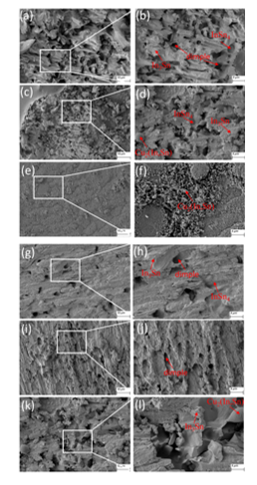
Fig. 7 The cross-sectional morphology of the solder joints after different numbers of thermal cycles (a-b)In-48Sn 200次, (c-d) In‑48Sn 600次, (e-f) In-48Sn 1000次, (g-h) In‑48Sn‑0.05GNSs 200次, (i-j) In‑48Sn‑0.05GNSs 600次, (k-l) In‑48Sn‑0.05GNSs 1000次

3. Conclusion
Based on the optimal graphene content, this paper investigates the effects of thermal cycling cycles (200, 400, 600, 800, and 1,000 cycles) on the various properties of solder joints made from In-48Sn and In-48Sn-0.05GNSs composite solders. The main conclusions are as follows:
(1) As the number of thermal cycles increased, the microstructure of the joints made with both composite brazing alloys gradually coarsened. Under the same thermal cycling conditions, the rate of microstructural coarsening in the In-48Sn-0.05GNS composite brazing alloy joints was significantly lower than that of the In-48Sn alloy, and the grain size of the Sn-rich phase increased at a slower rate. The average grain size of the γ-InSn4 phase in the solder joints of both composite solders gradually increased with the number of thermal cycles. After 200 thermal cycles, the average grain size of the γ-InSn4 phase in the In-48Sn composite solder joints was 10.4 μm, while the average grain size of the γ-InSn4 phase in the In-48Sn-0.05GNSs composite brazing alloy joints was 4.1 μm. After 1,000 thermal cycles, the average grain size of the γ-InSn₄ phase in the joints of both composite solders reached its maximum value, at 28.6 μm and 13.8 μm, respectively.
(2) As the number of thermal cycles increased, the IMC thickness of both the In-48Sn and In-48Sn-0.05GNS solder joints gradually increased; however, at the same number of thermal cycles, the IMC thickness of the In-48Sn-0.05GNS joints was consistently lower than that of the In-48Sn joints, and the growth rate was slower. After 1,000 thermal cycles, the IMC thicknesses reached maximum values of 5.462 μm and 4.915 μm, respectively, representing increases of approximately 50.3% and 54.9% compared to the values at 200 thermal cycles (3.639 μm and 3.174 μm).
(3) As the number of thermal cycles increased, the shear strength of the solder joints made from both the In-48Sn and In-48Sn-0.05GNSs composite solders gradually decreased. When the number of thermal cycles reached 1,000, the shear strengths of the joints for the two composite solders were 3.1 MPa and 12.7 MPa, respectively—a decrease of approximately 45.6% and 16.4% compared to the values at 600 thermal cycles. The shear fracture surface of the In-48Sn composite solder joint gradually shifted from ductile fracture to brittle fracture, while that of the In-48Sn-0.05GNSs composite solder joint gradually shifted from ductile fracture to a combination of ductile and brittle fracture.
COMPETING INTERESTS DISCLAIMER:
Authors have declared that they have no known competing financial interests OR non-financial interests OR personal relationships that could have appeared to influence the work reported in this paper.

References
- Jong D S ,Ghezeljehmeidan A ,Driel V W .Solder joint reliability predictions using physics-informed machine learning[J].Microelectronics Reliability,2025,172115797-115797.DOI:10.1016/J.MICROREL.2025.115797.
- Rad A S ,Movahedi M ,Kokabi H A , et al.Microstructure and mechanical behavior of Graphene NanoSheets enhanced lead-free Sn–0.3Ag–0.7Cu solder[J].Journal of Materials Science: Materials in Electronics,2024,35(20):1418-1418.DOI:10.1007/S10854-024-13158-3.
- Liu Z ,Wu H ,Zheng Y , et al.Microstructure and performance evolution of graphene-tailored SnBiIn low-melting-point solder alloy[J].Journal of Materials Science: Materials in Electronics,2025,36(30):1933-1933.DOI:10.1007/S10854-025-16019-9.
- Yin L ,Zhang Z ,Su Z , et al.Effects of Graphene Nanosheets on the Wettability and Mechanical Properties of Sn-0.3Ag-0.7Cu Lead-Free Solder[J].Journal of Electronic Materials,2020,49(12):1-6.DOI:10.1007/s11664-020-08537-5.
- Bhavan S J ,Kadavath G ,Honecker D .Small-angle neutron scattering analysis in graphene reinforced Sn–Ag lead-free solder alloys[J].Materials Chemistry and Physics,2026,356132321-132321.DOI:10.1016/J.MATCHEMPHYS.2026.132321.
- Yan H ,Ding Y ,Wang F .Enhancement on interface and shear properties of Sn-1.0Ag-0.5Cu solder joints by 0.05% Ge under isothermal aging and thermal cycling[J].Microelectronics Reliability,2025,174115899-115899.DOI:10.1016/J.MICROREL.2025.115899.
- Said M R ,Mohd R S ,Mohd A A M S , et al.Superconducting Lead-free Solder Joint: A Short Review[J].IOP Conference Series: Materials Science and Engineering,2020,957(1):012047-.DOI:10.1088/1757-899X/957/1/012047.
- Li Y ,Haodong W ,Yaocheng Z , et al.Effect of CuZnAl particle addition on the microstructure and shear property of Cu/In-48Sn/Cu solder joints by transient liquid phase bonding[J].Welding in the World,2023,68(1):61-69.DOI:10.1007/S40194-023-01621-4.
- Xuchao W ,Jun Z ,Enzhao C , et al.Grain growth kinetics and grain refinement mechanism in Al2O3/WC/TiC/graphene ceramic composite[J].Journal of the European Ceramic Society,2020,41(2):1391-1398.DOI:10.1016/j.jeurceramsoc.2020.10.019.
- Padua F G ,Rocha D S G ,Nascimento D R N , et al.Impact of graphene addition on intermetallic compounds (IMC) and mechanical properties of Sn–Bi solder alloys under thermal cycling[J].Materials & Design,2026,264115697-115697. DOI:10.1016/J.MATDES.2026.115697.
- Bhavan S J ,Amer M ,Unnikrishnan T .In situ X-ray Diffraction investigation of Graphene-Enhanced Sn-Ag solder Alloys: Insights into phase transformations[J].Materials Science & Engineering B,2025,321118492-118492.DOI:10.1016/J.MSEB.2025.118492.
- Hari V ,McDonald D S ,Tan F X , et al.Effect of Ni Addition on the Solidification of Liquid Al and Solid Cu Diffusion Couples[J].Materials,2025,18(24):5689-5689. DOI:10.3390/MA18245689.
- Zhang H ,Xu Z ,Motozuka S , et al.The effect of indium on the growth mechanism of interfacial intermetallic compounds during the wetting of Zn-3Al /Cu[J].Materials Science in Semiconductor Processing,2026,205110392-110392.DOI:10.1016/J.MSSP.2025.110392.
- Baser H F M ,Salleh M A A M ,Said M R , et al.Effect of indium on interfacial intermetallic compound (IMC) growth, thermal behaviour and mechanical properties of Sn–10Cu-xIn solder joints under multiple reflow cycles[J].Materials Chemistry and Physics,2026,349(P1):131748-131748.DOI:10.1016/J.MATCHEMPHYS.2025.131748.
- Amine E M B ,Sa’d H ,Ali A , et al.The Impact of Bi Content on the Coarsening Kinetics of IMC Particles and Creep Deformation Under Thermal Cycling[J].Journal of Electronic Materials,2023,53(1):380-393.DOI:10.1007/S11664-023-10780-5.
- Yao W ,Zhong B ,Zhang Y , et al.Effects of brazing parameters on interfacial reaction layer characteristics and mechanical performance of brazed Cu/Si3N4 using Ag-Cu-Ti filler alloy[J].Materials Science & Engineering A,2025,936148400-148400.DOI:10.1016/J.MSEA.2025.148400.
- Zhang Z ,Wang Z ,Xu J , et al.Regulation of interfacial intermetallic compounds growth and void defect formation in Sn-9Zn-0.02Al/Cu solder joint by balancing interfacial elemental diffusion: An effect of Pt alloying[J].Materials Characterization,2025,224115057-115057.DOI:10.1016/J.MATCHAR.2025.115057.
- Yan H ,Yin G ,Ji T , et al.Microstructure and reliability of Sn15Bi-xAg solder joints on Ni and Cu substrates during thermal cycling[J].Materials Today Communications,2025,44111916-111916.DOI:10.1016/J.MTCOMM.2025.111916.
- Ma D ,Wu P .Improved microstructure and mechanical properties for Sn58Bi0.7Zn solder joint by addition of graphene nanosheets[J].Journal of Alloys and Compounds,2016,671127-136.DOI:10.1016/j.jallcom.2016.02.093.
- Jiye Z ,Fu X T ,Qinfen G , et al.The Temperature-Dependent Phase Transformation and Microstructural Characterisation in In-Sn Solder Alloys[J].JOM,2023,75(8):3149-3161.DOI:10.1007/S11837-023-05870-Y.
- Zhang P ,Xue S ,Liu L , et al.Improvement in impact property of SAC305 BGA solder joint through epoxy addition[J].Microelectronics Reliability,2026,177115991-115991.DOI:10.1016/J.MICROREL.2025.115991.
- Yinghao B ,Weiqi G ,Shaobin W , et al.The Effect of Thermal Aging on the Mechanical Properties of Gold-Containing Solder Joints[J].Journal of Electronic Materials,2024,53(9):5460-5467.DOI:10.1007/S11664-024-11264-W.
- Qin W ,Shanshan C ,Shiyu Y , et al.Comparison of high-speed shear properties of low-temperature Sn-Bi/Cu and Sn-In/Cu solder joints[J].Journal of Materials Science: Materials in Electronics,2024,35(8):DOI:10.1007/S10854-024-12302-3.
- Yi J ,Kang J ,Rajendran H S , et al.Mechanistic insights into the interfacial and plastic behavior of nano-tungsten reinforced Sn–Bi lead-free alloys[J].Journal of Materials Science: Materials in Electronics,2026,37(7):482-482.DOI:10.1007/S10854-026-16886-W.
- Jie W ,Yiping W ,Weiqing H , et al.Unravelling the synergistic enhancement effect of Ag3Sn phase and graphene nanosheets addition on the thermal cycling reliability of Sn–xAg–0.7Cu solder joint[J].Journal of Materials Science: Materials in Electronics,2024,35(15):DOI:10.1007/S10854-024-12741-Y.
- Cheng-Bing Q ,Hong-Mei X ,Gui-Wen H , et al.Effects of cryo-thermal cycling on interlaminar shear strength and thermal expansion coefficient of carbon fiber/graphene oxide-modified epoxy composites[J].Composites Communications,2022,32DOI:10.1016/J.COCO.2022.101180.

