Design of projection optical system for dynamic star simulator

ABSTRACT
In order to improve the simulation accuracy of the dynamic star simulator for the infinite sky to meet the needs of the ground function detection of the star sensor, a design scheme of the collimation optical system of the dynamic star simulator with long pupil and large field of view is proposed in this paper. The technical parameters of the star simulator are determined according to the ground test indexes of the star sensor, and the parameters of the collimating optical system are calculated accordingly. Taking the complex double Gaussian structure as the initial structure, the optical design and optimization are carried out with the help of code V software, focusing on the constraint control of system distortion and field curvature. The final design results are as follows: the field of view of the collimating optical system is 20 °, the focal length is 34.3mm, the exit pupil distance is 150mm, the full field distortion is less than 0.05566%, and the modulation transfer function MTF is close to the diffraction limit. Tolerance analysis shows that the system has excellent imaging quality, reliable engineering stability, and can realize high-precision simulation of the infinite sky.
Key Words: Dynamic Star Simulator; Projection optical system; Long pupillary distance;

Introduction
As the core component of the spacecraft attitude control system, star sensor takes stars as the reference system, measures stars at different positions in the celestial body through the optical system, forms the observation star map, and transmits it to the image detector. It matches the existing navigation star map in the star list database with the measured observation star map, and confirms the position and attitude information of the spacecraft through attitude calculation, providing high-precision data support for spacecraft attitude control and celestial navigation. With the rapid development of aerospace technology, the industry has put forward higher requirements for the performance of star sensors. As the key equipment of star sensor ground calibration and performance test, star simulator complements the development of star sensor. Therefore, it is necessary to improve the accuracy of star simulator to meet the higher standard of star sensor ground calibration and performance test^{[1]}.
At this stage, China's research in the field of star simulators is steadily advancing in the direction of high precision, large field of view and lightweight. After long-term technical accumulation and engineering practice, the design technology of the matching collimating optical system has become mature. In 2015, Meng Yao^{[2]} developed a new dynamic star simulator. The effective field of view of the simulator is 11 °, and the exit pupil distance is 35mm; in 2018, Liu Huan^{[3]} developed a large field of view single star simulator, and designed a collimation optical system with an exit pupil distance of 15mm, a field of view of 20 °, and a distortion less than 0.03%; In 2019, Dai Yu^{[4]} developed a dynamic star simulator based on secondary imaging technology. The exit pupil distance of the simulator reached 60mm, the field of view range was 28.6 °, and the distortion was controlled within 0.045%; In 2021, Zhang Qi^{[5]} and others developed an ultra long pupil exit dynamic star simulator based on LCOS. The pupil exit distance of the simulator is 1250mm, the field of view is ± 2 °, and the distortion is less than 1%; In 2025, Liu Xin^{[6]} and others developed a dynamic star simulator with a long exit pupil distance, achieving an exit pupil distance of 700mm, a field of view of ± 2.5 °, a distortion of less than 0.4%, and an MTF of better than 0.6 at 61lp/mm. At present, the star simulator developed either has a large field of view or has a long exit pupil distance, but it does not achieve a large field of view and a long exit pupil distance at the same time, which can not meet the requirements of the field of view and pupil matching when the large field of view star simulator is combined with a large turntable, limiting its application in high-precision attitude measurement. Therefore, the development of a star simulator with both a large field of view and a long exit pupil is of great significance for the ground test of star sensor.
Aiming at this problem, a collimation optical system of dynamic star simulator with long pupil distance is designed in this paper. The system can not only reserve sufficient adjustable installation space between the star sensor and the star simulator to meet the installation and adjustment requirements of Ground Calibration and testing, but also maintain excellent imaging quality under the condition of long pupil distance, so as to realize the high-precision simulation of the infinite sky.

composition and working principle of dynamic star simulator
Dynamic star simulator is mainly used for real-time star map simulation on the ground to detect the function of star sensor. The composition and structure of dynamic star simulator is shown in Figure 1, which mainly includes lighting optical system, projection optical system, computer and dynamic display system. The star map generation module is in the computer in the form of star map generation software. During operation, the computer provides the orbit and attitude information of the star sensor in deep space. The computer control system of the star simulator completes the star search and coordinate conversion based on this information, and generates the corresponding star map, which is transmitted to the star map display device through the dynamic display system. The lighting optical system provides uniform lighting for the star map display device. The projection optical system and the lighting optical system realize the optical path connection through DMD. The projection optical system collimated and projected the star map generated by the star map display device to infinity in the form of the far center of the image. After the exit pupil is connected with the pupil of the star sensor, the star sensor optical system receives and images the star map in its focal plane. The star sensor collects and processes the star map perform function test^{[7]}.

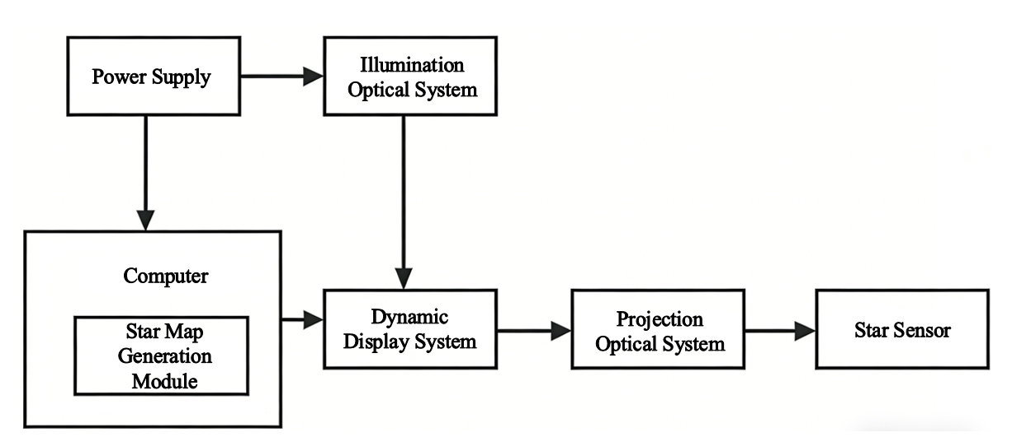
Figure 1 Composition structure diagram of dynamic star simulator
The projection optical system and the illumination optical system are connected by the star map display device DMD, which is placed at the entrance pupil of the projection optical system of the dynamic star simulator. DMD is a digital reflective display device, which is composed of multiple independently rotatable micro lens arrays. Each micro lens corresponds to a pixel point, and the size of a single pixel can reach several microns. Each micro mirror can realize+12 °, 0 °, -12 ° deflection under the control of the driving signal, corresponding to "on", "flat", "off" respectively. When the micro mirror is in the "on" state, the incident light is reflected by the micro mirror and enters the projection lens. When the micro mirror is in the "flat" state or "off" state, the incident light is reflected by the micro mirror and deviates from the projection lens. DMD can realize the light intensity output of different gray levels by controlling the switching time ratio of the micro mirror in the "on" state or "off" state. The higher the proportion of "on" state, the stronger the brightness of pixels. Selecting the DMD display device with high contrast as the star map display device of the dynamic star simulator can reduce the background noise of the image and improve the contrast of the simulated star map, which is conducive to star point extraction, star point recognition and attitude calculation speed, and improve the dynamic performance of the star simulator. The DMD pixel size selected in this paper is 7.56 μ m, the resolution is 1920 × 1080, and the size is 14.5152 × 8.1648mm.

optical system design

optical system parameters
In the dynamic star simulator, the projection optical system is directly connected with the star sensor to be tested, and its imaging quality directly determines the overall test accuracy of the star simulator. In the process of optical system design, in order to reduce the energy loss when the optical signal of star simulator is transmitted to the star sensor, on the basis of meeting the principle of pupil connection, it is necessary to make the exit pupil diameter of star simulator larger than the entrance pupil diameter of star sensor. Dynamic star simulator is the core equipment of star sensor ground calibration. Combined with the actual test requirements of star sensor, the field of view of the star simulator designed in this paper is 20 °, the focal length is 34.3mm, the exit pupil distance is 100mm, and the wave band is 400-800nm^{[8]},
According to the size of the DMD light valve and the field of view of the star map, the focal length of the projection optical system is:
$f'=\frac{P}{tan2ω}$ （3-1）
Among them, the field of view of the star map is 14.75 °× 13.5 °, the full diagonal field of view can be calculated to be 20 °, and P is the length of the DMD occupied in the 20 ° field of view. According to the selected DMD size of 14.51mm × 8.16mm and the pixel size of 7.56 μ m, it can be seen that p=12.096mm, 2 ω is the full field of view size, 2 ω=20 °, and F'is the focal length of the system. After calculation, the focal length of the optical system is 33.23mm. The F number of the optical system is:
$F=\frac{f'}{D}$ （3-2）
Where, D is the diameter of the entrance pupil of the optical system, D=6mm， Therefore, the F number is 5.539.
Table 1 Design parameters of projection optical system
Parameter name | Parameter value
Field of view of collimating objective lens (2 ω) | 20°
Design spectral range of collimating objective lens | 400-800nm
Exit pupil distance of collimating objective lens | 150mm
Exit pupil diameter of collimating objective lens | Ø6mm
Focal length of collimating objective lens | 33.23mm
F number | 5.539

design process of optical system
The initial structure of the optical system of the dynamic star simulator should be a collimated transmission optical system with achromatic, small distortion, large field of view and external exit pupil characteristics. According to the above requirements, for the imaging lens with a field of view of 20 °, the complex form of the double Gaussian structure is selected as the initial structure. The double Gaussian structure is characterized by a large relative aperture and a centrosymmetric structure centered on the diaphragm. It is composed of two symmetrical lens groups, which are divided into a front lens group and a rear lens group. The front lens group includes a positive lens and a negative meniscus lens.
Symmetrical layout can correct coma and distortion and other off-axis aberrations. Based on the symmetrical layout, the asymmetric double Gaussian structure is obtained by optimizing the design complexity. In the asymmetric structure, the power distribution is continuously adjusted to correct the chromatic aberration, and the thick meniscus lens is introduced to correct the field curvature. The unsymmetrical radius of curvature can correct the coma and distortion. By increasing the curvature radius of the negative lens, appropriately increasing the power of the positive lens, and adjusting the power allocated by each lens, the distortion can be corrected.
The structure diagram of the projection optical system meeting the design requirements is shown in Figure 2.

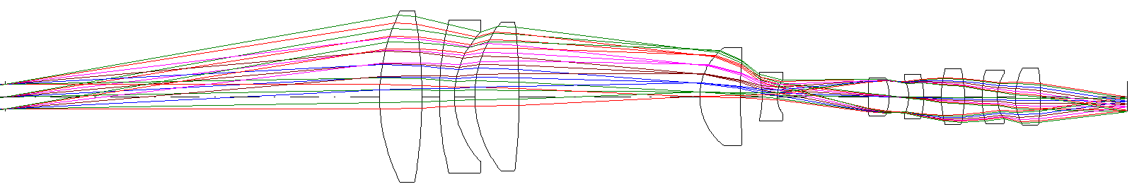
Figure 2 Structural diagram of projection optical system

image quality evaluation
The imaging quality of optical system is an important basis to determine whether the optical design meets the requirements. The code V software is used to design and simulate the collimation optical system of the long exit pupil distance dynamic star simulator, and the imaging performance of the system is comprehensively evaluated from the aspects of modulation transfer function, plot, energy concentration, field curvature and distortion. The analysis results are shown in Fig. 3-fig. 6, and the imaging quality of the long exit pupil distance collimation optical system is comprehensively evaluated.
The root mean square RMS radius can effectively reflect the light energy concentration by calculating the root mean square deviation of the distance between the intersection of each ray and the intersection of the main ray, which is more suitable for the evaluation of the actual imaging quality of the projection optical system^{[9]}.
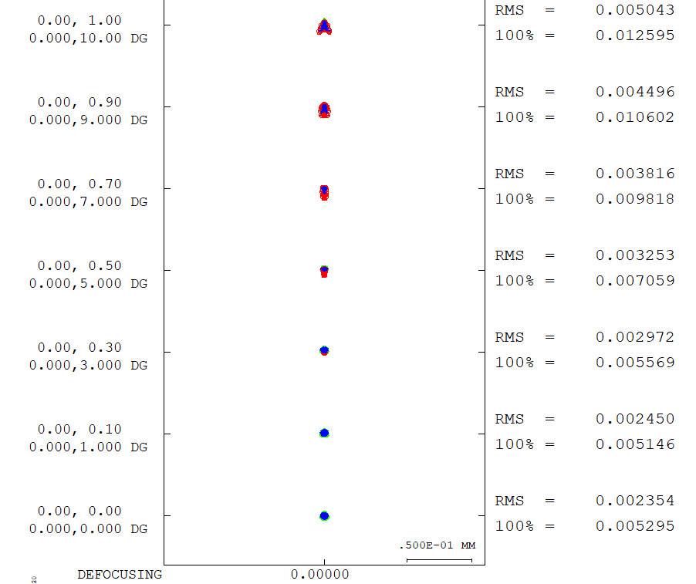
Figure 3 dot plot
The dynamic star simulator needs to realize the accurate simulation of star position. The core aberration that affects the accuracy of star position is optical system distortion, and the key aberration that affects the parallelism of star light is field curvature. In the projection optical system, distortion will lead to the deviation between the actual image height and the ideal image height. If the distortion is too large, it will directly affect the measurement accuracy and produce the star position error, which can not realize the accurate simulation of the star position, and it is difficult to meet the actual needs of the high-precision application of the dynamic star simulator.
For the star simulator, the simulated starlight must have strict parallelism after passing through the optical system. The existence of field curvature will bend the best imaging plane of the optical system in different field of view. In the collimating optical system, the beams of each field of view cannot achieve ideal parallel emission in the same axial position, resulting in the off-axis beam deviating from the parallel light state, and the beam of some field of view converges or diverges, significantly reducing the overall accuracy of the star simulator. In addition, too large field curvature will make the clear image plane deviate from the plane, resulting in imaging defects such as blurred middle clear edge or clear middle fuzzy edge, which will affect the clarity of star point simulation. Therefore, in the design process of projection optical system, distortion and field curvature should be strictly corrected to ensure the imaging accuracy and star point simulation effect of the system.
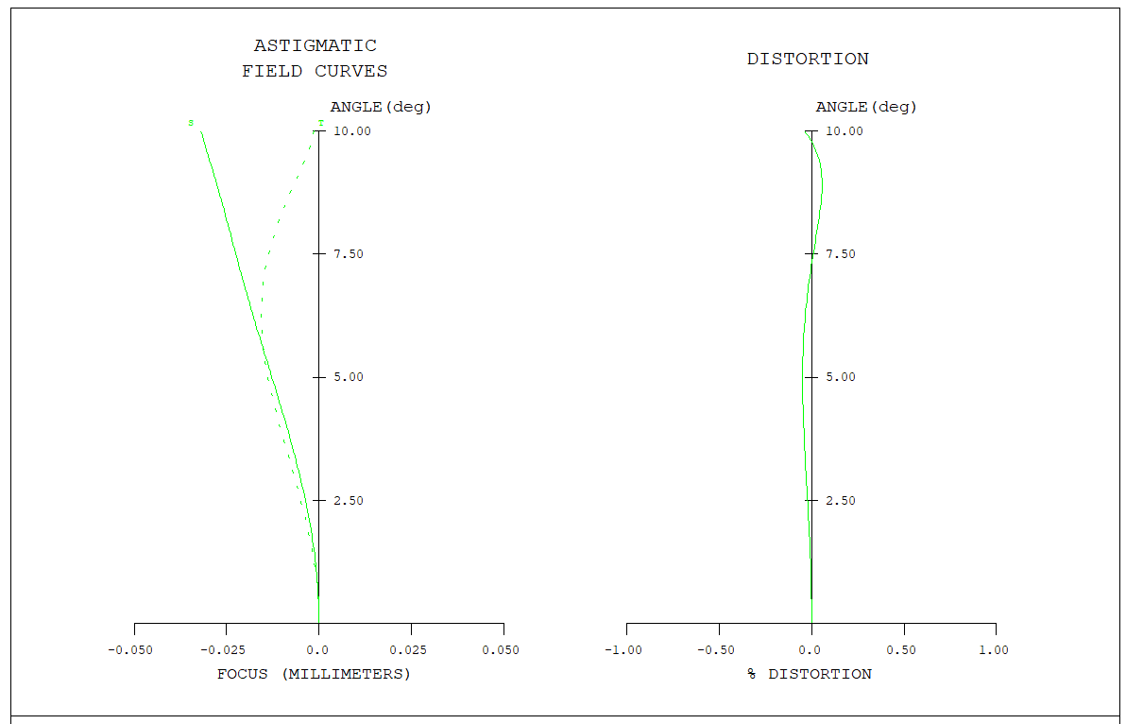
Figure 4 Field curvature and distortion of optical system
MTF represents the attenuation degree of amplitude of sinusoidal distribution functions of different frequencies after imaging by the optical system. It measures the efficiency of the optical system to transfer the light and dark contrast of the object side to the image side. It regards lens imaging as the transfer process of "contrast" of object details.
The size of the micromirror of the star map display device is 7.56um, and the Nyquist frequency of the system is
$v_{Nyquist}=\frac{1000}{2×7.56}=66lp/mm$ （4-1）
The MTF of the optical system is shown in Figure 5. The horizontal axis in the figure is the spatial frequency (the unit is the logarithm of lines per millimetre, representing the number of detail lines in the unit length), and the vertical axis is the modulation transfer coefficient (0-1. The closer the MTF value is to 1, the stronger the ability of the system to restore details and the clearer the image; The closer the MTF value is to 0, the more serious the detail contrast loss is, and the more blurred the image is). The MTF curves of 0 ω, 0.1 ω, 0.3 ω, 0.5 ω, 0.7 ω, 0.9 ω and full field of view are analyzed.
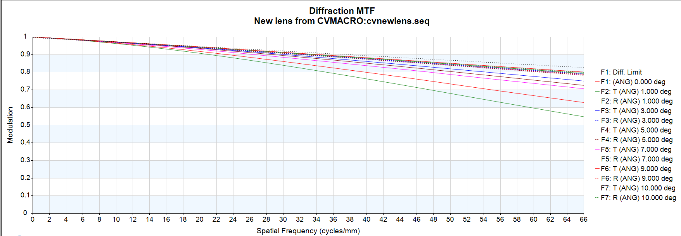
Figure 5 Modulation transfer function MTF
The surrounding energy distribution describes the percentage of concentrated energy in a certain area to the total energy, reflecting the ability of the optical system to focus light to the target area. In the dynamic star simulator, the higher the energy concentration of a single pixel, the higher the contrast of the simulated image.
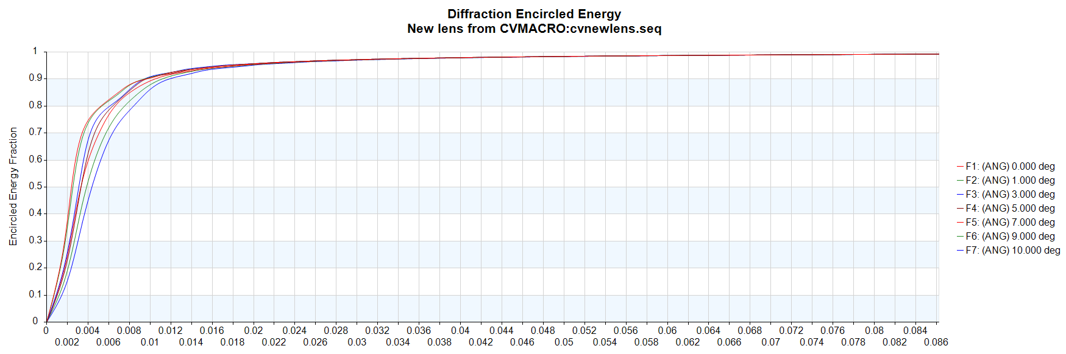
Figure 6 Enclosure energy distribution diagram
The point diagram of the designed projection optical system is shown in Figure 3. The RMS value of the full field of view is within 5.545 μ m, and the maximum opening angle of a single star is 31.3 ". From Figure 4, it can be seen that the maximum distortion value of the full field of view is 0.05566% and the field curve is small. From the figure, it can be seen that the MTF value of the full field of view at the Nyquist frequency of 66lp/mm is close to the diffraction line. The curve of the surrounding energy distribution of the system is shown in Figure 6. The single pixel of the DMD is 7.56 μ M. from the figure, it can be seen that the guard energy distribution at 7.56 μ m is greater than 80%. The results show that the system has high imaging quality and optical performance, and can completely it meets the design and application requirements of dynamic star simulator.

tolerance analysis
Tolerance analysis is the bridge between optical design and actual production. Tolerance analysis predicts the degradation degree of RMS spot or MTF of the optical system in the non ideal state by simulating the small changes of processing error (curvature deviation and thickness deviation of the lens), system assembly error (lens eccentricity, tilt, etc.) and other parameters, so as to judge whether the system meets the production demand. For high-precision equipment such as star sensor, in practical application, in order to ensure that the designed projection optical system can meet the design index requirements, it is necessary to carry out tolerance analysis, comprehensively consider the possible errors in the process of processing and system assembly and adjustment, verify whether the imaging quality of the projection optical system meets the design index requirements within the allowable error range by designing a reasonable tolerance range, and clarify whether the performance of the processed prototype meets the design index requirements, so as to ensure that the final product can still work stably under harsh conditions^{[10]}.
Table 2 Tolerance allocation
tolerance | requirement
DLF number of irregular apertures | 2
DLR radius increment (lens units) | Class A Template (0.0005*R)
DLT- thickness increment (lens units) | ±0.01
DLX surface x-displacement (lens unit) | 0.003
DLY- surface y-displacement (lens unit) | 0.003
DLN refractive index increment | 0.005
DSX group x-eccentricity (lens unit) | 0.001
DSY group y-eccentricity (lens unit) | 0.001
In tolerance analysis, the change of MTF directly reflects the damage degree of processing error and assembly error to imaging details. Tolerance analysis MTF is used to verify whether tolerance accumulation causes imaging quality to fall below the design threshold. The Nyquist cut-off frequency of MTF is 66lp/mm. The 500 groups of simulation results of Monte Carlo MTF analysis of optical system are shown in Figure 7.
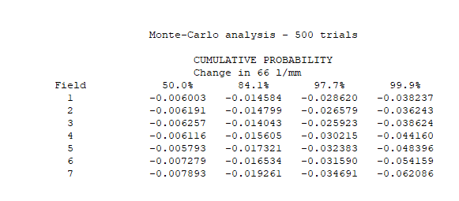
Figure 7 Monte Carlo MTF analysis of text data
After the tolerance allocation of the projection optical system, the 99% probability of the MTF value of the projection optical system in the half field of view 10 ° is reduced by 0.062086, and the MTF value is the minimum at the half field of view 10 °, which is 0.64116. According to the tolerance analysis results of MTF, it can be seen that the projection optical system can still maintain good imaging quality after tolerance allocation.
Table 3 Monte Carlo tolerance analysis results
Half field of view | MTF before tolerance analysis | MTF after tolerance analysis
0° | 0.711868 | 0.673631
1° | 0.711694 | 0.675451
3° | 0.709284 | 0.67066
5° | 0.705278 | 0.661118
7° | 0.700607 | 0.652211
9° | 0.704056 | 0.649897
10° | 0.703246 | 0.64116

Conclusion
In order to meet the needs of high-precision star sensor calibration on the ground, this paper uses code V software to design a dynamic star simulator collimation optical system with a pupil distance of 150 mm. After the system is optimized, the imaging quality is comprehensively evaluated. The results show that the system distortion is less than 0.05566% in the 20 ° full field of view, and the imaging quality is excellent; The results of Monte Carlo tolerance analysis show that the system has good engineering stability. The simulation results show that the star light output accuracy of the collimating optical system of the long pupil distance dynamic star simulator is better than 31.3 ", which can fully meet the technical requirements of star sensor calibration test for high-precision star simulation.

COMPETING INTERESTS DISCLAIMER:
Authors have declared that they have no known competing financial interests OR non-financial interests OR personal relationships that could have appeared to influence the work reported in this paper.

reference
[1]Wei Qinghua. *Research on Star Navigation Attitude Determination Algorithms and Star Sensor Calibration* [D]. Nanjing University of Science and Technology, 2021. DOI:10.27241/d.cnki.gnjgu.2021.002104.
[2]Meng Yao. *Research on Key Technologies for High-Precision Dynamic Star Simulators Based on LCOS Tiling* [D]. Changchun University of Science and Technology, 2016.
[3]Liu Huan. *Research on Key Technologies for Large Field-of-View Single-Star Simulators* [D]. Changchun University of Science and Technology, 2018.
[4]Dai Yu. *Design and Research of Optical Systems for Large Field-of-View, High-Dynamic Star Simulators* [D]. University of Chinese Academy of Sciences (Institute of Optics and Electronics, CAS), 2020. DOI:10.27543/d.cnki.gkgdk.2020.000017.
[5]Zhang Qi, Xu Xiping, Pan Yue, et al. Design of a Projection Optical System for Dynamic Star Simulators with Long Exit Pupil Distance [J]. *Journal of Changchun University of Science and Technology (Natural Sciences Edition)*, 2021, 44(06): 13-18.
[6]Liu Xin, Jiang Zikang, Guo Haoran, et al. Optical System Design for Dynamic Star Simulators with Long Exit Pupil Distance [J]. *Acta Optica Sinica*, 2025, 45(12): 282-289.
[7]Huang Cheng. *Design of Optical Systems for Large Field-of-View, High-Precision Dynamic Star Simulators* [D]. Changchun University of Science and Technology, 2017.
[8]Lu Y, Xu X, Zhang N, et al. Dynamic Spatial Small-Target Simulation System with Long-Exit Pupil Distance [J]. *Photonics*, 2025, 12(6): 578-578. DOI:10.3390/PHOTONICS12060578.
[9]Cao T, Wang Y L. Design of a Dynamic Target Simulator Optical System with a Large FOV and Long Exit Pupil Distance [J]. *Applied Optics*. Optics, 2024, 63(10): A115–A123. DOI: 10.1364/AO.510301.
[10] Wang Shiran, Wang Lingyun, Zheng Ru, et al. Design of a Collimating Optical System for a Static Star Simulator with Long Exit Pupil Distance [J]. Journal of Changchun University of Science and Technology (Natural Science Edition), 2023, 46(03): 39–45.

