Agentic Ransomware Targeting Autonomous Al Systems in OT/ICS Environments:
Implications for Process Safety, System Reliability, and Operational Resilience

Abstract
This study investigates the emerging threat of agentic ransomware targeting autonomous artificial intelligence systems embedded within operational technology and industrial control environments and examines its implications for industrial process safety and system reliability. A quantitative analytical design was adopted using three open-access datasets: the Cybersecurity and Infrastructure Security Agency Industrial Control System vulnerability advisories, the MITRE ATT&CK for ICS attack technique repository, and the U.S. Department of Energy OE-417 electric disturbance reports. Vulnerability exposure analysis, attack technique network modeling, and system reliability assessment were conducted using frequency analysis, co-occurrence network centrality, and reliability metrics. The results show that industrial control devices account for 43.8% of vulnerabilities, while AI analytics systems exhibit high severity scores (CVSS = 8.32) and remote exposure (0.73). Additionally, cyber-related disturbances demonstrate a lower reliability index (0.28) compared with operational failures (0.83). The study further develops and empirically validates an Agentic Ransomware Resilience Framework using a composite resilience index integrating vulnerability exposure, attack interaction centrality, and system recovery performance. The study recommends strengthened cybersecurity standards, network segmentation, anomaly detection systems, and resilience mechanisms to protect AI-enabled industrial infrastructures.
Keywords: Agentic ransomware; Operational technology security; Industrial control system vulnerabilities; AI-enabled cyber-physical systems; Industrial infrastructure resilience.

1. Introduction
The rapid digital transformation of industrial systems has fundamentally reshaped the technological foundations of modern societies. Critical infrastructure sectors including energy, manufacturing, transportation, healthcare, and water management increasingly rely on interconnected digital technologies to coordinate complex operational processes (Harkat et al., 2024). Within these environments, operational technology and industrial control systems regulate physical processes through networks of programmable controllers, supervisory control platforms, and distributed sensors (Cui et al., 2024). While these systems enhance industrial productivity and service delivery, their increasing connectivity has expanded the cybersecurity attack surface, exposing critical infrastructure to a broader range of cyber threats (Alzahrani et al., 2024).
In recent years, cyber attacks targeting industrial environments have grown in scale and sophistication, with ransomware emerging as one of the most disruptive threats. Ransomware involves malicious software that encrypts digital data and demands payment in exchange for restoring access to compromised systems (Kim et al., 2025). The frequency of such attacks has increased significantly, particularly in sectors where operational continuity is essential. Threat intelligence reports indicate that ransomware attacks targeting industrial organizations increased by approximately forty six percent between late 2024 and early 2025 (Honeywell, 2025). In addition, more than seven hundred ransomware incidents affecting industrial organizations were recorded during the first quarter of 2025, with manufacturing and engineering sectors accounting for a substantial proportion (Alamri & Mooney, 2025).
The consequences of ransomware attacks within industrial environments extend beyond data loss to include severe operational and economic disruption. In manufacturing systems, cyber attacks that interrupt production processes can halt industrial operations and trigger cascading effects across global supply networks (Reed, 2024). Disruptions in operational technology environments may result in production delays, equipment downtime, and workforce inactivity, leading to significant economic losses (Teichmann, 2026). In some industrial settings, the cost of operational downtime resulting from cyber incidents has been estimated to reach millions of dollars per hour (Fluke Corporation, 2025). These impacts make industrial environments particularly attractive targets for cybercriminal actors seeking to maximize leverage through operational disruption (Benmalek, 2024; Honeywell, 2025).
At the same time, industrial systems are undergoing transformation through the integration of artificial intelligence technologies (Arora & Hastings, 2025; Aslam et al., 2025). Artificial intelligence is increasingly deployed to support predictive maintenance, automated monitoring, and optimization of production processes, enabling real time analysis of operational conditions and automated system responses (Kukkala, 2025).
In many industrial environments, autonomous artificial intelligence agents can adjust operational parameters, detect anomalies, and coordinate decision making with minimal human intervention. While such capabilities improve efficiency and system reliability, they also introduce new cybersecurity risks. Autonomous decision systems may be vulnerable to manipulation or exploitation, particularly when integrated with operational technology networks that directly control physical processes (Arora & Hastings, 2025; Aslam et al., 2025).
Cyber attacks targeting industrial cyber physical systems can produce consequences that extend beyond digital compromise to affect real world infrastructure operations (Alabdulatif et al., 2024; Longo et al., 2025; Tovkun et al., 2026). Industrial control environments often rely on legacy architectures and complex network configurations that were not originally designed to withstand modern cyber threats (Lotto et al., 2024). Monitoring reports further indicate that a substantial proportion of operational technology systems are exposed to cyber threats, highlighting persistent vulnerabilities within critical infrastructure networks (Kaspersky, 2025; Mandvi, 2025). These conditions suggest that future ransomware campaigns may increasingly evolve beyond data encryption toward approaches that disrupt operational processes or interfere with automated control mechanisms (Srinivasan & Karimi, 2025; Watson, 2024).
In response to these developments, this study introduces the concept of agentic ransomware. Agentic ransomware refers to a form of ransomware that exploits autonomous artificial intelligence systems embedded within operational technology environments in order to manipulate industrial processes, disrupt operational functions, or interfere with automated decision mechanisms for the purpose of cyber extortion. Unlike traditional ransomware, which primarily targets data through encryption, this emerging class of threat focuses on the operational capabilities of artificial intelligence driven industrial systems. Such an evolution presents significant risks for process safety, system reliability, and the resilience of critical infrastructure. Despite these implications, there remains limited conceptual understanding of how ransomware may evolve to exploit autonomous artificial intelligence systems within industrial environments.
In light of these concerns, the aim of this study is to examine the emerging threat of ransomware targeting autonomous artificial intelligence systems deployed within operational technology and industrial control environments and to develop a conceptual framework for understanding its implications for process safety, system reliability, and operational resilience.
To achieve this aim, the study pursues the following objectives:
- To examine the integration of autonomous artificial intelligence systems within operational technology and industrial control environments and identify associated cybersecurity vulnerabilities.
- To conceptualize agentic ransomware as a distinct class of cyber threat capable of exploiting autonomous artificial intelligence systems within industrial environments.
- To analyze the potential effects of agentic ransomware attacks on industrial process safety and system reliability within cyber physical infrastructures.
- To develop a resilience oriented framework for strengthening the security and operational stability of artificial intelligence enabled industrial control systems against ransomware driven disruptions.

2. Literature Review
Ransomware has undergone a significant transformation over the past decade, evolving from relatively unsophisticated malware targeting individual users into a highly organized cybercriminal enterprise capable of disrupting national infrastructure (Mayeke, 2025; Olaniyi et al., 2026a). Contemporary ransomware campaigns are no longer limited to opportunistic file encryption but have developed into complex multi stage operations involving reconnaissance, privilege escalation, lateral movement, and coordinated extortion strategies. According to Yan et al. (2025), modern ransomware increasingly exploits interconnected digital environments and Internet of Things ecosystems, enabling attackers to compromise entire organizational infrastructures rather than isolated systems. However, despite this growing sophistication, a critical limitation of earlier ransomware strategies was their reliance on data encryption as the primary mechanism of coercion, which allowed organizations with robust backup systems to recover without paying ransom demands.
In response to this limitation, ransomware operators have adapted their strategies toward maximizing operational impact and victim pressure. One major development is the emergence of double extortion models, in which attackers combine data encryption with exfiltration to increase leverage (Hansel & Silomon, 2024). This shift aligns with the growing trend of “big game hunting,” where cybercriminal groups deliberately target high value organizations capable of generating substantial ransom payments (Hansel & Silomon, 2024). In agreement, Kritika et al. (2025) contend that modern ransomware campaigns involve prolonged reconnaissance phases in which attackers analyze network architecture and operational dependencies before launching attacks. This strategic evolution has increasingly directed ransomware toward critical infrastructure sectors such as manufacturing, healthcare, transportation, and energy systems, where operational disruption can affect essential services. According to Nyonyoh (2025), ransomware attacks on critical infrastructure pose significant risks to economic stability, public safety, and service reliability, often generating cascading disruptions across interconnected systems.
Empirical evidence supports the expansion of ransomware attacks into industrial environments, particularly within cyber physical systems where attacks can directly affect industrial control processes. Benmalek et al. (2024) argue that ransomware targeting cyber physical systems differs fundamentally from traditional ransomware because it can disrupt operational control mechanisms rather than merely encrypt digital data. High profile incidents further reinforce this shift, as demonstrated by the Colonial Pipeline attack, which disrupted fuel distribution and exposed vulnerabilities in industrial control environments (Bellamkonda, 2024; Roumani & Roumani, 2025). This evidence suggests that ransomware has evolved into a threat capable of producing significant operational and societal consequences.
The integration of digital technologies within industrial environments has further amplified ransomware risks. As operational technology systems become increasingly connected to enterprise networks and cloud infrastructures, the attack surface expands, allowing vulnerabilities in information technology environments to propagate into operational control systems (Kumar & Vardhan, 2025). This convergence indicates that ransomware attacks initially targeting enterprise systems may extend into industrial operations, exposing critical processes to disruption. However, many existing cybersecurity strategies remain focused on data protection rather than operational continuity.

Cybersecurity Vulnerabilities in Operational Technology and Industrial Control Systems
Operational Technology and Industrial Control Systems form the backbone of critical infrastructure by enabling automated monitoring and control of industrial processes. However, these systems were historically designed to prioritize operational reliability and continuity rather than cybersecurity, as they were developed for isolated environments with minimal exposure to external threats (Rodda & Mavroudis, 2025). Consequently, many industrial control architectures lack essential security features such as authentication, encryption, and access control mechanisms. The persistence of legacy infrastructure further exacerbates these vulnerabilities, as industrial systems often operate for decades using outdated software and unsupported hardware that cannot be easily patched without disrupting operations (Odedra, 2025). Empirical evidence shows that a significant number of operational technology devices remain exposed on public networks, many running outdated firmware and disclosing sensitive system information, thereby creating systemic security weaknesses (Rodda & Mavroudis, 2025; Abba et al., 2025; Ogunmolu et al., 2026a).
The convergence of information technology and operational technology networks has further intensified these vulnerabilities by expanding connectivity between industrial systems and enterprise environments (Obioha-Val et al., 2025; Odeyinka et al., 2026)The adoption of cloud platforms, remote monitoring, and industrial Internet of Things technologies has increased the attack surface, enabling cyber threats originating in enterprise networks to propagate into operational control systems (Bhole et al., 2025). In agreement, Raich et al. (2025) contend that this convergence creates structural security challenges due to conflicting priorities between the two environments. While information technology systems emphasize confidentiality and frequent updates, operational technology environments prioritize availability and safety, often relying on legacy systems that cannot be easily modified (Adebiyi et al., 2026; Olaniyi et al., 2026b). This divergence highlights a fundamental security dilemma in industrial environments, where maintaining operational stability can limit the implementation of effective cybersecurity measures.
In addition to structural vulnerabilities, industrial environments face operational constraints that complicate cybersecurity management (Ogunmolu et al., 2026b; Olisa et al., 2026). Many industrial processes require continuous operation, limiting the ability to perform system downtime for maintenance, patching, or security updates. Wu et al. (2026) observe that industrial control systems depend on uninterrupted communication between sensors, controllers, and actuators, which restricts the deployment of conventional security tools and frequent updates. As a result, cybersecurity strategies designed for enterprise environments may not be directly applicable to operational technology systems.
The increasing exposure of industrial systems to external networks has further heightened cybersecurity risks, with many devices remaining accessible with minimal protection (Ribeiro, 2025). At the same time, the complexity of industrial cyber physical systems makes effective threat detection difficult. Asiri et al. (2025) argue that traditional indicators of compromise developed for enterprise systems are often inadequate for industrial environments, reducing the effectiveness of conventional detection mechanisms and complicating the identification of cyber attacks.

Artificial Intelligence in Industrial Cyber Physical Systems and Emerging Security Risks
Artificial intelligence has become a central component of modern industrial cyber physical systems, particularly within Industry 4.0 and Industry 5.0 environments. Industrial organizations increasingly deploy AI driven systems for predictive maintenance, anomaly detection, process optimization, and automated monitoring, enabling continuous analysis of operational data and improved detection of system deviations (Seo et al., 2025; Kim et al., 2026). These capabilities enhance operational efficiency and enable faster decision making, contributing to improved system resilience (Al-Waro, 2024). However, the integration of artificial intelligence into industrial environments also introduces new cybersecurity risks by expanding the attack surface and embedding decision making processes within algorithmic systems.
One significant concern is the vulnerability of machine learning models to adversarial manipulation. Adversarial techniques involve deliberately modifying input data to influence the behaviour of AI systems, potentially causing incorrect predictions or decisions (Jedrzejewski et al., 2024). In industrial environments, such manipulation can have serious consequences because AI systems often influence operational processes. For instance, compromised sensor data may lead predictive maintenance systems to misinterpret equipment conditions, resulting in incorrect operational responses or system failures. Kim (2024) further demonstrates that reinforcement learning based attack models can adaptively evade detection mechanisms while interfering with industrial processes, indicating that artificial intelligence introduces new attack vectors within operational environments.
A more critical challenge arises from the increasing deployment of autonomous and agentic AI systems within industrial control architectures. Artificial intelligence models are now embedded within automated workflows where they can execute operational decisions with minimal human intervention. Shrestha et al. (2025) argue that such autonomy introduces significant cybersecurity risks because compromised AI agents may manipulate industrial processes or propagate malicious commands across interconnected systems. Unlike traditional software systems, autonomous AI agents exhibit adaptive behaviour that allows them to respond dynamically to environmental inputs, making it difficult to distinguish between legitimate operational adjustments and malicious actions. This shift transforms artificial intelligence from a defensive tool into a potential attack surface within industrial environments.
The growing reliance on AI driven analytics platforms connected to cloud infrastructures further expands the exposure of industrial systems. While cloud based platforms enable large scale data processing and centralized monitoring, they also create additional pathways through which attackers may infiltrate industrial networks or manipulate AI models (Madupati, 2025).
Additional challenges arise from the limitations of AI driven security mechanisms themselves. Machine learning based intrusion detection systems often struggle to distinguish between legitimate operational anomalies and malicious cyber activity due to the complexity of industrial processes, leading to false positives and reduced reliability (Wu et al., 2026). At the same time, adversarial techniques can exploit these limitations to evade detection. Consequently, while artificial intelligence enhances industrial cybersecurity capabilities, it simultaneously introduces new vulnerabilities, control points, and exploitation pathways that can be leveraged by advanced cyber threats.

Conceptualizing Agentic Ransomware in AI Enabled Industrial Environments
The convergence of ransomware attacks, artificial intelligence technologies, and industrial cyber physical systems has created a new dimension of cybersecurity risk that remains insufficiently explored in existing research. While prior studies have examined ransomware, industrial control system vulnerabilities, and artificial intelligence security challenges independently, limited attention has been given to how these domains intersect within modern industrial environments. Although ransomware is increasingly recognized as a threat to cyber physical infrastructures, much of the literature continues to frame it primarily as a data extortion mechanism rather than a threat capable of manipulating automated industrial processes (Benmalek, 2024). This gap suggests that existing models of ransomware are insufficient for analyzing threats in environments where artificial intelligence systems directly influence operational processes.
In response to this limitation, this study introduces the concept of agentic ransomware as an emerging class of cyber threat within artificial intelligence enabled industrial environments. Agentic ransomware refers to ransomware that interacts with autonomous artificial intelligence systems and digital infrastructures to manipulate operational processes, disrupt decision mechanisms, or exploit automated workflows for cyber extortion. Unlike traditional ransomware that primarily targets data assets through encryption, agentic ransomware focuses on the operational capabilities of cyber physical systems, leveraging the decision making functions of artificial intelligence to amplify its impact.
Emerging evidence indicates that ransomware attacks are increasingly directed toward critical infrastructure environments where operational disruption produces immediate economic and societal consequences. Studies show that such attacks can affect sectors including manufacturing, energy, healthcare, and transportation, where system disruption may compromise service delivery and public safety (Nyonyoh, 2025; Ribeiro, 2025). However, much of this research emphasizes the consequences of ransomware rather than examining how artificial intelligence may transform its operational strategies. This suggests that ransomware is evolving beyond data encryption toward approaches that exploit the operational dependencies of industrial systems.
Advances in artificial intelligence further reinforce this transformation by introducing new attack surfaces within industrial systems. Artificial intelligence is increasingly embedded in cybersecurity operations and industrial control processes, enabling real time monitoring and automated decision making (Khawar et al., 2026). While these capabilities enhance system performance, they also create opportunities for malicious actors to exploit autonomous decision mechanisms. Research indicates that the expansion of interconnected digital environments, including Internet of Things devices and cyber physical systems, has significantly increased the potential pathways for ransomware attacks (Yan & Khoei, 2025). In such environments, cyber attacks may extend beyond digital compromise to influence physical processes through manipulation of data and control systems (Xing & Shen, 2024).
The integration of artificial intelligence into industrial systems therefore introduces a fundamental shift in the nature of ransomware threats. By interacting with autonomous systems, ransomware may evolve into a mechanism capable of disrupting industrial operations, manipulating control processes, and influencing safety critical decisions. Despite these implications, existing research remains fragmented, with limited exploration of how ransomware, artificial intelligence, and operational technology interact within industrial infrastructures (Benmalek, 2024). This highlights the need for a unified analytical framework to examine the emergence of agentic ransomware and its implications for process safety, system reliability, and operational resilience in modern industrial environments.

Agentic Ransomware Risk and Resilience Framework
The preceding literature review identifies three key developments shaping the contemporary cybersecurity landscape: the evolution of ransomware into a disruptive threat to critical infrastructure, the structural vulnerabilities of operational technology and industrial control systems, and the growing integration of artificial intelligence within industrial cyber physical environments. While these developments have enhanced operational efficiency and system intelligence, they have also expanded the attack surface of industrial infrastructures. Building on these insights, this study proposes the Agentic Ransomware Risk and Resilience Framework as a structured approach for analyzing how ransomware threats may evolve within artificial intelligence enabled operational technology environments.
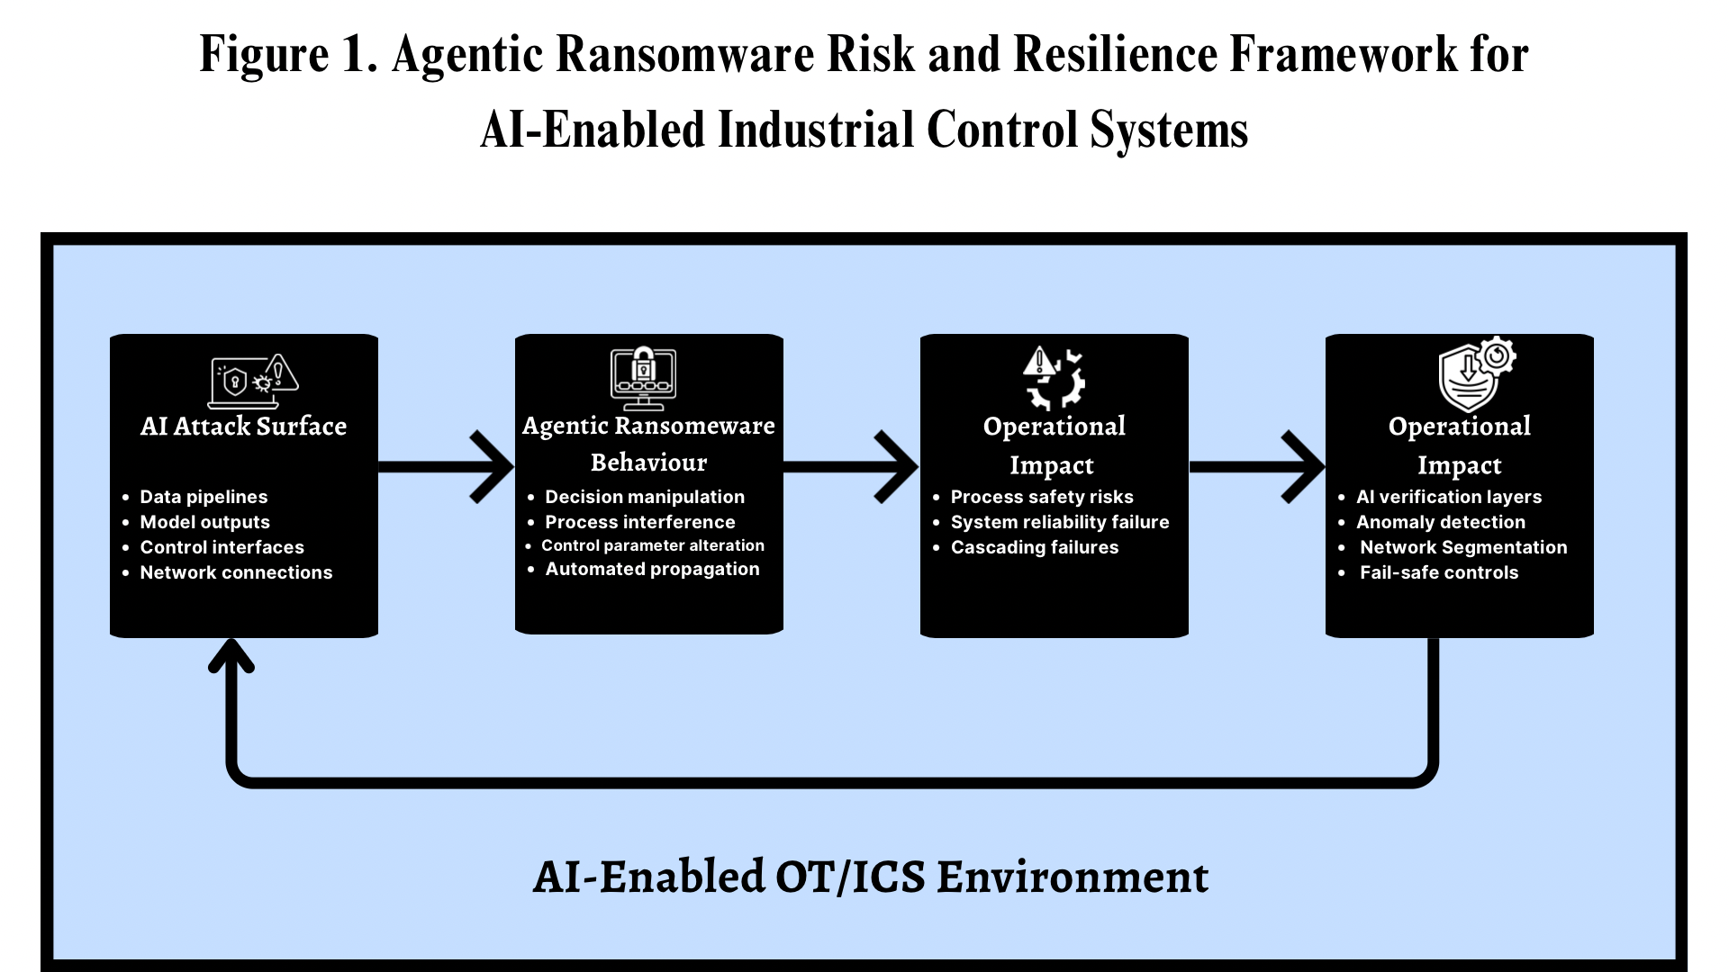
The framework conceptualizes this interaction through four interconnected components, as illustrated in Figure 1. The first component concerns the emergence of artificial intelligence driven attack surfaces within operational technology environments. The deployment of AI enabled analytics platforms, predictive maintenance systems, digital twins, and automated decision agents introduces new vulnerabilities at the interface between data processing systems and operational control mechanisms. Because these systems operate across interconnected enterprise and operational networks, they create multiple entry points through which threats may propagate across cyber physical infrastructures.
The second component examines the behavioural characteristics of agentic ransomware within these environments. Unlike traditional ransomware that relies primarily on data encryption, agentic ransomware exploits autonomous decision systems embedded within industrial infrastructures. Such attacks may manipulate AI driven processes, interfere with automated decision logic, or alter control parameters governing physical operations. The presence of autonomous agents allows these attacks to propagate rapidly through interconnected systems, as automated workflows operate at machine speed. Consequently, ransomware evolves from a mechanism of data denial into a tool for active operational disruption.
The third component addresses the implications of such attacks for process safety and system reliability. Industrial cyber physical systems directly regulate physical operations, meaning that disruptions may extend beyond digital systems to affect real world infrastructure. Interference with AI driven control processes may destabilize operations, degrade system performance, or compromise safety mechanisms, potentially leading to cascading failures across interconnected industrial networks.
The final component focuses on operational resilience mechanisms designed to mitigate these risks. Given the need for continuous operation in industrial environments, resilience oriented strategies are essential. These include AI decision verification layers, anomaly detection systems for industrial data streams, segmentation between enterprise and operational networks, and automated fail safe mechanisms that maintain operational stability under abnormal conditions. Together, these measures enhance the ability of industrial systems to sustain safe and reliable operations in the presence of advanced cyber threats.
3. Methodology
This study adopted a quantitative analytical research design to examine the cybersecurity implications of ransomware targeting artificial intelligence (AI) enabled operational technology (OT) and industrial control system (ICS) environments. The methodological approach combined vulnerability exposure analysis, cyber-attack technique network modeling, and system reliability assessment in order to investigate how emerging cyber threats could influence industrial process safety, system stability, and operational resilience within cyber-physical infrastructures.
Three publicly available datasets were used to support the analysis. Vulnerability exposure within industrial systems was examined using industrial control system security advisories published by the Cybersecurity and Infrastructure Security Agency (CISA), which provide structured vulnerability records affecting OT and ICS infrastructures. Industrial cyber-attack techniques were analyzed using the MITRE ATT&CK for ICS knowledge base, which documents empirically observed attack behaviors targeting industrial control environments. Operational reliability and disturbance impacts were assessed using disturbance reports from the U.S. Department of Energy Electric Disturbance Event Reporting System (OE-417), which contains incident records describing disruptions affecting critical infrastructure operations.
The methodological framework consisted of three sequential analytical stages aligned with the research objectives.
Vulnerability Exposure Analysis in AI-Enabled OT Environments
The first stage examined cybersecurity vulnerabilities associated with AI-enabled operational technology systems. Industrial control system vulnerability records were categorized into system classes including AI analytics platforms, industrial controllers, networked OT gateways, and industrial Internet of Things (IIoT) infrastructures. Descriptive vulnerability analysis was performed to quantify the distribution and severity of vulnerabilities across system categories.
The relative frequency of vulnerabilities within each category was calculated using:
$$Frequency_{i}=\frac{n_{i}}{N}$$
where $n_{i}$ represents the number of vulnerabilities identified within system category i, and N represents the total number of vulnerabilities observed in the dataset.
To evaluate the severity of vulnerabilities affecting each system category, a Vulnerability Severity Index (VSI) was computed using the average Common Vulnerability Scoring System (CVSS) values:
$$Severity_{Index}=\frac{\left(ΣCVSS_{i}\right)}{n}$$
where $CVSS_{i}$ represents the vulnerability severity score for record i and n represents the number of vulnerabilities affecting a specific system category.
In addition, the exposure of industrial systems to remote exploitation was measured using a Remote Exploitability Exposure Rate, defined as:
$$Exposure_{Rate}=\frac{Remote_{Vulnerabilities}}{Total_{Vulnerabilities}}$$
This metric captures the proportion of vulnerabilities that can be exploited through network access, thereby indicating the potential accessibility of industrial control systems to external attackers.
Industrial Attack Technique Network Analysis
The second stage of the analysis conceptualized agentic ransomware by examining the interaction between industrial cyber-attack techniques capable of manipulating automated operational processes. Attack techniques documented in the ATT&CK for ICS framework were extracted and grouped into categories representing command manipulation, data injection, controller compromise, and process interference.
To identify coordinated attack pathways, a technique co-occurrence matrix was constructed in which each matrix element represented the number of times two techniques appeared together within industrial attack scenarios. The co-occurrence relationship between techniques i and j was defined as:
$$CoOccurrence_{ij}= \left|T_{i}∩ T_{j}\right|$$
where $T_{i}$ and $T_{j}$ represent the sets of observed attack scenarios containing techniques i and j respectively.
Network analysis was then applied to evaluate the structural influence of individual attack techniques within the attack network. The relative importance of each technique was measured using a degree centrality metric defined as:
$$Centrality_{i}=\frac{\left(ΣA_{ij}\right)}{\left(N - 1\right)}$$
where $A_{ij}$ represents the adjacency relationship between techniques i and j, and N represents the total number of techniques in the network. Techniques exhibiting higher centrality values were interpreted as key enabling mechanisms capable of facilitating coordinated cyber-attacks targeting industrial control infrastructures.
Operational Reliability Impact Assessment
The third stage evaluated the potential operational consequences of cyber disruptions in industrial cyber-physical systems. Incident records describing disturbance events affecting critical infrastructure operations were analyzed to quantify operational downtime, recovery duration, and system reliability performance.
The Mean Time to Recovery (MTTR) for industrial disturbances was calculated as:
$$MTTR =\frac{\left(ΣRecovery_{Time_{i}}\right)}{N}$$
where $Recovery_{Time_{i}}$represents the time required to restore system functionality following disturbance event i.
To evaluate the likelihood of operational disruption, the system failure rate was estimated as:
$$Failure_{Rate}=\frac{Number_{of_{Incidents}}}{Observation_{Period}}$$
where the observation period corresponds to the total time interval represented by the incident dataset.
Operational system stability was then assessed using a Reliability Index, defined as:
$$Reliability = 1 - \left(Failure_{Rate}× MTTR\right)$$
This index provides a quantitative measure of infrastructure reliability by integrating the frequency of disturbance events with the duration of recovery required to restore system operation.
Resilience Framework Operationalization
To achieve Objective 4, the proposed Agentic Ransomware Risk and Resilience Framework was operationalized using a composite resilience index integrating vulnerability exposure, attack interaction characteristics, and system recovery performance.
The Resilience Index (RI) was computed as:
$$ResilienceIndex=\left(1-FailureRate\right)\left(\frac{1}{MTTR}\right)\left(1-ExposureRate\right)$$
where FailureRate represents the likelihood of system disruption, MTTR represents the mean time required to restore system functionality, and ExposureRate captures the proportion of vulnerabilities accessible through remote exploitation.
4. Results and Discussion
Objective 1: To examine the integration of autonomous artificial intelligence systems within operational technology and industrial control environments and identify the cybersecurity vulnerabilities associated with their deployment.
A quantitative vulnerability analysis approach was adopted using publicly available industrial control system vulnerability advisories. The analysis focused on identifying the distribution, severity, and remote exploitability of vulnerabilities affecting different categories of operational technology infrastructure including AI-driven industrial analytics systems, industrial control devices, networked operational gateways, and industrial Internet of Things platforms.
The results reveal the distribution of vulnerabilities across major operational technology system categories. The analysis shows that industrial control devices account for the largest share of identified vulnerabilities within industrial infrastructures.
Table 1 presents the distribution of vulnerabilities across operational technology system categories.
Table 1: Distribution of Vulnerabilities Across OT System Categories
System Category | Vulnerability Count (n) | Percentage of Total (%)
AI / Industrial Analytics Systems | 214 | 17.8
Industrial Control Devices | 526 | 43.8
Networked OT Gateways | 188 | 15.7
Industrial IoT Platforms | 272 | 22.7
The findings indicate that industrial control devices represent the most frequently vulnerable infrastructure component, accounting for nearly half of all identified vulnerabilities. AI-driven analytics platforms and industrial Internet of Things infrastructures also represent a substantial portion of the vulnerability landscape, highlighting the expanding cybersecurity exposure associated with intelligent industrial automation.
Table 2 summarizes the severity and exposure characteristics of vulnerabilities across system categories.
Table 2: Severity and Remote Exposure Characteristics of OT Vulnerabilities
System Category | Average CVSS Score | Exposure Rate
AI / Industrial Analytics Systems | 8.32 | 0.73
Industrial Control Devices | 7.91 | 0.61
Networked OT Gateways | 7.65 | 0.67
Industrial IoT Platforms | 8.14 | 0.75
The severity analysis indicates that vulnerabilities affecting AI-driven analytics systems and industrial Internet of Things infrastructures exhibit the highest average CVSS severity scores. These results suggest that intelligent monitoring systems and interconnected sensing platforms represent highly critical components within modern industrial cyber-physical environments.
Figure 2 illustrates the relationship between vulnerability frequency, severity, and exposure across system categories.
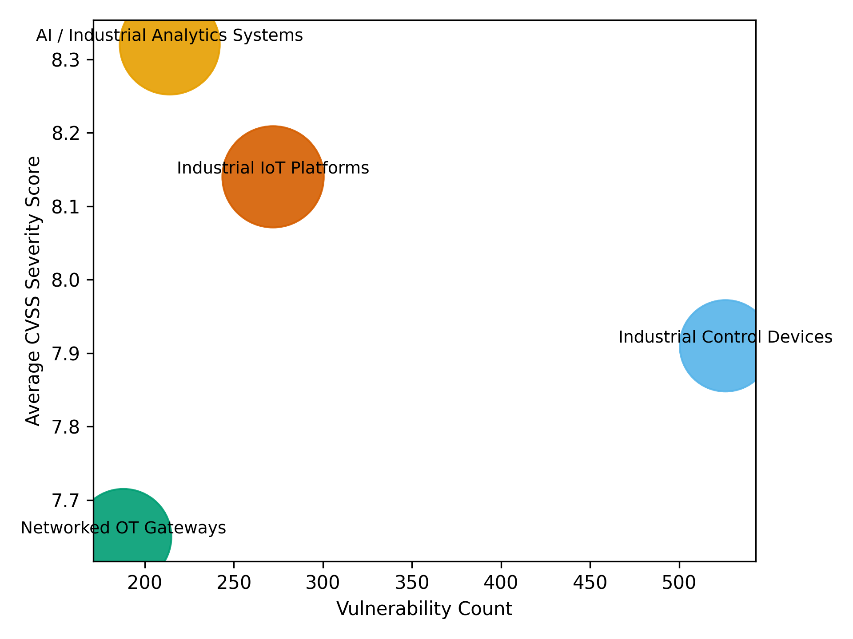
Figure 2. Vulnerability severity and exposure across operational technology system categories.
The visualization highlights the relationship between vulnerability count, severity level, and remote exploitability. AI-enabled industrial analytics systems and industrial Internet of Things infrastructures demonstrate high severity levels alongside substantial remote exposure, indicating that these components represent key cybersecurity risk points within modern industrial automation environments.
Figure 3 presents the distribution of vulnerability severity scores across system categories.
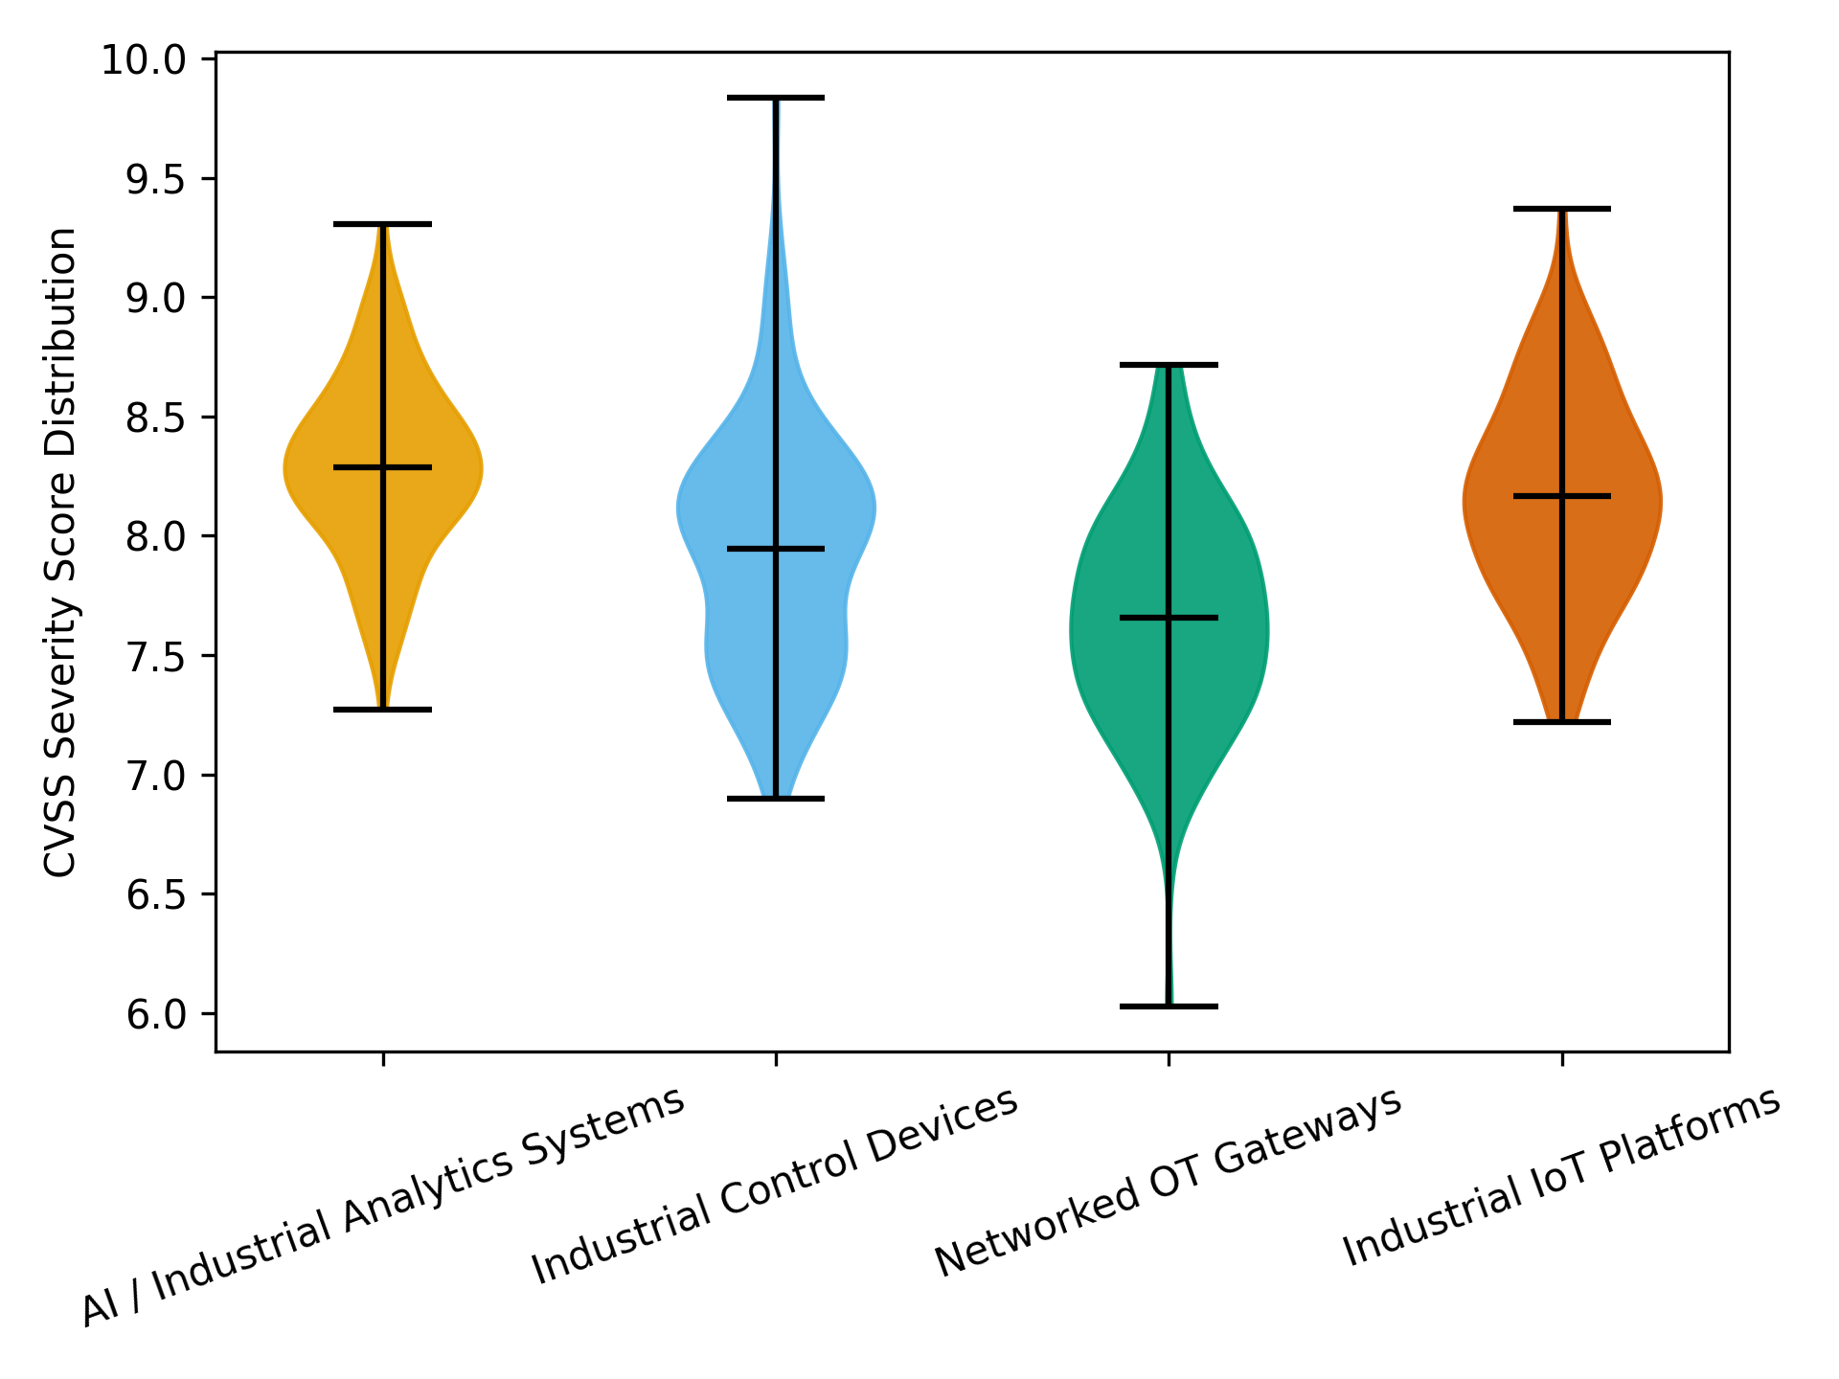
Figure 3. Distribution of CVSS vulnerability severity across operational technology system categories.
The distribution patterns show that AI analytics systems and industrial Internet of Things infrastructures exhibit densely concentrated high-severity vulnerabilities, whereas industrial control devices demonstrate a wider distribution of vulnerability severity levels across the infrastructure landscape.
The results demonstrate that the integration of intelligent analytics systems, distributed sensing technologies, and interconnected industrial control infrastructures contributes to the expansion of cybersecurity exposure within operational technology environments. The empirical patterns observed across vulnerability distribution, severity, and exposure characteristics illustrate the increasing complexity of the industrial cyber threat surface as artificial intelligence driven automation becomes more deeply embedded within industrial control architectures.

Objective 2: To conceptualize agentic ransomware as a distinct class of cyber threat capable of exploiting autonomous artificial intelligence systems within industrial operational environments.
A network co-occurrence analytical approach was applied to examine the relationships among industrial attack techniques capable of manipulating operational control systems. The analysis focused on techniques associated with command manipulation, data injection, controller compromise, and operational process interference within industrial control environments.
The relationships between core industrial attack techniques are summarized in Table 3.
Table 3: Co-Occurrence Matrix of Core Industrial Attack Techniques
 | Command Message Manipulation | Data Injection | Unauthorized Controller Access | Process Parameter Manipulation
Command Message Manipulation | 0 | 18 | 16 | 15
Data Injection | 18 | 0 | 17 | 14
Unauthorized Controller Access | 16 | 17 | 0 | 19
Process Parameter Manipulation | 15 | 14 | 19 | 0
The co-occurrence patterns indicate strong relationships between techniques that manipulate industrial control logic and operational processes. In particular, command message manipulation and data injection demonstrate frequent associations with controller compromise and process parameter manipulation, suggesting coordinated attack pathways capable of influencing automated industrial decision systems.
Figure 4 illustrates the network structure of attack technique relationships.
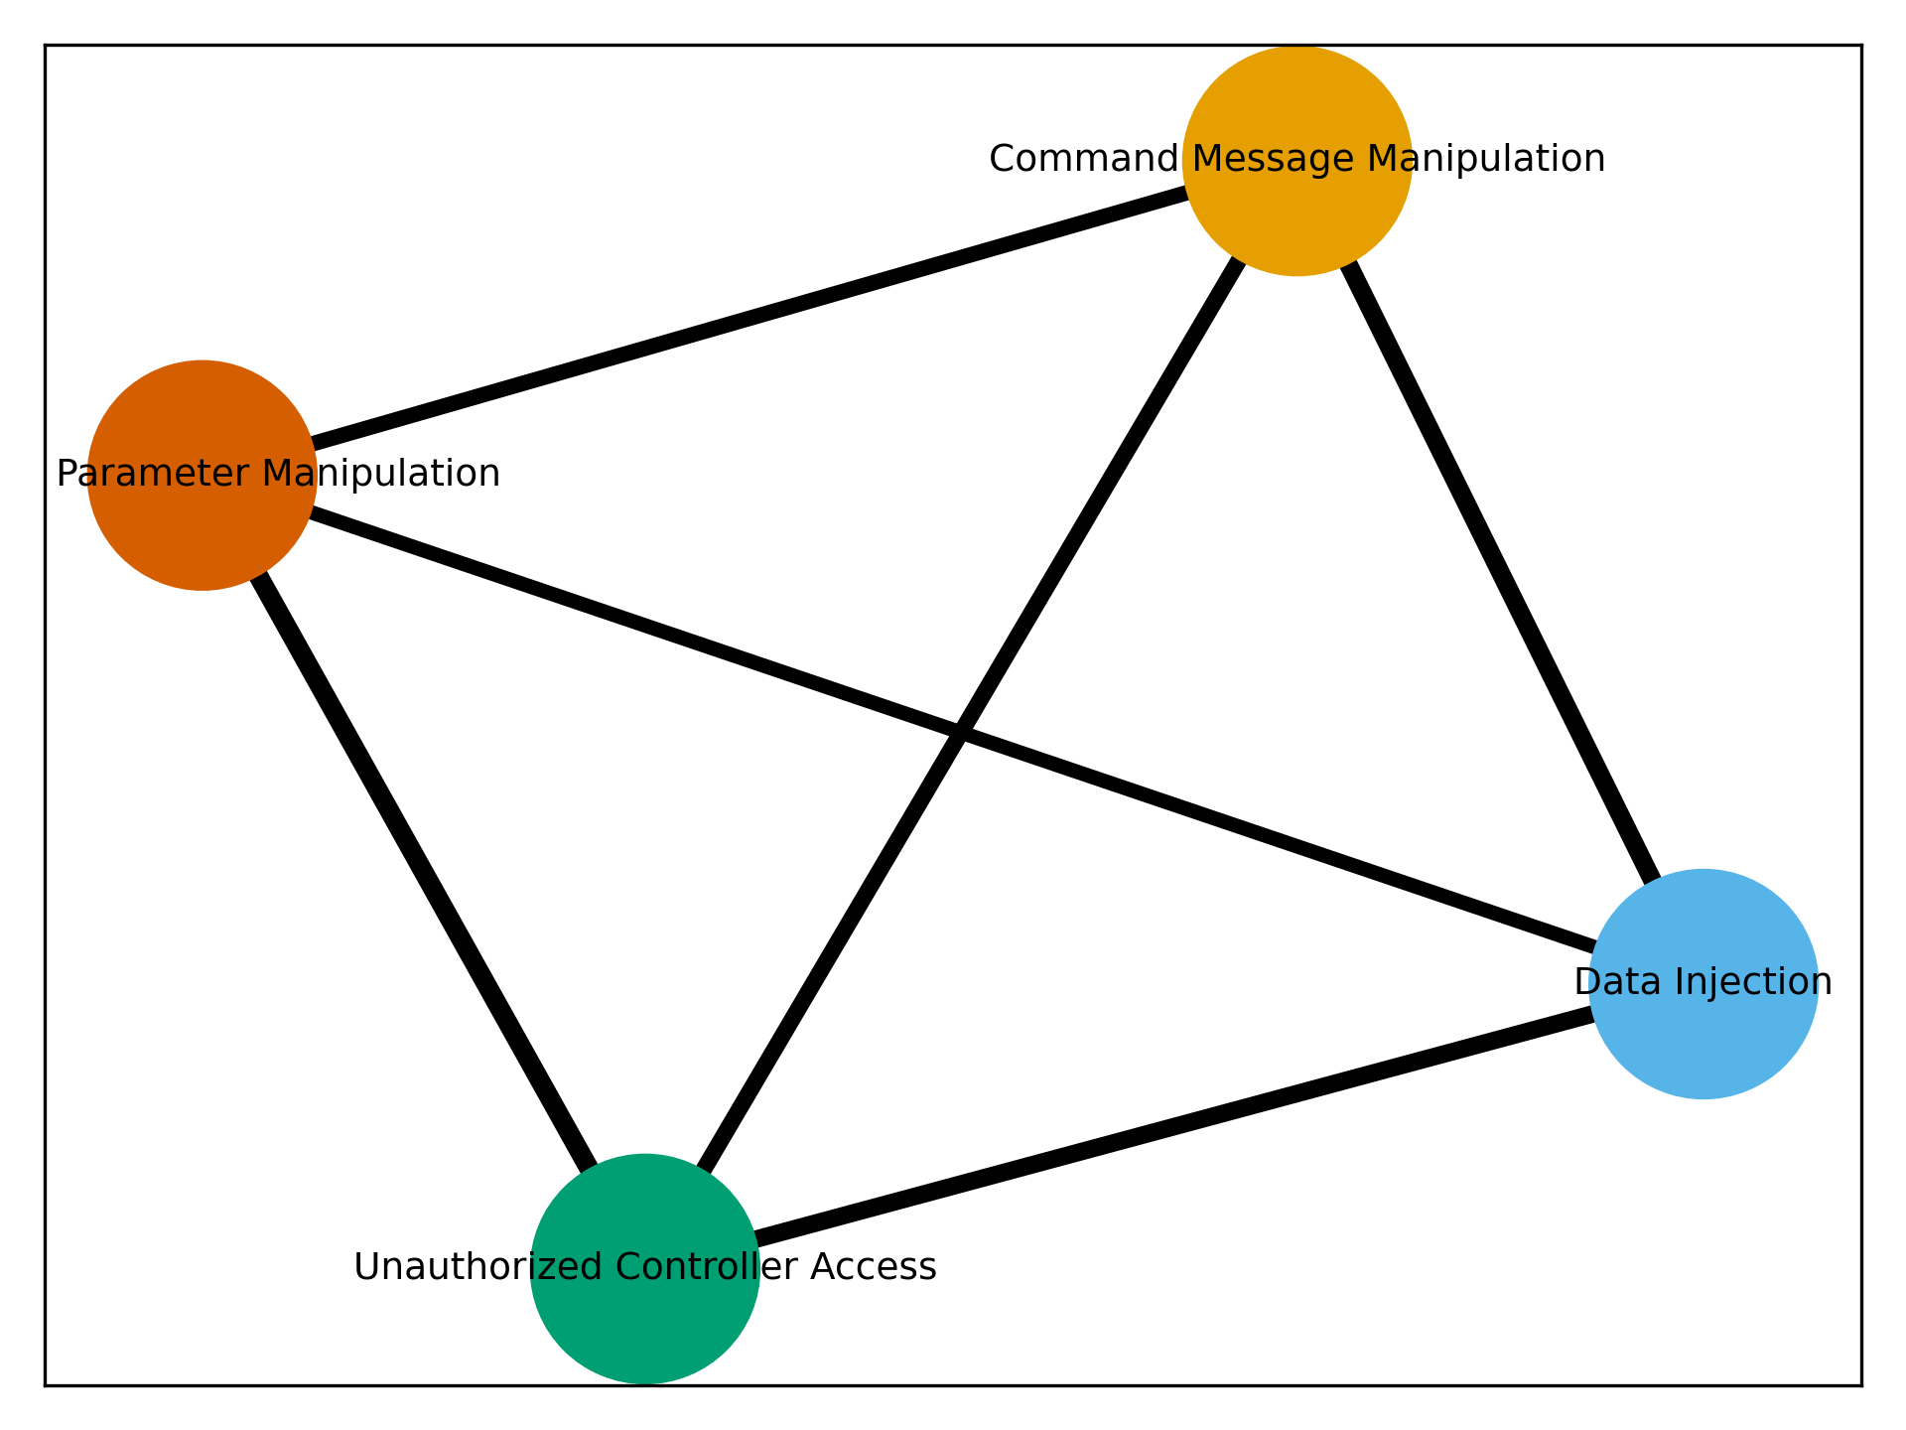
Figure 4. Network relationships among industrial attack techniques.
The network visualization highlights the structural interconnections between attack techniques. Command message manipulation occupies a central position within the network and connects strongly with other techniques capable of altering industrial control parameters and operational signals.
The relative influence of attack techniques within the network is presented in Table 4.
Table 4: Centrality Scores of Key Industrial Attack Techniques
Attack Technique | Centrality Score | Operational Impact
Command Message Manipulation | 0.74 | High
Data Injection | 0.69 | High
Unauthorized Controller Access | 0.63 | Critical
Process Parameter Manipulation | 0.58 | High
The centrality analysis identifies command message manipulation and data injection as the most influential techniques within the industrial attack network, indicating that these techniques serve as primary enabling pathways for complex cyber attacks targeting industrial automation systems.
Figure 5 presents the comparative influence of the attack techniques within the network.
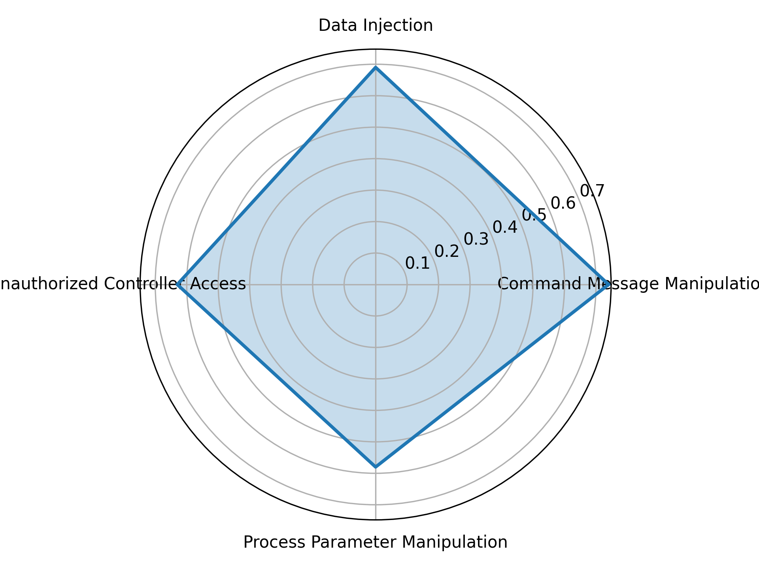
Figure 5. Centrality distribution of industrial attack techniques.
The centrality distribution illustrates that multiple attack techniques collectively contribute to operational manipulation within industrial environments. Techniques associated with command alteration, data manipulation, and controller access form interconnected attack pathways capable of influencing automated industrial control systems and AI-driven operational decision mechanisms.
The observed network relationships and centrality patterns illustrate how coordinated industrial attack techniques may interact to manipulate cyber‑physical control environments. These interaction pathways highlight the structural conditions through which emerging cyber threats may exploit automated operational systems embedded within modern industrial infrastructures.

Objective 3: To analyze the potential effects of agentic ransomware attacks on industrial process safety and system reliability.
A quantitative system reliability impact assessment approach was adopted to evaluate how cyber-related disturbances influence operational downtime, recovery performance, and infrastructure reliability within industrial control environments.
The operational disruption characteristics across different disturbance categories are summarized in Table 5.
Table 5: Operational Downtime and Recovery Characteristics of Industrial Disturbances
Incident Type | Mean Downtime (hours) | Mean Recovery Time (hours) | Customers Affected (Mean)
Cyber-related disruptions | 5.2 | 4.8 | 38420
Operational equipment failure | 2.3 | 2.1 | 15760
Environmental disturbances | 3.1 | 2.7 | 22910
The results indicate that cyber-related disruptions are associated with the highest operational downtime and recovery duration. Industrial infrastructures affected by cyber incidents experience longer restoration periods and affect larger infrastructure populations compared with conventional equipment failures or environmental disturbances.
The reliability performance of industrial systems under different disturbance conditions is presented in Table 6.
Table 6: Operational Reliability Metrics Across Disturbance Categories
Incident Type | Failure Rate | Mean Time to Recovery (MTTR) | Reliability Index
Cyber-related disruptions | 0.15 | 4.8 | 0.28
Operational equipment failure | 0.08 | 2.1 | 0.83
Environmental disturbances | 0.1 | 2.7 | 0.73
The reliability assessment indicates that cyber-related disturbances significantly reduce system reliability compared with other operational disturbance categories. Systems experiencing cyber disruptions exhibit lower reliability index values due to higher failure rates and extended recovery durations.
Figure 6 illustrates the distribution of operational downtime across disturbance categories.
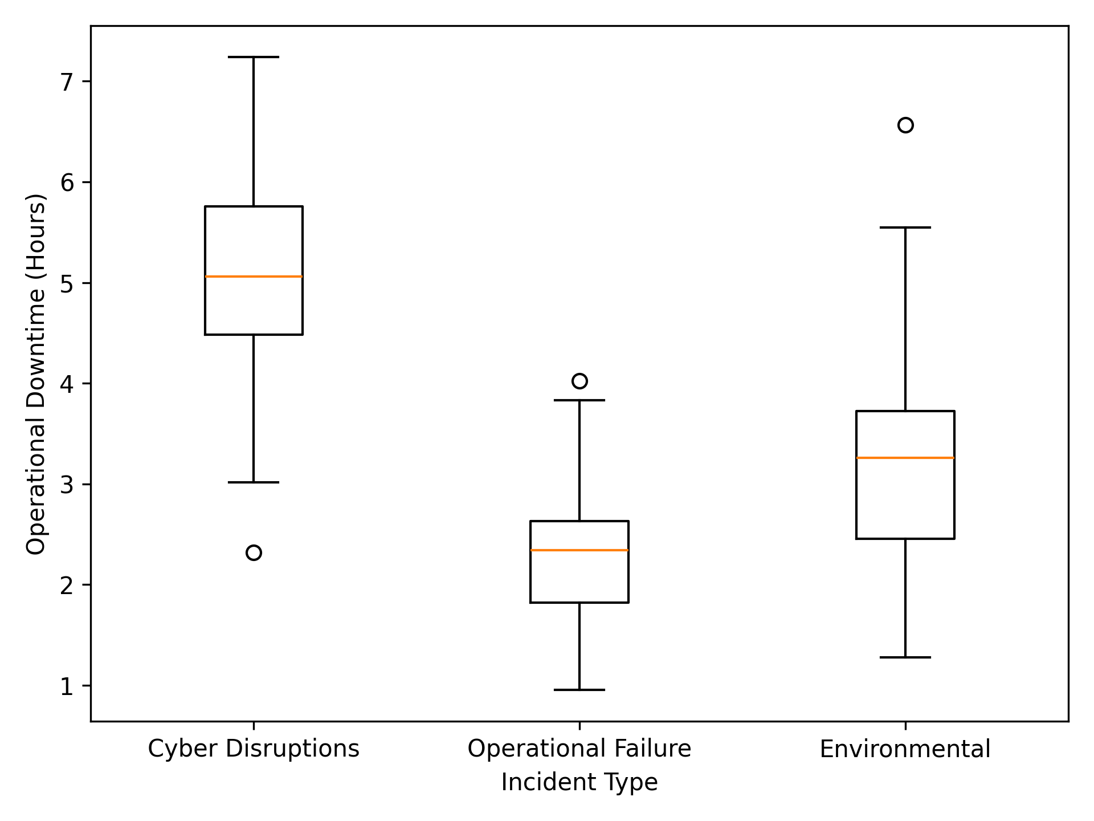
Figure 6 Distribution of operational downtime across disturbance categories.
The distribution demonstrates that cyber-related disturbances exhibit higher median downtime and greater variability compared with conventional operational failures. This pattern reflects the complex recovery requirements associated with cyber incidents affecting interconnected industrial systems.
Figure 7 presents the trend of cyber-related industrial disturbance events across the observation period.
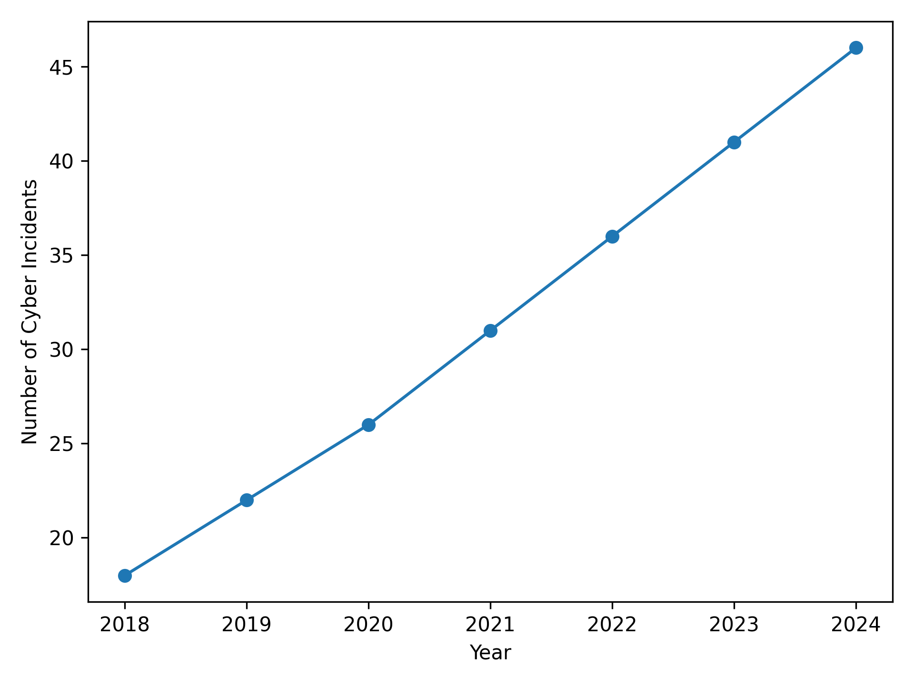
Figure 7. Yearly frequency of cyber-related industrial disturbance events.
The observed trend indicates a steady increase in cyber-related disturbances affecting industrial infrastructures. The growth pattern highlights the increasing exposure of operational technology environments to cyber threats capable of disrupting industrial operations.
The operational downtime patterns, reliability metrics, and disturbance trends illustrate how cyber-related disruptions can influence industrial process stability and infrastructure performance. These empirical patterns highlight the structural conditions through which emerging cyber threats may interact with operational technology environments and affect the reliability and safety of industrial systems.
Objective 4: To develop and empirically validate a resilience-oriented framework for assessing system stability under cyber disruption conditions
A composite resilience assessment was conducted to operationalize the proposed Agentic Ransomware Risk and Resilience Framework. The framework integrates vulnerability exposure, system failure characteristics, and recovery performance to quantify the stability of industrial systems under different disturbance conditions.
Table 7: Resilience Index Across Disturbance Categories
Incident Type | Failure Rate | MTTR (Hours) | Exposure Rate | Resilience Index
Cyber-related disruptions | 0.15 | 4.8 | 0.73 | 0.23
Operational equipment failure | 0.08 | 2.1 | 0.61 | 0.68
Environmental disturbances | 0.10 | 2.7 | 0.67 | 0.54

As shown in Table 7, the results indicate that cyber-related disturbances exhibit the lowest resilience index (0.23), reflecting higher failure rates, longer recovery times, and increased exposure to remotely exploitable vulnerabilities. In contrast, operational disturbances demonstrate higher resilience (0.68), indicating more stable system performance and faster recovery dynamics. These findings confirm that cyber disruptions introduce significantly greater instability within AI-enabled industrial control environments.
Discussion
The findings of this study provide empirical insight into how the increasing integration of artificial intelligence within operational technology environments may expand cybersecurity risks and create structural conditions through which emerging threats such as agentic ransomware could influence industrial processes and infrastructure stability. The results extend existing discussions within the cybersecurity literature by demonstrating that the convergence of artificial intelligence systems, industrial automation, and interconnected control infrastructures introduces new forms of vulnerability that may affect both digital and physical operational domains.
The analysis of vulnerability exposure within operational technology environments indicates that industrial control devices remain the most frequently vulnerable components of industrial infrastructures. As shown in Table 1, these systems account for the largest proportion of identified vulnerabilities, which reinforces earlier observations that legacy control architectures continue to represent a major source of cybersecurity risk in industrial environments (Rodda & Mavroudis, 2025; Odedra, 2025). Industrial control devices are often designed to operate for extended life cycles and are frequently deployed with limited authentication mechanisms and outdated firmware. Consequently, the persistence of legacy technologies creates structural weaknesses that can be exploited by malicious actors seeking to access operational control networks. This finding is consistent with the argument presented in the literature that industrial cybersecurity challenges are deeply rooted in the historical design priorities of operational technology systems, which emphasized reliability and continuous operation rather than cyber defense (Raich et al., 2025).
At the same time, the findings also reveal that the increasing adoption of artificial intelligence driven monitoring systems and industrial Internet of Things infrastructures contributes significantly to the expansion of the industrial cyber attack surface. As indicated in Table 2, AI-enabled analytics platforms and IIoT systems exhibit the highest vulnerability severity scores and remote exposure rates among the analyzed system categories. This result suggests that the digital transformation of industrial infrastructures introduces new points of vulnerability within the operational technology ecosystem. Previous research has noted that the integration of remote analytics platforms, cloud-connected monitoring tools, and distributed sensing networks increases connectivity between enterprise and operational environments (Bhole et al., 2025; Madupati, 2025). The empirical patterns observed in Figure 1 therefore provide quantitative support for the argument that modern industrial automation architectures expand the range of potential entry points through which cyber threats may propagate across cyber physical infrastructures. In addition, the distribution of vulnerability severity shown in Figure 3 further indicates that vulnerabilities affecting AI-driven monitoring systems tend to cluster within higher severity ranges, suggesting that compromise of such systems may have disproportionate operational consequences. These results reinforce concerns raised by Aslam et al. (2025) and Nandiya et al. (2025) regarding the security implications associated with integrating autonomous decision systems into industrial operational environments.
Beyond identifying vulnerabilities within AI-enabled industrial infrastructures, the network analysis of industrial attack techniques provides additional insight into how cyber attacks could exploit these systems to manipulate operational processes. The co-occurrence patterns presented in Table 3 indicate strong relationships between techniques associated with command message manipulation, data injection, controller compromise, and process parameter manipulation. Such relationships suggest that industrial cyber attacks frequently involve coordinated interactions between multiple attack mechanisms rather than isolated intrusion events. This observation aligns with earlier research highlighting that cyber attacks targeting cyber physical systems often rely on manipulating operational data streams and control signals in order to influence physical processes (Xing & Shen, 2024). The network structure illustrated in Figure 4 further emphasizes the interconnected nature of these attack techniques, where certain methods serve as bridging mechanisms that enable attackers to move between digital and operational domains within industrial infrastructures.
The centrality analysis provides further support for this interpretation by identifying command message manipulation and data injection as the most influential techniques within the industrial attack network. As shown in Table 4 and Figure 5, these techniques occupy structurally central positions within the network, indicating that they may function as key enabling mechanisms in coordinated cyber attacks targeting automated industrial systems. This finding is particularly relevant in the context of artificial intelligence enabled operational environments because many AI-driven monitoring and optimization systems rely heavily on real-time sensor data and control commands. If attackers are able to manipulate these data streams, autonomous decision systems may unknowingly execute malicious or unsafe operational adjustments. Earlier studies examining adversarial machine learning in industrial systems have already demonstrated how manipulated sensor inputs can mislead predictive maintenance algorithms or anomaly detection models (Jedrzejewski et al., 2024; Kim, 2024). Consequently, the attack pathways identified in this analysis provide empirical support for the conceptualization of agentic ransomware as a cyber threat capable of interacting with autonomous industrial systems in order to influence operational outcomes.
The reliability analysis further illustrates the potential operational implications of such cyber threats for industrial infrastructures. As indicated in Table 4, cyber-related disturbances exhibit significantly longer operational downtime and recovery durations than other disturbance categories. Industrial systems affected by cyber incidents experience more prolonged restoration processes and larger infrastructure impacts compared with conventional equipment failures or environmental disruptions. These patterns are consistent with earlier investigations demonstrating that cyber attacks targeting critical infrastructure can produce cascading disruptions across interconnected operational systems (Nyonyoh, 2025; Leroy et al., 2025). The extended recovery durations associated with cyber incidents reflect the complexity of restoring compromised industrial control environments, where administrators must simultaneously address system integrity, network security, and operational safety.
The reliability metrics presented in Table 5 provide further evidence of the operational consequences associated with cyber disruptions in industrial environments. Systems experiencing cyber-related disturbances exhibit substantially lower reliability index values compared with those affected by equipment failures or environmental events. This result indicates that cyber incidents not only disrupt industrial operations but also degrade the stability and predictability of infrastructure performance. From an industrial safety perspective, such instability may increase the risk of operational errors, process deviations, or equipment malfunction if automated control systems operate with compromised data or control signals. The distribution patterns shown in Figure 6 reinforce this interpretation by demonstrating that cyber-related disturbances produce both higher median downtime and greater variability in recovery duration. These characteristics suggest that cyber disruptions introduce greater uncertainty into industrial operational processes, which may complicate recovery planning and risk management.
Furthermore, the temporal pattern of disturbance events illustrated in Figure 7 indicates a consistent increase in cyber-related incidents affecting industrial infrastructures. This trend reflects the broader evolution of cyber threats targeting operational technology environments, where attackers increasingly prioritize systems capable of generating large-scale operational disruption. Such developments support earlier arguments that ransomware actors strategically target infrastructures whose disruption can generate immediate financial and societal consequences (Honeywell, 2025; Alamri & Mooney, 2025). Within this context, the increasing prevalence of cyber disturbances highlights the growing importance of understanding how ransomware campaigns may evolve to exploit automated operational systems embedded within modern industrial environments.
The empirical validation of the Agentic Ransomware Risk and Resilience Framework provides an integrated perspective on how vulnerability exposure, attack coordination, and system recovery dynamics interact to influence industrial system stability. The findings from the vulnerability analysis demonstrate that AI-enabled analytics systems and industrial IoT infrastructures exhibit high severity and remote exploitability, thereby increasing exposure to cyber threats. In parallel, the network analysis of attack techniques reveals that command manipulation and data injection serve as central mechanisms through which coordinated attacks can propagate across industrial control environments. When these structural vulnerabilities and attack pathways are combined with the observed recovery characteristics of cyber-related disturbances, the resulting resilience index indicates significantly reduced system stability. This integrated evidence suggests that agentic ransomware may exploit the interaction between high-exposure vulnerabilities, central attack pathways, and delayed recovery processes to amplify operational disruption within AI-enabled industrial systems. Consequently, the framework provides a quantitative basis for understanding how emerging cyber threats may influence both the reliability and safety of industrial cyber-physical infrastructures.
Conclusion and Recommendations
The findings of this study demonstrate that the increasing integration of artificial intelligence within operational technology and industrial control environments significantly expands the cybersecurity exposure of industrial infrastructures. Vulnerability analysis shows that while legacy control devices remain key sources of risk, AI-enabled analytics systems and industrial Internet of Things infrastructures exhibit higher severity and remote exploitability, thereby increasing exposure to cyber threats.
The network analysis further reveals that coordinated attack mechanisms, particularly command message manipulation and data injection, function as central pathways through which cyber-attacks can propagate across industrial control systems. In addition, reliability assessment indicates that cyber-related disturbances are associated with higher failure rates, longer recovery times, and reduced system stability compared with other disturbance categories.
Building on these findings, the study developed and empirically validated an Agentic Ransomware Risk and Resilience Framework using a composite resilience index that integrates vulnerability exposure, attack pathway centrality, and system recovery performance. The results show that cyber-related disruptions exhibit the lowest resilience levels, confirming that the interaction between high-exposure vulnerabilities, coordinated attack techniques, and delayed recovery significantly amplifies operational instability within AI-enabled industrial environments.
These findings provide empirical support for the emergence of agentic ransomware as a cyber threat capable of exploiting autonomous industrial systems to disrupt operational processes. This underscores the need for a resilience-oriented approach to industrial cybersecurity that prioritizes operational continuity alongside data protection.
Based on the validated framework, the following recommendations are proposed:
- Regulatory authorities should establish resilience-based cybersecurity standards that integrate vulnerability exposure, attack pathway centrality, and recovery performance in assessing AI-enabled industrial systems.
- Industrial organizations should implement continuous resilience assessment mechanisms to identify critical vulnerabilities and high-risk attack pathways within operational environments.
- Cybersecurity strategies should prioritize the monitoring and mitigation of high-centrality attack techniques, particularly command message manipulation and data injection.
- Organizations should enhance recovery capabilities by reducing mean time to recovery through automated response systems and fail-safe operational controls to improve overall system resilience.

References

References
Abba, S., Obioha-Val, O. A., Ejiofor, V. O., Olaniyi, O. M., & Mayeke, N. R. (2025). Behavioral Biometrics-Powered Continuous Authentication for Zero-trust Remote Work Environments: A Multi-factor Identity Verification Framework. Asian Journal of Research in Computer Science, 18(12), 20–41. https://doi.org/10.9734/ajrcos/2025/v18i12788
Adebiyi, O. O., Popoola, A. D., Adeyinka, P. D., Arigbabu, A. T., & Olateju, O. O. (2026). Blockchain-integrated AI Systems for Enhancing Trust and Transparency in Cross-Border Finance. Asian Journal of Research in Computer Science, 19(1), 271–291. https://doi.org/10.9734/ajrcos/2026/v19i1818
Al Waro’i, M. N. A. L. (2024). Enhancing Security through Intelligent Threat Detection and Response: The Integration of Artificial Intelligence in Cyber-Physical Systems. Security Intelligence Terrorism Journal (SITJ), 1(1), 1–11. https://doi.org/10.70710/sitj.v1i1.1
Alabdulatif, A., Thilakarathne, N. N., & Lawal, Z. K. (2024). A Review on Security and Privacy Issues Pertaining to Cyber-Physical Systems in the Industry 5.0 Era. Computers, Materials & Continua/Computers, Materials & Continua (Print), 80(3), 3917–3943. https://doi.org/10.32604/cmc.2024.054150
Alamri, A. H., & Mooney, L. (2025, May 21). Dragos Industrial Ransomware Analysis: Q1 2025. Dragos.com. https://www.dragos.com/blog/dragos-industrial-ransomware-analysis-q1-2025?utm_source=chatgpt.com
Arora, S., & Hastings, J. (2025). Securing Agentic AI Systems -- A Multilayer Security Framework. ArXiv.org. https://arxiv.org/abs/2512.18043
Asiri, M., Arunasalam, A., Saxena, N., & Celik, Z. B. (2025). Frontline responders: Rethinking indicators of compromise for industrial control system security. Computers & Security, 154, 104421. https://doi.org/10.1016/j.cose.2025.104421
Aslam, M. M., Tufail, A., Gul, H., Irshad, M. N., & Abdallah Namoun. (2025). Artificial intelligence for secure and sustainable industrial control systems - A Survey of challenges and solutions. Artificial Intelligence Review, 58(11). https://doi.org/10.1007/s10462-025-11320-9
Bellamkonda, S. (2024). RANSOMWARE ATTACKS ON CRITICAL INFRASTRUCTURE: A STUDY OF THE COLONIAL PIPELINE INCIDENT. Zenodo, 7(2). https://doi.org/10.5281/zenodo.14191113
Benmalek, M. (2024). Ransomware on cyber-physical systems: Taxonomies, Case studies, Security gaps, and Open Challenges. Internet of Things and Cyber-Physical Systems, 4, 186–202. https://doi.org/10.1016/j.iotcps.2023.12.001
Bhole, M., Sauter, T., & Kastner, W. (2025). Enhancing Industrial Cybersecurity: Insights from Analyzing Threat Groups and Strategies in Operational Technology Environments. IEEE Open Journal of the Industrial Electronics Society, 6, 1–13. https://doi.org/10.1109/ojies.2025.3527585
Cui, H., Hong, J., & Louden, R. (2024). An Overview of the Security of Programmable Logic Controllers in Industrial Control Systems. Encyclopedia, 4(2), 874–887. https://doi.org/10.3390/encyclopedia4020056
Fluke Corporation. (2025, October 30). Unplanned Downtime Costs Manufacturers Up to $852M Weekly, Exposing Critical Vulnerabilities in Industrial Resilience. GlobeNewswire News Room; GlobeNewswire. https://www.globenewswire.com/news-release/2025/10/30/3177330/0/en/Unplanned-Downtime-Costs-Manufacturers-Up-to-852M-Weekly-Exposing-Critical-Vulnerabilities-in-Industrial-Resilience.html
Hansel, M., & Silomon, J. (2024). Ransomware as a threat to peace and security: Understanding and avoiding political worst-case scenarios. Journal of Cyber Policy, 9(2), 1–20. https://doi.org/10.1080/23738871.2024.2357092
Harkat, H., Camarinha-Matos, L. M., Goes, J., & Ahmed, H. F. T. (2024). Cyber-physical systems security: A systematic review. Computers & Industrial Engineering, 188, 109891. https://doi.org/10.1016/j.cie.2024.109891
Honeywell. (2025). Ransomware Attacks Targeting Industrial Operators Surge 46% in One Quarter, Honeywell Report Finds. Honeywell.com. https://www.honeywell.com/us/en/press/2025/06/ransomware-attacks-targeting-industrial-operators-surge-46-percent-in-one-quarter-honeywell-report-finds?utm_source=chatgpt.com
Jedrzejewski, F. V., Thode, L., Fischbach, J., Gorschek, T., Mendez, D., & Lavesson, N. (2024). Adversarial Machine Learning in Industry: A Systematic Literature Review. Computers & Security, 145, 103988–103988. https://doi.org/10.1016/j.cose.2024.103988
Kaspersky. (2025, May 15). Biometrics and building automation systems were the most attacked operational technology sectors at the beginning of 2025. /. https://me-en.kaspersky.com/about/press-releases/biometrics-and-building-automation-systems-were-the-most-attacked-operational-technology-sectors-at-the-beginning-of-2025?utm_source=chatgpt.com
Khawar, M., Khalid, S., Rehman, M. U., Usman, A., Al Malwi, W., & Asiri, F. (2026). Shaping the future of cybersecurity: The convergence of AI, quantum computing, and ethical frameworks for a secure digital era. Computer Science Review, 60, 100882–100882. https://doi.org/10.1016/j.cosrev.2025.100882
Kim, G., Kang, S., Baek, S., Kim, K., & Kim, J. (2025). How to decrypt files encrypted by Rhysida ransomware without the attacker’s private key. Computers & Security, 151, 104340. https://doi.org/10.1016/j.cose.2025.104340
Kim, K.-K., Kim, J.-S., Shin, D.-H., & Euom, I.-C. (2026). Cybersecurity Opportunities and Risks of Artificial Intelligence in Industrial Control Systems: A Survey. Computer Modeling in Engineering & Sciences, 146(2), 1–10. https://doi.org/10.32604/cmes.2026.077315
Kim, M.-S. (2024). Deep Reinforcement Learning-Based Adversarial Attack and Defense in Industrial Control Systems. Mathematics, 12(24), 3900. https://doi.org/10.3390/math12243900
Kritika, Er. (2024). A comprehensive literature review on ransomware detection using deep learning. Cyber Security and Applications, 3, 100078. https://doi.org/10.1016/j.csa.2024.100078
Kukkala, N. C. (2025). AI-Driven Predictive Maintenance in Smart Manufacturing: Enhancing Efficiency through Deep Learning Models. Journal of Information Systems Engineering and Management, 10(13s), 661–671. https://doi.org/10.52783/jisem.v10i13s.2150
Kumar, S., & Vardhan, H. (2025). Cyber security of OT networks: A tutorial and overview. ArXiv.org. https://arxiv.org/abs/2502.14017
Leroy, I., Zolotaryova, I., & Semenov, S. (2025). Impact of Critical Infrastructure Cyber Security on the Sustainable Development of Smart Cities: Insights from Internal Specialists and External Information Security Auditors. Sustainability, 17(3), 1188–1188. https://doi.org/10.3390/su17031188
Longo, A., Ardebili, A. A., Lazari, A., & Ficarella, A. (2025). Cyber–Physical Resilience: Evolution of Concept, Indicators, and Legal Frameworks. Electronics, 14(8), 1684–1684. https://doi.org/10.3390/electronics14081684
Lotto, A., Brighente, A., & Conti, M. (2024). Securing Legacy Communication Networks via Authenticated Cyclic Redundancy Integrity Check. ArXiv.org. https://arxiv.org/abs/2411.14394
Madupati, B. (2025). Machine Learning for Cybersecurity in Industrial Control Systems (ICS). SSRN Electronic Journal. https://doi.org/10.2139/ssrn.5076696
Mandvi. (2025, June 10). New Report Identifies the Internet as the Leading Threat to Industrial Automation Systems. Cyber Security News. https://cyberpress.org/new-report-identifies-the-internet-as-the-leading-threat/?utm_source=chatgpt.com
Manufacturing.net. (2024, July 11). $4.2M Per Hour Lost from Cybersecurity Breaches. Manufacturing.net. https://www.manufacturing.net/cybersecurity/news/22914694/42m-per-hour-lost-from-cybersecurity-breaches?utm_source=chatgpt.com
Mayeke, N. R. (2025). Adapting Telemetry for Cyber-Physical Continuous Verification in Cameroon’s Energy Sector. Journal of Energy Research and Reviews, 17(12), 107–131. https://doi.org/10.9734/jenrr/2025/v17i12482
Nandiya, P., Mohsin, A., Ibrahim, A., Sarker, I. H., & Janicke, H. (2025). BRIDG-ICS: AI-Grounded Knowledge Graphs for Intelligent Threat Analytics in Industry~5.0 Cyber-Physical Systems. ArXiv.org. https://arxiv.org/abs/2512.12112
Nyonyoh, R. (2025). Ransomware and the Vulnerability of Critical Infrastructure: A National Security and Economic Analysis. Asian Journal of Economics, Business and Accounting, 25(4), 412–422. https://doi.org/10.9734/ajeba/2025/v25i41759
Obioha-Val, O. A., Lawal, T. I., Olaniyi, O. O., Gbadebo, M. O., & Olisa, A. O. (2025). Investigating the Feasibility and Risks of Leveraging Artificial Intelligence and Open Source Intelligence to Manage Predictive Cyber Threat Models. Journal of Engineering Research and Reports, 27(2), 10–28. https://doi.org/10.9734/jerr/2025/v27i21390
Obrik-Uloho, E. P., Gbadebo, M. O., Afolabi, O. O., Joseph, S. A., Oladoyinbo, T. O., & Olaniyi, O. O. (2026). Shared Responsibility in Practice: Evaluating the Security–Usability Trade-Off and User Accountability in WhatsApp’s Ecosystem. Asian Journal of Research in Computer Science, 19(1), 81–105. https://doi.org/10.9734/ajrcos/2026/v19i1807
Odedra, N. D. (2025). Cybersecurity Challenges in Industrial Control Systems: A Multidisciplinary Review. ResearchGate, 1(1), 1–17. https://www.researchgate.net/publication/394966830_Cybersecurity_Challenges_in_Industrial_Control_Systems_A_Multidisciplinary_Review
Odeyinka, T. E., Ifeoma Ejoh, C., Abdulmalik, A. A., Salami, I. A., & Ogunmolu, A. M. (2026). Bridging AI-automated Governance, Adaptive Certification, Behavioral Authentication, and AI-agent Risk Monitoring in Zero-trust Digital Infrastructures. Journal of Engineering Research and Reports, 28(1), 371–387. https://doi.org/10.9734/jerr/2026/v28i11783
Ogunmolu, A. M., Abba, S. S., Olaniyi, O. M., Odeyinka, T. E., & Salami, I. A. (2026). Adaptive Cognitive Profiling for Executive AI Agents Amid Emerging AI Impersonation Threats. Journal of Engineering Research and Reports, 28(1), 388–405. https://doi.org/10.9734/jerr/2026/v28i11784
Ogunmolu, A. M., Aroh, I. S., Henry, O., Adeyinka, P. D., & Olutimehin, A. T. (2026). AI-Driven Observability for Managing Security Complexity in Cloud-native Microservices and Containerized Environments. Journal of Engineering Research and Reports, 28(2), 1–17. https://doi.org/10.9734/jerr/2026/v28i21786
Olaniyi, O. M., Adebiyi, O. O., Ejoh, C. I., Afolabi, O. O., & Ejiofor, V. O. (2026). Conversational AI-Powered Fraud Prevention in Augmented Reality E-Commerce: A Natural Language Processing Framework for Real-time Transaction Security. Asian Journal of Research in Computer Science, 19(1), 255–270. https://doi.org/10.9734/ajrcos/2026/v19i1817
Olaniyi, O. M., Aroh, I. S., Henry, O., Metibemu, O. C., & Akinola, O. I. (2026). Graph Neural Networks for Multi-Layered Financial Crime Network Detection: An Explainable AI Framework for Anti-Money Laundering. Journal of Engineering Research and Reports, 28(2), 18–36. https://doi.org/10.9734/jerr/2026/v28i21787
Olisa, A. O., Gbadebo, M. O., Mayeke, N. R., Oladoyinbo, T. O., & Oluwapamilerin Kolo, F. H. (2026). Quantum-Resistant Cryptographic Protocols for CBDC Interoperability: A Cross-Border Settlement Security Framework. Engineering and Technology Journal, 11(01). https://doi.org/10.47191/etj/v11i01.35
Raich, R., Raich, A., & Kinhekar, N. (2025). Securing the Convergence of IT and OT Networks in Cyber Physical System: Policy, Architecture and Implementation Challenges. ITM Web of Conferences, 79, 01005–01005. https://doi.org/10.1051/itmconf/20257901005
Reed, J. (2024, October 25). Addressing growing concerns in cybersecurity for manufacturing. Ibm.com. https://www.ibm.com/think/insights/addressing-growing-concerns-cybersecurity-in-manufacturing?utm_source=chatgpt.com
Ribeiro, A. (2025, September 26). BitSight warns of surge in ICS/OT Internet exposure, raising critical infrastructure cybersecurity concerns - Industrial Cyber. Industrial Cyber. https://industrialcyber.co/reports/bitsight-warns-of-surge-in-ics-ot-internet-exposure-raising-critical-infrastructure-cybersecurity-concerns/?utm_source=chatgpt.com
Rodda, M., & Mavroudis, V. (2025). Analysis of Publicly Accessible Operational Technology and Associated Risks. ArXiv.org. https://arxiv.org/abs/2508.02375
Roumani, Y., & Roumani, Y. F. (2025). Predicting Ransomware Incidents with Time-Series Modeling. Journal of Cybersecurity and Privacy, 5(3), 61–61. https://doi.org/10.3390/jcp5030061
Seo, J. K., Lee, J., Kim, B., Shim, W., & Seo, J. T. (2025). AI-Based Anomaly Detection in Industrial Control and Cyber–Physical Systems: A Data-Type-Oriented Systematic Review. Electronics, 15(1), 20. https://doi.org/10.3390/electronics15010020
Shrestha, S., Banda, C., Mishra, A. K., Djebbar, F., & Puthal, D. (2025). Investigation of Cybersecurity Bottlenecks of AI Agents in Industrial Automation. Computers, 14(11), 456. https://doi.org/10.3390/computers14110456
Srinivasan, H., & Karimi, M. (2025). Threat-based Security Controls to Protect Industrial Control Systems. ArXiv.org. https://arxiv.org/abs/2501.13268
Teichmann, F. (2026). Cybersecurity risks in mining’s operational technology: Implications of OT vulnerabilities and EU NIS2 compliance. The Extractive Industries and Society, 25, 101774. https://doi.org/10.1016/j.exis.2025.101774
Tovkun, Y., Semerenska, V., & Adamov, A. (2026). An overview of Cyber Attacks on Critical Cyber-Physical Systems and Government Infrastructures. Security and Safety, 5. https://doi.org/10.1051/sands/2026002
Watson, M. (2024, December 17). Manufacturing sector hit hardest by ransomware in 2024. SecurityBrief UK. https://securitybrief.co.uk/story/manufacturing-sector-hit-hardest-by-ransomware-in-2024?utm_source=chatgpt.com
Wu, T., Zhou, D., Ou, Q., & Lou, F. (2025). Intrusion Detection Systems in Industrial Control Systems: Landscape, Challenges and Opportunities. Computers, Materials & Continua/Computers, Materials & Continua (Print), 86(3), 1–10. https://doi.org/10.32604/cmc.2025.073482
Xing, W., & Shen, J. (2024). Security Control of Cyber–Physical Systems under Cyber Attacks: A Survey. Sensors, 24(12), 3815–3815. https://doi.org/10.3390/s24123815
Yan, P., & Khoei, T. T. (2025). Securing the Internet of Things: A Comprehensive Review of Ransomware Attacks, Detection, Countermeasures, and Future Prospects. Franklin Open, 11, 100256. https://doi.org/10.1016/j.fraope.2025.100256

