Optimization of Biodiesel Production from the transesterification of Rubber seed oil

Abstract
The high cost of feedstock for biodiesel production limits the competitive potential of the fuel as a substitute for the petroleum diesel. The current study investigated the optimization of biodiesel yield from the transesterification of rubber seed oil. The operating parameters such as temperature, reaction time and methanol-to-oil ratio were optimized using Central Composite Design in Design Expert software. The physicochemical properties of the biodiesel produced were analyzed using appropriate ASTM methods and the fatty acid composition was determined with the help of a gas chromatography equipped with mass selective detector. The highest biodiesel yield was 76.6 % obtained at optimum operating conditions of temperature (60 ºC), reaction time (75 min), and methanol-to-oil ratio (4:1). The physichochemical properties of the biodiesel included density (848.4 g/m³), specific gravity (0.8675), viscosity at 40 ºC (2.030), kinematic viscosity (1,722 mm²/s), acid value (1.604 mg KOH/g), free fatty acid (0.802 %), flash point (89.4 ºC), pour point (-3.8 ºC), cloud point (-5.2 ºC), calorific value (40.1042 MJ/kg), and cetane number (46.9). The predominant fatty acid esters in the biodiesel included methyl tetradecanoate, hexadecanoic acid, methyl ester, 8-Octadecenoic acid, methyl ester, 9-octadecenoic acid, methyl ester, (E)-, (E)-11-Octadecenoic acid, methyl ester, and methyl stearate. The result of the physicochemical analysis revealed that the biodiesel produced is in agreement with the ASTM standards except that the fuel is slightly acidic. The composition of the fatty acid methyl ester revealed that the biodiesel produced possessed desired properties required for enhancing the performance of engines.
Kyewords: Rubber seeds oil; optimization; biodiesel; oil extraction; transesterification
1.0 Introduction
A multitude of industrial and food products employ plant oils that are derived from plants (Ifijen & Nkwor, 2020; Ifijen et al., 2023; Nkwor et al., 2021). There have been hundreds of years of this practice. One of these industrial uses is the creation of biodiesel, which requires a variety of oil types. According to ASTM, biodiesel is a liquid fuel made of fatty acid alkyl ester of long-chain fatty acids obtained from vegetable oil and animal fat (Ifijen et al., 2018). For the production of biodiesel, there are typically four main types of feedstocks: oil seed (vegetable oil), animal fats, algae, and various low-quality materials including used cooking oil, greases, and soap stock (Kumar et al., 2022). Oils like soybean, palm, and canola were primarily used in the creation of biodiesel on an industrial scale. However, the overuse of these vegetable oils (edible oil) causes a crisis in the ratio of food to fuel (Brahma et al., 2022). One of the biggest barriers to biodiesel's widespread commercialization is its high price. The price of the feedstock affects the cost of biodiesel by about 80% or more (Brahma et al., 2022). Recent production cost comparisons between diesel and biodiesel fuel show that fossil fuel diesel is more affordable than biodiesel (Kumar et al., 2022). Employing raw materials with a high free fatty acid content (FFA) or non-edible oils is a practical technique to lower the price of biodiesel (Atabani et al., 2023; Ramadhas et al., 2005). The use of non-edible oil, such as rubber seed oil, as a feedstock of biodiesel production is very promising (Ramos et al., 2019). This is because the price of non-edible oil is significantly lower than the price of edible oil, whose demand is constantly growing (Ifijen et al., 2022; Ogbiede et al., 2022; Otabor et al., 2019).
In order to produce biodiesel, non-edible oil sources like jatropha, Moringa oleifera, Pongamia pinnata, and camelina sativa have been used (Islam & Yaakob, 2018; Demirbas et al., 2016). The amount of oil (35–45 Wt.%) in rubber seed portrays a better competitor to other non-edible oil-bearing plants in the production of biodiesel, in addition to the renewable nature, environmental friendliness, and simplicity of the local production of RSO biodiesel. As a result, non-edible rubber seed oils have flourished as a promising substitute to diesel fuel (Maliki & Ifijen, 2020). They have almost minimal sulfur content, provide no storage issues, and have superior lubricating qualities (Nkwor et al., 2020). Additionally, trees that produce vegetable oils take in more carbon dioxide during photosynthesis than they release when they burn it (Manisalidis et al., 2020). Therefore, they fundamentally contribute to reducing the rising carbon dioxide levels in the atmosphere. Higher foreign exchange savings result from replacing diesel with renewable fuels generated in many nations, even for the largest oil exporting nations (Onaifo et al., 2016; Onaifo et al., 2022; Olugbemide et al., 2020). Therefore, this kind of project can help developing nations both solve their ecological problems and boost their economies. Vegetable oils have the potential, given their many benefits, to eventually replace petroleum-based fuels.
2.0 Materials and Methods
2.1 Material
A 5 L of rubber seed oil obtained from previous work using solvent extraction. The rubber seeds (Hevea brasiliensis) were collected from the Rubber Research Institute of Nigeria (RRIN), located in Iyanomo, Benin City, Nigeria. The chemicals used included H₂SO₄ (acid catalyst) with a purity of 98 %, KOH and NaOH (base catalysts) with purities of 96.5 % each, and methanol with a purity of 99 %. These chemicals were purchased from Wintech Chemical Industry, Benin City, Nigeria. Additionally, n-hexane with a purity of 98 % was purchased from Rovet Scientific (NIG) Limited, also based in Benin City, Nigeria.
2.2 Methods
2.2.1 Analysis of the rubber seed oil
(1). Acid value (AV) and free fatty acid (FFA)
This was determined as prescribed by Lestari et al. (2023). 2 g of the oil sample was weighed and transferred into a 250 mL conical flask. The sample was then dissolved in 50 mL of a mixture consisting of equal volumes of ethanol and toluene. 2-3 drops of phenolphthalein indicator were added to the resulting solution, causing it to change color from colorless to pinkish at the endpoint. Standardized sodium hydroxide solution was titrated with the solution of the equal volume mixture of ethanol and toluene. Throughout the titration, the phenolphthalein indicator was used to detect the color change at the endpoint, signaling that all the free fatty acids had been neutralized. The volume of sodium hydroxide required to reach the endpoint was carefully recorded. The acid value and the Free Fatty Acid (FFA) value were calculated using Equations 1 and 2, respectively.
Acid value (mg KOH/g) = $\frac{\text{volume of NAOH used × normality of NAOH ×5}\text{6.1}}{\text{Weight of oil}}$ (1)
FFA value (%) = $\frac{\text{Acid value × 28.2 }}{\text{Weight} \text{of oil}}$ (2)

2.2.2 Optimization of biodiesel production from rubber seed oil
This was carried out using the central composite design (CCD) in Design Expert software 11. The experimental conditions were obtained by using temperature (30 - 60 ºC), time (30 - 120 min), and methanol/oil ratio (2:1 - 6:1 g/g) (see Table 1). The biodiesel was prepared as described by Bokhari et al. (2014). For run 1 in Table 1, the amount of methanol and oil used was obtained using methanol/oil ratio of 6/1. The amount of the rubber seed oil obtained was added into a three-necked round-bottom flask. The flask was then positioned in a water bath on a hot plate heater. A condenser was placed in the central neck of the flask to prevent alcohol losses, while a thermometer with a cock was attached to the opposite side to monitor the temperature. The oil was heated to 30 °C by adjusting the hot plate temperature accordingly. A predetermined amount of methanol and 0.5 of the catalyst (sulfuric acid) were added through one neck of the flask. The mixture was stirred using a magnetic stirrer at a constant speed of 200 rpm. The temperature was maintained at 30 °C for 120 min. Upon completion of the reaction, the mixture was transferred to a separating funnel and left to settle for 24 hr under gravity. The resulting mixture was separated into two distinct layers: the upper layer containing fatty acid methyl ester and the lower layer containing glycerol as a by-product. The upper layer was then separated and washed with warm deionized water to eliminate impurities. The entire process was repeated for the remaining number of runs in Table 1.
2.2.3 Analysis of the biodiesel obtained from the transesterification of rubber seed oil
(A). Physicochemical properties of biodiesel produced from the transesterification of rubber seed oil
- Cetane number:
This was analyzed according to ASTM D975-08a ASTM D6751-12, EN 590:2004 and EN 14214:2012 Standards.
- Pour point
The pour point was analyzed according to ASTM D975-08a ASTM D6751-12, EN 590:2004 and EN 14214:2012 Standards.
- Flash point
This was analyzed according to ASTM D975-08a ASTM D6751-12, EN 590:2004 and EN 14214:2012 Standards.
- Acid value
This was analyzed according to ASTM D975-08a ASTM D6751-12, EN 590:2004 and EN 14214:2012 Standards.
Table 1. Experimental conditions for the production of biodiesel from rubber seed oil
Run | Temp (ºC) | Time (min) | Methanol/ Oil ratio
1 | 30 | 120 | 6/1
2 | 45 | 120 | 4/1
3 | 45 | 75 | 4/1
4 | 60 | 120 | 6/1
5 | 45 | 75 | 4/1
6 | 30 | 75 | 4/1
7 | 30 | 75 | 6/1
8 | 60 | 30 | 6/1
9 | 30 | 75 | 4/1
10 | 45 | 30 | 2/1
11 | 30 | 120 | 2/1
12 | 45 | 75 | 4/1
13 | 45 | 30 | 2/1
14 | 60 | 120 | 16/1
15 | 45 | 75 | 24/1
16 | 60 | 120 | 20/1
17 | 45 | 75 | 20/1
18 | 60 | 30 | 8/1
19 | 45 | 75 | 24/1

(B). Determination of the Fatty acid composition of the biodiesel

This was carried out using Agilent-Technologies 6890N Network GC system equipped with an Agilent-Technologies 5975 inert XL Mass selective detector and an Agilent-Technologies 7683B series auto injector. Separation was conducted on an Agilent Technologies capillary column HP-5MS (30 m × 0.25 mm; film thickness 0.25 μm). A sample volume of 1.0 μL was injected into the column with a split ratio of 100:1. Helium was used as the carrier gas at a flow rate of 1.2 mL min⁻¹. The column temperature was programmed from 150 °C to 250 °C at a linear ramp rate of 4 °C min⁻¹, with initial and final hold-up times of 1 and 5 min, respectively. GC/MS detection was carried out in electron ionization mode with an ionization energy of 70 eV. Injector and MS transfer line temperatures were set at 250 °C and 260 °C, respectively. The scanning mass range was selected from 30-550 m/z (mass-to-charge ratio). The identification of unknown samples was based on the matching of their relative retention times with those of standards obtained from Sigma Chemical Co., St Louis, MO, USA. Furthermore, samples were authenticated through comparison of their mass spectra with those from the NIST mass spectral library of the GC/MS system.
3.0 Result and Discussions
3.2 Optimization of biodiesel production from rubber seed oil
As has been described earlier, biodiesel was produced at different operating conditions of time, catalyst loading, and methanol-to-oil ratio to determine the optimum condition leading to the highest yield of biodiesel. The result obtained are presented in Table 2. This shows that the highest yield of biodiesel was 76.6 % obtained at a temperature (60 ºC), reaction time (30 min), catalyst loading (0.5 g), and methanol-to-oil ratio (4/1). Comparing this yield with 44.2 wt. % obtained at temperature (45 ºC), reaction time (75 min), catalyst loading (0.5 g), and methanol-to-oil ratio (4:1, g/g), reported in our previous work gave an increase of 73.30 %. The increased yield can be attributed to the higher temperature (60 ºC). According to Trirahayu et al. (2022), increase in temperature increases the biodiesel yield as the viscosity of the biodiesel is reduced resulting to enhanced mass transfer between the oil and methanol.
Table 2. Biodiesel yield obtained at different operation conditions from the transesterification of rubber seed oil
Run | Temp (ºC) | Time (min) | Methanol-to-oil ratio (g/g) | Biodiesel yield (%)
1 | 30 | 120 | 6/1 | 72.04
2 | 45 | 120 | 4/1 | 66.1
3 | 45 | 75 | 4/1 | 51.3
4 | 60 | 120 | 6/1 | 72.9
5 | 45 | 75 | 4/1 | 67
6 | 60 | 75 | 4/1 | 76.6
7 | 45 | 75 | 6/1 | 58.2
8 | 30 | 30 | 6/1 | 52.7
9 | 30 | 75 | 4/1 | 57.7
10 | 60 | 30 | 2/1 | 61.5
11 | 30 | 120 | 2/1 | 71
12 | 45 | 75 | 4/1 | 60.4
13 | 30 | 30 | 2/1 | 55.4
14 | 45 | 30 | 16/1 | 54.7
15 | 40 | 75 | 24/1 | 60.05
16 | 60 | 120 | 20/1 | 70.12
17 | 45 | 75 | 20/1 | 64.2
18 | 60 | 30 | 8/1 | 60.83
19 | 45 | 75 | 24/1 | 58.46

3.2.1 Statistical analysis of the biodiesel yield response
The analysis was carried out to develop a model which shows the relationship between the biodiesel yield and the operating parameters. From Table 3, a linear model was suggested by the Design Expert Software used based on the the proximity of the adjusted R-Squared (0.5304) and predicted R-Squared (0.4195) values despite having the least R-Squared value (0.6066) compared to the 2FI, quadratic and cube models, respectively. Similarly, the linear model showed the least standard deviation (5.26) and PRESS value (616.13) compared to other models. The model equation is presented in Equation 3.
$Biodiesel yield = 62.27 + 2.50A+7.52B-1.37C-0.76AB-0.54AC+1.92BC$ (3)
Where A = temperature (ºC), B = time (min) and C = methanol-to-oil ratio
Table 3. Model Summary Statistics
Source | Std. Dev. | R-Squared | Adjusted R-Squared | Predicted R-Squared | PRESS
Linear | 5.26 | 0.6066 | 0.5304 | 0.4195 | 616.13 | Suggested
2FI | 5.62 | 0.6429 | 0.4644 | 0.0007 | 1060.66
Quadratic | 5.63 | 0.7310 | 0.4619 | -0.3956 | 1481.25
Cube | 5.33 | 0.9661 | 0.5179 | -19.3418 | 21590.72 | Aliased
The fitness of the model to the experimental data was assessed with the help of the analysis of variance (ANOVA) (Table 4). The model F-value of 3.60 implies that the model is significant. The reaction time (B) with prob > F of 0.0012 is a significant model term since any model term was “Prob > F” less than 0.0500 is a significant model term. Based on this reason, other model terms in Equation 3 are not significant. The “Lack of Fit F-value” of 1.01 implies that the Lack of Fit is not significant. The normal plot of residues is presented in Figure 1. As can be seen from this figure, the points align closely to the straight diagonal line. This shows that the residuals are normally distributed indicating valid model assumptions.
Table 4. Analysis of variance for biodiesel yield linear model
Source | Sum of Squares | df | Mean Square | F Value | P-value  Prob > F
Model | 682.41 | 68 | 113.74 | 3.60 | 0.0281 | significant
A - Temperature | 62.40 | 1 | 62.40 | 1.98 | 0.1852
- Time | 564.90 | 1 | 564.90 | 17.89 | 0.0012
C-Methanol/oil ratio | 18.71 | 1 | 18.71 | 0.59 | 0.4563
AB | 4.68 | 1 | 4.68 | 0.15 | 0.7070
AC | 2.38 | 1 | 2.38 | 0.075 | 0.7885
BC | 29.34 | 1 | 29.34 | 0.93 | 0.3542
Residual | 378.98 | 12 | 31.58
Lact of Fit | 253.32 | 8 | 31.66 | 1.01 | 0.5356 | Not significant
Pure Error | 125.67 | 4 | 31.42
Cor Total | 1061.40 | 18

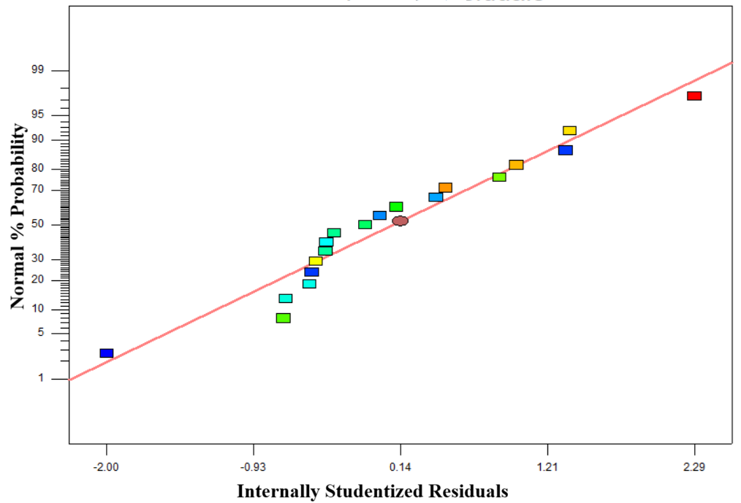
Figure 1. Normal plot of residuals
3.2.1 Factors affecting the yield of biodiesel obtained from the transesterification of rubber seed oil
3.2.1.1 Investigating the effect of temperature on the biodiesel yield
(A). Effect of single factors on the biodiesel yield
The effect of temperature, time and methanol-to-oil ratio on the biodiesel yield were investigated using Equation 3. The temperature was varied at 30, 45 and 60 ºC while maintaining time (75 min), catalyst loading (0.5 g), and methanol-to-oil ratio (4/1) constant. The result obtained is presented in Figure 2 (i), and it shows a linear proportionality between temperature and biodiesel yields. The minimum and maximum biodiesel yields were 57.7 % and 76.6 % obtained at 30 ºC and 60 ºC, respectively. Dhawane (2016) also obtained a maximum biodiesel yield of 90.61 % at 60 ºC. The increase in biodiesel yield at 60 ºC may be attributed to increase in the rate of reaction, and the temperature helps to maintain the methanol-to-oil ratio constant refluxing at a minimum loss by evaporation (Dhawane, 2016)
The effect of reaction time was investigated at 30, 75 and 120 min using Equation 3, while maintaining the temperature (45 ºC), and methanol-to-oil ratio and catalyst loading of 0.5 g constant. The result obtained is presented in Figure 2 (ii), and it shows that the maximum and minimum biodiesel yields of 54.7 % and 76.6 % were obtained after 30 min and 75 min, respectively. However, as the reaction time progressed to 120 min, the biodiesel yield declined to 66.1 %. This decrease in biodiesel yield may be due to the reversible reaction which promotes the backward reaction, and soap formation after a prolong period of time (Demirbas et al., 2009).
The effect of methanol-to-oil ratio on biodiesel yield was assessed using 2:1, 4:1 and 6:1 (g/g) and Equation 3 at constant temperature (45 ºC), reaction time (75 min) and catalyst loading (0.5 %). The result obtained is presented in Figure 2 (iii), and it shows that the maximum biodiesel yield of 67.0 % and minimum of 58.2 % were obtained using 4:1 and 6:1 (g/g), respectively. The lower biodiesel yield obtained using a high methanol-to-oil ratio (6:1) may be due to the increase in the polarity of the reaction mixture leading to the increase in the solubility of glycerol back into the ester product causing a shift to the backward reaction (Ayetor et al. (2015).
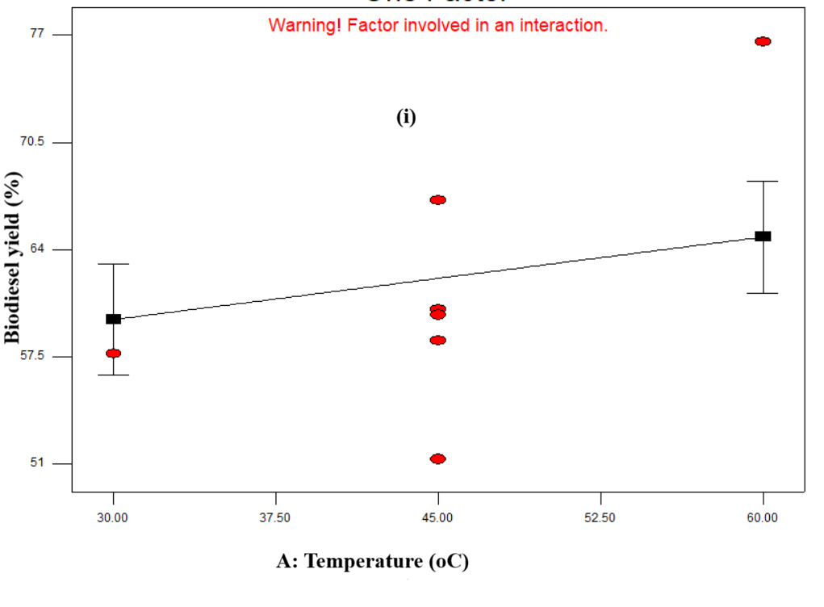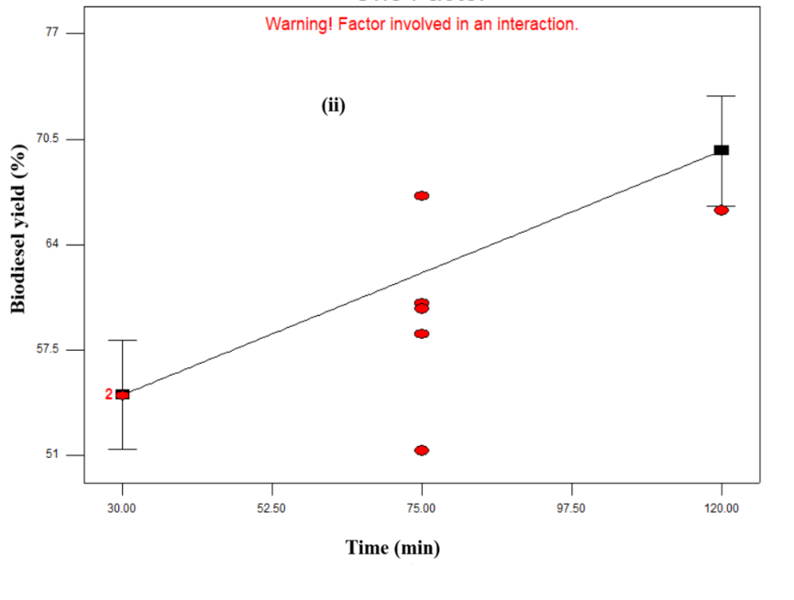
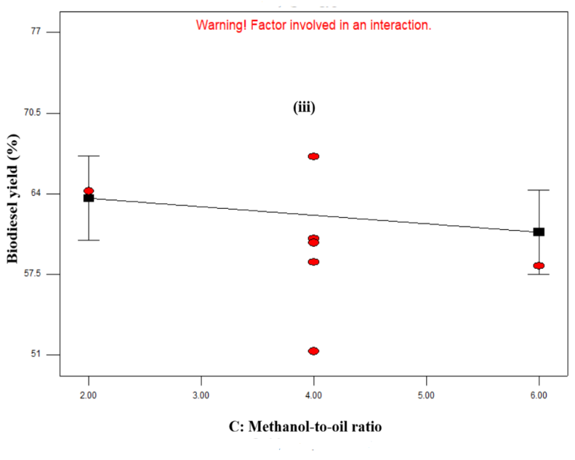

Figure 2: Effect of single factors on the biodiesel yield ((i) effect of temperature; (ii) effect of time; and (iii) effect of methanol-to-oil ratio)

(B). Effect of interaction of factors on the biodiesel yield
(1). Investigating the interaction effect of temperature and reaction time on the biodiesel yield
This was assessed using Equation 3, at the varied operating parameters of temperature (30, 45, 60 ºC) and reaction time (30, 75, 120 min) at constant methanol-to-oil ratio (4:1, g/g) and catalyst loading (0.5 g). The Central Composite Design(CCD) response surface model graph obtained is presented in Figure 3. The result show that the interaction of temperature (30 ºC) and reaction time (30 min) resulted to the highest biodiesel yield of 76.6 % at constant methanol-to-oil ratio (4:1, g/g) and catalyst loading (0.5 g). Comparing this result with the biodiesel yields obtained from single effect of the parameters temperature (30 ºC), and reaction time (30 min) which were 57.5 % and 54.75 %, respectively showed that the interaction of temperature and time had a positive effect on the biodiesel yield.
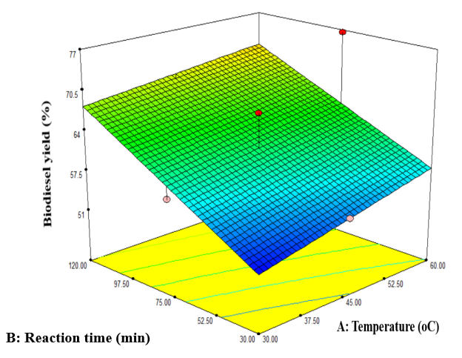
Figure 3. Illustrating the interaction effect of temperature and reaction time on biodiesel yield from the transesterification of rubber seed oil at constant methanol-to-oil ratio (4:1, g/g) and catalyst loading (0.5 g)
The effect of methanol-to-oil ratio and temperature on the biodiesel yield was determined using Equation 2 at the varied operating conditions of methanol-to-oil ratio (2:1, 4:1, 6:1, g/g) and temperature (30, 45, 60 ºC) at constant reaction time of 75 min and catalyst loading of 0.5 g. The CCD response surface 3D model graph obtained is presented in Figure 4. The result showed that the interaction of methanol-to-oil ratio and temperature contributed to the increase in biodiesel yield from 51.3 - 76.6.
(3). Investigating the interaction effect of methanol-to-oil ratio and reaction time on the biodiesel yield
This was investigated using Equation 3, at the varied operating parameters of methanol-to-oil ratio (2:1, 4:1, 6:1, g/g) and reaction time (30, 75, 120 min) at constant temperature (45 ºC) and
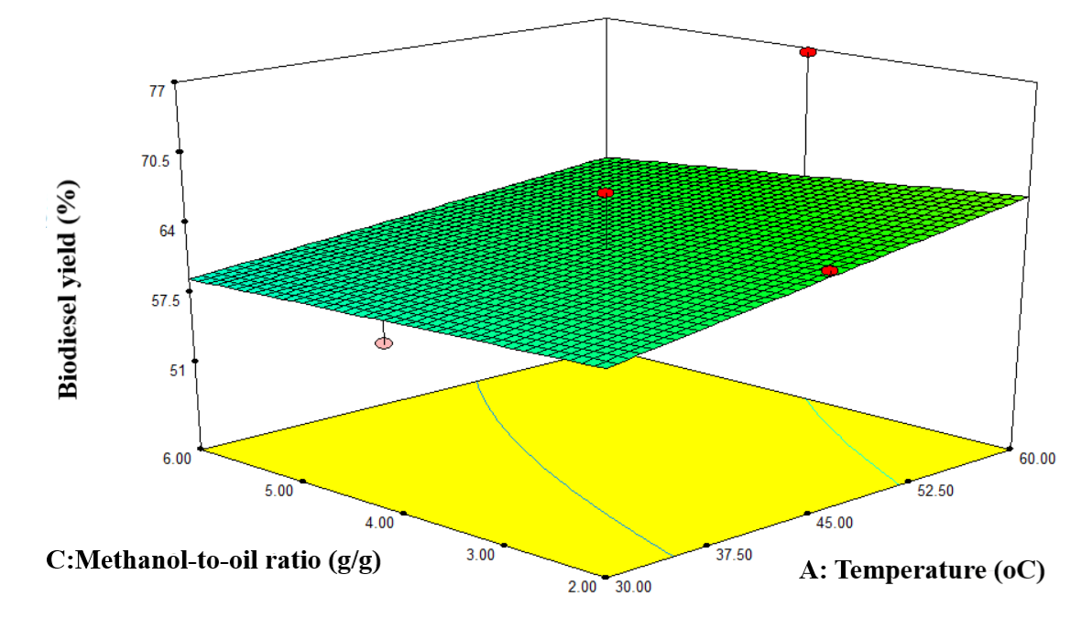
Figure 4. Illustrating the interaction effect of methanol-to-oil and temperature on biodiesel yield from the transesterification of rubber seed oil at constant reaction time (75 min) and catalyst loading (0.5 g)
catalyst loading (0.5 g). The CCD response surface model graph obtained is presented in Figure 5. The result show that the interaction of methanol-to-oil ratio (2:1, g/g) and reaction time (30 min) resulted to the highest biodiesel yield of 67 % at constant temperature (45 ºC) and catalyst loading (0.5 g).
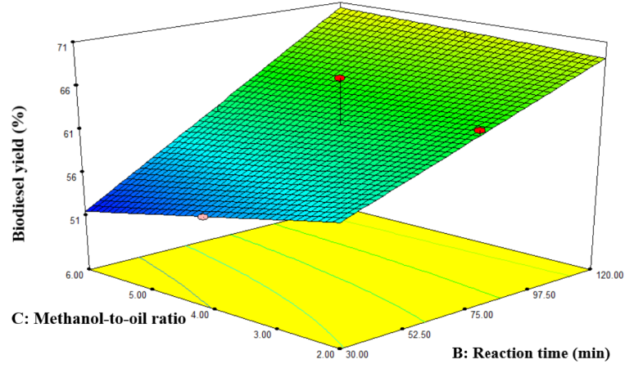

Figure 5. Illustrating the interaction effect of methanol-to-oil ratio and temperature on biodiesel yield from the transesterification of rubber seed oil at constant temperature of (45 ºC) and catalyst loading (0.5 g)
3.3 Analysis of the biodiesel produced from the transesterification of rubber seed oil (based US and EU biodiesel specifications)
(A) The physicochemical properties of biodiesel
The properties were analysed to determine the suitability of the biodiesel produced from the transesterification of rubber seed oil as fuel for automobile engines. The method used had been presented earlier in section 2. The results obtained are presented in Table 5.
Table 5. The physicochemical properties of biodiesel obtained from the transesterification of rubber seed oil
S/N | Property | ASTM D975-08a | ASTM | EN 590:2004 | EN 14214:2012 | Biodiesel from the current work | Biodiesel property from literature | Ref.
1. | Refractive Index |  |  |  |  | 1.446
2. | Density (g/m³) |  | 860-900 |  |  | 848.4 | 860 ±0.015 | Karmakar et al. (2022)
3. | Specific gravity |  | 0.86 - 0.9 (at 40 ºC) |  |  | 0.8675 | 0.8705 | Reshad et al. (2015)
4. | Viscosity at 40 ºC(mm²/s) |  | 1.9 - 6.0 |  |  | 2.030 | 3.82 | Adam et al. (2017)
5. | Kinematic viscosity (mm²/s) | 1.3 - 2.4 | 1.9 - 6.0 | 2.0 - 4.5 | 3.5 - 5.0 | 1.722 | 3.89 | Ahmed et al. (2014)
6. | Acid value (mg KOH/g) |  | 0.5 | 0.5 | 0.5 | 1.604 | 0.58 ±0.01 | Karmakar et al. (2022)
7. | Free fatty acid (%) |  |  |  |  | 0.802
8. | Flash point, min (ºC) | 38 |  | 55 | 101 | 89.4 | 136 ±1.25 | Karmakar et al. (2022)
9. | Pour Point (ºC) |  |  | -15 to -5 |  | -3.8 | -3  -1.3 | Reshad et al. (2015)  Adam et al. (2017)
10. | Cloud Point (ºC) |  |  | -35 to -15 |  | -5.2 | 3.2 | Ahmed et al. (2014)
11. | Calorific value (MJ/kg) |  | 35 min |  |  | 40.1042 | 39.53 | Reshad et al. (2015)
12. | Cetane number |  | 47 min |  |  | 46.9 | 49.8 ±0.3 | Karmakar et al. (2022)

(i). Flash Point
The flash point of a substance, such as biodiesel, refers to the lowest temperature at which its vapors can ignite when exposed to an external ignition source (Kaisan et al., 2020). It serves as a crucial safety parameter, delineating the temperature threshold below which the substance's vapors can readily ignite, posing potential fire hazards. Complying with specified flash point standards is paramount to ensure safe handling, storage, and transportation (Kaisan et al., 2020; Fu, 2019). The ASTM D975-08a standard stipulates a minimum flash point of 38°C for No. 1 diesel, establishing a baseline for safe operation within the fuel industry. From Table 5, the flash point of the biodiesel obtained from this work was 89.4 ºC which is greater than the minimum of 38 ºC prescribed in the ASTM standard. This shows that the biodiesel may not undergo spontaneous combustion or ignition in the presence of potential ignition sources. Such elevated flash points are often associated with improved thermal stability and resistance to ignition, mitigating the risk of accidents or fire incidents during fuel storage, handling, or transportation.
(ii). Density
Density plays a crucial role in various aspects of fuel production, storage, and utilization, influencing factors such as transportation efficiency, volumetric blending, and overall fuel performance (Hidayat et al., 2023; Wahyudi et al., 2023). In accordance with ASTM standards, biodiesel must adhere to a prescribed density range of 860-900 g/m³ to meet regulatory requirements and ensure consistency in quality and performance. From Table 5, the density of the biodiesel produced was 848.4 g/m³ which is within the ASTM specification. The compliance of the density with the ASTM standard underscores the suitability of the biodiesel as a fuel, ensuring compatibility with existing infrastructure and operational requirements within the biodiesel industry.
(iii). Kinematic Viscosity
Kinematic viscosity serves as a crucial parameter in assessing the fluidity and flow characteristics of biodiesel fuels, offering insights into their performance and suitability for various applications. According to ASTM D6751-12 standards, biodiesel fuels are required to exhibit a kinematic viscosity within the specified range of 1.9-6.0 mm²/s to ensure optimal flow properties and compatibility with existing fuel systems. As shown in Table 5, the biodiesel produced had a kinematic viscosity of 1.722 mm²/s. This result is within the ASTM specification and better than the 3.89 mm²/s presented by Ahmed et al. (2014). This shows that the biodiesel will flow smoothly into the combustion chamber of the engine, thereby increasing the combustion efficiency and engine lubrication (Suardi et al., 2023)
(iv). Acid Value
The acid value parameter serves as a critical indicator of the concentration of free fatty acids within biodiesel, offering insights into its stability and potential corrosive properties. Defined as the quantity of potassium hydroxide (KOH) required to neutralize the acidic components present in the biodiesel sample, the acid value is a key determinant of fuel quality and performance (Rajesh et al., 2023). In accordance with the EN 14104 standard, biodiesel fuels are required to maintain an acid value below the specified threshold of 0.50 mg KOH/g to ensure adequate stability and minimize corrosive tendencies. As shown in Table 5, the acid value obtained was 1.604 mg KOH/g, and this exceeds the maximum limit, indicating elevated levels of free fatty acids beyond the permissible range. Comparing this with the 0.5 ± 0.01mg KOH/g reported by Karmakar et al. (2022), still shows a higher value. The disparity maybe due to the difference in the method of production used. However, Excessive levels of free fatty acids can compromise fuel stability, promote corrosion within engine components, and adversely affect engine performance and longevity. Therefore, the biodiesel produced in this work may require further treatment prior to application as fuel in an automobile engine.
(v). Pour and Cloud Points
Pour and Cloud Points are crucial parameters that determine the cold-weather operability of biodiesel fuels. The pour point is the lowest temperature at which the biodiesel remains fluid and can flow freely without congealing or forming wax crystals (Yang et al., 2020). On the other hand, the cloud point indicates the temperature at which dissolved components in the biodiesel start to crystallize, leading to the formation of a cloudy appearance (Qubeissi et al., 2023). As shown in Table 5, the pour and cloud points obtained from this work were -3.8 ºC and -5.2 ºC, respectively. Comparing these with the pour point (-15 to -5 ºC), and cloud point (-35 to -15ºC), respectively, prescribed in EN 590:2004 shows that those obtained in this work is within the acceptable limit. This compliance indicates that even under extremely cold conditions, the biodiesel produced would maintain their fluidity and clarity, ensuring smooth handling and performance in low-temperature environments.
(vi). Cetane number
This shows the time lag between fuel injection into the combustion engine chamber and starting the ignition. The cetane number indicates a fuel's ignition quality, with higher values corresponding to shorter ignition delays and more complete combustion (Ahmad et al., 2021). As shown in Table 5, the cetane number of the biodiesel produced was 47 which corresponds to the minimum value of ASTM specification, and slightly below 49.8 ±0.3 obtained by Karmakar et al. (2022). This shows that the biodiesel has the capacity of self-ignition when put into the combustion, but that produced Karmakar et al. (2022) will burn faster.
(vii). Calorific or heating value
This shows the amount of heat released when a unit mass of fuel is burned, and a higher calorific value is desired for internal combustion engines to perform efficiently. As shown in Table 5, the calorific value of the biodiesel produced was 40.10. Comparing this with a minimum of 35 prescribed by the ASTM shows that the biodiesel has acceptable calorific value. The result is slightly greater than 39.53 reported by Reshad et al. (2015). This shows that the biodiesel has the capacity to enhance the performance of the engine.
(B). Determining the fatty ester composition of the biodiesel obtained from the tranesterification of rubber oil
The biodiesel was obtained from the tranesterification of rubber seed oil at temperature (60 ºC), time (75 min), catalyst loading (0.5 g) and methanol-to-ratio (4:1, g/g), and analysed using Agilent-Technologies 6890N Network GC system equipped with an Agilent-Technologies 5975 inert XL Mass selective detector and an Agilent-Technologies 7683B series auto injector. The method had been described in section 2. The results obtained are presented in Table 6, and it shows that methyl tetradecanoate, Hexadecanoic acid, methyl ester, 8-Octadecenoic acid, methyl ester, 9-Octadecenoic acid, methyl ester, (E)-, (E)-11-Octadecenoic acid, methyl ester, and Methyl stearate are the predominant methyl ester in the biodiesel produced. The presence of these esters in the biodiesel indicate that the fuel contains the following fatty acids oleic, palmitic, stearic, myristic, margaric, and lauric acids, respectively. The mixture of monounsaturated fatty acid like oleic acid, and saturated fatty acids which is dominant in the biodiesel produced show that the fuel has a good property required for enhancing engines performance.

Table 6. Compounds identified from the analysis of biodiesel obtained from the tranesterification of rubber seed oil at temperature (60 ºC), time (75 min), catalyst loading (0.5 g) and methanol-to-ratio (4:1, g/g)
S/N | Systemic Name | Trivial Name | Composition % Area
1. | Methyl tetradecanoate | Methyl tetradecanoate | 99
2. | Hexadecanoic acid, methyl ester | Hexadecanoic acid, methyl ester | 99
3. | 8-Octadecenoic acid, methyl ester | 8-Octadecenoic acid, methyl ester | 99
4. |  | 9-Octadecenoic acid, methyl ester, (E)- | 99
5. |  | (E)-11-Octadecenoic acid, methyl ester | 99
6. |  | Methyl stearate | 99
7. | Dodecanoic acid, methyl ester | Dodecanoic acid, methyl ester | 98
8. |  | Methyl tetradecanoate | 98
9. |  | Methyl tetradecanoate | 98
10. | Pentadecanoic acid, methyl ester | Pentadecanoic acid, methyl ester | 98
11. |  | Hexadecanoic acid, methyl ester | 98
12. |  | Heptadecanoic acid, methyl ester | 95
13. |  | Dodecane, 2,6,11-trimethyl- | 96
14. | Hexadecane, 2,6,10,14-tetramethyl- | Hexadecane, 2,6,10,14-tetramethyl- | 96

4.Conclusion
The optimization of biodiesel yield from the transesterification of rubber seed oil at varied operating conditions of temperature, reaction time and methanol-to-oil ratio using central composite design in Design Expert software has been studied. The extraction of the rubber seed oil resulted to a yield of 41.05 % which compared well with those from literature, and commercially used vegetable oils such as rapeseed and palm. This shows that rubber seed oil is a potential commercial feedstock for biodiesel production. The optimization of the biodiesel yield resulted to a maximum yield of 76. 6 % at the optimum operating conditions of temperature (60 ºC), reaction time (30 min), catalyst loading (0.5 g), and methanol-to-oil ratio (4:1, g/g). The physicochemical properties of the biodiesel produced such as density (848.4 g/m³), specific gravity (0.8675), viscosity at 40 ºC (2.030), kinematic viscosity (1,722 mm²/s), acid value (1.604 mg KOH/g), free fatty acid (0.802 %), flash point (89.4 ºC), pour point (-3.8 ºC), cloud point (-5.2 ºC), calorific value (40.1042 MJ/kg), and cetane number (46.9), and its fatty acid composition revealed that the fuel possesses the desired properties required for enhancing the performance of engines.

COMPETING INTERESTS DISCLAIMER:
Authors have declared that they have no known competing financial interests OR non-financial interests OR personal relationships that could have appeared to influence the work reported in this paper.

Reference
Ifijen, H.I., Nkwor, A.N. (2020). Selected under-exploited plant oils in nigeria: a correlative study of their physiochemical properties. Tanzania Journal of Science 46(3): 817-827. https://www.ajol.info/index.php/tjs/article/view/201129.
Ifijen, I.H., Bakare, I.O., Obazee, E.O., Ize-Iyamu, O.C., Udokpoh, N.U., Ohifuemen, A.O., Mohammed, F.U., Fagbemi, E. A., Ayeke, P.O. (2023). Utilization of plant oil based-fatliquor in the processing of leather. The Minerals, Metals & Materials Society (eds)
Nkwor, A.N., Ukoha, P.O., Ifijen, H.I. (2021). Synthesis of sulfonated sesamum indicum L. seed oil and its application as a fatliquor in leather processing. Journal of Leather Science and Engineering 3(16): 1-13. DOI: https://doi.org/10.1186/s42825-021-00053-4.
Ifijen, I.H., Ikhuoria, E.U., Omorogbe, S.O., Agbonlahor, O.G. (2018). Comparative studies on the use of palm kernel and coconut oil as biodiesel fuel sources. International Journal of Green Chemistry 4(1): 19-24.
Kumar, Y., Das, L., Biswas, K.G. (2022). Biodiesel: Features, potential hurdles, and future direction. In: Joshi, J., Sen, R., Sharma, A., Salam, P.A. (eds) Status and Future
Challenges for Non-conventional Energy Sources 2. Clean Energy Production Technologies. Springer, Singapore. https://doi.org/10.1007/978-981-16-4509-9_5.
Brahma, S., Nath, B., Basumatary, B., Dasc, B., Saikia, P., Patire, K., Basumatary, S. (2022). Biodiesel production from mixed oils: A sustainable approach towards industrial biofuel production. Chemical Engineering Journal Advances. 10: 10:100284. DOI: https://doi.org/10.1016/j.ceja.2022.100284.

Atabani A.E., Silitonga, A.S., Ong, H.C., Mahlia, T.M. I., Masjuki, H.H., Badruddin, I.A., Fayaz, H. (2013). Non-edible vegetable oils: A critical evaluation of oil extraction, fatty acid compositions, biodiesel production, characteristics, engine performance and emissions production. Renewable and Sustainable Energy Reviews. Elsevier 18(C): 211-24518:
211-245. DOI: 10.1016/j.rser.2012.10.013.
Ramadhas, A.S., Muraleedharan, C., Jayaraj, S. (2005). Performance and emission evaluation of a diesel engine fueled with methyl esters of rubber seed oil. Renewable Energy 30: 1789–1800. DOI: https://doi.org/10.1016/j.renene.2005.01.009.
Ramos, M., Dias, A.P.S., Puna, J.F., Gomes, J., Bordado, J.C. (2019). Biodiesel production processes and sustainable raw materials. Energies 12: 4408. DOI: https://doi.org/10.3390/en12234408.
Ifijen I.H., Nyaknno U.U., Onaiwu G.E., Jonathan, E.M. (2022). Coating properties of alkyd resin, epoxy resins and polyurethane based nanocomposites: A review. Momona Ethiopian Journal of Science 14:1-31. DOI: http://dx.doi.org/10.4314/mejs.v14i1.1.
Ogbiede, O.K., Omorotionmwan, E.A., Igenumah, O.D., I.H., Ifijen, Akhigbe, I.U. (2022). Comparative analysis on physicochemical properties and chemical composition of coconut and palm kernel oils. ChemSearch Journal 13(1): 70-75.
Otabor, G.O., Ifijen, I.H., Mohammed, F.U., Aigbodion, A.I., Ikhuoria, E.U. (2019). Alkyd resin from rubber seed oil/linseed oil blend: a comparative study of the blend properties. Heliyon 5(5): e01621. DOI: https://doi.org/10.1016/j.heliyon.2019.e01621.
Islam, A. K. M. A., Yaakob, S. R. P. P. Z. (2018). Non-edible vegetable oils as renewable resources for biodiesel production: South-East Asia Perspective. In M. Nageswara-Rao, & J. R. Soneji (Eds.), Advances in Biofuels and Bioenergy. https://doi.org/10.5772/intechopen.73304.
Demirbas, A., Bafail, A., Ahmad, W., Sheikh, M. (2016). Biodiesel production from non-edible plant oils. Energy Exploration & Exploitation. 34(2): 290-318. DOI:10.1177/0144598716630166.
Maliki, M., Ifijen, I.H. (2020) Extraction and characterization of rubber seed oil. International Journal of Scientific Engineering Science 4(6): 24-27.
Nkwor, A.N., Ukoha, P.O., Ifijen, H.I., Ikhuoria, E.U. (2020). The use of sulfonated jatropha curcas oil for the processing of mechanically improved leather. Chemistry Africa 3: 911–925. DOI: https://doi.org/10.1007/s42250-020-00189-6.
Manisalidis, I., Stavropoulou, E., Stavropoulos, A., Bezirtzoglou, E. (2020). Environmental and Health Impacts of Air Pollution: A Review. Frontiers in Public Health 8:14. DOI: 10.3389/fpubh.2020.00014.
Onaifo, J. O., Ikhuoria, E. U., Omorogbe, S. O., Agbonlahor, O. G., Ifijen, I. H. (2016). Coconut pit is an alternative source of producing renewable material (bioethanol). Journal of Applied Chemical Science International 6(2): 80-84. https://www.ikprress.org/index.php/JACSI/article/view/3944.
Onaifo, J.O., Ikhuoria, E.U., Ifijen, I.H., Abdullahi, S.M. (2022). Co-pyrolysis of soursop (Annona muricata) and mango (Mangifera indica) seeds: A Route to High-Quality
Bio-oil. Chemistry Africa. https://doi.org/10.1007/s42250-022-00536-9.

Olugbemide, A.D., Labunmi, L., Ifijen, I.H., Ogungbemide, D.I. (2020) Corn stover as substrate for bioenergy generation and precursor for biosilica production via anaerobic digestion. Tanzania Journal of Science 46(3): 807-816. https://www.ajol.info/index.php/tjs/article/view/201126.
Iyayi, A.F., Akpaka, P.O., Ukpeoyibo, U. (2008). Rubber seed processing for value-added latex production in Nigeria. African Journal of Agriculture Research 3(7): 505–9.
Lestari, A., Yerizam, M., & Hasan, A. (2023). Characterization of Rubber Seed (Hevea Brasiliensis) as Raw Material to Produce Biofuel. Journal of Applied Agricultural Science and Technology. https://doi.org/10.55043/jaast.v7i3.140.
Bokhari, A., Yusup S., Faridi, J.A., Kamil, R.N.M. (2014). Blending study of palm oil methyl esters with rubber seed oil methyl esters to improve biodiesel blending properties. Chemical Engineering Transactions 37: 571-576. DOI: 10.3303/CET1437096.
Edeh, I. (2020). Biodiesel Production as a Renewable Resource for the Potential Displacement of the Petroleum Diesel. IntechOpen. Pp 1-37
Lakshmi, S. B. A. V. S., Pillai, N. S., Mohamed, M. S. B. K., Narayanan, A. (2020). Biodiesel production with Al2O3 as heterogeneous catalyst: A comparative study of RSM and ANN optimization. Brazilian Journal of CHemical Engineering, 37:351-368, https://doi.org/10.1007/s43153-020-00027-9
Jilse, S., Chandrasekharan, M., Arockiasamy, S. (2016). A comparative study between chemical and enzymatic transesterification of high free fatty acid contained rubber seed oil for biodiesel production.Cogent Eng 3:1178370
Trirahayu, D.A., Abidin, A.Z., Putra, R.P., Hidayat, A.S., Safitri, E., Perdana, M.I. (2022). Process simulation and design considerations for biodiesel production from
rubber seed oil. Fuels 3: 563–579. DOI: https://doi.org/10.3390/ fuels3040034.
Dhawan, M., & Yadav, G. (2017). Insight into a catalytic process for simultaneous production of biodiesel and glycerol carbonate from triglycerides. Catalysis Today. https://doi.org/10.1016/J.CATTOD.2017.08.020.
Demirbas, A. (2009). Comparison of transesterification methods for production of biodiesel from vegetable oils and fats. Energy conversion and management 49(1): 125-130. DOI: https://doi.org/10.1016/j.enconman.2007.05.002.
Ayetor, G. K., Sunnu, A., Parbey, J. (2015). Effect of biodiesel production parameters on viscosity and yield of methyl esters: Jatropha Curcas, Elaeis guineensis and Cocos nucifera. Alexandria Engineering Journal, 54:1285-1280
Karmakar, B., Lalthazuala Rokhum, S., Halder, G. (2022). Injecting superheated C1 and C3 alcohol supports towards non-catalytic semi-continuous conversion of Hevea brasiliensis oil into biodiesel. Fuel 314, 122777
Reshad, A.S., Barman, P., Chaudhari, A.J., Tiwari, P., Kulkarni, V., Goud, V.V., Sahoo, N. (2015). Rubber seed oil methyl ester synthesis, engine performance, and emission characteristics of blends. Energy Fuel. 29 (8), 5136–5144.
Adam, I.K., Aziz, A.R.A., Heikal, M.R., Yusup, S. (2017). Performance and emission analysis of rubber seed methyl ester and antioxidant in a Multicylinder diesel engine. Energy Fuel. 31 (4), 4424–4435.
Ahmad, J., Yusup, S., Bokhari, A., Kamil, R.N.M. (2014). Study of fuel properties of rubberseed oil based biodiesel. Energy Convers. Manag. 78, 266–275.
Reshad, A.S., Barman, P., Chaudhari, A.J., Tiwari, P., Kulkarni, V., Goud, V.V., Sahoo, N. (2015). Rubber seed oil methyl ester synthesis, engine performance, and emission characteristics of blends. Energy Fuel. 29 (8), 5136–5144.
Adam, I.K., Abdul A.A.R., Heikal, M.R., Yusup, S., Firmansyah, Ahmad, A.S., Abidin, Z.E.Z. (2017). Performance and Emission Analysis of Rubber Seed, Palm, and Their
Combined Blend in a Multi-Cylinder Diesel Engine. Energies 11: 1522. DOI: https://doi.org/10.3390/en11061522.
Kaisan, M., Anafi, F., Nuszkowski, J., Kulla, D., & Umaru, S. (2020). Calorific value, flash point and cetane number of biodiesel from cotton, jatropha and neem binary and multi-blends with diesel. Biofuels, 11, 321 - 327. https://doi.org/10.1080/17597269.2017.1358944.
Fu, J. (2019). Flash points measurements and prediction of biofuels and biofuel blends with aromatic fluids. Fuel. https://doi.org/10.1016/J.FUEL.2018.12.105.
Hidayat, J., Sugiarto, B., Anggarani, R., Aisyah, L., Fathurrahman, N., Yogi, P., Riza, F., Hasfi, N., &, U. (2023). Evaluation of Quality of Biodiesel and Diesel Fuel with High Ratio Blends. IOP Conference Series: Earth and Environmental Science, 1187. https://doi.org/10.1088/1755- 1315/1187/1/012018.
Wahyudi, W., Nadjib, M., & Apriyanto, A. (2023). Correlation between Physical Properties and Specific Fuel Consumption in Jatropha -Used Cooking Oil Biodiesel Mixtures. Semesta Teknika. https://doi.org/10.18196/st.v26i2.20163.
Ahmad, J., Yusup, S., Bokhari, A., Ruzaimah, N.M.K. (2014). Study of fuel properties of rubbe seed oil-based biodiesel. Energy Conversion and Management. 78: 266-275, DOI: 10.1016/j.enconman.2013.10.056.
Rajesh, K., Sathiyamoorthi, R., Senthil, S., Murugapoopathi, S., & Damodharan, D. (2023). Analysis of performance and emission patterns of novel biofuel feedstock neat coconut fatty acid distillate (CFAD) fuelled single‐cylinder diesel engine. Heat Transfer, 52, 3732 - 3757. https://doi.org/10.1002/htj.22849.
Yang, T., Yin, S., Xie, M., Chen, F., Su, B., Lin, H., Xue, Y., & Han, S. (2020). Effects of N-containing pour point depressants on the cold flow properties of diesel fuel. Fuel, 272, 117666. https://doi.org/10.1016/j.fuel.2020.117666.
Qubeissi, M., Mahmoud, A., Al-Damook, M., Almshahy, A., Khatir, Z., Soyhan, H., & Shah, R. (2023). Comparative Analysis of Battery Thermal Management System Using Biodiesel Fuels. Energies. https://doi.org/10.3390/en16010565.
Ahmad, Z., Kaario, O., Qiang, C., & Larmi, M. (2021). Effect of pilot fuel properties on lean dual-fuel combustion and emission characteristics in a heavy-duty engine. Applied Energy. https://doi.org/10.1016/j.apenergy.2020.116134.

