Design and Fabrication of a Low-Cost Mechanical Deseeding Machine for Moringa (Moringa oleifera) Pods

Abstract:
Moringa (Moringa oleifera) is a highly nutritious and economically important crop widely cultivated for its pods, leaves, and seeds. The seeds are valuable for oil extraction, medicinal applications, and water purification purposes. However, deseeding of mature moringa pods is predominantly carried out manually, which is labor-intensive, time-consuming, and inefficient, particularly for small and marginal farmers engaged in value-added processing. To address this limitation, the present study focuses on the design and fabrication of a low-cost mechanical deseeding machine for moringa pods that enhances productivity while minimizing seed damage and operational cost. The machine is designed using locally available materials and simple mechanical components to ensure affordability and ease of maintenance. The working mechanism consists of a feeding hopper, crushing or splitting roller assembly, separation chamber, and seed collection unit. The design parameters were optimized based on pod dimensions, moisture content, and seed-to-pod ratio to achieve efficient splitting without damaging the seeds. The fabricated prototype operates either manually or with a low-power electric motor, making it suitable for rural and small-scale processing units. Performance evaluation of the machine includes parameters such as deseeding efficiency, seed recovery percentage, throughput capacity, seed damage rate, and operational cost. Preliminary trials indicate improved efficiency and significant reduction in labor requirement compared to traditional manual methods. The developed system aims to promote small-scale moringa processing enterprises, support farmer-producer org, & 6,anizations, and enhance value addition in moringa cultivation. The proposed machine contributes toward sustainable agricultural mechanization by providing an economical and user-friendly solution for post-harvest processing of moringa pods.
Keywords: Mechanical deseeding machine; Post-harvest processing; Seed recovery efficiency; Low-cost agricultural machinery; Value addition; Rural mechanization;
Introduction
Moringa oleifera, commonly known as drumstick tree or horseradish tree, is a multipurpose drought-resistant perennial crop native to India, valued for its nutrient-rich leaves, pods, and seeds. The tree's pods serve as a vital vegetable source, while seeds yield edible oil and bioactive compounds with applications in pharmaceuticals, nutraceuticals, and water purification. Globally, Moringa supports food security and rural livelihoods, but its commercial potential remains underexploited due to labor-intensive post-harvest processing, particularly deseeding (Abouegela et al., 2007). In India, Moringa cultivation spans about 52,000 hectares with an annual production exceeding 1.2 lakh metric tonnes (MT) as of 2023-24, positioning the country as the world's leading producer (National Horticulture Board, 2025). Tamil Nadu leads domestic production, accounting for over 40% of India's area under Moringa—approximately 21,000 hectares—yielding around 50,000 MT annually at a productivity of 2.4 MT per hectare (ananomyos , 2024). Districts like Tirunelveli, Thoothukudi, and Salem dominate, driven by favorable agro-climatic conditions and export demand for pods and seeds (Ali et al., 2019). Despite this, productivity lags behind potential (up to 4-5 MT/ha with improved practices) due to manual deseeding, which accounts for 30-40% of labor costs and leads to seed damage, reduced yields, and post-harvest losses of 15-20%. Traditional deseeding relies on manual splitting and extraction, a tedious process prone to inconsistencies and inefficiency, especially for smallholder farmers in Tamil Nadu who cultivate 70% of the crop on fragmented holdings. Existing mechanical deseeders, often imported or high-end models, cost over Rs.2-5 lakhs, rendering them inaccessible for resource-constrained producers. This study addresses these gaps by designing and fabricating a low-cost mechanical deseeding machine tailored for Moringa pods, emphasizing affordability (under Rs.50,000/-), ease of operation, and minimal seed damage. By enhancing processing efficiency, the innovation aims to boost farmer incomes, reduce drudgery, and support sustainable scaling of Moringa value chains in Tamil Nadu and beyond (Dudhal et al., 2023).
Review of Literature
Moringa oleifera has attracted considerable attention because of its nutritional, medicinal, and economic value, especially its pods and seeds, which are widely used as vegetables and for oil extraction. In post-harvest processing, however, the separation of seeds from pods remains a major bottleneck because the operation is still largely manual in many producing regions (Gupta and Bisht, 2020). Studies on moringa depodding and shelling consistently show that mechanization can reduce drudgery, improve throughput, and support commercial-scale seed processing. Earlier work focused on developing basic moringa seed shelling machines using locally available materials. A locally fabricated shelling machine could be useful for rural farmers and small-scale processors because its operating principle and cost were within their technical capability (Pande et al., 2018). Such studies established that simple machine concepts, if properly designed, can reduce dependence on hand shelling and improve post-harvest efficiency. They also highlighted the importance of using affordable fabrication materials for adoption in smallholder farming systems.The moringa depodding machinewas developed and evaluated its performance using response surface methodology (Shaik et al., 2016). Their study examined process variables such as moisture content and rotational speed and showed that these parameters strongly influence depodding efficiency, coefficient of wholeness, throughput capacity, and kernel breakage. The authors found that higher speed combined with lower moisture content improved depodding efficiency, with reported values around 93–94%, demonstrating that proper operating conditions are critical for effective machine performance. This work is important because it moved moringa processing research beyond basic fabrication and into optimization of operating parameters (Sinha et al., 2011). Other researchers have similarly emphasized that speed of rotation and moisture conditioning affect shelling or dehulling quality. Studies on moringa seed shelling machines reported that certain speeds produced smoother operation and better shelling performance, while excessively high speeds increased breakage and reduced quality. This shows that a successful design must balance shelling effectiveness with seed damage control. For a low-cost deseeding machine, this balance is especially important because farmers and small processors will expect the machine to preserve seed quality while remaining economical (Shishin, 2018). The depodding by hand or by hitting bags of pods is time-consuming and laborious, which creates a need for mechanized alternatives. This is particularly relevant in regions where moringa cultivation is expanding and value chains are becoming more commercial. As demand for quality moringa seed and seed-derived products rises, efficient depodding becomes necessary for timely processing and improved marketability (Takawira-Nyakuchena and Mushiri, 2020). From a design perspective, the available studies suggest that simple mechanisms using rollers, drums, shafts, spikes, and locally available power transmission components can achieve useful levels of performance. The conceptual dehulling machine described in later work used a drum, spikes, shafts, pulleys, belts, and bearings, showing that straightforward mechanical arrangements can be adapted for moringa processing. These studies are useful for identifying design elements that are practical for rural fabrication workshops (Zhang and Liu, 2021). Evaluation criteria in the literature commonly include throughput capacity, shelling or depodding efficiency, seed breakage, labour requirement, and cleaning performance. The exact indicators and demonstrated that machine performance can be quantified scientifically rather than judged only by visual observation. Their results showed that the developed machine performed favorably compared with traditional manual methods, confirming the value of mechanized processing. Such performance metrics are important for comparing alternative designs and selecting the best configuration for small-scale adoption. Another recurring theme is cost reduction through local fabrication. Several studies specifically mention that the machine components can be made from materials available in local markets, lowering fabrication cost and making the technology accessible to farmers, cooperatives, and small enterprises (Panda et al., 2025). This is especially significant for India, where moringa production is concentrated among small and medium farmers. A low-cost machine that can be fabricated locally would therefore match the economic conditions of the target users and encourage wider diffusion. In the Indian context, the need for such a machine is amplified by the scale of production in Tamil Nadu, where moringa is a major horticultural crop. Recent reports indicate that Tamil Nadu cultivates moringa on about 20,741 hectares and produces about 841,807 metric tons, making it the leading producing state in India. Earlier studies also noted that Tamil Nadu has long been one of the largest moringa-producing states, with high production concentrated in districts such as Tuticorin, Dindigul, Theni, and Tiruppur (Prisyazhnaya et al., 2020). The large production base creates a strong case for improving post-harvest mechanization, especially for seed recovery and value addition. Research on moringa cultivation in Tamil Nadu has also shown that production and productivity vary widely across districts, suggesting that post-harvest technologies must suit different farm sizes and processing scales (Sarma et al., 2026). Since moringa is grown for both pods and seeds, processing requirements can differ depending on the final use. This means a deseeding machine should be versatile, robust, and simple enough to serve farmers who may process pods seasonally and in relatively small batches. Existing studies provide useful design principles, performance variables, and evidence that mechanical depodding can reduce labour and improve efficiency (Shaik, 2014). However, there remains a need for an affordable, easy-to-operate, low-cost deseeding machine specifically suited to small and medium moringa growers in India, particularly in Tamil Nadu, where production is concentrated and post-harvest losses can be reduced through appropriate mechanization (Prasad et al., 2025).

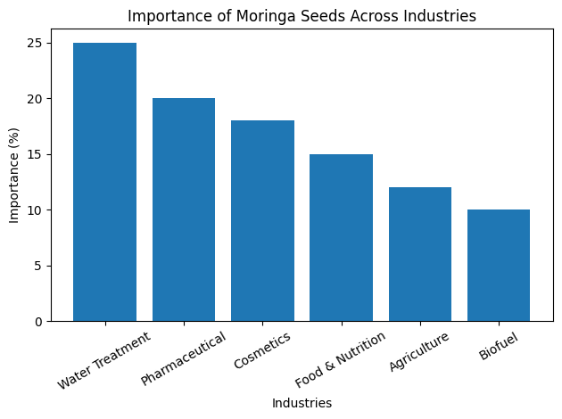
Figure.1. Importance of Moringa Seeds in Various Industries.
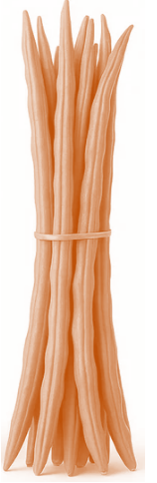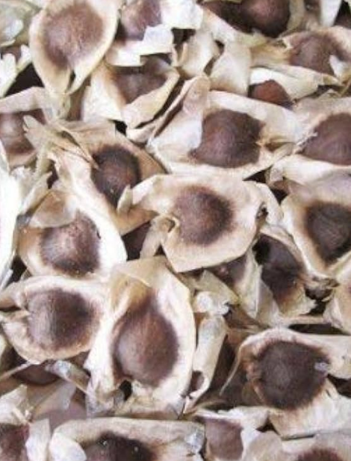
Figure.2. Moringa pods and seeds
Materials and Methods
A prototype moringa (Moringa oleifera) de-seeder machine was designed and fabricated to facilitate efficient separation of seeds from dried pods (Zheng et al., 2024). The machine was developed using locally available materials with emphasis on simplicity, cost-effectiveness, and ease of operation for small and medium-scale users (Gorad and Naik, 2017). The developed machine comprises five major components: frame structure, feeding unit, de-seeding mechanism, power transmission system, and separation unit. The frame was fabricated using mild steel (MS) square sections to ensure structural rigidity and durability. The rectangular frame consists of four vertical supports reinforced with horizontal cross members to minimize vibration during operation. The structure was designed at an ergonomic height to facilitate easy feeding and collection. An inclined trapezoidal hopper made of MS sheet was mounted at the top of the machine. The hopper is inclined at an appropriate angle to enable gravity-assisted feeding of moringa pods into the de-seeding chamber. The feeding rate is manually controlled to ensure uniform loading and to prevent choking. The de-seeding unit consists of a pair of rotating rollers integrated with spur gears. The rollers apply compressive and shear forces to crack the dried moringa pods. The intermeshing gear arrangement ensures synchronized rotation and effective crushing action. The clearance between rollers is adjustable to accommodate variation in pod size and to minimize mechanical damage to seeds. An electric motor is mounted on the frame to drive the de-seeding mechanism. Power is transmitted from the motor to the rollers through a gear drive system. Spur gears were selected for their high efficiency and positive engagement. The system provides the required torque and speed reduction for effective operation. The crushed mixture of seeds and husk falls into the separation chamber located below the rollers. Due to differences in size and weight, seeds are collected through the bottom outlet, while lighter husk material is discharged through a separate inclined outlet. Collection trays are placed at the outlets for easy handling.
Table. 1 Specification of the mornings deeseder machine
S.No. | Component | Specifications
 | Frame material | Mild Steel (MS) square pipe
 | Overall dimensions | 1050 mm (L) × 600 mm (W) × 1100 mm (H)
 | Hopper type | Trapezoidal, MS sheet
 | Hopper capacity | 5–10 kg per batch
 | De-seeding mechanism | Roller/gear-based crushing system
 | Roller material | Mild steel
 | Power source | Electric motor
 | Motor power | 1 HP
 | Transmission system | Spur gear drive
 | Operating speed | 200–400 rpm (adjustable)

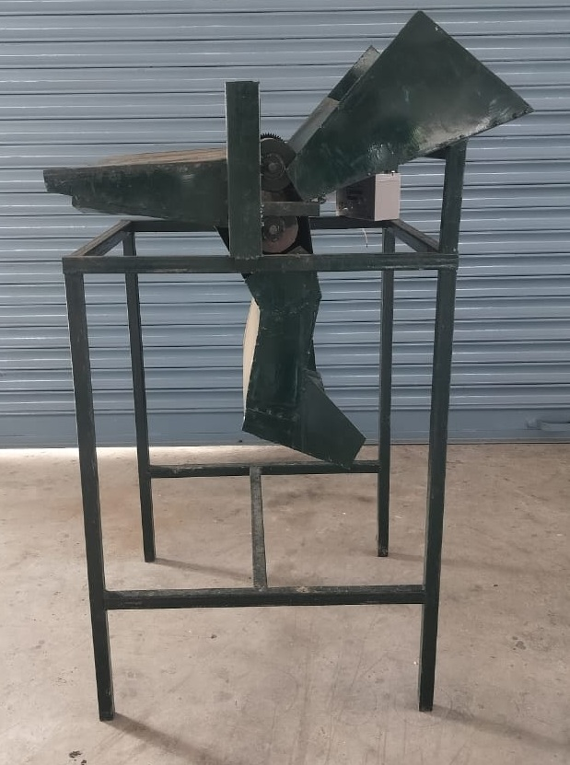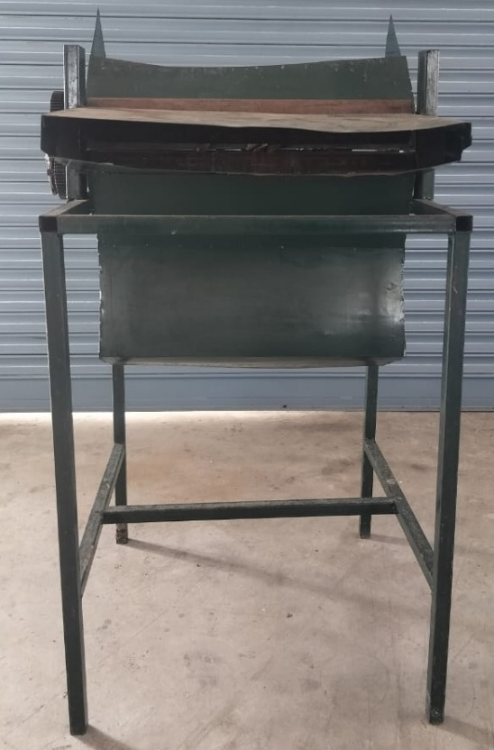
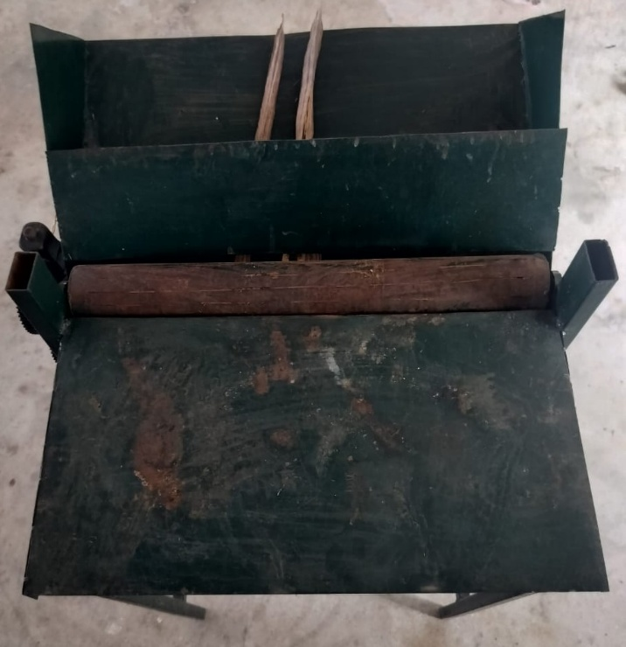

Figure.3. Prototype Moringa Deseeder Machine
(Front view, Side View and Top View)

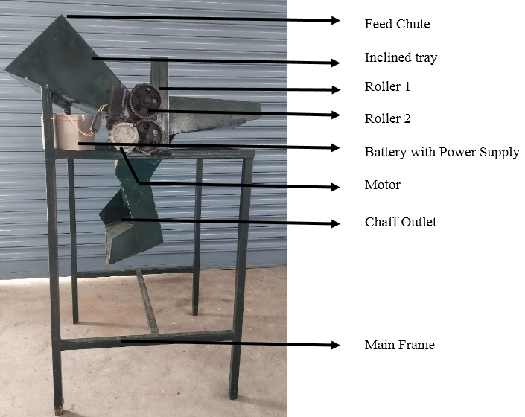
Figure.4. Low-Cost Moringa Deseeder Machine
Results and Discussion
The machine operates on the principle of mechanical compression and shearing. Dried moringa pods are fed through the hopper into the rotating roller mechanism (Ghadi and Arunkumar, 2014). The applied compressive force cracks the pods, releasing the seeds. The mixture then passes into the separation chamber, where seeds and husk are separated based on their physical properties such as size, density, and aerodynamic characteristics. Dried moringa pods were collected and sun-dried to a moisture content suitable for de-seeding (approximately 8–12% wet basis) (Galkin et al., 2018). Pods of uniform size and maturity were selected to ensure consistency during experimentation.
The performance of the developed moringa de-seeder machine was evaluated in terms of output capacity, seed recovery efficiency, seed damage, and overall machine weight (Feroz et al., 2024). The results obtained under typical operating conditions are discussed below. The output capacity of the machine was observed to range between 20 and 30 kg h⁻¹, depending on the condition of the moringa pods. Higher capacities were achieved when well-dried and uniform pods were used, as they were easier to crack and process. In contrast, slightly moist or non-uniform pods resulted in reduced throughput due to incomplete de-seeding and occasional clogging within the roller mechanism. The achieved capacity indicates that the machine is suitable for small- to medium-scale processing applications. The seed recovery efficiency of the machine varied from 85 to 95%. The higher efficiency values were obtained at optimal roller clearance and proper feeding rate. Efficient cracking of pods without excessive crushing contributed to improved separation of seeds from husk. Minor losses were attributed to seeds remaining trapped in partially crushed pods or being carried away with husk material. Overall, the efficiency demonstrates the effectiveness of the roller-based de-seeding mechanism. The percentage of mechanically damaged seeds was found to be less than 5–8%. Seed damage primarily occurred due to excessive compressive force between rollers and improper adjustment of clearance. At optimized operating conditions, the machine maintained acceptable levels of seed integrity, making the seeds suitable for further processing such as oil extraction or planting. The relatively low damage percentage indicates that the machine achieves a balance between effective de-seeding and seed preservation. The total weight of the machine was approximately 40–60 kg, depending on fabrication materials and component thickness. The moderate weight ensures adequate stability during operation while still allowing portability within farm or processing units. The compact and rigid frame design contributed to reduced vibration and improved operational efficiency. The combined performance parameters indicate that the developed moringa de-seeder machine performs efficiently under standard operating conditions. The machine offers a practical solution for reducing manual labor, improving processing speed, and maintaining acceptable seed quality. Variations in performance were mainly influenced by pod moisture content, size uniformity, and operational adjustments such as roller clearance and feed rate.
Conclusion
A moringa de-seeder machine was successfully designed, fabricated, and evaluated for efficient separation of seeds from dried moringa pods. The developed machine, based on a roller and gear-driven mechanism, demonstrated satisfactory performance under typical operating conditions. The machine achieved an output capacity of 20–30 kg h⁻¹, with a seed recovery efficiency of 85–95% and seed damage limited to below 5–8%. These results indicate that the machine effectively balances de-seeding efficiency with seed quality preservation. The moderate machine weight (40–60 kg) and compact design ensure operational stability while maintaining portability, making it suitable for small and medium-scale applications. Performance variations were observed primarily due to differences in pod moisture content, size uniformity, and operational parameters such as feed rate and roller clearance. Proper adjustment of these factors significantly enhances machine efficiency and reduces seed losses. The developed moringa de-seeder machine provides a cost-effective and labor-saving alternative to manual de-seeding methods. It has strong potential for adoption in rural and semi-mechanized processing systems, contributing to increased productivity and value addition in moringa cultivation.
References

- M. A. Abouegela, E. S. M. Khalifa, G. H. El-Sayed, and M. A. Eltawil, “A newly manufactured machine for deseeding of flax crop,” Misr Journal of Agricultural Engineering, vol. 24, no. 4, pp. 725–751, 2007.
- M. Ali, J. Cha, S. J. Park, T. Akhter, G. S. Kim, K. Yang, and H. J. Kim, “Development and performance evaluation of automatic plum seed remover,” Engineering in Agriculture, Environment and Food, vol. 12, no. 2, pp. 250–255, 2019.
- M. A. Dudhal, B. B. Vasant, N. P. Sandip, I. N. Musa, and K. D. Gorakh, “Development of pneumatic operated corn sheller machine,” JournalNX, vol. 10, no. 9, pp. 162–164, 2023.
- Z. Feroz, A. B. Zahoor, R. M. Shukla, R. Richa, M. Muzamil, S. Faisal, and J. Dixit, “Development and performance evaluation of power operated pea depoding machine for small and marginal farmers,” SKUAST Journal of Research, vol. 26, no. 2, pp. 174–184, 2024.
- A.V. Galkin, D. G. Fadeev, and I. V. Ushchapovskii, “Studying quality characteristics of flax fiber depending on deseeding device design,” Vestnik Mordovskogo Universiteta, vol. 28, no. 3, pp. 389–399, 2018.
- A.J. Ghadi and P. Arunkumar, “Design, development and fabrication of a low cost corn deseeding machine,” International Journal of Research in Engineering and Technology, vol. 3, no. 8, pp. 242–248, 2014.
- M. S. Gorad and P. V. R. Naik, “Design and development of corn chaff peeling machine,” International Journal of Advance Engineering and Research Development, vol. 4, no. 3, pp. 538–544, 2017.
- R. Gupta and D. Bisht, “Interventions to reduce drudgery of workers involved in small scale food processing units,” Journal of Community Mobilization and Sustainable Development, vol. 15, no. 3, pp. 555–558, 2020.
- T. C. Panda, M. S. Tomar, V. Bansode, M. Dwivedi, R. C. Pradhan, and D. Seth, “A review of decorticators for various industrial crops: Design, working principle, and parameters affecting the efficiency,” Indian Journal of Agricultural Engineering (IJAE), vol. 5, no. 1, pp. 16–22, 2025.
- H. H. Pande, N. Raj, and J. J. Raut, “Design and manufacturing of corn shelling machine,” International Journal of Innovations in Engineering Research and Technology, pp. 1–4, 2018.
- N. Prasad, S. C. Sharma, S. K. Pandey, and S. Kale, “Postharvest and storage management,” in Natural Gums and Resins: Botany and Sustainable Uses in Medicine, Nutrition, Perfumery and Cosmetics, CABI, pp. 191–216, 2025.
- I. M. Prisyazhnaya, V. T. Sinegovskaya, S. P. Prisyazhnaya, and M. O. Sinegovskii, “Harvester and transporting device development for high-quality soybean seeds obtaining,” in IOP Conference Series: Earth and Environmental Science, vol. 548, no. 6, p. 062078, 2020.
- P. P. Sarma, S. Das, S. Bhattacharjee, M. R. Khan, and R. Devi, “Beneficial effects of Musa balbisiana fruit pulp and Garcinia candy on gut microbiota alterations of aged albino Wistar rats,” PharmaNutrition, p. 100471, 2026.
- N. H. Shaik, “Development and evaluation of multi seated aonla seed removing machine,” M.Tech Thesis, Acharya N.G. Ranga Agricultural University, Bapatla, India, 2014.
- N. H. Shaik, D. B. Rao, B. B. Bhagath, and S. V. Vardhan, “Design and development of multi seated aonla deseeding machine,” Advances in Life Sciences, vol. 5, pp. 8749–8753, 2016.
- D. A. Shishin, “Influence of the deseeding device design on the air flow characteristics in the combing chamber of the flax harvester,” Tractors and Agricultural Machinery, vol. 85, no. 6, pp. 12–16, 2018.
- A.K. Sinha, S. Patel, and A. Verma, “Performance evaluation studies on tamarind dehuller-cum-deseeder,” Journal of Plant Development Sciences, vol. 3, no. 3–4, pp. 269–274, 2011.
- M. Takawira-Nyakuchena and T. Mushiri, “Design of an automated maize de-husking machine for the case of Zimbabwe,” Procedia Manufacturing, vol. 43, pp. 127–134, 2020.
- Z. Zhang and W. Liu, “Research on the design of agricultural machinery products based on ecological thinking—Taking sunflower seedling machine as an example,” in E3S Web of Conferences, vol. 275, p. 02027, 2021.
- Zheng, C. Hu, W. Yang, Z. Jin, Y. Yan, S. Yang, and L. Zhu, “Physical parameter measurement and discrete element simulation parameter calibration with fresh Rhizoma polygonati,” 2024.

