Survey and isolation of Colletotrichum gossypii causing cotton anthracnose disease from different regions of Rajasthan

ABSTRACT
In the present study, a roving survey was conducted during kharif, 2021-22 in different regions of cotton growing areas of Rajasthan to assess the occurrence of anthracnose incidence on cotton caused by Colletotrichum gossypii. A total of five isolates/ diseased samples of cotton showing lesions on leaves and spots on bolls symptoms were collected for isolation and examination and the results revealed endemic nature of the disease. Maximum mean severity of the disease was recorded at Hanumangarh district (42.25%) followed by Sri Ganganagar district (38.00%). Among five isolates of Colletotrichum gossypii, the isolate RJCG-3 was found to be more virulent. The fungus produced hyaline, smooth walled, falcate or curved conidia with brownish to yellowish acervuli and dull white to white or grey white mycelial growth on PDA medium and recorded the maximum mycelial growth (90.00 mm) and sporulation at seventh day after inoculation.
Keywords: Roving survey, Anthracnose, Colletotrichum gossypii
- INTRODUCTION
Cotton is a tropical shrub and belongs to Malvaceae family (Tariq et al. 2017, 2018). It is an important cash crop of India, known as ‘White gold’ and it plays a dominant role as leading raw material in textile industries and agriculture economy of country. Rajasthan ranked fourth in area with annual production of cotton after Maharashtra (4.29 million hectares, 9.59 million bales), Gujarat (2.27 million hectares, 7.27 million bales) and Telangana (2.36 million hectares, 5.99 million bales). It occupies an area around of 0.81 million hectares and production of 3.21 million bales with 675 kg/ha productivity ((Anonymous, 2020-2021). Among major cotton growing districts of Rajasthan, Hanumangarh occupies the first position in both area (0.21 mh) and production (0.75 million bales) (Anonymous, 2021). Among the pathogens, the fungal pathogens are more dominant on this crop and have been found to be very destructive. The major diseases occurring on cotton are damping-off, Fusarium wilt, seedling blight, root rot, bacterial blight, Verticillium wilt and Colletotrichum leaf spot. Anthracnose disease is known to reduce marketable yield from 10 to 80 % of the crop production in some developing countries (Poonpolgul and Kumphai 2007). Keeping in view on the crop losses caused by this devastating pathogen and to identify anthracnose hot spots in different cotton growing areas of Rajasthan, the present investigation has been carried out on survey of cotton anthracnose disease incidence and isolation of Colletotrichum gossypii and morphological characterization of the various isolates have been done.
- MATERIALS AND METHODS

Survey and collection of disease samples
During Kharif 2021-22, survey was carried out in different region of cotton growing areas of Rajasthan. Three fields were surveyed for each location. Anthracnose samples of cotton plants showing lesions on leaves and spots on bolls were collected for isolation and examination. The infected cotton leaves were brought to the laboratory and the small section from diseased samples (leaves) were cut with sterilized razor blade for microscopic examination. Isolates were coded as RJCG-1, RJCG-2, RJCG-3, RJCG-4 and RJCG-5. Disease incidence was observed for surveyed fields and per cent disease incidence (PDI) was calculated using the formula of Wheeler (1969).

Sum of all individual disease rating
Percent Disease = x 100
Index (PDI) Total number of plants assessed × Maximum disease rating

During survey the symptoms and signs on infected cotton leaves were critically observed using disease rating scale 0-9 given by Mayee and Datar (1986).

Scale | Disease Severity
0 | No symptoms on plant
1 | Small spots on leaves, less than 1 percent of leaf area diseased.
3 | Medium six spots on leaves covering 1-10 percent infected area
5 | Spots big; coalescing covering 11-25 percent of leaf area
7 | Spots large; coalescing covering 26-50 percent of leaf area
9 | Spots on leaves covering above 51 percent of leaf area

2.2 Isolation of pathogen
The pathogen responsible for causing anthracnose of cotton, Colletotrichum gossypii was isolated from the diseased leaf of cotton plants collected from the Agronomy farm, Rajasthan College of Agriculture, Udaipur. The samples were cut into small pieces/bits of 4-5 mm and surface sterilized with 0.1% mercuric chloride for 60 seconds, then washed three times with sterile distilled water. The bits were aseptically transferred on sterilized PDA medium poured plates and incubated at 28±2⁰C for mycelial growth of the pathogen. The obtained culture of the pathogen was purified by sub-culturing on PDA medium plates and slants. The pure culture was stored 4⁰C in BOD incubator for further use in the study.
2.3 Pathogenicity test
The susceptible cotton cultivar “RG-8” was raised in the pots and the pathogenicity tests of the pathogen were carried out. The two month old seedlings were inoculated with the spore suspension (3x10⁶ spore/ml) of the pathogen Colletotrichum gossypii. The plants treated with sterile distilled water served as control. Both inoculated and control plants were kept in poly house for development of typical symptoms of the disease. The symptoms were appeared on the leaves after 6-8 days of inoculation, initially symptoms were observed on the leaves as dull brown lesion which later turned dark brown. The pathogen was re-isolated from diseased leaves of inoculated plants and the obtained culture was compared with the original culture. The symptoms and pathogen culture were found similar with original field symptoms and initial pure culture of the pathogen. Thus, fulfilled Koch’s postulates and the pathogenicity of the test fungus.
- RESULTS AND DISCUSSION
  - Results
3.1.1 Distribution and incidence of the anthracnose
The data showed that maximum average anthracnose incidence was observed in fields of Hanumangarh (42.25%) followed by Ganganagar (38%), Udaipur (36%) and Chittorgarh (28.60%) districts of Rajasthan. The least incidence (27%) was observed in surveyed fields of Rajsamand district (Table 1 and Fig. 1).
The maximum disease incidence (36.90%) in Udaipur district was observed cotton crop grown at Agronomy farm, RCA, Udaipur followed by Mavli (35.80%) and minimum disease incidence was observed in Fatehnagar (35.30%) village fields. The maximum disease incidence in Chittorgarh district was observed in Chikarda village (29.00%) followed by

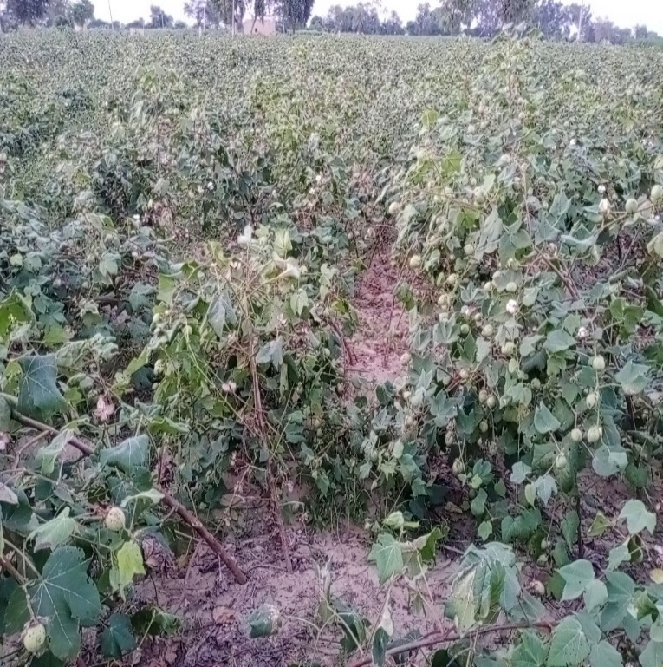
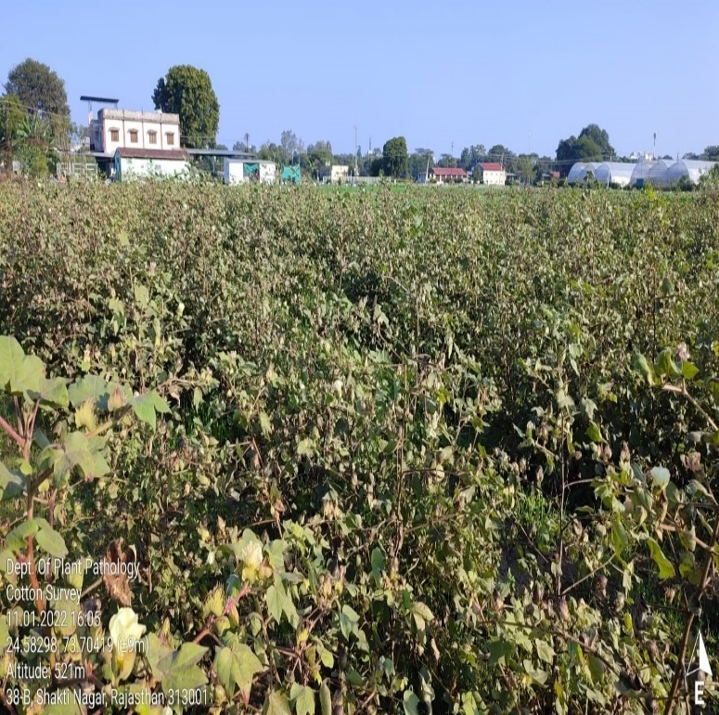
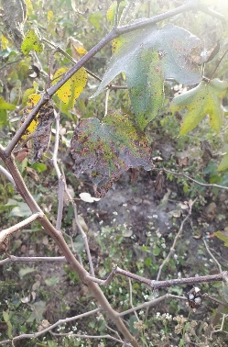
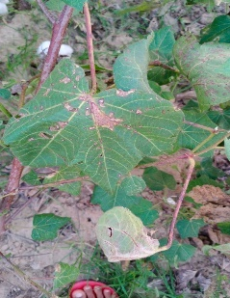

UDAIPUR CHITTORGARH
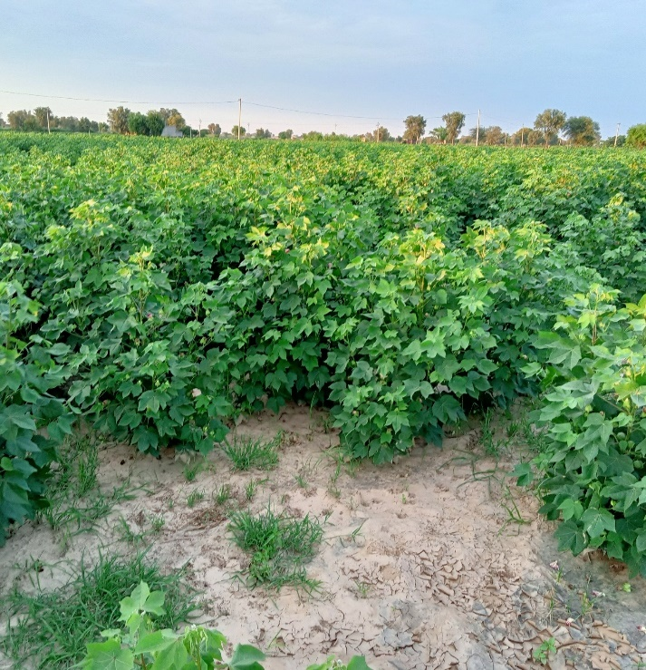
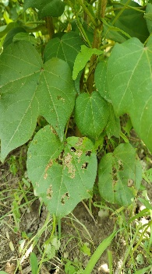
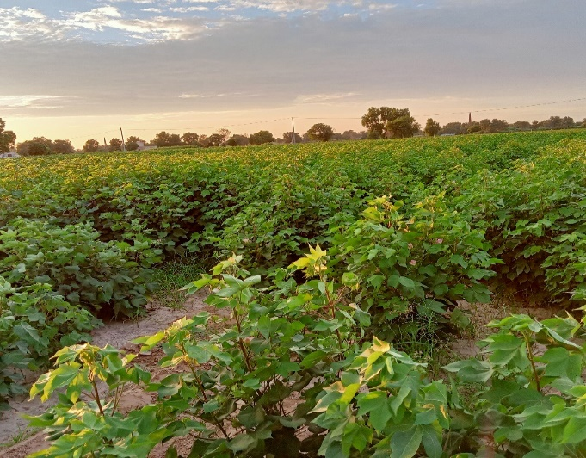
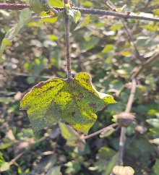

HANUMANGARH SRI GANGANAGAR
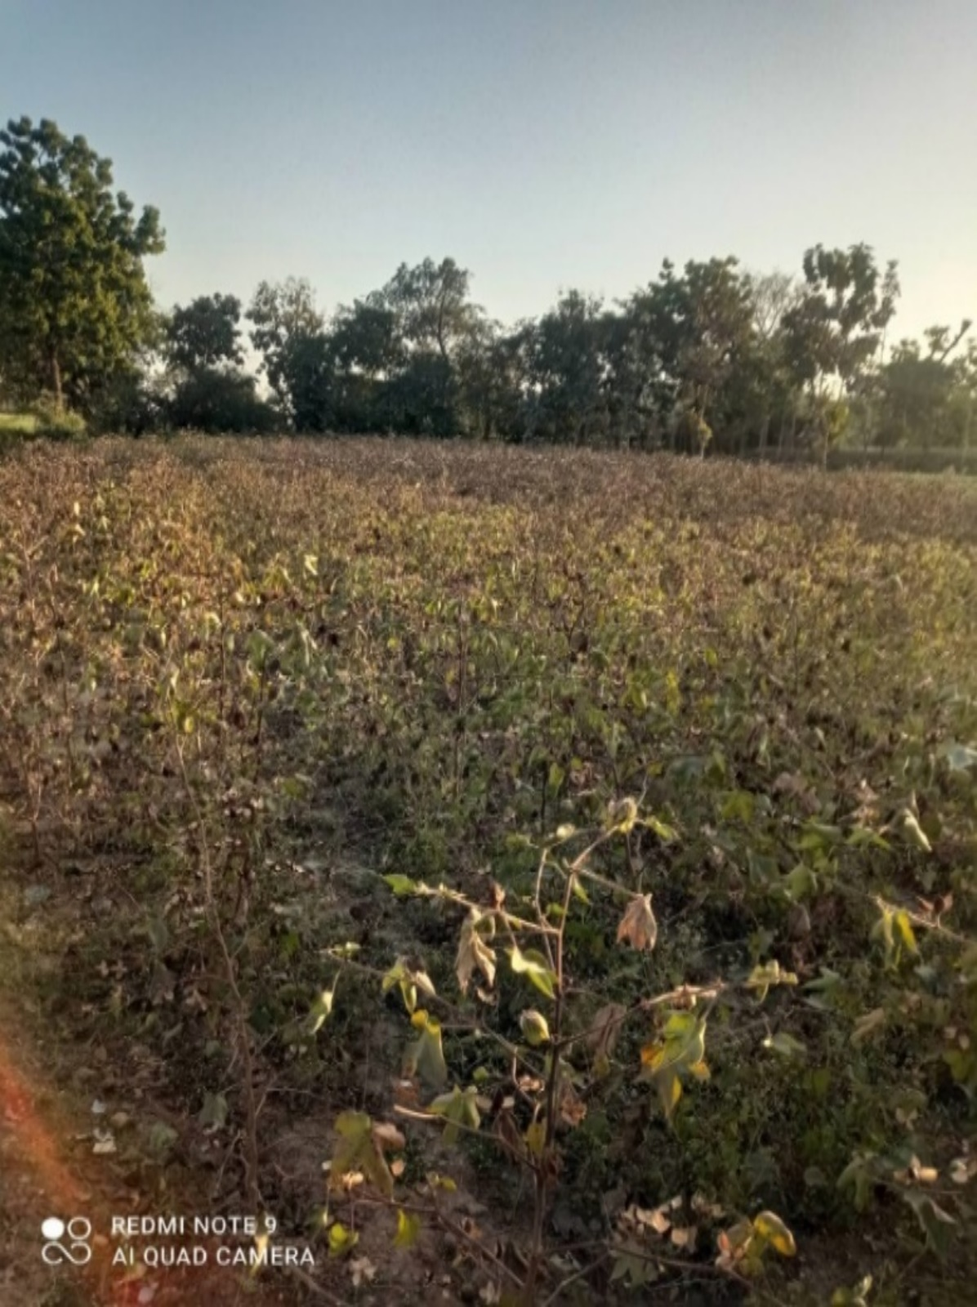
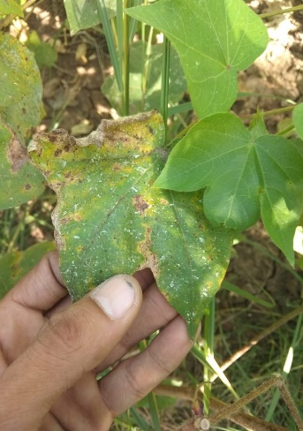

RAJSAMAND

Plate 1: Field view of surveyed cotton fields in different districts of Rajasthan during Kharif 2021-22.
Mangalwad (28.80%) and the minimum disease incidence was found in Mandpiya (28.00%). The maximum disease incidence in Hanumangarh district was observed in Chohilanwali village (43.00%) followed by Mainawali (42.50%) and the minimum disease incidence was found in Devnagar (41.51%). The maximum disease incidence in Sri Ganganagar district was observed in 15Z village (39.00%) followed by Suratgarh (38.12%) and the minimum disease incidence was observed in Piperan (36.88%). The maximum and minimum disease incidence in Rajsamand district was observed in Kuraj (28.00%) and Gilund (25.95%) respectively whereas incidence in Gogathala was 27.05 per cent.
The overall data revealed that the disease incidence of cotton anthracnose in different cotton growing areas of Rajasthan varied from 25.95 per cent to 43.00 per cent, with an average of 34.37 per cent. The highest severity (43.00%) of anthracnose was in village Chohilanwali (Hanumangarh) and the least (25.95%) was recorded in Gilund village of Rajsamand district.
3.1.2 Disease symptomatology
Typical symptoms of anthracnose on cotton leaf (Plate-1) appeared as elliptical or oblong spots with variable size on the leaves and bolls. In initial stage, spots were small but vary soon. Many of them increased in size and measured about 2 to 4 cm in length and 1 to 2 cm in width. Finally, each individual spots had a characteristics appearance with greyish white centre with numerous black dots consisting acervuli which were arranged as concentric rings on both surfaces with the definite yellowish hallow around the spots. The infected leaves were papery which easily tear off and dropped.
  - Discussion
During the survey, the average anthracnose disease incidence was varied from 27 to 42.25% in different regions of cotton growing areas of Rajasthan (Table 1 and Fig. 1). In Hanumangarh district, the maximum anthracnose incidence (42.25%) was recorded followed by Sri Ganganagar (38.00%), Udaipur (36.00%), Chittorgarh (28.60%) districts. The minimum anthracnose incidence was recorded in Rajsamand district (27.00 %). The per cent disease incidence may also increase under favourable weather conditions, the disease development was
Table 5: Data on incidence and severity of anthracnose of cotton caused by Colletotrichum gossypii in different cotton growing regions of Rajasthan during Kharif 2021-22
Sr. No. | Isolates code | Districts | Location | Coordinates | Variety | Percent disease incidence (PDI) | Average Percent disease incidence
1 | RJCG-1 | Udaipur | Agronomy farm, RCA, Udaipur | 24.5829 ̊ N, 73.70442 ̊ E | RG-8 | 36.90  (37.41) | 36  (36.87)
1 | RJCG-1 | Udaipur | Mavli | 24.7902 ̊ N, 73.9742 ̊ E | Ajeet 155 BG- II | 35.80  (36.75) | 36  (36.87)
1 | RJCG-1 | Udaipur | Fatehnagar | 24.8062 ̊ N, 74.0946 ̊ E | Super Raksha BG-II | 35.30  (36.45) | 36  (36.87)
2 | RJCG-2 | Chittorgarh | Chikarda | 24.5949 ̊ N, 74.4145 ̊ E | Ajeet 155 BG- II | 29.00  (32.58) | 28.60  (32.33)
2 | RJCG-2 | Chittorgarh | Mangalwad | 24.6075 ̊ N, 74.3016 ̊ E | Super Raksha BG- II | 28.80  (32.46) | 28.60  (32.33)
2 | RJCG-2 | Chittorgarh | Mandpiya, Gangrar tehsil | 25.2616 ̊ N, 74.6386 ̊ E | Super Raksha BG- II | 28.00  (31.95) | 28.60  (32.33)
3 | RJCG-3 | Hanumangarh | Chohilanwali | 29.3846 ̊ N, 74.2760 ̊ E | RCH-776  (Rashi-776) | 43.00  (40.98) | 42.25  (40.54)
3 | RJCG-3 | Hanumangarh | Mainawali | 29.3718 ̊ N, 74.3368 ̊ E | RCH-773 | 42.50  (40.69) | 42.25  (40.54)
3 | RJCG-3 | Hanumangarh | Devnagar | 29.488796 ̊ N, 74.074799 ̊ E | RCH-773 | 41.51  (40.11) | 42.25  (40.54)
4 | RJCG-4 | Sri Ganganagar | 15z | 29.8949 ̊ N, 73.7779 ̊ E | PCH-877 Bt 2 | 39.00  (38.64) | 38  (38.06)
4 | RJCG-4 | Sri Ganganagar | Suratgarh | 29.3219 ̊ N, 73.9009 ̊ E | ACH-945-2  BG- II | 38.12  (38.13) | 38  (38.06)
4 | RJCG-4 | Sri Ganganagar | Piperan | 29.2345 ̊ N, 73.9051 ̊ E | ACH-945-2  BG- II | 36.88  (37.39) | 38  (38.06)
5 | RJCG-5 | Rajsamand | Kuraj | 25.0749 ̊ N, 74.0976 ̊ E | Ajeet 155 BG- II | 28.00  (31.95) | 27  (31.31)
5 | RJCG-5 | Rajsamand | Gogathala | 25.0704 ̊ N, 74.0564 ̊ E | Super Raksha BG-II | 27.05  (31.34) | 27  (31.31)
5 | RJCG-5 | Rajsamand | Gilund | 25.0139 ̊ N, 74.2531 ̊ E | Ajeet 33 BG- II | 25.95  (30.62) | 27  (31.31)
 | SEm± |  |  |  |  |  | 0.45
 | CD at 5% |  |  |  |  |  | 1.48
 | CV % |  |  |  |  |  | 2.25

Fig.1: Data on incidence and severity of anthracnose of cotton caused by Colletotrichum gossypii in different cotton growing regions of Rajasthan during Kharif 2021-22.
fast, which ultimately affect the crop and yield. The overall data revealed that the anthracnose incidence in different cotton growing areas of Rajasthan was varied from 25.95 per cent to 43.00 per cent, with an average of 34.37 per cent. The highest severity (43.00%) of anthracnose was noticed from the Chohilanwali village of Hanumangarh district and the minimum 25.95% incidence was recorded from Gilund village of Rajsamand disrict.
The survey data on anthracnose of cotton disease are found similar to Yadav et al. (2017) studies where they conducted survey at four locations in Jaipur district and reported 60.33 per cent disease incidence, Badgujar et al. (2019) carried out an extensive roving survey during year 2017-18 and 2018-19 in the eight districts of Marathwada region to record incidence and intensity of anthracnose of chilli and reported higher disease intensity during 2017-18 (31.29%) as compared to 2018-19 (36.11%) while K. Sanjeev Kumar et al. (2019) conducted survey during Kharif, 2016-17 in Krishnagiri and Cuddalore districts of Tamil Nadu to assess the occurrence of fruit rot incidence of chilli caused by Colletotrichum capsici and recorded maximum mean severity (36.15%) at Kaveripattinam in Krishnagiri district followed by Vadakumangudi in Cuddalore district (34.12%). Ragul et. al. (2021) a spot survey was conducted on the incidence of chilli anthracnose during 2020-2021 at three districts in Southern districts of Tamil Nadu and maximum disease incidence (55.19%) was observed in Subramaniapuram village of Thoothukudi district and Pudhupatti village (50.17%) of Virudhunagar district. Patidar and Tomar (2022) conducted survey to know the per cent disease intensity of chilli anthracnose in four blocks of Sehore district of Madhya Pradesh during Rabi 2019-20 when the crop was three to four months old and recorded maximum per cent disease intensity (50.69%) in the Ashta block while the minimum per cent disease intensity (45.26%) was found in Sehore block.
Typical symptoms of anthracnose on cotton leaf appeared as elliptical or oblong spots with variable size on the leaves and bolls. Two or more spots coalesced and developed into irregular patches involve major portion of the leaf which eventually dried up. After drying spots were equally conspicuous on both the surfaces. In variably lesion were on the leaf blade where acervuli also observed in the leaf sheath. The infected leaves were papery which easily tear off and dropped. The fungus infects the leaves, petioles and the stem, causing dwarfism and over-sprouting of the branches, damaging the formation of bolls (Puia et al. 2020). Symptoms of disease include reduced boll weight, reduced length and thickness of fibers, and abnormal seed weight (Weir et al. 2012). The infected cotton plant parts showing typical disease symptoms were used for the isolation of the pathogen (Colletotrichum gossypii).
References
Anonymous. 2020-21(b). Agricultural statics at glance. Government of India, Ministry of Agriculture & Farmers Welfare (Directorate of Economics and Statistics, (DAC&FW), pp. 95.
Anonymous. 2021(a). Government of Rajasthan, Department of Agriculture, Rajasthan. (Commissionerate of Agriculture, Rajasthan- Jaipur), pp. 1 & 6.
Badgujar S L, Dhutraj D N and Ambadkar C V. 2019. Cultural and morphological variability amongst Colletotrichum capsici isolates collected from Marathwada region of Maharashtra state. International Journal of Chemical Studies 7 (5): 4364-4367.
Patidar S and Tomar D S. 2022. Survey for disease severity of anthracnose of chilli cause by Colletotrichum capsici in Sehore district of Madhya Pradesh. The Pharma Innovation Journal 11 (2): 698-700.
Poonpolgul S and Kumphai S. 2007. Chilli pepper anthracnose in Thailand. Country report. In: Oh DG, Kim KT, editors. Abstracts of the first international symposium on chilli anthracnose. Republic of Korea: National Horticultural Research Institute, Rural Development of Administration, pp. 23.
Puia J D, Martins B R, Hoshino A T, Borsato L C, Ferreira M G D B, Carvalho M A de, Machado J A, Mehta Y R and Vigo S C. 2020. Colletotrichum gossypii f. sp. cephalosporioides: Differential behaviour of cotton strains. Brazilian Journal of Animal and environmental Research 3: 738-746.
Ragul S, Sheela J, Ebenezar E G and Prabina B J. 2021. Survey and isolation of Colletotrichum capsici causing chilli anthracnose disease from Southern districts of Tamil Nadu. The Pharma Innovation Journal 10 (11): 1190-1194.
Sanjeev Kumar K, Balabaskar P, Kumar S, Siva Kumar T and Muthukumar A. 2019. Isolates of Colletotrichum capsici (syd.) butler and bisby causing anthracnose fruit rot incidence of chilli. Plant Archives 19 (2): 3295-3299.
Weir B S, Johnston P R and Damm U. 2012. The Colletotrichum gloeosporioides species complex. Studies in Mycology 73: 115–180.

Yadav A L, Ghasolia R P, Choudhary S and Yadav V K. 2017. Survey of chilli fruit rot; potential threat to chilli crops a focus on Jaipur district. International Journal of Chemical Studies 5 (4): 1556-1557.

