Multi-Environment Evaluation and Stability Analysis of Selected Wheat (Triticum aestivum L.) Genotypes for Yield and Protein Content

ABSTRACT
The present study was conducted to evaluate the performance and stability of 26 wheat (Triticum aestivum L.) genotypes across two environments using randomized block design with three replications. The genotypes were selected from a larger set of 111 entries evaluated earlier. Combined ANOVA revealed significant differences among genotypes for most traits shows presence of genetic variability and Significant genotype × environment interaction was observed for major yield contributing traits including grain yield per plant (GYP), grains per ear (GPE), and productive tillers (PT), justifying the use of GGE Biplot analysis.
GGE Biplot analysis for grain yield indicated that genotype 1 (HD3226) and genotype 2 (HP3334) performed best in different environments. Genotypes 17 (HI8777), 19 (HI1634), and 20 (RAJ4238) were identified as stable and high yielding and for GPE, genotypes 20(Raj4238), 21(HD3321), and 18(PBW826) showed superior performance whereas for PT, genotypes 17(HI8777), 11(VL907), and 14(HD3195) were found stable. Protein content showed very low variation and non-significant interaction, with genotypes 1(HD3226) and 2 (HP3334) performing relatively better. Overall, the study identified good genotypes with good yield performance and stability across different environments, which can be utilized in wheat improvement programs.
Keywords: Wheat, GGE Biplot, Stability analysis, Grain yield, Grains per ear, Productive tillers, Protein content, Genotype × environment interaction

INTRODUCTION

Wheat (Triticum aestivum L.) is a cornerstone of global food security, providing a important portion of daily calorie intake for millions of people (Joshi et al., 2017)[1]. With increasing climate variations and growing population demands, the need to develop stable, high-yielding, and nutritionally rich wheat variety has become critical. One of the key challenges in wheat improvement is the interaction between genotype and environment (G×E), which can significantly influence phenotypic expression and yield stability in Multi-environment trials (Yan et al., 2000[2] Gauch, 2006)[4]. ANOVA in RBD partitions total variation into three main components: variation due to treatments, variation due to blocks (environmental variation), and experimental error. The significance of treatment effects is helpful to determine whether observed differences among genotypes or treatments are statistically meaningful. Pooled ANOVA helps plant breeders identify stable and widely adapted genotypes by evaluating consistency of performance across environments. It is especially important in multi-location trials and stability studies. GGE Biplot analysis is a graphical method used to evaluate genotype performance and stability across multiple environments (Yan et al., 2000[2] Yan and Tinker, 2006)[5]. The GGE concept stands for Genotype main effect (G) plus Genotype × Environment interaction (GE).
In the present study, 26 good performing wheat genotypes were evaluated across two distinct environments representing different climatic and soil conditions. These genotypes were selected from an previous experiment of 111 entries evaluated under an augmented block design evaluated during Rabi 2022–2023. The current trial, conducted under a randomized block design, aimed to assess grain yield stability and traits such as protein content at two different agro-climatic environments.

MATERIALS AND METHODS
The present study was carried out during the Rabi season of 2023–2024 to evaluate the performance and stability of 26 wheat (Triticum aestivum L.) The present trial carried out at two locations: the BT Indigenous Seed Production Company Farm in Sainsowal, (Punjab), and the Himachal Hybrid Seeds Firm Farm in Lambagaon, (Himachal Pradesh). These sites differ in climatic conditions. The experimental layout followed a randomized block design (RBD) with three replications per location. Each genotype was grown in a plot size of 2 m × 1.15 m with row-to-row spacing of 23 cm and was sown manually in rows and 50 cm-wide drainage channel separated each block to avoid cross-contamination and improve irrigation efficiency. A recommended fertilizer dose of 120:60:40 kg/ha (ICAR-Indian Institute of wheat and barley Research, Karnal)[3]. N: P: K was applied Nitrogen was split into two doses — half at sowing and half at first irrigation.
  - Experimental Materials
Table no: 1: Wheat Genotypes
Sr.no. | Genotypes
1 | HD3226
2 | HP3334
3 | HP2002
4 | HS490
5 | BRW3829
6 | HI8757
7 | PBW725
8 | KPL429
9 | HD2733
10 | HPW360
11 | VL907
12 | WH1257
13 | HS507
14 | HD3195
15 | HD2967
16 | HI1620
17 | HI8777
18 | PBW826
19 | HI1634
20 | RAJ4238
21 | HD3321
22 | DBW222
23 | UP2844
24 | DBW305
25 | HI1612
26 | PBW550

  - 3.2 Traits Observations Recorded
A total of 13 traits were recorded. Data were collected from five randomly selected plants per plot for each genotype & two on a plot basis (days flowering and days to maturity)
Table no: 2 13 traits observed
Sr.no. | Traits | Abbreviations
1 | Plant height | PH
2 | Ear length | EL
3 | Ear weight | EW
4 | Productive tillers | PT
5 | Spikelets numbers | SN
6 | Harvest index | HI
7 | Protein content | PC
8 | Grains per Ear | GPE
9 | 1000 Kernel Weight | KWT
10 | Grain Yield per Plant | GYP
11 | Biological Yield | BY
12 | Days to 50% Flowering | DF
13 | Days to Maturity | DM

  - 3.3 Data Analysis
  - Data collected from both locations were analysed through the ANOVA (Gauch, 2006)[4] for both environment individually then combined analysis of variance (ANOVA) to assess the effects of genotype (G), environment (E), and genotype × environment interaction (G×E). Significant G×E interactions suggested further stability analysis using the GGE Biplot methodology (Yan et al., 2000[2] Yan and Tinker, 2006)[5]. This model provided information regarding genotype adaptability, interaction patterns, and identification of stable genotypes across environments despite of having only two environments. Statistical analysis of experimental data was performed using R Studio software and Kerala agriculture university Grapes software.

RESULTS & DISCUSSION
The results in Table no.3 showing pooled analysis of variance (ANOVA) under randomized block design across different environments showing significant differences among treatments for most of the traits, indicating the presence of sufficent amount of genetic variability in our experimental material. The treatment mean squares (Msq) were significant for plant height (PH), ear length (EL), productive tillers (PT), spikelet number (SN), kernel weight per tiller (KWT), grains per ear (GPE), grain yield per plant (GYP), biological yield (BY), days to flowering (DF), days to maturity (DM), and protein content (PC), which shows that there is good scope for selection and genetic improvement. However, ear width (EW) and harvest index (HI) showed non-significant differences, showing limited variability for these traits. The effect of location was significant for most of the traits showing a strong environmental influence on trait expression. Traits such as PH, EL, EW, PT, GPE, and DM having significant variation due to location, while grain yield per plant (GYP) and days to flowering (DF) were non-significant, suggesting relatively stable performance of these traits across environments. The significant location effect emphasizes the importance of multi-environment testing in evaluating genotype performance. The genotype × environment (G×E) interaction was found to be significant for most of the traits, including PH, EL, EW, PT, SN, KWT, GPE, GYP, and BY, indicating that genotypes responded differently across environments. This suggests that the relative performance of genotypes varied with environmental conditions, justifying the need for stability analysis such as GGE Biplot. Whereas, days to flowering (DF), days to maturity (DM), and protein content (PC) showed non-significant interaction effects, indicating their stability across environments. Similar significant genotype × environment interactions for yield and related traits have been reported in wheat by Baloch et al. (2020) [6] and Ajmera et al. (2021) [7], and Purchase et al. (2000) [8], highlighting the importance of multi-environment testing.
Table No: 3
POOLED RBD ANOVA
Source of variations | Degrees of freedom | PH(Msq) | EL(Msq) | EW(Msq) | PT(Msq) | SN(Msq) | KWT(Msq) | GPE(Msq) | GYP(Msq) | BY(Msq) | HI(Msq) | DF(Msq) | DM(Msq) | PC(Msq)
Location | 1 | 5635.692*** | 1285.351*** | 117.52*** | 490.012*** | 98.654** | 143.698** | 10463.388*** | 30.29ns | 24.897* | 617.099** | 0.273ns | 123.853*** | 0.92**
Treatment | 25 | 491.542*** | 220.738*** | 0.313ns | 361.519*** | 62.533*** | 197.143*** | 629.714*** | 1220.255*** | 32.351*** | 73.955ns | 230.62*** | 55.589*** | 276.271***
Replication with in location | 4 | 23.46 | 11.792 | 0.998 | 29.206 | 0.32 | 1.054 | 2.422 | 0.957 | 1.902 | 23.038 | 23.481 | 220.526 | 0.772
Location x Treatment | 25 | 52.075*** | 33.269*** | 0.448*** | 10.785*** | 8.9*** | 11.85*** | 106.077*** | 11.106*** | 3.886*** | 60.612*** | 0.165ns | 0.346ns | 0.099ns
Error | 100 | 1.486 | 3.285 | 0.049 | 2.815 | 1.299 | 1.39 | 2.405 | 3.791 | 1.177 | 19.245 | 1.369 | 17.559 | 1.237

DF = Degrees of freedom, ***= significant at P≤.001, ** = significant at P ≤ .01, * = significant at P ≤ .05, ns = not significant (P > .05).

Table no: 4 : 26 Wheat Genotypes

Genotype. No. | Genotypes
1 | HD3226
2 | HP3334
3 | HP2002
4 | HS490
5 | BRW3829
6 | HI8757
7 | PBW725
8 | KPL429
9 | HD2733
10 | HPW360
11 | VL907
12 | WH1257
13 | HS507
14 | HD3195
15 | HD2967
16 | HI1620
17 | HI8777
18 | PBW826
19 | HI1634
20 | RAJ4238
21 | HD3321
22 | DBW222
23 | UP2844
24 | DBW305
25 | HI1612
26 | PBW550

The GGE Biplot for grain yield per plant (GYP) revealed that PC1 and PC2 explained 92.05% and 7.95% of the total variation, respectively, indicating that most of the variation was shown by the first principal component. The graph view clearly showed that genotype 1 (HD3226) was positioned farthest in the direction of Environment 1, indicating that it was the best performing genotype under this environment. Similarly, genotype 2 (HP3334) was located far along the direction of Environment 2, suggesting its superior performance under that environment. Other genotypes such as 17(HI8777), 19(HI1634), 20(Raj4238), 21(HD3321), and 8(KPL429) were also aligned towards Environment 1 but with comparatively lower magnitude, indicating moderate performance. Likewise, genotypes 21(HD3321), 20(Raj4238), 18(PBW826), and 10 (HPW360) were oriented towards Environment 2 but were less distant than genotype 2.The identification of environment-specific superior genotypes through the polygon view of the GGE Biplot is in agreement with the findings of Yan et al. (2000)[2] and Akinwale et al. (2022)[9], who also reported differential genotype performance across environments.

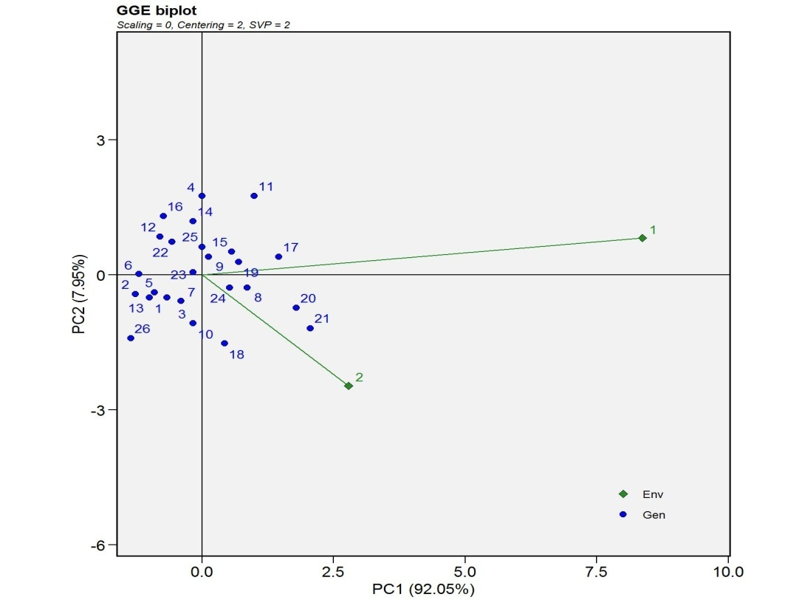
Fig No: 1 GYP which won where

The GGE Biplot based on the ideal genotype view shows that genotypes 17(HI8777), 19(HI1634), and 20(Raj4238) were located closest to the ideal genotype position, indicating their superior performance in terms of both high mean yield and stability. Genotypes such as 21(HD3321), 8(KPL429), and 24(DBW305) were positioned near the average environment coordination (AEC) axis, suggesting moderate performance with acceptable stability. Genotype 1(HD3226) was located far along the positive direction of the AEC axis, indicating high mean performance; however, its deviation from the axis suggested lower stability. The concept of ideal genotype combining high mean performance and stability observed in the present study is similar with the principles described by Yan and Tinker (2006)[5].

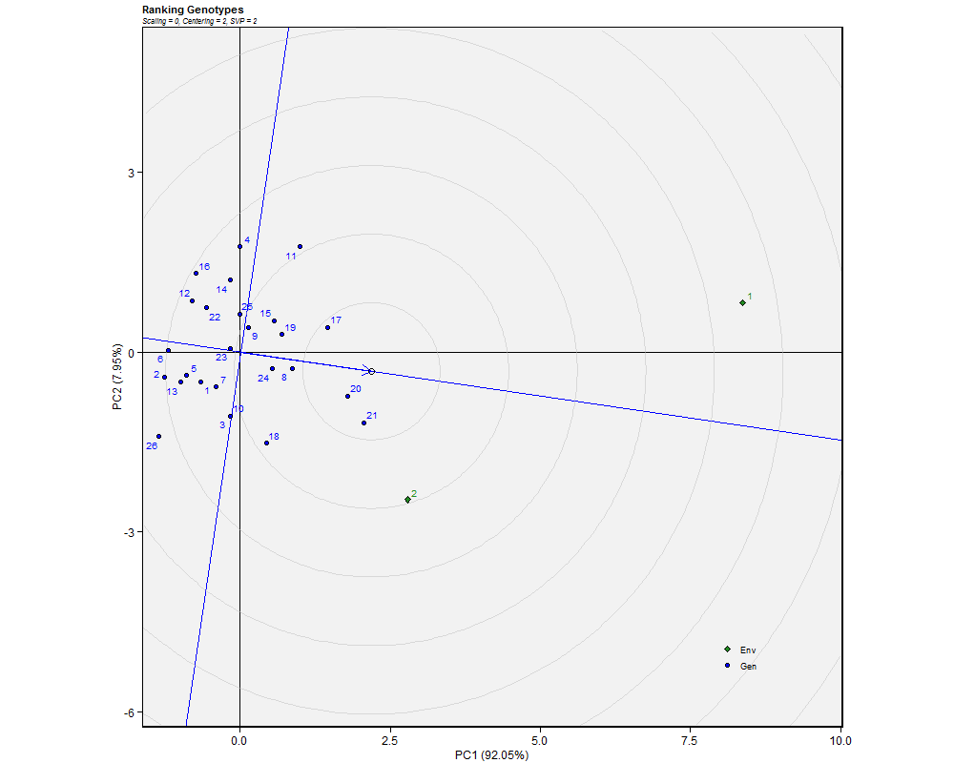
Fig No: 2 GYP Ideal genotypes
The GGE Biplot based on mean versus stability revealed that genotype 1(HD3226) was positioned farthest along the positive direction of the average environment coordination (AEC) axis, indicating the highest mean performance among all genotypes, however its deviation from the axis suggested lower stability. Genotypes 20(Raj4238), 21(HD3321), and 17(HI8777) were also located on the positive side of the AEC axis, indicating relatively high mean performance. Genotypes such as 8(KPL429), 24(DBW305), 19(HI1634), and 15(HD2967) exhibited moderate mean performance as they were positioned near the origin but slightly towards the positive side. The variation in mean performance and stability among genotypes, as revealed by the AEC method, has also been reported in earlier studies using GGE Biplot analysis (Yan and Tinker, 2006[5] Akinwale et al., 2022) [9].
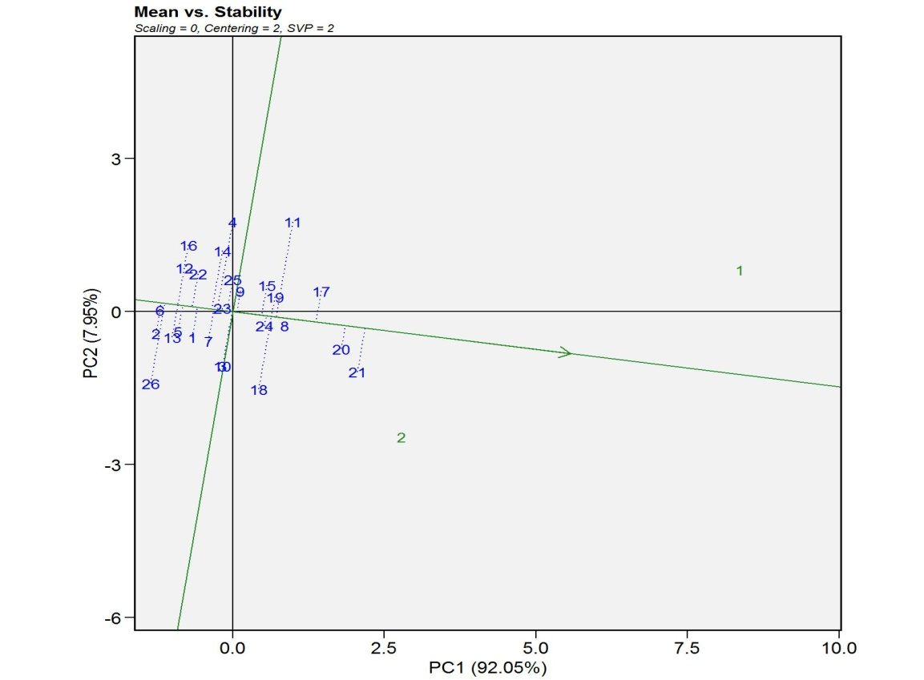
Fig No: 3 GYP Mean vs. Stability
The GGE Biplot for grains per ear (GPE) revealed that the first two principal components accounted for 89.98% and 10.02% of the total variation, respectively. The Biplot indicated that genotype 15(HD2967) was most closely aligned with the direction of Environment 1, suggesting its superior performance under this environment. Genotypes 19(HI1634), 17(HI8777), and 20(Raj4238) were also oriented in the same direction, indicating moderate performance. In contrast, genotype 21(HD3321) was positioned in the direction of Environment 2 and appeared to be the best performer under that environment, followed by genotypes 18(PBW826) and 10(HPW360) with relatively lower alignment. Similar patterns of genotype-specific adaptation to different environments have been reported by Akinwale et al. (2022)[9], confirming the effectiveness of GGE Biplot in identifying superior genotypes.

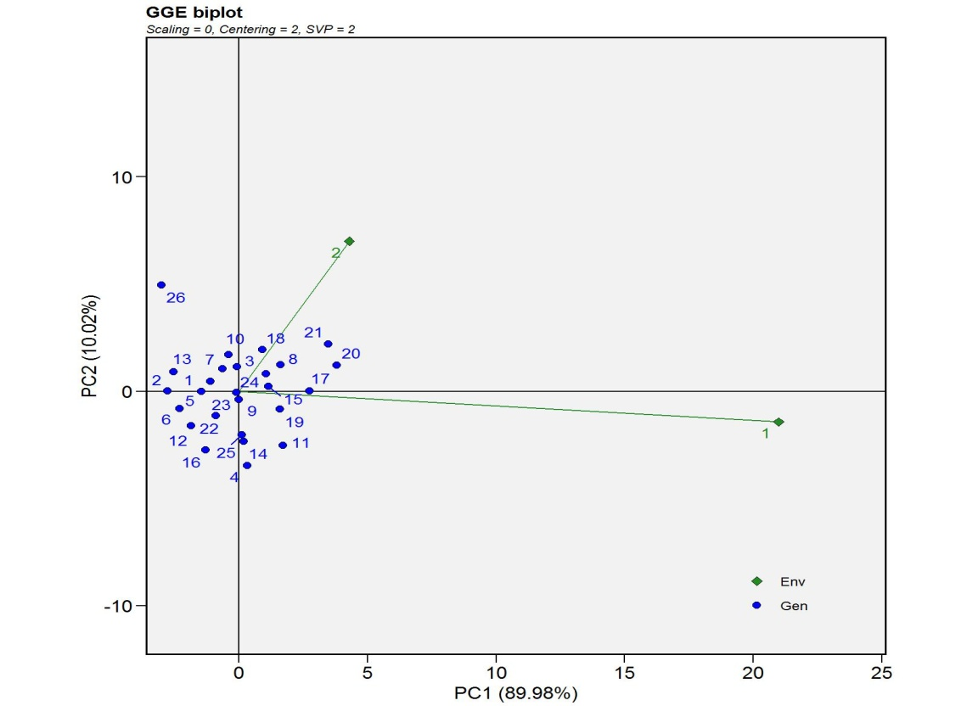
Fig no 4 GPE which won where
The GGE Biplot based on the ideal genotype view for grains per ear (GPE) indicated that genotypes 20(Raj4238), 21(HD3321), and 18 (PBW826) were positioned closest to the ideal genotype, suggesting their superiority in terms of both high mean performance and stability. Genotypes such as 17(HI8777), 19(HI1634), 15(HD2967), and 24 (DBW305) were also located relatively close to the average environment coordination (AEC) axis, indicating moderate performance with acceptable stability. Genotypes near the origin, including 23(UP2844), 22(DBW222), 25(HI1612), and 10(HPW360), demonstrated average performance with moderate stability. The identification of genotypes with both high performance and stability aligns with the ideal genotype concept proposed by Yan and Tinker (2006) [5].

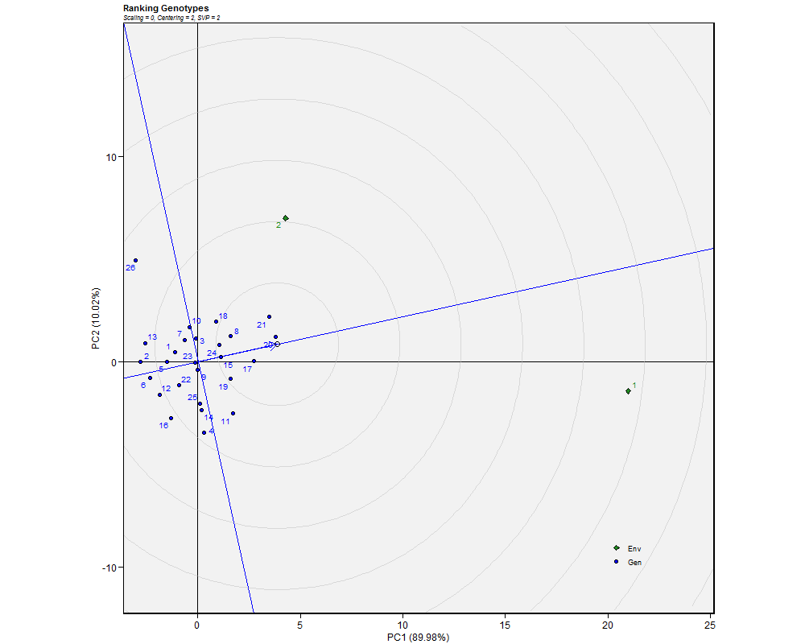
Fig no 5 GPE ideal genotypes

The GGE Biplot based on mean versus stability for grains per ear (GPE) indicated that genotype 1(HD3226) was positioned farthest along the positive direction of the average environment coordination (AEC) axis, suggesting the highest mean performance; however, its deviation from the axis indicated lower stability. Genotypes 21(HD3321), 20(Raj4238), and 18(PBW826) were also located on the positive side of the AEC axis, indicating relatively high mean performance. Stability analysis revealed that genotypes 23(UP2844), 25(HI1612), 22(DBW222), and 15(HD2967) had minimal projection from the AEC axis, indicating high stability across environments. The differentiation of genotypes based on mean performance and stability is in accordance with earlier GGE-based studies (Yan and Tinker, 2006)[5].

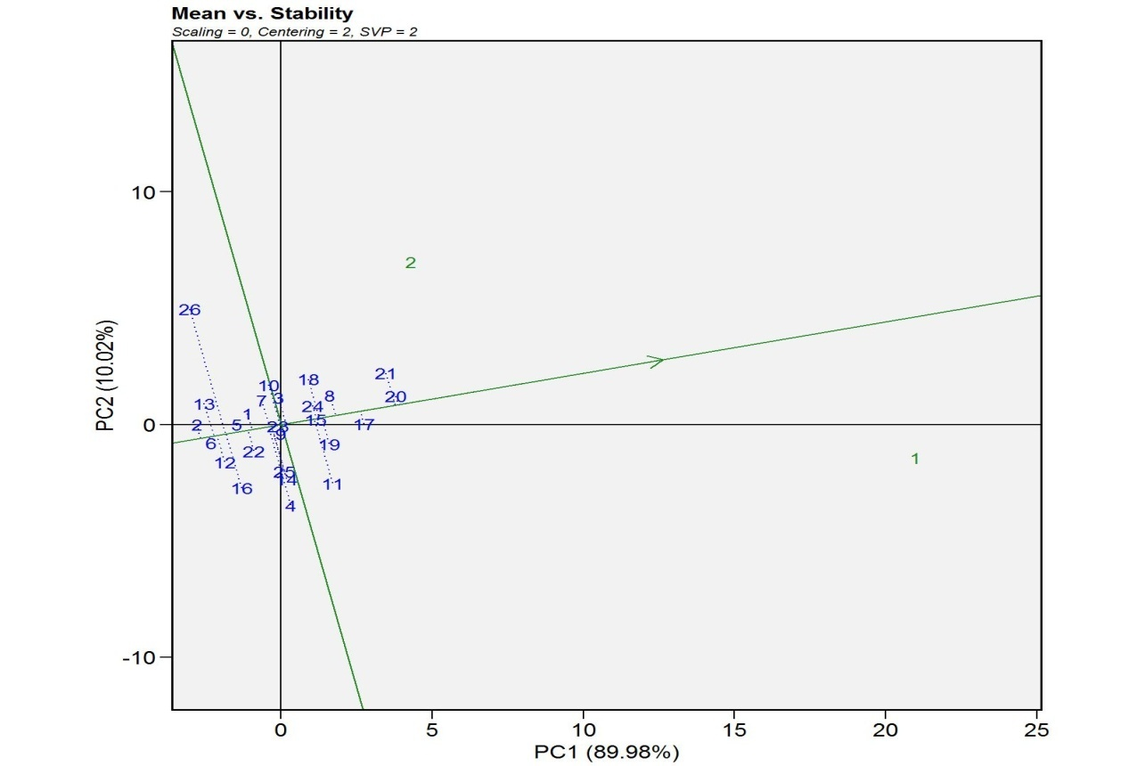
Fig no 6 GPE Mean vs. stability

The GGE Biplot for productive tillers (PT) indicated that the first two principal components explained 89.19% and 10.7% of the total variation, respectively. The Biplot revealed that genotype 16(HI1620) was most closely aligned with the direction of Environment 1, suggesting its superior performance under that environment, while genotypes 5(BRW3829), 23(UP2844), and 25(HI1612) also showed similar orientation with comparatively lower magnitude. In contrast, genotype 9(HD2733) was positioned farthest in the downward direction corresponding to Environment 2, indicating its best performance under this environment, followed by genotypes 18(PBW826), 13(HS507), and 10(HPW360). Several genotypes, including 2(HP3334), 22(DBW222), 6(HI8757), 3(HP2002), 12(WH1257), and 7(PBW725), were located near the central axis indicating no clear environmental dominance. The variation in genotype performance across environments observed in this study is supported by previous findings of Akinwale et al. (2022)[9], who reported similar interaction patterns.

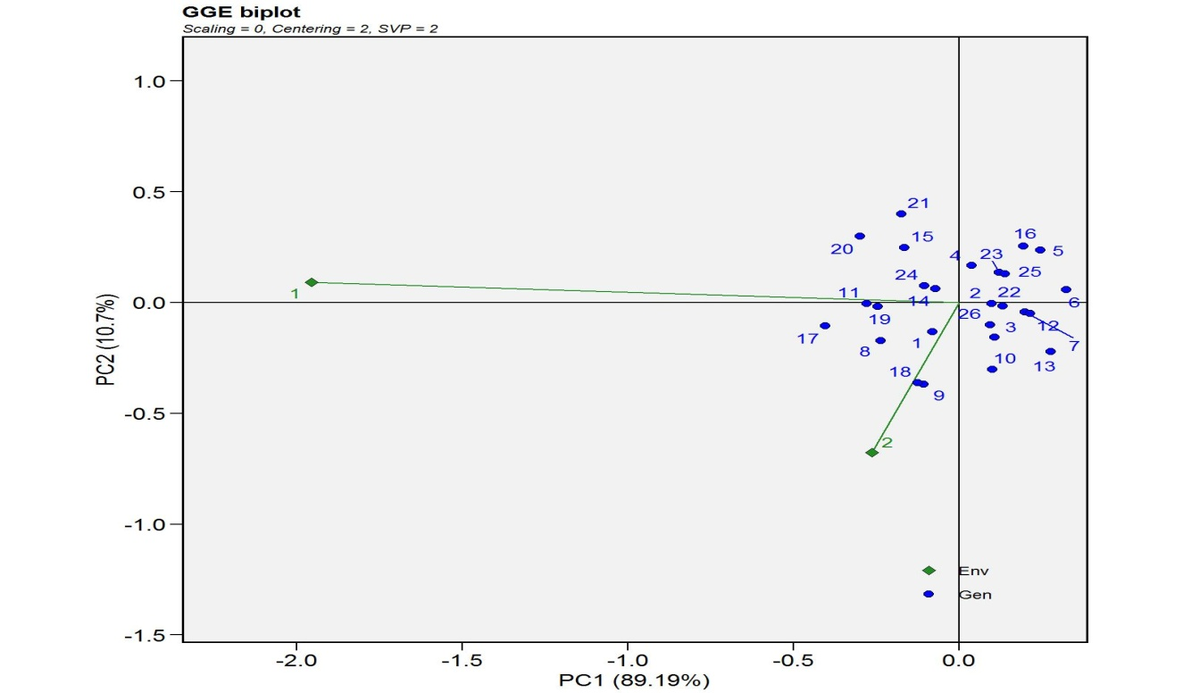
Fig no 7 PT which won where

The GGE Biplot based on the ideal genotype view for productive tillers (PT) indicated that genotypes 17(HI8777), 11(VL907), and 14 (HD3195) were positioned closest to the ideal genotype, suggesting their superiority in terms of both high mean performance and stability. Genotypes such as 24(DBW305), 20(Raj4238), and 15(HD2967) were also located near the average environment coordination (AEC) axis, indicating moderate performance with acceptable stability. Genotypes 5 (BRW3829)and 16(HI1620) were positioned towards the positive side of the AEC axis, indicating relatively higher mean performance; however, their deviation from the axis suggested lower stability. The presence of genotypes combining stability and higher mean values is in agreement with the ideal genotype concept explained by Yan and Tinker (2006)[5].

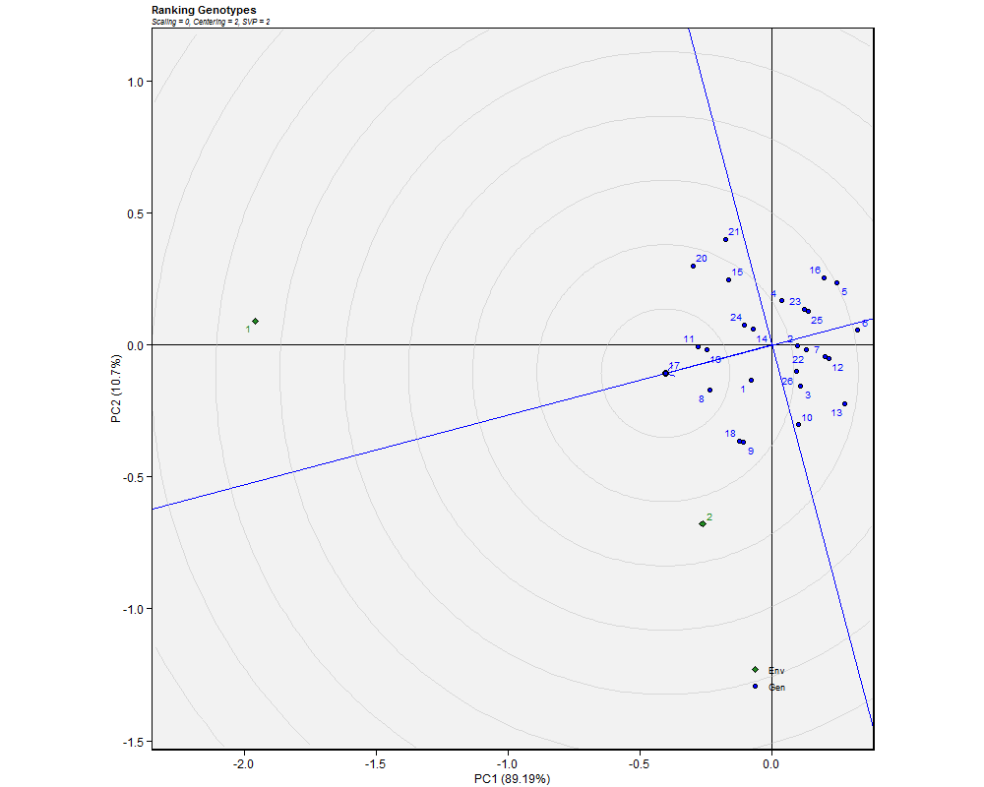
Fig no 8 PT Ideal genotype
The GGE Biplot based on mean versus stability for productive tillers (PT) revealed that genotypes 17(HI8777), 8(KPL429), and 19(HI1634) were aligned along the direction of the average environment coordination (AEC) axis, indicating relatively higher mean performance. Stability analysis indicated that genotypes 17(HI8777), 11(VL907), and 19 (HI1634) were located very close to the AEC axis, suggesting high stability across environments. The identification of stable genotypes with minimal deviation from the AEC axis is consistent with the interpretation of GGE Biplot described by Yan and Tinker (2006)[5].

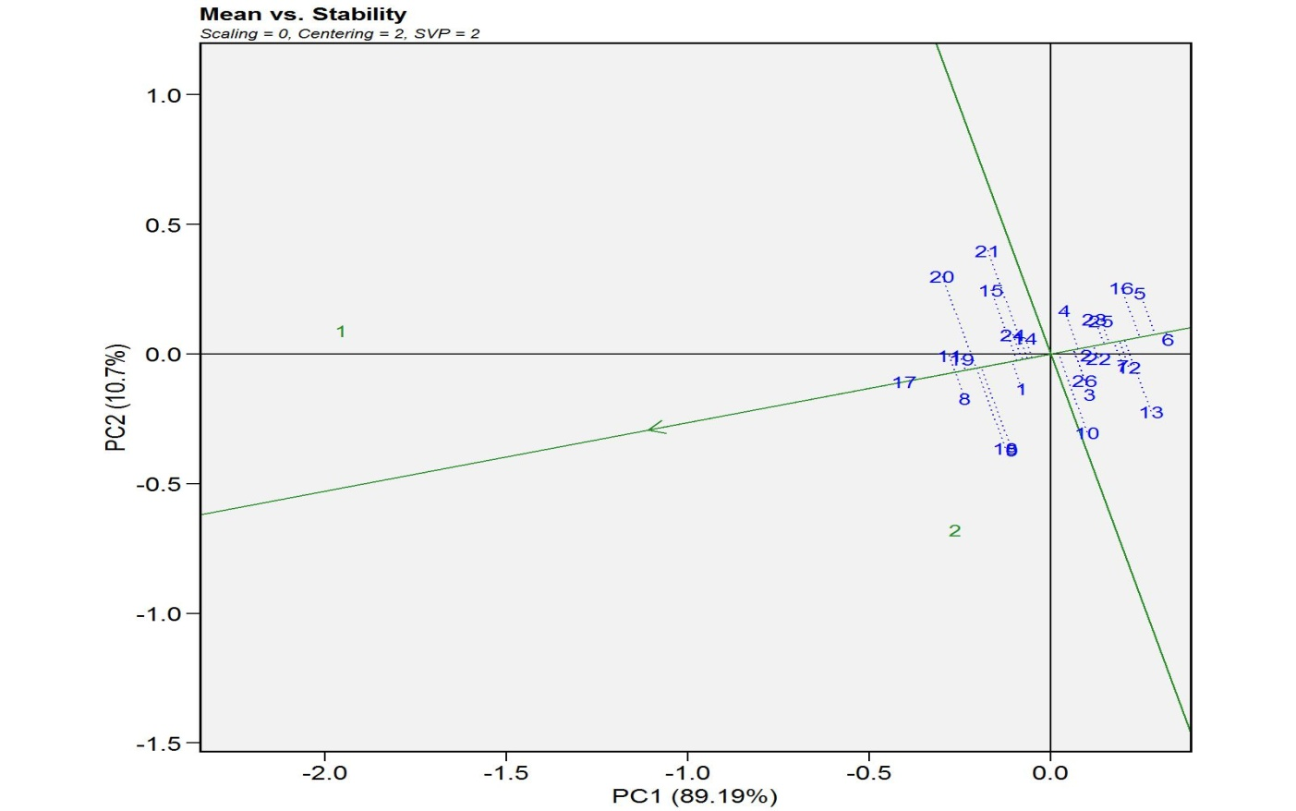
Fig no 9 PT mean vs. stability

The GGE Biplot for protein content indicated that both environments were oriented towards the left side of the Biplot, while the majority of genotypes were clustered on the opposite side. Genotypes 1 (HD3226) and 2(HP3334) were positioned in the same direction as the environments, suggesting their relatively better performance for protein content. In contrast, most other genotypes were located away from the environmental vectors, indicating comparatively lower performance. The clustering pattern further suggested limited variation among the majority of genotypes. The relatively low variation and stable performance of genotypes for protein content observed in this study are in accordance with earlier findings reported by Gupta et al. (2021)[13] and Rao et al. (2020)[14], where quality traits exhibited comparatively less genotype × environment interaction. Similar findings have also been reported by Mohammadi et al. (2016)[12], Farshadfar et al. (2012)[10], and Dehghani et al. (2009)[11], confirming the effectiveness of GGE Biplot in evaluating genotype stability.

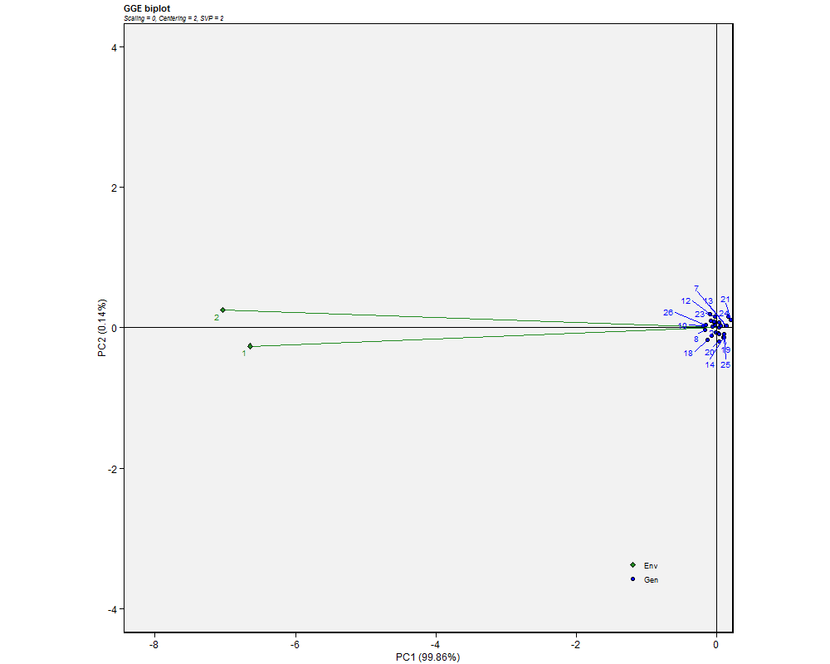

Fig no 10 PC which won where

The GGE Biplot based on the ideal genotype view for protein content revealed that genotype 2(HP3334) was located closest to the ideal genotype position, indicating superior performance in terms of both mean protein content and stability, followed by genotype 1(HD3226). The remaining genotypes were clustered on the opposite side of the biplot and were located far from the ideal genotype, suggesting comparatively lower performance. The clustering of most genotypes further indicated limited variability for protein content among the studied genotypes.

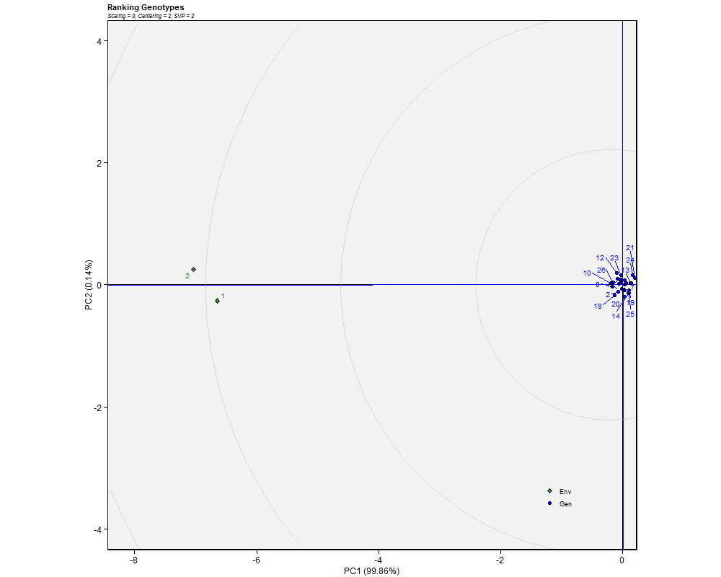
Fig no 11 PC Ideal genotypes

CONCLUSION
The study shows the presence of significant genetic variability and genotype × environment interaction for most of the traits highlights the importance of multi-environment evaluation. GGE Biplot analysis effectively identified adapted and stable genotypes. Genotypes HD3226 and HP3334 showed superior performance in specific environments, while genotypes HI8777, HI1634, and RAJ4238 exhibited stable and high yield performance across environments. Yield component traits such as grains per ear and productive tillers also showed variation among genotypes, contributing to yield differences. Protein content exhibited low variability and high stability, with only a few genotypes showing better performance. Overall, the identified genotypes can be considered for future breeding programs aimed at improving yield and stability in wheat.

REFRENCES
- Joshi, A. K., Mishra, B., & Ortiz-Ferrara, G. (2017). Wheat improvement in India: Present status, emerging challenges and future prospects. Indian Journal of Genetics and Plant Breeding, 77(1), 1–18.
- Yan, W., Hunt, L. A., Sheng, Q., & Szlavnics, Z. (2000). Cultivar evaluation and mega-environment investigation based on GGE biplot. Crop Science, 40(3), 597–605.
- ICAR–Indian Institute of Wheat and Barley Research. 2020. Package of practices for wheat cultivation. ICAR-IIWBR, Karnal, Haryana, India
- Gauch, H. G. (2006). Statistical analysis of yield trials by AMMI and GGE. Crop Science, 46(4), 1488–1500.
- Yan, W., & Tinker, N. A. (2006). Biplot analysis of multi-environment trial data: Principles and applications. Canadian Journal of Plant Science, 86(3), 623–645.
- Baloch, M. J., Veesar, N. F., & Jatoi, W. A. (2020). Stability analysis in wheat genotypes using GGE biplot and AMMI models. Pak. J. Agri. Agril. Engg. Vet. Sci., 36(1), 8–15.
- Ajmera, R., Singh, V., & Patel, R. (2021). Multi-environment analysis in wheat using AMMI and GGE biplot models. Journal of Cereal Research, 13(1), 24–30.
- Purchase, J. L., Hatting, H., & Van Deventer, C. S. (2000). Genotype × environment interaction of winter wheat in South Africa: II. Stability analysis of yield performance. South African Journal of Plant and Soil, 17(3), 101–107.
- Akinwale, M. G., Adetimirin, V. O., & Ogunniyan, D. J. (2022). Application of GGE biplot for genotype evaluation and mega-environment identification in wheat. African Crop Science Journal, 30(2), 123–132.
- Farshadfar, E., Sabaghpour, S. H., & Zali, H. (2012). Comparison of parametric and non-parametric methods for selecting stable and adapted wheat genotypes. Journal of Agricultural Science and Technology, 14(4), 745–756.
- Dehghani, H., Ebadi, A., & Yousefi, A. (2009). Biplot analysis of genotype by environment interaction for barley yield. Agronomy Journal, 101(3), 567–574.
- Mohammadi, R., Farshadfar, E., & Amri, A. (2016). Genotype × environment interaction and stability analysis of rainfed durum wheat genotypes. Crop Journal, 4(2), 126–135.
- Gupta, R., Sharma, P., & Kumar, D. (2021). Genetic analysis for protein content and yield components in bread wheat. Indian Journal of Agricultural Sciences, 91(4), 567–572.
- Rao, V. S., Prasad, K., & Mehta, S. L. (2020). Genotype-environment interaction for grain yield and quality traits in wheat. Wheat Research Journal, 9(1), 42–48.

