Influence of the colors of insect nets on growth parameters and physicochemical properties of Guinea sorrel (Hibiscus sabdariffa L.)

.
ABSTRACT

Guinea sorrel (Hibiscus sabdariffa L.) is a vegetable crop whose leaves, calyces, and seeds are used in human nutrition. However, it is susceptible to attacks by insect pests that reduce yields. To mitigate this, insect-proof nets of different colors are used as an alternative to chemical control. The general objective of this study was therefore to evaluate the effect of the colors of insect-proof nets on the growth and physicochemical parameters of Guinea sorrel. The study was conducted during the rainy season (RS), the cool dry season (CDS), and the hot dry season (HDS). The experimental design was a randomized complete block design with six treatments and four replications with a single factor irrespective of the cropping season. The following treatments: untreated control without net, chemical insecticide without net, black net, white net, green net, and biological insecticide without net, were randomly allocated to the experimental units. The results showed that black and green insect-proof nets limited plant growth during both the HDS and RS. In contrast, under the white insect-proof nets during the HDS, good plant growth was observed, notably with significant leaf production. The lower light levels observed under the insect-proof nets compared to plots without nets led to a reduction in physicochemical activity, in particular, lower carbohydrate and protein production in the leaves of the Guinea sorrel plants. Variations in light intensity during the growing seasons influenced the effects of insect nets on the growth of Guinea sorrel plants.

Keywords: dry biomass, insect nets, Hibiscus sabdariffa, light radiation

1. INTRODUCTION

Guinea sorrel (Hibiscus sabdariffa L.) is an annual or biennial plant species belonging to the Malvaceae family. It consists mainly of the sabdariffa and altissima varieties, which are generally propagated from seed. It is a sun-loving plant grown primarily in Sahelian countries such as Burkina Faso, Senegal, Mali, and northern Côte d’Ivoire (Sié et al., 2008). Because they are rich in minerals, proteins, fiber, and vitamins, parts of the plant such as the leaves, calyxes, and seeds are used for human consumption. The dried red calyxes of the sabdariffa variety are also used to make a delicious juice called “bissap” (Sié et al., 2009) and to produce jellies, jams, ice cream, and perfumes (Folefack, 2008). They are the subject of significant trade between certain African countries and Western nations. The stems of the altissima variety are primarily used in the production of textile fibers. These fibers are the subject of significant global trade (Sié et al., 2008). It is also cultivated for medicinal purposes (Lepengué et al., 2011). Despite its economic importance, H. sabdariffa is underutilized in sub-Saharan Africa in favor of major crops such as millet and sorghum.
Highly favored by insect pests, H. sabdariffa suffers from leaf damage caused by these pests, resulting in a significant reduction in yields. In an effort to protect their crops, many farmers often resort to the excessive use of chemical insecticides to control these pests (Yarou et al., 2017). To address this, bioinsecticides have been recommended as an alternative control method. Unfortunately, this control method appears to have adverse effects on beneficial insects (Yarou et al., 2017). Other methods, such as the use of resistant varieties (Boccas et al., 1976), integrated pest management, and the use of insect nets of different colors against crop pests, are increasingly being adopted. This latest control method, which relies on temperature variation and the blocking of light, is believed to affect plant growth and certain physicochemical properties. Thus, the overall objective of this study is to contribute to improving the productivity of Guinea sorrel by evaluating the influence of the colors of these insect-proof nets on the plants. To this end, the first step was to evaluate the influence of the colors of the insect-proof nets on the plant’s growth parameters as well as on the physicochemical properties of the leaves. Next, the study aimed to determine the temperatures under these nets and their impacts on the plants’ biomass.

2. material and methods

2.1 Material
Two types of materials were used in this study: plant material and technical equipment.

2.1.1 Plant Material
The plant material consisted of seeds of the altissima variety of roselle (Hibiscus sabdariffa L.). This variety is grown in the municipality of Korhogo, and the seeds were purchased at the local market in the city.

2.1.2 Technical equipment

In the field, the technical equipment included hoes and machetes for weeding the plots; muslin-type insect nets of different colors (white, green, and black); thermometers to measure temperatures; a precision scale for weighing biomass; and a caliper to measure diameters.
In the laboratory, the equipment comprised: a refrigerated centrifuge (TGL-16M) for separating mixtures of different densities; a spectrophotometer for determining the absorbance of chemicals in solution; a BIOBASE 45°C oven for drying samples; a desiccator to protect substances from moisture; a Soxhlet system for fat extraction, and a rotary evaporator for rapid solvent distillation. The main reagents used were: concentrated sulfuric acid (95–97%), 40% sodium hydroxide (NaOH), boric acid, 0.1N sulfuric acid, hexane, and 10% phenol.

2.2 Methods

2.2.1 Study Site

The experiments were conducted at the experimental site of Peleforo GON COULIBALY University in Korhogo (Figure 1). The study area is characterized by a cool season, with cool, dry winds (harmattan), from December to February. This is followed by a period of intense heat from March to May and a wet season from June to September, due to the onset of rains. Finally, the period from October to November is marked by a rise in temperature caused by the end of the rains, leading to a drop in humidity and an increase in evaporation (Traoré, 2003).

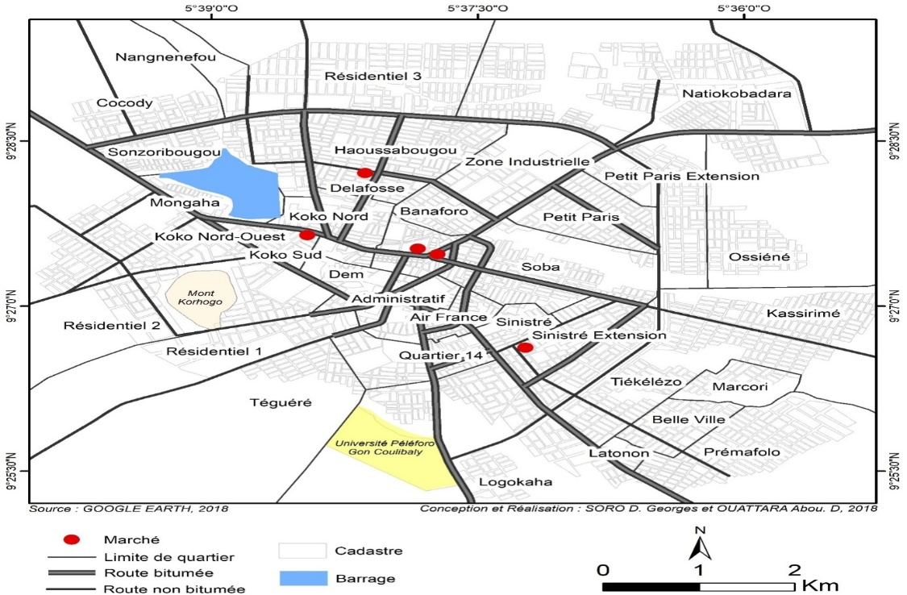
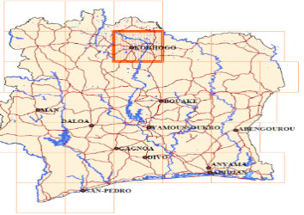
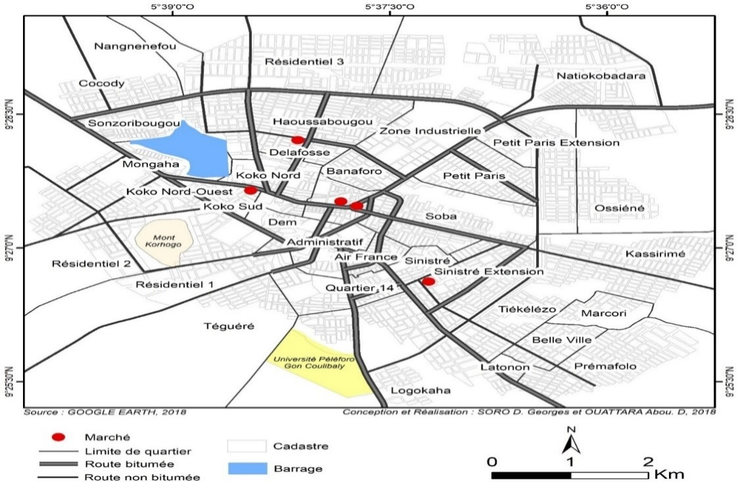

Site d’étude

Fig. 1: Overview of the study site (Source: Soro and Ouattara, 2018)

2.2.2 Experimental Design

The experimental design consisted of four completely randomized Fisher blocks with six treatments and four replicates. The total area was 63 m² (9 m x 7 m). The dimensions of an experimental unit or plot were 1 m x 1 m, or 1 m². These plots consisted of 5 rows, each containing 5 planting holes (totaling 25 holes per plot). The spacing between two adjacent rows was 0.5 m. Within a single block, the plots were separated by 0.25 m apart. Within a single block, the plots were separated by 0.5 m. The distance between two blocks was 1 m.

2.2.3 Conduct of the Experiment

Soil preparation involved leveling the field by plowing prior to sowing. The experiment was conducted during the rainy season (RS), the cool dry season (CDS), and the hot dry season (HDS). For each growing season, the trials lasted 39 days. Iron cages measuring 1 m x 1 m x 1 m (1 m³ in volume) were constructed matching the dimensions of the experimental plots. They were covered with insect-proof nets of different colors (green, black, and white) immediately after sowing (Figure 2). Six treatment treatments were applied, namely: control without netting or insecticide (T1), chemical insecticide treatment without netting (T2), black netting without insecticide (T3), white netting without insecticide (T4), green netting without insecticide (T5), and biological insecticide without netting (T6). Seeds were sown, in accordance with the practices of farmers in the study area, in moist seedbeds at a rate of 10 to 15 seeds per hole. Germination occurred three days after sowing (DAS) for all three trials. Thinning, again following the farmers’ practices, was carried out to leave 7 plants per hole, 10 days after seedlings emergence. In the CSF and HDS treatments, water was supplied to the plants by irrigating the plots. A total of 16 liters was applied per day to the plants per basic plot, at a rate of 8 liters in the morning and 8 liters in the evening, or 1 L/m². A total of 624 L/m² was applied per plot during the two experiments (CDS and HDS). During the rainy season (RS), no water was applied through irrigation.

2.2.4 Description of Insecticide Treatments

Chemical and biological treatments were applied as soon as the first infestations were observed. The affected plots were treated once a week using a 1.5-liter sprayer. The chemical insecticide used was a synthetic product, “Cypercal 50,” purchased on the market for insect control. As for biological control, it was carried out using essential oil of Ocimum canum and chitosan provided by the cotton company COIC. The dosage of these products used was 4 mL per 1.5 L of water per treatment.

2.2.5 Growth parameters measured in the field
The following parameters were measured on the 16th, 23rd, 30th, and 39th days after sowing (DAS): plant height, plant collar diameter, and dry above-ground biomass (leaves + stem) per plot. The dry above-ground biomass was obtained after sampling nine plants from the plots. These plants were then placed in envelopes for drying. Finally, they were weighed to determine their dry weight.

2.2.6 Temperature Measurement

Temperatures were recorded on the day that morphological parameters were measured and biomass samples collected. Thermometers were placed in the plots at 6:00 a.m. Temperature readings were taken again at 1:00 p.m.

2.2.7 Measurement of physicochemical parameters of leaves

2.2.7.1 Moisture content
Moisture content was determined using a slightly modified version of Method No. 925.09 by Horwitz and Latimer (2005). Five (5) grams of leaf litter were weighed into a capsule of known mass. The assembly (cap and sample) was then placed in a drying oven (MEMMERT) at a temperature of 105 °C. After 24 hours, successive weighings were performed on the assembly until constant weights were obtained.
Moisture contents were expressed as follows:

Formula 1 :
$$Humidity (\%)=\frac{(m1-m2)}{(m1-m0)}×100$$

m0: mass (g) of the empty capsule; m1: mass (g) of the assembly (capsule + leaf pulp) before steaming; m2: mass (g) of the assembly (capsule + leaf pulp) after steaming.

2.2.7.2 Ash Content
The method for determining ash content is that described by Horwitz and Latimer (2005). Ash is the whitish residue remaining after incineration. A 5-g portion of the ground material was placed in crucibles of known mass (m1). The assembly (crucible + ground material) was placed in a muffle furnace at 550 °C for 24 hours. The crucible was then removed from the furnace and allowed to cool in a borosilicate glass desiccator. Next, the mass (m2) of the crucible-ash assembly was determined by weighing. The ash content was calculated using the following formula:

Formula2:
$$ash content (\%)=\frac{m2-m0}{m1-m0}×100$$

m0: mass (g) of the empty crucible; m1: mass (g) of the assembly (crucible + waste) before incineration; m2: mass (g) of the assembly (crucible + waste) after incineration.

2.2.7.3 Protein Content

Crude protein was determined by measuring the total nitrogen content of the sample using the Kjeldahl method, Method No. 920.87 (Horwitz and Latimer, 2005). The method consists of 3 steps. Step 1: A 1 g mass of ground material was weighed into a digestion flask, to which a catalyst (95% K₂SO₄ + CuSO₄ and 2% selenium) and 20 mL of concentrated sulfuric acid (95–97%) were added successively. Digestion was carried out at 400 °C for 2 hours in a BUCHI digestion unit. After cooling the tube to room temperature, the digest was transferred to a 100 mL volumetric flask and made up almost to the mark with distilled water. Two blank tubes containing all reagents except the sample (ground material) were also processed in the same manner as the test samples (Leite et al., 2009). Step 2: Ten (10) mL of 40% (w/v) sodium hydroxide were added to 10 mL of the mineralized sample, and the mixture was placed in the distillation flask. The condenser of the distiller was then immersed in a beaker containing 20 mL of boric acid with a mixed indicator (methyl red + bromocresol green) added. Distillation was carried out for 10 minutes until a violet distillate was obtained (Leite et al., 2009). Step 3: The solution obtained after distillation (distillate) was titrated with 0.1 N sulfuric acid until the solution turned green. A blank was prepared using distilled water. The total protein content was calculated using the following formulas:

Formula 3 :
$$Total nitrogen (\%)=\frac{(V1-V0)×N×0.014}{m(e)}×100$$

Formula 4 :
$$Total protein \left(\%\right)=6,25× total nitrogen (\%)$$

V0: volume (mL) of 0.1 N sulfuric acid solution added for the blank test; V1: volume (mL) of sulfuric acid solution (0.1 N) added for the test (sample); N: normality of the sulfuric acid solution; M(e): mass (g) of the sample; 14: atomic mass of nitrogen; 6.25: conversion factor for nitrogen to protein.

2.2.7.4 Carbohydrate Content
Total sugars were determined using the phenol-sulfuric acid method (Dubois et al., 1956). In glass test tubes, 1 mL of 10% phenol plus 5 mL of concentrated sulfuric acid was added to 1 mL of each sample. The solutions were homogenized, and their absorbances were measured using a spectrophotometer at a wavelength of λ = 490 nm. The total sugar contents of the various samples were then determined based on the titration of a standard solution series.

2.2.7.5 Fat Content
The fat content was determined according to Method No. 920.39 (AOAC, 2005). Three grams (3 g) of ground material (P0) were placed in an extraction cartridge. The cartridge was plugged with cotton to prevent the sample from being carried away during extraction. 300 mL of hexane was poured into an empty glass flask of known mass (P1). The cartridge and flask assembly was fitted to the extraction apparatus (Soxthermautomatic Gerherdt). Extraction was performed using the reflux system for 8 hours at a temperature of 40°C. The flask containing the fat was heated to 80°C to remove the hexane. The flask was then cooled in a desiccator for 1 hour, and its mass (P2) was determined. The fat content (MG), expressed as a percentage of dry matter (% DM), was calculated using the following formula:

Formula 5 :
$$MG (\%)=\frac{(P2-P1)}{P0}×100$$

P0: mass of the ground material; P1: mass of the empty vessel; P2: mass of fat

2.2.8 Data Processing and Statistical Analysis
Data processing was performed using Microsoft Excel. This spreadsheet was used to calculate the means. Analysis of variance was performed using the statistical software Statistix 8.1. In cases of a significant effect at the 5% level, Tukey’s HSD test was performed to compare the means.

3. results and discussion
3.1 Results
3.1.1 Effect of insect net colors on plant height
The average plant heights for the different treatments studied over the three growing seasons are presented in table 1. Statistical analysis revealed significant difference between the treatments and compared to the control throughout the growing cycle. The colors of the nets influenced plant growth differently. Regardless of the season, plants under nets were significantly taller than those without nets. During the rainy season (RS), the plants covered with white nets achieved higher average heights (19.5 cm; 35.23 cm; 50.50 cm; 61.06 cm) throughout the growing cycle. Regarding the cool dry season (CDS), plants covered with black nets had the greatest heights from the 16th das (9.98 cm) through the 39th das (16.86 cm). In contrast, during the hot dry season (HDS), plants under white netting were taller from the 23rd das (18.25 cm) until the end of the cycle.

Table 1: average plant heights during the trial

Growing seasons | Treatments | Plant Height (cm)
Growing seasons | Treatments | 16 DAS | 23 DAS | 30 DAS | 39 DAS
Rainy Season | Green net | 16.5b | 22.46c | 25.35e | 30.28d
Rainy Season | White net | 19.5a | 35.23a | 50.50a | 61.06 a
Rainy Season | Black net | 19.5a | 28.08b | 35.16b | 45.41bc
Rainy Season | Biological treatment | 12.87c | 19.11d | 30.57cd | 44.64c
Rainy Season | Chemical treatment | 12.58c | 20.08d | 32.82bc | 50.75b
Rainy Season | Control | 13.13c | 18.42d | 27.81de | 42.92c
Cool dry season | Green net | 9.38a | 10.00b | 11.53b | 13.24b
Cool dry season | White net | 8.36b | 9.72b | 11.01b | 13.29b
Cool dry season | Black net | 9.98a | 12.27a | 13.31a | 16.86a
Cool dry season | Biological treatment | 6.82c | 6.66c | 7.04c | 7.74c
Cool dry season | Chemical treatment | 6.96c | 7.26c | 7.54c | 8.82c
Cool dry season | Control | 6.93c | 6.97c | 7.54c | 8.44c
Hot dry season | Green net | 11.90b | 14.98c | 15.87b | 23.99c
Hot dry season | White net | 12.83b | 18.25a | 23.77a | 40.57a
Hot dry season | Black net | 14.30a | 16.58b | 22.17a | 31.68b
Hot dry season | Biological treatment | 8.52c | 10.96d | 12.91c | 16.48e
Hot dry season | Chemical treatment | 8.97c | 11.74d | 13.33c | 20.04d
Hot dry season | Control | 8.60c | 10.28d | 14.08b | 17.76e
For a given variable and treatment, means designated by the same letter are not significantly different at the 5% level (Tukey HSD test)
DAS: Days After Sowing

3.1.2 Effect of insect net colors on the collar diameter of seedlings

The changes in average plant diameters across the different treatments studied over the three growing seasons are presented in Figure 2. Collar diameter values increased over the course of the growing cycle, regardless of treatment or growing season. Statistical analysis revealed a significant difference between the treatments studied, regardless of the growing season. During the rainy season (RS), plants under white nets exhibited the highest average collar diameter values from the 16th to the 23rd day after sowing (DAS). They were followed by those in the insecticide, biological, and control treatments, which achieved an average value of 3.23 mm at the 23rd DAS. From the 30th DAS onward until the end of the cycle, the plants treated with the chemical insecticide had the highest average values (6.13 mm), followed by those treated with the biological insecticide, the controls, and those under the white nets, which had an average value of 5.52 mm. As for the plants grown under green and black nets, they had the lowest average collar diameters from the 16th DAS until the end of the trial (3 mm and 3.54 mm). Regarding FSD, plants under black and white nets had the highest average collar diameters at the 39th day after sowing (2.46 mm and 2.39 mm). The lowest average values were observed in plants from the other treatments, at 1.79 mm each. Under HDS conditions, plants covered with white nets had the highest average collar diameters (ranging from 1.50 to 5.80 cm) throughout the growing season compared to plants in the other treatments. The average values for the control plants, plants treated with chemical and biological insecticides, and plants under black netting increased to 3.78 mm, 3.94 mm, 3.63 mm, and 3.25 mm, respectively, at the end of the cycle.

a

b

c

Fig. 2: Changes in stem-base diameter of seedlings over the growing cycle in relation to growing seasons (a = rainy season, b = Cool dry season, and c = hot dry season)
For a given variable and effect, means denoted by the same letter are not significantly different at the 5% level (Tukey HSD test)

3.1.3 Effect of Insect Net Colors on Dry Above-Ground Biomass of Plants

The average dry above-ground biomass produced by plants under the various treatments studied over the three growing seasons is presented in Table 2. The dry above-ground biomass of the plants varied statistically over the growing cycle regardless of the treatment or growing season. During the growing season, the results indicate that the increase in dry above-ground biomass was significantly higher in the absence of insect-proof nets. Indeed, plants treated with chemical and biological insecticides, as well as the controls, produced significantly more biomass compared to plants under insect-proof nets at 23, 30, and 39 days after sowing. Plants under green and black nets produced less biomass (2.43 g and 4.37 g) compared to those grown under white nets (13.62 g). Regarding the CSF, plants covered with black and white nets produced significantly more dry above-ground biomass (3.05 g and 3.71 g) at 39 DAS compared to plants in the other treatments. During the HDS, starting from the 23rd DAP, plants grown under white nets produced more biomass (19.01 g) through the end of the cycle compared to those in the other treatments.

Table 2: Dry above-ground biomass produced during the experiments

Growing seasons | Treatments | Dry aerial biomass (g)
Growing seasons | Treatments | 16 DAS | 23 DAS | 30 DAS | 39 DAS
Rainy Season | Green net | 0.66d | 1.02b | 1.99d | 2.43d
Rainy Season | White net | 1.28c | 4.06a | 6.61b | 13.62b
Rainy Season | Black net | 0.73d | 1.38b | 3.22c | 4.37c
Rainy Season | Biological treatment | 1.79a | 4.00a | 8.09a | 15.95a
Rainy Season | Chemical treatment | 1.61b | 3.99a | 7.96a | 15.91a
Rainy Season | Control | 1.59b | 3.87a | 7.20a | 15.44a
Cool dry season | Green net | 0.30c | 0.56c | 0.81c | 1.60e
Cool dry season | White net | 0.54a | 0.90a | 1.78a | 3.71a
Cool dry season | Black net | 0.33c | 0.75b | 1.14b | 3.05b
Cool dry season | Biological treatment | 0.47b | 0.71b | 1.13b | 1.94de
Cool dry season | Chemical treatment | 0.55a | 0.90a | 1.62a | 2.67bc
Cool dry season | Control | 0.53a | 0.80ab | 1.32b | 2.26cd
Hot dry season | Green net | 0.58c | 0.98d | 1.10d | 2.62f
Hot dry season | White net | 0.97a | 3.09a | 5.70a | 19.01a
Hot dry season | Black net | 0.55c | 1.37c | 2.16d | 4.35e
Hot dry season | Biological treatment | 0.92ab | 2.20b | 3.63c | 10.52d
Hot dry season | Chemical treatment | 0.87b | 2.06b | 4.33b | 12.88b
Hot dry season | Control | 0.94a | 2.06b | 3.77c | 11.70c
For a given variable and treatment, means designated by the same letter are not significantly different at the 5% level (Tukey HSD test)
DAS: Days After Sowing

3.1.4 Temperature readings under or without insect nets in the plots
The temperature readings recorded over the three growing seasons are presented in Table 3. Regardless of the growing season, these readings were higher under the black and green nets and lower in the plots not covered with insect nets. Intermediate values were recorded under the white nets, regardless of the growing season.

Table 3: Temperatures (°C) recorded for the different treatments during the trial

Growing seasons | Treatments | Temperatures in degrees Celsius (°C)
Growing seasons | Treatments | 16 DAS | 23 DAS | 30 DAS | 39 DAS
Rainy Season | White net | 37 | 36 | 37 | 36
Rainy Season | Black net | 41 | 39 | 39 | 39
Rainy Season | Green net | 41 | 39 | 39 | 39
Rainy Season | No net | 33 | 33.5 | 36 | 35
Cool dry season | White net | 36.5 | 38 | 38 | 38
Cool dry season | Black net | 37.2 | 40 | 40 | 40
Cool dry season | Green net | 38 | 40 | 40 | 40
Cool dry season | No net | 35 | 38 | 39 | 35
Hot dry season | White net | 38 | 37 | 38 | 37
Hot dry season | Black net | 39 | 41 | 41 | 41
Hot dry season | Green net | 39.5 | 41 | 41 | 41
Hot dry season | No net | 35 | 36 | 37 | 36

DAS: Days After Sowing.

3.1.5 Impact of insect net colors on the physicochemical properties of Guinea sorrel leaves
The influence of insect net colors, as well as biological and chemical treatments, on the physicochemical properties of Guinea sorrel leaves is summarized in Table 4. The results revealed significant differences in carbohydrate and protein content and moisture levels. The highest average carbohydrate (14.9%) and protein (4.25%) contents were obtained from plants that were not covered by insect-proof nets (the control plants and those treated with biological and chemical insecticides). These carbohydrate contents were followed by those of plants grown under white nets (10.76%) and those under green and black nets, which were statistically identical (8.31% and 9.08%). Protein contents were highest in plants grown under nets, which were statistically identical (3.5%). The highest moisture content (85.02%) was observed in plants grown under netting. The lowest moisture content (78.90%) was observed in plants not covered with insect-proof netting (the organic treatments, insecticide treatments, and controls). Furthermore, the organic treatments, insecticides, the control, and the nets had no effect on the plants’ lipid content and ash content.

Table 4: Physicochemical properties of plants at the end of the cycle in CDS
Treatments | Physicochemical compounds Contents (%)
Treatments | Carbohydrates | Moisture | Proteins | Lipids | Ash
Green net | 8.314c | 85.78a | 3.5b | 0.35a | 2.5a
White net | 10.76b | 83.70a | 3.5b | 0.36a | 1.66a
Black net | 9.08c | 85.58a | 3.20b | 0.29a | 1.82a
Insecticide T | 14.60a | 78.90b | 4.25a | 0.36a | 1.86a
Bio T | 15.39a | 77.95b | 4.35a | 0.36a | 1.91a
Control | 14.71a | 78.70b | 4.26a | 0.34a | 1.96a
For a given variable and effect, means designated by the same letter are not significantly different at the 5% level (Tukey HSD test); Insecticide T: Insecticide Treatment; Bio T: Biological Treatment

3.1 Discussion
Our study revealed distinct effects of the nets on growth parameters across different growing seasons. During the RS, plants grown under black and green nets exhibited low values for morphological parameters as well as dry above-ground biomass. This result could be explained by the low light levels observed under the green and black nets. The low photosynthetic activity resulting from this low light intensity is likely responsible for the low biomass production by these plants. This result corroborates that of Gouasmi (2006), who demonstrated that light is one of the factors limiting biomass production. Under low light conditions, photochemical reactions are slowed, which limits CO₂ uptake and consequently results in low biomass production (Siéné et al., 2010). However, the values for morphological parameters and above-ground dry biomass of the plants grown under the white nets were higher than those of the plants under the other nets. The results obtained could be explained by the fact that these nets allow more light to pass through than the other nets. This would account for the increase in photosynthetic activity in these plants. According to Siéné et al. (2010), biomass production in plants depends on the amount of radiation intercepted by the vegetation cover.
During the CDS, overall plant growth was slower than in other seasons, regardless of treatment. This slow growth is likely due to the Harmattan, which is characterized by a decrease in the quality of light radiation. According to Siéné (2013), the atmosphere contains aerosols, pollutants, dust, and more; when the sky is overcast, incident solar energy generally decreases. This may explain the low values observed. However, plant height and stem diameter at the base were higher for plants grown under the black and white nets compared to plants in the other treatments. These results could be explained by the higher temperatures measured under these nets compared to the plots without nets. Indeed, temperature and light have a significant impact on the plant. A decrease in light quality and quantity, as well as in temperature, leads to a reduction in sugar production through biochemical reactions (Tousignant et al., 2006). These results are consistent with those of Abdelhafeez et al. (1971), Harssema (1977), and Tindall et al. (1990), who argue that temperature is one of the environmental factors that strongly influences plant growth. It plays a role in enzymatic activities and chemical reactions (Hopkins, 2003) and affects the fluidity of cell membranes (Tran, 2005). The growth parameters were higher for the plants under the black nets compared to those under the white nets. This could be explained by the higher temperatures recorded under the black nets compared to the other nets. Indeed, a black body retains heat better than a white body. It is defined as a body that absorbs all radiation completely (Anonymous, 1984).
During the HDS, the best growth parameter values were obtained for plants grown under white nets. This net thus facilitated good growth of Guinea sorrel plants (Siéné et al., 2018) . For these same growth parameters, except for plant height, the lowest values were obtained for plants grown under the green and black nets. This result can be explained by the fact that the amount of radiation transmitted under the white nets is greater than that transmitted under the green and black nets. Thus, photosynthetic activity appears to be significant in plants grown under these white nets. Similar results have already been reported by Vu (2008). The high plant height values obtained under the green and black nets, compared to their low collar diameter values and low biomass, could be explained by the phenomenon of etiolation. Indeed, in the absence of light, plants grow rapidly and become spindly and discolored; this is the phenomenon of etiolation. These results confirm to some extent those obtained by Rabéchault (1962), who observed that seedlings grew taller in darkness than in the presence of light.
Plants grown under the nets had lower protein and carbohydrate contents compared to those grown without nets. The white color of the nets allowed for increased carbohydrate biosynthesis compared to the black and green colors, which were statistically identical. This result appears to be linked to the intensity and quality of the light received by the plants. Indeed, to carry out photosynthesis in the presence of light, the plant converts light energy into chemical energy in the form of sugar (carbohydrates). The sugars produced can then be converted into other organic molecules, such as amino acids (the building blocks of proteins), through physiological processes involved in the plant’s growth and development. These results confirm those of Laccotte (2018), who demonstrated that light is a crucial element in the biochemical reactions of photosynthesis that lead to the production of sugars (carbohydrates) using carbon dioxide (CO₂) and water. No treatment had an effect on the ash. This could be explained by the destruction of chloroplasts during incineration. The higher moisture content of the plants under the nets compared to those without nets is likely due to transpiration caused by the high temperature under the nets.

4. Conclusion
Based on the results of our study, it is important to note that the use of insect nets of different colors to control pests of Guinea sorrel affected the growth parameters of the plants regardless of the growing season. The presence of these nets above the plants also affected the levels of certain physicochemical parameters, such as sugars and proteins. During the RS, the insect nets used protected the plants from pests. However, they reduced the values of growth parameters, particularly stem diameter at the collar and dry above-ground biomass. The highest growth parameter values were obtained during the CDS with white and black nets, followed by the HDS with white nets. The variation in light radiation observed during the growing seasons was responsible for the different effects of the nets studied.
With regard to physicochemical properties, the levels were lower in plants grown under nets compared to those grown in plots without nets. It would be important to repeat this study through the fruiting stage in several agroecological zones to determine the effect of net colors on the physicochemical properties of the calyxes.

References

Anonymous, (1984). The Basics of Bioclimatology. 1-Physical Foundations. (INERA Department of Bioclimatology, Méribel). (www.Bibliothèques Bordeaux.fr/ les bases_de_la bioclimatologie) Accessed September 2019.
Abdelhafeez, A. T., Harssema, H., Veri, G., & Vekerk, K. (1971). Effects of soil and air temperature on growth, development and water use of tomatoes. Neth. J. Agric. Sci., 19, 67-75.
Boccas, B., & Pellegrin, F. (1976). Evaluation of the resistance of some varieties of roselle to Phytophthora parasitica. Cot. Fib. Trop., vol. XXXI, 1-4.
Dubois, M., Gilles, K. A., Hamilton, J. K., Roben, F. A., & Smith, F. (1956). Colorimetric method for determination of sugar and related substances. Anal Chem. Vol 28, 350 - 356.
Folefack, D. P., Njomaha, C. & Djouldé D. R. (2008). Analysis of the production and marketing system for Guinean sorrel juice in the city of Maroua. TROPICULTURA, vol. 26, 211–215.
Gouasmi, M. (2006). Modeling of photosynthetic activity from leaf to canopy: the case of a post-harvest fallow. Doctoral dissertation, UNIVERSITY OF TOULOUSE III-PAUL SABATIER, 128 pp.
Harssema, H. (1977). Root temperature and growth o young tomato plants. Wageningen, vol 19, p85.
Hopkins, W. G. (2003). Carbon Assimilation and Productivity. In: Plant Physiology. Translated from the 2nd American edition by Serge Rambour. Editions De Boeck Université, 515 pp.
Horwitz, W. & Latimer G.W. (2005). Official methods of analysis of AOAC International. 18th ed. Published by Gaithersburg, Md. : AOAC INTERNATIONAL, 2005.
Lacotte, V. (2018). Effect of light spectra emitted by LED lighting on the production of horticultural seedlings in a controlled environment.
Leite, M. F. J., Silva, A. J., Gadelha, T. S., Gadelha, A. C., & Jùnior S. P. J. (2009). Nutritional value and antinutritional factor of foliaceous vegetable Talinumfructicosum, Rev Inst Adolfo Lutz, vol 68: 341-345.
Lepengue, A. N., Kalenda, M., Amari, G., Ake, S., Kouadio, Y. J., Zouzou, M., & M’batchi B. (2011). The effect of auxin on the growth of roselle (Hibiscus sabdariffa L. var. sabdariffa) in Gabon. Journal of Animal & Plant Sciences, Vol. 11: 1409–1417.
Rabéchault, H. (1962). Research on the culture (in vitro 1) of oil palm (Elaeis guineensis Jacq.) embryos. I. Effects of indole-3-acetic acid. Oléagineux, Vol. 17, No. 10 – October.
Sie, R.S., Akaffou, D.S., Séka, D., Konan, K.J.L., Toueix, Y., Charles, G., Djè, Y., & Branchard, M. (2009). Characterization of diversity and agromorphological evaluation of a collection of Hibiscus sabdariffa L. in Côte d’Ivoire. Afrique SCIENCE vol. 05: 65–76.
Sié, R. S., Akaffou, D. S., Kone, D., Dogbo, O. D., Assohoun, V., Charles, G., & Branchard, M. (2008). Influence of growing conditions and substrate on the development of Guinea sorrel cuttings: Hibiscus sabdariffa (Malvaceae). African Agronomy vol. 20: 141–149.
Siené, L. A. C. (2013). Improvement of radiative balance modeling in relation to seeding density and canopy architecture: the case of the millet varieties (Pennisetum glaucum (L.) R. Br.) Souna3 and Sanio. Doctoral thesis, Félix Houphouet Boigny University, 270 pp.
Siené, L. A. C., Muller, B., & Ake, S. (2010). Effect of seeding density on changes in the light extinction coefficient and the conversion efficiency of radiation absorbed by the plant canopy of two millet varieties with different growth cycles. Int. J. Biol. Chem. Sci. vol. 4: 1462–1479.
Siené, L.A.C., Coulibaly, L.F., Kouame, K., Koné, S.S., & Koné, M. (2018). Effects of insect nets on the vegetative growth of the Guinea sorrel (Hibiscus sabdariffa L.), grown in the Korhogo region of Northern Côte d'Ivoire. American Journal of Engineering Research (AJER), Volume-7, Issue-7, pp-253-263.
Tousignant, M., & Delorme, M. (2006). Understanding how plants work to better manage their environment. Article published in Québec Vert, pp. 2–3.
Traoré, A. (2003). The “red gold” of Kenedougou: promoting roselle commercially.
Tindall, J. A., Mills, H. A., & Radcliffe, D. E. (1990). The effect of root zone temperature on nutrient uptake of tomato. Journ. of plant nutritio. vol 13 : 939-956.
Tran, T. L. M. (2005). Synthesis and accumulation of tropane alkaloids in Datura innoxia Mill. grown hydroponically: analysis of the effects of the biotic and abiotic environment; trials to implement a new production technology. Doctoral thesis, National Polytechnic Institute of Lorraine in Agricultural Sciences, France, 105 p.
Vu, T. D. (2008). Effect of the environment on the growth and accumulation of secondary metabolites in Datura innoxia Mill. grown in soilless conditions; impact of biotic and abiotic factors. Doctoral thesis, National Polytechnic Institute of Lorraine, 238 pp.
Yarou, B. B., Silvie, P., Komlan, F. A., Mensah, A., Alabi, T., Verheggen, F., & Francis F. (2017). Pesticidal plants and protection of vegetable crops in West Africa (literature review). Biotechnol. Agron. Soc. Environ. Vol. 21, 288–304.

