Original Research Article

Symptomatology, Disease Severity and Source of Resistance of Anthracnose of Betelvine (Piper betle L.) under Bareja Conditions of Madhya Pradesh

.
ABSTRACT

Anthracnose caused by Colletotrichum capsici is a major disease of betelvine (Piper betle L.) causing significant losses under humid bareja conditions. The present study was conducted during 2022–23 in betelvine-growing areas of Madhya Pradesh to assess disease severity, seasonal progression and varietal response to anthracnose. A roving survey revealed that disease severity ranged from 0.00 to 18.90 per cent PDI, with the highest incidence recorded in Rithi village of Katni district, while the disease was absent in Mandla district. Periodic observations showed that disease severity increased from July and reached a maximum during September (32.00% PDI), followed by a gradual decline and complete disappearance from January to April. Screening of betelvine cultivars under natural epiphytotic conditions revealed differential reactions, with cultivar SGM-1 exhibiting a resistant response and Mahoba Bangia, Gandhi Pan and Utkal Sudam showing moderately resistant reactions. The study emphasizes the role of seasonal factors and host resistance in the management of anthracnose of betelvine.

Keywords: Betelvine, Anthracnose, Disease severity, Host resistance, Bareja

1. INTRODUCTION
Betelvine (Piper betle L.) is an economically and culturally important perennial crop cultivated widely in India under protected shade structures known as barejas. India is one of the leading producers of betel leaves, and the crop plays a vital role in rural livelihoods, employment generation and socio-cultural practices (Guha and Jain, 1997; Guha, 2006). The leaves are valued not only for chewing purposes but also for their medicinal properties, including antimicrobial, antioxidant and digestive benefits. However, betelvine cultivation is highly vulnerable to diseases because of the warm and humid microclimate prevailing inside barejas, which favours rapid growth and spread of fungal pathogens (Sayeeduzzaman, 1988). Among the various diseases affecting betelvine, foliar and stem diseases are particularly destructive as they directly reduce leaf yield and market quality.
Anthracnose caused by Colletotrichum spp. is considered one of the most serious diseases of betelvine in India, causing significant yield and economic losses (Maity and Sen, 1982). The disease affects leaves, petioles and stems, producing characteristic necrotic and sunken lesions that often lead to premature leaf drop and vine drying. Disease severity is strongly influenced by environmental factors such as relative humidity, temperature and rainfall, with maximum incidence occurring during the monsoon and post-monsoon periods (Chattopadhyay and Maity, 1990). In Madhya Pradesh, anthracnose has been reported to occur with varying intensity across betelvine-growing regions (Singh and Joshi, 1971), yet systematic information on its severity, seasonal behaviour and availability of resistant cultivars under local conditions remains limited.

2. material and methods
The present investigation on anthracnose of betelvine (Piper betle L.) was carried out during 2022–23 in major betelvine-growing areas of Madhya Pradesh. A roving survey was conducted during October–November 2022 covering eight districts, namely Katni, Satna, Jabalpur, Chhatarpur, Panna, Narsinghpur, Mandla and Rewa, comprising 15 villages and 45 betelvine fields. In each field, ten plants were randomly selected and ten fully expanded leaves per plant were examined for disease severity. Anthracnose severity was recorded using a 0–5 disease rating scale, and percent disease index (PDI) was calculated following the method described by Mayee and Datar (1986). To study the seasonal progression of the disease, periodic observations were recorded at monthly intervals from July 2022 to April 2023 in the paan “bareja” of the Department of Plant Pathology, Jawaharlal Nehru Krishi Vishwa Vidyalaya, Jabalpur, using the same disease rating scale. Screening of betelvine cultivars against anthracnose was carried out under natural epiphytotic conditions in the experimental bareja, wherein cultivars were maintained under uniform cultural practices without fungicidal application. Disease severity was recorded and PDI values were used to categorize cultivars based on their reaction to the disease. The data obtained from survey, periodic observations and cultivar screening were compiled and expressed as mean PDI, and the results were presented in tabular and graphical form for interpretation.

Table 1. List of villages selected for survey in Madhya Pradesh state
S. No. | District | Village
1. | Jabalpur | Gandhigram  Panagar
2. | Narsinghpur | Niwari  Piparwani
3. | Mandla | Hirdenagar  Bhapsa
4. | Katni | Dheemarkheda  Rithi
5. | Satna | Maihar  Amarpatan
6. | Panna | Salena  Mohandra
7. | Chattarpur | Maharajpur  Vijawar
8. | Rewa | Gurh

Table 2. Scale of disease grading
Grade | Per cent area infected
0 | 0
1 | 1-10
2 | 11-25
3 | 26-50
4 | 51-75
5 | > 75

Table 3. List of cultivars used for screening against test fungus
S. No. | Name of Cultivars | S. No. | Name of Cultivars
1. | Tellaku (Ponnur,AP) | 9. | Bali pan
2. | MeethaPan(WB) | 10. | Simaralibarnalocal(WB)
3. | Swarna Kapoori | 11. | Kapooribihar
4. | Maghai | 12. | Yellow leaf (AP)
5. | Nov bangle | 13. | Ghanegatte(WB)
6. | SGM1 | 14. | Bangla
7. | Mysore local | 15. | Cuttak
8. | Mysorechiguru | 16. | Karapaku

3. results and discussion

3.1 Symptomology
Anthracnose symptoms were observed on the aerial parts of the plant, particularly on the leaves. Initially, minute circular to angular spots appeared on the upper surface of the leaves. These spots gradually enlarged and coalesced to form large, greyish necrotic patches surrounded by dark brown to deep brown margins and distinct yellow halos. Black dot-like structures (acervuli) were visible within the necrotic lesions, serving as a diagnostic feature of the disease. Lesions expanded irregularly in different directions, resulting in asymmetrical shapes. As the disease progressed, the affected tissue became thin and papery, often leading to the formation of shot holes. Severely infected leaves eventually underwent premature defoliation.

3.2 Severity of anthracnose disease in nearby betelvine growing areas of Madhya Pradesh
The survey conducted during October–November 2022 revealed considerable variation in anthracnose severity among districts, villages and farmers (Table 4). The percent disease index (PDI) at the farmer level ranged from 0.00 to 20.00 per cent. In Jabalpur district, the average disease severity was 10.57 per cent in Gandhigram village, with farmer-wise PDI values ranging from 10.30 to 11.00 per cent, while Panagar village recorded a higher average severity of 13.55 per cent, with PDI values ranging from 13.00 to 13.85 per cent. In Narsinghpur district, comparatively lower disease severity was observed, with average PDI values of 6.80 per cent in Niwari and 7.90 per cent in Piparwani villages. No incidence of anthracnose was recorded in Mandla district, as all surveyed farmers in Hirdenagar and Bhapsa villages showed 0.00 per cent PDI. In Katni district, disease severity was relatively higher, with an average PDI of 12.60 per cent in Dheemarkheda village, whereas the maximum average severity (18.90 per cent) was recorded in Rithi village, where farmer-wise PDI values ranged from 18.00 to 20.00 per cent. In Satna district, the average disease severity recorded in Maihar village was 14.00 per cent, with farmer-wise PDI values ranging from 13.60 to 14.25 per cent. Overall, the results indicated marked spatial variation in anthracnose severity across the surveyed betelvine-growing areas of Madhya Pradesh. The variation in disease severity may be attributed to differences in microclimatic conditions, ventilation within barejas and local cultivation practices. Similar regional variation in anthracnose severity of betelvine has also been reported earlier (Singh and Joshi, 1971; Chattopadhyay and Maity, 1990).

Table 4. District-wise severity of anthracnose of betelvine during October–November 2022
District | Village | Farmer | Percent Disease Index (PDI) | Average Severity (%)
Jabalpur | Gandhigram | F1 | 11.00 | 10.57
 |  | F2 | 10.40
 |  | F3 | 10.30
 | Panagar | F1 | 13.85 | 13.55
 |  | F2 | 13.80
 |  | F3 | 13.00
Narsinghpur | Niwari | F1 | 7.20 | 6.80
 |  | F2 | 6.40
 |  | F3 | 6.80
 | Piparwani | F1 | 8.10 | 7.90
 |  | F2 | 8.20
 |  | F3 | 7.40
Mandla | Hirdenagar | F1 | 0.00 | 0.00
 |  | F2 | 0.00
 |  | F3 | 0.00
 | Bhapsa | F1 | 0.00 | 0.00
 |  | F2 | 0.00
 |  | F3 | 0.00
Katni | Dheemarkheda | F1 | 12.20 | 12.60
 |  | F2 | 13.10
 |  | F3 | 12.50
 | Rithi | F1 | 20.00 | 18.90
 |  | F2 | 18.00
 |  | F3 | 18.80
Satna | Maihar | F1 | 14.25 | 14.00
 |  | F2 | 13.60
 |  | F3 | 13.70

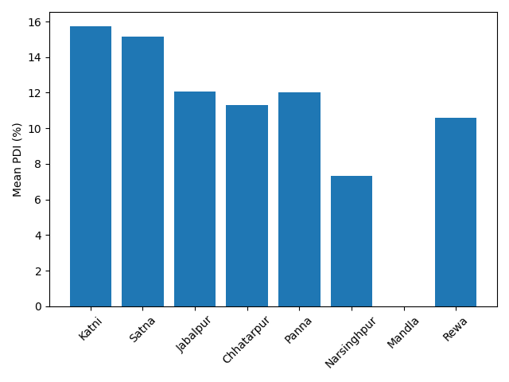
Fig. 1 Anthracnose disease severity in nearby betelvine growing areas of Madhya Pradesh during 2022-23

3.3 Periodic severity of anthracnose disease of betelvine in paan “bareja”
Periodic severity of anthracnose of betelvine was recorded in paan “bareja” of JNKVV, Jabalpur from July, 2022 to April, 2023. The results show that disease severity was 25.50 per cent in July, it increases up to 28.75per cent in August and 32.00 per cent in September. The severity was decrease from October to March. It was 0.00 per cent in the month of January, February and March their after it again increases. The peak disease incidence during the monsoon period can be attributed to high relative humidity and favourable temperature conditions, which promote pathogen infection and spread. The decline during winter months reflects unfavourable environmental conditions for pathogen development. These findings are in agreement with earlier reports indicating maximum anthracnose severity during the rainy season (Maity and Sen, 1982; Chattopadhyay and Maity, 1990).

Table 5. Periodic severity of anthracnose disease of betelvine at JNKVV, Jabalpur (2022–23)
S. No. | Months (2022-23) | PDI
1 | July | 25.50
2 | August | 28.75
3 | September | 32.00
4 | October | 10.50
5 | November | 5.50
6 | December | 1.50
7 | January | 0.00
8 | February | 0.00
9 | March | 0.00
10 | April | 0.00
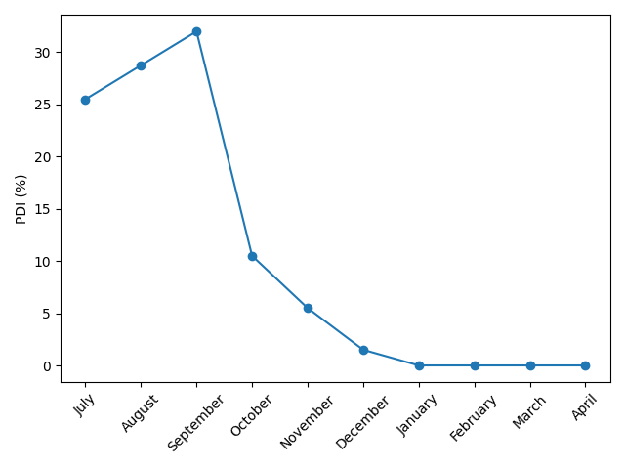
Fig 2. Periodic severity of anthracnose disease of betelvine at JNKVV, Jabalpur (2022–23)

3.4 Response of different betelvine cultivars against anthracnose
During the year 2022, sixteen betelvine cultivars were screened for their response against anthracnose disease under natural conditions in the paan bareja of Jawaharlal Nehru Krishi Vishwa Vidyalaya (JNKVV), Jabalpur. The plants were raised in pots with three replications. Among the cultivars evaluated, Karapaku recorded the lowest disease severity (5.00%) and was categorized as resistant (0–5% severity). Cultivars Kapooribihar (10.00%), Simaralibarna local (WB) (14.45%), Ghanegatte (WB) (18.38%), Mysore local (19.23%), Nov Bangle (20.22%), Bangla (22.34%) and Mysore Chiguru (24.34%) exhibited moderately resistant reactions, with disease severity ranging between 5 and 25 per cent. The remaining cultivars, namely SGM-1 (27.30%), Tellaku (Ponnur, AP) (28.35%), Swarna Kapoori (33.49%), Maghai (34.33%), Bali Pan (34.33%), Cuttak (35.47%), Yellow Leaf (AP) (39.34%) and Meetha Pan (WB) (43.34%), recorded 25–50 per cent disease severity and were categorized as susceptible. The results clearly indicated considerable variability among betelvine cultivars in their response to anthracnose under natural epiphytotic conditions. The resistant reaction of SGM-1 indicates the presence of inherent resistance, which can be effectively utilized in anthracnose management programmes. Similar resistance response of SGM-1 followed by Mahoba Bangia, Gandhi Pan and Utkal Sudam has been reported earlier by Biswas (2001). The identification of resistant and moderately resistant cultivars highlights the importance of host resistance as an eco-friendly and sustainable approach for managing anthracnose of betelvine.


Table. 6 Response of the different betelvine cultivars against C. capsici
S. No. | Name of Cultivar | Disease severity (%) | Cultivar reaction
1. | Tellaku (Ponnur,AP) | 28.35 | Susceptible
2. | MeethaPan(WB) | 43.34 | Susceptible
3. | Swarna Kapoori | 33.49 | Susceptible
4. | Maghai | 34.33 | Susceptible
5. | Nov bangle | 20.22 | Moderately Resistant
6. | SGM1 | 27.3 | Susceptible
7. | Mysore local | 19.23 | Moderately Resistant
8. | Mysore chiguru | 24.34 | Moderately Resistant
9. | Bali pan | 34.33 | Susceptible
10. | Simaralibarnalocal(WB) | 14.45 | Moderately Resistant
11. | Kapooribihar | 10.00 | Moderately Resistant
12. | Yellow leaf (AP) | 39.34 | Susceptible
13. | Ghanegatte(W) | 18.38 | Moderately Resistant
14. | Bangla | 22.34 | Moderately Resistant
15. | Cuttak | 35.47 | Susceptible
16. | Karapaku | 5.00 | Resistant

4. Conclusion

Anthracnose severity of betelvine varied significantly across districts and seasons in Madhya Pradesh. Maximum disease severity was recorded in Katni district, while Mandla remained disease-free. Cultivar SGM-1 showed resistant reaction and can be utilized effectively in integrated disease management programmes.

References

Biswas, S. (2001). Screening of betelvine cultivars against anthracnose caused by Colletotrichum spp. Journal of Mycopathological Research, 39(2), 87–90.

Chattopadhyay, S.B. & Maity, T.K. (1990). Diseases of betelvine and their management. Indian Phytopathology, 43(4), 561–565.

Guha, P. & Jain, R.K. (1997). Status and prospects of betelvine cultivation in India. Agricultural Reviews, 18(2), 89–95.

Maity, T.K. & Sen, C. (1982). Studies on anthracnose of betelvine. Indian Journal of Mycology and Plant Pathology, 12(3), 289–292.

Mayee, C.D. & Datar, V.V. (1986). Phytopathometry. Marathwada Agricultural University, Parbhani.

Singh, R.S. & Joshi, L.K. (1971). Survey of betelvine diseases in Madhya Pradesh. Indian Phytopathology, 24(3), 414–418.
.

