DEVELOPMENT AND EVALUATION OF AUTOMATED
FRUIT RIPENING CHAMBER

ABSTRACT
The development and evaluation of a fruit ripening chamber aim to provide a controlled environment for uniform, efficient, and safe ripening of fruits. Our project focuses on designing a chamber with optimal temperature, humidity, and ethylene gas regulation to accelerate ripening while maintaining fruit quality. The chamber is tested with various fruits, including bananas and mangoes, to evaluate its efficiency compared to traditional ripening methods. Key performance indicators such as ripening time, weight loss, firmness, color change, and sensory attributes are analyzed. The results indicate that the controlled ripening chamber significantly enhances fruit quality, reduces spoilage, and ensures safety by minimizing the use of harmful chemicals like calcium carbide. Our project concludes that the developed ripening chamber is a viable solution for commercial and small-scale fruit ripening operations.
Keywords: Ethylene gas, temperature, post-harvest technology, ripening, fruit

1.INTRODUCTION

Fruits are an essential component of the human diet because they provide important nutrients, vitamins, minerals, and antioxidants that contribute to human health. The quality, flavor, texture, and nutritional value of fruits are strongly influenced by the ripening process. Fruit ripening is a complex physiological and biochemical process that involves changes in color, texture, aroma, and taste due to metabolic activities within the fruit tissues (Prasanna et al., 2007; Seymour et al., 2013). Among the plant hormones involved in ripening, ethylene plays a crucial role in regulating the ripening of climacteric fruits such as banana, mango, papaya, and tomato (Barry & Giovannoni, 2007; Bapat et al., 2010).
Traditionally, fruits were allowed to ripen naturally after harvest. However, due to increasing market demand, transportation requirements, and supply chain pressures, artificial ripening techniques are widely used to accelerate the ripening process. In many developing countries, unsafe chemicals such as calcium carbide have sometimes been used to induce ripening, which poses serious health risks to consumers (Islam et al., 2016). Therefore, the use of controlled ripening chambers with safe ethylene gas is recommended for commercial fruit ripening.
Modern fruit ripening chambers are designed to provide controlled environmental conditions such as temperature, humidity, ventilation, and ethylene concentration to ensure uniform and safe ripening of fruits (Kader, 2002; Singh & Singh, 2019). Proper control of these parameters helps maintain fruit quality and extends shelf life during storage and transportation. Ethylene treatment in controlled environments significantly influences the physiological changes during ripening, including respiration rate, color development, and softening of fruit tissues (Kad et al., 2017; Saltveit, 1999).
With the advancement of technology, automated and intelligent systems have been introduced to improve the efficiency of ripening chambers. Recent developments in Internet of Things (IoT), gas sensors, and automated monitoring systems allow real-time control and monitoring of ripening conditions (Chen et al., 2019; Wang et al., 2025). These smart systems can detect gas concentrations, regulate temperature and humidity, and optimize the ripening process while minimizing human intervention. Additionally, technologies such as hyperspectral imaging and sensor-based monitoring have been explored to evaluate fruit ripeness and quality during storage and transportation (Zhang et al., 2020).
Low-cost ripening chamber designs have also been developed to support small and medium-scale fruit traders and farmers by providing affordable and efficient ripening solutions (Pujari et al., 2020). Such systems help maintain uniform ripening, reduce postharvest losses, and ensure better market value for fruits. Furthermore, advances in molecular biology and plant physiology have improved the understanding of fruit ripening mechanisms, enabling better control strategies for ripening processes (Giovannoni, 2004; Klee & Giovannoni, 2011).
Therefore, the development of an automated fruit ripening chamber is essential to ensure safe, efficient, and uniform fruit ripening while maintaining quality and minimizing health risks. Automation technologies combined with controlled environmental conditions can improve the overall performance of ripening systems and reduce manual intervention. The evaluation of such systems is necessary to assess their effectiveness in terms of ripening uniformity, energy efficiency, and fruit quality.
The present study focuses on the development and evaluation of an automated fruit ripening chamber designed to control key parameters such as temperature, humidity, and ethylene concentration. The system aims to provide a reliable and efficient method for ripening fruits while maintaining safety standards and improving postharvest management practices.
2.METHODOLOGY
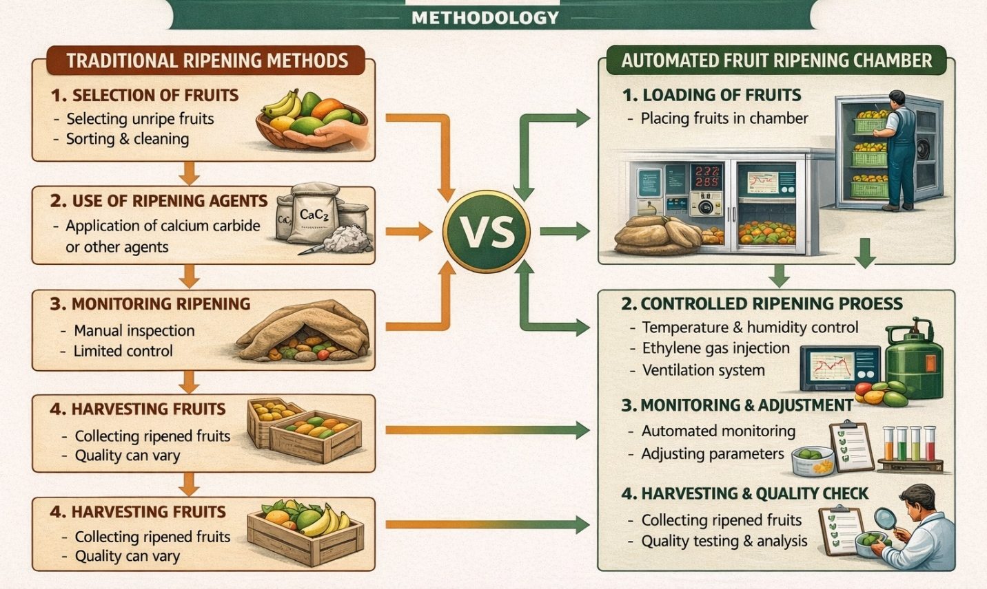
Figure.1.Methodology
3.DESIGN A FRUIT RIPENING CHAMBER
A fruit ripening chamber is a controlled environment designed to speed up the ripening of fruits like bananas, Sapota and mangoes. The chamber regulates temperature, humidity, and ethylene gas levels to ensure uniform ripening while maintaining fruit quality.
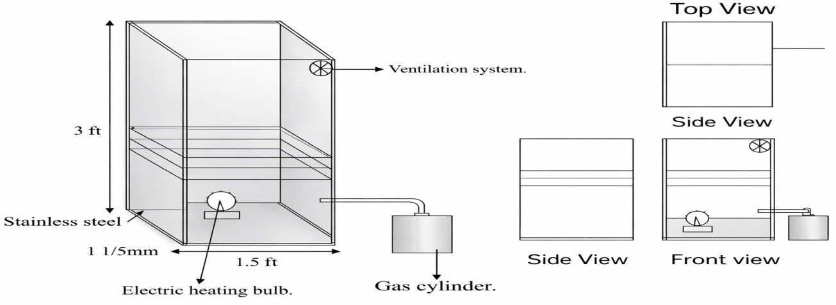
Figure.2.. 2D-design of fruit ripening chamber
Chamber Specification
- Outer Surface
  - Height:3ft Breadth:1.5ft
- Layer – 2Nos
- Bulb intensity-800 lumens
- Gas cylinder -2kg capacity Hollow cylinder

4.MATERIALS UTILIZES FOR FRUIT RIPENING CHAMBER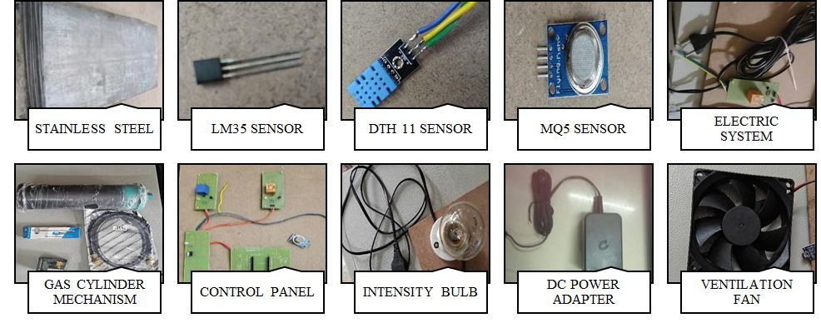

Figure 3.Materials used

PROPERTIES
- Outer Body: Stainless steel or mild steel sheets (3mm thick) for durability and insulation.
- Shelves: Stainless steel mesh or perforated metal sheets to allow proper air circulation.
- Heating Element: Electric heating bulb to maintain the required temperature.
- Ventilation System: Small exhaust fans or vents to control humidity and gas release.
- Gas System: Connection for an external gas cylinder to introduce ethylene or other ripening agents.

5.FABRICATION PROCESS
The ripening chamber is fabricated by cutting and welding stainless-steel sheets to form a rigid box-type enclosure. Inside the chamber, metallic shelves are fixed at equal intervals to ensure uniform fruit arrangement and proper exposure to the internal environment. A hinged door is mounted to provide convenient access while maintaining an effective seal. For thermal regulation, a heating bulb is installed at an appropriate central position to distribute heat evenly, and a thermostat or temperature controller is integrated to maintain the desired temperature range automatically.
Ventilation is provided by placing a small exhaust fan near the upper section of the chamber to expel excess heat and accumulated gases, along with side perforations that allow controlled air circulation. An external gas cylinder is connected through an inlet tube to introduce ethylene for ripening, and a regulator is fitted to manage the gas flow and avoid over-concentration. The electrical components—including the heating bulb, fan, and controllers—are wired to a power supply using properly insulated connections. Safety provisions such as proper grounding, along with a fuse or circuit breaker, are incorporated to prevent electrical hazards and ensure reliable operation.
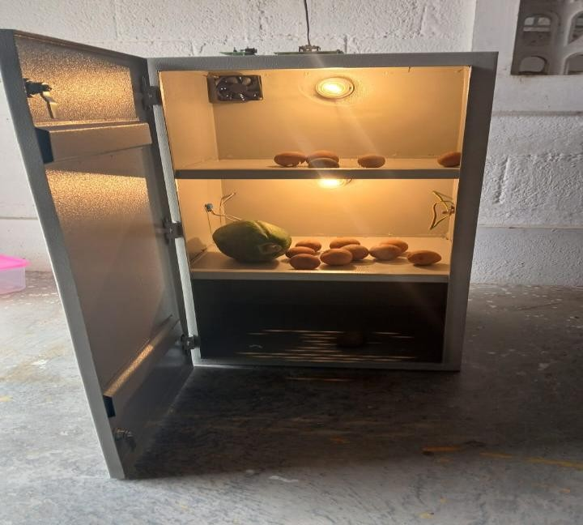
FIGURE .4. FRUIT RIPENING CHAMBER

6.WORKING PRINCIPLE
A fruit ripening chamber creates a controlled environment by regulating temperature, humidity, and ethylene gas to accelerate ripening while preserving quality. Insulated walls ensure energy efficiency, while automated systems maintain optimal conditions (15–25°C temperature and 85–95% humidity). Ethylene gas triggers biochemical changes, enhancing color, texture, and flavor. Ventilation ensures even gas distribution and prevents harmful buildup. Monitoring systems allow real-time adjustments for uniform ripening. Performance evaluation considers ripening time, fruit quality, and energy efficiency to optimize the process for commercial use. Fruit ripening is accompanied by a number of biochemical events, including changes in color, sugar, acidity, texture, and aroma volatiles that are crucial for the sensory quality.
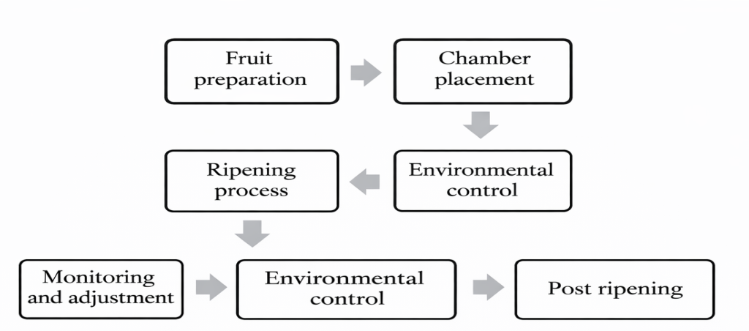
Figure.5.Working Process
- Fruit Preparation: Fruits are harvested at a mature but unripe stage to allow for controlled ripening.
- Chamber Placement: Fruits are placed in the ripening chamber, ensuring good air circulation.
- Environment Control: The chamber's systems regulate temperature, humidity, ethylene levels, and air circulation to create an optimal environment for ripening.
- Ripening Process: The controlled environment accelerates the natural ripening process, leading to changes in color, texture, and flavor.
- Monitoring and Adjustment: Sensors and control systems constantly monitor the ripening process and make adjustment as needed to maintain optimal conditions.
- Post-Ripening: Once the desired level of ripeness is achieved, the fruits are removed from the chamber and prepared for storage or distribution.
7.RESULT AND DISCUSSION
7.1.AUTOMATED RIPENING CHAMBER
The fabricated fruit ripening chamber successfully maintained optimal conditions for controlled ripening. The stainless-steel structure provided durability, corrosion resistance, and easy cleaning. The temperature sensor accurately monitored and maintained temperatures between 18-25°C, ensuring uniform ripening. The humidity sensor effectively controlled moisture levels within the 85-95% range, preventing fruit dehydration. The gas sensor efficiently detected ethylene and CO levels, allowing proper ventilation through the exhaust fan system. The heating bulb, with a 100W to 250W capacity, provided consistent warmth, preventing cold stress. Overall, the chamber facilitated faster, more uniform ripening compared to natural methods while minimizing spoilage and energy consumption. Minor improvements, such as better airflow distribution and automated control systems, could further enhance performance.
Fruits used for analysis
- Banana
- Sapota
- papaya
8. TRADITIONAL METHODS
SMOKING EXPOSURE FOR BANANA RIPENING
Smoking exposure is a traditional method where mature green bananas are placed in an enclosed room and exposed to smoke from burning straw or dried leaves. The trapped smoke and heat (30–40°C) stimulate ethylene action, accelerating ripening within 3–5 days.Care must be taken to avoid excessive heat, as it may cause uneven ripening and higher weight loss.
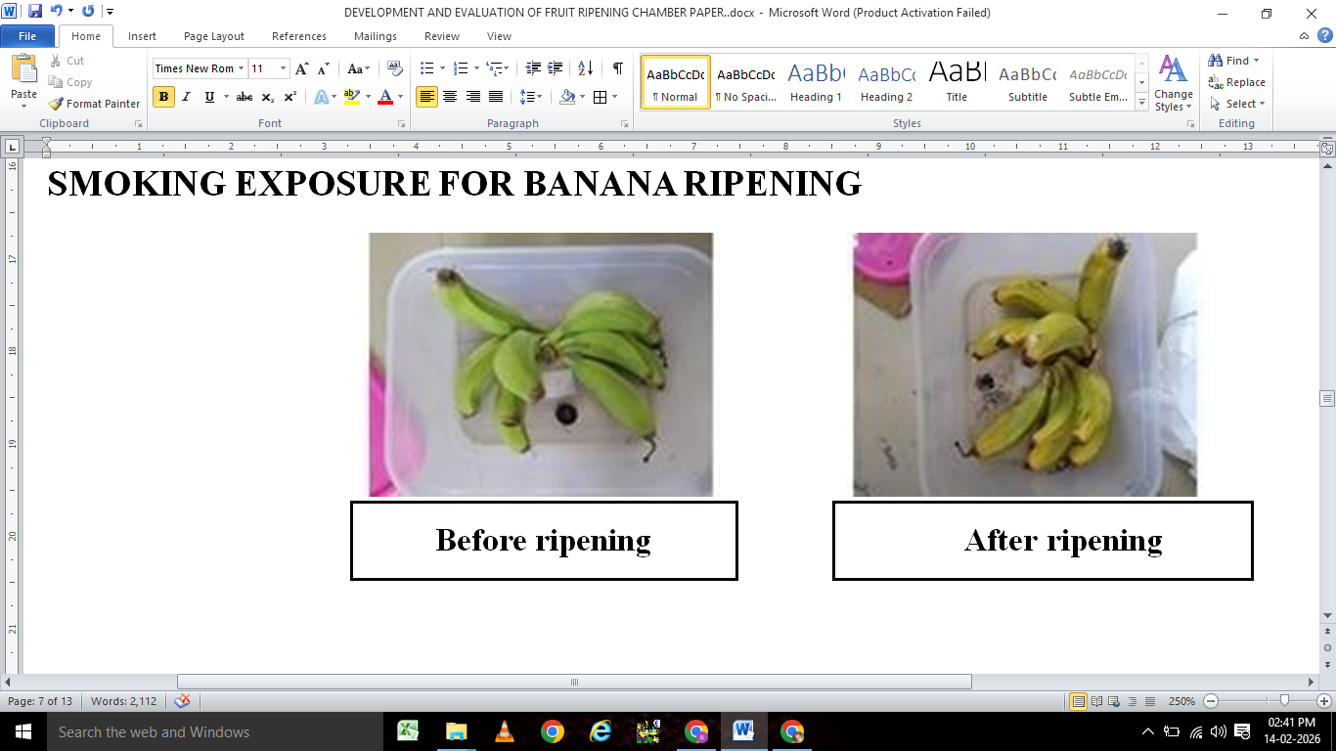
Figure.6. Visual Comparison of Bananas Before and After Ripening Using the Traditional Smoking Exposure Method.

PAPER WRAPPING FOR PAPAYA RIPENING
Paper wrapping is a traditional method used for papaya ripening in which mature green papayas are individually wrapped in newspaper or brown paper and kept at room temperature. The wrapping traps natural ethylene gas released by the fruit, creating a warm microenvironment that accelerates uniform ripening within 3–5 days. This method is simple and low-cost but may result in slight weight loss if stored for longer durations.
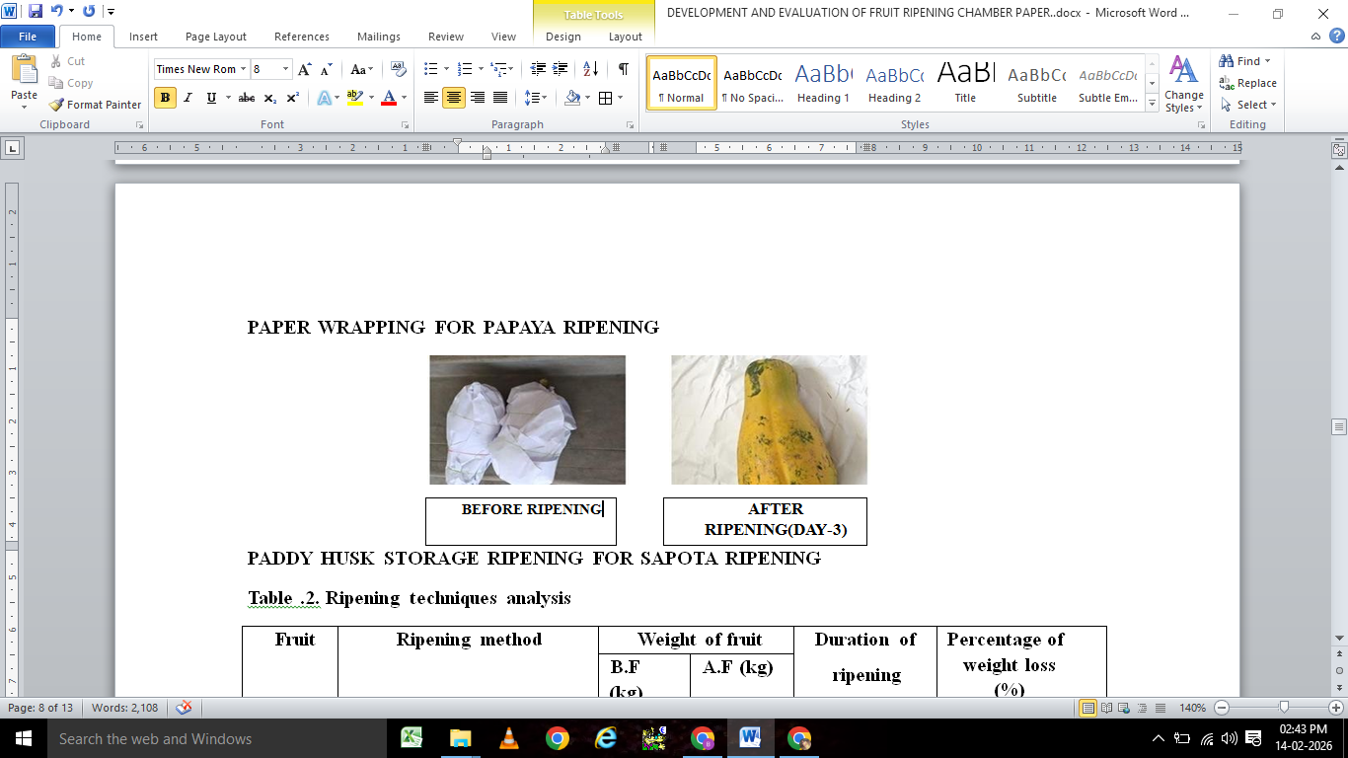
Figure.7. Visual Comparison of Papaya Before and After Ripening Using the Paper Wrapping Method (Day 3).
PADDY HUSK STORAGE RIPENING FOR SAPOTA RIPENING
Paddy husk storage is a traditional method used for sapota (chikoo) ripening, where mature green fruits are buried or layered in dry paddy husk and kept at room temperature. The husk acts as an insulating medium, retaining heat and trapping natural ethylene released by the fruits, thereby accelerating uniform ripening within 3–6 days. Although simple and low-cost, this method may cause higher weight loss and uneven ripening if moisture and temperature are not properly maintained.
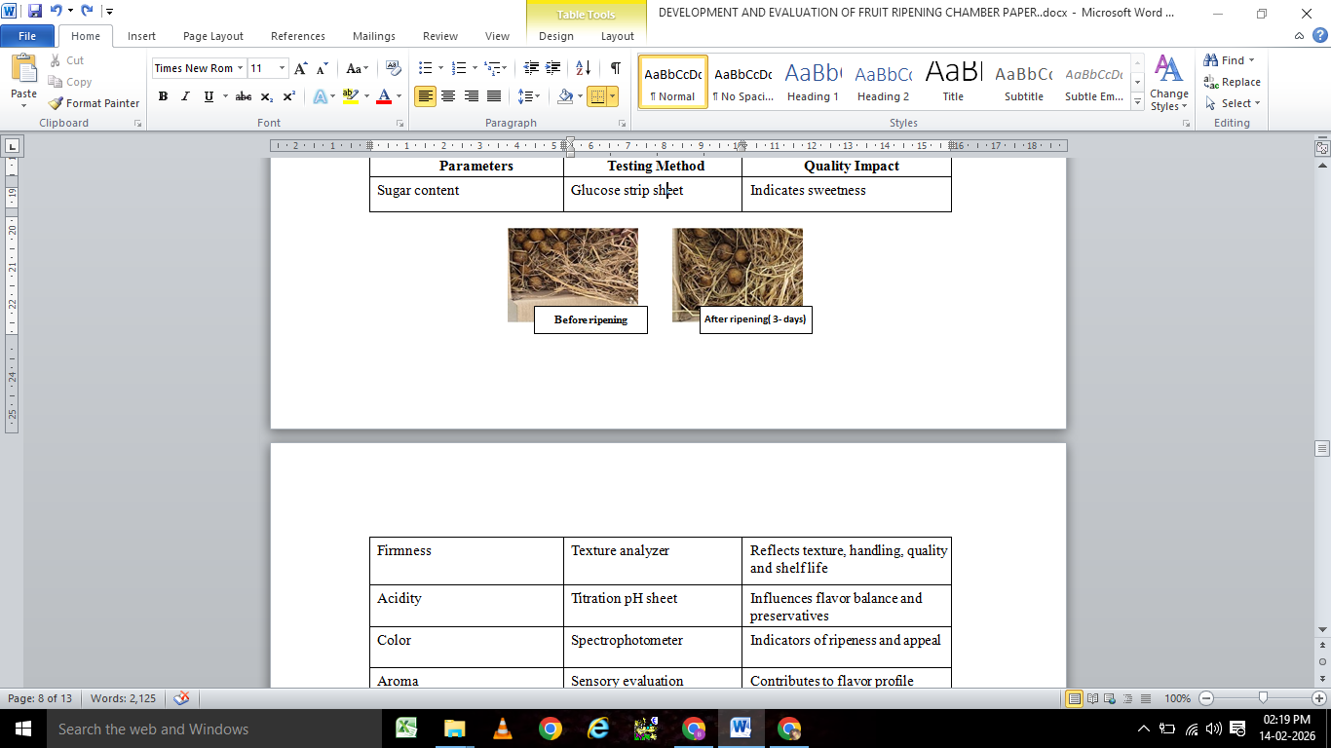
Figure 8.Effect of Paddy Husk Storage on Sapota Ripening: Comparative Visual Observation Before Treatment and After 3 Days of Storage.
9. COMPARATIVE ANALYSIS
Table .1. Ripening techniques analysis
Fruit | Ripening method | Weight of fruit |  | Duration of  ripening process  (hrs.) | Percentage of weight loss (%)
Fruit | Ripening method | B.F (kg) | A.F (kg) | Duration of  ripening process  (hrs.) | Percentage of weight loss (%)
Banana | Smoke exposure | 3 | 2.82 | 65 | 16
Banana | Chamber analysis | 3 | 2.95 | 16 | 5
Papaya | Paper wrapping | 1.2 | 1.15 | 75 | 10
Papaya | Chamber analysis | 1.5 | 1.48 | 18 | 2
Sapota | Paddy husk | 2 | 1.72 | 58 | 23
Sapota | Chamber analysis | 2 | 1.93 | 10 | 7
B.R-before ripening; A.R-after ripening
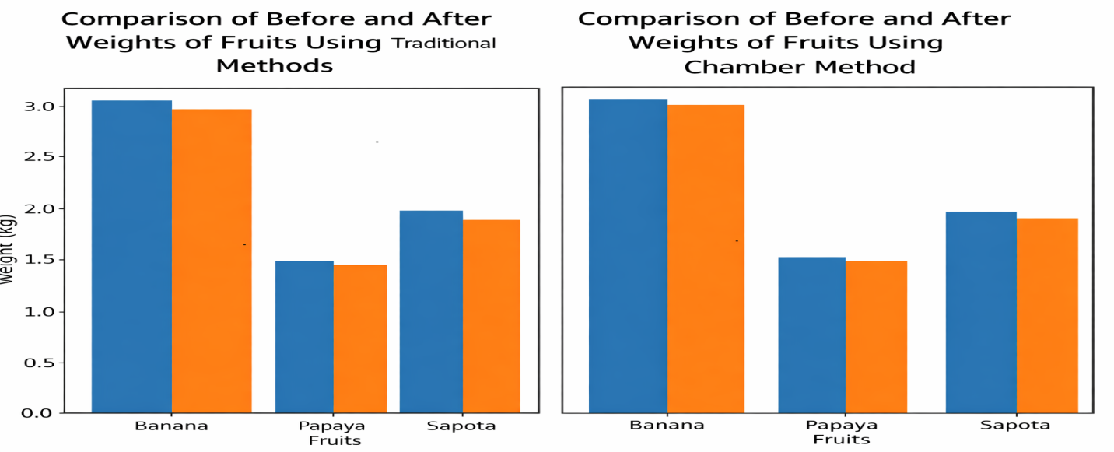
Figure 9. Comparative Analysis of Before and After Fruit Weights Using Traditional and Chamber Methods
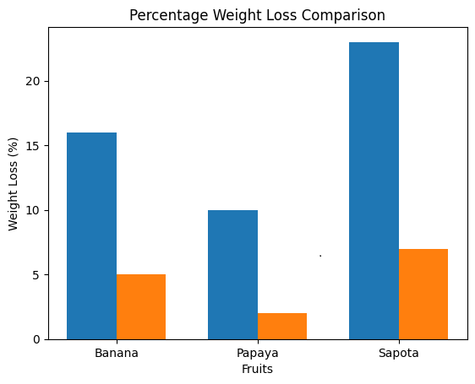
Figure 10. Comparison of Percentage of weight loss Traditional method and Automated Ripening chamber
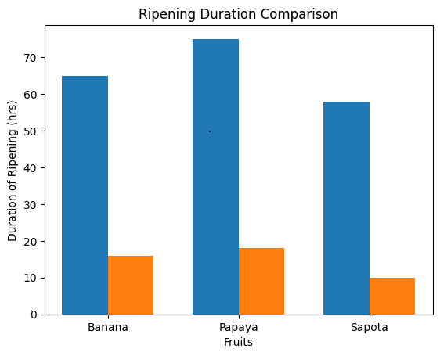
Figure.11.Comparison of Ripening Duration of Fruits Under Traditional and Chamber Methods
The results clearly show that the chamber analysis method is significantly more efficient than traditional ripening methods such as smoke exposure, paper wrapping, and paddy husk treatment. In all three fruits, the chamber method drastically reduced ripening time—banana from 65 to 16 hours, papaya from 75 to 18 hours, and sapota from 58 to 10 hours—indicating the effectiveness of controlled environmental conditions in accelerating physiological ripening processes. Additionally, percentage weight loss was considerably lower under chamber ripening, with banana reducing from 16% to 5%, papaya from 10% to 2%, and sapota from 23% to 7%. The higher weight loss observed in traditional methods can be attributed to uncontrolled temperature and humidity, prolonged ripening duration, and increased moisture evaporation. In contrast, the chamber maintains optimal humidity and temperature, minimizing transpiration and respiration losses while ensuring uniform ripening. Overall, the chamber method improves ripening efficiency, reduces post-harvest losses, and enhances economic returns, making it a superior alternative to conventional ripening practices.
Table.2. Fruit Quality Parameters in automated Ripening Chamber
Parameters | Testing Method | Quality Impact
Sugar content | Glucose strip sheet | Indicates sweetness
Firmness | Texture analyzer | Reflects texture, handling, quality and shelf life
Acidity | Titration pH sheet | Influences flavor balance and preservatives
Color | Spectrophotometer | Indicators of ripeness and appeal
Aroma | Sensory evaluation | Contributes to flavor profile
Moisture content | Hot air oven method | Affects texture, storage and spoilage rates

Glucose evaluation test- strip sheet
Mash a banana sample with distilled water, extract the liquid, and dip a glucose test strip in it. Compare the color on the strip to a reference chart to estimate the sugar concentration.

Sugar content TEST

Conversion formulas: mg/dl × 0.0555 = mmol/l; mmol/l × 18.018 = mg/dl.
Glucose Level For Mango = 314 mg/dl
Glucose Level For Banana = 317 mg/dl
Glucose Level For Sapota = 345 mg/dl

Acidity – pH test
The pH test for fruits is a simple yet informative method used to determine the acidity or alkalinity of various fruit samples. Using either pH test strips or a digital pH meter, each fruit is typically prepared in the form of juice, mash, or extract to ensure accurate testing.
pH-sheet TEST Comparison by

Fruit Estimated pH Acidity
Mango ~4.0 Moderately acidic
Banana ~4.5–5.0 Mild to moderately acidic
Sapodilla ~5.5–6.0 Slightly acidic

Sensory evaluation sheet
A sensory evaluation sheet is a tool used to systematically record and assess the sensory qualities of food, beverages, or other products based on characteristics like appearance, aroma, flavor, texture, and overall acceptability.



Figure.12. Sensory Evaluation form

Fruit ripening is a crucial stage in post-harvest handling that significantly influences fruit quality, market value, shelf life, and consumer acceptance. During ripening, fruits undergo several physiological and biochemical changes such as increased respiration rate, ethylene production, conversion of starch into sugars, softening of tissues, development of color, and formation of characteristic aroma and flavor. Traditionally, farmers and traders have used various conventional techniques to accelerate fruit ripening. These methods include smoke exposure for bananas, paper wrapping for papaya, and paddy husk storage for sapota. Although these methods are simple and inexpensive, they often lack environmental control, resulting in uneven ripening, higher weight loss, and reduced fruit quality. In the present study, an automated fruit ripening chamber was designed and fabricated to provide controlled environmental conditions for efficient and uniform ripening. The performance of this chamber was compared with traditional ripening methods using banana, papaya, and sapota fruits.
The automated ripening chamber was constructed using a stainless-steel structure, which offers durability, corrosion resistance, and easy cleaning. Stainless steel is commonly used in food processing and post-harvest handling systems because it maintains hygienic conditions and prevents contamination. The use of a stainless-steel structure ensures that the chamber can withstand repeated use without deterioration. Maintaining proper hygiene during fruit ripening is essential because fruits are susceptible to microbial contamination, which may lead to spoilage and reduced shelf life.
Temperature is one of the most important factors influencing the ripening process. Climacteric fruits such as banana, papaya, and sapota require an optimum temperature range to trigger the physiological changes associated with ripening. In the automated ripening chamber, the temperature sensor effectively monitored and maintained the temperature between 18°C and 25°C, which is considered suitable for controlled ripening. This temperature range supports enzymatic activities that convert starch into sugars, degrade chlorophyll pigments, and promote the formation of carotenoids responsible for fruit color. As a result, fruits ripened under these conditions develop improved sweetness, attractive appearance, and better flavor. In traditional ripening methods, temperature is not regulated and depends largely on ambient environmental conditions, which may lead to inconsistent ripening.
Humidity is another important parameter that affects fruit quality during ripening. Fruits contain a high percentage of water, and excessive moisture loss can lead to shrinkage, reduced weight, and loss of freshness. The humidity sensor in the automated ripening chamber maintained relative humidity levels between 85% and 95%, which is considered ideal for reducing dehydration and maintaining fruit firmness. By maintaining high humidity, the chamber minimizes water loss through transpiration and preserves the natural texture of the fruits. In contrast, traditional ripening methods expose fruits to uncontrolled humidity conditions, which often results in higher moisture loss and increased weight reduction.
The automated ripening chamber also included a gas sensor capable of detecting ethylene and carbon monoxide levels. Ethylene is a natural plant hormone that plays a key role in initiating and regulating fruit ripening. Climacteric fruits produce ethylene during the ripening process, which accelerates respiration and stimulates biochemical changes within the fruit tissues. Monitoring ethylene concentration is important to ensure that the ripening process proceeds efficiently without causing over-ripening. The gas sensor helped detect ethylene levels inside the chamber and allowed proper ventilation through an exhaust fan system. This maintained a balanced ripening environment and ensured uniform ripening of fruits.
A heating bulb with a power capacity ranging from 100 W to 250 W was installed in the chamber to maintain the required temperature. This heating system ensured consistent warmth inside the chamber and prevented cold stress, which could delay the ripening process. The heating bulb helped maintain stable environmental conditions and promoted uniform ripening across all fruits stored in the chamber.
The comparative analysis between traditional ripening methods and the automated ripening chamber clearly demonstrates the advantages of controlled ripening conditions. For banana, the traditional smoke exposure method required approximately 65 hours for ripening, whereas the automated chamber reduced the ripening time to 16 hours. Smoke exposure is a common traditional technique where bananas are placed in an enclosed room and exposed to smoke generated from burning straw or dried leaves. The heat and smoke stimulate ethylene activity and accelerate ripening. However, the temperature during this process is often uncontrolled and may reach 30–40°C, which can lead to uneven ripening and increased moisture loss.
For papaya, the traditional paper wrapping method required about 75 hours for ripening, whereas the automated chamber reduced the ripening duration to 18 hours. In this method, papayas are wrapped in newspaper or brown paper to trap the ethylene gas naturally released by the fruit. This creates a small microenvironment that encourages ripening. Although this technique is simple and cost-effective, it lacks proper environmental control and may result in inconsistent ripening outcomes.
In the case of sapota, the traditional paddy husk storage method required approximately 58 hours, whereas the automated chamber reduced the ripening time to 10 hours. In this method, sapota fruits are buried or layered in dry paddy husk, which acts as an insulating material that retains heat and traps ethylene gas. While this method helps accelerate ripening, it does not provide controlled environmental conditions and may result in uneven ripening and higher weight loss.
Another important observation from the comparative analysis is the difference in percentage weight loss between traditional methods and the automated chamber. Bananas ripened using smoke exposure experienced a weight loss of 16%, while bananas ripened in the automated chamber showed only 5% weight loss. Similarly, papayas ripened using paper wrapping showed 10% weight loss, whereas papayas ripened in the chamber showed only 2% weight loss. Sapota fruits ripened using paddy husk storage experienced the highest weight loss of 23%, while sapota fruits ripened in the chamber showed a reduced weight loss of 7%. The higher weight loss in traditional methods can be attributed to uncontrolled temperature, lower humidity, and longer ripening duration, which increase transpiration and respiration rates.
The evaluation of fruit quality parameters further confirmed the effectiveness of the automated ripening chamber. Sugar content is an important indicator of fruit ripeness and sweetness. During ripening, starch present in fruits is converted into simple sugars such as glucose and fructose. In this study, sugar content was measured using glucose strip sheets. The results indicated glucose levels of 317 mg/dl for banana, 314 mg/dl for mango, and 345 mg/dl for sapota, demonstrating that the fruits developed adequate sweetness during ripening.
The acidity level of fruits was determined using pH test strips. Acidity plays a significant role in determining the flavor and preservation quality of fruits. The pH values obtained in the study were approximately 4.0 for mango, 4.5–5.0 for banana, and 5.5–6.0 for sapota, which are typical values for properly ripened fruits. These acidity levels contribute to a balanced taste and improved flavor.
The sensory evaluation of fruits was conducted using a sensory evaluation sheet to assess characteristics such as appearance, color, aroma, texture, and overall acceptability. Fruits ripened in the automated chamber generally showed better sensory attributes compared to fruits ripened using traditional methods. The controlled environmental conditions promoted uniform color development, pleasant aroma formation, and desirable fruit texture.
Moisture content analysis using the hot air oven method also indicated that fruits ripened in the chamber retained better moisture levels compared to those ripened using traditional techniques. Maintaining appropriate moisture content is essential for preserving fruit texture, freshness, and shelf life.
Overall, the results of this study clearly indicate that the automated ripening chamber provides significant advantages over traditional ripening methods. The chamber reduces ripening time, minimizes weight loss, and improves fruit quality by maintaining controlled temperature, humidity, and gas concentration. These features ensure uniform ripening and reduce the risk of spoilage.
In addition to improving fruit quality, the automated ripening chamber also offers economic benefits for farmers and fruit traders. Faster ripening allows fruits to reach the market more quickly, reducing storage time and transportation costs. Reduced weight loss and improved fruit quality can increase market value and profitability. Furthermore, automated ripening systems reduce the dependence on unsafe chemical ripening agents such as calcium carbide, thereby ensuring safer and healthier fruits for consumers.
In conclusion, the automated fruit ripening chamber developed in this study proved to be an efficient and reliable technology for controlled fruit ripening. The chamber successfully maintained optimal environmental conditions, accelerated the ripening process, reduced post-harvest losses, and improved fruit quality. These findings highlight the potential of automated ripening technology as an effective solution for modern post-harvest management of fruits and for improving the overall efficiency of fruit marketing systems.
11.CONCLUSION AND FUTURE SCOPE
A fruit ripening chamber is an effective and controlled environment designed to accelerate and manage the ripening process of fruits. By controlling temperature, humidity, and ethylene gas concentration, ripening chambers enable uniform ripening, improved quality, and longer shelf life of fruits. These chambers are widely used for fruits like bananas, mangoes, and sapotas, ensuring that the fruits reach their peak ripeness while maintaining flavor, texture, and nutritional value.
Uniform Ripening: Ensures that all fruits ripen at the same time and to the same quality, reducing wastage due to uneven ripening.
Quality Maintenance: Preserves the natural taste, color, and texture of fruits, offering a better consumer experience.
Extended Shelf Life: By controlling the ripening environment, fruits can be stored for longer periods without losing their freshness, reducing post-harvest losses.
Increased Efficiency: Fruit ripening chambers optimize the ripening process, saving time and labor, and helping farmers and distributors achieve better market timing.
Issue faced during the analysis:
- Energy Consumption: Ripening chambers need a consistent supply of energy, which could lead to higher operational costs.
- Maintenance: Regular monitoring and maintenance are required to ensure optimal working conditions and prevent system failures.
In conclusion, a fruit ripening chamber is a valuable tool in modern agriculture and postharvest management, ensuring high-quality produce reaches consumers efficiently. While the setup can be costly, the benefits of reduced waste, improved quality, and extended shelf life make it a worthwhile investment for large-scale fruit growers and distributors.

REFERENCES
- Bapat, V. A., Trivedi, P. K., Ghosh, A., Sane, V. A., Ganapathi, T. R., & Nath, P. (2010). Ripening of fleshy fruit: Molecular insight and the role of ethylene. Biotechnology Advances, 28(1), 94–107. https://doi.org/10.1016/j.biotechadv.2009.10.002
- Barry, C. S., & Giovannoni, J. J. (2007). Ethylene and fruit ripening. Journal of Plant Growth Regulation, 26(2), 143–159. https://doi.org/10.1007/s00344-007-9002-y
- Chen, Y., Wang, X., & Li, Y. (2019). Intelligent monitoring system for fruit ripening based on IoT sensors. Computers and Electronics in Agriculture, 162, 528–536. https://doi.org/10.1016/j.compag.2019.04.021
- Giovannoni, J. J. (2004). Genetic regulation of fruit development and ripening. The Plant Cell, 16(suppl_1), S170–S180. https://doi.org/10.1105/tpc.019158
- Gupta, A., Pal, R. K., & Rajam, M. V. (2013). Delayed ripening and improved fruit processing quality in tomato by RNAi-mediated silencing of ACC synthase genes. Journal of Plant Physiology, 170(11), 987–995. https://doi.org/10.1016/j.jplph.2013.02.003
- Islam, M. N., Mursalat, M., & Khan, M. S. (2016). A review on the legislative aspect of artificial fruit ripening. Agriculture & Food Security, 5(8). https://doi.org/10.1186/s40066-016-0057-5
- Kad, V. P., Dhemre, J. K., Doke, N. D., Kadam, D. G., & Patil, R. V. (2017). Effect of ethylene on physiological changes during ripening of mango (Mangifera indica L.) cv. Kesar. Indian Journal of Agricultural Research, 51(5), 437–442. https://doi.org/10.18805/IJARe.A-4829
- Kader, A. A. (2002). Postharvest technology of horticultural crops. Horticultural Reviews, 28, 1–26. https://doi.org/10.1002/9780470650851.ch1
- Klee, H. J., & Giovannoni, J. J. (2011). Genetics and control of tomato fruit ripening and quality attributes. Annual Review of Genetics, 45, 41–59. https://doi.org/10.1146/annurev-genet-110410-132507
- Kumar, P., Tripathi, S., Deshmukh, R. K., Meshram, B. P., Lavanya, & Gaikwad, K. K. (2026). Emerging smart packaging materials and technologies for ethylene detection and freshness monitoring in fresh produce. Sustainable Food Technology, 4, 164–182. https://doi.org/10.1039/D5FB00379B
- Liu, M., Wang, C., Ji, H., Sun, M., Liu, T., Wang, J., & Zhu, Q. (2024). Ethylene biosynthesis and signal transduction during ripening and softening in non-climacteric fruits: An overview. Frontiers in Plant Science, 15. https://doi.org/10.3389/fpls.2024.1368692
- Prasanna, V., Prabha, T. N., & Tharanathan, R. N. (2007). Fruit ripening phenomena: An overview. Critical Reviews in Food Science and Nutrition, 47(1), 1–19. https://doi.org/10.1080/10408390600976841
- Pujari, K. H., Mehta, V. B., & Jogalekar, V. (2020). A low-cost fruit ripening chamber. Acta Horticulturae, 1278, 165–170. https://doi.org/10.17660/ActaHortic.2020.1278.21
- Saltveit, M. E. (1999). Effect of ethylene on quality of fresh fruits and vegetables. Postharvest Biology and Technology, 15(3), 279–292. https://doi.org/10.1016/S0925-5214(98)00091-X
- Seymour, G. B., Taylor, J. E., & Tucker, G. A. (2013). Biochemistry of fruit ripening. Annual Review of Plant Biology, 64, 219–241. https://doi.org/10.1146/annurev-arplant-050312-120204
- Singh, R., & Singh, A. P. (2019). Postharvest technology of fruits and vegetables for shelf life extension. Journal of Food Science and Technology, 56(5), 2399–2412. https://doi.org/10.1007/s13197-019-03747-1
- Wang, X., Zhang, Y., Chen, H., & Li, Z. (2025). Flexible gas sensing systems for monitoring fruit ripeness in cold chain storage and transportation. Journal of Cleaner Production, 501, 145270. https://doi.org/10.1016/j.jclepro.2025.145270
- Yahia, E. M. (2011). Modified and controlled atmospheres for the storage, transportation, and packaging of horticultural commodities. Stewart Postharvest Review, 7(1). https://doi.org/10.2212/spr.2011.1.1
- Zhang, J., Huang, W., & Li, J. (2020). Hyperspectral imaging for monitoring fruit ripeness and quality. Food Engineering Reviews, 12(3), 405–425. https://doi.org/10.1007/s12393-020-09233-4
- Zhu, Q., Gao, P., Liu, S., Zhu, Z., Amanullah, S., Davis, A. R., & Luan, F. (2017). Comparative transcriptome analysis reveals molecular regulation of fruit ripening. Scientific Reports, 7, 43368. https://doi.org/10.1038/srep43368

