Case report

Successful Management of Dilated Intrahepatic and Extrahepatic Ducts with Adenocarcinoma of the Pancreatic Head: A Case Report.

Abstract
More than 90% of cases of pancreatic cancer are adenocarcinomas, making them the most prevalent kind of the disease. This cancer develops in the pancreatic duct lining.
Adenocarcinoma may also arise from the cells that produce pancreatic enzymes. Abdominal pain, diarrhoea, nausea, weight loss and jaundice are features of adenocarcinoma. A rise in enzymes might cause joint discomfort and skin rashes in certain patients. Pancreatic head adenocarcinoma is a major cause of malignant biliary obstruction and frequently manifests as simultaneous intrahepatic and extrahepatic duct dilatation.
A 76-year-old male presented to the hospital with 3-days diarrhoea. Diagnosis showed tumour head of pancreas, leading to hepatobiliary obstruction, manifesting with pruritis, weight loss and loss of appetite. Initial CT scan, CA markers and other biochemical parameters were very abnormal. The patient initially received endoscopic stent placement and later surgery (Whipple’s procedure) to remove the tumour. Histology showed grade 1A adenocarcinoma. 6-cycle, 12 sessions of chemotherapy was done fortnightly, with paclitaxel and gemcitabine-based drugs. During these therapies, the elevated markers gradually reduced with variations in some biochemical parameters. Later CT scan showed no mass or calcification on the pancreas and no biliary dilatation.
Well differentiated adenocarcinoma of the pancreas can be treated when discovered early as poorly differentiated adenocarcinoma is very aggressive. Multidisciplinary individualized treatment is essential and should be utilized.

Keywords: Adenocarcinoma, intrahepatic bile duct dilatation, extrahepatic bile duct dilatation, chemotherapy, Whipple’s procedure.

INTRODUCTION
More than 90% of cases of pancreatic cancer are adenocarcinomas, making them the most prevalent and common gastrointestinal cancer disease, with poor prognosis (Siegel, et al., 2017). This cancer develops in the pancreatic duct lining. Adenocarcinoma may also arise from the cells that produce pancreatic enzymes. Abdominal pain, diarrhoea, nausea, weight loss and jaundice are features of adenocarcinoma (Hruban & Adsay, 2009). A rise in enzymes might cause joint discomfort and skin rashes in certain patients. Challenges to effective screening for pancreatic cancer include low disease prevalence and high cost of screening techniques such as endoscopic ultrasound and cross-sectional imaging (Berger et al., 2008). Interestingly, it is a disease that typically affects older adults and is slightly more common in men and African-Americans. Although pancreatic cancer is relatively uncommon in comparison to other more prevalent cancers (such as colorectal, lung, prostate, etc.), it is the fourth most common cause of death for both men and women.

CASE PRESENTATION
A 76-year-old male presented to the hospital with 3-days diarrhoea. Initial laboratory tests were within normal range. However, the patient returned 3-days later with body itching and jaundice. The physical examination showed no palpable mass but the next set of laboratory analysis showed normal electrolyte, urea but highly elevated creatinine (>120mmol/l), liver enzymes; ASP and ALT were raised, however, the ALP was over a 1000 u/l.
• Total protein - 89g/l; Albumin – 42g/l
• ALP: >1000 U/L
• AST: 95 U/L; ALT: 110 U/L
• CA 19-9: 860 U/mL
• Complete blood count: varied
- GGT: 80U/L
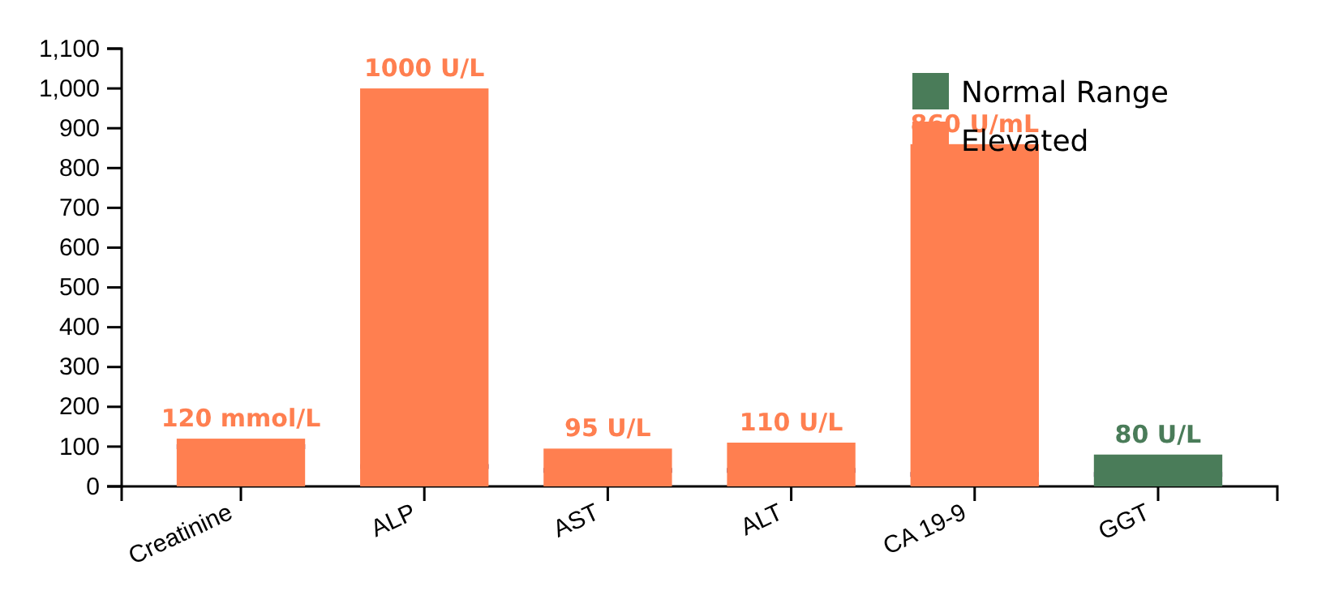
Fig. 1. Laboratory Test of the Patient
Imaging before ERCP: CT scan with contrast showed Gall bladder hydrops, dilated intrahepatic and extrahepatic ducts dilatation, enlarged pancreatic head with double ducts sign measuring 38.9cm and no distant metastasis. Conclusion of the findings includes:
- Ca head of pancreas – Dd: Periampullary tumours
ERCP: Biliary stenting achieved. There was no brush cytology.
Imaging after ERCP: CT scan with contrast showed that the 38.9cm mass in the pancreatic head had reduced to 4.07cm, with a remarkable positive change in size and biochemical parameters.
The radiology image after stenting is shown below:
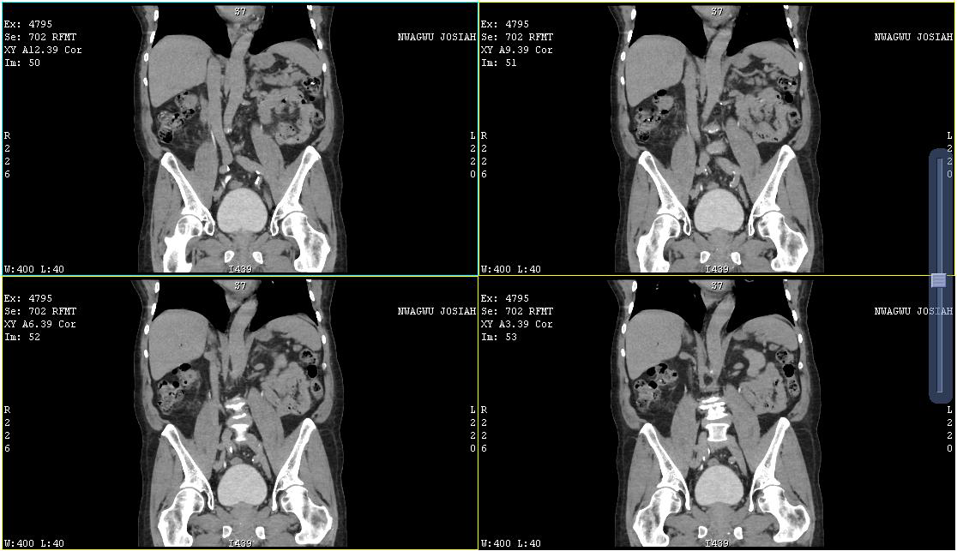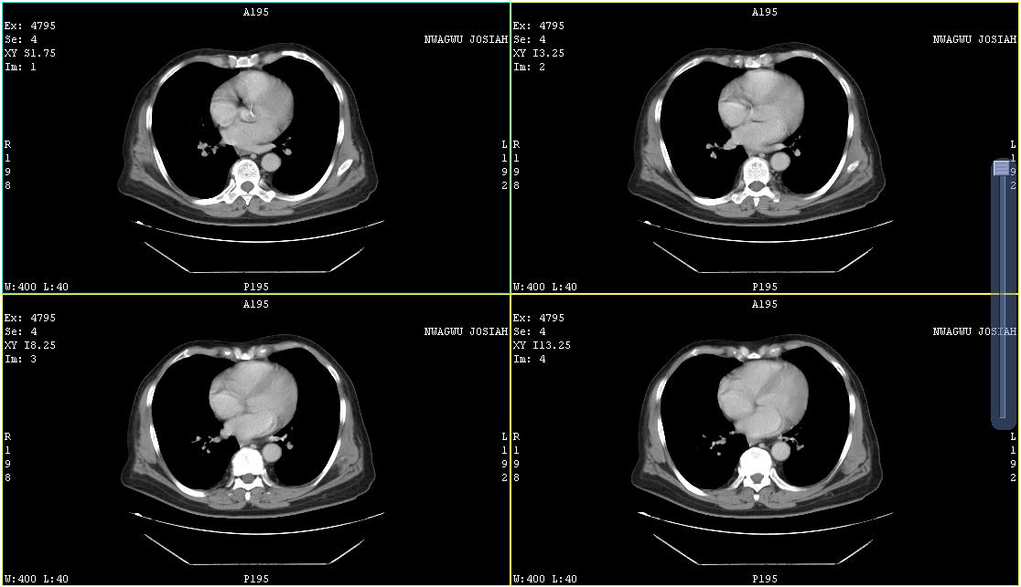
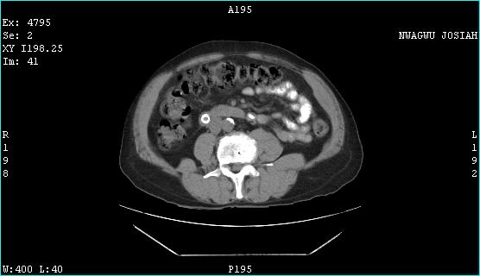
Fig. 2. Radiology image
The patient showed better appetite and absence of pruritus. The biochemical parameters also reduced drastically.
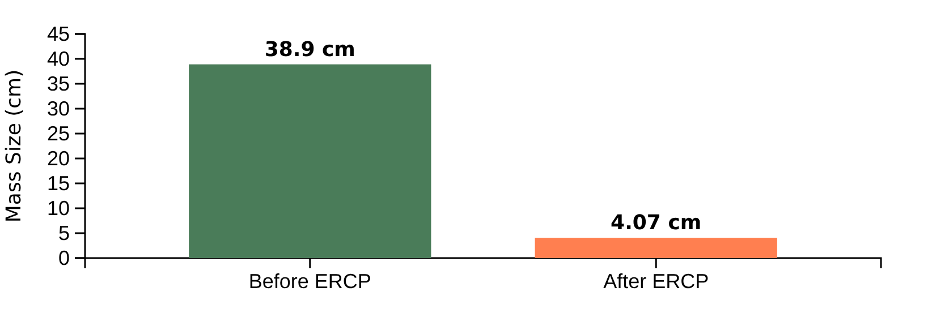
Fig. 3. Mass size before and after ERCP
Management: On further examination, surgery (Whipple’s procedure) was scheduled to remove the tumour on the head of the pancreas. The patient underwent a successful pancreaticoduodenectomy (Whipple’s procedure).
Histology after surgery: Following the Whipple’s surgery, specimen composed of the distal stomach, part of the duodenum and jejunum, head of the pancreas and part of the gall bladder were sent for histological analysis. Result showed well differentiated Adenocarcinoma at least stage Pt1aN0Mx, stage group-1A and gall bladder - chronic acalculous cholecystitis.
Postoperative course:
The patient recovered well and was discharged on day 10 post-op, and commenced adjuvant chemotherapy (NAB paclitaxel-gemcitabine-based regimen). The chemotherapy was 12 sessions, 6-cycle every forth night. Biochemical parameters often varied with slightly raised urea and/or creatinine and liver enzymes.
Imaging after Chemotherapy: Result showed pancreatic head surgically absent, with peripancreatic inflammatory changes – likely due to operative fibrosis with no mass or calcification and no biliary dilatation. The body and tail of the pancreas are normal.

Image after chemotherapy

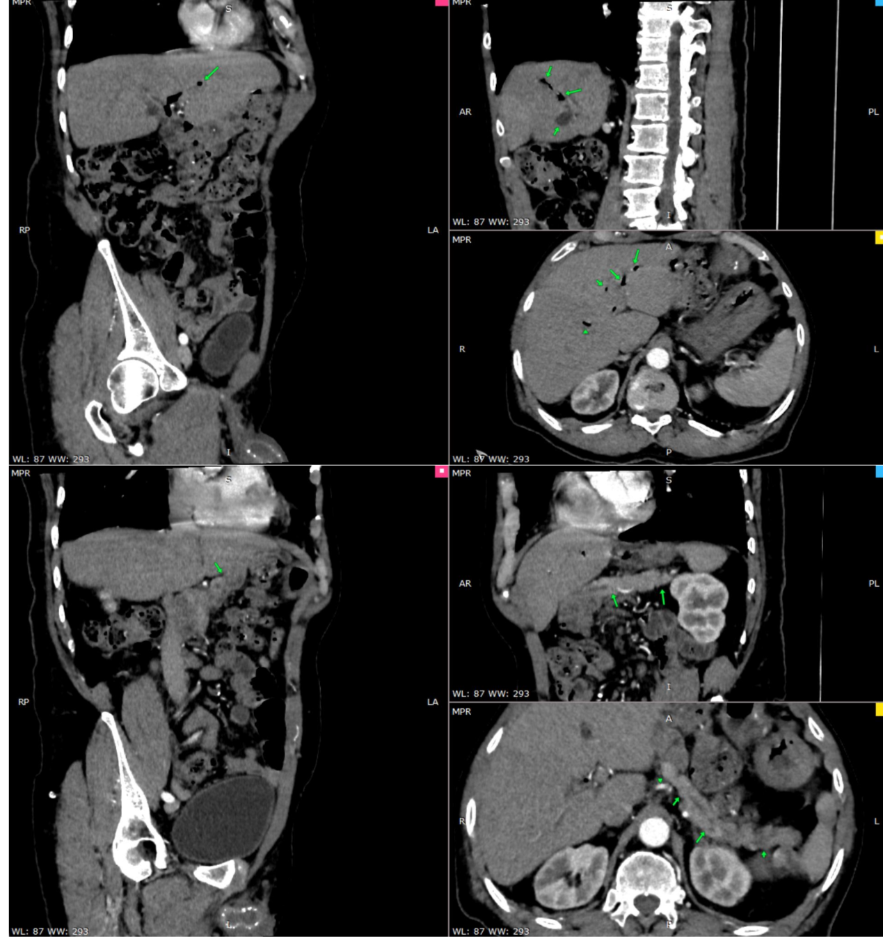

Fig. 4. Chemotherapy Image

Discussion
Pancreatic head adenocarcinoma of this patient presented with diarrhoea and subsequent obstruction with double duct sign leading to jaundice and pruritus. The obstruction impinged on part of the duodenum and part of the gall bladder leading to biliary drainage, which was circumvented by stenting.
Early diagnosis for pancreatic adenocarcinoma is difficult due to the fact that it presents with non-specific and generalize symptoms, however, pancreaticoduodenectomy (Whipple’s procedure) is the recommended procedure especially for well differentiated cells. Post-surgery survival is achieved by adjuvant therapy such as chemotherapy with NAB paclitaxel-gemcitabine regimen.
A multidisciplinary protocol with radiologists, medical laboratory scientists, surgeons, and gastroenterologists is supported by current study in order to maximise the type and timing of intervention.

Conclusion
This case demonstrates that with tumour head of pancreas presenting as intrahepatic and extrahepatic duct dilatation, timely information, early hospital visit and early diagnosis, biliary drainage via stenting where applicable and the gold standard of pancreaticoduodenectomy (Whipple’s procedure) can lead to successful outcome.

Consent
A well written informed consent document was duly read and signed by the participant

Competing Interest
Authors have declared that there are no competing interests

REFERENCES
Berger, A. C., Garcia, M., Hoffman, J. P., Regine, W. F., Abrams, R. A. & Safran, H. (2008). Postresection CA 19-9 predicts overall survival in patients with pancreatic cancer treated with adjuvant chemoradiation: a prospective validation by RTOG 9704. J Clin Oncol, 26, 5918–5922.

Bockhorn, M., Uzunoglu, F. G., Adham, M., Imrie, C., Milicevic, M., Sandberg, A. A., Asbun, H. J., Bassi, C., Büchler, M., Charnley, R. M., Conlon, K., Cruz, L. F., Dervenis, C., Fingerhutt, A., Friess, H., Gouma, D. J., Hartwig, W., Lillemoe, K. D., Montorsi, M. & Neoptolemos, J. P. (2014). International Study Group of Pancreatic Surgery Borderline resectable pancreatic cancer: a consensus statement by the International Study Group of Pancreatic Surgery (ISGPS). Surgery, 155(6), 977–988.

Conroy, T., Hammel, P., Hebbar, M., Ben Abdelghani, M., Wei, A. C., Raoul, J. L., Choné, L., Francois, E., Artru, P., Biagi, J. J., Lecomte, T., Assenat, E., Faroux, R., Ychou, M., Volet, J., Sauvanet, A., Breysacher, G., Di Fiore, F., Cripps, C. & Kavan, P. (2018). Canadian Cancer Trials Group and the Unicancer-GI–PRODIGE Group FOLFIRINOX or Gemcitabine as Adjuvant Therapy for Pancreatic Cancer. The New England journal of medicine, 379 (25), 2395–2406.

Hruban, R. H. & Adsay, N. V. (2009). Molecular classification of neoplasms of the pancreas. Hum Pathol, 40, 612–623.

Siegel, R. L, Miller, K. D. & Jemal, A. (2017). Cancer Statistics. CA Cancer J Clin, 67, 7
.
Tempero, M. A., Malafa, M. P., Al-Hawary, M., Behrman, S. W., Benson, A. B., Cardin, D. B., Chiorean, E. G., Chung, V., Czito, B., Del Chiaro, M., Dillhoff, M., Donahue, T. R., Dotan, E., Ferrone, C. R., Fountzilas, C., Hardacre, J., Hawkins, W. G., Klute, K., Ko, A. H., Kunstman, J. W. & George, G. V. (2021). Pancreatic Adenocarcinoma, Version 2.2021, NCCN Clinical Practice Guidelines in Oncology. Journal of the National Comprehensive Cancer Network : JNCCN, 19(4), 439–457.

