Review Article
Advances in Imaging Biomarkers for Oncology: A Comprehensive Review of Techniques, Clinical Applications, and Future Perspectives

Abstract
Imaging biomarkers are important for modern oncology because they provide quantitative ways to assess tumour function, monitor tumour progression, and evaluate response to treatment. Tumour imaging biomarker analysis includes structural characteristics such as the size of the tumour as well as functional (e.g., diffusion-weighted MRI, perfusion, and dynamic contrast-enhanced) as well as metabolic characteristics based on standardized uptake values from a Positron Emission Tomography (PET) scan. Radiomics (the creation of large volumes of image data) and artificial intelligence (AI)-based imaging biomarkers will also be discussed as potential sources of data that can be used to predict patient outcomes based on advanced imaging biomarkers. This narrative review will describe in detail the range of structural, functional, and molecular & metabolic imaging biomarkers that are being utilized in oncology today. This narrative review will also highlight the development of radiomics and artificial intelligence-based imaging biomarkers, which will help to generate high-dimensional imaging data, aiding the prediction of clinical outcomes based on those imaging biomarker data. Tumour detection, classification, creating treatment plans, determining the outcome of a treatment, and monitoring for any signs of a tumour returning are just some of the many clinical applications of imaging and metabolic biomarkers. Functional and metabolic imaging can detect therapeutic responses at an earlier point in time than will show on an anatomic image because functional and metabolic imaging captures biological changes before any change occurs in anatomy. The clinical translation of these biomarkers is significantly affected by issues regarding reproducibility, standardization, and multi-centre validation. The integration of imaging biomarkers into everyday practice is further complicated by variations in imaging processes and analytical techniques.

Keywords: Artificial Intelligence, Imaging Biomarkers, Oncology, Precision Therapy, Radiomics, Tumour

1. Introduction

Cancer is the leading cause of death along the globe. According to GLOBOCAN (2024), reports show an approximate total of about 20 million new cases of cancer were diagnosed worldwide in 2022 and it is estimated that number will grow to about 35 million diagnosed by 2050. Cancer is currently responsible for over 10 million deaths globally each year making it the second leading cause of death globally (Bray et al., 2024). There have been several changes made to cancer treatment strategies based upon a better understanding of cancer biology, with the introduction of therapies tailored to individuals through a more personalized approach referred to as "precision cancer medicine." In addition to being utilized in monitoring disease progress, using imaging to help assess treatment, diagnosing and characterizing cancers, staging of cancers and monitoring for the recurrence of cancers, imaging has long been used to assist in these areas. Imaging plays an important role in personalized cancer treatment. Imaging Biomarkers (IBs) can greatly improve patient outcomes (Califf, 2018). Biomarkers are defined as characteristics measured as indicators of normal biological processes, disease processes, or responses to exposure or treatment, including therapeutic interventions. They can be quantitative or qualitative. To be used in clinical practice, studies must be reliable, connected to relevant outcomes and show clinical usefulness. IBs have been introduced in medical literature as a way to use images quantitatively, rather than just visually by an imaging specialist. These IBs can diagnose, predict and evaluate various diseases and are often used in patient care. IBs must be exact, precise, and consistent when used in clinical practice and clinical studies (Zoccali et al., 2024). IBs provide both quantitative and qualitative information about tumour shape, physiology and metabolic activity. These indicators are critical for routine clinical monitoring, particularly because standard blood biomarkers have limited sensitivity in detecting early recurrences. Magnetic Resonance Imaging (MRI), Computed Tomography (CT), and Positron Emission Tomography (PET) are the three most prevalent non-invasive technologies for determining molecular features. Limitations of imaging technology can lead to errors in data collection, reconstruction, and analysis, reducing its effectiveness (O’Connor et al., 2017a). IBs are a type of biomarker obtained from in vivo medical images. They are a cost-effective and real-time solution for clinical use. The use of IBs in clinical trials necessitates a greater knowledge of quality assurance, which may provide issues for medical physics experts (MPEs). This paper aims to provide a comprehensive overview of imaging biomarkers in cancer, focusing on their biological basis, therapeutic applications, validation challenges, and recent discoveries (Chauvie et al., 2023).
2. Classification of Imaging Biomarkers
Imaging biomarkers in cancer can generally be divided into structural, functional, molecular, and computationally generated biomarkers as depicted in Fig. 1. Structural biomarkers mainly evaluate tumour morphology, such as size, volume, and enhancement features, and are often utilized for disease staging and assessing response. Functional biomarkers offer information regarding tumour physiology, including cellular density, perfusion, vascular permeability, and hypoxia, which indicate biological activity that goes beyond just anatomy (Akram et al., 2025). Molecular and metabolic indicators usually obtained from PET and specific tracers, it measures tumour metabolism and receptor expression, facilitating early evaluation of treatment response and disease severity. Recently, biomarkers based on radiomics and artificial intelligence have developed, extracting high-dimensional quantitative characteristics from imaging data to forecast tumour behaviour, treatment results, and survival rates. Collectively, these categories form a spectrum ranging from broad anatomical evaluation to sophisticated quantitative and computational analysis of tumour biology (Ali et al., 2020; Das et al., 2024).
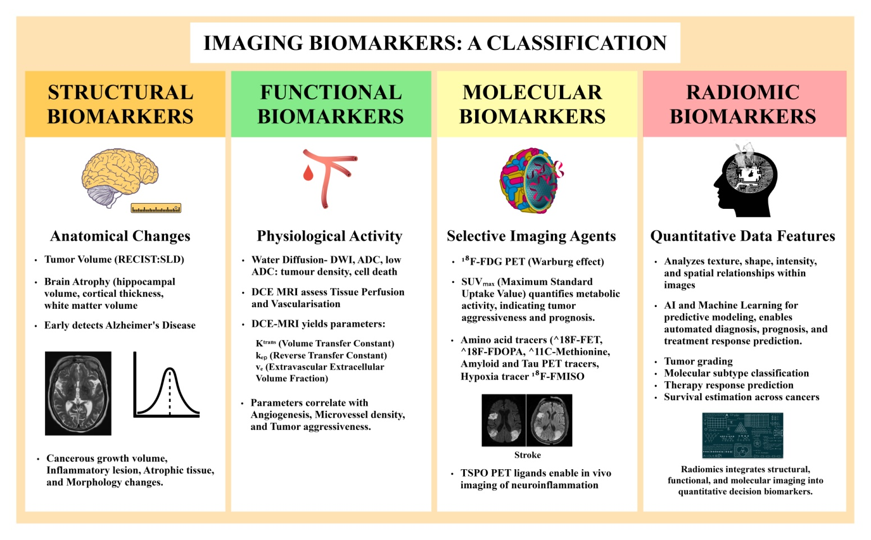
Fig. 1. Classifications of Biomarkers: Structural, Functional, Molecular, and Radiomic Biomarkers.

2.1 Structural Biomarkers
The most popular and fundamental metrics used in cancer imaging are structural imaging biomarkers shown in fig. 2. At their core, these are fundamental features that radiologists may identify and measure using routine imaging tests like as CT and MRI, which are often employed in clinical treatment and research to examine tumours. These indicators largely describe how a tumour appears and changes in shape, size, and internal appearance throughout the time, which offers a visual indication of disease presence and evolution (Alberich-Bayarri, 2017; Fox & Kennedy, 2009).
2.1.1 Response Evaluation standards in Solid Tumours (RECIST)
One of the most well-known structural indicators is tumour shape as determined by established standards, most notably the Response Evaluation standards in Solid Tumours (RECIST). It offers precise standards for measuring a tumour's longest diameter on CT or MRI scans to assess changes in that diameter over time to determine whether the tumour has shrunk, grown, or remained stable throughout treatment. These characteristics are used in clinical studies and practice for classifying reactions as complete, partial, stable, or developing. RECIST has become a global standard due to its reproducibility and ease of implementation (Smesseim et al., 2025). However, RECIST and basic diameter measurements have various limitations. Reducing tumours to a single linear number could not accurately represent changes in tumour load since tumours are three-dimensional entities with different geometries. For example, a tumour may experience structural alterations like necrosis (cell death), internal cavity creation, or uneven shrinkage without a discernible change in length. This means that significant biological reactions may go unnoticed if only size is considered. This restriction is particularly apparent in modern treatments such as targeted medicines or immunotherapies, which can inhibit tumour development or trigger internal alterations without resulting in rapid size reduction. Researchers and clinicians have increasingly relied on volumetric measurements (R. K. Jain et al., 2012; Welsh et al., 2012).

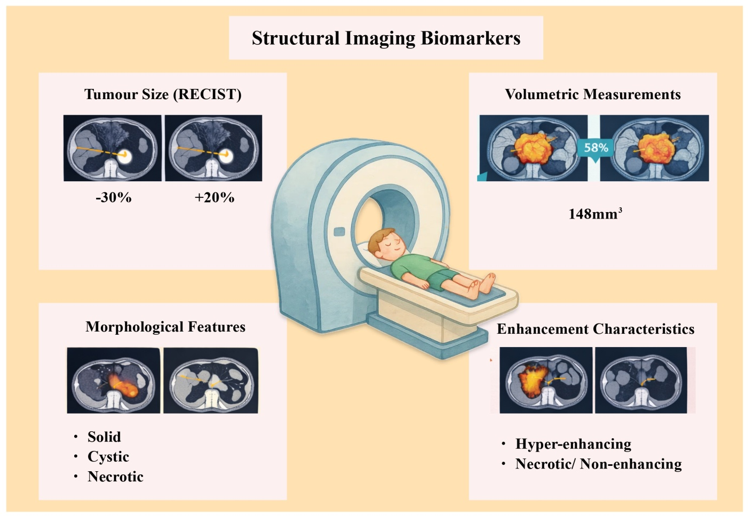
Fig. 2. Structural Biomarkers- Illustration of anatomical biomarkers including tumour size (RECIST criteria), shape and internal structure assessed by CT and MRI for diagnosis and staging.
2.1.2 Volumetric Biomarkers
Volumetric biomarkers utilize manual and semi-automatic or fully automated segmentation methods to determine the tumour's total volume rather than its diameter. Volumetric statistics better reflect the whole tumour burden, especially the irregularly shaped tumours, and can detect minor changes earlier than the size alone. Small but clinically meaningful volume decreases, for example, may indicate effective treatment even if a tumour's longest diameter stays constant. Advances in image processing and artificial intelligence are making volumetric assessment more practical and uniform across scanners and universities. Additionally, to the size and volume, morphological traits are very important for structural biomarkers because they characterize the form, border, internal architecture, and density of tumours (Goldmacher & Conklin, 2012; B. Zhao et al., 2010). This includes whether a tumour has smooth or uneven edges, necrotic regions, calcification patterns, and satellite nodules. Such characteristics aid in the difference between benign and malignant tumours and provide insight into tumour aggressiveness, and support clinical decisions on biopsy, surgery, or therapies. Some of the physical traits are associated with clinical consequences, like for example, tumours with spiculated boundaries frequently imply more invasive biology. A different aspect structural indicator is contrasting enhancement features, which describe how a tumour absorbs and releases contrast agents during CT or MRI images. Dynamic imaging can show alterations in the tumour's permeability and vascularity (blood supply) following the contrast injection. Contrast may be efficiently absorbed by tumours with a high blood vessel density, but necrotic parts could ignore it at all (Goldmacher & Conklin, 2012). Contrast may be efficiently absorbed by tumours with a high blood vessel density, but necrotic parts could ignore it at all. By tracking the rate and pattern of contrast change over time, contemporary methods such as dynamic contrast-enhanced MRI (DCE-MRI) does enable quantitative insights on blood flow and vascular architecture. These enhanced patterns could reveal biological processes like angiogenesis, (the formation of new blood vessels) which further allow doctors to evaluate therapy results more accurately. Structural Imaging biomarkers remain important in clinical settings because they are widely available, simple to interpret, and connected to established therapy guidelines (Gordon et al., 2014; O’Connor et al., 2011). However, their main disadvantage is that they frequently represent morphological end results rather than the first biological responses to treatment. For instance, after effective treatment, cellular alterations could take place before measurable size reduction, suggesting that depending just on structural indications could cause response detection to be delayed or misinterpret occurrences like pseudo-progression, in which tumours appear to grow before shrinking. To provide a more complete and timelier picture of tumour response in cancer treatment and research, structural biomarkers are increasingly being used in conjunction with functional and molecular biomarkers (Gillman et al., 2020a; Ollivier et al., 2001).
2.2 Functional Biomarkers
Functional imaging reveals physiological and biological traits instead of tumour's size and shape. It measures tissue features such as cellular density and vascularity and perfusion and oxygenation as shown in Fig. 3. Tumour growth and progression are driven by several key biological mechanisms, such as angiogenesis, uncontrolled cellular proliferation, and dynamic alterations within the tumour microenvironment. These processes influence tumour development, metastatic potential, and resistance to therapy, making them critical targets for oncologic assessment. Advanced imaging techniques such as diffusion-weighted imaging (DWI),

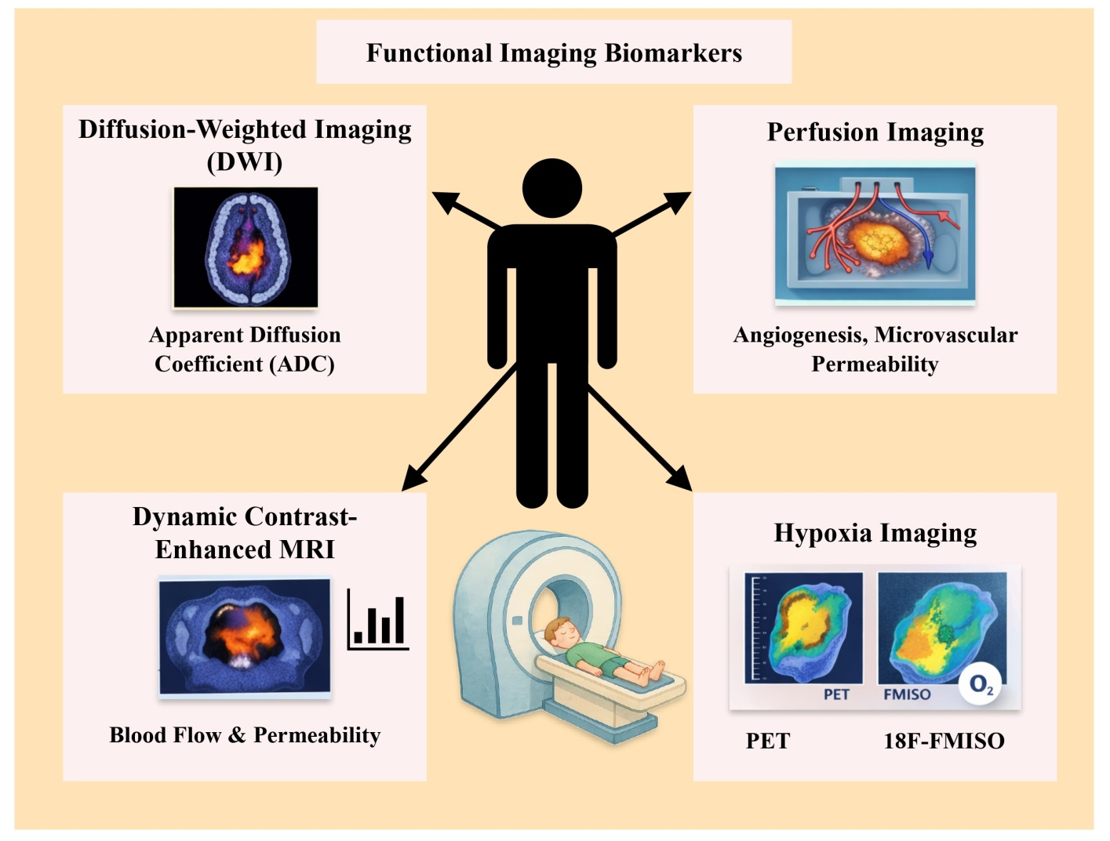
Fig. 3. Functional Imaging Biomarkers- Illustration of Biomarkers showing tumour metabolism, perfusion, hypoxia imaging using PET and advanced MRI techniques for diagnosis and precision treatment.
perfusion imaging, DCE-MRIand hypoxia imaging provide non-invasive methods for evaluating these underlying biological processes (Campbell et al., 2019). Through quantitative and functional imaging biomarkers, these modalities enable the assessment of tumour cellularity, vascular perfusion, and oxygenation status. Consequently, functional imaging plays an important role in characterizing tumour aggressiveness, predicting clinical prognosis, and monitoring therapeutic response in modern oncologic practice (Prestwich et al., 2015).
2.2.1 Diffusion Weighted Imaging and Apparent Diffusion Coefficient
Diffusion-weighted imaging (DWI) is a popular functional MRI approach in cancer diagnosis. It tracks the random brownian motion of water molecules within tissues. That motion is influenced by things like cellular density and membrane integrity. DWI reflects the microscopic movement of water molecules within tissues and indirectly provides information about the extracellular space. From DWI data, a quantitative parameter known as the apparent diffusion coefficient (ADC) is calculated to measure the degree of water diffusion within tissue (Bozgeyik et al., 2013). Lower ADC values typically indicate restricted diffusion, which is commonly observed in tumours with high cellular density. In such tissues, densely packed tumour cells reduce the extracellular space and limit the movement of water molecules. Numerous studies have demonstrated a strong inverse correlation between ADC values and tumour cellularity, making ADC an important imaging biomarker for tumour characterization. Meta-analysis found a negative correlation between the ADC and tumour cell count (Bozgeyik et al., 2013). So, tumours with more cells tend to have lower ADC. This matters in the clinic because aggressive tumours often have high cell density, and ADC can help with tumour characterization and grading. DWI is also useful for monitoring treatment responses. When therapy kills tumour cells, the cellular density falls. The extracellular space increases, and ADC values rise. ADC changes can sometimes show a response sooner than size-based measurements. ADC can help tell benign from malignant lesions. It may also help pick out metastatic lymph nodes or recurrent diseases in several cancer types (Padhani et al., 2009).
2.2.2 Perfusion Imaging
Perfusion imaging studies the blood supply in the tumour. It depicts the vascular density, blood flow, and perfusion in the tissues. Angiogenesis is a method that helps in the development of the tumour. Tumour angiogenesis is process of development of new blood vessels to provide nourishment to the rapidly dividing cells in the tumour. Functional imaging modalities used perfusion CT, perfusion MRI, and contrast-enhanced ultrasound. The parameters measured are blood volume, blood flow, and mean transit time. These parameters depict the vascularisation and microcirculation in the tumour. Higher values indicate increased angiogenesis in the tumour. Tumours showing increased angiogenesis depict increased perfusion and vascular permeability. All these parameters depict the potential and aggressiveness of the tumour. The tumour microenvironment is shown by perfusion imaging, which also aids in determining how effective anti-angiogenic medications are. Anti-angiogenic medications prevent the tumour's blood vessels from growing (R. Jain, 2011; Lugano et al., 2019; Saman et al., 2020).
2.2.3 Dynamic Contrast-Enhanced MRI (DCE-MRI)
Dynamic contrast-enhanced magnetic resonance imaging (DCE-MRI) is widely used to assess tumour perfusion and vascular permeability by analysing the temporal distribution of contrast agents within tumour tissue. Sequential images acquired following intravenous contrast administration allow quantitative evaluation of contrast agent uptake and washout within the tumour microenvironment. From DCE-MRI data, several pharmacokinetic parameters can be derived, including Ktrans (volume transfer constant), Kep (rate constant), and Ve (extravascular extracellular volume fraction). Among these, Ktrans is the most clinically relevant parameter, as it reflects both tumour blood vessel permeability and the rate at which contrast agent moves from the vascular plasma into the extravascular extracellular space. Numerous studies have demonstrated significant correlations between DCE-MRI–derived parameters and tumour micro-vessel density as well as angiogenic activity (:: :: KJR :: Korean Journal of Radiology, n.d.; Ferrier et al., 2007). Consequently, these parameters serve as valuable imaging biomarkers for evaluating tumour aggressiveness and for monitoring the response to anti-angiogenic therapies. For example, a decrease in Ktrans during therapy likely reflects effective inhibition of angiogenesis and decrease in vascular permeability. Due to the fact that vascular changes detected on DCE-MRI occur earlier than tumour volume reduction, DCE-MRI may provide an early indicator of response to therapy (Türkbey et al., 2010).
2.2.4 Hypoxia Imaging
Tumour Hypoxia refers to the areas of low oxygen (O2) concentrations in a tumour that result from the body's abnormal blood supply to that tumour (due to the development of blood vessels) and fast growth of those tumour cells. As a result, hypoxic cells are usually much more resistant than normoxic (normal oxygen content) cells to radiation and chemotherapy treatment and tend to have greater potential for metastasis (the process of cancer spreading). Functional imaging techniques that detect tumour oxygen concentrations help locate and map hypoxic regions of tumours. Functional imaging methods such as blood oxygen level-dependent (BOLD) MRI, oxygen-enhanced MRI, and PET imaging with hypoxia-selective tracer(s) [e.g., FMISO] all allow for the non-invasive visualization of the levels of oxygen in the tumours and thus provide information regarding the tumour microenvironment and also assist clinicians in identifying treatment-resistant areas, thereby guiding the development of personalized therapeutic interventions (Höckel & Vaupel, 2001; Muz et al., 2015).
2.3 Molecular and Metabolic Biomarkers
Molecular imaging of the tumour microenvironment (TME) can detect cancer early and track therapy progress. Newer imaging techniques, including PET, MRI, and optical and photo acoustic imaging, enable non-invasive evaluation of extensive parts of the TME. Symptoms may include low oxygen levels, new blood vessel creation, immune cell infiltration, extracellular matrix abnormalities, and altered energy consumption. New radiotracers, activatable probes, and multimodal nanoparticles make it easier to view the TME at a higher level and simultaneously display multiple things (Rakhshandehroo et al., 2022). TME imaging helps clinicians discover belligerent cancers earlier by detecting changes in molecules and functions before visible structural changes occur. These streamlines identifying and prioritizing hazards, leading to faster treatment initiation. Detecting TME traits without surgery allows for personalized treatment, early monitoring of progress, and adaptation to tumour behaviour. Normalizing imaging methodologies, demonstrating new probes' clinical applicability, and connecting molecular imaging data to other omics platforms are challenging tasks. As a result, finer and more accurate probe designs are required (Xu et al., 2022). Clinical trials across several centers are required to assess the predictive power of TME imaging biomarkers. Our goal is for Artificial Intelligence (AI) to construct models that can help us analyze photos and make more accurate predictions. Molecular imaging techniques have significantly advanced cancer diagnosis and management by enabling earlier detection, personalized treatment strategies, and improved monitoring of therapeutic outcomes. Unlike conventional anatomical imaging, molecular imaging biomarkers provide information about the metabolic and molecular characteristics of tumours rather than solely their morphological features. Malignant cells typically exhibit increased glucose metabolism to support rapid proliferation, a phenomenon commonly known as the Warburg effect (Alum, 2025; Olawade et al., 2026; Rajendran et al., 2026a). Positron emission tomography (PET) using ¹⁸F-fluorodeoxyglucose (¹⁸F-FDG), a glucose analog radiotracer, is therefore widely used for evaluating tumour metabolism in clinical oncology. FDG-PET imaging enables the assessment of whole-tumour metabolic activity by providing both visual and quantitative information about glucose uptake within tumour tissues. Quantitative PET parameters, including maximum standardized uptake value (SUVmax), metabolic tumour volume (MTV), and total lesion glycolysis (TLG), are increasingly recognized as important imaging biomarkers. A diagram for the same is depicted in Fig. 4. These parameters provide valuable insights into tumour biology and are widely used for assessing tumour aggressiveness, predicting prognosis, and evaluating response to therapy (Boellaard et al., 2025; d’Amico, 2015).
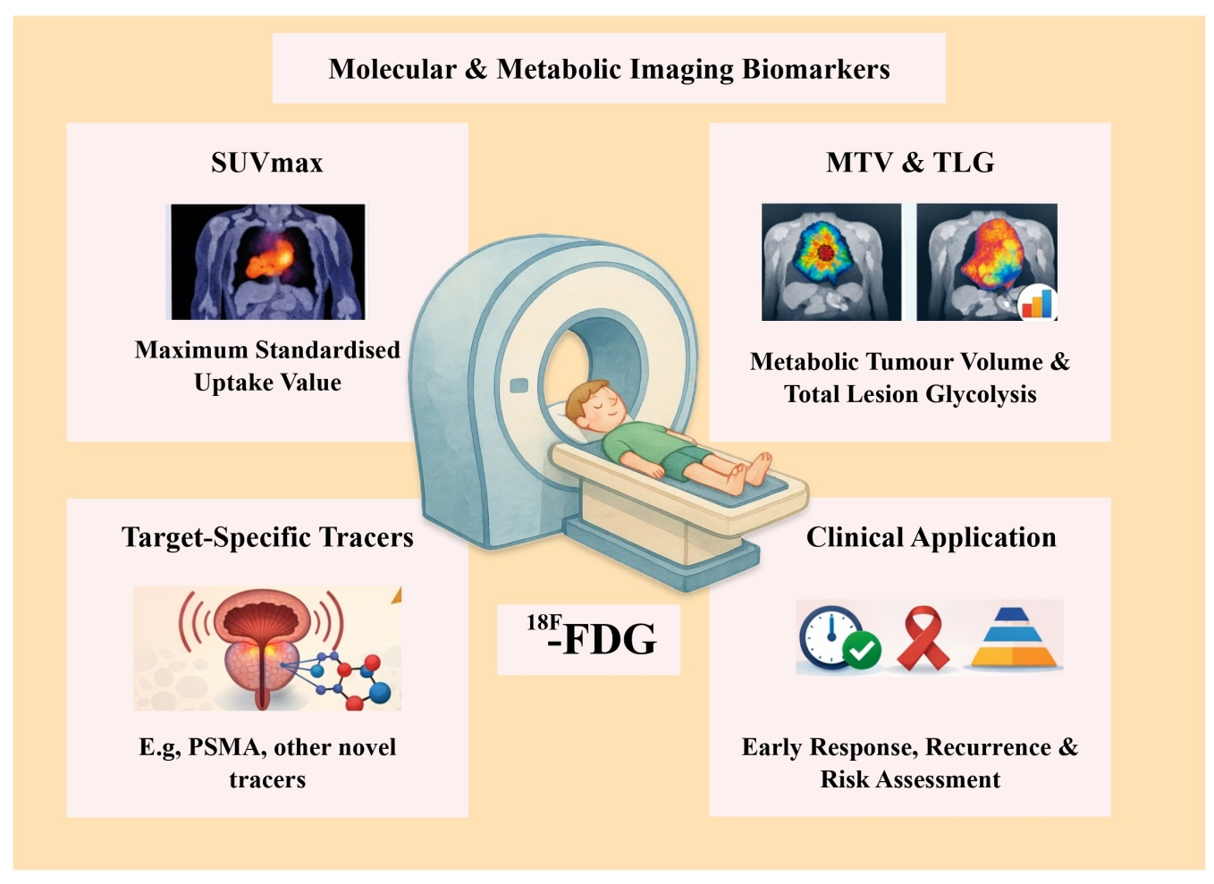
Fig. 4. Molecular Biomarkers- Illustration of targeted biomarkers assessing specific cellular and receptor level processes in tumour. (i.e PSMA, other novel tracers)
2.3.1 Standard Uptake Value (SUV)
The standardized uptake value (SUV), a quantitative parameter of PET imaging, characterises the concentration of radiotracer uptake normalized to the injected dose and individual patient body parameters for tissues. One example of an SUV is the maximum standardized uptake value (SUVmax), which is defined as the voxel with the greatest metabolic activity within a tumour. One reason for the popularity of the SUVmax value in clinical practice is that the measuring volume is relatively simple to perform and is less affected by inter-observer variability than other parameters. The SUVmax is a reflective of tumour metabolic activity, and elevated SUVmax have been associated with tumour aggressiveness, cellular proliferation, and poor prognosis (Kinahan & Fletcher, 2010; Standardized Uptake Value - an Overview | ScienceDirect Topics, n.d.). Clinical studies and meta-analyses have shown repeatedly that higher SUVmax are associated with poor clinical outcomes and that higher SUVmax correlate with an increased risk of disease progression and mortality in or across several types of malignant tumours. Although SUVmax is widely used in a clinical setting, it has limitations. Since SUVmax reflects only one voxel of metabolic activity within a tumour and not the entire tumour, SUVmax may not accurately reflect the metabolic burden (activity) of a tumour. Further, because of the heterogeneity of tumours and the potential influence of imaging artefact, additional volumetric PET measurements such as metabolic tumour volume (MTV) and total lesion glycolysis (TLG) have been proposed as additional quantitative methods to assess the total metabolic burden of cancer (Lee et al., 2014; Pan et al., 2011; K. Zhao et al., 2021).
2.3.2 Metabolic Tumour Volume
MTV is the cumulative amount of metabolic activity found in a given area of cancerous tissue as identified by PET imaging study’s metabolic functionality (i.e., what types of cells are alive and reproducing). To obtain its value, we identify voxel areas of metabolism above a pre-defined value of standardized uptake value (SUV) for both the tumour and the patient as a whole, and then add those voxel areas together in order to report on overall disease activity. Because MTV focuses on the entire tumour instead of just one area where increased metabolism was reported, it provides an accurate numeric representation of the total amount of cancer regenerative activity in the same manner as a blood test would provide information about the body’s general functioning (Im et al., 2018; A. Liu et al., 2017). Clinical studies show there is consistent correlation between mortality outcomes amongst patients that present with higher values of MTV. In other words, once all other factors have been accounted for (i.e., age, stage, etc.), the greater the value of MTV, there is usually an additional associated risk factor of increased likelihood for death, or shorter life expectancies, therefore assuming greater risk of cancer recurrence/progression. To illustrate this point further, the review articles evaluating PET imaging as a biomarker in Oncology, demonstrate that the greater the value of MTV, the greater the potential risk of recurrence or progression of that individual’s disease. Because MTV is a comprehensive measure of total disease activity over an entire three-dimensional modality of measurement, it is a valuable contribution to further characterizing patient characteristics than relying solely upon respectively the value of their maximum SUV (Bouron et al., 2022; Hicks, 2022). As such, the growing body of clinical observations is leading to the increasing interest in utilizing MTV as a reliable and non-invasive treatment biomarker for monitoring treatment response and managing patient risk in clinical trial investigations. Using metabolic imaging biomarkers allows us to measure biological changes in tumours quicker than other techniques. An example of metabolic change would be that prior to any change in size the tumour will exhibit metabolic activity. Thus, use of PET biomarkers using maximum standardized uptake volumes (SUVmax), volume of metabolic activity (MTV), and total lesion glycolysis (TLG) will allow clinicians to evaluate response to treatment earlier than the more conventional measurement based on change in size (Agarwal et al., 2025; Chardin et al., 2020).
2.3.3 Total Lesion Glycolysis
TLG can be used to assess both the size of a tumour and how active it is metabolically. It will show the total metabolic activity of a tumour by combining the MTV with the mean SUV as calculated from the size and the level of activity of the tumour. By determining how much total glycolytic activity takes place within a tumour, TLG will provide an accurate representation of how metabolically active the tumour is. Research suggests that TLG may better predict how responsive a patient will be to treatment than either MTV or SUV max alone. High TLG levels indicate considerable glycolytic activity throughout a large percentage of the tumour. Therefore, high TLG levels are associated with more aggressive cancers (Choi et al., 2023). There are several studies that show increased levels of TLG are also associated with decreased progression free survival and decreased overall survival in types of cancer such as lung cancer, lymphomas, and gastrointestinal stromal tumours. Finally, TLG combines both metabolic activity and tumour size, making it an excellent potential imaging biomarker for predicting therapeutic outcome and evaluating the effectiveness of therapies in patients with cancer. The quantitative PET parameters are also valuable when determining risk-stratifying patients. Patients with a high SUV max, MTV, and TLG value usually have a poor prognosis and high rate of disease progression. As such, clinicians will use these biomarkers to classify patients into different risk categories to help make treatment decisions (British Journal of Haematology | Wiley Online Library, n.d.; Lyra et al., 2022).
2.3.4 Target Specific Tracers
Modern PET scans use specific types of tracers in addition to conventional fluorodeoxyglucose (FDG) blood flow and metabolism measurements. One of the most widely used examples of a target-specific PET tracer is prostate-specific membrane antigen (PSMA) targeted imaging, which is used for detecting prostate cancer. Radiotracers such as ⁶⁸Ga-PSMA-11 and ¹⁸F-PSMA-1007 bind to PSMA, a transmembrane protein that is highly overexpressed on the surface of prostate cancer cells. The high density of PSMA receptors on these cells enables highly sensitive and specific detection of both primary and metastatic prostate cancer lesions (Islam et al., 2025; Trotter et al., 2023). Target-specific PET tracers allow visualization of molecular pathways involved in tumour development, thereby providing insights beyond conventional metabolic imaging. This approach is particularly valuable for detecting tumours that may not demonstrate significantly increased glucose metabolism on ¹⁸F-FDG PET imaging. Furthermore, receptor-targeted PET tracers can be integrated with therapeutic radionuclides in a theranostics approach, where the same molecular target is used for both diagnosis and treatment. In prostate cancer, this strategy is exemplified by PSMA-based imaging combined with targeted radionuclide therapy (Garg et al., 2025).
2.4 Radiomics and Artificial Intelligence derived Biomarkers
The fields of radiomics and artificial intelligence (AI) are enabling a new era of imaging biomarkers designed to obtain quantitative data from medical imaging that might not be observable with the naked eye. Traditional imaging evaluation is primarily based on subjective evaluation of a radiologist’s interpretation of both qualitative criteria for such things as tumour size, number, and/or contrast enhancement. However, radiomics uses sophisticated computer algorithms that translate medical images into vast amounts of quantitative features that represent the underlying biology of the tumour, its heterogeneity and microenvironment (Faraz et al., 2025). These features can then be evaluated using either machine learning or deep learning algorithms to predict clinical outcomes, response to treatment, and prognosis. Based upon these facts, radiomics is rapidly becoming a powerful platform for developing non-invasive biomarkers for precision oncology (Zhang et al., 2022).
2.4.1 Radiomics Workflow
The processing of radiomics biomarker development follows an order of operations starting with the capture and standardization of the acquired images (CT, MRI or PET) using a standard imaging protocol to ensure image quality and reliability of results when extracting features from images. If the settings on a scanner or the reconstruction parameters for an image being scanned are different than they should be or were originally set up to be, this will have a positive or negative effect on the extraction of the radiomic features (Aguirre-Meneses et al., n.d.-a). Therefore, it is important to have standardization in place during biomarker development to ensure reliability. The next operation in the workflow process will be segmenting the image dataset of the scanned tumour resulting in the definition of the tumour's region of interest (ROI). There are three ways that tumour segmentation can occur. The radiologist manually segments the tumour using techniques which they have been trained in the radiologist uses software tools to assist them with segmenting the tumour in a semi-automatic manner and the radiologist uses deep learning algorithms and/or neural networks to automatically identify the pixels which constitute the segmentation of the tumour (deSouza et al., 2022). The accuracy of segmentation is critical as only the features defined within the original ROI when performing a radiomics analysis may be extracted for analysis. Radiomic feature extraction occurs after segmentation is complete and can generally be categorized as shape features (the geometric characteristics of the tumour), first-order statistical features (the distribution of voxel intensities), and texture features (the spatial relationships between pixels). Shape features include volume and surface area of the tumour as well as compactness (Scapicchio et al., 2021). First-order statistical features represent how voxel intensity is distributed across the tumour; texture features describe the spatial relationships between image pixels and help to demonstrate intra-tumour heterogeneity and the degree of anatomical complexity. Machine learning models will be developed after radiomic feature extraction and will identify patterns in the data. To create a predictive model, machine learning algorithms (e.g., support vector machine, random forests, and neural networks) can be applied to correlate radiomic features with clinical outcomes such as treatment response and overall patient survival (Piedimonte et al., 2025; Smits et al., 2023). To illustrate the different steps involved in radiomics workflow, a flowchart is shown in Fig. 5.
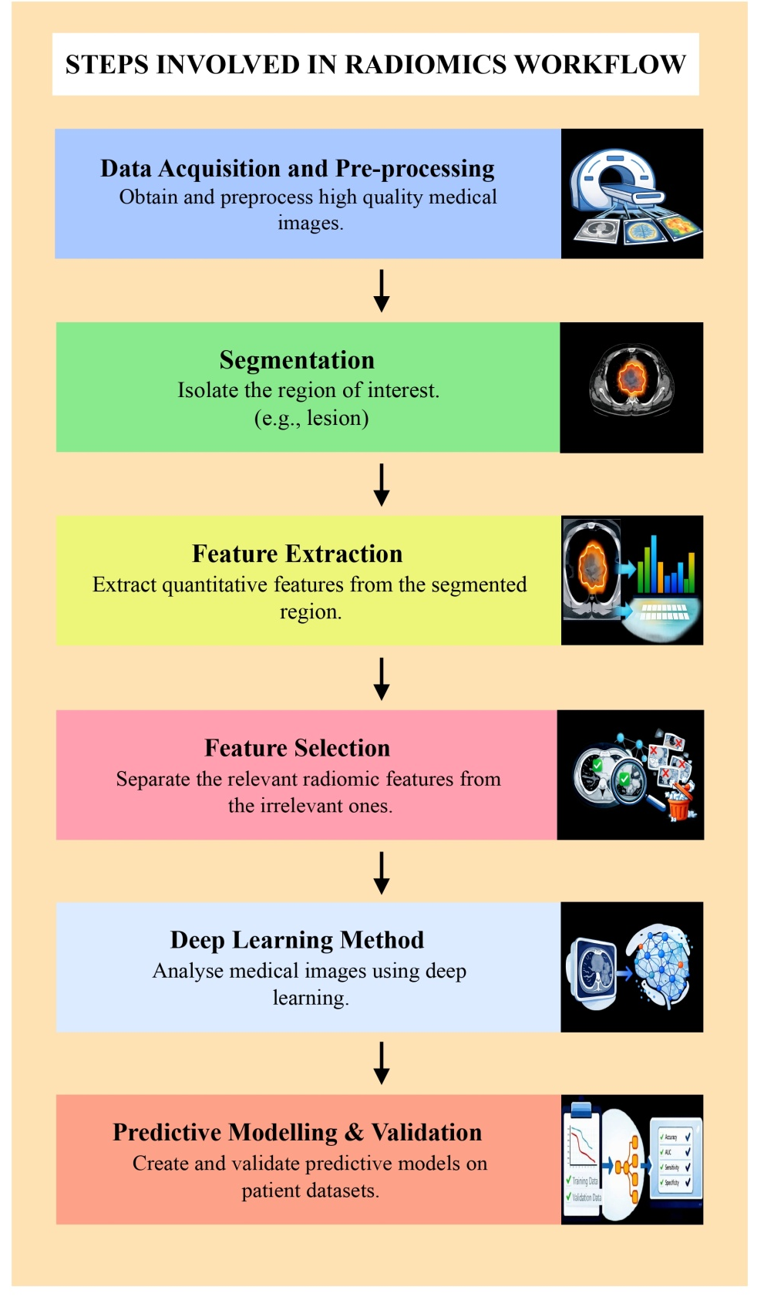
Fig. 5. Radiomic Workflow- Illustration of the radiomics process from image acquisition and segmentation to feature extraction and machine learning based prediction.
2.4.2 Radiomics and Tumour Heterogeneity
The main benefit of radiomics is that it can measure the heterogeneity of tumours, which is now understood to be one of the most significant contributors to a patient's cancer progression and/or response to treatment. Tumours generally have areas that contain varied distributions of cellular density, regional patterns of blood vessels, and differing amounts of metabolic activity. Traditional imaging methods often do not report on heterogeneity, whereas radiomic texture features can detect small differences in texture and appearance within a tumour. Radiomic features obtained from CT/MRI or PET images have been shown to correlate with tumour grading, gene expression patterns, and molecular pathways, which is sometimes referred to as radiogenomics (Forghani et al., 2019; Gillies et al., 2016). By associating features from images with gene expression information, radiomics provides a potential noninvasive approach to analyzing tumour biology. Artificial Intelligence in Imaging Biomarker development deep learning is an example of how AI has broadened the potential for conducting imaging biomarker research. Deep learning finds complex patterns in imaging datasets through automatic learning, without needing to first manually create features from the dataset. The use of Central Neural Networks (CNNs) in medical imaging has been applied to perform tasks such as identifying and segmenting tumours, classifying tumours, and predicting outcomes from those tumours. AI-based imaging biomarkers have demonstrated efficacy in providing predictive information for treatment response, survival outcomes, and metastatic risk across various cancer types, including lung, breast, and brain tumours. Additionally, AI has the capability of combining both imaging and clinical/genomic data to produce multimodal predictive models, thereby enabling the development of individualized treatment plans (Gupta et al., 2023; Janzen et al., 2024; Radiomics Analyses to Predict Histopathology in Patients with Metastatic Testicular Germ Cell Tumors before Post-Chemotherapy Retroperitoneal Lymph Node Dissection, n.d.).
2.4.3 Challenges, Limitations and Potential of Radiomics AI Biomarkers
There are multiple barriers to progress that Radiomics and AI-based biomarker research can have. One such example would be the reproducibility of radiomic features due to variations in imaging; scanner type and the methods used for reconstruction. The Image Biomarker Standardization Initiative (IBSI) addresses these issues through setting standards for radiomic feature computation and reporting. A second barrier to this area is the risk of overfitting in machine learning models, because of small datasets which happens when a machine learning-based model fits the training dataset but can’t adequately generalize to new patients (Avanzo et al., n.d.; Demircioğlu, n.d.). This can be resolved through external validation (using separate datasets) and multicenter studies. The interpretability of AI models in terms of clinical practice is an additional issue. Many deep learning algorithms are “black boxes”, where it is nearly impossible to understand how the output was generated for any given patient. Improving transparency and interpretability will be a necessity for making clinical leaps. Radiomics and imaging biomarkers produced from artificial intelligence (AI) will revolutionize how we see cancer even though they have some obstacles. These products give you quantitative, repeatable measures of tumour characteristics which can lead to quicker diagnosis, better evaluation of cancer risk, and personalized treatment strategies. Because of advancements in computation and data availability, the role for radiomics and AI will continue to grow with regard to developing imaging biomarkers for precision medicine in the field of oncology (Ennab & Mcheick, 2024; Explainable Artificial Intelligence (XAI) in Medical Imaging: A Systematic Review of Techniques, Applications, and Challenges | BMC Medical Imaging | Springer Nature Link, n.d.).
3. Clinical Applications of Imaging Biomarkers in Oncology
Imaging biomarkers are growing in importance within today’s healthcare environment because they are providing non-invasively collected quantitative measurements of the biology, response to treatment and progression of disease with regard to the tumour in oncology. Imaging biomarkers augment traditional imaging of the structural aspect of a tumour by providing structural, functional and molecular information all within an imaging study, which further assists clinicians in making a clinical decision (Chiu & Yen, 2023).
There are multiple ways in which imaging biomarkers are being used in the delivery of cancer care. One of the primary uses is the early diagnosis of cancer. Various imaging technologies (CT, MRI, PET) are used to diagnose a tumour, but they can also provide a quantitative determination of the physical and real characteristics of the tumour. These technologies allow for clear differentiation from malignant to benign tumour. Taking PET as an example, a clinician can determine levels of glucose metabolism, which helps establish tumour size, whereas with diffusion MRI, you can get an accurate representation of the number of cells present in a specific tumour, based upon density and other parameters like diffusion. Clinicians can then use this quantitative information about lesions to assist with the process of identifying suspected lesions and planning biopsy and treatment procedures (Chiu & Yen, 2023; Rajendran et al., 2026b).
Tumour characterization and staging are also significant functions of imaging biomarkers. By using quantitative imaging characteristics such as tumour volume, vascularity, metabolism, and tissue composition, clinicians will be able to assess the aggressiveness of tumours and whether they have spread through metastasizing as well as to assign various stages of tumours (i.e., staging). Accurate assessments of treatment and management options will be determined according to the stage of tumour and its aggressiveness. In addition to their use for staging and management answers, imaging biomarkers are also very useful in planning how to treat and select which specific treatment option to use for the particular patient. By assessing the biological or functional characteristics of the tumour (perfusion, metabolic activity, and receptor expression), imaging can assist in identifying those patients who will best respond to a specified treatment (such as chemotherapy, targeted therapies, or immuno-oncology therapies) (Cardoza-Ochoa et al., 2021; Ko et al., 2021). Additionally, in radiation oncology, imaging biomarkers will assist in defining the tumour boundary with greater precision and therefore will help with more accurate dose planning for radiation treatment to optimize the outcome of therapy while minimizing the adverse effect on normal tissues. One of the primaries used for imaging biomarkers is their potential for early evaluation of treatment response. Standard definitions of response typically rely on tumour size alone, which can take many weeks or months to differentiate from baseline following initiation of treatment. In contrast, functional and/or metabolic imaging may assess distant biological changes within the tumour almost immediately following initiation of therapy. For instance, decreases in metabolic activity as noted with PET or identified through DWI on MRI may provide information regarding treatment effectiveness prior to observation of tumour shrinkage (Sorace et al., 2020a). Timely assessments of response by clinicians enable the modification of the current therapy regimen if deemed ineffective. In addition to the early evaluation of response, imaging biomarkers are widely utilized as markers of tumour growth and recurrence. Imaging following surgery, chemotherapy, or radiotherapy may also demonstrate the presence of residual tumour or early recurrence prior to clinical symptomatology. In such situations, the use of functional and molecular imaging techniques is highly effective; imaging biomarkers may also identify metabolic activity within a recurrent tumour and, conversely, show no anatomical imaging abnormalities. Imaging biomarkers are used in response assessment, illness progression tracking, long-term prognosis, and risk assessment. It has been demonstrated that clinical outcomes including progression-free survival and overall survival are correlated with quantitative features of tumours, such as metabolic activity, vascularity, and textural complexity. Clinicians can classify patients into various risk categories and tailor treatment plans by combining imaging biomarkers with clinical and genetic data (Ahmed et al., 2026; 2020b; Sorace et al., 2020b).
All things considered, imaging biomarkers are now essential parts of contemporary cancer practice, facilitating the transition from merely anatomical imaging to quantitative and biologically relevant imaging techniques that enhance patient care, diagnosis, and treatment planning (Tharmaseelan et al., 2022).
4. Challenges and Standardization of Imaging Biomarkers
Imaging Biomarkers will have a major role in oncology but there are a number of issues that need to be addressed before they can be used as routine imaging biomarkers in a real-life setting. The standardization and reproducibility of imaging measurements is one of the biggest obstacles to overcome. Imaging biomarkers may be susceptible to variability in numerous technical factors such as scanner type, acquisition parameters, reconstruction algorithms, and image processing methods. Consequently, differences in these technical parameters may produce differences in the biomarker measurement values across different institutions (O’Connor et al., 2017b). This variability in measurement values limits the generalize ability and reliability of biomarker information in large groups of patients, especially those participating in multi-center imaging studies. Another key issue facing the imaging biomarker community is the repeatability and reproducibility of quantitative metrics from imaging, particularly in the context of radiomics studies. Studies have shown that certain radiomics attributes can be affected by differences in imaging protocols, slice thickness, noise level, and segmentation (Challenges in Ensuring the Generalizability of Image Quantitation Methods for MRI - Keenan - 2022 - Medical Physics - Wiley Online Library, n.d.; Flaiban et al., 2025). These types of variability can have an impact on the robustness of the corresponding biomarker measurements and consequently on the performance of predictive models developed by machine learning algorithms. Efforts are ongoing to address these problems. There are several international initiatives designed to aid the development of improved standardization (i.e. through establishing common definitions), improved reproducibility of results (i.e. through improved validation of results) and to support the development of imaging biomarkers through research. One of the most important of these efforts is the International Image Biomarker Standardization Initiative (IBSI) initiative. The mission of the IBSI is to create standardized definitions for radiomic imaging features, provide standards for calculating features and reporting results from those calculations (Q. Zhao et al., 2025). By providing standard/benchmark datasets and reference ranges for defined radiomic features the IBSI will enable researchers to efficiently validate their computation of the features against the IBSI standardization. As such, this creates a mechanism that ensures consistent extraction of biomarker results across different software programs. The translation of imaging biomarkers from research into clinical practice poses another challenge. Many imaging biomarkers have demonstrated promise in research studies but only a limited number have been validated through multicenter (>200 patient) clinical studies. In addition to the broad number of prospective clinical studies that would have to occur to translate an identified imaging biomarker into practice, the translation process also requires confirmation of the clinical benefits of that identified biomarker through other (i.e. imaging) evaluations; multicenter studies to demonstrate reproducible results across centers, obtaining regulatory approvals, and publishing the study results in peer-reviewed journals (Aguirre-Meneses et al., n.d.-b, n.d.-c; Hubbard Cristinacce et al., 2022).
Moreover, the development of good predictive models is limited by problems with data heterogeneity and a lack of sufficient numbers of patients. Many imaging biomarker research uses small numbers of patients; this leads to a greater likelihood of model over-fitted data and reduces the likelihood that the results will generalize to other types or to a larger number of patients. Therefore, it is critical to validate images using an independent dataset to ensure the integrity and clinical value of imaging biomarkers. Ethical and regulatory issues are also important factors in imaging biomarker development. Imaging data will increasingly merge with large clinical databases and artificial intelligence, creating questions about the privacy of the patients’ records, the transparency of the algorithms, and approval through regulatory bodies. Ensuring that imaging data are ethically used, and that the decision-support systems based on imaging data are transparent for the physician-at-hand, are key steps to the potential acceptance of these approaches into the clinical setting. While there are barriers to adopting imaging biomarkers into clinical practice, advances in imaging technology, computation, and international collaboration are likely to improve the reliability and integration into clinical practice of imaging biomarkers. As standardization, validation, and regulatory oversight progress, they are anticipated to be key components for providing quality cancer care and personalized approaches to oncology (Arango-Argoty et al., 2025; Woznicki et al., 2023).
5. Future Directions of Imaging Biomarkers in Oncology
In recent years, advances in technology, analysis methods, and precision medicine have led to a rapid evolution of the field of imaging biomarkers in oncology. The primary focus of future research will be the development of imaging biomarkers that are more quantitative, reproducible, and reflective of the underlying biology of the tumour in order to better characterize the heterogeneity of the tumour and develop more personalized treatment strategies for patients with cancer (Beaton et al., 2019; Limkin et al., 2017). As the field of oncology continues its shift towards the application of precision medicine, imaging biomarkers will play an important role in integrating anatomical data, functional data, and molecular data together so that clinicians can improve the diagnosis and management of their patients' cancer (Akram et al., 2025). One of the most exciting developments is the use of artificial intelligence (AI) together with radiomics to enhance the workflow of clinical imaging. Radiomics is the extraction of thousands of quantitative (numeric) features from scanned images of tumours (e.g. shape, texture, and heterogeneity of the tumour), and AI algorithms can be used to create predictive models of patient outcomes based on the patterns observed in the data (Hricak et al., 2025). Numerous studies have demonstrated that AI-derived imaging biomarkers are able to predict response to treatment, survival outcomes, and genetic mutations for a variety of tumour types including lung, brain, and breast tumours. As the volume of data and the available computational power continues to increase, the development of AI-based imaging biomarkers will provide clinicians with an even greater ability to create predictive models and develop patient treatment plans. One new area of research is known as Radiogenomics. The use of Radiogenomics is designed to create a relationship between characteristics seen by imaging and the genetic and biological underpinnings of a tumour (Radiogenomics - an Overview | ScienceDirect Topics, n.d.). By creating correlations between imaging biomarkers and genomic signatures of a tumour, the goal of Radiogenomics is to enable non-invasive assessments of tumour biology. This will create the possibility of reducing the need for multiple biopsies and better understanding the changes in tumours during treatment. Many of the early studies using Radiogenomics have shown positive correlations between the imaging features measured by Radiogenomics and gene expression data for tumours across a variety of tumour types (Z. Liu et al., 2021). The advancing development of hybrid imaging systems such as PET/MRI and new advanced multi parametric MRI sequences are expected to contribute significantly to the development of imaging biomarkers. These advanced imaging modalities allow the simultaneous evaluation of a few factors associated with a tumour's anatomy such as structure, function, and metabolism, providing an all-inclusive assessment of the biology of the tumour. The use of multi-modality imaging when diagnosing and assessing treatments of malignancies will potentially result in more accurate diagnoses and more effective treatment monitoring than those provided by the current methods (Rosenkrantz et al., 2016). The standardization and validation of imaging biomarkers will continue to be one of the most important goals for future research. The validation of imaging biomarkers across various patient populations and imaging systems will require large, multi-centre studies and international collaborations. Several of the ongoing initiatives such as QIBA (Quantitative Imaging Biomarkers Alliance) and IBSI (Image Biomarker Standardization Initiative) are designed to create and implement standards for imaging protocols and define imaging features for use in daily practice to improve the reproducibility of imaging biomarker results, thereby facilitating their clinical implementation. Overall, the future of imaging biomarkers lies in the integration of advanced imaging technologies, computational analytics, and molecular data, which together may enable earlier detection, more accurate prognostication, and personalized cancer therapy (deSouza et al., 2019; “ESR Statement on the Validation of Imaging Biomarkers,” 2020).
Conclusion
Today Imaging Biomarkers plays a major role in how we diagnose and manage cancer. Imaging biomarkers provides essential information that describes structure (anatomy), function (physiology), and activity (molecular change) of tumours. The advancement in imaging techniques has allowed for the creation of multiple types of imaging biomarkers: structural, functional, metabolic, and computational. Imaging Biomarkers are essential to assisting in the initial detection and characterization of tumours; treatment planning; assessment of treatment response; and prognostic prediction. All of which make imaging biomarkers an indispensable component of contemporary oncology care. It is now possible to evaluate the biology of tumours without having to invade them, as well as to monitor how they are changing over time using imaging techniques that offer measurable indicators of quantitative Imaging Biomarkers (e.g., diffusion, perfusion, Metabolic PET, and Radiomics) rather than solely relying on traditional images. Combining AI with Radiomics also allows for the ability to extract sizable amounts of potentially complex quantitative data that are difficult, if not impossible, to determine visually. Even though this technology presents many opportunities, there remain a few obstacles we must overcome (for example, reproducibility, standardization, and clinical validation) before these techniques can be effectively transitioned into standard clinical practice. Large, multicenter clinical trials need to be conducted to transition the application of Imaging Biomarker technologies into daily practice along with the development of standardized imaging techniques. As technical evolution continues and the emergence of interdisciplinary collaboration evolves, Imaging Biomarkers will have a significant impact on the advancement of precision-based oncology and thus enhance the diagnostic accuracy, selection of appropriate treatment modules and therefore, enhance the future of positive patient treatment outcomes.
Disclaimer (artificial intelligence)
Authors hereby declare that NO generative AI technologies such as Large Language Models (ChatGPT, COPILOT, etc) and text-to-image generators have been used during the writing or editing of manuscripts.
Consent
It is not applicable.
Ethical approval
It is not applicable.

References
: KJR :: Korean Journal of Radiology. (n.d.). Retrieved March 18, 2026, from https://kjronline.org/DOIx.php?id=10.3348/kjr.2025.0643
Agarwal, A., Wehrle, C. J., Satish, S., Mahajan, P., Kamath, S., Koyfman, S., Ma, W. W., Linganna, M., Modaresi Esfeh, J., Miller, C., Kwon, D. C. H., Schlegel, A., & Aucejo, F. (2025). PET-Assessed Metabolic Tumor Volume Across the Spectrum of Solid-Organ Malignancies: A Review of the Literature. Biomedicines, 13(1), 123. https://doi.org/10.3390/biomedicines13010123
Aguirre-Meneses, H., Stoehr-Muñoz, P., Molina-Gonzalez, M., Nuñez-Gaona, M.-A., & Roldan-Valadez, E. (n.d.-a). Radiomics and the Image Biomarker Standardisation Initiative (IBSI): A Narrative Review Using a Six-Question Map and Implementation Framework for Reproducible Imaging Biomarkers. Cureus, 17(10), e95335. https://doi.org/10.7759/cureus.95335
Aguirre-Meneses, H., Stoehr-Muñoz, P., Molina-Gonzalez, M., Nuñez-Gaona, M.-A., & Roldan-Valadez, E. (n.d.-b). Radiomics and the Image Biomarker Standardisation Initiative (IBSI): A Narrative Review Using a Six-Question Map and Implementation Framework for Reproducible Imaging Biomarkers. Cureus, 17(10), e95335. https://doi.org/10.7759/cureus.95335
Aguirre-Meneses, H., Stoehr-Muñoz, P., Molina-Gonzalez, M., Nuñez-Gaona, M.-A., & Roldan-Valadez, E. (n.d.-c). Radiomics and the Image Biomarker Standardisation Initiative (IBSI): A Narrative Review Using a Six-Question Map and Implementation Framework for Reproducible Imaging Biomarkers. Cureus, 17(10), e95335. https://doi.org/10.7759/cureus.95335
Ahmed, H. M., Al-Hussainy, A. F., Mustafa, W. W., Jyothi, S. R., Nayak, P. P., Janney, J. B., Singh, G., Sinha, A., Sameer, H. N., Salih, R. M., Adil, M., & Salajegheh, P. (2026). Circulating tumor DNA dynamics predict pathological response and guide therapy personalization in the neoadjuvant setting. Discover Oncology, 17(1), 365. https://doi.org/10.1007/s12672-026-04495-2
Akram, Z., Faraz, M., Nigar, A., Parveen, R., Khan, N., Anwer, M. R., Farooqui, A., & Zameer, S. (2025). Clinical Significance of CT and MR Perfusion Imaging in Cancer Diagnosis: Techniques, Parameters, and Diagnostic Implications. Journal of Cancer and Tumor International, 15(3), 43–60. https://doi.org/10.9734/jcti/2025/v15i3301
Akram, Z., Faraz, M., Fatima, U., Zameer, S., Anwar, Z., Shamsuddin, Habib, S., & Mustafa, M. (2025). Role of CT Scan and MRI in Cancer Diagnosis: A Comparative Review of Imaging Modalities for Precision Medicine. Journal of Cancer and Tumor International, 15(3), 179–189. https://doi.org/10.9734/jcti/2025/v15i3312

Alberich-Bayarri, A. (2017). Imaging Biomarker Structural Analysis. In L. Martí-Bonmatí & A. Alberich-Bayarri (Eds.), Imaging Biomarkers: Development and Clinical Integration (pp. 65–69). Springer International Publishing. https://doi.org/10.1007/978-3-319-43504-6_6
Ali, J. S., Ain, N. ul, Naz, S., & Zia, M. (2020). Biomarker selection and imaging design in cancer: A link with biochemical pathways for imminent engineering. Heliyon, 6(2), e03340. https://doi.org/10.1016/j.heliyon.2020.e03340
Alum, E. U. (2025). AI-driven biomarker discovery: Enhancing precision in cancer diagnosis and prognosis. Discover Oncology, 16, 313. https://doi.org/10.1007/s12672-025-02064-7
Arango-Argoty, G., Bikiel, D. E., Sun, G. J., Kipkogei, E., Smith, K. M., Carrasco Pro, S., Choe, E. Y., & Jacob, E. (2025). AI-driven predictive biomarker discovery with contrastive learning to improve clinical trial outcomes. Cancer Cell, 43(5), 875-890.e8. https://doi.org/10.1016/j.ccell.2025.03.029
Avanzo, M., Soda, P., Bertolini, M., Bettinelli, A., Rancati, T., Stancanello, J., Rampado, O., Pirrone, G., & Drigo, A. (n.d.). Robust radiomics: A review of guidelines for radiomics in medical imaging. Frontiers in Radiology, 5, 1701110. https://doi.org/10.3389/fradi.2025.1701110
Beaton, L., Bandula, S., Gaze, M. N., & Sharma, R. A. (2019). How rapid advances in imaging are defining the future of precision radiation oncology. British Journal of Cancer, 120(8), 779–790. https://doi.org/10.1038/s41416-019-0412-y
Boellaard, R., Herrmann, K., Barrington, S. F., Cranston, I., Mottaghy, F. M., Hoekstra, C. J., Beyer, T., Pike, L. C., Willemsen, A. TM., Graham, M. M., Zijlstra, J. M., Verzijlbergen, F., Krause, B. J., Arends, A. J., Weber, W. A., Hoekstra, O. S., Delgado Bolton, R. C., Testanera, G., Stroobants, S., … Oyen, W. JG. (2025). [18F]FDG PET/CT: EANM procedure guidelines for tumour imaging: version 3.0. The EANM Journal, 1, 100006. https://doi.org/10.1016/j.eanmj.2025.100006
Bouron, C., Mathie, C., Seegers, V., Morel, O., Jézéquel, P., Lasla, H., Guillerminet, C., Girault, S., Lacombe, M., Sher, A., Lacoeuille, F., Patsouris, A., & Testard, A. (2022). Prognostic Value of Metabolic, Volumetric and Textural Parameters of Baseline [18F]FDG PET/CT in Early Triple-Negative Breast Cancer. Cancers, 14(3), 637. https://doi.org/10.3390/cancers14030637
Bozgeyik, Z., Onur, M. R., & Poyraz, A. K. (2013). The role of diffusion weighted magnetic resonance imaging in oncologic settings. Quantitative Imaging in Medicine and Surgery, 3(5), 269–278. https://doi.org/10.3978/j.issn.2223-4292.2013.10.07
Bray, F., Laversanne, M., Sung, H., Ferlay, J., Siegel, R. L., Soerjomataram, I., & Jemal, A. (2024). Global cancer statistics 2022: GLOBOCAN estimates of incidence and mortality worldwide for 36 cancers in 185 countries. CA: A Cancer Journal for Clinicians, 74(3), 229–263. https://doi.org/10.3322/caac.21834
British Journal of Haematology | Wiley Online Library. (n.d.). Retrieved March 18, 2026, from https://onlinelibrary.wiley.com/doi/10.1111/bjh.20074?af=R
Califf, R. M. (2018). Biomarker definitions and their applications. Experimental Biology and Medicine, 243(3), 213–221. https://doi.org/10.1177/1535370217750088
Campbell, A., Davis, L. M., Wilkinson, S. K., & Hesketh, R. L. (2019). Emerging Functional Imaging Biomarkers of Tumour Responses to Radiotherapy. Cancers, 11(2), 131. https://doi.org/10.3390/cancers11020131
Cardoza-Ochoa, D., Cristancho-Rojas, C., & Rivera-Bravo, B. (2021). Initial experience with volumetric 18F-PSMA-1007 PET/CT for assessment of whole-body tumor burden as a quantitative imaging biomarker in biochemically recurrent prostate cancer. Journal of Nuclear Medicine, 62(supplement 1), 1315–1315.
Challenges in ensuring the generalizability of image quantitation methods for MRI - Keenan—2022—Medical Physics—Wiley Online Library. (n.d.). Retrieved March 18, 2026, from https://aapm.onlinelibrary.wiley.com/doi/10.1002/mp.15195
Chardin, D., Paquet, M., Schiappa, R., Darcourt, J., Bailleux, C., Poudenx, M., Sciazza, A., Ilie, M., Benzaquen, J., Martin, N., Otto, J., & Humbert, O. (2020). Baseline metabolic tumor volume as a strong predictive and prognostic biomarker in patients with non-small cell lung cancer treated with PD1 inhibitors: A prospective study. Journal for Immunotherapy of Cancer, 8(2), e000645. https://doi.org/10.1136/jitc-2020-000645
Chauvie, S., Mazzoni, L. N., & O’Doherty, J. (2023). A Review on the Use of Imaging Biomarkers in Oncology Clinical Trials: Quality Assurance Strategies for Technical Validation. Tomography, 9(5), 1876–1902. https://doi.org/10.3390/tomography9050149
Chiu, F.-Y., & Yen, Y. (2023). Imaging biomarkers for clinical applications in neuro-oncology: Current status and future perspectives. Biomarker Research, 11, 35. https://doi.org/10.1186/s40364-023-00476-7
Choi, J. W., Dean, E. A., Lu, H., Thompson, Z., Qi, J., Krivenko, G., Jain, M. D., Locke, F. L., & Balagurunathan, Y. (2023). Repeatability of metabolic tumor burden and lesion glycolysis between clinical readers. Frontiers in Immunology, 14, 994520. https://doi.org/10.3389/fimmu.2023.994520
d’Amico, A. (2015). Review of clinical practice utility of positron emission tomography with 18F-fluorodeoxyglucose in assessing tumour response to therapy. La Radiologia Medica, 120(4), 345–351. https://doi.org/10.1007/s11547-014-0446-4
Das, S., Dey, M. K., Devireddy, R., & Gartia, M. R. (2024). Biomarkers in Cancer Detection, Diagnosis, and Prognosis. Sensors, 24(1), 37. https://doi.org/10.3390/s24010037
Demircioğlu, A. (n.d.). Reproducibility and interpretability in radiomics: A critical assessment. Diagnostic and Interventional Radiology, 31(4), 321–328. https://doi.org/10.4274/dir.2024.242719
deSouza, N. M., Achten, E., Alberich-Bayarri, A., Bamberg, F., Boellaard, R., Clément, O., Fournier, L., Gallagher, F., Golay, X., Heussel, C. P., Jackson, E. F., Manniesing, R., Mayerhofer, M. E., Neri, E., O’Connor, J., Oguz, K. K., Persson, A., Smits, M., van Beek, E. J. R., & Zech, C. J. (2019). Validated imaging biomarkers as decision-making tools in clinical trials and routine practice: Current status and recommendations from the EIBALL* subcommittee of the European Society of Radiology (ESR). Insights into Imaging, 10, 87. https://doi.org/10.1186/s13244-019-0764-0
deSouza, N. M., van der Lugt, A., Deroose, C. M., Alberich-Bayarri, A., Bidaut, L., Fournier, L., Costaridou, L., Oprea-Lager, D. E., Kotter, E., Smits, M., Mayerhoefer, M. E., Boellaard, R., Caroli, A., de Geus-Oei, L.-F., Kunz, W. G., Oei, E. H., Lecouvet, F., Franca, M., Loewe, C., … Zahlmann, G. (2022). Standardised lesion segmentation for imaging biomarker quantitation: A consensus recommendation from ESR and EORTC. Insights into Imaging, 13, 159. https://doi.org/10.1186/s13244-022-01287-4
Ennab, M., & Mcheick, H. (2024). Enhancing interpretability and accuracy of AI models in healthcare: A comprehensive review on challenges and future directions. Frontiers in Robotics and AI, 11, 1444763. https://doi.org/10.3389/frobt.2024.1444763
ESR Statement on the Validation of Imaging Biomarkers. (2020). Insights into Imaging, 11, 76. https://doi.org/10.1186/s13244-020-00872-9
Explainable artificial intelligence (XAI) in medical imaging: A systematic review of techniques, applications, and challenges | BMC Medical Imaging | Springer Nature Link. (n.d.). Retrieved March 18, 2026, from https://link.springer.com/article/10.1186/s12880-025-02118-w
Faraz, M., Akram, Z., Zameer, S., Fatima, U., Zafar, K., Ansari, M. F., Afsha, & Alam, M. (2025). Recent advances in computed tomography and magnetic resonance imaging techniques for cancer detection with artificial intelligence and machine learning integration. International Journal of Research in Medical Sciences, 13(11), 5080–5086. https://doi.org/10.18203/2320-6012.ijrms20253652
Ferrier, M. C., Sarin, H., Fung, S. H., Schatlo, B., Pluta, R. M., Gupta, S. N., Choyke, P. L., Oldfield, E. H., Thomasson, D., & Butman, J. A. (2007). Validation of Dynamic Contrast-Enhanced Magnetic Resonance Imaging-Derived Vascular Permeability Measurements Using Quantitative Autoradiography in the RG2 Rat Brain Tumor Model. Neoplasia (New York, N.Y.), 9(7), 546–555. https://doi.org/10.1593/neo.07289
Flaiban, E., Orhan, K., Gonçalves, B. C., Lopes, S. L. P. de C., & Costa, A. L. F. (2025). Radiomics in Action: Multimodal Synergies for Imaging Biomarkers. Bioengineering, 12(11), 1139. https://doi.org/10.3390/bioengineering12111139
Forghani, R., Savadjiev, P., Chatterjee, A., Muthukrishnan, N., Reinhold, C., & Forghani, B. (2019). Radiomics and Artificial Intelligence for Biomarker and Prediction Model Development in Oncology. Computational and Structural Biotechnology Journal, 17, 995–1008. https://doi.org/10.1016/j.csbj.2019.07.001
Fox, N. C., & Kennedy, J. (2009). Structural imaging markers for therapeutic trials in Alzheimer’s disease. The Journal of Nutrition, Health and Aging, 13(4), 350–352. https://doi.org/10.1007/s12603-009-0040-y
Garg, P., Singhal, G., Horne, D., Kulkarni, P., Salgia, R., & Singhal, S. S. (2025). Molecular PET imaging: Unlocking the secrets of cancer metabolism. Biochemical Pharmacology, 242, 117202. https://doi.org/10.1016/j.bcp.2025.117202
Gillies, R. J., Kinahan, P. E., & Hricak, H. (2016). Radiomics: Images Are More than Pictures, They Are Data. Radiology, 278(2), 563–577. https://doi.org/10.1148/radiol.2015151169
Gillman, J. A., Pantel, A. R., Mankoff, D. A., & Edmonds, C. E. (2020a). Update on Quantitative Imaging for Predicting and Assessing Response in Oncology. Seminars in Nuclear Medicine, 50(6), 505–517. https://doi.org/10.1053/j.semnuclmed.2020.07.002
Gillman, J. A., Pantel, A. R., Mankoff, D. A., & Edmonds, C. E. (2020b). Update on Quantitative Imaging for Predicting and Assessing Response in Oncology. Seminars in Nuclear Medicine, 50(6), 505–517. https://doi.org/10.1053/j.semnuclmed.2020.07.002
Goldmacher, G. V., & Conklin, J. (2012). The use of tumour volumetrics to assess response to therapy in anticancer clinical trials. British Journal of Clinical Pharmacology, 73(6), 846–854. https://doi.org/10.1111/j.1365-2125.2012.04179.x
Gordon, Y., Partovi, S., Müller-Eschner, M., Amarteifio, E., Bäuerle, T., Weber, M.-A., Kauczor, H.-U., & Rengier, F. (2014). Dynamic contrast-enhanced magnetic resonance imaging: Fundamentals and application to the evaluation of the peripheral perfusion. Cardiovascular Diagnosis and Therapy, 4(2), 147–164. https://doi.org/10.3978/j.issn.2223-3652.2014.03.01
Gupta, M., Sharma, S. K., & Sampada, G. C. (2023). Classification of Brain Tumor Images Using CNN. Computational Intelligence and Neuroscience, 2023, 2002855. https://doi.org/10.1155/2023/2002855
Hicks, R. J. (2022). The Value of the Standardized Uptake Value (SUV) and Metabolic Tumor Volume (MTV) in Lung Cancer. Seminars in Nuclear Medicine, Lung Cancer and Mesothelioma, 52(6), 734–744. https://doi.org/10.1053/j.semnuclmed.2022.04.007
Höckel, M., & Vaupel, P. (2001). Tumor Hypoxia: Definitions and Current Clinical, Biologic, and Molecular Aspects. JNCI: Journal of the National Cancer Institute, 93(4), 266–276. https://doi.org/10.1093/jnci/93.4.266
Hricak, H., Mayerhoefer, M. E., Herrmann, K., Lewis, J. S., Pomper, M. G., Hess, C. P., Riklund, K., Scott, A. M., & Weissleder, R. (2025). Advances and challenges in precision imaging. The Lancet Oncology, 26(1), e34–e45. https://doi.org/10.1016/S1470-2045(24)00395-4
Hubbard Cristinacce, P. L., Keaveney, S., Aboagye, E. O., Hall, M. G., Little, R. A., O’Connor, J. P. B., Parker, G. J. M., Waterton, J. C., Winfield, J. M., & Jauregui-Osoro, M. (2022). Clinical translation of quantitative magnetic resonance imaging biomarkers – An overview and gap analysis of current practice. Physica Medica, 101, 165–182. https://doi.org/10.1016/j.ejmp.2022.08.015
Im, H.-J., Bradshaw, T., Solaiyappan, M., & Cho, S. Y. (2018). Current Methods to Define Metabolic Tumor Volume in Positron Emission Tomography: Which One is Better? Nuclear Medicine and Molecular Imaging, 52(1), 5–15. https://doi.org/10.1007/s13139-017-0493-6
Islam, R., Desai, S., Moran, M., & Golombos, D. M. (2025). The Role of PSMA PET Imaging in Prostate Cancer: Current Applications and Future Directions. Current Urology Reports, 26(1), 46. https://doi.org/10.1007/s11934-025-01268-2
Jain, R. (2011). Perfusion CT Imaging of Brain Tumors: An Overview. American Journal of Neuroradiology, 32(9), 1570–1577. https://doi.org/10.3174/ajnr.A2263
Jain, R. K., Lee, J. J., Ng, C., Hong, D., Gong, J., Naing, A., Wheler, J., & Kurzrock, R. (2012). Change in Tumor Size by RECIST Correlates Linearly With Overall Survival in Phase I Oncology Studies. Journal of Clinical Oncology, 30(21), 2684–2690. https://doi.org/10.1200/JCO.2011.36.4752
Janzen, I., Ho, C., Melosky, B., Ye, Q., Li, J., Wang, G., Lam, S., MacAulay, C., & Yuan, R. (2024). Machine Learning and Computed Tomography Radiomics to Predict Disease Progression to Upfront Pembrolizumab Monotherapy in Advanced Non-Small-Cell Lung Cancer: A Pilot Study. Cancers, 17(1), 58. https://doi.org/10.3390/cancers17010058
Kinahan, P. E., & Fletcher, J. W. (2010). PET/CT Standardized Uptake Values (SUVs) in Clinical Practice and Assessing Response to Therapy. Seminars in Ultrasound, CT, and MR, 31(6), 496–505. https://doi.org/10.1053/j.sult.2010.10.001
Ko, C.-C., Yeh, L.-R., Kuo, Y.-T., & Chen, J.-H. (2021). Imaging biomarkers for evaluating tumor response: RECIST and beyond. Biomarker Research, 9(1), 52. https://doi.org/10.1186/s40364-021-00306-8
Lee, J. W., Kang, C. M., Choi, H. J., Lee, W. J., Song, S. Y., Lee, J.-H., & Lee, J. D. (2014). Prognostic Value of Metabolic Tumor Volume and Total Lesion Glycolysis on Preoperative 18F-FDG PET/CT in Patients with Pancreatic Cancer. Journal of Nuclear Medicine, 55(6), 898–904. https://doi.org/10.2967/jnumed.113.131847
Limkin, E. J., Sun, R., Dercle, L., Zacharaki, E. I., Robert, C., Reuzé, S., Schernberg, A., Paragios, N., Deutsch, E., & Ferté, C. (2017). Promises and challenges for the implementation of computational medical imaging (radiomics) in oncology. Annals of Oncology, 28(6), 1191–1206. https://doi.org/10.1093/annonc/mdx034
Liu, A., Han, A., Zhu, H., Ma, L., Huang, Y., Li, M., Jin, F., Yang, Q., & Yu, J. (2017). The role of metabolic tumor volume (MTV) measured by [18F] FDG PET/CT in predicting EGFR gene mutation status in non-small cell lung cancer. Oncotarget, 8(20), 33736–33744. https://doi.org/10.18632/oncotarget.16806
Liu, Z., Wu, K., Wu, B., Tang, X., Yuan, H., Pang, H., Huang, Y., Zhu, X., Luo, H., & Qi, Y. (2021). Imaging genomics for accurate diagnosis and treatment of tumors: A cutting edge overview. Biomedicine & Pharmacotherapy, 135, 111173. https://doi.org/10.1016/j.biopha.2020.111173
Lugano, R., Ramachandran, M., & Dimberg, A. (2019). Tumor angiogenesis: Causes, consequences, challenges and opportunities. Cellular and Molecular Life Sciences: CMLS, 77(9), 1745–1770. https://doi.org/10.1007/s00018-019-03351-7
Lyra, V., Chatziioannou, S., & Kallergi, M. (2022). Clinical Perspectives for 18F-FDG PET Imaging in Pediatric Oncology: Μetabolic Tumor Volume and Radiomics. Metabolites, 12(3), 217. https://doi.org/10.3390/metabo12030217
Muz, B., de la Puente, P., Azab, F., & Azab, A. K. (2015). The role of hypoxia in cancer progression, angiogenesis, metastasis, and resistance to therapy. Hypoxia, 3, 83–92. https://doi.org/10.2147/HP.S93413
O’Connor, J. P. B., Aboagye, E. O., Adams, J. E., Aerts, H. J. W. L., Barrington, S. F., Beer, A. J., Boellaard, R., Bohndiek, S. E., Brady, M., Brown, G., Buckley, D. L., Chenevert, T. L., Clarke, L. P., Collette, S., Cook, G. J., deSouza, N. M., Dickson, J. C., Dive, C., Evelhoch, J. L., … Waterton, J. C. (2017a). Imaging biomarker roadmap for cancer studies. Nature Reviews. Clinical Oncology, 14(3), 169–186. https://doi.org/10.1038/nrclinonc.2016.162
O’Connor, J. P. B., Aboagye, E. O., Adams, J. E., Aerts, H. J. W. L., Barrington, S. F., Beer, A. J., Boellaard, R., Bohndiek, S. E., Brady, M., Brown, G., Buckley, D. L., Chenevert, T. L., Clarke, L. P., Collette, S., Cook, G. J., deSouza, N. M., Dickson, J. C., Dive, C., Evelhoch, J. L., … Waterton, J. C. (2017b). Imaging biomarker roadmap for cancer studies. Nature Reviews Clinical Oncology, 14(3), 169–186. https://doi.org/10.1038/nrclinonc.2016.162
O’Connor, J. P. B., Tofts, P. S., Miles, K. A., Parkes, L. M., Thompson, G., & Jackson, A. (2011). Dynamic contrast-enhanced imaging techniques: CT and MRI. The British Journal of Radiology, 84(Spec Iss 2), S112–S120. https://doi.org/10.1259/bjr/55166688
Olawade, D. B., Fidelis, S. C., Marinze, S., Egbon, E., Osunmakinde, A., & Osborne, A. (2026). Artificial intelligence in clinical trials: A comprehensive review of opportunities, challenges, and future directions. International Journal of Medical Informatics, 206, 106141. https://doi.org/10.1016/j.ijmedinf.2025.106141
Ollivier, L., Padhani, A. R., & Leclère, J. (2001). International criteria for measurement of tumour response. Cancer Imaging, 2(1), 31–32. https://doi.org/10.1102/1470-7330.2001.017
Padhani, A. R., Liu, G., Mu-Koh, D., Chenevert, T. L., Thoeny, H. C., Takahara, T., Dzik-Jurasz, A., Ross, B. D., Van Cauteren, M., Collins, D., Hammoud, D. A., Rustin, G. J., Taouli, B., & Choyke, P. L. (2009). Diffusion-Weighted Magnetic Resonance Imaging as a Cancer Biomarker: Consensus and Recommendations. Neoplasia (New York, N.Y.), 11(2), 102–125. https://doi.org/10.1593/neo.81328
Pan, L., Cheng, J., Zhou, M., Yao, Z., & Zhang, Y. (2011). The SUVmax (maximum standardized uptake value for F-18 fluorodeoxyglucose) and serum squamous cell carcinoma antigen (SCC-ag) function as prognostic biomarkers in patients with primary cervical cancer. Journal of Cancer Research and Clinical Oncology, 138(2), 239–246. https://doi.org/10.1007/s00432-011-1092-z
Piedimonte, S., Mohamed, M., Rosa, G., Gerstl, B., & Vicus, D. (2025). Predicting Response to Treatment and Survival in Advanced Ovarian Cancer Using Machine Learning and Radiomics: A Systematic Review. Cancers, 17(3), 336. https://doi.org/10.3390/cancers17030336
Prestwich, R. J. D., Vaidyanathan, S., & Scarsbrook, A. F. (2015). Functional Imaging Biomarkers: Potential to Guide an Individualised Approach to Radiotherapy. Clinical Oncology, Biomarkers and Imaging for Precision Radiotherapy, 27(10), 588–600. https://doi.org/10.1016/j.clon.2015.06.008
Radiogenomics—An overview | ScienceDirect Topics. (n.d.). Retrieved March 18, 2026, from https://www.sciencedirect.com/topics/biochemistry-genetics-and-molecular-biology/radiogenomics
Radiomics Analyses to Predict Histopathology in Patients with Metastatic Testicular Germ Cell Tumors before Post-Chemotherapy Retroperitoneal Lymph Node Dissection. (n.d.). Retrieved March 18, 2026, from https://www.mdpi.com/2313-433X/9/10/213
Rajendran, A., Philip, S., Elumalai, V., Srinivasan, S., & Elumalai, K. (2026a). Molecular imaging biomarkers of the tumour microenvironment: Advances in early cancer detection and treatment response monitoring. Advances in Biomarker Sciences and Technology, 8, 254–268. https://doi.org/10.1016/j.abst.2026.01.006
Rajendran, A., Philip, S., Elumalai, V., Srinivasan, S., & Elumalai, K. (2026b). Molecular imaging biomarkers of the tumour microenvironment: Advances in early cancer detection and treatment response monitoring. Advances in Biomarker Sciences and Technology, 8, 254–268. https://doi.org/10.1016/j.abst.2026.01.006
Rakhshandehroo, T., Smith, B. R., Glockner, H. J., Rashidian, M., & Pandit-Taskar, N. (2022). Molecular Immune Targeted Imaging of Tumor Microenvironment. Nanotheranostics, 6(3), 286–305. https://doi.org/10.7150/ntno.66556
Rosenkrantz, A. B., Friedman, K., Chandarana, H., Melsaether, A., Moy, L., Ding, Y.-S., Jhaveri, K., Beltran, L., & Jain, R. (2016). Current Status of Hybrid PET/MRI in Oncologic Imaging. AJR. American Journal of Roentgenology, 206(1), 162–172. https://doi.org/10.2214/AJR.15.14968
Saman, H., Raza, S. S., Uddin, S., & Rasul, K. (2020). Inducing Angiogenesis, a Key Step in Cancer Vascularization, and Treatment Approaches. Cancers, 12(5), 1172. https://doi.org/10.3390/cancers12051172
Scapicchio, C., Gabelloni, M., Barucci, A., Cioni, D., Saba, L., & Neri, E. (2021). A deep look into radiomics. La Radiologia Medica, 126(10), 1296–1311. https://doi.org/10.1007/s11547-021-01389-x
Smesseim, I., Groot Lipman, K. B. W., Lalezari, F., Burgers, J. A., & Trebeschi, S. (2025). The legend of the response evaluation criteria in solid tumors: A historical overview. Cancer, 131(17), e70064. https://doi.org/10.1002/cncr.70064
Smits, H. J. G., Ruiter, L. N., Breimer, G. E., Willems, S. M., & Philippens, M. E. P. (2023). Using Intratumor Heterogeneity of Immunohistochemistry Biomarkers to Classify Laryngeal and Hypopharyngeal Tumors Based on Histologic Features. Modern Pathology, 36(8), 100199. https://doi.org/10.1016/j.modpat.2023.100199
Sorace, A. G., Elkassem, A. A., Galgano, S. J., Lapi, S. E., Larimer, B. M., Partridge, S. C., Quarles, C. C., Reeves, K., Napier, T. S., Song, P. N., Yankeelov, T. E., Woodard, S., & Smith, A. D. (2020a). Imaging for response assessment in cancer clinical trials. Seminars in Nuclear Medicine, 50(6), 488–504. https://doi.org/10.1053/j.semnuclmed.2020.05.001
Sorace, A. G., Elkassem, A. A., Galgano, S. J., Lapi, S. E., Larimer, B. M., Partridge, S. C., Quarles, C. C., Reeves, K., Napier, T. S., Song, P. N., Yankeelov, T. E., Woodard, S., & Smith, A. D. (2020b). Imaging for response assessment in cancer clinical trials. Seminars in Nuclear Medicine, 50(6), 488–504. https://doi.org/10.1053/j.semnuclmed.2020.05.001
Standardized Uptake Value—An overview | ScienceDirect Topics. (n.d.). Retrieved March 18, 2026, from https://www.sciencedirect.com/topics/medicine-and-dentistry/standardized-uptake-value
Tharmaseelan, H., Hertel, A., Rennebaum, S., Nörenberg, D., Haselmann, V., Schoenberg, S. O., & Froelich, M. F. (2022). The Potential and Emerging Role of Quantitative Imaging Biomarkers for Cancer Characterization. Cancers, 14(14), 3349. https://doi.org/10.3390/cancers14143349
Trotter, J., Pantel, A. R., Teo, B.-K. K., Escorcia, F. E., Li, T., Pryma, D. A., & Taunk, N. K. (2023). Positron Emission Tomography (PET)/Computed Tomography (CT) Imaging in Radiation Therapy Treatment Planning: A Review of PET Imaging Tracers and Methods to Incorporate PET/CT. Advances in Radiation Oncology, 8(5), 101212. https://doi.org/10.1016/j.adro.2023.101212
Türkbey, B., Thomasson, D., Pang, Y., Bernardo, M., & Choyke, P. L. (2010). The role of dynamic contrast-enhanced MRI in cancer diagnosis and treatment. Diagnostic and Interventional Radiology (Ankara, Turkey), 16(3), 186–192. https://doi.org/10.4261/1305-3825.DIR.2537-08.1
Welsh, J. L., Bodeker, K., Fallon, E., Bhatia, S. K., Buatti, J. M., & Cullen, J. J. (2012). COMPARISON OF RECIST (RESPONSE EVALUATION CRITERIA IN SOLID TUMORS) WITH VOLUMETRIC MEASUREMENTS FOR ESTIMATION OF TUMOR BURDEN IN PANCREATIC ADENOCARCINOMA AND HEPATOCELLULAR CARCINOMA. American Journal of Surgery, 204(5), 580–585. https://doi.org/10.1016/j.amjsurg.2012.07.007
Woznicki, P., Laqua, F. C., Al-Haj, A., Bley, T., & Baeßler, B. (2023). Addressing challenges in radiomics research: Systematic review and repository of open-access cancer imaging datasets. Insights into Imaging, 14, 216. https://doi.org/10.1186/s13244-023-01556-w
Xu, Z., Qian, J., Meng, C., Liu, Y., Ding, Q., Wu, H., Li, P., Ran, F., Liu, G.-Q., Wang, Y., & Ling, Y. (2022). TME-targeting theranostic agent uses NIR tracking for tumor diagnosis and surgical resection and acts as chemotherapeutic showing enhanced efficiency and minimal toxicity. Theranostics, 12(6), 2535–2548. https://doi.org/10.7150/thno.68074
Zhang, X., Zhang, Y., Zhang, G., Qiu, X., Tan, W., Yin, X., & Liao, L. (2022). Deep Learning With Radiomics for Disease Diagnosis and Treatment: Challenges and Potential. Frontiers in Oncology, 12, 773840. https://doi.org/10.3389/fonc.2022.773840
Zhao, B., Oxnard, G. R., Moskowitz, C. S., Kris, M. G., Pao, W., Guo, P., Rusch, V. M., Ladanyi, M., Rizvi, N. A., & Schwartz, L. H. (2010). A pilot study of volume measurement as a method of tumor response evaluation to aid biomarker development. Clinical Cancer Research : An Official Journal of the American Association for Cancer Research, 16(18), 4647–4653. https://doi.org/10.1158/1078-0432.CCR-10-0125
Zhao, K., Wang, C., Shi, F., Huang, Y., Ma, L., Li, M., & Song, Y. (2021). Combined prognostic value of the SUVmax derived from FDG-PET and the lymphocyte-monocyte ratio in patients with stage IIIB-IV non-small cell lung cancer receiving chemotherapy. BMC Cancer, 21, 66. https://doi.org/10.1186/s12885-021-07784-x
Zhao, Q., Zhang, C., Zhang, W., Zhang, S., Liu, Q., & Guo, Y. (2025). Applications and challenges of biomarker-based predictive models in proactive health management. Frontiers in Public Health, 13, 1633487. https://doi.org/10.3389/fpubh.2025.1633487
Zoccali, C., Tripepi, G., Stel, V., Fu, E. L., Mallamaci, F., Dekker, F., & Jager, K. J. (2024). Biomarkers in clinical epidemiology studies. Clinical Kidney Journal, 17(6), sfae130. https://doi.org/10.1093/ckj/sfae130

