Evaluation of the Effects of Platelet-Rich Plasma on Histological Changes Following Experimental Spinal Cord Injury in Wistar Rats

ABSTRACT
Spinal cord injury (SCI) is a devastating central nervous system disorder that disrupts the structural integrity of the spinal cord causing motor, sensory and autonomic dysfunction leading to permanent paralysis. The aim of this study was to evaluate the effects of platelet-rich plasma (PRP) on histological changes following SCI in rats. A total of 25 female Wistar rats were assigned into 5 groups, with 5 rats in each group; Sham, SCI without treatment, SCI with 5 µL PRP, SCI with 10 µL PRP, and SCI with 15 µL PRP. The Sham group underwent laminectomy at the T9-T10 level only. All rats in the SCI groups underwent laminectomy followed by one minute compression of the spinal cord with an aneurysm clip to establish spinal cord injury. Appropriate volumes (5 µL, 10 μL and 15 µL) of activated PRP were injected intrathecally 24 hours post injury through a very tiny longitudinal incision between L4-L5 per rat in the different SCI + PRP groups. The rats were sacrificed on the 28th day and spinal cord tissue harvested, fixed and processed histologically. Sections stained by H&E and Cresyl fast violet techniques revealed normal histological appearance in the sham group, severe changes in the SCI only group, and the SCI + PRP groups showed different degrees of histopathological changes. In conclusion, administration of activated PRR post injury has shown protective and restorative effects of histological changes following SCI in Wistar rats in a dose dependant manner.
Keyword: Spinal cord injury, Paralysis, Restorative, Histological, Dysfunction, Intrathecal.
- INTRODUCTION
Spinal cord injury (SCI) is a devastating CNS disorder that disrupts the structural integrity of the spinal cord causing motor, sensory and autonomic dysfunction leading to permanent paralysis (Wang et al., 2026). It has also been defined as a nervous system disease characterized by sensory and motor dysfunction, axonal apoptosis, decreased vascular density, and inflammation (Zhang et al. 2023).
There are various causes of SCI, including traumatic and non-traumatic causes, with traumatic spinal cord injury being the most common cause (Hagan et al., 2022). Most SCI patients have a history of trauma, such as a car accident, sports injury, work-related accident, fall, or violence. However, SCI may also arise from non-traumatic causes, such as degenerative myelopathy, spine tumors or epidural abscesses causing cord compression, and vascular disease (Barriga-Martin et al., 2025). Majority of spinal cord injury in humans occur at the cervical level of the spinal cord. It is a neurological condition that can drastically change a person's life, and there are currently no restorative treatments available (Harikrishnan et al., 2019).
Spinal cord injury leads to complex pathophysiological cascades which include; oxidative stress, inflammation, neuronal death and impaired neuronal regeneration (Nowacka et al., 2025). Traumatic Spinal Cord Injury involves two phases: primary and secondary injuries. Primary injury occurs when the spinal cord tissue is violently damaged due to trauma, resulting in cell death, damage to the vasculature and blood-spine barrier, and a cascade of events that lead to extensive secondary damage (Havelikova et al., 2022). Majority of the degeneration of the nervous system that occurs after a traumatic event is caused by multifactorial secondary damage, which includes various molecular processes such as inflammation, neuronal death, ionic dysregulation, free radicals, mitochondrial dysfunction and lipid peroxidation, as well as disconnection of normal nerve pathways, blood-brain barrier dysfunction, apoptosis, and necrosis (Cofano et al., 2019). The histological changes includes; haemorrhage, swelling and chromatolysis at the acute stage (Chung and Yong, 2025), appearance of macrophages at the sub-acute stage (Nascimento et al., 2025), the formation of glial scars, Wallerian degeneration and cavitation in the chronic stage (Yang et al., 2020). A significant consequence of SCI is the formation of the fibrotic scars, composed primarily of fibroblasts, which can hinder functional recovery by preventing axonal regeneration (Kayabas et al., 2025).
Spinal cord injury is one of the leading causes of morbidity and mortality worldwide (Yadollahi et al., 2023). More than 27 million people globally are reported to suffer from long-term disability after SCI (Wiles, 2022). Generally, young adults are involved, where the burden of permanent neurological damage is unbearable for patients, for their care givers, and for the health system (Cofano et al., 2019). A recent review of cases of traumatic spinal cord injury in Saudi Arabia, found a male predominance among patients with traumatic spinal cord injuries, with a mean age of occurrence ranging from 28 to 36 years. The study revealed that the most common cause of injury was road traffic accidents (Almuqairsha et al., 2025).
In Nigeria, studies have revealed that over half of the cases of traumatic spinal cord injury involved individuals aged between 18 and 39 years. This is the economically active and productive group of individuals, who are daily exposed to physical activity-related accidents and hazards, including those encountered in occupational, sports, recreational, and transport-related activities (Ishaku et al., 2021; Ibikunle and Okoro, 2018).
Studies have shown that PRP concentrates are an abundant source of growth factors, such as platelet-derived growth factor (PDGF), transforming growth factor-β (TGF-β), vascular endothelial growth factor A (VEGF-A), insulin-like growth factor 1 (IGF-1), granulocyte-macrophage colony stimulating factor (GM-CSF), hepatocyte growth factor (HGF), and epithelial growth factor (EGF) (Tan et al., 2022). When activated, the platelets release these growth factors and cytokines, which are important signaling molecules in the healing process (Shang et al., 2025).
PRP enhances tissue repair by establishing a regenerative environment which supports structural repair and functional recovery (Wu et al., 2025). It promotes axonal regeneration and neuro-protection (Shang et al., 2025). It also promotes angiogenesis or blood vessel formation (Wang et al., 2023). In addition, it reduces the size of cavities formed at injury site and also improves functional outcome, such as the locomotor function (Toloui et al., 2024). It is also biocompatible and safe; therefore doesn’t cause any major immune response (Wang et al., 2023). Collectively, these findings position platelet-rich plasma as a promising candidate for the treatment of spinal cord injury. This study was aimed at evaluating the effects of platelet-rich plasma on the histological changes following experimental spinal cord injury in Wistar rats.
2.0 MATERIALS AND METHODS

2.1 Study Location
This study was carried out in collaboration with the Laboratories of Histopathology Department, School of Medical Laboratory Sciences, Usmanu Danfodiyo University, Sokoto, the Service Laboratory of Department of Histopathology, Usmanu Danfodiyo University Teaching Hospital, Sokoto and the Animal House of Faculty of Pharmaceutical Sciences, Usmanu Danfodiyo University, Sokoto.

2.2 Ethical Approval
All the procedures of this research were performed according to the Guideline for the Care and Use of Laboratory Animals, and protocols approval of the research was sorted from and approved by the Ethics and Research Committee on the use of Laboratory Animals for research of the Usmanu Danfodiyo University, Sokoto, with approval number: NHREC/UDUS-HREC/25/06/2023.

2.3 Experimental Animals
Thirty (30) female Wistar rats weighing 270-290g were purchased from Ahmadu Bello University, Zaria. Rats were housed in a standard temperature-controlled animal room at Faculty of Pharmaceutical Sciences, Usmanu Danfodiyo University, Sokoto, with a 12-hour light/dark cycle and free access to water and standard food.

3.4 Experimental Design
The twenty five (25) female Wistar rats for the research were randomized and assigned to five (5) equal groups (n = 5): Group A was the Sham group, where the rats underwent laminectomy without SCI and treatment; Group B, where rats underwent SCI but no treatment was given; Group C, where the rats underwent SCI and were treated with 5 µL of activated PRP; Group D, where the rats underwent SCI and were treated with 10 µL of activated PRP; and Group E, where the rats underwent SCI and were treated with 15 µL of activated PRP.

2.5 Preparation and Activation of Platelet-Rich Plasma
Blood was harvested from healthy Wistar rats through cardiac punctures under anaesthesia. The blood was anticoagulated with 3.2% sodium citrate at a blood/citrate ratio of 9:1. The blood was then centrifuged at 1500 rpm for 10 minutes at room temperature, and the supernatant (containing plasma and buffy coat) was collected and transferred into a new tube and centrifuged at 3500 rpm for 10 minutes at room temperature. The pellet was then extracted and diluted with a portion (about one third) of the supernatant plasma to form the final PRP concentration. The platelet-rich plasma was then activated using sterile 10% CaCl₂ solution in the ratio 0.1 mL of 10% CaCl₂ to 1.0 mL of PRP. The solution was then mixed by gentle swirling to prevent platelet damage. This is then incubated at 37⁰C for 5 minutes to form a cohesive gel for intrathecal injection.

2.6 Establishment of Spinal Cord Injury
Rats were anaesthetized by intraperitoneal injection with ketamine (80 mg/kg) and xylazine (10 mg/kg). The thoracic area of the rat was shaved following the application of iodine to the skin and then placed on stereotactic frame. Laminectomy of the caudal portion of T9 and all of T10 was performed by using fine Rongeur tool to expose the spinal cord without damage to the dura. The spinal cord at the vertebral T10 segment then underwent a minute compression with an aneurysm clip, horizontally to establish the spinal cord injury. The injury was confirmed by the observation of an immediate area of hematoma over the spinal cord tissue and a nervous twitch over the entire hind limb and tail region. Body temperature of the rat was checked and monitored during the surgery in the range of 36-37⁰C. After wound closure, iodine was applied to the skin. The rats were maintained at a warm temperature using a heat pad until they recovered from anesthesia. Subsequently, manual bladder evacuation was performed twice daily to prevent urinary infection and relieve pains. The condition of the wound was checked during the bladder evacuation and iodine applied to the skin once daily.

2.7 Administration of Platelet-Rich Plasma
The rats in the SCI + PRP groups were anesthetized by intraperitoneal injection with ketamine (80 mg/kg) and xylazine (10 mg/kg) twenty-four (24) hours post SCI surgery, and fixed at the edge of the worktable with forelimbs stretched out and the caudal half of the body hanging off the edge to flex the lumbar vertebral column. The skin covering the L4-L5 vertebrae was shaved and cleaned; a very tiny longitudinal incision was then made through the skin. Appropriate volumes (5 µL, 10 μL and 15 µL) of activated PRP were aspirated using microliter syringes (Hamilton) under sterile condition and injected intrathecally into the lumbar cistern per rat in the different SCI + PRP groups. The tail flick response was used as confirmatory sign of correct insertion of the needle through the dura mater.

2.8 Histological Techniques
Four weeks post spinal cord injury, the rats (n = 5) from each group were sacrificed through intraperitoneal injection as described earlier. Perfusion was carried out transcardially with 0.9% normal saline and subsequently with 10% neutral buffered formalin via the left ventricle. About 10 mm long sample segment of the spinal cord corresponding to the epicenter of injury was removed and post-fixed in 10% neutral buffered formalin. The samples were then processed and embedded by paraffin embedding technique, and sections were cut using a standard rotary microtome and mounted on clean microscope slides in two (2) sets per group for; Haematoxylin and Eosin (H&E) staining and Cresyl fast violet staining techniques.

2.8.1 Haematoxylin and Eosin Staining
The sections were dewaxed in two changes of xylene and hydrated in descending grades of alcohol, then stained using the standard Haematoxylin and Eosin staining protocol, then mounted in DPX to assess the histological changes of the spinal cord. Histological assessment was on the basis of neuronal damage, inflammatory cells infiltration and hemorrhage. A light microscope with digital camera (AmScope, USA) was used for photographic images at x400 magnification.

2.8.2 Cresyl Violet Staining for Nissl bodies
The staining for Nissl bodies with Cresyl fast violet (Merck, Germany) was performed following the standard procedure (Carson, 1997). The sections were deparaffinized in two changes of xylene and hydrated in descending grades of alcohol to distilled water. Sections were then stained in filtered 0.5% Cresyl fast violet solution for 2 minutes, rinsed in 95% alcohol for 2 minutes and washed in distilled water. Sections were then dehydrated in ascending grades of alcohol, cleared in xylene and mounted in DPX. A light microscope with digital camera (AmScope, USA) was used to assess the dark staining granules within the cell bodies of the neurons in the ventral horns of the spinal cord and photographic images were taken at x400 magnification.
3.0 RESULTS
3.1 Haematoylin and Eosin (H&E) Stained Sections
The H&E stained sections across the five different experimental groups revealed different histological changes as follows:

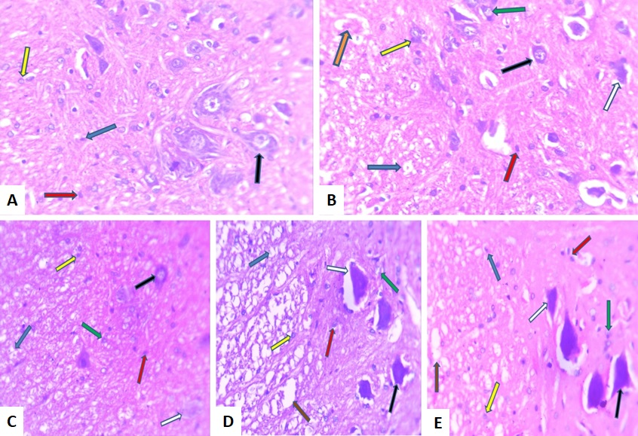
Figure 1: Sections of Spinal Cord Tissue Stained by H&E Staining Technique X400
A = Sham, B = SCI without treatment, C = SCI + 5 µL PRP, D = SCI + 10 µL PRP and E = SCI + 15 µL PRP.
Keys: Black arrows = Normal Neurons, White arrows = Degenerating neurons, Red arrows = Astrocytes, Blue arrows = Axons, Yellow arrows = Oligodendrocytes, Green arrows = Macrophages, Orange arrows = Haemorrhage and Brown arrows = Cavities.
Group A (Fig. 1A) section revealed normal histological features; normal nerve fibres and neuronal cell bodies with non reactive glial cells and no haemorrhage and inflammatory cells. Group B (Fig. 1B) section showed degenerating nerve fibres and neuronal cell bodies with reactive glial cells, and severe haemorrhage and inflammation with cavitations.
Group C (Fig. 1C) section revealed moderate improvement in the nerve fibres and cell bodies with some reactive glial cells and moderate haemorrhage and inflammation.
Group D (Fig. 1D) section showed appreciable improvement in the histological appearance of the nerve fibres and cell bodies with scanty reactive glial cells with no visible haemorrhage or inflammatory cells.
Group E (Fig. 1E) section revealed histological features similar to that of group D.
3.2 Cresyl Fast Blue Stained Sections
The Cresyl fast blue stained sections across the five different experimental groups revealed different histological changes as follows:

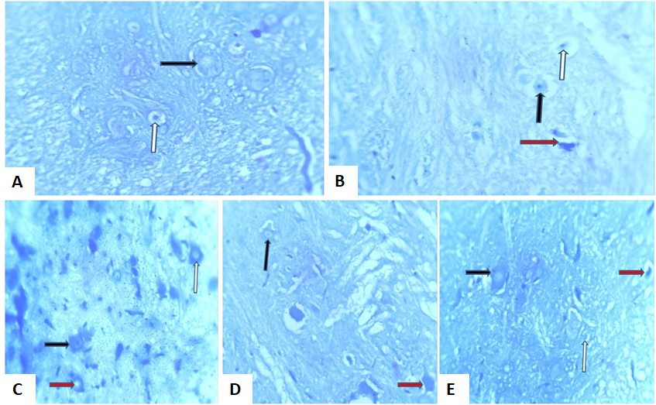
Figure 2: Sections of Spinal Cord Tissue Stained with Cresyl fast blue Staining Technique X400
A = Sham, B = SCI without treatment, C = SCI + 5 µL PRP, D = SCI + 10 µL PRP and E = SCI + 15 µL PRP.
Keys: Black arrows = Normal cell bodies with Nissl granules, White arrows = Axons, Red arrows = Degenerating cell bodies showing chromatolysis.
Group A (Fig. 2A) section revealed normal histological features; normal nerve fibres and neuronal cell bodies containing Nissl granules.
Group B (Fig. 2B) section showed severe degeneration of nerve fibres and neuronal cell bodies showing severe chromatolysis.
Group C (Fig. 2C) section revealed moderate degeneration of the nerve fibres and cell bodies showing moderate chromatolysis.
Group D (Fig. 2D) section showed appreciable improvement in the histological appearance of the nerve fibres, and cell bodies showing normal Nissl granules and mild chromatolysis. Group E (Fig. 2E) section revealed histological features similar to that of group D.

Table 1: Histological interpretations of stained slides
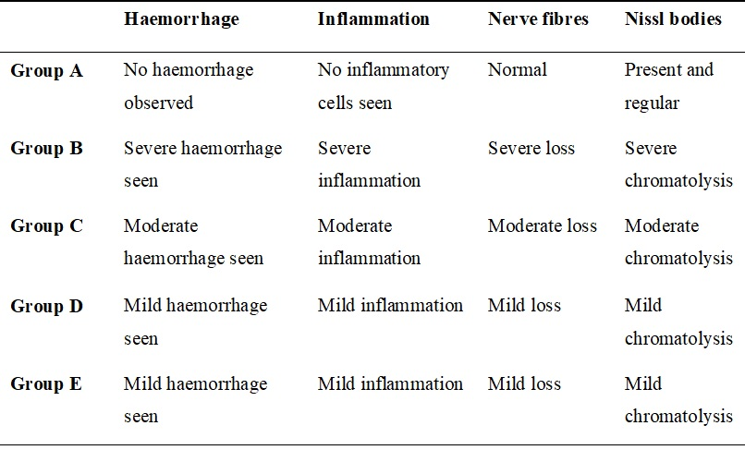

3.3 The Interpretation of the Histological Findings across the Groups
Group A: This is the Sham Control Group (Laminectomy only), as expected no haemorrhage or inflammation was observed in the H&E stained sections. The nerve fibres comprising of the axons and their supporting structures appeared normal and undamaged in the H&E stained sections. The Nissl bodies were present and regular in the Cresyl fast violet stained sections, indicating that the neuronal cell bodies and their rough endoplasmic reticulum or Nissl substance are structurally normal, suggesting healthy neuronal function. The overall result confirms that the surgical procedure itself (laminectomy) did not induce significant spinal cord pathology.
Group B: This group represents the full, untreated impact of the spinal cord injury. The findings were severe and indicated maximal tissue damage. Sections stained by H&E showed severe haemorrhage and inflammation, implying presence of extensive bleeding due to trauma and a robust inflammatory response, characterized by the infiltration of immune cells to the site of injury. The sections also showed substantial reduction in the number of intact nerve fibres (axons), indicating significant structural disruption of the spinal cord tissue. Cresyl fast violet staining showed severe dissolution or disintegration of Nissl bodies, also known as chromatolysis. This implies a profound neuronal stress and damage, where the cells are likely struggling to survive or repair themselves.
Group C: Treatment Group (SCI + 5 µL PRP). This group showed a partial, but notable, improvement compared to the untreated Group B. The H&E stained slides revealed reduced haemorrhage, from severe to moderate, suggesting that the lowest PRP dose may help in containing or resolving bleeding. The inflammatory response was less pronounced than in the untreated group. There was improvement in the nerve fibres showing moderate loss of axons. Cresyl fast violet stained slides revealed improvement in preservation of the Nissl bodies from severe to moderate chromatolysis; indicating that even the lowest dose of PRP has a protective effect on neuronal cell bodies, significantly reducing cellular stress.
Group D and E: Treatment Group (SCI + 10 µL PRP). This group showed a notable improvement compared to the untreated Group B. The severe pathology is reduced to mild levels across most parameters. The H&E stained slides revealed reduced haemorrhage, from severe to mild, suggesting that this PRP dose help in containing or resolving bleeding. The inflammatory response was less pronounced than in the untreated group. There was good improvement in the nerve fibres showing only mild loss of axons. Cresyl fast violet stained slides revealed improvement in preservation of the Nissl bodies from severe to mild chromatolysis. This is a very positive finding, indicating that this dose of PRP has a high protective effect on neuronal cell bodies, significantly reducing cellular stress.
4.0 DISCUSSION
The present study investigated the effects of varying doses (5 µL, 10 µL, and 15 µL) of activated PRP on histological outcomes following experimental SCI in Wistar rats. The findings demonstrated a clear dose-dependent neuro-protective effect, with all PRP-treated groups (Groups C, D, and E) showing marked improvements across all histological parameters compared to the untreated SCI control group (Group B).
The results showed severe haemorrhage in the untreated SCI group (Group B), which was reduced to moderate levels with 5 µL PRP (Group C) and to mild levels with both 10 µL and 15 µL PRP (Groups D and E). This dose-dependent reduction in haemorrhage is clinically significant, as secondary haemorrhage contributes substantially to the expansion of the initial injury and neurological deterioration. These findings agreed with recent work by Nie et al. (2024), who demonstrated that PRP-derived exosomes significantly reduce vascular permeability and restore tight junction integrity in blood-spinal cord barrier (BSCB) models. Their study showed that PRP-exosomes decreased the permeability of bEnd.3 cells under hypoxic-hypoglycemic conditions, while in vivo administration reduced Evans blue dye leakage and enhanced tight junction protein expression. The present study extends these observations by demonstrating that this vascular protective effect is dose-dependent, with higher PRP volumes (10-15 µL) achieving superior haemorrhage control. The vascular protective mechanisms of PRP are likely mediated through growth factors including vascular endothelial growth factor (VEGF) and platelet-derived growth factor (PDGF). It has been reported that intrathecal PRP administration stimulated angiogenesis and enhanced neuronal regeneration following SCI in rats, suggesting that PRP's vascular effects are integral to its neuroprotective properties (Chen et al., 2018).
Another more striking finding in this study is the dose-dependent reduction in inflammation, from severe in Group B to moderate in Group C, and mild in both Groups D and E. This anti-inflammatory effect represents one of the most critical therapeutic actions of PRP in SCI. Recent meta-analytic evidence supports these observations. In a systematic review and meta-analysis of PRP for SCI, confirmed that PRP administration significantly improves motor function in both moderate and severe injuries, with the effect being more pronounced in moderate injuries (Toloui et al., 2024). The anti-inflammatory mechanisms underlying these functional improvements have been elucidated by recent research. A recent study on leukocyte-rich PRP (L-PRP) demonstrated that PRP treatment significantly reduced IL-1β levels (40.15±3.10 pg/mL vs. 57.80±3.44 pg/mL in untreated SCI) and increased neuronal survival by approximately 27% (Colares et al., 2025). The present study's finding that 10 µL and 15 µL PRP achieved equivalent anti-inflammatory effects (both mild) suggests a possible ceiling effect, wherein volumes above 10 µL may not confer additional anti-inflammatory benefit. This observation has important implications for dose optimization in clinical translation.
The histological assessment of neuronal integrity revealed severe loss of nerve fibres and severe chromatolysis (loss of Nissl bodies) in untreated Group B. PRP treatment produced dose-dependent preservation; moderate changes with 5 µL, and mild changes with 10 -15 µL. These findings are strongly supported by the work of Margiana et al. (2024), who investigated PRP effects on peripheral nerve injury and spinal cord anterior horn histology. Their study demonstrated that PRP treatment significantly enhanced neuron density and improved Nissl body formation, with observable benefits by day 7 post-injury. They attributed these effects to modulation of Heat Shock Protein 70 (HSP 70) expression, which plays a crucial role in neuroprotection and inhibition of neuronal apoptosis. The preservation of Nissl bodies which are the rough endoplasmic reticulum essential for protein synthesis indicates that PRP-treated neurons maintain their metabolic and synthetic capacity. This is particularly important for axonal regeneration and synaptic reconstruction. The dose-response relationship observed (moderate preservation with 5 µL, mild changes with higher doses) suggests that higher growth factor concentrations achieved greater neuronal rescue in this experimental study.
5.0 CONCLUSION
The study demonstrated that administration of activated PRR post spinal cord injury has protective and restorative effects on histological changes following experimental SCI in Wistar rats in a dose dependant manner. It provides strong histological evidence supporting PRP as a potential therapy for SCI and contributes important dose-response data for clinical translation. The results align with and extend the growing body of literature documenting PRP's vascular protective, anti-inflammatory, neuroprotective, and pro-regenerative effects in spinal cord injury.

Ethical Approval
All authors hereby declare that all experiments have been examined and approved by the appropriate ethics committee and have therefore been performed following the ethical standard laid down in1964 Declaration of Helsinki.

Disclaimer (Artificial Intelligence)
Authors hereby declare that NO generative AI technologies such as Large Language Models (ChatGPT, COPILOT, etc.) and text-to-image generators have been used during writing or editing of this manuscript.

REFERENCES
Almuqairsha, S.A., Almoshigeh, A.N., Alsaud, M.S., Alawni, Z.A., Al-Ruqaie, S.S., Albarrak, R.M.A. and Alharbi, L.A. (2025). Traumatic spinal cord injury in Saudi Arabia: A systematic review. International Journal of Medicine in Developing Countries; 9(6):1333-1339.
Barriga-Martín, A., Pérez-Ruiz, P., Muñoz-Rodríguez, J.R., Romero-Muñoz, L., Peral-Alarma, M., Ríos-León, M. and Álvarez-Bautista, E. (2025). Epidemiology of traumatic spinal cord injury in Spain: a ten-year analysis of trend of clinical and demographic characteristics. The Journal of Spinal Cord Medicine; 48(5):884-890.
Carson, F.L. (1997). Histotechnology: A Self-Instructional Text. 2nd edn. American Society of Clinical Pathologists, Chicago, Illinois.
Chen, N.F., Sung, C.S., Wen, Z.H.,Chen, C.H., Feng, C.W., Hung, H.C.,Yang, S.N., Tsui, K.H. and Chen, W.F. (2018). Therapeutic Effect of Platelet-Rich Plasma in Rat Spinal Cord Injuries. Frontiers in Neuroscience; 12:252.
Chung, T. and Yong, F. (2025). Mechanism and pathophysiology of spinal cord injury. Traumatic Spinal Cord Injury; 15-24.
Cofano, F., Boido, M., Monticelli, M., Zenga, F., Ducati, A., Vercelli, A. and Garbossa, D. (2019). Mesenchymal Stem Cells for Spinal Cord Injury: Current Options, Limitations, and Future of Cell Therapy. International Journal of Molecular Sciences; 20(11):2698.
Colares, M.C., Thirupathi, A., Beirão, M.E., Zaccaron, R.P., de Roch Casagrande, L., Venturini, L.M., Mendes, C., De-Pieri, E., Gu, Y., Machado-de-Ávila, R.A. and Silveira, P.C.L. (2025). Platelet-rich plasma and IL-1β antagonist receptor peptide attenuate the inflammatory process of muscle injury in wistar rats. Scientific Reports; 15(1):14219.
Hagan, M.J., Feler, J., Sun, F., Leary, O.P., Bajaj, A., Kanekar, S., Oyelese, A.A., Telfeian, A.E., Gokaslan, Z.L. and Fridley, J.S. (2022). Spinal cord injury in adult and pediatric populations, Interdisciplinary Neurosurgery: Advanced Techniques and Case Management; 29:101594.
Harikrishnan, V.S., Krishnan, L.K., and Abelson, K.S.P. (2019). A novel technique to develop thoracic spinal laminectomy and a methodology to assess the functionality and welfare of the contusion spinal cord injury rat model. PloS one; 14(7):e0219001.
Havelikova, K., Smejkalova, B. and Jendelova, P. (2022). Neurogenesis as a Tool for Spinal Cord Injury. International Journal of Molecular Sciences; 23:3728.
Ibikunle, P.O. and Okoro, E.O. (2018). A fifteen years retrospective study of spinal cord injury in South‑Eastern Nigeria. EC Orthopaedics; 9:671‑87.
Ishaku, C.M., Jawa, B.K., Maduagwu, S.M., Hassan, A.B., Lawan, A., Rufa’i, A.A. and Oyeyemi, A.Y. (2021). Pattern and outcome of traumatic spinal cord injury managed at University of Maiduguri Teaching Hospital, Nigeria: A retrospective study. Nigerian Postgraduate Medical Journal; 28:139-44.
Kayabas, M., Kilic, M. and Bigol, S.A. (2025). Evaluation of the therapeutic and protective properties of agomelatine in an experimental rat spinal cord injury model. Rats; 3(2):61-65.
Margiana, R., Salma, N.M. and Jusuf, A.A. (2024). Impact of Platelet-Rich Plasma on Sciatic Nerve Injury in Rats: HSP 70 Expression and Histological Changes in the Anterior Horn of the Spinal Cord. South Eastern European Journal of Public Health; 25:73-81.
Nie, X., Liu, Y., Yuan, T., Yu, T., Yun, Z., Xue, W., Yu, T., An, J., Dai, A., Wu, K. and Liu, Q. (2024). Platelet-rich plasma-derived exosomes promote blood-spinal cord barrier repair and attenuate neuroinflammation after spinal cord injury. Journal of Nanobiotechnology; 22(1):456.
Nowacka, A., Sniegocki, M. and Ziolkowska, E. (2025). A review of the potential use of antioxidants in spinal cord injury. Antioxidants; 14(9):1081.
Shang K., Liu, Y. and Qadeer, A. (2025). Platelet-rich plasma in peripheral nerve injury repair: A comprehensive review of mechanisms, clinical applications and therapeutic potential. Experimental Biology and Medicine; 250:10746.
Tan, Q., Li, J., Yin, Y. and Shao, W. (2022). The role of growth factors in the repair of motor injury. Frontiers in Pharmacology; 13:898152.
Toloui, A., Adel, R.H., Aboutaleb, N. and Yousefifard, M. (2024). Effectiveness of platelet-rich plasma in treating spinal cord injury: A systematic review and meta-analysis. Basic and Clinical Neuroscience; 15(4):443-454.
Wang, X., Yu, H., Kold, S., Rahbek, O. and Bai, S. (2023). Wearable sensors for activity monitoring and motion control: A review. Biomimetic Intelligence and Robotics; 3:100089.
Wang, Y., Li, C., Yu, H., Wang, H. and Zhang, X.D. (2026). Molecular diagnosis and interventions for spinal cord inury. TrAC Trends in Analytical Chemistry; 196:118634.
Wiles, M.D. (2022). Airway management in patients with suspected or confirmed traumatic spinal cord injury: a narrative review of current evidence. Anaesthesia; 77:1120-1128.
Wu, W.S., Chen, L.R. and Chen, K.H. (2025). Platelet rich plasma (PRP) Molecular mechanisms, actions and clinical applications in human body. International Journal of Molecular Sciences; 26:10804.
Yadollahi, M., Karajizadeh, M., Bordbar, N. and Ghahramani, Z. (2023). Incidence and pattern of traumatic spinal cord injury in a single level I trauma center of southern Iran, Chinese Journal of Traumatology; 26(4):199-203.
Yang, T., Dai, Y. Chen, G. and Cui, S. (2020). Dissecting the dual role of the glial scar and scar-forming astrocytes in spinal cord injury. Frontiers in Cellular Neuroscience; 14:78.
Zhang, J.Y., Steven, Z.D. and Liao, K.H. (2023). Therapeutic effect of umbilical cord blood cells on spinal cord injury. Ibrain; 9(4):1‐10.

